The distribution of CashFlow values during the year with and without hedging

LogNormal distribution was selected for Monte Carlo simulation of asset price motions during the year.

10000 motions were simulated in total and 4 CashFlows, that are subject to risk of adverse EURUSD=X movements, were added:

# All Cashflows

|  |  |  |  |
| --- | --- | --- | --- |
| Date | Ammount | Buy | Hedging strategy |
| 2023-01-04 | 200000.0 | True | Collar [0.93,1.05] |
| 2023-03-31 | 200000.0 | True | FRD 0.99492 |
| 2023-06-30 | 200000.0 | True | Call option 1.05 |
| 2023-09-29 | 200000.0 | True | Collar [0.96,1.05] |

# No hedging

Given the distribution of EURUSD=X and the future cashflows, risks for the enterprise are the following:

|  |  |
| --- | --- |
| The worst total value of CFs | -996799.8749 |
| The best total value of CFs | -628228.3352 |
| VaR 1% | -872277.4951 |
| VaR 5% | -837879.7392 |

## Plot of total CashFlow value distribution WITHOUT HEDGING

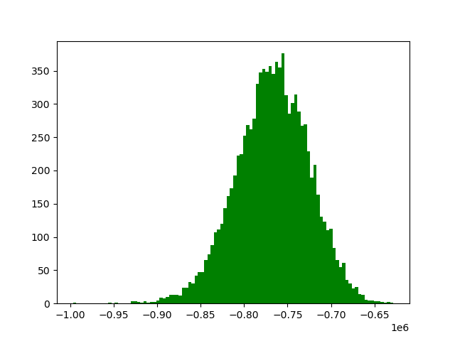

# Hedging implemented

|  |  |
| --- | --- |
| The worst total value of CFs | -840984.0000 |
| The best total value of CFs | -738546.0141 |
| VaR 1% | -840867.6717 |
| VaR 5% | -831435.1197 |

## Plot of total CashFlow value distribution WITH HEDGING

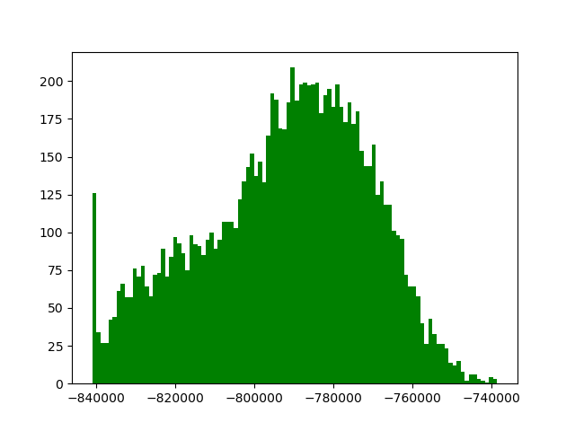

|  |  |
| --- | --- |
| Proportion of bad cases avoided | 4.31% |
| Proportion of good cases avoided | 25.01% |
| Worst case difference | 155815.87493183743 |
| Best case difference | 258253.8608624118 |