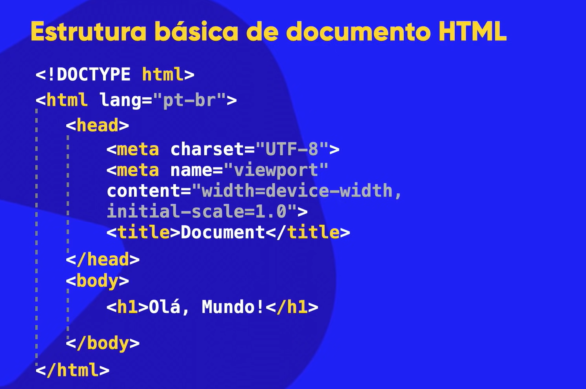

**Tag Type What It Is**

<p> HTML Text Tags Paragraph

<h1> HTML Text Tags Heading 1

<h2> HTML Text Tags Heading 2

<h3> HTML Text Tags Heading 3

<h4> HTML Text Tags Heading 4

<h5> HTML Text Tags Heading 5

<h6> HTML Text Tags Heading 6

<strong> HTML Text Tags Strong

<em> HTML Text Tags Emphasis

<abbr> HTML Text Tags Abbreviation

<address> HTML Text Tags Contact Information

<bdo> HTML Text Tags Override The Current Text Direction

<blockquote> HTML Text Tags Content From Another Source

<cite> HTML Text Tags Title Of The Work, Book, Website

<q> HTML Text Tags Inline Quotation

<code> HTML Text Tags Display A Part Of Programming Code

<ins> HTML Text Tags Text Inserted

<del> HTML Text Tags Text Deleted From The Document

<dfn> HTML Text Tags Term Defined Within A Sentence/Phrase

<kbd> HTML Text Tags Keyboard Input

<pre>

HTML Text Tags

Preformatted Text

<samp>

HTML Text Tags

Sample Output Of A Computer Program

<var>

HTML Text Tags

Variable Name Used In Mathematical Or Programming Context

<br>

HTML Text Tags

Single Line Break

<div>

HTML Text Tags

Division

<a>

HTML Link Tags

Anchor Tag For A Link

<base>

HTML Link Tags

Base Url For All Relative Url Within The Document

<img>

HTML Image And Object Tags

Image

<area>

HTML Image And Object Tags

Area Of An Image Map

<map>

HTML Image And Object Tags

Image Map

<param>

HTML Image And Object Tags

Parameter For An <Object> Element

<object>

HTML Image And Object Tags

Embed An Object

<ul>

HTML List Tags

Unordered List

<ol>

HTML List Tags

Ordered List

<li>

HTML List Tags

List

<dl>

HTML List Tags

Description List

<dt>

HTML List Tags

Term In Description List

<dd>

HTML List Tags

Definition/Description Of A Term In Description List

&lt – menor que (less than)

&gt – maior que (greater than)

<br> - quebra de linha (break row)

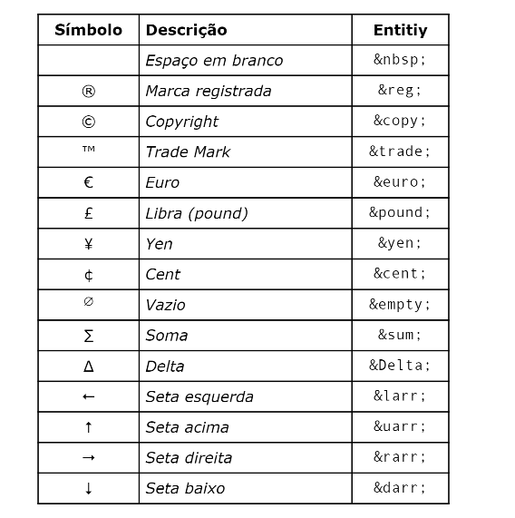

**IMAGENS, ÁUDIOS E VÍDEOS**

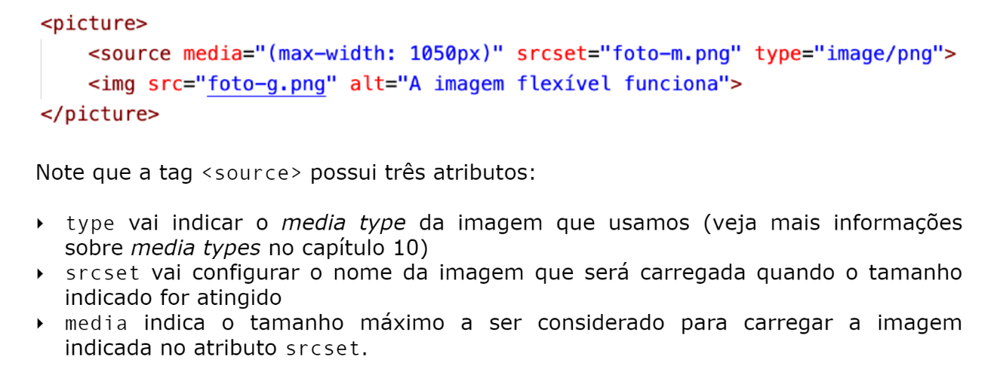

Utiliza-se o **source srcset** para imagens. Para imagens dinâmicas, coloca-se dentro da tag **<Picture>** primeiro a **tag <img>** com a foto de maior qualidade (padrão). Depois, para adaptar a imagem em diferentes dispositivos, coloca-se o **<source>** com o tamanho das imagens definidas pelo método **media** antes da tag **<img>.**

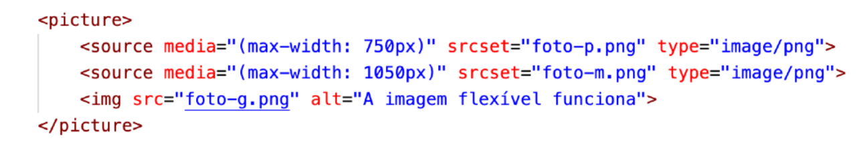

**ÁUDIOS**

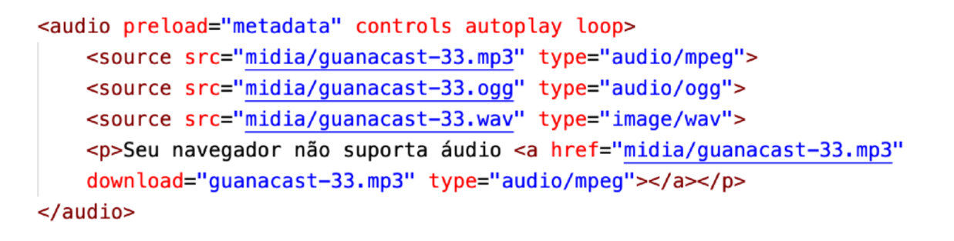

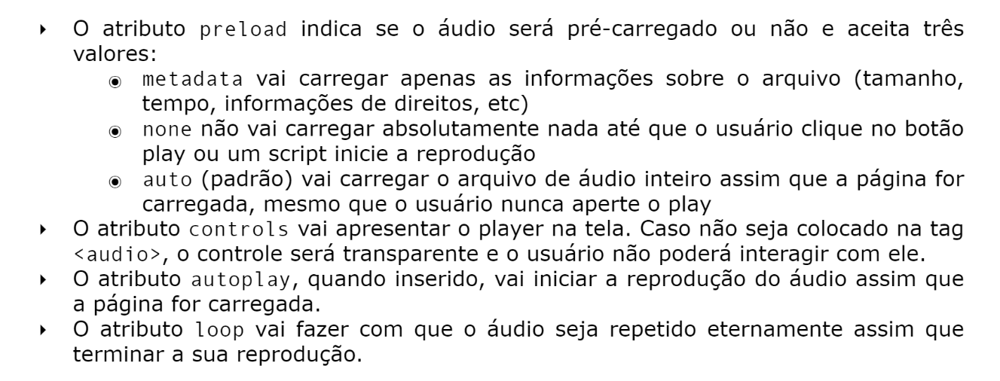

**VÍDEOS**

