**Technical Report**

* 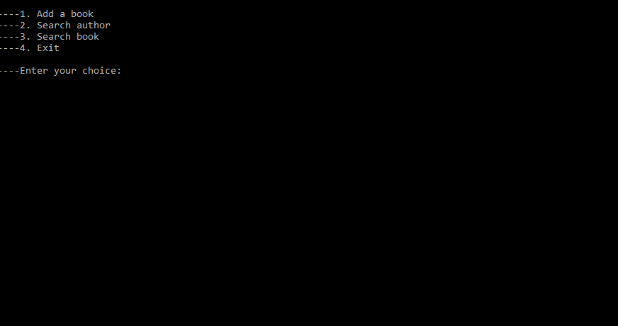The program from the lab homework describes how a library management system works. It has 3 main features: adding a book and the name of the author to the library , listing all the books that were written by a certain author and listing all the writers that co-authored a given book.
* The list of all the book titles and the authors was implemented using a singly linked list.

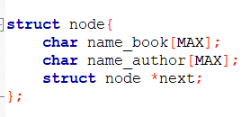

* The program is modular and is divided into 3 separate files: main.c, list.h and list.c.
* In main.c there is only the main function which prompts the user to input a choice in order to add a book or to query the list.

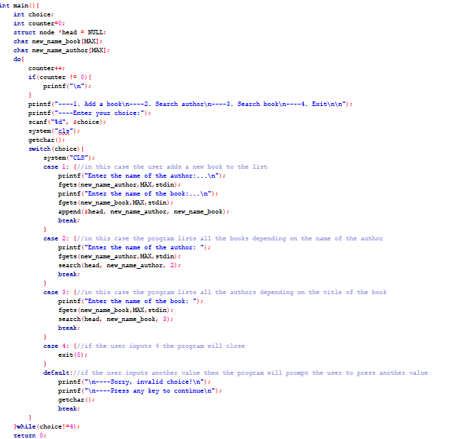

* 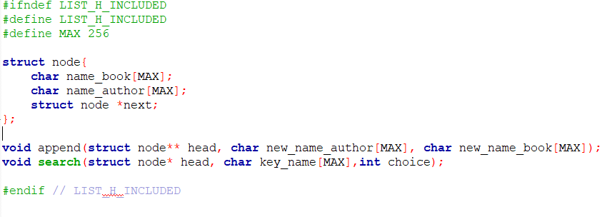List.h is a header file that contains all the declarations of the functions used in the program
* 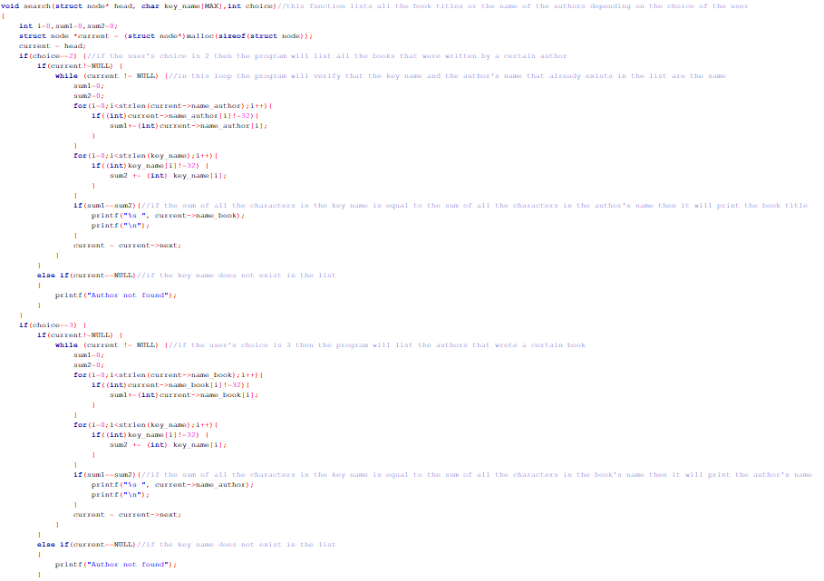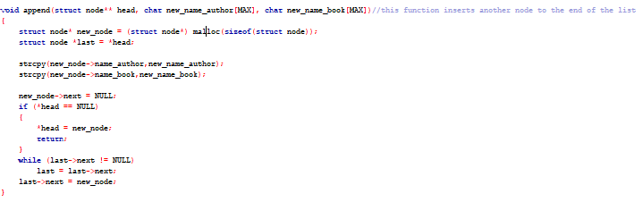List.c is contains all the definitions of the functions used in the project.
* The append function inserts a new node at the end of the list. It requires 3 parameters: the head of the list, the name of the author and the book title.
* The search function queries the list depending on the user’s choice:
  + If the user wants to see all the books that were written by a certain author then the program will prompt him to input the name of the author then it will list all the book titles.
  + If the user wants to see all the authors that wrote a book then the program will list all the author’s names.