Filename: controllerheader.jpg

File size: 24.4 KB

Found at https://www.pexels.com/photo/black-microsoft-xbox-game-controller-1298601/

Black Microsoft Xbox Game Controller. Creative Commons. Pexels.

Filename: gamer.jpg

File Size: 31.9 KB

Found at https://unsplash.com/photos/6ou8gWpS9ns



Photo by Fredrick Tendong. Creative Commons. Unsplash.

Filename: gameroom.jpg

File Size: 78.8 KB

Found at https://unsplash.com/photos/8Gdayy2Lhi0



Photo by Carl Raw. Creative Commons. Unsplash.

Filename: openworld.jpg

File Size: 246 KB

Found at https: //www.destructoid.com/how-breath-of-the-wild-dunks-on-most-open-world-games/

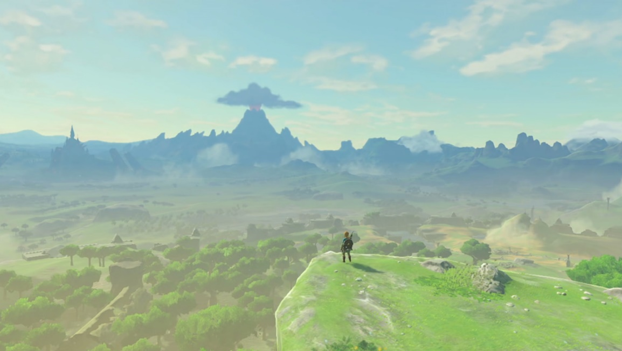

Photo by Anthony Burch. Creative Commons. Destructoid.

Filename: troopers.jpg

File Size: 62.8 KB

Found at https://unsplash.com/photos/YVgOh8w1R4s



Photo by Saksham Gangwar. Creative Commons. Unsplash.

Filename: videogames.jpg

File Size: 54.8 KB

Found at https://unsplash.com/photos/m3hn2Kn5Bns

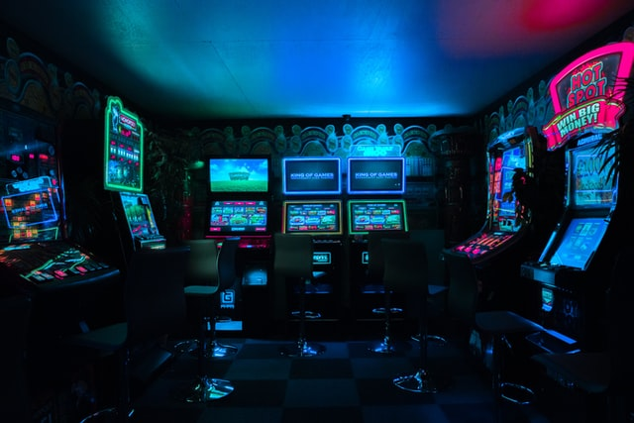

Photo by Carl Raw. Creative Commons. Unsplash.

Filename: eldinring.jpg

File Size: 210 KB

Found at https: https://www.rockpapershotgun.com/elden-ring-system-requirements-released-minimum-specs-list-the-gtx-1060-and-12gb-of-ram

Elden Ring Scene by Rock Paper Shotgun. Copyright 2022 by Gamer Network Limited.

Filename: hyrulecastle.jpg

File Size: 147 KB

Found at https://www.pixel4k.com/zelda-95391.html

Hyrule Castle by Pixel4k admin. Copyright 2022 by Pixel4k.

Filename: esports.png

File Size: 243 KB

Found at https://www.esportsforparents.com/things-parents-of-gamers-should-know-and-understand/

Get to Know the World of Online Gaming and Esports by Esports For Parents. Copyright 2022 by Ten Degree Tilt LLC

Filename: looper.png

File Size: 70.1 KB

](https://www.looper.com/223717/things-parents-never-understand-about-gaming/#)

Ori and the Blind Forest by Looper. Copyright 2022 by Static Media.

Filename: tournament.jpg

File Size: 55 KB

Found at https://www.pexels.com/photo/gaming-chairs-and-computers-9072216/

Gaming Chairs and Computers. Creative Commons. Pexels.