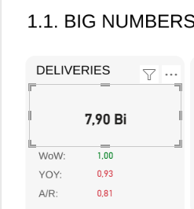
Nome do campo: DELIVERIES
Nome da métrica: tDeliveries
tDeliveries =
SUM(fConsolidated[DELIVERED])
// calculate(SUM(fConsolidated[DELIVERED]),REMOVEFILTERS(dProducts))

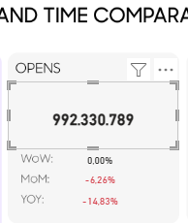
Nome do campo: OPEN
Nome da Métrica: tOpens
tOpens = calculate(SUM(fConsolidated[OPENS]),REMOVEFILTERS(dProducts))

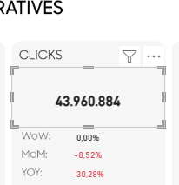
Nome do campo: CLICKS
Nome da métrica: tClicks
tClicks = calculate(SUM(fConsolidated[CLICKS]),REMOVEFILTERS(dProducts))
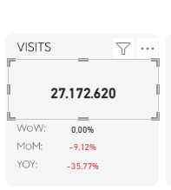
Nome do campo: VISITS
Nome da métrica: tVisits
tVisits =

VAR visitsAffiliate =
CALCULATE(
SUM(fConsolidated[Total_visits]),
fConsolidated[DATA_SOURCE] = "AFFILIATE",
REMOVEFILTERS(dProducts)
)

VAR visitsAll =
CALCULATE(
SUM(fConsolidated[Total_visits]),
REMOVEFILTERS(dProducts)
)

RETURN
(visitsAll - visitsAffiliate) + (visitsAffiliate * 0.044)
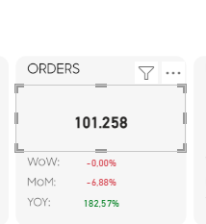
Nome do campo:
Nome da métrica: tOrdersCRM
tOrdersCRM =
VAR OrdersAppsFlyer =
CALCULATE(
// DISTINCTCOUNTNOBLANK(fConsolidated[Order_ID]),
SUM(auxOrderIDPerDate[ORDERS_BY_ORDERID]),
fConsolidated[Source] = "IOS" ||
fConsolidated[Source] = "ANDROID" ||
fConsolidated[Source] = "APP" ||
fConsolidated[CHANNEL / TRIGGER] = "APP PUSH"
)
VAR OrdersInsider =
CALCULATE(
SUM(fConsolidated[Total_orders]),
fConsolidated[Source] = "IOS" ||
fConsolidated[Source] = "ANDROID" ||
fConsolidated[Source] = "APP" ||
fConsolidated[Source] = "ARQUITECT" ||
fConsolidated[Source] = "ARCHITECT" ||
fConsolidated[Source] = "EPP" ||
fConsolidated[CHANNEL / TRIGGER] = "APP PUSH"
)

VAR ordersVTEX =
CALCULATE(
SUM(fConsolidated[Total_orders]),
fConsolidated[Source] = "VTEX"
)

VAR OrdersCRM = CALCULATE(
SUM(fConsolidated[Total_orders]),
fConsolidated[Source] = "ANALYTICS" || fConsolidated[Source] = "WHATSAPP"
)

VAR OrdersGA4 = [tOrdersGA4]

VAR OrdersAffiliate = CALCULATE(
SUM(fConsolidated[Total_orders]),
fConsolidated[DATA_SOURCE] = "AFFILIATE"
)

RETURN (OrdersAppsFlyer + OrdersInsider + OrdersCRM + ordersVTEX + OrdersGA4 + (OrdersAffiliate * 0.044)) - OrdersAffiliate

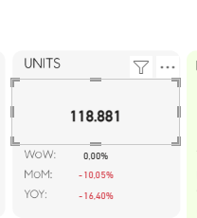
Nome do campo: UNITS
Nome da métrica: tUnits AA
tUnits AA =
VAR unitsAffiliate =
CALCULATE(
SUM(fConsolidated[Total_units]),
fConsolidated[DATA_SOURCE] = "AFFILIATE"
)

VAR unitsAll =
SUM(fConsolidated[Total_units])

RETURN
(unitsAll - unitsAffiliate) + (unitsAffiliate * 0.044)

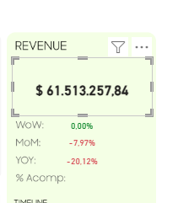
Nome do campo: REVENUE
Nome da métrica: tRevenueCRM
tRevenueCRM =
([tRevenueAA] + [tRevenueVTEX] + [tRevenueAPP] + [tRevenueWPAPP] + [tRevenueGA4] + ([tRevenueAffiliate] * 0.044)) - [tRevenueAffiliate]
Métricas que compõem
tRevenueAA:
tRevenueAA =
VAR MostrarLocal =
[currencySEDAselecionado]
&& [currencyMOEDAselecionado] = "BRL"

RETURN
IF(
MostrarLocal,
CALCULATE(
SUM(fConsolidated[Revenue_SEDA]),
fConsolidated[Source] = "ANALYTICS"
),
CALCULATE(
SUM(fConsolidated[Revenue]),
fConsolidated[Source] = "ANALYTICS"
)
)

tRevenueVTEX
tRevenueVTEX =
VAR MostrarLocal =
[currencySEDAselecionado]
&& [currencyMOEDAselecionado] = "BRL"

RETURN
IF(
MostrarLocal,
CALCULATE(
SUM(fConsolidated[Revenue_SEDA]),
fConsolidated[Source] = "VTEX"
),
CALCULATE(
SUM(fConsolidated[Revenue]),
fConsolidated[Source] = "VTEX"
)
)
tRevenueAPP
tRevenueAPP =
VAR MostrarLocal =
[currencySEDAselecionado]
&& [currencyMOEDAselecionado] = "BRL"

RETURN
IF(
MostrarLocal,
CALCULATE(
SUM(fConsolidated[Revenue_SEDA]),
FILTER(dAllDimensions, dAllDimensions[CHANNEL] = "APP PUSH")
),
CALCULATE(
SUM(fConsolidated[Revenue]),
FILTER(dAllDimensions, dAllDimensions[CHANNEL] = "APP PUSH")
)
)
tRevenueWPAPP
tRevenueWPAPP =
VAR MostrarLocal =
[currencySEDAselecionado]
&& [currencyMOEDAselecionado] = "BRL"

RETURN
IF(
MostrarLocal,
CALCULATE(
SUM(fConsolidated[Revenue_SEDA]),
FILTER(
fConsolidated,
fConsolidated[CHANNEL] = "WEB PUSH" &&
fConsolidated[Source] = "APP"
)
),
CALCULATE(
SUM(fConsolidated[Revenue]),
FILTER(
fConsolidated,
fConsolidated[CHANNEL] = "WEB PUSH" &&
fConsolidated[Source] = "APP"
)
)
)
tRevenueGA4
tRevenueGA4 =
CALCULATE(
SUM(fConsolidated[Revenue]),
LEFT(fConsolidated[Source], 9) = "GA4_SEASA"
)

tRevenueAffiliate
tRevenueAffiliate =
CALCULATE(
SUM(fConsolidated[Revenue]),
fConsolidated[DATA_SOURCE] = "AFFILIATE"
)
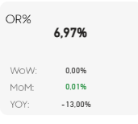
Nome do campo: OR%
Nome da métrica: OR%
OR% =
VAR mailOpens =
CALCULATE(
[tOpens],
// REMOVEFILTERS(dProducts),
fConsolidated[CHANNEL] = "WHATSAPP" || fConsolidated[CHANNEL] = "EMAIL"
)
VAR mailDeliveries =
CALCULATE(
[tDeliveries],
// REMOVEFILTERS(dProducts),
fConsolidated[CHANNEL] = "WHATSAPP" || fConsolidated[CHANNEL] = "EMAIL"
)
RETURN
IF(mailDeliveries > mailOpens, DIVIDE(mailOpens, mailDeliveries, 0), 0)
Métricas que compõem
tOpens
tDeliveries
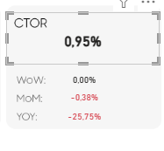
Nome do campo: CTOR
Nome da métrica: CTOR%
CTOR% =
VAR mailClicks =
CALCULATE(
[tClicks],
// CONTAINSSTRING(dAllDimensions[TrackingCode], "mail"),
// REMOVEFILTERS(dProducts),
fConsolidated[CHANNEL] = "WHATSAPP" ||
fConsolidated[CHANNEL] = "EMAIL")
VAR mailOpens =
CALCULATE(
[tOpens],
// CONTAINSSTRING(dAllDimensions[TrackingCode], "mail"),
// REMOVEFILTERS(dProducts),
fConsolidated[CHANNEL] = "WHATSAPP" ||
fConsolidated[CHANNEL] = "EMAIL")
RETURN
IF(mailOpens > mailClicks, DIVIDE(mailClicks, mailOpens, 0), 0)
Métricas que compõem:
tClicks
tOpens
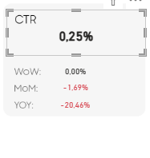
Nome do campo: CTR
Nome da métrica: CTR%
CTR% =
VAR mailClicks =
CALCULATE(
[tClicks],
FILTER(
dAllDimensions,
dAllDimensions[CHANNEL / TRIGGER] = "EMAIL" || dAllDimensions[CHANNEL / TRIGGER] = "PUSH"

), REMOVEFILTERS(dProducts)
)
VAR mailDeliveries =
CALCULATE(
[tDeliveries],
FILTER(
dAllDimensions,
dAllDimensions[CHANNEL / TRIGGER] = "EMAIL" || dAllDimensions[CHANNEL / TRIGGER] = "PUSH"
), REMOVEFILTERS(dProducts)
)

var CTR2 = DIVIDE([tClicks],[tDeliveries])

RETURN CTR2
Métricas que compõem:
tClicks
tDeliveries
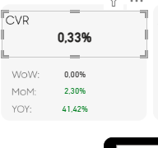
Nome do campo: CVR
Nome da métrica: CVR%
CVR% =
VAR visitsAFFILIATE =
CALCULATE(
[tVisits],
fConsolidated[DATA_SOURCE] = "AFFILIATE"
)

VAR visits =
[tVisits] - visitsAFFILIATE

RETURN
DIVIDE([tOrdersCRM_withVisits], visits, 0)
Métricas que compõem
tVisits
tOrdersCRM_withVisits
tOrdersCRM_withVisits =
VAR OrdersAppsFlyer =
CALCULATE(
// DISTINCTCOUNTNOBLANK(fConsolidated[Order_ID]),
SUM(auxOrderIDPerDate[ORDERS_BY_ORDERID]),
fConsolidated[Source] = "IOS" ||
fConsolidated[Source] = "ANDROID" ||
fConsolidated[Source] = "APP" ||
fConsolidated[CHANNEL / TRIGGER] = "APP PUSH"
)
VAR OrdersInsider =
CALCULATE(
SUM(fConsolidated[Total_orders]),
fConsolidated[Source] = "IOS" ||
fConsolidated[Source] = "ANDROID" ||
fConsolidated[Source] = "APP" ||
fConsolidated[Source] = "ARQUITECT" ||
fConsolidated[Source] = "EPP" ||
fConsolidated[CHANNEL / TRIGGER] = "APP PUSH"
)

VAR OrdersCRM = CALCULATE(
SUM(fConsolidated[Total_orders]),
fConsolidated[Source] = "ANALYTICS" || fConsolidated[Source] = "WHATSAPP"
)

VAR OrdersGA4 = [tOrdersGA4]

VAR OrdersVTEX2 =
CALCULATE(
SUM(fConsolidated[Total_orders]),
fConsolidated[DATA_SOURCE] = "VTEX_CARTAPP"
)

VAR OrdersAffiliate =
CALCULATE(
SUM(fConsolidated[Total_orders]),
fConsolidated[DATA_SOURCE] = "AFFILIATE"
)

RETURN OrdersAppsFlyer + OrdersInsider + OrdersCRM + OrdersGA4 - OrdersVTEX2 - OrdersAffiliate

// VAR VTEXseda =
// CALCULATE(
// DISTINCTCOUNT(fConsolidated[Order_ID]),
// fConsolidated[Source] = "VTEX"
// )

// VAR VTEXsela =
// CALCULATE(
// SUM(fConsolidated[Total_orders]),
// fConsolidated[DATA_SOURCE] = "ABANDCART_SELA"
// )
// tOrdersAA = SUM(fConsolidated[Total_orders]) + SUM(auxOrderIDPerDate[ORDERS_BY_ORDERID])
// tOrdersAA = [tOrders APP]
// tOrdersAA = [tOrdersCRM] + [tOrdersVTEX] + [tOrders APP]OrderstOrdersCRM =
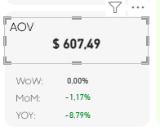
Nome do campo: AOV
Nome da métrica: AOV
AOV = DIVIDE([tRevenueCRM], [tOrdersCRM])
Métricas que compõem
tRevenueCRM
tOrdersCRM

