ICS2210 Report

By Gabriel Hili

Contents

Johnson’s Algorithm 2

Dry Run 5

Bibliography 8

# Evaluation & Discussion

## Underlying Data Structure

Since I knew that a state would always have 2 transitions, I represented my DFA in a state-transition table. The state-transition table has two arrays, one for each transition. The transitions of some state *i* are the indices in position *i* in the arrays of the transition table. I chose to use a state-transition table because; it has O(1) look-up time like an adjacency matrix and O(*v*t*) space complexity, like an adjacency list, where *v* is the number of vertices and *t* is the length of the alphabet. Since a given state can only have 2 transitions using an adjacency matrix would be wasteful, as the connections would be sparse.

To represent the final states, a Boolean array was used. A final state *f* means that the value at position *f* in the array is *True* and for non-final states it would be *False*.

## Algorithms

Hopcroft’s minimisation algorithm can be evaluated by checking if the automata still recognises the same language after minimisation. The moment the DFA is generated, 100,000 strings of length 32 are randomly generated and passed through the DFA. If the automata rejects and accepts the same strings after minimisation, then we can say with good probability that the automata recognises the same language.

The DFA class stores strings as 32-bit numbers, where *a* and *b* are represented by 0 and 1 respectively. If the string was accepted in the original graph, but the state it ended up in was not a final state, then we can conclude that the language recognised is not the same.

# Johnson’s Algorithm

Johnson’s algorithm was invented by Donald B. Johnson in 1975 [1]. It is used to find all simple cycles in a directed graph. The time complexity of this algorithm is O((E+V)(c+1)) where E is the number of edges, V is the number of vertices and c is the number of simple cycles in the graph.

In a nutshell, the algorithm first finds the Strongly Connected Components (SCC) of a graph. Then, for every vertex in a SCC, all simple cycles starting and ending in that vertex are found, by traversing the SCC in a Depth-First Search (DFS) fashion. After all simple cycles starting from that vertex are found, the vertex is removed from the graph, the SCCs are recomputed, and a new starting vertex is chosen. The algorithm repeats until the graph is empty.

while (!empty(G)) {

SCCs = G.getSCC()

for (scc in SCCs) {

for (v in scc) {

cycles.add(G.getSimpleCycles(v,scc))

G.remove(v)

SCCs = G.getSCC()

}

}

}

Fig 1. Pseudo-code for Johnson’s Algorithm.

Simple cycles are Hamiltonian Tours of a subset of vertices in the graph such that no vertex appears more than once, except the starting vertex which appears at the end. For example, the following graph contains 3 simple cycles {A →B →C →A}, {B →C →B} and {D →E →F→D}.

Fig 2. A Directed Graph with 3 simple cycles.

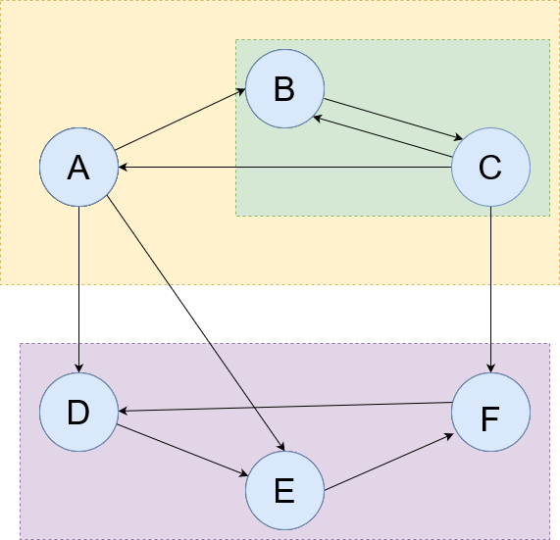

Strongly Connected Components are a subset of vertices in the graph such that any vertex is reachable from every other vertex. SCCs can be computed using Tarjan’s Strongly Connected Component Algorithm [2]. For every SCC, there cannot exist a path such that it leaves the SCC and comes back. For example the following graph has 3 SCCs.

Fig 3. A Directed Graph with 3 Strongly Connected Components.

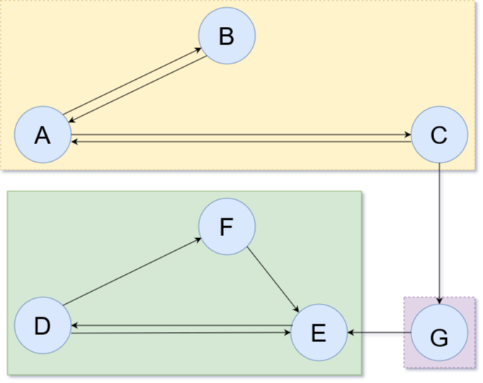

Given a strongly connected component and a starting vertex, Johnson’s algorithm will find all simple cycles starting from the starting vertex, within that strongly connected component. To do this, it makes use of 3 data structures. The *Stack, Blocked Set* *and Blocked Map*. The *Stack* is used to keep track of vertices traversed by the Depth-First Search. The *Blocked Set* is used to close off vertices because a valid cycle cannot be found through those vertices. This saves the algorithm time because it does not have to traverse a path which won’t lead to a simple cycle. Any vertex placed in the *Stack* or *Blocked Set* cannot be traversed by the DFS. The *Blocked Map* creates rules such that if a vertex in the *Blocked Set* becomes unblocked (it is removed from the *Blocked Set*) then another vertex must also be unblocked. Vertices unblocked by this rule may also fire additional rules which will unblock more consequent vertices. Once a rule fires, the rule is removed from the *Blocked Map*.

The algorithm starts from the starting vertex and performs DFS. Anytime an untraversed (not in the *Stack*) and unblocked (not in *Blocked Set*) vertex is encountered, it is added to the *Stack* and the *Blocked Set*. It is added to the *Blocked Set* to prevent the DFS from traversing a path which will not lead it to a simple cycle. If that vertex does lead to a simple cycle later on, then it is unblocked.

**Given a vertex *v* traversed by the DFS, the algorithm can react in 3 different ways.**

**Case 1**: If the starting vertex is re-encountered then that means a simple cycle was found. The *Stack* and the *Blocked Set* donot allow the DFS to expand into already seen vertices as untraversed vertices must be unseen and unblocked, so we know that the starting vertex was re-encountered through a simple cycle. The simple cycle found is composed of all the values between the top most value and the starting vertex in the *Stack*. The algorithm then recurses back to the parent, pops *v* from the *Stack* and continues traversing any other children, if any.

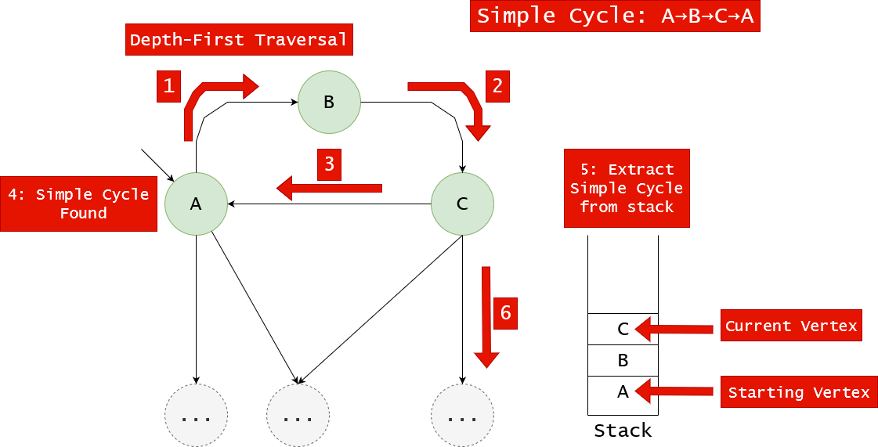

Fig 4. A simple cycle being detected and extracted from the Stack Stack.

**Case 2**: If a vertex *v* cannot be expanded further because all child vertices are in the *Blocked Set*, then the DFS recurses back to the parent of *v* and is popped from the *Stack*. We note that *v* cannot be expanded only because the children are blocked. So we add a rule in the *Blocked Map* that says if any child of *v* ever becomes unblocked, then we will unblock *v* to facilitate any future cycles passing through *v* and its child.

Fig 5. D cannot expand into B, because B is blocked.

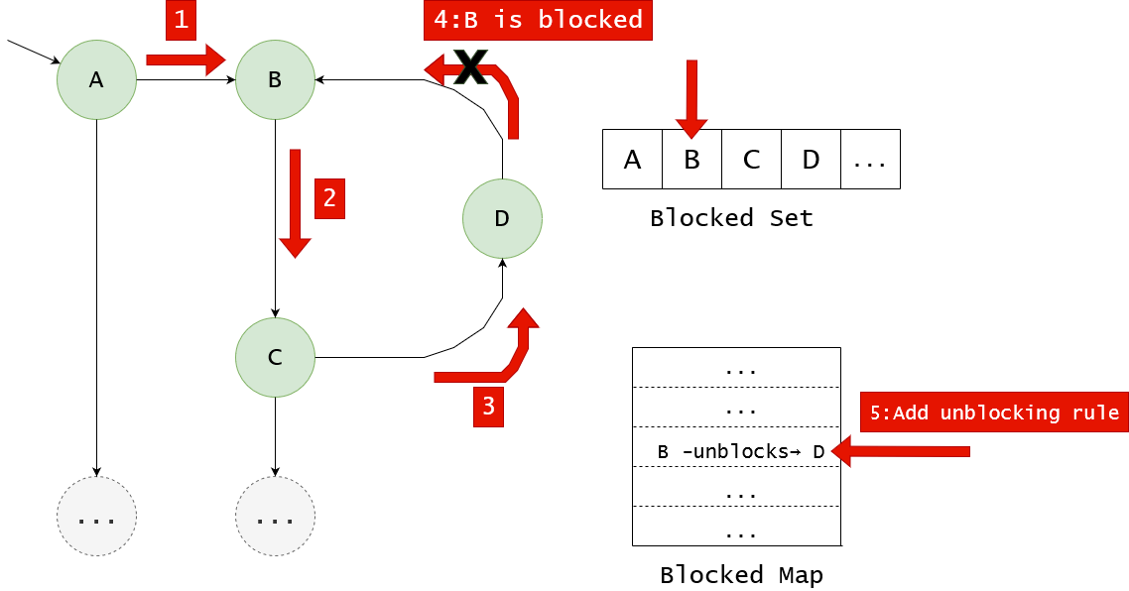

**Case 3**: If a vertex *v* cannot be expanded further because all child vertices are in *Blocked Set*, but one of *v’s* children was part of a found cycle, then: *v* is removed from the *Blocked Set*, DFS recurses back to the parent of *v* and *v* is popped from the *Stack*. We remove *v* from the *Blocked Set* because if we know there exists a vertex *w* that leads directly into *v* and then eventually into the starting vertex, then there might exist another vertex *w****′*** that is reachable from the starting vertex, which leads directly into *v*, hence finding another simple cycle. When *v* is unblocked, the algorithm consults the *Blocked Map* to see if any other vertices must also be unblocked.

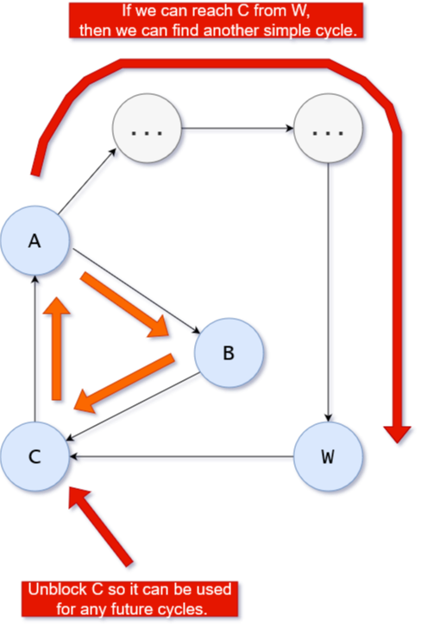

Fig 6. Unblocking C so the algorithm could attempt to re-enter C through W.

The algorithm traverses the graph using DFS updating the *Stack, Blocked Set* and *Blocked Map*, based on the above 3 cases. When the DFS finishes and returns to the starting vertex, as mentioned before, the algorithm will remove that vertex from the graph, re-compute the SCCs and start over. This repeats until all vertices are popped from the Graph.

## Dry Run

The following is a dry run of finding all simple cycles from the starting vertex A. We first decompose the graph G into its Strongly Connected Components. Then we pick the SCC containing A and perform the algorithm.

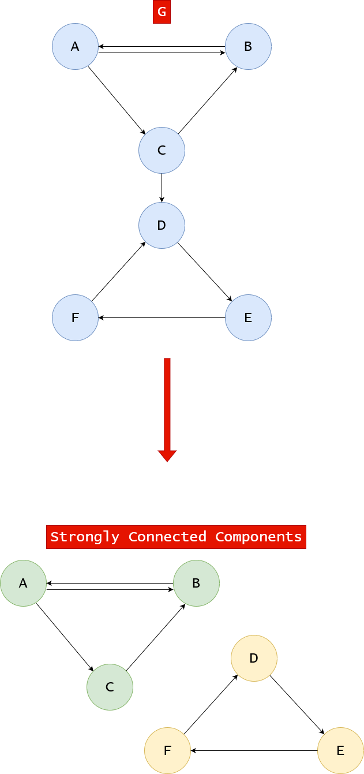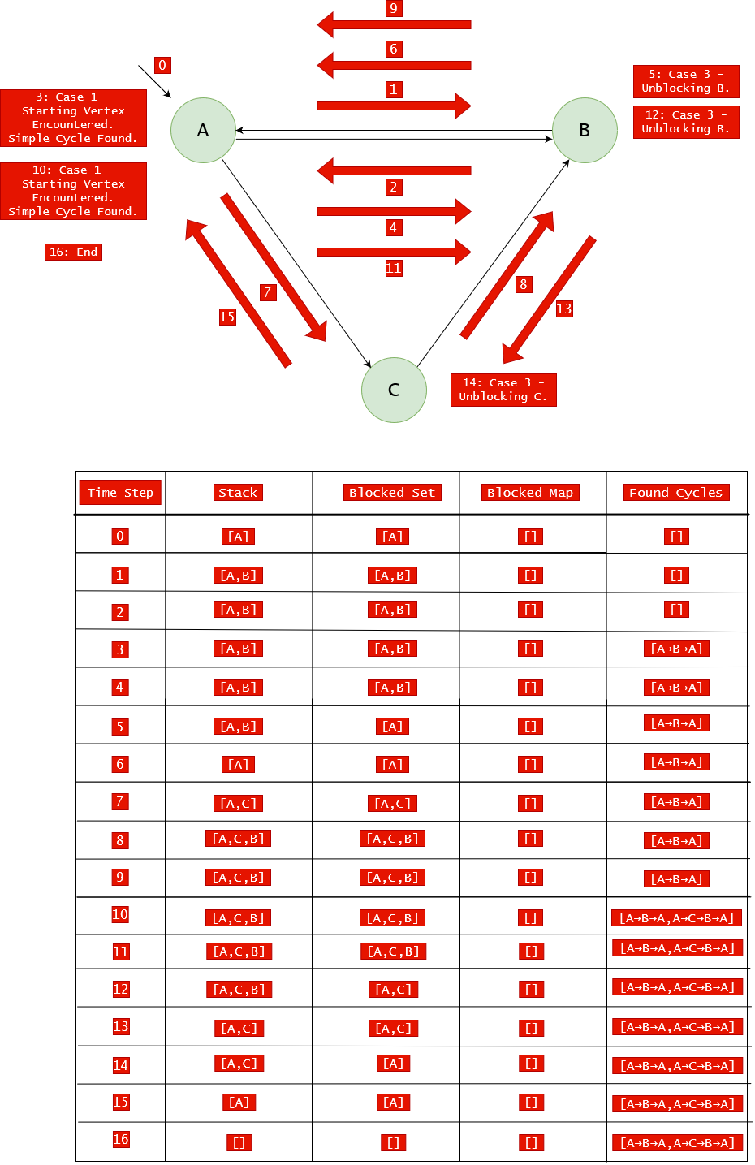

# Bibliography

[1] D. B. Johnson, “Finding All the Elementary Circuits of a Directed Graph,” SIAM Journal on Computing, vol. 4, no. 1, pp. 77–84, Mar. 1975, doi: 10.1137/0204007.

[2] R. Tarjan, “Depth-First Search and Linear Graph Algorithms,” SIAM Journal on Computing, vol. 1, no. 2, pp. 146–160, Jun. 1972, doi: 10.1137/0201010.