Toy Robot – Architecture

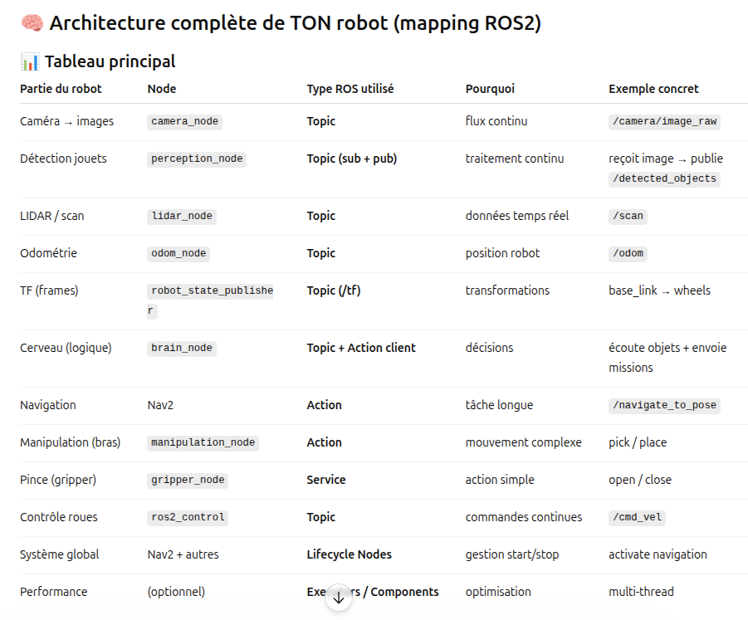

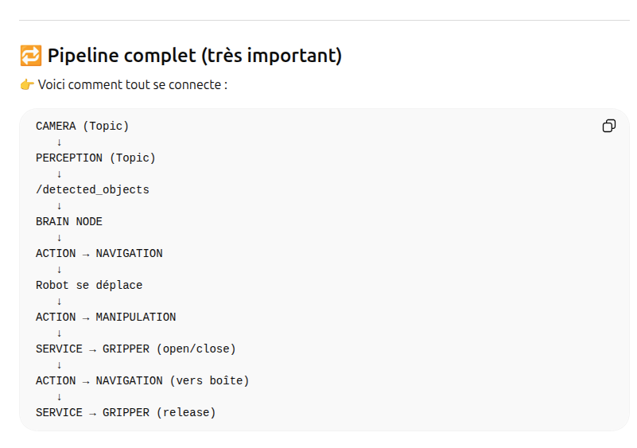

🔥 Traduction en code (important)
👉 Tu vas avoir :

Topics
/camera/image_raw
/detected_objects
/cmd_vel
/odom

Actions
/navigate_to_pose
/pick_object
/place_object

Services
/open_gripper
/close_gripper

