# Informe de Análisis de Inversión

Este informe contiene un análisis de los pesos óptimos del portafolio, estadísticas descriptivas de los activos y gráficos visuales de su rendimiento.

## Estadísticas Descriptivas

|  |  |  |  |  |  |  |  |  |
| --- | --- | --- | --- | --- | --- | --- | --- | --- |
| Ticker | count | mean | std | min | 25% | 50% | 75% | max |
| HOOD | 818.0 | 16.04 | 10.08 | 6.89 | 9.64 | 11.28 | 19.18 | 70.39 |
| META | 818.0 | 305.87 | 132.51 | 88.64 | 190.8 | 304.48 | 375.39 | 595.94 |
| MSFT | 818.0 | 322.9 | 65.54 | 210.62 | 271.48 | 311.18 | 376.84 | 466.72 |
| NVDA | 818.0 | 46.03 | 36.07 | 11.22 | 20.15 | 28.64 | 51.78 | 143.71 |
| TSLA | 818.0 | 238.46 | 57.47 | 108.1 | 193.77 | 236.92 | 268.38 | 409.97 |
| RMSFT | 818.0 | 0.0 | 0.02 | -0.08 | -0.01 | 0.0 | 0.01 | 0.08 |
| RTSLA | 818.0 | 0.0 | 0.04 | -0.13 | -0.02 | 0.0 | 0.02 | 0.2 |
| RNVDA | 818.0 | 0.0 | 0.03 | -0.11 | -0.02 | 0.0 | 0.02 | 0.22 |
| RMETA | 818.0 | 0.0 | 0.03 | -0.31 | -0.01 | 0.0 | 0.01 | 0.21 |
| RHOOD | 818.0 | -0.0 | 0.04 | -0.32 | -0.02 | -0.0 | 0.02 | 0.41 |

## Gráficos de Rendimiento

Gráfico de Series Temporales:

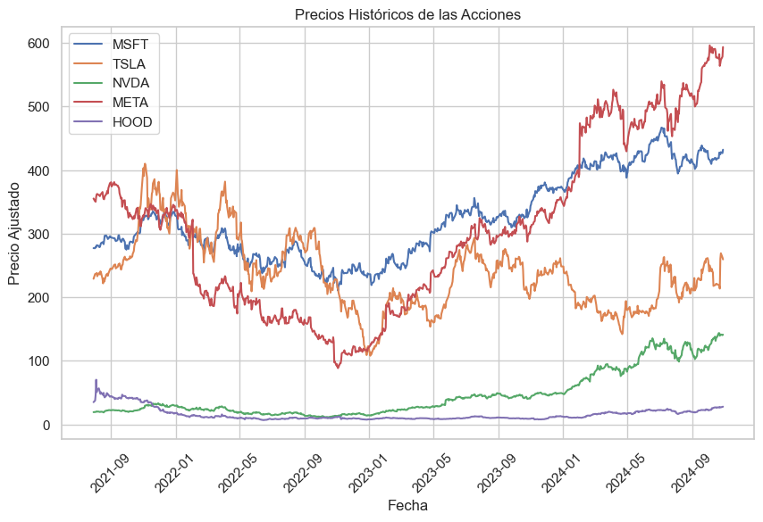

Gráfico de Box Plot:

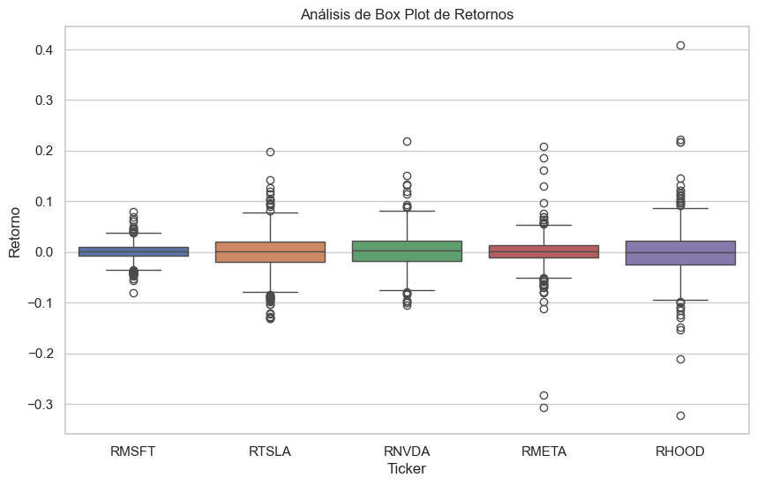

## Pesos Óptimos del Portafolio

MSFT: 0.00%

TSLA: 0.00%

NVDA: 100.00%

META: 0.00%

HOOD: 0.00%