Lab 2

**Nume: Grigore Sandi-Gabriel**

**Grupa: 3.2 A**

In this laboratory the goal was to experiment with assignment statements on one global reference.

I started by defining a global static variable that could be accessed everywhere.

Then I implemented my thread class implementing the “extends Thread” approach.

Finally I set up the test in Main.

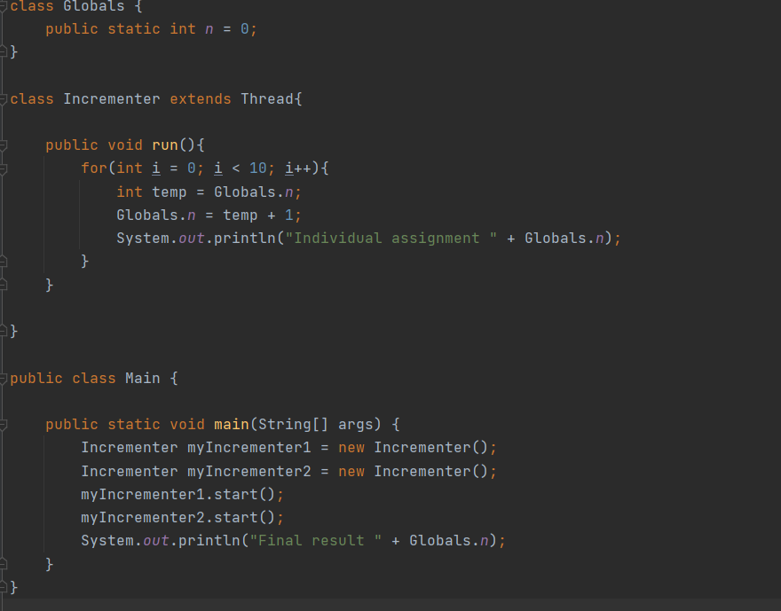

At first I only followed the final result, which was 0 and didn’t make sense. But when I started to follow the individual assignments I realized that something peculiar was going on. The assignments always seemed to have a different random order on every run.

