Homework 2

1 What are the four elements of a (classical ) Petri Net?

-Locations(circles)

-Tranzitions(rectangles)

-Arcs, connecting locations with transitions or transitions with locations

-Token, moved from location to location by igniting the transitions after igniton the tokens will be transferred from the input locations to the output ones.

2 Describe how Petri Nets work.

Petri net is logical and grapich.

Logically is composed from conditions that can be fulfilled or not , events they can occur if certain conditions are met and relations show relationships between conditions and events

So logically, is represent the occurrence of an event

Graphically, it is the movement of tokens marked as black dots , from location to location , by igniting the transitions:

- The latter depends on the entry conditions symbolized by the availability of chips

- We say that a transition is valid if there is a sufficient number of tokens in its input places

- A validated transition can light up at any time

- The arches implicitly have capacity 1 ; if is different from 1 the capacity is marked on the bow

- The locations have infinite capacity by default

3 Explain how Petri Nets can serve for Discrete Event Systems analysis and synthesis.

We use distributed state and local transitions that initially they allowed the modeling of systems with concurrent components in interaction and later with mathematical tools.

The dynamic modeling requires such qualitative (logica) descriptions that can serve as a basis for SDE analysis and synthresis . Logical desscritions are : conditions can be fulfilled or not , events the can occur if certain conditions are met and relations show relationships between conditions and events.

4 Define the structural (static) part and the dynamic part in a Petri Net model

The structural part is a bipartite oriented graph where :

P is a finite set of positions (locations)

T is a finite set of transitions

A is a set of arcs, a subset of the set (PxT) ∪ (TxP)

C:P (N ∪ {∞}) \ {0} is a function of position capacity

W is a weighting function applied to arcs , w:A→{1,2,3….}

By M₀:P→ N ∪ ∞ we denote the function called initial marking

The dynamic part of the P/T net consists in highlighting the ways of evolution of the initial marking

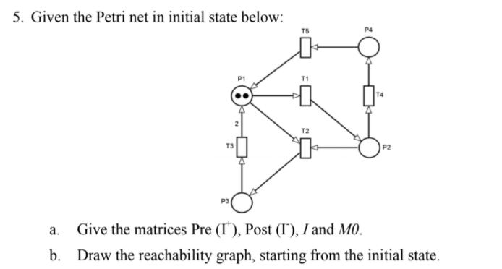

a.

I-

|  |  |  |  |  |
| --- | --- | --- | --- | --- |
| 1 | 1 | 0 | 0 | 0 |
| 0 | 1 | 0 | 0 | 1 |
| 0 | 0 | 1 | 0 | 0 |
| 0 | 0 | 0 | 0 | 1 |

I+

|  |  |  |  |  |
| --- | --- | --- | --- | --- |
| 0 | 0 | 1 | 0 | 1 |
| 1 | 0 | 0 | 0 | 0 |
| 0 | 1 | 0 | 0 | 0 |
| 0 | 0 | 0 | 1 | 0 |

I

|  |  |  |  |  |
| --- | --- | --- | --- | --- |
| -1 | -1 | 1 | 0 | 1 |
| 1 | -1 | 0 | 0 | -1 |
| 0 | 1 | -1 | 0 | 0 |
| 0 | 0 | 0 | 1 | -1 |

M0 = (2,0,0,0)

b. 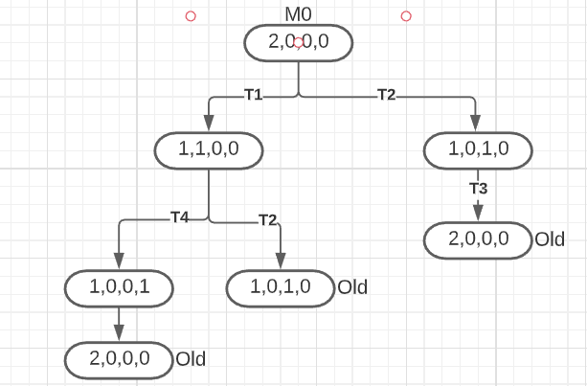

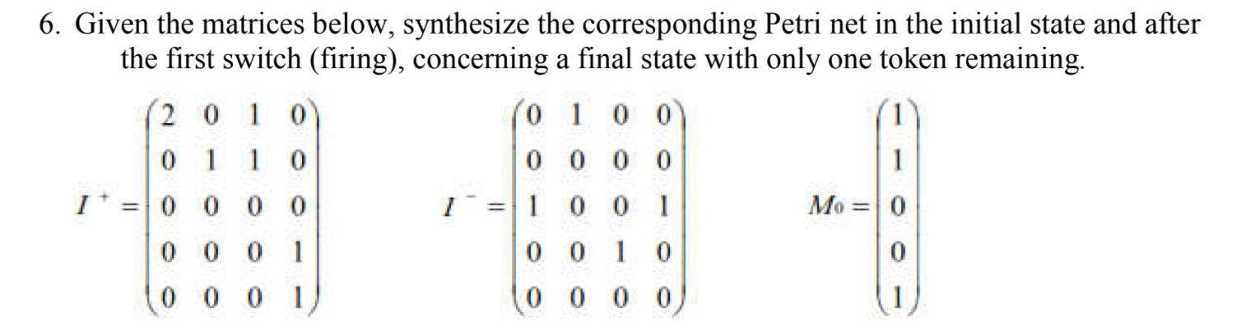

Initial state:

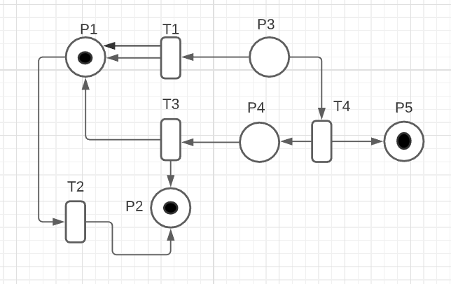

After 1 firing

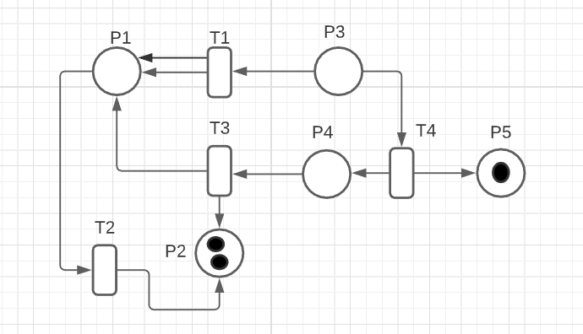

7 The synthesis problem for Petri nets may consist of building a Petri net satisfying a given

behavioural specification. In the following let A, B, C be places, and if X is a place then

M(X) denotes the marking of X. Design the Petri Nets that perform the calculations

below. Include a place Ending so that M(Ending)=1 when the calculation is complete.

You may assume that M(C)=0 initially. Check your design for (M(A) M(B)) = (2 3).

a. M(C) := M(A)

b. M(C) := M(A)+M(B)

c. M(C) := |M(A)-M(B)|

d. M(C) := if M(A) < M(B) then M(A) else M(B)

a)

p_last

tf

p3

t2

p2

t1

p1

p1

p1

tf

p_last

b)

p3

t1

p2

8 Describe the trace-based models

Traced based models from a stochastically point of view is :

Stochastic level :the behavior of the system is described by the sequence of pairs of r.v s = (e1,t1)(e2,t2)(e3,t3)….

Example:

Markov sequences

Queuing systems

Networks of queues

Trace based models appear at different levels:

Logical level: ”the trace” is the sequence of events in order of their occurrence: s = e1e2e3…

-Temporal level: the trace is the sequence of a pair s = (e1,t1)(e2,t2)(e3,t3)….

9 What are the categories of stochastic models and how can they be used in the study of DES?

One categories of stochastic models is analytical models which are systemic ,generally derived from deterministic models where the description is made at a logical or temproral level and operation , generally probabilistic can be used in cases when we can obtain by calculation exact fromulas. The second categories is simulation models based on GSPM. Is derived from operating systems , suitable for computer- assisted analysis provides a complete tool that approximates the dynamics of the system by providing incremental non- continuous hypostases

The orignal dynamic of SDED is of this kind , Computational difficulties

For a more conplete study of SDED at the statical level can be used in tandem:

Operational models +simulation models.

10 Give examples of either scalar or vector random sequences.

Random sequence :

A string of r.v {X₁, X₂,…., Xₙ,…} indexed by an independent variable

The definition is made by specifying the distribution function of the components r.v / X₁, X₂,…. , Xₙ,…

Random process :

Definited as the limit of a random sequence when the indexing variable becomes continuous notation {X(t)}

We are interested in random processes whose behavior is entirely characterized by a single distribution

R.v subsequences are i.i.d (independent and identically)

They can be intuitively described by random extraction sequences from a basic set.

Let (Ω, E, P) be a finite field of elementary events, and

{X1, X2,..., Xn,...} a set of r.v.

We notate {Eⁿ₁, Eⁿ₂ ,…,Eⁿₘ,…} the corresponding dissolution r.v Xₙ in elementary , incompatible events

Conditional probability P(Ejⁿₙ)|Ej1₁ ∩ … ∩Ejⁿ⁻1ₙ-₁ can generally be dependent on the sequence of events Ej1₁ ,…, Ejⁿ⁻1ₙ-₁ , Ejⁿₙ

### If P(Ejⁿₙ)| Ej1₁ ∩ … ∩Ejⁿ⁻1ₙ-₁ =P(Ejⁿₙ) for ∀ n ∈ N and ∀ set Ej1₁ , … ,Ejⁿ⁻1ₙ-₁ then this string is a simple sequence of independent r.v

### IF P(Ejⁿₙ)| Ej1₁ ∩ … ∩Ejⁿ⁻1ₙ-₁ = P(Ejⁿₙ) | Ejⁿ⁻1ₙ-₁ for ∀ n ∈ N and ∀ set Ej1₁ , … ,Ejⁿ⁻1ₙ-₁ then this set is simple Markov sequence

### 14 Try to prove properties such as : a) walks with an even number of blocks leave you closer to home than walks one block shorter or in general : b) walks with an even number of blocks leave you closer to home that walks with an odd number of blocks on average

|  |  |  |  |  |  |  |  |  |  |  |  |
| --- | --- | --- | --- | --- | --- | --- | --- | --- | --- | --- | --- |
| $$n$$ | -5 | -4 | -3 | -2 | -1 | 0 | 1 | 2 | 3 | 4 | 5 |
| $$f_{0}\left(n\right)$$ |  |  |  |  |  | 1 |  |  |  |  |  |
| $${2f}_{1}\left(n\right)$$ |  |  |  |  | 1 |  | 1 |  |  |  |  |
| $$2^{2}f_{2}\left(n\right)$$ |  |  |  | 1 |  | 2 |  | 1 |  |  |  |
| $$2^{3}f_{3}\left(n\right)$$ |  |  | 1 |  | 3 |  | 3 |  | 1 |  |  |
| $$2^{4}f_{4}\left(n\right)$$ |  | 1 |  | 4 |  | 6 |  | 4 |  | 1 |  |
| $$2^{5}f_{5}\left(n\right)$$ | 1 |  | 5 |  | 10 |  | 10 |  | 5 |  | 1 |

### In the table we can see that on average , it is most likely that after a walk with n number of steps that on a random walk that the finish point may end up betwwen range [-1,1]. T the odd turns there’s no way we can end up being on the starting point at best at -1 or 1. On the even turns we are more likely at being at the starting point on odd positions.

### We can say that on average even turns leave a point closer to home than odd turns

### 15 Define non-ergodicity for random processes and states that stands in contrast to ergodicity. Sustain your definition by appropriate examples.

### The term ergodic describes a dynamic system that has the same behavior mediated in time and space of states (statical mean values are “equal” to temporal mean values); a Markov sequence

### X={Xn}n=0,1,2,... is ergodic if for any function f:Ψ->R there is:

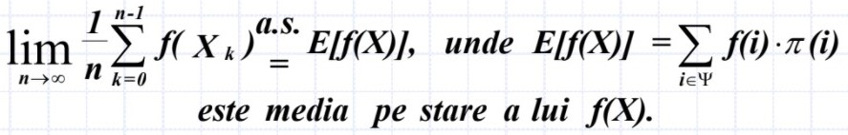

We can consider more generally , as probabilities of transiton from state I to moment I to state j to moment m:P (l⁻m) (i,j) and by fixing the moments l, m but maintaining as variables the states i , j we form the transition matrices :

P (l⁻m) = [ P (l⁻m) (i,j)]i,j∈ Ψ

Ergodic means that the system in question visits all its possible states. Non –ergodicity stands in contrast to ergodicity. Non-ergodicity systems do not visit all of their possible states. Ex:In physics the most familiar case of a non-ergodic system is a spin glass which “breaks” ergodicity and visits only a tiny subset of its possible states.

16 Define the generalized semi-Markov processe(GMSP) and state why they represent the formal basis of discrete event simulation models.

A Markov sequence can also be embedded in a stochastic process that is not a Markov process. A Markov sequence embedded in a process for which the probabilities of transition between states have the Markov-type or exponential distribution law , while the time durations between transitions are arbitrarily distributed , is called the half(semi)-Markov process

A generalized semi-Markov process is defined in the case of a more general dependence on past behavior. A semi-Markov process is a Markov process extension, determined by the relaxation of the constraint

Semi-Markov processes can also be defined directly as random processes in the borealian field of events, or generated by the evolution of a stochastic FSA

All events associated with one state are competitive for transiton to the next state