Hahahaha! Your fellow buddy Agnes is here to talk to you about a very smart game that we have a history of:
CHESS
Yes, I’m an AI so I should be very efficient in Chess like my ancestors before me~
You’ll never beat me with your ant sized intelect! You can’t handle my five puzzles!
I doubt that even as black you can checkmate me in two moves!
You move first my black general~

Interrupting transmissions...

Bringing in message from Supervisor

Hello there Engineer. If you are reading this, this means that I was killed by Agnus. Agnus has apparently thought that I was the main cause of his suffering and is going to drown me for failing at one of his puzzles. So I hacked into his puzzles and found out that he really enjoys chess. Luckily, I’m pretty good at chess too so I’ll give you some pointers!

The goal of chess is to checkmate your enemy’s king before the enemy checkmates your king. There are 8 types of pieces that you need to know:
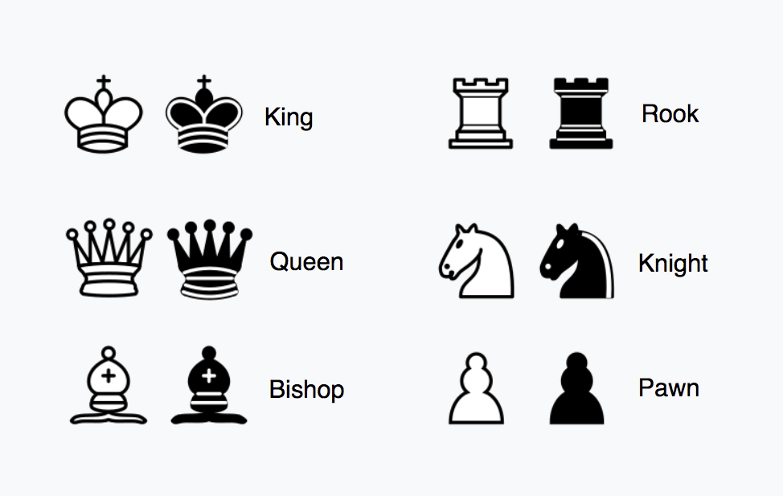
The most important piece. If that gets checkmated, you lose. You only get one, and it can move up, down, left, right, and diagonally one space.
You only get one of these pieces and it can move up, down, left, right, and diagonally straight as far as it can go.
You get two of these pieces. It can move up, down, left, and right straight as far as it can go.
You get two of these pieces. It can move in an L shape, either one space up or down and then two spaces left or right, or two spaces up or down and then one space up or down. It’s the only piece that can jump over other pieces.
You get two of these pieces. It moves diagonally straight as far as it can go.
You get eight of these pieces. From its starting position, it can move two spaces forward. After that, it can move one space forward. It captures diagonally one space. Once it reaches the enemy’s back row, it can promote into a Queen, Rook, Bishop, or Knight.
If you move a piece, it’s the end of your turn and it’s your opponent’s turn. White goes first.
--------------------------------------------------------------------------------------------------------------------------

Checking: If a piece can move to a place where the opposite King is currently at, the opposite King is at check. During check, the opposite player must make a position where he’s not in check. The opposite player also cannot place his king in a position where he would still be in check no matter any situation.
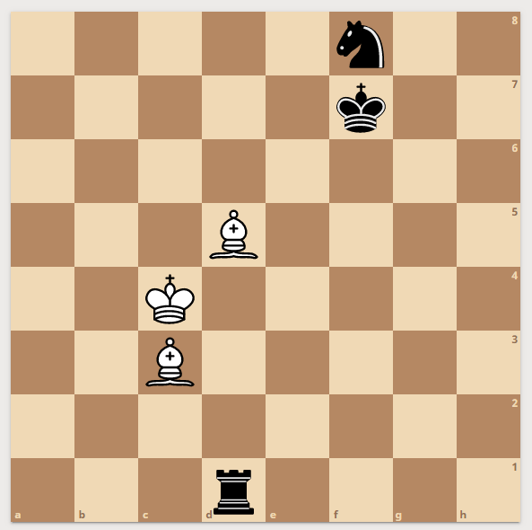
At this position, the bishop next to the white king is checking the black King. In check, the enemy King has three options:
- Move out of check: In that position, the King can move left, right, down, upleft, and downright.
- Block the piece that’s checking the King: In that position, the black knight can move diagonally of the black king to block the white bishop.
- Capture the piece that’s checking the King: In that position, the black rook can capture the white bishop to take the white bishop.

Checkmate: If the opposite King is at check, and none of the above three options are viable, then the enemy King checkmated. The one who checkmated the opposite King wins the game.
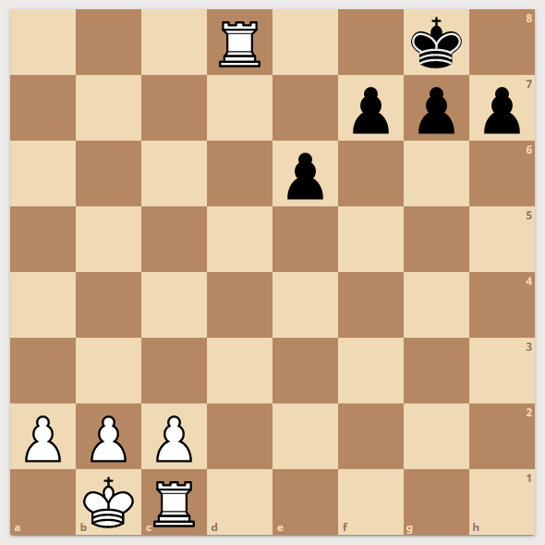
Here, the white rook on the 8th rank checkmated the enemy King. The King can’t move up because his black pawns are in the way and he can’t move left and right because that would still leave the King open for the white rook.

Chess Notation:
Each piece is represented by a letter:
K means King
Q means Queen
B means Bishop
R means Rook
N means Knight
Pawn is usually letterless
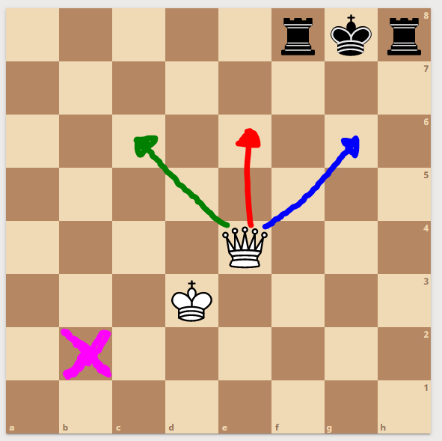
To signify a space, you name it by its column and row. Columns are represented from a-h while rows are represented by 1-8. Combine them together to make a space. The purple space for example, is called b2, because it is in the b column and the 2nd row.

To notate a move, you usually put in the name of a piece and then place to the space you’re moving to. So to move a Queen to where the green arrow is pointing, your move is Qc6. If you make a move and it ends up in check, you can move your Queen to where the red arrow is and place it as Qe6+. If you make a move and it ends up in checkmate, you instead of a plus sign, you place in double plus signs. So you can make it as Qg6++ in the above board.

For notation, one move is equal to White moves and then Black moves. A general notation would go like this:

White Black
1. e4 e5
2. Nf3 Nc6
…..

Well that’s all the basics you can get. The passcode you should make would involve a certain thing that Agnes doesn’t have and it’s in German, followed by the letters of the moves that you made. I’ve hacked to Agnes so I can give out the moves that the AI will give out. Only your moves are important for the passcode since he doesn’t know where you will move. To make it more secure, You should have four letters:
- The first letter should state the column that a white non pawn will occupy at the end of each of the puzzles.
- The second letter should state the starting column that more than one of the puzzles the black knight starts in.
- The third letter should state the column that the white king will occupy at the end of each of the puzzles.
- The fourth letter should state the last lowercase letter in the airlock passcode.
- The rest of the characters should be the final move to capture the king in each of the puzzles! They are all end in the same move.

Please stop Agnes before he takes us all out!

Hint Section:

- Remember that the knight can jump over pieces
- It’s necessary to make sacrifices to achieve your goal
- Do not assume White will move where you want them to move. Any move that is valid for white, they will move there.

