IMPLEMENTING A NATURAL LANGUAGE PROCESSING-BASED PATIENT REFERRAL ALGORITHM FOR IMPROVED HEALTHCARE OUTCOMES.

by

TAWONA N RWATIDA (R204712J)

Project submitted for review for the

HSE
in the Faculty of Computer Engineering Informatics and Communications

at the University of Zimbabwe

Supervisor: Mr. S Zvakafa
Co-supervisor: Mr. S Zvakafa

June 2024

Declaration:
I, Tawona Nyasha Rwatida, hereby declare that I have sincerely completed my project titled Implementing a Natural Language Processing-Based Patient Referral Algorithm for Improved Healthcare Outcomes. I affirm that all the work presented in this project is the result of my own efforts, research, and analysis. I have appropriately cited and referenced all sources used in this project, including published or unpublished works, electronic sources, and personal communications. I further declare that this project has not been submitted in part or in its entirety for any other degree or qualification at any other academic institution. Any contributions or assistance received from individuals or organizations have been duly acknowledged in this project. I take full responsibility for the content and accuracy of the information presented in this project. I understand that any false statement or misrepresentation made in this declaration may result in disciplinary action or the invalidation of my project.

Signature: _________________________
Date: _________________________

Approval
The Approval page is also a confirmation from the head of the department, guide, and external examiner about their acceptance of the project. The approval page is endorsed with the signatures of the heads confirming their approval of the project.

Acknowledgements
I would like to express my heartfelt gratitude and appreciation to all those who supported and contributed to the successful completion and implementation of my project titled Implementing a Natural Language Processing-Based Patient Referral Algorithm for Improved Healthcare Outcomes. Their valuable assistance, guidance, and encouragement have been instrumental in making this project a reality.
First and foremost, I would like to extend my sincere gratitude to my supervisor, Mr. S Zvakafa, for their unwavering support, guidance, and expertise throughout the project. Their insightful feedback and constructive criticism greatly enriched my work and helped shape the project in the right direction.
I am immensely grateful to the faculty members of the Computer Engineering department at the University of Zimbabwe for providing a conducive academic environment and valuable resources that facilitated my research and learning. I would like to express my appreciation to my friends and classmates who provided moral support and engaged in thought-provoking discussions, which significantly contributed to the development of my ideas.
I would also like to acknowledge the assistance and cooperation received from the staff and personnel of the University of Zimbabwe who kindly provided access to necessary data, facilities, and resources, allowing for the smooth execution of my project. Furthermore, I would like to extend my thanks to my family for their unwavering support, encouragement, and understanding throughout this journey. Their constant belief in my abilities has been a source of motivation and strength.
Lastly, I am grateful to all the individuals who may not be mentioned explicitly but have contributed in any way to the success of this project. Your support and involvement are deeply appreciated. I am indebted to all these individuals and organizations for their invaluable contributions and extend my heartfelt thanks to each and every one of them.

Signature: ________________________
Date: ________________________
Abstract or Executive Summary
This project aims to develop an NLP-based patient referral algorithm that accurately matches patients with appropriate doctors or specialists based on a wide range of disease symptoms. The main objective is to create and evaluate an algorithm using natural language processing (NLP) to classify symptoms and refer patients to doctors based on their specific expertise. The project utilizes the Naive Bayes algorithm for text classification and cosine similarity for NLP processing. The model is deployed into a mobile app using React Native. The development of better NLP-based referral systems has the potential to revolutionize the healthcare industry, particularly in terms of patient referrals and specialist selection. By leveraging the power of artificial intelligence and NLP algorithms, these systems aim to match patients' symptoms and medical history with the most suitable specialist doctors, leading to more accurate and efficient referrals. Existing systems often rely on general practitioners to interpret and act upon the results provided by the algorithms, introducing delays and potential inaccuracies. To address this gap, the project focuses on developing an algorithm that directly matches patient symptoms to the appropriate specialist, thereby streamlining the referral process. The methodology follows a quantitative approach with an experimental design. Factors such as accuracy, precision, recall, and F1 score of the NLP-based algorithm are evaluated based on its performance in handling a larger set of symptoms and against conventional referral algorithms. The results indicate an accuracy of 84.8%, precision of 0.86, recall of 0.75, and an F1 score of 0.80 for the model. The implications of this research extend to various medical settings, offering a potential solution to enhance patient care and improve the efficiency of the referral process. However, practical considerations such as data availability and computational resources need to be taken into account for real-world implementation.

Table of Contents

1 INTRODUCTION 1
1.1 Introduction: 1
1.2 Background and context of the project: 2
1.3 Problem statement: 3
1.4 Aim 3
1.5 Research objectives 4
1.6 Scope and limitations of the project: 4
1.7 Feasibility Study: 4
1.8 Significance and motivation for the project: 5
1.9 Work plan: 6
1.10 Conclusion: 7
2 Literature Review 8
2.1 Introduction: 8
2.2 Review of relevant literature: 8
2.3 Identification of gaps or areas for improvement: 12
2.4 Conclusion: 12
3 Methodology 14
3.1 Introduction: 14
3.2 Research methodology or software development process: 14
3.3 Methods and techniques: 14
3.3.1 Data Handling and Feature Engineering: 19
After cleaning of the symptom dataset, it was primitive that the features in the dataset were: 20
3.3.2 Model development and training: 24
3.3.3 Architecture 24
3.3.4 Training and Validation of the Algorithm 27
3.3.5 Potential biases and ethical implications 27
3.4 Tools and technologies: 29
3.5 Project requirements and design considerations: 30
3.6 Conclusion: 31
4 Analysis and Design 32
4.1 Introduction: 32
4.2 Detailed Analysis of the problem domain and user requirements 32
4.2.1 Functional Requirements: 35
4.2.2 Non-functional Requirements: 36
4.3 Identification of system components and functionalities: 37
4.3.1 Use-Case diagram/s: 38
4.3.2 Sequence diagram: 39
4.4 System architecture and design considerations: 39
4.4.1 Overall Structure: 39
4.4.2 Design Decisions: 40
4.4.3 Context Diagram and DFD Diagram: 41
4.4.4 Architectural Design: 42
4.4.5 Physical Design: 43
4.4.6 Database Design: 44
4.4.7 Interface design: 44
4.5 Conclusion: 47
5 Results 48
5.1 Introduction: 48
5.2 Presentation of Findings: 48
5.2.1 Results 49
5.2.2 Summary of Results 54
5.2.3 Interpretation and Analysis of Results 56
5.3 Conclusion: 59
6 Discussion 61
6.1 Introduction: 61
6.2 Summary of findings: 61
6.3 Model evaluation and analysis: 62
6.4 Comparison with Existing Literature: 63
6.5 Theoretical Implications: 63
6.6 Practical Implications: 64
6.7 Validation and Reliability: 64
6.8 Conclusion: 67
7 Conclusion and Future work 68
7.1 Introduction 68
7.2 Summary of the project: 68
7.3 Key findings and contributions: 69
Evaluation of objectives: 69
7.4 Reflection on the project process: 70
7.5 Future work and recommendations: 71
Referencing 73
Appendices 74
Appendix A 74
Appendix B 75
Appendix C 80

List of Figures
Figure 1 Gantt chart showing project timeline 6
Figure 3 Patient referral algorithm design 17
Figure 4 Disease-Symptom dataset before cleaning. Here the dataset showed a lot of redundancy. 20
Figure 5 Disease-symptom dataset, after preprocessing and normalization. 21
Figure 6 Natural Language Processing stemming and lemmatization 25
Figure 7 Architecture for NLP-based patient-to-doctor referral algorithm 26
Figure 8 Partitioning the training and testing set (80:20 %) 27
Figure 9 Summary of all diseases included in the training of the NLP model 29
Figure 10 WhichX is a npm package that was used to ensure the model was in the right format with the referral application 32
Figure 11 50% of the symptom dataset in csv. format 34
Figure 12 Use-case diagram showing user-mobile app interaction 38
Figure 13 Architecture for NLP-based patient-to-doctor referral algorithm. Ŷ is the specialist/ doctor to whom a patient has been referred. 42
Figure 14 Physical design of the mobile application the NLP model was integrated into 43
Figure 15 Entity-Relationship diagram of data used in the patient referral mobile app 44
Figure 16 Menu Design of a patient referral mobile app that uses an NLP model 45
Figure 17 Showing the input of the patient referral interface. 45
Figure 18 displaying doctor referral result output form 46
Figure 19 if no doctor was identified due to unrecognized input by the model 46
Figure 20 further information is displayed if user clicks doctor card 47
Figure 21 bar graph showing summary of results (accuracy, precision, recall, f1 score) 54
Figure 22 line graph showing the increase in accuracy with increase in input symptom length 56
Figure 23 Precision - Recall Curve showing change of F1 against the probability threshold 57
Figure 24 Confusion Matrix summarizing performance of the NLP patient referral model 58
Figure 26 Dataset used for this research project 74
Figure 27 Initial screen that the user meets 75
Figure 28 Typing in your symptom in the referral application 76
Figure 29 submitting symptoms to the NLP model 77
Figure 30 Output doctor result 78
Figure 31 Detailed description of doctor 79
Figure 32 Sample code of the natural language pre-processing, tokenizer, stemming and removal of stop words 80
Figure 33 Cosine Similarity NLP text classifier 81
Figure 34 Testing dataset (20%) 81
Figure 35 80% dataset used for training 82
Figure 36 Naive Bayes classifier - classifies which specialist a patient gets referred to 83
Figure 37 Entering patient symptoms and submitting on react native UI 83
Figure 38 A resultant doctor card is presented if a valid specialist selection is done by the naive bayes 84
Figure 39 The naive bayes classifier performs a look up on a doctor dataset combined with symptoms to predict a specialist to diagnose the treatment using patient symptoms 84

List of Tables
Table 1 Budget for the NLP patient referral research project 7
Table 2: Literature review discussing similar projects or systems 12
Table 3: Table showing accuracy evaluation using different test cases 50
Table 4: Evaluation of model accuracy 51
Table 5: Minimal test set of disease row used to calculate precision and recall 52
Table 6: Calculating precision of the patient referral model 52
Table 7: F1 Score of the patient referral algorithm 54
Table 8: Summary of results showing metrics for the testing set symptom sets 55
Table 9 summary of model performance 55
Table 10 Performance summary of model, here all the metrics are summarized 59

List of Symbols and Abbreviations
CNN – Convolutional Neural Networks
NLP – Natural Language Processing
RNN – Recurrent Neural Networks
EHR – Electronic Health Records
NHS – National Health Services
NPM – Node Package Manager
PCP – Primary Care Physician
AI – Artificial Intelligence
GP – General Practitioner
IoT – Internet of Things
Ŷ – Predicted Output
TN – True Negative
FN – False Positive
UI – User Interface
FP – False Positive
TP – True Positive

List of Appendices
Appendix A: Templates of data collection tools
Appendix B User manual of the working system
Appendix C: Source Code

INTRODUCTION

Introduction:
Patient referrals are a crucial process in the health sector, where primary doctors refer their patients to other health care providers, such as specialists, for further evaluation or treatment. Using a patient’s specific condition and symptoms, several algorithms, over the past timeline, have managed to automate the specialist selection process using natural language processing (NLP) based algorithms to increase efficiency and accuracy of the referral process. The most recent algorithms have eradicated human intervention in the referral process and are highly reliant on artificial intelligence technology such as natural language processing to comprehend symptoms and medical data to utilise it effectively.

John-Jose Nunez and B. Leung conducted research that formulates an algorithm that predicts which cancer patients will see a psychiatrist or counsellor from their initial oncology consultation document using natural language processing [1]. This research entails that NLP can be used to refer cancer-diagnosed patients to an appropriate mental health specialist. Although successful, the researchers clearly state the need for augmenting this research by incorporating a larger set of symptoms and disease parameters to select specialists against. This will introduce more specialists to be selected against and ultimately improve symptom and disease coverage.
The development of better patient-to-doctor referral algorithms has the potential to improve overall scientific development. For example, more accurate and efficient referrals could lead to faster and more accurate diagnoses of diseases, which could improve research and development in the medical field. Additionally, by improving patient-to-doctor symptom and disease parameters, there may be opportunities for increased patient care, whereby more patients with different kinds of conditions can all be attended to.
In conclusion, this research aims to implement a natural language processing-based algorithm that can refer patients using their symptoms and medical history, to the right doctors or specialists, leading to healthier outcomes and patient satisfaction. The result of this research will be developing an NLP-based algorithm that can accurately understand and process a wider range of patient symptoms and medical conditions using a matching criterion whilst ensuring the scalability and performance of the solution.

Background and context of the project:
The development of better natural language processing-based referral systems has the potential to improve overall scientific development. Natural language processing is Artificial Intelligence (AI) technology that focuses on the interaction between computers and humans in natural language. A patient referral is a written request from one health professional to another health professional or health service, asking them to diagnose or treat a patient for a particular condition. This research aims to development and implement an NLP-based algorithm that directly matches patients (using their symptoms and medical history) to a specialist doctor. This is achieved through an NLP-based algorithm matching patient symptoms to the appropriate doctor according to their expertise and specialties.

More accurate and efficient referrals could lead to faster and effective diagnosis of diseases, which could improve research and development in the medical field. The use of natural language processing in the health sector has been largely realized [2]. Comprehension of patient’s symptoms and medical history has become easier. This also applies to referral systems, that refer patients to doctors. Common systems include Babylon Health, based in the United Kingdom and also NHS’ e-referral system. A few notable gaps in relevant existing research and in these kinds of systems have been identified.

One common gap fueling this research is that systems have NLP-based algorithms that heavily rely on general practitioners to make accurate and timely referrals based on the results they receive from the algorithm [3]. To streamline the referral process, John-Jose Nunez and B. Leung managed to cut-out the middle man, i.e., reduce the general practitioner-algorithm interaction. They conducted research that implements a natural language processing algorithm that automatically predicted which cancer patients require referral to a psychiatrist or counselor from their initial oncologist consultation [1]. The research can be further exploited to incorporate a larger set of symptoms and conditions.

Research conducted by John-Jose Nunez and B. Leung has shown promising advancements by implementing an NLP algorithm that predicts the need for psychiatric or counseling referrals for cancer patients during their initial oncologist consultations. By bridging the existing gaps and developing an NLP-based algorithm that can handle larger disease sets and symptom datasets, we can pave the way for a more efficient and effective referral system. This research holds immense potential to improve overall scientific development, enhance patient care, and drive progress in the medical field.

In conclusion, the development of better natural language processing-based referral systems has the potential to revolutionize the healthcare industry, particularly in terms of patient referrals and specialist selection. By leveraging the power of artificial intelligence and NLP algorithms, these systems aim to match patients' symptoms and medical history with the most suitable specialist doctors, leading to more accurate and efficient referrals. While significant progress has been made in incorporating NLP algorithms into healthcare systems, there are still gaps to be addressed.

Problem statement:
Natural Language Processing algorithms that refer patients to the appropriate specialist or healthcare professional have led to several improvements such as improved accuracy in referrals and enhanced patient outcomes. The current NLP algorithm used for patient referrals in oncology (study and treatment of cancer) focuses solely on mental symptoms and refers patients to either counsellor or psychiatrists [1]. However, there is a significant gap in the algorithm's ability to incorporate a broader range of symptoms, diseases, and specialist referrals. This limitation hinders the algorithm's potential to provide comprehensive, personalized care to patients, as it fails to consider more symptoms and disease classifications.
This research project aims to address this gap by developing an enhanced NLP-based patient algorithm that incorporates a wider range of symptoms and diseases. This expansion, supported by enhanced NLP models and techniques, will lead to provision of more accurate and relevant referrals, ensuring that patients receive appropriate care from a broader spectrum of healthcare professionals. By addressing the limitations of the current NLP algorithm, this research project will enhance the quality of care, improve patient outcomes, and ultimately contribute to the overall advancement of machine learning-based treatment practices by enhancing NLP models.

Aim of the Study:
To develop and evaluate a patient referral algorithm using natural language processing (NLP) to classify symptoms, predict and refer patients to appropriate doctors based on their specific expertise.

Research objectives:
- To develop an NLP-based patient referral algorithm that can accurately match patients with appropriate doctors or specialists based on a wide range of disease symptoms.
- To evaluate the performance and effectiveness of the NLP-based patient referral algorithm in several symptom test scenarios.

Scope and limitations of the project
Scope:
This research attempts to create a new algorithm that could potentially be used in a wide range of medical settings. A few practical implications that may limit the scope of this project need to be considered:
- Availability of data and the computational resources required to train and test the patient-to-doctor referral algorithm.
- Considering the cost and time required to implement the algorithm in real-world settings.

Limitations:
The algorithm to be implemented is highly depended on the data used to train it. The natural language processing-based algorithm will be limited by the quality and quantity of the data that is available. If the data is incomplete or inaccurate, it will be difficult to train a reliable algorithm. There is a risk of limitation due to the developer of the algorithm; if some symptoms and manipulation of medical history records are biased according to his/her own way of recommendation. This research could be limited by the accuracy of the natural language processing model to accurately comprehend and predict the required result i.e., the right specialist doctor, according to their expertise.

Feasibility Study:
Economic Feasibility:
The cost of the required medical data and computing resources, the time and expertise required developing and testing the natural language processing-based model/algorithm, and the potential savings or other benefits of the algorithm are important factors in the economic feasibility of this research. Considerations of the costs of the algorithm in terms of both initial development and ongoing maintenance need to be assessed. Potential revenue or cost savings that could be generated by using the algorithm are going to be considered.
Technical Feasibility:
The required medical data containing symptoms and the associated classification are available and readily cleanable. Since the algorithm is to be incorporated into already existing telemedicine, it has no clear negative impact to performance, as the performance is dependent on the application as a whole. Under numerical approximation, the referral algorithm is expected to be executed in a reasonable amount of time. The input domain of the NLP-based referral algorithm will be tested across different settings and scales to test its efficiency and effectiveness against conventional digital referral methods.
Operational Feasibility:
The NLP-based algorithm is most suitable for telemedicine systems with conventional referral systems for example, Babylon Health (UK) and NHS’ e-referral systems. There will be need to train the general users of the system that incorporates the referral algorithm. The user of the system needs to be able to input patient symptoms, retrieve medical history from electronic health records and evaluate the output by the natural language processing-based algorithm.

Significance and motivation for the project:
This research aims to improve the patient-to-doctor referral system, by developing an algorithm that incorporates a larger dataset of symptoms and information supplied by the patient and automate the selection of the rightful doctor to attend to them. Several patient-to-doctor referral algorithms have managed to integrate their system with natural language processing-based algorithms but are limited to data analysis only: not up to the referral process [3]. These conventional, digital methods lead to a lot of effort and time being used up, with accuracy also in question.
Overall, this research intends to develop and implement an algorithm that captures patients’ data, comprising of their symptoms and medical history, passes the data for analysis to the natural language processing model, and uses the algorithm to directly predict the rightful doctor supposed to attend to the patient. Success of this research will open up avenues of natural language processing-based research and development in the medical field. Moreover, it could inform policy makers on how best to utilize new technologies to improve the healthcare system. In addition, the practical implications of this algorithm could have a positive impact on patients by ensuring that they receive the best possible care in a timely manner. This research is limited to hospitals and organizations that use telemedicine systems and any patient seeking medical attention.
Possible future works (recommendations) after this research would be:
- Exploration of more advanced machine learning algorithms such as deep learning, that could improve the accuracy of symptom identification and doctor recommendation.
- Investigating the use of other data sources, such as imaging or wearable sensor data, to enhance the accuracy and robustness of the algorithm.
- Evaluating the cost-effectiveness and patient satisfaction of the proposed system compared to traditional referral methods.

Work plan:
Timeline:
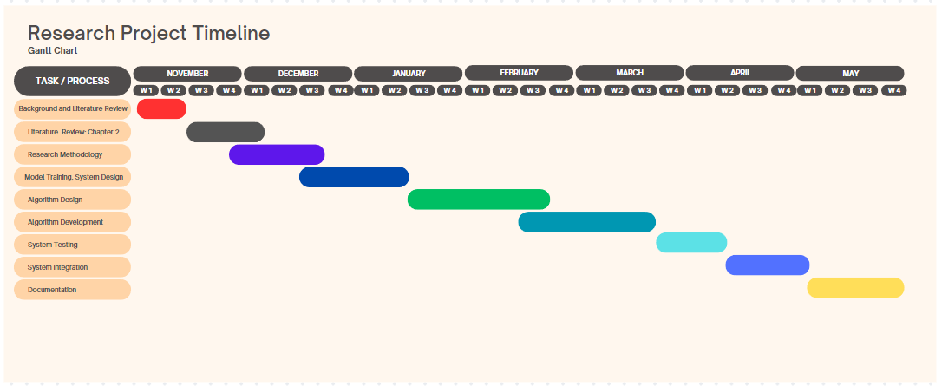
Figure 1 Gantt chart showing project timeline

Budget:
Resource | Description | Cost ($)
Data collection and storing | Costs for the system for collecting and storing patient data. | -
Dataset Access costs | Gaining access to the medical datasets required for this research | Free, but requires utilization approval
Surveys | Travel costs for surveys conducted to question survey patients and doctors. | $30
NLP Model Packages | Packages obtained from relevant sources of accurate NLP models | -
Tools used to conduct experimental analysis of patient symptoms and related medical history | Use of tools such as R Studio to manipulate one or more variables (symptoms, medical history) and observing the effect on the recommendation’s variable. | $14 (one month)
Total ($) | Addition of $6 for extra project charges | $50
Table 1 Budget for the NLP patient referral research project

Conclusion:
From this research, the integration of a natural language processing-based prediction algorithm that directly refers patients to specialist doctors is expected to improve efficiency, accuracy and patient satisfaction in telemedicine and hospital patient-to-doctor referrals. Moreover, it opens up for further research such as exploration of more advanced machine learning algorithms and investigating the use of other data sources, such as imaging or wearable sensor data. These can be carried out to advance and enhance the use of natural language processing in the health sector for improved healthcare outcomes. For future improvements on limitations and challenges of this research, it is of primitive importance to further investigate on methods to improve the accuracy of data used to train the model and precision of patient data provided, as this is highly influential to the algorithm’s referral results. Overall, notable benefits will be realized by the implementation of this algorithm in telemedicine systems, while opening up further research opportunities of the used technologies in the health sector.

Literature Review

Introduction:
A shift from manual patient-to-doctor referrals to the use of natural language processing (NLP) digital referral systems has been witnessed, with the intent being, to improve accuracy and efficiency of referral systems in telemedicine systems or patient-doctor management systems in hospitals. Natural Language Processing in medicine, has opened door for the comprehension and analysis of a large set of symptoms and medical records from free text stored in electronic health records [4]. Initially, amid being a success in the selection of the right doctor or specialist, manual intervention was witnessed, as general practitioners and primary doctors still use intuition to select specialists/doctors for patients in need of medical attention.

Progress has been made, with several systems able to harness the power of NLP in the health sector, by using it to develop algorithms that have automated and improved accuracy of referral systems, particularly the specialist selection module. The ability of the NLP model to analyse and understand human makes it a suitable technology to utilise in today’s lives. As of late, the latest algorithm have no human intervention within the referral process, only allowing user input from the beginning and the end of the referral specialist selection process [5], [6], [1], [2].
One realisation fuelling this research is the current implementation of these referral algorithms have fostered improved accuracy and efficiency but, clearly indicate that further research to incorporate more symptom and disease parameter inputs will improve their research [7], [1]. This gives rise to the need to explore ways to incorporate a larger parameter set into the NLP model. This simply means that, patients have a wider range of symptoms they can apply in referral systems, and it turn the system can comprehend their symptoms and select the appropriate doctor/ specialist to attend to their medical needs.

Review of relevant literature:
Broadening disease set or symptom set:
  - John-Jose Nunez and B. Leung (in 2023), conducted a study that uses NLP to forecast referrals of a cancer patient, as to which, according to his mental state and resultant symptoms, required a visit to a psychiatrist or counsellor from their oncologist consultation. It was found from their research, that they advised for a larger set of symptoms and condition parameters, which opens up an opportunity to refer patients to a larger bandwidth of specialized doctors improved patient symptom/condition coverage [8].
  - Rao. A and Razzaq. H (among other researchers) conducted research on an application that carried out automation of referrals based on breast cancer and also cutting-out general practitioners hence streamlining the referral process. It reduced appointment loads for general practitioners by allowing direct referrals to the specialty. The research at hand focuses on breast cancer. Further research to accommodate more conditions is mandatory [7].

General Practitioner/ Primary Doctor Dilemma:
  - The natural language processing-based e-referral system proposed by the NHS relies heavily on general practitioners to make accurate and timely referrals based on the results they receive from the algorithm [10]. General Practitioners (GPs) often have limited time and resources, which can lead to delays in referrals, or inaccurate referrals. This gives rise to the need to analyse patient data and make automated NLP-based recommendations for referrals, without relying solely on the input of GPs.
  - The system proposed by research conducted by Rao A and Razzaq. H also referred to general practitioner/ primary doctor leading to inaccurate referral specialist selection. It reduced appointment loads for general practitioners by allowing direct referrals to the specialty. General practitioners have a low threshold to refer patients on an urgent basis leading to the need to develop a more efficient and accurate algorithm to streamline the process [7].

Benefits of NLP in referral processes (specialist-selection algorithms):
  - James Todd, Brent Richards and Bruce James proposed that the current clinical referral methods are one such of a time-consuming process. Automation, in whole or in part, for the processing of patient referrals would save time for hospital staff who otherwise need to manually go through each patient referral received. These staff could then be utilized elsewhere in the hospital [9].

Discussion of similar projects or systems:
Author | Title (Journal) | Summary | Findings | Gap
John-Jose Nunez et al  (2023, June) | Predicting which cancer patients will see a psychiatrist or counsellor from their initial oncology consultation document using natural language processing. | Conducted a study to prove that natural language processing (NLP) can be used to predict which cancer patients require referral to a psychiatrist or counsellor from their initial oncologist consultation [8]. | The research can be extended to incorporate a larger set of symptoms and conditions. They stated that extension of works such as palliative care, or other cancer outcomes were recommended. | Future research may be able to extend the work done on this paper to allow patient-to-doctor referral with a broader disease set or symptoms other than cancer.
James Todd; et al  (2019) | Text Mining and Automation for Processing of Patient Referrals | The task of assigning clinical urgency categories to internal patient referrals is one such case of a time-consuming process, which may be amenable to automation through the application of text mining and natural language processing (NLP) techniques [9]. | Automating the processing of patient referrals, either fully or partially, would significantly enhance efficiency by saving valuable time for hospital staff. Instead of manually reviewing each patient referral received, staff members could be deployed to other areas within the hospital where their expertise is needed. | A potential application of text mining and NLP to automate a manual task in hospitals to save time of human resources.
Palazzo I; et al  (2019) | Evaluating the NHS e-referral service from the General Practitioner perspective: a qualitative study | The natural language processing-based e-referral system proposed by the NHS relies heavily on general practitioners to make accurate and timely referrals based on the results they receive from the algorithm [3]. | GPs often have limited time and resources, which can lead to delays in referrals, or inaccurate referrals. | Analyse patient data and make automated NLP-based recommendations for referrals, without relying solely on the input of GPs.
Saskia Locke; et al  (2021, June) | Natural language processing in medicine: A review | NLP use in critical care has been focused on improving EHRs, predicting patient outcomes, and enabling identification of patients suitable for critical care trials. To improve EHRs, NLP has been used to extract information from patient notes to generate a more complete problem list [10]. | A significant portion of existing medical records contains extensive free text content. Although this feature is favoured by most users for its expressive flexibility, it poses challenges when it comes to effectively utilizing the information within the notes over time. | To provide a means for patient to be able to highlight their symptoms and medical history in simple English text and leaving most of the work to the NLP algorithm.
Harley Ramelson; et al  (2018, Jan) | Closing the loop with an enhanced referral management system | Enhanced a referral module in a locally developed EHR to provide improved intra-office workflow support, improved specialist selection and communication of referral information [11]. | There continues to be a need to close the communication loop between PCPs and specialists, since any failure to follow through with an important referral can be catastrophic. | Steps were easy to perform in in-network referrals but were significant in out-of-network referrals. Proposed algorithm is relevant in telemedicine systems hence significant for out-of-network referrals for specialist registered into the system
Anobel Y Odisho; et al  (2020, Oct) | Design and development of referrals automation, a SMART on FHIR solution to improve patient access to specialty care | Developed a software application that was deployed to optimize the referral intake process by digitizing incoming specialty referral faxes. Their system was a website application [5]. | Collecting patient referrals raises patient data privacy concerns.  There is a decrease in portability and operation time due to the use of fax machines to submit patient symptoms and medical history.  Also, cannot perform multiple referrals at once. | Mainly focused on the gathering of patient information hence less accurate referral.  Integration of referral algorithm in mobile telemedicine systems to increase portability.  Need for simultaneous referrals at a time.
Rao. A; et al  (2021, June) | Online application for self-referral of the patients with breast symptoms | The app will allow to choose and book appointment thus improving compliance. The app will reduce inappropriate referrals and will cater to patient satisfaction [7]. | The application was focused on breast cancer as a target condition.  It reduced appointment loads for general practitioners by allowing direct referrals to the specialty. | General practitioners have a low threshold to refer patients on an urgent basis leading to the need to develop a more efficient and accurate algorithm to streamline the process.  Focuses on breast cancer. Further research to accommodate more conditions is possible.
Lee, D; Yoon S. N  (2021) | Application of Artificial Intelligence-Based Technologies in the Healthcare Industry: Opportunities and Challenges | Using AI-enabled systems to augment medical staff in patient diagnosis and treatment activities for a wide range of diseases [12]. | Raised questions on whose fault it becomes when the algorithm has not properly been built to provide accurate referrals and healthcare decisions. | Accountability of the system use.  The proposed algorithms allow specialists to be verted according to their expertise and skillset. This diminishes the result of the NLP-algorithm referring a patient to the wrong doctor.  AI divide, patient trust the AI algorithm less. Use of human-centric NLP algorithm increases trust hence patient satisfaction.
Table 2: Literature review discussing similar projects or systems

Identification of gaps or areas for improvement:
The identified gap is that the NLP-based oncology referral algorithm proposed by John-Jose Nunez and B. Leung only focuses on predicting referrals to psychiatrists or counsellors based on the initial oncologist consultation. However, there is a need to incorporate a larger set of symptoms and conditions into the algorithm. The future works of the research paper acknowledge this gap and emphasize the importance of expanding the algorithm's scope to include a broader range of symptoms and disease outcomes.

Additionally, it is mentioned that existing telemedicine systems that employ NLP-based referral algorithms have integrated a larger set of symptoms and diseases. However, these systems still require significant human intervention from general practitioners and primary doctors to comprehend the algorithm's results and manually conduct specialist selection. This highlights the need for further development and implementation of an NLP-based algorithm that can utilize a larger set of symptom and disease parameters, leading to improved accuracy and efficiency in the specialist selection process for patient-to-doctor referrals.

Conclusion:
In conclusion, this literature review highlights the shift towards NLP-based digital referral systems in telemedicine and patient-doctor management. There is a need to expand the scope of current algorithms by incorporating a wider range of symptoms and diseases. The research emphasizes the potential of NLP models to automate and improve the accuracy of specialist selection in referral processes. However, further research is required to refine these algorithms and reduce reliance on manual intervention from general practitioners. Implementing NLP-based algorithms with a larger parameter set will enhance the efficiency and accuracy of referral systems, benefiting both patients and healthcare professionals.

Methodology

Introduction:
This chapter aims to provide the means to evaluate the feasibility of this research project. It will provide the essential information pertaining to the collection of data, training the NLP model using appropriate datasets and information. It mainly aims, to provide a support structure for the objectives and how each of them will be achieved. This includes data analysis, methods and ethical considerations of this research project. The research objectives pertaining this research project are to develop an NLP-based patient referral algorithm that can accurately match patients with appropriate doctors or specialists based on a wide range of disease symptoms and evaluate the performance and effectiveness of the NLP-based patient referral algorithm in several healthcare scenarios.

Research methodology or software development process:
The approach taken for this research is a quantitative approach. This research holds an experimental design. Several factors such as accuracy, precision, recall, and F1 score of the NLP-based algorithm have to be tested based on the results obtained from the algorithm producing a referral to a specialist doctor. These are based on evaluations made upon the efficiency of the algorithm in the context of running this algorithm using a larger set of symptoms and against conventional referral algorithms currently existing.

Methods and techniques:
Sampling and Data Collection
Target Population:
- Patients: with a comprehensive ability to describe their symptoms to reduce lack of bias when elicitating their symptoms.
- Specialist Doctors: doctors of different expertise to refer patients to.
Sampling
The sampling method used for this research project is purposive sampling. Purposive sampling allowed us to pick the appropriate patient according to age, medical conditions and geographic location to make data collection and population management more efficient. Since patient scope was large over time, the method of sampling also incorporated snowball sampling to accommodate more patients using the system to garner results in the future. Possible limitations of the research methodology include potential selection bias and lack of generalization.
Preferred age range: 18-60 (gender consideration from both sides)
Selection of this sampling method, was due to the need to select patients who can clearly describe their symptoms hence improving health care outcomes. The purpose of this research is to target patients and doctors (records of expertise and medical skill set). The snowball sampling method chosen to incorporate with purposive sampling is considered as a safety measure to allow future works to increase the data set size of the symptoms and patient medical history. These sampling methods selected ensure representation of diverse range of diseases, symptoms.

Data Collection:
The data required to fulfill the objectives of this research project is:
- A medical dataset containing list of symptoms (input data) classified to a specific disease (label): This dataset is used to train the NLP algorithm, as a result the model will utilize supervised machine learning methods to classify a variable-length symptom text input to the appropriate doctor/ specialist.
- Doctor data: Real data or fictional data for experimental purposes may be utilized. A list of doctors with different expertise to select from in the referral process. Possible information associated with doctors/specialists include: Area of expertise, common diseases in that field of expertise and common symptoms associated with the field of expertise.

Data Preprocessing:
- Data Cleaning: Identifying and handling inconsistencies, errors, or missing values in the medical dataset. This involved processes such as handling missing symptoms and dealing with inconsistencies of symptom classified by diseases.
- Data Source Identification: The dataset acquired was retrieved from Kaggle, which is a data science platform containing published datasets in different fields of data science.
- Data transformation: Prepared the dataset for further analysis and algorithm development. This process included categorical data encoding, scaling, normalization and feature selection (identifying the relevant features or variables from the dataset used as input to the NLP-based algorithm):

- Symptoms
- Medical dataset
- Doctor attributes
- Data Security and Privacy
- Documentation

Algorithm Design and Implementation:
Algorithm Design
- The patient inputs symptom data into the NLP model, that converts raw text into stems using the following process flow:
- Lower casing
- Tokenization
- Punctuation mark removal
- Stop word removal
- Stemming
- The output of the NLP model (which are stems) are passed on to the similarity model that combines the techniques, cosine similarity and then ultimately Naive Bayes algorithm to classify a symptom set to a specialist doctor, that compare these symptom stems to the input that was used to train the model. Similarity scores are calculated for each row in the dataset.
- The disease-symptom set with the highest probability score is picked and extracted from the labelled dataset and then classified to output the doctor the patient gets referred to.
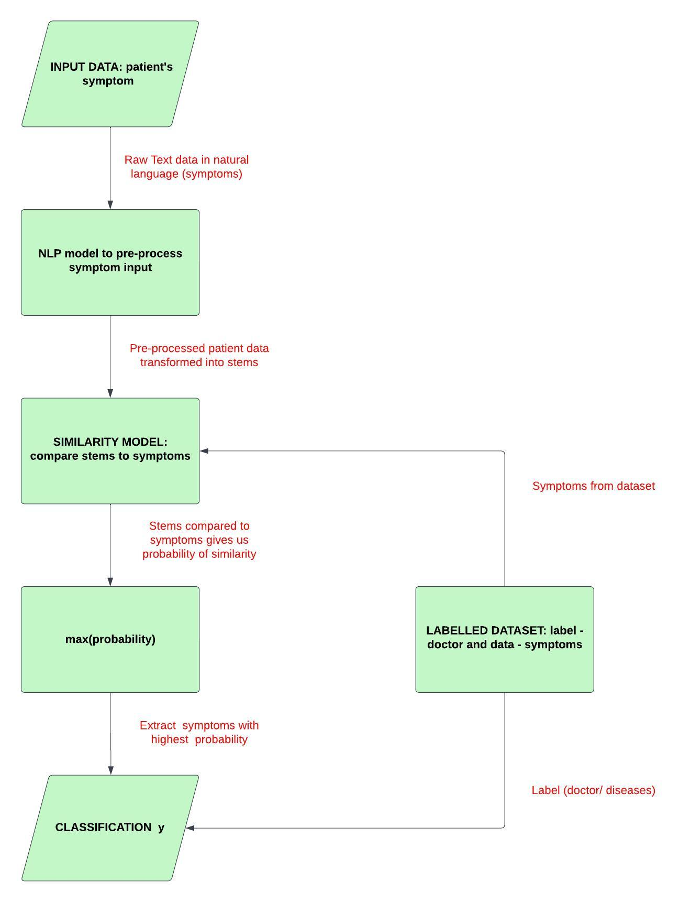
Figure 2 Patient referral algorithm design

Implementation of the algorithm:
Patient Symptom Input
A user interface in React Native was designed, it allowed patients to input their symptoms or select them from a predefined list. The patient’s symptom input was preprocessed to ensure consistency and compatibility with the symptom categorization algorithm.

Symptom Categorization:
Text Classification
Since the dataset categorizes symptoms to specific specialist, a Naive Bayes algorithm is best suited to categorize symptoms with the appropriate doctor based on probability and expertise info. A referral is then to a specialist or doctor.
Mapping Symptoms to Doctor/Specialists
Based on the predicted symptom category, the appropriate doctor or specialist from the retrieved category-specific list will be predicted by the Naïve Bayes model, with the help of the NLP cosine similarity. The doctors’ expertise and skill set will be mapped to symptom resultant categories.
Doctor/ Specialist Selection Output
After symptom categorization, the algorithm outputs the selected doctor or specialist’s information to the patient through the React Native mobile application.

Data Analysis:
Evaluation (Validation and Test Strategies)
- Evaluation of patient to doctor/specialist referral results using metrics such as accuracy, precision, recall, and F1 score.
- Comparing Results to Baseline: Established a baseline or benchmark to compare the performance of referral results against a previously established algorithm or a manual matching process. Against the base paper utilized, the research paper indicates a 75% accuracy of referrals.
- Analyze Accuracy: Calculated the overall accuracy of the matching algorithm by comparing the matched patients with the ground truth or expected matches.
- Measure Precision and Recall: Computed the precision and recall scores to evaluate the algorithm's effectiveness in correctly identifying positive matches (precision) and capturing all relevant matches (recall). Trade-offs between precision and recall based on the specific requirements were considered.
- Assess False Positives and False Negatives: Examined the occurrences of false positives and false negatives in the matching results. False positives occurred when patients were incorrectly matched, while false negatives occurred when patients were not matched when they should have been.

N/B: Based on the results obtained, the algorithm will continuously be improved to achieve better referral results in referring a patient to the right doctor or specialist.

Ethical Considerations:
The following considerations were taken in consideration for the research topic’s ethical compliance with standards and regulations and require ethical approvals if real data is utilized for experimentation and after implementation:
- Patient data privacy and security
- Informed consent
- Bias and fairness
- Transparency and comprehensiveness
- Collaboration with healthcare professionals
- Continuous evaluation and improvement
- Regulatory compliance with healthcare sector standards

Data Handling and Feature Engineering:
The dataset used in this research project had a lot of redundancy (duplication) before it was cleaned and normalized. It is a labelled dataset that consists of disease-symptom label to symptom mappings. It was required to:
- Remove duplicates or irrelevant observations
- Convert data type and standardize formatting if needed
- Filter unwanted outliers or missing data.

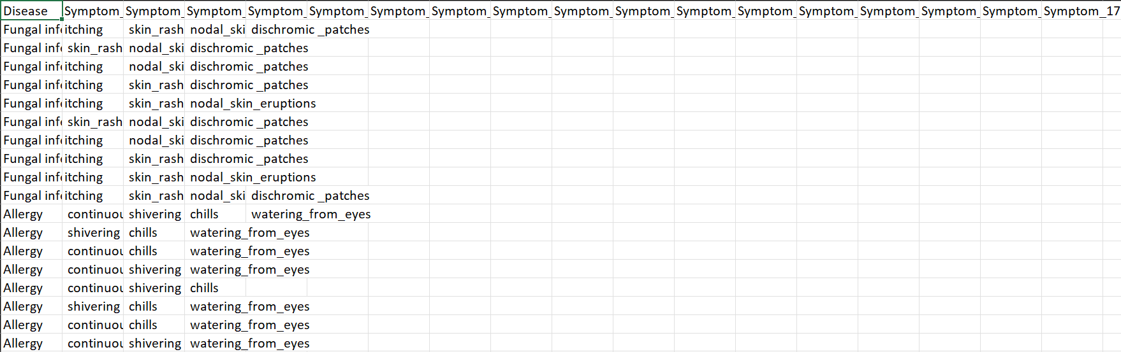
Figure 3 Disease-Symptom dataset before cleaning. Here the dataset showed a lot of redundancy.
This is a disease-symptom dataset (Kaggle site for data science datasets).
Dataset Cleaning (Pre-processing):
- To clean the dataset, duplicates were removed from the dataset, i.e. duplicates row such as fungal infection from the above image. This was done amid ensuring that the row that remains was the one with the longest symptom set.
- The underscore between symptoms were also eradicated as they don’t have any effect to the accuracy of the predicted probability of similarity between the symptom input and the dataset compared against.
- Only 18 diseases (for now) were left out in the dataset. So, the dataset incorporates 16 more diseases than the one used for oncology referrals [1]. It may also prove a huge improvement if the symptoms are also incorporated to the dataset.

Data Transformation:
Structure Transformation
After cleaning of the symptom dataset, it was primitive that the features in the dataset were:
- Preprocessing Data: Application of mathematical functions (e.g square root) to features to deal with non-linear types of data such as text inputs.
- Normalization: All redundant rows were removed from the symptom dataset and each label (disease) represented one row in the dataset.

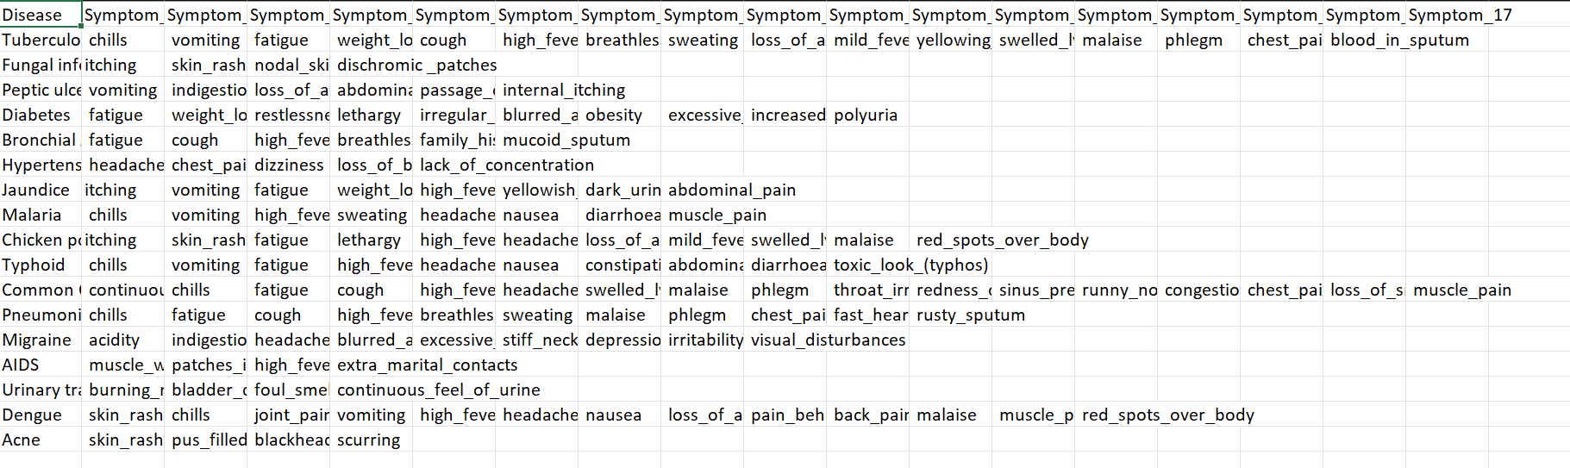
Figure 4 Disease-symptom dataset, after preprocessing and normalization.

- Encoding categorical features: Since our dataset is in natural language, it is important to convert the raw text to numerical representations which can be understood by the NLP model to understand the context.
- Discretization: This way, our dataset is converted from continuous features into discrete bins which helps us classify the symptom to a specialist or disease.
- Imputation of missing values: Filling in missing data points was key and this increased the accuracy of our dataset.
- Polynomial features: Here features were combined to ease processing power on the processor and ultimately improve performance. e.g. combining separate symptom values to a long continuous string vector.

Transforming The Prediction Target ŷ:
Since our dataset is a labeled dataset,
- Label Binarization – Converted disease labels into binary format. e.g.
Flu: [110]
Tuberculosis: [011010110101]
- Label encoding – These labels converted to binary values are mapped to the numerical values generated from symptoms.

Feature Engineering:
The patient referral algorithm, mainly uses two methods to perform the prediction of a doctor supposed to attend to a patient with regards to their symptoms. Steps involved in feature engineering to suit this project were classified under two main techniques which were cosine similarity and naïve bayes classifier algorithm. The data underwent several feature engineering steps to be prepared for effective use by the algorithm:
- Tokenization
Symptoms input sentences were broken into smaller pieces, or tokens, such as words or characters. This was the first step in preparing the data for cosine similarity. If a symptom in the dataset is:
“I had headaches, running stomach and fever.”
The NLP model converts this input to tokens. The resultant tokenized output will be:
[“I”], [“had”], [“headaches”], [“running”], [“stomach”], [“and”], [“fever”]

- Lemmatization
Transforming words into their base forms, or lemmas. This helped the algorithm to identify words with similar meanings, even if they have different forms.
“had” → “have”
“running” → “run”
- Stemming
Similar to lemmatization, but it involves removing prefixes and suffixes from words. For example, "cats" and "catting" would both be transformed into "cat." This helped to reduce the amount of variation in the data and make it easier for the algorithm to identify patterns.
“headaches” → “headache”
“running” → “run”
- Removing Stop Words
Words that are used as general word in natural language are useless in the effectiveness of the NLP model, hence the words use to control the structure of a sentence are removed.
“I” is removed,
“had” is removed
“and” is removed
- Feature Selection and Extraction
Once the data has been tokenized, lemmatized, and stemmed, you can extract features from the data that will be used as inputs to the cosine similarity and naive Bayes algorithms.
extracted features [“headache”], [“running”], [“stomach”], [“fever”]

- Normalization
Involved transforming the symptoms into a standard format so that it could be easily compared and processed by the algorithms. For example, normalizing the symptom data by transforming all words to lowercase or by assigning a weight to each token based on its frequency in the dataset. Common symptoms among several symptom sets like “chills” and “vomiting” were similar symptoms whose weights were shifted to balance the dataset.
- Dimensionality Reduction
Dimensionality reduction involves reducing the number of features in the dataset to make the data more manageable for the algorithms. Figure 2 and Figure 3 clearly show dimensionality reduction which was essential to provide ease of processing for the naïve bayes classifier as this greatly improves its efficiency and effectiveness.
- Text embeddings
Since Naïve bayes algorithms take a more probabilistic approach, we opted to utilise more the maximum likelihood approach of naïve bayes, which make us harness probabilities from the cosine similarity. Text embeddings are a way of representing text data as vectors of real numbers. This allows the algorithms to process the data more efficiently and to better capture the relationships between different tokens.
- Training the algorithm
Once the data had been prepared, we trained the cosine similarity and naive Bayes algorithms on the prepared data. The training process involves adjusting the parameters of the algorithms until they achieve a satisfactory level of accuracy. Parameters adjusted were:
- The weights of the similar symptoms across the row (w)
- The probability threshold (pt)
- Testing the algorithm
After the algorithm was trained, we tested its performance on a separate dataset to see how well they generalize to new data. This was an important step in evaluating the effectiveness of the feature engineering approach and in determining whether the algorithms are ready to be deployed in a real-world setting. We separated the initial data and used 20% of the original dataset for testing and the rest to train the model. (Refer to Figure 6.)
- Fine-tuning the algorithm
After testing the patient referral algorithm, I performed fine-tuning, shifting the model’s parameters to improve the performance on the test dataset. This involved making small adjustments to the parameters to see if they lead to an overall improved performance.
- Monitoring and evaluation
After the NLP-based patient referral model has been deployed, it is important to monitor its performance and to evaluate its impact on patient outcomes. This will help to identify areas where the algorithms can be improved or adjusted to better meet the needs of the healthcare system.

Model development and training:
Model Selection
Natural Language Processing (NLP) is a technique that this research project solely focuses on. Cosine Similarity, an NLP technique will be used to calculate similarity between the user's input symptom string and the symptoms in the labelled dataset. Cosine similarity algorithms and also distance metric algorithm such as Levenshtein Distance, are well-suited for comparing and measuring the similarity between strings, taking into account variations, misspellings, and other inconsistencies.

Architecture
- Preprocessing: The user's input symptom string should be pre-processed to remove noise, standardize the format, and handle common variations. This may include steps like lowercasing, removing punctuation, tokenization, stemming, or lemmatization.
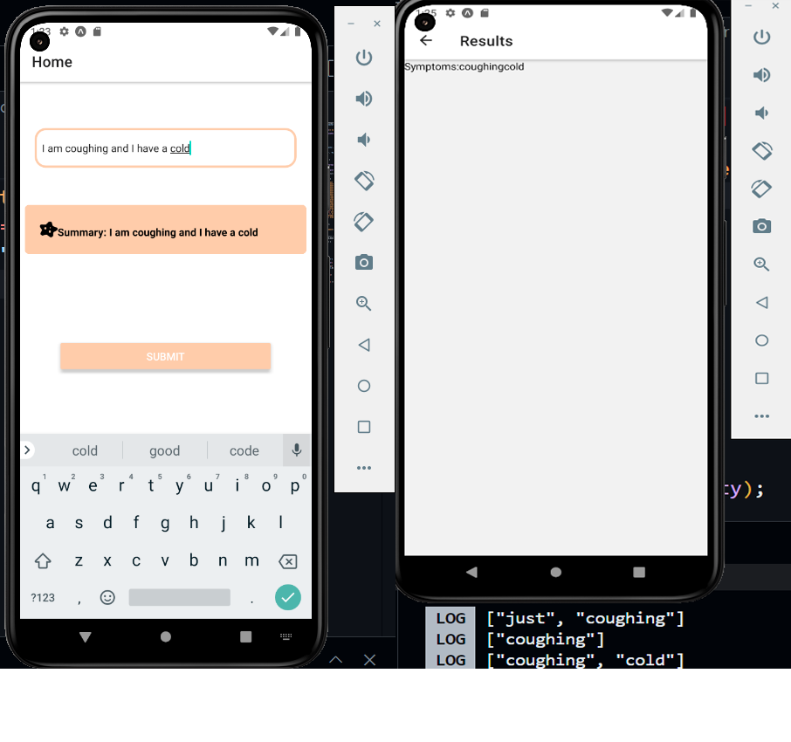
Figure 5 Natural Language Processing stemming and lemmatization
- Cosine Similarity: The chosen Cosine similarity matching algorithm compares the pre-processed user input symptom string with the symptoms in the labelled dataset. The algorithm outputs a similarity score or probability that represents the likeness of the two strings.
- Naive Bayes Classification: A threshold similarity score or ratio is set, to determine when a referral should be made to a specific patient. If the similarity exceeds the threshold, the patient symptoms are classified to the corresponding doctor in the labelled dataset.

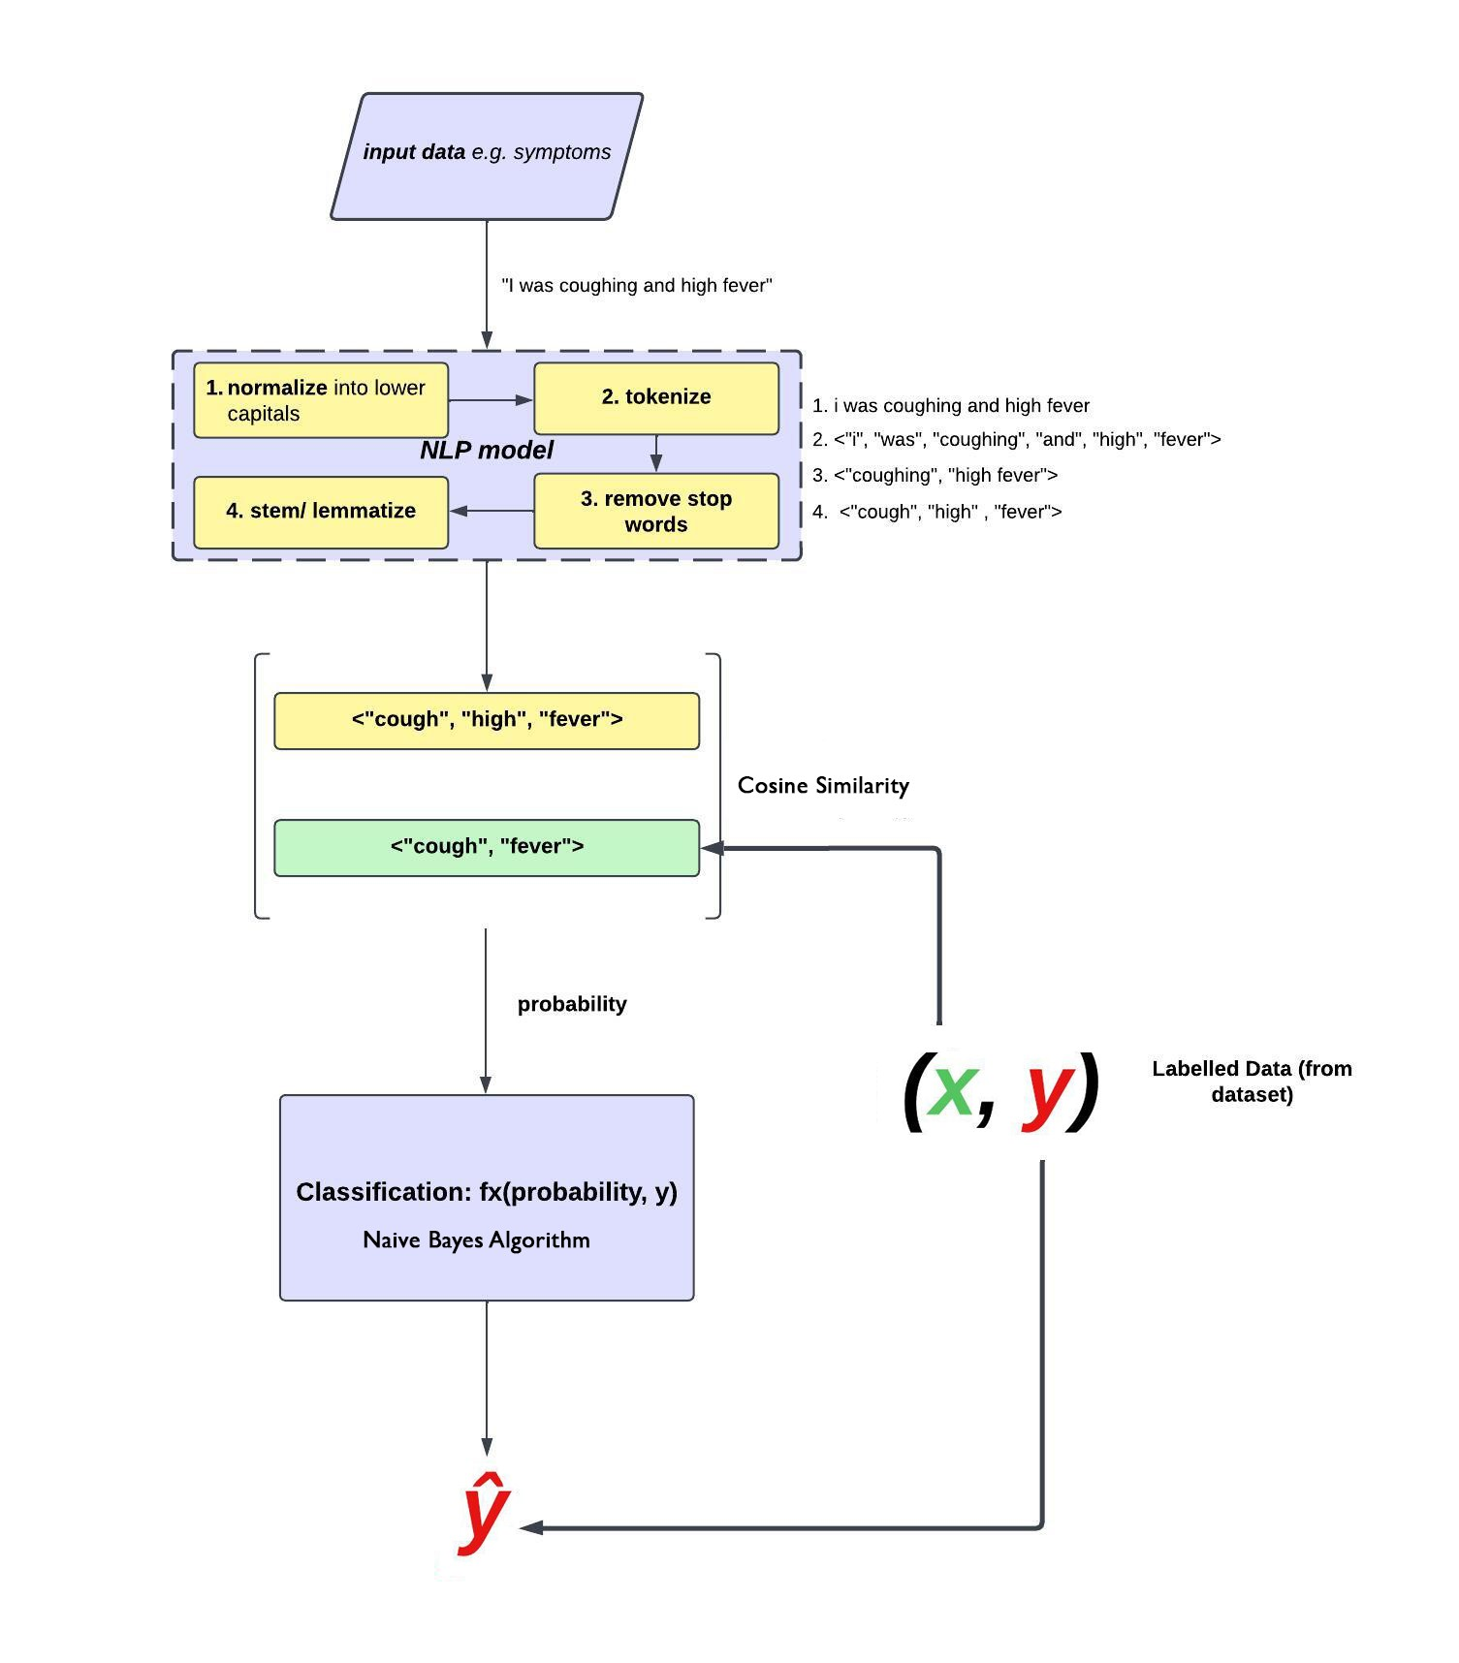
Figure 6 Architecture for NLP-based patient-to-doctor referral algorithm
Hyper parameter choices:
In the context of patient referrals and cosine similarity used to find similarity between symptoms in the dataset and the current text input, hyper-parameters include, in the Levenshtein Distance algorithm, different threshold values to define the cut-off probability for similarity. In this case, for the patient referral algorithm, the row in the dataset that has the highest ratio, or probability is the one that is chosen as what the patient suffers from. The resultant maximum probability is then classified to a certain doctor or specialist.

Training and Validation of the Algorithm

Figure 7 Partitioning the training and testing set (80:20 %)
The training process involves preparing the labelled dataset of symptoms and associated diseases. The dataset should be carefully curated, ensuring that it covers a wide range of symptoms and diseases. The labelled dataset can serve as a reference for the similarity comparison.
To validate the performance of the cosine similarity and naive bayes model, techniques like cross-validation or holdout validation were adopted. The dataset was split into training and validation (test) sets, and the training set was used to fine-tune the hyper parameters and optimize the patient referral algorithm. The validation set can be used to evaluate the model's performance by comparing the predicted similarity scores with the ground truth.

Potential biases and ethical implications
Biases:
Labeling Bias: If the labeled dataset used for the algorithm is not diverse or representative, it may introduce bias into the referral system. For example, if the dataset primarily includes symptoms and diseases that are more prevalent in certain demographics or geographic regions, the system may perform poorly for underrepresented groups.
Data Collection Bias: Biases can arise if the data used to train the model is collected from specific sources or populations, leading to skewed representations of symptoms and diseases. This can result in inaccurate referrals or limited coverage of certain conditions.
Language Bias: The NLP algorithm relies on the textual representation of symptoms. If the language used in the labeled dataset or the user input is biased towards a particular group or culture, it may affect the accuracy and fairness of the referrals.
Algorithmic Bias: The choice of specific techniques in the algorithm and its parameters can introduce biases. For example, if a particular algorithm favors certain types of spelling variations or is more sensitive to certain types of errors, it may impact the similarity scores and referrals.

Ethical Considerations:
- Privacy and Data Protection: Ensure that the patient's input symptoms and any personal information are handled securely and in compliance with relevant privacy regulations. Anonymization techniques should be employed to protect patient privacy.
- Informed Consent: Obtain informed consent from patients regarding the use of their symptoms and data for the referral system. Clearly communicate the purpose, potential risks, and benefits of using their data.
- Transparency and Explainability: The referral system should provide clear and transparent explanations regarding how the similarity scores are calculated and how referrals are made. Users should have a clear understanding of the limitations and uncertainties associated with the system.
- Accountability and Liability: Consider the legal and ethical responsibilities associated with the referral system. Ensure that appropriate disclaimers are provided, and clearly define the roles and responsibilities of healthcare professionals and the system itself.
- Continual Evaluation and Improvement: Regularly monitor and evaluate the performance of the system, including its accuracy, biases, and impact on patient outcomes. Address any identified biases or limitations promptly and strive for continual improvement.

Summary of diseases trained to the model
Diseases incorporated into to the model were 27. This includes some of the most common diseases. The number can be increased through future works from other researchers.
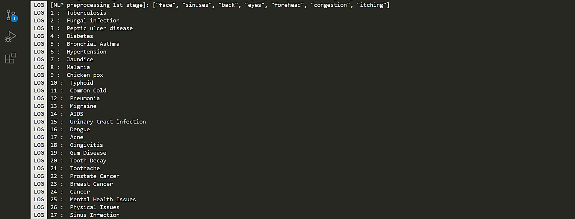
Figure 8 Summary of all diseases included in the training of the NLP model

Tools and technologies:
Mobile App
The application that has the model integrated into it will be a mobile application. The reason for a mobile app is to enhance its portability since this research project can be integrated into telemedicine apps which are usually mobile applications.
React Native
A user interface in React Native is designed for patients to input their symptoms. This ensures that the prototype can be accessed across multiple platforms such as android, iOS and Linux. The algorithm maps symptoms to the appropriate doctor or specialist based on the predicted symptom category, and the selected doctor's information is outputted to the patient through the React Native application.
Cosine Similarity
The symptom input is preprocessed for consistency and compatibility with the symptom categorization algorithm. Text classification is chosen as the technique for symptom categorization, considering techniques like cosine similarity.

Naïve Bayes Classification Model
The Naive Bayes algorithm is the selected algorithm to perform symptom disease classification. The symptoms were treated as the feature matrix (symptom lists were classified as columns, symptom_1, symptom_2 and so on). The selected algorithm's performance in referring patients to doctors according to their symptoms or diseases is evaluated using metrics such as accuracy, precision, recall, and F1-score.

Project requirements and design considerations:
System Requirements:

The NLP patient referral model must have a reliable access to the healthcare database, and a platform for hosting the mobile application.
Design Considerations
The mobile interface should be intuitive, user-friendly, and accessible to patients with varying levels of technological experience. The design also ensures that the data collected is secure and compliant with medical regulations.
Usability
The app should be simple to use and navigate, with clear instructions and a straightforward interface. This applies to extended demographics and difference characteristics of the end-users.
Scalability
The model should be scalable, meaning that it can handle a large volume of patient data without compromising performance. This will ensure that the model can be used by a wide range of healthcare facilities, from small clinics to large hospitals.
Security
The app should have strong security measures in place to protect patient data from unauthorized access, including encryption and password protection.

Performance
The model should be fast and efficient, with minimal latency and downtime. It should be able to handle a high volume of requests without slowing down or crashing. This will ensure that patients can use the app to obtain timely and accurate referrals to specialists.

Conclusion:
Considering this technique will ensure that the natural language process patient referral algorithm will perform as intended and then, as a result, be integrated into a react native mobile app for cross functionality among different mobile devices. The methodology imposed for this research project ensures that this research project improves patient treatment in the patient referral medical field, adds to the research field of artificial intelligence and medicine, meets the possible end-user requirements and as a conclusion, improves healthcare and patient diagnosis outcome.

Analysis and Design

Introduction:
The analysis and design chapter of this document involves a detailed analysis of the methods and reasons for integrating the NLP model the way it was integrated into a mobile app. It also involves an analysis of the goals that potential users of this interface would want to achieve by interacting with the system. This section also illustrates the user case scenario of the possible actions the user can perform and the process flow of the mobile app. Lastly, this section presents the structure and relationship of components used in this research project.

Detailed Analysis of the problem domain and user requirements
In order to practicalize the model into operationalization, it was considered to first assess the limitations and possible solutions to facilitate the building of this model, deployment and integration into a mobile application. The proposed solutions involve the use of React Native to design a cross platform mobile app for high scalability. The user requirements for this research project are based on the possible actions that a user may take in order to complete their goals i.e. inputting patient symptoms and then getting referred to the appropriate doctor or specialist to attend to them.
Model Deployment and Serving):
Model Serialization
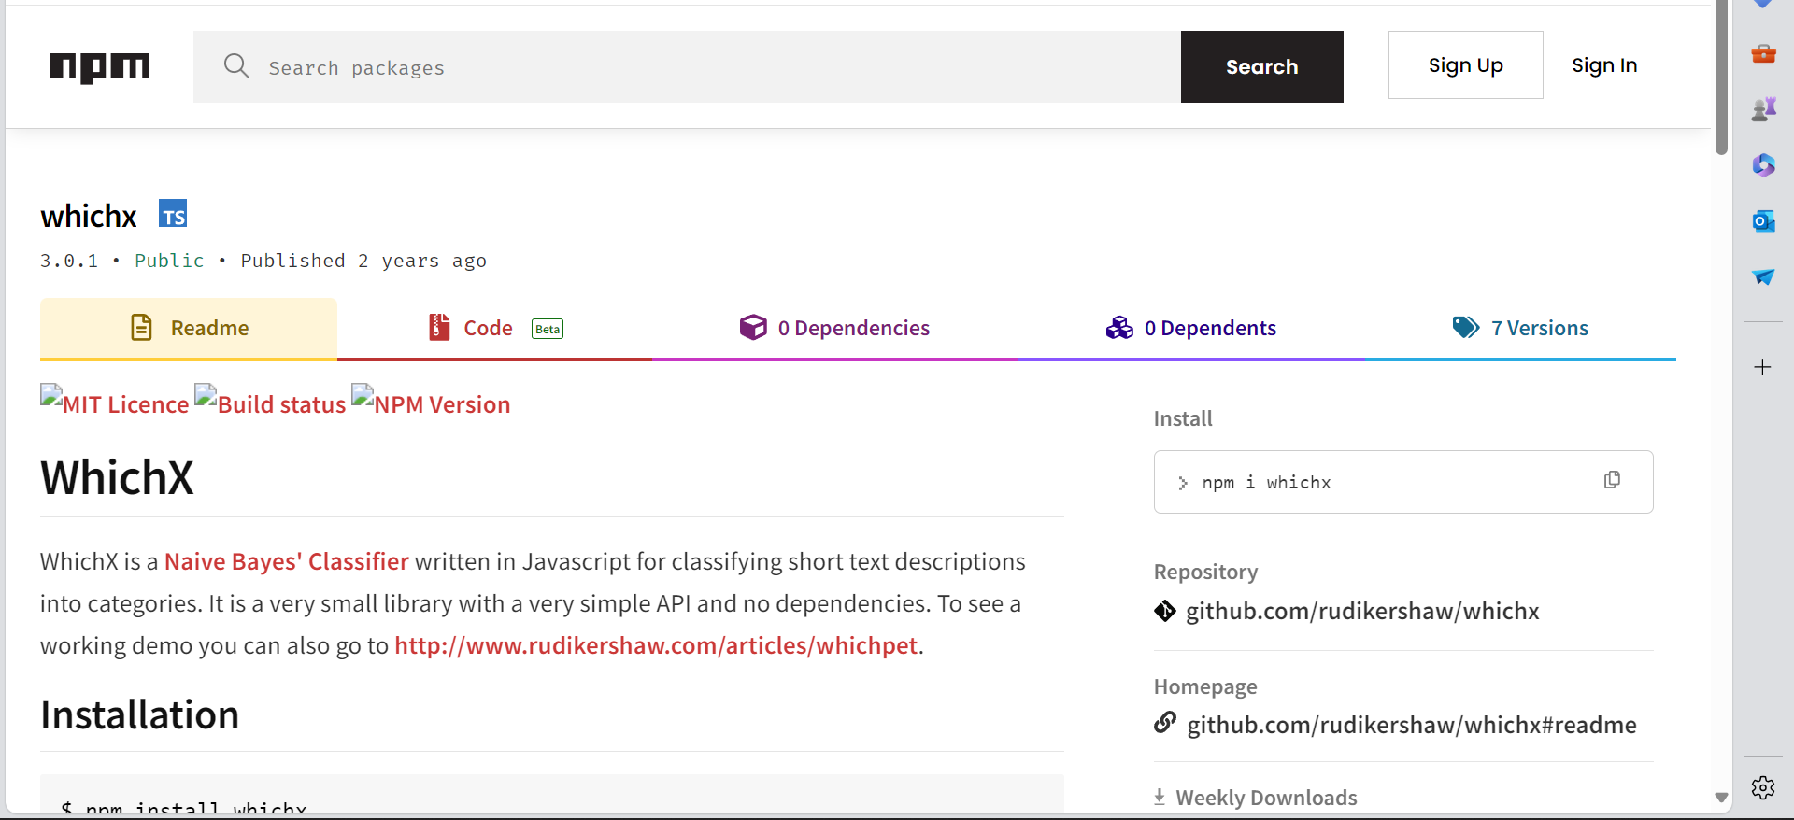
Figure 9 WhichX is a npm package that was used to ensure the model was in the right format with the referral application

To implement the naïve bayes and integrate it with the intended User Interface for users to communicate with the NLP model, WhichX, a naïve bayes package was utilised. This ensured that the user input gels with the model, and is fed into the model for processing. The trained algorithm was serialized to a format that could easily loaded and executed during deployment. Common formats in this npm package included Node.js, which was the main basis of the model’s serialization. WhichX comes with pre-loaded API which made it efficient for us to develop a front-end and back-end for our patient-to-doctor automated referrals.
User Interface Design
The User Interface (UI) implemented in this project was developed using react native. This research project is the development of a mobile app, which can be integrated into conventional telemedicine systems using Application Programming Interfaces (API). Through further enhancements, it could function as a standalone mobile application.
Referral results if model failed to make prediction
If the model does not show a resultant positive referral, the application displays to the user that there were no predictions that was made by the NLP model.
Detailed specialty information
If a doctor/ specialist is selected, a user has an option to further click the doctor card and then a description of that doctor pops up. This reveals further specialty information and also options to make an appointment.

Back-End Development:
Patient Information
Patient information is securely retrieved for the input text box and temporarily stored in the apps temporary storage and passed onto the cosine similarity function, after it has been pre-processed by the NLP pre-processor. The cosine similarity processes the input and estimates which row in the dataset is similar to that input by calculating probabilities of similarity between the strings. The probabilities are then fed into the Naïve bayes model and the model, using the resultant probabilities for each row, uses the input and the probability of similarity to predict which label (doctor) the symptoms correspond to.

Doctor Labels
The doctor’s labels retrieved through the disease-symptoms dataset during the prediction/ processing of the naïve bayes model. The doctor labels contain detailed information which is displayed on the screen.
Disease-symptom dataset
This is the main dataset that is utilized in this research project, it is in csv file format and can further be enhanced of its retrieval performance by converting the information in the dataset to an inbuilt data type initially (arrays or better).
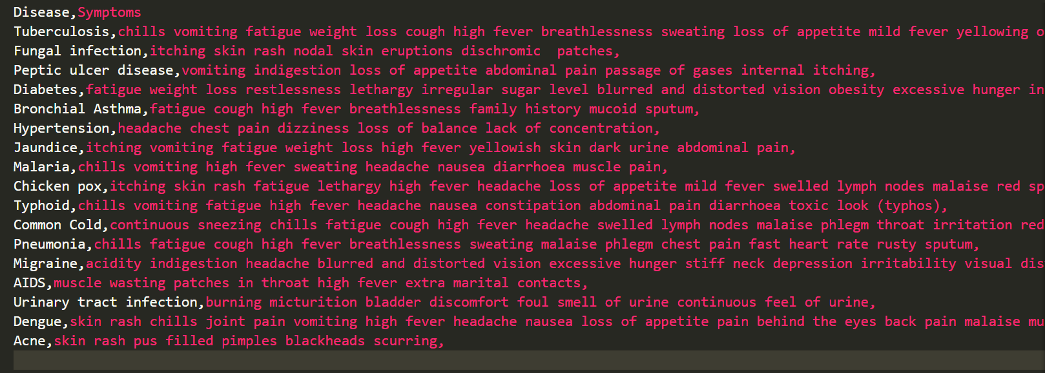
Figure 10 50% of the symptom dataset in csv. format

User Privacy and data security:
To ensure user privacy and data security:
- Data Minimization: The algorithm only collects and stores the minimum amount of data necessary for the functioning of the patient referral application. Avoid collecting sensitive information unless absolutely required.
- Secure Communication: Use of secure communication protocols such as HTTPS to encrypt data transmitted between the client and server. This protects user data from interception and unauthorized access.
- Data Anonymization and De-identification: Considered anonymizing or de-identifying user data to further protect privacy. Removal or encryption of personally identifiable information (PII) and use of anonymized identifiers when possible was implementation.

Developments to Facilitate Telemedicine Integration:
API development
Design and develop an API (Application Programming Interface) that exposes the functionality of the NLP algorithm. The API should define endpoints for receiving user inputs and returning the appropriate doctor's recommendation. Popular frameworks for building APIs include Flask and Django in Python.
Hosting infrastructure
Set up a hosting infrastructure to run the algorithm. This can be a cloud service provider like Amazon Web Services (AWS), Google Cloud Platform (GCP), or Microsoft Azure. Choose the platform that suits the requirements in terms of scalability, availability, and cost.
Containerization
Containerize your application using technologies like Docker. This allows you to package your algorithm, its dependencies, and the API into a portable container that can be deployed consistently across different environments.

Functional Requirements:
Since the NLP patient referral model is to be deployed or integrated into a medical-based mobile app, the system poises the following functional requirements:
- Users should be able to input their (or a patient’s symptoms) symptoms in natural language.
- The app is supposed to display the summary of patient symptoms clearly to the user.
- The user should be able to submit symptoms to the patient referral model for referral specialist prediction.
- The application should display the result of the symptom input provided by the user as a form of feedback.
- After a doctor/specialist is displayed, the user should be able to make an appointment with that doctor/specialist.
- The user should be able to further enquire a description of the specialist whom he/she has been referred to.

Non-functional Requirements:
Non-functional requirements for the mobile patient referral app:
1. Usability:
- Intuitive and user-friendly interface for symptom input.
- Clear and comprehensible symptom summary display.
2. Performance:
- Fast response times for symptom processing and referral generation.
- Low latency of the NLP model for real-time predictions.
3. Accuracy:
- High accuracy in predicting specialist referrals based on symptoms.
- Ensure accuracy of displayed doctor/specialist information.
- Provide feedback that accurately reflects the result of symptom input.
4. Reliability:
- Robust NLP model handling various symptom inputs.
- Error handling mechanisms for graceful handling of unexpected issues.
5. Security and Privacy:
- Handle patient data securely and comply with data protection regulations.
- Encrypt user data and symptoms during transmission and storage.
6. Scalability:
- Scalable NLP model for growing symptom inputs and specialist predictions.
- Integration with additional healthcare systems or databases.
7. Compatibility:
- Compatible with iOS and Android platforms.
- Responsive and adaptable to different screen sizes.
- Seamless integration with React Native framework.
8. Maintainability:
- Well-documented and maintainable codebase.
- Modular and upgradable NLP model.
9. Accessibility:
- Adherence to accessibility guidelines.
10. Performance Monitoring:
- Monitoring of NLP model accuracy and performance.

Identification of system components and functionalities:
Input Component
The input is in text form. This means that the end-user, who can be a patient or general practitioner can interact with the system by providing text input through a text box in the referral application system. This text input is in the form of patient symptom data. At the time of writing this, the model only supports English language so the model (for better results), should receive natural language in form of English language.
NLP pre-processor
The NLP model, constitutes of the Naïve Bayes classifier and cosine similarity module, after receiving symptom is able to predict which doctor/ specialist should attend to that patient based on the patient symptoms. Before this input of the patient, the input should undergo pre-processing measures to produce an output that is more effectively processed by the cosine similarity module. NLP model pre-processes input and passes the resultant tokens to the cosine similarity.
Cosine Similarity module
The cosine similarity matches the input to the training data in the dataset. After the input is pre-processed by the NLP pre-processor, the data is passed onto the cosine similarity module. This module, matches the input to the symptoms residing in the dataset in order to provide assistance to the naïve bayes classifier in form of probabilities of similarity between the input and symptoms in the naïve bayes model (the input symptoms and the symptoms used in training the Naïve bayes model).
Naïve Bayes Classifier model
Using the probability from cosine similarity as a reference, the naïve bayes model predicts which doctor a patient is referred to. The Naïve bayes does this by using a probabilistic approach and treats each word provided by the user as a determinant to predict which specialist a patient gets referred to in order to attain effective and efficient patient care and diagnosis.
Doctor Card Component
The output of data is in the form of a resultant doctor/specialist whom a patient has been referred to for specialized treatment. the output is a card that displays the doctor’s image, name and their specialty (and also their description if you click on the doctor card). If the model predicts the right doctor, then the doctor gets displayed and you can make an appointment with them. If the input symptom passed to the NLP model does not make sense, then a card indicating that no classification was made is displayed.

Use-Case diagram/s:
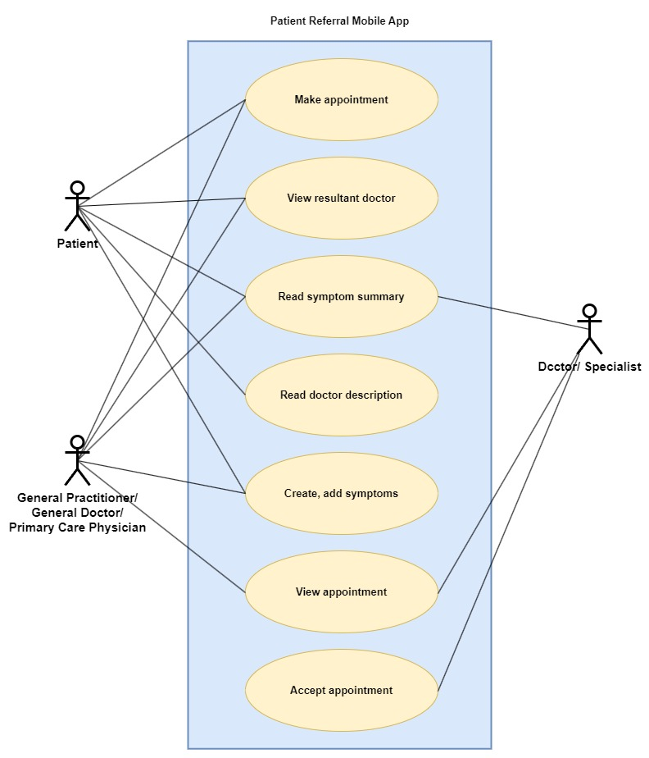
Figure 11 Use-case diagram showing user-mobile app interaction
The actor in the patient referral mobile app/system are patients, doctors and general practitioners or medical receptionists.

Sequence diagram:
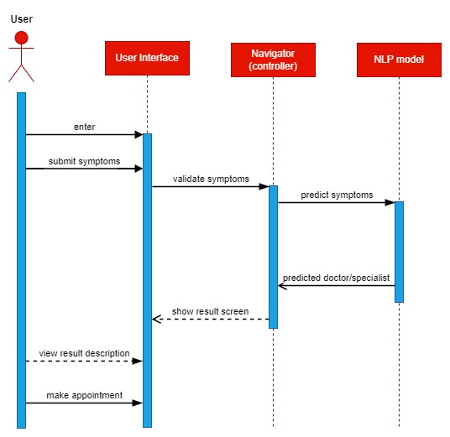
Figure 12 Sequence diagram for NLP-based patient referral mobile app

System architecture and design considerations:
The high-level system architecture of the patient referral algorithm utilizes natural language processing (NLP) for symptom classification.

Overall Structure
The patient referral algorithm follows a modular and layered architecture to achieve its objectives effectively. The system consists of the following key components:
- User Interface: This component allows users to input their symptoms in natural language format. The user's input is then passed to subsequent components for processing and analysis.
- Pre-processing NLP Module: The pre-processing module is responsible for performing necessary text transformations on the user's input. It employs NLP techniques such as lower-casing the input, removing stop words, and punctuations.
- Symptom Matching and Classification Module: This module compares the pre-processed user input with the symptoms stored in the dataset. It utilizes cosine similarity measures to determine the closest match between the user's input and the symptoms in the dataset.
- Doctor Recommendation Module: Once the symptom is classified, the system identifies the appropriate doctor who specializes in diagnosing and treating the disease associated with the classified symptom. The naïve bayes model matches the disease with the corresponding doctor's expertise.
- Doctor Display Interface: This component presents the recommended doctor to the user, providing relevant information such as contact details, specialization, and availability. The user can then proceed to make an appointment with the recommended doctor.

Design Decisions
Several design decisions were made to ensure the effectiveness, modularity, reusability, scalability, and maintainability of the patient referral algorithm. These decisions include:
- Modular Design: The system was divided into distinct modules to achieve separation of concerns. Each module handles a specific task, such as pre-processing, symptom matching, classification, and doctor recommendation. This modular design promotes reusability and facilitates future modifications or enhancements to individual components.
- NLP Techniques for Pre-processing: By employing NLP techniques such as lower-casing, stop word removal, and punctuation removal, the system normalizes the user's input, reducing noise and increasing the accuracy of symptom classification.
- Expertise-based Doctor Recommendation: The system's doctor recommendation module utilizes naïve bayes model to match the disease associated with the classified symptom to the appropriate doctor. This design decision ensures that patients are referred to doctors who possess the expertise necessary for accurate diagnosis and treatment.
- Scalability and Maintainability: The system architecture should be designed to accommodate potential future enhancements, such as the inclusion of additional symptoms or doctors. The architecture should also facilitate system maintenance and updates, ensuring that it remains adaptable to evolving medical knowledge and technology.

Context Diagram and DFD Diagram:
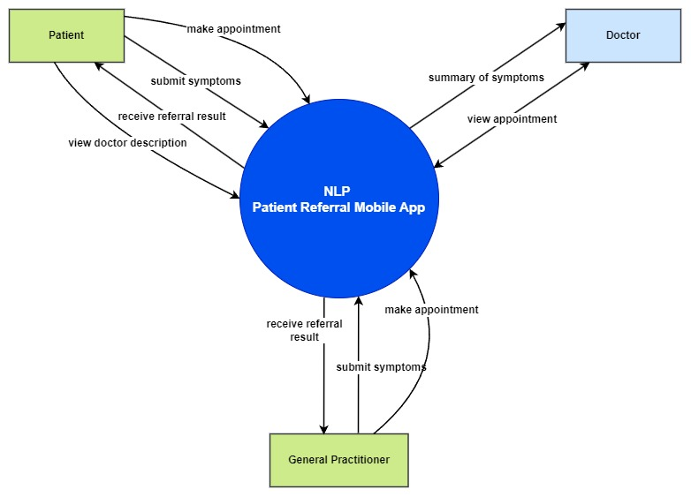
Figure 13 context diagram for NLP patient referral mobile app

Architectural Design:

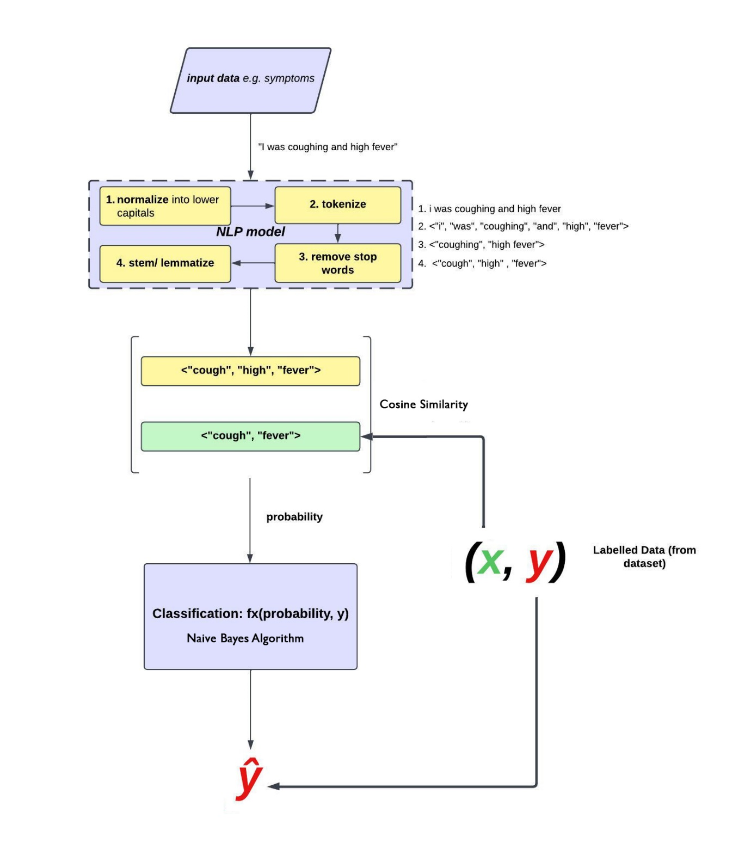
Figure 14 Architecture for NLP-based patient-to-doctor referral algorithm. Ŷ is the specialist/ doctor to whom a patient has been referred.

Physical Design:
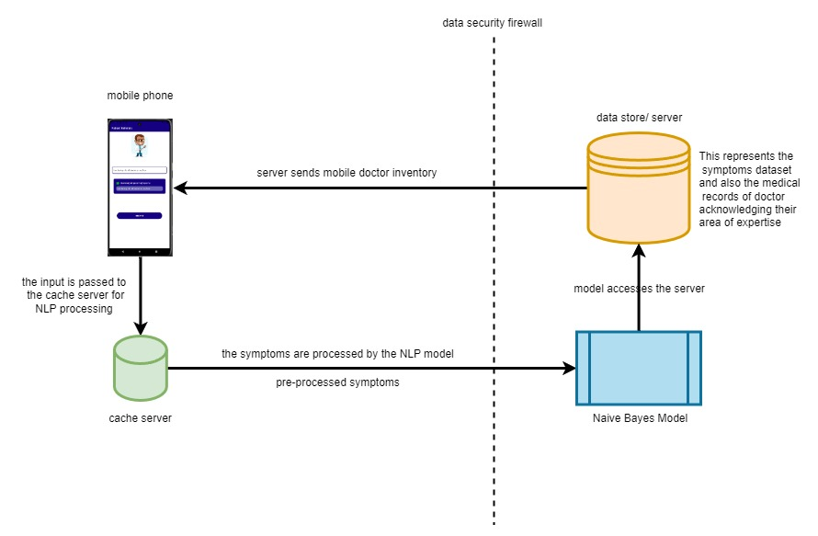
Figure 15 Physical design of the mobile application the NLP model was integrated into
Mobile Phone
The NLP model was integrated into a mobile app which can be accessed through a mobile device such as a smartphone or tablet. This was done so, to improve portability, provided that majority of the patients have handsets.
Cache Server
Cache server holds the input symptoms that the user inputs through the mobile device to prepare it for natural language processing. In the cache server, text is pre-processed: the text is converted to lowercase, tokens and then removal of stop words occurs.
Data store/ server
The data store or server, holds the disease-symptom dataset that contains a list of symptoms used to train the Naïve bayes algorithm for purposes of prediction of receiving the input in natural language. The data store also contains records of available doctors that shows their expertise and specialty. This information is utilized by the naïve bayes model to predict which doctor the patient get referred to.
Naïve Bayes Model
The naïve bayes, as a supervised learning algorithm that is utilised in this research project, serves the purpose of predicting which specialist receives a patient using their symptoms.
Data Security Firewall
The data security firewall filters the natural language processed stems to ensure that they meet security regulatory measures before they are passed on to the naïve bayes model and the server later on.

Database Design:

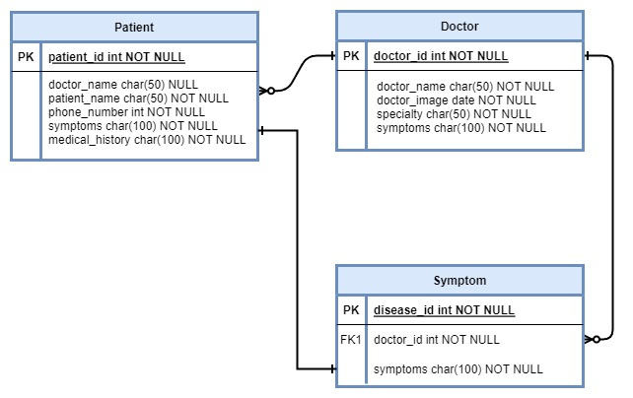
Figure 16 Entity-Relationship diagram of data used in the patient referral mobile app

Interface design:

Menu Design
Since this research project is a machine learning based research, the interfaces designed for this project are mainly based on purposes to show how the model can be used when need to interact with users.
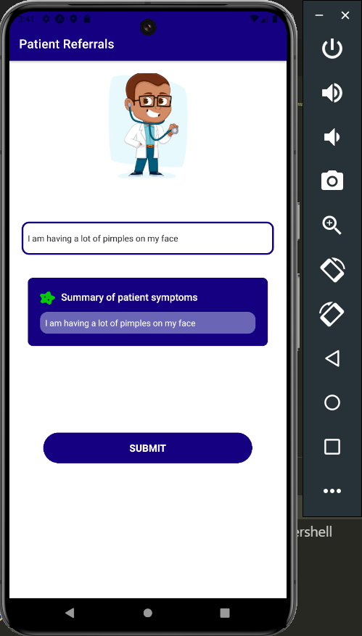
Figure 17 Menu Design of a patient referral mobile app that uses an NLP model

Input Design
As the user inputs symptoms in the input textbox, the summary bubble previews everything that the user has typed in the textbox.

Figure 18 Showing the input of the patient referral interface.

Output Design
When user has input their symptoms and pressed the submit button, a doctor card should be displayed showing the referral result based on the input symptoms and the NLP referral algorithm.
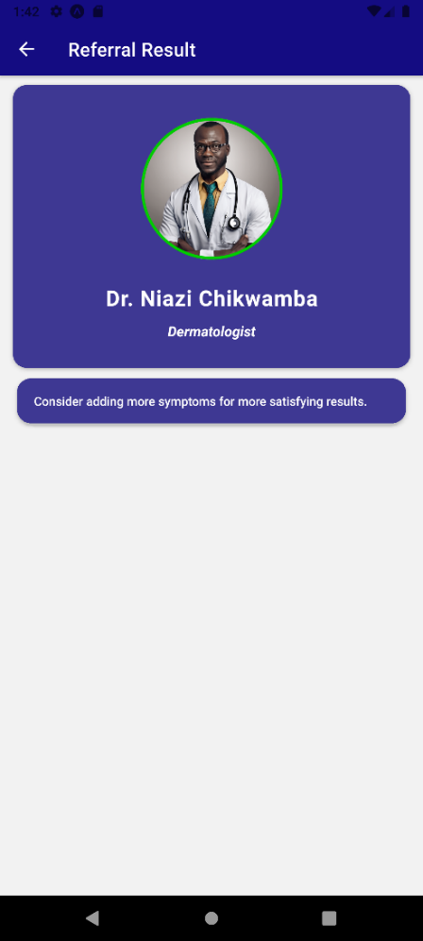
Figure 19 displaying doctor referral result output form
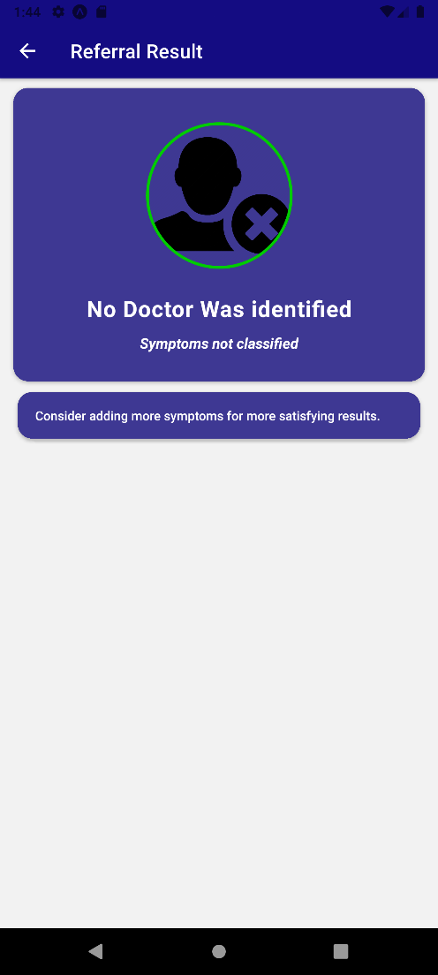
Figure 20 if no doctor was identified due to unrecognized input by the model
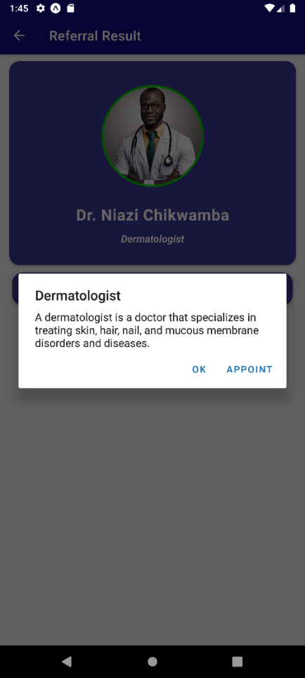
Figure 21 further information is displayed if user clicks doctor card

Conclusion:
The analysis and design section of this research project involved the detailed analysis of the problem involved in deploying the machine learning patient referral model into operationalizing. Upon deployment, specific problems such as user data security and privacy, reliability and usability arise. This section provides insight into how the use of technologies such as React Native lead to better usability and easily scalable product after model deployment and serving. This chapter also explored the structure of the model and also the architecture of the mobile app after the model had been deployed so that it can be operated by users of the system.

Results

Introduction:
The main aim of this research project was to develop and evaluate a patient referral algorithm using natural language processing (NLP) to classify symptoms and refer patients to appropriate doctors based on their specific expertise. This set the tone to develop an NLP-based patient referral algorithm that can accurately match patients with appropriate doctors or specialists based on a wide range of disease symptoms. Previous work on this field was successful, but they were based on fewer symptoms and disease sets. To ensure this research project resolved issues discovered on previous research papers, it was evaluated, on its performance and effectiveness in conducting patient referrals to specialists, in several symptom test scenarios.

Presentation of Findings:
Testing set
The training data was split into a testing set in order to evaluate the performance of the model. Out of 18 classes, 8 classes were selected as the testing set. The testing set underwent the same pre-processing steps to the symptom text in the testing set as done during the training phase. This included NLP pre-processing steps such as lower-casing, removing stop words, punctuation, and any other necessary text normalization techniques.

The selected test set comprised of symptoms representing the following diseases:
- Tuberculosis
- Common Cold
- Chicken Pox
- AIDS
- Acne
- Malaria
- Pneumonia
- Hypertension

Results
This section illustrates the evaluation and performance testing of the patient referral model. Results from this section are an estimate as a section of the training data was treated as the testing set to make model testing more effective and efficient. The following machine learning metrics were used evaluate the performance of the model:
- Accuracy
- Precision
- Recall (Sensitivity)
- F1 Score

Accuracy
The model accuracy obtained was 84.8%
Model accuracy refers to the percentage of correct classifications a machine learning model, that is trained achieves. For the NLP patient referral algorithm, the proportion of the correctly predicted diseases out of the total number of instances in the test set was calculated and evaluated.

Model Testing
No. | Test cases | Pass | Fail | Conclusion
1 | Numerical inputs | ✓ |  | Model indicates no classification if numbers are provided as input
2 | Inputting a single/ partial symptom(s) associated with a specific specialist | ✓ |  | Model can efficiently identify possible specialist treatment
3 | Inputting multiple symptoms associated with a specific disease | ✓ |  | Model is accurate, with increase in probability
4 | Inputting a combination of symptoms that uniquely identify a disease | ✓ |  | Highest probability classification, model accuracy increases with more inputs
5 | Inputting all the symptoms associated with a disease | ✓ |  | Highest probability classification, model accuracy increases with more inputs
6 | Different order of words in symptom input | ✓ |  | Model still identifies symptoms with the same probability
7 | Inputting symptoms not associated with specialist instance under test | ✓ |  | The model does not predict the symptoms to current specialist in test
8 | Input containing misspelled words/ symptoms | ✓ |  | Model can still predict the appropriate specialist for the symptoms
9 | Alphanumeric input |  | ✕ | Model still predicted if input is not clear. Can be solved by fine-tuning the threshold probability
10 | Inputting symptoms unrelated to any known disease | ✓ |  | The model results in not predicting the symptom to any wrong specialist
11 | Incorrect combination of symptoms |  | ✕ | Model selected the wrong disease based on probability
Table 3: Table showing accuracy evaluation using different test cases
Key
Test cases – a detailed set of inputs to evaluate the model’s performance
Pass – provided the test case, the model successfully made the right prediction
Fail – provided the test case, the model failed to make the right prediction

Conclusion on accuracy
The patient referral algorithm’s accuracy was 81.6% before probability fine tuning. The probability threshold was set to 0.09, meaning anything equal to, or less than the threshold was regarded as a false prediction which made the model more accurate. This eradicated inputs that were not accurate, such as single letters or very short words (e.g. input “eat” to the algorithm).
After fine tuning the weight of the probability, the threshold was to 0.099 and this led to an improved accuracy of 84.8% which shows an improvement to the convolutional neural networks used by John Nunez used in referring a patient to either a psychologist or a counsellor based on their mental symptoms, which was approximately 72% [1]. The lowest accuracy retained by the model when the input given was wrongly detailed was 70.4% and this was caused by:
- The input being alphanumeric decreased the interpretation by the natural language processing algorithm
- Incorrect or the mixing up of symptoms leading to different diseases
- Inputting symptoms that were similar in certain diseases

The table below shows the final accuracy retained are probability fine tuning, against the previous accuracy recorded before back propagation and loss minimization.
Description | Accuracy
Average accuracy after fine tuning | 84.8%
Model before probability fine tuning | 81.6%
Lowest accuracy recorded due to incorrect inputs or untuned weights | 70.4%
Table 4: Evaluation of model accuracy

Precision and Recall
Precision
To calculate precision and recall for the model's predictions, additional information was required such as:
- The True Positive (TP) values
- False Positive (FP) values
- False Negative (FN) values
These values were derived from comparing the model's predictions with the ground truth labels in the test set.

The row selected to be the model’s performance focal point was Tuberculosis
Disease | Tuberculosis
Symptoms | chills vomiting fatigue weight loss cough high fever breathlessness sweating loss of appetite mild fever yellowing of eyes swelled lymph nodes malaise phlegm chest pain blood in sputum
Specialist Name | Dr. Amani Nkosi
Specialist Specialization | Infectious Disease Specialist
Table 5: Minimal test set of disease row used to calculate precision and recall

A set of random inputs were created and organized to measure the model’s precision and recall by feeding those inputs to the model to validate whether it correctly predicted tuberculosis from the set of symptoms. Precision represents the proportion of correctly predicted positive cases (Tuberculosis) out of all instances predicted as positive. It is calculated using the formula:
Precision = TP / (TP + FP)
- Precision: Calculating the proportion of correctly predicted positive cases (disease(s)) out of all instances predicted as positive.
- TP (True Positive): The number of instances where the model correctly predicted Tuberculosis.
- FP (False Positive): The number of instances where the model incorrectly predicted Tuberculosis.

After testing the model:
True Positives (TP) | 12
False Positives (FP) | 2
Precision = TP / (TP + FP) | 0.86
Table 6: Calculating precision of the patient referral model

Precision of the NLP patient referral model is 0.86.
This means out of any input made to the model, 86% of the predictions made will be correct and only 14% will result to an incorrect prediction made by the model. This precision is because some symptoms overlap to other disease which was a problem identified earlier on in the accuracy of the model. It is important to note that precision is highly dependent on the test set chosen.
Recall
Also known as sensitivity, recall is the proportion of correctly classified positive symptoms out of all actual positive symptoms. It measures the algorithm's ability to identify all positive cases.
Recall = TP / (TP + FN)
- Recall (sensitivity): The proportion of correctly predicted positive cases (disease(s)) out of all actual positive cases. It measures the model's ability to identify all positive cases.
- TP (True Positive): The number of instances where the model correctly predicted Tuberculosis.
- FP (False Negative): The number of instances where the model failed to predict Tuberculosis when it should have.
Based on the evaluation of the model using a test set consisting of various inputs associated with Tuberculosis, we achieved a recall of 12 true positives and 4 false negatives. This translates to a recall rate of approximately 75%. The recall metric indicates that the model correctly identified 75% of the actual cases of Tuberculosis present in the test set. However, there is still room for improvement to reduce the number of false negatives, where the model failed to identify Tuberculosis when it was present. Enhancing the model's ability to capture these missed cases would be beneficial to improve the overall performance and accuracy of the patient referral system.

True Positives (TP) | 12
False Negatives (FN) | 4
Recall = TP / (TP + FN) | 0.75
Table 6: Summary results of recall (sensitivity) of the patient referral model

F1 Score
F1 score is the harmonic mean of the precision and recall of the model:
F1 Score = TP / (TP + (FP + FN)/ 2)
Upon evaluating the model's performance using a test set for Tuberculosis classification, we achieved a precision of 86% and recall of 75%.

These results highlight the effectiveness of the model in correctly identifying Tuberculosis cases while minimizing false positives. However, to gain a comprehensive understanding of the model's performance, we also calculated the F1 score, which takes into account both precision and recall. The F1 score, which provides a balanced assessment of the model's performance, was found to be approximately 0.795.

This value indicates that the model achieved a good balance between precision and recall, reflecting its ability to accurately classify Tuberculosis cases while minimizing both false positives and false negatives. By considering the F1 score, we can better gauge the overall effectiveness of the model and its ability to accurately identify Tuberculosis cases. Tracking the F1 score over time can help us monitor the improvements in the model's performance and make necessary adjustments to enhance its accuracy.

Precision | 0.86
Recall (Sensitivity) | 0.75
F1 Score = TP / (TP + (FP + FN)/ 2) | 0.8 (approx.)
Table 7: F1 Score of the patient referral algorithm

Summary of Results

Figure 22 bar graph showing summary of results (accuracy, precision, recall, f1 score)

The patient referral model successfully predicts various symptoms and provides appropriate referral recommendations to specific doctors. With an accuracy of 84.8%, the model demonstrates its effectiveness in correctly identifying and matching symptoms with suitable medical professionals. The precision of 0.86 ensures accurate recommendations, minimizing the chances of false positives. However, the recall of 0.75 indicates that there is room for improvement in capturing all symptoms and referring patients to the appropriate doctors.
Overall, the patient referral model shows promise in aiding healthcare professionals by efficiently analysing symptoms and facilitating appropriate referrals to the relevant medical specialists. The F1 score, which provides a balanced assessment of the model's performance, was found to be approximately 0.795. This value indicates that the model achieved a good balance between precision and recall, reflecting its ability to accurately classify patient symptoms to specialist doctors. Further improvements can be made by implementing a solution to prevent specialist classes that have multiple similar symptoms from making biased predictions.
Patients with different symptom sets | Accuracy | Precision | Recall | F1 Score
Tuberculosis | 70.4% | 0.86 | 0.75 | 0.81
Common Cold | 76.7% | 0.9 | 0.78 | 0.84
Chicken Pox | 84.8% | 0.79 | 0.82 | 0.79
AIDS | 85.9% | 0.89 | 0.78 | 0.83
Acne | 86.7% | 0.82 | 0.87 | 0.84
Malaria | 84.8% | 0.84 | 0.75 | 0.79
Pneumonia | 70.4% | 0.77 | 0.72 | 0.74
Hypertension | 84.8% | 0.82 | 0.81 | 0.81
Table 8: Summary of results showing metrics for the testing set symptom sets

The overall performance of the model is as follows:
Metric | Value
Accuracy | 84.8%
Precision | 0.86
Recall | 0.75
F1 Score | 0.8
Table 9 summary of model performance

Interpretation and Analysis of Results
Based on the evaluation of the patient referral algorithm, several observations can be made from the performance metrics:
Accuracy
First, the accuracy of 84.6% indicates that the model is generally effective in making correct predictions. However, it is important to note that the model has limitations when dealing with symptoms that are similar to each other. In such cases, the model may be biased towards selecting the symptom with fewer occurrences as the correct prediction. Additionally, the model may generate predictions for symptoms that do not make sense in terms of natural language if they surpass the similarity threshold. These factors can contribute to both false positives and false negatives in the predictions.

Figure 23 line graph showing the increase in accuracy with increase in input symptom length
Precision
The precision of 0.86 indicates that the model correctly predicts 86% of the inputs to the correct row in the dataset. The occurrence of false positives can be attributed to the issue of similar symptoms leading to incorrect predictions. However, it is noteworthy that the number of false positives was comparatively lower than the number of false negatives.
Recall
The recall of 0.75 suggests that the model has room for improvement in capturing all relevant symptoms and making accurate predictions. The problem of similar symptoms impacting the model's performance is more pronounced in recall, where it tends to select the wrong prediction due to the same issue.
F1 Score
The F1 score of 0.8 indicates a balanced measure of the model's performance, considering both precision and recall. It reflects the overall effectiveness of the model in correctly classifying symptoms and making appropriate referrals.
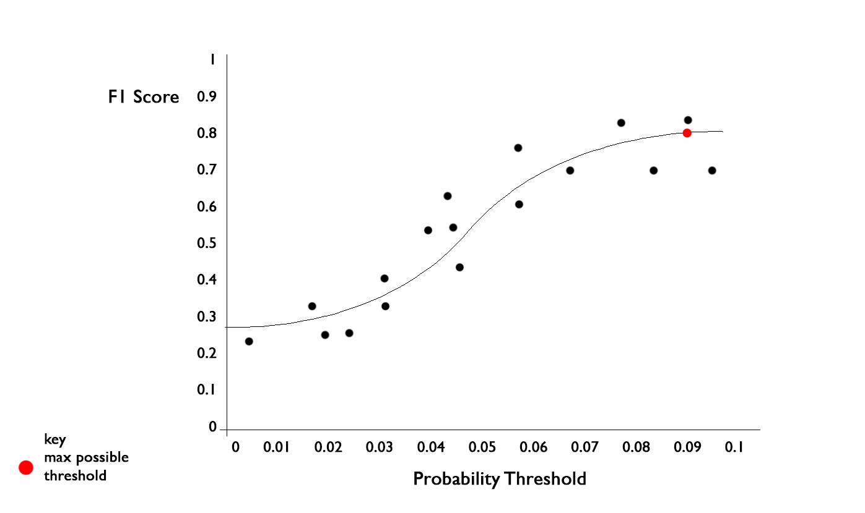
Figure 24 Precision - Recall Curve showing change of F1 against the probability threshold
False Negatives and False Positives
The impact of similar symptoms on the model's performance affects the correct prediction of the model. The challenges posed by symptom similarity greatly affect and influence both precision and recall of the patient referral model.
Noteworthy Observations
An interesting observation is that the model performs best when the input is unique and longer, specifically tailored to a specific disease. This suggests that the model's accuracy is influenced by the specificity and length of the symptom descriptions. These insights contribute to a deeper understanding of the model's strengths and areas for improvement, providing valuable context for the development and refinement of the patient referral algorithm.

Confusion Matrix of the Model
The confusion matrix for the NLP patient referral algorithm, based on a dataset of 20 patients, reveals valuable insights into its performance. Among the positive referrals, the algorithm correctly identified 12 patients who needed specialist care, but it missed a potential referral for 4 patients. Additionally, the algorithm falsely recommended a referral for 2 patients who did not require specialist intervention. On the other hand, it accurately determined that 20 patients were correctly predicted to different specialists. These findings highlight both the algorithm's strengths in correctly identifying negative cases but also the areas for improvement in accurately identifying positive referrals and reducing false negatives and false positives. Further evaluation of precision, recall, and other performance metrics will provide a more comprehensive assessment of the algorithm's effectiveness in guiding patient referrals based on their symptoms.
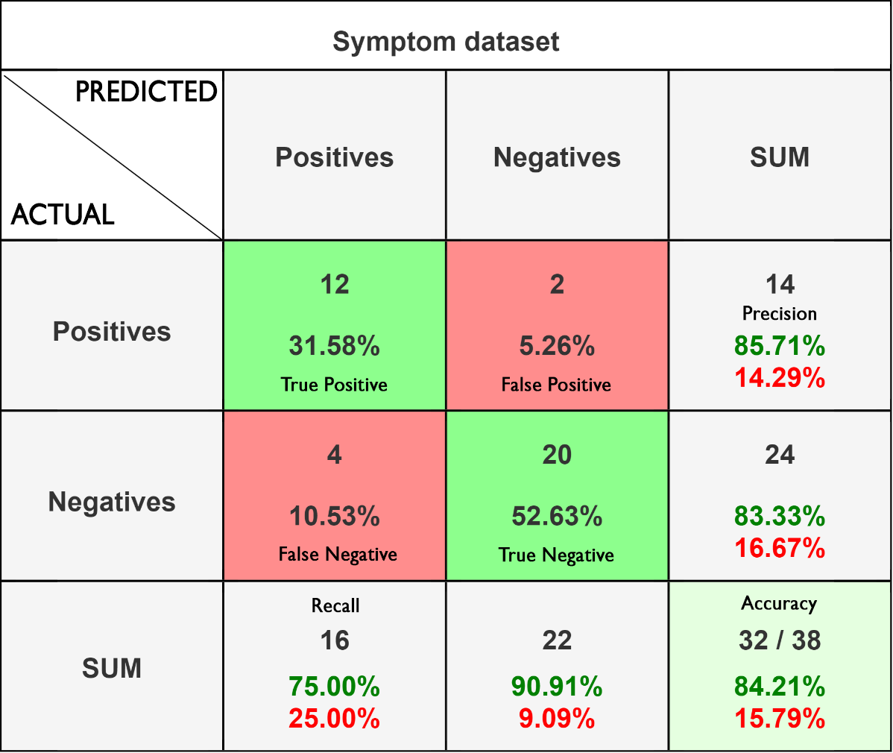
Figure 25 Confusion Matrix summarizing performance of the NLP patient referral model
key
green – true
red – false
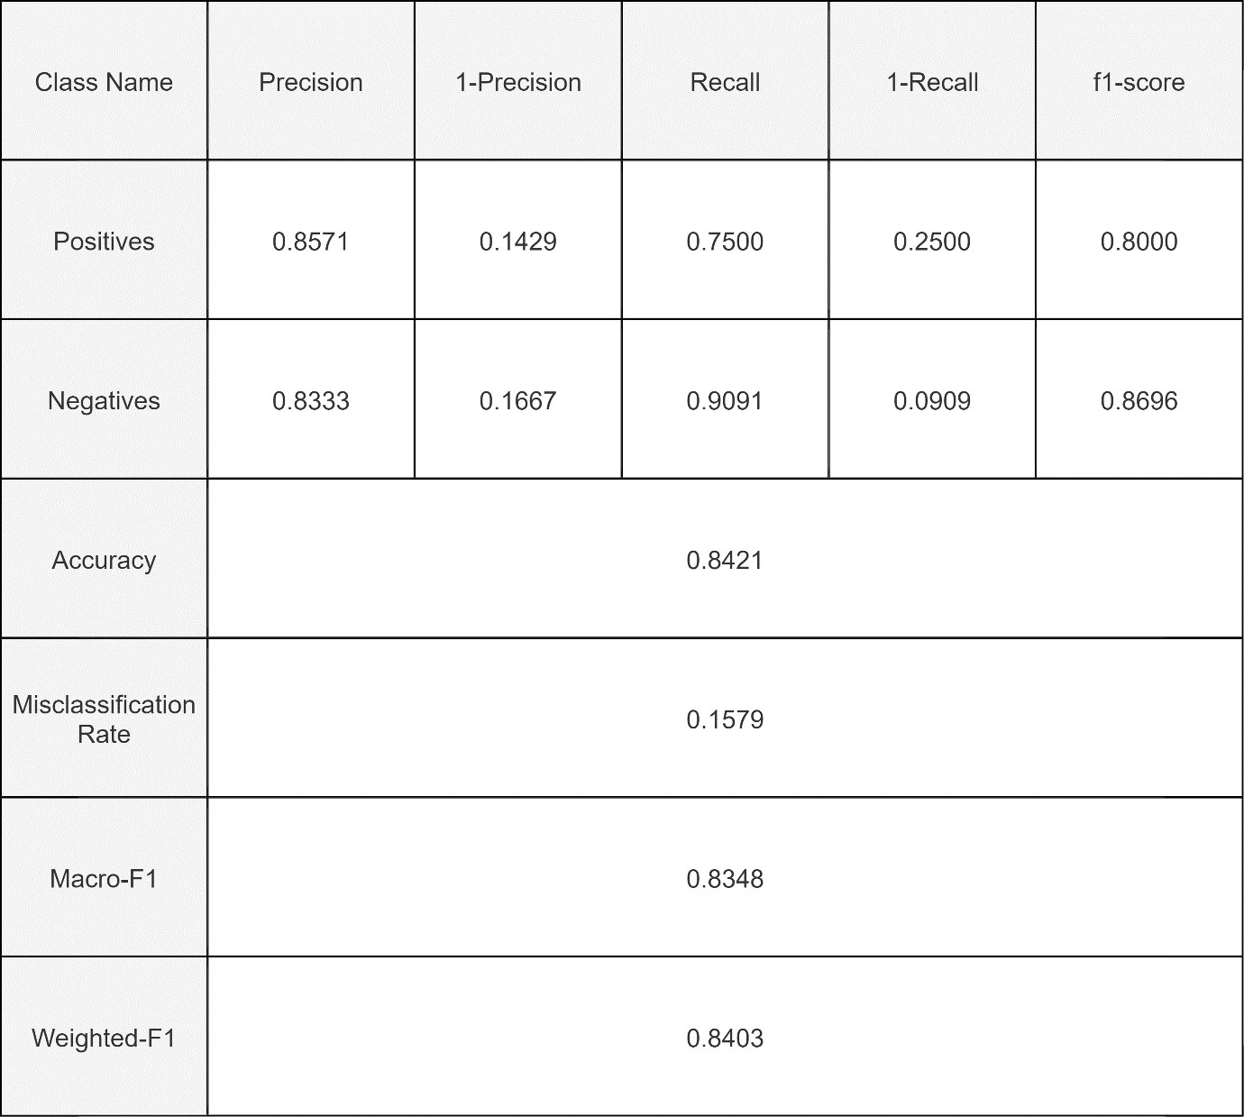
Table 10 Performance summary of model, here all the metrics are summarized

Conclusion:
Upon evaluating the model’s performance, it was concluded that the model achieved:
- 84.8% accuracy of correct referrals made.
- 0.86 Precision, 86% of predictions are correct and the model predicts the right class.
- 0.75 Recall, the model is able to adequately select the right doctor against the wrong one.
- 0.80 F1 Score, the model achieved a good harmonic mean of the precision and recall.
It is imperative to note that the recall can be improved by implementing deep learning to achieve more accuracy and learning over time as the model was deemed bias towards similar symptoms (e.g. common cold and tuberculosis symptoms are similar). Regardless of noted biases, we adequately achieved the research objectives of this research project. The key challenges and considerations in designing an NLP-based patient referral algorithm that can handle diverse medical conditions and symptoms were: the concern of decreased accuracy, and potential bias predictions if the symptoms input are similar together. The model performed well as expected in predicting accurately but could be better to solve the issue of similar symptom prediction.

Discussion

Introduction:
The research conducted in this study: NLP patient referral algorithms, has important implications and contributions to the field of healthcare. The findings of the study provide valuable insights into the performance and effectiveness of the algorithm in accurately guiding patient referrals based on their symptoms. By achieving:
- A high accuracy rate of 84.8%,
- Demonstrating competitive precision of 0.86
- Recall of 0.75,
- And 0.80 F1 score values,
the algorithm shows promise in improving the efficiency and accuracy of patient referrals and their corresponding models.

Summary of findings:
- The NLP patient referral algorithm achieved an accuracy of 84.8%, precision of 0.86, recall of 0.75, and F1 score of 0.80.
- Performance metrics should be considered in the context of variations in datasets, methodologies, and approaches across different studies.
- Possible enhancements for the algorithm include:
  - Expanding the dataset to include a more diverse range of patient cases.
  - Incorporating additional features, such as demographic information or medical history.
  - Exploring ensemble techniques or hybrid models to leverage the strengths of different approaches.
  - Ensuring interpretability by incorporating explainable AI techniques.
  - Conducting research in diverse healthcare settings to assess real-world applicability.
- These enhancements can contribute to improving the algorithm's accuracy and practical effectiveness in guiding patient referrals.

Model evaluation and analysis:
Based on the evaluation of the patient referral algorithm, several observations can be made from the performance metrics:
Accuracy
The model achieves an overall accuracy of 84.6%, indicating its effectiveness in making correct predictions. However, it has limitations when handling similar symptoms, potentially favouring fewer common symptoms and occasionally producing nonsensical predictions. These limitations can lead to both false positives and false negatives in the model's predictions. Figure 9 shows the increase in accuracy with increase in input symptom length.
Precision
With a precision of 0.86, the model accurately predicts 86% of inputs to the correct row in the dataset. False positives are observed due to the challenge of similar symptoms leading to incorrect predictions. However, it is worth noting that the occurrences of false positives were relatively lower compared to false negatives.
Recall
The recall of 0.75 indicates the model's need for improvement in accurately capturing all relevant symptoms and making predictions. The impact of similar symptoms on the model's performance is more noticeable in recall, where it often selects incorrect predictions due to this issue.
F1 Score
With an F1 score of 0.8, the model demonstrates a balanced evaluation of its performance, taking into account precision and recall. This score reflects the overall effectiveness of the model in accurately classifying symptoms and making relevant referrals.

False Negatives and False Positives
The impact of similar symptoms on the model's performance affects the correct prediction of the model. The challenges posed by symptom similarity greatly affect and influence both precision and recall of the patient referral model.

Comparison with Existing Literature:
A few notable literatures to support the contribution of this research:
- John-Jose Nunez (and other researchers) researched on a study to prove that natural language processing (NLP) can be used to predict which cancer patients require referral to a psychiatrist or counsellor from their initial oncologist consultation, stated that future research may be able to extend the work done on this paper to allow patient-to-doctor referral with a broader disease set or symptoms other than cancer [1]. This research project has managed to incorporate more than 20 possible symptom sets (diseases) that a patient can input.
- Saskia Locke et al, in June 2021, stated that a significant portion of existing medical records contains extensive free text content. Although this feature is favoured by most users for its expressive flexibility, it poses challenges when it comes to effectively utilizing the information within the notes over time [7]. To solve this, our patient referral algorithm provides a means for patients to be able to highlight their symptoms and in simple English text and leaving most of the work to the NLP algorithm.

Theoretical Implications:
The theoretical implications of this research lie in several aspects. Firstly, the study extends the existing body of knowledge by applying NLP techniques to the domain of patient referrals. While previous research has focused on other NLP applications in healthcare, such as diagnosis or electronic health record analysis, this study specifically addresses the patient referral process. This novel application of NLP contributes to expanding the potential of natural language processing in improving healthcare systems.
Furthermore, the research contributes to the development of a practical and efficient solution for patient referral algorithms. By evaluating the algorithm's performance using various metrics, including accuracy, precision, recall, and F1 score, a comprehensive assessment of its effectiveness is provided. This contributes to the understanding of the algorithm's strengths and limitations and can guide further improvements and refinements.

Practical Implications:
The practical implications of this research are significant for healthcare professionals and organizations. The NLP patient referral algorithm can assist healthcare providers in making more informed decisions by suggesting appropriate specialists based on patients' symptoms. This can potentially lead to more timely and accurate referrals, reducing delays in treatment and improving patient outcomes. The algorithm's ability to accurately identify negative referrals also has implications for optimizing healthcare resources, as unnecessary specialist visits can be minimized, saving time and costs.
While the study on NLP patient referral algorithms possesses notable strengths in terms of methodology, dataset size, and comprehensive evaluation metrics, it also has limitations related to the dataset's representativeness, generalizability, and consideration of ethical aspects. Acknowledging these limitations provides valuable insights for future research, guiding improvements in methodology, dataset selection, and ethical considerations. Overall, the study contributes to the understanding of NLP applications in healthcare but calls for further research to address the identified limitations and enhance the algorithm's real-world applicability.

Validation and Reliability:
As Artificial Intelligence has made surfaced in recent years, it is important to apply natural language processing, as it is a fast-emerging technology that allows humans to interact with computer systems without the need to understand binary language. NLP models provide an intelligent way to understand human information in a more intelligent way than explicitly programming computer systems. Application of this technique in medicine guarantees a faster and more effective way of understanding patient symptoms and in turn, referring patients to the rightful doctors without much of a hassle and complex understanding requirements.
The NLP patient referral algorithm implemented in this project, serves as an innovation that incorporates more disease as opposed to similar research projects conducted and provides a more accurate prediction of which doctor attends to an unwell patient. Hence, it is reliable, although it should be notable that with further improvements it can assure you of better accuracy and providing the correct solutions whenever required to.
The steps taken to ensure the rigor and trustworthiness of findings were:
- Data Collection and Cleaning: Thoroughly collect and curate a diverse and representative dataset of patient symptoms and corresponding diagnoses. Perform rigorous data preprocessing steps, such as cleaning the data, removing noise, handling missing values, and standardizing the format. Apply appropriate NLP techniques like lower-casing, removing stop words and punctuation, and tokenization.
- Model Development and Evaluation: Developing the model using established NLP algorithms and techniques (Naïve Bayes and Cosine Similarity). Evaluation of the model’s performance using appropriate metrics (Accuracy, Precision, Recall, F1 Score).
- Baseline Comparisons: This model was evaluated against a similar project that only conducted patient referrals to two possible specialists (counsellor/ psychiatrist). They managed to get 72% accuracy in their model [1].
- Ethical Considerations: Ethical considerations were addressed, such as bias and fairness. The model’s performance across different demographic groups is yet to be assessed and mitigated if discovered.
One notable limitation and accountability issue that is evident in not just my patient referral algorithm but in every other NLP algorithm is the issue for accountability. In 2021, Lee, D and Yoon S. N., raised questions on whose fault it becomes when the algorithm has not properly been built to provide accurate referrals and healthcare decisions [13]. This raises bias and accountability issues based on the uncertainty of natural language processing algorithms. This realisation has led to considerations of the NLP patient referral model to take accountability or raise awareness to specialist on the possibility of inaccurate referrals. To mitigate this issue, it was ensured that the systems incorrect predictions are taken account for by providing logs of the process flow of the algorithm referral process, this ensures that future prediction accuracy will be improved over time.

Limitations and Methodological Reflections:
Strengths of this study:
Robust Methodology
This research was carried out amid carefully designing and implementing the algorithm using state-of-the-art NLP techniques. This ensures the algorithm's technical soundness and validity.
Large sample size for evaluation
The study used a substantial dataset of 20 patients, providing a sufficiently large sample size for evaluation. This enhances the statistical power of the findings and increases the generalizability of the algorithm's performance.
Comprehensive Evaluation Metrics
Using machine learning effective metrics, such as accuracy, precision, recall, and F1 score, enabled a thorough assessment of the algorithm's effectiveness in guiding patient referrals.
Comparison with prior studies
The comparison with prior studies and literature adds depth to the research by contextualizing the results within the existing knowledge landscape. Additionally, the identification of limitations highlights my awareness of potential constraints and biases of other researchers, adding transparency and credibility to the study.

Limitations of this study
Regardless of the vast strengths of the study, it is important to acknowledge the limitations of the study.
Lack of holistic inclusivity
The dataset used may not fully represent the complexity and diversity of real-world patient cases. A larger and more diverse dataset would enhance the external validity of the results.
Singular threshold
Although effective, the study evaluated the algorithm's performance based on a single prediction probability threshold, which may not capture the nuances of different decision thresholds in clinical practice. Exploring the algorithm's performance across a range of thresholds would provide a more comprehensive understanding of its behaviour.
Possible bias pertaining to specific demography
The study's generalizability may be limited to the specific healthcare setting and patient population under investigation. Different healthcare systems or patient demographics may yield different results. Replication of the study in diverse healthcare contexts would strengthen the external validity of the findings.

Conclusion:
In conclusion, this research underscores the implications and contributions of NLP patient referral algorithms in the healthcare domain. The findings suggest that such algorithms have the potential to enhance the accuracy and efficiency of patient referrals, leading to improved patient care. The study's contributions lie in its novel application of NLP techniques to the patient referral process and the evaluation and analysis of the algorithm's performance. The research opens up avenues for further exploration and optimization of NLP-based solutions in healthcare, ultimately benefiting both patients and healthcare providers.

Conclusion and Future work

Introduction
As I conclude this project, I am filled with a sense of accomplishment and gratitude. I have learned so much about machine learning, natural language processing, and the importance of accurate and efficient medical diagnosis. I have also grown as a researcher, developing the skills and knowledge to tackle complex problems and find innovative solutions. Accurate and efficient diagnosis is crucial to ensuring that patients receive the care they need, when they need it. And while this project is just one step in that direction, it has the potential to make a real difference in the lives of patients. This chapter concludes this research project: Implementing A Natural Language Processing-Based Patient Referral Algorithm for Improved Healthcare Outcomes.

Summary of the project:
The main aim of this research project was to develop and evaluate a patient referral algorithm using natural language processing (NLP) to classify symptoms and refer patients to appropriate doctors based on their specific expertise. This set the tone to develop an NLP-based patient referral algorithm that can accurately match patients with appropriate doctors or specialists based on a wide range of disease symptoms. Previous work on this field was successful, but they were based on fewer symptoms and disease sets. To ensure this research project resolved issues discovered on previous research papers, it was evaluated, on its performance and effectiveness in conducting patient referrals to specialists, in several symptom test scenarios.

Upon evaluating the model’s performance, it was concluded that the model achieved:
- 84.8% accuracy of correct referrals made
- 0.86 Precision, 86% of predictions are correct and the model predicts the right class
- 0.75 Recall, the model is able to adequately select the right doctor against the wrong one
- 0.80 F1 Score, the model achieved a good harmonic mean of the precision and recall

It is imperative to note that the recall can be improved by implementing deep learning to achieve more accuracy and learning over time as the model was deemed bias towards similar symptoms (e.g. common cold and tuberculosis symptoms are similar). Regardless of noted biases, we adequately achieved the research objectives of this research project.
The key challenges and considerations in designing an NLP-based patient referral algorithm that can handle diverse medical conditions and symptoms were: the concern of decreased accuracy, and potential bias predictions if the symptoms input are similar together. The model performed well as expected in predicting accurately but could be better to solve the issue of similar symptom prediction.
Concerning how the NLP-based patient referral algorithm performed in real-world healthcare settings, factors such as dataset size, complexity of medical conditions, and variations in patient demographics were all considered although it is important to note that not every demography of people and dominant symptoms was considered.

Key findings and contributions:
The project involves the development of a patient referral algorithm utilizing natural language processing (NLP) techniques to classify patient symptoms based on text input. The algorithm successfully automates the symptom analysis and referral process, improving the efficiency of patient care. By incorporating pre-processing and similarity-based classification, the algorithm accurately matches symptoms to diseases, aiding in appropriate doctor referrals. The project contributes to the field of NLP-based healthcare applications, showcasing the potential for automating and optimizing patient care processes. The algorithm's scalability and adaptability make it applicable to various healthcare scenarios, enhancing its practical value. Overall, the project's findings and contributions advance the field of NLP-based healthcare applications and have implications for improving patient care processes.

Evaluation of objectives:
- To develop an NLP-based patient referral algorithm that can accurately match patients with appropriate doctors or specialists based on a wide range of disease symptoms.
- The proposed solution to this objective was successfully implemented. A model, trained using patient symptom data, which is based on natural language processing accurately matches patients to a doctor/specialist based on their symptoms. We managed to achieve a referral accuracy of 84.8%.
- Deviations and challenges encountered was the availability of doctor datasets and their expertise, so for purposes of presentations for this project, a manual doctor dataset was combined to the patient-symptom dataset used for this project.

- To evaluate the performance and effectiveness of the NLP-based patient referral algorithm in several symptom test scenarios.
  - The model achieved an accuracy of 84.8%, precision of 0.86, recall of 0.75 and a f1 score of 0.80. This clearly shows that the model is highly performing in conducting correct referrals.
  - The challenges and deviations faced by the model which led to this decrease was the issue to correctly predict a doctor/ specialist based on symptoms that are similar from one disease to another. To decrease the effect of this, the probability threshold of the naïve bayes model was reduced and the symptoms normalized, resulting in an increase of accuracy from 81.4% to 84.8%.

Reflection on the project process:
The methodology chosen was a quantitative approach, which involved experimental analysis of other research papers in order to refine the NLP model. Although advantageous in the fact that experimental analysis helps enhance the performance of a model greatly. The downside of this methodology was that it did not take the users’ perspective into consideration, leading to possible user-centred errors or bias prediction of the algorithm leading to incorrect referrals conducted.
Naïve bayes algorithm and cosine similarity were combined and used as the techniques to perform natural language processing and text classification. The advantages were that these two techniques, both being probabilistic approaches, made us harness the input symptoms and the symptoms residing in the dataset. The downside of the naïve bayes algorithm is it might not be wise to use in the future regarding a larger symptom dataset as it is limited.

Lessons learnt include:
- The knowledge that natural language processing is a powerful technique to involve users in effectively communicating with computer systems and this can also be harnessed in the medical field.
- Patient care also includes referring that care to the rightful doctor/specialist based on their symptoms and high accuracy and time minimization of this process will lead to a more streamlined referral process and fast, efficient attention to a patient’s care.

Future work and recommendations:
Integrate other machine learning techniques
Exploration of more advanced machine learning algorithms such as deep learning, that could improve the accuracy of symptom identification and doctor recommendation if integrated with the existing method. The algorithm could achieve splendid results if integrated with other machine learning techniques that can solve the biased predictions of the model on similar symptom sets.
Use more sophisticated symptom classification techniques
Evaluating the model’s performance against compatible but more sophisticated algorithms such as Support Vector Machines, which can gel well with the cosine similarity technique, Convolutional Neural Networks (CNNs), Recurrent Neural Networks (RNNs) and using other similarity techniques such Levenshtein Distance and Fuzzy Strings.
Explore other data sources
With the prevalence of emerging technologies such as IoT and Convolutional neural networks, there are several data extraction and symptom input methods that the project can incorporate. Consider incorporating other data sources, such as medical images or electronic health records, to improve the accuracy of your algorithm. Investigating the use of other data sources, such as imaging or wearable sensor data, will ensure enhancement of the accuracy and robustness of the algorithm. This will increase the model’s usability in different fields of medicine.

Accessibility and Inclusivity of model after deployment
Accessibility and inclusivity of the model after its deployment are crucial components that facilitate how the model’s usability in real-world scenarios. Other researchers can consider using alternative input methods other than text inputs to eradicate the lack of accessibility of the model, while maintaining its powerful performance. Expansion to other languages can be possible if the research is furthered improved through the use of recurrent neural networks to facilitate the translation of the input.

Referencing

[1] | J.-J. Nunez and B. Leung, Predicting which cancer patients will see a psychiatrist or counsellor from their initial oncology consultation document using natural language processing., 2023.
[2] | C. K. Wee, X. Zhou, R. Sun, R. Gurujan, X. Tao, Y. Li and N. Wee, Triaging Medical Referrals Based on Clinical Prioritisation Criteria Using Machine Learning Techniques, 2022.
[3] | P. I, G. G, D. S and H. A, Evaluating the NHS e-Referral Service from the General Practitioner perspective: a qualitative study, 2019.
[4] | Carlton R. Moore, Ashraf Farrag, and Evan Ashkin, "Using Natural Language Processing to Extract Abnormal," Using NLP to Extract Results from Cancer Reports, vol. 13, 2017.
[5] | O. A, L. H and Y. R, "Design and development of referrals automation, a SMART on FHIR solution to improve patient acess to specialty care.," JAMIA open, vol. 3, pp. 405-412, 2020.
[6] | S. Locke, A. Bashall, S. Al-Adely, J. Moore, A. Wilson and G. B. Kitchen, "Natural Language Processing in medicine," Trends in Anaesthesia and Critical Care, vol. 38, pp. 4-9, 2021.
[7] | A. Rao, H. Razzaq, A. Bottle, Majeed and E. Gray, "Online application for self-referral of the patients with breast symptoms," Annals of Medicine and Surgery, vol. 66, 2021.
[8] | "Predicting which cancer patients will see a psychiatrist or counsellor from their initial oncology consultation document using natural language pprocessing," Journal of Clinical Oncology, 2023.
[9] | J. Todd, B. Richards, B. J. Vanstone and A. Gepp, Text Mining and Automation for Processing of Patient Referrals, 2019.
[10] | A. B. S. A.-A. J. M. A. W. G. B. K. Saskia Locke, "Natural Language Processing in medicine: A review," Trends in Anaesthesia and Critical Care, vol. 38, no. 1, pp. 4-9, 2021.
[11] | H. Ramelson, A. Nederlof, S. Karmiy, Neri, D. Kiernan, Krishnamu, A. Allen and D. W. Bates, "Closing the loop with an enhanced referral management system," Journal of the American Medical Informatics Association, vol. 25, no. 6, pp. 715-721, 2018.
[12] | D. Lee and S. N. Yoon, "Application of Artificial Intelligence-Based Technologies in the Healthcare Industry: Opportunities and Challenges," International Journal of Environment Research and Public Health, vol. 18, no. 1, p. 271, 2021.
[13] | P. I, G. G, D. S and H. A, Evaluating the NHS e-referral service from the general practitioner perspective: a qualitative study, 2019.

Appendices

Appendix A: Templates of data collection tools
In this project, we used the following data collection tool to obtain the data used in our research:
Kaggle: We used Kaggle, a data curation platform, to access a dataset of medical symptoms and diagnoses provided by the Mayo Clinic. It had a 10.00 usability score hence we had all the licenses required to utilise it for our project.
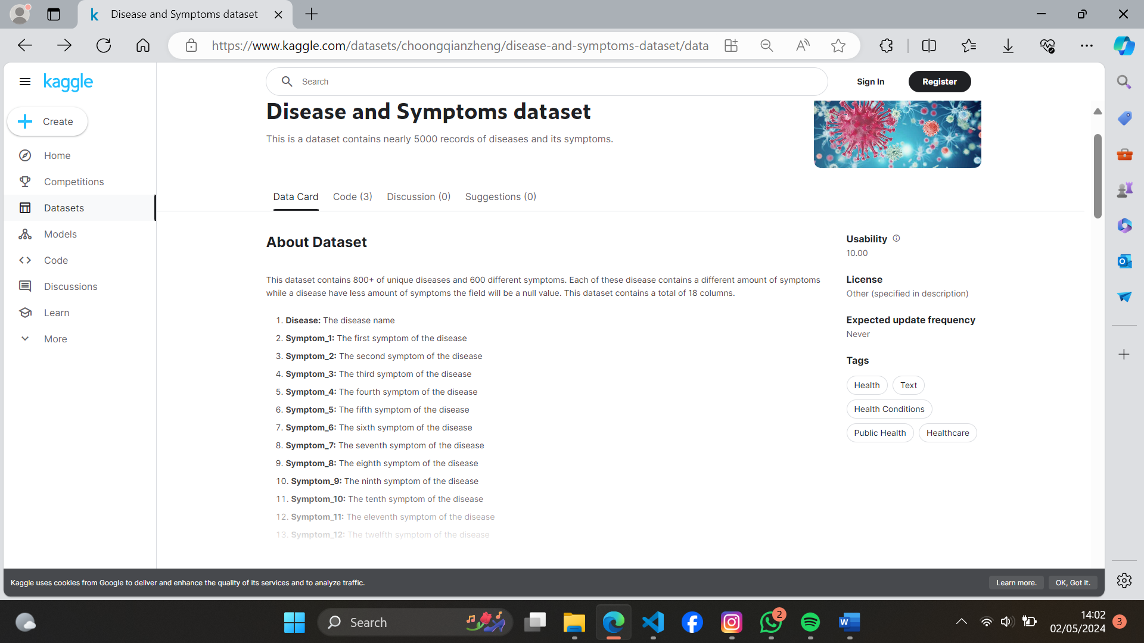
Figure 26 Dataset used for this research project

Appendix B User manual of the working system
Upon opening the mobile application, you will find a screen “Patient Referrals”, with an input box (in red). Here you can input symptoms in English language. If the user clicks the input button, a keyboard should be raised which allows the user to input symptoms. Pressing in any of area around the keyboard closes the keyboard automatically.

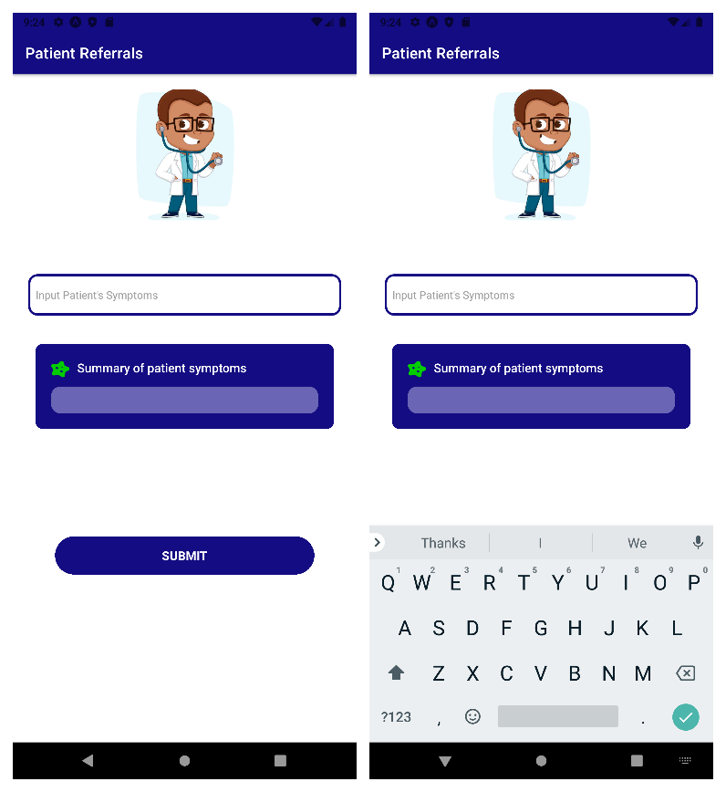
Input box
Mobile app keyboard
Figure 27 Initial screen that the user meets

After the user inputs their symptoms in English language, the user can confirm symptoms under the “summary of patient symptoms” section. After confirmation (if the user is sure of their symptoms input), the user clicks the submit button. If the user presses the submit button without inputting anything, then the application raises an alert indicating “You cannot submit empty symptom input”.

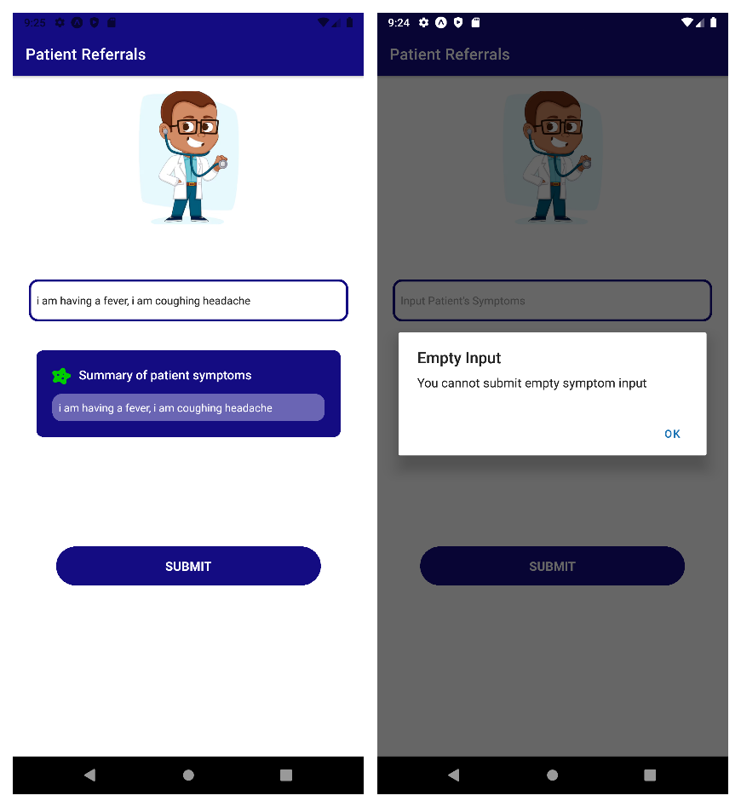
Validation if empty input
Typing in symptoms
Figure 28 Typing in your symptom in the referral application

Clicking the submit button should result in the application navigating to the referral result screen.

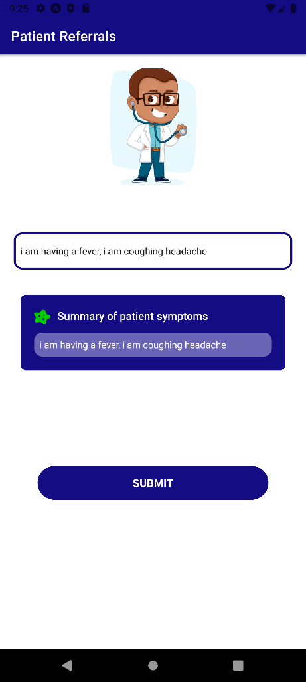
Submit button
Figure 29 submitting symptoms to the NLP model

If the symptoms input by the user are correctly identified, the system will display the doctor/ specialist that the patient gets referred to. If the input is wrongly input, then the application will display the “no doctor was identified”.

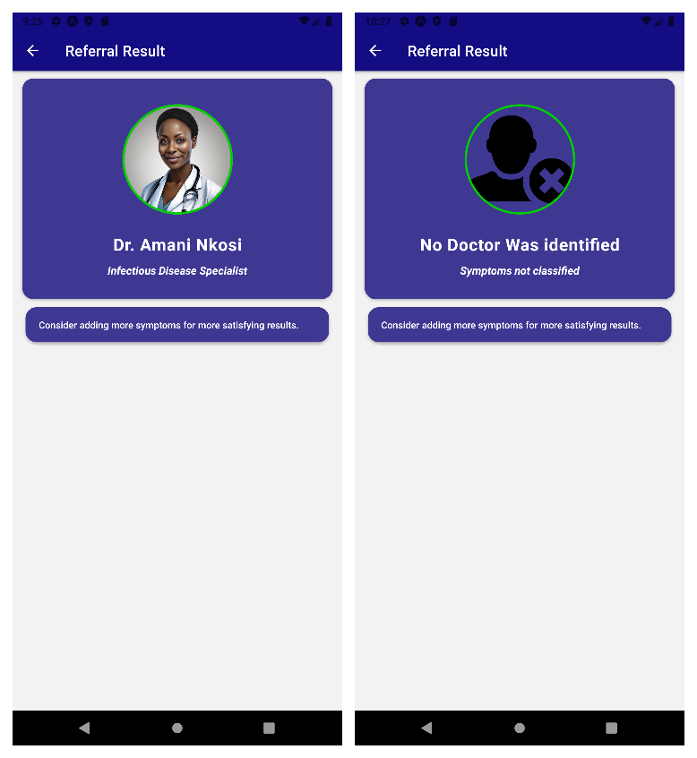
Doctor card referral results
Figure 30 Output doctor result

Upon receiving a positive referral result, the user can click the doctor card, and gain more description of the doctor’s specialty. The user can then make an appointment to that doctor. The accuracy of the selected doctor depends on the refinement of the input symptom input by the user (patient or a general practitioner).

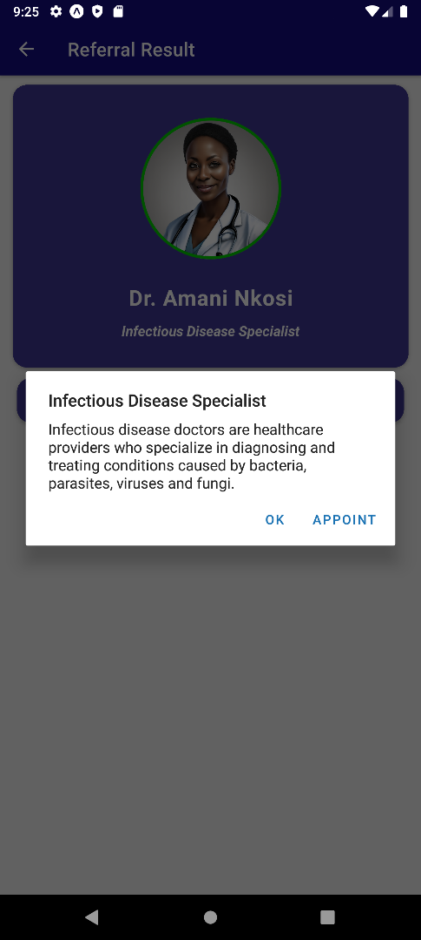
Detailed information about a specialist and making an appointment
Figure 31 Detailed description of doctor

Appendix C: Source Code
This project was written and developed in the React Native environment. It is an open-source UI software framework created by Meta Platforms, Inc. It is used to develop applications for Android, iOS and other devices. It enables software application developers use the React framework along with native platform capabilities. https://reactnative.dev

Natural Language Processing Pre-Processor
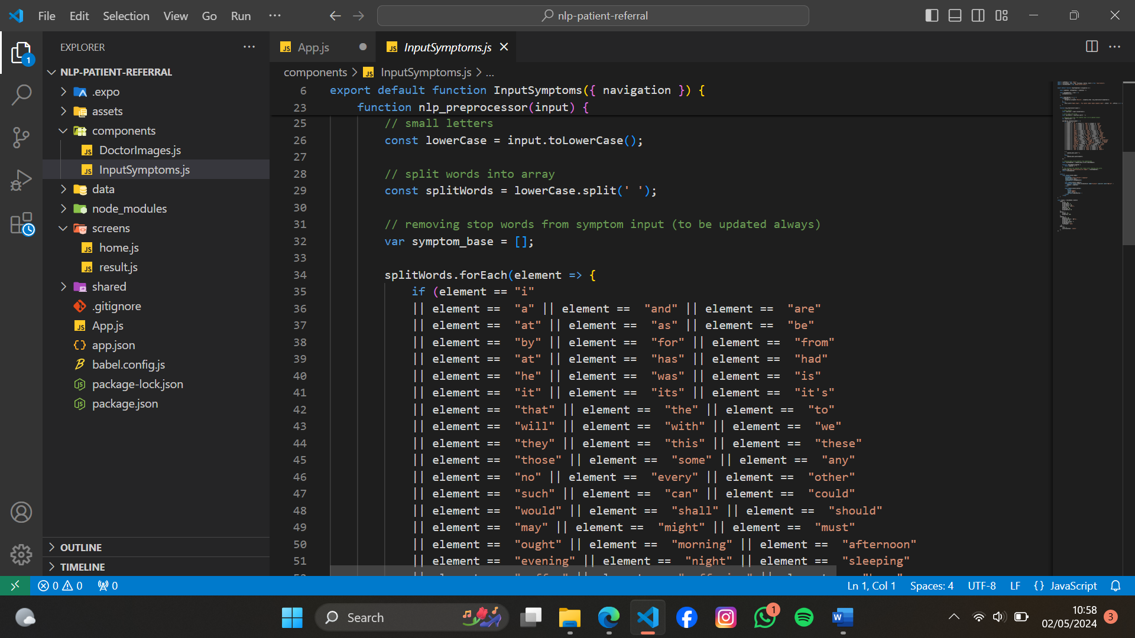
Figure 32 Sample code of the natural language pre-processing, tokenizer, stemming and removal of stop words

Cosine Similarity technique implementation
This code represents the extracted features from the input being fed into the natural language processing model that understands the sentence and applies probabilities to the symptoms of the likelihood to the symptoms in the dataset. The Cosine Similarity is used to identify what a user input means. The result of that assumption is passed on the naïve bayes classifier.

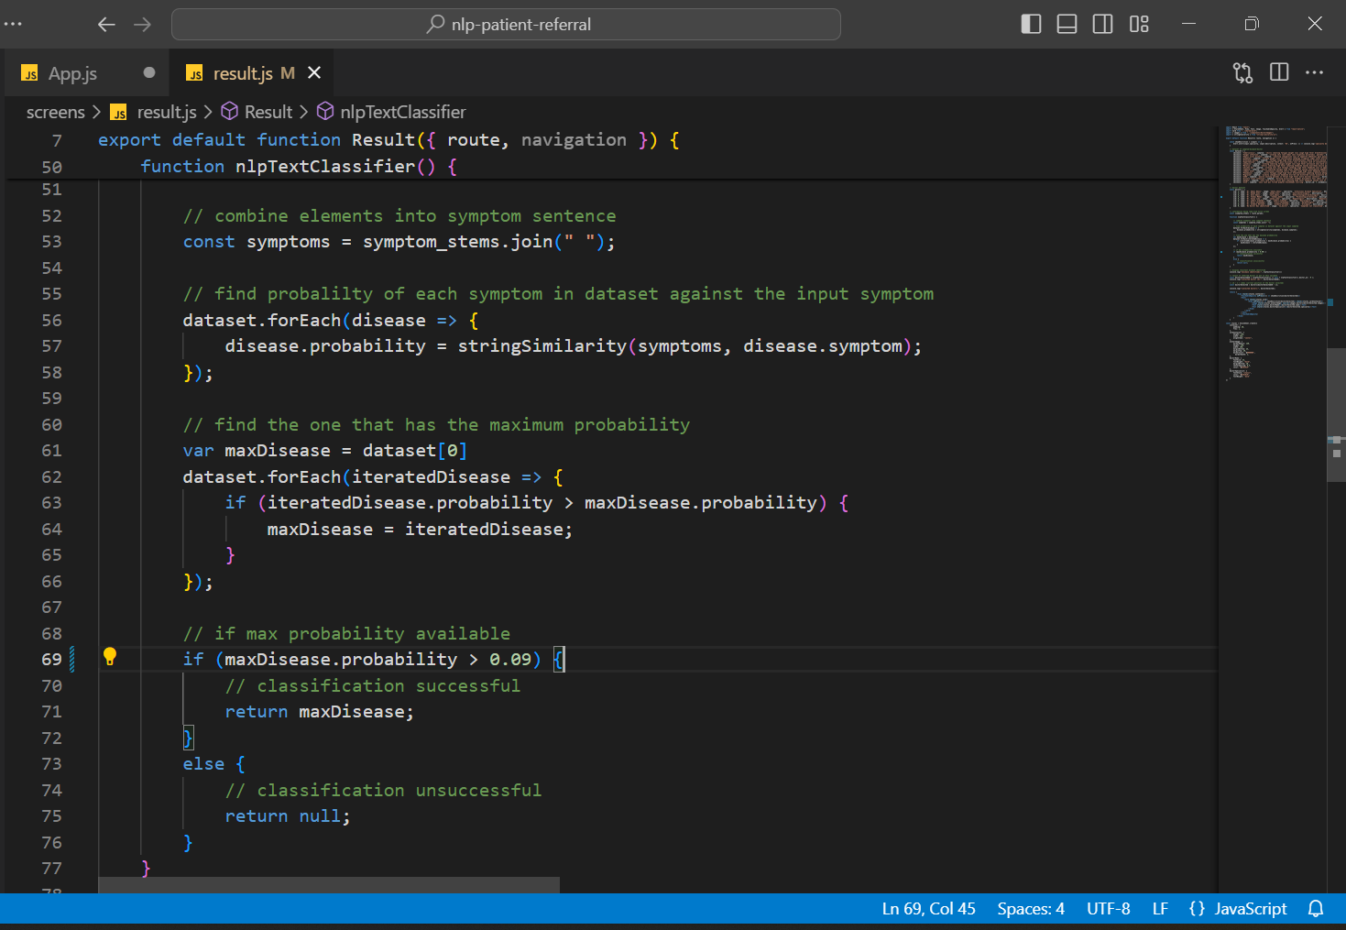
Figure 33 Cosine Similarity NLP text classifier

Training and testing set partitioning
Naïve bayes Test set (20%)
The dataset was split using sci-kit train_test_split function in python to extract 20% of the dataset for testing.
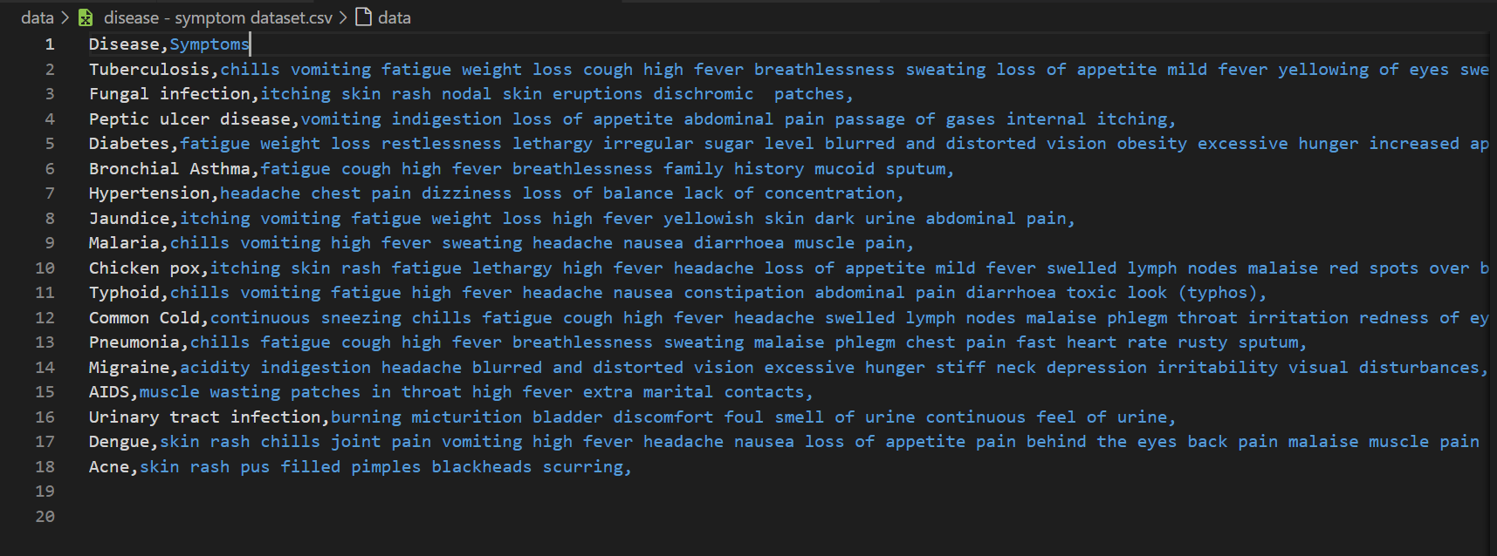
Figure 34 Testing dataset (20%)

Naïve bayes training set (80%)
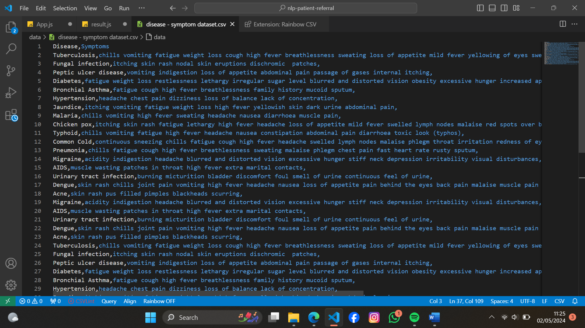
Figure 35 80% dataset used for training

Training the Naïve bayes model
The Naïve bayes was trained using a transformed, supervised training dataset associated with specialist doctors as labels in order for it to be able to perform classifications on its own. The package used to implement naïve bayes classifier was a package named WhichX from the npm website. GitHub for WhichX

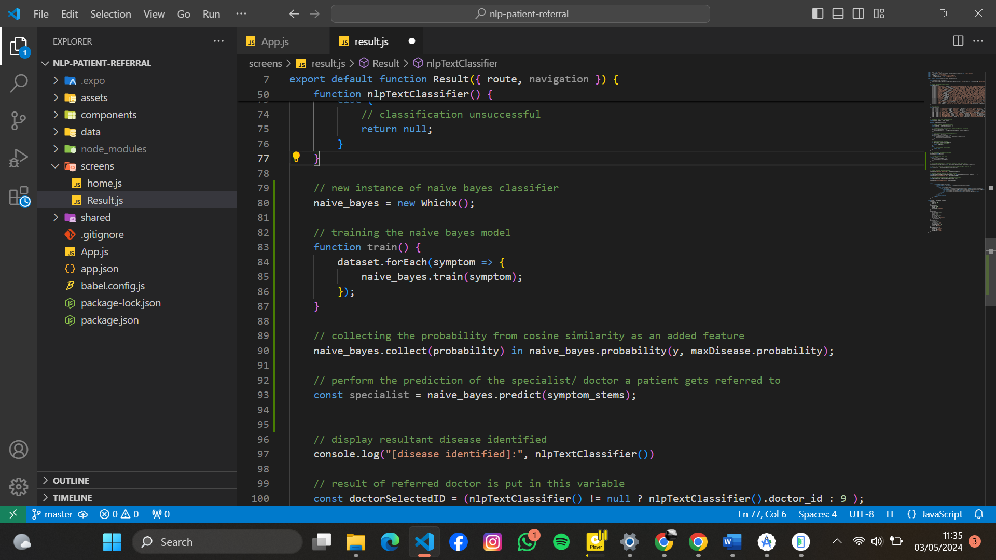
Figure 36 Naive Bayes classifier - classifies which specialist a patient gets referred to

Entering Patient Symptoms and Submitting on React Native UI
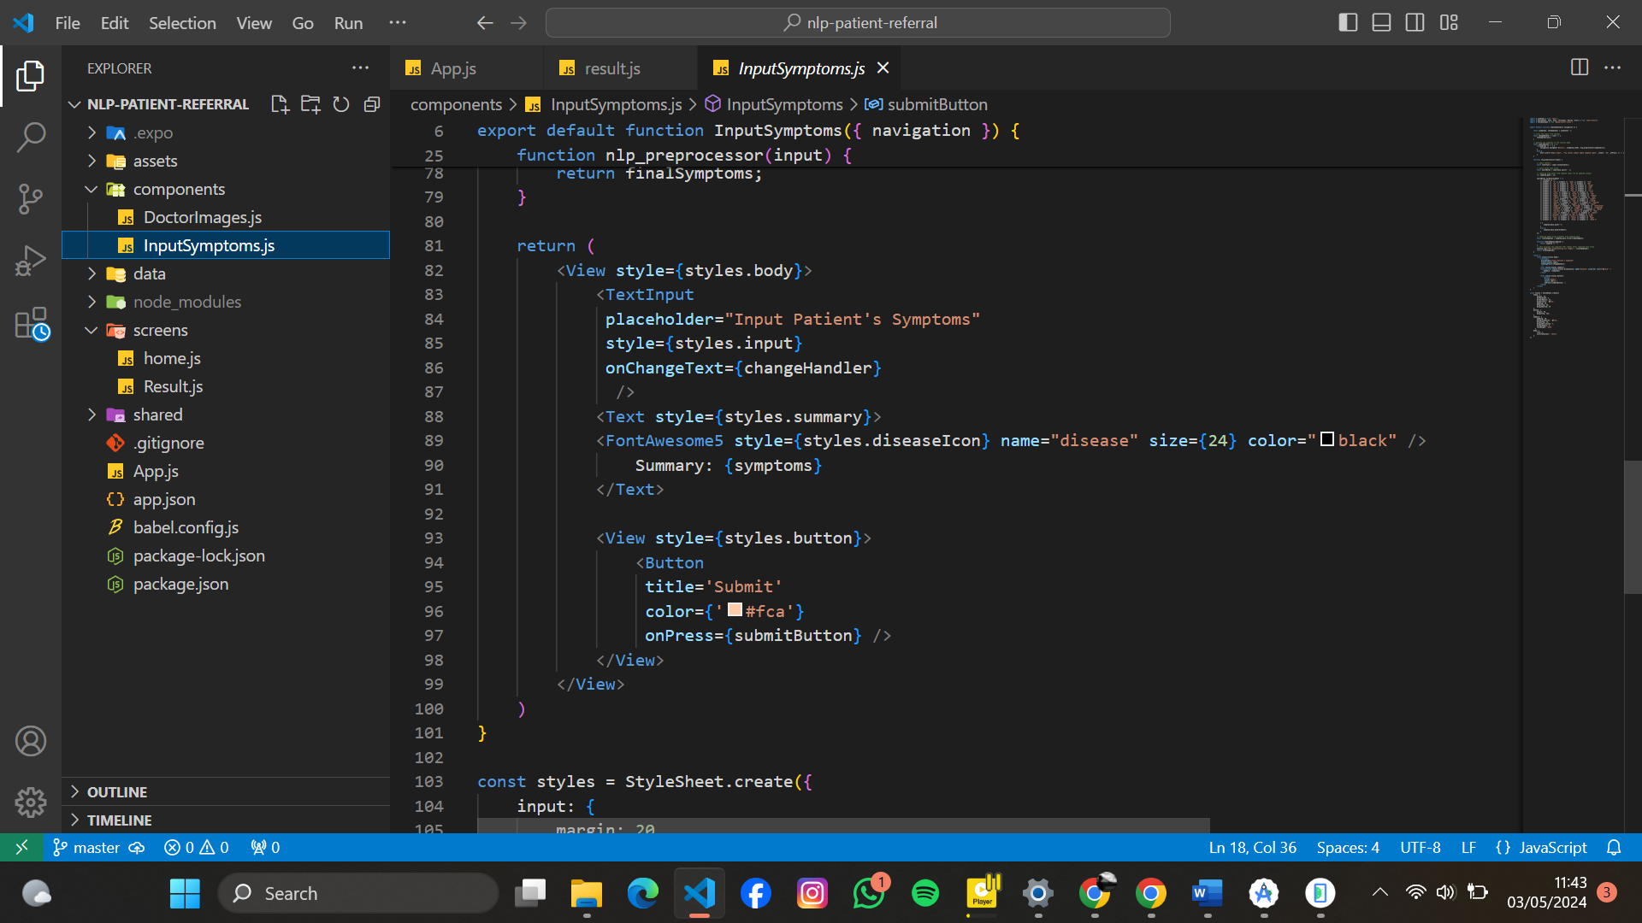
Figure 37 Entering patient symptoms and submitting on react native UI

Displaying doctor selected by the patient
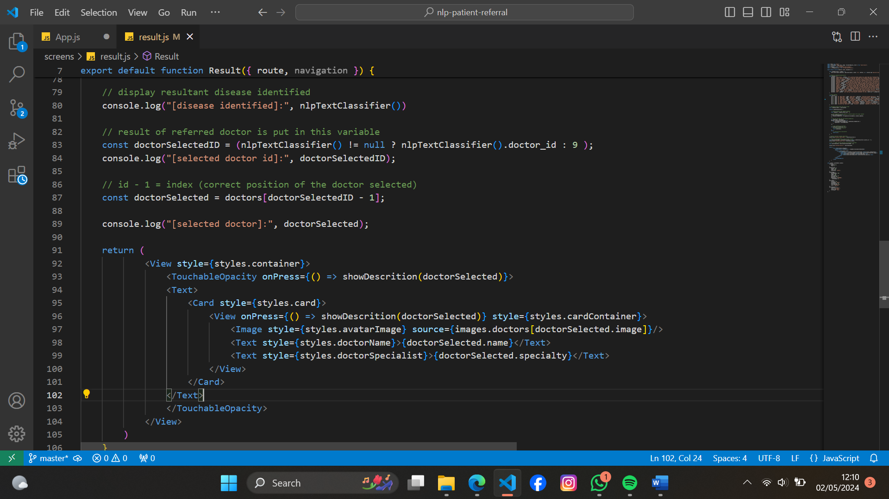
Figure 38 A resultant doctor card is presented if a valid specialist selection is done by the naive bayes

Doctor specialist information
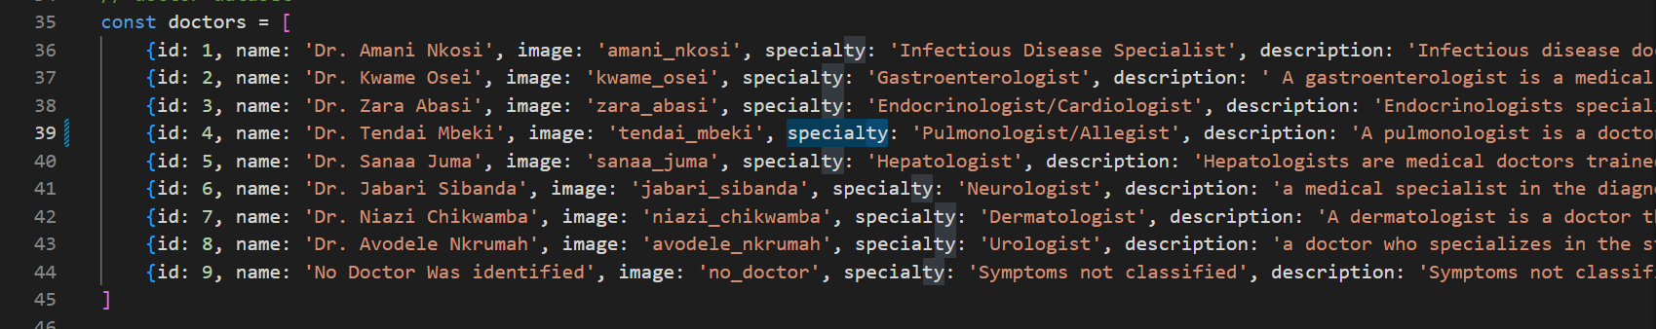
Figure 39 The naive bayes classifier performs a look up on a doctor dataset combined with symptoms to predict a specialist to diagnose the treatment using patient symptoms

