**Left:** Oracle

**Right:** ChatGPT

**----------------------------------------------------------------**

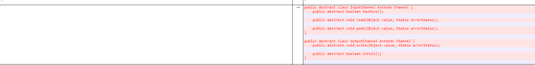

Short text describing what the cause is & what's different

**----------------------------------------------------------------**



Short text describing what the cause is & what's different

**----------------------------------------------------------------**



Short text describing what the cause is & what's different

**----------------------------------------------------------------**

**Second Iteration?** Yes/No

**Re Execution?** Yes/No