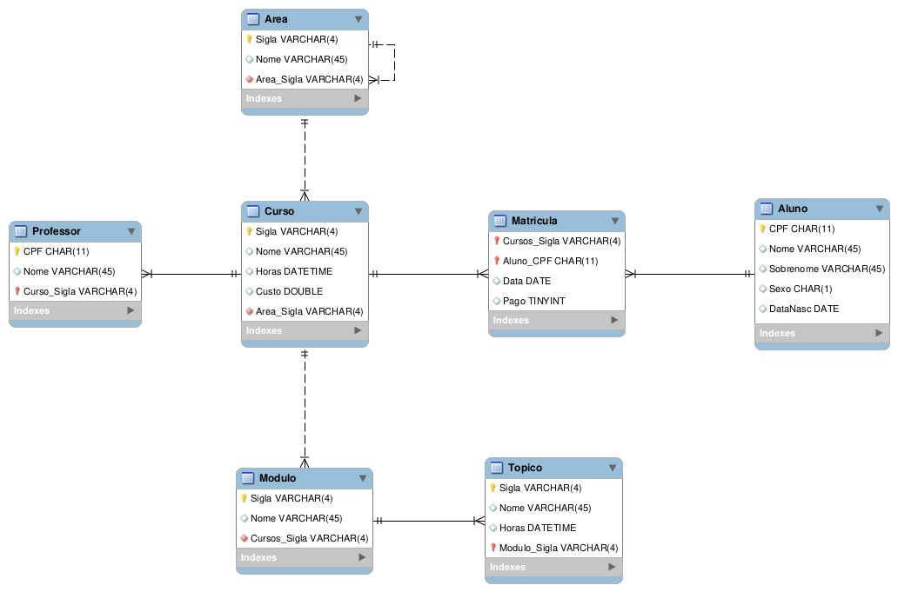
1.)

2.)
/*
GABRIEL MARTINS PEREIRA - 733875
CIÊNCIAS DA COMPUTAÇÃO
*/

CREATE SCHEMA SAM_DB;
USE SAM_DB;

CREATE TABLE CURSO (
SIGLA VARCHAR(4) NOT NULL,
NOME VARCHAR(45) NULL,
HORAS DATETIME NULL,
CUSTO DOUBLE NULL)
ENGINE = InnoDB;

ALTER TABLE CURSO ADD CONSTRAINT PK_CURSO PRIMARY KEY (SIGLA);
ALTER TABLE CURSO ADD CONSTRAINT FK_CURSO_AREA
FOREIGN KEY (AREA) REFERENCES AREA(SIGLA)
ON DELETE SET NULL ON UPDATE CASCADE;

CREATE TABLE AREA (
SIGLA VARCHAR(4) NOT NULL,
NOME VARCHAR(45) NULL)
ENGINE = InnoDB;

ALTER TABLE AREA ADD CONSTRAINT PK_AREA PRIMARY KEY(SIGLA);
ALTER TABLE AREA ADD CONSTRAINT FK_AREA_SUPERAREA
FOREIGN KEY (SUPERAREA) REFERENCES AREA(SIGLA)
ON DELETE SET NULL ON UPDATE CASCADE;

CREATE TABLE PROFESSOR (
CPF VARCHAR(4) UNIQUE NOT NULL,
NOME VARCHAR(45) NULL)
ENGINE = InnoDB;

ALTER TABLE PROFESSOR ADD CONSTRAINT FK_PROFESSOR_CURSO
FOREIGN KEY (CURSO) REFERENCES CURSO(SIGLA)
ON DELETE SET NULL ON UPDATE CASCADE;
ALTER TABLE PROFESSOR ADD CONSTRAINT PK_PROFESSOR PRIMARY KEY(CPF);
ALTER TABLE PROFESSOR ADD CONSTRAINT PK_PROFESSOR_CURSO PRIMARY KEY(CURSO);

CREATE TABLE MODULO (
SIGLA VARCHAR(4) NOT NULL,
NOME VARCHAR(45) NULL)
ENGINE = InnoDB;

ALTER TABLE MODULO ADD CONSTRAINT PK_MODULO PRIMARY KEY(SIGLA);
ALTER TABLE MODULO ADD CONSTRAINT FK_MODULO_CURSO
FOREIGN KEY (CURSO) REFERENCES CURSO(SIGLA)
ON DELETE SET NULL ON UPDATE CASCADE;

CREATE TABLE TOPICO (
SIGLA VARCHAR(4) NOT NULL,
NOME VARCHAR(45) NULL,
HORAS DATETIME NULL)
ENGINE = InnoDB;

ALTER TABLE TOPICO ADD CONSTRAINT FK_TOPICO_MODULO
FOREIGN KEY (MODULO) REFERENCES MODULO(SIGLA)
ON DELETE SET NULL ON UPDATE CASCADE;
ALTER TABLE TOPICO ADD CONSTRAINT PK_TOPICO PRIMARY KEY(SIGLA);
ALTER TABLE TOPICO ADD CONSTRAINT PK_TOPICO_MODULO PRIMARY KEY(MODULO);

CREATE TABLE ALUNO (
CPF CHAR(11) UNIQUE NOT NULL,
NOME VARCHAR(45) NULL,
SOBRENOME VARCHAR(45) NULL,
SEXO CHAR(1) NULL,
DATANASC DATE NULL)
ENGINE = InnoDB;

ALTER TABLE ALUNO ADD CONSTRAINT PK_ALUNO PRIMARY KEY(CPF);

CREATE TABLE MATRICULA (
DATAMAT DATE NULL,
PAGO TINYINT NULL)
ENGINE = InnoDB;

ALTER TABLE MATRICULA ADD CONSTRAINT FK_MATRICULA_ALUNO
FOREIGN KEY (ALUNO) REFERENCES ALUNO(CPF)
ON DELETE SET NULL ON UPDATE CASCADE;
ALTER TABLE MATRICULA ADD CONSTRAINT FK_MATRICULA_CURSO
FOREIGN KEY (CURSO) REFERENCES CURSO(SIGLA)
ON DELETE SET NULL ON UPDATE CASCADE;
ALTER TABLE MATRICULA ADD CONSTRAINT PK_MATRICULA_ALUNO PRIMARY KEY(ALUNO);
ALTER TABLE MATRICULA ADD CONSTRAINT PK_MATRICULA_CURSO PRIMARY KEY(CURSO);

