Decolonizing expertise in Ecology and Evolution

In the TV show “Better Call Saul”, Saul Goodman, an untrustworthy lawyer, discovers a massive fraud case. He presents this case to a big law company to get some help to put the case together. In exchange for bringing the case, the head of this big company offers Saul a fair amount of money, which is promptly accepted. However, Saul requires one nonnegotiable condition: a room in the company so that he can organically be part of the investigation. The company says no, and Saul refuses the money because recognizing his intellectual merit in the case was a priority. From TV shows to real life, and in a very different environment than lawyer companies, researchers in institutions from the Global South probably can see the parallels with the situation described before. In the academic environment, Global North institutions and researchers have traditionally led the research world for centuries, extending the frontiers of scientific knowledge, even because of the old legacy of the European expansion and scientific revolutions that started in the 17th-18th centuries.

Scientific research in the Global South is often seen as peripherical, and Southern researchers struggle to find recognition and intellectual approval from the North. In the global division of scientific labor Global North is perceived as pushing the boundaries of scientific knowledge through general theories. On the other hand, Global South fills the role of empirically testing or proving through case studies the theories from the Global North 1. In summary, Global North sets the tone for what is worth studying, while Global South is the case provider for the first. This pattern is evident when we look at geographical markers (any spatial delimitation, but here were represented by country names) in the titles of studies for different regions of the world (Figure 1A) 2.

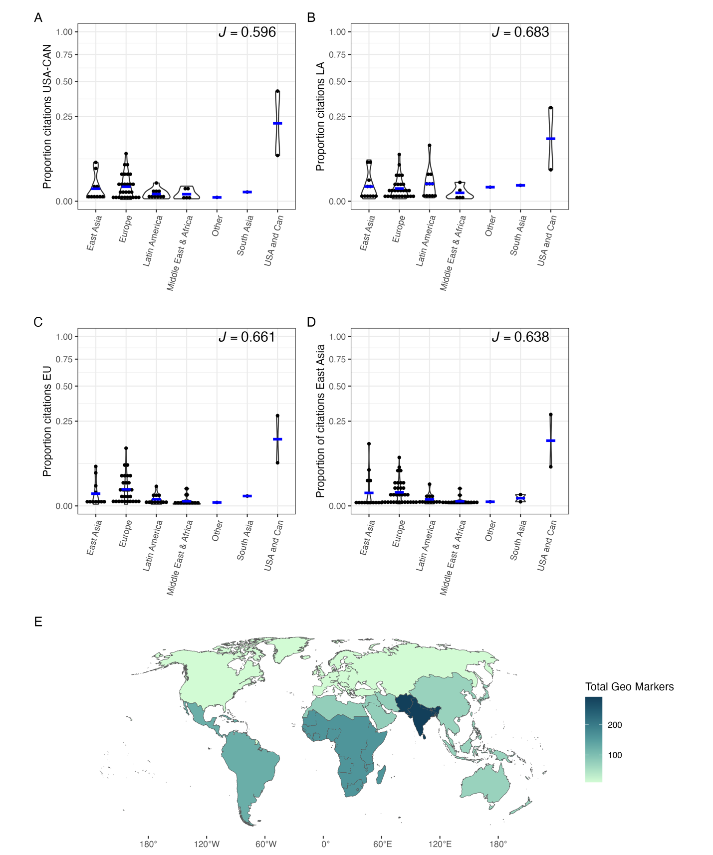

Figure 1: Citation bias represented by the proportion of the number of times (black dots) articles of a given region were cited by different countries (A – United States of America and Canada; B – Latin America; C – Europe; D – East Asia). On the top right of each figure is the Pielou index, as the higher the value, the more biased the citations received by each region. Blue bars represent the mean value for each region. In E is the number of times country names appeared in the article titles produced by each region. For all figures, we used data from the top 1000 cited articles in high-ranked Ecology and Evolution journals for each world region.

In the last ten years, concerns about diversification, equality, and inclusion in the academic environment has grown, mainly towards the direction of increasing the diversity in research environments by stimulating researchers from underrepresented groups (women, global south, LGBTQI+, black people, to cite a few) in research institutes and universities of the Global North. Nowadays, it is rare to find a call that does not contain statements like “We highly encourage applicants from underrepresented backgrounds…”. While we acknowledge that efforts to build inclusive teams are one of the pillars toward the decolonization of science 3, we also believe that this action alone does not change the *status quo* of science, in which researchers from the Global North are viewed as experts while researchers from the Global South are seeing as rare exceptions of scientific authority, or even doing untrustworthy science. Expertise in colonization manifests in different instances. One is the citation bias towards global north researchers (Figure 1A-D). Another example is the underrepresentation (not to cite cases of complete lack of recognition) of scientists from the global south as plenary speakers or even their presence in conferences, and editorial boards of traditional journals, only to cite a few. Like in Lord of The Rings’ famous quotation, “the one ring to rule them all” we still live a type of “the one knowledge to rule them all,” and as we know, the path to take the ring to Mordor (or academic decolonization) is not easy.

While we acknowledge some progress represented by positive interventions to increase diversity, equity, and inclusion (DEI) in science, as mentioned above, little or nothing has been done to reduce the practices that promote the global academic labor division that puts Global South researchers as primarily data gathers or case study producers. This is what we call here a colonial practice of intellectual expertise. Overcoming this bias implies recognizing the knowledge produced outside the Global North as being as reliable and scientifically sound as the one made by research institutes in the Global North. Some practices deeply rooted in science must be changed to decolonize academic expertise. Here, we argue that if the Global North is committed to changing the *status quo* of scientific knowledge, researchers and research institutes must do a better job toward actions that improve the intellectual visibility of underrepresented groups by first recognizing practices in scientific work that promote intellectual colonialism, and then, by acknowledging that, moving forward to implement actions that break down the labor division in scientific knowledge.

**Recognizing intellectual colonialism: some examples**

Scientific solutions require specific and contextual knowledge, especially in the current context of global changes. For example, management actions and policies developed to protect and maintain biological diversity and ecosystem services might not be the same in tropical and temperate regions. Consequently, specialists and scientific knowledge produced in those places must be heard and read to develop better solutions. One recent example of intellectual colonialism was a panel proposed in a meeting to debate the future and policies of the Brazilian Amazon Forest. However, this panel was built with no researcher based on countries within the extend of Amazon Forest (after some public pressure, the event was canceled).

Another classic example of intellectual colonialism is the bias in citations and claims of scientific discovery. Citations and recognition of scientific achievements are usually measured through the number of citations (even though the controversies around this measure). However, it is common that papers produced by researchers or institutions from the Global South are not cited in studies from research groups from the Global North, even publications presented in high-impact and traditional journals. This situation creates a vicious cycle in which northern institutions, mainly in Europe and North America, dictate knowledge, maintaining the *status quo* of scientific expertise.

**Some suggestions from Global south**

We delve into the idea that the change must come from the oppressed. Ironically, the evidence shows that the Global South is the one acting towards a more equitable science by promoting a more equitable scientific academic recognition (expressed by equitability in citation proportion in Figure 1B).

Some simple actions can be taken to reduce the intellectual colonization practices in science, and here we cite a few that can help to solve the problems mentioned. Despite most of our suggestions being derived from examples in Ecology and Evolution, we believe that the points here can be applied to any scientific area.

*Journals, societies, and boarding members of scientific meetings/events*

Always ask whether the event, journal, or boarding committee is inclusive enough. How many editors are from underrepresented countries? Is it needed the presence of geographical markers in Global South studies? Depending on the answer to those simple questions, we can move on to possible solutions toward DEI. Regarding scientific societies, one possibility to decolonize expertise is the implementation of programs to support the submission of papers from the Global South through language support. One recent example is the EELS program (Evolution English Language Support) promoted by the Society for the Study of Evolution. The program offers cost-free English language editing for non-native English-speaking authors, reducing the language barriers to scientific publication.

*Authors from the Global North and research groups*

It is common for editors and reviewers to request to cite works forgotten during the literature review process. However, almost all the time, those references comprise studies from researchers or institutions in the Global North. We suggest that authors from the Global North check if their references are inclusive enough given the topic in their studies. Some may argue that this can comprise an extra work loading, but we see it as the same workload that authors from Global South have when asked to review their references or cite works from Global North authors. As mentioned before, citations are one of the currencies in the academic job market and a proxy of intellectual merit. If the whole system of authority revolves around authors from the Global North, no matter the quality of work from the Global South, their intellectual merit will never be recognized4.

*Diversity alone doesn’t guarantee a more equitable science.*

Despite DEI having its three components as equally indispensable to achieve a less colonial scientific practice3, most of the efforts are only centered on the diversity aspect. We believe that simply including authors from underrepresented countries in Global North institutes without thinking and acting towards practices that disrupt the colonialism in intellectual expertise is of little help, sometimes serving as a decoy for DEI practices.

**Final message**

Research institutes outside the Global South still have a long way ahead when compared with the Global North institutes regarding the number of publications (in terms of quantity), and different factors can explain this. However, in terms of quality, numerous examples of universities and research groups of excellence in the Global South are a reference in different areas of Ecology and Evolution (not to mention other areas in STEM), even struggling with reduced budgets and historical scientific colonialism. Here we showed some simple actions that can dramatically change the *status quo* of scientific knowledge. Recognizing intellectual colonialism practices is the first step, but not enough if the aim of scientific practitioners is to build a truly inclusive environment and reduce inequalities. We can learn from the great Brazilian educator and philosopher Paulo Freire that praxis, i.e., “reflection and action upon the world in order to transform it,” is the only way toward a non-oppressive, inclusive, and diverse science. True changes in an oppressive system can only come from those who have been oppressed, but for this, the Global South needs a room in the same place the global North is.

**Data availability**

All data used to produce Figure 1 was collected in the Web of Science Core collection between December 2022 and February 2023. All processed data is available in the link XXXX.

**References**

1. Castro Torres, A. F. & Alburez-Gutierrez, D. North and South: Naming practices and the hidden dimension of global disparities in knowledge production. *Proc. Natl. Acad. Sci. U.S.A.* **119**, e2119373119 (2022).

2. Ergin, M. & Alkan, A. Academic neo-colonialism in writing practices: Geographic markers in three journals from Japan, Turkey and the US. *Geoforum* **104**, 259–266 (2019).

3. Trisos, C. H., Auerbach, J. & Katti, M. Decoloniality and anti-oppressive practices for a more ethical ecology. *Nature Ecology & Evolution* (2021) doi:10.1038/s41559-021-01460-w.

4. Gomez, C. J., Herman, A. C. & Parigi, P. Leading countries in global science increasingly receive more citations than other countries doing similar research. *Nat Hum Behav* **6**, 919–929 (2022).