Decolonizing expertise in Ecology and Evolution

In the TV show “Better Call Saul”, Saul Goodman, an untrustworthy lawyer, discovers a massive fraud case. He presents this case to a big law firm to get some help to put the case together. In exchange for bringing the case, the head of this law firm offers Saul a fair amount of money, which is promptly accepted. However, Saul requires one nonnegotiable condition: a room in the firm so that he can organically be part of the investigation. The request is denied, and Saul refuses the money because recognizing his intellectual merit in the case was a priority. From TV shows to real life, and in a very different environment than law firms, researchers in institutions from the Global South probably can see the parallels with the situation described before. Scientific research in the Global South is often seen as peripherical, and Southern researchers struggle to find recognition and intellectual approval from the North. While Global North is perceived as pushing the boundaries of scientific knowledge through general theories, Global South fills the role of empirically testing through case studies or data providers 1. This global division of scientific labor is evident when we look at geographical markers (any spatial delimitation, but here represented by country names) in the titles of studies for different regions of the world (Figure 1E)2.

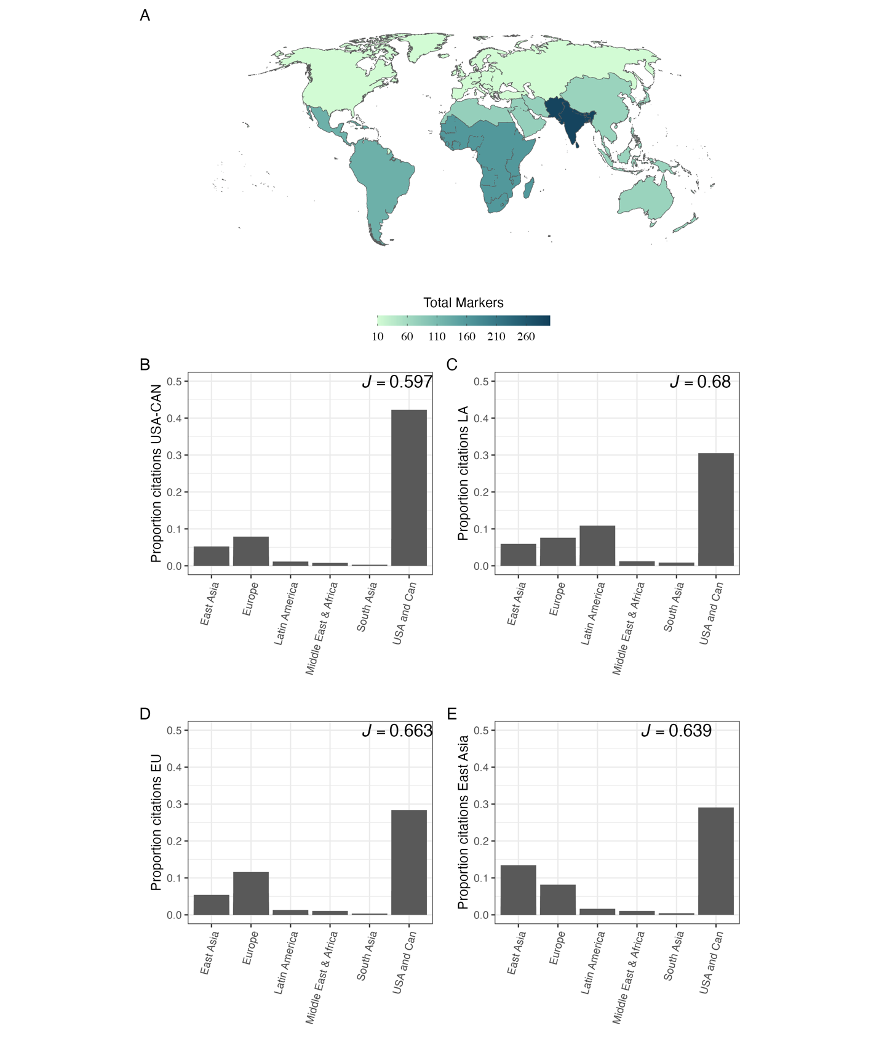

Figure 1: Citation bias represented by the proportion of the number of times articles (black dots) published in each region that were cited in articles published by authors affiliated to institutions in (A) – United States of America and Canada, (B) – Latin America, (C) – Europe, and (D) – East Asia, from 1945 to 2023. On the top right of each figure is the Pielou evenness index; the lower the value, the more biased the geographical distribution of citations in the articles published in the region. Blue bars represent the mean value for each region. In E, the number of times country names appeared in the article titles produced by each region is shown. For all figures, we used data from the top 1000 cited single-author articles in high-ranked Ecology and Evolution journals for each world region. World region was defined accordingly to the World Bank classification of the countries.

In the last ten years, concerns about diversification, equality, and inclusion in the academic environment have grown, mainly towards the direction of increasing the diversity in research environments by stimulating researchers from underrepresented groups (women, Global South, LGBTQI+, black people, to cite a few) in research institutes and universities of the Global North. Nowadays, it is rare to find a call that does not contain statements like “We highly encourage applicants from underrepresented backgrounds…”. While we acknowledge that efforts to build inclusive teams are one of the pillars toward the decolonization of science 3, we also believe that this action alone does not change the *status quo* of science, in which researchers from the Global North are viewed as experts. In contrast, researchers from the Global South are perceived as rare exceptions of scientific authority.

The perception that expertise flows from Global North to Global South is maintained by different actions deeply rooted in scientific practice, creating the neocolonial practice of academic knowledge. Examples of these practices are the citation bias towards Global North researchers (Figure 1A-D), the underrepresentation (not to cite cases of complete lack of recognition) of scientists from the Global South as plenary speakers or even their presence in conferences, and editorial boards of long-standing journals, only to cite a few4. Like in Lord of The Rings’ famous quotation, “the one ring to rule them all” we still live a type of “the one knowledge to rule them all,” and as we know, the path to take the ring to Mordor (or academic decolonization) is not easy.

While we acknowledge some progress represented by positive interventions to increase diversity, equity, and inclusion (DEI) in science, as mentioned above, little or nothing has been done to reduce the practices that promote the global academic labor division that puts Global South researchers as primarily data gathers or case study producers. Overcoming this bias implies recognizing the knowledge produced outside the Global North as being as reliable and scientifically sound as the one made by research institutes in the Global North. Some practices deeply rooted in science must be changed to decolonize academic expertise. Here, we argue that if the Global North is committed to changing the *status quo* of scientific knowledge, researchers and research institutes must do a better job toward actions that improve the intellectual visibility of underrepresented groups by first recognizing practices in scientific work that promote intellectual colonialism, and then, by acknowledging that, moving forward to implement actions that break down the labor division in scientific knowledge. In the following sections, we detailed efforts that the Global North, from research institutes to individuals, should adopt to promote effective decolonization of expertise.

**Recognizing intellectual colonialism: some examples**

Scientific solutions require specific and contextual knowledge, especially in the current context of global changes. For example, management actions and policies developed to protect and maintain biological diversity and ecosystem services might not be the same in tropical and temperate regions. Consequently, specialists and scientific knowledge produced in those places must be heard and read to develop better solutions. One recent example of intellectual colonialism was a panel proposed in a meeting to debate the future and policies of the Brazilian Amazon Forest. However, this panel was built with no researcher based on countries within the extend of Amazon Forest (after some public pressure, the event was canceled).

Another classic example of intellectual colonialism is the bias in citations and claims of scientific discovery. Citations and recognition of scientific achievements are usually measured through the number of citations (even though the controversies around this measure). However, it is common that papers with novel insights or findings published by researchers or institutions from the Global South are not cited in studies from research groups from the Global North, even publications presented in long-standing, high-impact journals 5. This situation creates a vicious cycle in which northern institutions, mainly in Europe and North America, dictate knowledge, maintaining the *status quo* of scientific expertise.

**Some suggestions from Global South**

We delve into the idea that the change must come from the oppressed. Ironically, the evidence shows that the Global South is the one acting towards a more equitable science by promoting a more equitable scientific expertise recognition (expressed by the equitability in citation proportion in Figure 1B).

Some simple actions can be taken to reduce the intellectual colonization practices in science, and here we cite a few that can help to solve the problems mentioned. Despite most of our suggestions being derived from Ecology and Evolution examples, we believe they can be applied to any scientific area.

*Journals, societies, and boarding members of scientific meetings/events*

Always ask whether the event, journal, or boarding committee is inclusive enough. How many editors are from underrepresented countries? Are geographical markers needed in Global South studies? Depending on the answer to those simple questions, we can move on to possible solutions toward DEI. Another problem is the high charges asked by journals to make articles open-access. Most do not provide waivers for developing countries, making open access a privilege mostly exclusive to Global North countries. A quick example from Brazil illustrates this point. A scientific journal asks for more than 4,000 dollars to make the article open-access with the argument that it increases the chances of being cited three times. However, this amount of money corresponds to around two entire salaries of a tenure track professor in a federal university in Brazil (the situation is even worse in other developing countries from the Global South). Consequently, this type of policy actively promotes the citation cycle mentioned before.

Regarding scientific societies, one possibility to decolonize expertise is the implementation of programs to support the submission of papers from the Global South through language support. One recent example is the EELS program (Evolution English Language Support) promoted by the Society for the Study of Evolution. The program offers cost-free English language editing for non-native English-speaking authors, reducing the language barriers to scientific publication.

*Authors from the Global North and research groups*

It is common for editors and reviewers to request to cite works neglected during the literature review process. However, those references comprise studies from researchers or institutions in the Global North almost all the time, irrespective of equally valuable references being available from the Global South. Furthermore, despite the importance that local traditional knowledge has had, and still has, to advance ecological theory, these traditional populations are usually seemed through the colonial lens in which the knowledge that comes from them must be lapidated or improved by global north, placing them on the spot of simple data gathers and providers6.

We suggest that authors from the Global North check if their references are inclusive enough by not neglecting relevant articles from the Global South, given the topic in their studies. Some may argue that this can comprise an extra work loading, but we see it as the same workload that authors from Global South have when asked to review their references or cite works from Global North authors. As mentioned before, citations are one of the currencies in the academic job market and a proxy of intellectual merit. If the whole system of authority revolves around authors from the Global North, no matter the quality of work from the Global South, their intellectual merit will never be recognized5.

*Diversity alone doesn’t guarantee a more equitable science.*

Despite DEI having its three components as equally indispensable to achieve a non-neocolonial scientific practice3, most of the efforts are only centered on the diversity aspect. However, neo-colonization practices can be found throughout the whole system of scientific practice. Even when scientific findings from Global South survive the biased reviewing process7 it still needs to face the lack of expertise recognition by the Global North4. We believe that simply including authors from underrepresented countries in Global North institutes without thinking and acting towards practices that disrupt the neocolonialism in academic expertise is of little help, sometimes serving as a decoy for DEI practices.

**Final message**

Research institutes outside the Global South still have a long way ahead when compared with the Global North institutes regarding the number of publications (in terms of quantity), and different factors can explain this. However, in terms of quality, numerous examples of universities and research groups of excellence in the Global South are a reference in different areas of Ecology and Evolution (not to mention other areas in STEM), even struggling with reduced budgets and various forms of historical colonialism. Here we suggested some simple actions that can dramatically change the *status quo* of scientific knowledge. Recognizing intellectual colonialism practices is the first step, but not enough if the aim of scientific practitioners is to build a truly inclusive environment and reduce inequalities. We can learn from the great Brazilian educator and philosopher Paulo Freire that praxis, i.e., “reflection and action upon the world in order to transform it,”8 is the only way toward a non-oppressive, inclusive, and diverse science. True changes in an oppressive system can only come from those who have been oppressed, but for this, the Global South needs a room in the same place the global North is.

**Data availability**

All data used to produce Figure 1 was collected in the Web of Science Core collection between December 2022 and February 2023. All processed data is available in the link XXXX.

**References**

1. Castro Torres, A. F. & Alburez-Gutierrez, D. North and South: Naming practices and the hidden dimension of global disparities in knowledge production. *Proc. Natl. Acad. Sci. U.S.A.* **119**, e2119373119 (2022).

2. Ergin, M. & Alkan, A. Academic neo-colonialism in writing practices: Geographic markers in three journals from Japan, Turkey and the US. *Geoforum* **104**, 259–266 (2019).

3. Trisos, C. H., Auerbach, J. & Katti, M. Decoloniality and anti-oppressive practices for a more ethical ecology. *Nature Ecology & Evolution* (2021) doi:10.1038/s41559-021-01460-w.

4. Liu, F., Rahwan, T. & AlShebli, B. Non-White scientists appear on fewer editorial boards, spend more time under review, and receive fewer citations. *Proc. Natl. Acad. Sci. U.S.A.* **120**, e2215324120 (2023).

5. Gomez, C. J., Herman, A. C. & Parigi, P. Leading countries in global science increasingly receive more citations than other countries doing similar research. *Nat Hum Behav* **6**, 919–929 (2022).

6. Ribas, C. C. Escaping Darwin’s shadow: how Alfred Russel Wallace inspires Indigenous researchers. *Nature* **613**, 24–26 (2023).

7. Smith, O. M. *et al.* Peer review perpetuates barriers for historically excluded groups. *Nature Ecology & Evolution* (2023) doi:10.1038/s41559-023-01999-w.

8. Freire, P. Pedagogia do oprimido. São Paulo: Paz e Terra (1974). 213p.