**Title**: Three pathways to better recognize the expertise of Global South researchers

Gabriel Nakamura1, Bruno Eleres Soares2, Valério De Patta Pillar3, José Alexandre Felizola Diniz-Filho4 and Leandro Duarte3

1- National Institute of Science and Technology – Ecology, Evolution and Conservation Biology, Universidade Federal de Goiás, Goiânia, Brazil

2 – University of Toronto-Scarborough, Toronto, Canada

3 – Universidade Federal do Rio Grande do Sul, Ecology Department, Porto Alegre, Brazil

4 – Universidade Federal de Goiás, Ecology and Evolution Department, Goiânia, Brazil.

**Summary**

It is widely perceived how research institutes have been adopting the discourse of champions of diversity, inclusion, and equity (DEI) in the last XXX years. Despite progress in diversity and inclusion in the academic environment, we highlight here that nothing or, at very best, little work has been done to overcome the scientific labor division in academic research that promotes neocolonial practices in academic recognition and jeopardizes equity. In this piece, we bring secondary data that reinforce biased patterns in academic recognition between Global North and South (citation bias and geographical markers), and propose three actions that should be adopted by researchers, research institutes, journals, and scientific societies from the Global North that allows for a fairer recognition of the academic expertise produced by the Global South.

**Main text**

In the TV show “Better Call Saul”, the main character discovers a massive fraud case. He presents this case to a big law firm to get some help to put the case together. In response, the head of the law firm offers him a high payment but refuses to include him in the investigation. Saul refused the payment because recognizing his intellectual expertise by including him in the investigation was the priority. In a very different environment than a TV show law firm, researchers from the Global South face a parallel experience (adding the fact that fundings is usually directed towards Global North). Scientific research in the Global South is often seen as peripherical, and Southern researchers struggle to find their expertise recognized by the Global North. While the Global North is perceived as pushing the boundaries of scientific knowledge through general theories, the Global South is perceived as taking the role of empirically testing those theories or of providing data or fieldwork expertise 12. In the worst-case scenario, empirical data obtained in Global South countries are pivotal for the development of general theories led by Global North researcher, with no accountability of researcher from where the data was extracted1. This action erase even more important contributions to the field of ecology and evolution from Global South Researchers. This global division of labor is evident when we look at geographical markers (any spatial delimitation, but here represented only by country names) in the titles of studies for different regions of the world (Figure 1A)3.

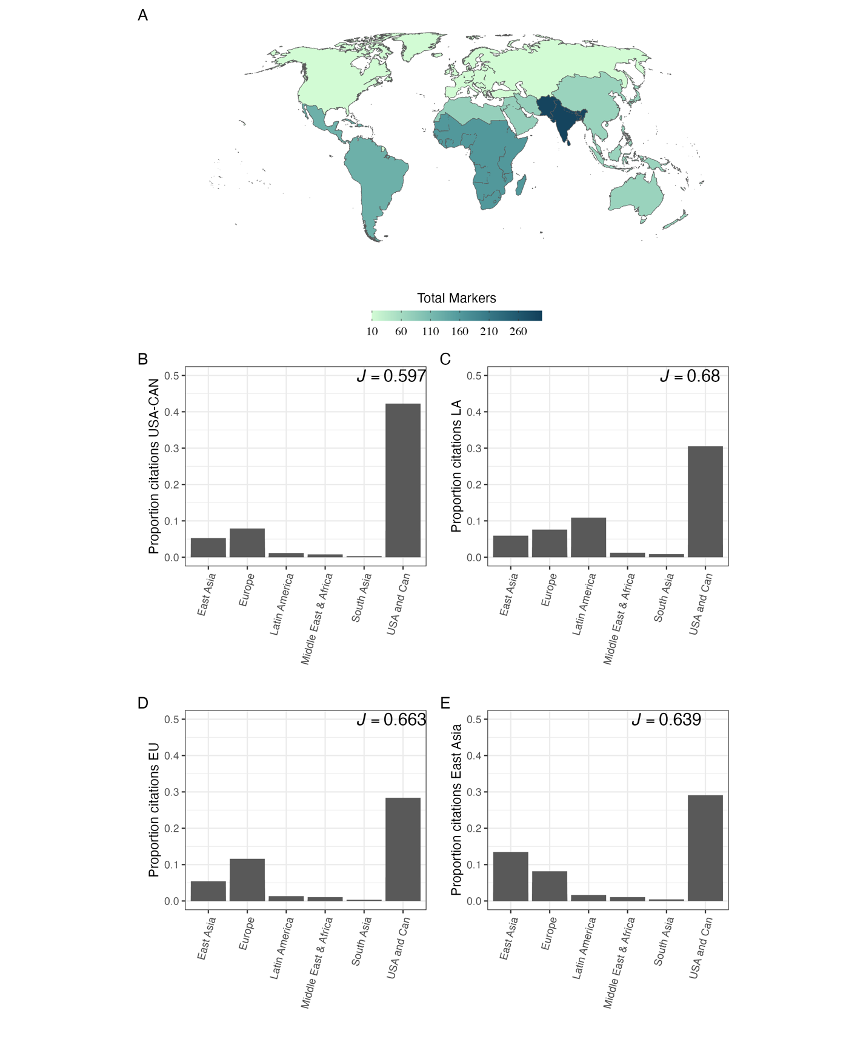

Figure 1: Map showing the number of times country names appeared in the article titles produced by each region (A). For all figures, we used data from the top 1000 articles in high-ranked Ecology and Evolution journals for each world region (see supplementary material for a complete list of journals). World region was defined accordingly to the World Bank classification of the countries. Bar plots (B-D) represent the proportion of the number of times articles published in each region that were cited in articles published by authors affiliated with institutions in (B) – United States of America and Canada, (C) – Latin America, (D) – Europe, and (E) – East Asia, from 1945 to 2023. On the top right of each bar plot is the Pielou evenness index; the lower the value, the more biased towards a given region the distribution of citations in the articles published in the region.

Diversity, equity, and inclusion (DEI) have been a central part of the academic debate in the last few years, driving cultural and structural changes in research institutes and universities of the Global North. A significant focus at the Global North has been on diversifying the pool of applicants by encouraging applicants from underrepresented backgrounds to apply and promoting the debate on building inclusive teams 45. While these actions are essential to advance DEI in the Global North academic ecosystem, they seldom change the global disparities in resource and academic recognition.

In general, Global North researchers are seen as experts in a given field, and Global South ones are perceived as local examples of scientific authority that comes from the North. The perception that expertise flows from the Global North to the Global South is maintained by deeply rooted practices in academia, creating the colonial structure of academic knowledge. Another example of academic neocolonialism is the bias in citations6,7 and claims of scientific discovery. Citations and recognition of scientific achievements are usually measured through the number of citations (despite the controversies around this measure)8. However, it is common that papers with novel insights or findings published by researchers or institutions from the Global South are not cited in studies from research groups from the Global North (Figure 1B-E), even publications presented in long-standing, high-impact journals 7. This situation creates a vicious cycle in which northern institutions, mainly in Europe and North America, dictate knowledge, maintaining the *status quo* of academic expertise. Other examples include the underrepresentation (or complete lack of representation) of scientists from the Global South as speakers in conferences and editorial boards of long-standing journals6. Some mechanisms maintaining this structure include taking English as the *lingua franca* of scientific practice9 and even positive bias for Global North countries to publish in (their own) high impact journals10 .

While we acknowledge the recent progress in DEI in academia, little or nothing has been done to reduce the practices that promote the global academic labor division that frames Global South researchers as primarily data gatherers or case study producers. Overcoming this neocolonial structure implies recognizing the knowledge produced outside the Global North as being as reliable and scientifically sound as the one made by research institutes in the Global North. Scientific solutions require specific and contextual knowledge, especially in the face of global changes11. For example, management actions and policies developed to protect and maintain biological diversity and ecosystem services might not be the same in tropical and temperate regions12. Also, the values that different communities hold might require different responses and debates with local and global science13. Consequently, excluding the scientific knowledge produced in those places is rooted in academic colonialism and should be considered to develop better solutions.

Here, we argue that if the Global North is committed to changing the *status quo* of academic knowledge, researchers and research institutes must do a better job toward actions that improve the intellectual visibility of underrepresented groups by (i) recognizing practices in scientific work that promote intellectual neocolonialism and (ii) implementing actions that break down the labor division in scientific knowledge. In the following sections, we propose interventions that the Global North, from individuals to institutions, should adopt to support a contra-colonial structure knowledge production.

**Some suggestions from the Global South**

It is known that the notion of privilege is usually unrecognized by those who are privileged by it14. Therefore, we delve into the idea that the change must come from the oppressed, and we, the Global South researchers, should be the ones driving changes in our scientific practice15,16. The evidence shows that the Global South is the one acting towards a more equitable science by promoting a more equitable academic recognition (expressed by the higher equitability in citation proportion in Figure 1C). Nevertheless, to be effective, structural changes in the global academic system must be carried out by the entire community. Here, we cite simple actions that could be taken to mitigate intellectual neocolonial practices in science and further recognize the expertise of researchers from the Global South. Despite most of our suggestions being derived from Ecology and Evolution examples, we believe they can be applied to any scientific area.

*Action 1: Increasing diversity in scientific groups (journals, societies, and boarding members of scientific meetings/events)*

*Why does it matter?* Since board member of conferences and editorial boards and societies are a non-random sample of ecological researchers and experts17, their decisions are biased at certain extension to their personal experiences and backgrounds. Therefore, increasing the participation of historically excluded groups improves the decision-making process by amplifying and considering different points of view with diverse backgrounds and perspectives.

*What to do?* Journals and scientific societies must diversify their editorial and committee boards by including researchers from historically marginalized groups. Their participation in these spaces would help to identify and tackle specific problems faced by people from coming from different backgrounds. For example, non-native English speakers might face additional barriers to submit papers in English-only journals because of language. In response, the Society for the Study of Evolution provides cost-free English language editing for non-native English-speaking authors, reducing the language barriers to scientific publication18.

*Action 2 – Reducing costs of open-access publications*

*Why does it matter?* Most publishers do not provide waivers for developing countries, making open access a privilege for Global North researchers19. For example, if the open access fees of a given journal is 4,000 United States dollars, this would be equivalent to almost two monthly wages of an assistant professor in Brazil. Even when waivers are provided, the cost is often prohibitive, excluding most researchers from the Global South to take part in more globalized venues of publishing.

*What to do?* Provide more waivers for Global South researchers, actively pursue partnerships with Global North institutions to cover fees.

*Action 3 – Referencing the Global South expertise*

*Why does it matter?* Modern science requires finding solutions that are adequate for different contexts. Students and researchers are exposed mostly to the science produced by the Global North in their curricula, texbooks,20 and articles, providing them a limited overview of potential solutions to global problems. For students and researchers, amplifying their sources or information to the Global South increase the capacity of generalization, the understanding of contextual environmental and socioeconomic factors affecting biodiversity, and social engagement21. For researchers at the Global South, the increasing recognition of our work means increasing citations that might boost our careers and potential collaboration with Global North researchers12.

*What to do?* Researchers and professors should familiarize with the literature produced by Global South researchers, especially when working with tropical ecology. Authors from the Global North must check if their references do not neglect relevant articles and examples from the Global South. Publishers and editors might demand more globalized examples or suggest literature when necessary. A starting point could be explicitly encourage reviewer to actively be aware of possible bias in citations.

**Towards a contra-colonial science**

Research institutes in the Global South still have a long way ahead when compared with the Global North institutes regarding the number of publications (in terms of quantity), and different factors can explain this. However, in terms of quality, numerous examples of universities and research groups of excellence in the Global South are a reference in different areas of Ecology and Evolution (not to mention other areas in STEM), even struggling with reduced budgets and various forms of historical colonialism. Here we suggested three simple actions that can dramatically change the *status quo* of scientific knowledge. Recognizing intellectual colonialism practices is the first step, but not enough if the aim of scientific practitioners is to build a truly inclusive environment and reduce inequalities. We can learn from the great Brazilian educator and philosopher Paulo Freire that *praxis*, i.e., “reflection and action upon the world in order to transform it,” is the only way toward a non-oppressive, inclusive, and diverse science. True changes in an oppressive system can only come from those who have been oppressed, but for this, the Global South needs to take a seat at the same table as the Global North already has.

**Data availability**

All data used to produce Figure 1 was collected in the Web of Science Core collection between December 2022 and February 2023. All data and scripts used to make Figure 1 are available in the link <https://github.com/GabrielNakamura/Citation_bias>.

**Authors Contributions**

GN conceived the idea with significant input from BES and LD. GN wrote the first draft with significant input from BES. All authors contributed with the discussion of the theme, suggestions, and text review.

**Competing interests**

The authors declare that there are no competing interests.

**References**

1. Baker, K., Eichhorn, M. P. & Griffiths, M. Decolonizing field ecology. *Biotropica* **51**, 288–292 (2019).

2. Castro Torres, A. F. & Alburez-Gutierrez, D. North and South: Naming practices and the hidden dimension of global disparities in knowledge production. *Proc. Natl. Acad. Sci. U.S.A.* **119**, e2119373119 (2022).

3. Ergin, M. & Alkan, A. Academic neo-colonialism in writing practices: Geographic markers in three journals from Japan, Turkey and the US. *Geoforum* **104**, 259–266 (2019).

4. Oliveira, W. *et al.* Advancing racial equity in Brazil’s academia. *Science* **376**, 707–707 (2022).

5. Trisos, C. H., Auerbach, J. & Katti, M. Decoloniality and anti-oppressive practices for a more ethical ecology. *Nature Ecology & Evolution* (2021) doi:10.1038/s41559-021-01460-w.

6. Liu, F., Rahwan, T. & AlShebli, B. Non-White scientists appear on fewer editorial boards, spend more time under review, and receive fewer citations. *Proc. Natl. Acad. Sci. U.S.A.* **120**, e2215324120 (2023).

7. Gomez, C. J., Herman, A. C. & Parigi, P. Leading countries in global science increasingly receive more citations than other countries doing similar research. *Nat Hum Behav* **6**, 919–929 (2022).

8. Antunes, A. A. HOW TO EVALUATE SCIENTIFIC PRODUCTION. *Rev. Col. Bras. Cir.* **42**, 17–19 (2015).

9. Amano, T. *et al.* *The cost of being a non-native English speaker in science*. http://ecoevorxiv.org/repository/view/4691/ (2022) doi:10.32942/X29G6H.

10. Fox, C. W., Meyer, J. & Aimé, E. Double‐blind peer review affects reviewer ratings and editor decisions at an ecology journal. *Functional Ecology* 1365-2435.14259 (2023) doi:10.1111/1365-2435.14259.

11. Hernandez, J., Meisner, J., Jacobs, L. A. & Rabinowitz, P. M. Re-Centering Indigenous Knowledge in climate change discourse. *PLOS Clim* **1**, e0000032 (2022).

12. Amano, T. *et al.* Tapping into non-English-language science for the conservation of global biodiversity. *PLoS Biol* **19**, e3001296 (2021).

13. Cardou, F. & Vellend, M. Stealth advocacy in ecology and conservation biology. *Biological Conservation* **280**, 109968 (2023).

14. Wu, K. & Dunning, D. Hypocognition and the Invisibility of Social Privilege. in *Advances in Group Processes* (eds. Thye, S. R. & Lawler, E. J.) 1–23 (Emerald Publishing Limited, 2020). doi:10.1108/S0882-614520200000037001.

15. Freire, P. *Pedagogy of the oppressed*. (Continuum, 2000).

16. Leal, J. S. *et al.* *Decolonising ecological research: a debate between global North geographers and global South field ecologists*. https://osf.io/wbzh2 (2022) doi:10.31235/osf.io/wbzh2.

17. Bruna, E. M. Editorial board members are a non-random sample of ecological experts. *Nat Ecol Evol* **2**, 202–202 (2017).

18. Amano, T., Rios Rojas, C., Boum II, Y., Calvo, M. & Misra, B. B. Ten tips for overcoming language barriers in science. *Nat Hum Behav* **5**, 1119–1122 (2021).

19. Kwon, D. Open-access publishing fees deter researchers in the global south. *Nature* d41586-022-00342-w (2022) doi:10.1038/d41586-022-00342-w.

20. Russell, A. E. *et al.* Integrating tropical research into biology education is urgently needed. *PLoS Biol* **20**, e3001674 (2022).

21. Razanatsoa, E. *et al.* Fostering local involvement for biodiversity conservation in tropical regions: Lessons from Madagascar during the COVID‐19 pandemic. *Biotropica* **53**, 994–1003 (2021).

22. Smith, O. M. *et al.* Peer review perpetuates barriers for historically excluded groups. *Nature Ecology & Evolution* (2023) doi:10.1038/s41559-023-01999-w.