**Taxonomic and phylogenetic beta diversity in headwater streams of the Paraná and Paraguay basins.**

Authors: Gabriel Nakamura de Souza1*, Wagner Vicentin2 and Yzel Rondon Súarez3

1 Universidade Federal do Rio Grande do Sul, Avenida Bento Gonçalves , 9500, Porto Alegre, RS.

2 Universidade Federal de Mato Grosso do Sul, Avenida Costa e Silva, Campo Grande, MS.

3 Universidade Estadual de Mato Grosso do Sul, Rod. Dourados – Itahum km 12, Dourados, MS.

* email: gabriel.nakamura.souza@gmail.com

**Abstract**

Describe the variation among ecological communities and find for their causes is a key task in ecological studies. Patterns of species replacement and richness differences along environmental gradients or biogeographic realms shed light on different ecological and evolutionary mechanisms acting on community structure. In aquatic ecosystems communities from different watershed are supposed to host distinct species and the question of how much of these differences in species composition are affected by environmental and evolutionary history is an open question for these environments, particularly in the tropical region. Therefore, in this work we investigate the patterns of taxonomic and phylogenetic composition of headwater streams of Paraná and Paraguay basins to understand how ecological and evolutionary factors affect the assembly of fish communities in these two basins. We quantified the taxonomic and phylogenetic beta-diversity by decomposing them in nestedness and turnover components. We showed that environmental and biogeographic factors affected different aspects of headwater stream fish communities. Whereas clade turnover is greater among streams with higher differences in water velocity, clade nestedness is higher among streams with greater differences in altitude and pH. Regarding taxonomic component, the high taxonomic turnover was found among the two basin, indicating a effect of biogeographical and local environmental factors acting different in determine the structure of the fish community in stream headwaters of this region.

Keywords: phylobetadiversity; tropical streams; community assembly; turnover; nestedness

**Introduction**

Community composition is a result of numerous factors acting both contemporary and historically to determine the assembly of currently species in space (1). The patterns of variation exhibited in community composition, when properly investigated (2), can reveal the imprints leaved by the different factors acting on the assembly process of these communities (e.g. Kissling et al. 2012). In this sense, beta diversity metrics that considers both taxonomic information in the composition of species joint with an investigation of the distribution of lineages in space and time has been showed effective to reveal the balance among contemporary and historical factors acting on community organization (4–8).

Particularly, the investigation of the variation in communities of distinct biogeographic areas (Morrone, XXX) have the potential to reveal historical factors associated with bioregions acting on the determination of community structure. We can ask if the variation among communities are mainly determined by historical constraints (for example, related to the biogeographical barriers) or environmental factors. For example, Duarte et al (2014) shows how the taxonomic and phylogenetic beta diversity patterns reveals that differences in tree composition of Atlantic Forest complex is mainly due to recent events in the evolutionary history of the group. In aquatic ecosystems, Petry et al. (2016) stress the importance of historical connectivity acting on organization the fish community of costal lagoons. Therefore, investigate taxonomic and phylogenetic variation from different biogeographic region offers an important avenue of investigation.

Particularly, in neotropical freshwater ecosystem, the understanding of the balance among historical and local environmental factors is rarely addressed. Paraná and Paraguay basins comprises two of the main tributaries in South America, each one with particularities in their environmental characteristics and biotas, being considered as two distinct bioregions (ref). In this perspective, the Paraná and Paraguay basins comprise an interesting system to investigate the interplay among contemporary and historical/biogeographical factors. Particularly, headwater stream fish communities from different basins are separated from long distances, making them very adequate to address the historical perspective on the study of community assembly.

Valério et al. (2007) investigated the factors that influence the distribution of fish communities of headwater streams in Paraná and Paraguay basins, and, as far as we know, this is the main work showing the patterns and mechanisms affecting fish communities in these region. However, the authors concentrate only on the distribution patterns of taxonomic variation among the basins, do not considering the phylogenetic aspects of beta diversity, that can reveal complementary information regarding the community structure.

The current knowledge suggested that the biogeographical isolation of the two basins results in stream fish communities (Valerio et al., 2007) and that Upper Paraná river basin constitute an area of high endemism due to Sete Quedas fall, that works as a biogeographical barrier. Furthermore, the characteristics of Paraguai basin can result in a taxonomically more variable fish fauna than in Paraná (9,10). However, the amount of this difference in taxonomic composition can be a result of differences in processes acting on clade distribution, and this is an open question at the moment. Further, to which process the variation in community composition is associated (species substitution or species loss) remains unclear.

Therefore, our aim is to assess the patterns of taxonomic and phylogenetic beta diversity in headwater stream fish communities of Paraguay and Paraná Basins, testing for the influence of local and biogeographical factors in the distribution of species composition and lineages among these two distinct aquatic bioregions. We hypothesize that Paraná and Paraguai basins presented differences in clade composition, and that this difference is mainly associated with a substitution of species. Furthermore, we

Specifically we investigate if 1) the beta diversity present in taxonomic level is a result of recent events of diversification in the evolutionary history of the fish species, reflected by low values of phylogenetic beta diversity; or if the high beta diversity in taxonomic level is accompanied by high phylogenetic beta diversity, indicating very distinct evolutionary histories of species between these two basins and 2) if high values of phylogenetic beta diversity and taxonomic beta diversity is a result of a process of substitution (turnover) or a richness gradients in species and linneages (nestedness component) and, finally, which unveil the factors (local or regional) are mainly related with the differences in phylogenetic and taxonomic composition between basins.

**Methods**

*Sampling sites*

The streams sampled are located within an area of 200 km length between the Paraguay and Paraná basins, near S20° 54’ to 22° 18’ latitude and W54° 56’ to 56° 05’ longitude (Figure 1).

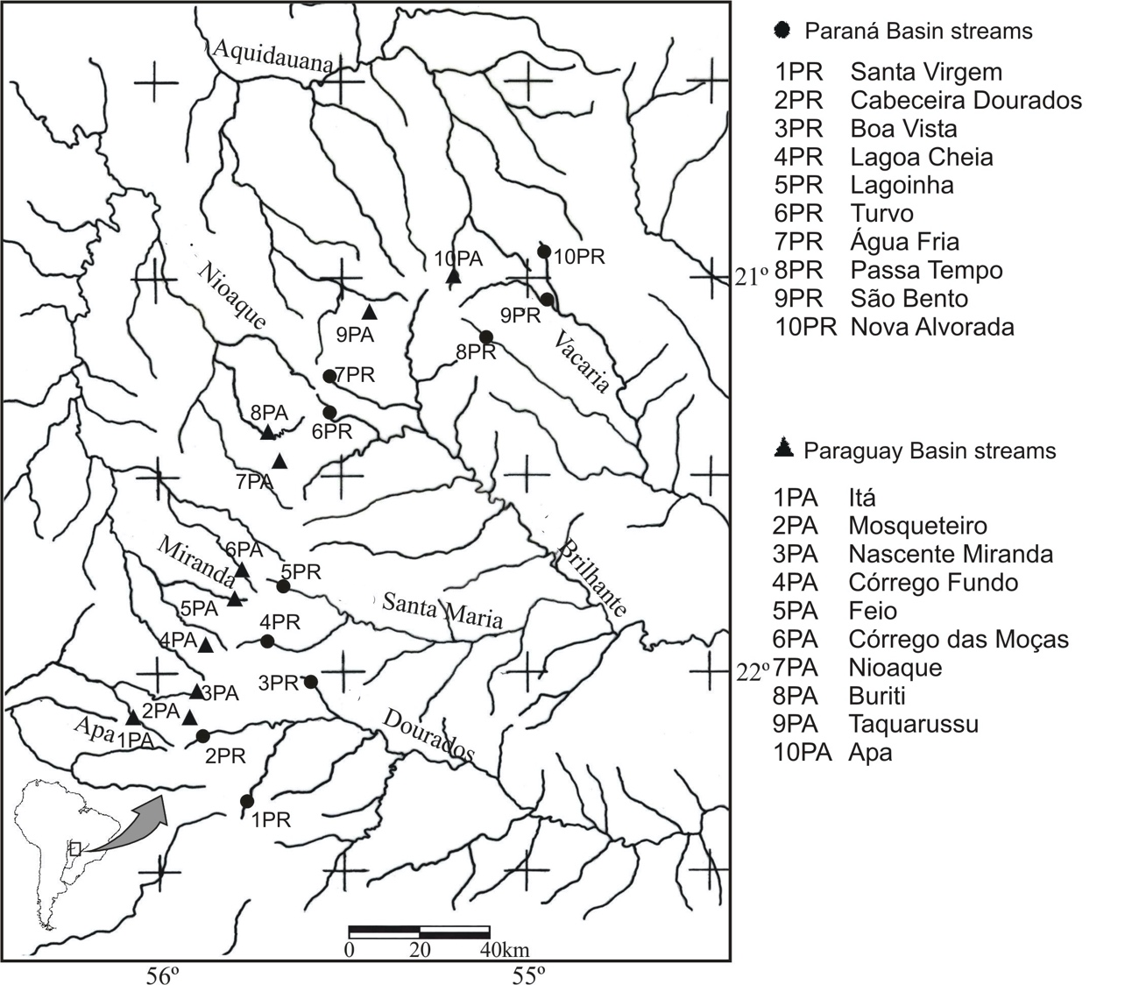

Figure 1

We collected samples bimonthly in 10 streams of each basin (Figure 1), from January to November 2004, totaling 60 samples per basin. In each basin, we selected streams from four sub-basins, according to their accessibility from the road, their position in the hydrographic basin and their environmental integrity (visual assessment). The relief of the Apa and Miranda sub-basins in the Paraguay catchments is uneven, with many waterfalls higher than 30 m, which act as barriers to fish migration within the basin. Stream widths ranged from 0.6 m to 7 m, stream depths from 0.11 m to 1.75 m, water velocity from 0.056 m*s–1 to 1.90 m*s–1 and altitude from 264 m to 641 m. The streams are relatively well-preserved, with most of the natural riparian vegetation remaining, as well as a small human population. Names and codes for the streams are shown in Figure 1.

We took samples during daylight with a rectangular sieve of 1.2 to 0.8 m, with a 2 mm mesh size and standardized sampling effort (20 throws) at each site, and approximately 50 m long hauls. We chose this method to avoid complications related to the use of electroshocking in streams with low water conductivity, difficult access, and variable turbidity that impedes the visual detection of fish.

In all analyzed streams, we collected a set of key environmental variables known to influence stream fish communities: pH, conductivity (mS/cm), water temperature, and dissolved oxygen, using a YSI model 556 field multi probe. We obtained turbidity with a portable turbidity meter. Stream depth was recorded from 10 locations in each stream, using a graduated wooden stick. We measured water velocity (m/s) three to five times in different parts of the stream using the float method. To obtain stream width (m), we used a measured tape, and to measure altitude (m) we used the altimeter of a GPS. For the analyzed streams, we utilized mean values of stream depth and velocity.

*Phylogenetic hypothesis for stream fish communities of Parana and Paraguay basins*

We calculated phylogenetic beta diversity turnover and nestedness using an adaptation of a molecular time-calibrated tree for bony fishes proposed by (11)Rabosky et al. The adaptation of the original phylogeny consisted in replace the taxa present in the original phylogeny by sister taxa (or the closest specie available in the phylogeny) present in the species pool of Ivinhema river basin. Some polytomies were solved with aid of other works on specific groups (Santos, 2007; Oliveira *et al*. 2011; Nakatani *et al*. 2011; Armbruster, 2004; Sullivan *et al*. 2013; Lavoué *et al*. 2012; Hertwig, 2007), being that this procedure was made only solve the topological relationships of species. The original phylogeny was downloaded with use of R package fishtre (12)(Chang et al. 2019). The R code used to replace species from original phylogeny for species from Ivinhema river basin are presented in Appendix SX of Supplementary material.

Assessing turnover and nestedness components of taxonomic and phylogenetic beta diversity

To quantify the amount of beta diversity in each of the two basins, and to determine how much of it is due to nestedness and turnover components, we utilized the method proposed by (13)Baselga et al. (2012). Total beta diversity is calculated as being the pairwise dissimilarity obtained through Sorensen index. The turnover is represented by Simpson index, and correspond to the dissimilarity among a pair of sites (or communities) without the richness differences. With these two measures, the nestedness portion is obtained through the subtraction of beta diversity with turnover component (Simpson). Beta diversity values ranged from 0 to 1, where 1 correspond to completely different communities. The great advantage of this method is that results provided by different sources of variation (in this case taxonomic and functional aspects of diversity) can be compared with the same methodology.

All results of these calculations were represented as mean values with their respective standard deviations, except when only two samples were compared as in the case of Paraguay-Paraná and Paraguay-Paraná endemic species. Comparing these results allowed us to describe the functional and taxonomic variation in different components of beta diversity and determine whether the taxonomic endemism reported in the literature is accompanied by functional endemism (Question 1).

The results are represented in three matrixes: the first contained the total beta diversity between samples, the second contained the turnover component and the third contained the nestedness component. We performed a Principal Coordinate Analysis (PCoA) using the matrixes of the turnover and nestedness components. This allowed us to assess the main components of beta diversity responsible for the patterns of functional and taxonomic variation in the fish fauna between the two basins (Question 2). For this analysis we used the Sorensen index (Baselga et al. 2012) applied to the data set that contained all samples, taking the square root of values before performing the PCoAs to reduce the non-Euclidean property presented in the data set (Legendre & Cáceres, 2014) .

To examine the relationship between different components of functional and taxonomic beta diversity (Question 3) we performed Mantel tests, using 999 permutations to assess the statistical significance of these relationships. Using this approach, we were able to evaluate whether the different components of functional and taxonomic beta diversity were independent of each other, or if they were correlated (and therefore could be used as a proxy for one another).

To investigate the relationship between environmental heterogeneity and beta diversity, we performed Mantel tests between the different components of functional and taxonomic pairwise beta diversity and environmental distances, the latter obtained by measuring the Euclidean distance between the first five principal components of variation (PCA) of key environmental characteristics of streams, which accounted for approximately 82% of total variation. The p values were obtained by a permutation procedure using 999 randomizations.

Finally, to analyze the relationship between key environmental variables and patterns of spatial distribution of different components of functional and taxonomic beta diversity (Question 4) we applied the envfit function to the axes returned from the PCoA of the beta diversity matrix. We assessed the statistical significance of environmental variables by a nonparametric procedure, using 999 permutations. Through this set of analyses, we could determine which variables most affected the different aspects of beta diversity in the analyzed streams. All analyses and calculations were performed in R (R Development Core Team, 2014). All p values calculated were stated as α=0.05.

**Results**

We find that the variation among headwater stream fish communities is mainly due to a substitution in species among the two basins, as shown by high taxonomic turnover. However, the turnover presented among two basins is not a result of distinct evolutionary lineages occupying these two basins, since the phylogenetic turnover was not significant.

By decomposing taxonomic beta diversity we found that the turnover component in all data sets was more important than the nestedness component, excepted for functional beta diversity, where the turnover component is lower than nestedness.(Table 1). However, the null analysis pointed that, whereas taxonomic turnover showed less than expected, taxonomic nestedness showed higher (p<XXXX).

Table 1

The PCoA of taxonomic turnover between streams of the Paraná and Paraguay basins resulted in two distinct groups of points, one formed by the Paraná streams, and the other by the Paraguay streams, highlighting the taxonomically divergent ichthyofaunal composition of these two basins. On the other hand, the PCoA results for the nestedness component of taxonomic and functional beta diversity and the turnover component of functional beta diversity did not differ between streams of the basins (Figure 2). In other words, the major portion of variation between basins was due to the turnover of species, accounting for an average of 76%±0.16% of the total taxonomic beta diversity.

Figure 2.

Results of the Mantel tests indicated a significant relationship between taxonomic and functional turnover. Despite this significant relationship, the correlation between the two measures was low (r= 0.34), with greater taxonomic than functional turnover. The relationship between beta functional and taxonomic nestedness as well was significant, with a correlation coefficient of 0.64. All other aspects of beta diversity were not significantly related (Figure 3).

Figure 3.

With respect to environmental characteristics we observed that the taxonomic total beta diversity (without separating the turnover and nestedness components), was significantly positively related to local environmental differences in the streams. The same relation was observed for the nestedness component of functional beta diversity (Figure 4). Despite the significance of these relationships, we observed only weak correlation coefficients between these two aspects of beta diversity and environmental characteristics.

Figure 4.

Null analysis

We find values of taxonomic beta diversity significant different than expected by the null models used. While taxonomic turnover showed lower than expected, nestedness component showed higher than expected by the null model. On the contrary, mean phylogenetic beta diversity showed a random pattern (p>0.05).

Finally, analyzing the effect of environmental variables on functional and taxonomic components of beta diversity, we observed that the altitude of streams significantly influenced the nestedness component of both taxonomic and functional beta diversity, while depth significantly influenced the turnover component of both taxonomic and functional beta diversity, and width influenced only the turnover component of functional beta diversity (Table 2).

Table 2.

**Discussion**

In general, our results indicate functional convergence between species of the two basins. Valério et al. (2007), studying the same streams, found that the two basins have distinct faunal compositions. Our results corroborate their findings by showing the replacement of species between streams, using the turnover component of taxonomic beta diversity. However, expanding the results of Valério et al., we found that species are replaced by other species with similar functional attributes despite the taxonomic turnover. In summary, the results obtained by the decomposition of beta diversity and PCoA confirm high endemism in these basins (Castro, 1999; Chernoff & Willink, 2000), responsible for high values of taxonomic turnover. But, expanding these findings, we could demonstrate that the two endemic faunas have similar functional attributes related to microhabitat occupation, trophic and reproductive characteristics in each basin.

The significant relationship between the nestedness component of taxonomic beta diversity and functional beta diversity indicated a positive relation between reduction in number of species with reduction in functional space of communities. This means that greater differences in richness between streams indicate greater differences in the volume of functional space occupied by communities. In general, the results of Mantel tests between different aspects of functional and taxonomic beta diversity indicated that nestedness and turnover are independent components of beta diversity, highlighting the importance of both. Each of these components can indicate a different mechanism underlying the temporal and spatial distribution of species. These results corroborate the findings of Villeger et al. (2013) for fish communities in France, who observed a positive relationship between functional and taxonomic turnover, but not between the components of nestedness and turnover.

The observed weak relationship between environmental heterogeneity and different components of functional and taxonomic beta diversity is also noteworthy: despite different spatial scales not explicitly included in the analysis, our findings appear to confirm the dispersal-environmental control model proposed by Heino et al. (2015). In this model, variation of beta diversity is not accompanied by increased values of environmental heterogeneity due to high dispersal capability of species on small spatial scales (mass effect), or as may be the case in our study, due to dispersal limitation on large spatial scales, such as two biogeographically distinct basins. Thus, species sorting does not appear to be the sole mechanism for determining the distribution of species and functional attributes in the analyzed streams, since only total taxonomic beta diversity and the nestedness component of functional beta diversity showed a significant, although weak, relationship with environmental characteristics (r = 0.24 and r = 0.19, respectively).

Despite the weak relationship between environmental characteristics and beta diversity, we analyzed the effects of key environmental variables on different aspects of taxonomic and functional beta diversity. Interestingly, different components of beta diversity are correlated with different environmental variables. While nestedness is mainly correlated with altitude, variation in turnover is better described by depth and width.

Unfortunately, it is difficult to determine the exact mechanisms that account for the relation between the altitude of streams and nestedness patterns. As described by Heino et al. (2010), several mechanisms have been suggested to generate or correlate with nestedness patterns (Cutler, 1998; Jonsson, 2001; Rosenzweig, 1995; Wright et al., 1998). In addition, variation in altitude can be related to many stream characteristics, such as differential colonization (Kadmon, 1995; Lomolino, 1996) due to isolation and dispersal capacities of fish, or environmental filtering processes such as altitude-dependent stream characteristics (Honnay et al. 1999; Hylander et al. 2005). However, based on the characteristics of the analyzed streams, we are inclined to the hypothesis by Hylander et al. (2005) that nestedness patterns of communities are related to the presence of nested habitats, more than nested habitat quality, since not all streams differ considerably in environmental integrity.

In relation to turnover, wider and deeper streams allow the presence of larger species that have different functional attributes and substitute species with smaller body size that predominate in shallow streams, thus altering functional space and species composition in streams with higher water flow.

Our data demonstrate that different components of beta diversity were affected in the studied communities, depending on environmental variation. We found that altitude is mainly related to species loss (nestedness), while depth and width are mainly related to the substitution of species (turnover).

**Conclusion**

The present work represents a step forward in relation to that developed by Valerio et al. (2007) by include the investigation of historical factors influencing the assembly of the stream fish communities in the Paraná and Paraguay basins.

**Acknowledgements**

The authors thank FUNDECT (Process: 489/02) and UEMS for financial support, and Flávio C. T. Lima (Museu de Zoologia da Universidade de São Paulo) for taxonomic help. Dagmar Frisch corrected the English text.

**References**

Adler, P. B., A. Fajardo, A. R. Kleinhesselink & N. J. B. Kraft, 2013. Trait-based tests of coexistence mechanisms. Ecology Letters16, 1294–1306.

Baselga, A.& C. D. L.Orme, 2012. Betapart: An R package for the study of beta diversity. Methods in Ecology and Evolution3, 808–812.

Bini, L. M., V. L.Landeiro, A. Padial, T. Siqueira & J. Heino, 2014. Nutrient enrichment is related to two facets of beta diversity for stream invertebrates across the United States. Ecology, 95, 1569–1578.

Britski, H. A. & F. Langeani, 1988. *Pimelodusparanaensis*, um novo Pimelodidae (Pisces, Siluriformes) do Alto Parana, Brasil. Revista Brasileira de Zoologia 5: 409–417.

Castro, R., 1999. Evolução Da Ictiofauna De Riachos Sul Americanos: Padrões gerais e possíveis processos causais. In: Charamasch, E. P., R. Mazzoni & P. R. Peres-Neto (eds), Ecologia de peixes de riachos. Série Oecologia Brasiliensis VI. PPGE-UFRJ, Rio de Janeiro: 139-155.

Chernoff, B., P. W. Willink & A. Machado-Allison, 2004. Spatial partitioning of fishes in the Río Paraguay, Paraguay. Interciencia, 29: 183 - 192.

Cianciaruso, M. V., I. A. Silva & M. A. Batalha, 2009. Diversidades filogenética e funcional: novas abordagens para a Ecologia de comunidades. Biota Neotropica, 9: 93–103.

Colzani, E., T. Siqueira, M. T. Suriano & F. O. Roque, 2013. Responses of aquatic insect functional diversity to landscape changes in Atlantic forest. Biotropica, 45: 343–350.

Cutler, A. H., 1998. Nested patterns of species distribution: Processes and implications. In McKinney M. L. & J. A. Drake (eds), Biodiversity Dynamics. Columbia University Press, New York: 212–231.

Diaz, S. & M. Cabido, 2001. Vive *la différence* : Plant functional diversity matters to ecosystem processes. Trends in Ecology and Evolution, 16: 646–655.

Froese, R. & D. Pauly, 2013. FishBase: World Wide Web electronic publication. http://www.fishbase.org (accessedin February 2015).

Heino, J., A. S. Melo, L. M. Bini, F. Altermatt, S. Al-Shami, D. G.Angeler & C. R. Townsend, 2015. A comparative analysis reveals weak relationships between ecological factors and beta diversity of stream insect metacommunities at two spatial levels. Ecology and Evolution 5: 1235-1248.

Heino, J., H. Mykrä, & J. Rintala, 2010. Assessing patterns of nestedness in stream insect assemblages along environmental gradients. Ecoscience17: 345–355.

Honnay, O., M. Hermy & P. Coppin, 1999. Nested plant communities in deciduous forest fragments: Species relaxation or nested habitats? Oikos84: 119–129.

Hylander, K., C. Nilsson, B. G.Jonsson & T. Göthner, 2005. Differences in habitat quality explain nestedness in a land snail meta-community. Oikos108: 351–361.

Jonsson, B. G., 2001. A null model for randomization test of nestedness in species assemblages. Oecologia, 127: 309–313.

Kadmon, R., 1995. Nested subsets and geographical isolation. Ecology, 76: 458–465.

Legendre, P. & M. De Cáceres, 2013. Beta diversity as the variance of community data: Dissimilarity coefficients and partitioning. Ecology Letters 16: 951–963.

Lomolino, M. V., 1996. Investigating causality of nestedness of insular communities: Selective immigrations or extinctions? Journal of Biogeography 23: 699–703.

Magurran, A. E. & B. J. McGill, 2010. Challenges and opportunities in the measurement and assessment of biological diversity. In Magurran, A. E & B. J. McGill (eds), Biological diversity: frontiers in measurement and assessment.Oxford University Press, Oxford: 85-94.

Petchey, O. L., & K. J. Gaston, 2006. Functional diversity: back to basics and looking forward. Ecology Letters 9: 741–758.

R Development Core Team, 2012. R: A language and environment for statistical computing. R Foundation for Statistical Computing, Vienna, Austria. URL http://www.R-project.org/.

Ricotta, C., 2005. Through the jungle of biological diversity. Acta Biotheoretica 53: 29–38.

Valério, S. B., Y. R.Súarez, T. R. Felipe, K. K. Tondato & L. Q. L. Ximenes, 2007. Organization patterns of headwater-stream fish communities in the Upper Paraguay-Paraná basins. Hydrobiologia 583: 241–250.

Villéger, S., G. Grenouillet & S. Brosse, 2013. Decomposing functional β-diversity reveals that low functional β-diversity is driven by low functional turnover in European fish assemblages.Global Ecology and Biogeography 22: 671–681.

Weitzman, S. H., N. A. Menezes & M. J. Weitzman, 1988. Phylogenetic biogeography of the Glandulocaudinae (Teleostei: Characiformes, Characidae) with comments on distribution of the other freshwater fishes in eastern and southeastern Brazil. In Vanzolini, P. E. & W. R. Heyer (eds), Proceedings of a Workshop on Neotropical Distribution Patterns. Academia Brasileira de Ciências, Rio de Janeiro: 379–427.

Wright, D. H., B. D. Patterson, G. M. Mikkelson, A. Cutler & W. Atmar, 1998. A comparative analysis of nested subset patterns of assemblage composition. Oecologia, 113: 1–20.

**Figure captions**:

**Fig. 1** Headwater streams sampled in an interface region of the Paraná and Paraguay basins. Filled circles represent streams of the Paraná basin, and filled triangles represent streams of the Paraguay basin. The names of streams and their respective codes are indicated at the bottom of the map (Valério et al 2007)

**Fig. 2** Turnover and nestedness components of taxonomic and functional beta diversity in streams of the Paraná and Paraguay basins. Clockwise from top left: nestedness component of functional beta diversity, turnover component of functional beta diversity, turnover component of taxonomic beta diversity and nestedness component of taxonomic beta diversity. Filled circles correspond to Paraná streams and triangles to Paraguay streams.

**Fig. 3** PCPS of stream fish communities from Paraná and Paraguay basins. The squares indicates the streams of Paraná basin and triangles indicates the streams of Paraguay basin.

**Tables**