***Imprints of tropical niche conservatism in the radiation of Tyrannidae***

Alina van Dijk1, Gabriel Nakamura1, Arthur V. Rodrigues1, Renan Maestri1, Leandro D.S. Duarte1

1Programa de Pós-Graduação em Ecologia, Universidade Federal do Rio Grande do Sul, Porto Alegre RS, Brazil.

**ABSTRACT**

The latitudinal gradient of species richness is a result of either differing rates or differing accumulation of speciation, extinction and dispersal between tropical and temperate regions. Recently, debate revolved around two hypotheses to explain richness gradients of birds, namely the Tropical Niche Conservatism (TNC) and the Out of the Tropics (OTT). Under TNC, an old colonization of the tropical region coupled with infrequent dispersal to temperate regions is the principal driver of birds’ richness gradients. Under OTT, net diversification in the tropical region is higher than in the temperate regions, and dispersal from tropical to temperate regions is frequent. Here, we evaluated the support for each hypothesis during the radiation of New-World Tyrannidae. We mapped Tyrannidae richness across one degree cells (assemblages) through the Americas, and quantified the age and phylogenetic clustering of each assemblage based on a time-calibrated phylogenetic hypothesis coupled with ancestral range estimation. We found that the mean age of tropical assemblages is consistently higher than temperate ones, and that temperate assemblages form a phylogenetically clustered group of species. Both evidences give more support for the TNC than for the OTT hypothesis. We contend that Tyrannidae diversification history was strongly influenced by an historical effect related to the older colonization of the tropical region compared to temperate regions, with probably recent and infrequent events of dispersal to temperate regions. Direct evidences of differential speciation and extinction rates can be further explored helping with additional evidence to distinguish both scenarios.

**Keywords:** ancestral dispersal, assemblage age, birds, latitudinal diversity gradient, tropical niche conservatism, out of the tropics.

**INTRODUCTION**

The diversity observed in the tropics is a topic that of great attention in ecological agenda (Hawkins 2001, Hillebrand 2004, Wiens and Graham 2005, Jablonski et al. 2006). In situ speciation and historical dispersion are supposed to generate the differences in diversity observed among tropical and temperate regions, and some empirical evidence based on diversity patterns supported the effects of these mechanisms in some groups (e.g. Crouch et al. 2018).

Particularly, two hypotheses highlight in situ speciation and historical movements of species (historical dispersal) as central mechanisms to explain the great diversity in the tropics and its differences regarding temperate regions. While Tropical Niche Conservatism (TNC) assumes that the clades originated in the tropics diversified locally and then a subset of them spread to temperate biomes (Wiens & Donoghue 2004; Jansson *et al.* 2013; Duchêne & Cardillo 2015), Out of The Tropics (OTT) suggests that most clades originated in the tropics, but these clades presented frequent dispersion to temperate zones (Jablonski *et al.* 2006; Mittelbach *et al.* 2007; Jansson *et al.* 2013; Duchêne & Cardillo 2015). Therefore, TNC and OTT differ in the timing and frequency of historical dispersal, the first is infrequently and late, whereas the second is frequent and continuous during evolution of species.

Since both OTT and TNC hypothesis are concordant regarding the role of in situ speciation in the tropics, differentiating between them necessarily pass through the estimation of a measure that explicitly consider the timing of migration events. Crouch et al. (2019) argued that the identification of relative importance of in situ speciation and historical dispersal can be identified by calculating a measure of phylogenetic diversity that estimate the mean phylogenetic distance among species in an assemblage (MPD and MNTD (Webb et al. 2002)). The rationale behind the use of these metrics is that assemblages that present low phylogenetic diversity (positive values of MPD or MNTD) are an indicative of great contribution of in situ speciation (Figure 1A), whereas communities with high phylogenetic diversity than expected by species richness are supposed to be assembly mainly by events of historical dispersal. However, the amount of phylogenetic diversity in an assemblage does not indicate the ways in which diversity arose, if by means of historical events of dispersion or in situ speciation, that is central to differentiate between TNC and OTT hypothesis.

Figure 1 illustrate the problem regarding the use of MNTD or MPD to infer past events of historical dispersion. Suppose two communities (island 1 and island 2), both presenting low phylogenetic diversity. Following to the proposition of Crouch et al. (2018) both island are shaped mainly by in situ speciation. However, the same phylogenetic patter could be obtained by events of in situ speciation (A) or historical dispersion (B), and this information would not be evident by only account for present patterns of phylogenetic diversity.

In this work we propose a new approach that explicitly consider the timing of migration events to differentiate among the two situations presented in Figure 1. Assemblages shaped mainly by in situ speciation must present low phylogenetic diversity and be more ancient than assemblages that the historical dispersion plays an important role, since the species observed in the assemblage arrived, or preserve their area of occurrence during its evolutionary trajectory. Otherwise, recent communities regarding the age of arrival of species indicates that historical dispersion among areas are an important factor to generate the observed pattern of phylogenetic diversity. The new framework proposed here allowed to identify hypothesis that explicity consider the timing and frequency of historical dispersal, as OTT and TNC. Expectations regarding phylogenetic patterns and assemblage ages accordingly OTT and TNC are presented in Table S1.



Figure 1: Predictions of values of net relatedness index and the age of the assemblages for tropical and temperate biomes. See text for explanation.

**METHODS**

The area of study is the America continent, since the geographic range of Tyrannidae species is restricted to this continent (Fiztpark 1980). The continent was subdivided in grid cells of 1 degree (~110 km² near the equator), excluding islands. These cells were classified as tropical (below 23° of latitude) and temperate (above 23° of latitude). We adapted the biomes classification proposed by Olson et al. (2001) aggregating small and near biomes, in order to come up with 10 biomes. This was done due to limitations imposed by BioGeoBEARS (Matzke 2013), that allows the character reconstruction for a maximum of 10 character states.

**Species data**

We compiled the geographic ranges of 392 species of the family Tyrannidae including both breeding and winter distributions from BirdLife International (BirdLife International and NatureServe 2017). Based on these maps, we generate assemblages for each grid cell in the American continent. The evolutionary relationship among species was based in a consensus phylogenetic tree using Maximum Clade Credibility (MCC) method (Heled and Bouckaert 2013). This method evaluates the frequency in which a clade is represented in a set of phylogenetic trees. The product of frequency values for the clades of a tree is the score of Clade Credibility for the phylogenetic tree. Therefore, the consensus phylogenetic tree is the tree with the highest product of clade frequency among the set of phylogenetic trees. For this, we used 1000 phylogenetic hypotheses randomly sampled from the Bayesian pseudo-posterior distribution, time-calibrated bird tree phylogenies (available at http://birdtree.org; see Jetz et al., 2012 for details). The consensus tree was chose among 1000 trees using the *MaxCladeCred* function from phangorn package (Schliep 2011) in R (R Core Team, 2018).

**Quantifying assemblage phylogenetic clustering**

To quantify the degree of phylogenetic clustering of the assemblages we used the net relatedness index (NRI) (Webb et al. 2002). NRI is the standardized measure of the mean pairwise phylogenetic distance among species in an assemblage and quantifies how much cluster or overdispersed are the species of an assemblage. Negative NRI values indicates overdispersion, i.e. species in an assemblage are less related than expected by chance, and positive NRI values indicates clustering, i.e. species in an assemblage are more related than expected by chance (Webb et al. 2002). NRI is calculated as follow:

$$NRI= -1* \frac{{\overline{X}}_{obs }- {\overline{X}}_{N}}{sd(X_{N})}$$

where the ${\overline{X}}_{obs }$ is the mean phylogenetic distance between two taxa in the observed assemblage, ${\overline{X}}_{N}$ is the mean phylogenetic distance between two taxa in the expected assemblage under null model*,* and $sd(X_{N})$ is the standard deviation of ${\overline{X}}_{N}$ (Webb et al. 2002). We calculated NRI with *ses.mpd* function of the picante package (Kembel et al. 2010), using 999 randomization of species identities in the phylogenetic tree.

**Mean age of assemblage**

In order to complement the analysis of phylogenetic clustering of assemblages, we developed a method to estimate the mean age of assemblages. Our rationale is that the time in which the lineage of a species is in a biome could be calculated by estimating the areas in which the ancestral of the species occupied in the past. With ancestral area reconstructed for all species, we could measure the time of arrival of the species’ lineage in a assemblage. With the estimated time of arrival of the species lineage in hands, we can then calculate the mean age of assemblage based on all species that occupy a given assemblage. Therefore, the procedure for assemblage age estimate consists in three steps: 1) estimation of the ancestral areas for all species; 2) measure the time in which the ancestral of a given species spend uninterruptedly in that biome and finally 3) calculate the mean time for a given assemblage. The details of how we conducted these steps is given in the following sections.

***Ancestral area estimation***

To estimate the ancestral area of current Tyrannidae birds species we used BioGeoBEARS (Matzke 2013) package in R (R Core Team, 2018). The ancestral area consists in the biome occupied by the ancestral of current species. BioGeoBEARS provides models to estimate ancestral areas that emphasize different process of historical biogeography. The parsimony‐based Dispersal‐Vicariance Analysis (DIVA) (Ronquist 1997), emphasizes the vicariance process in speciation. DIVA assumes that the area of daughter species is a part of the areas of the ancestral species (vicariance), unless the ancestor occupies a single area, then sympatry is allowed. The Dispersal‐Extinction Cladogenesis (DEC) model (Ree and Smith 2008) assumes that both vicariance and sympatry could origin daughter species. In DEC model the area occupied by a daughter species could be the same of its ancestor or a subset of the ancestor’s area. However, DEC model assumes that new species could occupy only one of the ancestor’s areas, in both sympatry and vicariance processes. The BayArea model (Landis et al. 2013) assumes that speciation occurs only in sympatry, then the daughter species occupy the same areas of its ancestor, which can be single or multiple areas. Other three models are provided by including the founder effects to all models previous described. Thus, in these models a daughter species could ‘jump’ to new area, not occupied by its ancestor. These models are coded including a ‘+J’ to the model abbreviation.

Here, we estimate the ancestral area for Tyrannidae species based on these six models: DIVA, DIVA+J, DEC, DEC+J, BayArea and BayArea+J. To this estimation, each species was classified as belonging to a maximum of three biome, based on the most frequent biomes a species occurs. After run all six models we conduct model selection using Akaike Information Criterion to discriminate which one provides the best estimation of ancestral areas. The best ranked model of ancestral area estimation was used for the calculation of time arrival of species’ lineage in a biome.

***Calculating the mean age of the assemblage***

We calculated the arrival time for each species’ lineage in the biome in which the assemblage belongs. The arrival time was computed as the node age of the most ancient ancestor, in which that its descendants also occupied the biome of the assemblage, estimated to occur in the biome of the assemblage. When the more recent ancestral of a species was estimated to occupy a different biome than the occupied by the current species in the assemblage of interest, we assign an arrival time of 1 x 10-5 Ma. Thus, we assume that when the dispersion occurred after the last speciation event in the tree, the time of arrival was very recent. After obtained the age for all species in all biomes, the mean age of the assemblage is the mean of the arrival time of species to the biome of the assemblage.

**Data analysis**

To evaluate the OTT and TNC hypothesis for the relationship of richness and latitudinal gradient, we tested whether the NRI is different between Tropical and Temperate assemblages with one-way Anova, as well as conducted a regression model with latitude as a predictor of NRI values. Furthermore, we tested whether the mean age of assemblages is different between Tropical and Temperate assemblages with one-way Anova. This analysis was conducted in R environment (R Core Team, 2018).

**RESULTS**

In accordance with the latitudinal diversity gradient, the 392 species of the family exhibit a strong richness gradient, where the assemblages with highest richness are found near the Equator and at forest habitats (Amazonia and Atlantic Forest).

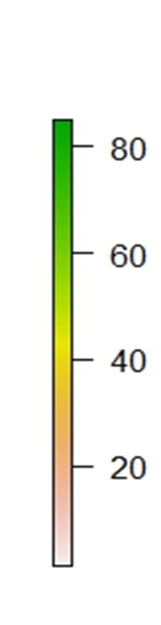 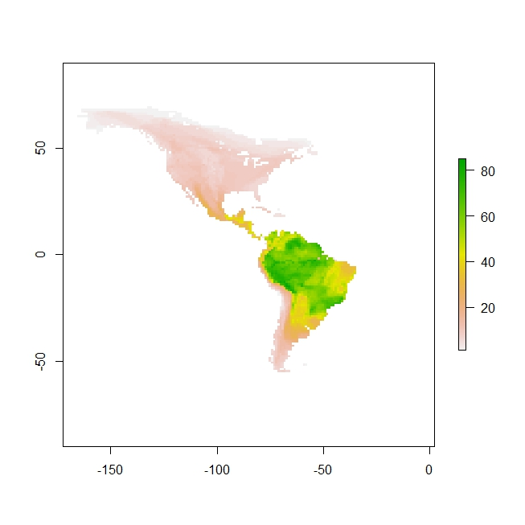

Equator

Figure 2: Species richness gradient for the 392 species of Tyrannidae.

**Phylogenetic clustering within latitudinal zones**

We observed a range of NRI values, mostly positive, indicative of widespread phylogenetic clustering. The degree of phylogenetic clustering varies among latitudinal zones in which some latitudes show greater degree of clustering than others (Figure 3). The latitude 20º have the highest values of clustering and the lowest value was in 0º. Temperate assemblages (latitude higher than 23º) we have a predominance of positive values of NRI, which are clustered assemblages (Figure 4). The One-way Anova returned *F-value* of 2967.485 (DF= 3830, *p-value*= 0.00009) and R²= 0.4366.

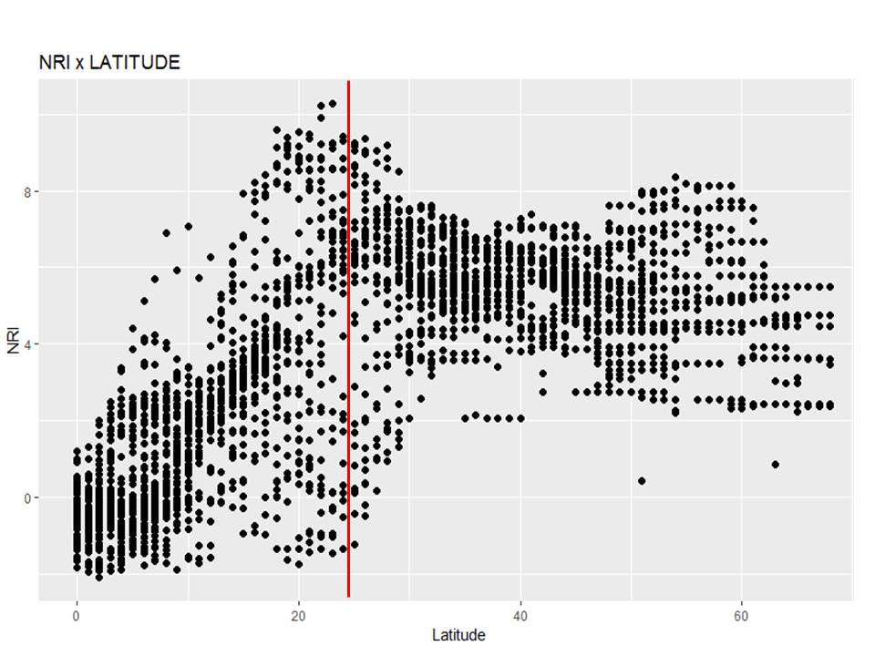

Figure 3: Values of Net Relatedness Index (NRI) across assemblages at different latitudes. In the equator, we have the lowest value of NRI. After the latitude 23º (Red line) we have a predominance of positive values.

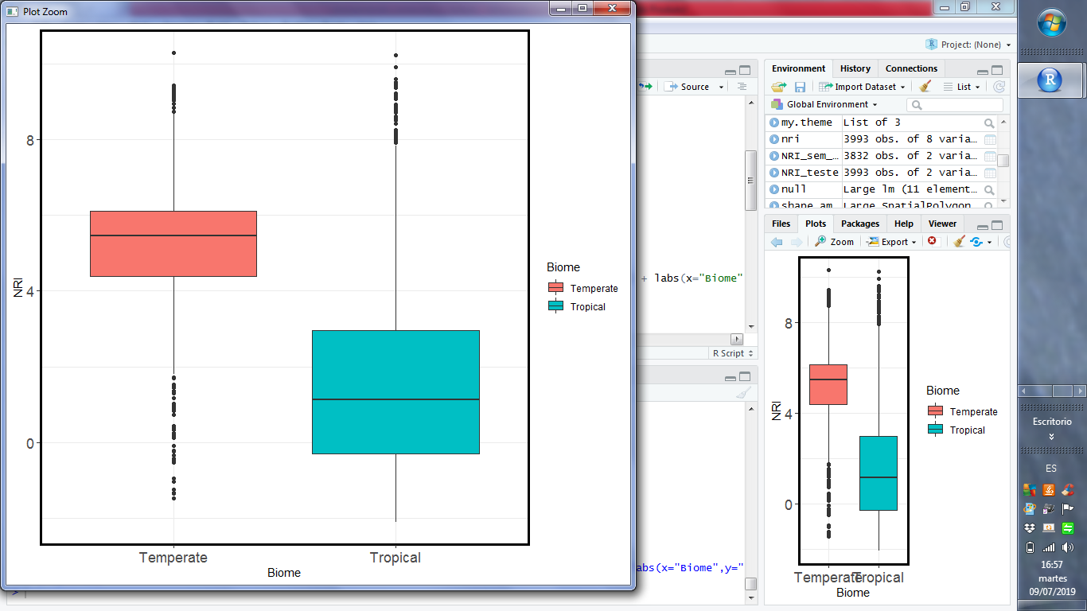

Figure 4: Values of NRI in the different regions. Note that, in temperate assemblages, a predominance of positive values of NRI (clustered assemblages) and in tropical biomes a low value of NRI (overdispersed assemblages).

**Age of the assemblage**

*Ancestral range estimation*

We selected the model which received the lowest AIC score (Table S2) and extracted the highest probabilities of the ancestral to be occupying the biome in the selected model (BayArea+J).

After computing the age of assemblage, we observed that the recent assemblages are found in temperate biomes (Figure 5). The value of *F* was 724.011 (DF= 3991, *p-value*= 0.00009) and R²= 0.5421. Anova showed a lower value of *F* and a significant value of p (lower than 0.05)*,* which means, that these groups (tropical or temperate biomes) are different in both situations.

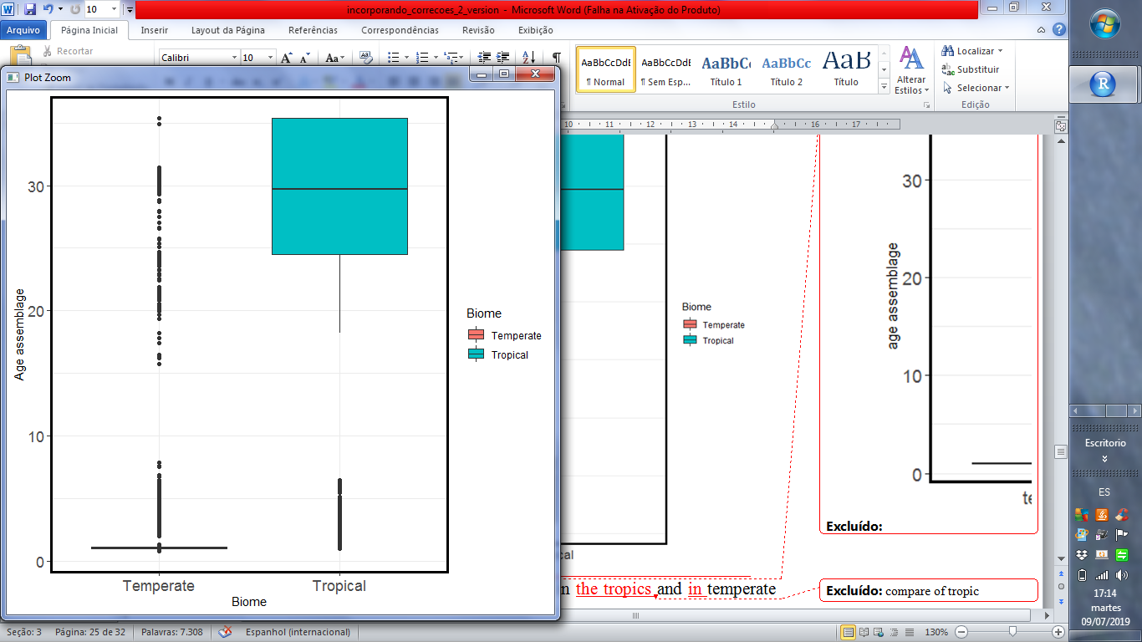

Figure 5: Values for age of the assemblages in the tropics and in temperate biomes. Tropic assemblages, in average, have the highest values of age assemblage in Ma while in temperate assemblages this value is low.

**DISCUSSION**

Both TNC and OTT assume that the major bird clades were originated in tropical environments and the temperate clades are derived from older tropical clades (Wiens and Graham 2005, Jablonski et al. 2006, Jansson et al. 2013). However, the TNC predicts a few dispersal events, while the OTT, in contrast, a continuous dispersal of lineages into temperate biomes. In other words, the temperate assemblages will be clustered for TNC and overdispersed for OTT (Duchêne and Cardillo 2015). We were able to show that in temperate biomes there are clustered assemblages consistent with the expectations of TNC. Beside of that, further support is provided by the age of the assemblage, since the assemblages have a recent age in temperate biomes. However, for TNC the dispersal event is expected to have occurred during the Eocene-Oligocene Climate transition (around 34 Ma) (Duchêne and Cardillo 2015), while the values found for the age of assemblages in temperate biomes are lower than that. Nevertheless, our values are consistent with the evidence of fossil record of avian (Mayr 2004, Manegold et al. 2014) and woody angiosperms (Kerkhoff et al. 2014), which found that most of temperate lineages should have arisen after the Eocene-Oligocene Climate Transition, when the Earth began to cool and tropical environments shrank in a relative comparison to temperate and boreal zones. As consequence, a few and recent lineages were found in temperate biomes, broadly supporting the expectations of the TNC and less consistent with the expectations of OTT. Also, using the age of the assemblage, we are able to show that the richness found in temperate assemblages have originated recently and the phylogenetic structure indicates that *in situ* speciation are predominant in temperate assemblages. More specifically, age indicates that this *in situ* speciation was promoted recently.

It is interesting to note that the suborder Suboscines, appears to originate in austral Gondwana and became isolated in South America when the continent was separated from Antarctica (about 40 Ma) (Kennedy et al. 2014). In the Cenozoic era, South America, continued isolated and only joined when the Isthmus of Panama are formed (3-4 Ma), event known as “Great American Biotic Interchange- GABI” (Smith and Klicka 2010). After that, among the Suboscines, a few lineages of Tyrannidae have colonized North America (Ricklefs 2002). This explain why we have many lineages of Tyrannidae in South America (324 species) and a few in North America (125 species of Tyrannidae) (Weir et al. 2009). The ability to colonize new regions should be difficulty for Tyrannidae because this family have a tropical forest-inhabiting and most families that have tropical forest-inhabiting required a completed land to cross (Weir et al. 2009). So, the interchange of species between South America to North America only succeeds when the Isthmus of Panama was closed since this event creates a completed land to cross. Also, the characteristic of the most Suboscines, is they are restricted to rain forest interiors (Kennedy et al. 2014) and explain why the dispersal event occur only when the Istmo of Panama are closed, even though bird have the capability of flying (Weir et al. 2009). Thus cluster assemblages in temperate biomes show that a few lineages managed to cross to North America (Ohlson et al. 2008). The old age of the assemblage in the tropics found could be explained by the fact that the origin of this family is in South America, more specifically, inside tropical rainforests (Ohlson et al. 2008).

To conclude, our work comes with two caveats. First, the estimation of the ancestral area is based on the results of BioGEOBEARS what could be controversial. In our case, the best probability of the data given the model was BayArea+J. We assumed that no range evolution occurs at cladogenesis, which means that the ancestral range is copied to both daughters’ lineages. Also, prior to the ancestral range estimation, we had to classify the biomes. It is essential to note that the classification used (Olson et al. 2001b) could express the history of occupation of the ancestor or not. Therefore, the first caveat is that the ancestral range estimation is based on the result of BioGEOBEARS which is a result of the biome classification adopted and the model used.

The second caveat is the lack of good fossil record, particularly in tropical biomes (Weir et al. 2009), since avian bones are thin and light as a consequence fossilize poorly (Smith and Klicka 2010). Also, more specifically, the fossil record of New World Suboscines is very sparse (Batalha-Filho et al. 2014). For example, the results of (Oliveros et al. 2019) indicated that the rate shift within Passerida occurred several million years earlier than the expected of the phylogeny of (Jetz et al. 2012). In conclusion, the time-calibrated tree used in this study could express different information if we had more fossils in our backbone and, as a result, the time of the arrival of the ancestor could be early that we expected and maybe affect the results founded. Although we have these caveats, using phylogenetic plus biogeographical areas of occurrence, we estimated the time and the directions of occurrence shifts over time. These estimates permitted accessed the age of the assemblage and properly test the OTT and TNC hypotheses.

**References**

**REVER, INCLUIR DA DISSERTAÇÃO**

Fitzpatrick, J.W. (1980). Foraging behavior of neotropical tyrant flycatchers. cooper *Ornithol. Soc*., 43–57.

Batalha-Filho, H. et al. 2014. Phylogeny and historical biogeography of gnateaters (Passeriformes, Conopophagidae) in the South America forests. - Mol. Phylogenet. Evol. 79: 422–432.

Bini, L. M. et al. 2004. Macroecological explanations for differences in species richness gradients: A canonical analysis of South American birds. - J. Biogeogr. in press.

Crouch, N. M. A. et al. 2019. Evaluating the contribution of dispersal to community structure in Neotropical passerine birds. - Ecography (Cop.). 42: 390–399.

Duchêne, D. A. and Cardillo, M. 2015. Phylogenetic patterns in the geographic distributions of birds support the tropical conservatism hypothesis. - Glob. Ecol. Biogeogr. in press.

Hawkins, B. A. 2001. Ecology’s oldest pattern? - Trends Ecol. Evol. in press.

Heled, J. and Bouckaert, R. R. 2013. Looking for trees in the forest: Summary tree from posterior samples. - BMC Evol. Biol. in press.

Hillebrand, H. 2004. On the Generality of the Latitudinal Diversity Gradient. - Am. Nat 163: 192–211.

Jablonski, D. et al. 2006. Out of the tropics: Evolutionary dynamics of the latitudinal diversity gradient. - Science (80-. ). in press.

Jansson, R. et al. 2013. What can multiple phylogenies say about the latitudinal diversity gradient? A new look at the tropical conservatism, out of the tropics, and diversification rate hypotheses. - Evolution (N. Y). 67: 1741–1755.

Jetz, W. et al. 2012. The global diversity of birds in space and time. - Nature 491: 444–448.

Kembel, S. W. et al. 2010. Picante: R tools for integrating phylogenies and ecology. - Bioinformatics 26: 1463–1464.

Kennedy, J. D. et al. 2014. Into and out of the tropics: The generation of the latitudinal gradient among New World passerine birds. - J. Biogeogr. in press.

Kerkhoff, A. J. et al. 2014. The latitudinal species richness gradient in New World woody angiosperms is consistent with the tropical conservatism hypothesis. - PNAS 111: 8125–8130.

Landis, M. J. et al. 2013. Bayesian analysis of biogeography when the number of areas is large. - Syst. Biol. 62: 789–804.

Liu, Z. et al. 2009. Eocene-Oligocene Climate Transition. - Science 323: 1187–1190.

Manegold, A. et al. 2014. Miocene Songbirds and the Composition of the European Passeriform Avifauna. - Auk 121: 1155–1160.

Matzke, N. J. 2013. Probabilistic historical biogeography: new models for founder-event speciation, imperfect detection, and fossils allow improved accuracy and model-testing. - Front. Biogeogr. in press.

Mayr, G. 2004. Old World Fossil Record of Modern-Type Hummingbirds. - Science (80-. ). 304: 861–864.

Mittelbach, G. G. et al. 2007. Evolution and the latitudinal diversity gradient: Speciation, extinction and biogeography. - Ecol. Lett. 10: 315–331.

Ohlson, J. et al. 2008. Tyrant flycatchers coming out in the open: Phylogeny and ecological radiation of Tyrannidae (Aves, Passeriformes). - Zool. Scr. 37: 315–335.

Oliveros, C. H. et al. 2019. Earth history and the passerine superradiation. - Proc. Natl. Acad. Sci.: 201813206.

Olson, D. M. et al. 2001a. Terrestrial Ecoregions of the World: A New Map of Life on Earth. - Bioscience 51: 933.

Olson, D. M. et al. 2001b. Terrestrial Ecoregions of the World: A New Map of Life on Earth. - Bioscience in press.

Pontarp, M. et al. 2019. The Latitudinal Diversity Gradient: Novel Understanding through Mechanistic Eco-evolutionary Models. - Trends Ecol. Evol. 34: 211–223.

Rahbek, C. and Graves, G. R. 2001. Multiscale assessment of patterns of avian species richness. - Proc. Natl. Acad. Sci. 98: 4534–4539.

Ree, R. H. and Smith, S. A. 2008. Maximum likelihood inference of geographic range evolution by dispersal, local extinction, and cladogenesis. - Syst. Biol. 57: 4–14.

Ricklefs, R. E. 2002. Splendid isolation: Historical ecology of the South American passerine fauna. - J. Avian Biol. in press.

Ronquist, F. 1997. Dispersal-vicariance analysis: A new approach to the quantification of historical biogeography. - Syst. Biol. 46: 195–203.

Smith, B. T. and Klicka, J. 2010. The profound influence of the late Pliocene Panamanian uplift on the exchange, diversification, and distribution of new world birds. - Ecography (Cop.). 33: 333–342.

Team, R. C. 2018. R: A language and environment for statistical computing. - R Found. Stat. Comput. Vienna, Austria. in press.

Webb, C. O. et al. 2002. Phylogenies and Community Ecology. - Annu. Rev. Ecol. Syst. 33: 475–505.

Weir, J. T. et al. 2009. The Great American Biotic Interchange in birds. - Proc. Natl. Acad. Sci. 106: 21737–21742.

Wiens, J. J. and Donoghue, M. J. 2004. Historical biogeography, ecology and species richness. - Trends Ecol. Evol. 19: 639–644.

Wiens, J. J. and Graham, C. H. 2005. Niche Conservatism: Integrating Evolution, Ecology, and Conservation Biology. - Annu. Rev. Ecol. Evol. Syst. 36: 519–539.