UNIVERSIDADE FEDERAL DO RIO GRANDE DO SUL INSTITUTO DE BIOCIÊNCIAS

PROGRAMA DE PÓS-GRADUAÇÃO EM ECOLOGIA

Dissertação de Mestrado

*Gradiente latitudinal de riqueza de espécies:*

*A evolução pode explicar este padrão?*

Alina van Dijk

Porto Alegre, Agosto de 2019.

*Gradiente latitudinal de riqueza de espécies:*

*A evolução pode explicar este padrão?*

Alina van Dijk

Dissertação apresentada ao Programa de

Pós-Graduação em Ecologia, do

Instituto de Biociências da Universidade

Federal do Rio Grande do Sul, como

parte dos requisitos para obtenção do

título de Mestre em Ecologia.

Orientador: Prof. Dr. Leandro S. Duarte

Coorientador: Prof. Dr. Renan Maestri

Comissão Examinadora

Prof. Dr.

Prof. Dra.

Profa. Dra.

Porto Alegre, Agosto de 2019.

*In memoriam* Tia Corie e Oma Didy

“I hope that you will find what I have done here interesting and useful. I also hope, however, that you will soon go well beyond where I have left off.”

James Brown, Macroecology, pag 247,1995.

**AGRADECIMENTOS**

Agradeço:

Ao CNPq pelo financiamento,

Ao PPG Ecologia pelo financiamento e aprendizado,

Ao Leandro pela confiança,

Ao Renan pela compreensão,

Ao Gabriel pela paciência,

Aos pertencentes do LEFF e do LEMA pela companhia e amizade,

Ao fórum do BioGeoBEARS e r-sig-phylo, em especial, ao Brian C. O'Meara, Joseph Brown, Emmanuel Paradis, Roee Maor, Liam Revell, por me ajudarem a encontrar soluções,

Ao Ignacio Quintero por me explicar o porquê,

Aos meus amigos da Unicamp por me ensinarem que ser próximo nem sempre significa estar perto,

Aos meus amigos da Ufrgs que me ampararam a me sentir em casa,

A minha família e ao meu namorado pelo amor e apoio,

A todos os que vivem no Brasil por financiarem minha formação e pesquisa.

Muito obrigada!

**RESUMO**

Por que os trópicos possuem maior quantidade de espécies? Este padrão é descrito pelo crescente aumento da riqueza de espécies dos polos para os trópicos e duas hipóteses propostas para explicá-lo são: a Conservação de Nicho Tropical (TNC) e a Fora dos Trópicos (OTT). O principal diferencial entre ambas as hipóteses é a predição quanto à importância da dispersão: na primeira a dispersão é rara, enquanto na segunda a dispersão é frequente. Isto causa duas importantes implicações. Primeiro, na estrutura filogenética da assembleia: Se, poucas linhagens chegaram aos biomas temperados às assembleias serão agrupadas. Porém, se muitas linhagens dispersaram, as assembleias nas regiões temperadas serão dispersas filogeneticamente. A segunda implicação é na idade da assembleia das regiões temperadas, no entanto, para testá-la desenvolvemos uma métrica que permite inferir quando o ancestral chegou ao bioma: Se a idade da assembleia é alta, indica que o clado está há muito tempo naquele bioma. Se, no entanto, a idade for baixa, sugere uma chegada recente ao bioma. Para testar estas hipóteses, nos utilizamos uma família de pássaros (Tyrannidae) e encontramos que as assembleias nos biomas temperados são agrupadas e que exibem um baixo valor de idade suportando as predições da Conservação de Nicho Tropical.

**Palavras-chave:** Padrão global de riqueza, dispersão ancestral, aves.

**ABSTRACT**

Why do the tropics have more species? This pattern is described by the growing increase in the species richness of the poles toward the tropics and two hypotheses proposed to explain the latitudinal diversity gradient are the Tropical Niche Conservatism (TNC) and the Out of the Tropics (OTT). The principal difference between both is the prediction of the importance of dispersion: in the first, rare and in the second, frequent. This generates two important implications. First, in phylogenetic structure of the assemblage: If, few lineages arrive in the temperate biomes the assemblages will be in cluster. But, if many lineages have dispersed, the temperate assemblages will be overdispersed phylogenetically. The second implication is in the age of the assembly of the temperate regions. However, to test it we developed a metric that allows infers when the ancestor arrives in the biome: If the age of the assemblage is high, indicates that the ancestor of the lineage is a long time in that biome. But, if the age is low, suggest a recent arrival to the biome. To test these hypotheses, we used a family of birds (Tyrannidae) and we found that the assemblages in temperate biomes are cluster phylogenetically and exhibit a low age of assemblage supporting the predictions of Tropical Niche Conservation: Few and recent dispersion events to temperate biomes.

**Key words**: Global pattern of richness, ancestral dispersal, birds.

**SUMÁRIO**

1. Agradecimentos............................................................................. 4

2. Resumo.......................................................................................... 5

3. Abstract......................................................................................... 6

5. Introdução Geral........................................................................... 8

6. Capítulo 1..................................................................................... 10

7. Material Suplementar................................................................... 32

8. Conclusão..................................................................................... 33

**INTRODUÇÃO GERAL**

Por que os trópicos possuem maior número de espécies em relação a zonas temperadas? Este padrão é conhecido desde os tempos de Humboldt (Hawkins 2001), Darwin e Wallace (Mittelbach *et al.* 2007), e é descrito pelo crescente aumento da riqueza de espécies dos polos para os trópicos (Rohde 1992; Gaston 2000; Willig *et al.* 2003; Pontarp *et al.* 2019), sendo conhecido por gradiente latitudinal de diversidade ou padrão global de riqueza. O padrão de aumento da riqueza com a diminuição da latitude não difere entre os hemisférios norte e sul, nem entre grupos marinhos e terrestres, ectotérmicos ou endotérmicos, e, devido a isso, corrobora com a ideia de que este é o padrão estatístico mais consistente (Hillebrand 2004) e antigo da ecologia (Hawkins 2001). Mesmo sendo um padrão conspícuo ainda há pouco consenso sobre suas causas e o que determina esta distribuição (Gaston 2000; Hawkins *et al.* 2006). Existem mais de 120 hipóteses propostas para explicar a grande quantidade de espécies nos trópicos sendo que muitas são vagas, imprecisas, tautológicas, implausíveis e não suportadas pela evidência empírica (Rahbek & Graves 2001; Bini *et al.* 2004). Mesmo que a riqueza possa estar correlacionada com variações nas condições ambientais, como vários trabalhos já encontraram (Mittelbach *et al.* 2001; Hawkins *et al.* 2003; Willig *et al.* 2003; Rodríguez-Castañeda *et al.* 2017) ainda é necessário entender como o mecanismo desta variação age, ou seja, é preciso compreender os mecanismos evolutivos e biogeográficos que atuam numa escala local e regional, que são: a especiação, a extinção e a dispersão (Wiens & Donoghue 2004; Duchêne & Cardillo 2015).

Algumas das hipóteses evolutivas mais discutidas para explicar o gradiente latitudinal de diversidade levam em consideração estes mecanismos evolutivos e biogeográficos (Mittelbach *et al.* 2007) que são: a Hipótese da Conservação de Nicho Tropical (Wiens & Donoghue 2004; Wiens & Graham 2005) e a Fora dos Trópicos (Jablonski *et al.* 2006). A primeira defende que a maioria dos clados se originou nos trópicos e que as transições das linhagens dos trópicos para as zonas temperadas são raras. Isto seria causado porque o ancestral tropical teria um nicho fortemente conservado (Pontarp *et al.* 2019) e a riqueza encontrada em latitudes menores seria causada pelo acumulo de espécies nestas regiões ao longo do tempo (Wiens & Donoghue 2004; Jansson *et al.* 2013). Já a Hipótese Fora dos Trópicos sugere que mesmo que maioria dos clados tenham se originado nos trópicos a tendência é a expansão da sua distribuição. Desta maneira, a transição entre zonas tropicais para temperadas será mais frequente (Jablonski *et al.* 2006; Jansson *et al.* 2013).

Motivados pelo cenário exposto, nosso objetivo nesta dissertação foi analisar o gradiente latitudinal de riqueza de espécies tendo em vista estas duas hipóteses. Como já foi apontado, por existirem muitas hipóteses para o gradiente latitudinal, o progresso a ser feito nesta área depende da evidencia empírica que pode falsificar as hipóteses propostas (Jablonski *et al.* 2006) e por este motivo, este capítulo possui tal abordagem empírica estando estruturada em um único capítulo, na qual testamos especificamente estas ideias. Para tanto, utilizamos uma família de aves da Subordem Suboscines, como modelo de estudo (Tyrannidae) (Kennedy *et al.* 2014). Esta família apresenta uma distribuição restrita ao novo mundo, com ampla diversidade de formas corporais, de papéis ecológicos e de abundância, e devido a estas características, torna-se ideal para uma alta gama de estudos sobre radiação adaptativa em um grupo de aves continental(Fitzpatrick 1980).

**CAPÍTULO 1**

*Inside out: Can the dispersion*

*explain the latitudinal diversity gradient?*

**ABSTRACT [1]**

Two hypotheses proposed to explain the latitudinal diversity gradient are the Tropical Niche Conservatism (TNC) and the Out of the Tropics (OTT) which make three distinct predictions about dispersal across latitudes, the age and phylogenetic clustering of the temperate assemblages. For dispersal, it is rare for TNC (few clades colonizing extratropical latitudes) and frequent for OTT (subsequent latitudinal range expansions). For phylogenetic clustering of temperate assemblages: if a few lineages arrive in temperate biomes (TNC) the assemblages will be clustered. Otherwise, if many lineages arrive (OTT), the assemblages will be overdispersed. Third, the age of temperate assemblages: for TNC will be recent and for OTT, could be recent or old. To test the age we developed a framework that allows infers when the ancestor arrived in the biome. To test these predictions we used the bird family Tyrannidae. We found high values of clustered in temperate assemblages and low values of age assemblage in temperate biome. These results support the predictions for TNC: few and recent events of dispersion to temperate assemblages.

**Keywords:** Global pattern of richness, ancestral dispersal, birds.

**INTRODUCTION**

The latitudinal diversity gradient is defined by an increase in species richness from poles to equator and it is the most striking pattern in ecology and biogeography (Hawkins 2001; Hillebrand 2004; Wiens & Graham 2005; Jablonski *et al.* 2006). Although there are many hypotheses developed to explain this pattern, the majority are untestable, vague, tautological or unsatisfactory supported by empirical evidence (Rahbek & Graves 2001; Bini *et al.* 2004) and until now there is limited consensus about the underlying causes of this pattern (Duchêne & Cardillo 2015; Pontarp *et al.* 2019). While some explanations for the latitudinal diversity gradient have support, such as correlations between richness and climatic variables, productivity, and habitat diversity, generally these correlations do not mechanistically explain how these variables increase species richness (Wiens & Donoghue 2004; Wiens & Graham 2005).

In fact, the mechanisms affecting species richness must be based on evolutionary and biogeographic processes such as speciation, extinction and dispersal (Wiens & Graham 2005; Mittelbach *et al.* 2007; Duchêne & Cardillo 2015). Currently, two competing hypotheses incorporate these processes (Table 1). First, the Tropical Niche Conservatism (TNC), which proposes that most clades originated in the tropics and then spread to temperate biomes. In this situation, dispersal events are infrequent, since to disperse to temperate biomes only few species could evolve adaptations to invade and persist in freezing temperatures, which implies that the niche conservatism helped to keep the difference in species richness in tropics and temperate regions over time (Pontarp *et al.* 2019). The second hypothesis, Out of the Tropics (OTT), also suggested that most clades originate in the tropics but these clades tended to expand their distribution to temperate zones, through dispersal, more frequently. In OTT, the pattern of species richness was sustained by two different processes: higher speciation in the tropics and frequent dispersal to temperate zones (Jablonski *et al.* 2006). Therefore, TNC and OTT differ in the frequency of dispersal to temperate regions (lower/rare in TNC and higher/common in OTT), which would led to a difference in the phylogenetic structure of the assemblages in temperate zones: Tropical Niche Conservatism predicts that the temperate biomes will have phylogenetically clustered assemblages (i.e temperate species are more closely related to each other than expected), while Out of the Tropics assumes that temperate biomes will have phylogenetically overdispersed assemblages (i.e temperate species are less closely related to one another than expected).

To infer speciation and dispersal, we can use phylogenetic data, because these two processes affect the phylogenetic structure of the assemblage. If *in situ* speciation is predominant in the assemblage, the assemblage exhibits a clustered structure. Otherwise, if dispersal is more frequent, the assemblage will have a overdispersed structure (Webb 2000; Crouch *et al.* 2019). So, using phylogenetic data we can infer historical process that contributes to generate the assemblage (Crouch *et al.* 2019). Moreover, it is essential to note that both processes do not receive equal attention: many studies investigated rates of speciation (Haffer 1969; Lovette & Bermingham 1999; Stephens & Wiens 2003; Cardillo *et al.* 2005; Allen *et al.* 2006; Weir & Schluter 2007; Rabosky & Matute 2013; Rabosky *et al.* 2013, 2015; Cutter & Gray 2016) and a few explicitly infer patterns of dispersion across latitudes (Duchêne & Cardillo 2015).

It is important to remind that the phylogenetic structure of the assemblage fail to distinguish when and where the dispersal events occurs and to test TNC and OTT this is decisive: The Tropical Niche Conservatism assumes that dispersal to temperate biomes is recent because during the Eocene-Oligocene Climate Transition (around 34 Ma) the average temperatures in high latitudes dropped by around 5º C (Liu *et al.* 2009) and as a consequence of that, permitted a emergence of new large areas with a temperate climate and then the dispersal of tropical lineages to temperate biomes (Wiens & Donoghue 2004; Jansson *et al.* 2013; Duchêne & Cardillo 2015). Otherwise, OTT suggests continuous dispersal of lineages into temperate biomes, and is less explicit about the timing of the dispersal events (Jablonski *et al.* 2006; Duchêne & Cardillo 2015). So, for TNC the age of the assemblage in temperate biomes would be low. On the other hand; Out of the Tropics, the age of the assemblage, could be recent or old (Figure 1).

In this study, we calculate the value of net relatedness index (NRI), a standardized measure of the mean patristic distance among pairs of species that enable us to know the phylogenetic structure of the assemblage (Webb 2000; Webb *et al.* 2002). After that, we developed an analytical framework capable to estimate the arrival of the ancestor in the biome in which the species are found and then we calculate the age of the assemblage. Using this, we aim to distinguish, TNC or OTT: if the Tropical Niche Conservatism is supported, the temperate assemblages will exhibit clustered assemblages and the dispersal event happened recently, as a consequence of that, the age of the assemblage in temperate biomes will be lower (Figure 1). However, if Out of the Tropics receive better support we expect that temperate assemblages will be overdispersed and the age of the assemblage could be old or recent (Figure 1).

Because there are many hypotheses for the latitudinal diversity gradient, the progress is fast if the empirical evidence can falsify the hypotheses proposed (Jablonski *et al.* 2006). Here, we choose a family of the Suborder Suboscine to test these hypotheses. The Suboscines originated in austral Gondwana and became isolate in South America when the continent was separated from Antarctica (about 40 Ma) (Kennedy *et al.* 2014) and the family, Tyrannidae, has its origin inside tropical rainforests in South America (Ohlson *et al.* 2008) and presents a restricted distribution in New World. This family is known to be one of the largest and most diverse bird families in the world. Have a great diversity of body forms, ecological roles and the numerical dominance makes them a good model for a series of studies on evolutionary radiations in a group of continental birds (Fitzpatrick, 1980). Also, this family has the origin in South America and this continent was an isolated island throughout most of the tertiary, during which time passerine birds diversified throughout the world. This continent supported the evolutionary diversification of many unusual lineages of plants and animals and because the ecology, behavior and life histories of birds are relatively accessible, the South America enable us to study the roles of phylogenetic conservatism and the key innovations in the development of a regional fauna (Ricklefs 2002).

Table 1: Differences between the two hypotheses proposed to explain the latitudinal diversity gradient and the expected difference in the value of net relatedness index. For expanded version of this table, which include: process, assumption, geographic origin of the clade, composition of assemblage in temperate biomes, position in the phylogeny of switching events and frequency of dispersal see: Table S1-Supplementary information.

|  |  |  |  |
| --- | --- | --- | --- |
| Hypothesis | Proposed patterns | Predictions | References |
| Tropical Niche Conservatism (TNC) | Tropical origins of major groups of organisms; only few species could evolve adaptations to invade and persist in freezing temperatures, implying that species are endemic and clustered phylogenetically  in temperate biomes  The dispersal event to temperate biomes is recent because during the Eocene-Oligocene Climate Transition (around 34 Ma) the average temperatures in high latitudes dropped by around 5º C (Liu *et al.* 2009), as a consequence of that, permitted a emergence of new large areas with a temperate climate and then the dispersal of tropical lineages to temperate biomes | Values of NRI  are high in temperate zones because only few ancestors arrived in these biomes and generated the richness *in-situ* in this biome  Values of age of assemblage will be low in temperate assemblages | (Wiens & Donoghue 2004; Jansson *et al.* 2013; Duchêne & Cardillo 2015)  (Wiens & Donoghue 2004; Jansson *et al.* 2013; Duchêne & Cardillo 2015) |
| Out of the Tropics (OTT) | Tropical biomes continually produce lineages and have a frequent net movement of species from tropical to temperate biomes and because that species are less closely related and phylogenetically overdispersed in temperate biomes | Low value of NRI in biomes of temperate region | (Jablonski *et al.* 2006; Mittelbach *et al.* 2007; Jansson *et al.* 2013; Duchêne & Cardillo 2015) |

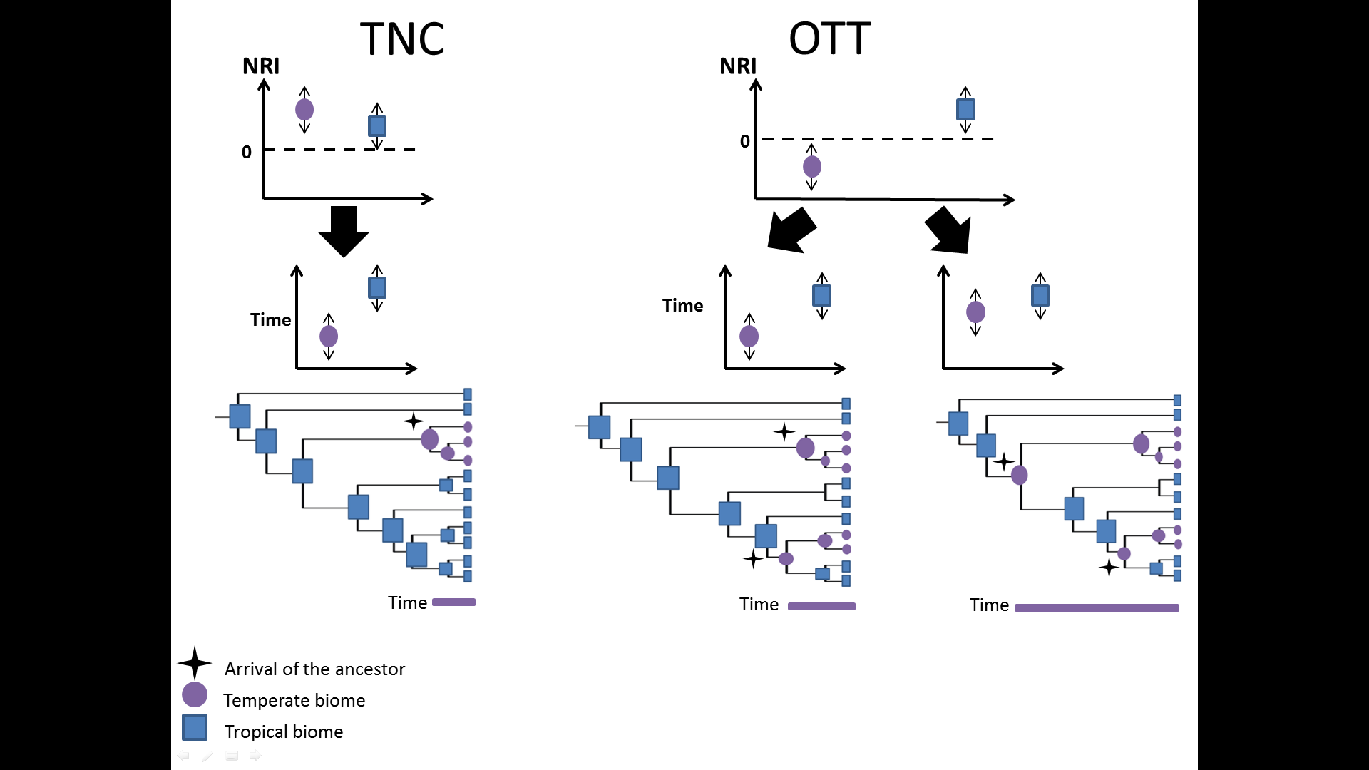

Figure 1: Predictions of values of net relatedness index and the age of the assemblage for temperate biomes. We expected for Tropical Niche Conservatism high values of NRI, indicative of clustering assemblages in temperate biomes. On the other hand, for Out of the Tropics, we expected low values of NRI in temperate assemblages. We also shows that the value of NRI not inform the age of the arrival of the ancestor of the lineage. If, we have this information, we are able to distinguish if the arrival was recent (prediction of TNC) or if the arrival was old.

**METHODS**

***Phylogenetic and geographic data***

We compiled the geographic ranges of 392 species of the family Tyrannidae including both breeding and winter distributions from BirdLife International (BirdLife International and NatureServe 2017). This family is restricted to the New World (Fiztpark 1980). The taxonomy follows Jetz et al. (2012). We used 1000 phylogenetic hypotheses randomly sampled from the Bayesian pseudoposterior distribution, time-calibrated bird tree phylogenies (available at http://birdtree.org; cf. Jetz et al., 2012 for details). These trees are explicitly designed to be used as pseudo-posterior distribution and we constructed a consensus tree using the program R, with the function MaxCladeCred in the package phangorn (Schliep 2011). This approach evaluates each of the sample posterior trees and then computes the relative frequencies with which clade are represented across the set. After that, the product of these scores is taken as the tree’s scores. The tree which has the highest product is the maximum credibility tree, and in this paper, we refer as consensus tree (MCC).

Species composition of assemblages were obtained by dividing the entire America in a gridded area of 110 × 110 km² (~1° × 1° at the equator), excluding islands. We choose this resolution because for well-known taxa, such as birds, the resolution recommended is 110 × 110 km² or higher (Hurlbert & Jetz 2007). We consider as tropical assemblages all the cells positioned between 0 and 23 degrees of latitude, and the cells that had values greater than 23 degrees were classified as temperate assemblages. Then, we rasterized the range maps of BirdLife, which contain the distribution of each species, and the overlap of these range maps gives us the composition of the assemblages and, summing species incidences of each assemblage, species richness.

***Quantifying phylogenetic clustering within latitudinal zones***

To quantify the degree of phylogenetic clustering of the assemblages we used the net relatedness index (Webb *et al.* 2002). Negative NRI values indicated overdispersion and positive values clustering (Webb *et al.* 2002). NRI is standardized measure of the mean pairwise phylogenetic distance of a taxa in a sample, relative to a phylogeny of a species pool, and quantifies clustering of taxa on a tree. It is calculated by:

Where the is the phylogenetic distance between two taxa in the phylogeny of the pool, mn is the mean of all possible pairs *N* taxa*,* andare the mean and standard deviation expected for *N* taxa randomly distributed on the phylogeny of the pool (Webb *et al.* 2002). We randomized species identities 999 times and using the R function ses.mpd in the package *picante* (Kembel *et al.* 2010) we calculated the z-values of mean pairwise distance and then we multiplicity these values by -1 to turn them into NRI values. So, we obtained values of NRI that indicate the degree of phylogenetic clustering or dispersion in the assemblages. We used these values of NRI of each assemblage with the associated latitude of the same assemblage and then compare the values with other cells.

***Calculating the age of the assemblage***

To obtain the age of the assemblage we merge the calculation of when the ancestor arrived in the biome with information obtained through the present composition of each assemblage. Basically, our method requires 1) the ancestral range estimation for each ancestral 2) map in which biome each assemblage is and 3) calculate the age of the assemblages based only on the portion of evolutionary history that arose after the establishment of the ancestral in the biome in which the species are currently found. These steps are explained in detail in the next sections.

1. *Ancestral range estimation*

The first step to construct this framework it is to find when the ancestor arrive in the biome. To access this information we estimated ancestral ranges with the package BioGEOBEARS (Matzke 2013) using a maximum likelihood approach. This analysis requires inform *a priori:* 1) The biomes and 2) the current biome in which the specie is found. So, 1) we choose the classification of biomes proposed by (Olson *et al.* 2001) that consider global maps of floristic, zoogeographic provinces, broad vegetation types, regional maps of units based on the distribution of selected groups of plants and animals and the world’s biotic province maps. This classification divided the terrestrial world into 14 biomes and eight biogeographic realms. For reasons of computational simplicity we aggregated the small and near biomes and after this procedure we have 10 biomes to estimated 2) the species was considered to belong to a maximum of three biomes. If the geographic range of the current species was bigger than three biomes we excluded the biome with the lower occupancy. In BioGeoBEARS, the geographic range is not fixed to a single state; the method considers the combination of biomes. To make the estimative faster we limited the combination of biome to three. So, the package considered, in this situation, the combination of three, two and one biome to estimate the ancestral geographic range. Moreover, in BioGEOBEARS it is possible to evaluate six alternative models (DEC, DEC+J, DIVA, DIVA+J, BayArea, and BayArea+J) to infer the geographic range evolution. Each model makes some assumptions about the process of “dispersal” (range expansion), “extinction” (range contraction) and cladogenesis along phylogeny branches (Matzke 2013). Briefly, the difference among these models are: DEC model (Dispersal-Extinction-Cladogenesis) is a parametric method based on probabilities (Ree *et al.* 2005). At cladogenesis events assumes daughter lineages inherit the ancestral range if the ancestor lives in a single area or if the ancestral is widespread one the daughter lineage will live in a subset of these areas, or one area will split off by vicariance. DEC assumes that one daughter lineage will always have a range of one area (Matzke 2013). DIVA model (Dispersal-Vicariance Analysis) assumes that dispersal and extinction have value of one; otherwise vicariance events have zero cost (Ronquist 1997). So, the difference between DEC and DIVA is: the first, one of the daughter lineages inherits the whole area of its ancestor and the other inherits only a small portion. Otherwise DIVA predicts the classical vicariance, a widely distributed ancestor generates two species in which each species inherits exactly the same number of areas (Ronquist & Sanmartín 2011). So, for that situation, DIVA estimates histories when the evolution of geographic range has been simple: where the speciation was driven by vicariance (Kodandaramaiah 2010). BayArea (Bayesian Biogeographic Inference) is a Bayesian inference which has the principal advantage to include more areas *a priori* (Landis *et al.* 2013) and assumes that no range evolution occurs at cladogenesis events (Matzke 2013). Also, BioGEOBEARS permit to include the additional parameter +J which permit events for founder-event speciation (Jump-dispersal events) in these three models explained. Recently the DEC+ J received criticism because it is a poor model of founder-event speciation and not being statistically comparable to DEC model. Both differ in the relative allocation of explanatory power between cladogenetic and anagenetic events. So, statistical model selection between DEC and DEC+ J should not be done (Ree & Sanmartín 2018). The debate still open and we think in the importance of jump- dispersal event, since birds can fly, and also because that estimations of ancestral distributions in passerines in South America have revealed that models which include jump-dispersal event present best evaluation (Batalha-Filho *et al.* 2014). So, we included this model in our evaluations.

After computing the log likelihood scores of all models, we used the Akaike Information Criteria (AIC) to select the best model of geographic range evolution and then we selected the highest value of the probabilities of ancestral occupy the biome in this selected model. So, we constructed a matrix, called EcoNodes, containing the information where are the past geographical range of the ancestor nodes. In the rows, we will have the node of the phylogeny and in the columns the corresponding occupation of the ancestor for each node.

The matrix Nodes, expressed which species belongs to which node, in the lines the number of each node and the columns the presence or absence of the 392 species of Tyrannidae for each node. The matrix Econodes multiplied by Nodes resulted in a matrix that has the ancestral area associated with each node. In this resulting matrix, we do not have the association of the time the arrival. To access this information, we inserted the values of time. We used the same consensus tree (MCC) dated and then inserted this dates in the lines and the columns the node affiliated (Matrix Time). After that, we had when the ancestors arrived and when the transition for another biome occurred.

1. *Mapping the current biome for each assemblage*

In this step, we have to track where the present species are and compare with the ancestor occupation. To make that we constructed a matrix, Eco, whichcongregates each biome has each assemblages. The classification of biome follows the same criteria used in the ancestral range estimation (Olson *et al.* 2001) and the assemblage is consider a gridded area of 1°x1° resolution resulting in 5565 cells (assemblages). We used a matrix, Composition (W), which gives us the composition of each assemblage. The multiplication of these matrixes results in a matrix that has the correspondent biome associate of each assemblage.

*Calculating the age of the assemblage*

It is important to note that the occupation of the ancestor is based in the occurrence of the actual species. So, if the ancestral occupied another biome in relation of the current range of the specie, the age of the assemblage is not calculated. But if the position of the ancestor is the same as of the present species, we retrocede the occupation until we find one that is different from the current distribution of the species and then we calculated after this event happened. In addition, if the ancestor’s transition occurs after the last-split event, this metric cannot infer the ancestor arrival. So, to indicate events like this, we adopted the value of 0.00001. In this case, if a lineage has a value of 0.00001, it indicates that the transition to another biome occurred after the last-split event. Using the information of the past and the present, step 1 and 2, we calculated the arrival of the ancestor. So, for each species we computed the age of the ancestor and thereafter we calculated the age of the assemblage for each cell.

***Testing OTT and TNC hypothesis***

To test the OTT and TNC hypothesis we applied the One-way Anova with permutation test since this test allowed to tested categorical descriptor (Tropical or Temperate biomes) with quantitative descriptor (NRI and Age of the Assemblages). The one-way Anova compares the means between the groups and means that are statistically significantly different from each other. So, if the test returns statistically significant result, we reject the null hypothesis, because that these groups are statistically significantly different from each other (Legendre & Legendre 2012). Also, One-way Anova permits randomly samples of the data and then finding the *F-statistic* and the *p-value*. The value of *F,* give us, the variance between these two populations are significantly different and the *p-value*, for a given statistical model, the probability that, when the null hypothesis is true, the statistical summary would be greater than or equal to the actual observed result. Using both measures (value of *F* and *p-value*) we are able to distinguish if the null hypothesis is true, in that case, if the assemblages of temperate or tropical biomes are equal. So, we can test TNC and OTT hypotheses. We selected 10.000 permutations for each test: the first, using the values ​​of NRI as variable response and the tropical or temperate biomes as predict variable and the second test, we used the age of the assemblage as response variable and the tropical or temperate biomes as predictor variable.

**RESULTS**

**Tyrant flycatchers species richness**

Following the latitudinal diversity gradient, the 392 species of the family exhibit a strong richness gradient, where the sites with highest richness are found forest habitats (Amazonia and Atlantic Forest).

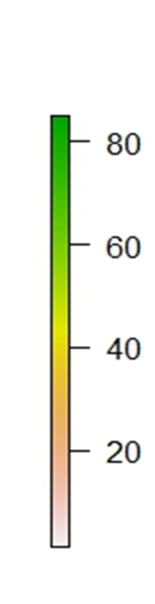 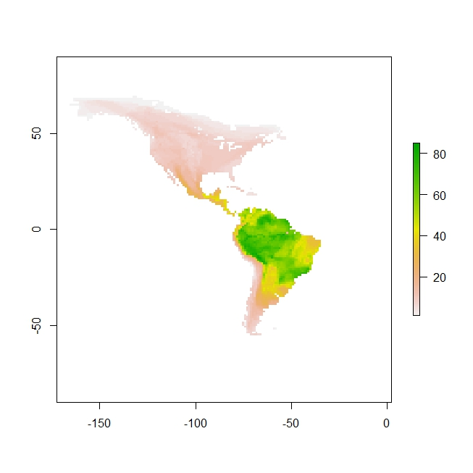

Equator

**Figure 2**: Species richness of 392 species of Tyrannidae. Note that this distribution follows the global pattern of species richness.

**Phylogenetic clustering within latitudinal zones**

We observed (Figure 3) the degree of phylogenetic clustering varies among the latitudinal zones in with some latitudes show greater degree of clustering than others. For example, in the latitude 20º we have the highest values of clustering and in temperate assemblages (latitude higher than 23º) we have positive values of NRI, which means, clustered assemblages. Also, (Figure 4) we have the predominance of positive values of NRI in temperate assemblages. The One-way Anova returned the *F-value* corresponds a 2967.485, the degrees of freedom (DF) were 3830, the *p-value* were 0.00009 and R² 0.4366.

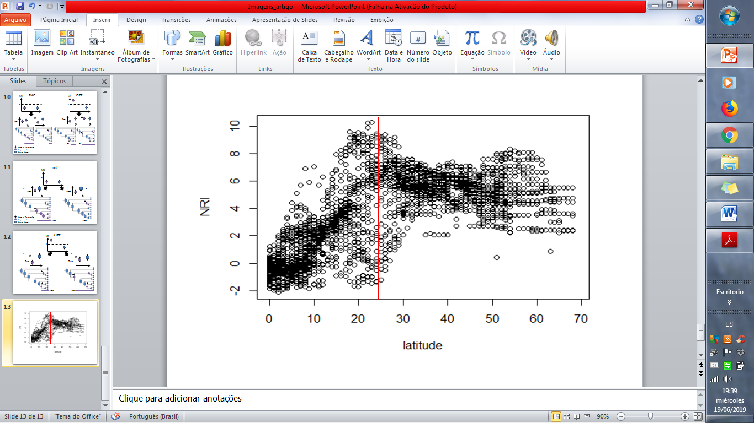

**Figure 3**: Values of NRI across different latitudes. In the equator, we have the lowest value of NRI. After the latitude 23º (Red line), we have the temperate assemblages, that acquired a clustered phylogenetic structure.

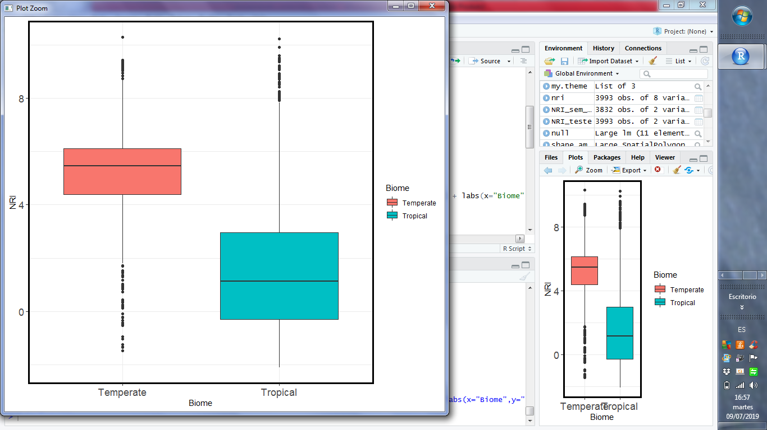

**Figure 4**: Values of NRI in the different biomes. Note that, in temperate assemblages, a predominance of positive values of NRI and in tropical biomes a low value of NRI.

**Age of the assemblage**

*Ancestral range estimation*

The results of the ancestral range estimation were made in the six models (DEC, DEC+J, DIVA, DIVA+J, BayArea, and BayArea+J) and we selected the model which received the lowest AIC score (Table S2) and then we extracted the highest probabilities of the ancestral occupy the biome in the selected model (BayArea+J).

After computing the age of assemblage, we observed (Figure 5) that the recent assemblages are found in temperate biomes. The value of *F* was 724.011, DF was 3991, the *p-value* was 0.00009 and R² 0.5421. So, for the first and the second test, we found a lower value of *F* and a significant value of p (lower than 0.05)*,* which means, that we can reject the null hypothesis in both situations.

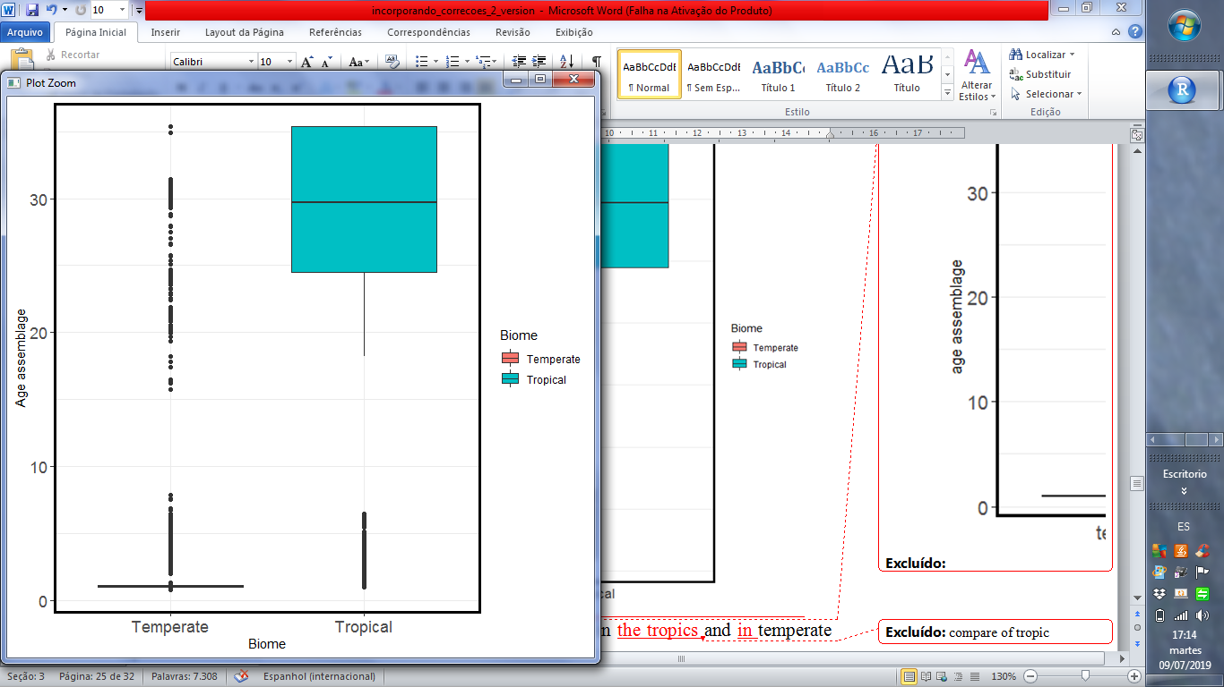

**Figure 5**: Values of the age of the assemblages in the tropics and in temperate biomes. We observed that in tropic assemblages, in average, the highest values of age assemblage and opposite of this, in temperate assemblages, the age is low.

**DISCUSSION**

The TNC and OTT both assume that the major bird clades have the origin in tropical environments and the temperate clades are derived from older tropical clades (Wiens & Graham 2005; Jablonski *et al.* 2006; Jansson *et al.* 2013). However, the TNC predict a few dispersal events and OTT continuous dispersal of lineages into temperate biomes. So, for TNC, the temperate assemblages will be clustered. However, for OTT, the temperate assemblages will be overdispersed (Duchêne & Cardillo 2015). We were able to show that in temperate biomes we have clustered assemblages suggesting that *in situ* speciation is predominant (Crouch *et al.* 2019). The clustered assemblages in temperate biomes are consistent with the expectations of TNC. Also, further support is provided by the age of the assemblage, because in temperate biomes, the assemblages have a recent age. So, the ancestor in the tropics tend to stay in these biomes and in temperate biomes, the dispersal event was recent. But, for TNC the dispersal event is expected occur during the Eocene-Oligocene Climate transition (around 34 Ma) and the values that we found of age assemblage in temperate biomes are lower than that. This is consistent with the evidence of fossil record of avian (Mayr 2004; Manegold *et al.* 2014) and woody angiosperms (Kerkhoff *et al.* 2014) that found the most of temperate lineages should have arisen after the Eocene-Oligocene Climate Transition, when the Earth began to cool and tropical environments contracted relative to the temperate and boreal zones. As consequence of that, our findings are, we have a few and recent lineages in temperate biomes broadly supporting the expectations of the TNC and, less consistent with the expectations of OTT.

It is interesting to note that for this family, the suborder Suboscines appear to originate in austral Gondwana and became isolate in South America when the continent was separated from Antarctica (about 40 Ma) (Kennedy *et al.* 2014) and continuous isolated throughout the Cenozoic era and only South America were joined when the Isthmus of Panama are formed (3-4 Ma), event known as “Great American Biotic Interchange- GABI” (Smith & Klicka 2010), after that a few lineages colonized North America (Ricklefs 2002). This explain why we have many lineages in South America (324 species) and a few in North America (125 species) (Weir *et al.* 2009). The ability to colonize new regions should be difficulty for Tyrannidae because most families that have tropical forest-inhabiting required a completed land to cross South America to North America (Weir *et al.* 2009). So, the interchange of species between South America to North America only succeeds when the Isthmus of Panama was closed since this event creates a completed land to cross. Also, the characteristic of the most Suboscines are there are restricted to rain forest interiors (Kennedy *et al.* 2014) and explain why the dispersal event occur only when the Istmo of Panama are closed, even being birds (Weir *et al.* 2009). This also support the results found: Cluster assemblages in temperate biomes because a few lineages could managed to cross to North America (Ohlson *et al.* 2008) and old age of the assemblage in the tropics. Since the origin of this family is in South America, more specifically, inside tropical rainforests (Ohlson *et al.* 2008). To conclude, our work comes with two caveats. First, the estimation of the ancestral area is based on the results of BioGEOBEARS that could be controversial. In our case, the best probability of the data given the model was BayArea+J. So, we assume that no range evolution occurs at cladogenesis, which means that, the ancestral range is copied to both daughters’ lineages. Also, prior to the ancestral range estimation, we had to classify the biomes. It is essential to note that the classification we used (Olson *et al.* 2001) could express the history of occupation of the ancestor or not. So, the first caveat is: the ancestral range estimation is based on the result of BioGEOBEARS which in turn, is a result of the biome classification adopted and the model used. The second caveat, is the bird’s lack of good fossil record, particularly in tropical biomes (Weir *et al.* 2009), since avian bones are thin and light as a consequence fossilize poorly (Smith & Klicka 2010). Also, more specifically, the fossil record of New World Suboscines is very sparse (Batalha-Filho *et al.* 2014). So, the time-calibrated tree used in this study could be express other information if we had more fossils in our backbone and as a result, the time of the arrival of the ancestor has other value too. For example, other work (Oliveros *et al.* 2019) found different location of the rate shift within *Passerida* placing the shift closer to the initial diverge in crown *Passerida* than in the analyses of Jetz *et al* 2012. So, the results of Oliveros *et al*. indicated that the rate shift occurred several million years earlier than the expected of the phylogeny of Jetz *et al*. and illustrate how the estimation of the ancestor arrived could be early that we expected and maybe affect the results founded.

In our study, we tested two hypotheses for the latitudinal diversity gradient and we found support for Tropical Niche Conservatism. These results support the predictions for TNC, recent and few events of dispersion toward to temperate biomes.

**REFERENCES**

Allen, A.P., Gillooly, J.F., Savage, V.M. & Brown, J.H. (2006). Kinetic effects of temperature on rates of genetic divergence and speciation. *Proc. Natl. Acad. Sci.*, 103, 9130–9135.

Batalha-Filho, H., Pessoa, R.O., Fabre, P.H., Fjeldså, J., Irestedt, M., Ericson, P.G.P., *et al.* (2014). Phylogeny and historical biogeography of gnateaters (Passeriformes, Conopophagidae) in the South America forests. *Mol. Phylogenet. Evol.*, 79, 422–432.

Bini, L.M., Diniz-Filho, J.A.F. & Hawkins, B.A. (2004). Macroecological explanations for differences in species richness gradients: A canonical analysis of South American birds. *J. Biogeogr.*

Cardillo, M., Orme, C.D.L. & Owens, I.P.F. (2005). Testing for latitudinal bias in diversification rates: an example using New World birds. *Ecology*, 86, 2278–2287.

Crouch, N.M.A., Capurucho, J.M.G., Hackett, S.J. & Bates, J.M. (2019). Evaluating the contribution of dispersal to community structure in Neotropical passerine birds. *Ecography (Cop.).*, 42, 390–399.

Cutter, A.D. & Gray, J.C. (2016). Ephemeral ecological speciation and the latitudinal biodiversity gradient. *Evolution (N. Y).*, 70, 2171–2185.

Duchêne, D.A. & Cardillo, M. (2015). Phylogenetic patterns in the geographic distributions of birds support the tropical conservatism hypothesis. *Glob. Ecol. Biogeogr.*

Fitzpatrick, J.W. (1980). Foraging behavior of neotropical tyrant flycatchers. *cooper Ornithol. Soc.*, 43–57.

Gaston, K.J. (2000). Global patterns in biodiversity, 405, 220–227.

Haffer, J. (1969). Speciation in Amazonian Forest Birds. *Science (80-. ).*, 165, 131–138.

Hawkins, B.A. (2001). Ecology’s oldest pattern? *Trends Ecol. Evol.*, 16.

Hawkins, B.A., Diniz-Filho, J.A.F., Jaramillo, C.A. & Soeller, S.A. (2006). Post-Eocene climate change, niche conservatism, and the latitudinal diversity gradient of New World birds. *J. Biogeogr.*

Hawkins, B.A., Field, R., Cornell, H. V, Currie, D.J., Guegan, J.F., Kaufman, D.M., *et al.* (2003). Energy, water, and broad-scale geographic patterns of species richness. *Ecology*, 84, 3105–3117.

Hillebrand, H. (2004). On the Generality of the Latitudinal Diversity Gradient. *Am. Nat*, 163, 192–211.

Hurlbert, A.H. & Jetz, W. (2007). Species richness, hotspots, and the scale dependence of range maps in ecology and conservation. *PNAS*, 104, 13384–13389.

Jablonski, D., Roy, K. & Valentine, J.W. (2006). Out of the tropics: Evolutionary dynamics of the latitudinal diversity gradient. *Science (80-. ).*

Jansson, R., Rodríguez-Castañeda, G. & Harding, L.E. (2013). What can multiple phylogenies say about the latitudinal diversity gradient? A new look at the tropical conservatism, out of the tropics, and diversification rate hypotheses. *Evolution (N. Y).*, 67, 1741–1755.

Kembel, S.W., Cowan, P.D., Helmus, M.R., Cornwell, W.K., Morlon, H., Ackerly, D.D., *et al.* (2010). Picante: R tools for integrating phylogenies and ecology. *Bioinformatics*, 26, 1463–1464.

Kennedy, J.D., Wang, Z., Weir, J.T., Rahbek, C., Fjeldså, J. & Price, T.D. (2014). Into and out of the tropics: The generation of the latitudinal gradient among New World passerine birds. *J. Biogeogr.*

Kerkhoff, A.J., Moriarty, P.E. & Weiser, M.D. (2014). The latitudinal species richness gradient in New World woody angiosperms is consistent with the tropical conservatism hypothesis. *PNAS*, 111, 8125–8130.

Kodandaramaiah, U. (2010). Use of dispersal-vicariance analysis in biogeography - A critique. *J. Biogeogr.*, 37, 3–11.

Landis, M.J., Matzke, N.J., Moore, B.R. & Huelsenbeck, J.P. (2013). Bayesian analysis of biogeography when the number of areas is large. *Syst. Biol.*, 62, 789–804.

Legendre, P. & Legendre, L. (2012). *Numerical Ecology*. Elsevier.

Liu, Z., Pagani, M., Zinniker, D., Deconto, R.M., Huber, M., Brinkhuis, H., *et al.* (2009). Eocene-Oligocene Climate Transition. *Science*, 323, 1187–1190.

Lovette, I.J. & Bermingham, E. (1999). Explosive speciation in the New World Dendroica warblers. *Proc. R. Soc. B Biol. Sci.*, 266, 1629–1636.

Manegold, A., Mayr, G. & Mourer-Chauviré, C. (2014). Miocene Songbirds and the Composition of the European Passeriform Avifauna. *Auk*, 121, 1155–1160.

Matzke, N.J. (2013). Probabilistic historical biogeography: new models for founder-event speciation, imperfect detection, and fossils allow improved accuracy and model-testing. *Front. Biogeogr.*, 5.

Mayr, G. (2004). Old World Fossil Record of Modern-Type Hummingbirds. *Science (80-. ).*, 304, 861–864.

Mittelbach, G.G., Schemske, D.W., Cornell, H. V., Allen, A.P., Brown, J.M., Bush, M.B., *et al.* (2007). Evolution and the latitudinal diversity gradient: Speciation, extinction and biogeography. *Ecol. Lett.*

Mittelbach, G.G., Steiner, C.F., Scheiner, S.M., Gross, K.L., Reynolds, H.L., Waide, R.B., *et al.* (2001). What is the observed relationship between species richness and productivity? *Ecology*, 82, 2381–2396.

Ohlson, J., Fjeldså, J. & Ericson, P.G.P. (2008). Tyrant flycatchers coming out in the open: Phylogeny and ecological radiation of Tyrannidae (Aves, Passeriformes). *Zool. Scr.*, 37, 315–335.

Oliveros, C.H., Field, D.J., Ksepka, D.T., Barker, F.K., Aleixo, A., Andersen, M.J., *et al.* (2019). Earth history and the passerine superradiation. *Proc. Natl. Acad. Sci.*, 201813206.

Olson, D.M., Dinerstein, E., Wikramanayake, E.D., Burgess, N.D., Powell, G.V.N., Underwood, E.C., *et al.* (2001). Terrestrial Ecoregions of the World: A New Map of Life on Earth. *Bioscience*.

Pontarp, M., Bunnefeld, L., Cabral, J.S., Etienne, R.S., Fritz, S.A., Gillespie, R., *et al.* (2019). The Latitudinal Diversity Gradient: Novel Understanding through Mechanistic Eco-evolutionary Models. *Trends Ecol. Evol.*

Rabosky, D.L. & Matute, D.R. (2013). Macroevolutionary speciation rates are decoupled from the evolution of intrinsic reproductive isolation in Drosophila and birds. *Proc. Natl. Acad. Sci.*, 110, 15354–15359.

Rabosky, D.L., Santini, F., Eastman, J., Smith, S.A., Sidlauskas, B., Chang, J., *et al.* (2013). Rates of speciation and morphological evolution are correlated across the largest vertebrate radiation. *Nat. Commun.*, 4, 1–8.

Rabosky, D.L., Title, P.O. & Huang, H. (2015). Minimal effects of latitude on present-day speciation rates in New World birds. *Proc. R. Soc. B Biol. Sci.*, 282.

Rahbek, C. & Graves, G.R. (2001). Multiscale assessment of patterns of avian species richness. *Proc. Natl. Acad. Sci.*, 98, 4534–4539.

Ree, R.H., Moore, B.R., Webb, C.O. & Donoghue, M.J. (2005). A likelihood framework for inferring the evolution of geographic range on phylogenetic trees. *Evolution (N. Y).*

Ree, R.H. & Sanmartín, I. (2018). Conceptual and statistical problems with the DEC+J model of founder-event speciation and its comparison with DEC via model selection. *J. Biogeogr.*, 45, 741–749.

Ricklefs, R.E. (2002). Splendid isolation: Historical ecology of the South American passerine fauna. *J. Avian Biol.*

Rodríguez-Castañeda, G., Hof, A.R. & Jansson, R. (2017). How bird clades diversify in response to climatic and geographic factors. *Ecol. Lett.*

Rohde, K. (1992). Latitudinal Gradients in Species Diversity: The Search for the Primary Cause. *Oikos*, 65, 514.

Ronquist, F. (1997). *Dispersal-vicariance analysis: A new approach to the quantification of historical biogeography*. *Syst. Biol*.

Ronquist, F. & Sanmartín, I. (2011). Phylogenetic Methods in Biogeography. *Annu. Rev. Ecol. Evol. Syst.*, 42, 441–464.

Smith, B.T. & Klicka, J. (2010). The profound influence of the late Pliocene Panamanian uplift on the exchange, diversification, and distribution of new world birds. *Ecography (Cop.).*, 33, 333–342.

Stephens, P.R. & Wiens, J.J. (2003). Explaining Species Richness from Continents to Communities: The Time-for-Speciation Effect in Emydid Turtles. *Am. Nat.*, 161, 112–128.

Webb. (2000). Exploring the Phylogenetic Structure of Ecological Communities: An Example for Rain Forest Trees. *Am. Nat.*, 156, 145–155.

Webb, C.O., Ackerly, D.D., McPeek, M.A. & Donoghue, M.J. (2002). Phylogenies and Community Ecology. *Annu. Rev. Ecol. Syst.*, 33, 475–505.

Weir, J.T., Bermingham, E. & Schluter, D. (2009). The Great American Biotic Interchange in birds. *Proc. Natl. Acad. Sci.*, 106, 21737–21742.

Weir, J.T. & Schluter, D. (2007). The latitudinal gradient in recent speciation and extinction rates of birds and mammals. *Science (80-. ).*, 315, 1574–1576.

Wiens, J.J. & Donoghue, M.J. (2004). Historical biogeography, ecology and species richness. *Trends Ecol. Evol.*

Wiens, J.J. & Graham, C.H. (2005). Niche Conservatism: Integrating Evolution, Ecology, and Conservation Biology. *Annu. Rev. Ecol. Evol. Syst.*, 36, 519–539.

Willig, M.R., Kaufman, D.M. & Stevens, R.D. (2003). Latitudinal Gradients of Biodiversity: Pattern, Process, Scale, and Synthesis. *Annu. Rev. Ecol. Evol. Syst.*

**SUPPLEMENTARY INFORMATION**

**Table S1.** Differences between Tropical Niche Conservatism and Out of the Tropics

|  |  |  |
| --- | --- | --- |
|  | Tropical niche conservatism | Out of the tropics |
| Processes | Diversification and dispersion | Diversification and dispersion |
| Assumption | Time to diversification is greater in the tropics than in temperate biomes | Time to diversification is greater in the tropics than in temperate biomes |
| Geographic origin of the clade | Tropical origins of major groups of organisms | Tropics continually produce lineages and have a frequent movement from tropical to temperate biomes |
| Composition of assemblages in temperate biomes | Endemic and clustered phylogenetically | Species are less closely related and Phylogenetically overdispersed |
| Position in the phylogeny of switching events | Recent, near tips | Anywhere |
| Dispersal | Is rare | Frequent to tropical to extra-tropical but rare in direction to temperate to tropical |

**References:** (Wiens & Donoghue 2004; Jablonski *et al.* 2006; Mittelbach *et al.* 2007; Jansson *et al.* 2013; Duchêne & Cardillo 2015)

**Table S2.** Log likelihood (LnL), Number of parameters, AIC and AIC weight of the six models of ancestral range estimation evaluated from the BioGeoBEARS analyses.

|  |  |  |  |  |
| --- | --- | --- | --- | --- |
| Models | Log likelihood (LnL) | Number of parameters | AIC | AIC_wt |
| DEC | -1872 | 2 | 3748 | 8.7e-107 |
| DEC+J | -1872 | 3 | 3750 | 3.1e-107 |
| DIVALIKE | -2002 | 2 | 4009 | 2.4e-163 |
| DIVALIKE+J | -2003 | 3 | 4011 | 7.6e-164 |
| BAYAREALIKE | -1660 | 2 | 3323 | 1.7e-14 |
| BAYAREALIKE+J | -1627 | 3 | 3260 | 1.00 |

**CONCLUSÃO**

Mostramos a importância de considerarmos os eventos de dispersão e de quando o ancestral de cada espécie chegou ao bioma. Ao analisar estes componentes, conseguimos distinguir duas proeminentes hipóteses que tentam explicar o gradiente latitudinal de riqueza de espécies. Concluímos que nossos resultados apoiam amplamente as expectativas da Conservação de Nicho Tropical e que os resultados são menos consistentes com as predições para a hipótese Fora dos trópicos. Colocando em perspectiva que o tempo para diversificação, à conservação de nicho latitudinal e a dispersão como mecanismos que explicam o gradiente latitudinal de diversidade em aves. Isto trás implicações na distribuição atual da biodiversidade, uma vez que se os trópicos são as origens das linhagens e que se os eventos dispersivos contribuíram para a riqueza encontrada nas zonas temperadas perdas de biodiversidade, nos biomas tropicais, trará consequências evolutivas para todos os biomas.

1. Este artigo segue a formatação da *Ecology Letters* e tem como autores:

   Alina van Dijk, Gabriel Nakamura, Renan Maestri e Leandro da Silva Duarte.