Imprints of tropical niche conservatism in the radiation of Tyrannidae
Alina van Dijk¹, Gabriel Nakamura¹, Arthur V. Rodrigues¹, Renan Maestri¹, Leandro D.S. Duarte¹
¹Programa de Pós-Graduação em Ecologia, Universidade Federal do Rio Grande do Sul, Porto Alegre RS, Brazil.
ABSTRACT
The latitudinal gradient of species richness is a result of either differing rates or differing accumulation of speciation, extinction and dispersal between tropical and temperate regions. Recently, debate revolved around two hypotheses to explain richness gradients of birds, namely the Tropical Niche Conservatism (TNC) and the Out of the Tropics (OTT). Under TNC, an old colonization of the tropical region coupled with infrequent dispersal to temperate regions is the principal driver of birds’ richness gradients. Under OTT, net diversification in the tropical region is higher than in the temperate regions, and dispersal from tropical to temperate regions is frequent. Here, we evaluated the support for each hypothesis during the radiation of New-World Tyrannidae. We mapped Tyrannidae richness across one degree cells (assemblages) through the Americas, and quantified the age and phylogenetic clustering of each assemblage based on a time-calibrated phylogenetic hypothesis coupled with ancestral range estimation. We found that the mean age of tropical assemblages is consistently higher than temperate ones, and that temperate assemblages form a phylogenetically clustered group of species. Both evidences give more support for the TNC than for the OTT hypothesis. We contend that Tyrannidae diversification history was strongly influenced by an historical effect related to the older colonization of the tropical region compared to temperate regions, with probably recent and infrequent events of dispersal to temperate regions. Direct evidences of differential speciation and extinction rates can be further explored helping with additional evidence to distinguish both scenarios.
Keywords: ancestral dispersal, assemblage age, birds, latitudinal diversity gradient, tropical niche conservatism, out of the tropics.
INTRODUCTION
The diversity observed in the tropics is a topic of great attention in ecological agenda (Hawkins 2001, Hillebrand 2004, Wiens and Graham 2005, Jablonski et al. 2006). In situ speciation and historical dispersion are supposed to generate the differences in diversity observed among tropical and temperate regions, and some empirical evidence based on diversity patterns supported the effects of these mechanisms in some groups (e.g. Crouch et al. 2018).
Particularly, two concurrent hypotheses highlight in situ speciation and historical movements of species (historical dispersal) as central mechanisms to explain the diversity in the tropics and its differences regarding temperate regions. While Tropical Niche Conservatism (TNC) assumes that the clades originated in the tropics, diversified locally and then a subset of them spread to temperate biomes (Wiens & Donoghue 2004; Jansson et al. 2013; Duchêne & Cardillo 2015), Out of The Tropics (OTT) suggests that most clades originated in the tropics, but these clades presented frequent dispersion to temperate zones (Jablonski et al. 2006; Mittelbach et al. 2007; Jansson et al. 2013; Duchêne & Cardillo 2015). Therefore, TNC and OTT differ in the timing and frequency of historical dispersal, the first is infrequently and late, whereas the second is frequent and continuous during evolution of species.
Since both OTT and TNC hypothesis are concordant regarding the role of in situ speciation in the tropics, differentiating between them necessarily pass through the estimation of a measure that explicitly consider the timing of migration events (specific time for TNC and diffused for OTT), that is, the timing and importance of historical dispersion. Crouch et al. (2019) argued that the identification of relative importance of in situ speciation and historical dispersal can be identified by calculating a measure of phylogenetic diversity that estimate the mean phylogenetic distance among species in an assemblage (ses.MPD and ses.MNTD (Webb et al. 2002). The rationale behind the use of this metric is that assemblages that present low phylogenetic diversity (positive values of ses.MPD or ses.MNTD) are an indicative of great contribution of in situ speciation (Figure 1A), whereas communities with high phylogenetic diversity than expected by species richness are supposed to be assembly mainly by events of historical dispersal. However, the amount of phylogenetic diversity in an assemblage does not indicate the ways in which diversity arose, if by means of historical dispersion or in situ speciation, that is central to differentiate between TNC and OTT hypothesis (Figure 1B).
Figure 1 illustrate the problem regarding the use of MNTD or MPD to infer the relative importance of past events of historical dispersion and in situ speciation. Suppose two communities (island 1 and island 2), both presenting low phylogenetic diversity. Following to the proposition of Crouch et al. (2018) both islands are shaped mainly by in situ speciation, since the ancestors of the present-day species came from the same island. However, the same phylogenetic pattern could be obtained by events of historical dispersion (B) if the ancestors of present-day species came from other island than that we observed in current distribution of species, and this information would not be available by only account for current patterns of phylogenetic diversity revealed by any metric.
In this work we propose a new approach that explicitly consider the timing of migration events to differentiate among the two situations presented in Figure 1. Assemblages shaped mainly by in situ speciation must present more ancient assemblages than assemblages in which the historical dispersion plays an important role, since in situ speciation is a consequence of the conservatism of the occurrence area of the lineage during its evolutionary trajectory (Figure 1A). Otherwise recent assemblages will indicate that historical dispersion among areas are an important factor to generate the observed pattern of phylogenetic diversity, since the ancestors changed their habitat to the new one that we current observe the occurrence of that species. The new framework proposed here were used to test the two hypothesis that explicitly consider the timing and frequency of historical dispersal: OTT and TNC. Expectations regarding phylogenetic patterns and assemblage ages accordingly OTT and TNC are presented in Table S1.

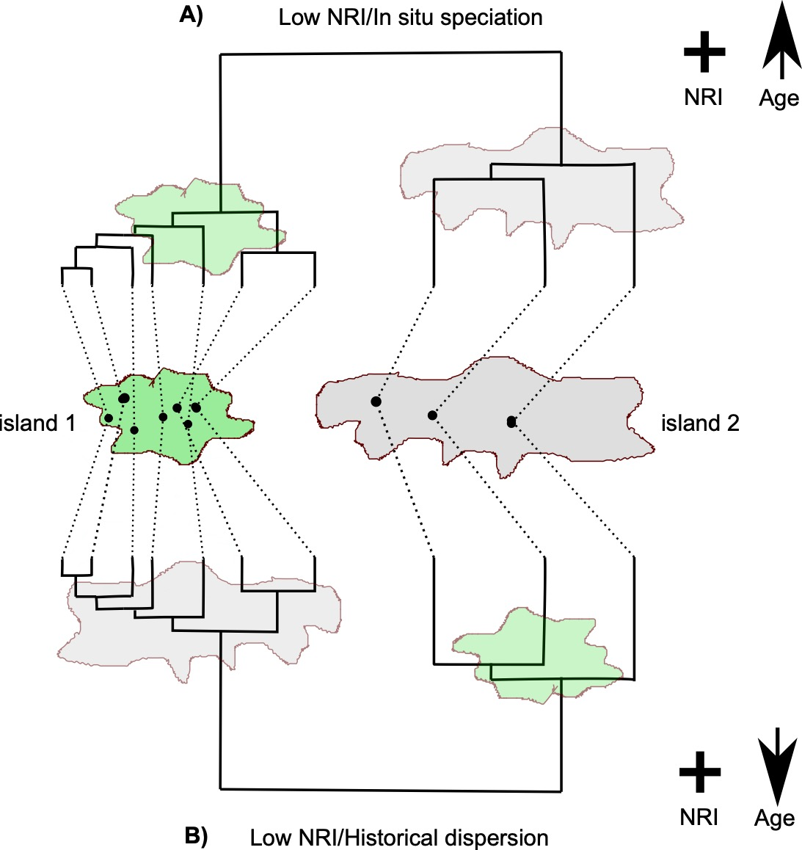
Figure 1: Two scenarios showing assemblages in two islands. Both A and B presented low phylogenetic diversity accordingly to NRI metric (positive values), however, in A the assemblages are older than in B, indicating that in the second, the role of historical dispersal was more important than in situ speciation.
METHODS
We test OTT and TNC using Tyrannidae family. Tyranidae is an ideal group to investigate the predictions of these two hypotheses because of its widespread geographic distribution and high species richness across the Americas. Tyrannids are members of the Suborder Suboscine; the latter originated in austral Gondwana and became isolated in South America when the continent was separated from Antarctica (about 40 Ma) (Kennedy et al. 2014). The family Tyrannidae has its origin probably inside tropical rainforests in South America (Ohlson et al. 2008) and presents a restricted distribution in the New World. This family is known to be one of the largest and most diverse bird families in the world. It shows a great diversity of body forms and ecological roles that made them a good model for a series of studies on evolutionary radiations in a group of continental birds (Fitzpatrick, 1980). Additionally, as ecology, behavior and life histories of birds are relatively accessible (ref), American tyrannids enable us to study the roles of phylogenetic conservatism and key innovations in the development of a regional fauna (Ricklefs 2002).
The area of study is the America continent, since the geographic range of Tyrannidae species is restricted to this continent (Fiztpark 1980). The continent was subdivided in grid cells of 1 degree (~110 km² near the equator), excluding islands. These cells were classified as tropical (below 23° of latitude) and temperate (above 23° of latitude).
Species data
We compiled the geographic ranges of 392 species of the family Tyrannidae including both breeding and winter distributions from BirdLife International (BirdLife International and NatureServe 2017). Based on these maps, we generate assemblages for each grid cell in the American continent. The evolutionary relationship among species was based in a consensus phylogenetic tree using Maximum Clade Credibility (MCC) method (Heled and Bouckaert 2013). This method evaluates the frequency in which a clade is represented in a set of phylogenetic trees. The product of frequency values for the clades of a tree is the score of Clade Credibility for the phylogenetic tree. Therefore, the consensus phylogenetic tree is the tree with the highest product of clade frequency among the set of phylogenetic trees. For this, we used 1000 phylogenetic hypotheses randomly sampled from the Bayesian pseudo-posterior distribution, time-calibrated bird tree phylogenies (available at http://birdtree.org; see Jetz et al., 2012 for details). The consensus tree was chose among 1000 trees using the MaxCladeCred function from phangorn package (Schliep 2011) in R (R Core Team, 2018).
Ancestral area reconstruction
Since OTT and TNC predictions specifies the timing and frequency in which species disperse from tropical to temperate regions we used reconstruction of the ancestral area of the Tyranidae species in South America continent based on its occurrence in biomes using BioGeoBEARS package (Matzke 2013). We adapted the biomes classification proposed by Olson et al. (2001) aggregating small and near biomes, in order to come up with 10 biomes. This was done to overcome limitations imposed by BioGeoBEARS, that allows the character reconstruction for a maximum of 10 character states.
We estimate the ancestral area of Tyranidae species based on six model presented in BioGeoBEARS. The parsimony‐based Dispersal‐Vicariance Analysis (DIVA) (Ronquist 1997), emphasizes the vicariance process in speciation. DIVA assumes that the area of daughter species is a part of the areas of the ancestral species (vicariance), unless the ancestor occupies a single area, then sympatry is allowed. The Dispersal‐Extinction Cladogenesis (DEC) model (Ree and Smith 2008) assumes that both vicariance and sympatry could origin daughter species. In DEC model the area occupied by a daughter species could be the same of its ancestor or a subset of the ancestor’s area. However, DEC model assumes that new species could occupy only one of the ancestor’s areas, in both sympatry and vicariance processes. The BayArea model (Landis et al. 2013) assumes that speciation occurs only in sympatry, then the daughter species occupy the same areas of its ancestor, which can be single or multiple areas. Other three models are provided by including the founder effects to all models previous described. Thus, in these models a daughter species could ‘jump’ to new area, not occupied by its ancestor. These models are coded including a ‘+J’ to the model abbreviation.
We allowed that each species can belong up to three biomes, based on the most frequent biomes that a species occurs. After run all six models we conduct model selection using Akaike Information Criterion to discriminate which one provides the best estimation of ancestral areas. The best ranked model of ancestral area estimation was used for the calculation of time arrival of species’ lineage in a biome.

Quantifying phylogenetic patterns
We quantified the phylogenetic diversity of the assemblages calculating net relatedness index (NRI) (Webb et al. 2002). NRI is the standardized measure of the mean pairwise phylogenetic distance among species in an assemblage and quantifies how much cluster or overdispersed are the species of an assemblage. Negative NRI values indicates overdispersion, i.e. species in an assemblage are less related than expected by chance, and positive NRI values indicates clustering, i.e. species in an assemblage are more related than expected by chance (Webb et al. 2002). NRI is calculated as follow:
$$NRI= -1* \frac{{\overline{X}}_{obs }- {\overline{X}}_{N}}{sd(X_{N})}$$
where the ${\overline{X}}_{obs }$ is the mean phylogenetic distance between two taxa in the observed assemblage, ${\overline{X}}_{N}$ is the mean phylogenetic distance between two taxa in the expected assemblage under null model, and $sd(X_{N})$ is the standard deviation of ${\overline{X}}_{N}$ (Webb et al. 2002). We calculated NRI with ses.mpd function of the picante package (Kembel et al. 2010), using 999 randomization of species identities in the phylogenetic tree.
Mean age of assemblages
In order to access if the observed NRI for assemblages is a result of in situ speciation or historical dispersal we calculate the mean age of assemblages from arrival times that each species´s lineages reach the assemblages. The arrival time was computed as the node age of the most ancient ancestor in which its descendants also occupied the biome of the assemblage. When the most recent ancestral of a species was estimated to occupy a different biome than the occupied by the current species in the assemblage of interest, we assign an arrival time of 1 x 10⁻⁵ Ma. Thus, we assume that when the dispersion occurred after the last speciation event in the tree, the time of arrival was very recent. After obtained the age for all species in all biomes, the mean age of the assemblage is the mean of the arrival time of species to the biome of the assemblage.

Data analysis
To evaluate the OTT and TNC hypothesis, we tested for differences in NRI and mean age of assemblage between Tropical and Temperate assemblages with one-way non parametric Anova (Legendre XXXX), and complementary a regression model with latitude as a predictor of NRI values (Appendix 2, Figure S2). We also spatialized the results of NRI and mean age for all Tyranidae assemblages of America continent. All analysis was conducted in R environment (R Core Team, 2018) and all codes and functions used are available at .
RESULTS
The Tyranidae assemblages presented a strong richness gradient with highest richness are found near the Equator and at forest habitats (Amazonia and Atlantic Forest) (Figure 2).
Equator
Figure 2: Species richness gradient for the 392 species of Tyrannidae.
We selected the BayArea+J as the model to represent the ancestral biome of species (Table S2).
We observed a difference in phylogenetic diversity among temperate and tropical regions (F= , p= ), with a predominance of phylogenetic clustering in temperate and overdispersion in tropical regions
(Figure 3). The mean age of assemblages also differed between tropical and temperate regions (F= , p= ), with temperate region presenting more recent assemblages than tropical region. Particularly, in the tropical region, we also noted that the most ancient assemblages are located at tropical forests (Amazon and Atlantic forests), whereas temperate regions host the most recent assemblages, furthermore, we identify an area with intermediate ages separating South and North America (Figure 4b).

Figure 3: Boxplots showing the NRI values (a) and mean age of assemblages (b) for temperate and tropical communities.

Figure 4: NRI (a) and age of assemblages (b) for Tyranidae assemblages.

DISCUSSION
Understand the effects of deep past acting on contemporary community includes the description of patterns of phylogenetic diversity (Gerhold et al. 2018), however, the process-by-pattern approach is limited regarding the mechanisms that can be evoked to explain the phylogenetic diversity patterns of present day assemblages (Gerhold et al. 2015). Here we show that analyzing only the patterns of phylogenetic clustering or overdispersion through NRI does not allow to account for the relative importance distinct historical processes (in situ speciation and historical dispersion), as previous stated by other works (Crouch et al. 2019).
The methodological improvement presented in this work that joins the phylogenetic diversity assessment with ancestral state reconstruction tools, allowed to evidence TNC as the most probable explanation to explain the phylogenetic diversity patterns and historical events that conducted to differences among tropical and temperate Tyranidae assemblages. Without an approach that joins the information bring by ancestral character reconstruction and present patterns of phylogenetic diversity, the differentiation between competing hypothesis that have as fundamental information the past events become impossible by using only phylogenetic metrics that considers the state of present day species.
The rationale of combining the age of assemblage with community phylogenetic metrics was previously presented by Pinto-Ledezma et al. (2019) as an alternative to find for historical explanation for the phylogenetic structure of Furnaridae species. However, the approach adopted by the authors differs from ours in operational and conceptual way. Operationally, the age of assemblages was calculated as being the length of tip branches in the tree, that brings a difference to the meaning of our assemblage age measure, that allows to a direct assessment of how long an assemblage is occupied by the lineages of species observed in the present. Pinto-Ledesma et al (2019) argues that the age of assemblage can be a proxy for diversification rates (sensu Jetz et al. 2012a). Since our measure of assemblage age holds a different meaning, it can be a complementary approach for the study of historical process in structuring assemblages.
Our results evidenced that the ages of temperate assemblages are most recent than pointed out in other works. Duchêne and Cardillo (2015) defend that the dispersal events under TNC hypothesis occurred during the Eocene-Oligocene climate transition (around 34Ma). Despite the discrepancy among our results and that found by Duchene and Cardillo (2015) our results are consistent with the fossil rec ord of avian (Mayr 2004, Manegold et al. 2014) and wood angiosperms (Kerkhoff et al. 2014), that support the idea that most of temperate lineages should have arisen after the Eocene-Oligocene climate transition, when the Earth began to cool and tropical environmental shrank in a relative comparison to temperate and boreal zones. As consequence, a few and recent lineages were found in temperate biomes, supporting the expectations of the TNC and less consistent with the expectations of OTT.
It is interesting to note that the suborder Suboscines, appears to originate in austral Gondwana and became isolated in South America when the continent was separated from Antarctica (about 40 Ma) (Kennedy et al. 2014). In the Cenozoic era South America continued isolated and only joined North America when the Isthmus of Panama are formed (~3-4 Mya) in the event known as “Great American Biotic Interchange- GABI” (Smith and Klicka 2010). After that a few lineages of Tyrannidae have colonized North America (Ricklefs 2002). Our results are concordant to the history of colonization of Tyranidae family, since we can note older assemblages in South America (with approximately 35Mya) and newer assemblages in North America (~3Mya) with an transition area containing assemblages with intermediate ages among these two continents (Figure 4b). This result evidence the importance of in situ speciation in South America continent and historical migrations in North America.
The ability to colonize new regions should be difficulty for Tyrannidae because this family have a tropical forest-inhabiting and most families that have tropical forest-inhabiting required a completed land to cross (Weir et al. 2009). So, the interchange of species between South America to North America only succeeds when the Isthmus of Panama was closed since this event creates a completed land to cross (precisa de ref aqui). Also, the characteristic of the most Suboscines, is that they are restricted to rainforest interiors (Kennedy et al. 2014) and explain why the dispersal event occur only when the Istmo of Panama are closed, even though bird have the capability of flying (Weir et al. 2009). Thus phylogenetically clustered and recent assemblages in temperate biomes evidence that a few lineages managed to cross to North America after the connection with South America allowed by the Istmo of Panama (Ohlson et al. 2008). Our study brings a different interpretation to explain the phylogenetic structure of Tyranidae assemblages bring by Crouch et al (2019), in which the authors asserts that phylogenetic clustering is an indicative of in situ speciation process.
Some caveats must be highlighted. First, the estimation of the ancestral area is based on the results of BioGEOBEARS that can present different outcomes depending on the model choose to perform the character reconstruction. In our case, the best support was found for BayArea+J model. We assumed that no range evolution occurs at cladogenesis, which means that the ancestral range is copied to both daughters’ lineages. Despite this caveat, our framework allows to use the results came from other models of character reconstruction, however the test of different models and its effects on the estimates of ages of assemblages is out of the scope of the present work.
The second caveat is the lack of good fossil record, particularly in tropical biomes (Weir et al. 2009), since avian bones are thin and light as a consequence fossilize poorly (Smith and Klicka 2010). Also, more specifically, the fossil record of New World Suboscines is very sparse (Batalha-Filho et al. 2014). For example, the results of (Oliveros et al. 2019) indicated that the rate shift within Passerida occurred several million years earlier than the expected of the phylogeny of (Jetz et al. 2012b). Finally, the time-calibrated tree used in this study could express different information if we had more fossils in our backbone and, as a result, the time of the arrival of the ancestor could be early that we expected and maybe affect the results founded.
In summary, our work overcome an problem relating to the use of pattern-to-process approach to infer the role of historical mechanisms to shape ecological communities (in situ speciation and historical dispersal), by explicitly consider the information of ancestral states of species to interpret the present day phylogenetic information. This improvement allows to evidence that TNC is the most probable process to explain the differences in phylogenetic patterns presented among temperate and tropical regions for Tyranidae.

References

Fitzpatrick, J.W. (1980). Foraging behavior of neotropical tyrant flycatchers. cooper Ornithol. Soc., 43–57.
Batalha-Filho, H. et al. 2014. Phylogeny and historical biogeography of gnateaters (Passeriformes, Conopophagidae) in the South America forests. - Mol. Phylogenet. Evol. 79: 422–432.
Crouch, N. M. A. et al. 2019. Evaluating the contribution of dispersal to community structure in Neotropical passerine birds. - Ecography (Cop.). 42: 390–399.
Duchêne, D. A. and Cardillo, M. 2015. Phylogenetic patterns in the geographic distributions of birds support the tropical conservatism hypothesis. - Glob. Ecol. Biogeogr. in press.
Gerhold, P. et al. 2015. Phylogenetic patterns are not proxies of community assembly mechanisms (they are far better). - Funct. Ecol. 29: 600–614.
Gerhold, P. et al. 2018. The Deep Past Controls the Phylogenetic Structure of Present, Local Communities. - Annu. Rev. Ecol. Evol. Syst. 49: 477–497.
Hawkins, B. A. 2001. Ecology’s oldest pattern? - Trends Ecol. Evol. in press.
Heled, J. and Bouckaert, R. R. 2013. Looking for trees in the forest: Summary tree from posterior samples. - BMC Evol. Biol. in press.
Hillebrand, H. 2004. On the Generality of the Latitudinal Diversity Gradient. - Am. Nat 163: 192–211.
Jablonski, D. et al. 2006. Out of the tropics: Evolutionary dynamics of the latitudinal diversity gradient. - Science (80-. ). in press.
Jetz, W. et al. 2012a. The global diversity of birds in space and time. - Nature 491: 444–448.
Jetz, W. et al. 2012b. The global diversity of birds in space and time. - Nature 491: 444–448.
Kembel, S. W. et al. 2010. Picante: R tools for integrating phylogenies and ecology. - Bioinformatics 26: 1463–1464.
Kennedy, J. D. et al. 2014. Into and out of the tropics: The generation of the latitudinal gradient among New World passerine birds. - J. Biogeogr. in press.
Kerkhoff, A. J. et al. 2014. The latitudinal species richness gradient in New World woody angiosperms is consistent with the tropical conservatism hypothesis. - PNAS 111: 8125–8130.
Landis, M. J. et al. 2013. Bayesian analysis of biogeography when the number of areas is large. - Syst. Biol. 62: 789–804.
Manegold, A. et al. 2014. Miocene Songbirds and the Composition of the European Passeriform Avifauna. - Auk 121: 1155–1160.
Matzke, N. J. 2013. Probabilistic historical biogeography: new models for founder-event speciation, imperfect detection, and fossils allow improved accuracy and model-testing. - Front. Biogeogr. in press.
Mayr, G. 2004. Old World Fossil Record of Modern-Type Hummingbirds. - Science (80-. ). 304: 861–864.
Ohlson, J. et al. 2008. Tyrant flycatchers coming out in the open: Phylogeny and ecological radiation of Tyrannidae (Aves, Passeriformes). - Zool. Scr. 37: 315–335.
Oliveros, C. H. et al. 2019. Earth history and the passerine superradiation. - Proc. Natl. Acad. Sci.: 201813206.
Olson, D. M. et al. 2001a. Terrestrial Ecoregions of the World: A New Map of Life on Earth. - Bioscience 51: 933.
Olson, D. M. et al. 2001b. Terrestrial Ecoregions of the World: A New Map of Life on Earth. - Bioscience in press.
Pinto-Ledezma, J. N. et al. 2019. Drivers of phylogenetic assemblage structure of the furnariides, a widespread clade of lowland neotropical birds. - Am. Nat. 193: E41–E56.
Ree, R. H. and Smith, S. A. 2008. Maximum likelihood inference of geographic range evolution by dispersal, local extinction, and cladogenesis. - Syst. Biol. 57: 4–14.
Ricklefs, R. E. 2002. Splendid isolation: Historical ecology of the South American passerine fauna. - J. Avian Biol. in press.
Ronquist, F. 1997. Dispersal-vicariance analysis: A new approach to the quantification of historical biogeography. - Syst. Biol. 46: 195–203.
Smith, B. T. and Klicka, J. 2010. The profound influence of the late Pliocene Panamanian uplift on the exchange, diversification, and distribution of new world birds. - Ecography (Cop.). 33: 333–342.
Team, R. C. 2018. R: A language and environment for statistical computing. - R Found. Stat. Comput. Vienna, Austria. in press.
Webb, C. O. et al. 2002. Phylogenies and Community Ecology. - Annu. Rev. Ecol. Syst. 33: 475–505.
Weir, J. T. et al. 2009. The Great American Biotic Interchange in birds. - Proc. Natl. Acad. Sci. 106: 21737–21742.
Wiens, J. J. and Graham, C. H. 2005. Niche Conservatism: Integrating Evolution, Ecology, and Conservation Biology. - Annu. Rev. Ecol. Evol. Syst. 36: 519–539.

