**Introduction**

Because we want to explain people how dating platforms work and why they are so successful.

**Content**

Dating platforms, are websites or apps, where you can find someone you like or find attractive, by turning on a filter to find people with your personal preferences. You can easily create an account and put your information in it, height, eye color, etc. Example: Parship, Loovo and Tinder.

Our website should describe following topics:

* History
  + Why are they so popular?
  + Difference between big dating platforms
* Definition
* Pros and Cons

**Wireframe**

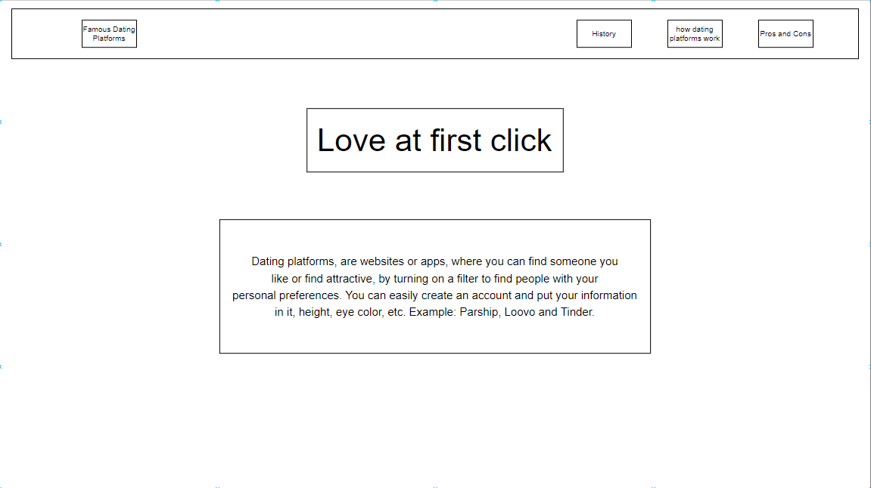

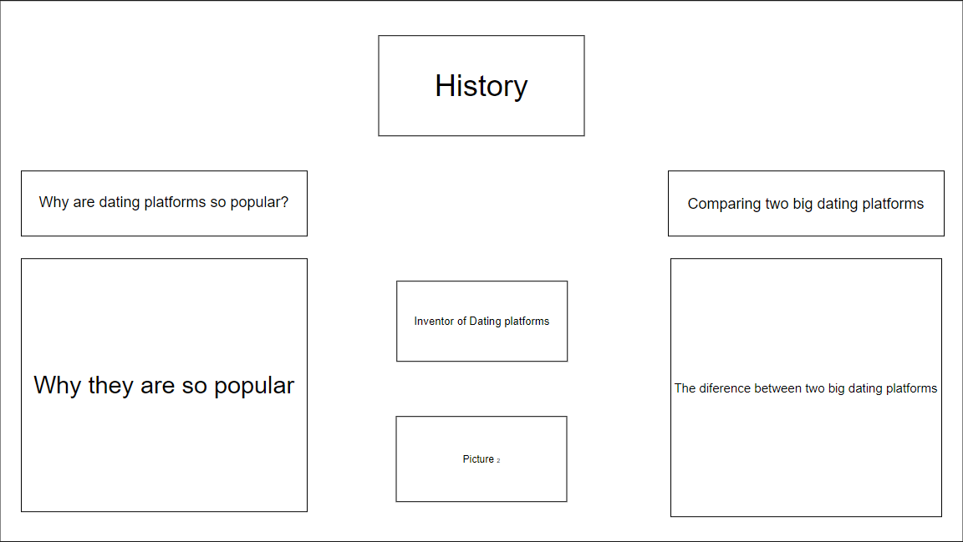

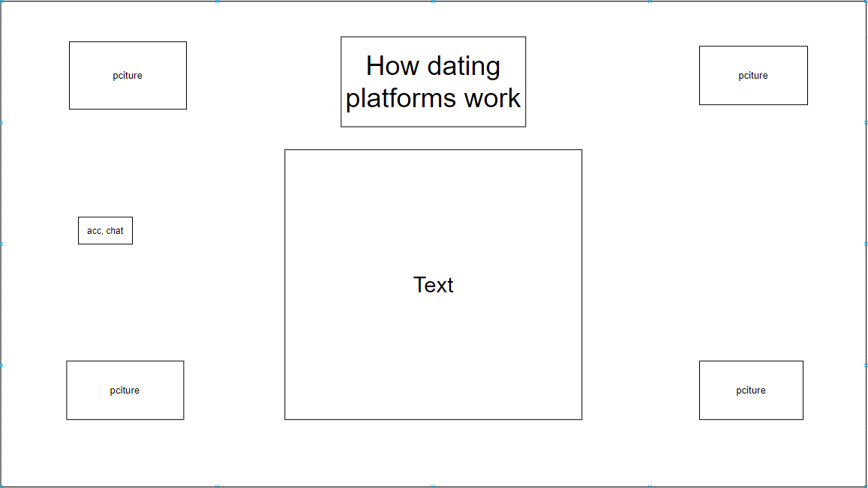

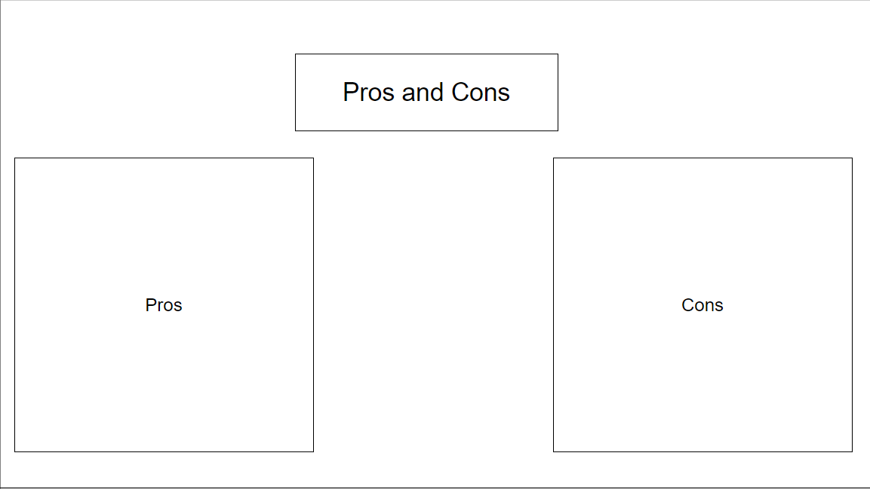

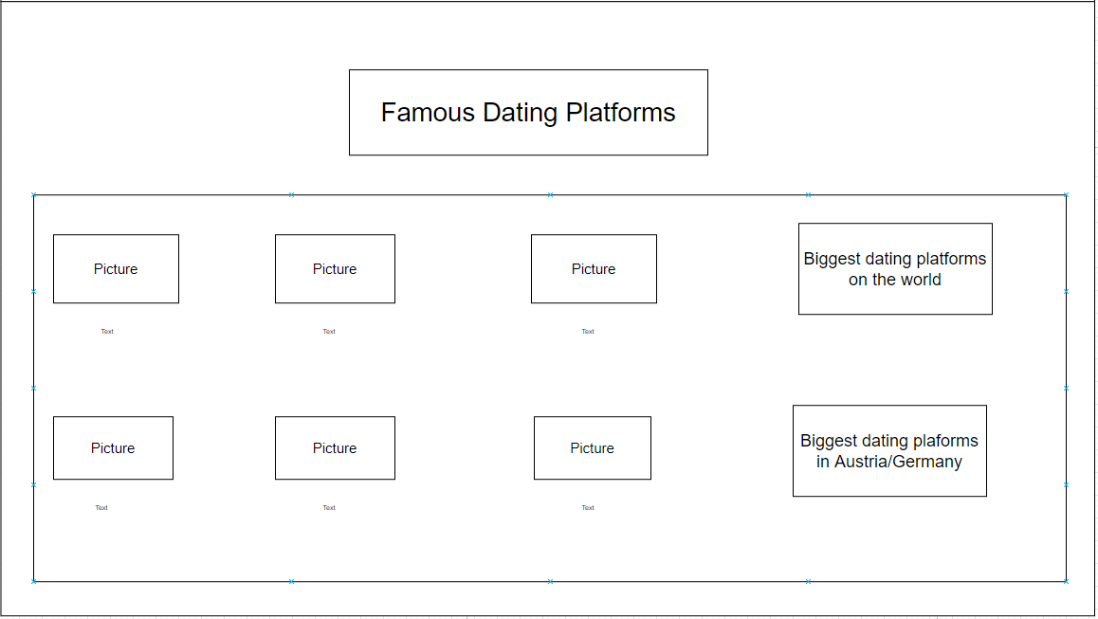

**Web application**

You can create an account (birthday, appearance, etc.),you can accept/ decline people, you can chat with people.

**What are our abilities?**

* Basic HTML
* Basic CSS
* C#
* Basic C

**Requirements**

* Advanced HTML
* Advanced CSS

**What Programs do we need?**

* Google Chrome (for the testing and debugging of the website)
* Atom (text editor)

**Planning**

* The project needs to be finished at the end of the school year.
* History page: 25.01.21
* Definition page: 01.02.21
* Pros and Cons page: 08.02.21
* Famous Dating platforms page: 15.02.21