Installation Instructions:

1. Right click the zip folder and extract it. Inside is a folder.
2. Paste contents of entire folder into this directory: "C:\Program Files\ScrapTabletNetworkSettings"
   1. You should be able to paste the entire folder.
   2. Make sure you do not extract the folder into another file with the same name.
   3. “C:\Program Files\ScrapTabletNetworkSettings\ScrapTabletNetworkSettings” will not work

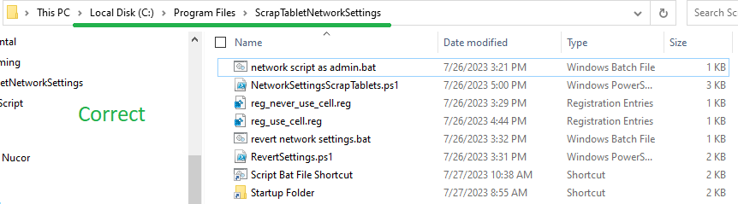

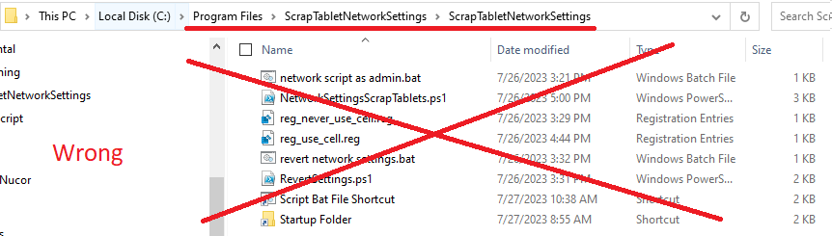

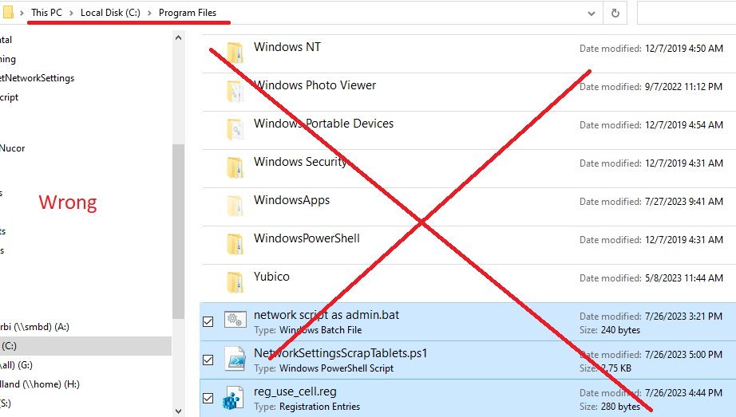

1. In that folder *must* be the files:
   1. “network script as admin.bat”
   2. “networkSettingsScrapTablets.ps1”
   3. “reg_use_cell.reg”
2. Copy/Paste the batch file shortcut into the startup folder:
   1. C:\ProgramData\Microsoft\Windows\Start Menu\Programs\StartUp
   2. Both shortcuts should be in the zip file. If they do not exist, right click the batch file and press “create shortcut”.
   3. Everything should look like below.

1. This is complete. Every restart this script will run. A powershell prompt will pop up for about 10 seconds.