Statistical Interpretations and Graphics
The Script-Based Language R

Gabriel Sorensen
SUU CSIS 4550

Abstract: This paper examines the design and implementation choices of the R language as compared with Java and C++ as well as the benefits it offers users as a computing language.
Keywords: R, Language, Programming, Data Modeling, Graphics

Introduction (“R”, and why it should be used)

Just about every letter in the English alphabet has a programming language attached to it, from A+ to Z++; and this paper considers the language R. R is vastly more popular now than it was when it first was created in New Zealand at the University of Auckland. By Ross Ihaka, and Robert Gentleman in 1993 they named the language according to the letters of their first names and also as a homage to the language S. R is an object-oriented, imperative, functional, procedural, reflective language modeled after S combined with the semantics and lexical scoping of Scheme. This language was created as a solution to large data and statistics computing, much like S was designed to do the same by being a forefront to writing full FORTRAN to model data. R is a GNU project meaning it is open source. The language was released as “stable” (version 1.0) in February of 2000 for Unix, Linux, and Windows; with Mac support being added in December of 2001 (version 1.4)[1].

Terminology
There are a few terms that are important to being successful writing in R, most of which comes from documentation. The CRAN ( Comprehensive R Archive Network ) is the central hub where one can find the installer packages, source-code, packages, news, FAQs, and documentation. Another important point to make is that R is an interpreted language, meaning there is no “compiled” files and everything is entered into a command line for R similar to Windows' command prompt or Unix/Linux's terminal. This gives the language a huge flexibility in interactivity. For example, a programmer could open an R command prompt and type this example code in and then get an answer.
> # The arrow is the command input line
> # This is a comment
> 25 # print a number
[1] 25 # [1] is the output of our singular line input
> 6 - 3 # perform a calculation
[1] 3
> log(2) # natural log which is a native function to R
[1] 0.6931472
R is also filled with the concept of flexible scripting, i.e. there are many ways to write a script in R. As a general rule lines are individual statements, if and loop statements execute the following line if true, and functions will return the last variable used. However, R does support formatting similar to Java where statements are terminated with a semicolon, and most structures (functions, classes, if-else statements, and loops) can have their contents enclosed in curly braces if multiple lines need to be evaluated in the course of execution. Consider the following code example:
> x <- 100
> if (x > 50 ) print(“x is greater than 50.”)
[1] “x is greater than 50.” # method 1

and
> x <- 12;
if (x > 30) {
x <- 3;
print(“x is less than 30, and was assigned a value of 3.”);
}
[1] “x is less than 30, and was assigned a value of 3.” # method 2
Both examples are valid R code so it is important to pick a style that you want and stick to it as to not confuse yourself and others that might eventually read your code. [9]

Variables
In R everything is an object, either a symbolic object (pointer to a value), or a variable. In the underlying source of R (written in C) all objects in R are C pointers to specific structures with a C type definition of SEXPREC. [2?? link to CRAN html ref] All objects in R cannot be directly accessed in memory, but can be accessed through the named reference that created the object. Names in R are effectively unlimited (most likely depends on the hardware), case sensitive (“a” and “A” are two different variable names), and in most cases all alphanumeric symbols are allowed (includes most accented characters although discouraged for portability) as well as using “.” and “_” with the special restriction that a name must start with a “.” or a letter, and if a name does start with a dot the following character must not be a digit.
The R language is much like Java in that it tries to keep the user in a virtual environment that can abstract things like memory management, garbage collection, typing, and scoping away from the developer allowing a closer relation of the developer with the data and how it is changed, viewed, and presented. R has an environmental hierarchy view for scoping as well as using curly braces to block off statements from others. In R the developer can create an environment inside of the current R environment to encase logic and variables away from the parent environment, which can be useful in creating packages or other structures. By default, running R from a command line or without specifying the environment, R sets the system to run everything in the global environment which is the head parent of all the environments and can be accessed from anywhere using the globalenv() command.

Strings, Collections, and Data Frames
One other interesting part of R is that variables are dynamically typed, and can be any of 12 types. There are your basic logic types (TRUE, FALSE), numerics (0, 5.7, pi, etc...), complex (3+4i), character ('c', “hey”, ' '), matrices (of one type, a special vector type), arrays(which in R are treated as vectors with a dimension of 1), and lists/collections (the names are interchangeable, and are arrays, but not locked to a singular type). There are also the special types: NULL (a single pointer to nothing, shared by all nulls as an empty pointer), functions (anything that returns a variable, including functions making this language functional), data frames (which are lists of lists, or a generalized matrix of sorts), and factors (nominals, a tricky form used to map values to sets). The important types that R brings to light are vectors (which includes arrays and matrices) and data frames. R was built to preform large amounts of calculations on data sets that could possibly contain hundreds of thousands of values[5]. Most times these large data sets will be contained in data frames. So when thinking of data frames, the best way to explain them is to imagine an excel spreadsheet. In fact R's standard packages include various ways to take various spreadsheet files and parse them into data-frames for ease of use. R by default comes with some sample data-frames in its datasets package and viewing the sample data-frame “mtcars” by using View(mtcars) gives us the result in fig 1.
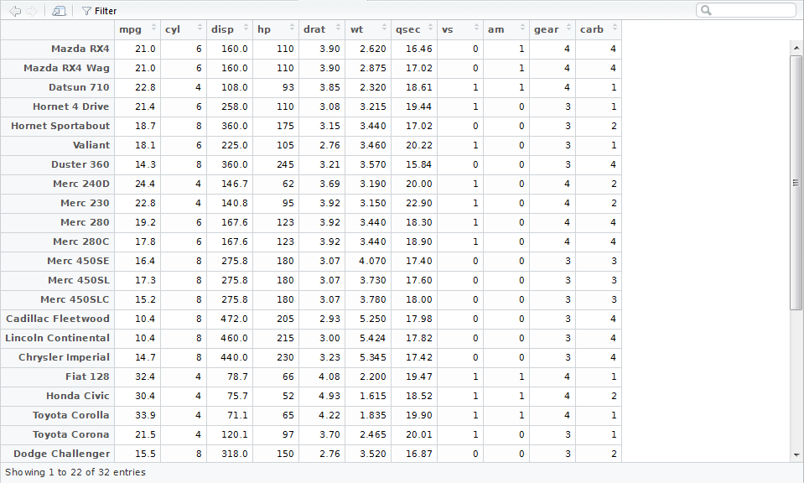fig 1. Sample data frame. [ View(mtcars) ]

There are also a plethora of mistakes and nuances of R that should be noted as a beginner to the language. The first thing to note is the assignment operator “<-”, this is not seen in many other languages, but is the preferred assignment operator. Although “=” is just as acceptable it can only be used at the top level (read. Not inside a compiled package or library). There are also the assignment operators “<<-” and “->>” which are reassignment operators. These reassignment operators are used mostly in functions where internal variables are created and accessed, because in R everything is immutable[6] and by reassigning a variable that already exists duplicates the variable in memory unless the garbage collector has already eaten it. The immutability of variables is important to note, specifically in the context of functions, where these functions can not modify the actual data of the parameters passed to it. Another big common mistake is forgetting what variables have been created in the current environment or workspace. Most R editors will let you save the state of the workspace, which includes variables.[3] So if you have created a variable “X” previously and forgot to reassign or recreate the variable in the current environment, you could end up with garbage data. The last common mistake that many beginners make is that the values “NULL”, “NA”, 0, “”, and “NAN” are each used in unique cases and where those values show up makes a huge difference in the data.

Control and Flow
R does not have goto statements, which is a big deal in control and flow of programming design. People will see a goto statement and instantaneously tell you that the code is bad. Or conversely, they might call your language garbage. There has been little need for control statements like goto and gosub since languages like BASIC and COBOL became replaced by newer languages with greater control structures such as: if, else, ifelse, for, while, repeat, break, next, and continue. It has been studied by many programmers and many influential ones have said time and time again that GOTO is generally a bad idea. William Wulf has specifically said, “the goto statement in programming language is a principal culprit in programs which are difficult to understand, modify, and debug.“.[8]

Subprograms and Parameters
In R there is no main function in which everything is sequentially run, instead R reads one line at a time and computes from the top down. This allows for the programmer to effectively move through the data and get out the information that they might need. It would be simple for a programmer to type the following and produce a visual graph for a data-frame:
> fileToRead <- file.access(“Example.csv); # assume that Example.csv exists
> data-frame1 <- read.csv(file = fileToRead, header = TRUE, sep = ",", quote = "\"", dec = ".", fill = TRUE, comment.char = "");
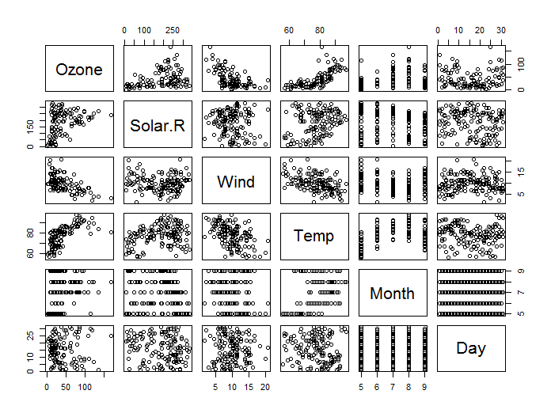
> plot(data-frame1);
which gives us a graph plot that might look something similar to this.

A programmer could create a main-like function that is the only function run as the R script that contains all the subsequent functions, variables, and expressions. However, this would add an unnecessary layer and barrier to R being the flexible interpreted language it is. Functions in R do not have to return a value, although not specifying a return value means that the language will decide what variable gets returned to the caller, and functions that are run do not have to have their return value saved. Suppose you wanted a function that modified a global variable (globals are frowned on in R), you could then make a function as follows:
> # assume that numOfCows is a global variable
> addOneCow <- function() {
numOfCows <- numOfCows + 1;
return(0); # or numOfCows will be returned
}
> addOneCow(); # this will increment the global variable
> thisNum <- addOneCow(); # or we do not have to save the function output
> thisNum;
[1] 0

Conclusion
There is an increasing need of data analysts and tools to model, analyze, and interpret data. R provides a simple way to preform data visualizations and computations on the fly, and by being a flexible, extensible language that programmers can spend more time with the data rather than with the semantics of the language. With its simple syntax, great garbage-collection (for ease of variable and memory use), and large package selection, there is not much R can't do just as well as other languages. If R still doesn't sound like it would be ideal for you, remember that most R objects can be directly interfaced in most other languages. And with the language still growing and packages still appearing R will be one of the top data analysis languages for a while to come.[4]

References
- The Comprehensive R Archive Network https://cran.r-project.org/src/base/NEWS
- Tal Yarkoni, The Master Troll of Statistical Languages, http://www.talyarkoni.org/blog/2012/06/08/r-the-master-troll-of-statistical-languages
- A. F. Zuur and E. N. Ieno, A beginner's guide to R. Dordrecht: Springer, 2009.
- J. King and R. Magoulas, 2015 Data Science Salary Survey, Third. Sebastopol, CA: O'Reilly Media Inc., 2015.
- S. J. Eglen, “A Quick Guide to Teaching R Programming to Computational Biology Students,” PLoS Comput Biol PLoS Computational Biology, 2009.
- H. Wickham, “Mutable objects in R,” Comput Stat Computational Statistics, pp. 405–418, 2011.
- H. Wang, P. Wu, and D. Padua, “Optimizing R VM,” Proceedings of Annual IEEE/ACM International Symposium on Code Generation and Optimization - CGO '14.
- W. A. Wulf, “A case against the GOTO,” Proceedings of the ACM annual conference on - ACM '72.
- P. Burns, The R Inferno. 2011. http://www.burns-stat.com/documents/books/the-r-inferno/

