BookLoop

Use-Case Model

Version 1.0

Revision History

|  |  |  |  |
| --- | --- | --- | --- |
| **Date** | **Version** | **Description** | **Author** |
| 18 Mar 2021 | 1.0 | The initial main use cases for the application. | Stancu Gabriel - Iulian |
|  |  |  |  |
|  |  |  |  |
|  |  |  |  |

Table of Contents

1. Use-Cases Identification 4

2. UML Use-Case Diagrams 5

# Use-Cases Identification

**Use case:** login into the application’s main screen

**Level:** user-goal

**Primary actor:** registered / unregistered user (reader)

**Main success scenario:** enter the login screen, type username and password, login

**Extensions:** login failed because of: unregistered user (the user should create an account in the sign up interface), bad password, bad username (in these two cases the user retries the credentials for logging in).

**Use case:** take part in the books’ cycle

**Level:** sub - function

**Primary actor:** registered user (reader)

**Main success scenario:** from the main screen, search for books of interest, enter book post, start chat with seller with intent to buy / exchange

**Extensions:** add / remove posts related to your own books

**Use case:** socialize using the application

**Level:** sub - function

**Primary actor:** registered user (reader)

**Main success scenario:** from the main screen, chat with contacts from your list

**Extensions:** add / remove contacts, chat with people from groups you belong to

# UML Use-Case Diagrams

1. Enter the application

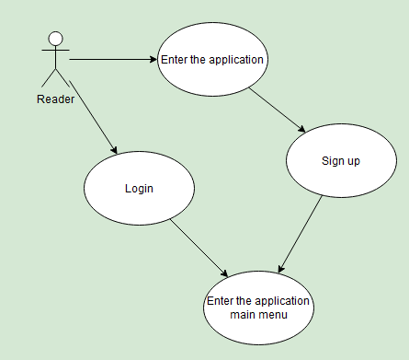

1. Take part in books’ cycle

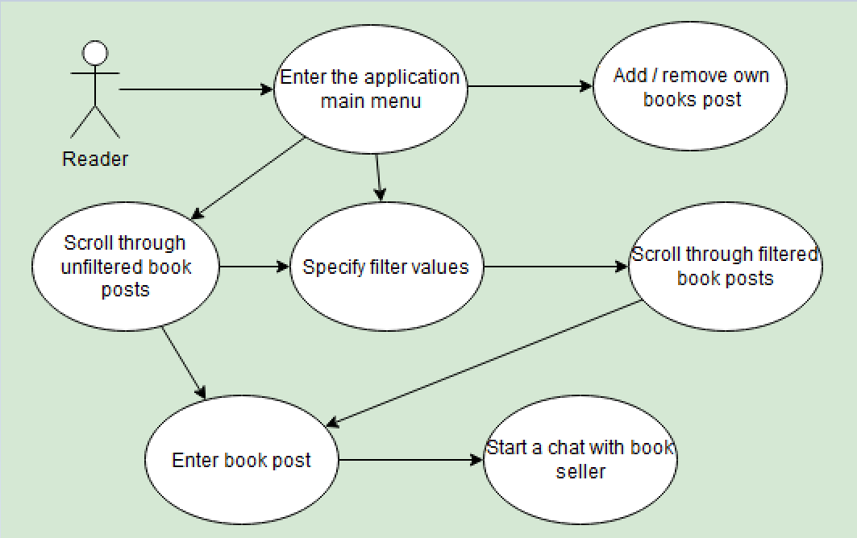

1. Socialize using the application

