*Blackjack*

-documentation-

Toma Gabriel-Francisc, IE, sg6

1. **Summary**

The Application Blackjack allows you to play the blackjack casino card game against a simulated dealer or against a friend that sits next to you, Of course, there is no gambling with actual money involved.

1. **Goal and potential users**

The goal of the application is to simply help the time pass when you’re bored with a few rounds of blackjack with either a dealer or a friend. Or you can also use you to test or ‘sharp’ your blackjack skills. The potential user can be anyone who enjoys this type of card game without having to gamble any money.

1. **Introduction**

Once you open the application you can choose one of the two options of game mode. Playing against a dealer which is simulated by the game, or playing with a friend in a ‘local mode’.

1. **State of art**

At the moment, there are multiple apps available on the mobile app markets where you can play blackjack, most of them being inside of applications that represent casinos, but also there are many applications where you can simply ‘simulate’ the game without having to put any money into it. And then of course, the game can also be played with a real deck of cards in the real world.

1. **The original contribution of the author**

* The functions that reproduces the card drawing effect for the player and the dealer
* The GUI (it’s as simple as it can be, so I doubt there will be questions about it being plagiarized)
* Most of the code ( with a few exceptions where I went on the stack overflow website for some help)

1. **Development plan**

For this application the main program used was Android Studio which provides a user-friendly interface even for the newcomers in the app development area, providing you instant access to the code itself aswell as the xml layouts.

* 1. **Explaining the user interface**

-The main menu that presents the two game modes

- Regardless of the choice you make, you will be redirected to a player activity where you will be able to see the first card you drew from the deck and two buttons, a draw and a stop button. The draw buttons draws you another card and it gets added up to your score. You can keep drawing cards as long as you don’t surpass the score limit (21). In case you jump over 21, in both cases you will receive an alert that says that you lost and you will be redirected to the main menu. Once you press stop, a new activity will be displayed and depending on the game mode you chose earlier the following screens will show:

- The dealer screen where you will see the dealer drawing cards and stopping at some point, in the end comparing your scores and displaying the winner.

- An identical screen of the one of the player where the 2nd player can draw cards and stop at any point he wishes. The outcome will be again an alert that displays the winner, whether he is player1 or player2.

INTERFACE

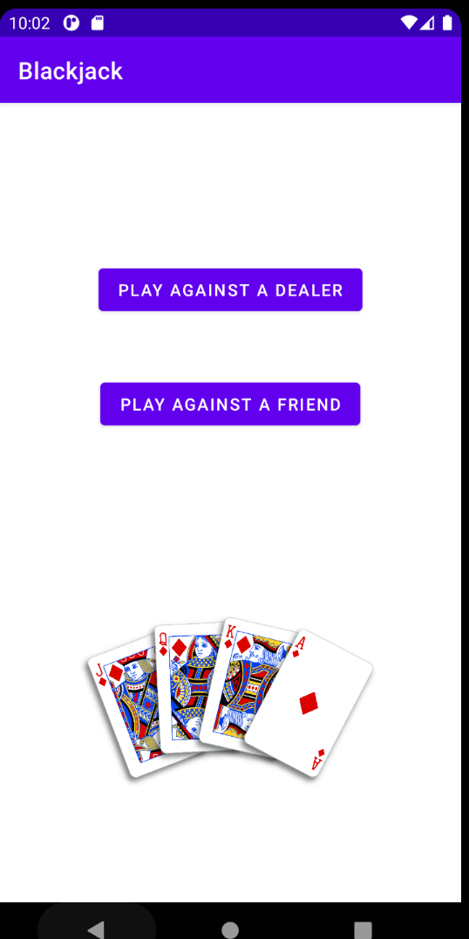 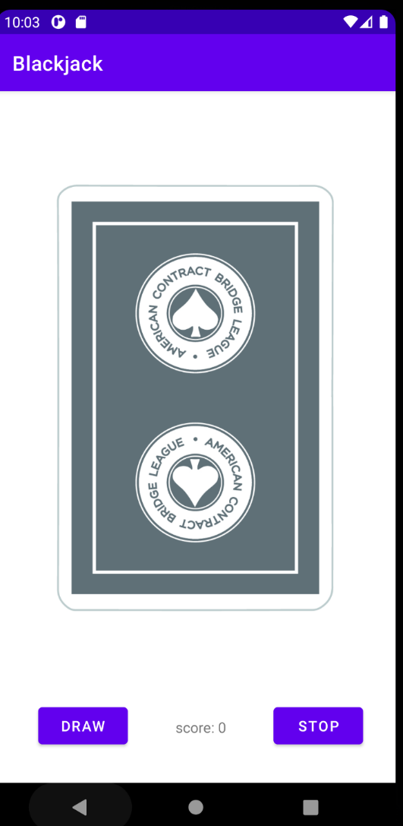 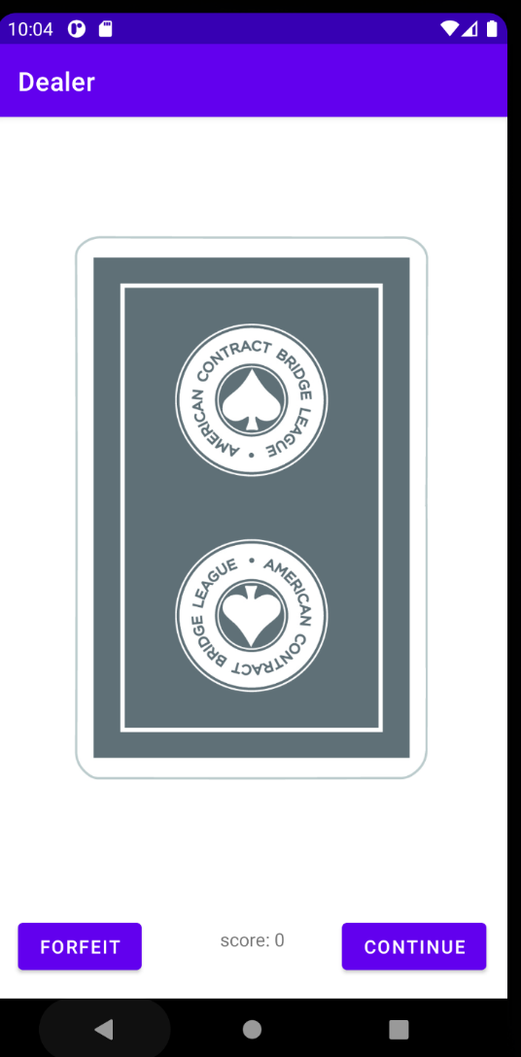 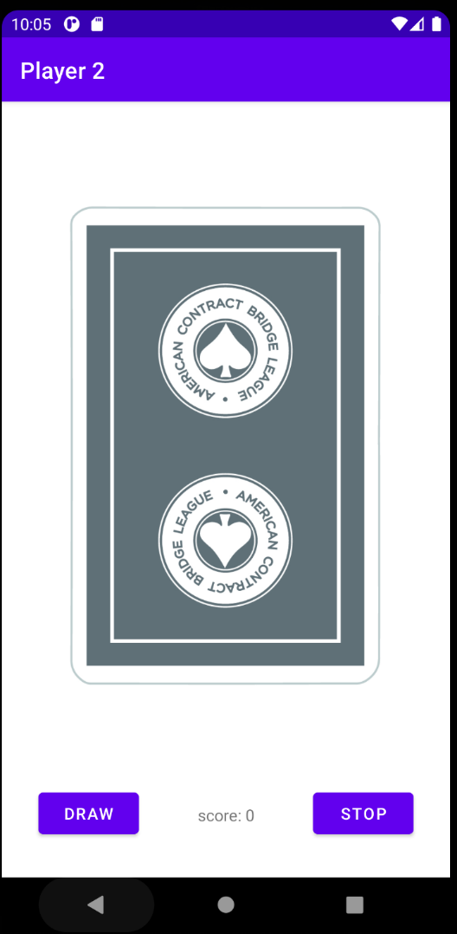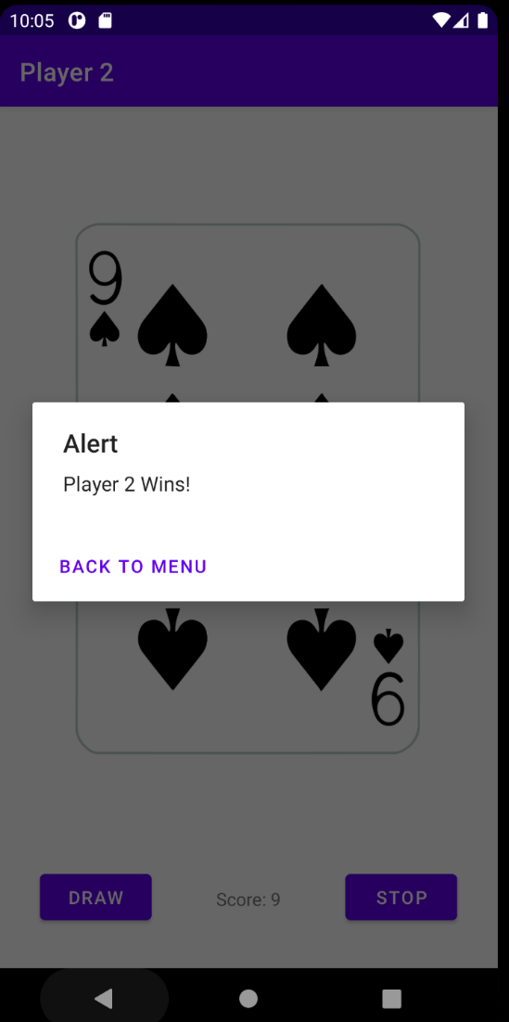 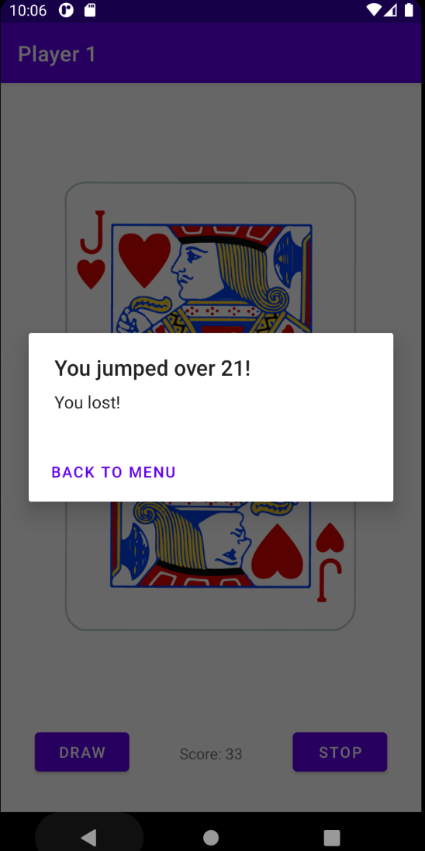

1. **References**

[1] <https://developer.android.com/studio/intro>

[2] <https://stackoverflow.com/questions/768969/passing-a-bundle-on-startactivity> (And several more links that helped me building the app)

[3] <https://my-learning.w3schools.com/courses/?tut=java>

[4] <http://acbl.mybigcommerce.com/52-playing-cards/>