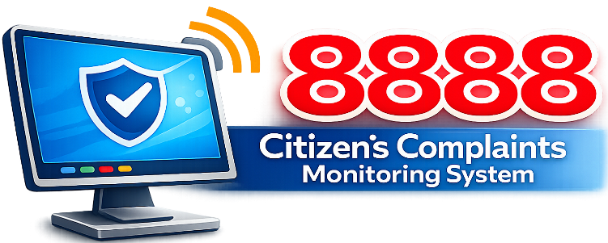


DILG 8888 Citizen Complaints Monitoring
System User Manual

Admin / Encoder
Full System Access — Admin Account Guide

Department of the Interior and Local Government
April 2026

Table of Contents
1. System Overview ……..……………………………………………………………..3
1.1 User Roles ……..……..…………………………………………………………….3
1.2 Elapsed Time - Row Color Indicator ……..……………………………………...3
1.3 Complaint Status Flow ..……..……………………………………………………3
1.4 How to Log in ………..……………………………………………………………..4
1.5 How to Log out ……..……………………………………………………………...5
2. Admin / Encoder Guide ……..……………………………………………………..6
2.1 Dashboard ……..…………………………………………………………...……..6
3. Managing Complaints ……..………………………………………………...…….6
3.1 Adding a New Complaint ……..…………………………………………......6 - 8
3.2 Complaint List ……..……………………………………………………………...8
3.2.1 Comment a Complaint ……..……………………………………………..9 - 10
3.2.2 Viewing a Complaint ……..……………………………………………...11 - 12
3.2.3 Editing a Complaint ……..……………………………………………….12 - 13
3.2.4 Deleting a Complaint ……..……………………………………………..13 - 14
3.3 Requesting a Revision ……..……………………………………………...15 - 17
3.4 Marking a Complaint as Complete ……..………………………………...17 - 18
4. Managing Users ……..……………………………………………………….…...19
4.1 Adding a New User ……..………………………………………………….19 - 20
4.2 Editing a User ……..……………………………………………………………..20
4.3 Deactivating a user ……..……………………………………………………….21
5. Quick Reference: Role Permissions ……..……………………………………..22
6. Troubleshooting & FAQS ……..………………………………………………….22
6.1 Common Issues ……..…………………………………………………………..22

1. System Overview
The DILG 8888 Citizen Complaints Monitoring System is a web-based platform designed for the Department of the Interior and Local Government to efficiently track, manage, and resolve citizen complaints referred to local government units (LGUs). The system operates through a unified login portal shared across all modules (DILG Portal, DILG 8888 Complaint Manager, and DILG Elista System), ensuring a consistent and secure session for all users.

1.1 User Roles
There are three (3) distinct roles in the system. Each role has specific permissions and responsibilities:
Role | Display Name & Description
Encoder | Admin - Full system access. Can add, edit, delete complaints; manage users; view all records; request revisions; and mark complaints as complete.
Responder | LGU - Municipal responder. Can acknowledge complaints assigned to their municipality, upload resolution PDFs, and view their complaint history.
MLGOO | MLGOO - Municipal Monitoring. Can view complaints and monitor status for their assigned municipality.

1.2 Elapsed Time — Row Color Indicator
The color highlight applies to the entire complaint row in the Complaints List. It is based on how many days have passed since the Date Sent (counted from today, not from resolution).
Row Color | Condition | Mean
No Color (White) | 0 - 1 Day or Same Day | Complaint is new or recently sent. No urgency.
Yellow | 2 Days | Warning — complaint is approaching the deadline. LGU should respond soon.
Red | 3 Days | Urgent — complaint has been unresolved for too long. Immediate action needed.

1.3 Complaint Status Flow
Every complaint moves through a defined lifecycle:
Status | Meaning
REFERRED | Complaint has been encoded and assigned to a municipality. Awaiting LGU acknowledgment.
PENDING | LGU has reviewed the complaint and has uploaded a resolution. Waiting for encoder review.
FOR CORRECTION | Encoder has requested changes to the uploaded resolution. LGU must re-upload.
COMPLETE | Encoder has reviewed and accepted the resolution. The complaint is closed.

1.4 How to Log In
- Open your web browser and navigate to the system URL provided by your administrator, you will be redirected to the Core login page. You will be redirected to the Core login page. 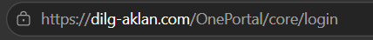
- Enter your Username and Password.
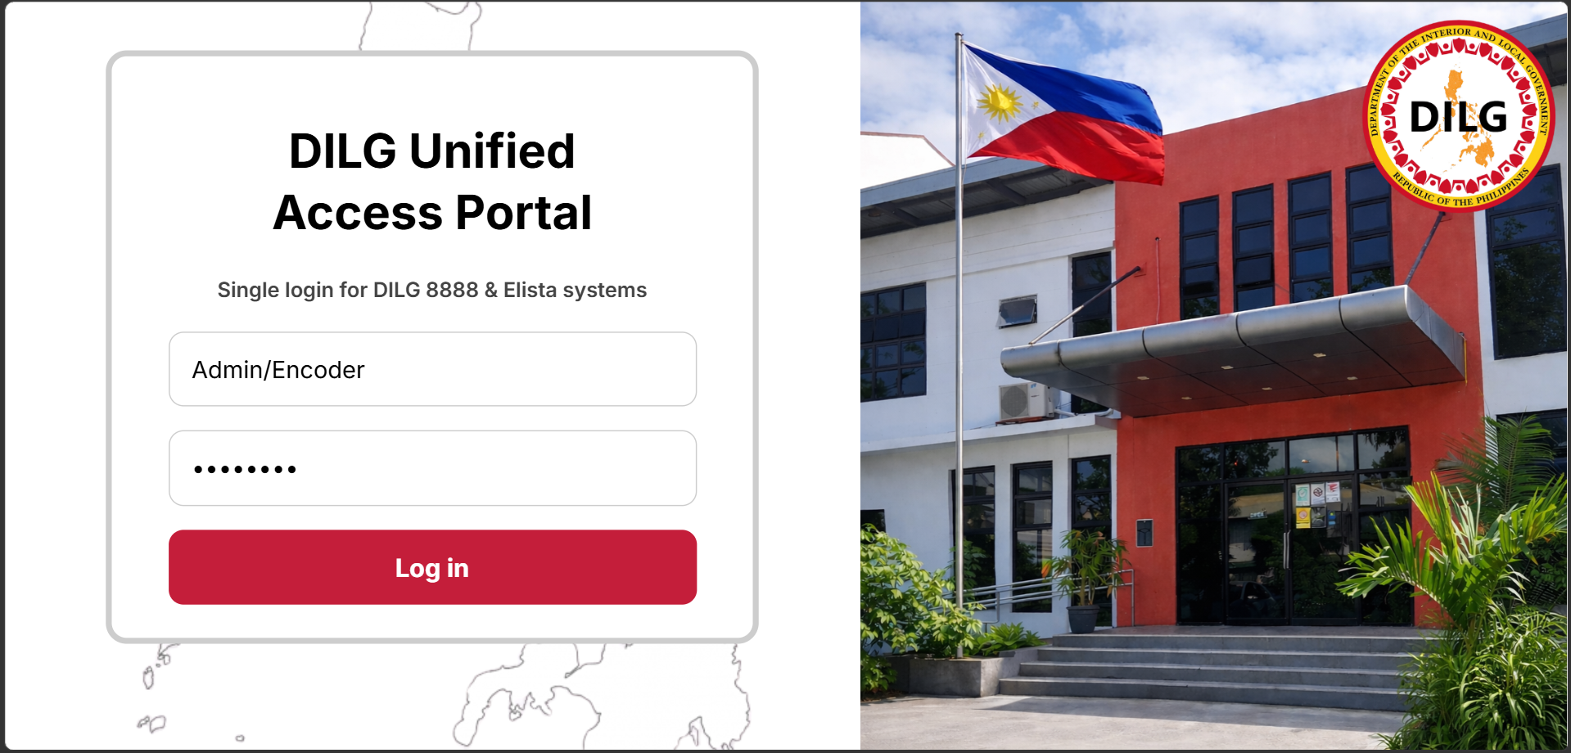
- Click the Log in button. The website will redirect you to the DILG Portal.

- Select “Open DILG 8888”.
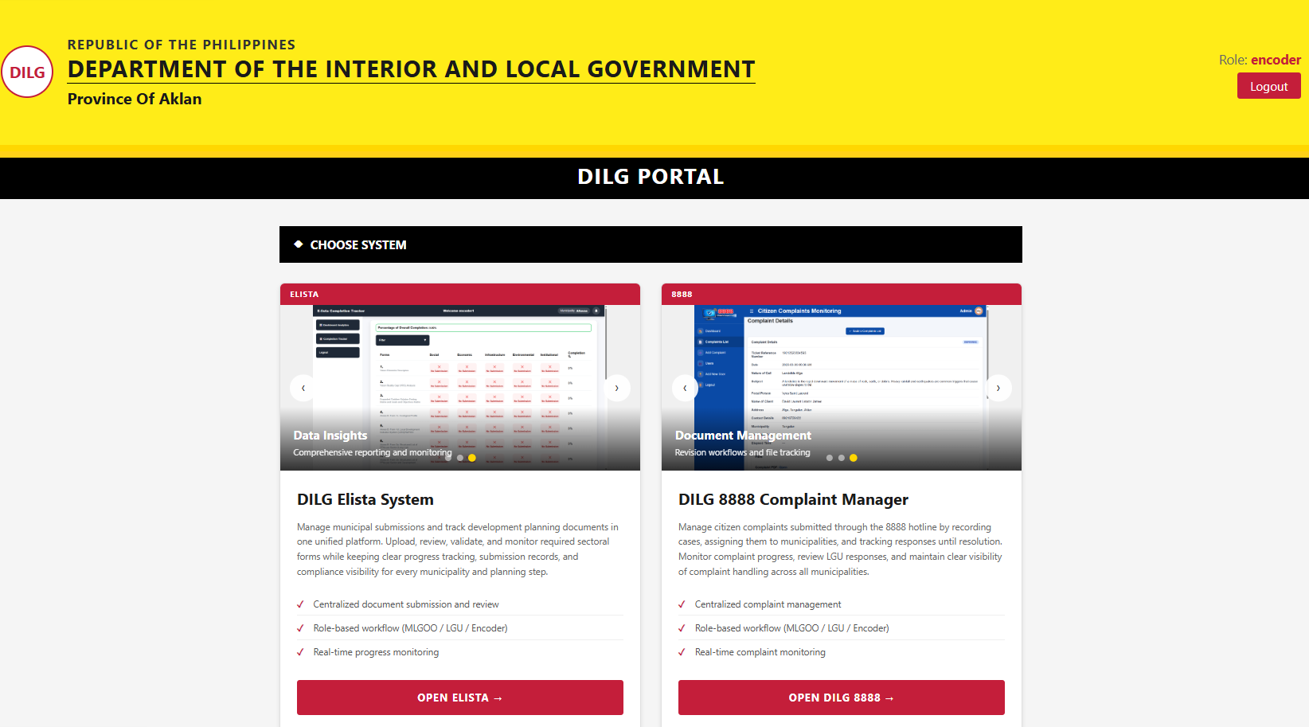

1.5 How to Log Out

Select “❌Close” from the sidebar navigation

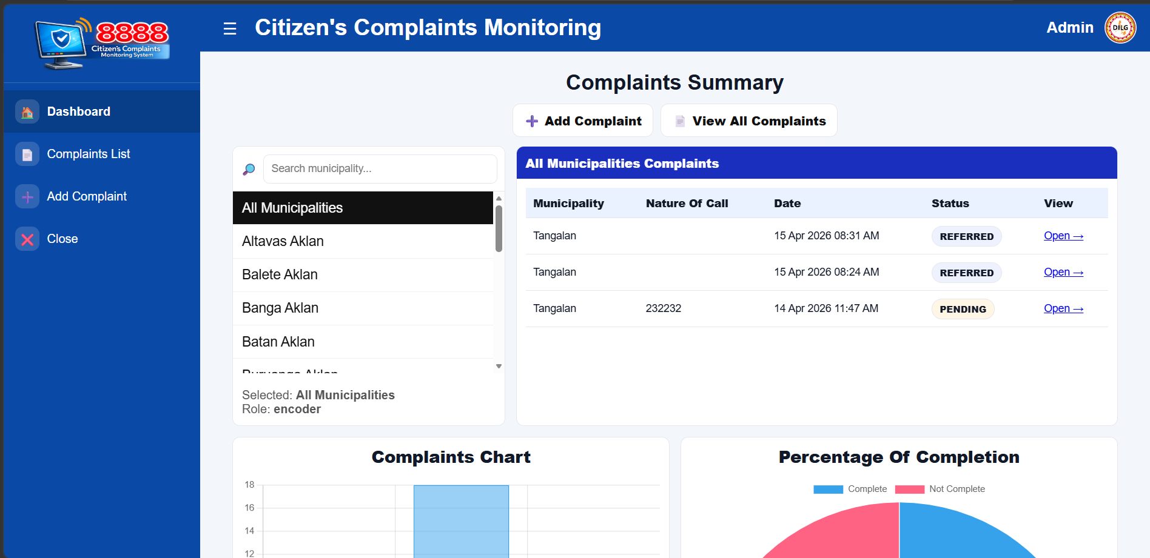

In DILG PORTAL and click “Logout” at the top right of the header/navigation bar.

Important

DO NOT SHARE your login credentials with other users.

2. Admin / Encoder Guide
The Admin (Encoder) account has the highest level of access. This role is responsible for encoding complaints, managing users, reviewing resolutions, and maintaining the overall integrity of the system.

2.1 Dashboard
After logging in, the Admin is brought to the Dashboard. This page provides a real-time summary of complaint statistics across all municipalities, including totals by status and recent activity.
The sidebar navigation provides quick access to all available pages:
- 1. Dashboard — Overview and analytics
- 2. Complaints List — Full list of all encoded complaints
- 3. Add Complaint — Form to encode a new complaint
- 4. Close — End the current session

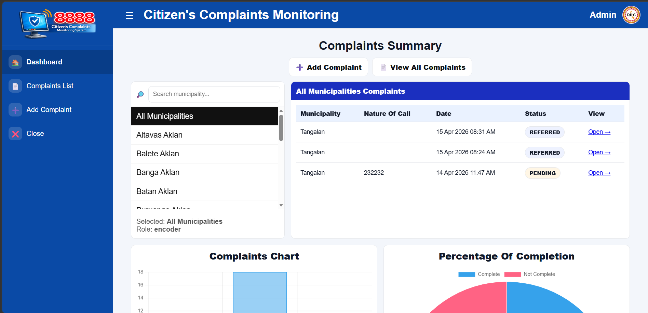
4
3
2
1

3. Managing Complaints

3.1 Adding a New Complaint
- 1. Select “Add Complaint” from the sidebar.
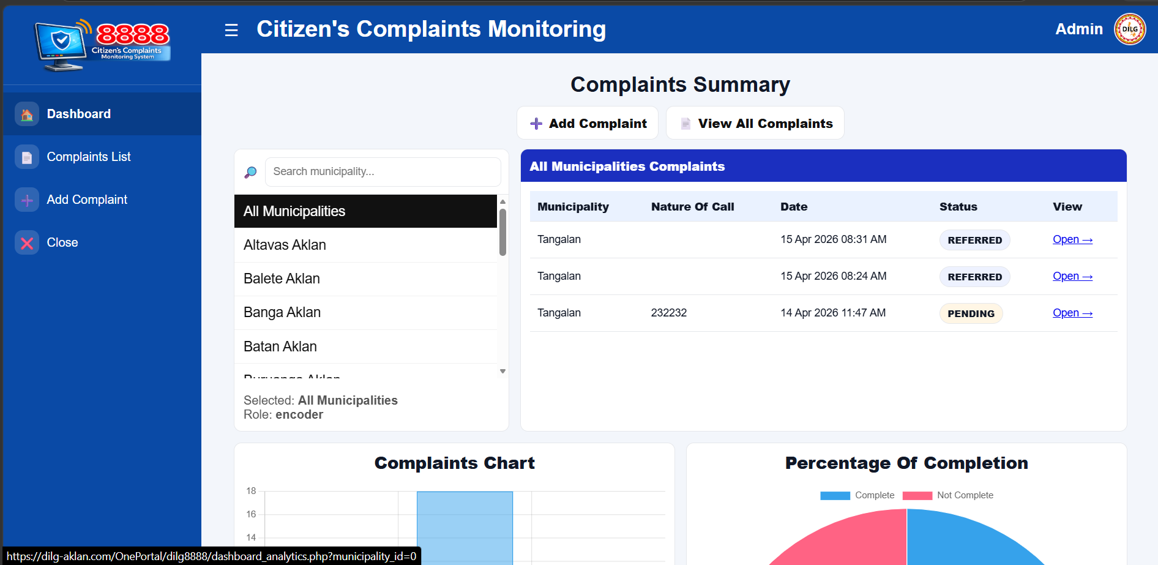
- 2. Fill in the encoder form with the following fields:
Field | Details
Ticket Reference No. | Required. Ticket Reference Number (e.g., PXXXXXXXX-XXX-X).
Date | Optional. If left blank, the system uses the current date and time automatically.
Nature of Call | Required. Brief description of the type of complaint (e.g., Public Order).
Subject | Required. Detailed description of the complaint.
Focal Person | Required. The DILG focal person handling the complaint.
Name of Client | Optional. Name of the citizen who filed the complaint. Saved as N/A if blank.
Address | Optional. Address of the complainant. Saved as N/A if blank.
Contact Details | Optional. Phone number or email of the complainant. Saved as N/A if blank.
Assign Municipality * | Required. Select the LGU responsible for resolving this complaint.
Complaint PDF * | Required. Upload the official complaint document (PDF format only).
Example:
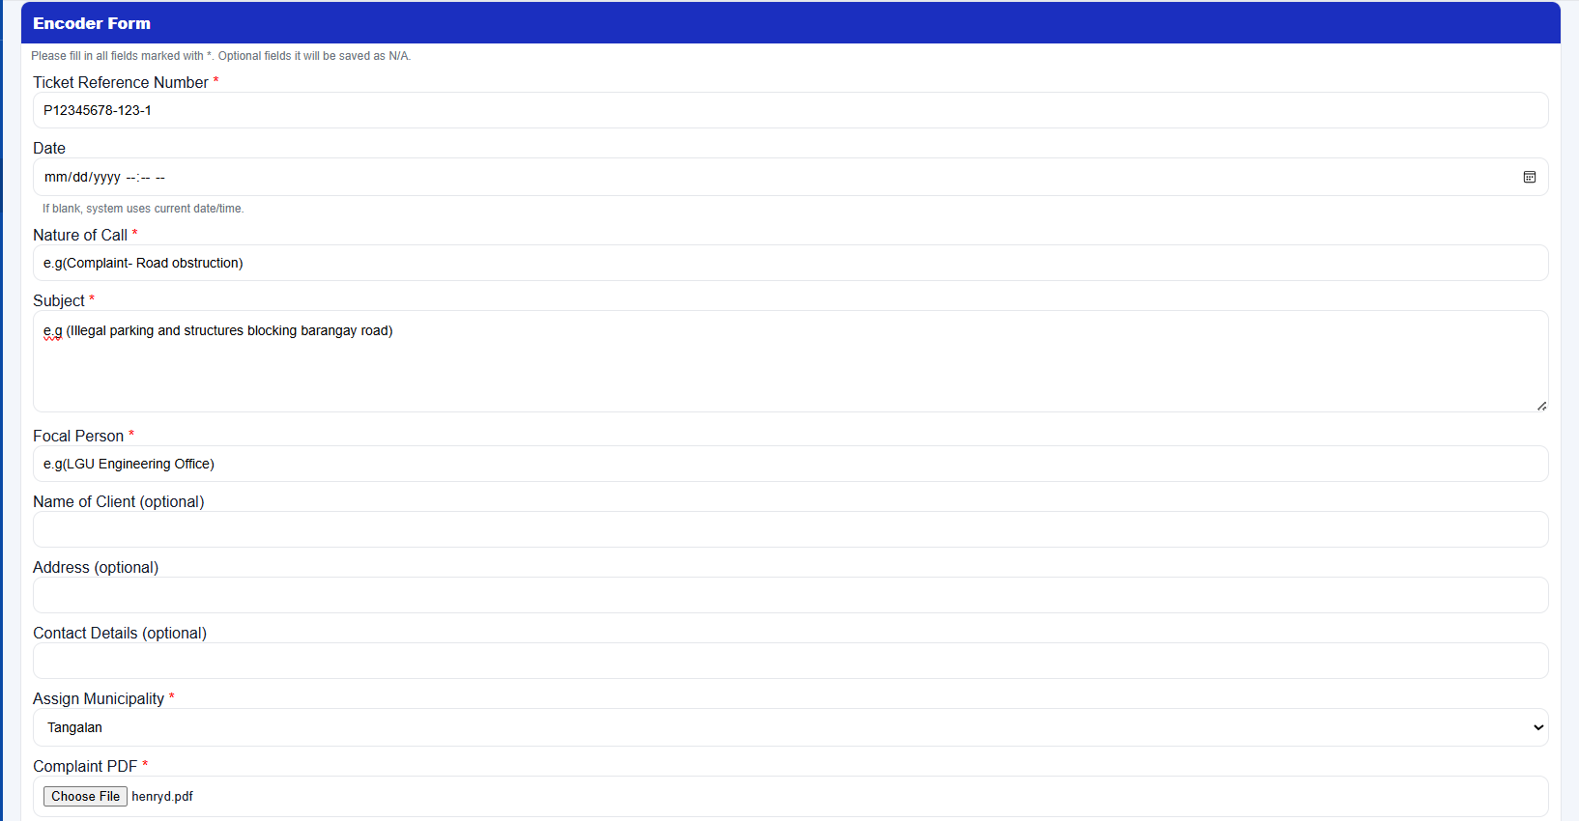
- 3. Once you have completed, click “Save Complaint”.


- 4. A confirmation prompt will appear. Select “OK” to save the complaint. You can select “Cancel” if you made a mistake while filling out the fields. (The complaint is saved with a status of REFERRED.)
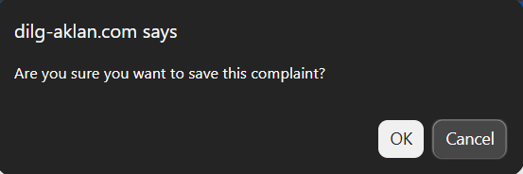
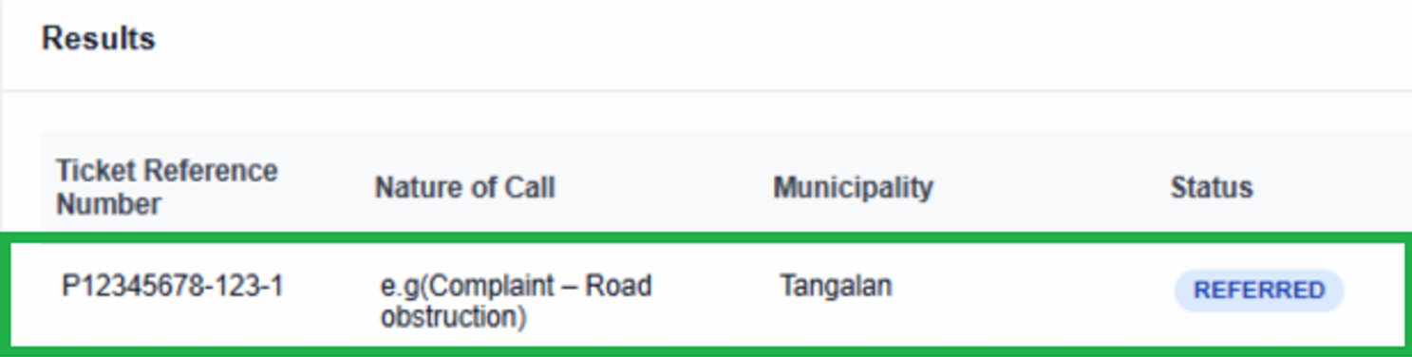

Duplicate Tracking Number
- If you enter a Ticket Reference No. that already exists in the system, you will receive an alert or warning and the complaint will NOT be saved.
- Leave the Ticket Reference No. blank if unsure.

3.2 Complaint List

Complaints List from the sidebar. You will see a table of all encoded complaints with their Ticket Reference Number, Nature of call, Municipality, current Status, Dates, Files, and Action.
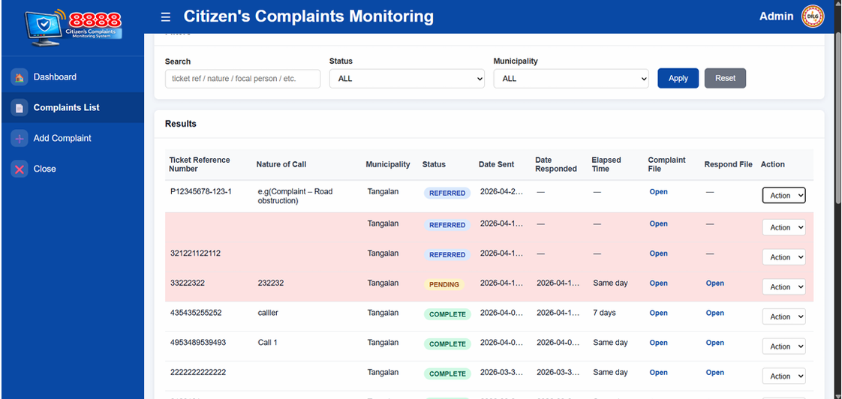

3.2.1 Comment a Complaint

Encoders can comment on the complaints so they can communicate with each other, as well as with MLGOO and LGU.

1. Select the “Complaints List” from the sidebar.
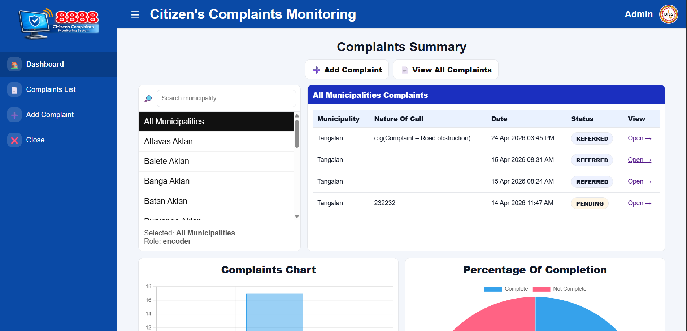

2. Find the complaints, search or scroll for the complaint that you want to comment.
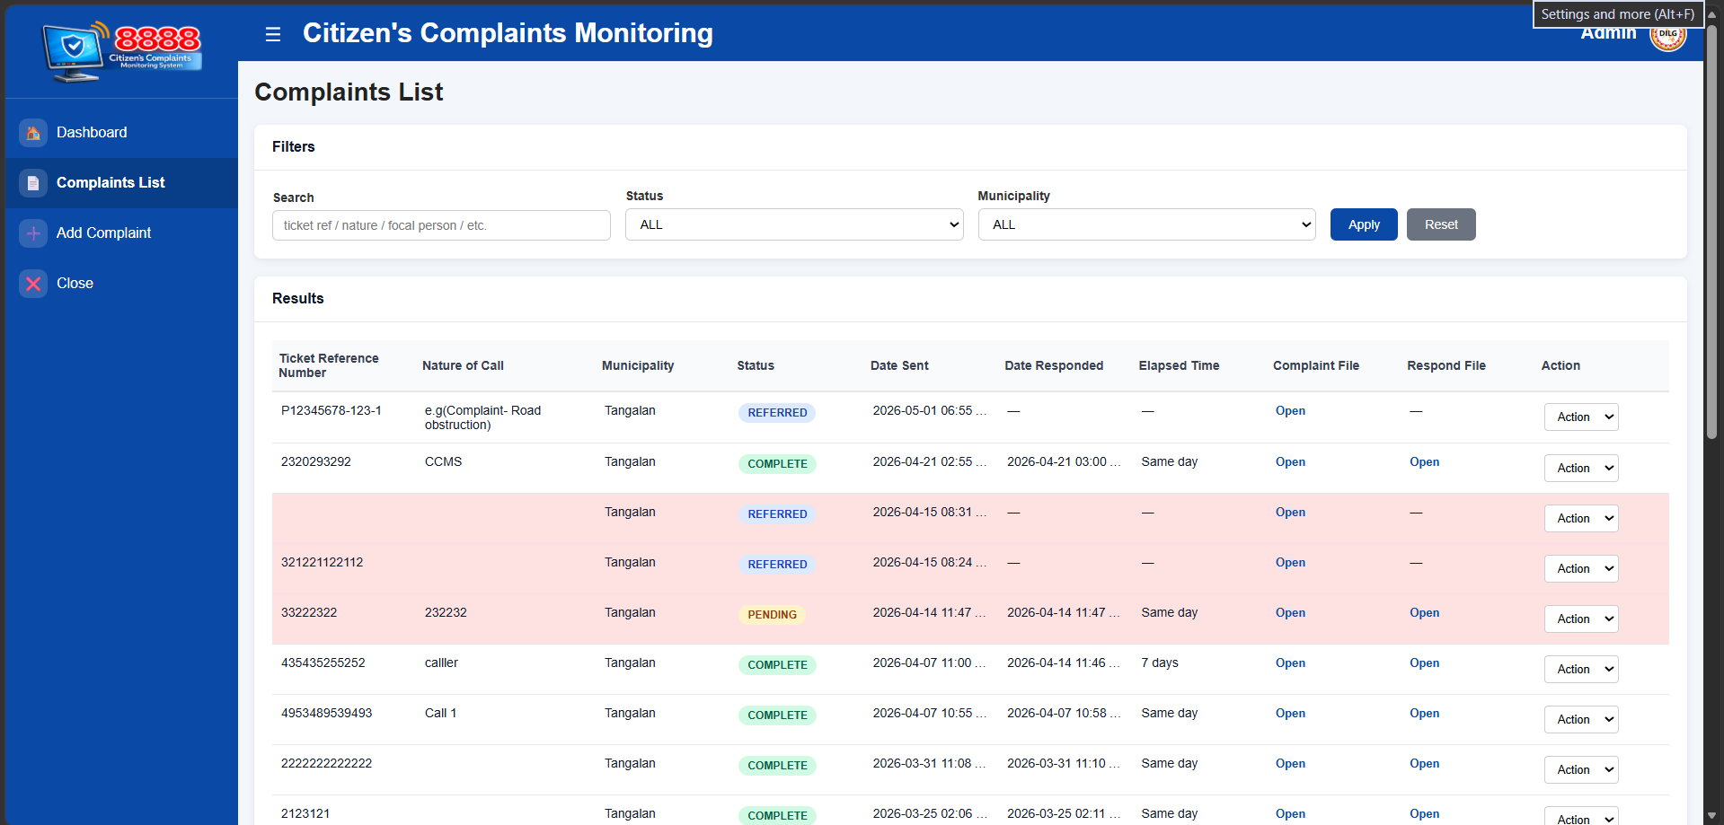
- 3. In the Action column on the ride side of the complaint row, click the “Action” dropdown button.
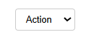

- 4. Select “View” from the dropdown menu to see the complaint details.
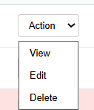

5. Scroll down and type your comment or observation in the text field.

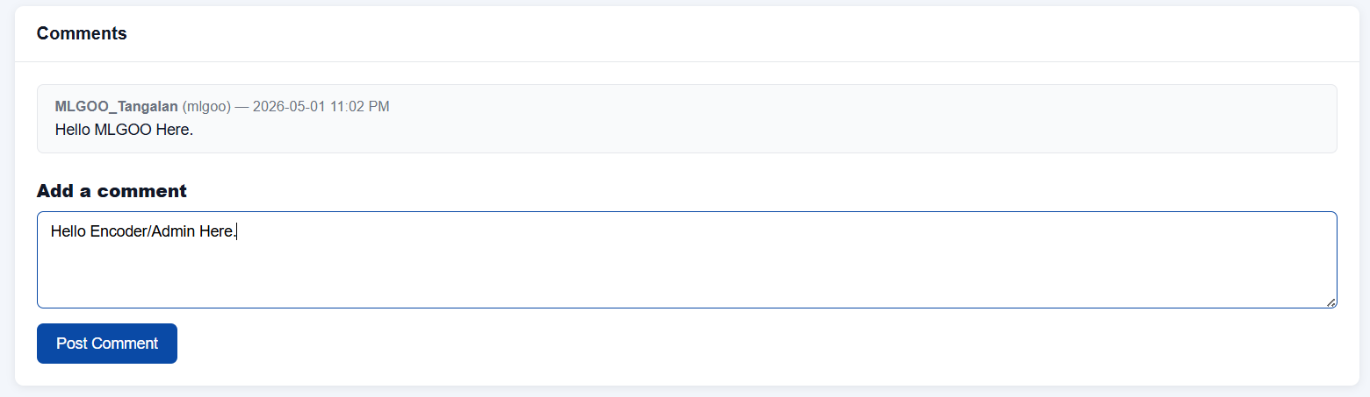
- 6. Select “Post Comment” to apply comment on the complaint.

Example:
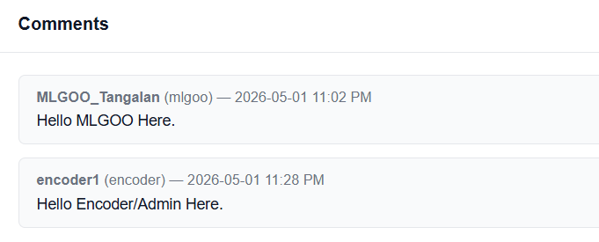

3.2.2 Viewing a Complaint
When the user selects “View” from the action dropdown in the complaints list, the system allows them to see the complaints details of a specific complaint:

- 1. Select the “Complaints List” from the sidebar.
- 2. Find the complaints, search or scroll for the complaint that you want to view.
- 3. In the Action column on the ride side of the complaint row, click the “Action” dropdown button.

- 4. Select “View” from the dropdown menu to see the complaint details.

3.2.3 Editing a Complaint
The edit form allows updating any complaint field. You may optionally replace the Complaint PDF by uploading a new file. If no new file is selected, the existing file is kept. The municipality field is required.
- 1. Select the “Complaints List” from the sidebar.
- 2. Find the complaints, search or scroll for the complaint that you want to edit.

- 3. In the Action column on the ride side of the complaint row, click the “Action” dropdown button.
- 4. Select “Edit” from the dropdown menu to edit the complaint.
- 5. Once you have finished editing the complaint details, click or select “Save Changes” to save the updates.


3.2.4 Deleting a Complaint
Clicking Delete brings up a confirmation screen showing the complaint details. Confirming will permanently delete the complaint record and any associated PDF files from the server. This action cannot be undone.
- 1. Select the “Complaints List” from the sidebar.

- 2. Find the complaints, search or scroll for the complaint that you want to delete.
- 3. In the Action column on the ride side of the complaint row, click the “Action” dropdown button .
- 4. Select “Delete” from the dropdown menu to delete the complaint.
- 5. A confirmation screen will appear showing the complaints - Tracking Number , Municipality, & Subject. If you are sure, select "Yes, Delete" to delete complaint, if not, select "Cancel". Please review carefully.
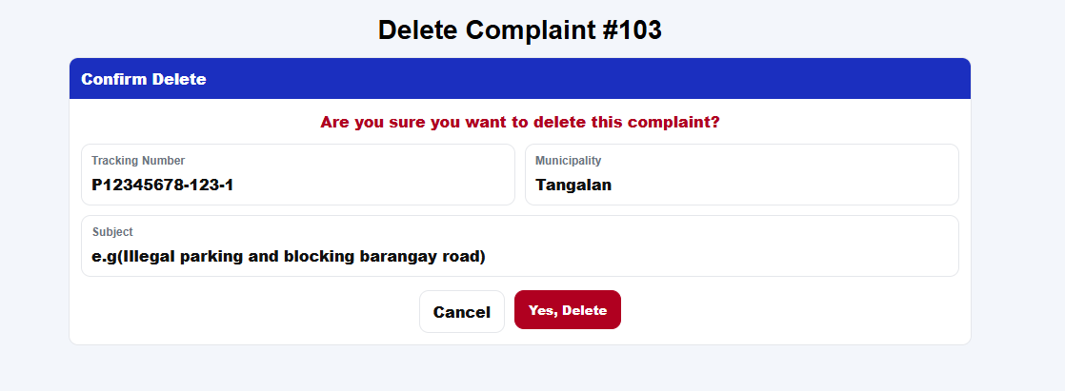

Warning
- Deleting a complaint is irreversible. Both the complaint PDF and resolution PDF will be permanently removed.
- Only Admins/Encoders can delete the complaints.

3.3 Requesting a Revision
If the LGU has uploaded a resolution PDF that requires corrections, the Admin can request a revision from the complaint view page.
- 1. Select the “Complaints List” from the sidebar.
- 2. Find the complaints, search or scroll for the complaint that you want to Request Revision. (Only Pending and Complete “Status” can be request revision. Even when the complaint is marked complete, you can still request a revision).

- 3. In the Action column on the ride side of the complaint row, click the “Action” dropdown button.

- 4. Select “View” from the dropdown menu.

- 5. Scroll down and select “Request Revision”
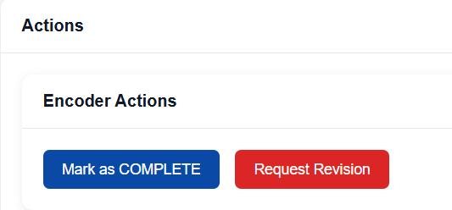
- 6. Write the reason for the revision remarks to understand why it is wrong.
Example:
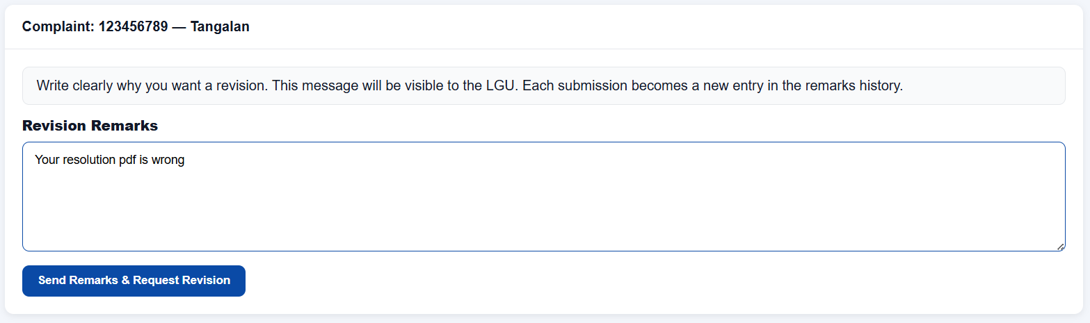
- 7. Click “Send Remarks & Request Revision” to send requested revision to LGU Municipality user. The status will change to “FOR CORRECTION”.
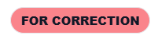
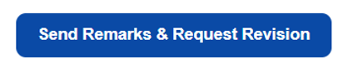

Revision remarks are stacked — each request adds a new entry to the history. The LGU can view all previous remarks in chronological order.
Example:
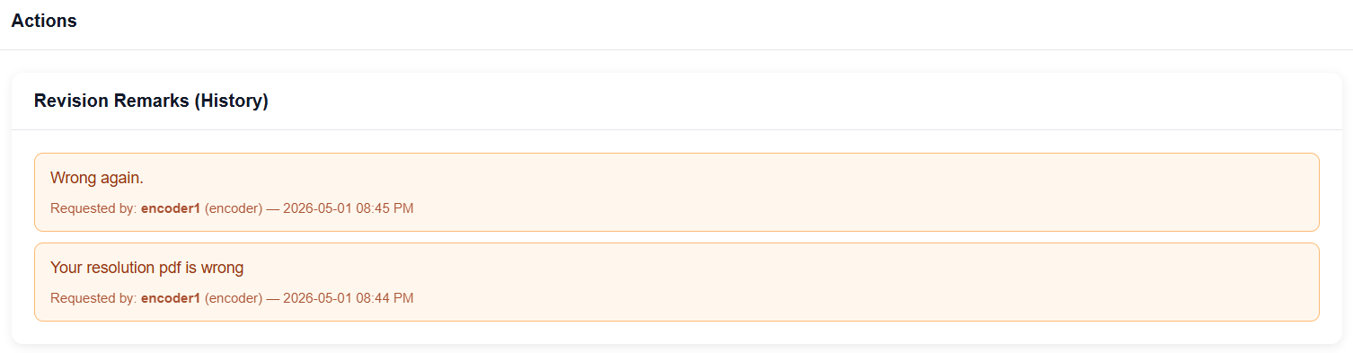

3.4 Marking a Complaint as Complete
Once the Admin is satisfied with the uploaded resolution, the complaint can be Marked as COMPLETE from the complaint view page and the status in the complaints list will be changed to COMPLETE.
- 1. Select the “Complaints List” from the sidebar.
- 2. Find the complaints, search or scroll for the complaint that you want to Marked as COMPLETE. (Only Pending “Status” can be Marked as COMPLETE.

- 3. In the Action column on the ride side of the complaint row, click the “Action” dropdown button.
- 4. Select “View” from the dropdown menu.
- 5. Scroll down and select “Marked as COMPLETE”

- 6. A confirmation prompt will appear. Select “OK” to save the complaint. You can select “Cancel”. (The complaint is saved with a status of Complete.)
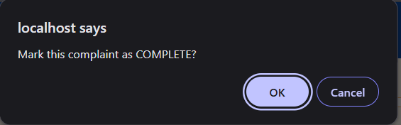

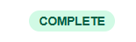

4. Managing Users
Only Admins/Encoders can create, edit, and deactivate user accounts.
- 1. Go to DILG PORTAL and scroll down to ENCODER ADMINISTRATION.
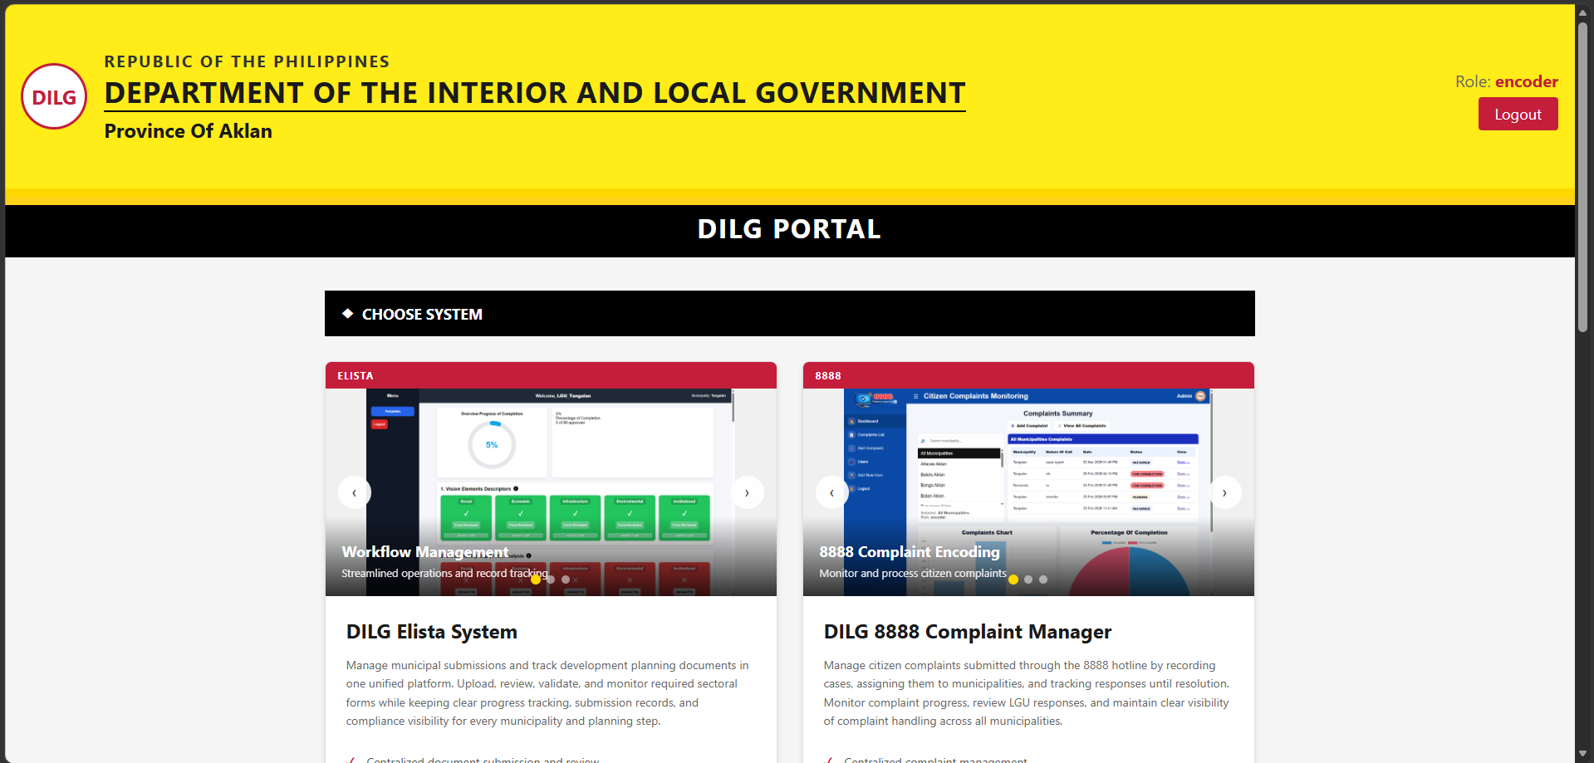
- 2. Click Open Users.
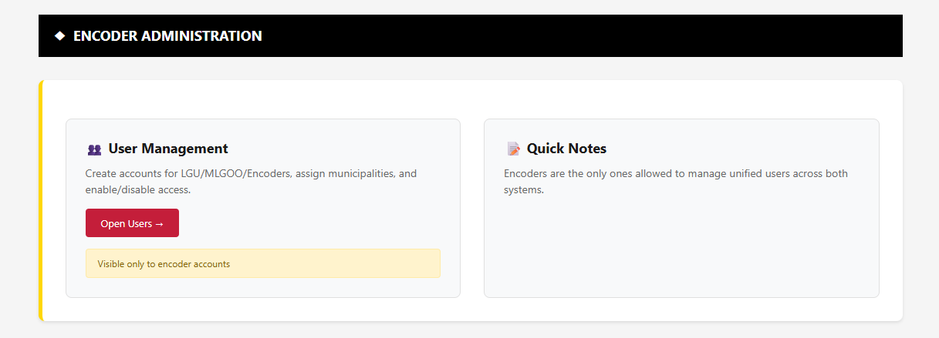

4.1 Adding a New User
- 1. Click Add New User.
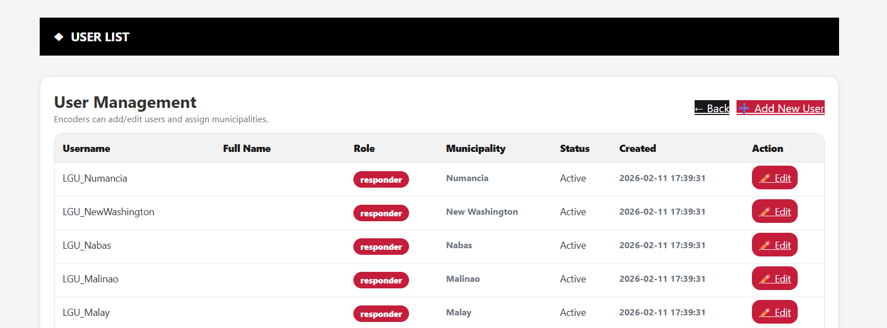

- 2. Fill in the form:
Field | Details
Full Name | Required for Encoder role only. Leave blank for LGU and MLGOO.
Username * | Required. Must be at least 3 characters and unique in the system.
Password * | Required. Minimum 6 characters.
Role * | Select from: encoder, responder (LGU), or mlgoo.
Municipality | Required for responder and mlgoo roles. Not applicable for encoders.
Active | Check to activate the account. Uncheck to create an inactive account.
Example:
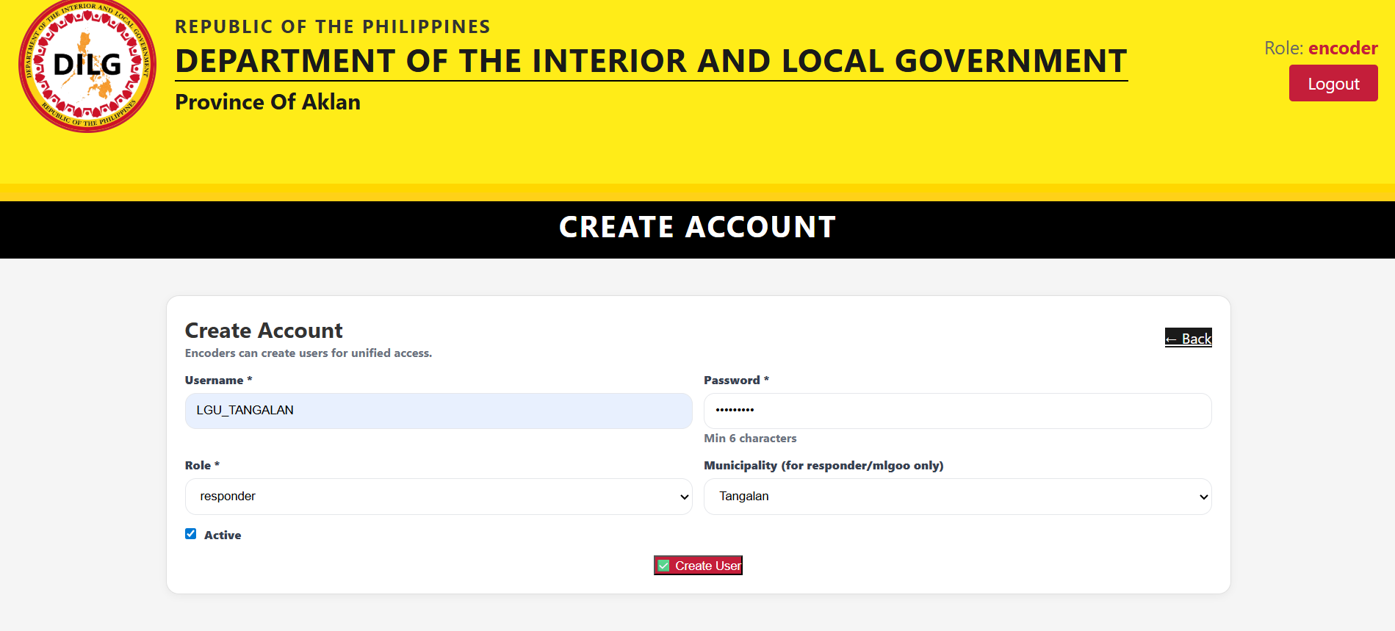
- 3. Click “✅ Create User” to save the account that you created.
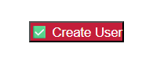

4.2 Editing a User
From the Users list, click Edit next to any user. You can update their name, username, role, municipality, and active status. Leave the New Password field blank to keep the existing password.
- 1. Select the user that you want to edit them and click “✏️ Edit”.
- 2. Once you finishing editing the user, click “Save Changes” to save the updates.
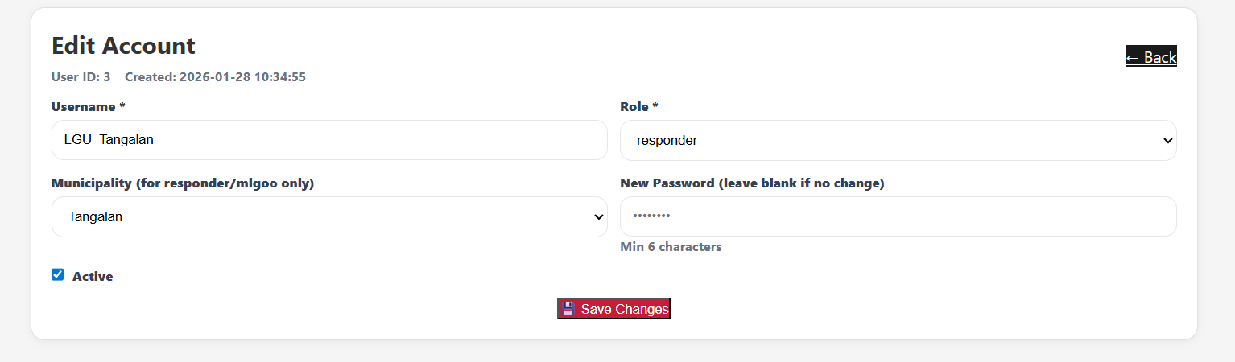

4.3 Deactivating a User
For data integrity, the system does not hard-delete user accounts. Instead, accounts are deactivated by unchecking the Active checkbox in the Edit User form. Deactivated users cannot log in.
- 1. Select the user that you want to deactivate them and click “✏️ Edit”.
- 2. Uncheck the checkbox beside Active.
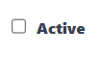
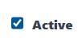
- 3. Click “Save Changes” to save the updates.
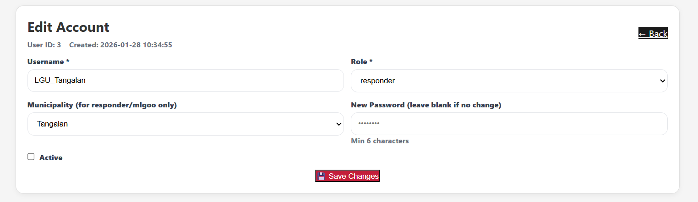

Note
- Admins cannot delete their own account.
- The Delete User action sets is_active = 0 (deactivates) to preserve audit records.
- Only the encoder role supports the Full Name field.

5. Quick Reference: Role Permissions

Feature / Action | Admin | LGU | MLGOO
View complaints (own municipality) | Yes | Yes | Yes
View all complaints (all municipalities) | Yes | No | No
Add / Encode new complaint | Yes | No | No
Edit complaint details | Yes | No | No
Delete complaint | Yes | No | No
Acknowledge / Open complaint | No | Yes | No
Upload resolution PDF | No | Yes | No
Request revision from LGU | Yes | No | No
Mark complaint as COMPLETE | Yes | No | No
View audit/Complaint logs | Yes | No | No
Add new user accounts | Yes | No | No
Edit user accounts | Yes | No | No
Deactivate user accounts | Yes | No | No

6. Troubleshooting & FAQs

6.1 Common Issues

Issue | Solution
Cannot log in | Verify username and password. Make sure the account is Active. Contact your system administrator if needed.
Duplicate ticket reference number error | The ticket reference number entered already exists. Check the complaints list or leave the field blank.
Cannot delete a complaint | Only Admins can delete complaints. Confirm you are logged in with an encoder account.
Revision request button is greyed out | No resolution PDF has been uploaded yet by the LGU. Wait for the LGU to upload before requesting a revision.
PDF file rejected | Only PDF files (.pdf extension) are accepted. Do not upload Word documents, images, or other file types.
User cannot log in after creation | Check that the is_active flag is set to 1 (Active) in the user record.

