

DILG 8888 Citizen Complaints Monitoring
System User Manual

LGU (Responder)
Municipal Responder Account Guide

Department of the Interior and Local Government
April 2026

Table of Contents
1. System Overview ……………………………………………………………………………………………..3
1.1 Elapsed Time - Row Color Indicator ……………………………………………………………………...3
1.2 Complaint Status flow ………………………………………………………………………………………3
1.3 How to Log In ……………………………………………………………………………………………3 - 4
1.4 How to Log Out ……………………………………………………………………………………………..5
2. LGU (Responder) Guide …………………………………………………………………………………….5
2.1 Dashboard ……………………………………………………………………………………………….5 - 6
2.2 Notification …..………………………………………………………………………………………………6
2.3 Complaint List …………………………………………………………………………………………….…7
2.4 Uploading a Resolution PDF …………………………………………………………………………..7 - 9
2.5 Handling Revision Requests ………………………………………………………………………..10 - 11
2.6 Viewing Revision History …………………………………………………………………………………12
3. Quick Reference: Role Permissions ………………………………………………………………………13
4. Troubleshooting & FAQS ………………………………………………………………………………..…13
4.1 Common Issues ……………………………………………………………………………………………13

1. System Overview
The DILG 8888 Citizen Complaints Monitoring System is a web-based platform for tracking and resolving citizen complaints. As an LGU (Responder), you are responsible for reviewing complaints assigned to your municipality and uploading official resolution documents.

Elapsed Time — Row Color Indicator
The color highlight applies to the entire complaint row in the Complaints List. It is based on how many days have passed since the Date Sent (counted from today, not from resolution).
Row Color | Condition | Mean
No Color (White) | 0 - 1 Day or Same Day | Complaint is new or recently sent. No urgency.
Yellow | 2 Days | Warning — complaint is approaching the deadline. LGU should respond soon.
Red | 3 Days | Urgent — complaint has been unresolved for too long. Immediate action needed.

1.2 Complaint Status Flow
Understanding complaint statuses will help you respond correctly:

Status | Meaning
REFERRED | Complaint has been encoded and assigned to your municipality. Review the complaint and upload a resolution PDF.
PENDING | You have uploaded a resolution. The encoder is reviewing it.
FOR CORRECTION | The encoder has requested corrections. Read the remarks and re-upload a corrected resolution PDF.
COMPLETE | The encoder has accepted the resolution. The complaint is closed.

1.3 How to Log In
All users log in through the unified Core login page.
- Open your web browser and navigate to the system URL provided by your administrator, you will be redirected to the Core login page. You will be redirected to the Core login page.
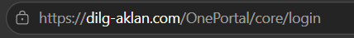

- Enter your Username and Password.
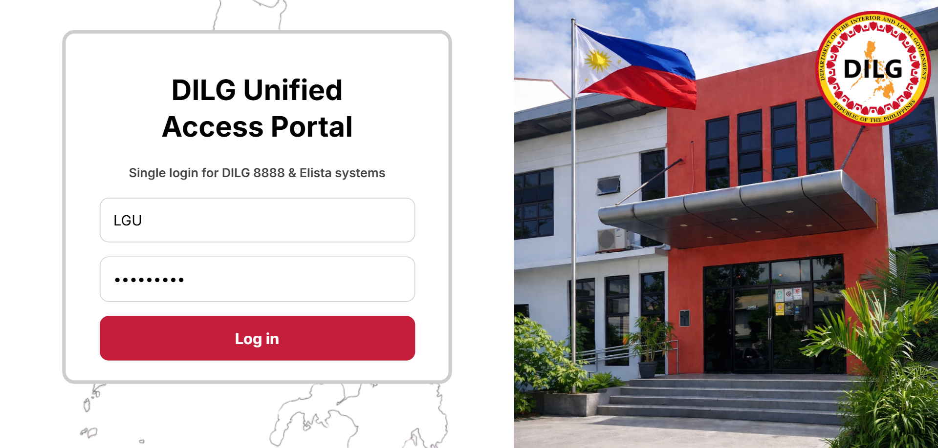

- Click the Log in button. The website will redirect you to the DILG Portal.

- Select “Open DILG 8888”.
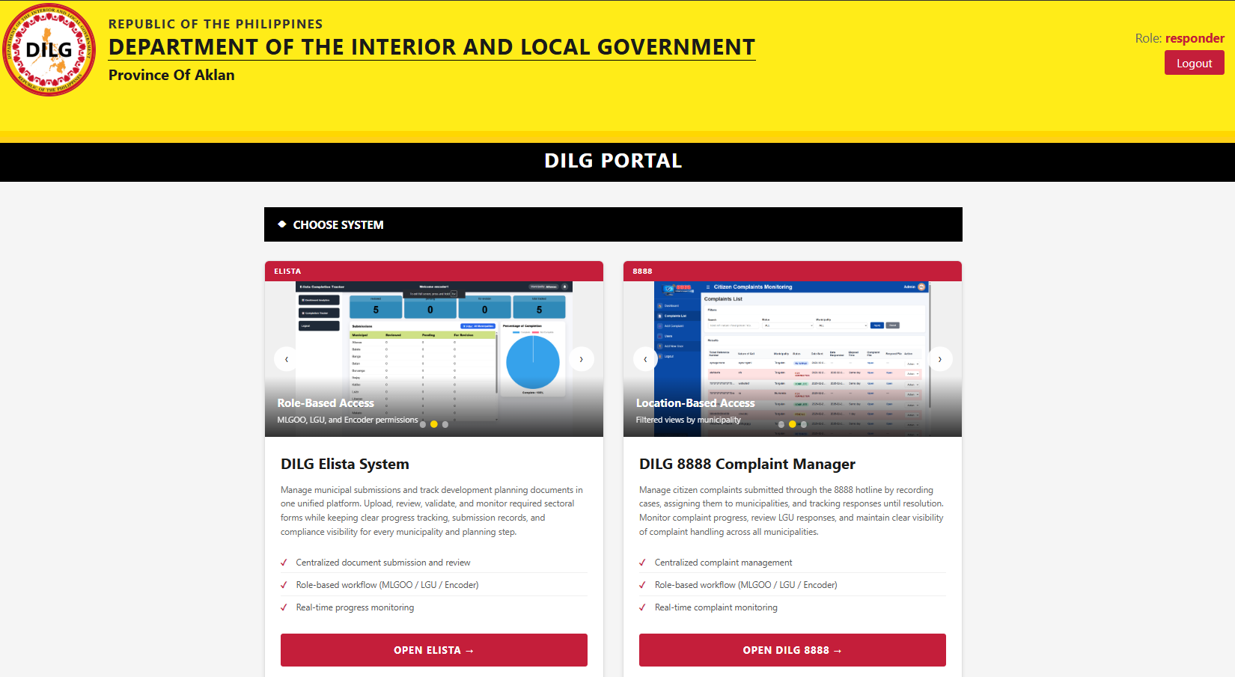
Important
- You can only see complaints assigned to your municipality.
- As a LGU, your account is a responder, view complaints and add comments.

1.4 How to Log Out

Select “❌Close” from the sidebar navigation

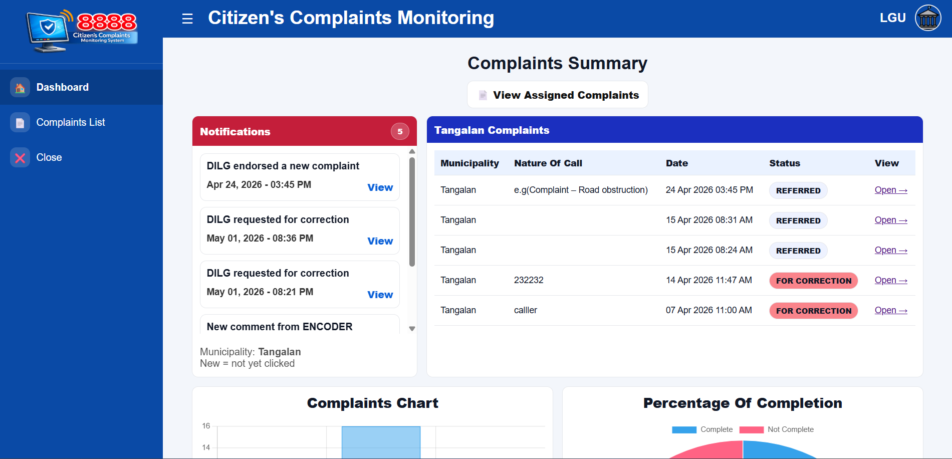

In DILG PORTAL and click “Logout” at the top right of the header/navigation bar.

2. LGU (Responder) Guide
The LGU (Responder) account is assigned to municipal responders responsible for acknowledging and resolving complaints referred to their municipality.

2.1 Dashboard
After logging in, the LGU user sees only the complaints assigned to their municipality. The sidebar provides access:
- 1. Dashboard — Overview and analytics
- 2. Complaints List — Full list of all encoded complaints
- 3. Close — End the current session
3
2
1

2.2 Notification
The dashboard has a Notifications panel that automatically alerts users when something happens to a complaint. There are 4 types of notifications, and they work differently per role:
- Endorsed a new complaint – Admin / Encoder encodes and assigns a new complaint to their municipality.
- Requested for correction – Admin / Encoder want to "Request Revision" on a complaint to their municipality.
- New Comment from Encoder – Admin / Encoder posted a comment on a complaint.
- Completed a complaint – Admin / Encoder marks a complaint as COMPLETE.
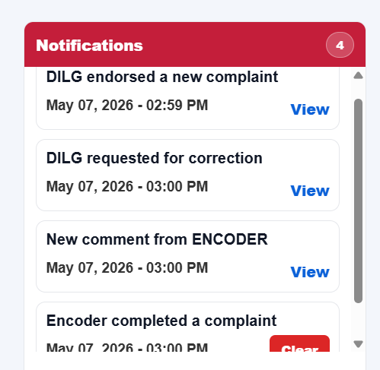

2.3 Complaint List
The complaints list shows:
- Ticket Reference Number.
- Nature of Call
- Municipality
- Current Status
- Date received (Sent, Responded, Elapsed Time)
- Complaint File & Resolution File
- Action buttons for current Status: Complete and Preferred “View” only, but Pending and For Correction there is “Action” option to “View or Edit”.
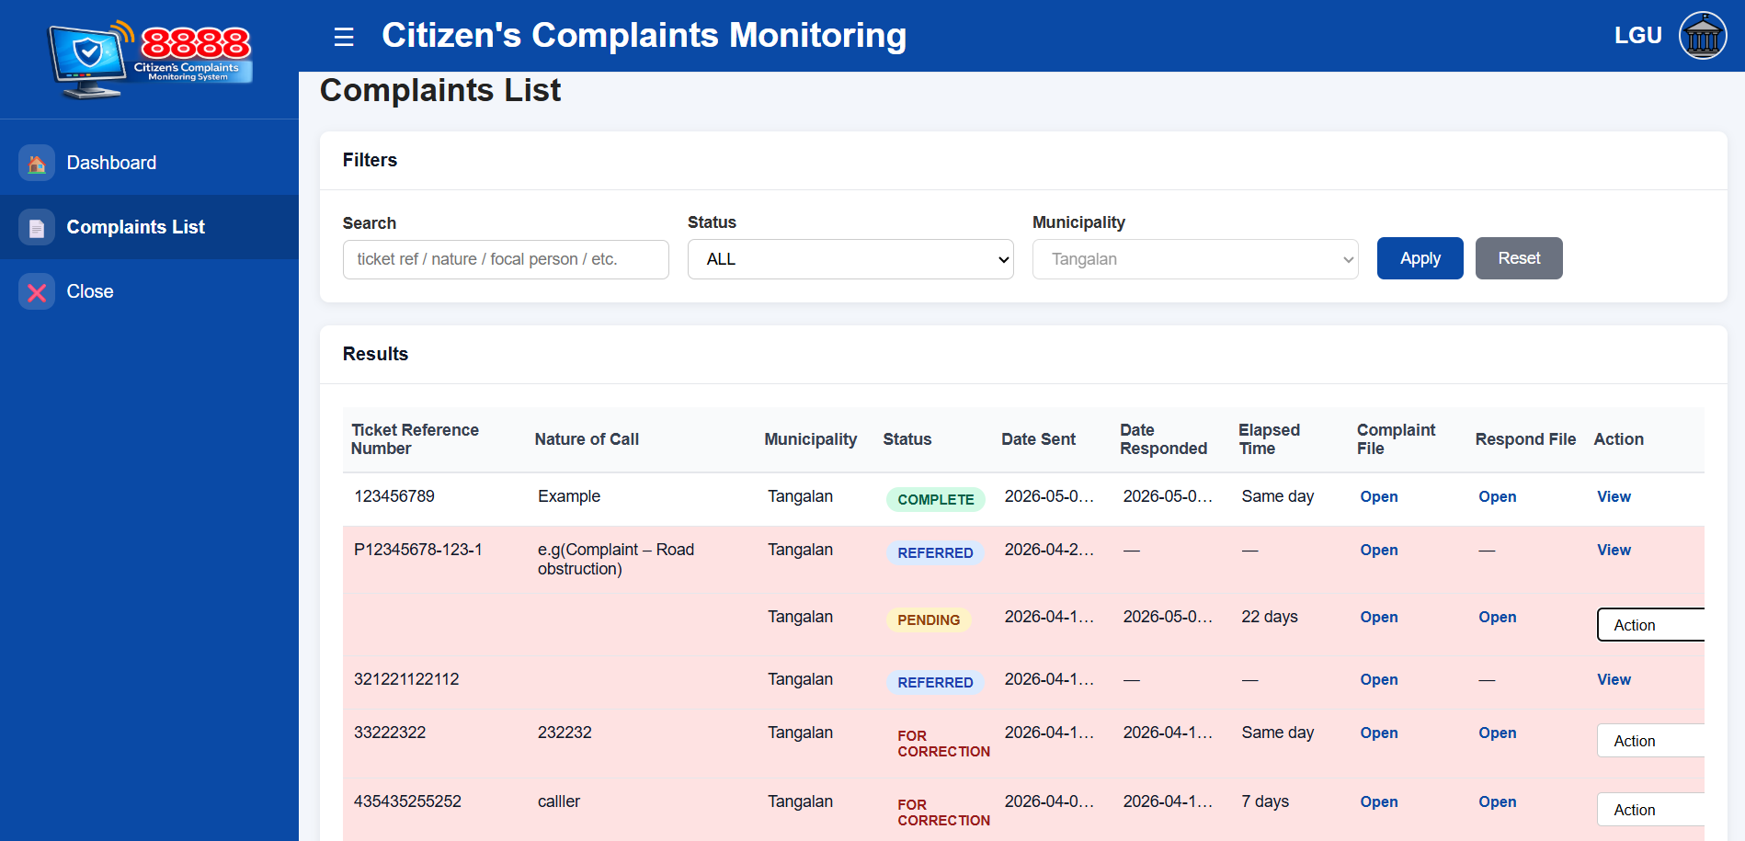

2.4 Uploading a Resolution PDF
After reviewing the complaint PDF, the LGU can upload the resolution PDF.

Select the “Complaints List” from the sidebar.
- Find the current status “PREFERRED” of complaints, search or scroll for the complaint.
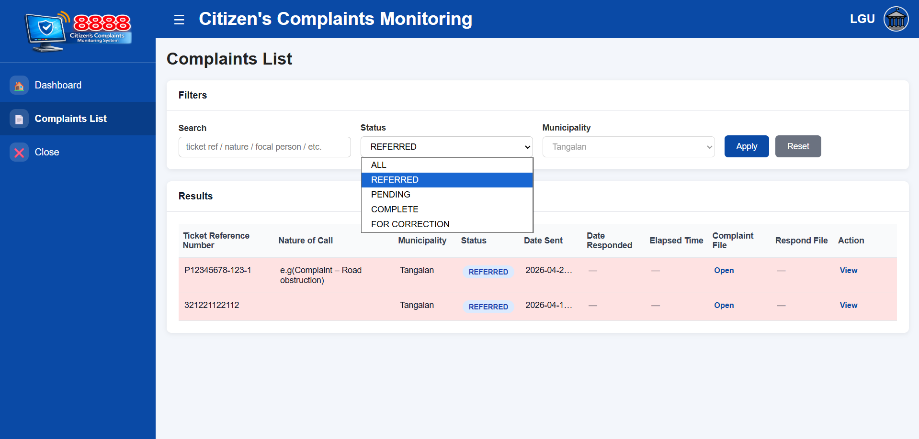
- In the Action column on the ride side of the complaint row, below that select or click “View”.
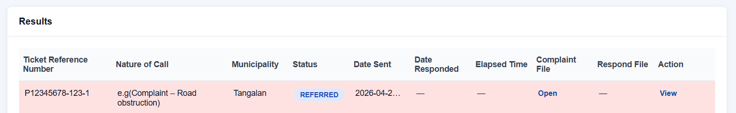
- Scroll down to “Actions on Responder” Underneath, select “Upload / Replace Resolution PDF”.
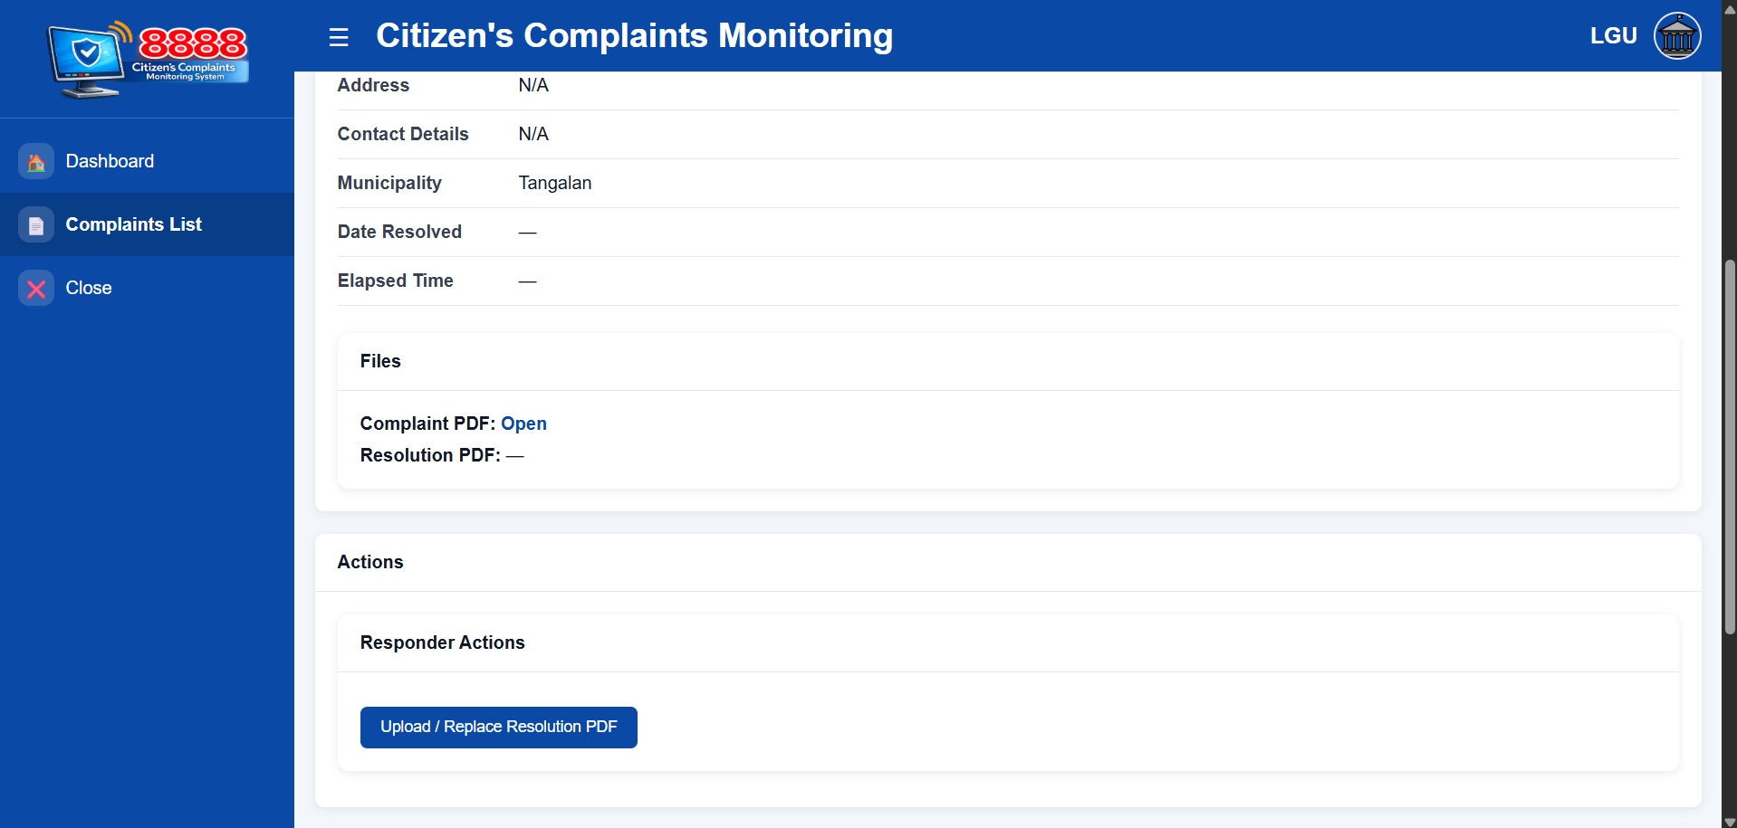

- On the Select PDF File, click “Choose File”.
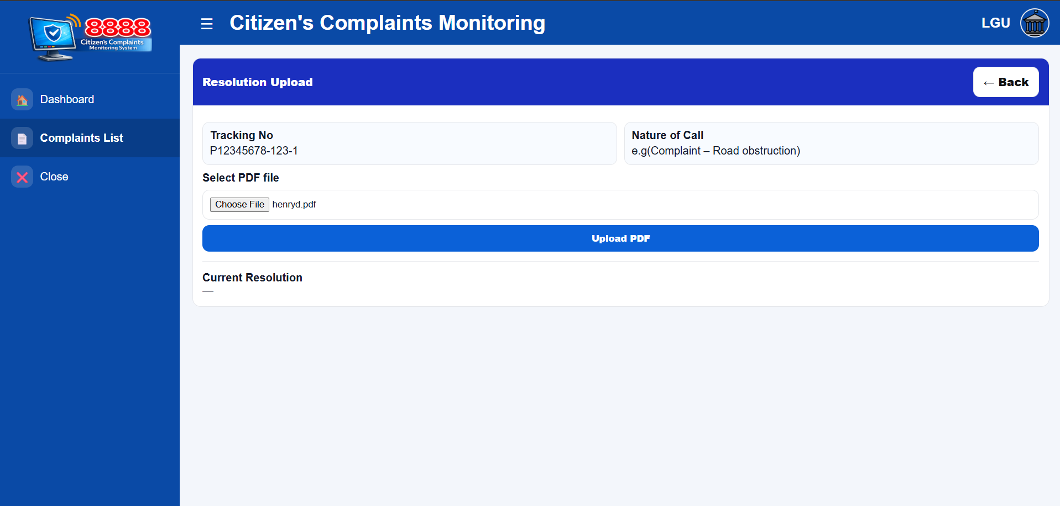
- Once you upload the PDF file, Select Upload PDF to upload pdf to the complaint and it will save as Resolution PDF.
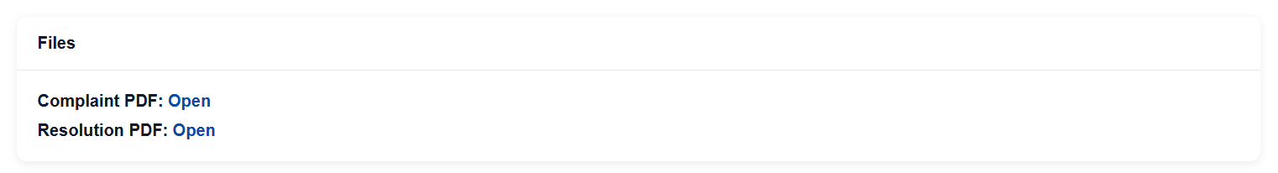

You may re-upload/update the resolution PDF at any time if the complaint status is PENDING not COMPLETE. The old file is automatically deleted when a new one is uploaded.
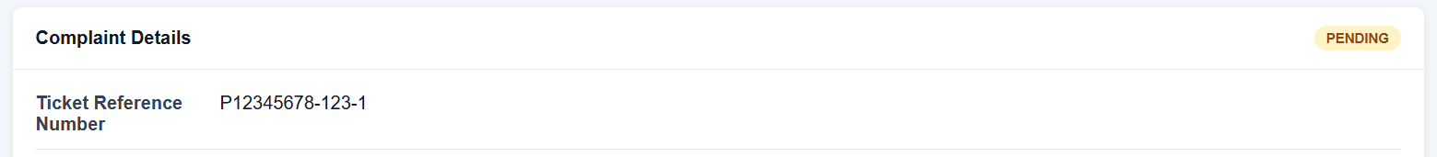
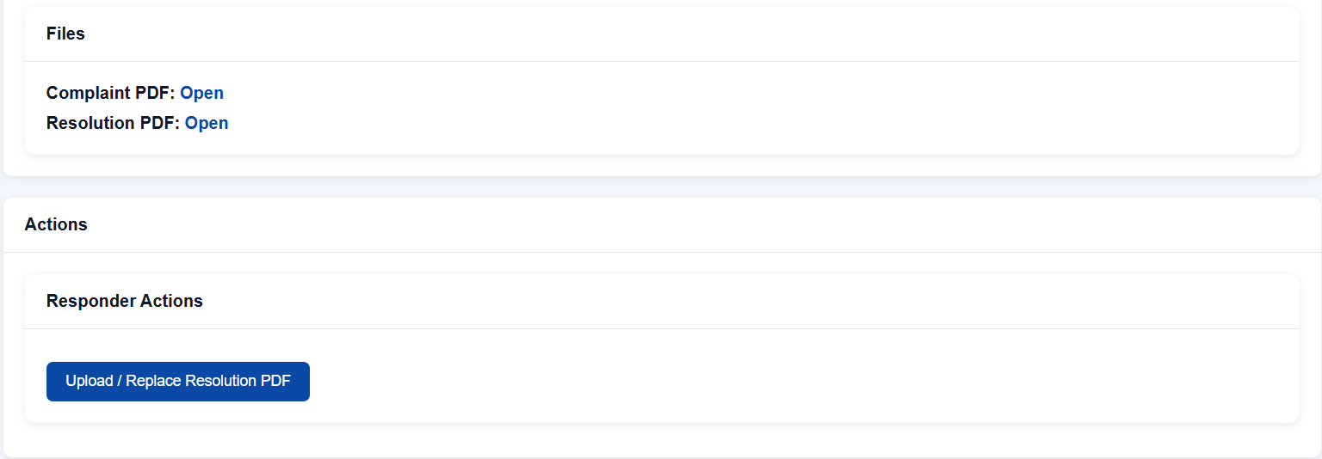

Important
- Only PDF files are accepted. If your document is in Word format, convert it to PDF first.
- Uploading a new resolution will automatically overwrite and delete the previous file.

2.5 Handling Revision Requests
When the Admin requests a revision, the complaint status changes to FOR CORRECTION. You will see the revision remarks from the Admin/Encoder in Revision Remarks (History).
- Select the “Complaint List” from the sidebar.
- Find the current status “FOR CORRRECTION” of complaints, search or scroll for the complaint.
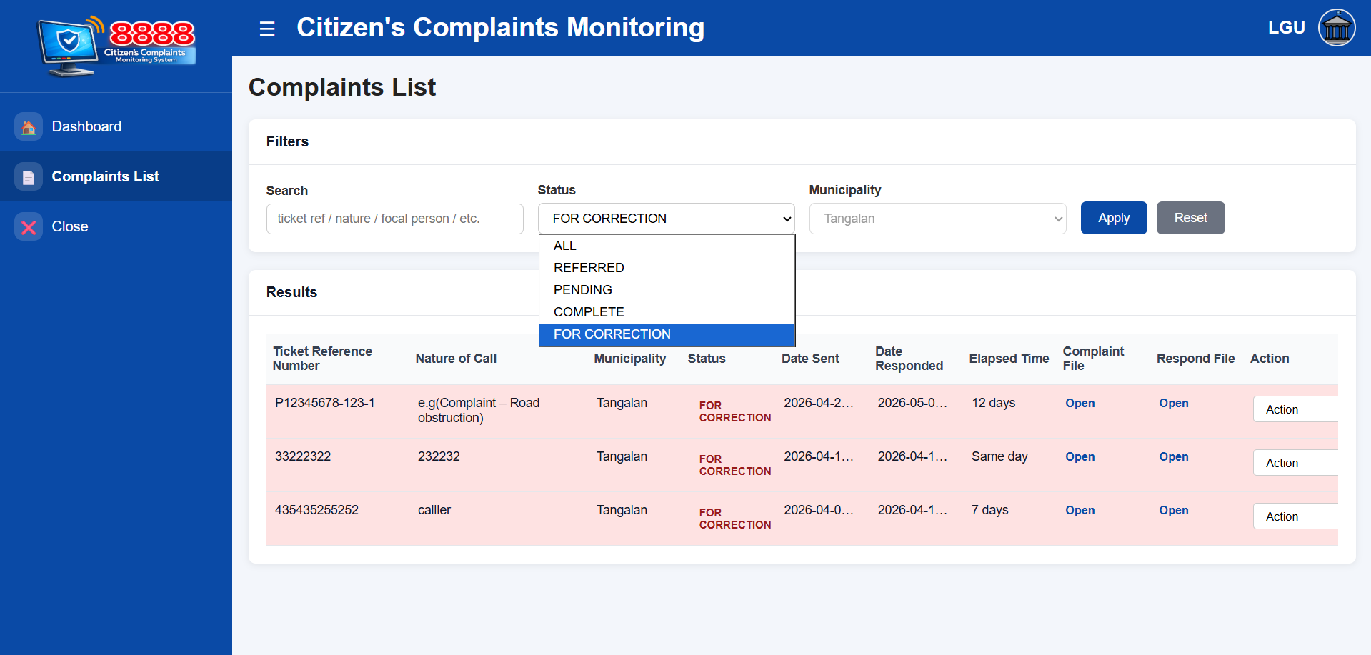

- In the Action column on the ride side of the complaint row, below that select or click “Action” then select “View”.
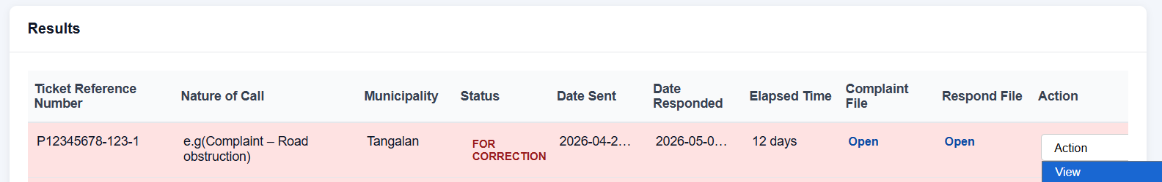
- Scroll down to “Actions on Responder” Underneath, select “Upload / Replace Resolution PDF”.
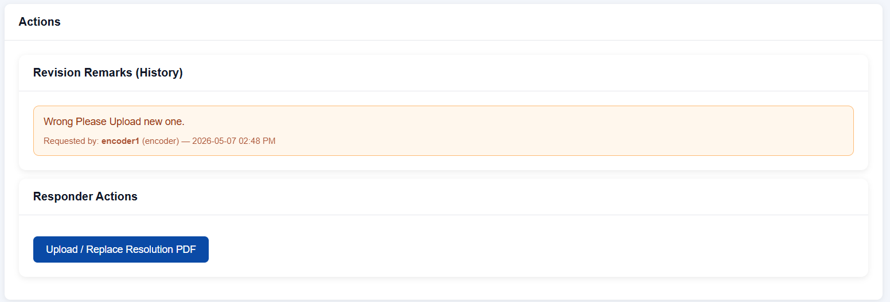
- On the Select PDF File, click “Choose File”.
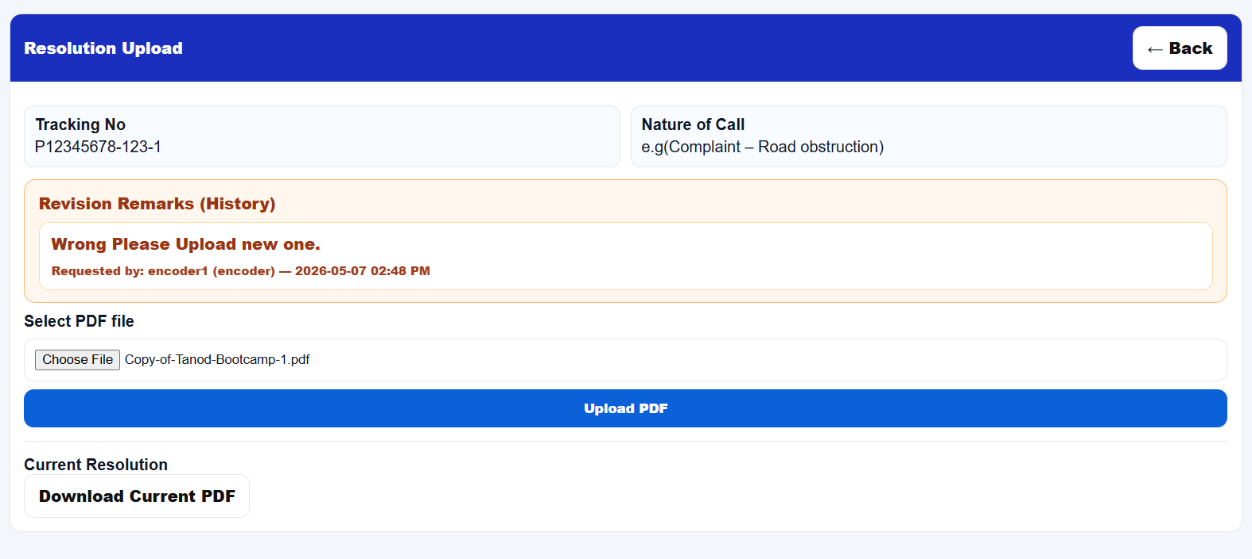
- Once you upload the PDF file, Select Upload PDF to upload pdf to the complaint and it will save as Resolution PDF.
Note on Completed Complaints
- Only after the Admin reopens the complaint (by requesting a revision) only then you can upload again.

2.6 Viewing Revision Remarks History
All revision requests from the Admin / Encoder are stacked in chronological order. When you open the Upload Resolution page for a complaint with revision history, you will see:
- Each revision remark entered by the Admin
- The username and role of the person who made the request
- The date and time the revision was requested
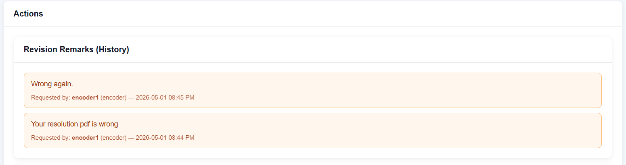
This history section helps you track all feedback given for a complaint and ensure all corrections have been addressed.

3. Quick Reference: Role Permissions

Feature / Action | Admin | LGU | MLGOO
View complaints (own municipality) | Yes | Yes | Yes
View all complaints (all municipalities) | Yes | No | No
Add / Encode new complaint | Yes | No | No
Edit complaint details | Yes | No | No
Delete complaint | Yes | No | No
Acknowledge / Open complaint | No | Yes | No
Upload resolution PDF | No | Yes | No
Request revision from LGU | Yes | No | No
Mark complaint as COMPLETE | Yes | No | No
View audit/Complaint logs | Yes | No | No
Add new user accounts | Yes | No | No
Edit user accounts | Yes | No | No
Deactivate user accounts | Yes | No | No

4. Troubleshooting & FAQs

4.1 Common Issues

Issue | Solution
Cannot log in | Verify your username and password. Make sure your account is Active. Contact your Admin if needed.
Cannot upload resolution PDF | Ensure you have clicked View on the complaint first. Only PDF files are accepted. Confirm the complaint is not in COMPLETE status.
Upload Resolution button is missing | The complaint may already be COMPLETE. Contact the Admin to reopen it via a revision request.
Cannot see a complaint in the list | LGU accounts only see complaints assigned to their municipality. Contact your Admin if a complaint is missing.
PDF file rejected | Only PDF (.pdf) files are accepted. Convert Word documents to PDF before uploading.
Status did not change after upload | Refresh the page. If the issue persists, contact your Admin/Encoder.

