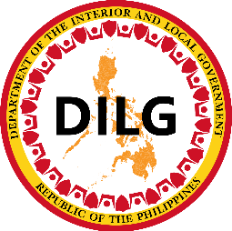

DILG 8888 Citizen Complaints Monitoring
System User Manual

MLGOO
Municipal Local Government Operations Officer — Monitoring Guide

Department of the Interior and Local Government
April 2026

Table of Contents
1. System Overview ……………………………………………………………………………………………3
1.1 Elapsed Time - Row Color Indicator ……………………………………………………………………..3
1.2 Complaint Status flow ……………………………………………………………………………………..3
1.3 How to Log In ………………………………………………………………………………………..…3 - 4
1.4 How to Log Out ……………………………………………………………………………………………5
2. MLGOO Guide ………………………………………………………………………………………………5
2.1 Dashboard & Navigation ………………………………………………………………………………5 - 6
2.2 Notification ………………………………………………………………………………………………….6
2.3 Viewing a Complaints …………………………………………………………………………………7 - 8
2.4 Adding a Comment on a Complaint …………………………………………………………………8 - 9
3. Quick Reference: Role Permissions ……………………………………………………………………10
4. Troubleshooting & FAQS …………………………………………………………………………………10
4.1 Common Issues …………………………………………………………………………………………10

1. System Overview
The DILG 8888 Citizen Complaints Monitoring System is a web-based platform for tracking and resolving citizen complaints. As an MLGOO (Municipal Local Government Operations Officer), your account is a monitoring role — you can view complaints and add comments, but you cannot add, edit, delete, or upload documents.

1.1 Elapsed Time — Row Color Indicator
The color highlight applies to the entire complaint row in the Complaints List. It is based on how many days have passed since the Date Sent (counted from today, not from resolution).
Row Color | Condition | Mean
No Color (White) | 0 - 1 Day or Same Day | Complaint is new or recently sent. No urgency.
Yellow | 2 Days | Warning — complaint is approaching the deadline. LGU should respond soon.
Red | 3 Days | Urgent — complaint has been unresolved for too long. Immediate action needed.

1.2 Complaint Status Flow
Use this reference to understand the status of complaints in your municipality:

Status | Meaning
REFERRED | Complaint assigned to LGU — waiting for LGU to upload a resolution.
PENDING | LGU has uploaded a resolution — waiting for Admin to review and approve or request correction.
FOR CORRECTION | Admin has requested corrections from the LGU — LGU is preparing a revised resolution.
COMPLETE | Admin has approved the resolution — complaint is closed.

1.3 How to Log In
All users log in through the unified Core login page.
- Open your web browser and navigate to the system URL provided by your administrator, you will be redirected to the Core login page. You will be redirected to the Core login page. 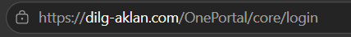

- Enter your Username and Password.
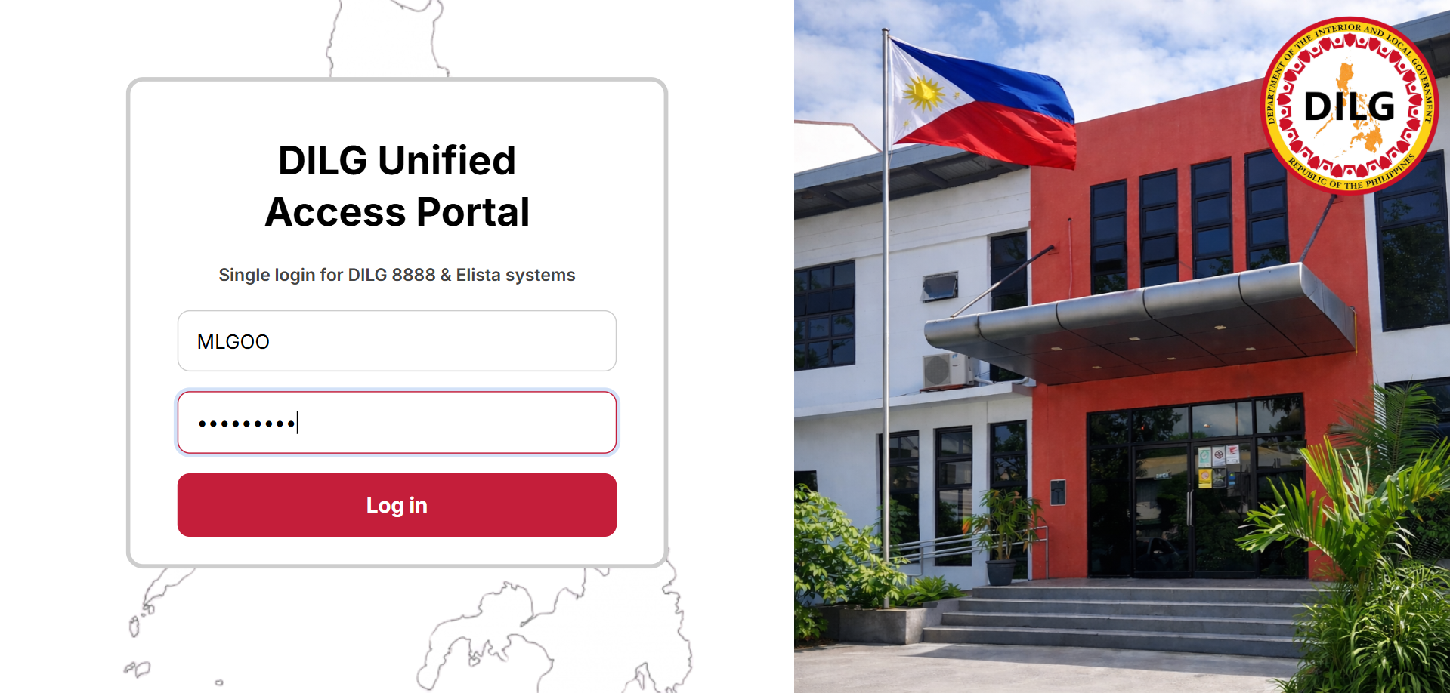

- Click the Log in button. The website will redirect you to the DILG Portal.

- Select “Open DILG 8888”.
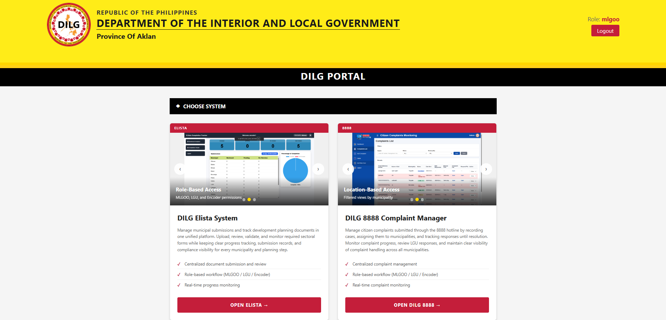

Important
- You can only see complaints assigned to your municipality.
- As an MLGOO, your account is read-only you can view complaints and add comments only.

1.4 How to Log Out

Select “❌Close” from the sidebar navigation
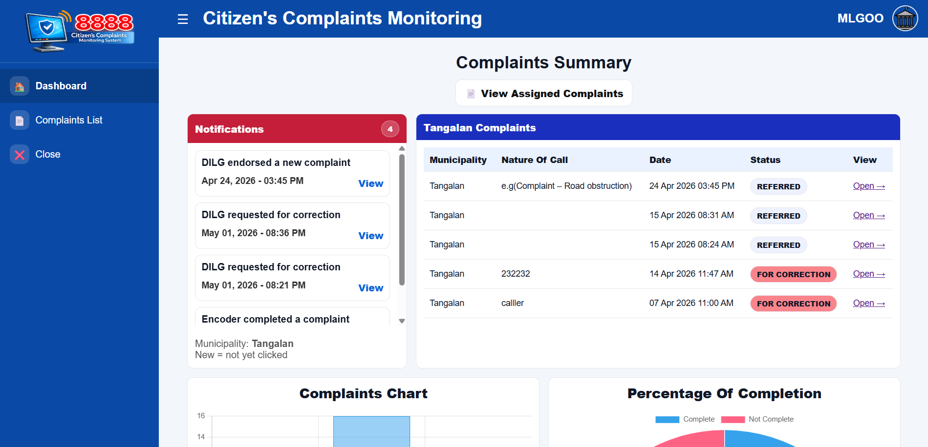

In DILG PORTAL and click “Logout” at the top right of the header/navigation bar.
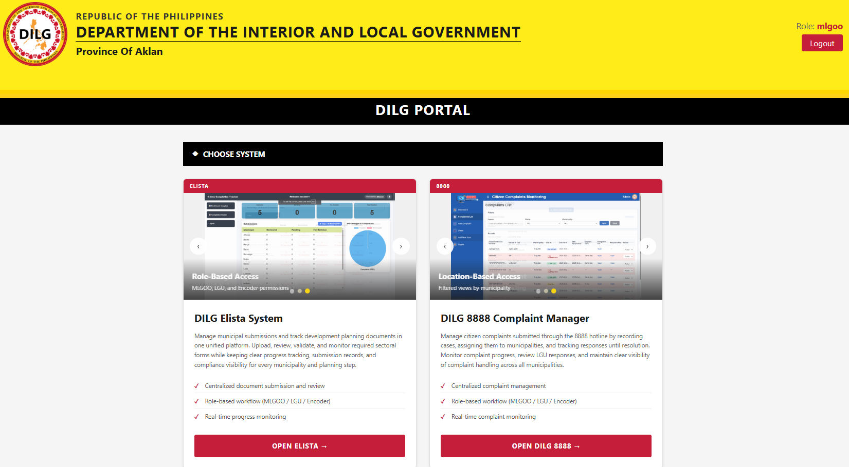

2. MLGOO Guide
The MLGOO (Municipal Local Government Operations Officer) account is a monitoring role. MLGOO users can view and monitor complaints assigned to their municipality but do not have the ability to add, edit, delete, or upload documents but can view and comment only.

2.1 Dashboard & Navigation
After logging in, the MLGOO user sees complaints relevant to their assigned municipality.
The sidebar navigation provides quick access to all available pages:
- 1. Dashboard — Overview and analytics
- 2. Complaints List — Full list of all encoded complaints
- 3. Close — End the current session
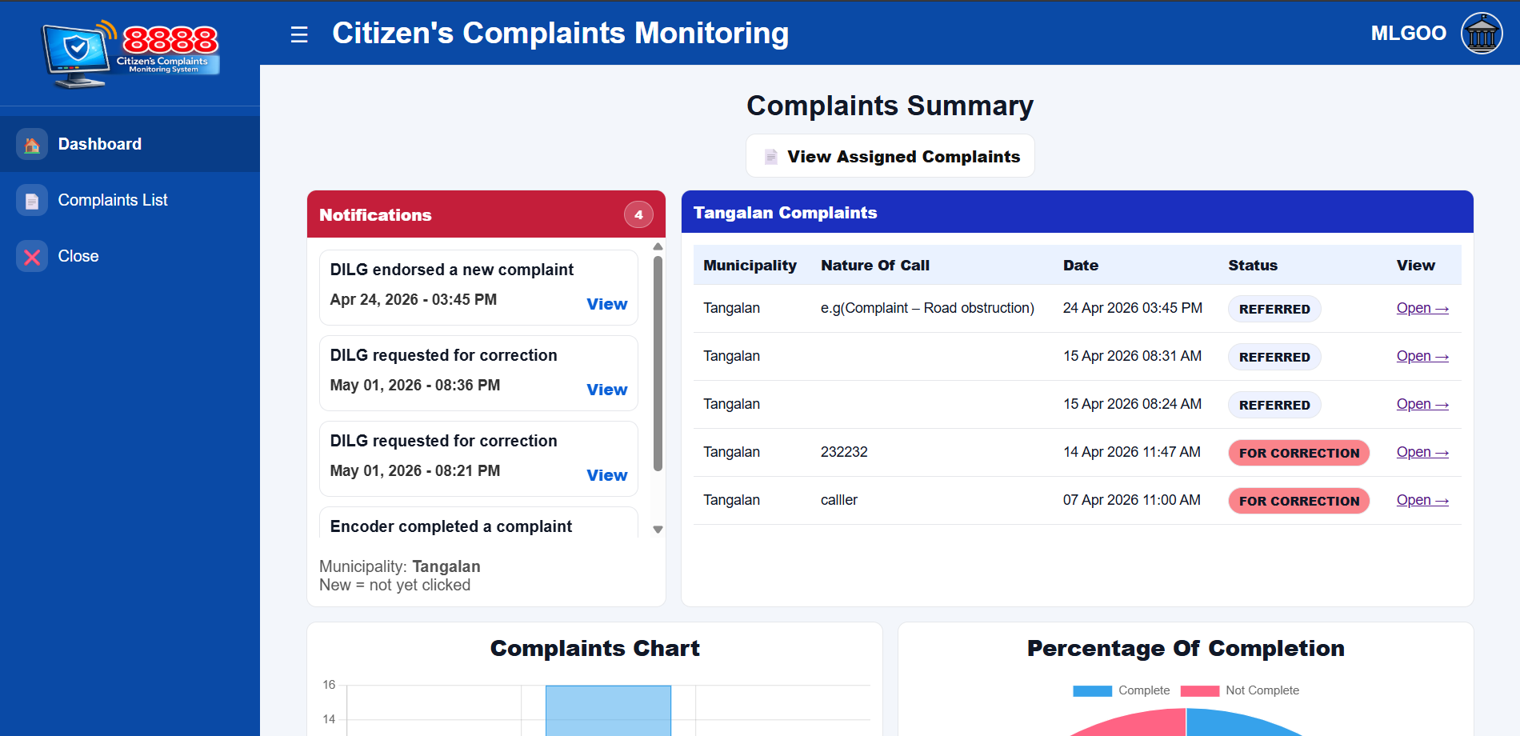
3
2
1

2.2 Notification
The dashboard has a Notifications panel that automatically alerts users when something happens to a complaint. There are 4 types of notifications, and they work differently per role:
- Endorsed a new complaint – Admin / Encoder encodes and assigns a new complaint to their municipality.
- Requested for correction – Admin / Encoder want to "Request Revision" on a complaint to their municipality.
- New Comment from Encoder – Admin / Encoder posted a comment on a complaint.
- Completed a complaint – Admin / Encoder marks a complaint as COMPLETE.

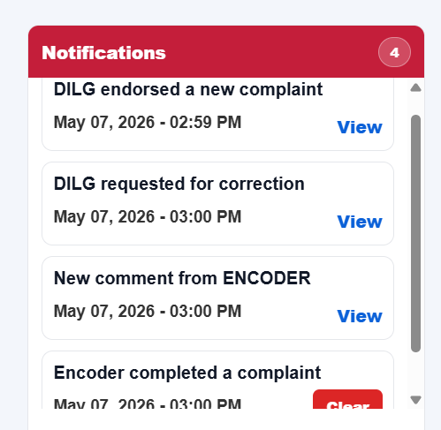

2.3 Viewing a Complaints
MLGOO users can view the full details of any complaint. To view a complaint:
- Select the “Complaints List” from the sidebar.
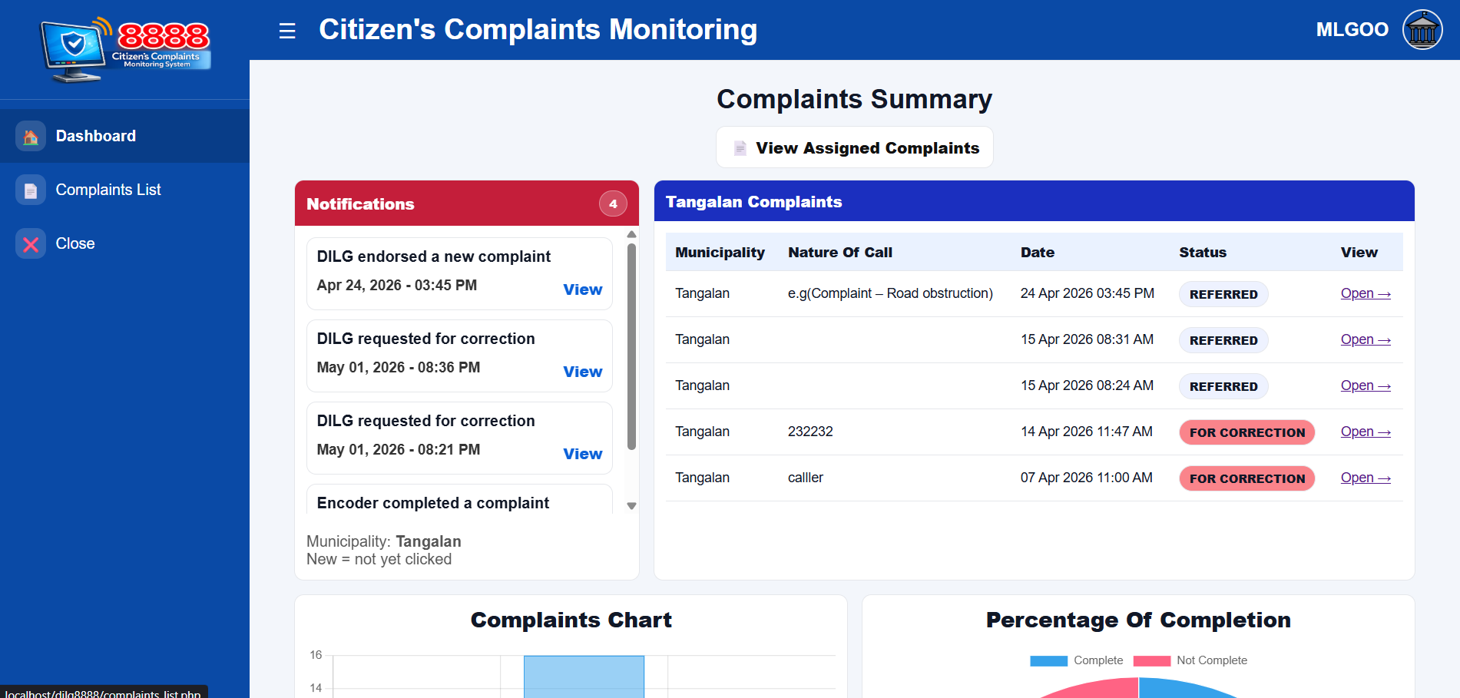
- Find the complaints, search or scroll for the complaint that you want to view.
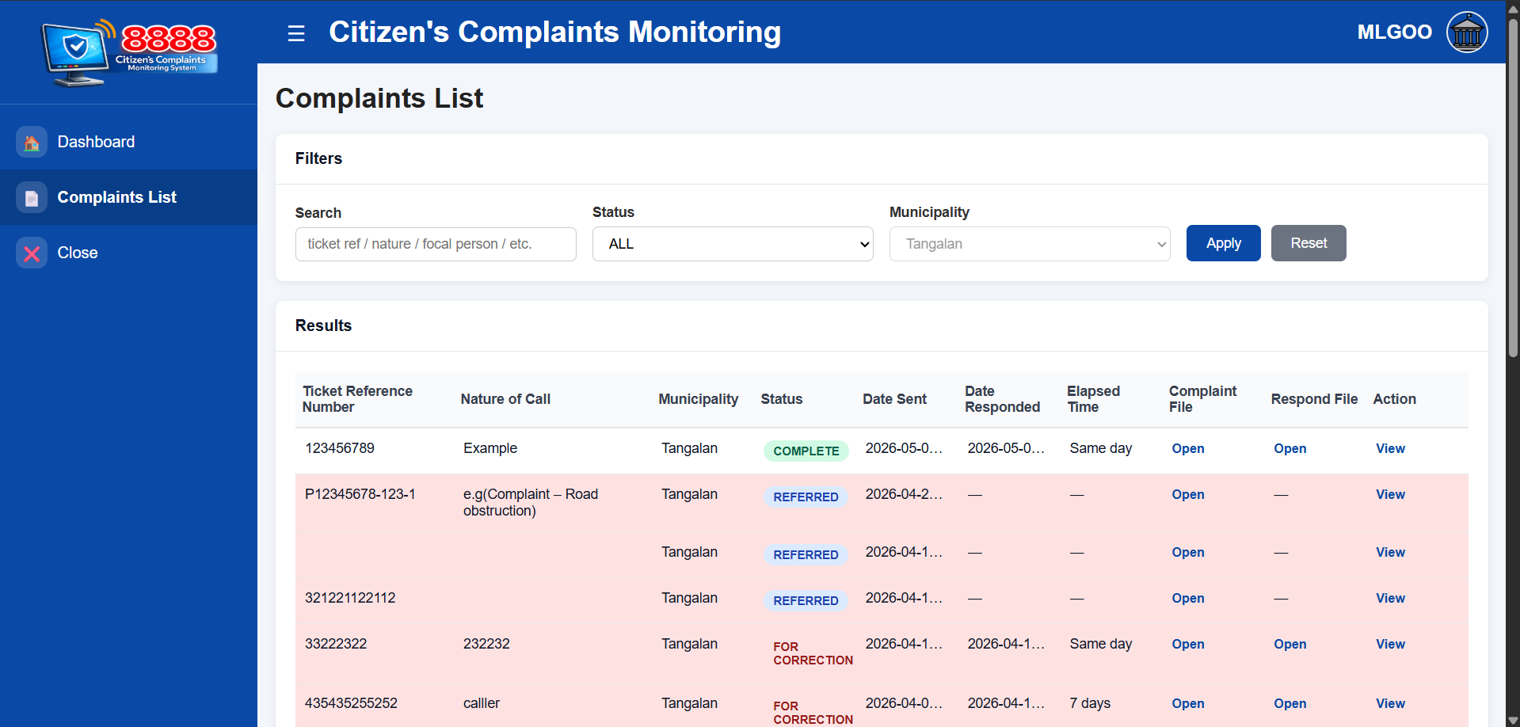
- In the Action column on the below, select “View” to see the complaint details.
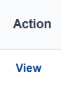

MLGOO users can view the full details of any complaint including:
- Complaint information (ticket reference number, subject, nature of call, complainant, date)
- Assigned municipality
- Current status
- Date the complaint was acknowledged by the LGU
- Complaint PDF & Resolution PDF
- Revision remarks history

2.4 Adding a Comment on a Complaint
MLGOO accounts can add comments on the complaint view page to record observations or notes for the Admin/Encoder to review.
- Select the “Complaints List” from the sidebar.
- Find the complaints, search or scroll for the complaint that you want to comment.

- In the Action column on the below, select “View” to see the complaint details.
- Scroll down and type your comment or observation in the text field.
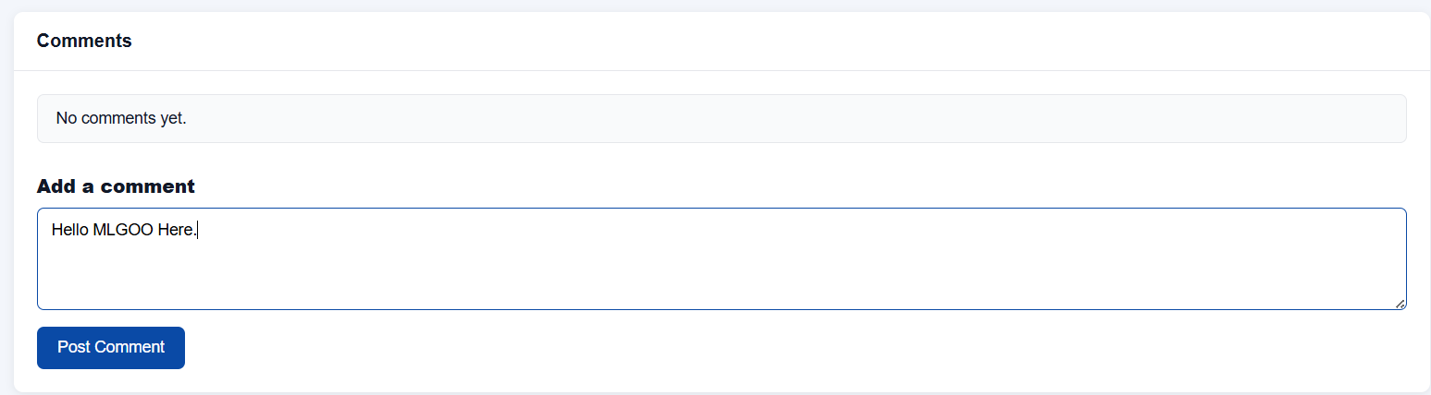
- Select “Post Comment” to apply comment on the complaint.
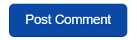
Example:
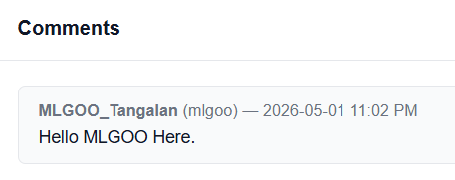

MLGOO Permissions
- MLGOO accounts are read-only for complaint records and they can comment on complaint view.
- MLGOO users cannot add, edit, or delete complaints.
- MLGOO users cannot upload resolution PDFs.
- MLGOO users cannot request revisions.
- MLGOO users cannot manage other user accounts.
- If you need to make changes, contact your Admin/Encoder.

3. Quick Reference: Role Permissions

Feature / Action | Admin | LGU | MLGOO
View complaints (own municipality) | Yes | Yes | Yes
View all complaints (all municipalities) | Yes | No | No
Add / Encode new complaint | Yes | No | No
Edit complaint details | Yes | No | No
Delete complaint | Yes | No | No
Acknowledge / Open complaint | No | Yes | No
Upload resolution PDF | No | Yes | No
Request revision from LGU | Yes | No | No
Mark complaint as COMPLETE | Yes | No | No
View audit/Complaint logs | Yes | No | No
Add new user accounts | Yes | No | No
Edit user accounts | Yes | No | No
Deactivate user accounts | Yes | No | No

4. Troubleshooting & FAQs

4.1 Common Issues

Issue | Solution
Cannot log in | Verify your username and password. Make sure your account is Active. Contact your Admin if needed.
Cannot see a complaint | MLGOO accounts only show complaints assigned to your municipality. Contact your Admin if a complaint appears to be missing.
Cannot upload or edit anything | MLGOO is a read-only monitoring role. Only Admins and LGU accounts can modify complaint records.
Cannot see resolution PDF | The LGU may not have uploaded a resolution yet, or the complaint is still in REFERRED status.
Need to escalate an issue | Add a comment on the complaint view page, or contact your Admin/Encoder directly.

