
MINISTRY OF EDUCATION, CULTURE AND RESEARCH
OF THE REPUBLIC OF MOLDOVA
Technical University of Moldova
Faculty of Computers, Informatics and Microelectronics
Department of Software Engineering and Automation

Report
Laboratory Work No.1 & No.2
Operating Systems
Lab 1: The OS as a Resource Manager
Lab 2: Meet the OS You Will Build (xv6)

Done by: Botezatu Gabriela
st. gr. FAF-243,
Checked by: Reițman Patrici

Chișinău – 2026

TABLE OF CONTENTS
1 LABORATORY WORK 1: THE OS AS A RESOURCE MANAGER 3
1.1 Objective 3
1.2 Tasks: 3
1.3 Theoretical Notes: 3
1.4 Working Environment: 4
1.5 Files and Directories (File Management): 5
1.6 Processes (Process Management): 6
1.7 Memory (Memory Management): 9
1.8 Devices and Storage (I/O Management): 9
1.9 Results: 11
2 LABORATORY WORK 2: MEET THE OS YOU WILL BUILD 12
2.1 Objective 12
2.2 Tasks: 12
2.3 Theoretical Notes: 12
2.4 Building and Booting xv6: 13
2.5 Using xv6: 13
2.6 Reading the Source: 14
2.7 Implementation of the sleep Program: 16
CONCLUSION 19
REFERENCES 22

1 LABORATORY WORK 1: THE OS AS A RESOURCE MANAGER

1.1 Objective
The objective of this laboratory work is to observe the operating system acting as a resource manager on a real Linux system. Working only from the terminal, the four core responsibilities of any operating system are examined in practice: file management, process management, memory management and device (I/O) management. For each of them, the relevant commands are executed and the observed behaviour is recorded and interpreted.

1.2 Tasks:
- Identify the current user, the running kernel and the uptime of the system.
- Explore the file-system tree, create, copy, rename and remove files, and change their permissions.
- List the running processes, start a background process, find it and terminate it; inspect it through /proc.
- Examine the total, used and free memory of the system and the resident memory of a single process.
- Examine the mounted file systems, the block devices and the device files in /dev.
- Answer the "Observe" questions for every part and summarise the four resources managed by the OS.

1.3 Theoretical Notes:
An operating system (OS) is the layer of software that stands between application programs and the hardware. It has two complementary roles: it offers programs a convenient, abstract machine (files instead of disk sectors, processes instead of a bare CPU), and it acts as a resource manager that shares the limited resources of the computer between many competing programs in a safe and efficient way.
The resources managed by every general-purpose operating system can be grouped into four classes:
- Files and storage. The OS organises raw disk blocks into a hierarchical tree of named files and directories, and enforces ownership and access permissions on each of them.
- Processes (CPU). Every running program is a process with its own identifier (PID), state and address space. The OS creates processes, isolates them from one another and schedules them on the available CPUs.
- Memory. The OS divides physical RAM between processes, gives every process its own virtual address space and may move inactive pages to a swap area on disk.
- Devices (I/O). Disks, terminals and other peripherals are hidden behind uniform interfaces. In UNIX-like systems they are presented as special files in /dev, following the principle that "everything is a file".
Linux exposes a large part of its internal state through pseudo-file systems such as /proc and /sys. These are not stored on disk: their content is generated by the kernel at the moment it is read. This makes it possible to look inside the resource manager using ordinary file commands such as cat, ls and grep.

1.4 Working Environment:
All commands were executed as an ordinary (non-root) user on an Ubuntu 24.04 LTS virtual machine running Linux kernel 7.0.0-34-generic on x86_64, with 2 virtual CPUs and about 8 GB of RAM. A working folder ~/os-lab1 was created and the first three commands were used to identify the user, the kernel and the running time of the system.
mkdir -p ~/os-lab1 && cd ~/os-lab1
whoami # who am I to the OS
uname -a # which kernel is managing this machine
uptime # how long has this OS been running
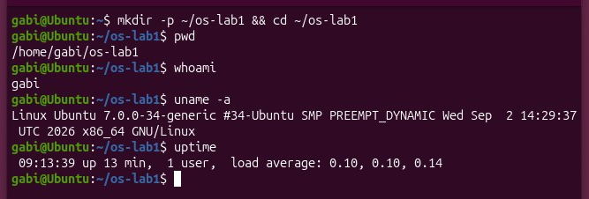
Figure 1 Identifying the user, the kernel and the uptime
The output shows that the session belongs to the user gabi, that the machine is running a Linux 7.0.0-34-generic kernel on an x86_64 architecture, and that the system had been running for about 13 minutes with a very low load average.

1.5 Files and Directories (File Management):
The OS turns a raw disk into a tidy tree of named files that have owners and permissions. The tree was first explored starting from the root directory "/" and from the home directory of the user.
pwd # where am I
ls -la / # the root of the whole tree
ls -la ~ # my home directory
cd /etc && ls | head
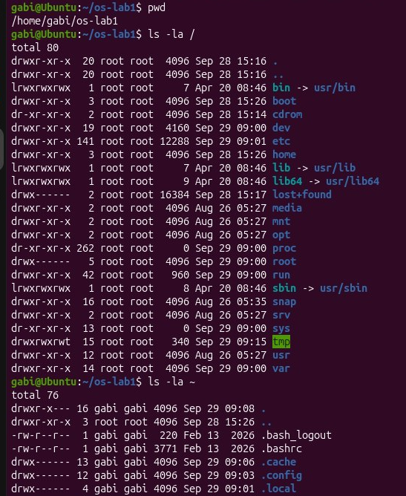
Figure 2 Exploring the root and the home directory
Next, a file was created, copied, renamed and removed, and its permissions were changed with chmod. After every step, ls -l shows how the directory tree was modified by the OS.
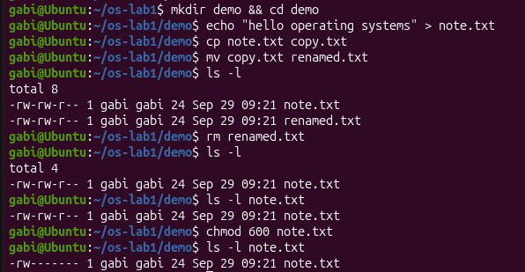
Figure 3 Creating, copying, renaming, removing a file and changing its permissions
Observations:
- Owner and group. The files created in the demo directory are owned by the user gabi and belong to the group gabi. This can be seen in the output of ls -l, where gabi gabi represents the owner and the group of the files.
- Meaning of -rw------- after chmod 600. The first character - indicates a regular file. The next three characters rw- mean that the owner can read and write the file but cannot execute it. The following --- means that the group has no permissions, and the final --- means that other users have no permissions. Therefore, chmod 600 gives read and write permissions only to the owner. After chmod 644, the permissions become -rw-r--r--, meaning that the owner can read and write the file, while the group and other users can only read it.
- Two directories under "/". /etc contains system-wide configuration files and settings.
/dev contains special device files that represent hardware and other devices available to the operating system.

1.6 Processes (Process Management):
Every running program is a process that the OS has created, isolated and scheduled. The processes currently managed by the kernel were listed with ps and top.
ps aux | head
ps aux | wc -l # how many processes exist right now
top # live view; press q to quit
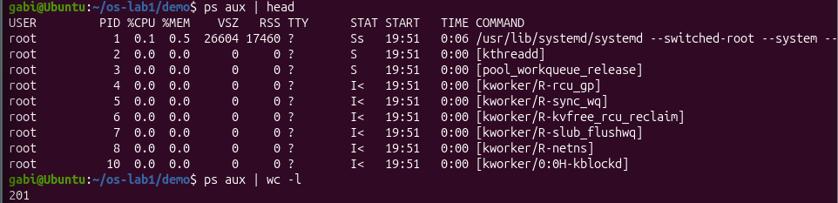
Figure 4 Listing the processes with ps
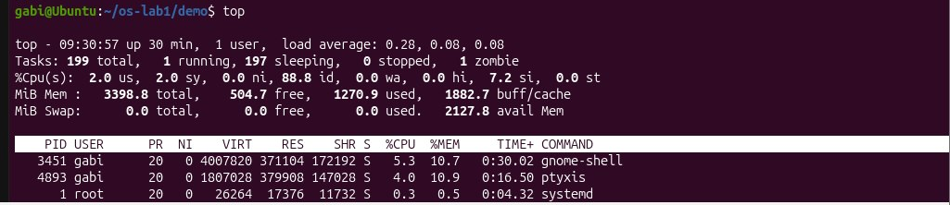
Figure 5 Listing the processes with top
A sleep process was then started in the background, located among all processes and terminated with kill. A second sleep process was inspected through the /proc pseudo-file system, where the kernel publishes a directory for every PID.
sleep 300 & # run in the background; note the PID printed
jobs # shell view of background jobs
ps -ef | grep sleep # find it among all processes
kill <PID> # ask the OS to terminate it
sleep 300 & PID=$!
ls /proc/$PID/
cat /proc/$PID/status | head -20
kill $PID
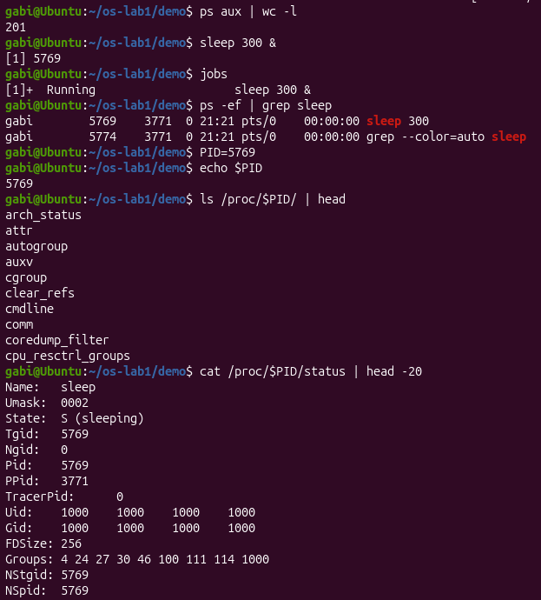
Figure 6 Starting, finding, inspecting and terminating a background process
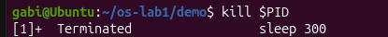
Figure 7 Terminating a background process

Observations:
- Process number 1. PID 1 is the first user-space process started by the Linux kernel during system startup. On this Ubuntu system, PID 1 is systemd, which initializes the system and manages system services and processes.
- Number of processes. The command ps aux | wc -l printed 201 lines, meaning that approximately 200 processes were running, with one additional line corresponding to the ps aux header.
- State of the sleeping process. The line in /proc/5769/status shows State: S (sleeping). This means that the sleep process is currently waiting and is not actively using the CPU. Its PID is 5769.

1.7 Memory (Memory Management):
The OS gives each process its own view of memory and shares the physical RAM between all of them. The totals for the whole system and the resident memory of one process were examined.
free -h # total / used / free RAM and swap
cat /proc/meminfo | head -6
sleep 300 & PID=$!
grep VmRSS /proc/$PID/status # real RAM used by this process
kill $PID
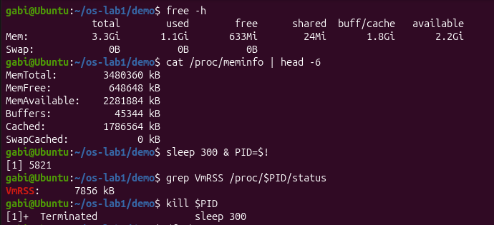
Figure 8 System memory and the resident memory of a process
Observations:
- The virtual machine has approximately 3.3 GiB of RAM (MemTotal = 3,480,360 kB). About 633 MiB are completely free, while approximately 2.2 GiB are available for use. Some memory is used by buffers and cache and can be reclaimed by the operating system when needed.
- Swap. Swap is an area on disk that can be used by the operating system as additional virtual memory when physical RAM is needed. On this virtual machine, no swap is configured (Swap: 0B).
- VmRSS of sleep. The sleep process has a resident memory size (VmRSS) of 7856 kB, which is approximately 7.7 MB of physical RAM. This is relatively small and is not surprising because sleep is a very simple process that performs very little work while waiting.

1.8 Devices and Storage (I/O Management):
The OS hides every disk, terminal and device behind uniform, file-like interfaces. The mounted file systems, the block devices and the device files were listed.
df -h # mounted filesystems and free space
lsblk # the block devices (disks) themselves
du -sh ~/os-lab1 # size of the work folder
ls -l /dev | head # devices presented as files
mount | head
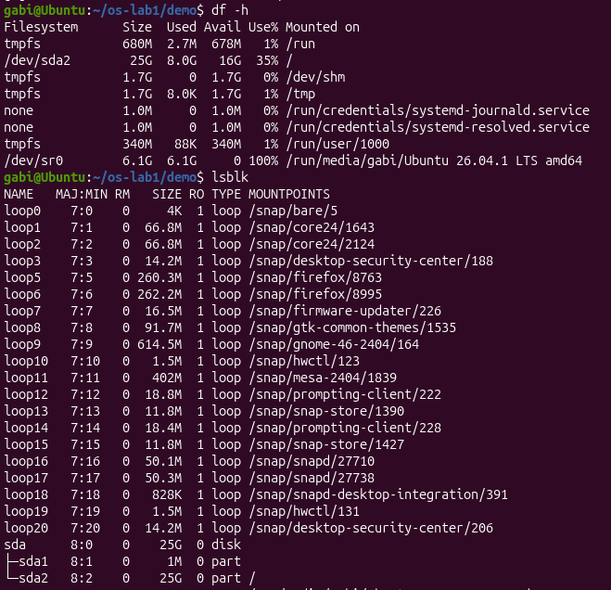
Figure 9 File systems and block devices
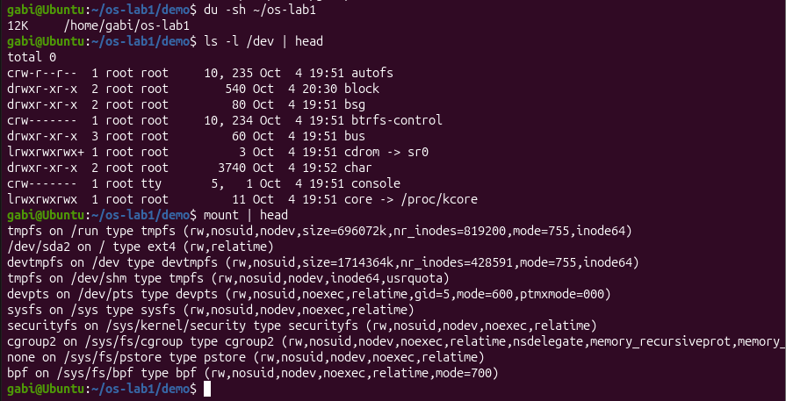
Figure 10 Directory usage, device files and mounted file systems

Observations:
- Root file system. The root file system / is mounted on /dev/sda2, which is a partition of the 25 GB virtual disk /dev/sda. This can be seen in the outputs of df -h and lsblk, where /dev/sda2 is mounted on /.
- An entry from /dev. /dev/console is a character device that represents the system console. The leading c in its permissions indicates that it is a character device. It provides a file-like interface through which the operating system can interact with the console.
- "Everything is a file". “Everything is a file” means that Linux represents many system resources, including disks, terminals and devices, through file-like interfaces. As a result, similar commands and operations can be used to access and inspect different types of resources.

1.9 Results:
The four parts of the laboratory show how the operating system manages different system resources. The table below summarises each resource, the commands used to inspect it, and the main observations obtained during the laboratory.
Table 1 Summary of the resources managed by the OS
Resource | Command used | Observation
Files | ls -l, chmod | Files have an owner, a group, and permissions that determine who can read, write, or execute them.
Processes (CPU) | ps aux, jobs, /proc/<pid>/status | Approximately 200 processes were running. The created sleep process had PID 5769 and was in the S (sleeping) state.
Memory | free -h, /proc/<pid>/status | The VM had approximately 3.3 GiB of RAM and no swap. The sleep process used 7856 kB (~7.7 MB) of resident memory.
Devices (I/O) | lsblk, df -h, ls -l /dev | The virtual disk was /dev/sda (25 GB), and the root file system / was mounted on /dev/sda2. Devices are exposed through special files in /dev.

2 LABORATORY WORK 2: MEET THE OS YOU WILL BUILD

2.1 Objective
The objective of this laboratory work is to build the xv6 teaching operating system from source, boot it in the QEMU emulator, use it as a small UNIX system, study the separation between the kernel and the user programs, and write a first user program that runs inside xv6 and makes a system call into the kernel.

2.2 Tasks:
- Compile the xv6 kernel and user programs and boot the system in QEMU.
- Run the built-in programs of xv6 (ls, cat, echo, grep, wc) and use a pipe.
- Read the source code of user programs and locate the system calls they use in the kernel.
- Implement a new user program, sleep, that pauses for a given number of clock ticks.
- Add the program to the build, rebuild xv6 and test it.
- Optionally, implement pingpong, which exchanges one byte between two processes over pipes.

2.3 Theoretical Notes:
xv6 is a modern re-implementation of the sixth edition of UNIX (Unix V6), developed at MIT for teaching. It is written in ANSI C and runs on a RISC-V multiprocessor. The whole system is small: the kernel used in this work has about 6600 lines of C and assembly in 23 source files, which makes it possible to read and understand the complete operating system. Because no physical RISC-V machine is needed, xv6 is run inside QEMU, an emulator that imitates a RISC-V computer ("virt" machine) with 128 MB of RAM, three CPU cores (harts) and a virtio disk.
The xv6 source tree is divided into two folders, and this division reflects the fundamental structure of every operating system:
- kernel/ contains the operating system itself: the scheduler, memory management, the file system, the drivers and the system-call handlers. This code runs in supervisor mode and has full access to the hardware.
- user/ contains ordinary programs (sh, ls, cat, echo, ...). They run in user mode, are isolated from each other and can obtain services only by asking the kernel through system calls.
A system call is the controlled entry point from user mode into the kernel. In xv6 every system call has a small assembly stub in user/usys.S that places the system-call number in register a7 and executes the RISC-V ecall instruction. The CPU then traps into the kernel, where the function syscall() reads a7, looks up the handler in a table and stores its return value in register a0 of the calling process.

2.4 Building and Booting xv6:
The course copy of xv6 (github.com/mit-pdos/xv6-riscv, commit 06aad25) was built with the RISC-V cross-compiler riscv64-linux-gnu-gcc 13.3 and run with qemu-system-riscv64 8.2.2. A single command compiles the kernel, the user programs and the file-system image fs.img and then boots the system:
cd ~/xv6-riscv
make qemu
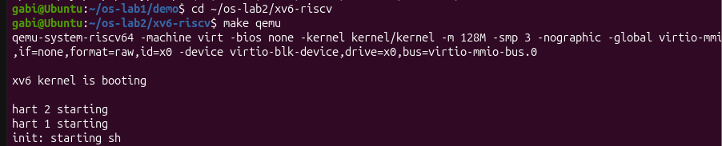
Figure 11 Building xv6 and booting it in QEMU
After a few seconds the kernel prints "xv6 kernel is booting", the two additional harts (CPU cores) start, the init process launches the shell and the $ prompt appears. To leave xv6 the QEMU exit sequence Ctrl-A, then X is used.

2.5 Using xv6:
At the xv6 prompt the built-in programs were executed, including a pipeline between ls and grep:
$ ls
$ cat README
$ echo hello xv6
$ ls | grep c # pipes work here too
$ wc README
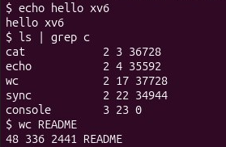
Figure 12 Running the built-in programs of xv6
Observations:
- Programs shipped with xv6. The root directory contains several built-in programs, including cat, echo, grep, ls, mkdir, rm, wc, kill, ln, sh, and usertests.
- OS features needed for a pipe. A pipe requires process management, because the shell must run the two commands as separate processes, and inter-process communication (IPC), because the kernel must transfer the output of one process to the input of another through the pipe.
- xv6 shell vs. Linux shell. The xv6 shell supports basic Unix commands, arguments, pipes and redirection like the Linux shell, but it is much simpler and does not provide features such as command history, tab completion, variables, or advanced scripting.

2.6 Reading the Source:
After stopping QEMU, the xv6 source tree was examined. The project is mainly divided into kernel/, which contains the privileged operating-system code, and user/, which contains the ordinary programs running on top of the operating system.
The source code of user/ls.c and user/cat.c was examined using the commands provided in the laboratory. The cat program uses system calls to interact with the operating system, including open(), read(), write() and close().
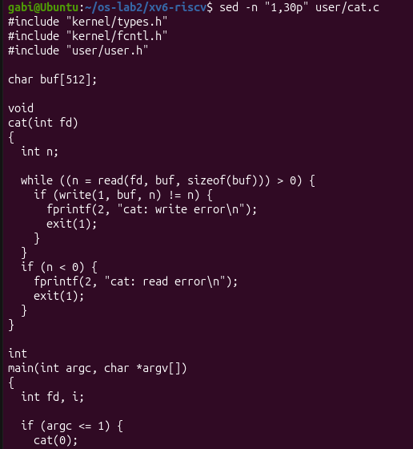
Figure 13 Source code and system calls used by user/cat.c
The system calls available to user programs are declared in user/user.h. The implementations of sys_read() and sys_write() were then located in kernel/sysfile.c. In the examined version of xv6, sys_read() starts at line 69 and sys_write() at line 83.
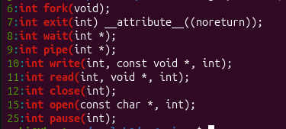
Figure 14 System calls declared in user/user.h
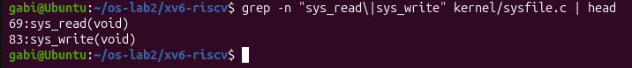
Figure 15 Location of sys_read and sys_write in kernel/sysfile.c
Observations:
- System calls used by user/cat.c. open() asks the kernel to open a file and return a file descriptor. read() reads data from the file into a buffer, write() sends the data to standard output, and close() releases the file descriptor. The program also uses exit() to terminate.
- Location of sys_read. sys_read() is implemented in kernel/sysfile.c, starting at line 69. In the examined source code, sys_write() starts at line 83.
- kernel/ vs. user/. The code in kernel/ implements privileged operating-system services, while the code in user/ contains ordinary programs that request these services through system calls.

2.7 Implementation of the sleep Program:
The sleep program pauses the current process for a number of clock ticks specified as a command-line argument. The program first validates the number of arguments, converts the provided value to an integer, and then requests the operating system to suspend the process for the specified number of ticks.
Algorithm Description:
sleep(argv):
if the number of arguments is not 2:
print "usage: sleep <ticks>" to stderr
exit with status 1
ticks = atoi(argv[1])
call the system function to pause the process for ticks
exit with status 0

Implementation:
The program was implemented in user/sleep.c. In the xv6 version used for this laboratory, the available user-level function is pause(), therefore the program calls pause(atoi(argv[1])) after validating the command-line argument.
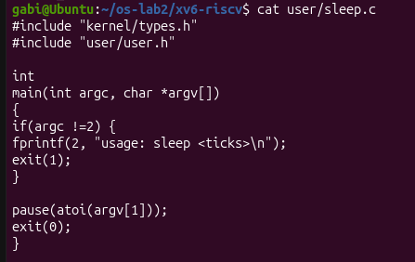
Figure 16 Source code of user/sleep.c
To make the new program available inside xv6, $U/_sleep\ was added to the UPROGS list in the Makefile.
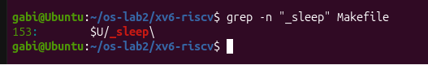
Figure 17 Adding sleep to UPROGS in the Makefile
The xv6 system was then rebuilt and started using make qemu. The program was tested with both a valid argument and a missing argument. Running sleep 10 paused execution and then returned to the shell prompt. Running sleep without an argument correctly displayed:
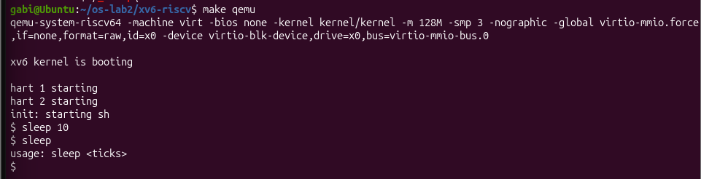
Figure 18 Building xv6 and testing the sleep program
The successful execution confirms that the new user program was included in the xv6 file-system image and can request the operating system to suspend its execution for the specified number of ticks.

CONCLUSION
The purpose of these two laboratory works was to develop a practical understanding of the role and internal organization of an operating system by studying it from two complementary perspectives. The first laboratory focused on observing Linux as a resource manager from the user’s point of view, while the second laboratory introduced xv6 as a small operating system whose source code can be examined, compiled, executed, and extended. Together, the two laboratory works helped connect the theoretical concepts of operating systems with their practical implementation.
During the first laboratory work, the main resources managed by an operating system were investigated directly from the Linux terminal: files and directories, processes, memory, and devices. Working with files demonstrated that the operating system provides a structured file-system hierarchy and controls access through ownership and permissions. Commands such as ls, chmod, cp, mv, and rm showed that common file operations are actually performed and controlled by the operating system.
Process management was explored using commands such as ps, top, jobs, and kill. The results showed that the operating system manages a large number of processes simultaneously and keeps information about each process, including its identifier and current state. The /proc pseudo-file system provided an additional way of examining this information directly. A background sleep process was created, located, inspected, and terminated, demonstrating how Linux creates, schedules, monitors, and controls running programs. In the performed experiment, approximately 200 processes were active, while the created sleep process could be observed in the sleeping state.
Memory management was also examined in practice. The commands free and /proc/<pid>/status showed both the overall distribution of physical memory and the amount of memory used by an individual process. The virtual machine had approximately 3.3 GiB of RAM and no configured swap, while the tested sleep process used approximately 7.7 MB of resident physical memory. This demonstrated that memory management is not limited to reporting free and used RAM; the operating system is responsible for distributing physical memory among processes and providing each process with its own controlled memory environment.
The investigation of devices and storage completed the resource-management perspective. Commands such as df, lsblk, mount, and ls -l /dev showed how storage devices, partitions, mounted file systems, and device interfaces are represented by Linux. In particular, the virtual disk was identified as /dev/sda, while /dev/sda2 contained the root file system. The presence of device files in /dev illustrated the UNIX principle that many different resources can be accessed through file-like interfaces.
The second laboratory work moved from observing an operating system externally to examining its internal structure. xv6 was compiled from source and successfully booted using QEMU on emulated RISC-V hardware. Although xv6 is considerably smaller than Linux, interacting with its shell showed that it provides the essential characteristics of a UNIX-like operating system, including user programs, files, pipes, processes, and system calls. Commands such as ls, cat, echo, grep, and wc behaved in a familiar way, while the use of a pipe demonstrated the cooperation between process management and inter-process communication.
An important part of the second laboratory was examining the separation between user programs and the kernel. The source code showed that programs located in user/ cannot directly perform privileged operations. Instead, they request services from the operating system through system calls. For example, cat uses operations such as open(), read(), write(), and close(), while the corresponding kernel functionality is implemented by system-call handlers such as sys_read() and sys_write() in kernel/sysfile.c. This made the transition from user mode to kernel mode much more concrete and demonstrated how an ordinary program communicates with the operating system.
The implementation of the sleep program provided practical experience with extending xv6. A new source file was created in the user/ directory, the program was added to the UPROGS list in the Makefile, and the complete operating system was rebuilt. In the version of xv6 used during the laboratory, the available function was pause(), so the implementation used pause(atoi(argv[1])) after validating the command-line arguments. After rebuilding xv6, sleep 10 successfully paused and returned to the shell, while calling sleep without an argument correctly displayed the usage message. This confirmed that the newly implemented program had been included in the xv6 file-system image and was able to request a service from the operating system.
Overall, these laboratory works demonstrated that an operating system can be understood both as a resource manager and as a software system composed of interacting components. Linux provided a realistic environment for observing how resources are managed in a modern operating system, while xv6 made it possible to examine the mechanisms behind similar operations at source-code level. The transition from executing Linux commands to reading xv6 source code and finally implementing and running a new xv6 program helped establish a clear connection between user actions, system calls, and kernel services.
As a result, the laboratory works provided a stronger practical foundation for understanding processes, memory, file systems, devices, system calls, user mode, and kernel mode. They also demonstrated that operating-system concepts are not only theoretical abstractions but mechanisms that can be directly observed, tested, and modified. This experience with xv6 therefore creates a useful basis for the following laboratory works, where the focus can move from using existing kernel functionality to modifying and extending the kernel itself.

REFERENCES
1. Operating Systems 2026-2027, Laboratory Work 1: “The OS as a Resource Manager (Linux)”, FCIM / FAF / Technical University of Moldova.
2. Operating Systems 2026-2027, Laboratory Work 2: “Meet the OS You Will Build (xv6)”, FCIM / FAF / Technical University of Moldova.
3. MIT PDOS. xv6-riscv source repository. Available at: https://github.com/mit-pdos/xv6-riscv

