
MINISTRY OF EDUCATION, CULTURE AND RESEARCH
OF THE REPUBLIC OF MOLDOVA
Technical University of Moldova
Faculty of Computers, Informatics and Microelectronics
Department of Software Engineering and Automation

Report
Laboratory Work No.3 & No.4
Operating Systems
Lab 3: The Command Line: Shell, Pipes and Text Filters
Lab 4: The xv6 Shell from the Outside

Done by: Botezatu Gabriela
st. gr. FAF-243,
Checked by: Reițman Patricia

Chișinău – 2026

TABLE OF CONTENTS
1 LABORATORY WORK 3: THE COMMAND LINE: SHELL, PIPES AND TEXT FILTERS 3
1.1 Objective 3
1.2 Tasks: 3
1.3 Theoretical Notes: 3
1.4 Working Environment: 4
1.5 Moving Fast and Finding Help: 5
1.6 What the Shell Does to the Command Line: 6
1.7 Redirection, Chaining and Jobs: 8
1.8 Answering Questions with One-Liners: 10
1.9 The First Script: 13
1.10 Results: 15
2 LABORATORY WORK 4: THE XV6 SHELL FROM THE OUTSIDE 16
2.1 Objective 16
2.2 Tasks: 16
2.3 Theoretical Notes: 16
2.4 Fixing sleep for the Current xv6: 17
2.5 bash versus the xv6 Shell: 18
2.6 Who Expands *? A Program that Prints its argv: 21
2.7 Reading the Shell: 23
CONCLUSION 26
REFERENCES 28

1 LABORATORY WORK 3: THE COMMAND LINE: SHELL, PIPES AND TEXT FILTERS

1.1 Objective
The objective of this laboratory work is to learn to work quickly and precisely in the bash shell on Linux. The work focuses on predicting what the shell does to a command line before the command is executed (globbing, quoting, variable and command substitution), on redirecting the standard streams of a program, on chaining commands and running background jobs, and on answering concrete questions about a data set with one-line pipelines of small text filters. Finally, the best one-liners are turned into a first shell script.

1.2 Tasks:
- Use Tab completion and the command history, find out whether a command is built-in or external, inspect PATH and read the manual pages.
- Predict, run and explain the expansions the shell performs on a command line: globbing, quoting, brace, arithmetic and command substitution.
- Redirect standard output and standard error to files, compare the order of redirections, chain commands with ;, && and || and control a background job.
- Answer eight questions about an artificial web access log, each with a single command line, and save them in oneliners.sh.
- Write the script report.sh that summarises the log, complete its TODO loop and test its error handling.
- Answer the "Observe" questions for every part.

1.3 Theoretical Notes:
The shell is an ordinary user program that reads a command line, transforms it and asks the operating system to run the requested programs. Before any program is started, bash processes the line in a fixed order:
- Splitting into words and operators. The line is split on blanks; the characters | & ; ( ) < > are recognised as operators.
- Expansions. Brace expansion ({1..5}), tilde expansion (~), parameter expansion ($HOME), command substitution ($(...)), arithmetic expansion ($((...))) and finally pathname expansion (globbing: *, ?, [...]) are performed.
- Quote removal. The quotes that protected parts of the line are removed, so the program never sees them.
- Redirections and execution. The standard streams are connected to files or pipes and the program is started with the resulting argument list.
Every process starts with three open file descriptors: 0 – standard input (stdin), 1 – standard output (stdout) and 2 – standard error (stderr). Redirection operators (<, >, >>, 2>, 2>&1) change where these descriptors point, and a pipe (|) connects the stdout of one process to the stdin of the next. This makes it possible to build complex processing from small filters such as grep, cut, sort, uniq, wc, head, tail and tr, each of which does one job well (the UNIX philosophy).
Every command returns an exit status: 0 means success and any other value means failure (for example 127 – command not found). The operators && and || use this status to decide whether the next command is executed, while ; always runs it.

1.4 Working Environment:
All commands were executed as an ordinary user in a bash terminal on the same Ubuntu 24.04 LTS virtual machine as in the previous laboratory works. A working folder ~/os-lab3 was created and the data set for Part 4 (an artificial web access log with 500 lines) was generated with the script provided in the laboratory:
mkdir -p ~/os-lab3 && cd ~/os-lab3
for i in $(seq 1 500); do
echo "2026-10-05 10:$(printf %02d $((i % 60))) user$((i % 7)) $([ $((i % 5)) -eq 0 ] && echo FAIL || echo OK) /page$((i % 4))"
done > access.log
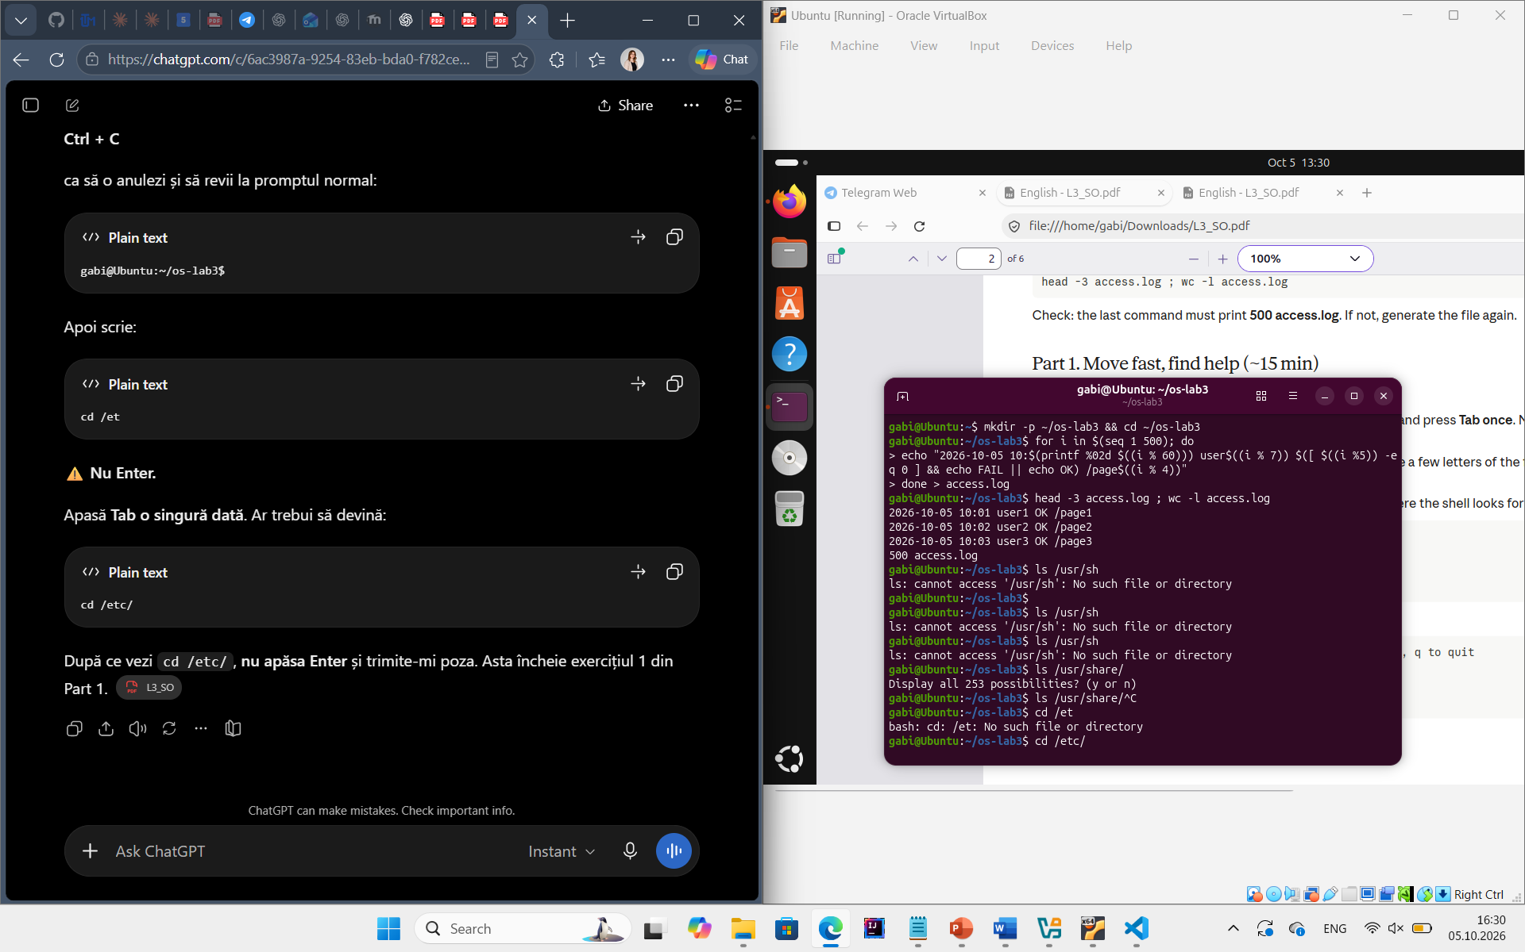
head -3 access.log ; wc -l access.log

Figure 1.1 – Generating the access.log data set
The last command printed 500 access.log, which confirms that the file was generated correctly. Each line has five fields: the date, the time, the user, the result (OK or FAIL) and the requested page, for example 2026-10-05 10:01 user1 OK /page1.

1.5 Moving Fast and Finding Help:
First, Tab completion and the command history were tested. Typing ls /usr/sh and pressing Tab twice displayed all the entries of /usr that start with "sh" (because there is more than one match, the first Tab does nothing and the second one lists the candidates). Typing cd /et and pressing Tab once completed the name to cd /etc/, since there is only one match. After three different commands were executed, Ctrl+R opened the reverse history search; typing a few letters of the first command found it in the history and Enter executed it again.
Figure 1.2 – Tab completion
Next, the type of the commands and the places where the shell looks for programs were examined:
type cd ; type ls ; type echo ; which ls
echo $PATH
echo $PATH | tr ':' '\n' # one directory per line
nosuchprog ; echo "exit code: $?"
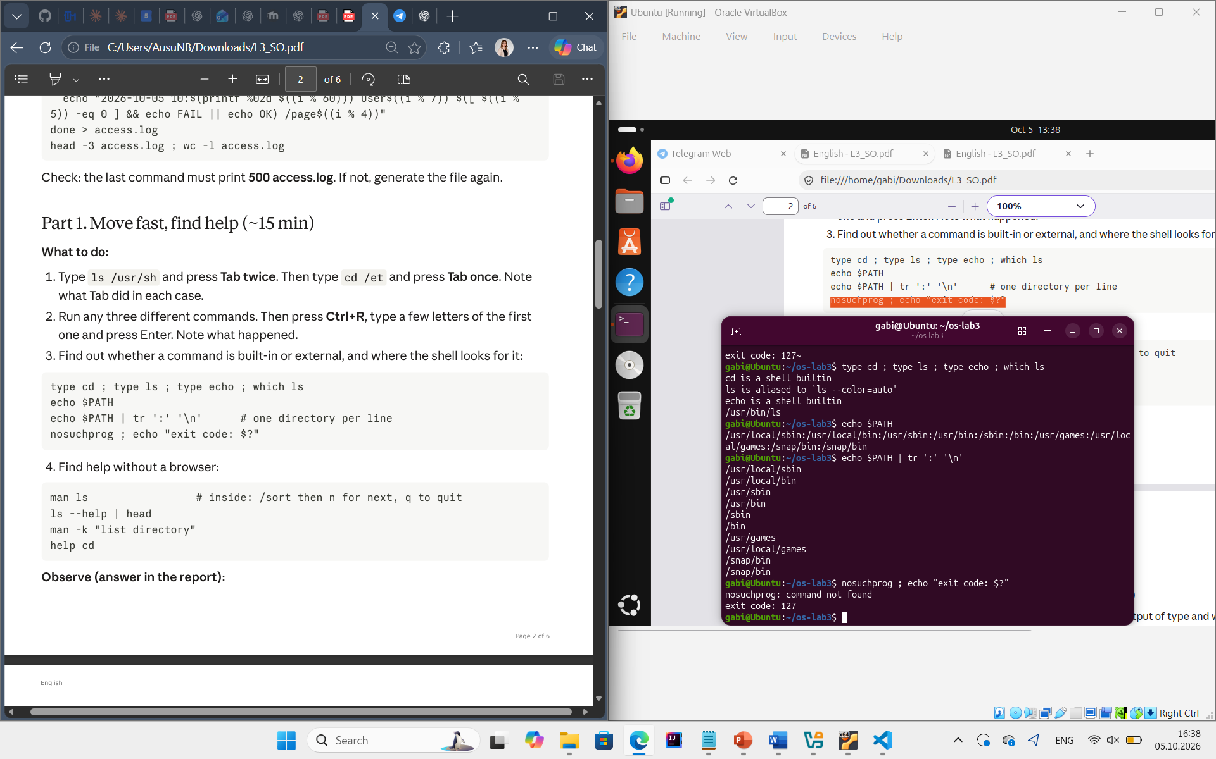
Figure 1.3 – Output of type and which
Figure 1.4 – The directories in PATH
Figure 1.5 – Exit code of a missing command
Help was obtained without a browser using man ls (searching inside with /sort and n), ls --help | head, man -k "list directory" and help cd (help is used for the built-in commands of bash, which have no separate program).
Observations:
- Built-in commands. cd and echo are shell built-ins, while ls is an external program (/usr/bin/ls). cd MUST be a built-in: the current directory is a property of each process. If cd were an external program, the shell would start it as a child process, the child would change its own directory and then exit, and the directory of the shell itself would remain unchanged.
- PATH. The PATH variable contains 10 entries (9 unique directories). /snap/bin appears twice. The directories are /usr/local/sbin, /usr/local/bin, /usr/sbin, /usr/bin, /sbin, /bin, /usr/games, /usr/local/games, and /snap/bin. ls is located in /usr/bin (which ls prints /usr/bin/ls).
- Exit code of a missing command. A command that is not found prints "command not found" and returns the exit code 127.
- Sorting by time. The option -t of ls sorts the entries by modification time, newest first (found in man ls with /sort).

1.6 What the Shell Does to the Command Line:
A test directory with several files was created, including a file whose name contains a space:
mkdir -p ~/os-lab3/play && cd ~/os-lab3/play
touch a.c b.c file1.txt file2.txt notes.txt "alfa beta.txt"
ls
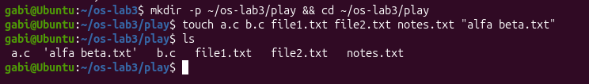
Figure 1.6 – Files created in the play directory
For each of the following lines a prediction was written down first, then the line was executed and the real output was compared with the prediction. The results are presented in Table 1.1.
Table 1.1 – Predictions and real outputs of the shell expansions
Command | My prediction | Real output | Explanation (if different)
echo *.c | a.c b.c | a.c b.c | –
echo file?.txt | file1.txt file2.txt | file1.txt file2.txt | –
echo [a-b]* | a.c b.c | a.c alfa beta.txt b.c | [a-b]* matches every name that starts with a or b, so "alfa beta.txt" also matches.
echo *.xyz | (empty line) | *.xyz | When a pattern matches no file, bash leaves the word unchanged.
ls alfa beta.txt | alfa beta.txt | ls: cannot access 'alfa' ... 'beta.txt': No such file or directory | Without quotes the name is split into two words, so ls receives two arguments.
ls "alfa beta.txt" | alfa beta.txt | alfa beta.txt | –
echo '$HOME' "$HOME" \$HOME | $HOME /home/gabi $HOME | $HOME /home/gabi $HOME | –
echo {1..5} ; echo $((7 * 6)) | 1 2 3 4 5 and 42 | 1 2 3 4 5 and 42 | –
echo "today is $(date +%A), I am $(whoami)" | today is Monday, I am gabi | today is Monday, I am gabi | –
touch log{1..3}.txt && ls log* | log1.txt log2.txt log3.txt | log1.txt log2.txt log3.txt | –
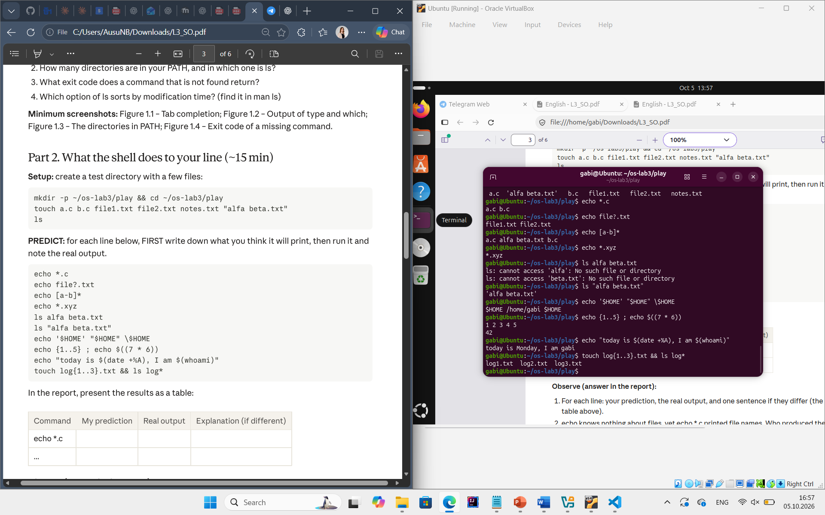
Figure 1.7 – Globbing results
Figure 1.8 – The ls error on a name with a space, and the fix
Figure 1.9 – Single quotes, double quotes and backslash
Observations:
- Predictions. The predictions, the real outputs and the explanations of the differences are given in Table 1.1. The two mismatches were caused by globbing rules: a pattern can match names that contain spaces, and a pattern that matches nothing is passed to the program unchanged.
- Who produced the file names. echo knows nothing about files; the file names were produced by the shell. Before starting echo, bash performed pathname expansion and replaced *.c with the list of matching names, so echo received the arguments "a.c" and "b.c" and simply printed them.
- Why ls alfa beta.txt failed. Without quotes or an escaped space, the shell treats alfa and beta.txt as two separate arguments, and neither file exists. Two ways to fix it are to quote the name (ls "alfa beta.txt" or ls 'alfa beta.txt') or escape the space with a backslash (ls alfa\ beta.txt). Tab completion can also insert the required escaping automatically.
- Single vs. double quotes. Inside single quotes nothing is expanded – the text is taken literally ('$HOME' prints $HOME). Inside double quotes the text stays one word, but $ expansions and $(...) substitutions are still performed ("$HOME" prints /home/gabi). A backslash protects only the next character (\$HOME prints $HOME).

1.7 Redirection, Chaining and Jobs:
The following commands were executed one by one in ~/os-lab3:
cd ~/os-lab3
ls /etc /nope > out.txt 2> err.txt
wc -l out.txt ; cat err.txt
ls /etc /nope > all.txt 2>&1 ; tail -2 all.txt
echo first > notes.md ; echo second >> notes.md ; cat notes.md
wc -l < access.log
ls /nope 2> /dev/null || echo "failed with code $?"
mkdir -p tmp && cd tmp && echo "I am in $(pwd)" ; cd ~/os-lab3
sleep 100 &
jobs ; kill %1 ; jobs
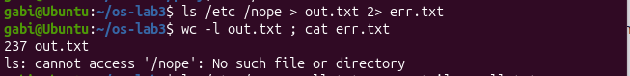
Figure 1.10 – stdout and stderr in separate files
To compare the order of the redirections, the two versions below were executed and the terminal and the file were inspected:
ls /etc /nope > all.txt 2>&1
ls /etc /nope 2>&1 > all.txt
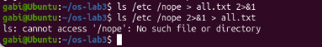
Figure 1.11 – Comparing the order of redirections
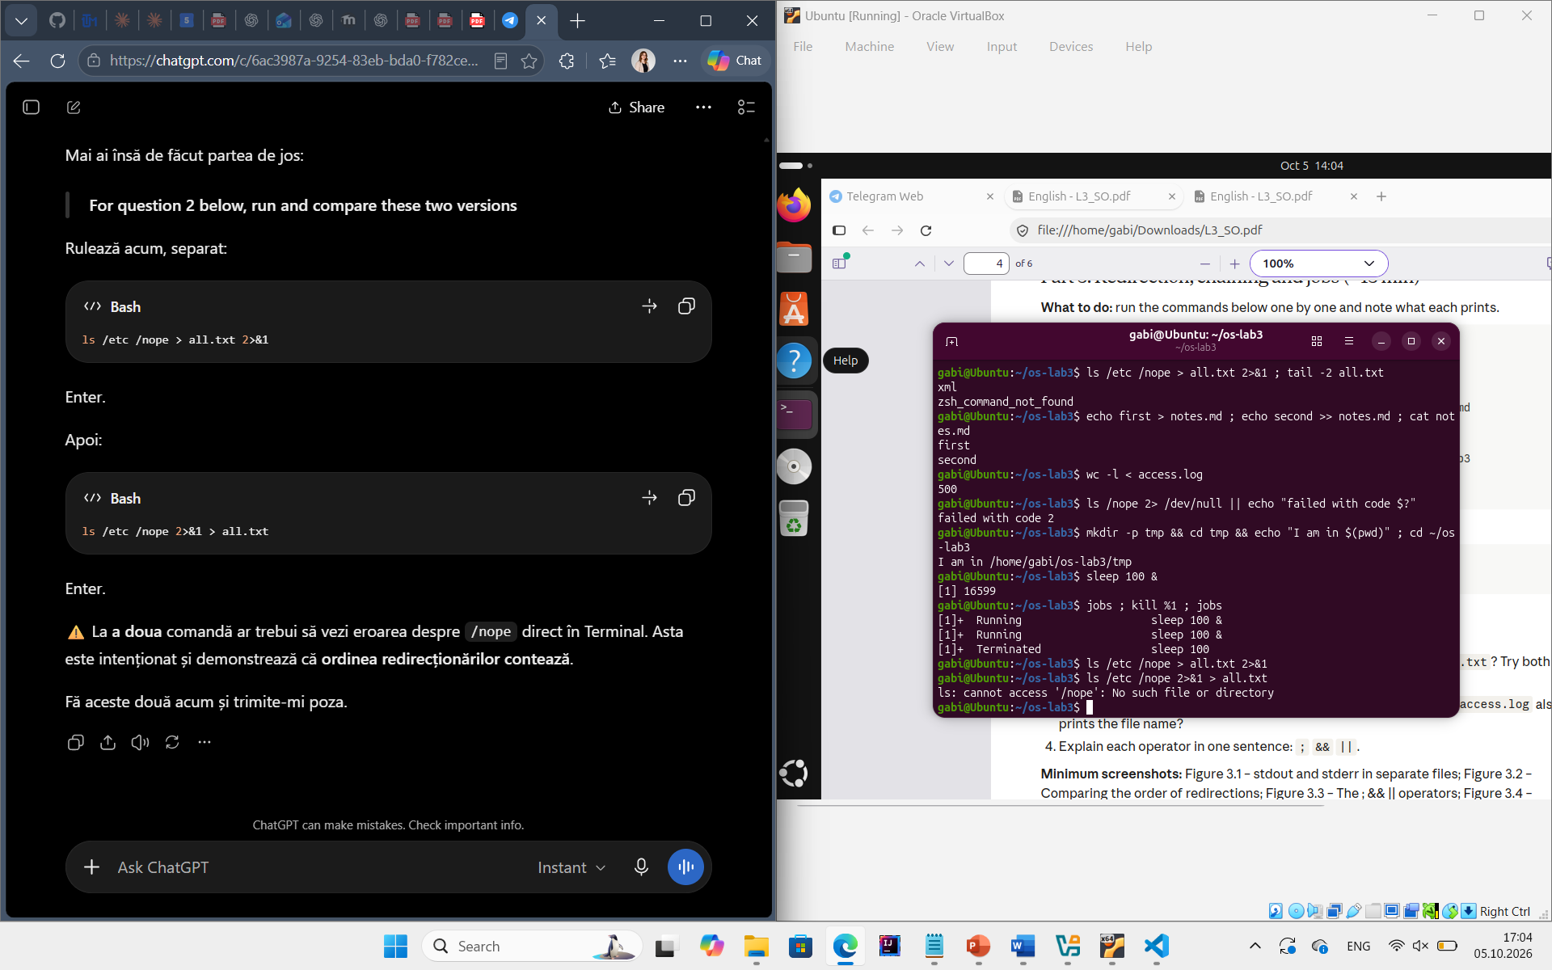
Figure 1.12 – The ; && || operators
Figure 1.13 – Running a background job and stopping it
The command echo first > notes.md ; echo second >> notes.md showed the difference between > (truncate and write) and >> (append): the file contains both lines. The command ls /nope 2> /dev/null || echo ... printed "failed with code 2", because the error message was discarded in /dev/null and ls returned 2. sleep 100 & started a background job ([1] with its PID), jobs showed it as Running, and after kill %1 it was reported as Terminated and disappeared from the list.
Observations:
- Where the output went. The error message "ls: cannot access '/nope': No such file or directory" went to err.txt (stderr, descriptor 2), while the listing of /etc went to out.txt (stdout, descriptor 1). wc -l out.txt printed 237 lines.
- > all.txt 2>&1 vs. 2>&1 > all.txt. Redirections are processed from left to right. In > all.txt 2>&1, stdout is first pointed to all.txt and then stderr is made a copy of stdout, so both the listing and the error end up in the file. In 2>&1 > all.txt, stderr is first made a copy of the current stdout (the terminal), and only then stdout is moved to the file. Therefore the error message still appears on the screen and only the listing goes to all.txt.
- wc -l < access.log vs. wc -l access.log. With < the shell opens the file and connects it to the stdin of wc; wc receives no file name argument, it only reads a stream, so it prints just the number (500). With wc -l access.log the file name is an argument, wc opens the file itself and prints the name next to the count.
- Operators. ; runs the next command unconditionally, after the previous one finishes. && runs the next command only if the previous one succeeded (exit code 0). || runs the next command only if the previous one failed (exit code different from 0).

1.8 Answering Questions with One-Liners:
Each line of access.log has the form "date time user result page". Every question was answered with a single command line built from small filters joined by pipes, and all lines were saved in oneliners.sh, with the question as a comment above each command. Because the data set is generated by a formula, the results are the same for everyone.
Q1. How many requests failed?
grep -c FAIL access.log
The command prints 100: every fifth request (i divisible by 5) failed.
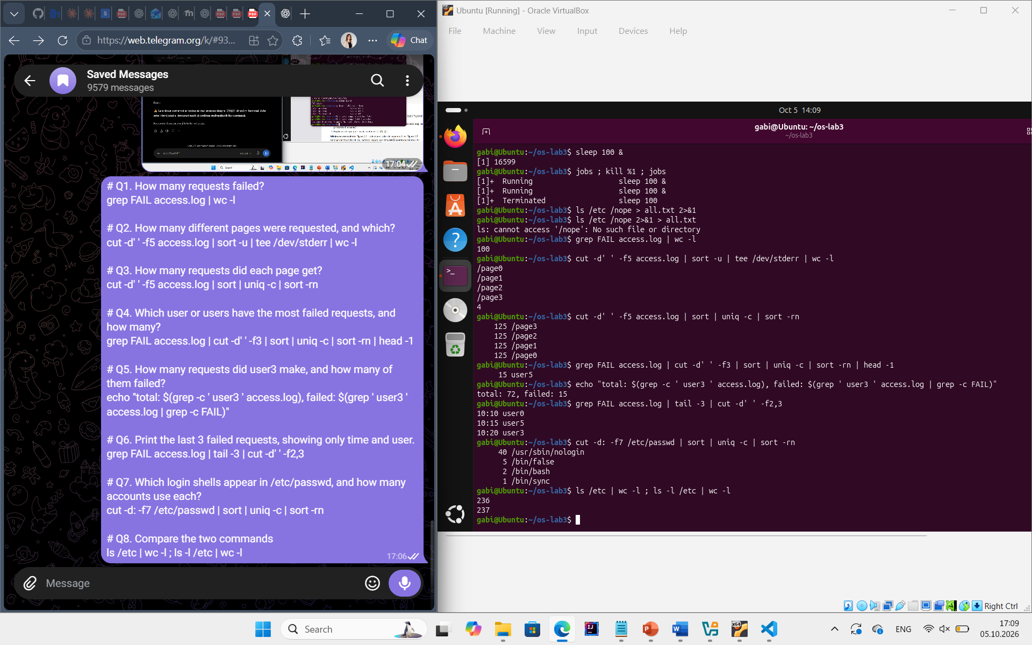
Figure 1.14 – Number of failed requests
Q2. How many different pages were requested, and which?
cut -d' ' -f5 access.log | sort -u ; cut -d' ' -f5 access.log | sort -u | wc -l
Four different pages were requested: /page0, /page1, /page2 and /page3.
Figure 1.15 – The different pages that were requested
Q3. How many requests did each page get?
cut -d' ' -f5 access.log | sort | uniq -c
Each page received 125 requests; 4 × 125 = 500, which matches the number of lines in the log.
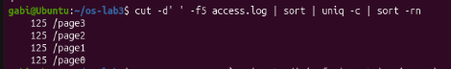
Figure 1.16 – Number of requests per page
Q4. Which user or users have the most failed requests, and how many?
grep FAIL access.log | cut -d' ' -f3 | sort | uniq -c | sort -rn | head -2
user3 and user5 share the first place with 15 failed requests each; all the other users have 14. The per-user counts add up to 15 + 15 + 5 × 14 = 100, the same as Q1.
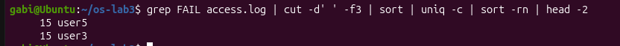
Figure 1.17 – Users with the most failed requests
Q5. How many requests did user3 make, and how many of them failed?
grep -c ' user3 ' access.log ; grep ' user3 ' access.log | grep -c FAIL
user3 made 72 requests, of which 15 failed. The spaces around user3 in the pattern prevent false matches with other fields.
Figure 1.18 – Requests and failures of user3
Q6. Print the last 3 failed requests, showing only time and user.
grep FAIL access.log | tail -3 | cut -d' ' -f2,3
The output is: 10:10 user0, 10:15 user5 and 10:20 user3.
Figure 1.19 – The last three failed requests
Q7. Which login shells appear in /etc/passwd, and how many accounts use each?
cut -d: -f7 /etc/passwd | sort | uniq -c | sort -rn
The result shows that most accounts are system accounts with the shell /usr/sbin/nologin, meaning they cannot log in interactively. Only two accounts use /bin/bash, while one account uses /bin/sync.
Figure 1.20 – Login shells in /etc/passwd
Q8. PREDICT, then explain: why do ls /etc | wc -l and ls -l /etc | wc -l differ by exactly one?
ls /etc | wc -l ; ls -l /etc | wc -l
The prediction was that ls -l adds one extra line, and the outputs (236 and 237) confirmed it. When its output is not a terminal, ls prints one name per line, so the first count is the number of entries. ls -l prints the same entries, one per line, but adds a first line "total N" with the number of disk blocks used, so the count is larger by exactly one.
Figure 1.21 – The difference between ls and ls -l
Finally, the whole file was executed in ~/os-lab3 with bash oneliners.sh, and all the answers were printed in order.
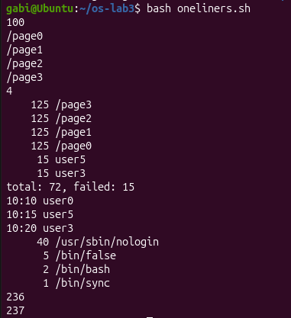
Figure 1.22 – Full run of oneliners.sh
Check. The counts of Q3 add up to 500 and the per-user failures behind Q4 add up to the result of Q1 (100), which confirms that the pipelines filter the right fields.

1.9 The First Script:
The best one-liners were turned into a program. The script report.sh receives the name of the log file as its first argument, checks that the file exists, prints the total number of requests and the number of failures, and then, in the completed TODO part, prints the number of failures for each user from user0 to user6 with a for loop.
#!/bin/bash
# usage: ./report.sh access.log
log=$1
if [ ! -f "$log" ]; then
echo "no such file: $log" >&2
exit 1
fi
total=$(wc -l < "$log")
fails=$(grep -c FAIL "$log")
echo "$total requests, $fails failed"
for n in $(seq 0 6); do
echo "user$n: $(grep " user$n " "$log" | grep -c FAIL) failures"
done
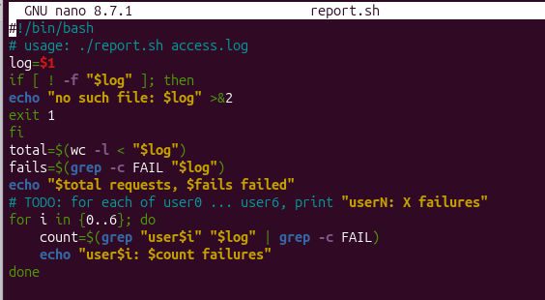
Figure 1.24 – Contents of report.sh
The script was made executable and tested both on the log and on a file that does not exist:
chmod +x report.sh
./report.sh access.log
./report.sh nope.log ; echo "exit code: $?"
On access.log the script printed "500 requests, 100 failed", followed by the lines user0: 14 failures, user1: 14, user2: 14, user3: 15, user4: 14, user5: 15 and user6: 14 failures – the same numbers as in Q4. For nope.log it printed "no such file: nope.log" and the exit code 1.
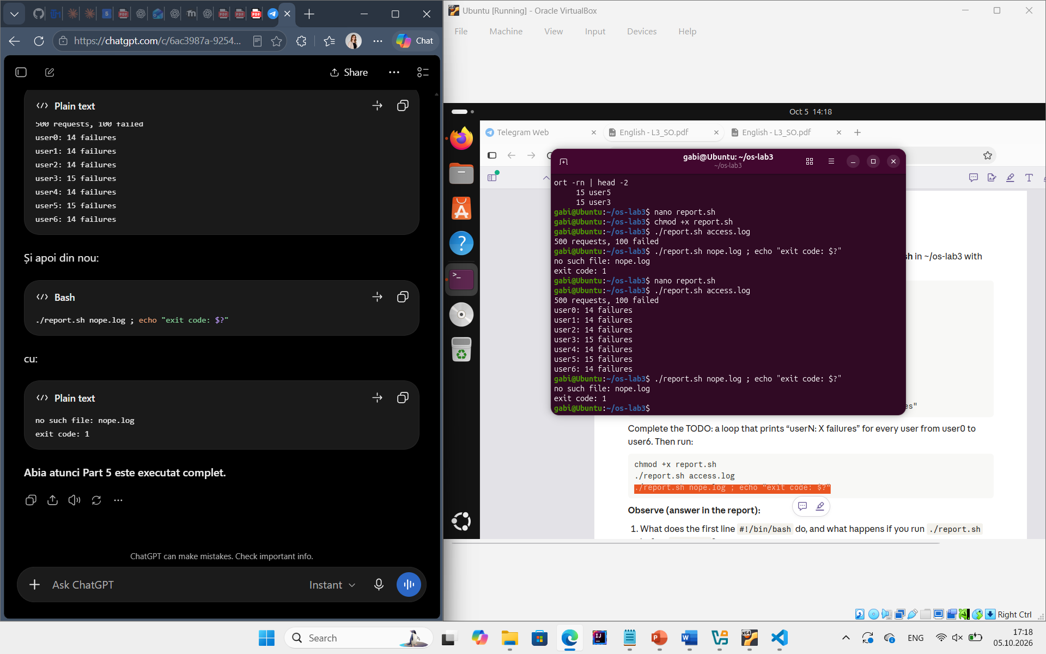
Figure 1.25 – Running the script on access.log
Figure 1.26 – Error handling for a missing file
Observations:
- The first line #!/bin/bash. This line is called a shebang. When the file is executed, the kernel reads the first two characters #! and runs the interpreter written after them (/bin/bash), passing it the script as an argument. Without chmod +x, running ./report.sh fails with "Permission denied", because the file does not have the execute permission. It can still be run with bash report.sh, since then bash only reads the file.
- ./report.sh instead of report.sh. A command name without a slash is searched only in the directories listed in PATH, and the current directory is not in PATH (for security reasons). Writing ./report.sh gives an explicit path to the file in the current directory, so no search is performed.
- >&2 and exit 1. Error messages are written to stderr so that they are not mixed with the normal output: if the output of the script is redirected to a file or a pipe, the error is still visible on the screen and does not pollute the data. exit 1 returns a non-zero status, so that the calling shell or another script (for example with && or ||) can detect that the script failed.

1.10 Results:
The laboratory showed what the shell does with a command line before a program is executed and how small tools can be combined to answer questions about data. The main results are summarised in Table 1.2.
Table 1.2 – Summary of the results of Laboratory Work 3
Topic | Commands used | Observation
Finding help | type, which, $PATH, man, help | cd and echo are built-ins, ls is /usr/bin/ls; a missing command returns 127.
Expansions | echo *.c, quotes, {1..5}, $((...)), $(...) | The shell expands patterns and removes quotes; the program only receives the final words.
Redirection | >, >>, <, 2>, 2>&1, /dev/null | stdout and stderr are separate streams; redirections are applied from left to right.
Chaining, jobs | ;, &&, ||, &, jobs, kill %1 | The exit status decides whether the next command runs; jobs run in the background.
One-liners | grep, cut, sort, uniq, wc, head, tail | 100 failed requests, 4 pages × 125 requests, user3 and user5 with 15 failures each.
Script | report.sh, chmod +x, exit codes | The script reports per-user failures and returns 1 with a message on stderr for a missing file.

2 LABORATORY WORK 4: THE XV6 SHELL FROM THE OUTSIDE

2.1 Objective
The objective of this laboratory work is to use the xv6 shell (user/sh.c) side by side with bash and to discover by experiment what every shell must do and what bash adds on top of it. A small program that prints its own arguments is written for both xv6 and Linux, in order to see who expands * and who removes the quotes. Before that, the sleep program from Laboratory Work 2 is checked against the current version of xv6.

2.2 Tasks:
- Check whether the xv6 tree uses sleep() or pause() and make the sleep program build and run.
- Run the same set of commands in bash and in the xv6 shell and compare the results in a table.
- Write the program args for xv6 and args_linux for Linux, which print argc and every argv[i], and run them with the same command lines in both shells.
- Read user/sh.c: find the kinds of commands, the place where each kind is executed and the code that handles cd.
- Answer the "Observe" questions for every part.

2.3 Theoretical Notes:
A shell is a command interpreter that runs in user mode, like any other program. Its main loop is simple: print a prompt, read a line, parse it, create a child process with fork(), and in the child call exec() to replace the process with the requested program, while the parent waits for the child with wait(). Redirections are implemented by closing a file descriptor in the child and opening a file, which receives the lowest free descriptor; pipes are implemented with pipe() and dup().
The xv6 shell is about 500 lines of C and implements only this core: running programs with arguments, the redirections <, > and >>, pipes, lists with ;, background execution with & and grouping with parentheses. Everything that makes bash comfortable – variables, quoting, globbing, a search PATH, history and completion – is missing. Comparing the two shells therefore shows clearly which features are provided by the kernel (processes, files, pipes) and which ones are only conveniences implemented by the shell program.

2.4 Fixing sleep for the Current xv6:
In August 2025 the authors of xv6 renamed the system call sleep() to pause(). To check which name the local tree uses, user/user.h was searched:
cd ~/xv6-riscv
grep -n "pause\|sleep" user/user.h
The result is a single line, 25:int pause(int);, so the tree (commit 06aad25) uses the new name. The program user/sleep.c from Laboratory Work 2 already calls pause(atoi(argv[1])), and $U/_sleep\ is present in the UPROGS list of the Makefile.
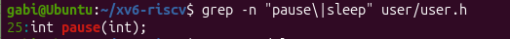
Figure 2.1 – The grep result in user.h
#include "kernel/types.h"
#include "user/user.h"

int
main(int argc, char *argv[])
{
if(argc != 2){
fprintf(2, "usage: sleep <ticks>\n");
exit(1);
}
pause(atoi(argv[1]));
exit(0);
}
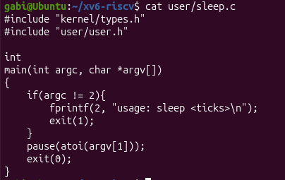
Figure 2.2 – The updated sleep.c
xv6 was rebuilt and booted with make qemu. The command sleep 20 paused for 20 ticks and returned to the prompt, while sleep without an argument printed "usage: sleep <ticks>".
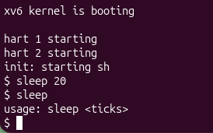
Figure 2.3 – sleep running in xv6, with and without an argument

2.5 bash versus the xv6 Shell:
Every command was run twice: once in bash, in an empty test folder ~/shtest that contains a file named README, and once at the xv6 $ prompt. The results are compared in Table 2.1.
mkdir ~/shtest && cd ~/shtest && touch README
Table 2.1 – Comparison of bash and the xv6 shell
Command | Tests | bash | xv6
echo hello > f ; cat < f | redirection | hello | hello – redirection works.
ls | grep READ | pipe | README | The README line of ls (name, type, inode, size) – pipes work.
(echo a; echo b) | wc | grouping, list | 2 2 4 | 2 2 4 – grouping and lists work.
echo one ; echo two | sequence | one, two | one, two – sequences work.
echo bg & | background | [1] <PID>, bg, then [1]+ Done | bg, printed without a job number, sometimes after the next $ prompt.
ls * | globbing | f README | ls: cannot open * – no globbing.
echo $HOME | variables | /home/gabi | $HOME – no variables.
echo "a b" | quotes | a b | "a b" – the quotes are printed, they are not removed.
mkdir d ; cd d ; ls .. | PATH | d f README | exec cd failed; ls .. lists the root directory "/".
arrow up, Tab, Ctrl+R | history, completion | Previous command, completion, history search | Not supported: the arrow key only sends an escape sequence that the shell treats as ordinary characters; Tab and Ctrl+R do nothing useful.
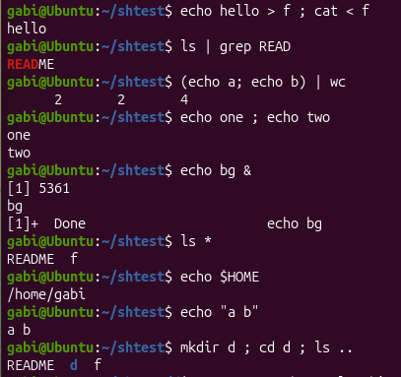
Figure 2.4 – The commands run in bash
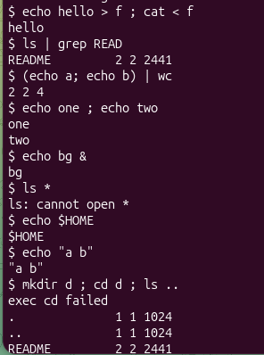
Figure 2.5 – The same commands run in xv6
In xv6, cd is recognised only when it is at the very beginning of the line. In the line mkdir d ; cd d ; ls .. it is in the middle of a list, so the shell tries to run a program called cd, which does not exist ("exec cd failed"), and ls .. is executed in the root directory. When cd d is typed on its own line, the directory is changed, but then ls stops working:
$ mkdir d
$ cd d
$ ls
exec ls failed
$ /ls ..
$ cd /
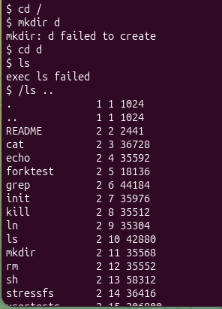
Figure 2.6 – ls failing after cd d, and the working alternative
Observations:
- Common features and bash-only features. Both shells run programs with arguments and support the redirections <, > and >>, pipes |, sequences with ;, background execution with & and grouping with ( ). Only bash has variables ($HOME), quoting, globbing (*), a search PATH, job control (jobs, %1), command history, Tab completion and the history search with Ctrl+R (as well as && and ||, command substitution and scripting).
- Why ls stops working after cd d. The xv6 shell has no PATH: it calls exec() with the name exactly as typed, so "ls" is looked up relative to the current directory. All the xv6 programs live in the root directory "/", so after cd d the file d/ls does not exist and exec fails. The program can be run from inside d with an absolute path, /ls (or /ls .. to list the parent), or by returning with cd /.
- The most useful missing feature. In daily work the most missed feature would be globbing (and, together with it, the command history with the arrow keys), because typing every file name by hand is slow. The easiest feature to add is a PATH-like search: if exec(argv[0]) fails and the name does not contain "/", the shell can simply retry with "/" + argv[0], which needs only a few lines in the EXEC case of runcmd().

2.6 Who Expands *? A Program that Prints its argv:
To see exactly what a program receives from the shell, the program user/args.c was written for xv6. It prints the number of arguments and every argument between square brackets, so that spaces inside an argument are visible. The line $U/_args\ was added to UPROGS in the Makefile.
#include "kernel/types.h"
#include "user/user.h"

int
main(int argc, char *argv[])
{
printf("argc = %d\n", argc);
for(int i = 0; i < argc; i++)
printf("argv[%d] = [%s]\n", i, argv[i]);
exit(0);
}
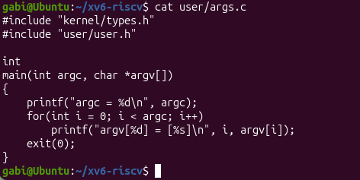
Figure 2.7 – args.c and the UPROGS line
The same program was written for Linux as args_linux.c, with #include <stdio.h> instead of the two xv6 headers and return 0 instead of exit(0), and compiled with gcc -o args args_linux.c. The same lines were then executed in both shells (in bash with ./args, in a folder that contains .c files):
args one two three
args *.c "x y"
args $HOME
args 'single quoted'
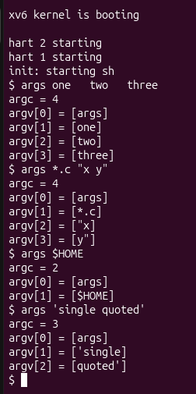
Figure 2.8 – args output in xv6
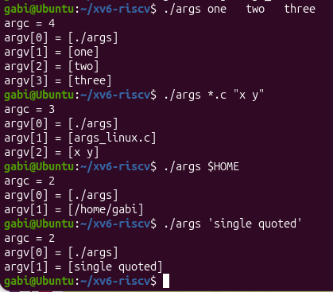
Figure 2.9 – args_linux output in bash
The outputs for args *.c "x y" are:
Table 2.2 – Output of args *.c "x y" in the two shells
xv6 | bash (Linux)
argc = 4 | argc = 3
argv[0] = [args] | argv[0] = [./args]
argv[1] = [*.c] | argv[1] = [args_linux.c]
argv[2] = ["x] | argv[2] = [x y]
argv[3] = [y"]

For the other lines: args $HOME received [$HOME] in xv6 and [/home/gabi] in bash, and args 'single quoted' received two arguments ['single] and [quoted'] in xv6, but one argument [single quoted] in bash.
Observations:
- Number of arguments. In xv6 the program received 4 arguments: the name, the literal *.c, and the two halves "x and y" with the quotes still attached. In bash, the program received 3 arguments: ./args, args_linux.c (the matching .c file in the current directory), and x y as a single argument without quotes. If the folder contains more .c files, bash passes one argument for each of them.
- Who expands the asterisk and removes the quotes. The shell. The program itself only prints what it receives, and the kernel copies the argv array given to exec() into the new process without changing it. The same args program shows different arguments only because bash expands *.c and removes the quotes before calling exec(), while the xv6 shell does not.
- The extra spaces in one two three. They disappeared in both shells: argc = 4 and the arguments are [one], [two] and [three]. Both shells split the line into words on blanks and pass only the words, so the number of spaces between them is lost.

2.7 Reading the Shell:
Finally, the source of the xv6 shell was read in ~/xv6-riscv with the commands below:
wc -l user/sh.c
grep -n "#define" user/sh.c # the kinds of commands
grep -n "case " user/sh.c # where each kind is run
grep -n "cd" user/sh.c | head
The whole shell has 499 lines. Lines 8–12 define the five kinds of commands (EXEC 1, REDIR 2, PIPE 3, LIST 4, BACK 5), and line 14 defines MAXARGS 10, the maximum number of arguments. Each kind is executed in a case of the switch in runcmd() (lines 75, 83, 93, 101 and 125); the other case lines belong to the tokenizer gettoken() (lines 284–294), to parseredirs() (lines 391–397) and to nulterminate() (lines 469–493).
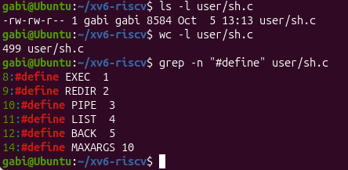
Figure 2.10 – The command kinds defined in sh.c
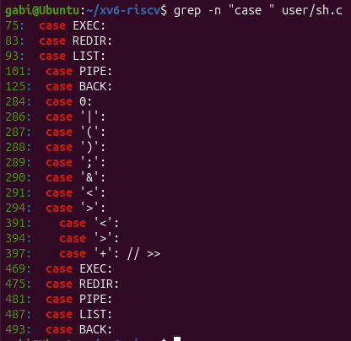
Figure 2.11 – Where each kind is run
The search for "cd" returns only line 170, the error message "cannot cd %s". The code around it, in main(), is:
if (cmd[0] == 'c' && cmd[1] == 'd' && cmd[2] == ' ') {
// Chdir must be called by the parent, not the child.
cmd[strlen(cmd) - 1] = 0; // chop \n
if (chdir(cmd + 3) < 0)
fprintf(2, "cannot cd %s\n", cmd + 3);
} else {
if (fork1() == 0)
runcmd(parsecmd(cmd));
wait(0);
}
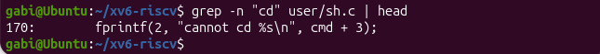
Figure 2.12 – The code that handles cd
Observations:
- The five kinds of commands. EXEC – a simple command with arguments, produced by an ordinary word (for example ls ..); REDIR – a redirection, produced by <, > or >>; PIPE – produced by |; LIST – a sequence, produced by ;; BACK – background execution, produced by &. Parentheses ( ) only group commands and do not create a new kind.
- Where cd is handled. cd is handled in main() (line 166), before the shell forks: if the line starts with "cd ", the shell calls chdir() itself. It cannot be a separate program, because the current directory belongs to each process: a child would change only its own directory and then exit, leaving the shell where it was. This also explains why cd fails in the middle of a list – it is checked only at the start of the line.
- Code that handles the asterisk or the dollar sign. There is no such code: the only $ in sh.c is the prompt string "$ " (line 137), and * appears only as the C pointer operator. The xv6 shell does no globbing and no variable expansion, which explains the results of Part 2: ls * and echo $HOME print the characters literally, and the quotes are not removed either.

CONCLUSION
The purpose of these two laboratory works was to understand the shell – the program through which the user talks to the operating system – both from the point of view of a user who wants to work fast and from the point of view of a programmer who wants to know what a shell really is. Laboratory Work 3 used bash on Linux, a complete and comfortable shell, while Laboratory Work 4 compared it with the minimal xv6 shell, whose whole source fits in about 500 lines.
The first part of Laboratory Work 3 showed how to move quickly in the terminal using Tab completion and the history search, and how to find information without a browser using man, --help and help. The commands type and which revealed that some commands are built into the shell, while others are separate programs found through the directories listed in PATH. The command cd must be a built-in, because the current directory is a property of the shell process itself and cannot be changed by a child process. A command that is not found returns the exit code 127.
The second part demonstrated that a large amount of work is done by the shell before a program starts. The experiments with echo showed that pathname expansion, brace expansion, arithmetic expansion and command substitution are all performed by bash, and that the program receives only the final list of words. Writing a prediction before each command made the less obvious rules visible: a pattern that matches nothing is passed unchanged, a pattern can match a name with a space, and an unquoted name with a space becomes two arguments. The difference between single quotes, double quotes and the backslash was also established in practice.
The third part focused on the standard streams. Sending stdout and stderr to different files showed that they are independent channels, and comparing > all.txt 2>&1 with 2>&1 > all.txt proved that redirections are applied from left to right. The operators ;, && and || showed how the exit status of a command controls the execution of the next one, and a background job was started, listed and stopped with jobs and kill %1.
The fourth part applied all these mechanisms to a concrete data set. Questions about the access log were answered with one-line pipelines of grep, cut, sort, uniq, wc, head and tail: 100 of the 500 requests failed, each of the four pages received 125 requests, and user3 and user5 had the most failures, 15 each. The cross-checks (the page counts add up to 500 and the per-user failures add up to 100) confirmed that the pipelines were correct. The last part turned these one-liners into the script report.sh, which checks its argument, writes errors to stderr and returns a non-zero exit code on failure, as a well-behaved UNIX program should.
Laboratory Work 4 moved to xv6. The sleep program from the previous laboratory was confirmed to work with the current system call name, pause(). Running the same commands in bash and in the xv6 shell separated the essential features of a shell from the conveniences: both shells run programs, redirect input and output, build pipes, run lists and background commands, because these rely directly on the system calls fork(), exec(), wait(), open(), close(), dup() and pipe(). Variables, quoting, globbing, the search PATH, history and completion exist only in bash. The missing PATH explained why ls stops working in xv6 after cd d, and why it can still be run with the absolute path /ls.
The args program gave a precise answer to the question of who expands * and removes quotes. The same program received four arguments in xv6 and three in bash for the same line, which proves that these transformations are made by the shell, not by the program and not by the kernel, which only passes the argv array to the new process. Reading user/sh.c confirmed this: the shell knows five kinds of commands (EXEC, REDIR, PIPE, LIST and BACK), handles cd in the parent process before forking, and contains no code for * or $.
Overall, the two laboratory works showed that the shell is not part of the kernel but an ordinary user program built on a small set of system calls. Knowing exactly what the shell does to a line makes it possible to predict the behaviour of commands, avoid common mistakes with spaces and quotes, and combine small tools into powerful one-liners and scripts. This understanding also prepares the next laboratory works, in which features of the xv6 shell and kernel can be extended directly in the source code.

REFERENCES
1. Operating Systems 2026-2027, Laboratory Work 3: “The Command Line: Shell, Pipes and Text Filters”, FCIM / FAF / Technical University of Moldova.
2. Operating Systems 2026-2027, Laboratory Work 4: “The xv6 Shell from the Outside”, FCIM / FAF / Technical University of Moldova.
3. MIT PDOS. xv6-riscv source repository. Available at: https://github.com/mit-pdos/xv6-riscv
4. GNU Bash Reference Manual. Available at: https://www.gnu.org/software/bash/manual/

