
MINISTRY OF EDUCATION, CULTURE AND RESEARCH
OF THE REPUBLIC OF MOLDOVA
Technical University of Moldova
Faculty of Computers, Informatics and Microelectronics
Department of Software Engineering and Automation

Report
Laboratory Work No.5
Operating Systems
Lab 5: The File System with Your Own Hands

Done by: Botezatu Gabriela
st. gr. FAF-243,
Checked by: Reițman Patricia

Chișinău – 2026

TABLE OF CONTENTS
1 LABORATORY WORK 5: THE FILE SYSTEM WITH YOUR OWN HANDS 3
1.1 Objective 3
1.2 Tasks: 3
1.3 Theoretical Notes: 3
1.4 Working Environment: 4
1.5 The Tree and the File Types: 5
1.6 Inodes and Links: 6
1.7 Permissions: 9
1.8 Disks and the Kernel as Files: 12
1.9 Stretch Tasks: 14
1.10 Results: 15
CONCLUSION 17
REFERENCES 19

1 LABORATORY WORK 5: THE FILE SYSTEM WITH YOUR OWN HANDS

1.1 Objective
The objective of this laboratory work is to check in practice, on a Linux system, the main ideas about file systems: the single directory tree and the types of files that live in it, the inode that stays behind every file name, hard and symbolic links, the permission system of UNIX, and the disks and partitions on which the file systems are stored. No programs are written; the work consists of running commands, observing their output carefully and explaining what was seen.

1.2 Tasks:
- Explore the directory tree and identify the type of several files from the output of ls -l and file.
- Inspect the inode of a file with stat, create hard and symbolic links and observe what happens when the original name or the target is removed.
- Compare the size of a file with the space it occupies on the disk, using a very small file and a sparse file.
- Change the permissions of files and directories, explain the umask and the meaning of r and x on a directory, and examine the setuid and sticky bits.
- Look at the disks, partitions and mounted file systems, and read information about the hardware and the current process from /proc.
- Answer the "Observe" questions for every part and complete two of the optional stretch tasks.

1.3 Theoretical Notes:
In UNIX-like systems all files are organised in a single tree that starts at the root directory /. Other disks and partitions do not get letters as in Windows; their file systems are mounted on a directory of the tree. Besides regular files and directories, the tree contains symbolic links, device files (character and block devices), named pipes and sockets. The type of each entry is shown by the first letter of ls -l: - regular file, d directory, l symbolic link, c character device, b block device, p pipe and s socket.
The data about a file (type, permissions, owner, size, time stamps, number of links and the location of its data blocks) is kept in an inode, identified by a number that is unique inside one file system. The name of the file is not stored in the inode: a directory is only a table that maps names to inode numbers. Because of this:
- A hard link is just another name (another directory entry) for the same inode. All the names are equal, and the inode keeps a link counter.
- A symbolic link is a separate small file with its own inode, whose content is the path of the target. It can point to a directory or to another file system, but it breaks if the target disappears.
- Deleting a file with rm (the system call unlink()) removes only one name and decrements the link counter. The inode and the data are freed only when the counter reaches 0 and no process keeps the file open.
Access to a file is controlled by three groups of three permission bits, rwx for the owner (u), the group (g) and all the others (o), often written as an octal number (for example 644 = rw-r--r--). On a directory, r allows listing the names, w allows creating and deleting entries, and x allows passing through the directory to reach the files inside it. The umask is subtracted from the default permissions (666 for files, 777 for directories) when a new file is created. Three special bits complete the system: setuid (the program runs with the rights of the owner of the file), setgid, and the sticky bit (in a shared directory only the owner of a file can delete it).
Linux also shows information about the kernel as files: the directory /proc is a virtual file system whose contents are generated by the kernel when they are read, and /proc/self always refers to the process that is reading it.

1.4 Working Environment:
All commands were executed in a bash terminal on the same Ubuntu 24.04 LTS virtual machine as in the previous laboratory works. The work was done as the ordinary user gabi and not as root, because root ignores most of the permission checks and the experiments of Part 3 would give misleading results. A working folder ~/os-lab5 was created for the experiments:
whoami # must not print root
mkdir -p ~/os-lab5 && cd ~/os-lab5
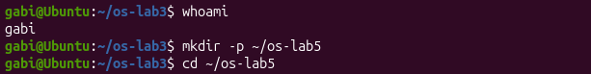
Figure 1.1 – Checking the user and creating the working folder
The command whoami printed gabi, which confirms that the experiments are run as a normal user.

1.5 The Tree and the File Types:
First, the top level of the tree, several well-known paths and the devices in /dev were examined:
ls /
ls -ld /etc /etc/passwd /bin /dev/null /tmp
ls -l /dev | head
file /usr/bin/ls /etc/passwd /bin
du -sh /var/log 2>/dev/null ; du -sh /usr 2>/dev/null
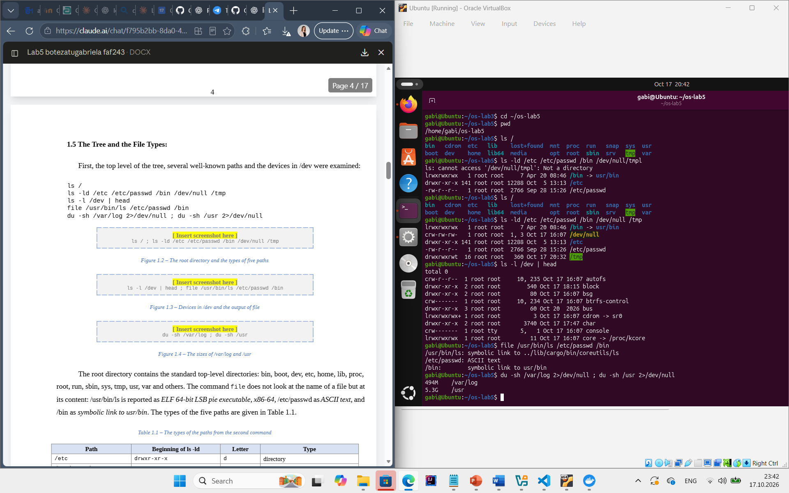
Figure 1.2 – The root directory and the types of five paths
Figure 1.3 – Devices in /dev and the output of file
Figure 1.4 – The sizes of /var/log and /usr
The root directory contains the standard top-level directories: bin, boot, dev, etc, home, lib, proc, root, run, sbin, sys, tmp, usr, var and others. The command file does not look at the name of a file but at its content: /usr/bin/ls is reported as ELF 64-bit LSB pie executable, x86-64, /etc/passwd as ASCII text, and /bin as symbolic link to usr/bin. The types of the five paths are given in Table 1.1.
Table 1.1 – The types of the paths from the second command
Path | Beginning of ls -ld | Letter | Type
/etc | drwxr-xr-x | d | directory
/etc/passwd | -rw-r--r-- | - | regular file (text)
/bin | lrwxrwxrwx … /bin -> usr/bin | l | symbolic link to usr/bin
/dev/null | crw-rw-rw- … 1, 3 | c | character device (major 1, minor 3)
/tmp | drwxrwxrwt | d | directory (with the sticky bit t)

Observations:
- File types. /etc is a directory (d), /etc/passwd is a regular file (-), /bin is a symbolic link (l), /dev/null is a character device (c) and /tmp is a directory (d) whose permissions end with t, the sticky bit (Table 1.1).
- What /bin is. On Ubuntu 24.04 /bin is not a real directory but a symbolic link to usr/bin (a relative path, so it points to /usr/bin). This is the "merged /usr" layout: the programs live only in /usr/bin, and /bin is kept as a link for compatibility with old scripts that use paths such as /bin/bash.
- Devices. A character device is /dev/null (the line starts with c and shows the numbers 1, 3 instead of a size); other examples in the first lines of /dev are autofs and console. A block device is the disk /dev/block (its line starts with b, for example brw-rw---- 1 root disk 8, 0). Character devices transfer data as a stream of bytes, while block devices are accessed in fixed-size blocks and can be used to hold a file system.
- /var/log or /usr. /usr is much bigger: 5.3G compared to 494M for /var/log, that is about 11 times more. /usr holds all the installed programs and libraries, while /var/log only holds the text log files of the system.

1.6 Inodes and Links:
An inode, and a name that is not part of it. A small file was created and its inode was inspected:
echo hello > notes.txt
stat notes.txt
ls -li notes.txt
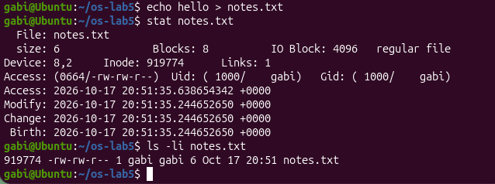
Figure 1.5 – The inode of notes.txt shown by stat and ls -li
The command stat showed Size: 6 (five letters and the newline), Blocks: 8, Inode: 919774 and Links: 1, the permissions 0664/-rw-rw-r--, the owner gabi and four time stamps (Access, Modify, Change and Birth). The command ls -li printed the same inode number in the first column.
Hard link, then remove the "original".
ln notes.txt hard.txt
ls -li notes.txt hard.txt
rm notes.txt
cat hard.txt ; ls -li hard.txt
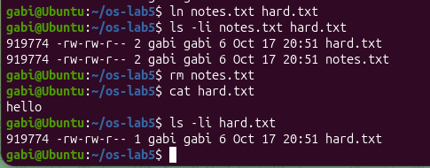
Figure 1.6 – A hard link before and after removing notes.txt
After ln, both names showed the same inode number and the link count 2. After rm notes.txt, the command cat hard.txt still printed hello, and the link count of hard.txt went back to 1.
Symbolic link, then remove its target.
ln -s hard.txt soft.txt
ls -li hard.txt soft.txt
cat soft.txt
rm hard.txt
cat soft.txt ; ls -l soft.txt
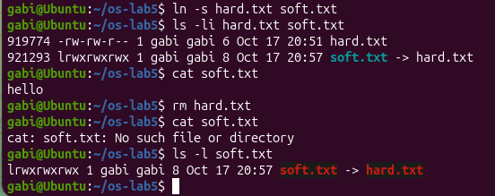
Figure 1.7 – A symbolic link that becomes dangling
soft.txt received its own inode number (different from hard.txt), the type l, the permissions lrwxrwxrwx and the size 8, and ls displayed it as soft.txt -> hard.txt. While hard.txt existed, cat soft.txt printed hello. After rm hard.txt, the same command failed with cat: soft.txt: No such file or directory, although ls -l soft.txt still showed the link.
Directories have links too. The prediction was 2 links for an empty directory and 4 after creating two subdirectories:
mkdir d ; ls -ld d
mkdir d/x d/y ; ls -ld d
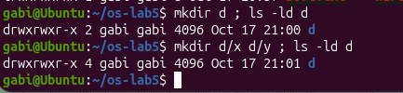
Figure 1.8 – The link count of a directory
The output confirmed the prediction: drwxrwxr-x 2 for the new directory and drwxrwxr-x 4 after mkdir d/x d/y.
Size is not space.
echo x > one.txt ; ls -l one.txt ; du -h one.txt
truncate -s 1G big.img ; ls -lh big.img ; du -h big.img
rm big.img
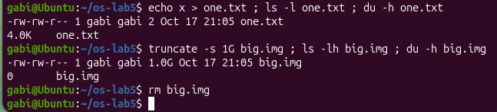
Figure 1.9 – The size of a file compared to the space it uses
one.txt has a size of 2 bytes in ls -l, but du reports 4.0K. big.img has a size of 1.0G in ls -lh, but du reports 0.
Observations:
- The numbers in stat. The inode is the number after Inode: (919744, the same as the first column of ls -li). The number after Links: is the link count, the number of names (directory entries) that point to this inode; for a new file it is 1.
- Why hard.txt could still be read. notes.txt and hard.txt were two names of the same inode, and neither of them was the "original". rm does not delete the file; it calls unlink(), which removes only one directory entry and decrements the link count from 2 to 1. The inode and the data blocks are freed only when the link count becomes 0 (and no process has the file open), so the data was still reachable through hard.txt.
- Why cat soft.txt failed. A symbolic link stores only a path, not the inode of the target. When cat opened soft.txt, the kernel followed the stored path "hard.txt", but that name no longer existed, so open() failed with "No such file or directory". The link itself still exists (it is a dangling link). Its size is exactly 8 bytes because its content is the string hard.txt, which has 8 characters (without a terminating zero).
- The links of a directory. A new directory d has 2 links: its name d in the parent directory, and the entry . (dot) inside d itself, which points to d. Each subdirectory contains the entry .. (dot-dot) that points back to its parent, so creating d/x and d/y added two more links, giving 2 + 2 = 4. In general, the link count of a directory is 2 plus the number of its subdirectories.
- 2 bytes using 4.0K, and 1 GB using 0. The file system allocates space in whole blocks, here of 4096 bytes (IO Block: 4096 in stat), so even a file of 2 bytes takes one full block of 4.0K. truncate -s 1G only changes the size recorded in the inode, without writing any data: the result is a sparse file, whose missing blocks are "holes" that read as zeros but are not allocated on the disk. ls shows the size from the inode, while du counts the blocks really allocated, which is 0.

1.7 Permissions:
Files.
echo secret > s.txt
chmod 600 s.txt ; ls -l s.txt
chmod 000 s.txt ; cat s.txt
chmod u+r s.txt ; cat s.txt
umask ; touch new.txt ; mkdir newdir ; ls -ld new.txt newdir
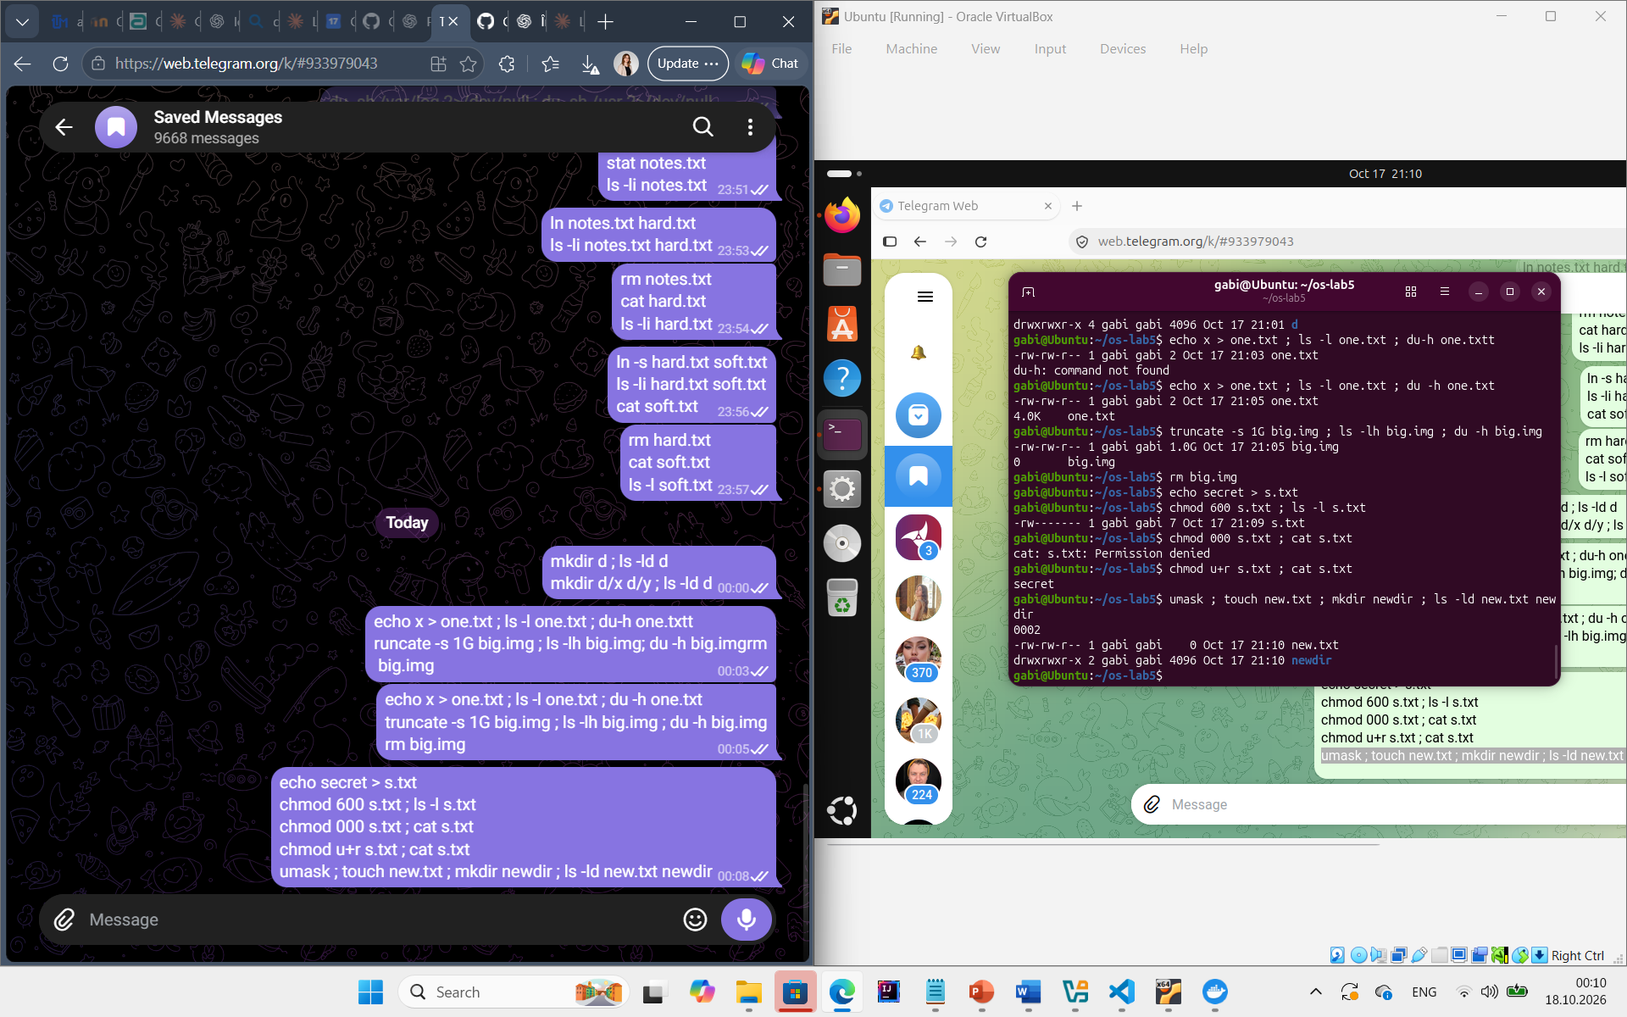
Figure 1.10 – Changing the permissions of s.txt
Figure 1.11 – The umask and the permissions of a new file and directory
After chmod 600 the file showed -rw-------. After chmod 000 the command cat s.txt failed with Permission denied, and after chmod u+r it printed secret again. The umask is 0002, and the new objects were created as -rw-rw-r-- (new.txt) and drwxrwxr-x (newdir).
Directories. A directory box containing the file f was created, and its permissions were reduced first to read only and then to execute only. The predictions and the real results are shown in Table 1.2.
mkdir box ; echo hi > box/f
chmod u=r,go= box ; ls box ; cat box/f # read only
chmod u=x,go= box ; ls box ; cat box/f # execute only
chmod 755 box
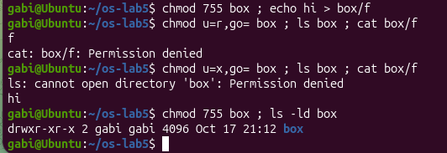
Figure 1.12 – The box experiment: r and x on a directory
Table 1.2 – Predictions and real results of the box experiment
Permissions of box | Command | My prediction | Real output
r-- (u=r) | ls box | f | f, together with the message ls: cannot access 'box/f': Permission denied
r-- (u=r) | cat box/f | Permission denied | cat: box/f: Permission denied
--x (u=x) | ls box | Permission denied | ls: cannot open directory 'box': Permission denied
--x (u=x) | cat box/f | hi | hi

Special bits and other people's files.
ls -l /usr/bin/passwd ; ls -ld /tmp
cat /etc/shadow
ls -l /etc/shadow
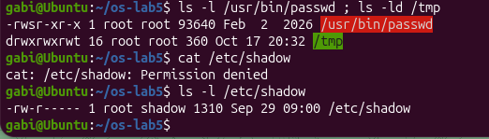
Figure 1.13 – The setuid bit of passwd, the sticky bit of /tmp and /etc/shadow
/usr/bin/passwd is shown as -rwsr-xr-x root root and /tmp as drwxrwxrwt root root. cat /etc/shadow failed with Permission denied, and ls -l showed -rw-r----- root shadow.
Observations:
- Octal permissions as rwx strings. The four values and one real use for each are given in Table 1.3.
- Why ownership does not help with chmod 000. The kernel first decides which class the user belongs to (owner, group or others) and then checks only the bits of that class. Since gabi is the owner, only the owner bits are checked, and they are ---, so the read is refused; the kernel does not fall back to the group or other bits. Ownership gives only one extra right: the owner may always change the permissions with chmod, which is why chmod u+r worked and the file could be read again.
- The umask. The umask is 0002, which removes the write bit for others. New files start from 666 (rw-rw-rw-, programs do not get x by default) and new directories from 777; 666 − 002 = 664, so new.txt is -rw-rw-r--, and 777 − 002 = 775, so newdir is drwxrwxr-x. (Ubuntu uses 0002 because each user has a private group with the same name; with the more common value 0022 the results would be 644 and 755.)
- The box experiment. A directory is a table of names. r allows reading that table, so ls box could still print the name f; however, ls (with colours, as aliased in Ubuntu) also tries to stat the file to find its type, and that needs x, hence the error message. Without x the path box/f cannot be followed, so cat box/f was refused. x allows passing through the directory, that is, using it in a path to reach a file whose name is already known: cat box/f worked, but the names could not be listed, so ls box failed. A directory with only x is like a dark room in which you can take an object only if you know exactly where it is.
- The s and the t. The s in place of the x of the owner of /usr/bin/passwd is the setuid bit: when any user runs the program, the process gets the effective user ID of the owner of the file, here root. passwd needs it because the password hashes are stored in /etc/shadow, which belongs to root and cannot be read or written by normal users (-rw-r----- root shadow, as the failed cat showed); with setuid, an ordinary user can change their own password, while passwd itself checks that they only change their own entry. The t at the end of /tmp is the sticky bit: everyone may create files in /tmp (rwx for others), but a file can be deleted or renamed only by its owner (or root), so users cannot remove each other's files.
Table 1.3 – Common octal permissions
Octal | rwx string | Typical use
600 | rw------- | A private file that only the owner may read and write, for example the SSH private key ~/.ssh/id_rsa.
644 | rw-r--r-- | An ordinary file readable by everyone but writable only by its owner, for example /etc/passwd or a document.
755 | rwxr-xr-x | A program or a public directory that everyone can run or enter, for example /usr/bin/ls or /usr.
700 | rwx------ | A private directory or script, for example ~/.ssh or a personal script that only the owner may run.

1.8 Disks and the Kernel as Files:
lsblk
df -h
mount | grep " / "
grep -c processor /proc/cpuinfo
head -3 /proc/meminfo
head -5 /proc/self/status
ls -l /proc/self/fd
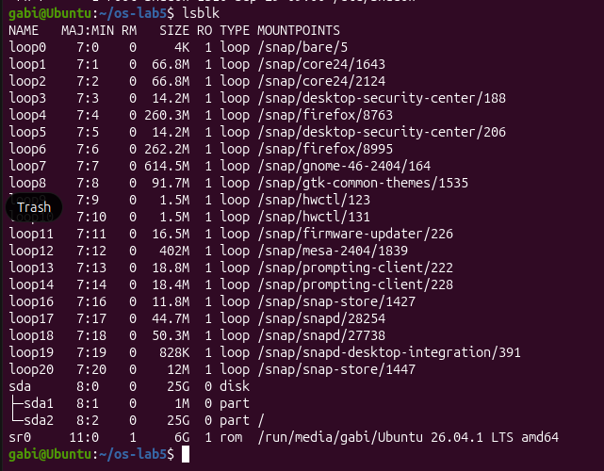
Figure 1.14 – The disks and partitions shown by lsblk
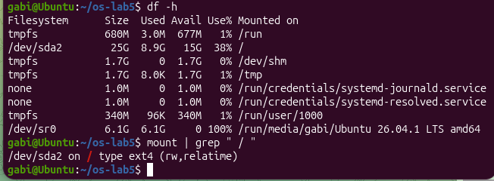
Figure 1.15 – Mounted file systems and the root file system
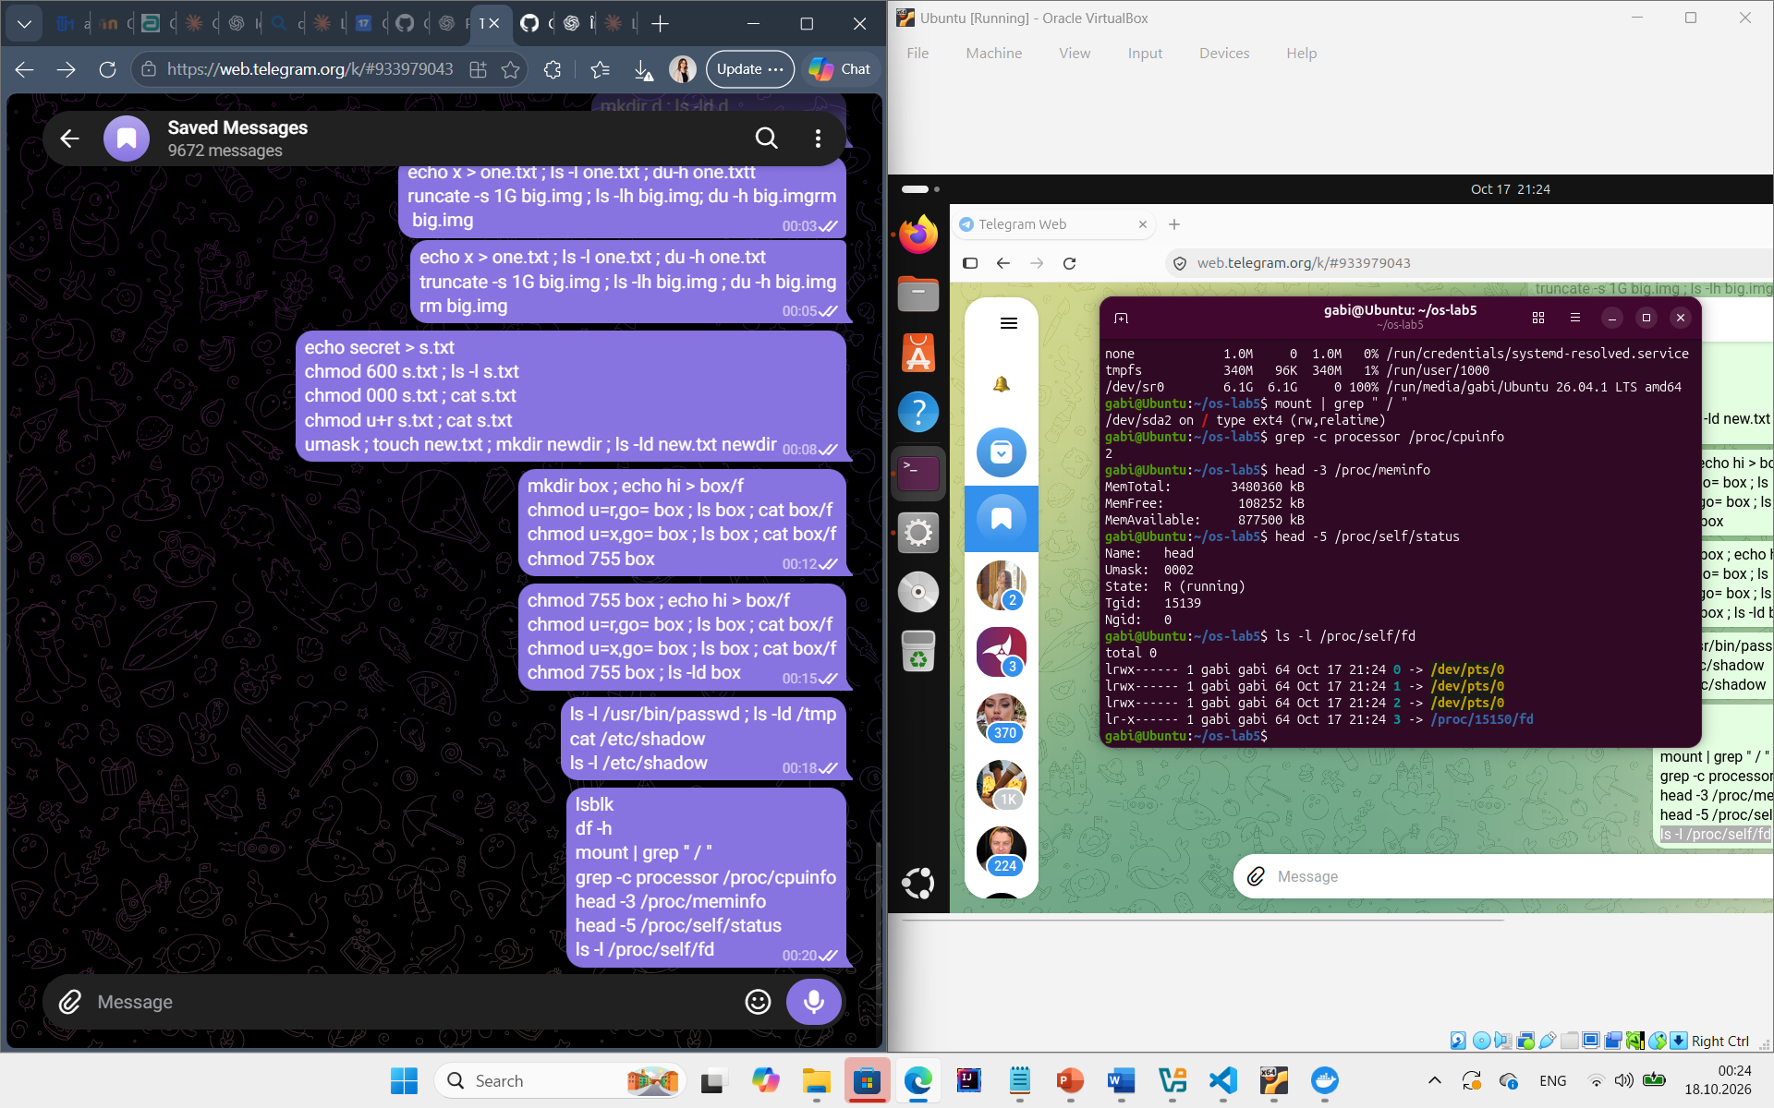
Figure 1.16 – CPU and memory information from /proc
Figure 1.17 – /proc/self/status and the open file descriptors
Based on the output of lsblk and mount, the structure of the disk is the following:
sda 25G disk
├─sda1 1M part (BIOS boot, not mounted)
└─sda2 25G part mounted at / type ext4
sr0 … rom (virtual CD drive)
loop0 … loopN … loop snap packages, mounted under /snap
Observations:
- The disk. The virtual machine has one disk, /dev/sda of 25 GB, divided into two partitions; the partition /dev/sda2 is mounted at / with the file system type ext4 (the line of mount is /dev/sda2 on / type ext4 (rw,relatime)). The loop devices are image files of the snap packages, mounted read-only under /snap.
- How full the root file system is. According to df -h, the root file system has 25G in total, of which 8.9G are used and 15G are available, that is 38% used.
- CPU and RAM. grep -c processor /proc/cpuinfo printed 2, so the system has 2 CPU cores (logical processors). The first line of /proc/meminfo is MemTotal: 3480360 kB, that is about 3.3 GB of RAM; the next lines, MemFree and MemAvailable, show how much of it is free and how much can be made available. These are the resources allocated to the virtual machine, not necessarily those of the whole laptop.
- The name in /proc/self/status. The first line was Name: head. /proc/self is a link that the kernel resolves to the directory of the process that is reading it. The file was opened by the process running head, not by bash, so it described head. For the same reason, ls -l /proc/self/fd showed the descriptors of ls: 0, 1 and 2 pointing to the terminal (/dev/pts/0) and 3 pointing to /proc/PID/fd, the directory that ls itself had opened in order to list it.

1.9 Stretch Tasks:
Two of the optional tasks were completed: (a) magic numbers and (c) deleting a file that is still open.
(a) Magic numbers. The file /etc/passwd was compressed with gzip, but the result was saved under the misleading name notes.txt:
gzip -c /etc/passwd > notes.txt
file notes.txt
xxd notes.txt | head -1
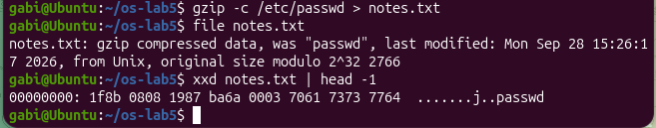
Figure 1.18 – A gzip file named notes.txt and its first bytes
In spite of the .txt extension, file reported notes.txt: gzip compressed data, was "passwd", … from Unix. The first line of xxd begins with 00000000: 1f8b 0808. The bytes 1f 8b are the magic number of gzip: file compares the first bytes of the content with a database of known signatures (/usr/share/misc/magic) and ignores the name. The next byte 08 is the compression method (deflate), and the flag byte 08 means that the original file name, "passwd", is stored in the header, which is why file could print it. Other examples are 7f 45 4c 46 ("\x7fELF") for executables and 25 50 44 46 ("%PDF") for PDF documents. For Linux, the extension is only a part of the name.
(c) Deleting a file that is still open. A file of 100 MB was created, opened on descriptor 3 of the shell, and then deleted:
head -c 100M /dev/zero > bigfile ; df -h ~
exec 3< bigfile ; rm bigfile
ls -l /proc/$$/fd ; df -h ~
exec 3<&- ; df -h ~
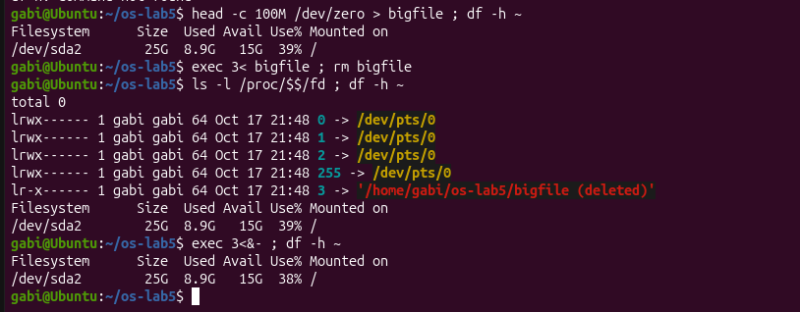
Figure 1.19 – A deleted file that is still open
After rm, the file no longer appeared in ls, but /proc/$$/fd (the descriptors of the current shell) still contained the line 3 -> /home/gabi/os-lab5/bigfile (deleted). The used space in df did not decrease after rm; it decreased by about 100 MB only after the descriptor was closed with exec 3<&-. rm removed the last name, so the link count became 0, but the kernel also counts the open references to the inode: the inode and its data blocks are freed only when the link count is 0 and the last descriptor is closed. This is why deleting a large log file that a running program still writes to does not free any space until that program is restarted.

1.10 Results:
The laboratory showed in practice how the file system is organised on Linux and which information belongs to the name and which to the inode. The main results are summarised in Table 1.4.
Table 1.4 – Summary of the results of Laboratory Work 5
Topic | Commands used | Observation
Tree and file types | ls -ld, ls -l /dev, file, du | /bin is a link to usr/bin; /dev/null is a character device; file uses the content, not the name.
Inodes and links | stat, ls -li, ln, ln -s, rm | A hard link is another name for the same inode; a symbolic link stores a path (8 bytes for hard.txt) and breaks when the target is removed.
Directory links | mkdir, ls -ld | A directory has 2 + (number of subdirectories) links, because of . and .. .
Size and space | ls -l, du, truncate | 2 bytes occupy one 4 KB block; a 1 GB sparse file occupies 0 blocks.
Permissions | chmod, umask, ls -l | Only the bits of the user's class are checked; umask 0002 gives 664 and 775; r lists a directory, x lets you pass through it.
Special bits | ls -l /usr/bin/passwd, ls -ld /tmp | setuid lets passwd run as root to edit /etc/shadow; the sticky bit protects files in /tmp.
Disks and /proc | lsblk, df, mount, /proc | The root file system is ext4 on /dev/sda2; /proc/self describes the process that reads it.
Stretch | file, xxd, exec 3<, /proc/$$/fd | gzip starts with 1f 8b; the space of a deleted file is freed only after the last descriptor is closed.

CONCLUSION
The purpose of this laboratory work was to check, with ordinary commands on a real Linux system, the ideas about file systems presented in the lecture. Instead of writing programs, every part consisted of running a few commands, predicting their result where possible and explaining the output, which made it possible to see how the abstractions of the operating system really behave.
The first part showed that Linux has a single directory tree that starts at /, and that this tree contains not only regular files and directories but also symbolic links and device files. The first letter of ls -l identified each type, and file proved that the real type of a file is determined from its content and not from its name. On Ubuntu 24.04, /bin turned out to be a symbolic link to usr/bin, a consequence of the merged /usr layout.
The second part was the most important one: it separated the name of a file from the file itself. stat showed that all the information about a file is kept in its inode, while the directory only maps a name to an inode number. A hard link created a second, equal name for the same inode, and removing the "original" name did not affect the data, because rm only removes a name and decrements the link count. A symbolic link, on the other hand, is a small separate file that stores a path; it became dangling when its target was removed, and its size of 8 bytes was exactly the length of the path hard.txt. The link count of directories was explained by the entries . and .., and the experiment with a 2-byte file and a 1 GB sparse file showed that the size of a file and the space it occupies on the disk are two different values.
The third part examined the permission system. The experiment with chmod 000 showed that the kernel checks only the permission bits of the class to which the user belongs, so being the owner does not grant access, but it does allow changing the permissions. The umask explained the default permissions of new files and directories. The box experiment gave a precise meaning to the bits of a directory: r allows listing the names, while x allows passing through the directory to reach a known file. Finally, the setuid bit of passwd and the sticky bit of /tmp showed how UNIX solves two practical problems: letting ordinary users change a file that belongs to root in a controlled way, and sharing a directory without letting users delete each other's files.
The fourth part showed the layers below the tree: the disk, its partitions and the file system mounted at /, as well as the virtual file system /proc, through which the kernel presents information about the hardware and the processes as ordinary text files. The fact that /proc/self/status showed the name head confirmed that /proc/self always refers to the process that reads it.
The stretch tasks completed the picture. The magic number 1f 8b showed how file recognises a format regardless of the extension, and the experiment with a deleted but still open file showed that the kernel frees an inode only when it has no names and no open descriptors, which explains why the disk space is released only after the file is closed.
Overall, the laboratory work demonstrated that a file is an inode with data blocks, and that names, links and permissions are separate mechanisms built around it. Understanding this model makes it possible to explain the behaviour of everyday commands such as rm, ln, chmod and du, to avoid common mistakes with links and permissions, and it prepares the next laboratory work, in which the file system can be examined from the inside, in the source code of the kernel.

REFERENCES
1. Operating Systems 2026-2027, Laboratory Work 5: “The File System with Your Own Hands” (Track A: warm-up on Linux), FCIM / FAF / Technical University of Moldova.
2. Linux man-pages project: stat(1), ln(1), chmod(1), umask(2), unlink(2), path_resolution(7), inode(7). Available at: https://man7.org/linux/man-pages/
3. The Linux Kernel documentation. The /proc Filesystem. Available at: https://docs.kernel.org/filesystems/proc.html
4. Filesystem Hierarchy Standard, version 3.0. The Linux Foundation. Available at: https://refspecs.linuxfoundation.org/fhs.shtml

