
MINISTRY OF EDUCATION, CULTURE AND RESEARCH
OF THE REPUBLIC OF MOLDOVA
Technical University of Moldova
Faculty of Computers, Informatics and Microelectronics
Department of Software Engineering and Automation

Report
Laboratory Work No.7
Operating Systems
Lab 7: Three Small Programs:
Processes, Redirection, a Pipe

Done by: Botezatu Gabriela
st. gr. FAF-243,
Checked by: Reițman Patricia

Chișinău – 2026

TABLE OF CONTENTS
1 LABORATORY WORK 7: THREE SMALL PROGRAMS: PROCESSES, REDIRECTION, A PIPE 3
1.1 Objective 3
1.2 Tasks: 3
1.3 Theoretical Notes: 4
1.4 Working Environment: 5
1.5 Creating a Process with fork, exec and wait: 5
1.6 A Zombie, on Purpose: 8
1.7 Redirection of the Standard Output: 10
1.8 Building a Pipe by Hand: 12
1.9 Optional Task: Three Stages: 14
1.10 Results: 16
CONCLUSION 17
REFERENCES 19

1 LABORATORY WORK 7: THREE SMALL PROGRAMS: PROCESSES, REDIRECTION, A PIPE

1.1 Objective
The objective of this laboratory work is to answer, by running real code on Linux, three questions from the lecture: how a new process is born, where printf actually writes, and how the shell executes a command such as ls | wc -l. The work consists of compiling and running four short C programs that do by hand exactly what the shell does: run.c creates a process with fork, exec and wait; zombie.c shows a terminated child that was not yet waited for; redirect.c sends the output of ls -l into a file by playing with file descriptors; and pipeline.c connects two programs with a pipe. In each program one line is changed on purpose and the effect is observed.

1.2 Tasks:
- Write run.c, which forks a child that becomes ls -l while the parent waits for it; then make the child run date and a program that does not exist, and compare the exit statuses seen by the parent.
- Write zombie.c by adding sleep(20); before waitpid, and observe the child in the process table with ps while the parent sleeps and after it wakes up.
- Write redirect.c, which does the same as ls -l > out.txt: in the child it closes descriptor 1, opens the file and then runs ls.
- Write pipeline.c, which does the same as ls /etc | wc -l with one pipe and two children, compare its result with the shell, and observe what happens when the parent does not close the writing end of the pipe.
- Complete the optional task: pipeline3.c for ls /usr/bin | grep x | wc -l, with two pipes and three children.
- Answer all the "Observe" questions with the commands and outputs that support them.

1.3 Theoretical Notes:
On UNIX-like systems a new program is never started in one step. The shell, and any other program, uses three separate system calls, and the space between them is exactly what makes redirection and pipes possible:
- fork() creates a copy of the calling process. The copy (the child) has its own PID but the same code, the same memory contents and the same open file descriptors. fork returns twice: 0 in the child, the PID of the child in the parent, and -1 if no process could be created.
- exec (here execlp, which searches the program in the directories of PATH) replaces the program of the current process with a new one. The PID stays the same and the open file descriptors are kept. If it succeeds, exec never returns, because the code that called it no longer exists; it returns -1 only on failure.
- wait() / waitpid() blocks the parent until a child ends and collects its exit status, which is extracted with WEXITSTATUS(status). Between the moment the child ends and the moment its parent waits for it, the child is a zombie: the program is gone, but the kernel keeps its entry (PID and exit status) in the process table.
Every process has a table of open files indexed by small integers, the file descriptors. By convention 0 is the standard input, 1 the standard output and 2 the standard error. printf always writes to descriptor 1, without knowing what is behind it. Two rules are essential: open, dup and pipe always return the smallest free descriptor number, and the descriptor table is inherited by fork and kept by exec. Therefore, to redirect the output of a program, the shell closes 1 in the child between fork and exec and opens a file in its place.
A pipe is a buffer in the kernel with two ends: p[0] for reading and p[1] for writing. A read from an empty pipe blocks as long as at least one writing end is still open anywhere in the system; it returns 0 (end of file) only after every writing end has been closed. For this reason each process must close the ends of the pipe it does not use, otherwise the reader may wait forever.

1.4 Working Environment:
Unlike the previous two laboratory works, which were done inside xv6, this work belongs to Track A and runs directly on Linux, on the same Ubuntu 24.04 LTS virtual machine. A new directory was created for it and the version of the compiler was checked:

$ mkdir -p ~/os-lab7 && cd ~/os-lab7
$ gcc --version | head -1

All programs were compiled with gcc -Wall -Wextra, so that the compiler reports every warning. The source files run.c, zombie.c, redirect.c, pipeline.c and pipeline3.c were created in ~/os-lab7 and pushed to the course Git repository together with this report.

1.5 Creating a Process with fork, exec and wait:
The program run.c does what the shell does when the command ls -l is typed: it copies itself (fork), the copy becomes ls (exec), and the original waits for it (wait). Both processes print their PID, so the relation between them can be seen in the output:

#include <stdio.h>
#include <stdlib.h>
#include <unistd.h>
#include <sys/wait.h>

/* the three steps of the shell for the command: ls -l */
int main(void)
{
printf("parent: my PID is %d\n", getpid());
fflush(stdout);

pid_t pid = fork(); /* step 1: copy myself */
if (pid < 0) { perror("fork"); return 1; }

if (pid == 0) { /* only the child runs this */
printf("child: my PID is %d, my parent is %d\n",
getpid(), getppid());
fflush(stdout);
execlp("ls", "ls", "-l", (char *)NULL); /* step 2: become ls */
perror("exec"); /* runs only if exec failed */
exit(127);
}

int status;
waitpid(pid, &status, 0); /* step 3: wait for the child */
printf("parent: child %d ended with status %d\n",
pid, WEXITSTATUS(status));
return 0;
}

The program was compiled and run:

$ gcc -Wall -Wextra -o run run.c && ./run

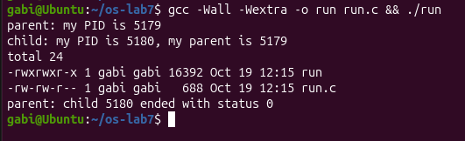
Figure 1.1 – run.c: the child becomes ls -l and the parent waits for it
The lines appear in the expected order: the parent prints its PID, the child prints its PID and the PID of its parent, then the listing of ls -l follows, and only at the end the parent reports that the child ended. Next, the execlp line was replaced so that the child runs date:

execlp("date", "date", (char *)NULL);

$ gcc -Wall -Wextra -o run run.c && ./run

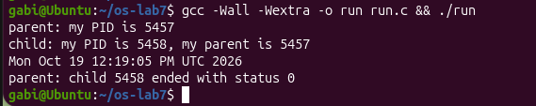
Figure 1.2 – The same program, with the child running date
Finally, the child was asked to run a program that does not exist:

execlp("nosuchprog", "nosuchprog", (char *)NULL);

$ gcc -Wall -Wextra -o run run.c && ./run

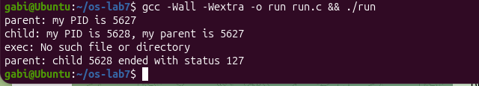

Figure 1.3 – exec fails for nosuchprog and the child exits with 127
Observations:
- Why perror("exec") is printed only with nosuchprog. When execlp succeeds, the program of the child is replaced by ls (or date): its code, data and stack are thrown away, including the lines perror("exec") and exit(127) that follow the call. A successful exec therefore never returns, and those lines are never reached. With nosuchprog, execlp searches every directory of PATH, finds no such file, fails and returns -1 with errno = ENOENT. Only then does the child continue with the next line, and perror prints exec: No such file or directory.
- The number printed as "my parent". The value returned by getppid() in the child is exactly the number printed by the parent in the first line, parent: my PID is …. It is the PID of the process ./run that called fork. In the other direction, the PID printed by the child as my PID is the value that fork returned in the parent, which is why the same number appears again in the last line, parent: child … ended.
- The status seen by the parent. With ls (and also with date) the parent prints status 0: the program ended successfully and its exit code 0 was passed by the kernel to waitpid, from which WEXITSTATUS extracts it. With nosuchprog the parent prints status 127. This value does not come from any program: the child itself called exit(127) after exec failed. It is the same convention the shell uses: after typing an unknown command in bash, echo $? also prints 127 ("command not found").

1.6 A Zombie, on Purpose:
A zombie is a child that has ended but has not yet been waited for by its parent. To produce one, the original run.c (the version with ls) was copied to zombie.c and a single line was added, just before waitpid:

int status;
sleep(20); /* the new line */
waitpid(pid, &status, 0); /* step 3: wait for the child */

The program was started in the background, with its output discarded, and the process table was printed while the parent was sleeping:

$ gcc -Wall -Wextra -o zombie zombie.c
$ ./zombie > /dev/null &
$ sleep 2; ps -o pid,ppid,stat,cmd
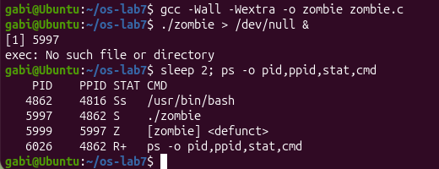

Figure 1.4 – The child ls appears as a zombie while the parent sleeps
After waiting 20 seconds, the same ps command was run again:

$ ps -o pid,ppid,stat,cmd

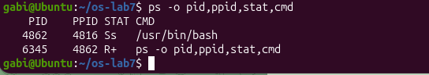
Figure 1.5 – The process table after the parent called waitpid
Observations:
- The letter in the STAT column. ls appears as [ls] <defunct> with the letter Z, which means zombie (defunct). ls produced its listing in a fraction of a second and terminated, but its parent ./zombie is in state S (sleeping inside sleep(20)) and has not called waitpid yet. The kernel has already freed the memory of ls (that is why its name is shown in brackets, without arguments), but it must keep the entry in the process table with the PID and the exit status, because the parent has the right to ask for them later. The PPID of the zombie is the PID of ./zombie, which shows whose child it is.
- After 20 seconds. The line [ls] <defunct> is no longer there, and neither is ./zombie, which has finished. The line that made it disappear is waitpid(pid, &status, 0);: after sleep(20) returned, the parent collected the exit status of the child, and only then did the kernel remove its entry. This is called reaping the child. If the parent had ended without waiting, the zombie would have been adopted by init (PID 1), which waits for all orphans, so it would still have been removed.

1.7 Redirection of the Standard Output:
The program redirect.c does what the shell does for ls -l > out.txt. In the child it closes descriptor 1, so that 1 becomes the smallest free number, opens the file (which therefore receives number 1), and then runs ls. The message about the descriptor is printed with fprintf(stderr, …), that is to descriptor 2, which was not touched:

#include <stdio.h>
#include <stdlib.h>
#include <fcntl.h>
#include <unistd.h>
#include <sys/wait.h>

/* does the same as the shell command: ls -l > out.txt */
int main(void)
{
pid_t pid = fork();
if (pid == 0) {
close(1); /* descriptor 1 is now free */
int fd = open("out.txt", O_WRONLY | O_CREAT | O_TRUNC, 0644);
if (fd < 0) { perror("open"); exit(1); }
fprintf(stderr, "open gave descriptor %d\n", fd);
execlp("ls", "ls", "-l", (char *)NULL); /* ls writes to 1, as always */
perror("exec");
exit(127);
}
waitpid(pid, NULL, 0);
printf("done: the listing is in out.txt\n");
return 0;
}

The program was compiled and run, and then the beginning of the file was printed:

$ gcc -Wall -Wextra -o redirect redirect.c && ./redirect
$ head -3 out.txt

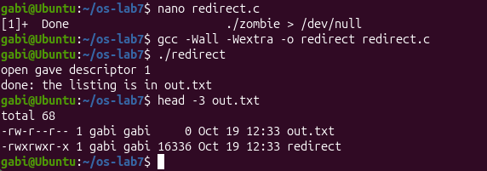

Figure 1.6 – redirect.c: the listing of ls -l goes into out.txt
Observations:
- The number given by open. open returned descriptor 1. The kernel always gives the lowest-numbered descriptor that is not open in the process. In the child, 0 (standard input) and 2 (standard error) were still open, while 1 had just been closed, so 1 was the smallest free number. In this way out.txt took the place of the standard output without any special system call.
- Why the listing does not appear on the screen. ls was not changed at all: it writes its listing to descriptor 1, as always. Because exec keeps the descriptor table, descriptor 1 of ls is the file out.txt, not the terminal, so the listing goes into the file. The two lines that do appear on the screen come from descriptors that were not redirected: open gave descriptor 1 was written by the child to descriptor 2, and done: the listing is in out.txt was written by the parent, whose descriptor 1 is still the terminal, since the redirection was done only in the child. In the file, out.txt itself appears with size 0, because it had just been created and was still empty at the moment ls read the directory.
- Redirecting the errors. To do the same as 2> err.txt, descriptor 2 must be closed before open. The file would then receive number 2, and every error message of the program (for example the output of perror) would go into err.txt, while the normal output would stay on the terminal.

1.8 Building a Pipe by Hand:
The program pipeline.c builds the pipeline ls /etc | wc -l with one pipe and two forks. In the first child, descriptor 1 becomes the writing end p[1]; in the second child, descriptor 0 becomes the reading end p[0]. dup copies a descriptor into the smallest free number, exactly like open. After the dup, each child closes both original ends, and the parent, which uses neither end, closes them too:

#include <stdio.h>
#include <stdlib.h>
#include <unistd.h>
#include <sys/wait.h>

/* does the same as the shell command: ls /etc | wc -l */
int main(void)
{
int p[2];
if (pipe(p) < 0) { perror("pipe"); return 1; }

if (fork() == 0) { /* ls: its 1 becomes p[1] */
close(1);
dup(p[1]); /* smallest free number: 1 */
close(p[0]);
close(p[1]);
execlp("ls", "ls", "/etc", (char *)NULL);
perror("exec ls");
exit(127);
}

if (fork() == 0) { /* wc: its 0 becomes p[0] */
close(0);
dup(p[0]); /* smallest free number: 0 */
close(p[0]);
close(p[1]);
execlp("wc", "wc", "-l", (char *)NULL);
perror("exec wc");
exit(127);
}

close(p[0]); /* the parent uses neither end */
close(p[1]);
wait(NULL);
wait(NULL);
return 0;
}

The descriptors of the three processes after the dup calls are shown in Table 1.1.
Table 1.1 – The file descriptors of the processes in pipeline.c
Process | Descriptor 0 | Descriptor 1 | p[0] and p[1]
child 1 (ls) | terminal | pipe, writing end | closed after dup
child 2 (wc -l) | pipe, reading end | terminal | closed after dup
parent | terminal | terminal | closed, not used

The program was compiled and run, and its result was compared with the one of the real shell:

$ gcc -Wall -Wextra -o pipeline pipeline.c && ./pipeline
$ ls /etc | wc -l

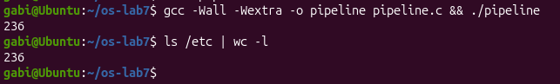
Figure 1.7 – pipeline.c and the shell give the same number
Then the program was broken on purpose: in the parent, the line close(p[1]); was turned into a comment:

close(p[0]); /* the parent uses neither end */
/* close(p[1]); */

$ gcc -Wall -Wextra -o pipeline pipeline.c && ./pipeline

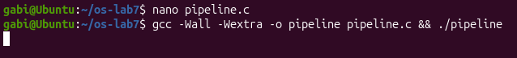
Figure 1.8 – Without close(p[1]) in the parent the program does not end and is stopped with Ctrl-C
Observations:
- The same number. Yes: ./pipeline and ls /etc | wc -l printed the same number, the number of entries in /etc. The program performs exactly the steps of the shell, and neither ls nor wc knows that it is connected to a pipe; they simply write to 1 and read from 0.
- The child that never ends. After the change, the child that never ends is wc. ls writes its short listing into the pipe and exits normally, as it would anyway. wc -l keeps waiting, nothing is printed, and the parent stays blocked in its second wait(NULL), so the program had to be stopped with Ctrl-C.
- What wc is waiting for. wc is waiting for end of file on its standard input, which a pipe delivers only when every writing end is closed, and the parent still holds p[1] open, so read blocks forever instead of returning 0. At the same time the parent waits for wc, so the two processes wait for each other.

1.9 Optional Task: Three Stages:
The optional program pipeline3.c builds ls /usr/bin | grep x | wc -l, with two pipes and three children. Pipe a connects ls to grep, and pipe b connects grep to wc. The middle process redirects both of its standard descriptors: 0 becomes a[0] and 1 becomes b[1]. As the lesson of Part 4 shows, every child closes all four pipe ends after its dup, and so does the parent; a helper function close_all is used for this:

#include <stdio.h>
#include <stdlib.h>
#include <unistd.h>
#include <sys/wait.h>

/* does the same as the shell command: ls /usr/bin | grep x | wc -l */
static void close_all(int a[2], int b[2])
{
close(a[0]); close(a[1]);
close(b[0]); close(b[1]);
}

int main(void)
{
int a[2], b[2]; /* a: ls -> grep, b: grep -> wc */
if (pipe(a) < 0 || pipe(b) < 0) { perror("pipe"); return 1; }

if (fork() == 0) { /* ls: its 1 becomes a[1] */
close(1);
dup(a[1]);
close_all(a, b);
execlp("ls", "ls", "/usr/bin", (char *)NULL);
perror("exec ls");
exit(127);
}

if (fork() == 0) { /* grep: 0 = a[0], 1 = b[1] */
close(0);
dup(a[0]);
close(1);
dup(b[1]);
close_all(a, b);
execlp("grep", "grep", "x", (char *)NULL);
perror("exec grep");
exit(127);
}

if (fork() == 0) { /* wc: its 0 becomes b[0] */
close(0);
dup(b[0]);
close_all(a, b);
execlp("wc", "wc", "-l", (char *)NULL);
perror("exec wc");
exit(127);
}

close_all(a, b); /* the parent uses no end */
wait(NULL);
wait(NULL);
wait(NULL);
return 0;
}

$ gcc -Wall -Wextra -o pipeline3 pipeline3.c && ./pipeline3
$ ls /usr/bin | grep x | wc -l

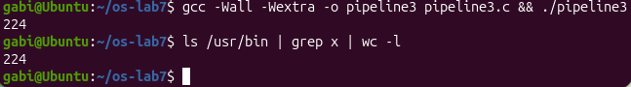
Figure 1.9 – pipeline3.c and the shell give the same number
Both commands printed the same number, the number of programs in /usr/bin whose name contains the letter x. The program also ends by itself: when ls exits, the last writing end of a is closed, so grep receives end of file; when grep exits, the last writing end of b is closed, so wc receives end of file, prints the count and exits. If any process had forgotten to close b[1], wc would hang exactly as in Part 4, and if any had forgotten a[1], grep would hang and wc together with it.

1.10 Results:
The laboratory work showed, with four small programs, the mechanisms that the shell uses for every command. The main results are summarised in Table 1.2.
Table 1.2 – Summary of the results of Laboratory Work 7
Topic | Commands / code | Observation
fork + exec + wait | run.c with ls -l, date | The child prints the parent's PID as "my parent"; the parent sees status 0.
Failed exec | execlp("nosuchprog", …) | exec returns only on failure, so perror runs; the child exits with 127, like "command not found" in the shell.
Zombie | zombie.c, ps -o pid,ppid,stat,cmd | The ended child is shown as [ls] <defunct> with STAT Z until waitpid reaps it.
Redirection | redirect.c, head -3 out.txt | After close(1), open returns 1; ls writes to out.txt without being changed.
Errors | 2> err.txt | Close descriptor 2 before open instead of 1.
Pipe | pipeline.c vs ls /etc | wc -l | Same number; ls writes to p[1] as its 1, wc reads from p[0] as its 0.
Open write end | / close(p[1]); / | wc never ends: it waits for end of file, which never comes while the parent holds p[1].
Optional | pipeline3.c | Two pipes, three children, every end closed; same result as the shell.

CONCLUSION
The purpose of this laboratory work was to see, from the outside of a real operating system, how the shell turns a line of text into running processes. Instead of reading the source code of a kernel, as in the previous laboratory works, the same ideas were tested on Linux with four short programs that repeat the work of the shell step by step.
The first part showed that a process is created in two separate steps. fork produces an almost identical copy of the parent, and exec replaces the program of that copy while keeping its PID. The experiment with nosuchprog made the behaviour of exec very clear: the line after it runs only when it fails, because a successful exec leaves no code to return to. The parent learns how its child ended only through waitpid, and the exit status 127 explained where the familiar "command not found" status of the shell comes from.
The second part showed what happens between the end of a child and the moment its parent waits for it. For 20 seconds ls remained in the process table as a zombie, marked with the letter Z, even though its program had already disappeared. Only waitpid removed it. This explains why a program that creates many children must always wait for them: otherwise the process table fills with entries that serve no purpose.
The third and fourth parts answered the question of where printf writes: always to descriptor 1, and the program never knows what is behind it. Because a new descriptor always receives the smallest free number and because exec keeps the descriptor table, the shell can redirect the output of any program to a file, or connect it to another program through a pipe, by changing a few numbers in the child between fork and exec. The broken version of pipeline.c showed the most important rule of pipes: the reader receives end of file only after every writing end has been closed, so a single forgotten close makes wc wait forever. The optional three-stage pipeline confirmed that the same rule, applied carefully to every process, works for longer pipelines as well.
Overall, the laboratory work demonstrated that the features of the shell that look complex, such as running a program, > and |, are built from a very small set of system calls: fork, exec, wait, open, close, dup and pipe. Understanding how these calls cooperate makes it much easier to understand how any command line is executed, and how to write programs that start other programs correctly.

REFERENCES
1. Operating Systems 2026-2027, Laboratory Work 7: “Three Small Programs: Processes, Redirection, a Pipe” (Track A: the real OS, from the outside (Linux)), FCIM / FAF / Technical University of Moldova.
2. R. Cox, F. Kaashoek, R. Morris. xv6: a simple, Unix-like teaching operating system (RISC-V version), Chapter 1: Operating system interfaces (processes and memory, I/O and file descriptors, pipes). MIT. Available at: https://pdos.csail.mit.edu/6.1810/
3. R. H. Arpaci-Dusseau, A. C. Arpaci-Dusseau. Operating Systems: Three Easy Pieces, Chapter 5: Interlude: Process API. Available at: https://pages.cs.wisc.edu/~remzi/OSTEP/
4. Linux man-pages project: fork(2), execve(2), exec(3), wait(2), open(2), dup(2), pipe(2), ps(1). Available at: https://man7.org/linux/man-pages/

