
MINISTRY OF EDUCATION, CULTURE AND RESEARCH
OF THE REPUBLIC OF MOLDOVA
Technical University of Moldova
Faculty of Computers, Informatics and Microelectronics
Department of Software Engineering and Automation

Report
Laboratory Work No.9
Operating Systems
Lab 9: Watching System Calls with strace

Done by: Botezatu Gabriela
st. gr. FAF-243,
Checked by: Reițman Patricia

Chișinău – 2026

TABLE OF CONTENTS
1 LABORATORY WORK 9: WATCHING SYSTEM CALLS WITH STRACE 3
1.1 Objective 3
1.2 Tasks: 3
1.3 Theoretical Notes: 3
1.4 Working Environment: 5
1.5 The System Calls of a Real Command: 5
1.6 A Program That Calls the Kernel Directly: 7
1.7 Counting One Kind of Call: 11
1.8 Results: 15
CONCLUSION 16
REFERENCES 17

1 LABORATORY WORK 9: WATCHING SYSTEM CALLS WITH STRACE

1.1 Objective
The objective of this laboratory work is to watch, from outside, the border between a user program and the kernel of Linux: the system call. The tool strace runs a program and prints every system call it makes, together with its arguments and its return value. First, the system calls of a familiar command, ls -l, are observed. Then a small C program, syscalls.c, opens a file, writes a line into it and reads it back using only the system calls open, write, read and close, and its calls are compared with the lines printed by strace. Finally, strace -c is used to count how many times one kind of call is made and to see how this number depends on where the output of a program goes.

1.2 Tasks:
- Install strace and run strace -f -e trace=openat,read,write,close ls -l; find the call that ls uses to print and the descriptor it writes to, and count roughly how many system calls one ls makes.
- Write, compile and run syscalls.c, which uses open, write, read and close directly, and check that its output matches the expected one.
- Run the program under strace -e trace=openat,write,read,close and find, among the setup lines, the six calls made by the code of the program.
- Count one kind of system call with strace -c and compare the number of write calls when the output goes to the terminal and when it is redirected to a file.
- Answer all the "Observe" questions with the commands and outputs that support them.

1.3 Theoretical Notes:
A system call is the only way for a user program to ask the kernel for a service, such as opening a file or printing on the screen. A C program does not execute it directly: it calls a small function of the C library (glibc), for example write, which puts the number of the call in register rax and its arguments in other registers, and executes the x86-64 instruction syscall. The processor switches to kernel mode, the kernel performs the work and returns a result, which is a non-negative number on success or -1 (with errno set) on error. The calls used in this work are the following:
- open(path, flags, mode) asks the kernel for a file and returns a file descriptor, a small integer that indexes the table of open files of the process. The kernel always returns the lowest free number. In current versions of glibc, open is implemented with the more general call openat(AT_FDCWD, path, ...), where AT_FDCWD means "relative to the current directory"; that is why strace prints openat.
- write(fd, buf, count) copies count bytes from the memory of the program to the file or device behind fd and returns how many bytes were written.
- read(fd, buf, count) copies at most count bytes into buf and returns how many were actually read; 0 means end of file.
- close(fd) frees the descriptor, so the number can be given again by a later open.
By convention, every process starts with three descriptors already open, inherited from its parent (usually the shell): 0 is the standard input, 1 the standard output and 2 the standard error. Functions such as printf are not system calls: they belong to the stdio library, which collects the text in a buffer in user memory and calls write(1, ...) only when the buffer must be emptied. When the standard output is a terminal the buffer is emptied at every newline (line buffering); when it is a file or a pipe it is emptied only when it is full, usually at 4096 bytes, or at the end of the program (full buffering).
strace uses the ptrace system call to stop the traced program at every entry into and exit from the kernel, and prints one line per call: its name, its arguments and, after the = sign, its return value. Its own output goes to the standard error, so it does not mix with the redirected output of the program. The options used in this work are -f (also follow the child processes), -e trace= (show only the listed calls) and -c (instead of the lines, print at the end a table with the number of calls of every kind, their time and their errors).

1.4 Working Environment:
The laboratory work was performed on an Ubuntu Linux virtual machine running in Oracle VirtualBox, using Track A (Linux), without xv6. The experiments were conducted in the Ubuntu terminal using GCC to compile the C program and strace to observe the system calls. strace was installed from the Ubuntu repositories and its version was checked:
sudo apt install strace
strace -V
All the files for this laboratory work were created in the ~/lab9 directory.The output of strace was read directly in the terminal; to count lines, its standard error was redirected into a pipe with 2>&1.

1.5 The System Calls of a Real Command:
In the first part strace was run on a familiar command, ls -l. To keep the output readable, only the four calls that work with files were shown, and -f was added so that the calls of a child process, if any, are also printed:
strace -f -e trace=openat,read,write,close ls -l
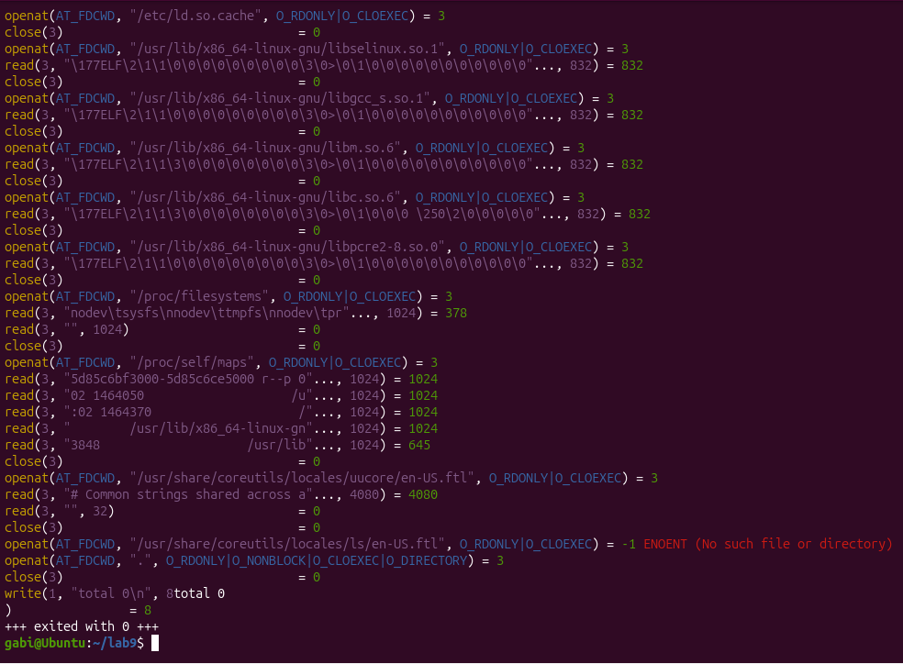
Figure 1.1 – The calls openat, read, write and close made by ls -l
The trace shows three groups of calls. At the beginning, before any line of ls itself runs, the dynamic loader opens /etc/ld.so.cache and the shared libraries that ls needs (libselinux.so.1, libc.so.6, libpcre2-8.so.0), and for each of them it reads the first 832 bytes, the ELF header, and closes the file. Then ls opens a few configuration files: /proc/filesystems, the locale files, /etc/nsswitch.conf, /etc/passwd and /etc/group (to turn the numeric user and group IDs into the names shown in the listing) and the time-zone file used to print the dates. The current directory itself is opened with the flag O_DIRECTORY; its entries are read with getdents64, which is not in the list of traced calls. At the end of the trace, the write(1, "total 0\n", 8) system call appears, indicating that the directory was empty at the time of execution. The output was written to file descriptor 1 (standard output). The program then terminated successfully.
To count the calls, the trace was sent into wc -l, once only for the four calls above and once for all calls:

strace -f -e trace=openat,read,write,close ls -l 2>&1 >/dev/null | wc -l
strace ls -l 2>&1 >/dev/null | wc -l

About 40 lines were obtained for the four calls and about 120 for all the calls, which means that one simple ls -l of a small directory makes more than a hundred system calls, most of them only to start the program and to prepare the information it prints (an exact table is obtained with strace -c in Part 3).
Observations:
- Which call prints and to which descriptor. ls prints with the system call write, and it writes to descriptor 1, the standard output, as shown by the system call write(1, "total 0\n", 8) = 8 in the terminal output.
- The program never opens the screen: descriptor 1 was already open when ls started, inherited from the shell, and points to the terminal. The program does not open the screen directly. File descriptor 1 is already available when ls starts, inherited from the shell, and points to standard output. The number of write calls may vary depending on the amount of output and whether it is displayed on the terminal or redirected to a file.
- The lines of strace are not printed by ls: they go to descriptor 2 of strace, which is why 2>&1 was needed to count them.
- How many calls. Around 40 calls of the four kinds and more than 100 calls in total for one ls -l. Only a few of them are the real work of the command (opening the directory and one write per line or one for the whole listing); most of them are the loading of the shared libraries and the reading of configuration files.

1.6 A Program That Calls the Kernel Directly:
The program syscalls.c opens a file, writes a line into it, then reopens the file and reads the line back. For the file it uses only the system calls open, write, read and close; printf is used only to show on the screen what each call returned:
/* syscalls.c - open, write, read and close, using only system calls.
* Build: gcc -Wall -Wextra -o syscalls syscalls.c
* Run: ./syscalls
* See the calls: strace ./syscalls
*/
#include <fcntl.h> /* open */
#include <unistd.h> /* write, read, close */
#include <string.h> /* strlen */
#include <stdio.h> /* printf */

int main(void) {
const char *msg = "hello, kernel\n";

/* open() is a system call: ask the kernel for a file, get back a descriptor */
int fd = open("note.txt", O_CREAT | O_WRONLY | O_TRUNC, 0644);
if (fd < 0) { perror("open"); return 1; }
printf("open returned descriptor %d\n", fd);

/* write() is a system call: hand the bytes to the kernel */
ssize_t n = write(fd, msg, strlen(msg));
printf("write sent %zd bytes\n", n);
close(fd);

/* read it back, through the kernel again */
fd = open("note.txt", O_RDONLY);
char buf[64];
n = read(fd, buf, sizeof(buf) - 1);
buf[n] = '\0';
printf("read got %zd bytes: %s", n, buf);
close(fd);
return 0;
}

The program was compiled with all warnings enabled and run:

gcc -Wall -Wextra -o syscalls syscalls.c
./syscalls

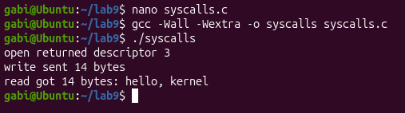
Figure 1.2 – Compiling and running syscalls
The compilation produced no warnings and the output is exactly the expected one: open returned descriptor 3, write sent 14 bytes and read got 14 bytes: hello, kernel. The message has 14 bytes: the 13 characters of "hello, kernel" and the newline. Then the same program was watched from outside with strace:

strace -e trace=openat,write,read,close ./syscalls

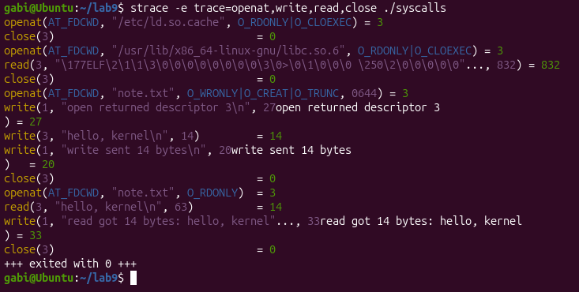
Figure 1.3 – strace shows the calls of syscalls.c
The first lines belong to the dynamic loader, which opens /etc/ld.so.cache and libc.so.6 before main starts, in the same way as for ls. After them come the six calls written in the program, in the same order as in the source code:

openat(AT_FDCWD, "note.txt", O_WRONLY|O_CREAT|O_TRUNC, 0644) = 3
write(3, "hello, kernel\n", 14) = 14
close(3) = 0
openat(AT_FDCWD, "note.txt", O_RDONLY) = 3
read(3, "hello, kernel\n", 63) = 14
close(3) = 0

Mixed with them, there are also calls that do not appear in the source code: write(1, "open returned descriptor 3\n", 27) and the two similar ones. They are made by printf, which, at the moment its buffer is emptied, also has to use the system call write on descriptor 1. The correspondence between the C code and the calls seen by the kernel is given in Table 1.1.
Table 1.1 – The calls of syscalls.c and the lines printed by strace
C code | Line printed by strace | Meaning of the result
open("note.txt", O_CREAT | O_WRONLY | O_TRUNC, 0644) | openat(AT_FDCWD, "note.txt", O_WRONLY|O_CREAT|O_TRUNC, 0644) = 3 | descriptor 3, the lowest free one
write(fd, msg, strlen(msg)) | write(3, "hello, kernel\n", 14) = 14 | 14 bytes handed to the kernel
close(fd) | close(3) = 0 | descriptor 3 is free again
open("note.txt", O_RDONLY) | openat(AT_FDCWD, "note.txt", O_RDONLY) = 3 | number 3 is given again
read(fd, buf, sizeof(buf) - 1) | read(3, "hello, kernel\n", 63) = 14 | asked for 63 bytes, got 14
close(fd) | close(3) = 0 | success
printf(...) (3 times) | write(1, "open returned descriptor 3\n", 27) = 27 ... | stdio uses write on descriptor 1
To check the explanation of the descriptor numbers, the program was also run once with its standard input closed (the shell operator <&- closes descriptor 0 before the program starts):

./syscalls <&-

open returned descriptor 0
write sent 14 bytes
read got 14 bytes: hello, kernel

Observations:
- Why the first descriptor is 3. Descriptors 0, 1 and 2 are already taken when main starts: they are the standard input, the standard output and the standard error. The shell opened them on the terminal, and they were copied into the process by fork and kept by exec, as seen in Labs 7 and 8. The kernel always gives the lowest free number, so the first openat of the program receives 3. The test with <&- confirms this rule: when descriptor 0 is closed before the program starts, the same open returns 0. The second openat also returns 3, because the close(3) before it freed that number.
- open becomes openat. The program calls open, but the kernel receives openat with the first argument AT_FDCWD. The C function open is only a wrapper of glibc that calls the newer system call, where the path is relative to the current directory. write, read and close keep their names, and their arguments are exactly those of the source code: the descriptor 3, the 14 bytes of the message and the 63 bytes (sizeof(buf) - 1) asked for by read, of which only 14 exist in the file.
- printf is not a system call. The three lines printed on the screen also reach the kernel as write(1, ...). When the program is run in a terminal, each of them is a separate write, because printf empties its buffer at every newline.

1.7 Counting One Kind of Call:
The option -c of strace does not print the calls one by one; it counts them and prints a table at the end. First, all the calls of ls -l were counted:

strace -c ls -l

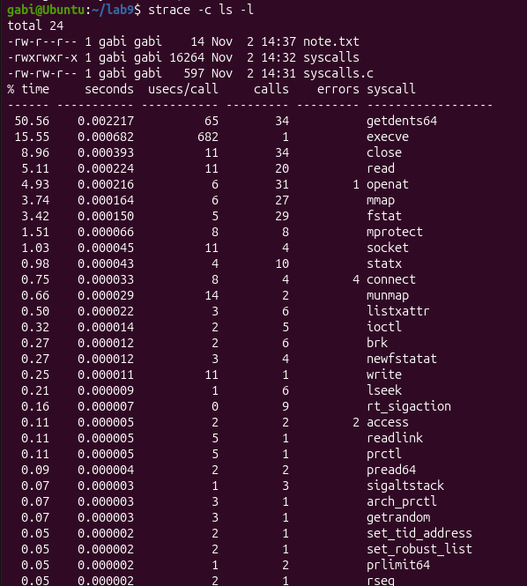
Figure 1.4 – strace -c: the number of system calls of every kind made by ls -l
The table confirms that even a simple ls -l command requires many system calls. The most frequent calls include getdents64, close, read, openat, mmap and fstat. Many of these operations are related to loading shared libraries, accessing directory information and reading configuration files. The write system call is responsible for displaying the final output. Some calls may report errors during normal execution without preventing the command from completing successfully.
Then, with -e trace=write, only one kind of call was counted: the write calls of syscalls, once with the output on the terminal and once with the output redirected to a file:
strace -c -e trace=write ./syscalls
strace -c -e trace=write ./syscalls > out.txt
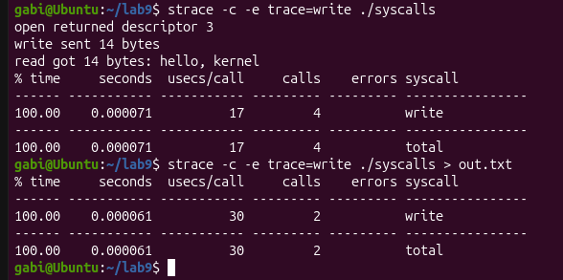

Figure 1.5 – The write calls of syscalls on the terminal and redirected to a file
On the terminal the program makes 4 write calls: one into note.txt and one for each of the three lines of printf. Redirected to a file it makes only 2: the one into note.txt and a single write(1, ...) of 80 bytes at the end of the program, which contains all three lines. The same comparison was made with a command that prints much more, the listing of /usr/bin:
strace -c -e trace=write ls -l /usr/bin
strace -c -e trace=write ls -l /usr/bin > list.txt

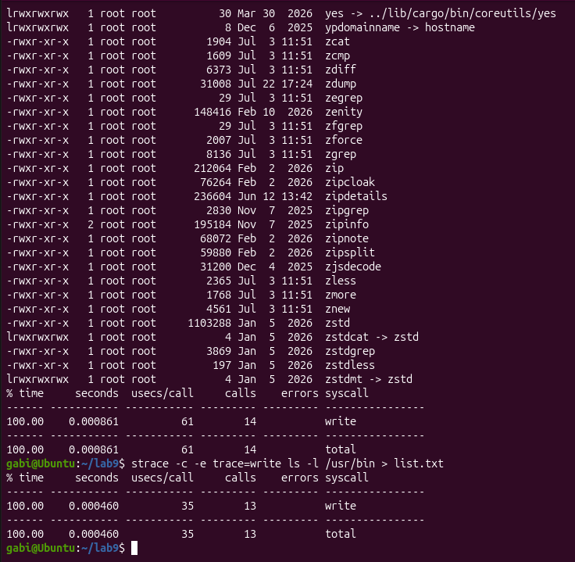
Figure 1.6 – The write calls of ls -l /usr/bin on the terminal and redirected to a file
When the output was displayed on the terminal, the ls -l /usr/bin command performed 14 write system calls. When the output was redirected to list.txt, the number decreased to 13 write calls. These results show that the number of write operations can vary depending on the destination of the output. The difference is related to output buffering, which allows data to be grouped before being written.
Observations:
- Most system calls are not the useful work. Out of more than 100 calls of ls -l, only the opening and reading of the directory and the final write are the job asked by the user. The rest are the price of starting a dynamically linked program and of turning numbers into names and dates. This is also why strace -c is useful: it shows at once which calls dominate the time of a program.
- The number of write calls depends on where the output goes. The program does not change, but the number of write calls changes from 4 to 2 for syscalls.c and from 14 to 13 for ls -l /usr/bin. The reason is the buffer of stdio: at startup the library checks whether descriptor 1 is a terminal; if it is, the buffer is emptied at every newline, so that the user sees each line immediately; if it is a file, the buffer is emptied only when its 4096 bytes are full or when the program ends. Since every system call costs a switch into the kernel and back, fewer and larger write calls make the program faster, which is why stdio buffers the output at all.

1.8 Results:
The laboratory work showed, with strace, what a program asks from the kernel. The main results are summarised in Table 1.2.
Table 1.2 – Summary of the results of Laboratory Work 9
Topic | Commands / code | Observation
Calls of ls -l | strace -f -e trace=openat,read,write,close ls -l | Libraries and configuration files are opened first; the listing is printed with write on descriptor 1.
Number of calls | strace ... | wc -l, strace -c ls -l | About 40 calls of the four kinds and about 125 calls in total for one ls -l.
Direct system calls | syscalls.c: open, write, read, close | Output as expected: descriptor 3, 14 bytes written and 14 bytes read back.
C code vs. kernel | strace -e trace=openat,write,read,close ./syscalls | open appears as openat(AT_FDCWD, ...); the other calls keep their names and arguments.
Descriptors 0, 1, 2 | ./syscalls <&- | They are inherited from the shell; the kernel gives the lowest free number, so 3, or 0 if stdin is closed.
Counting write | strace -c -e trace=write | 4 calls on the terminal and 2 when redirected for syscalls.c; 14 calls on the terminal and 13 when redirected for ls -l /usr/bin, illustrating the effect of output buffering.

CONCLUSION
The purpose of this laboratory work was to look at the system call from the outside, on a real operating system, with the tool strace, and to see which requests a program really sends to the Linux kernel.
The first part showed that even a simple command such as ls -l makes more than a hundred system calls. Most of them do not belong to the task of the command: the dynamic loader opens and maps the shared libraries, and ls reads several configuration files to turn numbers into user names, group names and dates. The result itself reaches the screen through a single kind of call, write, on descriptor 1, which ls never opened because it received it from the shell.
The second part made the same border visible in a program written by hand. Every open, write, read and close of syscalls.c appeared in the trace with the same arguments and in the same order as in the source code, with one small difference: the C function open is a wrapper of glibc that calls openat. The first descriptor returned was 3 because 0, 1 and 2 are always taken by the standard input, output and error, and running the program with the standard input closed showed that the kernel simply gives the lowest free number. The trace also showed that printf is not a system call, but ends in the same write on descriptor 1.
The third part used strace -c to count system calls and compare the results under different output conditions. For syscalls.c, the number of write calls decreased from 4 to 2 when the output was redirected to a file. For ls -l /usr/bin, the number decreased from 14 to 13. These experiments demonstrated that output buffering influences the number of system calls performed, even when the executed program remains unchanged.
Overall, the laboratory work showed that the C library only prepares the requests, and that everything a program does with files and devices goes through a small set of system calls. strace makes these calls visible, which makes it a practical tool for understanding and debugging any Linux program, even one whose source code is not available.

REFERENCES
1. Operating Systems 2026-2027, Laboratory Work 9: "Watching System Calls with strace" (Track A: the real OS, from the outside (Linux)), FCIM / FAF / Technical University of Moldova.

