
MINISTRY OF EDUCATION, CULTURE AND RESEARCH
OF THE REPUBLIC OF MOLDOVA
Technical University of Moldova
Faculty of Computers, Informatics and Microelectronics
Department of Software Engineering and Automation

Report
Laboratory Work No.6
Operating Systems
Lab 6: Inside the xv6 File System

Done by: Botezatu Gabriela
st. gr. FAF-243,
Checked by: Reițman Patricia

Chișinău – 2026

TABLE OF CONTENTS
1 LABORATORY WORK 6: INSIDE THE XV6 FILE SYSTEM 3
1.1 Objective 3
1.2 Tasks: 3
1.3 Theoretical Notes: 3
1.4 Working Environment: 4
1.5 Reading What xv6 Shows: 5
1.6 The mystat Program: 6
1.7 The Limits of the File System: 10
1.8 The find Program: 12
1.9 Stretch Task: 15
1.10 Results: 16
CONCLUSION 17
REFERENCES 19

1 LABORATORY WORK 6: INSIDE THE XV6 FILE SYSTEM

1.1 Objective
The objective of this laboratory work is to look at the file system from the inside, in the source code of a real, small operating system. xv6 contains the same ideas as ext4 (inodes, directories stored as tables of entries, hard links and a journal), but implemented in a few hundred readable lines. The work consists of reading what xv6 shows about its files, writing a mystat program that prints the inode information of a file, measuring the limits defined in kernel/fs.h, and writing a find program that walks the directory tree recursively.

1.2 Tasks:
- Run ls inside xv6, decode the type of every entry using kernel/stat.h and explain the size of an empty directory.
- Complete user/mystat.c, which calls stat() and prints the type, inode number, link count and size of each argument, and use it to observe hard links being created and removed.
- Find in the kernel the place where the link count is decremented and the place where the data blocks are freed, and list the fields of an on-disk xv6 inode.
- Measure the limits of the file system: the maximum length of a name, the maximum size of a file and the layout of the disk.
- Write user/find.c, which prints every path under a directory whose last component has a given name, and complete the optional stretch task (the -n option).
- Answer all the "Observe" questions with the commands and outputs that support them.

1.3 Theoretical Notes:
The xv6 file system is organised in layers: the disk driver and the buffer cache, the log (journal) that makes a group of block writes atomic, the inode layer, the directory layer and, on top, path names and file descriptors. The disk is an array of blocks of BSIZE = 1024 bytes, divided into fixed areas:

[ boot | super | log | inodes | bitmap | data ... data ]

An on-disk inode (struct dinode) describes one file: its type, the device numbers (for device files), the number of links and the size, followed by 13 block addresses. The first NDIRECT = 12 addresses point directly to data blocks; the 13th points to an indirect block, which is itself a block filled with further block numbers. The name of a file is not stored in the inode. A directory is an ordinary file whose content is a sequence of fixed-size entries (struct dirent), each one holding an inode number and a name of at most DIRSIZ = 14 characters. An entry with inode number 0 is a free slot. Because of this:
- A hard link (ln) is a second directory entry with the same inode number; the inode keeps the number of such names in the field nlink.
- Removing a name (rm, the system call unlink) clears one directory entry and decrements nlink. The inode and its blocks are freed only when nlink becomes 0 and no process still uses the inode.
- Walking the tree means opening a directory, reading its entries one by one with read(), building the full path of each entry and calling stat() on it to find out whether it is a file or another directory.
Compared with Linux, xv6 deliberately leaves out many features: there are no permissions, owners, time stamps or symbolic links, and the whole disk has only 2000 blocks and 200 inodes. This makes the essential mechanisms easy to see.

1.4 Working Environment:
The work was done on the same Ubuntu 24.04 LTS virtual machine as the previous laboratory works, in the ~/xv6-riscv tree. xv6 is compiled with the cross-compiler riscv64-linux-gnu-gcc and runs inside the emulator qemu-system-riscv64. The two new programs were created as user/mystat.c and user/find.c, and the lines $U/_mystat\ and $U/_find\ were added to the UPROGS list of the Makefile. The commands of every part were run on a fresh disk, started with make clean ; make qemu.

1.5 Reading What xv6 Shows:
First, the root directory was listed on a fresh disk, a new directory a was created and its content was listed:

$ ls
$ mkdir a
$ ls a

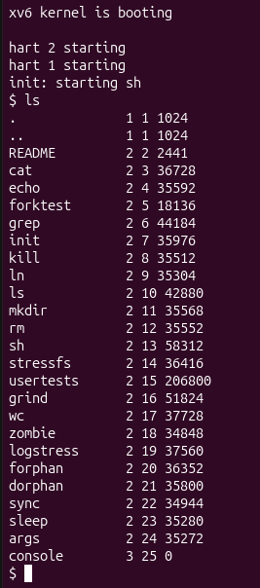
Figure 1.1 – The root directory of xv6 listed with ls
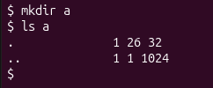
Figure 1.2 – Creating the directory a and listing its content
Each line of ls contains the name, the type, the inode number and the size in bytes. The meaning of the type numbers is defined in kernel/stat.h.
Observations:
- Types 1, 2 and 3. According to kernel/stat.h, 1 is T_DIR (a directory), 2 is T_FILE (a regular file) and 3 is T_DEVICE (a device file). In the listing, . and .. have type 1, README and all the programs (cat, echo, ..., mystat, find) have type 2, and console has type 3 and size 0: it contains no data, the kernel sends its reads and writes to the console driver.
- The root inode. The root directory has inode number 1 (ROOTINO in kernel/fs.h); inode 0 is never used, because an inode number 0 marks a free directory entry. In the root, . and .. both show inode 1 because the root has no parent: when mkfs builds the disk it makes .. of the root point to the root itself, so going "up" from / stays in /.
- The size of an empty directory. A directory entry is a struct dirent of fixed size: a ushort inum of 2 bytes and char name[DIRSIZ] of 14 bytes, that is 2 + 14 = 16 bytes. The empty directory a has size 32 = 2 × 16, so it contains exactly two entries: . (inode 26, the directory a itself) and .. (inode 1, its parent, the root). The root directory has size 1024 because mkfs rounds its size up to one whole block; the new entry a was written into a free slot of that block, so the size did not change.

1.6 The mystat Program:
The library call stat() opens a path and fills a struct stat with the fields dev, ino, type, nlink and size. The program completed in user/mystat.c converts the type into a word and prints one line for each argument; if stat() fails, an error message is written to file descriptor 2 and the program continues with the next argument:

#include "kernel/types.h"
#include "kernel/stat.h"
#include "user/user.h"

char *
typename(int t)
{
switch(t){
case T_DIR: return "directory";
case T_FILE: return "file";
case T_DEVICE: return "device";
}
return "?";
}

int
main(int argc, char *argv[])
{
struct stat st;

if(argc < 2){
fprintf(2, "usage: mystat path...\n");
exit(1);
}
for(int i = 1; i < argc; i++){
if(stat(argv[i], &st) < 0){
fprintf(2, "mystat: cannot stat %s\n", argv[i]);
continue;
}
printf("%s: %s, inode %d, links %d, size %d bytes\n",
argv[i], typename(st.type), st.ino, st.nlink, (int)st.size);
}
exit(0);
}

The program was first run on the three types of files:

$ mystat README . console

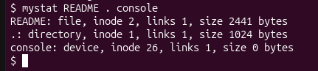
Figure 1.3 – mystat on a file, a directory and a device
The output is the same as the one given in the laboratory text: README is a file with inode 2 and 2441 bytes, . is the root directory with inode 1, and console is a device with inode 26 and size 0. Then mystat was used to watch a hard link being created and the original name being removed:

$ ln README r2
$ mystat README r2
$ rm README
$ mystat r2
$ cat r2 | wc
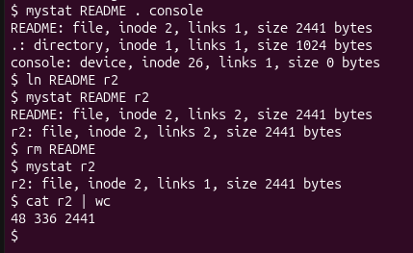
Figure 1.4 – A hard link before and after removing README
To answer the questions about the kernel, the function sys_unlink() in kernel/sysfile.c, the function iput() in kernel/fs.c and the definition of struct dinode in kernel/fs.h were read.
Observations:
- After ln and after rm. After ln README r2, both names showed the same line: file, inode 2, links 2, size 2441 bytes. After rm README, mystat r2 showed file, inode 2, links 1, size 2441 bytes, and cat r2 | wc printed 48 336 2441, the complete content of the old README. Only the link count changed (2 → 1) and one name disappeared; the inode number, the size and the data did not change, because ln and rm modify only directory entries and the counter, never the file itself.
- Where the link count is decremented. In sys_unlink() in kernel/sysfile.c, the directory entry is first overwritten with zeros (memset(&de, 0, ...) and writei), then line 244 executes ip->nlink--; followed by iupdate(ip), which writes the inode back to disk (line 239, dp->nlink--, is used only when a directory is removed, for its .. entry). The data blocks are not freed here. They are freed in iput() in kernel/fs.c (line 357): when the last in-memory reference is released (ip->ref == 1) and ip->nlink == 0, the kernel calls itrunc(), which frees all the data blocks and the indirect block, and then ifree(), which marks the inode as free. So the blocks are freed only when the file has no names left and no process has it open. In the experiment above this did not happen, because r2 still kept the link count at 1.
- The fields of an xv6 inode. struct dinode has only six fields: type, major, minor, nlink, size and addrs[NDIRECT + 1] (Table 1.1). There is no owner (uid/gid), no permission bits (mode), no time stamps and no special type for symbolic links, which is why xv6 cannot have permissions or symlinks. The structure has 4 × 2 + 4 + 13 × 4 = 64 bytes, so 1024 / 64 = 16 inodes fit in one block.
Table 1.1 – The fields of struct dinode compared to an ext4 inode
Field | Size | Meaning in xv6 | In ext4
type | 2 bytes | T_DIR, T_FILE, T_DEVICE; 0 = free inode | part of i_mode (also symlink, pipe, socket)
major, minor | 2 + 2 bytes | device numbers, used only for T_DEVICE | stored in the block pointers
nlink | 2 bytes | number of directory entries for this inode | i_links_count
size | 4 bytes | size of the file in bytes | i_size (64 bits)
addrs[13] | 52 bytes | 12 direct blocks + 1 indirect block | extents tree
– | – | missing: owner, permissions, time stamps | i_uid, i_gid, mode bits, atime, mtime, ctime

1.7 The Limits of the File System:
The constants that determine the limits were printed from kernel/fs.h, the layout of the disk was read from the message printed by mkfs while building the image, and a directory with a long name was created inside xv6:

grep -n "define BSIZE\|define NDIRECT\|define NINDIRECT\|define DIRSIZ" kernel/fs.h
make clean ; make fs.img 2>&1 | grep nmeta

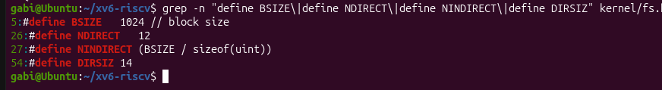

Figure 1.5 – The constants that define the limits in kernel/fs.h

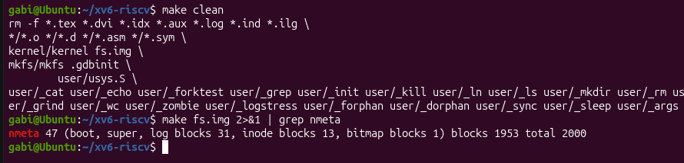

Figure 1.6 – The layout of the disk printed by mkfs

$ mkdir averyveryverylongname
$ ls
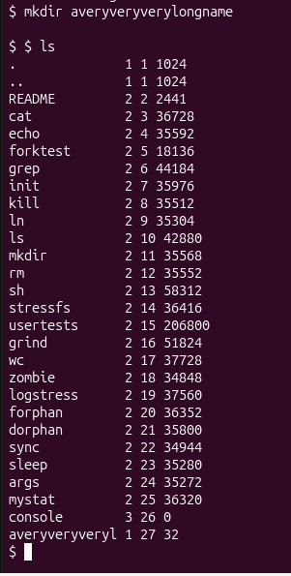

Figure 1.7 – A name longer than DIRSIZ is truncated
Observations:
- The long name. ls shows the directory as averyveryveryl (type 1, inode 26, size 32): only the first 14 characters of averyveryverylongname were kept, and no error was reported. The constant responsible is DIRSIZ = 14, the size of the name field of struct dirent. While the path is parsed, skipelem() in kernel/fs.c copies at most DIRSIZ characters of each component, so the rest of the name is silently cut off. Since the field is exactly 14 bytes long, a name of 14 characters is stored without a terminating zero.
- The largest file. A file can use 12 direct blocks and one indirect block. The indirect block has BSIZE = 1024 bytes and every block number takes 4 bytes, so it holds NINDIRECT = 1024 / 4 = 256 block numbers. The calculation is: MAXFILE = NDIRECT + NINDIRECT = 12 + 256 = 268 blocks, and 268 × 1024 = 274 432 bytes = 268 KB. A larger file cannot be written, because there is no place to store the address of block number 269.
- The layout of the disk. The line nmeta 47 (boot, super, log blocks 31, inode blocks 13, bitmap blocks 1) blocks 1953 total 2000 shows that the whole disk has 2000 blocks of 1 KB (FSSIZE), that is about 2 MB. Of these, 47 are metadata and 1953 are data blocks. The distribution is given in Table 1.2.
Table 1.2 – The layout of the xv6 disk (fs.img)
Area | Blocks | Explanation
boot block | 1 | block 0, not used by xv6
superblock | 1 | block 1, describes the sizes and the start of each area
log | 31 | 1 header block + LOGBLOCKS = 30 blocks for the journal
inodes | 13 | 200 inodes (NINODES) / 16 inodes per block, rounded up
bitmap | 1 | one bit per block; one block has 8192 bits, enough for 2000 blocks
data | 1953 | 2000 − 47 = 1953 blocks for the content of files and directories
total | 2000 | FSSIZE = 2000 blocks × 1 KB ≈ 2 MB

1.8 The find Program:
find <dir> <name> must print every path under <dir> whose last component is <name>. The program was written starting from user/ls.c, which already shows how to open a directory, read the struct dirent entries one by one, build the full path in a buffer and call stat() on it. The main difference is that find calls itself recursively for every entry, and therefore must be careful with three things:
- entries with inum == 0 are free slots and are skipped;
- the entries . and .. are never followed, otherwise the recursion would never end (. leads to the same directory and .. back to the parent);
- every opened directory is closed before returning, because a process can have only NOFILE = 16 open files and a deep tree would exhaust them.
The complete program user/find.c (including the optional -n option from the stretch task) is:

#include "kernel/types.h"
#include "kernel/stat.h"
#include "user/user.h"
#include "kernel/fs.h"
#include "kernel/fcntl.h"

int show_inum = 0; // set by the optional third argument -n

// Return a pointer to the last component of path.
char *
lastname(char *path)
{
char *p;
for(p = path + strlen(path); p >= path && *p != '/'; p--)
;
return p + 1;
}

void
find(char *path, char *name)
{
char buf[512], *p;
int fd;
struct dirent de;
struct stat st;

if((fd = open(path, O_RDONLY)) < 0){
fprintf(2, "find: cannot open %s\n", path);
return;
}
if(fstat(fd, &st) < 0){
fprintf(2, "find: cannot stat %s\n", path);
close(fd);
return;
}

// The path itself matches?
if(strcmp(lastname(path), name) == 0){
if(show_inum)
printf("%s %d\n", path, st.ino);
else
printf("%s\n", path);
}

if(st.type != T_DIR){
close(fd);
return;
}

if(strlen(path) + 1 + DIRSIZ + 1 > sizeof buf){
fprintf(2, "find: path too long\n");
close(fd);
return;
}
strcpy(buf, path);
p = buf + strlen(buf);
*p++ = '/';

while(read(fd, &de, sizeof(de)) == sizeof(de)){
if(de.inum == 0) // free slot
continue;
memmove(p, de.name, DIRSIZ);
p[DIRSIZ] = 0;
if(strcmp(p, ".") == 0 || strcmp(p, "..") == 0)
continue; // never recurse into . and ..
find(buf, name);
}
close(fd); // only NOFILE = 16 per process
}

int
main(int argc, char *argv[])
{
if(argc < 3 || argc > 4){
fprintf(2, "usage: find dir name [-n]\n");
exit(1);
}
if(argc == 4 && strcmp(argv[3], "-n") == 0)
show_inum = 1;

struct stat st;
if(stat(argv[1], &st) < 0){
fprintf(2, "find: cannot stat %s\n", argv[1]);
exit(1);
}
if(st.type != T_DIR){
fprintf(2, "find: %s is not a directory\n", argv[1]);
exit(1);
}

find(argv[1], argv[2]);
exit(0);
}

The function find() first compares the last component of the current path with the searched name using strcmp and prints the path if they are equal. If the path is a directory, it appends a / and, for every valid entry, copies the name after it and calls find() again on the longer path. The program was tested on a fresh disk (make clean ; make qemu) with the commands from the laboratory text:

$ mkdir a
$ mkdir a/b
$ echo x > a/b/r2
$ echo y > a/r2
$ ln cat r2
$ find . r2
$ find a b
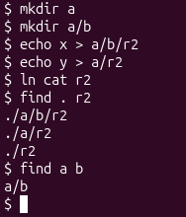
Figure 1.8 – Testing find on a fresh disk
The output is exactly the expected one: find . r2 found the three files named r2 (./a/b/r2, ./a/r2 and ./r2), at three different depths of the tree, and find a b found the directory a/b, which shows that directories are matched too, not only files.

1.9 Stretch Task:
A third argument was added: with -n, find prints the inode number next to each path (the variable show_inum in the listing above). It was used to answer the question which of the three r2 files is the same file as cat:

$ find . r2 -n

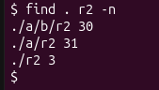
Figure 1.9 – find with the inode number of every match
The output was ./a/b/r2 28, ./a/r2 29 and ./r2 3. In the listing of Part 1, cat has inode 3, so only ./r2 is the same file as cat: the command ln cat r2 created a second name for the program. The files ./a/b/r2 (inode 28) and ./a/r2 (inode 29) are different files, created by echo, with their own inodes and a content of only 2 bytes (one letter and a newline). The names are equal, but only the inode number tells whether two names refer to the same file.

1.10 Results:
The laboratory work showed in the source code how the ideas of a UNIX file system are implemented. The main results are summarised in Table 1.3.
Table 1.3 – Summary of the results of Laboratory Work 6
Topic | Commands / code | Observation
File types | ls, kernel/stat.h | 1 = directory, 2 = file, 3 = device; the root has inode 1 and its .. points to itself.
Directory entries | mkdir a, ls a | An entry has 16 bytes (2 for inum + 14 for the name); an empty directory has 32 bytes: . and .. .
mystat | stat(), struct stat | Prints type, inode, links and size; README is inode 2, console is a device of size 0.
Hard links | ln, rm, mystat | ln raised the link count of inode 2 to 2; after rm the data was still reachable through r2.
Freeing a file | sys_unlink, iput | unlink only decrements nlink; itrunc frees the blocks in iput when nlink = 0 and ref = 1.
On-disk inode | struct dinode | 6 fields, 64 bytes; no owner, permissions, time stamps or symlinks.
Limits | kernel/fs.h, mkfs | Names of at most 14 characters; files of at most 268 blocks = 274 432 bytes; disk of 2000 blocks.
find | open, read, stat, recursion | Finds ./a/b/r2, ./a/r2, ./r2 and a/b; skips free slots, . and ..; closes every directory.
Stretch | find . r2 -n | Only ./r2 has inode 3, the same file as cat.

CONCLUSION
The purpose of this laboratory work was to look inside a real file system, the one of xv6, and to connect the commands used in the previous laboratory work with the code that implements them. Because xv6 is small, it was possible to follow each observation down to a few lines of the kernel.
The first part showed that the information printed by ls comes directly from the inode and from the directory entries. The types of files are just the numbers 1, 2 and 3 defined in kernel/stat.h, the root directory has the fixed inode number 1, and a directory is nothing more than a file made of 16-byte entries. The size of 32 bytes of an empty directory was explained by its two entries, . and ...
In the second part, writing mystat showed how a user program obtains this information through the system call stat(). The experiment with ln and rm confirmed, this time on xv6, that a hard link is only another directory entry for the same inode, and that removing a name only decrements the link counter. Reading sys_unlink() and iput() made the rule exact: the data blocks are freed by itrunc() only when the inode has no names and no in-memory references left. The structure struct dinode also explained what xv6 cannot do: since it has no fields for the owner, the permissions or the time stamps, these features simply do not exist.
The third part showed that the limits of a file system are direct consequences of a few constants. DIRSIZ = 14 explained the truncated name averyveryveryl; NDIRECT, NINDIRECT and BSIZE gave a maximum file size of 268 blocks, or 274 432 bytes; and the line printed by mkfs showed how the 2000 blocks of the disk are divided between the boot block, the superblock, the log, the inodes, the bitmap and the data. Real file systems such as ext4 remove these limits with larger blocks, longer names, multiple levels of indirect blocks or extents.
In the fourth part, find combined everything: opening a directory, reading its entries, building paths and using stat() to decide whether to descend. The recursion worked only after taking care of the free slots, of the entries . and .., and of the limit of 16 open files per process. The stretch task showed that names alone cannot tell whether two files are the same: of the three files named r2, only the one with inode 3 was the program cat.
Overall, the laboratory work demonstrated that the abstractions of a file system — files, directories, links and paths — are built from very simple pieces: numbered inodes with block addresses and directories that map names to inode numbers. Understanding these pieces in xv6 makes it much easier to understand larger file systems like ext4, which are based on the same ideas.

REFERENCES
1. Operating Systems 2026-2027, Laboratory Work 6: “Inside the xv6 File System” (Track B: build your own small OS), FCIM / FAF / Technical University of Moldova.
2. R. Cox, F. Kaashoek, R. Morris. xv6: a simple, Unix-like teaching operating system (RISC-V version), Chapter 8: File system. MIT. Available at: https://pdos.csail.mit.edu/6.1810/
3. xv6-riscv source code: kernel/fs.h, kernel/fs.c, kernel/sysfile.c, kernel/stat.h, mkfs/mkfs.c, user/ls.c. Available at: https://github.com/mit-pdos/xv6-riscv
4. MIT 6.1810 Operating System Engineering, Lab: Xv6 and Unix utilities (the find exercise). Available at: https://pdos.csail.mit.edu/6.1810/

