
MINISTRY OF EDUCATION, CULTURE AND RESEARCH
OF THE REPUBLIC OF MOLDOVA
Technical University of Moldova
Faculty of Computers, Informatics and Microelectronics
Department of Software Engineering and Automation

Report
Laboratory Work No.11
Operating Systems
Lab 11: The Race and the Semaphore

Done by: Botezatu Gabriela
st. gr. FAF-243,
Checked by: Reițman Patricia

Chișinău – 2026

TABLE OF CONTENTS
1 LABORATORY WORK 11: THE RACE AND THE SEMAPHORE 3
1.1 Objective 3
1.2 Tasks: 3
1.3 Theoretical Notes: 3
1.4 Working Environment: 5
1.5 See the Race: 5
1.6 Fix It: Mutex, then Semaphore: 8
1.7 A Semaphore as a Signal: 12
1.8 A Semaphore as a Counter: the Parking Lot: 14
1.9 Optional Task: No Lock at All: 17
1.10 Results: 19
CONCLUSION 21
REFERENCES 22

1 LABORATORY WORK 11: THE RACE AND THE SEMAPHORE

1.1 Objective
The objective of this laboratory work is to see, on a real Linux system, what happens when two threads change the same variable at the same time without any protection, and then to fix the problem with the two classic tools of synchronisation: the mutex and the semaphore. The lost additions of a shared counter are first made visible, then removed with pthread_mutex_lock / pthread_mutex_unlock and with sem_wait / sem_post. Finally, the same semaphore is used in its three roles: as a lock (start value 1), as a signal that imposes an order between two threads (start value 0) and as a counter of free resources (start value N), on the example of a parking lot with three places.

1.2 Tasks:
- Write and run race.c, in which two threads add 1 to the same counter one million times each, and explain why the result is never 2 000 000.
- Protect the counter with a mutex (mutex.c) and then with a semaphore that starts at 1 (sem.c); check that both give exactly 2 000 000 and see what happens when the semaphore starts at 2.
- Measure with time the price of the lock, comparing race, mutex and sem.
- Use a semaphore that starts at 0 as a signal (order.c), so that thread B reads a message only after thread A has written it; repeat with the start value 1.
- Use a semaphore that starts at 3 as a counter of free places (parking.c, 6 cars and 3 places) and observe what happens with only one place.
- Complete the optional task: the same counter with an atomic operation (atomic.c) and no lock at all.
- Answer the "Observe" questions of Parts 1 to 4.

1.3 Theoretical Notes:
A thread is a separate flow of execution inside a process. All the threads of a process share the same address space, so a global variable such as counter is the same memory location for every thread. This makes communication between threads very cheap, but it also means that two threads can read and write the same location at the same moment. On Linux, threads are created with the POSIX threads library: pthread_create starts a new thread that runs a given function, and pthread_join waits for it to finish. Programs that use it are compiled with -pthread.
A race condition appears when the result of a program depends on the exact order in which the instructions of several threads are interleaved. The part of the code that touches the shared data is called the critical section, and the goal of synchronisation is mutual exclusion: at most one thread may be inside the critical section at any time. The tools used in this work are the following:
- The mutex. A lock with two states, free and taken. pthread_mutex_lock takes it, or puts the thread to sleep while another thread holds it; pthread_mutex_unlock frees it and lets a waiting thread in. A mutex has an owner: the thread that locked it is the one that must unlock it.
- The semaphore. Introduced by E. W. Dijkstra, it is an integer that never goes below 0, together with two atomic operations. sem_wait (Dijkstra's P) decrements the value, or blocks while it is 0; sem_post (V) increments it and wakes a waiting thread. A semaphore has no owner, so one thread may wait and a different one may post. It is created with sem_init(&s, 0, value), where 0 means that it is shared between the threads of one process.
- The meaning of the start value. The start value decides the role of the semaphore: 1 gives a lock (a binary semaphore, like a mutex), 0 gives a signal (nothing has happened yet, whoever waits must wait for a post) and N gives a counter of N identical resources.
- The atomic operation. For a single variable the processor can do the read, the addition and the write as one indivisible instruction. In C11 this is atomic_fetch_add from stdatomic.h; no other thread can come in the middle of it.
The programs of this work are compiled without -O2. With the optimizer turned on, gcc may keep counter in a register for the whole loop, or replace the loop by a single addition of 1 000 000, and then the race of Part 1 would become very hard to see. Without optimisation, every counter++ really reads the variable from memory and writes it back.

1.4 Working Environment:
The work was done on an Ubuntu 26.04 LTS virtual machine running in Oracle VirtualBox, this time directly on Linux and not inside xv6. The compiler is gcc 15.2.0, checked with gcc --version. All the programs were written in a new folder, ~/os-lab11, created with mkdir -p ~/os-lab11 and cd ~/os-lab11, and compiled with gcc using the options -Wall -pthread. Every program was run several times, because the results of concurrent programs can change from one run to another. The files written in this work are:

race.c mutex.c sem.c
order.c parking.c atomic.c (optional)
report.md

1.5 See the Race:
In the first part two threads each add 1 to the same global counter, one million times. If additions were never lost, the final value would be 2 000 000. The program race.c has no protection at all:

/* race.c - two threads add to the same counter, with no protection.
* Build: gcc -Wall -pthread -o race race.c (no -O2)
*/
#include <stdio.h>
#include <pthread.h>

#define N 1000000

long counter = 0; /* shared by both threads */

void *add(void *arg) {
for (int i = 0; i < N; i++)
counter++; /* read, add 1, write back */
return NULL;
}

int main(void) {
pthread_t a, b;
pthread_create(&a, NULL, add, NULL);
pthread_create(&b, NULL, add, NULL);
pthread_join(a, NULL);
pthread_join(b, NULL);
printf("counter = %ld (expected %d)\n", counter, 2 * N);
return 0;
}

The program was compiled and run three times:

$ gcc --version
$ mkdir -p ~/os-lab11
$ cd ~/os-lab11
$ nano race.c
$ gcc -Wall -pthread -o race race.c
$ ./race
$ ./race
$ ./race
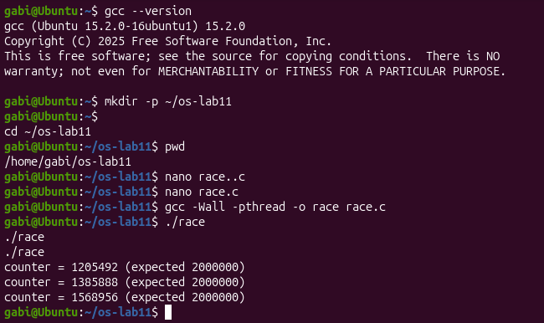
Figure 1.1 – race: three runs, three different wrong results
The three runs printed the values 1205492, 1385888 and 1568956, while the expected value is 2 000 000 (Figure 1.1). Not only is the result wrong, it is also different every time: between about 430 000 and 790 000 additions, that is from 22 % to 40 %, were lost. A fourth run, made later with time, gave yet another value, 1866315 (Figure 1.4). To see what the processor really executes, the loop was compiled to assembly with gcc -S race.c; the single line counter++ becomes three instructions:

mov counter(%rip), %rax # 1. load the value from memory
add $1, %rax # 2. add 1 in a register
mov %rax, counter(%rip) # 3. store the result back

Observations:
- The three steps of counter++. The CPU (1) loads the current value of counter from memory into a register, (2) adds 1 to the register and (3) stores the register back into memory. Between these steps the thread can be interrupted, and the other thread, which runs at the same time on another core, can access the same memory location.
- How an addition is lost. Suppose counter is 5. Thread A loads 5 into its register; before A stores, thread B also loads 5. A adds 1 and stores 6; B adds 1 to its own copy and also stores 6. Two increments were executed, but the counter grew only by 1: the write of B overwrote the write of A. Every time this interleaving happens, one addition disappears.
- Why the result changes at every run. The exact interleaving of the two threads is decided by the scheduler and by the hardware: on which cores the threads run, when they are interrupted, how long a cache line takes to move from one core to another. None of these is the same from one run to the next, so the number of lost additions, and therefore the final value, is different every time. This is why a race is so hard to debug: a program can give a correct-looking result once and a wrong one the next time.

1.6 Fix It: Mutex, then Semaphore:
The line counter++ is the critical section, so it must be executed by only one thread at a time. In mutex.c it is placed between pthread_mutex_lock and pthread_mutex_unlock:

/* mutex.c - the same counter, now protected by a mutex. */
#include <stdio.h>
#include <pthread.h>

#define N 1000000

long counter = 0;
pthread_mutex_t lock = PTHREAD_MUTEX_INITIALIZER;

void *add(void *arg) {
for (int i = 0; i < N; i++) {
pthread_mutex_lock(&lock); /* only one thread past this line */
counter++; /* the critical section */
pthread_mutex_unlock(&lock); /* let the other one in */
}
return NULL;
}

int main(void) {
pthread_t a, b;
pthread_create(&a, NULL, add, NULL);
pthread_create(&b, NULL, add, NULL);
pthread_join(a, NULL);
pthread_join(b, NULL);
printf("counter = %ld (expected %d)\n", counter, 2 * N);
return 0;
}

The program was compiled and run three times:

$ nano mutex.c
$ gcc -Wall -pthread -o mutex mutex.c
$ ./mutex
$ ./mutex
$ ./mutex
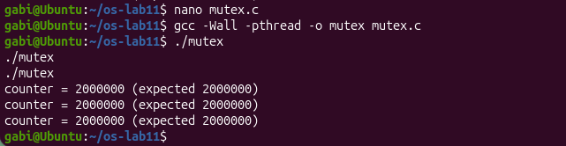
Figure 1.2 – mutex: the counter is always 2 000 000
All three runs printed counter = 2000000 (expected 2000000) (Figure 1.2). With the lock, the load, the add and the store of one thread can no longer be interleaved with those of the other thread, so no addition is lost.
The same lock can be built from a semaphore that starts at 1. sem_wait takes the only unit (1 → 0) and lets the thread in; the other thread finds 0 and waits; sem_post gives the unit back (0 → 1). The program sem.c differs from mutex.c only in these lines:

#include <semaphore.h>
sem_t s;

void *add(void *arg) {
for (int i = 0; i < N; i++) {
sem_wait(&s); /* 1 -> 0: I go in; at 0: wait */
counter++;
sem_post(&s); /* 0 -> 1: the next one may go in */
}
return NULL;
}

int main(void) {
sem_init(&s, 0, 1); /* 0 = shared between threads, 1 = start value */
... /* create, join and print as before */
sem_destroy(&s);
return 0;
}

$ nano sem.c
$ gcc -Wall -pthread -o sem sem.c
$ ./sem
$ ./sem
$ ./sem
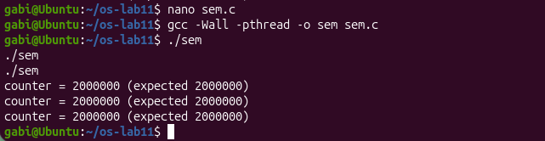
Figure 1.3 – sem: the semaphore that starts at 1 also gives 2 000 000
The semaphore gave the same correct result in all three runs (Figure 1.3). Then the cost of the lock was measured with time:

$ time ./race
$ time ./mutex
$ time ./sem
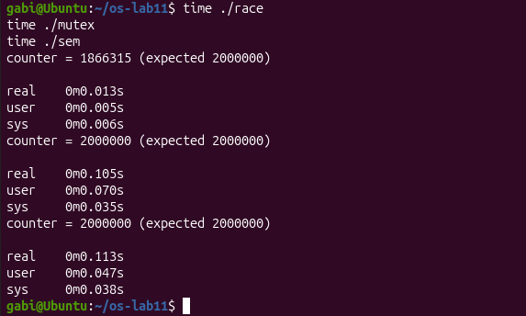
Figure 1.4 – The price of the lock: race, mutex and sem measured with time
The measured times were 0.013 s for race (with another wrong result, 1866315), 0.105 s for mutex and 0.113 s for sem (Figure 1.4). The values are close to those of the reference machine (0.00 s, 0.10 s and 0.12 s), and the order is the same: no lock is the fastest, the mutex is about eight times slower, and here the semaphore is a little slower than the mutex. The sys time also grows, from 0.006 s for race to 0.035 s and 0.038 s for the locked versions: it is the time spent in the kernel to put a thread to sleep and to wake it up when the lock is busy. A second measurement, made at the end of the work together with the optional program (Figure 1.11), gave 0.078 s for mutex and 0.062 s for sem: this time the semaphore was faster, so the difference between the two locks is small and changes from run to run, while both stay clearly slower than race.
To answer the second question, the start value of the semaphore was changed to 2 in sem.c, with sem_init(&s, 0, 2), and the program was compiled and run again:

$ nano sem.c # sem_init(&s, 0, 2)
$ gcc -Wall -pthread -o sem sem.c
$ ./sem
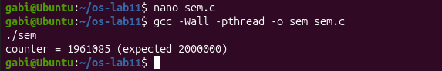
Figure 1.5 – sem_init(&s, 0, 2): both threads are let in, the race returns
The answer was wrong again: counter = 1961085 (Figure 1.5). After the test, the start value was set back to 1 and sem.c was compiled again.
Observations:
- Always 2 000 000? Yes. mutex and sem were each run three times, and every run printed exactly 2000000 (Figures 1.2 and 1.3). The critical section is executed by one thread at a time, so every load-add-store sequence is completed before the other thread can start its own.
- sem_init(&s, 0, 2). The start value is the number of threads that may pass sem_wait at the same time. With 2, the first thread takes one unit (2 → 1), and the second thread takes the other (1 → 0) without waiting, so both threads can be inside the critical section together, and the race of Part 1 returns. The result, 1961085, was again below 2 000 000 (Figure 1.5). It was much closer to it than in race.c because each iteration now spends most of its time in sem_wait and sem_post and only a short moment in counter++, so the two threads collide less often. A semaphore used as a lock must therefore start at 1.
- Why the locked version is slower. In race.c each iteration is three simple instructions. With a lock, every one of the two million iterations also calls a lock and an unlock function, which use atomic instructions and memory barriers. When the lock is taken, the other thread has to wait, and if it waits long enough it is put to sleep through the futex system call and woken up later, which explains the sys time. In addition, the variable and the lock move all the time between the caches of the two cores. Finally, the two threads no longer work in parallel on the counter: the lock serialises them, which is exactly what makes the result correct.
Table 1.1 – The three versions of the shared counter
Program | Protection | Result
race.c | none | wrong and different at every run (1 205 492 – 1 568 956), 0.013 s
mutex.c | pthread_mutex_lock / unlock | always 2 000 000, 0.105 s
sem.c (start 1) | sem_wait / sem_post | always 2 000 000, 0.113 s
sem.c (start 2) | two threads allowed inside | wrong again (1 961 085)

1.7 A Semaphore as a Signal:
In the third part the problem is not that two threads run the critical section at the same time, but the order of the events: thread B must read a message only after thread A has written it. A semaphore that starts at 0 works like a closed door: B stops at sem_wait until A opens it with sem_post. On purpose, B is created first and A pretends that its work takes one second:

/* order.c - thread B must wait until thread A has written the message. */
#include <stdio.h>
#include <string.h>
#include <unistd.h>
#include <pthread.h>
#include <semaphore.h>

char message[32];
sem_t ready; /* starts at 0: nothing is ready yet */

void *writer(void *arg) {
sleep(1); /* pretend the work takes a while */
strcpy(message, "hello");
printf("A: message written\n");
sem_post(&ready); /* 0 -> 1: wake up B */
return NULL;
}

void *reader(void *arg) {
printf("B: waiting for the message...\n");
sem_wait(&ready); /* blocks while the value is 0 */
printf("B: I read \"%s\"\n", message);
return NULL;
}

int main(void) {
sem_init(&ready, 0, 0);
pthread_t a, b;
pthread_create(&b, NULL, reader, NULL); /* B starts first, on purpose */
pthread_create(&a, NULL, writer, NULL);
pthread_join(a, NULL);
pthread_join(b, NULL);
sem_destroy(&ready);
return 0;
}

$ nano order.c
$ gcc -Wall -pthread -o order order.c
$ ./order
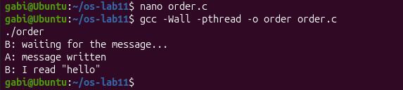
Figure 1.6 – order: B waits at sem_wait until A posts
The output is exactly the expected one (Figure 1.6): B: waiting for the message... appeared at once, then nothing happened for one second, and then A: message written and B: I read "hello" appeared together. Although B started first, it could not go past sem_wait, because the value of the semaphore was 0; only the sem_post of A, made after strcpy, raised it to 1 and woke B up. Then the start value was changed to 1, with sem_init(&ready, 0, 1):

$ nano order.c # sem_init(&ready, 0, 1)
$ gcc -Wall -pthread -o order order.c
$ ./order
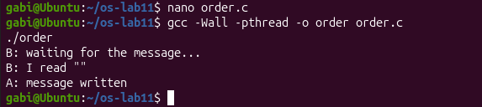
Figure 1.7 – order with the start value 1: B reads an empty message
This time the order of the lines changed (Figure 1.7): B: waiting for the message... was followed immediately by B: I read "", and only one second later by A: message written. After the test, the start value was set back to 0.
Observations:
- What B reads with the start value 1. B reads an empty string, "". Because the semaphore already has the value 1, sem_wait in B does not block: it takes the unit (1 → 0) and B goes on to read message immediately, while A is still sleeping and has not written anything yet. message is a global array, so it is filled with zeros at the start of the program, and printing it gives an empty string. The sem_post of A comes too late and only raises the value back to 1, with nobody waiting for it. The semaphore no longer imposes any order.
- A semaphore that starts at 0. It means "the event has not happened yet": any thread that calls sem_wait is blocked until another thread announces, with sem_post, that the event has happened.

1.8 A Semaphore as a Counter: the Parking Lot:
In the fourth part six cars, that is six threads, try to use a parking lot with three places. The semaphore places starts at 3 and counts the free places: every car takes one with sem_wait before it enters, stays parked for one second and gives it back with sem_post when it leaves. The variable inside is used only for printing, and the mutex is there only so that the change of inside and the printf that shows it stay together:

/* parking.c - 6 cars, 3 places. A semaphore that starts at 3 counts the free places. */
#include <stdio.h>
#include <unistd.h>
#include <pthread.h>
#include <semaphore.h>

#define PLACES 3
#define CARS 6

sem_t places; /* free places */
pthread_mutex_t lock = PTHREAD_MUTEX_INITIALIZER;
int inside = 0; /* only for printing */

void *car(void *arg) {
long id = (long)arg;
sem_wait(&places); /* take a place, or wait */
pthread_mutex_lock(&lock);
inside++;
printf("car %ld enters (inside: %d)\n", id, inside);
pthread_mutex_unlock(&lock);

sleep(1); /* parked */

pthread_mutex_lock(&lock);
inside--;
printf("car %ld leaves (inside: %d)\n", id, inside);
pthread_mutex_unlock(&lock);
sem_post(&places); /* give the place back */
return NULL;
}

int main(void) {
sem_init(&places, 0, PLACES);
pthread_t t[CARS];
for (long i = 0; i < CARS; i++)
pthread_create(&t[i], NULL, car, (void *)(i + 1));
for (int i = 0; i < CARS; i++)
pthread_join(t[i], NULL);
sem_destroy(&places);
return 0;
}

$ nano parking.c
$ gcc -Wall -pthread -o parking parking.c
$ ./parking
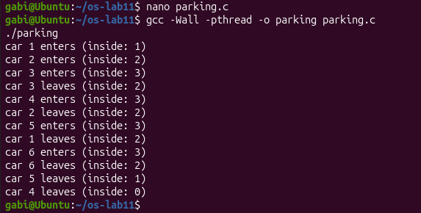
Figure 1.8 – parking: 6 cars, 3 places, never more than 3 inside
In this run (Figure 1.8) cars 1, 2 and 3 entered first, and inside grew to 3. Cars 4, 5 and 6 were already created, but they stayed blocked in sem_wait, because the value of the semaphore had reached 0. A waiting car entered only when another one left: car 4 right after car 3, car 5 after car 2 and car 6 after car 1. Every sem_post freed exactly one place, so after the first three cars inside only moved between 2 and 3, and at the end it went down to 0. It never went above 3. The order of the cars is different from the one on the sheet, because the threads are scheduled differently at every run. Then PLACES was set to 1:

$ nano parking.c # #define PLACES 1
$ gcc -Wall -pthread -o parking parking.c
$ ./parking
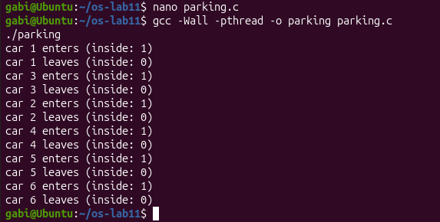
Figure 1.9 – parking with PLACES = 1: one car at a time
Now every enters line is immediately followed by the leaves line of the same car (in the order 1, 3, 2, 4, 5, 6), and inside only takes the values 1 and 0 (Figure 1.9). Since every car stays parked for one second and only one can be inside, the cars run one after another, which takes about six seconds instead of two.
Observations:
- The largest value of inside. The largest value seen is 3. It is guaranteed by the line sem_wait(&places);, together with the start value set by sem_init(&places, 0, PLACES). The semaphore starts at 3, every car that enters takes one unit, and units are given back only by sem_post(&places), after the car has left. So at most three cars can be between sem_wait and sem_post at any moment, and the fourth one is blocked while the value is 0. The mutex does not limit the number of cars; it only keeps inside++ and its printf together.
- PLACES set to 1. The semaphore becomes a binary semaphore, that is, a lock, exactly like the semaphore of sem.c in Part 2: its value is only 1 or 0, so only one car can be inside at a time, and the parking lot becomes a critical section entered by one thread after another.
Table 1.2 – The three roles of the same semaphore
Program | Start value | Role of sem_wait / sem_post
sem.c | 1 | lock: only one thread in the critical section; wait = enter, post = leave
order.c | 0 | signal: wait = "wait for the event", post = "the event has happened" (posted by another thread)
parking.c | 3 (N) | counter: wait = take one of N resources, post = give it back; at most N threads inside

1.9 Optional Task: No Lock at All:
For a single counter there is a third way, without any lock: an atomic operation. In atomic.c the counter is declared atomic_long, and the addition is done with atomic_fetch_add, which performs the load, the addition and the store as one indivisible step of the CPU. On x86-64 it is compiled into a single instruction with the lock prefix, so no other core can access the variable in the middle of it. Nothing has to be installed, because stdatomic.h comes with gcc:

/* atomic.c - the counter of race.c, with one atomic instruction per addition. */
#include <stdio.h>
#include <pthread.h>
#include <stdatomic.h>

#define N 1000000

atomic_long counter = 0; /* every operation on it is indivisible */

void *add(void *arg) {
for (int i = 0; i < N; i++)
atomic_fetch_add(&counter, 1); /* load, add, store as ONE step */
return NULL;
}

int main(void) {
pthread_t a, b;
pthread_create(&a, NULL, add, NULL);
pthread_create(&b, NULL, add, NULL);
pthread_join(a, NULL);
pthread_join(b, NULL);
printf("counter = %ld (expected %d)\n", (long)counter, 2 * N);
return 0;
}

$ nano atomic.c
$ gcc -Wall -pthread -o atomic atomic.c
$ time ./atomic
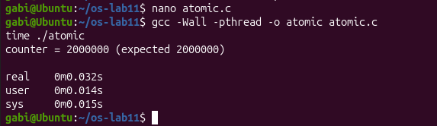
Figure 1.10 – atomic: the right result without a lock
The program printed counter = 2000000 (expected 2000000) in 0.032 s (Figure 1.10), very close to the 0.03 s of the reference machine and about three times faster than the 0.105 s of the mutex in Figure 1.4. The result is correct because the three steps of counter++ can no longer be separated, and it is faster because no thread ever has to wait for a lock or be put to sleep. To compare the four versions in the same conditions, they were then measured one after another:

$ time ./race
$ time ./mutex
$ time ./sem
$ time ./atomic
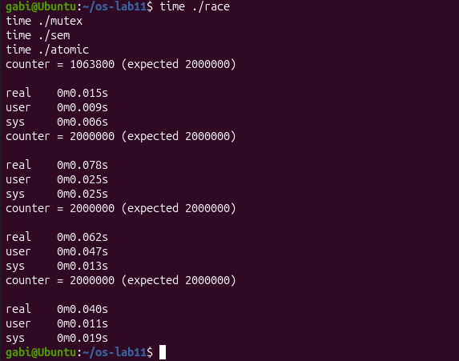
Figure 1.11 – race, mutex, sem and atomic measured together
The times were 0.015 s for race (wrong again, 1063800), 0.078 s for mutex, 0.062 s for sem and 0.040 s for atomic (Figure 1.11). The atomic version is slower than race, because every addition is a locked instruction that must take the cache line away from the other core, but it is faster than both locks and, unlike race, it is always right. The atomic operation is, however, useful only when the critical section is a single operation on a single variable; when several variables must change together, as inside and the printf of the parking lot, a mutex or a semaphore is still needed.

1.10 Results:
The laboratory work showed a race condition on a real Linux system and removed it with three different tools. The main results are summarised in Table 1.3.
Table 1.3 – Summary of the results of Laboratory Work 11
Topic | Commands / code | Observation
See the race | ./race (three times) | Three different wrong results (1 205 492, 1 385 888, 1 568 956): counter++ is load, add, store, and the threads overwrite each other.
Mutex | ./mutex | Always 2 000 000: one thread at a time in the critical section.
Semaphore as a lock | ./sem, sem_init(&s, 0, 1) | Always 2 000 000; with start value 2 the race returns (1 961 085).
Price of the lock | time ./race, ./mutex, ./sem | 0.013 s / 0.105 s / 0.113 s (second measurement 0.015 / 0.078 / 0.062 s): the lock is correct but much slower.
Semaphore as a signal | ./order, sem_init(&ready, 0, 0) | B always reads "hello"; with start value 1 it reads "" before A has written.
Semaphore as a counter | ./parking, PLACES 3 | Never more than 3 cars inside; with PLACES 1 one car at a time (1, 3, 2, 4, 5, 6).
Optional | time ./atomic | Always 2 000 000 in 0.032 s (0.040 s in the common measurement: race 0.015 s, mutex 0.078 s, sem 0.062 s), with no lock and no waiting.

CONCLUSION
In this laboratory work I left xv6 for a while and went back to the real Linux system, to look at a problem that every program with more than one thread has to face: two threads that touch the same data at the same time. The work was short, but it was one of the clearest so far, because every idea could be seen directly in a number printed on the screen.
The first part was the most surprising one. A line as simple as counter++ lost up to 40 % of two million additions, and gave a different result at every run. Looking at the three instructions generated by gcc, load, add and store, explained everything: the line only looks like one step, and the other thread can come in between. This also showed why races are dangerous in practice: nothing crashes, the program just quietly gives a wrong answer.
The second part fixed the counter with a mutex and with a semaphore that starts at 1, and both always gave exactly 2 000 000. Changing the start value to 2 brought the race back, which made it clear that the start value of a semaphore is the number of threads allowed to pass at the same time. Measuring with time showed the other side of the coin: the correct versions were many times slower, because the threads must wait for each other and sometimes ask the kernel to put them to sleep.
The third and the fourth parts showed that a semaphore is more than a lock. Starting at 0, it became a signal that forced B to read the message only after A had written it, and the experiment with the start value 1, in which B read an empty string, showed exactly what goes wrong without that signal. Starting at 3, it counted the free places of the parking lot and never let more than three cars in, while with one place it turned back into a simple lock.
The optional atomic version gave the correct result much faster than the mutex, but only because the critical section was a single addition. Overall, the work showed that the same small tool, an integer with sem_wait and sem_post, can be a lock, a signal or a counter depending only on its start value, and that the choice of the right synchronisation tool is always a balance between correctness and speed.

REFERENCES
1. OS_2026_-_Lab_11_-_The_Race_and_the_Semaphore_Linux.pdf – Operating Systems 2026-2027, Laboratory Work 11: "The Race and the Semaphore" (Track A: the real OS, from the outside (Linux)), FCIM / FAF, Technical University of Moldova.

