Parallel to Serial Bridge
Functional Specification
July 6th, 2018



Apache License 2.0

1 Introduction
A parallel-to-serial block(P2S) converts one or more parallel inputs into a serial data output, transmitted one bit at a time. For data synchronization, P2S uses one clock signal.

All the input data must be read at the same time from the parallel interface and buffered until serial transmission ends. The parallel input data is used to calculate the “end pattern” which is a cyclic redundancy check. Although the output is one bit wide, the parallel data is ordered according to parallel to serial conversion rules.

On the serial interface a starting pattern will be transmitted first to identify the beginning of the packet.

2 I/O Ports and Parameters
This section describes the ports and parameters of P2S block.

2.1 Ports2.1 Ports
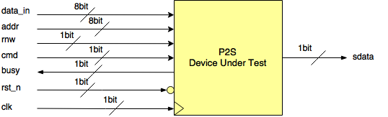
Figure 1. P2S - Device Under Test

In the table below you may find a description of each of the ports.

Port Name | Width  (bits) | Direction | Reset value | Description
data_in | 8 | in | - | The value on this port is sampled by P2s when cmd is ’1’ and rnw is ‘0’
addr | 8 | in | - | The value on this port is sampled by P2s when cmd is ’1’.
rnw | 1 | in | - | The value on this port is sampled by P2s when cmd is ’1’. It indicates a read or write command.
cmd | 1 | in | - | P2S samples this port every cycle as long as busy is not asserted(i.e. is ‘0’). This port triggers the serialization of data_in, addr and rnw values.
busy | 1 | out | 0 | P2S indicates through this port if it can accept a command. As long as busy is asserted it will not accept another command (i.e. ignores cmd value).
sdata | 1 | out | 0 | The data sampled on input parallel interface is transmitted serially on this port.
rst_n | 1 | in | - | Reset signal active on ‘0’.
clk | 1 | in | - | Clock signal of 100MHz.

Table 1. Interface description

3 Operation

3.1 Clock and Reset
P2S uses positive edge of the clk to sample the input data, advance the internal finite state machine and drive the output data.

Reset has a negative logic: when its value is 0 it will reset all the outputs and internal logic. If the reset is activated while busy is enabled, the transmission will be stopped, but some data might have already been transmitted.

3.2 Input protocol
All the input ports are sampled on the positive clk edge, only if cmd is active. The value of data_in will be sampled only if there is a write operation(i.e. rnw = ‘0’); for a read command constant 0x5A is used instead of data_in.
The busy signal is asserted if P2S can not accept a new command. P2S supports buffering of one command until the current one ends. This allows the device that controls P2S (e.g. CPU) to send data over the serial link at maximum speed. The value of cmd is ignored as long as the busy signal is active: the CPU must assert cmd until 1 clock cycle after busy is released to make sure the command was scheduled for serialization. Figure 2 shows the protocol for read and write commands.
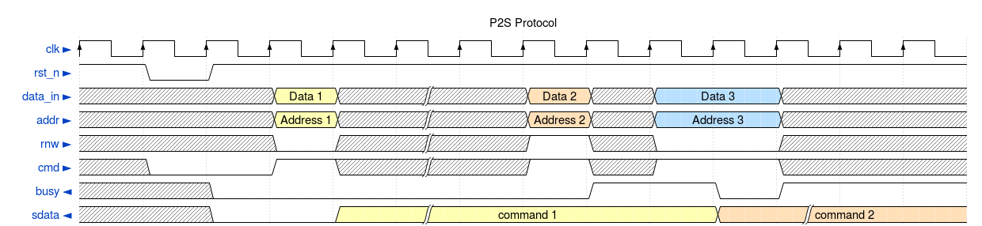
Figure 2. Write command followed by a Read command

All the input data, the “start pattern” and CRC are retained in one of the two shift registers (i.e. a ping-pong buffer as shown in Figure 3). P2S can save one command in a shift register while it serializes the data in the other shift registers.

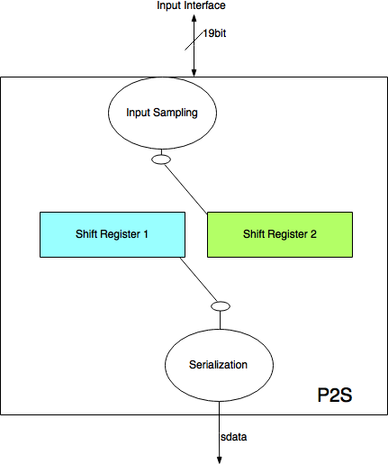
Figure 3. Ping-pong buffer

3.3 Output protocol
The data in the buffer is transmitted sequentially, from left to right, as shown in the image below:
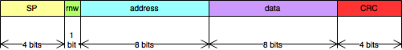
Figure 4. Serial Data Order

The transmission of serial data starts in the cycle following the command OR as soon as the current serialization finished if the command was buffered. Once the last bit of CRC was sent out the current buffer is released and can take in another command.
The “start pattern” indicates the start of transmission on the serial line(i.e. sdata signal). The CRC is calculated using polynomial is 1+x+x⁴ for the 17-bits of user data (start pattern is not included).

4 CRC Implementation
Below is a possible implementation of the CRC function for polynomial x^4 + x^1 + 1 and 17-bit data width. The buf_data signal holds the command data and initial_crc is the seed value for the CRC.

initial_crc = 4'hF;
crc[0] = buf_data[15] ^ buf_data[11] ^ buf_data[10] ^ buf_data[9] ^ buf_data[8] ^ buf_data[6] ^ buf_data[4] ^ buf_data[3] ^ buf_data[0] ^ initial_crc[2];
crc[1] = buf_data[16] ^ buf_data[15] ^ buf_data[12] ^ buf_data[8] ^ buf_data[7] ^ buf_data[6] ^ buf_data[5] ^ buf_data[3] ^ buf_data[1] ^ buf_data[0] ^ initial_crc[2] ^ initial_crc[3];
crc[2] = buf_data[16] ^ buf_data[13] ^ buf_data[9] ^ buf_data[8] ^ buf_data[7] ^ buf_data[6] ^ buf_data[4] ^ buf_data[2] ^ buf_data[1] ^ initial_crc[0] ^ initial_crc[3];
crc[3] = buf_data[14] ^ buf_data[10] ^ buf_data[9] ^ buf_data[8] ^ buf_data[7] ^ buf_data[5] ^ buf_data[3] ^ buf_data[2] ^ initial_crc[1];

