S&P 500 Visual Data Report
What an investor is actually buying

Main Question
When someone buys the S&P 500, what are they buying?

Quick Answer
Buying the S&P 500 gives exposure to many companies and sectors, but the exposure is not evenly split. The largest companies, sectors, and sub-industries receive the biggest share of each dollar invested.

Key Findings
- The S&P 500 is diversified, but it is not equally weighted.
- The top 10 companies make up 43.4% of the estimated index weight.
- Information Technology is the largest sector by estimated weight.
- Sector exposure changes when measured by company count instead of market-cap weight.
- The total market value is much higher than the combined estimated book value.
- Financials have one of the lower aggregate price-to-book ratios.
- The largest sub-industry is not necessarily inside the largest sector.

1. Sector Weight
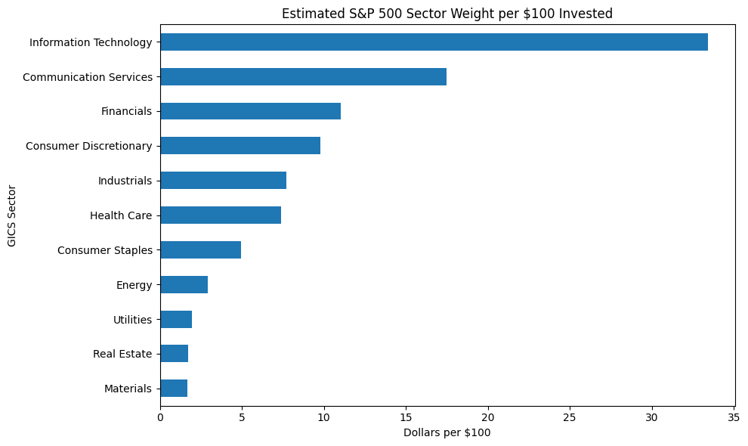 | 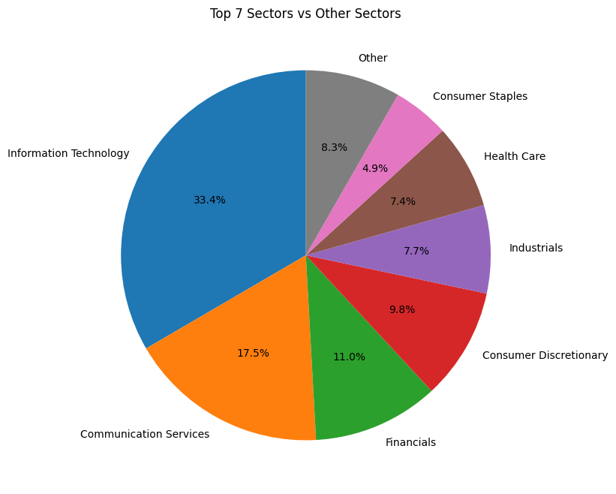

What the charts show
- Information Technology is the largest estimated sector allocation.
- Communication Services is the second-largest sector allocation.
- The top sectors receive much more of each $100 invested than the smaller sectors.

2. Company Concentration
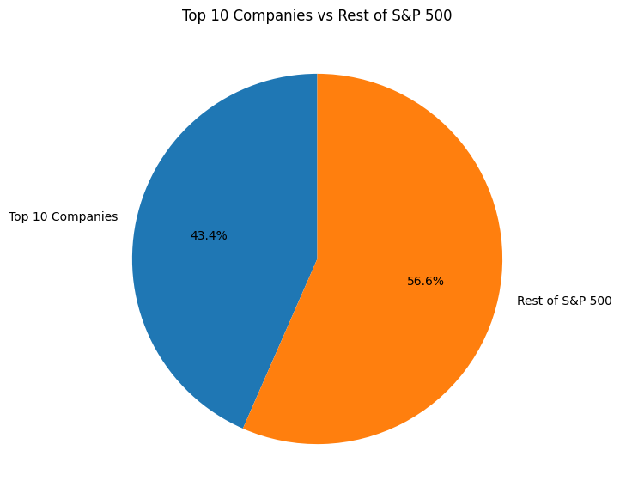 | 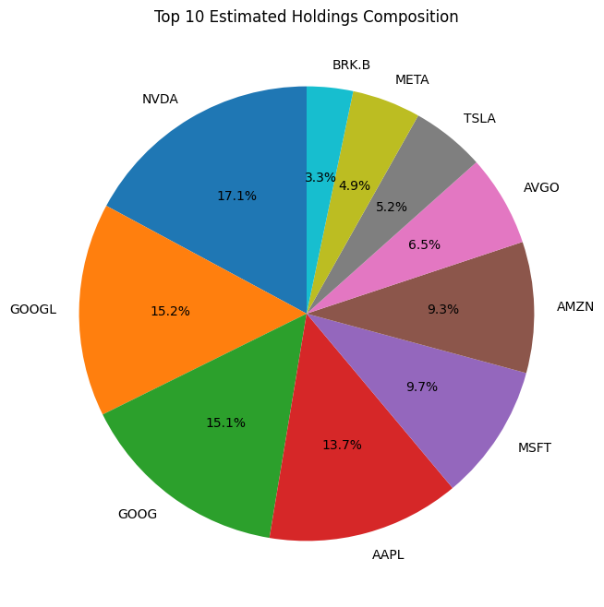

What the charts show
- The top 10 companies account for 43.4% of the estimated S&P 500 weight.
- The rest of the index is spread across hundreds of companies.
- Even inside the top 10, the weights are not evenly divided.

3. Company Count vs Market-Cap Weight
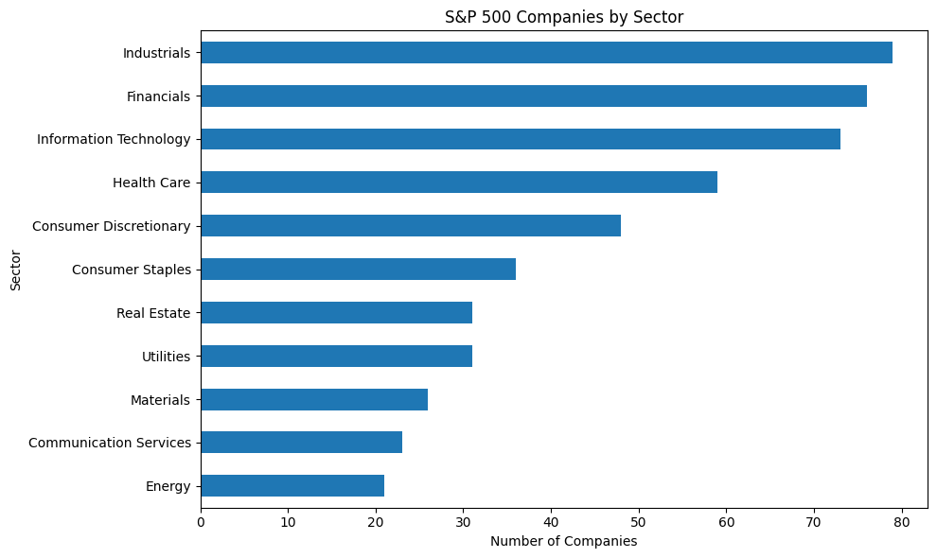 | 

What the charts show
- The sector with the most companies is not automatically the sector with the largest weight.
- Market-cap weighting gives more influence to larger companies.
- This is why sector exposure by count and sector exposure by dollars invested can look very different.

4. Sub-Industry Concentration
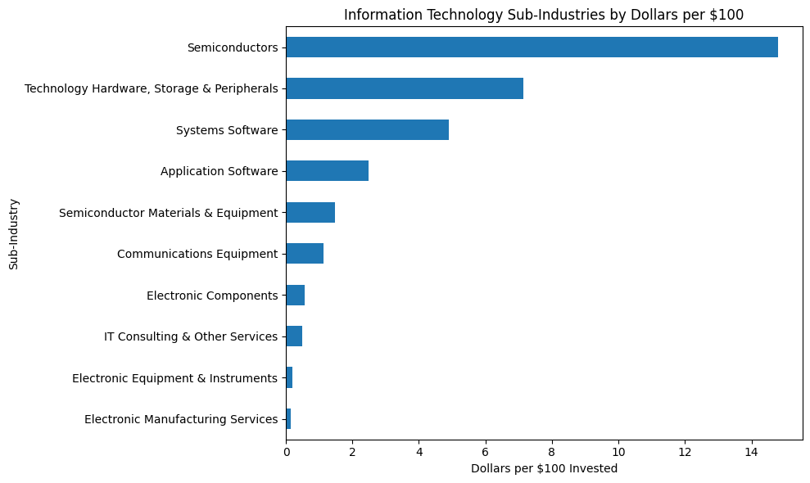 | 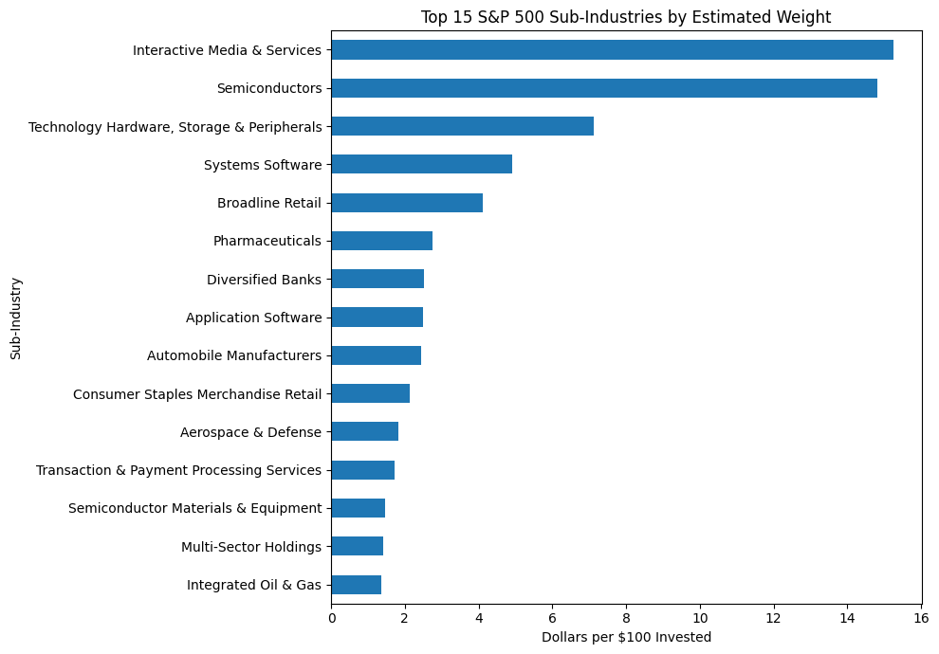

What the charts show
- Within Information Technology, Semiconductors receive the largest estimated allocation.
- Across the full index, Interactive Media & Services is the largest sub-industry by estimated weight.
- Broad sector labels can hide important concentration inside specific business types.

5. Market Value and Price-to-Book
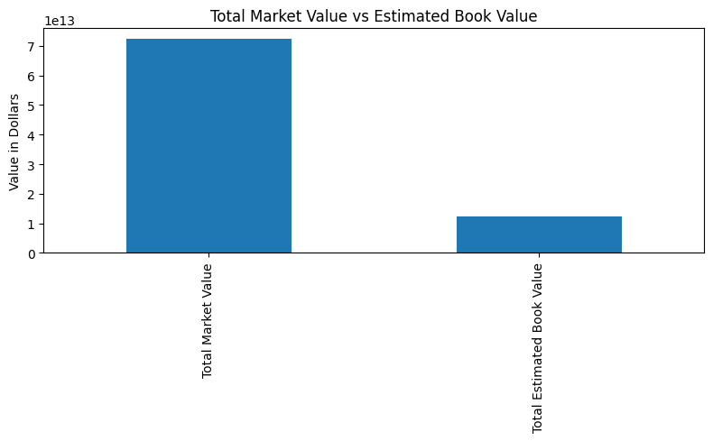 | 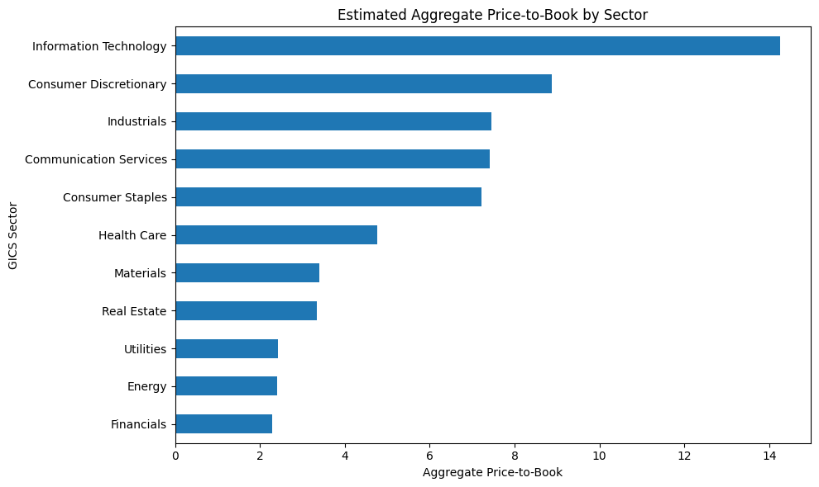

What the charts show
- The combined market value is much higher than the combined estimated book value.
- Aggregate price-to-book ratios differ by sector.
- Information Technology has one of the highest aggregate price-to-book ratios, while Financials have one of the lower ratios.

Limitations
- Weights are estimates based on regular market capitalization, not official float-adjusted S&P 500 weights.
- Financial data may include missing, delayed, or unusual values.
- Price-to-book ratios can be affected by accounting rules, intangible assets, share repurchases, and negative book equity.
- The analysis represents one point in time.

Conclusion
The S&P 500 provides broad exposure, but it is not equally balanced. The largest companies and sectors have the greatest influence on the index. The visual analysis also shows that valuation and concentration differ across sectors and sub-industries.

Direct visual summary based on the project charts and exported analysis data.

