**TailwindCSS:** [Curso gratuito Tailwind CSS #1 - Introdução e instalação (youtube.com)](https://www.youtube.com/watch?v=1eLaBow7Zbo&list=PLcoYAcR89n-r1m-tMfV4qndrRWpT_rb9u)  
É um utility-first CSS framework que prioriza a construção ultra-rápida de interfaces customizadas.

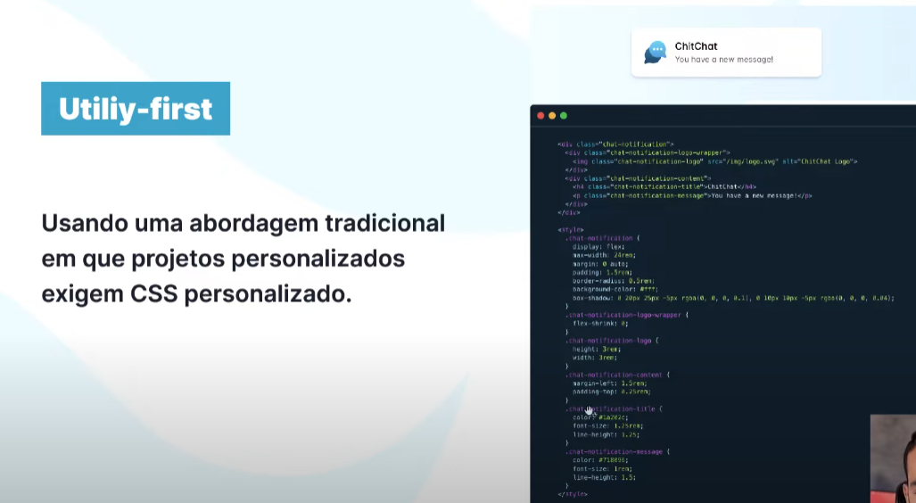

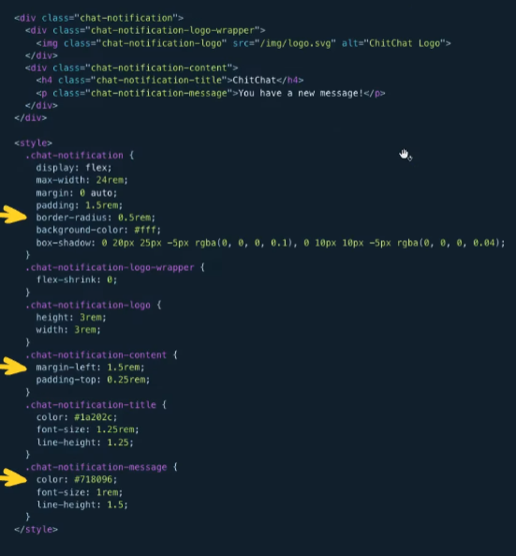

Transformando em Tailwind:

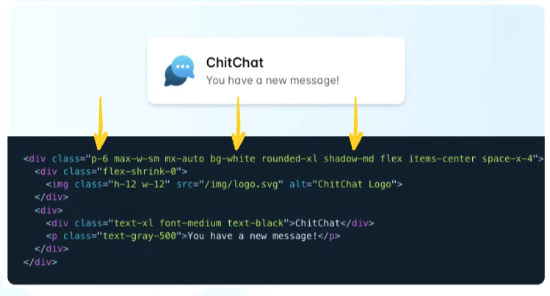

Design responsivo:

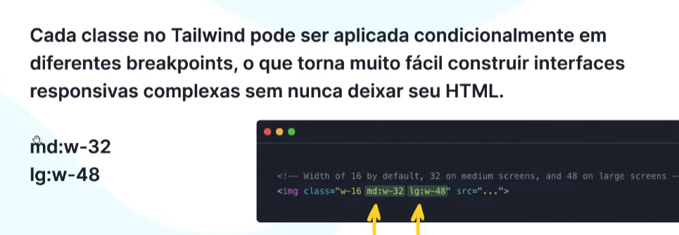

Estados (hover,focus...):

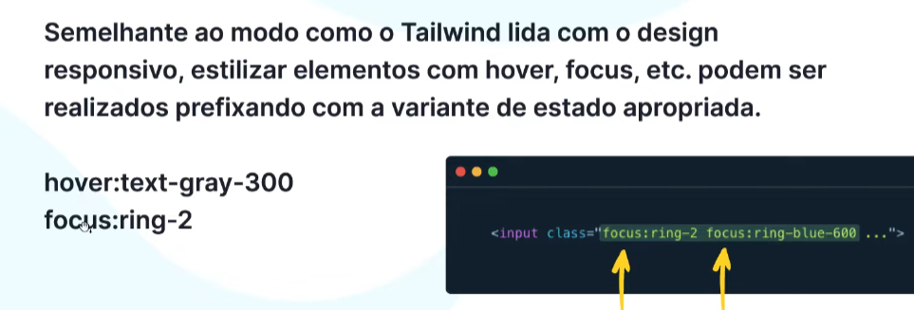

Darkmode:

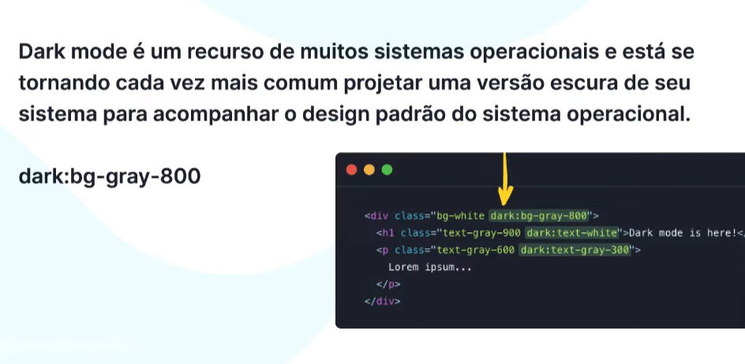

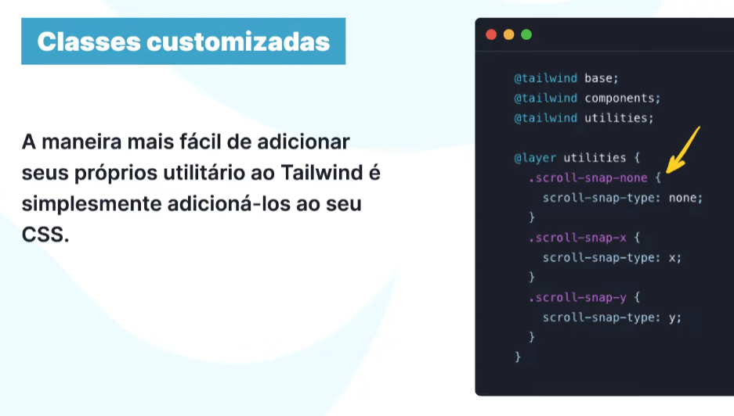

*Não usa css em inline porque da erro em vários fatores.

**TYPOGRAPHY**

**Font Family:** [Font Family - Tailwind CSS](https://tailwindcss.com/docs/font-family)

**Tamanho de Fonte**: [Font Size - Tailwind CSS](https://tailwindcss.com/docs/font-size)

**Força da fonte:** [Font Weight - Tailwind CSS](https://tailwindcss.com/docs/font-weight)

Tudo é feito dentro de uma classe. Ex:

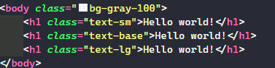

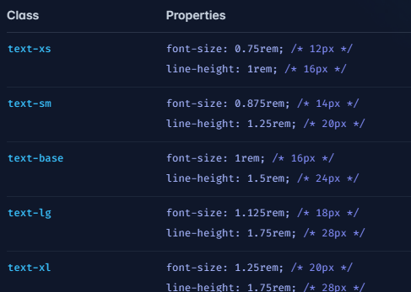

**Mexer em cor**: [Text Color - Tailwind CSS](https://tailwindcss.com/docs/text-color) // [Customizing Colors - Tailwind CSS](https://tailwindcss.com/docs/customizing-colors) - colors do tailwind.

**Alinhamento de texto**: [Text Align - Tailwind CSS](https://tailwindcss.com/docs/text-align)

**Decoração de texto**: [Text Decoration - Tailwind CSS](https://tailwindcss.com/docs/text-decoration)

**Espaçamento entre letra**: [Letter Spacing - Tailwind CSS](https://tailwindcss.com/docs/letter-spacing)

**Espaçamento entre linha**: [Line Height - Tailwind CSS](https://tailwindcss.com/docs/line-height)

**Texto na linha que quer**: [Line Clamp - Tailwind CSS](https://tailwindcss.com/docs/line-clamp)

**Lista dentro ou fora**: [List Style Position - Tailwind CSS](https://tailwindcss.com/docs/list-style-position)

**ESPAÇAMENTO/SPACING**

[Customizing Spacing - Tailwind CSS](https://tailwindcss.com/docs/customizing-spacing)

**Padding:** [Padding - Tailwind CSS](https://tailwindcss.com/docs/padding)

**Margin**: [Margin - Tailwind CSS](https://tailwindcss.com/docs/margin)

**Espaço**: [Space Between - Tailwind CSS](https://tailwindcss.com/docs/space)

EX:

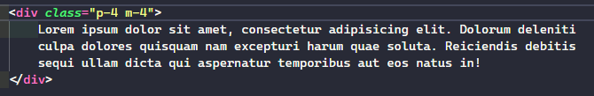

**BORDAS/BORDERS**

**Radius:** [Border Radius - Tailwind CSS](https://tailwindcss.com/docs/border-radius)

**Tamanho da borda**: [Border Width - Tailwind CSS](https://tailwindcss.com/docs/border-width)

**Cor da borda**: [Border Color - Tailwind CSS](https://tailwindcss.com/docs/border-color)

**BACKGROUND**

**Color:** [Background Color - Tailwind CSS](https://tailwindcss.com/docs/background-color)

**Attachment**: [Background Attachment - Tailwind CSS](https://tailwindcss.com/docs/background-attachment)

**Image p/gradient**: [Background Image - Tailwind CSS](https://tailwindcss.com/docs/background-image)

**SOZING: LARGURA/ALTURA**

**Largura**: [Width - Tailwind CSS](https://tailwindcss.com/docs/width)

**Altura**: [Height - Tailwind CSS](https://tailwindcss.com/docs/height)