**Hellweg2D Interface Guide**

Prepared by Evgeny Savin

To calculate beam dynamics in TW linacs you need to follow some simple steps, describing below.

***1. INPUT file.***

Program reads the initial data from text file «INPUT.txt» which must be in the same folder as the “Hellweg2D.exe” file. If the data was successfully read, you will see the correct numbers in the main window. If the data is not correct you can look through the «PARSER.txt» file to see what lines were successfully read. The example of an input file is presented in Figure1.1

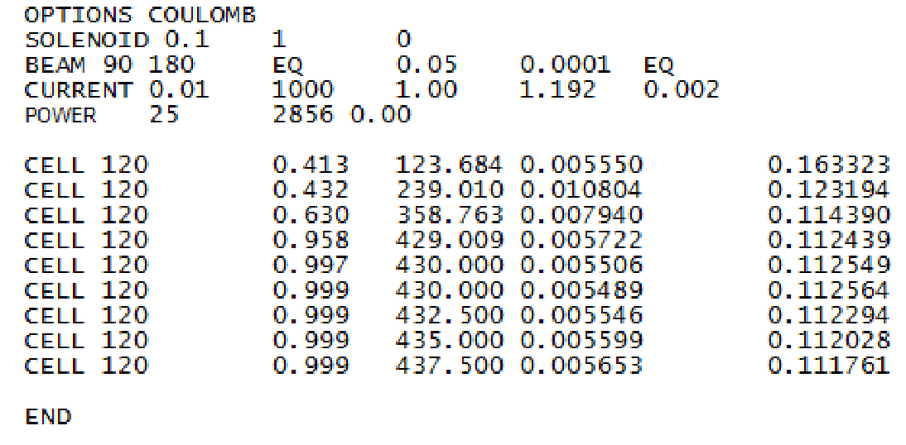

Fig. 1.1 INPUT.txt structure

Operators description:

- OPTIONS. This keyword defines extra modes that will be used in calculations.

*COULOMB –* defines a space charge influence. *Ex. OPTIONS COULOMB REVERSE*

- SOLENOID. This keyword sets the source of external longitudinal magnetic field. There are 3 parameters to define solenoid specification: magnetic field strength B[T]; solenoid length L[m]; longitudinal coordinate of the start of the solenoid Z0[m]

*Ex. SOLENOID 0.15 0.2 0.1*

Custom magnetic field distribution can be imported from file. In this case you add the name of the file with magnetic field data after the keyword SOLENOID.

*Ex. SOLENOID BFIELD.txt*

The following input file format must be used: first column is z coordinate in [m], second is magnetic field in [Gs]. Z-coordinates can be outside the simulation domain.

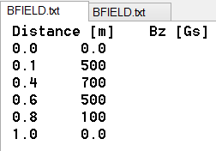 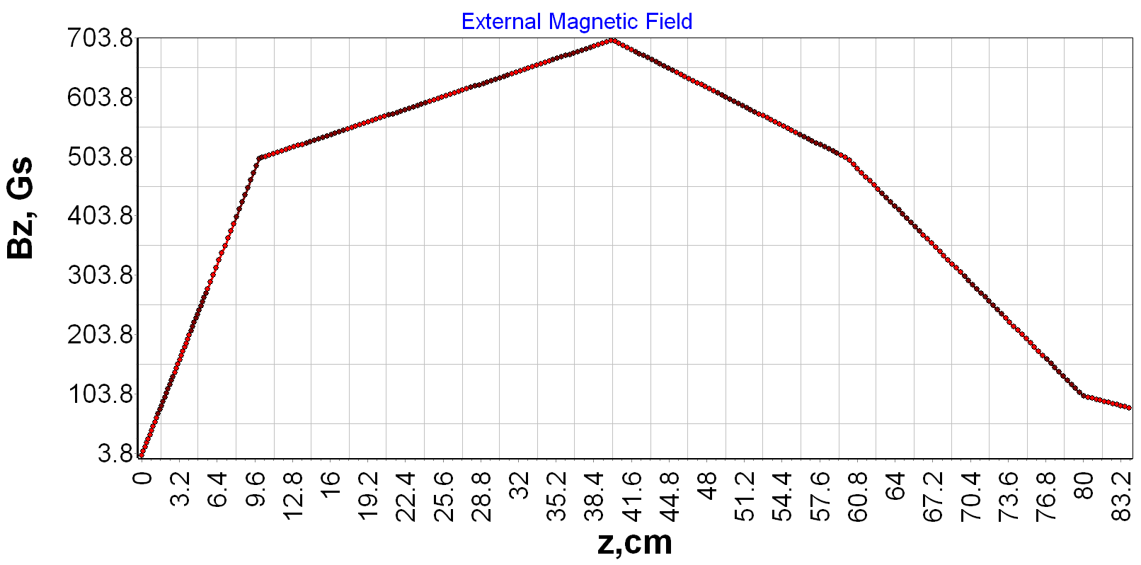

Fig. 1.2 BFIELD.txt file structure and imported field

*-* BEAM. Here is defined the initial distribution of particles in a longitudinal phase space. There are 6 parameters to be defined: average phase φ0[grad]; type of particles phase distribution (NORM for normal distribution, EQ for uniform distribution); average energy W[MeV]; thickness of energy spectrum ΔW[MeV]; type of particles energy distribution (NORM for normal distribution, EQ for uniform distribution). *Ex. BEAM 90 20 EQ 0.8 0.1 NORM*

- CURRENT. This keyword describes the initial parameter of an electron beam: beam pulse current I0[A]; number of particles in beam N; Twiss parameters α, β[cm/rad], ε[cm/rad]

*Ex. CURRENT 0.15 1000 2.2 2.8 0.004*

The particles distribution in transverse phase space x-x' can be exported from the external file. In this case you add the name of file with x-vx data after the beam current value.

*Ex. CURRENT 0.15 beam.txt*

The following input file format must be used: first column is x coordinate in [m], second is transverse velocity in [m/s]. This is the format of exported particles from beam monitor in CST Particle Studio Tracking Solver.

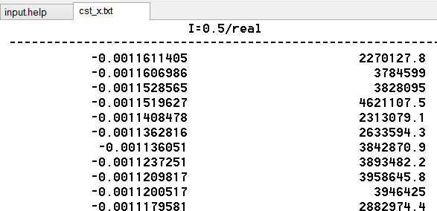 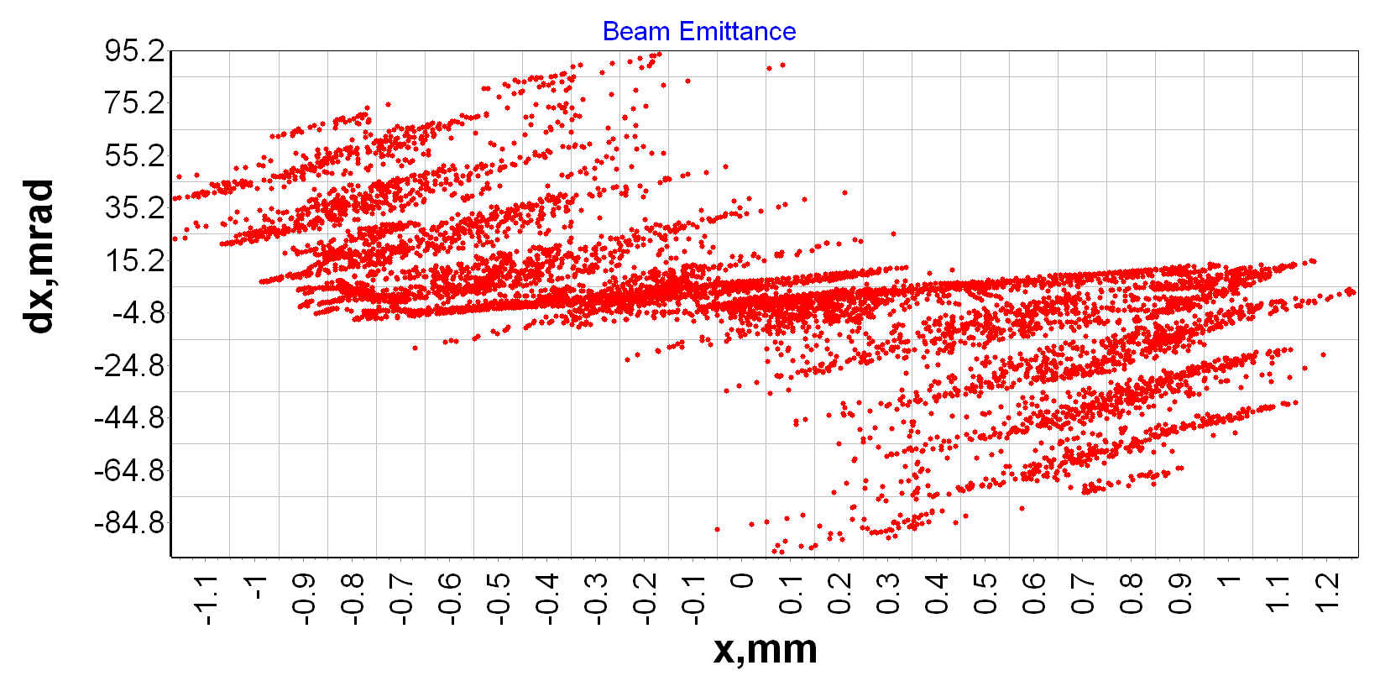

Fig. 1.3 cst_x.txt file structure and imported distribution

- POWER. Defines RF power input parameters: input pulse power P0[MW]; operating frequency F0[MHz]; phase shift from the reference phase Δφ[grad] (this parameter can be undefined – in this case it will be automatically assumed to be zero )

*Ex. POWER 2.0 2856 Ex. COUPLER 4.5 5712 90*

It possible to modulate extra RF power inputs by putting operator POWER before coupling CELL line (pic 1.4). This operation equates power counter to value defined in the POWER line (pic.1.5b)

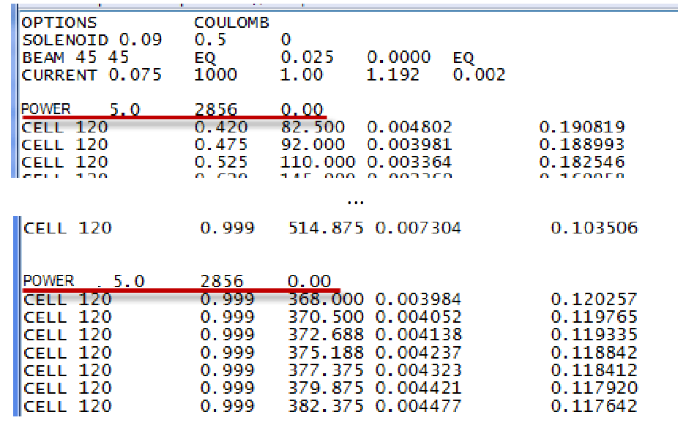

Fig. 1.4 Example of extra RF power input

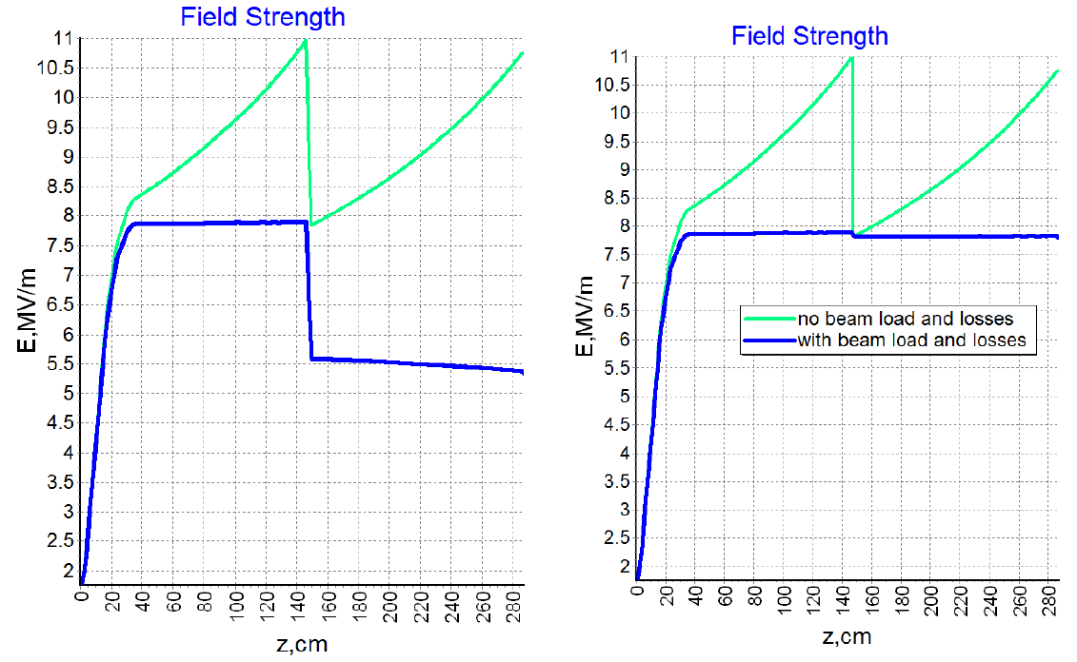

a b

Fig.1.5 Longitudinal electrical field in linac (a – without extra POWER line; b- with extra POWER line)

- CELL. In this line 5 cells parameters are defined: phase shift per cell θ*grad+; relative phase speed βphase; normalized value of electrical accelerating field intensity ; normalized attenuation factor αλ3/2[m1/2]; normalized aperture radius a/λ (If last 2 parameters are not defined, program automatically recalculates it for DLS structure using tables. But in this case only modes π/2 and 2π/3 can be calculated)

*Ex. CELL 120 0.999 380.0 0.01 0.12 Ex. CELL 90 0.8 200.0*

-CELLS. Almost the same function as CELL, but this line defines N number of cells with equal parameters

*Ex. CELLS 6 120 0.999 380.0 0.01 0.12*

-DRIFT. You can define a drift tube using 2 parameters: length L[cm]; radius a[cm]

*Ex. DRIFT 10.0 2.0*

Please, note that the DRIFT element will terminate any power used before.

COMMENTS. Any line with improper format will be ignored and not copied into the output file. To make a comment use '!' symbol in the beginning of the line

*Ex. !This line is a comment*

***2. Simulation and post-processing results.***

Program interface is presented in Figure 2.1

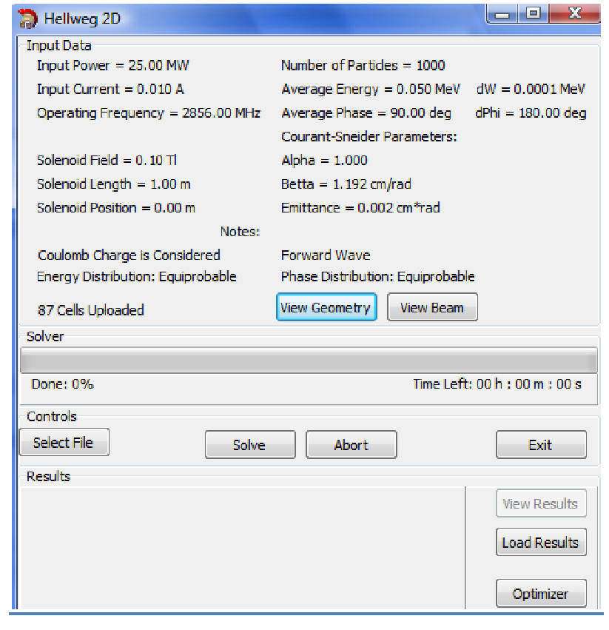

Fig. 2.1 Hellweg2D Interface

Hellweg2D automatically reads an input file and displays user defined parameters.

You can watch defined cells parameters on the graphs by pushing “View Geometry” and defined beam parameters on the graph by pushing ”View Beam”

After solving the problem (button “Solve”) «OUTPUT.txt» file is automatically generated. You can watch results of calculations in the Hellweg2D window (Fig.2.2) or you can find OUTPUT.TXT in program folder.

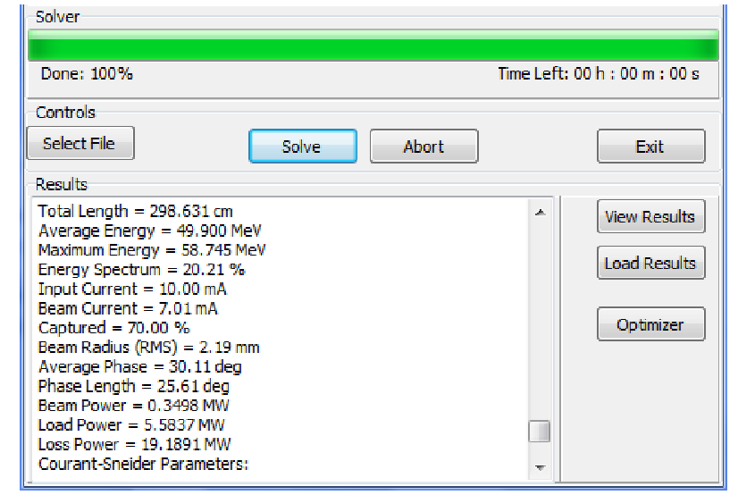

Fig. 2.2 Results of calculation

Button “View Result” lets user to watch graphical results such as Field vs. coordinate; phase space; energy spectrum, etc (Fig.2.3).

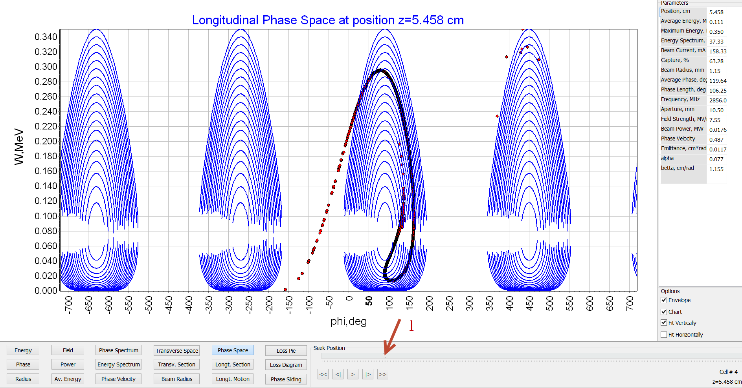

Fig 2.3 Graphical results

Using marker 1 (Fig. 2.3) user can watch beam parameters in any longitudinal coordinate

***3. Optimizer.***

Hellweg2D has a very convenient feature – Optimizer (Fig. 3.1)

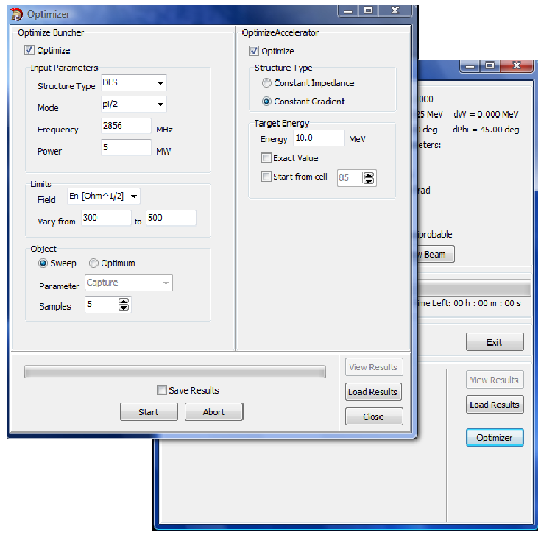

Fig. 3.1 Optimizer interface

This function can calculate DLS cells parameters (relative phase speed βphase; normalized value of electrical accelerating field intensity ; normalized attenuation factor αλ3/2[m1/2]; normalized aperture radius a/λ) using included tables to obtain the desired energy on the end of the accelerator without access to the INPUT file.

- Optimize Buncher. In this window user defines coupler parameters and desired buncher field parameters.

*∙Input parameters:* Choice between π/2 and 2π/3 modes; operating frequency; input pulse power.

*∙Limits:* It necessary to define allowable variations of the values of the accelerating electrical field on the end of the buncher. User can choose between 3 field dimensions: dimensionless field A; normalized electrical field ; absolute value of electrical field E [MV/m].

∙*Object:* There are 2 algorithms to calculate buncher cells parameters: *Sweep* divides an interval defined in Limits for equal parts (Samples) and calculates field in them using table’s data; *Optimum* chooses the best field value to obtain the best capture coefficient/energy spectrum/phase spectrum (Parameter).

- Optimize Accelerator. In this window user defines desired output parameters.

*∙Structure type:* The choice between Constant Gradient or Constant Impedance structures. In the first case the optimizer will add the cells identical to the last one. In second case, it will adjust the aperture radius in order to maintain the same electrical field gradient.

*∙Target Energy:* It is necessary to define desired output energy. Marker “Exact Value” varies beam current to obtain exact value of average beam energy.

Marker “Start from cell” is used when it is necessary to modulate accelerating structure after the already defined cells parameters in INPUT file (Optimize Buncher marker is switched off)

- Get Results. You can find results in the OUTPUT file in the Results folder

***4. Configuration file.***

Mesh parameters and interpolation parameters are defined in file Hellweg.ini which placed in program folder (Fig. 4.1)

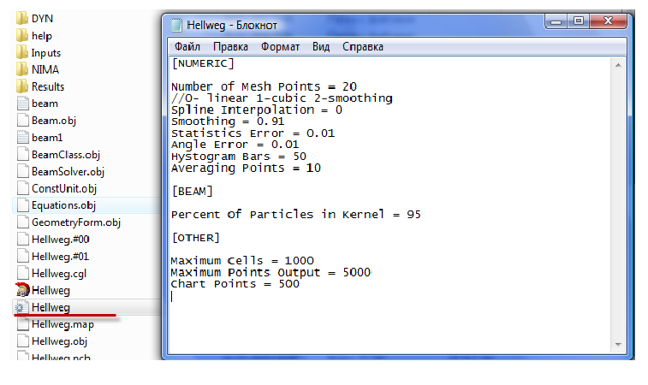

Fig. 4.1 Hellweg2D configuration file

- Number of mesh points. This value of mesh points will be used for accelerating field interpolation in cell. Please, note that the same number of points will be used for a single DRIFT element.

- Interpolation. Relative phase speed and value of accelerating electrical field are defined in the centers of cells. Then these values are interpolated for other mesh cells (Number of mesh points). In Figure 4.2 are presented 2 kinds of interpolations (linear and cubic). It is recommended to use linear interpolation to avoid nonphysical field oscillations. Smoothing spline can be used for example to obtain spectrum envelope.

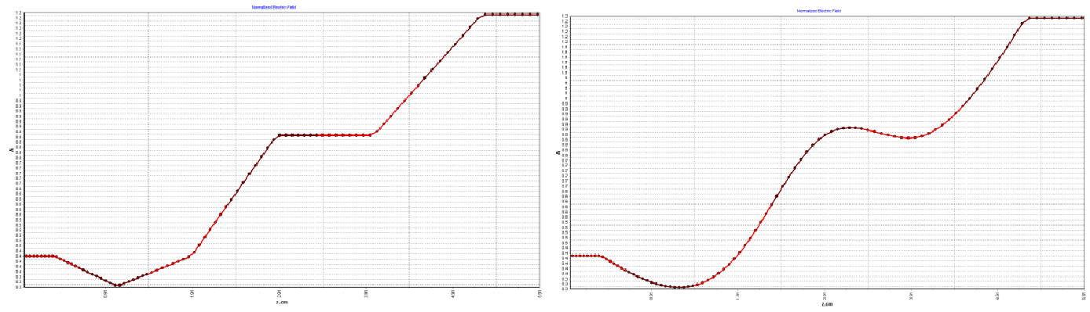

a b

Fig. 4.2 Interpolation types (a-linear; b-cubic)

**Thank you for using our program!**

**Have a good simulation time with Hellweg2D!**