**Hellweg2D Interface Guide**

To calculate beam dynamics in TW linacs, you need to follow some simple steps, describing below.

***1. INPUT file.***

The program reads the initial data from text file «INPUT.txt» which must be in the same folder as the “Hellweg2D.exe” file. If the data was successfully read, you would see the correct numbers in the main window. If the data is not correct, you can look through the «PARSER.txt» file to see what lines were successfully read. The example of an input file is presented in Figure 1.

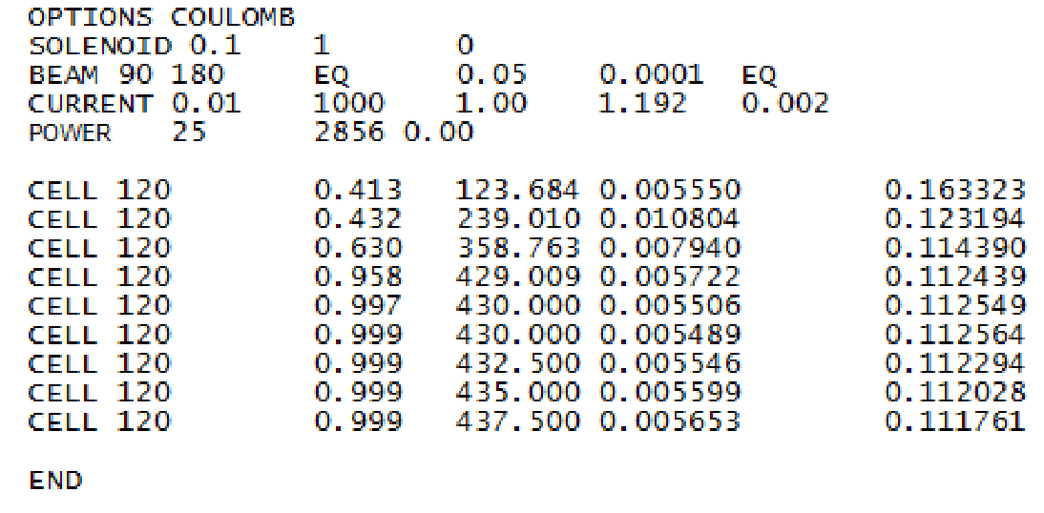

Figure 1. INPUT.txt structure

Operators description:

- OPTIONS. This keyword defines extra modes that will be used in calculations.

* *MAGNETIZED*

The code assumes that the beam is born in the magnetic field with Bz(0).

*Ex. OPTIONS MAGNETIZED*

- SOLENOID. This keyword sets the source of the external longitudinal magnetic field. There are three parameters to define solenoid specification: magnetic field strength B[T]; solenoid length L[m]; longitudinal coordinate of the start of the solenoid Z0[m]

*Ex. SOLENOID 0.15 0.2 0.1*

Custom magnetic field distribution can be imported from a file. In this case, you add the name of the file with magnetic field data after the keyword SOLENOID.

*Ex. SOLENOID BFIELD.txt*

The following input file format must be used: the first column is z coordinate in [m], the second is a magnetic field in [Gs]. Z-coordinates can be outside the simulation domain.

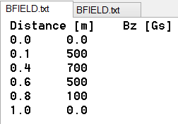 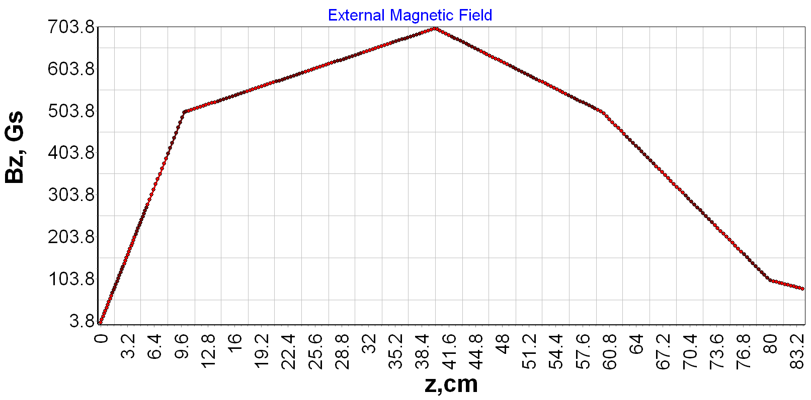

Figure 2. BFIELD.txt file structure and imported field

*-* BEAM. This line defines the parameters of the initial distribution or import of particles in transversal and longitudinal phase space. Currently, there is a possibility to input the whole particles phase space from one of the standard format files, or define/import the transversal and longitudinal distribution separately. In the latter case, the keyword for the longitudinal distribution should immediately follow the transverse distribution definition (see examples section).

Here is the list of the possible keywords (“bold” parameters are optional):

* *CST_PID FileName* ***φ0 [deg] Δφ [deg] σφ [deg]***

The code will import the initial distribution form CST PID file with “FileName” name. The normal phase distribution (see NORM2D) can be optionally defined by two parameters: mean phase (φ0), and phase length (±Δφ). Optionally, the RMS deviation (σφ) can be defined. If no phase distribution parameters are defined, the code will generate the uniform distribution from 0 to 360 deg. If the deviation is not defined, the code will assume a uniform distribution. The format of “pid” file is the following:

x [m], y [m], z [m], px [], py [], pz [], m0 [kg], q0 [C], I [A]

*Ex. BEAM CST_PID cst_example.pid*

*Ex. BEAM CST_PID cst_example.pid 90 180*

*Ex. BEAM CST_PID cst_example.pid 90 180 50*

* *CST_PID FileName* ***COMPRESS***

The code will import the initial distribution from CST PID file with “FileName” name. If the imported beam consists of multiple bunches, the keyword COMPRESS can be added to compress all particles into one bunch. The particle with time t will have the phase φ=-t*c/λ. The format of this file is the following:

x [m], y [m], z [m], px [], py [], pz [], m0 [kg], q0 [C], Q [C], t [s]

*Ex. BEAM CST_PID cst_example.pit*

*Ex. BEAM CST_PID cst_example.pit COMPRESS*

* *FILE2D FileName1* ***FileName2***

The code will import 2D distribution from the file with *FileName1* name. In the case of longitudinal distribution, the file should have the following format: *φ [deg], W[MeV].* In case of transversal distribution, the format must be: *r [cm], r’ [rad]*. Optionally, the second file can be defined for transversal distribution only. In this case, the code will read *x [cm] x’ [rad]* distribution from the first file, and *y[cm] y’[rad]* from the second file, and converts the distribution to cylindrical coordinates r, θ, pr, and pθ. The user must ensure that the number of particles from different files matches, as well as the order of the particles in the file.

*Ex. BEAM FILE2D radius.txt FILE2D energy.txt*

*Ex. BEAM FILE2D particles_x.txt particles_y.txt FILE2D energy.txt*

* *FILE1D FileName φ0 [deg] Δφ [deg]* ***σφ [deg]***

The code will import the energy distribution from the file with *FileName* name. The file should have the following column: *W[MeV].* The normal phase distribution (see NORM2D) should be defined by two parameters: mean phase (φ0), and phase length (±Δφ). Optionally, the RMS deviation (σφ) can be defined. If the deviation is not defined, the code will assume a uniform distribution. In the case of multiple files are defined, the user must ensure that the number of particles from different files matches, as well as the order of the particles in the file. This type of distribution can only be used for longitudinal phase space

*Ex. BEAM FILE2D radius.txt FILE1D energy.txt 90 180*

*Ex. BEAM FILE2D radius.txt FILE1D energy.txt 90 180 20*

* *FILE4D FileName*

The code will import the 4D transversal phase space distribution from the file with *FileName* name. The file should have the following format: *x [cm] x’ [rad] y[cm] y’[rad]*. In the case of multiple files are defined, the user must ensure that the number of particles from different files matches, as well as the order of the particles in the file. This type of distribution can only be used for transversal phase space

*Ex. BEAM FILE4D phase_space.txt FILE1D energy.txt 90 180*

* *TWISS2D αx, βx [cm/rad], εx [cm*rad]*

The code will generate the x-x’ distribution with αx, βx [cm/rad], εx [cm*rad] Twiss parameters (Figure 3), and y-y’ distribution for the same parameters. x-x’ and y-y’ distributions are independent. Then the code converts the distribution to cylindrical coordinates r, θ, and pr. pθ is assumed to equal to zero to avoid particle magnetization. This type of distribution can only be used for transversal phase space.

C:\Users\sitch\AppData\Local\Microsoft\Windows\INetCacheContent.Word\Fig0b.tif

Figure 3. Phase space defined by Twiss parameters.

*Ex. BEAM TWISS2D 0.14 2.0 0.0005 FILE2D energy.txt*

* *TWISS4D αx, βx [cm/rad], εx [cm*rad] αy, βy [cm/rad], εy [cm*rad]*

The code will generate the x-x’ distribution with αx, βx [cm/rad], εx [cm*rad] Twiss parameters (Figure 3), and y-y’ distribution with αy, βy [cm/rad], εy [cm*rad]. x-x’ and y-y’ distributions are independent. Then the code converts the distribution to cylindrical coordinates r, θ, and pr. pθ is assumed equal to zero to avoid particle magnetization. This type of distribution can only be used for transversal phase space.

*Ex. BEAM TWISS4D 0.14 2.0 0.0005 0.28 4.0 0.0015 FILE2D energy.txt*

* *NORM2D W0 [MeV] ΔW [MeV]* ***σW [MeV]*** *φ0 [deg] Δφ [deg]* ***σφ [deg]***

The code will independently generate the Gaussian energy and phase distribution with mean energy (W0), energy spread (±ΔW), mean phase (φ0), and phase length (±Δφ). Optionally, the rms deviations (σW, σφ) can be defined for both energy and phase distribution. It is impossible to define the RMS deviation for only one parameter! If deviations are not defined, the code will assume uniform distributions. If ΔW (or Δφ) is zero or negative, the code will generate the Gaussian distribution with no boundaries. If ΔW2<12·σW2, the distribution will be uniform! Otherwise, the code generates Truncated Gaussian distribution with the limits W0- ΔW and W0+ΔW. The same for phase distribution. See Figure 4. This type if distribution can only be used for longitudinal phase space

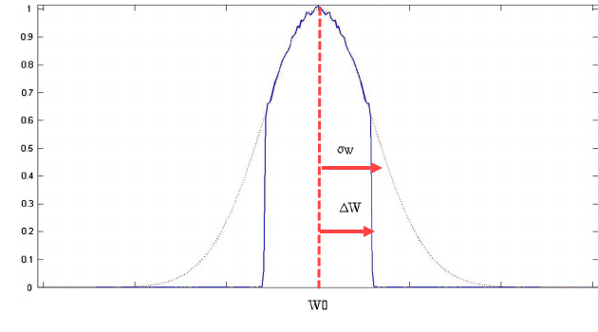

Figure 4. Example of Truncated Gaussian Distribution

*Ex. BEAM TWISS2D 0.14 2.0 0.0005 NORM2D 1.0 0.5 0.25 90 180 20*

*Ex. BEAM FILE2D beam.txt NORM2D 1.0 0.5 90 180*

* *SPH2D Rcath [cm],* ***Rsph [cm], kT [eV]***

The code will generate radial distribution from the spherical cathode (see Figure 5). *Rcath [cm]* defines the radial limit of the particles. Rayleigh distributions with σR=Rcathwill be modeled. *Rsph [cm]* is an optional parameter for cathode sphericity. If Rsph=0 or not defined, the cathode will be cylindrical (flat). If Rsph >0, the cathode is concave. If Rsph <0, the cathode is convex. The normal (to the cathode surface) component of r’ is defined as r’=-sin(r/Rsph). Optional parameter kT [eV] defines the thermal emittance. This type of distribution can only be used for transversal phase space.

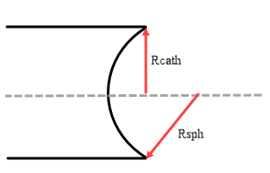

Figure 5. Example of spherical cathode distribution

*Ex. BEAM SPH2D 0.564 1.0 10.0 NORM2D 1.0 0.5 90 180*

*Ex. BEAM SPH2D 0.564 1.0 FILE2D energy.txt*

*Ex. BEAM SPH2D 0.564 FILE1D energy.txt 90 180*

* *ELL2D ax [cm], by [cm],* φ ***[deg], h***

The code will generate a radial elliptical distribution with *ax [cm] and by [cm]* half-axes. Optionally, the beam can be rotated in x-y space by an angle of φ[deg]. If phi is not defined, it is assumed zero. See Figure 6. Optional parameter h defines the RMS deviation of the Gaussian distribution as *σx= ax/h, σy= ay/h*. If not defined, h is assumed to equal to 1. No particles will be generated outside of the ellipse. Radial and azimuthal speeds assumed to be zero. This type of distribution can only be used for transversal phase space.

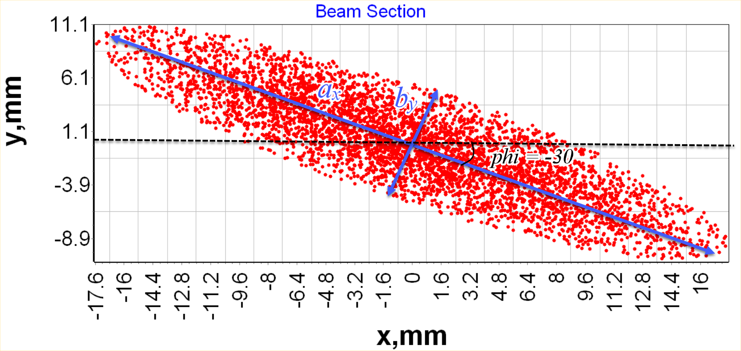

Figure 6. Example of Elliptical distribution

*Ex. BEAM ELL2D 2.0 0.5 -30 2 NORM2D 1.0 0.5 90 180*

*Ex. BEAM ELL2D 2.0 0.5 -30 FILE2D energy.txt*

*Ex. BEAM ELL2D 2.0 0.5 FILE1D energy.txt 90 180*

- CURRENT. This line defines the beam current *I0[A]* during the RF pulse (*I0*=*Q/Tpulse*), and a number of particles in beam *Np*. If the beam is generated randomly, the Np parameters must be defined. If the particles distribution is imported from the file, the Np parameter is optional. In this case, if Np is defined and less than number of imported particles, the code will consider only the first Np of the imported particles. If Np is greater than the number of imported particles, it will be ignored.

*Ex. CURRENT 0.15 1000*

- POWER. Defines RF power input parameters: input pulse power P0[MW]; operating frequency F0[MHz]; phase shift from the reference phase Δφ[deg] (this parameter can be undefined – in this case it will be automatically assumed to be zero )

*Ex. POWER 2.0 2856*

*Ex. POWER 4.5 5712 90*

It possible to modulate extra RF power inputs by putting operator POWER before coupling CELL line (pic 1.4). This operation equates power counter to value defined in the POWER line (pic.1.5b).

If not power sources are defined, the system wavelength would be assumed to 1 meter!

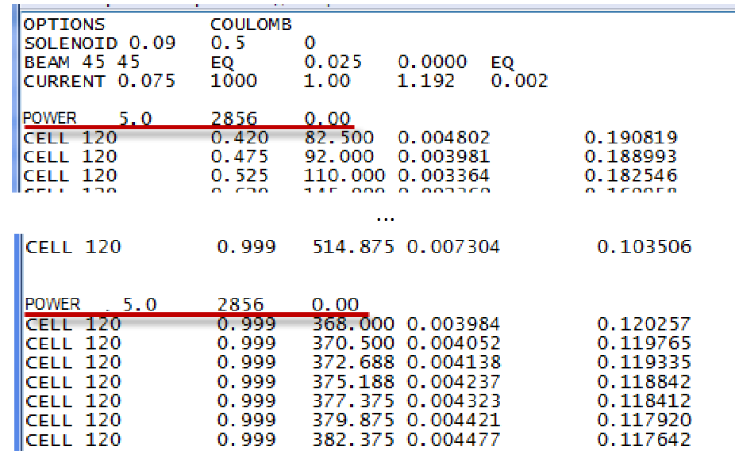

Fig. 1.4 Example of extra RF power input

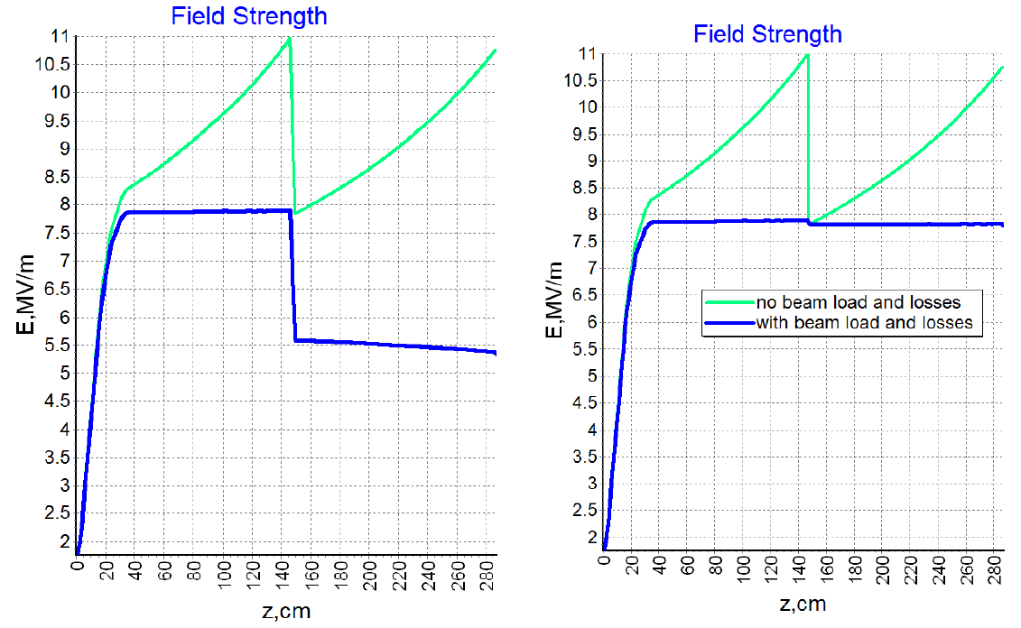

a b

Fig.1.5 Longitudinal electrical field in linac (a – without extra POWER line; b- with extra POWER line)

- CELL. In this line 5 cells parameters are defined: phase shift per cell θ*grad+; relative phase speed βphase; normalized value of electrical accelerating field intensity ; normalized attenuation factor αλ3/2[m1/2]; normalized aperture radius a/λ (If last 2 parameters are not defined, program automatically recalculates it for DLS structure using tables. But in this case only modes π/2 and 2π/3 can be calculated)

*Ex. CELL 120 0.999 380.0 0.01 0.12*

*Ex. CELL 90 0.8 200.0*

-CELLS. Almost the same function as CELL, but this line defines N number of cells with equal parameters

*Ex. CELLS 6 120 0.999 380.0 0.01 0.12*

-DRIFT. You can define a drift tube using 2 parameters: length L[cm]; radius a[cm]. Optionally, it is possible to add the number of mesh points for drift element after the radius that will override the global mesh settings.

*Ex. DRIFT 10.0 2.0*

*Ex. DRIFT 10.0 2.0 100*

Please, note that the DRIFT element will terminate any power used before.

-SAVE. If this line is present, the code will export the live particle parameters (phase, energy, radius, azimuth and radial velocity) at position define in the INPUT to the defined file

*Ex. CELLS 3 120 0.999 380.0*

*SAVE beam.log*

*DRIFT 10.0 2.0*

In this example, the particle parameters will be exported at the position between 3 cells and drift. Multiple export commands are possible, but two SAVE lines at the same position will be overwritten.

It is possible to define the number of particles to be exported or the region of particles numbers after the name of file

*Ex. SAVE beam.log 500*

*Ex. SAVE beam.log 1000 2000*

In the first example, the first 500 particles will be exported. In the second one, only the particles with numbers from 1000 to 2000 will be exported. Lost particles are not exported.

Several flags are allowed to define the particular parameters to be exported. If no flags are defined, all parameters (except live status) will be exported. If at least one flag is set, only flagged parameters will be exported.

LOST – export the lost or live status of the particle

PHASE – export the phase of the particle

ENERGY – export the energy of the particle

RADIUS – export the radius of the particle

AZIMUTH – export the azimuth of the particle

VX – export the radial velocity of the particle

The flags must be defined in any combination after the number of elements region or after the file name if the region is not defined.

*Ex. SAVE beam.log LOST ENERGY*

*Ex. SAVE beam.log 500 ENERGY PHASE RADIUS*

*Ex. SAVE beam.log 500 2000 LOST RADIUS VX*

COMMENTS. Any line with improper format will be ignored and not copied into the output file. To make a comment use the '!' symbol at the beginning of the line

*Ex. !This line is a comment*

***2. Simulation and post-processing results.***

Program interface is presented in Figure 2.1

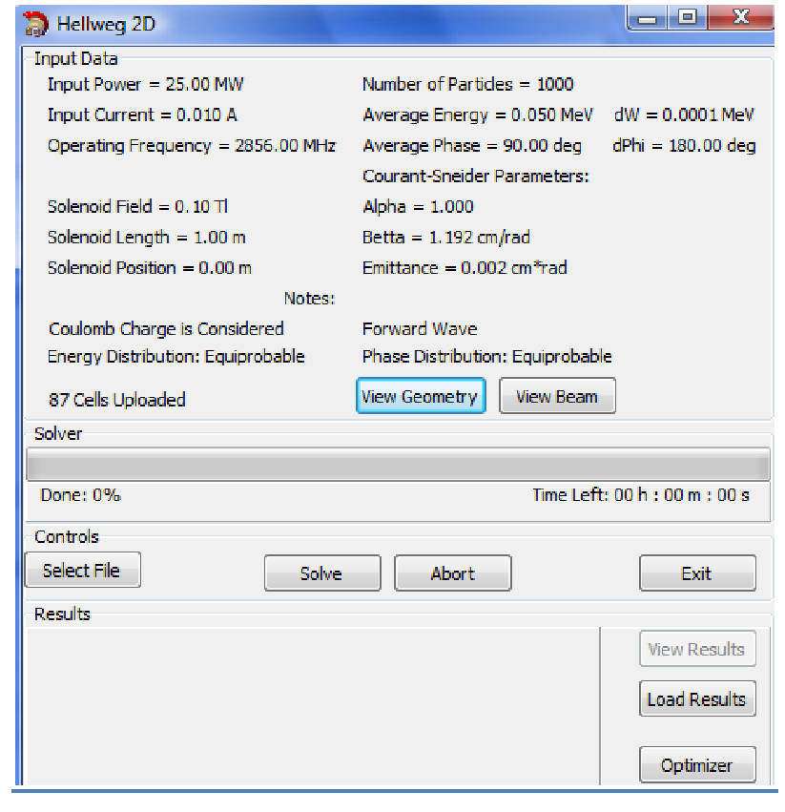

Fig. 2.1 Hellweg2D Interface

Hellweg2D automatically reads an input file and displays user defined parameters.

You can watch defined cells parameters on the graphs by pushing “View Geometry” and defined beam parameters on the graph by pushing ”View Beam”

After solving the problem (button “Solve”) «OUTPUT.txt» file is automatically generated. You can watch results of calculations in the Hellweg2D window (Fig.2.2) or you can find OUTPUT.TXT in program folder.

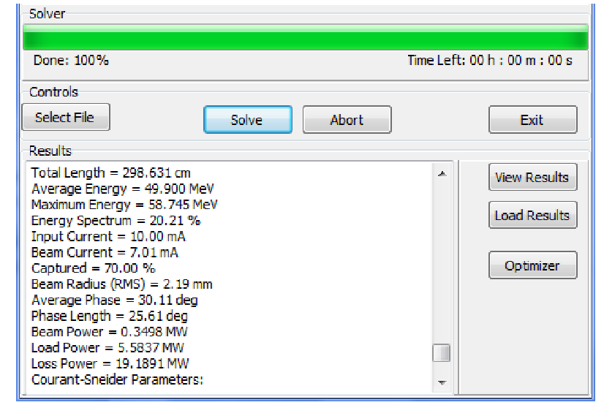

Fig. 2.2 Results of calculation

Button “View Result” lets user to watch graphical results such as Field vs. coordinate; phase space; energy spectrum, etc (Fig.2.3).

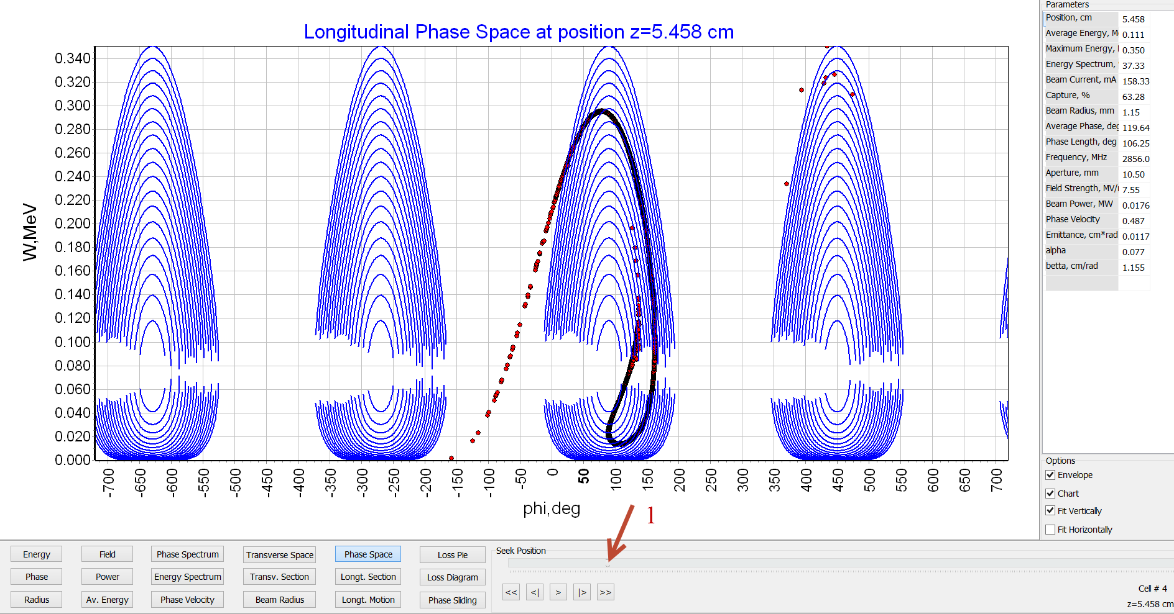

Fig 2.3 Graphical results

Using marker 1 (Fig. 2.3) user can watch beam parameters in any longitudinal coordinate

***3. Optimizer.***

Hellweg2D has a very convenient feature – Optimizer (Fig. 3.1)

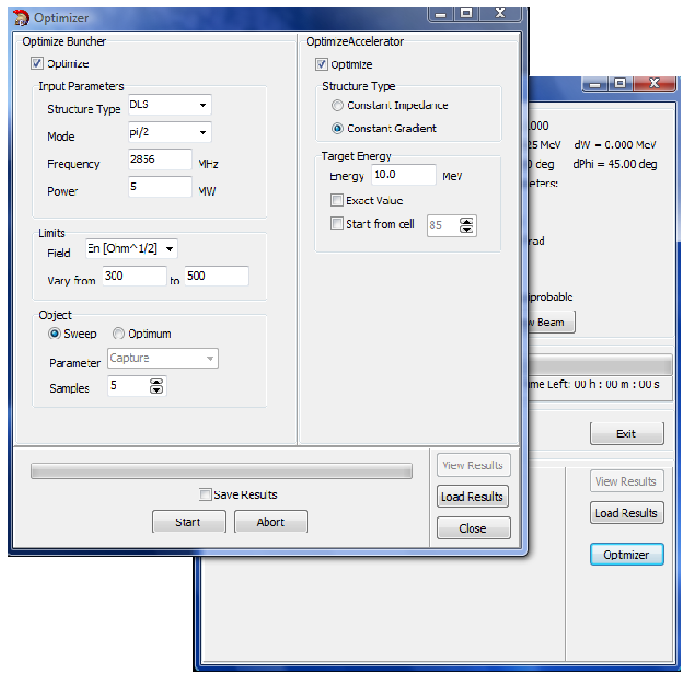

Fig. 3.1 Optimizer interface

This function can calculate DLS cells parameters (relative phase speed βphase; normalized value of electrical accelerating field intensity ; normalized attenuation factor αλ3/2[m1/2]; normalized aperture radius a/λ) using included tables to obtain the desired energy on the end of the accelerator without access to the INPUT file.

- Optimize Buncher. In this window user defines coupler parameters and desired buncher field parameters.

*∙Input parameters:* Choice between π/2 and 2π/3 modes; operating frequency; input pulse power.

*∙Limits:* It necessary to define allowable variations of the values of the accelerating electrical field on the end of the buncher. User can choose between 3 field dimensions: dimensionless field A; normalized electrical field ; absolute value of electrical field E [MV/m].

∙*Object:* There are 2 algorithms to calculate buncher cells parameters: *Sweep* divides an interval defined in Limits for equal parts (Samples) and calculates field in them using table’s data; *Optimum* chooses the best field value to obtain the best capture coefficient/energy spectrum/phase spectrum (Parameter).

- Optimize Accelerator. In this window user defines desired output parameters.

*∙Structure type:* The choice between Constant Gradient or Constant Impedance structures. In the first case the optimizer will add the cells identical to the last one. In second case, it will adjust the aperture radius in order to maintain the same electrical field gradient.

*∙Target Energy:* It is necessary to define desired output energy. Marker “Exact Value” varies beam current to obtain exact value of average beam energy.

Marker “Start from cell” is used when it is necessary to modulate accelerating structure after the already defined cells parameters in INPUT file (Optimize Buncher marker is switched off)

- Get Results. You can find results in the OUTPUT file in the Results folder

***4. Configuration file.***

Mesh parameters and interpolation parameters are defined in file Hellweg.ini which placed in program folder (Fig. 4.1)

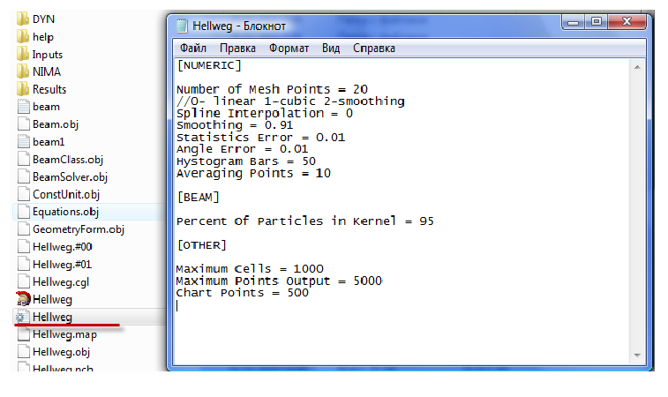

Fig. 4.1 Hellweg2D configuration file

- Number of mesh points. This value of mesh points will be used for accelerating field interpolation in cell. Please, note that the same number of points will be used for a single DRIFT element.

- Interpolation. Relative phase speed and value of accelerating electrical field are defined in the centers of cells. Then these values are interpolated for other mesh cells (Number of mesh points). In Figure 4.2 are presented 2 kinds of interpolations (linear and cubic). It is recommended to use linear interpolation to avoid nonphysical field oscillations. Smoothing spline can be used for example to obtain spectrum envelope.

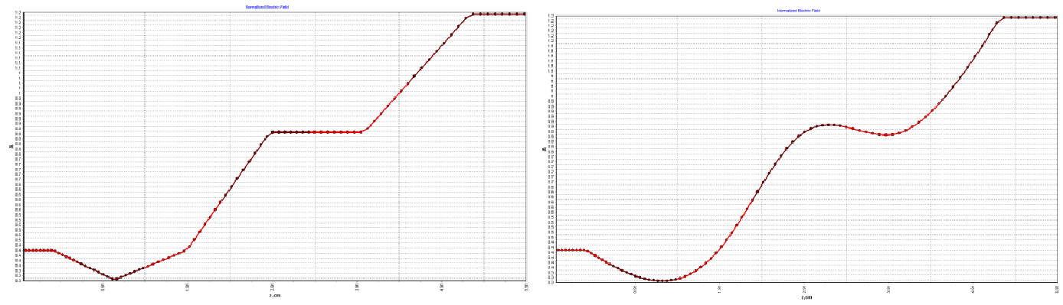

a b

Fig. 4.2 Interpolation types (a-linear; b-cubic)

**Thank you for using our program!**

**Have a good simulation time with Hellweg2D!**