**Waves in the cylindrical waveguides**

1. *Theory of the waveguides*

Maxwell equations for empty space without sources (here  and ):

 (1)

Dependences on time :

 (2)

then (1) moves to (further  and ):

 (3)

Calculate  from (3a):



or

 (4a)

Similarly, it is possible to find that

 (4b)

Dependence on longitudinal coordinate  (further in cylindrical coordinates  and ):

 (5)

Then (equations (3) give

 (6)

Let substitute (6e) into (6a):



or, if determine the constant  as

 (7)

then



In similar way it is possible to find the other transversal components. So one has for them the following expressions:

 (8)

So, the transversal components are expressed through the longitudinal components only. These longitudinal components obey to equations (4):



or

 (9a)

and similar equation for :

 (9b)

These equations may be solved by method of separation of the variables:

 (10)

then (9) means that



or

 (11)

First term in left part is a function on  and second is a function on  only. It means that each term of the left part is some constant. Let it equals . Then equation for function  is

 (12)

and it solution is

 (13)

So, equation (11) means that for each  function  depends on this index and obeys the equation



or

 (14a)

Let define the dimensionless variable  and then last equation is as follows:

 (14b)

This is Bessel equation with the following finite solution in the point :



So, taking into account all previous analysis one can write the final expressions for longitudinal components of electric and magnetic fields:

 (15)

Indefinite constants  can be found using boundary conditions on the wall of waveguide (see later). After that the transversal components of fields can be found due to expressions (8).

The following classification of waves in the waveguide is accepted.

* For waves (waves) exists the longitudinal electric component only, i.e. . These are the transversal magnetic waves.
* For waves (waves) exists the longitudinal magnetic component only, i.e. . These are the transversal electric waves.
* The waves with  are hybrids.

1. *Simple examples: symmetrical modes*
2. For symmetrical wave in the plain cylindrical waveguide  and then



Boundary condition  will be satisfied for this type of wave if . It is possible for  such as



If  are the roots of function , i.e.

 (16a)

then

 (16b)

The first roots  are as follows.

Table 1.

|  |  |  |  |  |  |  |  |
| --- | --- | --- | --- | --- | --- | --- | --- |
|  | 0 | 1 | 2 | 3 | 4 | 5 | 6 |
|  | 2.4048 | 5.5201 | 8.6537 | 11.7917 | 14.9309 | 18.0711 | 21.2116 |

So, in plain cylindrical waveguide the infinite number of the symmetrical modes for  can exist and each of them is described as

 (16c)

Meaning of indexing for modes: index “0” corresponds to azimuthal value  and index “*n*” indicates the number of root .

1. For symmetrical wave in the plain cylindrical waveguide  and then



Boundary condition  will be satisfied for this type of wave if . It is possible for  such as



If  are the roots of function , i.e.

 (17a)

then

 (17b)

The first roots  are as follows.

Table 2.

|  |  |  |  |  |  |  |  |
| --- | --- | --- | --- | --- | --- | --- | --- |
|  | 0 | 1 | 2 | 3 | 4 | 5 | 6 |
|  | 0.0000 | 3.8317 | 7.0156 | 10.1735 | 13.3237 | 16.4706 | 19.6159 |

So, in plain cylindrical waveguide the infinite number of the symmetrical modes for  can exist and each of them is described as

 (17c)

Meaning of indexing for modes is the same as for modes.

1. *Simple examples: nonsymmetrical modes* *in the plain cylindrical waveguide*
2. For first nonsymmetrical wave in the plain cylindrical waveguide  and then



Boundary condition  will be satisfied for this type of wave if . It is possible for  such as



Roots  of the function  and then eigen values  are presented by equations (17a) and (17b) correspondingly. Values  of are presented in the Table 2. So, in plain cylindrical waveguide infinite number of nonsymmetrical modes for  can exist and each of them is described as

 (18)

Meaning of indexing for modes: index “1” corresponds to azimuthal value  and index “*n*” indicates the number of root .

1. For first nonsymmetrical wave in the plain cylindrical waveguide  and then



Boundary condition  will be satisfied for this type of wave if . It is possible for  such as



Let  are the roots of equation

 (19a)

then

 (19b)

The first roots  can be found from graphical solution of the equation (19a) (see Figure 1) and are presented in the Table 3.

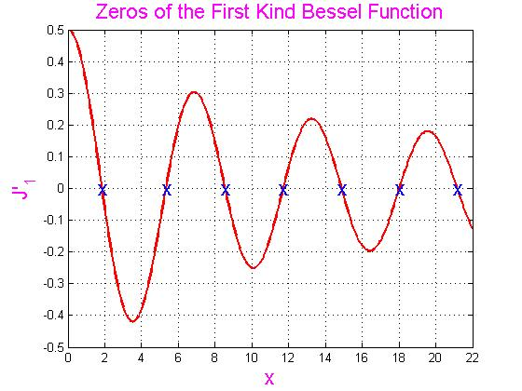

Figure 1. Roots of the equation (19a).

Table 3.

|  |  |  |  |  |  |  |  |
| --- | --- | --- | --- | --- | --- | --- | --- |
|  | 0 | 1 | 2 | 3 | 4 | 5 | 6 |
|  | 1.841184 | 5.331442 | 8.536316 | 11.706004 | 14.863588 | 18.015528 | 21.164370 |

So, in the plain cylindrical waveguide the infinite number of the symmetrical modes for  can exist and each of them is described as

 (19c)

Meaning of indexing for modes is the same as for modes.

1. *Hybrid modes in the infinite plain cylindrical waveguide*

For first nonsymmetrical wave in the plain cylindrical waveguide  and then the components of the field are as follows (see equations (15)):

 (20a)

To satisfy the boundary condition  firstly let find the second component of electrical field :

 (20b)

Boundary conditions  lead to the following system of equations:



It is obvious that this system has only the trivial solution. It means that nonsymmetrical modes cannot exist in the infinite plain cylindrical waveguide.

1. *Waves in a periodical structure (disk-loaded waveguide)*

A disk-loaded waveguide (DLW) is the most common structure for linear accelerators and is shown in Figure 2.

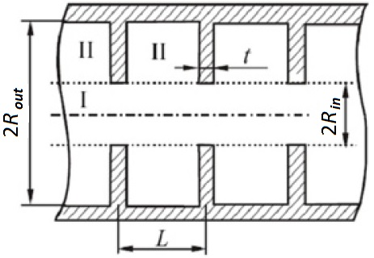

Figure 2. Disk-loaded waveguide.

Electromagnetic fields in the longitudinal periodical structure with period  for each cell obey to Floquet theorem:

 (21)

Here  is a phase change for a spatial shift along one cell of the structure. These relations mean that fields can be described using periodical over  functions :

 (22a)

or

 (22b)

These periodical functions can be expanding to the Fourier series:

 (22c)

where Fourier amplitudes are



The verifying of these relations is as follows (for example, for electric field):



So,

 (23a)

And similarly

 (23b)

These expressions mean that any wave processes like  in the periodical structure with phase shift  during shift on one spatial period  is equivalent to the sum of the infinite number of plain inhomogeneous waves  correspondingly, i.e. these processes consist from simple harmonics with wave constant

 (24a)

and

 (24b)

Each of these harmonics has the phase velocity

 (24c)

and the same group velocity

 (24d)

The substitution of the expressions (23) into equations (3) shows that each separate harmonic of the fields obeys to the equations (8):

 (25)

In these equations the value  is used (compare with (7)):

 (26)

and first index ”p” numerates the number of harmonic and second alphabet index describes the corresponding component of the fields.

The substitution of the expressions (23) into equations (4) shows that each separate harmonic of the fields obeys to the following wave equations:



It means that longitudinal components  obey to the equations like (9):

 (27)

Repeating approach to solving these equations, as set out in Section 1, we find that the radial dependence of the harmonic obeys the following equation (compare with (14a)):

 (28)

It is again the Bessel equation. Its solutions are Bessel functions first kind  and second kind :

 (29)

Naturally, each harmonic of the total components for the fields  consists from all azimuthal harmonic (compare with (10) and taking (13) into account):

 (30)

So, taking into account all previous analysis one can write the final expressions for longitudinal components of electric and magnetic fields:

 (31)

Dispersion equation usually has roots of both signs for . It means that the solutions (29) describe waves propagating in directions. Therefore, only non-negative value of the index , which corresponds the positive value of , usually are considered. Moreover, in the problems associated with the movement of the beam through such a structure the most important harmonic of the field is such whose phase velocity close to the speed of the particle beam. This feature of the solution will be taking into account later.

1. *Hybrid modes in the disk-loaded waveguide*

First nonsymmetrical wave () in the disk-loaded waveguide has the different components of the fields in the “inner” (; area I) and “outer” (; area II) areas. Because the fields are limited everywhere in wave guide than for inner area it is necessary to exclude from expression s for the field terms with Neiman functions . So the longitudinal components of the harmonics of the fields are as follows:

 (32)

These expressions include six coefficients . Following six boundary conditions allow to find these coefficients:



or

 (33)

Two first conditions give



and after redefinition of the constants  and  the expressions (32) take the following form:

 (34)

Then in according with (25)

 (35a)

 (35b)

 (35c)

(35d)

 (35e)

 (35f)

 (35g)

 (35h)

After substituting expressions (34) and (35) into last four boundary conditions (33) we obtain the following system of equations for constants  :









More convenient to present this system in the matrix  form:

 (36)

where non-zero elements of matrix are:

 (37)

 (37)

This homogeneous system has nontrivial solution if

 (38)

Rewrite this equation taking into account the relations (see (37)) between matrix elements:





So, the dispersion equation (38) splits into two:



and

These equations mean that dispersion equation splits into the following three separate equations which define the parameter  and by this the value of:

 (39)

The roots of the first and second of these equations are presented in the Table 2 and Table 3 correspondingly.

When the solution of the equations (39) is found, the coefficients , which determine all components of the fields  (see expressions (34) and (35)) can be expressed through one of them. For example, let express coefficients  through coefficients , using equations (36) in the following form (; it is enough to use only first three equations):



Then

 (39)

At last, expressions (34) and (35) give all components of the harmonic of the fields and total values of the fields are expressed by equations (31).