element Survey

diagram

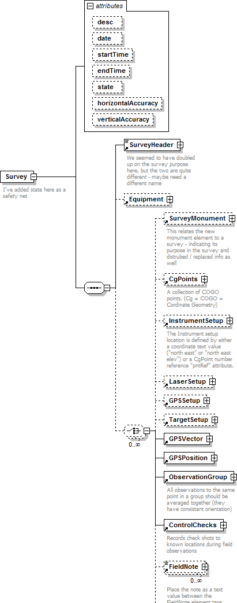

namespace | 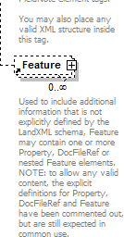
 | http://www.landxml.org/schema/LandXML-1.2
properties | content complex
children | SurveyHeader Equipment SurveyMonument CgPoints InstrumentSetup LaserSetup GPSSetup TargetSetup GPSVector GPSPosition ObservationGroup ControlChecks FieldNote Feature
used by | element LandXML
attributes | Name Type Use Default Fixed annotation desc xs:string  date xs:date  startTime xs:dateTime  endTime xs:dateTime  state stateType horizontalAccuracy xs:string verticalAccuracy xs:string
annotation | documentation  I've added state here as a safety net
source | <xs:element name="Survey">  <xs:annotation>  <xs:documentation>I've added state here as a safety net</xs:documentation>  </xs:annotation>  <xs:complexType>  <xs:sequence>  <xs:element ref="SurveyHeader"/>  <xs:element ref="Equipment" minOccurs="0"/>  <xs:choice minOccurs="0" maxOccurs="unbounded">  <xs:element ref="SurveyMonument" minOccurs="0"/>  <xs:element ref="CgPoints" minOccurs="0"/>  <xs:element ref="InstrumentSetup" minOccurs="0"/>  <xs:element ref="LaserSetup" minOccurs="0"/>  <xs:element ref="GPSSetup" minOccurs="0"/>  <xs:element ref="TargetSetup" minOccurs="0"/>  <xs:element ref="GPSVector"/>  <xs:element ref="GPSPosition"/>  <xs:element ref="ObservationGroup"/>  <xs:element ref="ControlChecks"/>  <xs:element ref="FieldNote" minOccurs="0" maxOccurs="unbounded"/>  <xs:element ref="Feature" minOccurs="0" maxOccurs="unbounded"/>  </xs:choice>  </xs:sequence>  <xs:attribute name="desc" type="xs:string"/>  <xs:attribute name="date" type="xs:date"/>  <xs:attribute name="startTime" type="xs:dateTime"/>

<xs:attribute name="endTime" type="xs:dateTime"/>
<xs:attribute name="state" type="stateType"/>
<xs:attribute name="horizontalAccuracy" type="xs:string"/>
<xs:attribute name="verticalAccuracy" type="xs:string"/>
</xs:complexType>
</xs:element>

attribute Survey/@desc
type | xs:string
properties | isRef 0
source | <xs:attribute name="desc" type="xs:string"/>

attribute Survey/@date
type | xs:date
properties | isRef 0
source | <xs:attribute name="date" type="xs:date"/>

attribute Survey/@startTime
type | xs:dateTime
properties | isRef 0
source | <xs:attribute name="startTime" type="xs:dateTime"/>

attribute Survey/@endTime
type | xs:dateTime
properties | isRef 0
source | <xs:attribute name="endTime" type="xs:dateTime"/>

attribute Survey/@state
type | stateType
properties | isRef 0
facets | enumeration abandoned enumeration destroyed enumeration existing enumeration proposed
source | <xs:attribute name="state" type="stateType"/>

attribute Survey/@horizontalAccuracy
type | xs:string
properties | isRef 0
source | <xs:attribute name="horizontalAccuracy" type="xs:string"/>

attribute Survey/@verticalAccuracy
type | xs:string
properties | isRef 0

source | <xs:attribute name="verticalAccuracy" type="xs:string"/>

XML Schema documentation generated by XMLSpy Schema Editor http://www.altova.com/xmlspy

element SurveyHeader

diagram

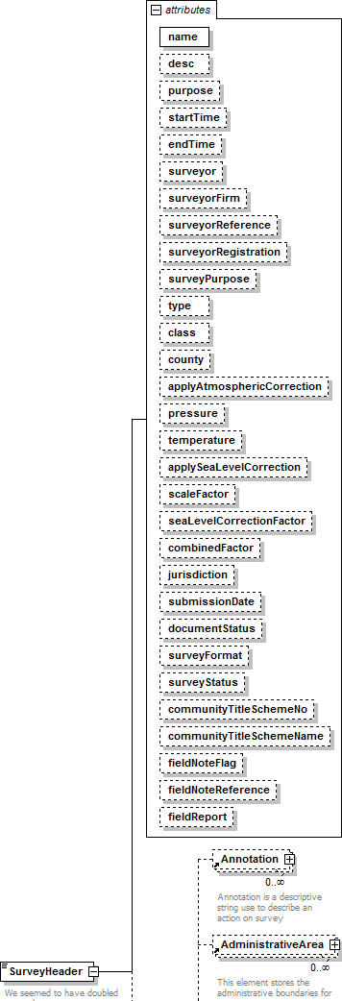

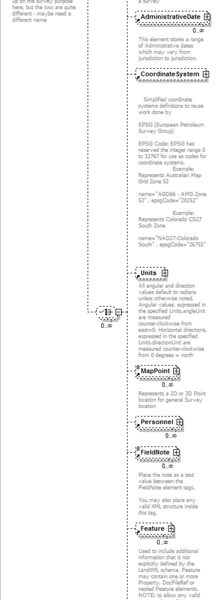

namespace | 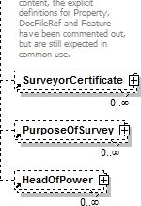
 | http://www.landxml.org/schema/LandXML-1.2
properties | content complex  mixed true
children | Annotation AdministrativeArea AdministrativeDate CoordinateSystem Units MapPoint Personnel FieldNote Feature SurveyorCertificate PurposeOfSurvey HeadOfPower
used by | element Survey
attributes | Name Type Use Default Fixed annotation name xs:string required  desc xs:string  purpose purposeTy pe  startTime xs:dateTime  endTime xs:dateTime  surveyor xs:string  surveyorFirm xs:string  surveyorReference xs:string  surveyorRegistration xs:string  surveyPurpose xs:string  ty pe surveyType  class xs:string  county xs:string  app ly AtmosphericCorrection xs:boolean  pressure xs:double  temperature xs:double app ly SeaLevelCorrection xs:boolean scaleFactor xs:double seaLevelCorrectionFactor xs:double combinedFactor xs:double  jurisdiction jurisdictionType  submissionDate xs:date  documentStatus documentStatusType  surveyFormat surveyFormatType  surveyStatus surveyStatusType  community TitleSchemeNo xs:int community TitleSchemeNamexs:string fieldNoteFlag xs:boolean  fieldNoteReference xs:string  fieldReport xs:string
annotation | documentation  We seemed to have doubled up on the survey purpose here, but the two are quite different - maybe need a different name
source | <xs:element name="SurveyHeader">  <xs:annotation>  <xs:documentation>We seemed to have doubled up on the survey purpose here, but the two are quite different - maybe need a different name</xs:documentation>

</xs:annotation>
<xs:complexType mixed="true">
<xs:choice minOccurs="0" maxOccurs="unbounded">
<xs:element ref="Annotation" minOccurs="0" maxOccurs="unbounded"/>
<xs:element ref="AdministrativeArea" minOccurs="0" maxOccurs="unbounded"/>
<xs:element ref="AdministrativeDate" minOccurs="0" maxOccurs="unbounded"/>
<xs:element ref="CoordinateSystem" minOccurs="0"/>
<xs:element ref="Units" minOccurs="0"/>
<xs:element ref="MapPoint" minOccurs="0" maxOccurs="unbounded"/>
<xs:element ref="Personnel" minOccurs="0" maxOccurs="unbounded"/>
<xs:element ref="FieldNote" minOccurs="0" maxOccurs="unbounded"/>
<xs:element ref="Feature" minOccurs="0" maxOccurs="unbounded"/>
<xs:element ref="SurveyorCertificate" minOccurs="0" maxOccurs="unbounded"/>
<xs:element ref="PurposeOfSurvey" minOccurs="0" maxOccurs="unbounded"/>
<xs:element ref="HeadOfPower" minOccurs="0" maxOccurs="unbounded"/>
</xs:choice>
<xs:attribute name="name" type="xs:string" use="required"/>
<xs:attribute name="desc" type="xs:string"/>
<xs:attribute name="purpose" type="purposeType"/>
<xs:attribute name="startTime" type="xs:dateTime"/>
<xs:attribute name="endTime" type="xs:dateTime"/>
<xs:attribute name="surveyor" type="xs:string"/>
<xs:attribute name="surveyorFirm" type="xs:string"/>
<xs:attribute name="surveyorReference" type="xs:string"/>
<xs:attribute name="surveyorRegistration" type="xs:string"/>
<xs:attribute name="surveyPurpose" type="xs:string"/>
<xs:attribute name="type" type="surveyType"/>
<xs:attribute name="class" type="xs:string"/>
<xs:attribute name="county" type="xs:string"/>
<xs:attribute name="applyAtmosphericCorrection" type="xs:boolean"/>
<xs:attribute name="pressure" type="xs:double"/>
<xs:attribute name="temperature" type="xs:double"/>
<xs:attribute name="applySeaLevelCorrection" type="xs:boolean"/>
<xs:attribute name="scaleFactor" type="xs:double"/>
<xs:attribute name="seaLevelCorrectionFactor" type="xs:double"/>
<xs:attribute name="combinedFactor" type="xs:double"/>
<xs:attribute name="jurisdiction" type="jurisdictionType"/>
<xs:attribute name="submissionDate" type="xs:date"/>
<xs:attribute name="documentStatus" type="documentStatusType"/>
<xs:attribute name="surveyFormat" type="surveyFormatType"/>
<xs:attribute name="surveyStatus" type="surveyStatusType"/>
<xs:attribute name="communityTitleSchemeNo" type="xs:int"/>
<xs:attribute name="communityTitleSchemeName" type="xs:string"/>
<xs:attribute name="fieldNoteFlag" type="xs:boolean"/>
<xs:attribute name="fieldNoteReference" type="xs:string"/>
<xs:attribute name="fieldReport" type="xs:string"/>
</xs:complexType>
</xs:element>

attribute SurveyHeader/@name
type | xs:string
properties | isRef 0  use required
source | <xs:attribute name="name" type="xs:string" use="required"/>

attribute SurveyHeader/@desc
type | xs:string

properties | isRef 0
source | <xs:attribute name="desc" type="xs:string"/>

attribute SurveyHeader/@purpose
type | purposeTy pe
properties | isRef 0
facets | enumeration normal enumeration check enumeration backsight enumeration foresight enumeration traverse enumeration sideshot enumeration resection enumeration levelLoop enumeration digitalLevel enumeration remoteElevation  enumeration recipricalObservation  enumeration topo enumeration cutSheets enumeration asbuilt
source | <xs:attribute name="purpose" type="purposeType"/>

attribute SurveyHeader/@startTime
type | xs:dateTime
properties | isRef 0
source | <xs:attribute name="startTime" type="xs:dateTime"/>

attribute SurveyHeader/@endTime
type | xs:dateTime
properties | isRef 0
source | <xs:attribute name="endTime" type="xs:dateTime"/>

attribute SurveyHeader/@surveyor
type | xs:string
properties | isRef 0
source | <xs:attribute name="surveyor" type="xs:string"/>

attribute SurveyHeader/@surveyorFirm
type | xs:string
properties | isRef 0
source | <xs:attribute name="surveyorFirm" type="xs:string"/>

attribute SurveyHeader/@surveyorReference
type | xs:string
properties | isRef 0

source | <xs:attribute name="surveyorReference" type="xs:string"/>

attribute SurveyHeader/@surveyorRegistration
type | xs:string
properties | isRef 0
source | <xs:attribute name="surveyorRegistration" type="xs:string"/>

attribute SurveyHeader/@surveyPurpose
type | xs:string
properties | isRef 0
source | <xs:attribute name="surveyPurpose" type="xs:string"/>

attribute SurveyHeader/@type
type | surveyType
properties | isRef 0
facets | enumeration compiled enumeration computed enumeration surveyed
source | <xs:attribute name="type" type="surveyType"/>

attribute SurveyHeader/@class
type | xs:string
properties | isRef 0
source | <xs:attribute name="class" type="xs:string"/>

attribute SurveyHeader/@county
type | xs:string
properties | isRef 0
source | <xs:attribute name="county" type="xs:string"/>

attribute SurveyHeader/@applyAtmosphericCorrection
type | xs:boolean
properties | isRef 0
source | <xs:attribute name="applyAtmosphericCorrection" type="xs:boolean"/>

attribute SurveyHeader/@pressure
type | xs:double
properties | isRef 0
source | <xs:attribute name="pressure" type="xs:double"/>

attribute SurveyHeader/@temperature
type | xs:double

properties | isRef 0
source | <xs:attribute name="temperature" type="xs:double"/>

attribute SurveyHeader/@applySeaLevelCorrection
type | xs:boolean
properties | isRef 0
source | <xs:attribute name="applySeaLevelCorrection" type="xs:boolean"/>

attribute SurveyHeader/@scaleFactor
type | xs:double
properties | isRef 0
source | <xs:attribute name="scaleFactor" type="xs:double"/>

attribute SurveyHeader/@seaLevelCorrectionFactor
type | xs:double
properties | isRef 0
source | <xs:attribute name="seaLevelCorrectionFactor" type="xs:double"/>

attribute SurveyHeader/@combinedFactor
type | xs:double
properties | isRef 0
source | <xs:attribute name="combinedFactor" type="xs:double"/>

attribute SurveyHeader/@jurisdiction
type | jurisdictionType
properties | isRef 0
source | <xs:attribute name="jurisdiction" type="jurisdictionType"/>

attribute SurveyHeader/@submissionDate
type | xs:date
properties | isRef 0
source | <xs:attribute name="submissionDate" type="xs:date"/>

attribute SurveyHeader/@documentStatus
type | documentStatusType
properties | isRef 0
source | <xs:attribute name="documentStatus" type="documentStatusType"/>

attribute SurveyHeader/@surveyFormat
type | surveyFormatType
properties | isRef 0

source | <xs:attribute name="surveyFormat" type="surveyFormatType"/>

attribute SurveyHeader/@surveyStatus
type | surveyStatusType
properties | isRef 0
source | <xs:attribute name="surveyStatus" type="surveyStatusType"/>

attribute SurveyHeader/@communityTitleSchemeNo
type | xs:int
properties | isRef 0
source | <xs:attribute name="communityTitleSchemeNo" type="xs:int"/>

attribute SurveyHeader/@communityTitleSchemeName
type | xs:string
properties | isRef 0
source | <xs:attribute name="communityTitleSchemeName" type="xs:string"/>

attribute SurveyHeader/@fieldNoteFlag
type | xs:boolean
properties | isRef 0
source | <xs:attribute name="fieldNoteFlag" type="xs:boolean"/>

attribute SurveyHeader/@fieldNoteReference
type | xs:string
properties | isRef 0
source | <xs:attribute name="fieldNoteReference" type="xs:string"/>

attribute SurveyHeader/@fieldReport
type | xs:string
properties | isRef 0
source | <xs:attribute name="fieldReport" type="xs:string"/>

XML Schema documentation generated by XMLSpy Schema Editor http://www.altova.com/xmlspy

element AdministrativeArea
diagram | 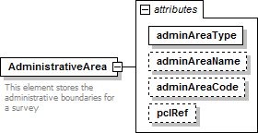
namespace | http://www.landxml.org/schema/LandXML-1.2
properties | content complex
used by | elements LocationAddress SurveyHeader
attributes | Name Type Use Default Fixed annotation adminAreaType adminAreaTypeType required  adminAreaName xs:string  adminAreaCode xs:string  pclRef parcelNameRefs
annotation | documentation  This element stores the administrative boundaries for a survey
source | <xs:element name="AdministrativeArea">  <xs:annotation>  <xs:documentation>This element stores the administrative boundaries for a survey</xs:documentation>  </xs:annotation>  <xs:complexType>  <xs:attribute name="adminAreaType" type="adminAreaTypeType" use="required"/>  <xs:attribute name="adminAreaName" type="xs:string"/>  <xs:attribute name="adminAreaCode" type="xs:string"/>  <xs:attribute name="pclRef" type="parcelNameRefs"/>  </xs:complexType>  </xs:element>

attribute AdministrativeArea/@adminAreaType
type | adminAreaTypeType
properties | isRef 0  use required
source | <xs:attribute name="adminAreaType" type="adminAreaTypeType" use="required"/>

attribute AdministrativeArea/@adminAreaName
type | xs:string
properties | isRef 0
source | <xs:attribute name="adminAreaName" type="xs:string"/>

attribute AdministrativeArea/@adminAreaCode
type | xs:string
properties | isRef 0
source | <xs:attribute name="adminAreaCode" type="xs:string"/>

attribute AdministrativeArea/@pclRef
type | parcelNameRefs
properties | isRef 0
source | <xs:attribute name="pclRef" type="parcelNameRefs"/>

XML Schema documentation generated by XMLSpy Schema Editor http://www.altova.com/xmlspy

element AdministrativeDate
diagram | 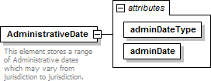
namespace | http://www.landxml.org/schema/LandXML-1.2
properties | content complex
used by | element SurveyHeader
attributes | Name Type Use Default Fixed annotation adminDateType adminDateTypeType required  adminDate xs:date required
annotation | documentation  This element stores a range of Administrative dates which may vary from jurisdiction to jurisdiction.
source | <xs:element name="AdministrativeDate">  <xs:annotation>  <xs:documentation>This element stores a range of Administrative dates which may vary from jurisdiction to jurisdiction.</xs:documentation>  </xs:annotation>  <xs:complexType>  <xs:attribute name="adminDateType" type="adminDateTypeType" use="required"/>  <xs:attribute name="adminDate" type="xs:date" use="required"/>  </xs:complexType>  </xs:element>

attribute AdministrativeDate/@adminDateType
type | adminDateTypeType
properties | isRef 0  use required
source | <xs:attribute name="adminDateType" type="adminDateTypeType" use="required"/>

attribute AdministrativeDate/@adminDate
type | xs:date
properties | isRef 0  use required
source | <xs:attribute name="adminDate" type="xs:date" use="required"/>

XML Schema documentation generated by XMLSpy Schema Editor http://www.altova.com/xmlspy

27/01/2026, 14:32 LandXML-1.2Doc - Units
element Units
diagram | 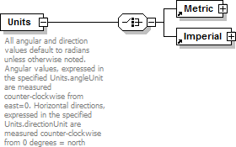
namespace | http://www.landxml.org/schema/LandXML-1.2
properties | content complex
children | Metric Imperial
used by | elements LandXML Pipes Structs SurveyHeader
annotation | documentation  All angular and direction values default to radians unless otherwise noted. Angular values, expressed in the specified Units.angleUnit are measured counter-clockwise from east=0. Horizontal directions, expressed in the specified Units.directionUnit are measured counter-clockwise from 0 degrees = north
source | <xs:element name="Units">  <xs:annotation>  <xs:documentation>All angular and direction values default to radians unless otherwise noted. Angular values, expressed in the specified Units.angleUnit are measured counter-clockwise from east=0.  Horizontal directions, expressed in the specified Units.directionUnit are measured counter-clockwise from 0 degrees = north</xs:documentation>  </xs:annotation>  <xs:complexType>  <xs:choice>  <xs:element ref="Metric"/>  <xs:element ref="Imperial"/>  </xs:choice>  </xs:complexType>  </xs:element>

XML Schema documentation generated by XMLSpy Schema Editor http://www.altova.com/xmlspy

element Annotation
diagram | 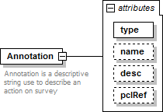
namespace | http://www.landxml.org/schema/LandXML-1.2
properties | content complex
used by | element SurveyHeader
attributes | Name Type Use Default Fixed annotation ty pe annotationType required  name xs:string  desc xs:string  pclRef parcelNameRefs
annotation | documentation  Annotation is a descriptive string use to describe an action on survey
source | <xs:element name="Annotation">  <xs:annotation>  <xs:documentation>Annotation is a descriptive string use to describe an action on survey</xs:documentation>  </xs:annotation>  <xs:complexType>  <xs:attribute name="type" type="annotationType" use="required"/>  <xs:attribute name="name" type="xs:string"/>  <xs:attribute name="desc" type="xs:string"/>  <xs:attribute name="pclRef" type="parcelNameRefs"/>  </xs:complexType>  </xs:element>

attribute Annotation/@type
type | annotationType
properties | isRef 0  use required
source | <xs:attribute name="type" type="annotationType" use="required"/>

attribute Annotation/@name
type | xs:string
properties | isRef 0
source | <xs:attribute name="name" type="xs:string"/>

attribute Annotation/@desc
type | xs:string
properties | isRef 0
source | <xs:attribute name="desc" type="xs:string"/>

attribute Annotation/@pclRef
type | parcelNameRefs
properties | isRef 0
source | <xs:attribute name="pclRef" type="parcelNameRefs"/>

XML Schema documentation generated by XMLSpy Schema Editor http://www.altova.com/xmlspy

element CoordinateSystem
diagram | 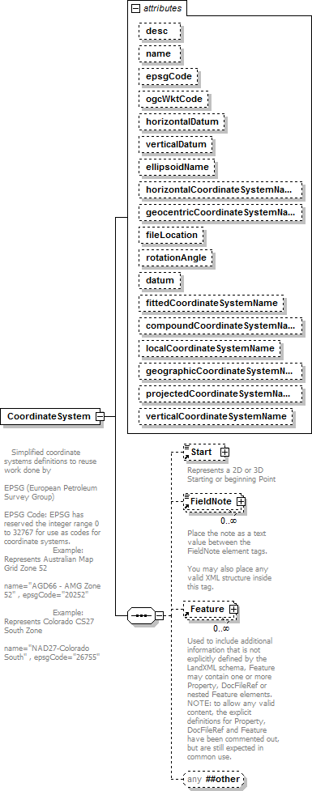

namespace | http://www.landxml.org/schema/LandXML-1.2
properties | content complex
children | Start FieldNote Feature
used by | elements LandXML SurveyHeader
attributes | Name Type Use Default Fixed annotation  desc xs:string  name xs:string  epsgCode xs:string  ogcWktCode xs:string  horizontalDatum xs:string  verticalDatum xs:string  ellipsoidName xs:string horizontalCoordinateSystemName xs:string geocentricCoordinateSystemName xs:string fileLocation xs:anyURI  rotationAngle angle  datum xs:string  fittedCoordinateSystemName xs:string compoundCoordinateSystemName xs:string localCoordinateSystemName xs:string geographicCoordinateSystemNamexs:string projectedCoordinateSystemName xs:string verticalCoordinateSystemName xs:string
annotation | documentation  Simplified coordinate systems definitions to reuse work done by EPSG (European Petroleum Survey Group)  EPSG Code: EPSG has reserved the integer range 0 to 32767 for use as codes for coordinate systems.  Example: Represents Australian Map Grid Zone 52 name="AGD66 - AMG Zone 52" , epsgCode="20252"  Example: Represents Colorado CS27 South Zone name="NAD27-Colorado South" , epsgCode="26755"
source | <xs:element name="CoordinateSystem">  <xs:annotation>  <xs:documentation>  Simplified coordinate systems definitions to reuse work done by EPSG (European Petroleum Survey Group)  EPSG Code: EPSG has reserved the integer range 0 to 32767 for use as codes for coordinate systems.  Example: Represents Australian Map Grid Zone 52 name="AGD66 - AMG Zone 52" , epsgCode="20252"  Example: Represents Colorado CS27 South Zone name="NAD27-Colorado South" , epsgCode="26755"  </xs:documentation>  </xs:annotation>  <xs:complexType>  <xs:sequence>  <xs:element ref="Start" minOccurs="0"/>  <xs:element ref="FieldNote" minOccurs="0" maxOccurs="unbounded"/>  <xs:element ref="Feature" minOccurs="0" maxOccurs="unbounded"/>  <xs:any namespace="##other" processContents="skip" minOccurs="0"/>  </xs:sequence>  <xs:attribute name="desc" type="xs:string"/>  <xs:attribute name="name" type="xs:string"/>  <xs:attribute name="epsgCode" type="xs:string"/>  <xs:attribute name="ogcWktCode" type="xs:string"/>

<xs:attribute name="horizontalDatum" type="xs:string"/>
<xs:attribute name="verticalDatum" type="xs:string"/>
<xs:attribute name="ellipsoidName" type="xs:string"/>
<xs:attribute name="horizontalCoordinateSystemName" type="xs:string"/>
<xs:attribute name="geocentricCoordinateSystemName" type="xs:string"/>
<xs:attribute name="fileLocation" type="xs:anyURI"/>
<xs:attribute name="rotationAngle" type="angle"/>
<xs:attribute name="datum" type="xs:string"/>
<xs:attribute name="fittedCoordinateSystemName" type="xs:string"/>
<xs:attribute name="compoundCoordinateSystemName" type="xs:string"/>
<xs:attribute name="localCoordinateSystemName" type="xs:string"/>
<xs:attribute name="geographicCoordinateSystemName" type="xs:string"/>
<xs:attribute name="projectedCoordinateSystemName" type="xs:string"/>
<xs:attribute name="verticalCoordinateSystemName" type="xs:string"/>
<!-- The attributes below are provided for backward compatibility only and should no longer be used. -
->
</xs:complexType>
</xs:element>

attribute CoordinateSystem/@desc
type | xs:string
properties | isRef 0
source | <xs:attribute name="desc" type="xs:string"/>

attribute CoordinateSystem/@name
type | xs:string
properties | isRef 0
source | <xs:attribute name="name" type="xs:string"/>

attribute CoordinateSystem/@epsgCode
type | xs:string
properties | isRef 0
source | <xs:attribute name="epsgCode" type="xs:string"/>

attribute CoordinateSystem/@ogcWktCode
type | xs:string
properties | isRef 0
source | <xs:attribute name="ogcWktCode" type="xs:string"/>

attribute CoordinateSystem/@horizontalDatum
type | xs:string
properties | isRef 0
source | <xs:attribute name="horizontalDatum" type="xs:string"/>

attribute CoordinateSystem/@verticalDatum
type | xs:string
properties | isRef 0

source | <xs:attribute name="verticalDatum" type="xs:string"/>

attribute CoordinateSystem/@ellipsoidName
type | xs:string
properties | isRef 0
source | <xs:attribute name="ellipsoidName" type="xs:string"/>

attribute CoordinateSystem/@horizontalCoordinateSystemName
type | xs:string
properties | isRef 0
source | <xs:attribute name="horizontalCoordinateSystemName" type="xs:string"/>

attribute CoordinateSystem/@geocentricCoordinateSystemName
type | xs:string
properties | isRef 0
source | <xs:attribute name="geocentricCoordinateSystemName" type="xs:string"/>

attribute CoordinateSystem/@fileLocation
type | xs:anyURI
properties | isRef 0
source | <xs:attribute name="fileLocation" type="xs:anyURI"/>

attribute CoordinateSystem/@rotationAngle
type | angle
properties | isRef 0
source | <xs:attribute name="rotationAngle" type="angle"/>

attribute CoordinateSystem/@datum
type | xs:string
properties | isRef 0
source | <xs:attribute name="datum" type="xs:string"/>

attribute CoordinateSystem/@fittedCoordinateSystemName
type | xs:string
properties | isRef 0
source | <xs:attribute name="fittedCoordinateSystemName" type="xs:string"/>

attribute CoordinateSystem/@compoundCoordinateSystemName
type | xs:string
properties | isRef 0
source | <xs:attribute name="compoundCoordinateSystemName" type="xs:string"/>

attribute CoordinateSystem/@localCoordinateSystemName
type | xs:string
properties | isRef 0
source | <xs:attribute name="localCoordinateSystemName" type="xs:string"/>

attribute CoordinateSystem/@geographicCoordinateSystemName
type | xs:string
properties | isRef 0
source | <xs:attribute name="geographicCoordinateSystemName" type="xs:string"/>

attribute CoordinateSystem/@projectedCoordinateSystemName
type | xs:string
properties | isRef 0
source | <xs:attribute name="projectedCoordinateSystemName" type="xs:string"/>

attribute CoordinateSystem/@verticalCoordinateSystemName
type | xs:string
properties | isRef 0
source | <xs:attribute name="verticalCoordinateSystemName" type="xs:string"/>

XML Schema documentation generated by XMLSpy Schema Editor http://www.altova.com/xmlspy

element Feature
diagram | 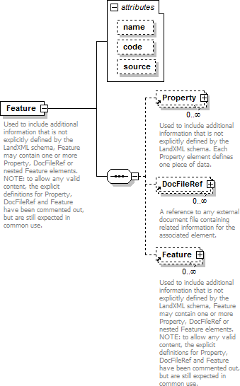
namespace | http://www.landxml.org/schema/LandXML-1.2
properties | content complex
children | Property DocFileRef Feature
used by | elements Alignment Alignments Backsight BikeFacilities Boundaries Boundary Breakline Breaklines BridgeElement Cant CgPoints Channel CircPipe CircStruct Classification ClimbLane Connection Contour Contours ControlChecks CoordGeom CoordinateSystem Corner Corrections CrashData CrashHistory CrossSect CrossSects CrossSectSurf Curb Curve Daily TrafficVolume DataPoints DecisionSightDistance Definition DesignCrossSectSurf DesignHour DesignSpeed DesignSpeed85th Ditch DrivewayDensity EggPipe ElliPipe Equipment Faces Feature GPSAntennaDetails GPSPosition GPSReceiverDetails GPSSetup GPSVector GradeModel GradeSurface HazardRating InletStruct InstrumentDetails InstrumentSetup Intersection Intersections IrregularLine Lanes LaserDetails LaserSetup Line Monuments NoPassingZone ObservationGroup ObstructionOffset OffsetLane OutletStruct Parcel Parcels PassingLane PeakHour Pipe PipeFlow PipeNetwork PipeNetworks Pipes PlanFeature PlanFeatures PointFiles PointResults PostedSpeed ProfAlign Profile ProfSurf Project RectPipe RectStruct RedHorizontalPosition ReducedArcObservation ReducedObservation RedVerticalObservation RetWall Roadside RoadSign Roadway Roadways SourceData Speeds Spiral StaEquation Struct StructFlow Structs Superelevation Surface Surfaces SurfVolume SurfVolumes Survey SurveyHeader SurveyMonument TargetSetup ThruLane Timing TrafficControl TrafficVolume TurnLane TurnRestriction TurnSpeed TwoWayLeftTurnLane Volume Watershed Watersheds WideningLane Zone ZoneCrossSectStructure ZoneCutFill ZoneHinge ZoneMaterial Zones ZoneSlope ZoneWidth  complexType RawObservationType
attributes | Name Type Use Default Fixed annotation name xs:string optional

code xs:string
source optional
annotation | documentation  Used to include additional information that is not explicitly defined by the LandXML schema, Feature may contain one or more Property, DocFileRef or nested Feature elements.  NOTE: to allow any valid content, the explicit definitions for Property, DocFileRef and Feature have been commented out, but are still expected in common use.  documentation  Each Property element defines one piece of data.
source | <xs:element name="Feature">  <xs:annotation>  <xs:documentation>Used to include additional information that is not explicitly defined by the LandXML schema, Feature may contain one or more Property, DocFileRef or nested Feature elements. NOTE: to allow any valid content, the explicit definitions for Property, DocFileRef and Feature have been commented out, but are still expected in common use.</xs:documentation>  <xs:documentation>Each Property element defines one piece of data.</xs:documentation>  </xs:annotation>  <xs:complexType>  <xs:sequence>  <xs:element ref="Property" minOccurs="0" maxOccurs="unbounded"/>  <xs:element ref="DocFileRef" minOccurs="0" maxOccurs="unbounded"/>  <xs:element ref="Feature" minOccurs="0" maxOccurs="unbounded"/>  <!-- <xs:any namespace="##any" processContents="skip" minOccurs="0" maxOccurs="unbounded"/>  -->  </xs:sequence>  <xs:attribute name="name" type="xs:string" use="optional"/>  <xs:attribute name="code" type="xs:string"/>  <xs:attribute name="source" use="optional"/>  </xs:complexType>  </xs:element>

attribute Feature/@name
type | xs:string
properties | isRef 0  use optional
source | <xs:attribute name="name" type="xs:string" use="optional"/>

attribute Feature/@code
type | xs:string
properties | isRef 0
source | <xs:attribute name="code" type="xs:string"/>

attribute Feature/@source
properties | isRef 0  use optional
source | <xs:attribute name="source" use="optional"/>

XML Schema documentation generated by XMLSpy Schema Editor http://www.altova.com/xmlspy

element MapPoint
diagram | 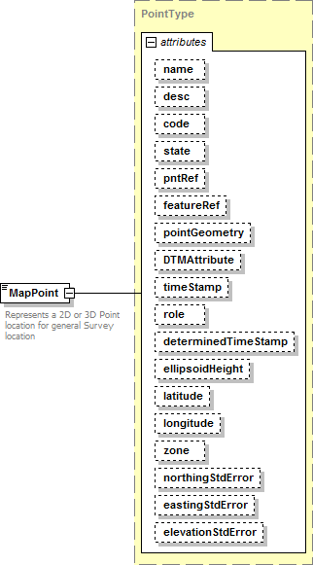
namespace | http://www.landxml.org/schema/LandXML-1.2
type | PointType
properties | content complex  mixed true
used by | element SurveyHeader
facets | minLength 0  maxLength 3
attributes | Name Type Use Default Fixed annotation name xs:string  desc xs:string  code xs:string  state stateType  pntRef pointNameRef  featureRef featureNameRef optional pointGeometry pointGeometry Type DTMAttribute DTMAttributeType  timeStamp xs:dateTime optional  role surveyRoleType optional  determinedTimeStamp xs:dateTime optional

ellipsoidHeight ellipsoidHeightType optional

latitude latLongAngle optional
longitude latLongAngle optional
zone xs:string optional
northingStdError xs:double optional
eastingStdError xs:double optional
elevationStdError xs:double optional
annotation | documentation  Represents a 2D or 3D Point location for general Survey location  documentation  Defined by either a coordinate text value ("north east" or "north east elev") or a PointType number reference "pntRef" attribute.
source | <xs:element name="MapPoint" type="PointType">  <xs:annotation>  <xs:documentation>Represents a 2D or 3D Point location for general Survey location</xs:documentation>  <xs:documentation>Defined by either a coordinate text value ("north east" or "north east elev") or a PointType number reference "pntRef" attribute.</xs:documentation>  </xs:annotation>  </xs:element>

XML Schema documentation generated by XMLSpy Schema Editor http://www.altova.com/xmlspy

element Personnel
diagram | 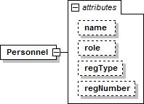
namespace | http://www.landxml.org/schema/LandXML-1.2
properties | content complex
used by | element SurveyHeader
attributes | Name Type Use Default Fixed annotation name xs:string  role surveyorRoleType  regTy pe registrationType  regNumber xs:string
source | <xs:element name="Personnel">  <xs:complexType>  <xs:attribute name="name" type="xs:string"/>  <xs:attribute name="role" type="surveyorRoleType"/>  <xs:attribute name="regType" type="registrationType"/>  <xs:attribute name="regNumber" type="xs:string"/>  </xs:complexType>  </xs:element>

attribute Personnel/@name
type | xs:string
properties | isRef 0
source | <xs:attribute name="name" type="xs:string"/>

attribute Personnel/@role
type | surveyorRoleType
properties | isRef 0
source | <xs:attribute name="role" type="surveyorRoleType"/>

attribute Personnel/@regType
type | registrationType
properties | isRef 0
source | <xs:attribute name="regType" type="registrationType"/>

attribute Personnel/@regNumber
type | xs:string
properties | isRef 0
source | <xs:attribute name="regNumber" type="xs:string"/>

XML Schema documentation generated by XMLSpy Schema Editor http://www.altova.com/xmlspy

element Equipment
diagram | 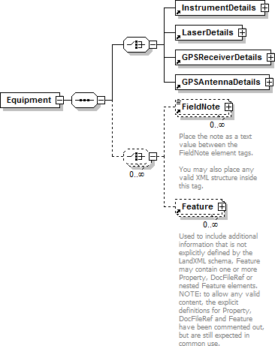
namespace | http://www.landxml.org/schema/LandXML-1.2
properties | content complex
children | InstrumentDetails LaserDetails GPSReceiverDetails GPSAntennaDetails FieldNote Feature
used by | element Survey
source | <xs:element name="Equipment">  <xs:annotation>  <xs:documentation/>  </xs:annotation>  <xs:complexType>  <xs:sequence>  <xs:choice>  <xs:element ref="InstrumentDetails"/>  <xs:element ref="LaserDetails"/>  <xs:element ref="GPSReceiverDetails"/>  <xs:element ref="GPSAntennaDetails"/>  </xs:choice>  <xs:choice minOccurs="0" maxOccurs="unbounded">  <xs:element ref="FieldNote" minOccurs="0" maxOccurs="unbounded"/>  <xs:element ref="Feature" minOccurs="0" maxOccurs="unbounded"/>  </xs:choice>  </xs:sequence>  </xs:complexType>  </xs:element>

XML Schema documentation generated by XMLSpy Schema Editor http://www.altova.com/xmlspy

element GPSAntennaDetails
diagram | 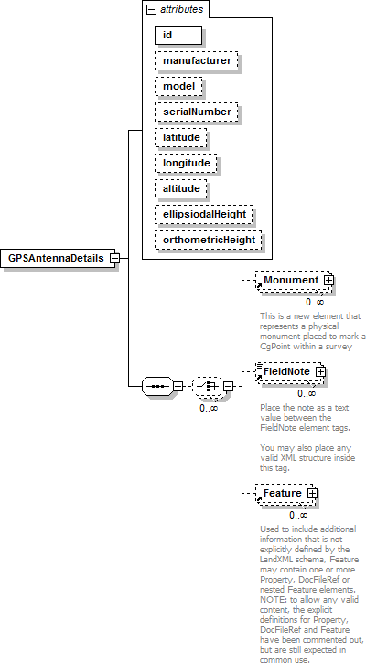
namespace | http://www.landxml.org/schema/LandXML-1.2
properties | content complex
children | Monument FieldNote Feature
used by | element Equipment
attributes | Name Type Use Default Fixed annotation id xs:ID required  manufacturer xs:string model xs:string serialNumber xs:string latitude xs:double  longitude xs:double  altitude xs:double

ellipsiodalHeight xs:double
orthometricHeight xs:double
source | <xs:element name="GPSAntennaDetails">  <xs:annotation>  <xs:documentation/>  </xs:annotation>  <xs:complexType>  <xs:sequence>  <xs:choice minOccurs="0" maxOccurs="unbounded">  <xs:element ref="Monument" minOccurs="0" maxOccurs="unbounded"/>  <xs:element ref="FieldNote" minOccurs="0" maxOccurs="unbounded"/>  <xs:element ref="Feature" minOccurs="0" maxOccurs="unbounded"/>  </xs:choice>  </xs:sequence>  <xs:attribute name="id" type="xs:ID" use="required"/>  <xs:attribute name="manufacturer" type="xs:string"/>  <xs:attribute name="model" type="xs:string"/>  <xs:attribute name="serialNumber" type="xs:string"/>  <xs:attribute name="latitude" type="xs:double"/>  <xs:attribute name="longitude" type="xs:double"/>  <xs:attribute name="altitude" type="xs:double"/>  <xs:attribute name="ellipsiodalHeight" type="xs:double"/>  <xs:attribute name="orthometricHeight" type="xs:double"/>  </xs:complexType>  </xs:element>

attribute GPSAntennaDetails/@id
type | xs:ID
properties | isRef 0  use required
source | <xs:attribute name="id" type="xs:ID" use="required"/>

attribute GPSAntennaDetails/@manufacturer
type | xs:string
properties | isRef 0
source | <xs:attribute name="manufacturer" type="xs:string"/>

attribute GPSAntennaDetails/@model
type | xs:string
properties | isRef 0
source | <xs:attribute name="model" type="xs:string"/>

attribute GPSAntennaDetails/@serialNumber
type | xs:string
properties | isRef 0
source | <xs:attribute name="serialNumber" type="xs:string"/>

attribute GPSAntennaDetails/@latitude
type | xs:double

properties | isRef 0
source | <xs:attribute name="latitude" type="xs:double"/>

attribute GPSAntennaDetails/@longitude
type | xs:double
properties | isRef 0
source | <xs:attribute name="longitude" type="xs:double"/>

attribute GPSAntennaDetails/@altitude
type | xs:double
properties | isRef 0
source | <xs:attribute name="altitude" type="xs:double"/>

attribute GPSAntennaDetails/@ellipsiodalHeight
type | xs:double
properties | isRef 0
source | <xs:attribute name="ellipsiodalHeight" type="xs:double"/>

attribute GPSAntennaDetails/@orthometricHeight
type | xs:double
properties | isRef 0
source | <xs:attribute name="orthometricHeight" type="xs:double"/>

XML Schema documentation generated by XMLSpy Schema Editor http://www.altova.com/xmlspy

element Monument
diagram | 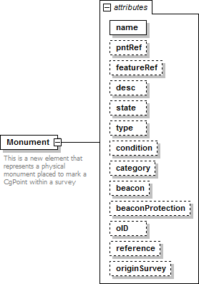
namespace | http://www.landxml.org/schema/LandXML-1.2
properties | content complex
used by | elements GPSAntennaDetails Monuments
attributes | Name Type Use Default Fixed annotation name xs:string required  pntRef pointNameRef  featureRef featureNameRef optional  desc xs:string  state monumentState  ty pe monumentType  condition monumentCondition  category monumentCategory  beacon beaconType beaconProtection beaconProtectionType oID xs:string  reference xs:string  originSurvey xs:string
annotation | documentation  This is a new element that represents a physical monument placed to mark a CgPoint within a survey
source | <xs:element name="Monument">  <xs:annotation>  <xs:documentation>This is a new element that represents a physical monument placed to mark a CgPoint within a survey</xs:documentation>  </xs:annotation>  <xs:complexType>  <xs:attribute name="name" type="xs:string" use="required"/>  <xs:attribute name="pntRef" type="pointNameRef"/>  <xs:attribute name="featureRef" type="featureNameRef" use="optional"/>  <xs:attribute name="desc" type="xs:string"/>  <xs:attribute name="state" type="monumentState"/>  <xs:attribute name="type" type="monumentType"/>

<xs:attribute name="condition" type="monumentCondition"/>
<xs:attribute name="category" type="monumentCategory"/>
<xs:attribute name="beacon" type="beaconType"/>
<xs:attribute name="beaconProtection" type="beaconProtectionType"/>
<xs:attribute name="oID" type="xs:string"/>
<xs:attribute name="reference" type="xs:string"/>
<xs:attribute name="originSurvey" type="xs:string"/>
</xs:complexType>
</xs:element>

attribute Monument/@name
type | xs:string
properties | isRef 0  use required
source | <xs:attribute name="name" type="xs:string" use="required"/>

attribute Monument/@pntRef
type | pointNameRef
properties | isRef 0
source | <xs:attribute name="pntRef" type="pointNameRef"/>

attribute Monument/@featureRef
type | featureNameRef
properties | isRef 0  use optional
source | <xs:attribute name="featureRef" type="featureNameRef" use="optional"/>

attribute Monument/@desc
type | xs:string
properties | isRef 0
source | <xs:attribute name="desc" type="xs:string"/>

attribute Monument/@state
type | monumentState
properties | isRef 0
source | <xs:attribute name="state" type="monumentState"/>

attribute Monument/@type
type | monumentType
properties | isRef 0
source | <xs:attribute name="type" type="monumentType"/>

attribute Monument/@condition
type | monumentCondition
properties | isRef 0

source | <xs:attribute name="condition" type="monumentCondition"/>

attribute Monument/@category
type | monumentCategory
properties | isRef 0
facets | enumeration benchmark enumeration central enumeration reference enumeration rural enumeration standard traverse  enumeration urban standard traverse
source | <xs:attribute name="category" type="monumentCategory"/>

attribute Monument/@beacon
type | beaconType
properties | isRef 0
facets | enumeration cairn enumeration chimney enumeration large quadripod enumeration lighthouse enumeration marine beacon enumeration mast enumeration mast with targets enumeration no beacon enumeration other enumeration pillar enumeration post enumeration small quadripod enumeration tower enumeration tripod enumeration unknown
source | <xs:attribute name="beacon" type="beaconType"/>

attribute Monument/@beaconProtection
type | beaconProtectionType
properties | isRef 0
facets | enumeration cover enumeration cover and box enumeration fence enclosure enumeration marker post enumeration no protection enumeration other enumeration quadripod enumeration unknown
source | <xs:attribute name="beaconProtection" type="beaconProtectionType"/>

attribute Monument/@oID
type | xs:string
properties | isRef 0

source | <xs:attribute name="oID" type="xs:string"/>

attribute Monument/@reference
type | xs:string
properties | isRef 0
source | <xs:attribute name="reference" type="xs:string"/>

attribute Monument/@originSurvey
type | xs:string
properties | isRef 0
source | <xs:attribute name="originSurvey" type="xs:string"/>

XML Schema documentation generated by XMLSpy Schema Editor http://www.altova.com/xmlspy

element GPSReceiverDetails
diagram | 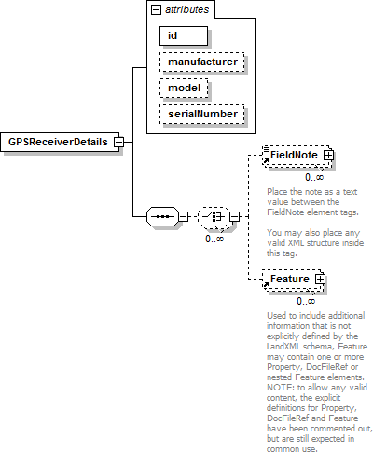
namespace | http://www.landxml.org/schema/LandXML-1.2
properties | content complex
children | FieldNote Feature
used by | element Equipment
attributes | Name Type Use Default Fixed annotation id xs:ID required  manufacturer xs:string model xs:string serialNumber xs:string

source | <xs:element name="GPSReceiverDetails">  <xs:annotation>  <xs:documentation/>  </xs:annotation>  <xs:complexType>  <xs:sequence>  <xs:choice minOccurs="0" maxOccurs="unbounded">  <xs:element ref="FieldNote" minOccurs="0" maxOccurs="unbounded"/>  <xs:element ref="Feature" minOccurs="0" maxOccurs="unbounded"/>  </xs:choice>  </xs:sequence>  <xs:attribute name="id" type="xs:ID" use="required"/>  <xs:attribute name="manufacturer" type="xs:string"/>  <xs:attribute name="model" type="xs:string"/>  <xs:attribute name="serialNumber" type="xs:string"/>  </xs:complexType>  </xs:element>

attribute GPSReceiverDetails/@id
type | xs:ID
properties | isRef 0  use required
source | <xs:attribute name="id" type="xs:ID" use="required"/>

attribute GPSReceiverDetails/@manufacturer
type | xs:string
properties | isRef 0
source | <xs:attribute name="manufacturer" type="xs:string"/>

attribute GPSReceiverDetails/@model
type | xs:string
properties | isRef 0
source | <xs:attribute name="model" type="xs:string"/>

attribute GPSReceiverDetails/@serialNumber
type | xs:string
properties | isRef 0
source | <xs:attribute name="serialNumber" type="xs:string"/>

XML Schema documentation generated by XMLSpy Schema Editor http://www.altova.com/xmlspy

element InstrumentDetails
diagram | 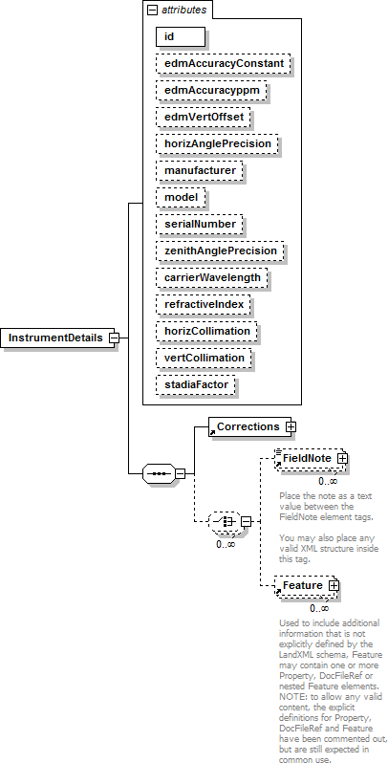
namespace | http://www.landxml.org/schema/LandXML-1.2
properties | content complex
children | Corrections FieldNote Feature
used by | element Equipment
attributes | Name Type Use Default Fixed annotation id xs:ID required  edmAccuracyConstant xs:double  edmAccuracyp pm xs:double

edmVertOffset xs:double horizAnglePrecision xs:double manufacturer xs:string
model xs:string
serialNumber xs:string zenithAnglePrecision xs:double carrierWavelength xs:double refractiveIndex xs:double
horizCollimation xs:double
vertCollimation xs:double
stadiaFactor xs:double
source | <xs:element name="InstrumentDetails">  <xs:annotation>  <xs:documentation/>  </xs:annotation>  <xs:complexType>  <xs:sequence>  <xs:element ref="Corrections"/>  <xs:choice minOccurs="0" maxOccurs="unbounded">  <xs:element ref="FieldNote" minOccurs="0" maxOccurs="unbounded"/>  <xs:element ref="Feature" minOccurs="0" maxOccurs="unbounded"/>  </xs:choice>  </xs:sequence>  <xs:attribute name="id" type="xs:ID" use="required"/>  <xs:attribute name="edmAccuracyConstant" type="xs:double"/>  <xs:attribute name="edmAccuracyppm" type="xs:double"/>  <xs:attribute name="edmVertOffset" type="xs:double"/>  <xs:attribute name="horizAnglePrecision" type="xs:double"/>  <xs:attribute name="manufacturer" type="xs:string"/>  <xs:attribute name="model" type="xs:string"/>  <xs:attribute name="serialNumber" type="xs:string"/>  <xs:attribute name="zenithAnglePrecision" type="xs:double"/>  <xs:attribute name="carrierWavelength" type="xs:double"/>  <xs:attribute name="refractiveIndex" type="xs:double"/>  <xs:attribute name="horizCollimation" type="xs:double"/>  <xs:attribute name="vertCollimation" type="xs:double"/>  <xs:attribute name="stadiaFactor" type="xs:double"/>  <!-- In order to compute the atmospheric corrections correctly record the  EDM instrument carrier wavelength (carrierWavelength) and the group refractive index for the instrument (refractiveIndex). -->  <!-- To allow for older style top mounted EDM's -->  </xs:complexType>  </xs:element>

attribute InstrumentDetails/@id
type | xs:ID
properties | isRef 0  use required
source | <xs:attribute name="id" type="xs:ID" use="required"/>

attribute InstrumentDetails/@edmAccuracyConstant
type | xs:double
properties | isRef 0
source | <xs:attribute name="edmAccuracyConstant" type="xs:double"/>

attribute InstrumentDetails/@edmAccuracyppm
type | xs:double
properties | isRef 0
source | <xs:attribute name="edmAccuracyppm" type="xs:double"/>

attribute InstrumentDetails/@edmVertOffset
type | xs:double
properties | isRef 0
source | <xs:attribute name="edmVertOffset" type="xs:double"/>

attribute InstrumentDetails/@horizAnglePrecision
type | xs:double
properties | isRef 0
source | <xs:attribute name="horizAnglePrecision" type="xs:double"/>

attribute InstrumentDetails/@manufacturer
type | xs:string
properties | isRef 0
source | <xs:attribute name="manufacturer" type="xs:string"/>

attribute InstrumentDetails/@model
type | xs:string
properties | isRef 0
source | <xs:attribute name="model" type="xs:string"/>

attribute InstrumentDetails/@serialNumber
type | xs:string
properties | isRef 0
source | <xs:attribute name="serialNumber" type="xs:string"/>

attribute InstrumentDetails/@zenithAnglePrecision
type | xs:double
properties | isRef 0
source | <xs:attribute name="zenithAnglePrecision" type="xs:double"/>

attribute InstrumentDetails/@carrierWavelength
type | xs:double
properties | isRef 0
source | <xs:attribute name="carrierWavelength" type="xs:double"/>

attribute InstrumentDetails/@refractiveIndex
type | xs:double

properties | isRef 0
source | <xs:attribute name="refractiveIndex" type="xs:double"/>

attribute InstrumentDetails/@horizCollimation
type | xs:double
properties | isRef 0
source | <xs:attribute name="horizCollimation" type="xs:double"/>

attribute InstrumentDetails/@vertCollimation
type | xs:double
properties | isRef 0
source | <xs:attribute name="vertCollimation" type="xs:double"/>

attribute InstrumentDetails/@stadiaFactor
type | xs:double
properties | isRef 0
source | <xs:attribute name="stadiaFactor" type="xs:double"/>

XML Schema documentation generated by XMLSpy Schema Editor http://www.altova.com/xmlspy

element Corrections
diagram | 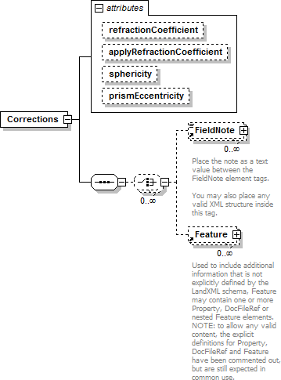
namespace | http://www.landxml.org/schema/LandXML-1.2
properties | content complex
children | FieldNote Feature
used by | element InstrumentDetails
attributes | Name Type Use Default Fixed annotation refractionCoefficient xs:double  app ly RefractionCoefficientxs:boolean sphericity xs:double  prismEccentricity xs:double
source | <xs:element name="Corrections">  <xs:annotation>  <xs:documentation/>  </xs:annotation>  <xs:complexType>  <xs:sequence>  <xs:choice minOccurs="0" maxOccurs="unbounded">  <xs:element ref="FieldNote" minOccurs="0" maxOccurs="unbounded"/>  <xs:element ref="Feature" minOccurs="0" maxOccurs="unbounded"/>  </xs:choice>  </xs:sequence>  <xs:attribute name="refractionCoefficient" type="xs:double"/>  <xs:attribute name="applyRefractionCoefficient" type="xs:boolean"/>  <xs:attribute name="sphericity" type="xs:double"/>  <xs:attribute name="prismEccentricity" type="xs:double"/>  <!-- if 'true' then atmospheric corrections are to be applied to the measured distances read from the file -->

<!-- if 'true' then sea level corrections are to be applied to the measured distances read from the file --
>
<!-- this is for recording the refraction coefficient used in the curvature and refraction correction of zenith angles -->
<!-- if 'true' then RefractionCoefficient should be applied to the measured zenith angles read from the file -->
</xs:complexType>
</xs:element>

attribute Corrections/@refractionCoefficient
type | xs:double
properties | isRef 0
source | <xs:attribute name="refractionCoefficient" type="xs:double"/>

attribute Corrections/@applyRefractionCoefficient
type | xs:boolean
properties | isRef 0
source | <xs:attribute name="applyRefractionCoefficient" type="xs:boolean"/>

attribute Corrections/@sphericity
type | xs:double
properties | isRef 0
source | <xs:attribute name="sphericity" type="xs:double"/>

attribute Corrections/@prismEccentricity
type | xs:double
properties | isRef 0
source | <xs:attribute name="prismEccentricity" type="xs:double"/>

XML Schema documentation generated by XMLSpy Schema Editor http://www.altova.com/xmlspy

element LaserDetails
diagram | 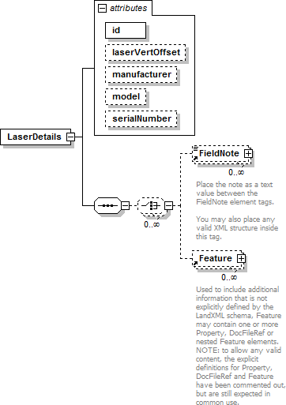
namespace | http://www.landxml.org/schema/LandXML-1.2
properties | content complex
children | FieldNote Feature
used by | element Equipment
attributes | Name Type Use Default Fixed annotation id xs:ID required  laserVertOffset xs:double manufacturer xs:string model xs:string serialNumber xs:string
source | <xs:element name="LaserDetails">  <xs:annotation>  <xs:documentation/>  </xs:annotation>  <xs:complexType>  <xs:sequence>  <xs:choice minOccurs="0" maxOccurs="unbounded">  <xs:element ref="FieldNote" minOccurs="0" maxOccurs="unbounded"/>  <xs:element ref="Feature" minOccurs="0" maxOccurs="unbounded"/>  </xs:choice>  </xs:sequence>  <xs:attribute name="id" type="xs:ID" use="required"/>  <xs:attribute name="laserVertOffset" type="xs:double"/>  <xs:attribute name="manufacturer" type="xs:string"/>

<xs:attribute name="model" type="xs:string"/>
<xs:attribute name="serialNumber" type="xs:string"/>
</xs:complexType>
</xs:element>

attribute LaserDetails/@id
type | xs:ID
properties | isRef 0  use required
source | <xs:attribute name="id" type="xs:ID" use="required"/>

attribute LaserDetails/@laserVertOffset
type | xs:double
properties | isRef 0
source | <xs:attribute name="laserVertOffset" type="xs:double"/>

attribute LaserDetails/@manufacturer
type | xs:string
properties | isRef 0
source | <xs:attribute name="manufacturer" type="xs:string"/>

attribute LaserDetails/@model
type | xs:string
properties | isRef 0
source | <xs:attribute name="model" type="xs:string"/>

attribute LaserDetails/@serialNumber
type | xs:string
properties | isRef 0
source | <xs:attribute name="serialNumber" type="xs:string"/>

XML Schema documentation generated by XMLSpy Schema Editor http://www.altova.com/xmlspy

element SurveyMonument
diagram | 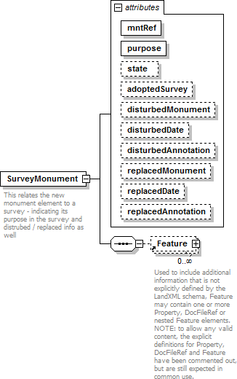
namespace | http://www.landxml.org/schema/LandXML-1.2
properties | content complex
children | Feature
used by | element Survey
attributes | Name Type Use Default Fixed annotation mntRef monumentNameRef required  purpose monumentPurpose required  state monumentState  adoptedSurvey xs:string disturbedMonument xs:string disturbedDate xs:date disturbedAnnotation xs:string replacedMonument xs:string replacedDate xs:date replacedAnnotation xs:string
annotation | documentation  This relates the new monument element to a survey - indicating its purpose in the survey and distrubed / replaced info as well
source | <xs:element name="SurveyMonument">  <xs:annotation>  <xs:documentation>This relates the new monument element to a survey - indicating its purpose in the survey and distrubed / replaced info as well</xs:documentation>  </xs:annotation>  <xs:complexType>

<xs:sequence>
<xs:element ref="Feature" minOccurs="0" maxOccurs="unbounded"/>
</xs:sequence>
<xs:attribute name="mntRef" type="monumentNameRef" use="required"/>
<xs:attribute name="purpose" type="monumentPurpose" use="required"/>
<xs:attribute name="state" type="monumentState"/>
<xs:attribute name="adoptedSurvey" type="xs:string"/>
<xs:attribute name="disturbedMonument" type="xs:string"/>
<xs:attribute name="disturbedDate" type="xs:date"/>
<xs:attribute name="disturbedAnnotation" type="xs:string"/>
<xs:attribute name="replacedMonument" type="xs:string"/>
<xs:attribute name="replacedDate" type="xs:date"/>
<xs:attribute name="replacedAnnotation" type="xs:string"/>
</xs:complexType>
</xs:element>

attribute SurveyMonument/@mntRef
type | monumentNameRef
properties | isRef 0  use required
source | <xs:attribute name="mntRef" type="monumentNameRef" use="required"/>

attribute SurveyMonument/@purpose
type | monumentPurpose
properties | isRef 0  use required
source | <xs:attribute name="purpose" type="monumentPurpose" use="required"/>

attribute SurveyMonument/@state
type | monumentState
properties | isRef 0
source | <xs:attribute name="state" type="monumentState"/>

attribute SurveyMonument/@adoptedSurvey
type | xs:string
properties | isRef 0
source | <xs:attribute name="adoptedSurvey" type="xs:string"/>

attribute SurveyMonument/@disturbedMonument
type | xs:string
properties | isRef 0
source | <xs:attribute name="disturbedMonument" type="xs:string"/>

attribute SurveyMonument/@disturbedDate
type | xs:date
properties | isRef 0
source | <xs:attribute name="disturbedDate" type="xs:date"/>

attribute SurveyMonument/@disturbedAnnotation
type | xs:string
properties | isRef 0
source | <xs:attribute name="disturbedAnnotation" type="xs:string"/>

attribute SurveyMonument/@replacedMonument
type | xs:string
properties | isRef 0
source | <xs:attribute name="replacedMonument" type="xs:string"/>

attribute SurveyMonument/@replacedDate
type | xs:date
properties | isRef 0
source | <xs:attribute name="replacedDate" type="xs:date"/>

attribute SurveyMonument/@replacedAnnotation
type | xs:string
properties | isRef 0
source | <xs:attribute name="replacedAnnotation" type="xs:string"/>

XML Schema documentation generated by XMLSpy Schema Editor http://www.altova.com/xmlspy

element CgPoints
diagram | 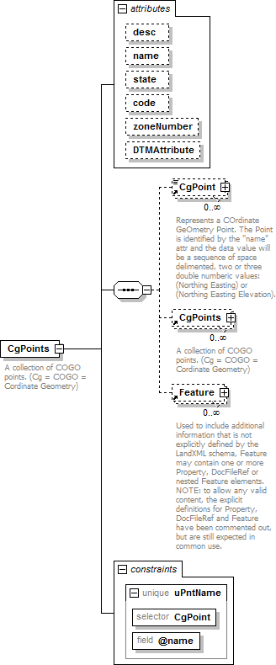
namespace | http://www.landxml.org/schema/LandXML-1.2
properties | content complex
children | CgPoint CgPoints Feature
used by | elements CgPoints LandXML Survey
attributes | Name Type Use Default Fixed annotation desc xs:string  name xs:string  state stateType

code xs:string
zoneNumber zoneNumberType
DTMAttribute DTMAttributeType
identity constraints | Name Refer Selector Field(s)  unique uPntName CgPoint @name
annotation | documentation  A collection of COGO points. (Cg = COGO = Cordinate Geometry)
source | <xs:element name="CgPoints">  <xs:annotation>  <xs:documentation>A collection of COGO points. (Cg = COGO = Cordinate Geometry)  </xs:documentation>  </xs:annotation>  <xs:complexType>  <xs:sequence>  <xs:element ref="CgPoint" minOccurs="0" maxOccurs="unbounded"/>  <xs:element ref="CgPoints" minOccurs="0" maxOccurs="unbounded"/>  <xs:element ref="Feature" minOccurs="0" maxOccurs="unbounded"/>  <!-- Allow nested CgPoints collections -->  </xs:sequence>  <xs:attribute name="desc" type="xs:string"/>  <xs:attribute name="name" type="xs:string"/>  <xs:attribute name="state" type="stateType"/>  <xs:attribute name="code" type="xs:string"/>  <xs:attribute name="zoneNumber" type="zoneNumberType"/>  <xs:attribute name="DTMAttribute" type="DTMAttributeType"/>  </xs:complexType>  <xs:unique name="uPntName">  <xs:selector xpath="CgPoint"/>  <xs:field xpath="@name"/>  </xs:unique>  </xs:element>

attribute CgPoints/@desc
type | xs:string
properties | isRef 0
source | <xs:attribute name="desc" type="xs:string"/>

attribute CgPoints/@name
type | xs:string
properties | isRef 0
source | <xs:attribute name="name" type="xs:string"/>

attribute CgPoints/@state
type | stateType
properties | isRef 0
facets | enumeration abandoned enumeration destroyed enumeration existing enumeration proposed
source | <xs:attribute name="state" type="stateType"/>

attribute CgPoints/@code
type | xs:string
properties | isRef 0
source | <xs:attribute name="code" type="xs:string"/>

attribute CgPoints/@zoneNumber
type | zoneNumberType
properties | isRef 0
facets | minInclusive 1  maxInclusive 99
source | <xs:attribute name="zoneNumber" type="zoneNumberType"/>

attribute CgPoints/@DTMAttribute
type | DTMAttributeType
properties | isRef 0
facets | enumeration determinebyfeature enumeration donotinclude enumeration spot  enumeration spotandbreak enumeration void enumeration drapevoid enumeration breakvoid enumeration island enumeration boundary enumeration contour enumeration feature enumeration ground enumeration xsection enumeration user
source | <xs:attribute name="DTMAttribute" type="DTMAttributeType"/>

XML Schema documentation generated by XMLSpy Schema Editor http://www.altova.com/xmlspy

element CgPoint
diagram | 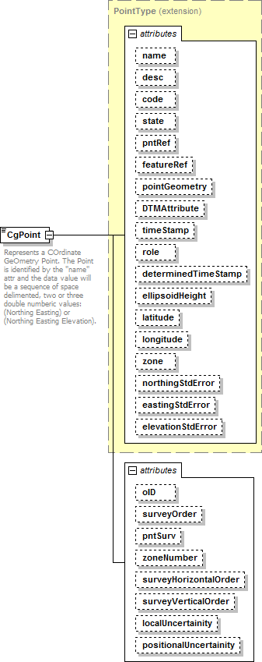
namespace | http://www.landxml.org/schema/LandXML-1.2
type | extension of PointType
properties | content complex  mixed true
used by | element CgPoints

facets | minLength 0  maxLength 3
attributes | Name Type Use Default Fixed annotation name xs:string  desc xs:string  code xs:string  state stateType  pntRef pointNameRef  featureRef featureNameRef optional pointGeometry pointGeometry Type DTMAttribute DTMAttributeType  timeStamp xs:dateTime optional  role surveyRoleType optional determinedTimeStamp xs:dateTime optional ellipsoidHeight ellipsoidHeightType optional latitude latLongAngle optional  longitude latLongAngle optional  zone xs:string optional  northingStdError xs:double optional  eastingStdError xs:double optional  elevationStdError xs:double optional  oID xs:string  surveyOrder xs:string  pntSurv survPntType  zoneNumber zoneNumberType surveyHorizontalOrder xs:string surveyVerticalOrder xs:string localUncertainity xs:double positionalUncertainity xs:double
annotation | documentation  Represents a COrdinate GeOmetry Point. The Point is identified by the "name" attr and the data value will be a sequence of space delimented, two or three double numberic values: (Northing Easting) or (Northing Easting Elevation).
source | <xs:element name="CgPoint">  <xs:annotation>  <xs:documentation>Represents a COrdinate GeOmetry Point. The Point is identified by the "name" attr and the data value will be a sequence of space delimented, two or three double numberic values: (Northing Easting) or (Northing Easting Elevation).</xs:documentation>  </xs:annotation>  <xs:complexType mixed="true">  <xs:simpleContent>  <xs:extension base="PointType">  <xs:attribute name="oID" type="xs:string"/>  <xs:attribute name="surveyOrder" type="xs:string"/>  <xs:attribute name="pntSurv" type="survPntType"/>  <xs:attribute name="zoneNumber" type="zoneNumberType"/>  <xs:attribute name="surveyHorizontalOrder" type="xs:string"/>  <xs:attribute name="surveyVerticalOrder" type="xs:string"/>  <xs:attribute name="localUncertainity" type="xs:double"/>  <xs:attribute name="positionalUncertainity" type="xs:double"/>  </xs:extension>  </xs:simpleContent>  </xs:complexType>  </xs:element>

attribute CgPoint/@oID
type | xs:string
properties | isRef 0

source | <xs:attribute name="oID" type="xs:string"/>

attribute CgPoint/@surveyOrder
type | xs:string
properties | isRef 0
source | <xs:attribute name="surveyOrder" type="xs:string"/>

attribute CgPoint/@pntSurv
type | survPntType
properties | isRef 0
facets | enumeration monument enumeration control enumeration sideshot enumeration boundary enumeration natural boundary enumeration traverse enumeration reference enumeration administrative
source | <xs:attribute name="pntSurv" type="survPntType"/>

attribute CgPoint/@zoneNumber
type | zoneNumberType
properties | isRef 0
facets | minInclusive 1  maxInclusive 99
source | <xs:attribute name="zoneNumber" type="zoneNumberType"/>

attribute CgPoint/@surveyHorizontalOrder
type | xs:string
properties | isRef 0
source | <xs:attribute name="surveyHorizontalOrder" type="xs:string"/>

attribute CgPoint/@surveyVerticalOrder
type | xs:string
properties | isRef 0
source | <xs:attribute name="surveyVerticalOrder" type="xs:string"/>

attribute CgPoint/@localUncertainity
type | xs:double
properties | isRef 0
source | <xs:attribute name="localUncertainity" type="xs:double"/>

attribute CgPoint/@positionalUncertainity
type | xs:double

properties | isRef 0
source | <xs:attribute name="positionalUncertainity" type="xs:double"/>

XML Schema documentation generated by XMLSpy Schema Editor http://www.altova.com/xmlspy

element InstrumentSetup
diagram | 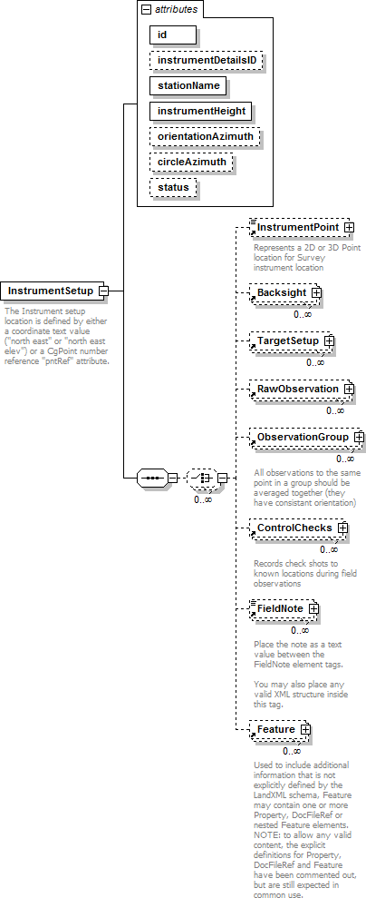

namespace | http://www.landxml.org/schema/LandXML-1.2
properties | content complex
children | InstrumentPoint Backsight TargetSetup RawObservation ObservationGroup ControlChecks FieldNote Feature
used by | element Survey
attributes | Name Type Use Default Fixed annotation id xs:ID required  instrumentDetailsID xs:IDREF  stationName xs:string required  instrumentHeight xs:double required  orientationAzimuth direction  circleAzimuth direction  status observationStatusType
annotation | documentation  The Instrument setup location is defined by either a coordinate text value ("north east" or "north east elev") or a CgPoint number reference "pntRef" attribute.
source | <xs:element name="InstrumentSetup">  <xs:annotation>  <xs:documentation>The Instrument setup location is defined by either a coordinate text value ("north east" or "north east elev") or a CgPoint number reference "pntRef" attribute.</xs:documentation>  </xs:annotation>  <xs:complexType>  <xs:sequence>  <xs:choice minOccurs="0" maxOccurs="unbounded">  <xs:element ref="InstrumentPoint" minOccurs="0"/>  <xs:element ref="Backsight" minOccurs="0" maxOccurs="unbounded"/>  <xs:element ref="TargetSetup" minOccurs="0" maxOccurs="unbounded"/>  <xs:element ref="RawObservation" minOccurs="0" maxOccurs="unbounded"/>  <xs:element ref="ObservationGroup" minOccurs="0" maxOccurs="unbounded"/>  <xs:element ref="ControlChecks" minOccurs="0" maxOccurs="unbounded"/>  <xs:element ref="FieldNote" minOccurs="0" maxOccurs="unbounded"/>  <xs:element ref="Feature" minOccurs="0" maxOccurs="unbounded"/>  </xs:choice>  </xs:sequence>  <xs:attribute name="id" type="xs:ID" use="required"/>  <xs:attribute name="instrumentDetailsID" type="xs:IDREF"/>  <xs:attribute name="stationName" type="xs:string" use="required"/>  <xs:attribute name="instrumentHeight" type="xs:double" use="required"/>  <xs:attribute name="orientationAzimuth" type="direction"/>  <xs:attribute name="circleAzimuth" type="direction"/>  <xs:attribute name="status" type="observationStatusType"/>  </xs:complexType>  </xs:element>

attribute InstrumentSetup/@id
type | xs:ID
properties | isRef 0  use required
source | <xs:attribute name="id" type="xs:ID" use="required"/>

attribute InstrumentSetup/@instrumentDetailsID
type | xs:IDREF
properties | isRef 0

source | <xs:attribute name="instrumentDetailsID" type="xs:IDREF"/>

attribute InstrumentSetup/@stationName
type | xs:string
properties | isRef 0  use required
source | <xs:attribute name="stationName" type="xs:string" use="required"/>

attribute InstrumentSetup/@instrumentHeight
type | xs:double
properties | isRef 0  use required
source | <xs:attribute name="instrumentHeight" type="xs:double" use="required"/>

attribute InstrumentSetup/@orientationAzimuth
type | direction
properties | isRef 0
source | <xs:attribute name="orientationAzimuth" type="direction"/>

attribute InstrumentSetup/@circleAzimuth
type | direction
properties | isRef 0
source | <xs:attribute name="circleAzimuth" type="direction"/>

attribute InstrumentSetup/@status
type | observationStatusType
properties | isRef 0
facets | enumeration modified  enumeration deleted
source | <xs:attribute name="status" type="observationStatusType"/>

XML Schema documentation generated by XMLSpy Schema Editor http://www.altova.com/xmlspy

element InstrumentPoint
diagram | 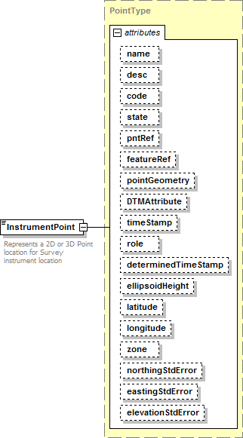
namespace | http://www.landxml.org/schema/LandXML-1.2
type | PointType
properties | content complex  mixed true
used by | elements InstrumentSetup LaserSetup
facets | minLength 0  maxLength 3
attributes | Name Type Use Default Fixed annotation name xs:string  desc xs:string  code xs:string  state stateType  pntRef pointNameRef  featureRef featureNameRef optional pointGeometry pointGeometry Type DTMAttribute DTMAttributeType  timeStamp xs:dateTime optional  role surveyRoleType optional  determinedTimeStamp xs:dateTime optional

ellipsoidHeight ellipsoidHeightType optional

latitude latLongAngle optional
longitude latLongAngle optional
zone xs:string optional
northingStdError xs:double optional
eastingStdError xs:double optional
elevationStdError xs:double optional
annotation | documentation  Represents a 2D or 3D Point location for Survey instrument location  documentation  Defined by either a coordinate text value ("north east" or "north east elev") or a PointType number reference "pntRef" attribute.
source | <xs:element name="InstrumentPoint" type="PointType">  <xs:annotation>  <xs:documentation>Represents a 2D or 3D Point location for Survey instrument location</xs:documentation>  <xs:documentation>Defined by either a coordinate text value ("north east" or "north east elev") or a PointType number reference "pntRef" attribute.</xs:documentation>  </xs:annotation>  </xs:element>

XML Schema documentation generated by XMLSpy Schema Editor http://www.altova.com/xmlspy

element Backsight
diagram | 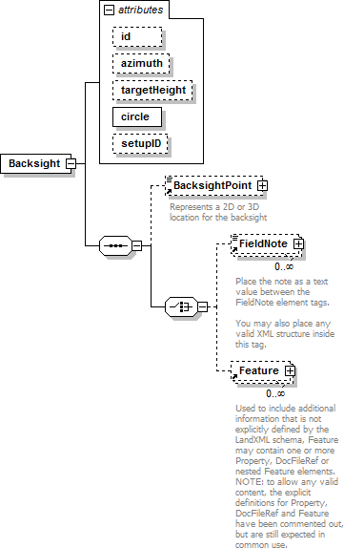
namespace | http://www.landxml.org/schema/LandXML-1.2
properties | content complex
children | BacksightPoint FieldNote Feature
used by | elements InstrumentSetup LaserSetup ObservationGroup
attributes | Name Type Use Default Fixed annotation id xs:ID  azimuth direction  targetHeight xs:double  circle angle required  setupID xs:IDREF
source | <xs:element name="Backsight">  <xs:annotation>  <xs:documentation/>  </xs:annotation>  <xs:complexType>  <xs:sequence>  <xs:element ref="BacksightPoint" minOccurs="0"/>  <xs:choice>  <xs:element ref="FieldNote" minOccurs="0" maxOccurs="unbounded"/>  <xs:element ref="Feature" minOccurs="0" maxOccurs="unbounded"/>

</xs:choice>
</xs:sequence>
<xs:attribute name="id" type="xs:ID"/>
<xs:attribute name="azimuth" type="direction"/>
<xs:attribute name="targetHeight" type="xs:double"/>
<xs:attribute name="circle" type="angle" use="required"/>
<xs:attribute name="setupID" type="xs:IDREF"/>
</xs:complexType>
</xs:element>

attribute Backsight/@id
type | xs:ID
properties | isRef 0
source | <xs:attribute name="id" type="xs:ID"/>

attribute Backsight/@azimuth
type | direction
properties | isRef 0
source | <xs:attribute name="azimuth" type="direction"/>

attribute Backsight/@targetHeight
type | xs:double
properties | isRef 0
source | <xs:attribute name="targetHeight" type="xs:double"/>

attribute Backsight/@circle
type | angle
properties | isRef 0  use required
source | <xs:attribute name="circle" type="angle" use="required"/>

attribute Backsight/@setupID
type | xs:IDREF
properties | isRef 0
source | <xs:attribute name="setupID" type="xs:IDREF"/>

XML Schema documentation generated by XMLSpy Schema Editor http://www.altova.com/xmlspy

element BacksightPoint
diagram | 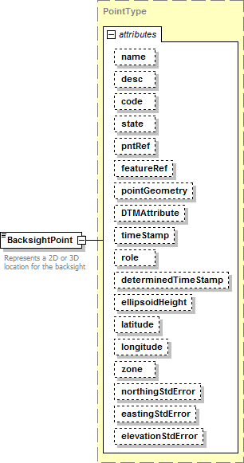
namespace | http://www.landxml.org/schema/LandXML-1.2
type | PointType
properties | content complex  mixed true
used by | element Backsight
facets | minLength 0  maxLength 3
attributes | Name Type Use Default Fixed annotation name xs:string  desc xs:string  code xs:string  state stateType  pntRef pointNameRef  featureRef featureNameRef optional pointGeometry pointGeometry Type DTMAttribute DTMAttributeType  timeStamp xs:dateTime optional  role surveyRoleType optional  determinedTimeStamp xs:dateTime optional

ellipsoidHeight ellipsoidHeightType optional

latitude latLongAngle optional
longitude latLongAngle optional
zone xs:string optional
northingStdError xs:double optional
eastingStdError xs:double optional
elevationStdError xs:double optional
annotation | documentation  Represents a 2D or 3D location for the backsight  documentation  It is defined by either a coordinate text value ("north east" or "north east elev") or a CgPoint number reference "pntRef" attribute.
source | <xs:element name="BacksightPoint" type="PointType">  <xs:annotation>  <xs:documentation>Represents a 2D or 3D location for the backsight</xs:documentation>  <xs:documentation>It is defined by either a coordinate text value ("north east" or "north east elev") or a CgPoint number reference "pntRef" attribute.</xs:documentation>  </xs:annotation>  </xs:element>

XML Schema documentation generated by XMLSpy Schema Editor http://www.altova.com/xmlspy

element TargetSetup
diagram | 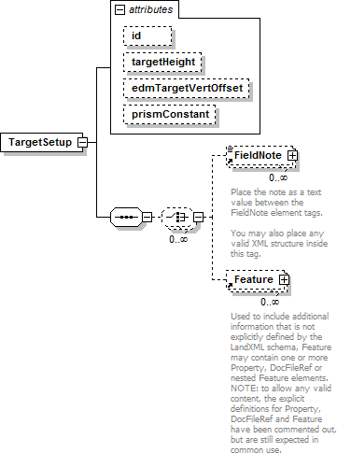
namespace | http://www.landxml.org/schema/LandXML-1.2
properties | content complex
children | FieldNote Feature
used by | elements GPSSetup InstrumentSetup LaserSetup Survey
attributes | Name Type Use Default Fixed annotation id xs:ID  targetHeight xs:double edmTargetVertOffset xs:double prismConstant xs:double
source | <xs:element name="TargetSetup">  <xs:annotation>  <xs:documentation/>  </xs:annotation>  <xs:complexType>  <xs:sequence>  <xs:choice minOccurs="0" maxOccurs="unbounded">  <xs:element ref="FieldNote" minOccurs="0" maxOccurs="unbounded"/>  <xs:element ref="Feature" minOccurs="0" maxOccurs="unbounded"/>  </xs:choice>  </xs:sequence>  <xs:attribute name="id" type="xs:ID"/>  <xs:attribute name="targetHeight" type="xs:double"/>  <xs:attribute name="edmTargetVertOffset" type="xs:double"/>  <xs:attribute name="prismConstant" type="xs:double"/>  <!-- To allow for older style EDM's -->

</xs:complexType>
</xs:element>

attribute TargetSetup/@id
type | xs:ID
properties | isRef 0
source | <xs:attribute name="id" type="xs:ID"/>

attribute TargetSetup/@targetHeight
type | xs:double
properties | isRef 0
source | <xs:attribute name="targetHeight" type="xs:double"/>

attribute TargetSetup/@edmTargetVertOffset
type | xs:double
properties | isRef 0
source | <xs:attribute name="edmTargetVertOffset" type="xs:double"/>

attribute TargetSetup/@prismConstant
type | xs:double
properties | isRef 0
source | <xs:attribute name="prismConstant" type="xs:double"/>

XML Schema documentation generated by XMLSpy Schema Editor http://www.altova.com/xmlspy

element TargetPoint
diagram | 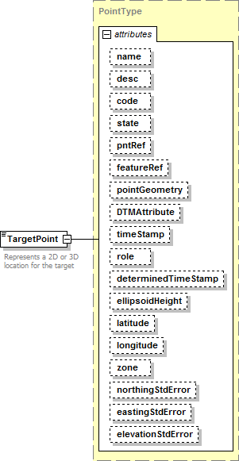
namespace | http://www.landxml.org/schema/LandXML-1.2
type | PointType
properties | content complex  mixed true
used by | elements GPSPosition GPSVector ObservationGroup PointResults ReducedArcObservation ReducedObservation  complexType RawObservationType
facets | minLength 0  maxLength 3
attributes | Name Type Use Default Fixed annotation name xs:string  desc xs:string  code xs:string  state stateType  pntRef pointNameRef  featureRef featureNameRef optional pointGeometry pointGeometry Type DTMAttribute DTMAttributeType  timeStamp xs:dateTime optional  role surveyRoleType optional

determinedTimeStamp xs:dateTime optional ellipsoidHeight ellipsoidHeightType optional latitude latLongAngle optional
longitude latLongAngle optional
zone xs:string optional
northingStdError xs:double optional
eastingStdError xs:double optional
elevationStdError xs:double optional
annotation | documentation  Represents a 2D or 3D location for the target  documentation  It is defined by either a coordinate text value ("north east" or "north east elev") or a CgPoint number reference "pntRef" attribute.
source | <xs:element name="TargetPoint" type="PointType">  <xs:annotation>  <xs:documentation>Represents a 2D or 3D location for the target</xs:documentation>  <xs:documentation>It is defined by either a coordinate text value ("north east" or "north east elev") or a CgPoint number reference "pntRef" attribute.</xs:documentation>  </xs:annotation>  </xs:element>

XML Schema documentation generated by XMLSpy Schema Editor http://www.altova.com/xmlspy

element RawObservation

diagram

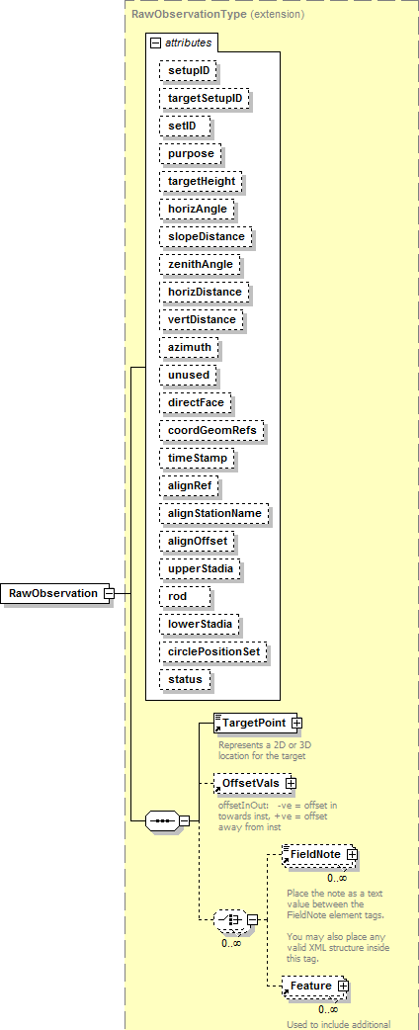

namespace | 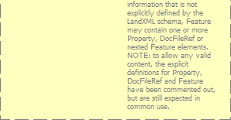
 | http://www.landxml.org/schema/LandXML-1.2
type | extension of RawObservationType
properties | content complex  mixed false
children | TargetPoint OffsetVals FieldNote Feature
used by | elements InstrumentSetup LaserSetup ObservationGroup
attributes | Name Type Use Default Fixed annotation setupID xs:IDREF  targetSetupID xs:IDREF  setID  purpose purposeTy pe  targetHeight xs:double  horizAngle angle optional  slopeDistance xs:double optional  zenithAngle zenithAngle optional  horizDistance xs:double  vertDistance xs:double  azimuth direction optional  unused xs:boolean  directFace xs:boolean coordGeomRefs coordGeomNameRefs timeStamp xs:dateTime  alignRef alignmentNameRef alignStationName xs:string alignOffset offsetDistance  up perStadia xs:double  rod xs:double  lowerStadia xs:double  circlePositionSet xs:double  status observationStatusType
source | <xs:element name="RawObservation">  <xs:complexType mixed="false">  <xs:complexContent mixed="false">  <xs:extension base="RawObservationType"/>  </xs:complexContent>  </xs:complexType>  </xs:element>

XML Schema documentation generated by XMLSpy Schema Editor http://www.altova.com/xmlspy

element ObservationGroup

diagram

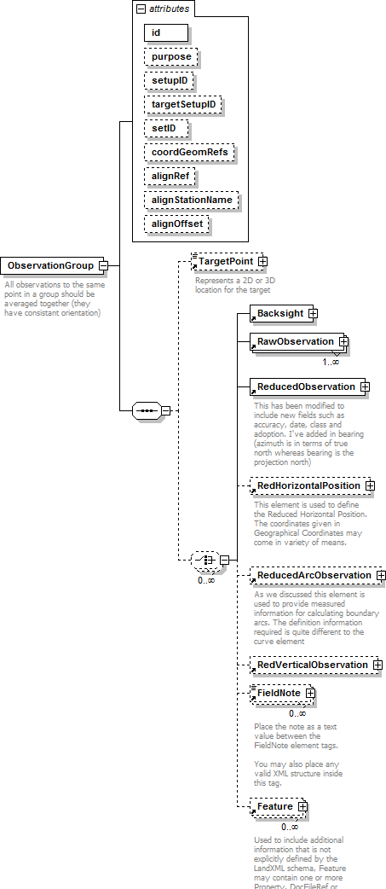

namespace | 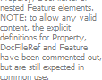
 | http://www.landxml.org/schema/LandXML-1.2
properties | content complex
children | TargetPoint Backsight RawObservation ReducedObservation RedHorizontalPosition ReducedArcObservation RedVerticalObservation FieldNote Feature
used by | elements ControlChecks InstrumentSetup Survey
attributes | Name Type Use Default Fixed annotation id xs:ID required  purpose purposeTy pe  setupID xs:IDREF  targetSetupID xs:IDREF  setID  coordGeomRefs coordGeomNameRefs alignRef alignmentNameRef alignStationName xs:string  alignOffset offsetDistance
annotation | documentation  All observations to the same point in a group should be averaged together (they have consistant orientation)
source | <xs:element name="ObservationGroup">  <xs:annotation>  <xs:documentation>All observations to the same point in a group should be averaged together (they have consistant orientation)</xs:documentation>  </xs:annotation>  <xs:complexType>  <xs:sequence>  <xs:element ref="TargetPoint" minOccurs="0"/>  <xs:choice minOccurs="0" maxOccurs="unbounded">  <xs:element ref="Backsight"/>  <xs:element ref="RawObservation" maxOccurs="unbounded"/>  <xs:element ref="ReducedObservation"/>  <xs:element ref="RedHorizontalPosition" minOccurs="0"/>  <xs:element ref="ReducedArcObservation" minOccurs="0"/>  <xs:element ref="RedVerticalObservation" minOccurs="0"/>  <xs:element ref="FieldNote" minOccurs="0" maxOccurs="unbounded"/>  <xs:element ref="Feature" minOccurs="0" maxOccurs="unbounded"/>  </xs:choice>  </xs:sequence>  <xs:attribute name="id" type="xs:ID" use="required"/>  <xs:attribute name="purpose" type="purposeType"/>  <xs:attribute name="setupID" type="xs:IDREF"/>  <xs:attribute name="targetSetupID" type="xs:IDREF"/>  <xs:attribute name="setID"/>  <xs:attribute name="coordGeomRefs" type="coordGeomNameRefs"/>  <xs:attribute name="alignRef" type="alignmentNameRef"/>  <xs:attribute name="alignStationName" type="xs:string"/>  <xs:attribute name="alignOffset" type="offsetDistance"/>  <!-- coordGeomRefs identifies one or more 'name' values that link to specific <Line>, <Curve>,  <Spiral> or <IrregularLine> in a <CoordGeom> element. This allows linking an survey observation to specific <Parcel>.<CoordGeom> based geometry. -->  <!-- alignRef is the name of the alignment.  alignStationName is the station value where the rod reading is taken.

alignOffset is the signed (+/-) distance from the CL of the referenced alignment. -->
</xs:complexType>
</xs:element>

attribute ObservationGroup/@id
type | xs:ID
properties | isRef 0  use required
source | <xs:attribute name="id" type="xs:ID" use="required"/>

attribute ObservationGroup/@purpose
type | purposeTy pe
properties | isRef 0
facets | enumeration normal enumeration check enumeration backsight enumeration foresight enumeration traverse enumeration sideshot enumeration resection enumeration levelLoop enumeration digitalLevel enumeration remoteElevation  enumeration recipricalObservation  enumeration topo enumeration cutSheets enumeration asbuilt
source | <xs:attribute name="purpose" type="purposeType"/>

attribute ObservationGroup/@setupID
type | xs:IDREF
properties | isRef 0
source | <xs:attribute name="setupID" type="xs:IDREF"/>

attribute ObservationGroup/@targetSetupID
type | xs:IDREF
properties | isRef 0
source | <xs:attribute name="targetSetupID" type="xs:IDREF"/>

attribute ObservationGroup/@setID
properties | isRef 0
source | <xs:attribute name="setID"/>

attribute ObservationGroup/@coordGeomRefs
type | coordGeomNameRefs
properties | isRef 0
source | <xs:attribute name="coordGeomRefs" type="coordGeomNameRefs"/>

attribute ObservationGroup/@alignRef
type | alignmentNameRef
properties | isRef 0
source | <xs:attribute name="alignRef" type="alignmentNameRef"/>

attribute ObservationGroup/@alignStationName
type | xs:string
properties | isRef 0
source | <xs:attribute name="alignStationName" type="xs:string"/>

attribute ObservationGroup/@alignOffset
type | offsetDistance
properties | isRef 0
source | <xs:attribute name="alignOffset" type="offsetDistance"/>

XML Schema documentation generated by XMLSpy Schema Editor http://www.altova.com/xmlspy

element ControlChecks
diagram | 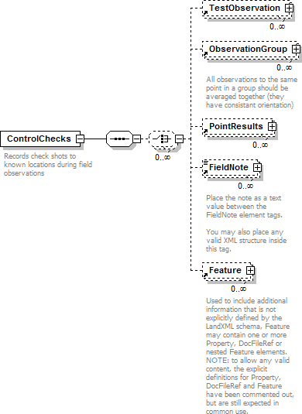
namespace | http://www.landxml.org/schema/LandXML-1.2
properties | content complex
children | TestObservation ObservationGroup PointResults FieldNote Feature
used by | elements InstrumentSetup Survey
annotation | documentation  Records check shots to known locations during field observations
source | <xs:element name="ControlChecks">  <xs:annotation>  <xs:documentation>Records check shots to known locations during field observations</xs:documentation>  </xs:annotation>  <xs:complexType>  <xs:sequence>  <xs:choice minOccurs="0" maxOccurs="unbounded">  <xs:element ref="TestObservation" minOccurs="0" maxOccurs="unbounded"/>  <!-- LandXML-1.2 schema note: Use of ObservationGroup is depricated and used for backward compatibility,  use multiple TestObservation elements -->  <xs:element ref="ObservationGroup" minOccurs="0" maxOccurs="unbounded"/>  <xs:element ref="PointResults" minOccurs="0" maxOccurs="unbounded"/>  <xs:element ref="FieldNote" minOccurs="0" maxOccurs="unbounded"/>  <xs:element ref="Feature" minOccurs="0" maxOccurs="unbounded"/>  </xs:choice>

</xs:sequence>
</xs:complexType>
</xs:element>

XML Schema documentation generated by XMLSpy Schema Editor http://www.altova.com/xmlspy

element ObservationGroup

diagram



namespace | 
 | http://www.landxml.org/schema/LandXML-1.2
properties | content complex
children | TargetPoint Backsight RawObservation ReducedObservation RedHorizontalPosition ReducedArcObservation RedVerticalObservation FieldNote Feature
used by | elements ControlChecks InstrumentSetup Survey
attributes | Name Type Use Default Fixed annotation id xs:ID required  purpose purposeTy pe  setupID xs:IDREF  targetSetupID xs:IDREF  setID  coordGeomRefs coordGeomNameRefs alignRef alignmentNameRef alignStationName xs:string  alignOffset offsetDistance
annotation | documentation  All observations to the same point in a group should be averaged together (they have consistant orientation)
source | <xs:element name="ObservationGroup">  <xs:annotation>  <xs:documentation>All observations to the same point in a group should be averaged together (they have consistant orientation)</xs:documentation>  </xs:annotation>  <xs:complexType>  <xs:sequence>  <xs:element ref="TargetPoint" minOccurs="0"/>  <xs:choice minOccurs="0" maxOccurs="unbounded">  <xs:element ref="Backsight"/>  <xs:element ref="RawObservation" maxOccurs="unbounded"/>  <xs:element ref="ReducedObservation"/>  <xs:element ref="RedHorizontalPosition" minOccurs="0"/>  <xs:element ref="ReducedArcObservation" minOccurs="0"/>  <xs:element ref="RedVerticalObservation" minOccurs="0"/>  <xs:element ref="FieldNote" minOccurs="0" maxOccurs="unbounded"/>  <xs:element ref="Feature" minOccurs="0" maxOccurs="unbounded"/>  </xs:choice>  </xs:sequence>  <xs:attribute name="id" type="xs:ID" use="required"/>  <xs:attribute name="purpose" type="purposeType"/>  <xs:attribute name="setupID" type="xs:IDREF"/>  <xs:attribute name="targetSetupID" type="xs:IDREF"/>  <xs:attribute name="setID"/>  <xs:attribute name="coordGeomRefs" type="coordGeomNameRefs"/>  <xs:attribute name="alignRef" type="alignmentNameRef"/>  <xs:attribute name="alignStationName" type="xs:string"/>  <xs:attribute name="alignOffset" type="offsetDistance"/>  <!-- coordGeomRefs identifies one or more 'name' values that link to specific <Line>, <Curve>,  <Spiral> or <IrregularLine> in a <CoordGeom> element. This allows linking an survey observation to specific <Parcel>.<CoordGeom> based geometry. -->  <!-- alignRef is the name of the alignment.  alignStationName is the station value where the rod reading is taken.

alignOffset is the signed (+/-) distance from the CL of the referenced alignment. -->
</xs:complexType>
</xs:element>

attribute ObservationGroup/@id
type | xs:ID
properties | isRef 0  use required
source | <xs:attribute name="id" type="xs:ID" use="required"/>

attribute ObservationGroup/@purpose
type | purposeTy pe
properties | isRef 0
facets | enumeration normal enumeration check enumeration backsight enumeration foresight enumeration traverse enumeration sideshot enumeration resection enumeration levelLoop enumeration digitalLevel enumeration remoteElevation  enumeration recipricalObservation  enumeration topo enumeration cutSheets enumeration asbuilt
source | <xs:attribute name="purpose" type="purposeType"/>

attribute ObservationGroup/@setupID
type | xs:IDREF
properties | isRef 0
source | <xs:attribute name="setupID" type="xs:IDREF"/>

attribute ObservationGroup/@targetSetupID
type | xs:IDREF
properties | isRef 0
source | <xs:attribute name="targetSetupID" type="xs:IDREF"/>

attribute ObservationGroup/@setID
properties | isRef 0
source | <xs:attribute name="setID"/>

attribute ObservationGroup/@coordGeomRefs
type | coordGeomNameRefs
properties | isRef 0
source | <xs:attribute name="coordGeomRefs" type="coordGeomNameRefs"/>

attribute ObservationGroup/@alignRef
type | alignmentNameRef
properties | isRef 0
source | <xs:attribute name="alignRef" type="alignmentNameRef"/>

attribute ObservationGroup/@alignStationName
type | xs:string
properties | isRef 0
source | <xs:attribute name="alignStationName" type="xs:string"/>

attribute ObservationGroup/@alignOffset
type | offsetDistance
properties | isRef 0
source | <xs:attribute name="alignOffset" type="offsetDistance"/>

XML Schema documentation generated by XMLSpy Schema Editor http://www.altova.com/xmlspy

element PointResults
diagram | 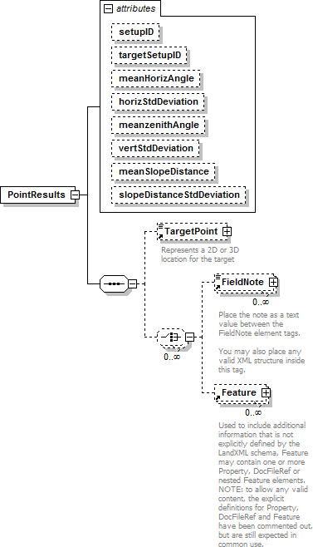
namespace | http://www.landxml.org/schema/LandXML-1.2
properties | content complex
children | TargetPoint FieldNote Feature
used by | element ControlChecks
attributes | Name Type Use Default Fixed annotation setupID xs:IDREF  targetSetupID xs:IDREF  meanHorizAngle xs:double  horizStdDeviation xs:double  meanzenithAngle zenithAngle  vertStdDeviation xs:double meanSlopeDistance xs:double slopeDistanceStdDeviationxs:double
source | <xs:element name="PointResults">  <xs:annotation>

<xs:documentation/>
</xs:annotation>
<xs:complexType>
<xs:sequence>
<xs:element ref="TargetPoint" minOccurs="0"/>
<xs:choice minOccurs="0" maxOccurs="unbounded">
<xs:element ref="FieldNote" minOccurs="0" maxOccurs="unbounded"/>
<xs:element ref="Feature" minOccurs="0" maxOccurs="unbounded"/>
</xs:choice>
</xs:sequence>
<xs:attribute name="setupID" type="xs:IDREF"/>
<xs:attribute name="targetSetupID" type="xs:IDREF"/>
<xs:attribute name="meanHorizAngle" type="xs:double"/>
<xs:attribute name="horizStdDeviation" type="xs:double"/>
<xs:attribute name="meanzenithAngle" type="zenithAngle"/>
<xs:attribute name="vertStdDeviation" type="xs:double"/>
<xs:attribute name="meanSlopeDistance" type="xs:double"/>
<xs:attribute name="slopeDistanceStdDeviation" type="xs:double"/>
</xs:complexType>
</xs:element>

attribute PointResults/@setupID
type | xs:IDREF
properties | isRef 0
source | <xs:attribute name="setupID" type="xs:IDREF"/>

attribute PointResults/@targetSetupID
type | xs:IDREF
properties | isRef 0
source | <xs:attribute name="targetSetupID" type="xs:IDREF"/>

attribute PointResults/@meanHorizAngle
type | xs:double
properties | isRef 0
source | <xs:attribute name="meanHorizAngle" type="xs:double"/>

attribute PointResults/@horizStdDeviation
type | xs:double
properties | isRef 0
source | <xs:attribute name="horizStdDeviation" type="xs:double"/>

attribute PointResults/@meanzenithAngle
type | zenithAngle
properties | isRef 0
source | <xs:attribute name="meanzenithAngle" type="zenithAngle"/>

attribute PointResults/@vertStdDeviation
type | xs:double

properties | isRef 0
source | <xs:attribute name="vertStdDeviation" type="xs:double"/>

attribute PointResults/@meanSlopeDistance
type | xs:double
properties | isRef 0
source | <xs:attribute name="meanSlopeDistance" type="xs:double"/>

attribute PointResults/@slopeDistanceStdDeviation
type | xs:double
properties | isRef 0
source | <xs:attribute name="slopeDistanceStdDeviation" type="xs:double"/>

XML Schema documentation generated by XMLSpy Schema Editor http://www.altova.com/xmlspy

element TestObservation

diagram

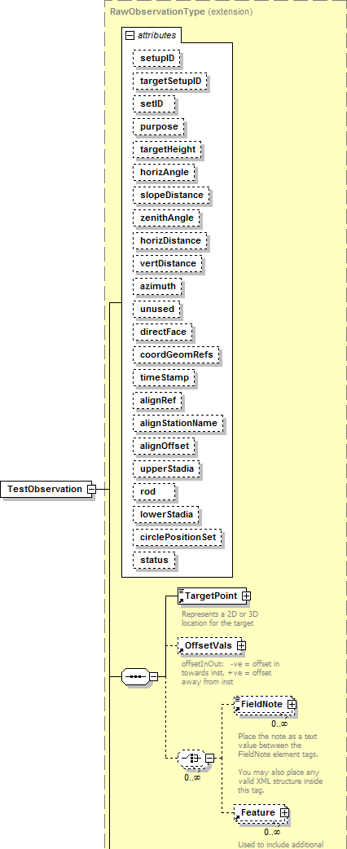

namespace | 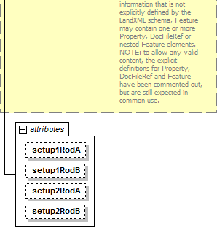
 | http://www.landxml.org/schema/LandXML-1.2
type | extension of RawObservationType
properties | content complex  mixed false
children | TargetPoint OffsetVals FieldNote Feature
used by | element ControlChecks
attributes | Name Type Use Default Fixed annotation setupID xs:IDREF  targetSetupID xs:IDREF  setID  purpose purposeTy pe  targetHeight xs:double  horizAngle angle optional  slopeDistance xs:double optional  zenithAngle zenithAngle optional  horizDistance xs:double  vertDistance xs:double  azimuth direction optional  unused xs:boolean  directFace xs:boolean coordGeomRefs coordGeomNameRefs timeStamp xs:dateTime  alignRef alignmentNameRef alignStationName xs:string alignOffset offsetDistance  up perStadia xs:double  rod xs:double  lowerStadia xs:double  circlePositionSet xs:double  status observationStatusType  setup1RodA xs:double  setup1RodB xs:double  setup2RodA xs:double  setup2RodB xs:double
source | <xs:element name="TestObservation">  <xs:complexType mixed="false">  <xs:complexContent mixed="false">

<xs:extension base="RawObservationType">
<xs:attribute name="setup1RodA" type="xs:double"/>
<xs:attribute name="setup1RodB" type="xs:double"/>
<xs:attribute name="setup2RodA" type="xs:double"/>
<xs:attribute name="setup2RodB" type="xs:double"/>
</xs:extension>
</xs:complexContent>
</xs:complexType>
</xs:element>

attribute TestObservation/@setup1RodA
type | xs:double
properties | isRef 0
source | <xs:attribute name="setup1RodA" type="xs:double"/>

attribute TestObservation/@setup1RodB
type | xs:double
properties | isRef 0
source | <xs:attribute name="setup1RodB" type="xs:double"/>

attribute TestObservation/@setup2RodA
type | xs:double
properties | isRef 0
source | <xs:attribute name="setup2RodA" type="xs:double"/>

attribute TestObservation/@setup2RodB
type | xs:double
properties | isRef 0
source | <xs:attribute name="setup2RodB" type="xs:double"/>

XML Schema documentation generated by XMLSpy Schema Editor http://www.altova.com/xmlspy

element ReducedArcObservation

diagram

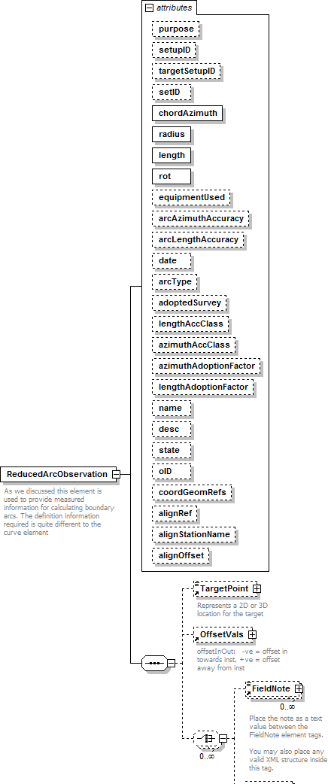

namespace | 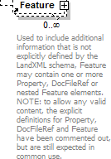
 | http://www.landxml.org/schema/LandXML-1.2
properties | content complex
children | TargetPoint OffsetVals FieldNote Feature
used by | element ObservationGroup
attributes | Name Type Use Default Fixed annotation purpose purposeTy pe  setupID xs:IDREF  targetSetupID xs:IDREF  setID  chordAzimuth direction required  radius xs:double required  length xs:double required  rot clockwise required equipmentUsed equipmentTy pe arcAzimuthAccuracy xs:double  arcLengthAccuracy xs:double  date xs:date  arcType xs:string  adoptedSurvey xs:string  lengthAccClass xs:string azimuthAccClass xs:string azimuthAdoptionFactorxs:double lengthAdoptionFactor xs:double name xs:string  desc xs:string  state stateType  oID xs:string  coordGeomRefs coordGeomNameRefs alignRef alignmentNameRef alignStationName xs:string  alignOffset offsetDistance
annotation | documentation  As we discussed this element is used to provide measured information for calculating boundary arcs. The definition information required is quite different to the curve element
source | <xs:element name="ReducedArcObservation">  <xs:annotation>  <xs:documentation>As we discussed this element is used to provide measured information for calculating boundary arcs. The definition information required is quite different to the curve element</xs:documentation>  </xs:annotation>  <xs:complexType>  <xs:sequence>  <xs:element ref="TargetPoint" minOccurs="0"/>  <xs:element ref="OffsetVals" minOccurs="0"/>

<xs:choice minOccurs="0" maxOccurs="unbounded">
<xs:element ref="FieldNote" minOccurs="0" maxOccurs="unbounded"/>
<xs:element ref="Feature" minOccurs="0" maxOccurs="unbounded"/>
</xs:choice>
</xs:sequence>
<xs:attribute name="purpose" type="purposeType"/>
<xs:attribute name="setupID" type="xs:IDREF"/>
<xs:attribute name="targetSetupID" type="xs:IDREF"/>
<xs:attribute name="setID"/>
<xs:attribute name="chordAzimuth" type="direction" use="required"/>
<xs:attribute name="radius" type="xs:double" use="required"/>
<xs:attribute name="length" type="xs:double" use="required"/>
<xs:attribute name="rot" type="clockwise" use="required"/>
<xs:attribute name="equipmentUsed" type="equipmentType"/>
<xs:attribute name="arcAzimuthAccuracy" type="xs:double"/>
<xs:attribute name="arcLengthAccuracy" type="xs:double"/>
<xs:attribute name="date" type="xs:date"/>
<xs:attribute name="arcType" type="xs:string"/>
<xs:attribute name="adoptedSurvey" type="xs:string"/>
<xs:attribute name="lengthAccClass" type="xs:string"/>
<xs:attribute name="azimuthAccClass" type="xs:string"/>
<xs:attribute name="azimuthAdoptionFactor" type="xs:double"/>
<xs:attribute name="lengthAdoptionFactor" type="xs:double"/>
<xs:attribute name="name" type="xs:string"/>
<xs:attribute name="desc" type="xs:string"/>
<xs:attribute name="state" type="stateType"/>
<xs:attribute name="oID" type="xs:string"/>
<xs:attribute name="coordGeomRefs" type="coordGeomNameRefs"/>
<xs:attribute name="alignRef" type="alignmentNameRef"/>
<xs:attribute name="alignStationName" type="xs:string"/>
<xs:attribute name="alignOffset" type="offsetDistance"/>
<!-- coordGeomRefs identifies one or more 'name' values that link to specific <Line>, <Curve>,
<Spiral> or <IrregularLine> in a <CoordGeom> element. This allows linking an survey observation to specific <Parcel>.<CoordGeom> based geometry. -->
<!-- alignRef is the name of the alignment.
alignStationName is the station value where the rod reading is taken. alignOffset is the signed (+/-) distance from the CL of the referenced alignment. -->
</xs:complexType>
</xs:element>

attribute ReducedArcObservation/@purpose
type | purposeTy pe
properties | isRef 0
facets | enumeration normal enumeration check enumeration backsight enumeration foresight enumeration traverse enumeration sideshot enumeration resection enumeration levelLoop enumeration digitalLevel enumeration remoteElevation  enumeration recipricalObservation  enumeration topo enumeration cutSheets enumeration asbuilt
source | <xs:attribute name="purpose" type="purposeType"/>

attribute ReducedArcObservation/@setupID
type | xs:IDREF
properties | isRef 0
source | <xs:attribute name="setupID" type="xs:IDREF"/>

attribute ReducedArcObservation/@targetSetupID
type | xs:IDREF
properties | isRef 0
source | <xs:attribute name="targetSetupID" type="xs:IDREF"/>

attribute ReducedArcObservation/@setID
properties | isRef 0
source | <xs:attribute name="setID"/>

attribute ReducedArcObservation/@chordAzimuth
type | direction
properties | isRef 0  use required
source | <xs:attribute name="chordAzimuth" type="direction" use="required"/>

attribute ReducedArcObservation/@radius
type | xs:double
properties | isRef 0  use required
source | <xs:attribute name="radius" type="xs:double" use="required"/>

attribute ReducedArcObservation/@length
type | xs:double
properties | isRef 0  use required
source | <xs:attribute name="length" type="xs:double" use="required"/>

attribute ReducedArcObservation/@rot
type | clockwise
properties | isRef 0  use required
facets | enumeration cw  enumeration ccw
source | <xs:attribute name="rot" type="clockwise" use="required"/>

attribute ReducedArcObservation/@equipmentUsed
type | equipmentTy pe

properties | isRef 0
source | <xs:attribute name="equipmentUsed" type="equipmentType"/>

attribute ReducedArcObservation/@arcAzimuthAccuracy
type | xs:double
properties | isRef 0
source | <xs:attribute name="arcAzimuthAccuracy" type="xs:double"/>

attribute ReducedArcObservation/@arcLengthAccuracy
type | xs:double
properties | isRef 0
source | <xs:attribute name="arcLengthAccuracy" type="xs:double"/>

attribute ReducedArcObservation/@date
type | xs:date
properties | isRef 0
source | <xs:attribute name="date" type="xs:date"/>

attribute ReducedArcObservation/@arcType
type | xs:string
properties | isRef 0
source | <xs:attribute name="arcType" type="xs:string"/>

attribute ReducedArcObservation/@adoptedSurvey
type | xs:string
properties | isRef 0
source | <xs:attribute name="adoptedSurvey" type="xs:string"/>

attribute ReducedArcObservation/@lengthAccClass
type | xs:string
properties | isRef 0
source | <xs:attribute name="lengthAccClass" type="xs:string"/>

attribute ReducedArcObservation/@azimuthAccClass
type | xs:string
properties | isRef 0
source | <xs:attribute name="azimuthAccClass" type="xs:string"/>

attribute ReducedArcObservation/@azimuthAdoptionFactor
type | xs:double
properties | isRef 0

source | <xs:attribute name="azimuthAdoptionFactor" type="xs:double"/>

attribute ReducedArcObservation/@lengthAdoptionFactor
type | xs:double
properties | isRef 0
source | <xs:attribute name="lengthAdoptionFactor" type="xs:double"/>

attribute ReducedArcObservation/@name
type | xs:string
properties | isRef 0
source | <xs:attribute name="name" type="xs:string"/>

attribute ReducedArcObservation/@desc
type | xs:string
properties | isRef 0
source | <xs:attribute name="desc" type="xs:string"/>

attribute ReducedArcObservation/@state
type | stateType
properties | isRef 0
facets | enumeration abandoned enumeration destroyed enumeration existing enumeration proposed
source | <xs:attribute name="state" type="stateType"/>

attribute ReducedArcObservation/@oID
type | xs:string
properties | isRef 0
source | <xs:attribute name="oID" type="xs:string"/>

attribute ReducedArcObservation/@coordGeomRefs
type | coordGeomNameRefs
properties | isRef 0
source | <xs:attribute name="coordGeomRefs" type="coordGeomNameRefs"/>

attribute ReducedArcObservation/@alignRef
type | alignmentNameRef
properties | isRef 0
source | <xs:attribute name="alignRef" type="alignmentNameRef"/>

attribute ReducedArcObservation/@alignStationName
type | xs:string
properties | isRef 0
source | <xs:attribute name="alignStationName" type="xs:string"/>

attribute ReducedArcObservation/@alignOffset
type | offsetDistance
properties | isRef 0
source | <xs:attribute name="alignOffset" type="offsetDistance"/>

XML Schema documentation generated by XMLSpy Schema Editor http://www.altova.com/xmlspy

element ReducedObservation

diagram

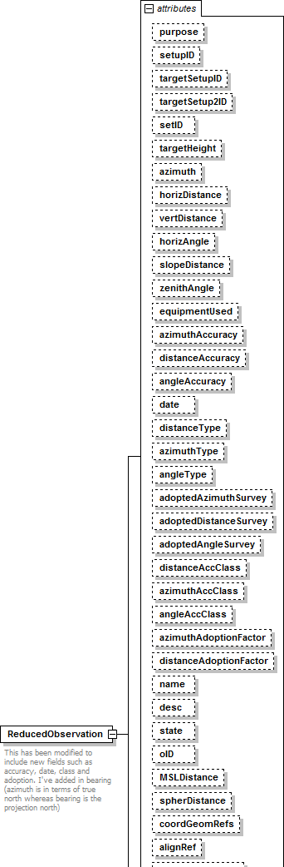

namespace | 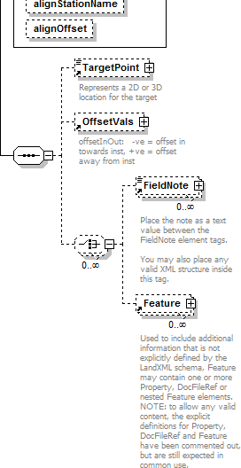
 | http://www.landxml.org/schema/LandXML-1.2
properties | content complex
children | TargetPoint OffsetVals FieldNote Feature
used by | element ObservationGroup
attributes | Name Type Use Default Fixed annotation purpose purposeTy pe  setupID xs:IDREF  targetSetupID xs:IDREF  targetSetup2ID xs:IDREF  setID  targetHeight xs:double  azimuth direction optional  horizDistance xs:double optional  vertDistance xs:double optional  horizAngle angle optional  slopeDistance xs:double optional  zenithAngle zenithAngle optional  equipmentUsed equipmentTy pe azimuthAccuracy xs:double distanceAccuracy xs:double angleAccuracy xs:double  date xs:date  distanceType observationType  azimuthType observationType  angleType observationType  adoptedAzimuthSurvey xs:string

adoptedDistanceSurveyxs:string adoptedAngleSurvey xs:string distanceAccClass xs:string azimuthAccClass xs:string angleAccClass xs:string azimuthAdoptionFactor xs:double distanceAdoptionFactor xs:double name xs:string
desc xs:string
state stateType
oID xs:string
MSLDistance xs:string
spherDistance xs:string coordGeomRefs coordGeomNameRefs alignRef alignmentNameRef alignStationName xs:string
alignOffset offsetDistance
annotation | documentation  This has been modified to include new fields such as accuracy, date, class and adoption. I've added in bearing (azimuth is in terms of true north whereas bearing is the projection north)  documentation  - maybe this doesn't matter, may need to discuss
source | <xs:element name="ReducedObservation">  <xs:annotation>  <xs:documentation>This has been modified to include new fields such as accuracy, date, class and adoption. I've added in bearing (azimuth is in terms of true north whereas bearing is the projection north)  </xs:documentation>  <xs:documentation> - maybe this doesn't matter, may need to discuss</xs:documentation>  </xs:annotation>  <xs:complexType>  <xs:sequence>  <xs:element ref="TargetPoint" minOccurs="0"/>  <xs:element ref="OffsetVals" minOccurs="0"/>  <xs:choice minOccurs="0" maxOccurs="unbounded">  <xs:element ref="FieldNote" minOccurs="0" maxOccurs="unbounded"/>  <xs:element ref="Feature" minOccurs="0" maxOccurs="unbounded"/>  </xs:choice>  </xs:sequence>  <xs:attribute name="purpose" type="purposeType"/>  <xs:attribute name="setupID" type="xs:IDREF"/>  <xs:attribute name="targetSetupID" type="xs:IDREF"/>  <xs:attribute name="targetSetup2ID" type="xs:IDREF"/>  <xs:attribute name="setID"/>  <xs:attribute name="targetHeight" type="xs:double"/>  <xs:attribute name="azimuth" type="direction" use="optional"/>  <xs:attribute name="horizDistance" type="xs:double" use="optional"/>  <xs:attribute name="vertDistance" type="xs:double" use="optional"/>  <xs:attribute name="horizAngle" type="angle" use="optional"/>  <xs:attribute name="slopeDistance" type="xs:double" use="optional"/>  <xs:attribute name="zenithAngle" type="zenithAngle" use="optional"/>  <xs:attribute name="equipmentUsed" type="equipmentType"/>  <xs:attribute name="azimuthAccuracy" type="xs:double"/>  <xs:attribute name="distanceAccuracy" type="xs:double"/>  <xs:attribute name="angleAccuracy" type="xs:double"/>  <xs:attribute name="date" type="xs:date"/>  <xs:attribute name="distanceType" type="observationType"/>  <xs:attribute name="azimuthType" type="observationType"/>  <xs:attribute name="angleType" type="observationType"/>  <xs:attribute name="adoptedAzimuthSurvey" type="xs:string"/>  <xs:attribute name="adoptedDistanceSurvey" type="xs:string"/>

<xs:attribute name="adoptedAngleSurvey" type="xs:string"/>
<xs:attribute name="distanceAccClass" type="xs:string"/>
<xs:attribute name="azimuthAccClass" type="xs:string"/>
<xs:attribute name="angleAccClass" type="xs:string"/>
<xs:attribute name="azimuthAdoptionFactor" type="xs:double"/>
<xs:attribute name="distanceAdoptionFactor" type="xs:double"/>
<xs:attribute name="name" type="xs:string"/>
<xs:attribute name="desc" type="xs:string"/>
<xs:attribute name="state" type="stateType"/>
<xs:attribute name="oID" type="xs:string"/>
<xs:attribute name="MSLDistance" type="xs:string"/>
<xs:attribute name="spherDistance" type="xs:string"/>
<xs:attribute name="coordGeomRefs" type="coordGeomNameRefs"/>
<xs:attribute name="alignRef" type="alignmentNameRef"/>
<xs:attribute name="alignStationName" type="xs:string"/>
<xs:attribute name="alignOffset" type="offsetDistance"/>
<!-- coordGeomRefs identifies one or more 'name' values that link to specific <Line>, <Curve>,
<Spiral> or <IrregularLine> in a <CoordGeom> element.
This allows linking an survey observation to specific <Parcel>.<CoordGeom> based geometry. -->
<!-- alignRef is the name of the alignment.
alignStationName is the station value where the rod reading is taken.
alignOffset is the signed (+/-) distance from the CL of the referenced alignment. -->
</xs:complexType>
</xs:element>

attribute ReducedObservation/@purpose
type | purposeTy pe
properties | isRef 0
facets | enumeration normal enumeration check enumeration backsight enumeration foresight enumeration traverse enumeration sideshot enumeration resection enumeration levelLoop enumeration digitalLevel enumeration remoteElevation  enumeration recipricalObservation  enumeration topo enumeration cutSheets enumeration asbuilt
source | <xs:attribute name="purpose" type="purposeType"/>

attribute ReducedObservation/@setupID
type | xs:IDREF
properties | isRef 0
source | <xs:attribute name="setupID" type="xs:IDREF"/>

attribute ReducedObservation/@targetSetupID
type | xs:IDREF
properties | isRef 0

source | <xs:attribute name="targetSetupID" type="xs:IDREF"/>

attribute ReducedObservation/@targetSetup2ID
type | xs:IDREF
properties | isRef 0
source | <xs:attribute name="targetSetup2ID" type="xs:IDREF"/>

attribute ReducedObservation/@setID
properties | isRef 0
source | <xs:attribute name="setID"/>

attribute ReducedObservation/@targetHeight
type | xs:double
properties | isRef 0
source | <xs:attribute name="targetHeight" type="xs:double"/>

attribute ReducedObservation/@azimuth
type | direction
properties | isRef 0  use optional
source | <xs:attribute name="azimuth" type="direction" use="optional"/>

attribute ReducedObservation/@horizDistance
type | xs:double
properties | isRef 0  use optional
source | <xs:attribute name="horizDistance" type="xs:double" use="optional"/>

attribute ReducedObservation/@vertDistance
type | xs:double
properties | isRef 0  use optional
source | <xs:attribute name="vertDistance" type="xs:double" use="optional"/>

attribute ReducedObservation/@horizAngle
type | angle
properties | isRef 0  use optional
source | <xs:attribute name="horizAngle" type="angle" use="optional"/>

attribute ReducedObservation/@slopeDistance
type | xs:double
properties | isRef 0

 | use optional
source | <xs:attribute name="slopeDistance" type="xs:double" use="optional"/>

attribute ReducedObservation/@zenithAngle
type | zenithAngle
properties | isRef 0  use optional
source | <xs:attribute name="zenithAngle" type="zenithAngle" use="optional"/>

attribute ReducedObservation/@equipmentUsed
type | equipmentTy pe
properties | isRef 0
source | <xs:attribute name="equipmentUsed" type="equipmentType"/>

attribute ReducedObservation/@azimuthAccuracy
type | xs:double
properties | isRef 0
source | <xs:attribute name="azimuthAccuracy" type="xs:double"/>

attribute ReducedObservation/@distanceAccuracy
type | xs:double
properties | isRef 0
source | <xs:attribute name="distanceAccuracy" type="xs:double"/>

attribute ReducedObservation/@angleAccuracy
type | xs:double
properties | isRef 0
source | <xs:attribute name="angleAccuracy" type="xs:double"/>

attribute ReducedObservation/@date
type | xs:date
properties | isRef 0
source | <xs:attribute name="date" type="xs:date"/>

attribute ReducedObservation/@distanceType
type | observationType
properties | isRef 0
source | <xs:attribute name="distanceType" type="observationType"/>

attribute ReducedObservation/@azimuthType
type | observationType
properties | isRef 0

source | <xs:attribute name="azimuthType" type="observationType"/>

attribute ReducedObservation/@angleType
type | observationType
properties | isRef 0
source | <xs:attribute name="angleType" type="observationType"/>

attribute ReducedObservation/@adoptedAzimuthSurvey
type | xs:string
properties | isRef 0
source | <xs:attribute name="adoptedAzimuthSurvey" type="xs:string"/>

attribute ReducedObservation/@adoptedDistanceSurvey
type | xs:string
properties | isRef 0
source | <xs:attribute name="adoptedDistanceSurvey" type="xs:string"/>

attribute ReducedObservation/@adoptedAngleSurvey
type | xs:string
properties | isRef 0
source | <xs:attribute name="adoptedAngleSurvey" type="xs:string"/>

attribute ReducedObservation/@distanceAccClass
type | xs:string
properties | isRef 0
source | <xs:attribute name="distanceAccClass" type="xs:string"/>

attribute ReducedObservation/@azimuthAccClass
type | xs:string
properties | isRef 0
source | <xs:attribute name="azimuthAccClass" type="xs:string"/>

attribute ReducedObservation/@angleAccClass
type | xs:string
properties | isRef 0
source | <xs:attribute name="angleAccClass" type="xs:string"/>

attribute ReducedObservation/@azimuthAdoptionFactor
type | xs:double
properties | isRef 0
source | <xs:attribute name="azimuthAdoptionFactor" type="xs:double"/>

attribute ReducedObservation/@distanceAdoptionFactor
type | xs:double
properties | isRef 0
source | <xs:attribute name="distanceAdoptionFactor" type="xs:double"/>

attribute ReducedObservation/@name
type | xs:string
properties | isRef 0
source | <xs:attribute name="name" type="xs:string"/>

attribute ReducedObservation/@desc
type | xs:string
properties | isRef 0
source | <xs:attribute name="desc" type="xs:string"/>

attribute ReducedObservation/@state
type | stateType
properties | isRef 0
facets | enumeration abandoned enumeration destroyed enumeration existing enumeration proposed
source | <xs:attribute name="state" type="stateType"/>

attribute ReducedObservation/@oID
type | xs:string
properties | isRef 0
source | <xs:attribute name="oID" type="xs:string"/>

attribute ReducedObservation/@MSLDistance
type | xs:string
properties | isRef 0
source | <xs:attribute name="MSLDistance" type="xs:string"/>

attribute ReducedObservation/@spherDistance
type | xs:string
properties | isRef 0
source | <xs:attribute name="spherDistance" type="xs:string"/>

attribute ReducedObservation/@coordGeomRefs
type | coordGeomNameRefs
properties | isRef 0

source | <xs:attribute name="coordGeomRefs" type="coordGeomNameRefs"/>

attribute ReducedObservation/@alignRef
type | alignmentNameRef
properties | isRef 0
source | <xs:attribute name="alignRef" type="alignmentNameRef"/>

attribute ReducedObservation/@alignStationName
type | xs:string
properties | isRef 0
source | <xs:attribute name="alignStationName" type="xs:string"/>

attribute ReducedObservation/@alignOffset
type | offsetDistance
properties | isRef 0
source | <xs:attribute name="alignOffset" type="offsetDistance"/>

XML Schema documentation generated by XMLSpy Schema Editor http://www.altova.com/xmlspy

element RedVerticalObservation
diagram | 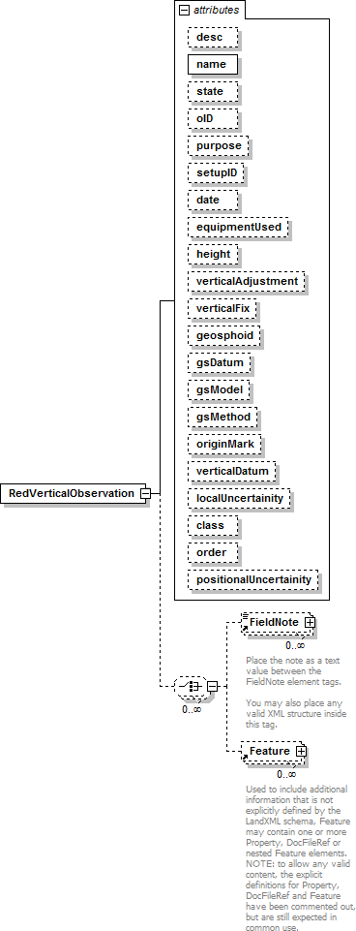
namespace | http://www.landxml.org/schema/LandXML-1.2

properties | content complex
children | FieldNote Feature
used by | element ObservationGroup
attributes | Name Type Use Default Fixed annotation desc xs:string  name xs:string required  state xs:string  oID xs:string  purpose purposeTy pe  setupID xs:IDREF  date xs:date  equipmentUsed equipmentTy pe height xs:double verticalAdjustment xs:string verticalFix xs:string  geosphoid xs:double  gsDatum xs:string  gsModel xs:string  gsMethod xs:string  originMark xs:string  verticalDatum xs:string localUncertainity xs:double class xs:string  order xs:string  positionalUncertainity xs:double
source | <xs:element name="RedVerticalObservation">  <xs:complexType>  <xs:choice minOccurs="0" maxOccurs="unbounded">  <xs:element ref="FieldNote" minOccurs="0" maxOccurs="unbounded"/>  <xs:element ref="Feature" minOccurs="0" maxOccurs="unbounded"/>  </xs:choice>  <xs:attribute name="desc" type="xs:string"/>  <xs:attribute name="name" type="xs:string" use="required"/>  <xs:attribute name="state" type="xs:string"/>  <xs:attribute name="oID" type="xs:string"/>  <xs:attribute name="purpose" type="purposeType"/>  <xs:attribute name="setupID" type="xs:IDREF"/>  <xs:attribute name="date" type="xs:date"/>  <xs:attribute name="equipmentUsed" type="equipmentType"/>  <xs:attribute name="height" type="xs:double"/>  <xs:attribute name="verticalAdjustment" type="xs:string"/>  <xs:attribute name="verticalFix" type="xs:string"/>  <xs:attribute name="geosphoid" type="xs:double"/>  <xs:attribute name="gsDatum" type="xs:string"/>  <xs:attribute name="gsModel" type="xs:string"/>  <xs:attribute name="gsMethod" type="xs:string"/>  <xs:attribute name="originMark" type="xs:string"/>  <xs:attribute name="verticalDatum" type="xs:string"/>  <xs:attribute name="localUncertainity" type="xs:double"/>  <xs:attribute name="class" type="xs:string"/>  <xs:attribute name="order" type="xs:string"/>  <xs:attribute name="positionalUncertainity" type="xs:double"/>  </xs:complexType>  </xs:element>

attribute RedVerticalObservation/@desc
type | xs:string

properties | isRef 0
source | <xs:attribute name="desc" type="xs:string"/>

attribute RedVerticalObservation/@name
type | xs:string
properties | isRef 0  use required
source | <xs:attribute name="name" type="xs:string" use="required"/>

attribute RedVerticalObservation/@state
type | xs:string
properties | isRef 0
source | <xs:attribute name="state" type="xs:string"/>

attribute RedVerticalObservation/@oID
type | xs:string
properties | isRef 0
source | <xs:attribute name="oID" type="xs:string"/>

attribute RedVerticalObservation/@purpose
type | purposeTy pe
properties | isRef 0
facets | enumeration normal enumeration check enumeration backsight enumeration foresight enumeration traverse enumeration sideshot enumeration resection enumeration levelLoop enumeration digitalLevel enumeration remoteElevation  enumeration recipricalObservation  enumeration topo enumeration cutSheets enumeration asbuilt
source | <xs:attribute name="purpose" type="purposeType"/>

attribute RedVerticalObservation/@setupID
type | xs:IDREF
properties | isRef 0
source | <xs:attribute name="setupID" type="xs:IDREF"/>

attribute RedVerticalObservation/@date
type | xs:date
properties | isRef 0

source | <xs:attribute name="date" type="xs:date"/>

attribute RedVerticalObservation/@equipmentUsed
type | equipmentTy pe
properties | isRef 0
source | <xs:attribute name="equipmentUsed" type="equipmentType"/>

attribute RedVerticalObservation/@height
type | xs:double
properties | isRef 0
source | <xs:attribute name="height" type="xs:double"/>

attribute RedVerticalObservation/@verticalAdjustment
type | xs:string
properties | isRef 0
source | <xs:attribute name="verticalAdjustment" type="xs:string"/>

attribute RedVerticalObservation/@verticalFix
type | xs:string
properties | isRef 0
source | <xs:attribute name="verticalFix" type="xs:string"/>

attribute RedVerticalObservation/@geosphoid
type | xs:double
properties | isRef 0
source | <xs:attribute name="geosphoid" type="xs:double"/>

attribute RedVerticalObservation/@gsDatum
type | xs:string
properties | isRef 0
source | <xs:attribute name="gsDatum" type="xs:string"/>

attribute RedVerticalObservation/@gsModel
type | xs:string
properties | isRef 0
source | <xs:attribute name="gsModel" type="xs:string"/>

attribute RedVerticalObservation/@gsMethod
type | xs:string
properties | isRef 0
source | <xs:attribute name="gsMethod" type="xs:string"/>

attribute RedVerticalObservation/@originMark
type | xs:string
properties | isRef 0
source | <xs:attribute name="originMark" type="xs:string"/>

attribute RedVerticalObservation/@verticalDatum
type | xs:string
properties | isRef 0
source | <xs:attribute name="verticalDatum" type="xs:string"/>

attribute RedVerticalObservation/@localUncertainity
type | xs:double
properties | isRef 0
source | <xs:attribute name="localUncertainity" type="xs:double"/>

attribute RedVerticalObservation/@class
type | xs:string
properties | isRef 0
source | <xs:attribute name="class" type="xs:string"/>

attribute RedVerticalObservation/@order
type | xs:string
properties | isRef 0
source | <xs:attribute name="order" type="xs:string"/>

attribute RedVerticalObservation/@positionalUncertainity
type | xs:double
properties | isRef 0
source | <xs:attribute name="positionalUncertainity" type="xs:double"/>

XML Schema documentation generated by XMLSpy Schema Editor http://www.altova.com/xmlspy

element RedHorizontalPosition
diagram | 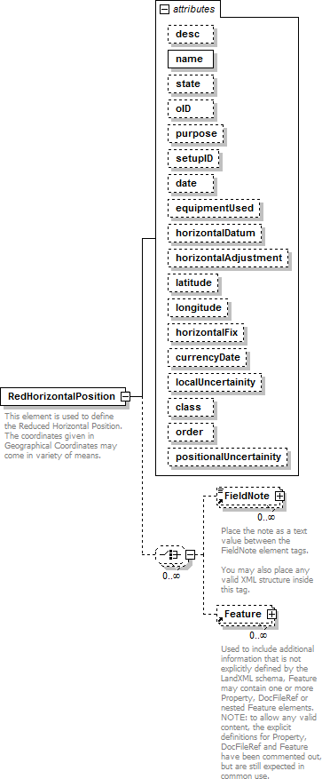
namespace | http://www.landxml.org/schema/LandXML-1.2
properties | content complex
children | FieldNote Feature
used by | element ObservationGroup

attributes | Name Type  desc xs:string  name xs:string  state xs:string  oID xs:string  purpose purposeTy pe  setupID xs:IDREF  date xs:date  equipmentUsed equipmentTy pe horizontalDatum xs:string horizontalAdjustment xs:string latitude xs:string  longitude xs:string  horizontalFix xs:string  currencyDate xs:string localUncertainity xs:double class xs:string  order xs:string  positionalUncertainity xs:double | Use  required | Default | Fixed | annotation
annotation | documentation  This element is used to define the Reduced Horizontal Position. The coordinates given in Geographical Coordinates may come in variety of means.
source | <xs:element name="RedHorizontalPosition">  <xs:annotation>  <xs:documentation>This element is used to define the Reduced Horizontal Position. The coordinates given in Geographical Coordinates may come in variety of means. </xs:documentation>  </xs:annotation>  <xs:complexType>  <xs:choice minOccurs="0" maxOccurs="unbounded">  <xs:element ref="FieldNote" minOccurs="0" maxOccurs="unbounded"/>  <xs:element ref="Feature" minOccurs="0" maxOccurs="unbounded"/>  </xs:choice>  <xs:attribute name="desc" type="xs:string"/>  <xs:attribute name="name" type="xs:string" use="required"/>  <xs:attribute name="state" type="xs:string"/>  <xs:attribute name="oID" type="xs:string"/>  <xs:attribute name="purpose" type="purposeType"/>  <xs:attribute name="setupID" type="xs:IDREF"/>  <xs:attribute name="date" type="xs:date"/>  <xs:attribute name="equipmentUsed" type="equipmentType"/>  <xs:attribute name="horizontalDatum" type="xs:string"/>  <xs:attribute name="horizontalAdjustment" type="xs:string"/>  <xs:attribute name="latitude" type="xs:string"/>  <xs:attribute name="longitude" type="xs:string"/>  <xs:attribute name="horizontalFix" type="xs:string"/>  <xs:attribute name="currencyDate" type="xs:string"/>  <xs:attribute name="localUncertainity" type="xs:double"/>  <xs:attribute name="class" type="xs:string"/>  <xs:attribute name="order" type="xs:string"/>  <xs:attribute name="positionalUncertainity" type="xs:double"/>  </xs:complexType>  </xs:element>

attribute RedHorizontalPosition/@desc
type | xs:string
properties | isRef 0
source | <xs:attribute name="desc" type="xs:string"/>

attribute RedHorizontalPosition/@name
type | xs:string
properties | isRef 0  use required
source | <xs:attribute name="name" type="xs:string" use="required"/>

attribute RedHorizontalPosition/@state
type | xs:string
properties | isRef 0
source | <xs:attribute name="state" type="xs:string"/>

attribute RedHorizontalPosition/@oID
type | xs:string
properties | isRef 0
source | <xs:attribute name="oID" type="xs:string"/>

attribute RedHorizontalPosition/@purpose
type | purposeTy pe
properties | isRef 0
facets | enumeration normal enumeration check enumeration backsight enumeration foresight enumeration traverse enumeration sideshot enumeration resection enumeration levelLoop enumeration digitalLevel enumeration remoteElevation  enumeration recipricalObservation  enumeration topo enumeration cutSheets enumeration asbuilt
source | <xs:attribute name="purpose" type="purposeType"/>

attribute RedHorizontalPosition/@setupID
type | xs:IDREF
properties | isRef 0
source | <xs:attribute name="setupID" type="xs:IDREF"/>

attribute RedHorizontalPosition/@date
type | xs:date
properties | isRef 0
source | <xs:attribute name="date" type="xs:date"/>

attribute RedHorizontalPosition/@equipmentUsed
type | equipmentTy pe
properties | isRef 0
source | <xs:attribute name="equipmentUsed" type="equipmentType"/>

attribute RedHorizontalPosition/@horizontalDatum
type | xs:string
properties | isRef 0
source | <xs:attribute name="horizontalDatum" type="xs:string"/>

attribute RedHorizontalPosition/@horizontalAdjustment
type | xs:string
properties | isRef 0
source | <xs:attribute name="horizontalAdjustment" type="xs:string"/>

attribute RedHorizontalPosition/@latitude
type | xs:string
properties | isRef 0
source | <xs:attribute name="latitude" type="xs:string"/>

attribute RedHorizontalPosition/@longitude
type | xs:string
properties | isRef 0
source | <xs:attribute name="longitude" type="xs:string"/>

attribute RedHorizontalPosition/@horizontalFix
type | xs:string
properties | isRef 0
source | <xs:attribute name="horizontalFix" type="xs:string"/>

attribute RedHorizontalPosition/@currencyDate
type | xs:string
properties | isRef 0
source | <xs:attribute name="currencyDate" type="xs:string"/>

attribute RedHorizontalPosition/@localUncertainity
type | xs:double
properties | isRef 0
source | <xs:attribute name="localUncertainity" type="xs:double"/>

attribute RedHorizontalPosition/@class
type | xs:string

properties | isRef 0
source | <xs:attribute name="class" type="xs:string"/>

attribute RedHorizontalPosition/@order
type | xs:string
properties | isRef 0
source | <xs:attribute name="order" type="xs:string"/>

attribute RedHorizontalPosition/@positionalUncertainity
type | xs:double
properties | isRef 0
source | <xs:attribute name="positionalUncertainity" type="xs:double"/>

XML Schema documentation generated by XMLSpy Schema Editor http://www.altova.com/xmlspy

element Backsight
diagram | 
namespace | http://www.landxml.org/schema/LandXML-1.2
properties | content complex
children | BacksightPoint FieldNote Feature
used by | elements InstrumentSetup LaserSetup ObservationGroup
attributes | Name Type Use Default Fixed annotation id xs:ID  azimuth direction  targetHeight xs:double  circle angle required  setupID xs:IDREF
source | <xs:element name="Backsight">  <xs:annotation>  <xs:documentation/>  </xs:annotation>  <xs:complexType>  <xs:sequence>  <xs:element ref="BacksightPoint" minOccurs="0"/>  <xs:choice>  <xs:element ref="FieldNote" minOccurs="0" maxOccurs="unbounded"/>  <xs:element ref="Feature" minOccurs="0" maxOccurs="unbounded"/>

</xs:choice>
</xs:sequence>
<xs:attribute name="id" type="xs:ID"/>
<xs:attribute name="azimuth" type="direction"/>
<xs:attribute name="targetHeight" type="xs:double"/>
<xs:attribute name="circle" type="angle" use="required"/>
<xs:attribute name="setupID" type="xs:IDREF"/>
</xs:complexType>
</xs:element>

attribute Backsight/@id
type | xs:ID
properties | isRef 0
source | <xs:attribute name="id" type="xs:ID"/>

attribute Backsight/@azimuth
type | direction
properties | isRef 0
source | <xs:attribute name="azimuth" type="direction"/>

attribute Backsight/@targetHeight
type | xs:double
properties | isRef 0
source | <xs:attribute name="targetHeight" type="xs:double"/>

attribute Backsight/@circle
type | angle
properties | isRef 0  use required
source | <xs:attribute name="circle" type="angle" use="required"/>

attribute Backsight/@setupID
type | xs:IDREF
properties | isRef 0
source | <xs:attribute name="setupID" type="xs:IDREF"/>

XML Schema documentation generated by XMLSpy Schema Editor http://www.altova.com/xmlspy

element BacksightPoint
diagram | 
namespace | http://www.landxml.org/schema/LandXML-1.2
type | PointType
properties | content complex  mixed true
used by | element Backsight
facets | minLength 0  maxLength 3
attributes | Name Type Use Default Fixed annotation name xs:string  desc xs:string  code xs:string  state stateType  pntRef pointNameRef  featureRef featureNameRef optional pointGeometry pointGeometry Type DTMAttribute DTMAttributeType  timeStamp xs:dateTime optional  role surveyRoleType optional  determinedTimeStamp xs:dateTime optional

ellipsoidHeight ellipsoidHeightType optional

latitude latLongAngle optional
longitude latLongAngle optional
zone xs:string optional
northingStdError xs:double optional
eastingStdError xs:double optional
elevationStdError xs:double optional
annotation | documentation  Represents a 2D or 3D location for the backsight  documentation  It is defined by either a coordinate text value ("north east" or "north east elev") or a CgPoint number reference "pntRef" attribute.
source | <xs:element name="BacksightPoint" type="PointType">  <xs:annotation>  <xs:documentation>Represents a 2D or 3D location for the backsight</xs:documentation>  <xs:documentation>It is defined by either a coordinate text value ("north east" or "north east elev") or a CgPoint number reference "pntRef" attribute.</xs:documentation>  </xs:annotation>  </xs:element>

XML Schema documentation generated by XMLSpy Schema Editor http://www.altova.com/xmlspy

element InstrumentPoint
diagram | 
namespace | http://www.landxml.org/schema/LandXML-1.2
type | PointType
properties | content complex  mixed true
used by | elements InstrumentSetup LaserSetup
facets | minLength 0  maxLength 3
attributes | Name Type Use Default Fixed annotation name xs:string  desc xs:string  code xs:string  state stateType  pntRef pointNameRef  featureRef featureNameRef optional pointGeometry pointGeometry Type DTMAttribute DTMAttributeType  timeStamp xs:dateTime optional  role surveyRoleType optional  determinedTimeStamp xs:dateTime optional

ellipsoidHeight ellipsoidHeightType optional

latitude latLongAngle optional
longitude latLongAngle optional
zone xs:string optional
northingStdError xs:double optional
eastingStdError xs:double optional
elevationStdError xs:double optional
annotation | documentation  Represents a 2D or 3D Point location for Survey instrument location  documentation  Defined by either a coordinate text value ("north east" or "north east elev") or a PointType number reference "pntRef" attribute.
source | <xs:element name="InstrumentPoint" type="PointType">  <xs:annotation>  <xs:documentation>Represents a 2D or 3D Point location for Survey instrument location</xs:documentation>  <xs:documentation>Defined by either a coordinate text value ("north east" or "north east elev") or a PointType number reference "pntRef" attribute.</xs:documentation>  </xs:annotation>  </xs:element>

XML Schema documentation generated by XMLSpy Schema Editor http://www.altova.com/xmlspy

element InstrumentSetup
diagram | 

namespace | http://www.landxml.org/schema/LandXML-1.2
properties | content complex
children | InstrumentPoint Backsight TargetSetup RawObservation ObservationGroup ControlChecks FieldNote Feature
used by | element Survey
attributes | Name Type Use Default Fixed annotation id xs:ID required  instrumentDetailsID xs:IDREF  stationName xs:string required  instrumentHeight xs:double required  orientationAzimuth direction  circleAzimuth direction  status observationStatusType
annotation | documentation  The Instrument setup location is defined by either a coordinate text value ("north east" or "north east elev") or a CgPoint number reference "pntRef" attribute.
source | <xs:element name="InstrumentSetup">  <xs:annotation>  <xs:documentation>The Instrument setup location is defined by either a coordinate text value ("north east" or "north east elev") or a CgPoint number reference "pntRef" attribute.</xs:documentation>  </xs:annotation>  <xs:complexType>  <xs:sequence>  <xs:choice minOccurs="0" maxOccurs="unbounded">  <xs:element ref="InstrumentPoint" minOccurs="0"/>  <xs:element ref="Backsight" minOccurs="0" maxOccurs="unbounded"/>  <xs:element ref="TargetSetup" minOccurs="0" maxOccurs="unbounded"/>  <xs:element ref="RawObservation" minOccurs="0" maxOccurs="unbounded"/>  <xs:element ref="ObservationGroup" minOccurs="0" maxOccurs="unbounded"/>  <xs:element ref="ControlChecks" minOccurs="0" maxOccurs="unbounded"/>  <xs:element ref="FieldNote" minOccurs="0" maxOccurs="unbounded"/>  <xs:element ref="Feature" minOccurs="0" maxOccurs="unbounded"/>  </xs:choice>  </xs:sequence>  <xs:attribute name="id" type="xs:ID" use="required"/>  <xs:attribute name="instrumentDetailsID" type="xs:IDREF"/>  <xs:attribute name="stationName" type="xs:string" use="required"/>  <xs:attribute name="instrumentHeight" type="xs:double" use="required"/>  <xs:attribute name="orientationAzimuth" type="direction"/>  <xs:attribute name="circleAzimuth" type="direction"/>  <xs:attribute name="status" type="observationStatusType"/>  </xs:complexType>  </xs:element>

attribute InstrumentSetup/@id
type | xs:ID
properties | isRef 0  use required
source | <xs:attribute name="id" type="xs:ID" use="required"/>

attribute InstrumentSetup/@instrumentDetailsID
type | xs:IDREF
properties | isRef 0

source | <xs:attribute name="instrumentDetailsID" type="xs:IDREF"/>

attribute InstrumentSetup/@stationName
type | xs:string
properties | isRef 0  use required
source | <xs:attribute name="stationName" type="xs:string" use="required"/>

attribute InstrumentSetup/@instrumentHeight
type | xs:double
properties | isRef 0  use required
source | <xs:attribute name="instrumentHeight" type="xs:double" use="required"/>

attribute InstrumentSetup/@orientationAzimuth
type | direction
properties | isRef 0
source | <xs:attribute name="orientationAzimuth" type="direction"/>

attribute InstrumentSetup/@circleAzimuth
type | direction
properties | isRef 0
source | <xs:attribute name="circleAzimuth" type="direction"/>

attribute InstrumentSetup/@status
type | observationStatusType
properties | isRef 0
facets | enumeration modified  enumeration deleted
source | <xs:attribute name="status" type="observationStatusType"/>

XML Schema documentation generated by XMLSpy Schema Editor http://www.altova.com/xmlspy

element ObservationGroup

diagram



namespace | 
 | http://www.landxml.org/schema/LandXML-1.2
properties | content complex
children | TargetPoint Backsight RawObservation ReducedObservation RedHorizontalPosition ReducedArcObservation RedVerticalObservation FieldNote Feature
used by | elements ControlChecks InstrumentSetup Survey
attributes | Name Type Use Default Fixed annotation id xs:ID required  purpose purposeTy pe  setupID xs:IDREF  targetSetupID xs:IDREF  setID  coordGeomRefs coordGeomNameRefs alignRef alignmentNameRef alignStationName xs:string  alignOffset offsetDistance
annotation | documentation  All observations to the same point in a group should be averaged together (they have consistant orientation)
source | <xs:element name="ObservationGroup">  <xs:annotation>  <xs:documentation>All observations to the same point in a group should be averaged together (they have consistant orientation)</xs:documentation>  </xs:annotation>  <xs:complexType>  <xs:sequence>  <xs:element ref="TargetPoint" minOccurs="0"/>  <xs:choice minOccurs="0" maxOccurs="unbounded">  <xs:element ref="Backsight"/>  <xs:element ref="RawObservation" maxOccurs="unbounded"/>  <xs:element ref="ReducedObservation"/>  <xs:element ref="RedHorizontalPosition" minOccurs="0"/>  <xs:element ref="ReducedArcObservation" minOccurs="0"/>  <xs:element ref="RedVerticalObservation" minOccurs="0"/>  <xs:element ref="FieldNote" minOccurs="0" maxOccurs="unbounded"/>  <xs:element ref="Feature" minOccurs="0" maxOccurs="unbounded"/>  </xs:choice>  </xs:sequence>  <xs:attribute name="id" type="xs:ID" use="required"/>  <xs:attribute name="purpose" type="purposeType"/>  <xs:attribute name="setupID" type="xs:IDREF"/>  <xs:attribute name="targetSetupID" type="xs:IDREF"/>  <xs:attribute name="setID"/>  <xs:attribute name="coordGeomRefs" type="coordGeomNameRefs"/>  <xs:attribute name="alignRef" type="alignmentNameRef"/>  <xs:attribute name="alignStationName" type="xs:string"/>  <xs:attribute name="alignOffset" type="offsetDistance"/>  <!-- coordGeomRefs identifies one or more 'name' values that link to specific <Line>, <Curve>,  <Spiral> or <IrregularLine> in a <CoordGeom> element. This allows linking an survey observation to specific <Parcel>.<CoordGeom> based geometry. -->  <!-- alignRef is the name of the alignment.  alignStationName is the station value where the rod reading is taken.

alignOffset is the signed (+/-) distance from the CL of the referenced alignment. -->
</xs:complexType>
</xs:element>

attribute ObservationGroup/@id
type | xs:ID
properties | isRef 0  use required
source | <xs:attribute name="id" type="xs:ID" use="required"/>

attribute ObservationGroup/@purpose
type | purposeTy pe
properties | isRef 0
facets | enumeration normal enumeration check enumeration backsight enumeration foresight enumeration traverse enumeration sideshot enumeration resection enumeration levelLoop enumeration digitalLevel enumeration remoteElevation  enumeration recipricalObservation  enumeration topo enumeration cutSheets enumeration asbuilt
source | <xs:attribute name="purpose" type="purposeType"/>

attribute ObservationGroup/@setupID
type | xs:IDREF
properties | isRef 0
source | <xs:attribute name="setupID" type="xs:IDREF"/>

attribute ObservationGroup/@targetSetupID
type | xs:IDREF
properties | isRef 0
source | <xs:attribute name="targetSetupID" type="xs:IDREF"/>

attribute ObservationGroup/@setID
properties | isRef 0
source | <xs:attribute name="setID"/>

attribute ObservationGroup/@coordGeomRefs
type | coordGeomNameRefs
properties | isRef 0
source | <xs:attribute name="coordGeomRefs" type="coordGeomNameRefs"/>

attribute ObservationGroup/@alignRef
type | alignmentNameRef
properties | isRef 0
source | <xs:attribute name="alignRef" type="alignmentNameRef"/>

attribute ObservationGroup/@alignStationName
type | xs:string
properties | isRef 0
source | <xs:attribute name="alignStationName" type="xs:string"/>

attribute ObservationGroup/@alignOffset
type | offsetDistance
properties | isRef 0
source | <xs:attribute name="alignOffset" type="offsetDistance"/>

XML Schema documentation generated by XMLSpy Schema Editor http://www.altova.com/xmlspy

element RawObservation

diagram



namespace | 
 | http://www.landxml.org/schema/LandXML-1.2
type | extension of RawObservationType
properties | content complex  mixed false
children | TargetPoint OffsetVals FieldNote Feature
used by | elements InstrumentSetup LaserSetup ObservationGroup
attributes | Name Type Use Default Fixed annotation setupID xs:IDREF  targetSetupID xs:IDREF  setID  purpose purposeTy pe  targetHeight xs:double  horizAngle angle optional  slopeDistance xs:double optional  zenithAngle zenithAngle optional  horizDistance xs:double  vertDistance xs:double  azimuth direction optional  unused xs:boolean  directFace xs:boolean coordGeomRefs coordGeomNameRefs timeStamp xs:dateTime  alignRef alignmentNameRef alignStationName xs:string alignOffset offsetDistance  up perStadia xs:double  rod xs:double  lowerStadia xs:double  circlePositionSet xs:double  status observationStatusType
source | <xs:element name="RawObservation">  <xs:complexType mixed="false">  <xs:complexContent mixed="false">  <xs:extension base="RawObservationType"/>  </xs:complexContent>  </xs:complexType>  </xs:element>

XML Schema documentation generated by XMLSpy Schema Editor http://www.altova.com/xmlspy

element RedHorizontalPosition
diagram | 
namespace | http://www.landxml.org/schema/LandXML-1.2
properties | content complex
children | FieldNote Feature
used by | element ObservationGroup

attributes | Name Type  desc xs:string  name xs:string  state xs:string  oID xs:string  purpose purposeTy pe  setupID xs:IDREF  date xs:date  equipmentUsed equipmentTy pe horizontalDatum xs:string horizontalAdjustment xs:string latitude xs:string  longitude xs:string  horizontalFix xs:string  currencyDate xs:string localUncertainity xs:double class xs:string  order xs:string  positionalUncertainity xs:double | Use  required | Default | Fixed | annotation
annotation | documentation  This element is used to define the Reduced Horizontal Position. The coordinates given in Geographical Coordinates may come in variety of means.
source | <xs:element name="RedHorizontalPosition">  <xs:annotation>  <xs:documentation>This element is used to define the Reduced Horizontal Position. The coordinates given in Geographical Coordinates may come in variety of means. </xs:documentation>  </xs:annotation>  <xs:complexType>  <xs:choice minOccurs="0" maxOccurs="unbounded">  <xs:element ref="FieldNote" minOccurs="0" maxOccurs="unbounded"/>  <xs:element ref="Feature" minOccurs="0" maxOccurs="unbounded"/>  </xs:choice>  <xs:attribute name="desc" type="xs:string"/>  <xs:attribute name="name" type="xs:string" use="required"/>  <xs:attribute name="state" type="xs:string"/>  <xs:attribute name="oID" type="xs:string"/>  <xs:attribute name="purpose" type="purposeType"/>  <xs:attribute name="setupID" type="xs:IDREF"/>  <xs:attribute name="date" type="xs:date"/>  <xs:attribute name="equipmentUsed" type="equipmentType"/>  <xs:attribute name="horizontalDatum" type="xs:string"/>  <xs:attribute name="horizontalAdjustment" type="xs:string"/>  <xs:attribute name="latitude" type="xs:string"/>  <xs:attribute name="longitude" type="xs:string"/>  <xs:attribute name="horizontalFix" type="xs:string"/>  <xs:attribute name="currencyDate" type="xs:string"/>  <xs:attribute name="localUncertainity" type="xs:double"/>  <xs:attribute name="class" type="xs:string"/>  <xs:attribute name="order" type="xs:string"/>  <xs:attribute name="positionalUncertainity" type="xs:double"/>  </xs:complexType>  </xs:element>

attribute RedHorizontalPosition/@desc
type | xs:string
properties | isRef 0
source | <xs:attribute name="desc" type="xs:string"/>

attribute RedHorizontalPosition/@name
type | xs:string
properties | isRef 0  use required
source | <xs:attribute name="name" type="xs:string" use="required"/>

attribute RedHorizontalPosition/@state
type | xs:string
properties | isRef 0
source | <xs:attribute name="state" type="xs:string"/>

attribute RedHorizontalPosition/@oID
type | xs:string
properties | isRef 0
source | <xs:attribute name="oID" type="xs:string"/>

attribute RedHorizontalPosition/@purpose
type | purposeTy pe
properties | isRef 0
facets | enumeration normal enumeration check enumeration backsight enumeration foresight enumeration traverse enumeration sideshot enumeration resection enumeration levelLoop enumeration digitalLevel enumeration remoteElevation  enumeration recipricalObservation  enumeration topo enumeration cutSheets enumeration asbuilt
source | <xs:attribute name="purpose" type="purposeType"/>

attribute RedHorizontalPosition/@setupID
type | xs:IDREF
properties | isRef 0
source | <xs:attribute name="setupID" type="xs:IDREF"/>

attribute RedHorizontalPosition/@date
type | xs:date
properties | isRef 0
source | <xs:attribute name="date" type="xs:date"/>

attribute RedHorizontalPosition/@equipmentUsed
type | equipmentTy pe
properties | isRef 0
source | <xs:attribute name="equipmentUsed" type="equipmentType"/>

attribute RedHorizontalPosition/@horizontalDatum
type | xs:string
properties | isRef 0
source | <xs:attribute name="horizontalDatum" type="xs:string"/>

attribute RedHorizontalPosition/@horizontalAdjustment
type | xs:string
properties | isRef 0
source | <xs:attribute name="horizontalAdjustment" type="xs:string"/>

attribute RedHorizontalPosition/@latitude
type | xs:string
properties | isRef 0
source | <xs:attribute name="latitude" type="xs:string"/>

attribute RedHorizontalPosition/@longitude
type | xs:string
properties | isRef 0
source | <xs:attribute name="longitude" type="xs:string"/>

attribute RedHorizontalPosition/@horizontalFix
type | xs:string
properties | isRef 0
source | <xs:attribute name="horizontalFix" type="xs:string"/>

attribute RedHorizontalPosition/@currencyDate
type | xs:string
properties | isRef 0
source | <xs:attribute name="currencyDate" type="xs:string"/>

attribute RedHorizontalPosition/@localUncertainity
type | xs:double
properties | isRef 0
source | <xs:attribute name="localUncertainity" type="xs:double"/>

attribute RedHorizontalPosition/@class
type | xs:string

properties | isRef 0
source | <xs:attribute name="class" type="xs:string"/>

attribute RedHorizontalPosition/@order
type | xs:string
properties | isRef 0
source | <xs:attribute name="order" type="xs:string"/>

attribute RedHorizontalPosition/@positionalUncertainity
type | xs:double
properties | isRef 0
source | <xs:attribute name="positionalUncertainity" type="xs:double"/>

XML Schema documentation generated by XMLSpy Schema Editor http://www.altova.com/xmlspy

element ReducedArcObservation

diagram



namespace | 
 | http://www.landxml.org/schema/LandXML-1.2
properties | content complex
children | TargetPoint OffsetVals FieldNote Feature
used by | element ObservationGroup
attributes | Name Type Use Default Fixed annotation purpose purposeTy pe  setupID xs:IDREF  targetSetupID xs:IDREF  setID  chordAzimuth direction required  radius xs:double required  length xs:double required  rot clockwise required equipmentUsed equipmentTy pe arcAzimuthAccuracy xs:double  arcLengthAccuracy xs:double  date xs:date  arcType xs:string  adoptedSurvey xs:string  lengthAccClass xs:string azimuthAccClass xs:string azimuthAdoptionFactorxs:double lengthAdoptionFactor xs:double name xs:string  desc xs:string  state stateType  oID xs:string  coordGeomRefs coordGeomNameRefs alignRef alignmentNameRef alignStationName xs:string  alignOffset offsetDistance
annotation | documentation  As we discussed this element is used to provide measured information for calculating boundary arcs. The definition information required is quite different to the curve element
source | <xs:element name="ReducedArcObservation">  <xs:annotation>  <xs:documentation>As we discussed this element is used to provide measured information for calculating boundary arcs. The definition information required is quite different to the curve element</xs:documentation>  </xs:annotation>  <xs:complexType>  <xs:sequence>  <xs:element ref="TargetPoint" minOccurs="0"/>  <xs:element ref="OffsetVals" minOccurs="0"/>

<xs:choice minOccurs="0" maxOccurs="unbounded">
<xs:element ref="FieldNote" minOccurs="0" maxOccurs="unbounded"/>
<xs:element ref="Feature" minOccurs="0" maxOccurs="unbounded"/>
</xs:choice>
</xs:sequence>
<xs:attribute name="purpose" type="purposeType"/>
<xs:attribute name="setupID" type="xs:IDREF"/>
<xs:attribute name="targetSetupID" type="xs:IDREF"/>
<xs:attribute name="setID"/>
<xs:attribute name="chordAzimuth" type="direction" use="required"/>
<xs:attribute name="radius" type="xs:double" use="required"/>
<xs:attribute name="length" type="xs:double" use="required"/>
<xs:attribute name="rot" type="clockwise" use="required"/>
<xs:attribute name="equipmentUsed" type="equipmentType"/>
<xs:attribute name="arcAzimuthAccuracy" type="xs:double"/>
<xs:attribute name="arcLengthAccuracy" type="xs:double"/>
<xs:attribute name="date" type="xs:date"/>
<xs:attribute name="arcType" type="xs:string"/>
<xs:attribute name="adoptedSurvey" type="xs:string"/>
<xs:attribute name="lengthAccClass" type="xs:string"/>
<xs:attribute name="azimuthAccClass" type="xs:string"/>
<xs:attribute name="azimuthAdoptionFactor" type="xs:double"/>
<xs:attribute name="lengthAdoptionFactor" type="xs:double"/>
<xs:attribute name="name" type="xs:string"/>
<xs:attribute name="desc" type="xs:string"/>
<xs:attribute name="state" type="stateType"/>
<xs:attribute name="oID" type="xs:string"/>
<xs:attribute name="coordGeomRefs" type="coordGeomNameRefs"/>
<xs:attribute name="alignRef" type="alignmentNameRef"/>
<xs:attribute name="alignStationName" type="xs:string"/>
<xs:attribute name="alignOffset" type="offsetDistance"/>
<!-- coordGeomRefs identifies one or more 'name' values that link to specific <Line>, <Curve>,
<Spiral> or <IrregularLine> in a <CoordGeom> element. This allows linking an survey observation to specific <Parcel>.<CoordGeom> based geometry. -->
<!-- alignRef is the name of the alignment.
alignStationName is the station value where the rod reading is taken. alignOffset is the signed (+/-) distance from the CL of the referenced alignment. -->
</xs:complexType>
</xs:element>

attribute ReducedArcObservation/@purpose
type | purposeTy pe
properties | isRef 0
facets | enumeration normal enumeration check enumeration backsight enumeration foresight enumeration traverse enumeration sideshot enumeration resection enumeration levelLoop enumeration digitalLevel enumeration remoteElevation  enumeration recipricalObservation  enumeration topo enumeration cutSheets enumeration asbuilt
source | <xs:attribute name="purpose" type="purposeType"/>

attribute ReducedArcObservation/@setupID
type | xs:IDREF
properties | isRef 0
source | <xs:attribute name="setupID" type="xs:IDREF"/>

attribute ReducedArcObservation/@targetSetupID
type | xs:IDREF
properties | isRef 0
source | <xs:attribute name="targetSetupID" type="xs:IDREF"/>

attribute ReducedArcObservation/@setID
properties | isRef 0
source | <xs:attribute name="setID"/>

attribute ReducedArcObservation/@chordAzimuth
type | direction
properties | isRef 0  use required
source | <xs:attribute name="chordAzimuth" type="direction" use="required"/>

attribute ReducedArcObservation/@radius
type | xs:double
properties | isRef 0  use required
source | <xs:attribute name="radius" type="xs:double" use="required"/>

attribute ReducedArcObservation/@length
type | xs:double
properties | isRef 0  use required
source | <xs:attribute name="length" type="xs:double" use="required"/>

attribute ReducedArcObservation/@rot
type | clockwise
properties | isRef 0  use required
facets | enumeration cw  enumeration ccw
source | <xs:attribute name="rot" type="clockwise" use="required"/>

attribute ReducedArcObservation/@equipmentUsed
type | equipmentTy pe

properties | isRef 0
source | <xs:attribute name="equipmentUsed" type="equipmentType"/>

attribute ReducedArcObservation/@arcAzimuthAccuracy
type | xs:double
properties | isRef 0
source | <xs:attribute name="arcAzimuthAccuracy" type="xs:double"/>

attribute ReducedArcObservation/@arcLengthAccuracy
type | xs:double
properties | isRef 0
source | <xs:attribute name="arcLengthAccuracy" type="xs:double"/>

attribute ReducedArcObservation/@date
type | xs:date
properties | isRef 0
source | <xs:attribute name="date" type="xs:date"/>

attribute ReducedArcObservation/@arcType
type | xs:string
properties | isRef 0
source | <xs:attribute name="arcType" type="xs:string"/>

attribute ReducedArcObservation/@adoptedSurvey
type | xs:string
properties | isRef 0
source | <xs:attribute name="adoptedSurvey" type="xs:string"/>

attribute ReducedArcObservation/@lengthAccClass
type | xs:string
properties | isRef 0
source | <xs:attribute name="lengthAccClass" type="xs:string"/>

attribute ReducedArcObservation/@azimuthAccClass
type | xs:string
properties | isRef 0
source | <xs:attribute name="azimuthAccClass" type="xs:string"/>

attribute ReducedArcObservation/@azimuthAdoptionFactor
type | xs:double
properties | isRef 0

source | <xs:attribute name="azimuthAdoptionFactor" type="xs:double"/>

attribute ReducedArcObservation/@lengthAdoptionFactor
type | xs:double
properties | isRef 0
source | <xs:attribute name="lengthAdoptionFactor" type="xs:double"/>

attribute ReducedArcObservation/@name
type | xs:string
properties | isRef 0
source | <xs:attribute name="name" type="xs:string"/>

attribute ReducedArcObservation/@desc
type | xs:string
properties | isRef 0
source | <xs:attribute name="desc" type="xs:string"/>

attribute ReducedArcObservation/@state
type | stateType
properties | isRef 0
facets | enumeration abandoned enumeration destroyed enumeration existing enumeration proposed
source | <xs:attribute name="state" type="stateType"/>

attribute ReducedArcObservation/@oID
type | xs:string
properties | isRef 0
source | <xs:attribute name="oID" type="xs:string"/>

attribute ReducedArcObservation/@coordGeomRefs
type | coordGeomNameRefs
properties | isRef 0
source | <xs:attribute name="coordGeomRefs" type="coordGeomNameRefs"/>

attribute ReducedArcObservation/@alignRef
type | alignmentNameRef
properties | isRef 0
source | <xs:attribute name="alignRef" type="alignmentNameRef"/>

attribute ReducedArcObservation/@alignStationName
type | xs:string
properties | isRef 0
source | <xs:attribute name="alignStationName" type="xs:string"/>

attribute ReducedArcObservation/@alignOffset
type | offsetDistance
properties | isRef 0
source | <xs:attribute name="alignOffset" type="offsetDistance"/>

XML Schema documentation generated by XMLSpy Schema Editor http://www.altova.com/xmlspy

element ReducedObservation

diagram



namespace | 
 | http://www.landxml.org/schema/LandXML-1.2
properties | content complex
children | TargetPoint OffsetVals FieldNote Feature
used by | element ObservationGroup
attributes | Name Type Use Default Fixed annotation purpose purposeTy pe  setupID xs:IDREF  targetSetupID xs:IDREF  targetSetup2ID xs:IDREF  setID  targetHeight xs:double  azimuth direction optional  horizDistance xs:double optional  vertDistance xs:double optional  horizAngle angle optional  slopeDistance xs:double optional  zenithAngle zenithAngle optional  equipmentUsed equipmentTy pe azimuthAccuracy xs:double distanceAccuracy xs:double angleAccuracy xs:double  date xs:date  distanceType observationType  azimuthType observationType  angleType observationType  adoptedAzimuthSurvey xs:string

adoptedDistanceSurveyxs:string adoptedAngleSurvey xs:string distanceAccClass xs:string azimuthAccClass xs:string angleAccClass xs:string azimuthAdoptionFactor xs:double distanceAdoptionFactor xs:double name xs:string
desc xs:string
state stateType
oID xs:string
MSLDistance xs:string
spherDistance xs:string coordGeomRefs coordGeomNameRefs alignRef alignmentNameRef alignStationName xs:string
alignOffset offsetDistance
annotation | documentation  This has been modified to include new fields such as accuracy, date, class and adoption. I've added in bearing (azimuth is in terms of true north whereas bearing is the projection north)  documentation  - maybe this doesn't matter, may need to discuss
source | <xs:element name="ReducedObservation">  <xs:annotation>  <xs:documentation>This has been modified to include new fields such as accuracy, date, class and adoption. I've added in bearing (azimuth is in terms of true north whereas bearing is the projection north)  </xs:documentation>  <xs:documentation> - maybe this doesn't matter, may need to discuss</xs:documentation>  </xs:annotation>  <xs:complexType>  <xs:sequence>  <xs:element ref="TargetPoint" minOccurs="0"/>  <xs:element ref="OffsetVals" minOccurs="0"/>  <xs:choice minOccurs="0" maxOccurs="unbounded">  <xs:element ref="FieldNote" minOccurs="0" maxOccurs="unbounded"/>  <xs:element ref="Feature" minOccurs="0" maxOccurs="unbounded"/>  </xs:choice>  </xs:sequence>  <xs:attribute name="purpose" type="purposeType"/>  <xs:attribute name="setupID" type="xs:IDREF"/>  <xs:attribute name="targetSetupID" type="xs:IDREF"/>  <xs:attribute name="targetSetup2ID" type="xs:IDREF"/>  <xs:attribute name="setID"/>  <xs:attribute name="targetHeight" type="xs:double"/>  <xs:attribute name="azimuth" type="direction" use="optional"/>  <xs:attribute name="horizDistance" type="xs:double" use="optional"/>  <xs:attribute name="vertDistance" type="xs:double" use="optional"/>  <xs:attribute name="horizAngle" type="angle" use="optional"/>  <xs:attribute name="slopeDistance" type="xs:double" use="optional"/>  <xs:attribute name="zenithAngle" type="zenithAngle" use="optional"/>  <xs:attribute name="equipmentUsed" type="equipmentType"/>  <xs:attribute name="azimuthAccuracy" type="xs:double"/>  <xs:attribute name="distanceAccuracy" type="xs:double"/>  <xs:attribute name="angleAccuracy" type="xs:double"/>  <xs:attribute name="date" type="xs:date"/>  <xs:attribute name="distanceType" type="observationType"/>  <xs:attribute name="azimuthType" type="observationType"/>  <xs:attribute name="angleType" type="observationType"/>  <xs:attribute name="adoptedAzimuthSurvey" type="xs:string"/>  <xs:attribute name="adoptedDistanceSurvey" type="xs:string"/>

<xs:attribute name="adoptedAngleSurvey" type="xs:string"/>
<xs:attribute name="distanceAccClass" type="xs:string"/>
<xs:attribute name="azimuthAccClass" type="xs:string"/>
<xs:attribute name="angleAccClass" type="xs:string"/>
<xs:attribute name="azimuthAdoptionFactor" type="xs:double"/>
<xs:attribute name="distanceAdoptionFactor" type="xs:double"/>
<xs:attribute name="name" type="xs:string"/>
<xs:attribute name="desc" type="xs:string"/>
<xs:attribute name="state" type="stateType"/>
<xs:attribute name="oID" type="xs:string"/>
<xs:attribute name="MSLDistance" type="xs:string"/>
<xs:attribute name="spherDistance" type="xs:string"/>
<xs:attribute name="coordGeomRefs" type="coordGeomNameRefs"/>
<xs:attribute name="alignRef" type="alignmentNameRef"/>
<xs:attribute name="alignStationName" type="xs:string"/>
<xs:attribute name="alignOffset" type="offsetDistance"/>
<!-- coordGeomRefs identifies one or more 'name' values that link to specific <Line>, <Curve>,
<Spiral> or <IrregularLine> in a <CoordGeom> element.
This allows linking an survey observation to specific <Parcel>.<CoordGeom> based geometry. -->
<!-- alignRef is the name of the alignment.
alignStationName is the station value where the rod reading is taken.
alignOffset is the signed (+/-) distance from the CL of the referenced alignment. -->
</xs:complexType>
</xs:element>

attribute ReducedObservation/@purpose
type | purposeTy pe
properties | isRef 0
facets | enumeration normal enumeration check enumeration backsight enumeration foresight enumeration traverse enumeration sideshot enumeration resection enumeration levelLoop enumeration digitalLevel enumeration remoteElevation  enumeration recipricalObservation  enumeration topo enumeration cutSheets enumeration asbuilt
source | <xs:attribute name="purpose" type="purposeType"/>

attribute ReducedObservation/@setupID
type | xs:IDREF
properties | isRef 0
source | <xs:attribute name="setupID" type="xs:IDREF"/>

attribute ReducedObservation/@targetSetupID
type | xs:IDREF
properties | isRef 0

source | <xs:attribute name="targetSetupID" type="xs:IDREF"/>

attribute ReducedObservation/@targetSetup2ID
type | xs:IDREF
properties | isRef 0
source | <xs:attribute name="targetSetup2ID" type="xs:IDREF"/>

attribute ReducedObservation/@setID
properties | isRef 0
source | <xs:attribute name="setID"/>

attribute ReducedObservation/@targetHeight
type | xs:double
properties | isRef 0
source | <xs:attribute name="targetHeight" type="xs:double"/>

attribute ReducedObservation/@azimuth
type | direction
properties | isRef 0  use optional
source | <xs:attribute name="azimuth" type="direction" use="optional"/>

attribute ReducedObservation/@horizDistance
type | xs:double
properties | isRef 0  use optional
source | <xs:attribute name="horizDistance" type="xs:double" use="optional"/>

attribute ReducedObservation/@vertDistance
type | xs:double
properties | isRef 0  use optional
source | <xs:attribute name="vertDistance" type="xs:double" use="optional"/>

attribute ReducedObservation/@horizAngle
type | angle
properties | isRef 0  use optional
source | <xs:attribute name="horizAngle" type="angle" use="optional"/>

attribute ReducedObservation/@slopeDistance
type | xs:double
properties | isRef 0

 | use optional
source | <xs:attribute name="slopeDistance" type="xs:double" use="optional"/>

attribute ReducedObservation/@zenithAngle
type | zenithAngle
properties | isRef 0  use optional
source | <xs:attribute name="zenithAngle" type="zenithAngle" use="optional"/>

attribute ReducedObservation/@equipmentUsed
type | equipmentTy pe
properties | isRef 0
source | <xs:attribute name="equipmentUsed" type="equipmentType"/>

attribute ReducedObservation/@azimuthAccuracy
type | xs:double
properties | isRef 0
source | <xs:attribute name="azimuthAccuracy" type="xs:double"/>

attribute ReducedObservation/@distanceAccuracy
type | xs:double
properties | isRef 0
source | <xs:attribute name="distanceAccuracy" type="xs:double"/>

attribute ReducedObservation/@angleAccuracy
type | xs:double
properties | isRef 0
source | <xs:attribute name="angleAccuracy" type="xs:double"/>

attribute ReducedObservation/@date
type | xs:date
properties | isRef 0
source | <xs:attribute name="date" type="xs:date"/>

attribute ReducedObservation/@distanceType
type | observationType
properties | isRef 0
source | <xs:attribute name="distanceType" type="observationType"/>

attribute ReducedObservation/@azimuthType
type | observationType
properties | isRef 0

source | <xs:attribute name="azimuthType" type="observationType"/>

attribute ReducedObservation/@angleType
type | observationType
properties | isRef 0
source | <xs:attribute name="angleType" type="observationType"/>

attribute ReducedObservation/@adoptedAzimuthSurvey
type | xs:string
properties | isRef 0
source | <xs:attribute name="adoptedAzimuthSurvey" type="xs:string"/>

attribute ReducedObservation/@adoptedDistanceSurvey
type | xs:string
properties | isRef 0
source | <xs:attribute name="adoptedDistanceSurvey" type="xs:string"/>

attribute ReducedObservation/@adoptedAngleSurvey
type | xs:string
properties | isRef 0
source | <xs:attribute name="adoptedAngleSurvey" type="xs:string"/>

attribute ReducedObservation/@distanceAccClass
type | xs:string
properties | isRef 0
source | <xs:attribute name="distanceAccClass" type="xs:string"/>

attribute ReducedObservation/@azimuthAccClass
type | xs:string
properties | isRef 0
source | <xs:attribute name="azimuthAccClass" type="xs:string"/>

attribute ReducedObservation/@angleAccClass
type | xs:string
properties | isRef 0
source | <xs:attribute name="angleAccClass" type="xs:string"/>

attribute ReducedObservation/@azimuthAdoptionFactor
type | xs:double
properties | isRef 0
source | <xs:attribute name="azimuthAdoptionFactor" type="xs:double"/>

attribute ReducedObservation/@distanceAdoptionFactor
type | xs:double
properties | isRef 0
source | <xs:attribute name="distanceAdoptionFactor" type="xs:double"/>

attribute ReducedObservation/@name
type | xs:string
properties | isRef 0
source | <xs:attribute name="name" type="xs:string"/>

attribute ReducedObservation/@desc
type | xs:string
properties | isRef 0
source | <xs:attribute name="desc" type="xs:string"/>

attribute ReducedObservation/@state
type | stateType
properties | isRef 0
facets | enumeration abandoned enumeration destroyed enumeration existing enumeration proposed
source | <xs:attribute name="state" type="stateType"/>

attribute ReducedObservation/@oID
type | xs:string
properties | isRef 0
source | <xs:attribute name="oID" type="xs:string"/>

attribute ReducedObservation/@MSLDistance
type | xs:string
properties | isRef 0
source | <xs:attribute name="MSLDistance" type="xs:string"/>

attribute ReducedObservation/@spherDistance
type | xs:string
properties | isRef 0
source | <xs:attribute name="spherDistance" type="xs:string"/>

attribute ReducedObservation/@coordGeomRefs
type | coordGeomNameRefs
properties | isRef 0

source | <xs:attribute name="coordGeomRefs" type="coordGeomNameRefs"/>

attribute ReducedObservation/@alignRef
type | alignmentNameRef
properties | isRef 0
source | <xs:attribute name="alignRef" type="alignmentNameRef"/>

attribute ReducedObservation/@alignStationName
type | xs:string
properties | isRef 0
source | <xs:attribute name="alignStationName" type="xs:string"/>

attribute ReducedObservation/@alignOffset
type | offsetDistance
properties | isRef 0
source | <xs:attribute name="alignOffset" type="offsetDistance"/>

XML Schema documentation generated by XMLSpy Schema Editor http://www.altova.com/xmlspy

element RedVerticalObservation
diagram | 
namespace | http://www.landxml.org/schema/LandXML-1.2

properties | content complex
children | FieldNote Feature
used by | element ObservationGroup
attributes | Name Type Use Default Fixed annotation desc xs:string  name xs:string required  state xs:string  oID xs:string  purpose purposeTy pe  setupID xs:IDREF  date xs:date  equipmentUsed equipmentTy pe height xs:double verticalAdjustment xs:string verticalFix xs:string  geosphoid xs:double  gsDatum xs:string  gsModel xs:string  gsMethod xs:string  originMark xs:string  verticalDatum xs:string localUncertainity xs:double class xs:string  order xs:string  positionalUncertainity xs:double
source | <xs:element name="RedVerticalObservation">  <xs:complexType>  <xs:choice minOccurs="0" maxOccurs="unbounded">  <xs:element ref="FieldNote" minOccurs="0" maxOccurs="unbounded"/>  <xs:element ref="Feature" minOccurs="0" maxOccurs="unbounded"/>  </xs:choice>  <xs:attribute name="desc" type="xs:string"/>  <xs:attribute name="name" type="xs:string" use="required"/>  <xs:attribute name="state" type="xs:string"/>  <xs:attribute name="oID" type="xs:string"/>  <xs:attribute name="purpose" type="purposeType"/>  <xs:attribute name="setupID" type="xs:IDREF"/>  <xs:attribute name="date" type="xs:date"/>  <xs:attribute name="equipmentUsed" type="equipmentType"/>  <xs:attribute name="height" type="xs:double"/>  <xs:attribute name="verticalAdjustment" type="xs:string"/>  <xs:attribute name="verticalFix" type="xs:string"/>  <xs:attribute name="geosphoid" type="xs:double"/>  <xs:attribute name="gsDatum" type="xs:string"/>  <xs:attribute name="gsModel" type="xs:string"/>  <xs:attribute name="gsMethod" type="xs:string"/>  <xs:attribute name="originMark" type="xs:string"/>  <xs:attribute name="verticalDatum" type="xs:string"/>  <xs:attribute name="localUncertainity" type="xs:double"/>  <xs:attribute name="class" type="xs:string"/>  <xs:attribute name="order" type="xs:string"/>  <xs:attribute name="positionalUncertainity" type="xs:double"/>  </xs:complexType>  </xs:element>

attribute RedVerticalObservation/@desc
type | xs:string

properties | isRef 0
source | <xs:attribute name="desc" type="xs:string"/>

attribute RedVerticalObservation/@name
type | xs:string
properties | isRef 0  use required
source | <xs:attribute name="name" type="xs:string" use="required"/>

attribute RedVerticalObservation/@state
type | xs:string
properties | isRef 0
source | <xs:attribute name="state" type="xs:string"/>

attribute RedVerticalObservation/@oID
type | xs:string
properties | isRef 0
source | <xs:attribute name="oID" type="xs:string"/>

attribute RedVerticalObservation/@purpose
type | purposeTy pe
properties | isRef 0
facets | enumeration normal enumeration check enumeration backsight enumeration foresight enumeration traverse enumeration sideshot enumeration resection enumeration levelLoop enumeration digitalLevel enumeration remoteElevation  enumeration recipricalObservation  enumeration topo enumeration cutSheets enumeration asbuilt
source | <xs:attribute name="purpose" type="purposeType"/>

attribute RedVerticalObservation/@setupID
type | xs:IDREF
properties | isRef 0
source | <xs:attribute name="setupID" type="xs:IDREF"/>

attribute RedVerticalObservation/@date
type | xs:date
properties | isRef 0

source | <xs:attribute name="date" type="xs:date"/>

attribute RedVerticalObservation/@equipmentUsed
type | equipmentTy pe
properties | isRef 0
source | <xs:attribute name="equipmentUsed" type="equipmentType"/>

attribute RedVerticalObservation/@height
type | xs:double
properties | isRef 0
source | <xs:attribute name="height" type="xs:double"/>

attribute RedVerticalObservation/@verticalAdjustment
type | xs:string
properties | isRef 0
source | <xs:attribute name="verticalAdjustment" type="xs:string"/>

attribute RedVerticalObservation/@verticalFix
type | xs:string
properties | isRef 0
source | <xs:attribute name="verticalFix" type="xs:string"/>

attribute RedVerticalObservation/@geosphoid
type | xs:double
properties | isRef 0
source | <xs:attribute name="geosphoid" type="xs:double"/>

attribute RedVerticalObservation/@gsDatum
type | xs:string
properties | isRef 0
source | <xs:attribute name="gsDatum" type="xs:string"/>

attribute RedVerticalObservation/@gsModel
type | xs:string
properties | isRef 0
source | <xs:attribute name="gsModel" type="xs:string"/>

attribute RedVerticalObservation/@gsMethod
type | xs:string
properties | isRef 0
source | <xs:attribute name="gsMethod" type="xs:string"/>

attribute RedVerticalObservation/@originMark
type | xs:string
properties | isRef 0
source | <xs:attribute name="originMark" type="xs:string"/>

attribute RedVerticalObservation/@verticalDatum
type | xs:string
properties | isRef 0
source | <xs:attribute name="verticalDatum" type="xs:string"/>

attribute RedVerticalObservation/@localUncertainity
type | xs:double
properties | isRef 0
source | <xs:attribute name="localUncertainity" type="xs:double"/>

attribute RedVerticalObservation/@class
type | xs:string
properties | isRef 0
source | <xs:attribute name="class" type="xs:string"/>

attribute RedVerticalObservation/@order
type | xs:string
properties | isRef 0
source | <xs:attribute name="order" type="xs:string"/>

attribute RedVerticalObservation/@positionalUncertainity
type | xs:double
properties | isRef 0
source | <xs:attribute name="positionalUncertainity" type="xs:double"/>

XML Schema documentation generated by XMLSpy Schema Editor http://www.altova.com/xmlspy

element TargetPoint
diagram | 
namespace | http://www.landxml.org/schema/LandXML-1.2
type | PointType
properties | content complex  mixed true
used by | elements GPSPosition GPSVector ObservationGroup PointResults ReducedArcObservation ReducedObservation  complexType RawObservationType
facets | minLength 0  maxLength 3
attributes | Name Type Use Default Fixed annotation name xs:string  desc xs:string  code xs:string  state stateType  pntRef pointNameRef  featureRef featureNameRef optional pointGeometry pointGeometry Type DTMAttribute DTMAttributeType  timeStamp xs:dateTime optional  role surveyRoleType optional

determinedTimeStamp xs:dateTime optional ellipsoidHeight ellipsoidHeightType optional latitude latLongAngle optional
longitude latLongAngle optional
zone xs:string optional
northingStdError xs:double optional
eastingStdError xs:double optional
elevationStdError xs:double optional
annotation | documentation  Represents a 2D or 3D location for the target  documentation  It is defined by either a coordinate text value ("north east" or "north east elev") or a CgPoint number reference "pntRef" attribute.
source | <xs:element name="TargetPoint" type="PointType">  <xs:annotation>  <xs:documentation>Represents a 2D or 3D location for the target</xs:documentation>  <xs:documentation>It is defined by either a coordinate text value ("north east" or "north east elev") or a CgPoint number reference "pntRef" attribute.</xs:documentation>  </xs:annotation>  </xs:element>

XML Schema documentation generated by XMLSpy Schema Editor http://www.altova.com/xmlspy

element TargetSetup
diagram | 
namespace | http://www.landxml.org/schema/LandXML-1.2
properties | content complex
children | FieldNote Feature
used by | elements GPSSetup InstrumentSetup LaserSetup Survey
attributes | Name Type Use Default Fixed annotation id xs:ID  targetHeight xs:double edmTargetVertOffset xs:double prismConstant xs:double
source | <xs:element name="TargetSetup">  <xs:annotation>  <xs:documentation/>  </xs:annotation>  <xs:complexType>  <xs:sequence>  <xs:choice minOccurs="0" maxOccurs="unbounded">  <xs:element ref="FieldNote" minOccurs="0" maxOccurs="unbounded"/>  <xs:element ref="Feature" minOccurs="0" maxOccurs="unbounded"/>  </xs:choice>  </xs:sequence>  <xs:attribute name="id" type="xs:ID"/>  <xs:attribute name="targetHeight" type="xs:double"/>  <xs:attribute name="edmTargetVertOffset" type="xs:double"/>  <xs:attribute name="prismConstant" type="xs:double"/>  <!-- To allow for older style EDM's -->

</xs:complexType>
</xs:element>

attribute TargetSetup/@id
type | xs:ID
properties | isRef 0
source | <xs:attribute name="id" type="xs:ID"/>

attribute TargetSetup/@targetHeight
type | xs:double
properties | isRef 0
source | <xs:attribute name="targetHeight" type="xs:double"/>

attribute TargetSetup/@edmTargetVertOffset
type | xs:double
properties | isRef 0
source | <xs:attribute name="edmTargetVertOffset" type="xs:double"/>

attribute TargetSetup/@prismConstant
type | xs:double
properties | isRef 0
source | <xs:attribute name="prismConstant" type="xs:double"/>

XML Schema documentation generated by XMLSpy Schema Editor http://www.altova.com/xmlspy

element ControlChecks
diagram | 
namespace | http://www.landxml.org/schema/LandXML-1.2
properties | content complex
children | TestObservation ObservationGroup PointResults FieldNote Feature
used by | elements InstrumentSetup Survey
annotation | documentation  Records check shots to known locations during field observations
source | <xs:element name="ControlChecks">  <xs:annotation>  <xs:documentation>Records check shots to known locations during field observations</xs:documentation>  </xs:annotation>  <xs:complexType>  <xs:sequence>  <xs:choice minOccurs="0" maxOccurs="unbounded">  <xs:element ref="TestObservation" minOccurs="0" maxOccurs="unbounded"/>  <!-- LandXML-1.2 schema note: Use of ObservationGroup is depricated and used for backward compatibility,  use multiple TestObservation elements -->  <xs:element ref="ObservationGroup" minOccurs="0" maxOccurs="unbounded"/>  <xs:element ref="PointResults" minOccurs="0" maxOccurs="unbounded"/>  <xs:element ref="FieldNote" minOccurs="0" maxOccurs="unbounded"/>  <xs:element ref="Feature" minOccurs="0" maxOccurs="unbounded"/>  </xs:choice>

</xs:sequence>
</xs:complexType>
</xs:element>

XML Schema documentation generated by XMLSpy Schema Editor http://www.altova.com/xmlspy

element ObservationGroup

diagram



namespace | 
 | http://www.landxml.org/schema/LandXML-1.2
properties | content complex
children | TargetPoint Backsight RawObservation ReducedObservation RedHorizontalPosition ReducedArcObservation RedVerticalObservation FieldNote Feature
used by | elements ControlChecks InstrumentSetup Survey
attributes | Name Type Use Default Fixed annotation id xs:ID required  purpose purposeTy pe  setupID xs:IDREF  targetSetupID xs:IDREF  setID  coordGeomRefs coordGeomNameRefs alignRef alignmentNameRef alignStationName xs:string  alignOffset offsetDistance
annotation | documentation  All observations to the same point in a group should be averaged together (they have consistant orientation)
source | <xs:element name="ObservationGroup">  <xs:annotation>  <xs:documentation>All observations to the same point in a group should be averaged together (they have consistant orientation)</xs:documentation>  </xs:annotation>  <xs:complexType>  <xs:sequence>  <xs:element ref="TargetPoint" minOccurs="0"/>  <xs:choice minOccurs="0" maxOccurs="unbounded">  <xs:element ref="Backsight"/>  <xs:element ref="RawObservation" maxOccurs="unbounded"/>  <xs:element ref="ReducedObservation"/>  <xs:element ref="RedHorizontalPosition" minOccurs="0"/>  <xs:element ref="ReducedArcObservation" minOccurs="0"/>  <xs:element ref="RedVerticalObservation" minOccurs="0"/>  <xs:element ref="FieldNote" minOccurs="0" maxOccurs="unbounded"/>  <xs:element ref="Feature" minOccurs="0" maxOccurs="unbounded"/>  </xs:choice>  </xs:sequence>  <xs:attribute name="id" type="xs:ID" use="required"/>  <xs:attribute name="purpose" type="purposeType"/>  <xs:attribute name="setupID" type="xs:IDREF"/>  <xs:attribute name="targetSetupID" type="xs:IDREF"/>  <xs:attribute name="setID"/>  <xs:attribute name="coordGeomRefs" type="coordGeomNameRefs"/>  <xs:attribute name="alignRef" type="alignmentNameRef"/>  <xs:attribute name="alignStationName" type="xs:string"/>  <xs:attribute name="alignOffset" type="offsetDistance"/>  <!-- coordGeomRefs identifies one or more 'name' values that link to specific <Line>, <Curve>,  <Spiral> or <IrregularLine> in a <CoordGeom> element. This allows linking an survey observation to specific <Parcel>.<CoordGeom> based geometry. -->  <!-- alignRef is the name of the alignment.  alignStationName is the station value where the rod reading is taken.

alignOffset is the signed (+/-) distance from the CL of the referenced alignment. -->
</xs:complexType>
</xs:element>

attribute ObservationGroup/@id
type | xs:ID
properties | isRef 0  use required
source | <xs:attribute name="id" type="xs:ID" use="required"/>

attribute ObservationGroup/@purpose
type | purposeTy pe
properties | isRef 0
facets | enumeration normal enumeration check enumeration backsight enumeration foresight enumeration traverse enumeration sideshot enumeration resection enumeration levelLoop enumeration digitalLevel enumeration remoteElevation  enumeration recipricalObservation  enumeration topo enumeration cutSheets enumeration asbuilt
source | <xs:attribute name="purpose" type="purposeType"/>

attribute ObservationGroup/@setupID
type | xs:IDREF
properties | isRef 0
source | <xs:attribute name="setupID" type="xs:IDREF"/>

attribute ObservationGroup/@targetSetupID
type | xs:IDREF
properties | isRef 0
source | <xs:attribute name="targetSetupID" type="xs:IDREF"/>

attribute ObservationGroup/@setID
properties | isRef 0
source | <xs:attribute name="setID"/>

attribute ObservationGroup/@coordGeomRefs
type | coordGeomNameRefs
properties | isRef 0
source | <xs:attribute name="coordGeomRefs" type="coordGeomNameRefs"/>

attribute ObservationGroup/@alignRef
type | alignmentNameRef
properties | isRef 0
source | <xs:attribute name="alignRef" type="alignmentNameRef"/>

attribute ObservationGroup/@alignStationName
type | xs:string
properties | isRef 0
source | <xs:attribute name="alignStationName" type="xs:string"/>

attribute ObservationGroup/@alignOffset
type | offsetDistance
properties | isRef 0
source | <xs:attribute name="alignOffset" type="offsetDistance"/>

XML Schema documentation generated by XMLSpy Schema Editor http://www.altova.com/xmlspy

element PointResults
diagram | 
namespace | http://www.landxml.org/schema/LandXML-1.2
properties | content complex
children | TargetPoint FieldNote Feature
used by | element ControlChecks
attributes | Name Type Use Default Fixed annotation setupID xs:IDREF  targetSetupID xs:IDREF  meanHorizAngle xs:double  horizStdDeviation xs:double  meanzenithAngle zenithAngle  vertStdDeviation xs:double meanSlopeDistance xs:double slopeDistanceStdDeviationxs:double
source | <xs:element name="PointResults">  <xs:annotation>

<xs:documentation/>
</xs:annotation>
<xs:complexType>
<xs:sequence>
<xs:element ref="TargetPoint" minOccurs="0"/>
<xs:choice minOccurs="0" maxOccurs="unbounded">
<xs:element ref="FieldNote" minOccurs="0" maxOccurs="unbounded"/>
<xs:element ref="Feature" minOccurs="0" maxOccurs="unbounded"/>
</xs:choice>
</xs:sequence>
<xs:attribute name="setupID" type="xs:IDREF"/>
<xs:attribute name="targetSetupID" type="xs:IDREF"/>
<xs:attribute name="meanHorizAngle" type="xs:double"/>
<xs:attribute name="horizStdDeviation" type="xs:double"/>
<xs:attribute name="meanzenithAngle" type="zenithAngle"/>
<xs:attribute name="vertStdDeviation" type="xs:double"/>
<xs:attribute name="meanSlopeDistance" type="xs:double"/>
<xs:attribute name="slopeDistanceStdDeviation" type="xs:double"/>
</xs:complexType>
</xs:element>

attribute PointResults/@setupID
type | xs:IDREF
properties | isRef 0
source | <xs:attribute name="setupID" type="xs:IDREF"/>

attribute PointResults/@targetSetupID
type | xs:IDREF
properties | isRef 0
source | <xs:attribute name="targetSetupID" type="xs:IDREF"/>

attribute PointResults/@meanHorizAngle
type | xs:double
properties | isRef 0
source | <xs:attribute name="meanHorizAngle" type="xs:double"/>

attribute PointResults/@horizStdDeviation
type | xs:double
properties | isRef 0
source | <xs:attribute name="horizStdDeviation" type="xs:double"/>

attribute PointResults/@meanzenithAngle
type | zenithAngle
properties | isRef 0
source | <xs:attribute name="meanzenithAngle" type="zenithAngle"/>

attribute PointResults/@vertStdDeviation
type | xs:double

properties | isRef 0
source | <xs:attribute name="vertStdDeviation" type="xs:double"/>

attribute PointResults/@meanSlopeDistance
type | xs:double
properties | isRef 0
source | <xs:attribute name="meanSlopeDistance" type="xs:double"/>

attribute PointResults/@slopeDistanceStdDeviation
type | xs:double
properties | isRef 0
source | <xs:attribute name="slopeDistanceStdDeviation" type="xs:double"/>

XML Schema documentation generated by XMLSpy Schema Editor http://www.altova.com/xmlspy

element TestObservation

diagram



namespace | 
 | http://www.landxml.org/schema/LandXML-1.2
type | extension of RawObservationType
properties | content complex  mixed false
children | TargetPoint OffsetVals FieldNote Feature
used by | element ControlChecks
attributes | Name Type Use Default Fixed annotation setupID xs:IDREF  targetSetupID xs:IDREF  setID  purpose purposeTy pe  targetHeight xs:double  horizAngle angle optional  slopeDistance xs:double optional  zenithAngle zenithAngle optional  horizDistance xs:double  vertDistance xs:double  azimuth direction optional  unused xs:boolean  directFace xs:boolean coordGeomRefs coordGeomNameRefs timeStamp xs:dateTime  alignRef alignmentNameRef alignStationName xs:string alignOffset offsetDistance  up perStadia xs:double  rod xs:double  lowerStadia xs:double  circlePositionSet xs:double  status observationStatusType  setup1RodA xs:double  setup1RodB xs:double  setup2RodA xs:double  setup2RodB xs:double
source | <xs:element name="TestObservation">  <xs:complexType mixed="false">  <xs:complexContent mixed="false">

<xs:extension base="RawObservationType">
<xs:attribute name="setup1RodA" type="xs:double"/>
<xs:attribute name="setup1RodB" type="xs:double"/>
<xs:attribute name="setup2RodA" type="xs:double"/>
<xs:attribute name="setup2RodB" type="xs:double"/>
</xs:extension>
</xs:complexContent>
</xs:complexType>
</xs:element>

attribute TestObservation/@setup1RodA
type | xs:double
properties | isRef 0
source | <xs:attribute name="setup1RodA" type="xs:double"/>

attribute TestObservation/@setup1RodB
type | xs:double
properties | isRef 0
source | <xs:attribute name="setup1RodB" type="xs:double"/>

attribute TestObservation/@setup2RodA
type | xs:double
properties | isRef 0
source | <xs:attribute name="setup2RodA" type="xs:double"/>

attribute TestObservation/@setup2RodB
type | xs:double
properties | isRef 0
source | <xs:attribute name="setup2RodB" type="xs:double"/>

XML Schema documentation generated by XMLSpy Schema Editor http://www.altova.com/xmlspy

element LaserSetup
diagram | 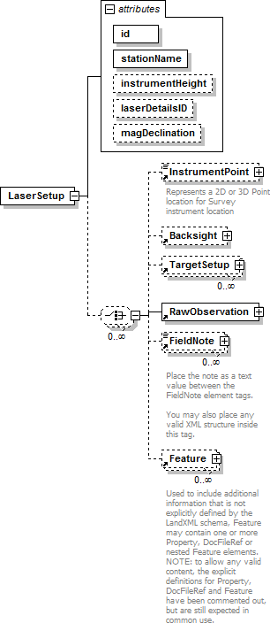
namespace | http://www.landxml.org/schema/LandXML-1.2
properties | content complex
children | InstrumentPoint Backsight TargetSetup RawObservation FieldNote Feature
used by | element Survey
attributes | Name Type Use Default Fixed annotation id xs:ID required  stationName required  instrumentHeight xs:double laserDetailsID xs:IDREF magDeclination xs:double
source | <xs:element name="LaserSetup">  <xs:annotation>  <xs:documentation/>

</xs:annotation>
<xs:complexType>
<xs:choice minOccurs="0" maxOccurs="unbounded">
<xs:element ref="InstrumentPoint" minOccurs="0"/>
<xs:element ref="Backsight" minOccurs="0"/>
<xs:element ref="TargetSetup" minOccurs="0" maxOccurs="unbounded"/>
<xs:element ref="RawObservation"/>
<xs:element ref="FieldNote" minOccurs="0" maxOccurs="unbounded"/>
<xs:element ref="Feature" minOccurs="0" maxOccurs="unbounded"/>
</xs:choice>
<xs:attribute name="id" type="xs:ID" use="required"/>
<xs:attribute name="stationName" use="required"/>
<xs:attribute name="instrumentHeight" type="xs:double"/>
<xs:attribute name="laserDetailsID" type="xs:IDREF"/>
<xs:attribute name="magDeclination" type="xs:double"/>
</xs:complexType>
</xs:element>

attribute LaserSetup/@id
type | xs:ID
properties | isRef 0  use required
source | <xs:attribute name="id" type="xs:ID" use="required"/>

attribute LaserSetup/@stationName
properties | isRef 0  use required
source | <xs:attribute name="stationName" use="required"/>

attribute LaserSetup/@instrumentHeight
type | xs:double
properties | isRef 0
source | <xs:attribute name="instrumentHeight" type="xs:double"/>

attribute LaserSetup/@laserDetailsID
type | xs:IDREF
properties | isRef 0
source | <xs:attribute name="laserDetailsID" type="xs:IDREF"/>

attribute LaserSetup/@magDeclination
type | xs:double
properties | isRef 0
source | <xs:attribute name="magDeclination" type="xs:double"/>

XML Schema documentation generated by XMLSpy Schema Editor http://www.altova.com/xmlspy

element GPSSetup
diagram | 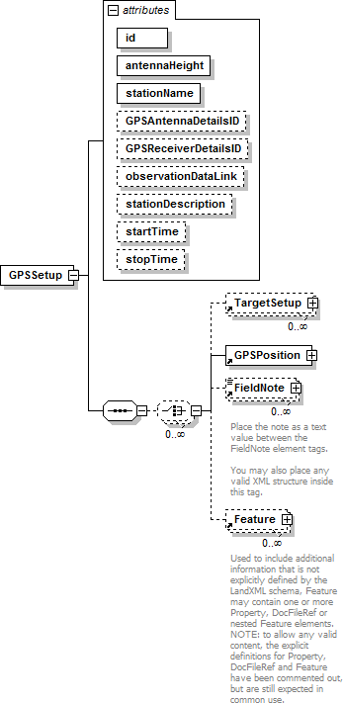
namespace | http://www.landxml.org/schema/LandXML-1.2
properties | content complex
children | TargetSetup GPSPosition FieldNote Feature
used by | element Survey
attributes | Name Type Use Default Fixed annotation id xs:ID required  antennaHeight xs:double required  stationName required  GPSAntennaDetailsID xs:IDREF GPSReceiverDetailsID xs:IDREF observationDataLink stationDescription  startTime GPSTime

 | stopTime GPSTime
source | <xs:element name="GPSSetup">  <xs:annotation>  <xs:documentation/>  </xs:annotation>  <xs:complexType>  <xs:sequence>  <xs:choice minOccurs="0" maxOccurs="unbounded">  <xs:element ref="TargetSetup" minOccurs="0" maxOccurs="unbounded"/>  <xs:element ref="GPSPosition"/>  <xs:element ref="FieldNote" minOccurs="0" maxOccurs="unbounded"/>  <xs:element ref="Feature" minOccurs="0" maxOccurs="unbounded"/>  </xs:choice>  </xs:sequence>  <xs:attribute name="id" type="xs:ID" use="required"/>  <xs:attribute name="antennaHeight" type="xs:double" use="required"/>  <xs:attribute name="stationName" use="required"/>  <xs:attribute name="GPSAntennaDetailsID" type="xs:IDREF"/>  <xs:attribute name="GPSReceiverDetailsID" type="xs:IDREF"/>  <xs:attribute name="observationDataLink"/>  <xs:attribute name="stationDescription"/>  <xs:attribute name="startTime" type="GPSTime"/>  <xs:attribute name="stopTime" type="GPSTime"/>  <!-- GPS Time = Nbr of GPS weeks * 604800 (seconds in a week) + seconds in GPS week -->  </xs:complexType>  </xs:element>

attribute GPSSetup/@id
type | xs:ID
properties | isRef 0  use required
source | <xs:attribute name="id" type="xs:ID" use="required"/>

attribute GPSSetup/@antennaHeight
type | xs:double
properties | isRef 0  use required
source | <xs:attribute name="antennaHeight" type="xs:double" use="required"/>

attribute GPSSetup/@stationName
properties | isRef 0  use required
source | <xs:attribute name="stationName" use="required"/>

attribute GPSSetup/@GPSAntennaDetailsID
type | xs:IDREF
properties | isRef 0
source | <xs:attribute name="GPSAntennaDetailsID" type="xs:IDREF"/>

attribute GPSSetup/@GPSReceiverDetailsID
type | xs:IDREF
properties | isRef 0
source | <xs:attribute name="GPSReceiverDetailsID" type="xs:IDREF"/>

attribute GPSSetup/@observationDataLink
properties | isRef 0
source | <xs:attribute name="observationDataLink"/>

attribute GPSSetup/@stationDescription
properties | isRef 0
source | <xs:attribute name="stationDescription"/>

attribute GPSSetup/@startTime
type | GPSTime
properties | isRef 0
source | <xs:attribute name="startTime" type="GPSTime"/>

attribute GPSSetup/@stopTime
type | GPSTime
properties | isRef 0
source | <xs:attribute name="stopTime" type="GPSTime"/>

XML Schema documentation generated by XMLSpy Schema Editor http://www.altova.com/xmlspy

element GPSPosition
diagram | 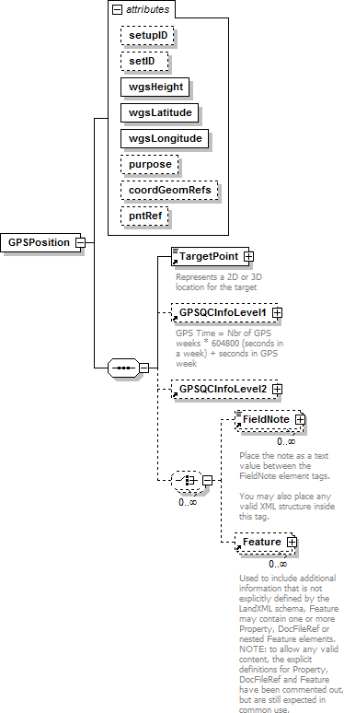
namespace | http://www.landxml.org/schema/LandXML-1.2
properties | content complex
children | TargetPoint GPSQCInfoLevel1 GPSQCInfoLevel2 FieldNote Feature
used by | elements GPSSetup Survey
attributes | Name Type Use Default Fixed annotation setupID xs:IDREF  setID  wgsHeight xs:double required  wgsLatitude xs:double required

wgsLongitude xs:double required
purpose

coordGeomRefs coordGeomNameRefs
pntRef pointNameRef
source | <xs:element name="GPSPosition">  <xs:annotation>  <xs:documentation/>  </xs:annotation>  <xs:complexType>  <xs:sequence>  <xs:element ref="TargetPoint"/>  <xs:element ref="GPSQCInfoLevel1" minOccurs="0"/>  <xs:element ref="GPSQCInfoLevel2" minOccurs="0"/>  <xs:choice minOccurs="0" maxOccurs="unbounded">  <xs:element ref="FieldNote" minOccurs="0" maxOccurs="unbounded"/>  <xs:element ref="Feature" minOccurs="0" maxOccurs="unbounded"/>  </xs:choice>  </xs:sequence>  <xs:attribute name="setupID" type="xs:IDREF"/>  <xs:attribute name="setID"/>  <xs:attribute name="wgsHeight" type="xs:double" use="required"/>  <xs:attribute name="wgsLatitude" type="xs:double" use="required"/>  <xs:attribute name="wgsLongitude" type="xs:double" use="required"/>  <xs:attribute name="purpose"/>  <xs:attribute name="coordGeomRefs" type="coordGeomNameRefs"/>  <xs:attribute name="pntRef" type="pointNameRef"/>  <!-- coordGeomRefs identifies one or more 'name' values that link to specific <Line>, <Curve>,  <Spiral> or <IrregularLine> in a <CoordGeom> element. This allows linking an survey observation to specific <Parcel>.<CoordGeom> based geometry. -->  </xs:complexType>  </xs:element>

attribute GPSPosition/@setupID
type | xs:IDREF
properties | isRef 0
source | <xs:attribute name="setupID" type="xs:IDREF"/>

attribute GPSPosition/@setID
properties | isRef 0
source | <xs:attribute name="setID"/>

attribute GPSPosition/@wgsHeight
type | xs:double
properties | isRef 0  use required
source | <xs:attribute name="wgsHeight" type="xs:double" use="required"/>

attribute GPSPosition/@wgsLatitude
type | xs:double
properties | isRef 0  use required

source | <xs:attribute name="wgsLatitude" type="xs:double" use="required"/>

attribute GPSPosition/@wgsLongitude
type | xs:double
properties | isRef 0  use required
source | <xs:attribute name="wgsLongitude" type="xs:double" use="required"/>

attribute GPSPosition/@purpose
properties | isRef 0
source | <xs:attribute name="purpose"/>

attribute GPSPosition/@coordGeomRefs
type | coordGeomNameRefs
properties | isRef 0
source | <xs:attribute name="coordGeomRefs" type="coordGeomNameRefs"/>

attribute GPSPosition/@pntRef
type | pointNameRef
properties | isRef 0
source | <xs:attribute name="pntRef" type="pointNameRef"/>

XML Schema documentation generated by XMLSpy Schema Editor http://www.altova.com/xmlspy

element GPSQCInfoLevel1
diagram | 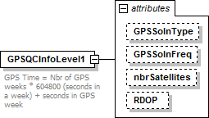
namespace | http://www.landxml.org/schema/LandXML-1.2
properties | content complex
used by | elements GPSPosition GPSVector
attributes | Name Type Use Default Fixed annotation GPSSolnType GPSSolutionTypeEnum  GPSSolnFreq GPSSolutionFrequencyEnum  nbrSatellites xs:integer  RDOP xs:double
annotation | documentation  GPS Time = Nbr of GPS weeks * 604800 (seconds in a week) + seconds in GPS week
source | <xs:element name="GPSQCInfoLevel1">  <xs:annotation>  <xs:documentation>GPS Time = Nbr of GPS weeks * 604800 (seconds in a week) + seconds in GPS week </xs:documentation>  </xs:annotation>  <xs:complexType>  <xs:attribute name="GPSSolnType" type="GPSSolutionTypeEnum"/>  <xs:attribute name="GPSSolnFreq" type="GPSSolutionFrequencyEnum"/>  <xs:attribute name="nbrSatellites" type="xs:integer"/>  <xs:attribute name="RDOP" type="xs:double"/>  </xs:complexType>  </xs:element>

attribute GPSQCInfoLevel1/@GPSSolnType
type | GPSSolutionTypeEnum
properties | isRef 0
facets | enumeration Unknown enumeration Code enumeration Float enumeration Fixed enumeration Network Float enumeration Network Fixed enumeration WAAS Float enumeration WAAS Fixed
source | <xs:attribute name="GPSSolnType" type="GPSSolutionTypeEnum"/>

attribute GPSQCInfoLevel1/@GPSSolnFreq
type | GPSSolutionFrequencyEnum
properties | isRef 0
facets | enumeration Unknown

 | enumeration L1 enumeration L2 enumeration L2 Squared enumeration Wide Lane enumeration Narrow Lane enumeration Iono Free
source | <xs:attribute name="GPSSolnFreq" type="GPSSolutionFrequencyEnum"/>

attribute GPSQCInfoLevel1/@nbrSatellites
type | xs:integer
properties | isRef 0
source | <xs:attribute name="nbrSatellites" type="xs:integer"/>

attribute GPSQCInfoLevel1/@RDOP
type | xs:double
properties | isRef 0
source | <xs:attribute name="RDOP" type="xs:double"/>

XML Schema documentation generated by XMLSpy Schema Editor http://www.altova.com/xmlspy

element GPSQCInfoLevel2
diagram | 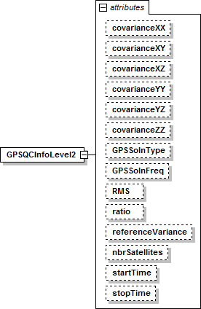
namespace | http://www.landxml.org/schema/LandXML-1.2
properties | content complex
used by | elements GPSPosition GPSVector
attributes | Name Type Use Default Fixed annotation covarianceXX xs:double  covarianceXY xs:double  covarianceXZ xs:double  covarianceYY xs:double  covarianceYZ xs:double  covarianceZZ xs:double  GPSSolnType GPSSolutionTypeEnum GPSSolnFreq GPSSolutionFrequencyEnum RMS xs:double  ratio xs:double  referenceVariance xs:double  nbrSatellites xs:integer  startTime GPSTime  stopTime GPSTime
source | <xs:element name="GPSQCInfoLevel2">  <xs:annotation>  <xs:documentation/>  </xs:annotation>  <xs:complexType>  <xs:attribute name="covarianceXX" type="xs:double"/>  <xs:attribute name="covarianceXY" type="xs:double"/>  <xs:attribute name="covarianceXZ" type="xs:double"/>  <xs:attribute name="covarianceYY" type="xs:double"/>  <xs:attribute name="covarianceYZ" type="xs:double"/>  <xs:attribute name="covarianceZZ" type="xs:double"/>  <xs:attribute name="GPSSolnType" type="GPSSolutionTypeEnum"/>

<xs:attribute name="GPSSolnFreq" type="GPSSolutionFrequencyEnum"/>
<xs:attribute name="RMS" type="xs:double"/>
<xs:attribute name="ratio" type="xs:double"/>
<xs:attribute name="referenceVariance" type="xs:double"/>
<xs:attribute name="nbrSatellites" type="xs:integer"/>
<xs:attribute name="startTime" type="GPSTime"/>
<xs:attribute name="stopTime" type="GPSTime"/>
<!-- GPS Time = Nbr of GPS weeks * 604800 (seconds in a week) + seconds in GPS week -->
</xs:complexType>
</xs:element>

attribute GPSQCInfoLevel2/@covarianceXX
type | xs:double
properties | isRef 0
source | <xs:attribute name="covarianceXX" type="xs:double"/>

attribute GPSQCInfoLevel2/@covarianceXY
type | xs:double
properties | isRef 0
source | <xs:attribute name="covarianceXY" type="xs:double"/>

attribute GPSQCInfoLevel2/@covarianceXZ
type | xs:double
properties | isRef 0
source | <xs:attribute name="covarianceXZ" type="xs:double"/>

attribute GPSQCInfoLevel2/@covarianceYY
type | xs:double
properties | isRef 0
source | <xs:attribute name="covarianceYY" type="xs:double"/>

attribute GPSQCInfoLevel2/@covarianceYZ
type | xs:double
properties | isRef 0
source | <xs:attribute name="covarianceYZ" type="xs:double"/>

attribute GPSQCInfoLevel2/@covarianceZZ
type | xs:double
properties | isRef 0
source | <xs:attribute name="covarianceZZ" type="xs:double"/>

attribute GPSQCInfoLevel2/@GPSSolnType
type | GPSSolutionTypeEnum
properties | isRef 0

facets | enumeration Unknown enumeration Code enumeration Float enumeration Fixed enumeration Network Float enumeration Network Fixed enumeration WAAS Float enumeration WAAS Fixed
source | <xs:attribute name="GPSSolnType" type="GPSSolutionTypeEnum"/>

attribute GPSQCInfoLevel2/@GPSSolnFreq
type | GPSSolutionFrequencyEnum
properties | isRef 0
facets | enumeration Unknown enumeration L1 enumeration L2 enumeration L2 Squared enumeration Wide Lane enumeration Narrow Lane enumeration Iono Free
source | <xs:attribute name="GPSSolnFreq" type="GPSSolutionFrequencyEnum"/>

attribute GPSQCInfoLevel2/@RMS
type | xs:double
properties | isRef 0
source | <xs:attribute name="RMS" type="xs:double"/>

attribute GPSQCInfoLevel2/@ratio
type | xs:double
properties | isRef 0
source | <xs:attribute name="ratio" type="xs:double"/>

attribute GPSQCInfoLevel2/@referenceVariance
type | xs:double
properties | isRef 0
source | <xs:attribute name="referenceVariance" type="xs:double"/>

attribute GPSQCInfoLevel2/@nbrSatellites
type | xs:integer
properties | isRef 0
source | <xs:attribute name="nbrSatellites" type="xs:integer"/>

attribute GPSQCInfoLevel2/@startTime
type | GPSTime
properties | isRef 0

source | <xs:attribute name="startTime" type="GPSTime"/>

attribute GPSQCInfoLevel2/@stopTime
type | GPSTime
properties | isRef 0
source | <xs:attribute name="stopTime" type="GPSTime"/>

XML Schema documentation generated by XMLSpy Schema Editor http://www.altova.com/xmlspy

element TargetSetup
diagram | 
namespace | http://www.landxml.org/schema/LandXML-1.2
properties | content complex
children | FieldNote Feature
used by | elements GPSSetup InstrumentSetup LaserSetup Survey
attributes | Name Type Use Default Fixed annotation id xs:ID  targetHeight xs:double edmTargetVertOffset xs:double prismConstant xs:double
source | <xs:element name="TargetSetup">  <xs:annotation>  <xs:documentation/>  </xs:annotation>  <xs:complexType>  <xs:sequence>  <xs:choice minOccurs="0" maxOccurs="unbounded">  <xs:element ref="FieldNote" minOccurs="0" maxOccurs="unbounded"/>  <xs:element ref="Feature" minOccurs="0" maxOccurs="unbounded"/>  </xs:choice>  </xs:sequence>  <xs:attribute name="id" type="xs:ID"/>  <xs:attribute name="targetHeight" type="xs:double"/>  <xs:attribute name="edmTargetVertOffset" type="xs:double"/>  <xs:attribute name="prismConstant" type="xs:double"/>  <!-- To allow for older style EDM's -->

</xs:complexType>
</xs:element>

attribute TargetSetup/@id
type | xs:ID
properties | isRef 0
source | <xs:attribute name="id" type="xs:ID"/>

attribute TargetSetup/@targetHeight
type | xs:double
properties | isRef 0
source | <xs:attribute name="targetHeight" type="xs:double"/>

attribute TargetSetup/@edmTargetVertOffset
type | xs:double
properties | isRef 0
source | <xs:attribute name="edmTargetVertOffset" type="xs:double"/>

attribute TargetSetup/@prismConstant
type | xs:double
properties | isRef 0
source | <xs:attribute name="prismConstant" type="xs:double"/>

XML Schema documentation generated by XMLSpy Schema Editor http://www.altova.com/xmlspy

element GPSVector
diagram | 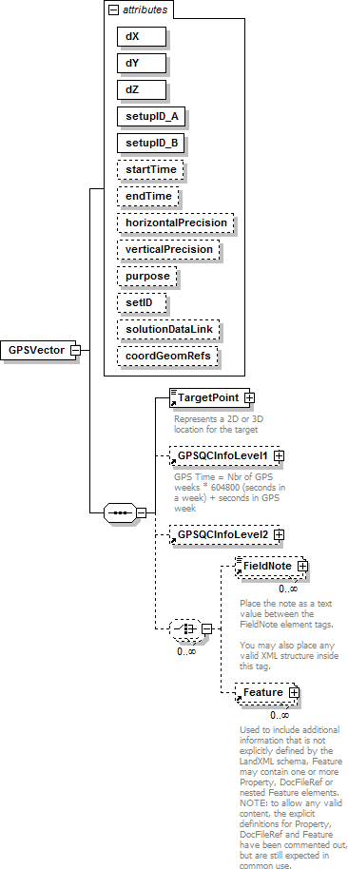
namespace | http://www.landxml.org/schema/LandXML-1.2
properties | content complex

children | TargetPoint GPSQCInfoLevel1 GPSQCInfoLevel2 FieldNote Feature
used by | element Survey
attributes | Name Type Use Default Fixed annotation dX xs:double required  dY xs:double required  dZ xs:double required  setupID_A xs:IDREF required  setupID_B xs:IDREF required  startTime xs:dateTime optional  endTime xs:dateTime optional  horizontalPrecision xs:double optional  verticalPrecision xs:double optional  purpose purposeTy pe  setID solutionDataLink  coordGeomRefs coordGeomNameRefs
source | <xs:element name="GPSVector">  <xs:annotation>  <xs:documentation/>  </xs:annotation>  <xs:complexType>  <xs:sequence>  <xs:element ref="TargetPoint"/>  <xs:element ref="GPSQCInfoLevel1" minOccurs="0"/>  <xs:element ref="GPSQCInfoLevel2" minOccurs="0"/>  <xs:choice minOccurs="0" maxOccurs="unbounded">  <xs:element ref="FieldNote" minOccurs="0" maxOccurs="unbounded"/>  <xs:element ref="Feature" minOccurs="0" maxOccurs="unbounded"/>  </xs:choice>  </xs:sequence>  <xs:attribute name="dX" type="xs:double" use="required"/>  <xs:attribute name="dY" type="xs:double" use="required"/>  <xs:attribute name="dZ" type="xs:double" use="required"/>  <xs:attribute name="setupID_A" type="xs:IDREF" use="required"/>  <xs:attribute name="setupID_B" type="xs:IDREF" use="required"/>  <xs:attribute name="startTime" type="xs:dateTime" use="optional"/>  <xs:attribute name="endTime" type="xs:dateTime" use="optional"/>  <xs:attribute name="horizontalPrecision" type="xs:double" use="optional"/>  <xs:attribute name="verticalPrecision" type="xs:double" use="optional"/>  <xs:attribute name="purpose" type="purposeType"/>  <xs:attribute name="setID"/>  <xs:attribute name="solutionDataLink"/>  <xs:attribute name="coordGeomRefs" type="coordGeomNameRefs"/>  <!-- coordGeomRefs identifies one or more 'name' values that link to specific <Line>, <Curve>,  <Spiral> or <IrregularLine> in a <CoordGeom> element. This allows linking an survey observation to specific <Parcel>.<CoordGeom> based geometry. -->  </xs:complexType>  </xs:element>

attribute GPSVector/@dX
type | xs:double
properties | isRef 0  use required
source | <xs:attribute name="dX" type="xs:double" use="required"/>

attribute GPSVector/@dY
type | xs:double
properties | isRef 0  use required
source | <xs:attribute name="dY" type="xs:double" use="required"/>

attribute GPSVector/@dZ
type | xs:double
properties | isRef 0  use required
source | <xs:attribute name="dZ" type="xs:double" use="required"/>

attribute GPSVector/@setupID_A
type | xs:IDREF
properties | isRef 0  use required
source | <xs:attribute name="setupID_A" type="xs:IDREF" use="required"/>

attribute GPSVector/@setupID_B
type | xs:IDREF
properties | isRef 0  use required
source | <xs:attribute name="setupID_B" type="xs:IDREF" use="required"/>

attribute GPSVector/@startTime
type | xs:dateTime
properties | isRef 0  use optional
source | <xs:attribute name="startTime" type="xs:dateTime" use="optional"/>

attribute GPSVector/@endTime
type | xs:dateTime
properties | isRef 0  use optional
source | <xs:attribute name="endTime" type="xs:dateTime" use="optional"/>

attribute GPSVector/@horizontalPrecision
type | xs:double
properties | isRef 0  use optional
source | <xs:attribute name="horizontalPrecision" type="xs:double" use="optional"/>

attribute GPSVector/@verticalPrecision
type | xs:double

properties | isRef 0  use optional
source | <xs:attribute name="verticalPrecision" type="xs:double" use="optional"/>

attribute GPSVector/@purpose
type | purposeTy pe
properties | isRef 0
facets | enumeration normal enumeration check enumeration backsight enumeration foresight enumeration traverse enumeration sideshot enumeration resection enumeration levelLoop enumeration digitalLevel enumeration remoteElevation  enumeration recipricalObservation  enumeration topo enumeration cutSheets enumeration asbuilt
source | <xs:attribute name="purpose" type="purposeType"/>

attribute GPSVector/@setID
properties | isRef 0
source | <xs:attribute name="setID"/>

attribute GPSVector/@solutionDataLink
properties | isRef 0
source | <xs:attribute name="solutionDataLink"/>

attribute GPSVector/@coordGeomRefs
type | coordGeomNameRefs
properties | isRef 0
source | <xs:attribute name="coordGeomRefs" type="coordGeomNameRefs"/>

XML Schema documentation generated by XMLSpy Schema Editor http://www.altova.com/xmlspy

element GPSPosition
diagram | 
namespace | http://www.landxml.org/schema/LandXML-1.2
properties | content complex
children | TargetPoint GPSQCInfoLevel1 GPSQCInfoLevel2 FieldNote Feature
used by | elements GPSSetup Survey
attributes | Name Type Use Default Fixed annotation setupID xs:IDREF  setID  wgsHeight xs:double required  wgsLatitude xs:double required

wgsLongitude xs:double required
purpose

coordGeomRefs coordGeomNameRefs
pntRef pointNameRef
source | <xs:element name="GPSPosition">  <xs:annotation>  <xs:documentation/>  </xs:annotation>  <xs:complexType>  <xs:sequence>  <xs:element ref="TargetPoint"/>  <xs:element ref="GPSQCInfoLevel1" minOccurs="0"/>  <xs:element ref="GPSQCInfoLevel2" minOccurs="0"/>  <xs:choice minOccurs="0" maxOccurs="unbounded">  <xs:element ref="FieldNote" minOccurs="0" maxOccurs="unbounded"/>  <xs:element ref="Feature" minOccurs="0" maxOccurs="unbounded"/>  </xs:choice>  </xs:sequence>  <xs:attribute name="setupID" type="xs:IDREF"/>  <xs:attribute name="setID"/>  <xs:attribute name="wgsHeight" type="xs:double" use="required"/>  <xs:attribute name="wgsLatitude" type="xs:double" use="required"/>  <xs:attribute name="wgsLongitude" type="xs:double" use="required"/>  <xs:attribute name="purpose"/>  <xs:attribute name="coordGeomRefs" type="coordGeomNameRefs"/>  <xs:attribute name="pntRef" type="pointNameRef"/>  <!-- coordGeomRefs identifies one or more 'name' values that link to specific <Line>, <Curve>,  <Spiral> or <IrregularLine> in a <CoordGeom> element. This allows linking an survey observation to specific <Parcel>.<CoordGeom> based geometry. -->  </xs:complexType>  </xs:element>

attribute GPSPosition/@setupID
type | xs:IDREF
properties | isRef 0
source | <xs:attribute name="setupID" type="xs:IDREF"/>

attribute GPSPosition/@setID
properties | isRef 0
source | <xs:attribute name="setID"/>

attribute GPSPosition/@wgsHeight
type | xs:double
properties | isRef 0  use required
source | <xs:attribute name="wgsHeight" type="xs:double" use="required"/>

attribute GPSPosition/@wgsLatitude
type | xs:double
properties | isRef 0  use required

source | <xs:attribute name="wgsLatitude" type="xs:double" use="required"/>

attribute GPSPosition/@wgsLongitude
type | xs:double
properties | isRef 0  use required
source | <xs:attribute name="wgsLongitude" type="xs:double" use="required"/>

attribute GPSPosition/@purpose
properties | isRef 0
source | <xs:attribute name="purpose"/>

attribute GPSPosition/@coordGeomRefs
type | coordGeomNameRefs
properties | isRef 0
source | <xs:attribute name="coordGeomRefs" type="coordGeomNameRefs"/>

attribute GPSPosition/@pntRef
type | pointNameRef
properties | isRef 0
source | <xs:attribute name="pntRef" type="pointNameRef"/>

XML Schema documentation generated by XMLSpy Schema Editor http://www.altova.com/xmlspy

element ObservationGroup

diagram



namespace | 
 | http://www.landxml.org/schema/LandXML-1.2
properties | content complex
children | TargetPoint Backsight RawObservation ReducedObservation RedHorizontalPosition ReducedArcObservation RedVerticalObservation FieldNote Feature
used by | elements ControlChecks InstrumentSetup Survey
attributes | Name Type Use Default Fixed annotation id xs:ID required  purpose purposeTy pe  setupID xs:IDREF  targetSetupID xs:IDREF  setID  coordGeomRefs coordGeomNameRefs alignRef alignmentNameRef alignStationName xs:string  alignOffset offsetDistance
annotation | documentation  All observations to the same point in a group should be averaged together (they have consistant orientation)
source | <xs:element name="ObservationGroup">  <xs:annotation>  <xs:documentation>All observations to the same point in a group should be averaged together (they have consistant orientation)</xs:documentation>  </xs:annotation>  <xs:complexType>  <xs:sequence>  <xs:element ref="TargetPoint" minOccurs="0"/>  <xs:choice minOccurs="0" maxOccurs="unbounded">  <xs:element ref="Backsight"/>  <xs:element ref="RawObservation" maxOccurs="unbounded"/>  <xs:element ref="ReducedObservation"/>  <xs:element ref="RedHorizontalPosition" minOccurs="0"/>  <xs:element ref="ReducedArcObservation" minOccurs="0"/>  <xs:element ref="RedVerticalObservation" minOccurs="0"/>  <xs:element ref="FieldNote" minOccurs="0" maxOccurs="unbounded"/>  <xs:element ref="Feature" minOccurs="0" maxOccurs="unbounded"/>  </xs:choice>  </xs:sequence>  <xs:attribute name="id" type="xs:ID" use="required"/>  <xs:attribute name="purpose" type="purposeType"/>  <xs:attribute name="setupID" type="xs:IDREF"/>  <xs:attribute name="targetSetupID" type="xs:IDREF"/>  <xs:attribute name="setID"/>  <xs:attribute name="coordGeomRefs" type="coordGeomNameRefs"/>  <xs:attribute name="alignRef" type="alignmentNameRef"/>  <xs:attribute name="alignStationName" type="xs:string"/>  <xs:attribute name="alignOffset" type="offsetDistance"/>  <!-- coordGeomRefs identifies one or more 'name' values that link to specific <Line>, <Curve>,  <Spiral> or <IrregularLine> in a <CoordGeom> element. This allows linking an survey observation to specific <Parcel>.<CoordGeom> based geometry. -->  <!-- alignRef is the name of the alignment.  alignStationName is the station value where the rod reading is taken.

alignOffset is the signed (+/-) distance from the CL of the referenced alignment. -->
</xs:complexType>
</xs:element>

attribute ObservationGroup/@id
type | xs:ID
properties | isRef 0  use required
source | <xs:attribute name="id" type="xs:ID" use="required"/>

attribute ObservationGroup/@purpose
type | purposeTy pe
properties | isRef 0
facets | enumeration normal enumeration check enumeration backsight enumeration foresight enumeration traverse enumeration sideshot enumeration resection enumeration levelLoop enumeration digitalLevel enumeration remoteElevation  enumeration recipricalObservation  enumeration topo enumeration cutSheets enumeration asbuilt
source | <xs:attribute name="purpose" type="purposeType"/>

attribute ObservationGroup/@setupID
type | xs:IDREF
properties | isRef 0
source | <xs:attribute name="setupID" type="xs:IDREF"/>

attribute ObservationGroup/@targetSetupID
type | xs:IDREF
properties | isRef 0
source | <xs:attribute name="targetSetupID" type="xs:IDREF"/>

attribute ObservationGroup/@setID
properties | isRef 0
source | <xs:attribute name="setID"/>

attribute ObservationGroup/@coordGeomRefs
type | coordGeomNameRefs
properties | isRef 0
source | <xs:attribute name="coordGeomRefs" type="coordGeomNameRefs"/>

attribute ObservationGroup/@alignRef
type | alignmentNameRef
properties | isRef 0
source | <xs:attribute name="alignRef" type="alignmentNameRef"/>

attribute ObservationGroup/@alignStationName
type | xs:string
properties | isRef 0
source | <xs:attribute name="alignStationName" type="xs:string"/>

attribute ObservationGroup/@alignOffset
type | offsetDistance
properties | isRef 0
source | <xs:attribute name="alignOffset" type="offsetDistance"/>

XML Schema documentation generated by XMLSpy Schema Editor http://www.altova.com/xmlspy

element ControlChecks
diagram | 
namespace | http://www.landxml.org/schema/LandXML-1.2
properties | content complex
children | TestObservation ObservationGroup PointResults FieldNote Feature
used by | elements InstrumentSetup Survey
annotation | documentation  Records check shots to known locations during field observations
source | <xs:element name="ControlChecks">  <xs:annotation>  <xs:documentation>Records check shots to known locations during field observations</xs:documentation>  </xs:annotation>  <xs:complexType>  <xs:sequence>  <xs:choice minOccurs="0" maxOccurs="unbounded">  <xs:element ref="TestObservation" minOccurs="0" maxOccurs="unbounded"/>  <!-- LandXML-1.2 schema note: Use of ObservationGroup is depricated and used for backward compatibility,  use multiple TestObservation elements -->  <xs:element ref="ObservationGroup" minOccurs="0" maxOccurs="unbounded"/>  <xs:element ref="PointResults" minOccurs="0" maxOccurs="unbounded"/>  <xs:element ref="FieldNote" minOccurs="0" maxOccurs="unbounded"/>  <xs:element ref="Feature" minOccurs="0" maxOccurs="unbounded"/>  </xs:choice>

</xs:sequence>
</xs:complexType>
</xs:element>

XML Schema documentation generated by XMLSpy Schema Editor http://www.altova.com/xmlspy

