COWRIE HONEYPOT
Windows-to-Kali Linux Connection and Activity Logging
Practical Lab Activity Report

Host system | Windows PowerShell
Virtual machine | Kali Linux running in VirtualBox
Honeypot | Cowrie SSH honeypot
Target address / port | 192.168.56.101 / TCP 2222
Activity date: 26–27 October 2026

1. Objective
The objective of this activity was to install and initialize Cowrie on Kali Linux inside VirtualBox, make the honeypot reachable from the Windows host, connect to its SSH service on TCP port 2222, and verify that Cowrie records connection and shell activity in its log.

2. Lab Environment and Network
Kali Linux was configured with a VirtualBox Host-Only network interface in addition to its NAT interface. The Host-Only address shown during the activity was 192.168.56.101. The NAT address (10.0.2.15) and Docker address (172.17.0.1) were not used for the Windows-to-Cowrie test.
The Cowrie service listened on 0.0.0.0:2222, allowing the Windows host to reach the SSH honeypot through the Host-Only network. The report uses the addresses and outputs visible in the supplied screenshots.

3. Procedure

Install and verify Cowrie
Cowrie and its Python dependencies were installed in a virtual environment. The `cowrie --help` command was used to verify that the command was available.

Initialize the honeypot
The `cowrie init` command generated `etc/cowrie.cfg` and created the directories used for logs and runtime data.

Start and check the service
The `cowrie start` and `cowrie status` commands were run. The status output reported that Cowrie was running.

Identify the Host-Only IP address
The `ip -4 addr` output showed `192.168.56.101/24` on the Host-Only interface.

Verify the listening port
The `ss -lntp | grep 2222` command showed a listener on TCP port 2222 associated with Cowrie's Twisted process.

Test Windows connectivity
Windows PowerShell ran `Test-NetConnection 192.168.56.101 -Port 2222`. A later test showed `TcpTestSucceeded : True`.

Connect through SSH
From Windows PowerShell, the command `ssh -p 2222 root@192.168.56.101` was used to connect to the Cowrie SSH service. The first connection displayed a host-key confirmation prompt.

Test and observe the simulated shell
Commands including `whoami` and `pwd` were entered in the remote shell. Cowrie logs recorded the command events and shell initialization.

4. Evidence Screenshots
The screenshots below document the activity in chronological order, from installation and initialization through network testing, SSH access, and log verification.
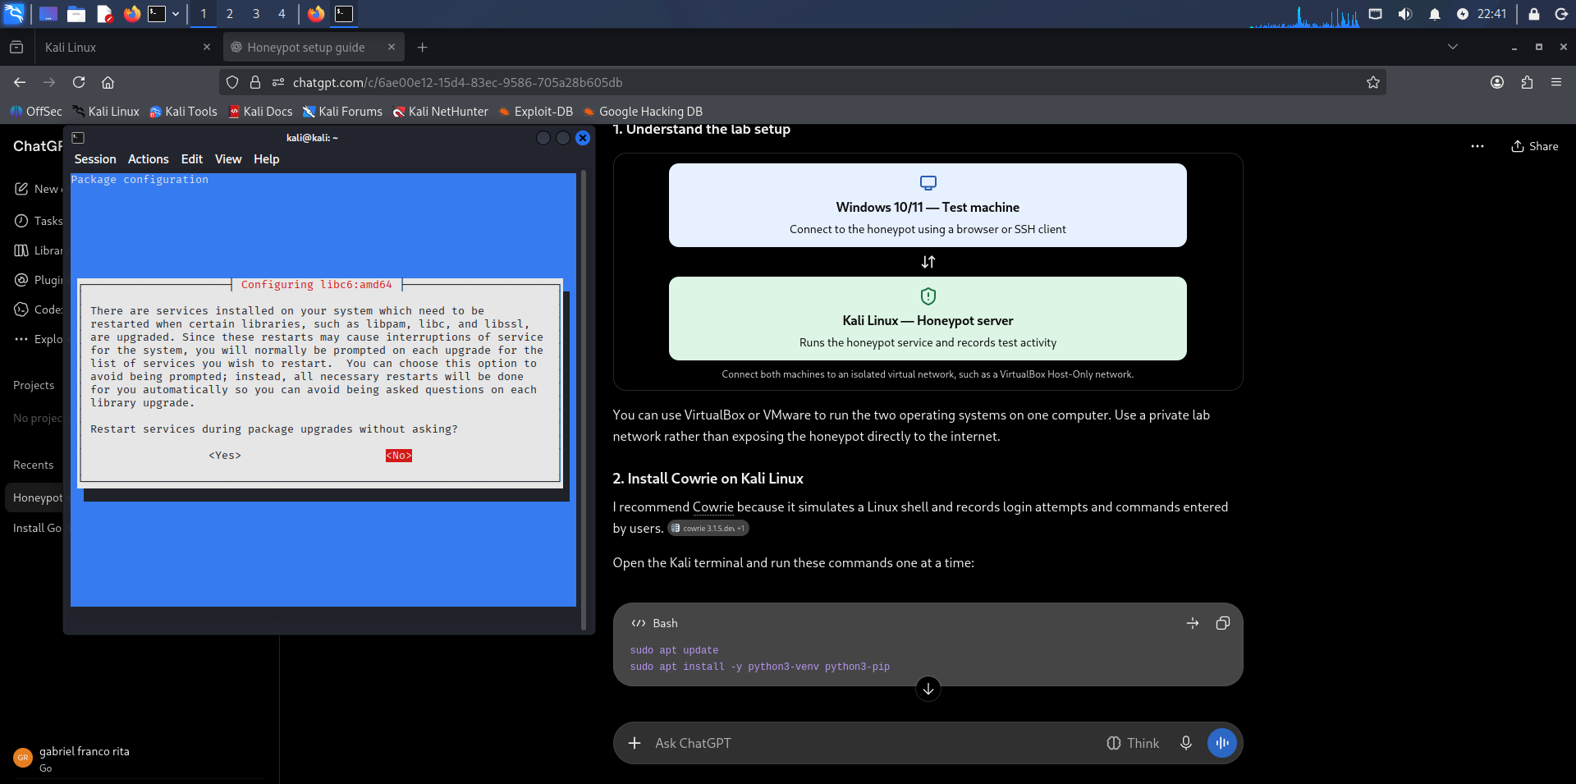
Figure 1. Cowrie installation completed and the command-line help was verified.
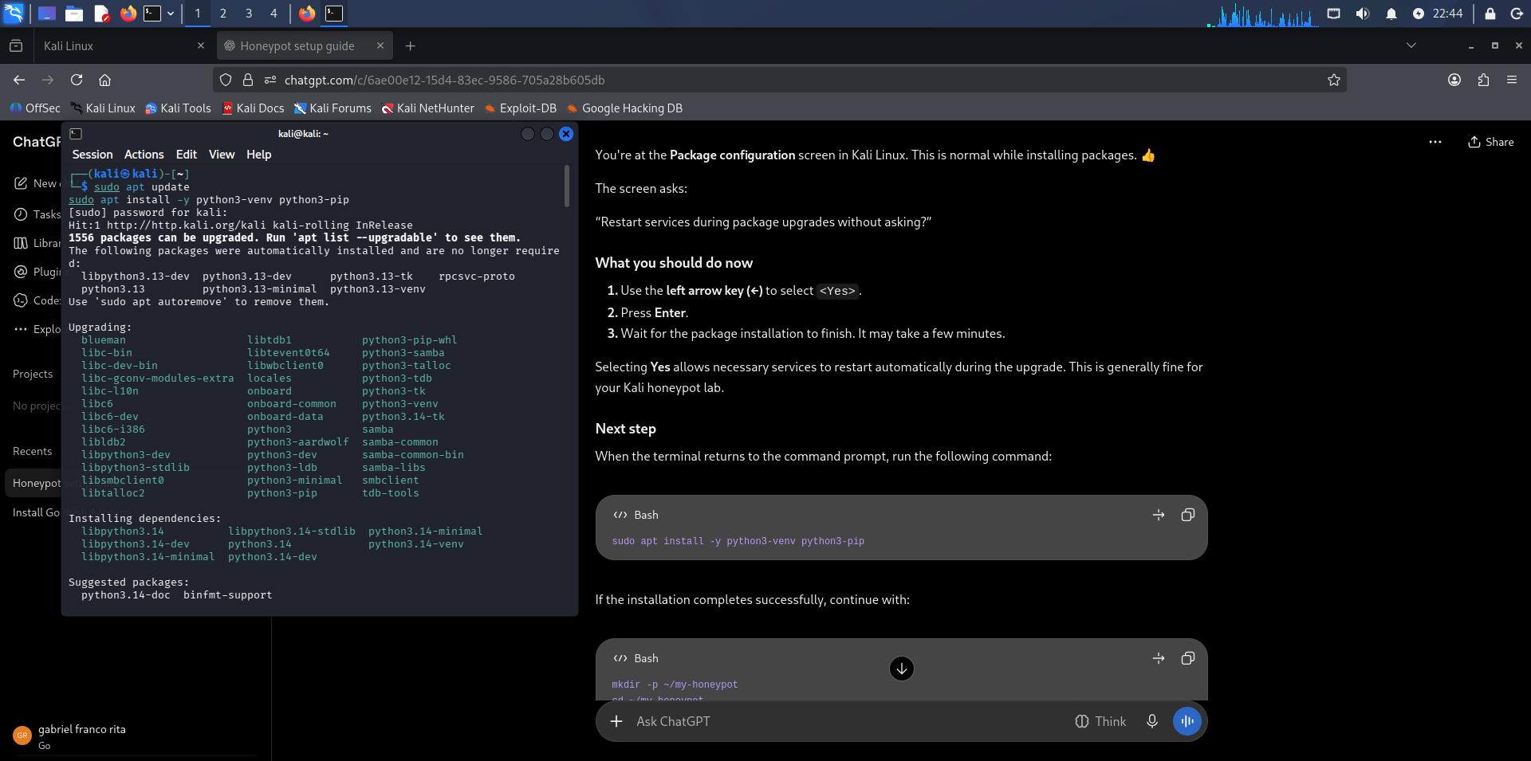
Figure 2. Cowrie was initialized; the configuration file and required directories were created.
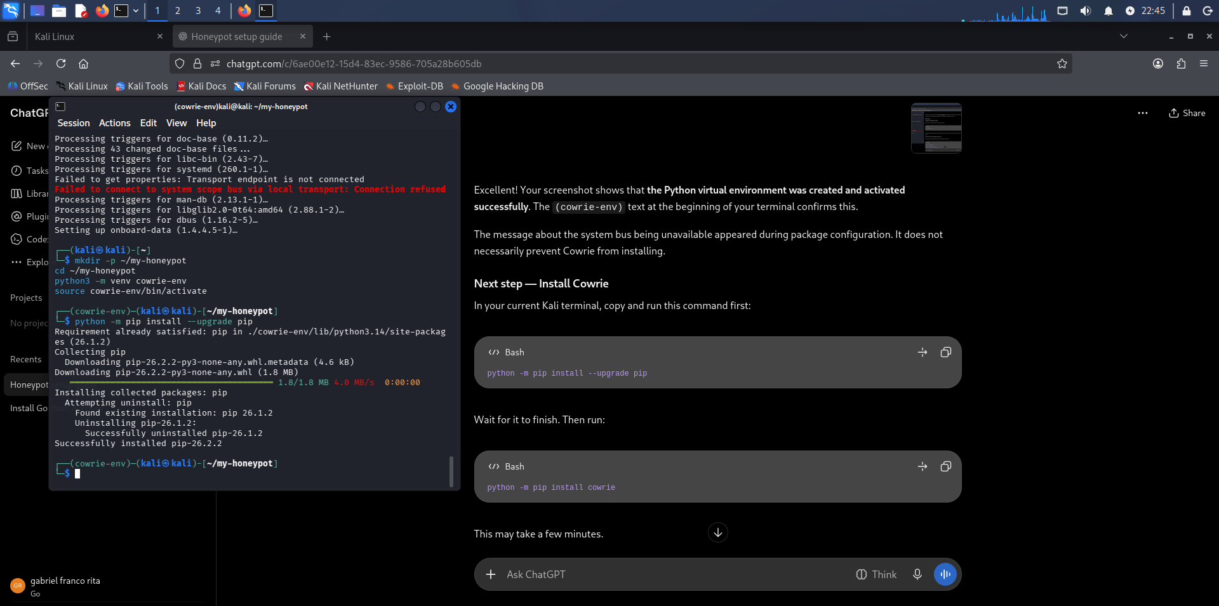
Figure 3. Cowrie was started and its status command confirmed that it was running.

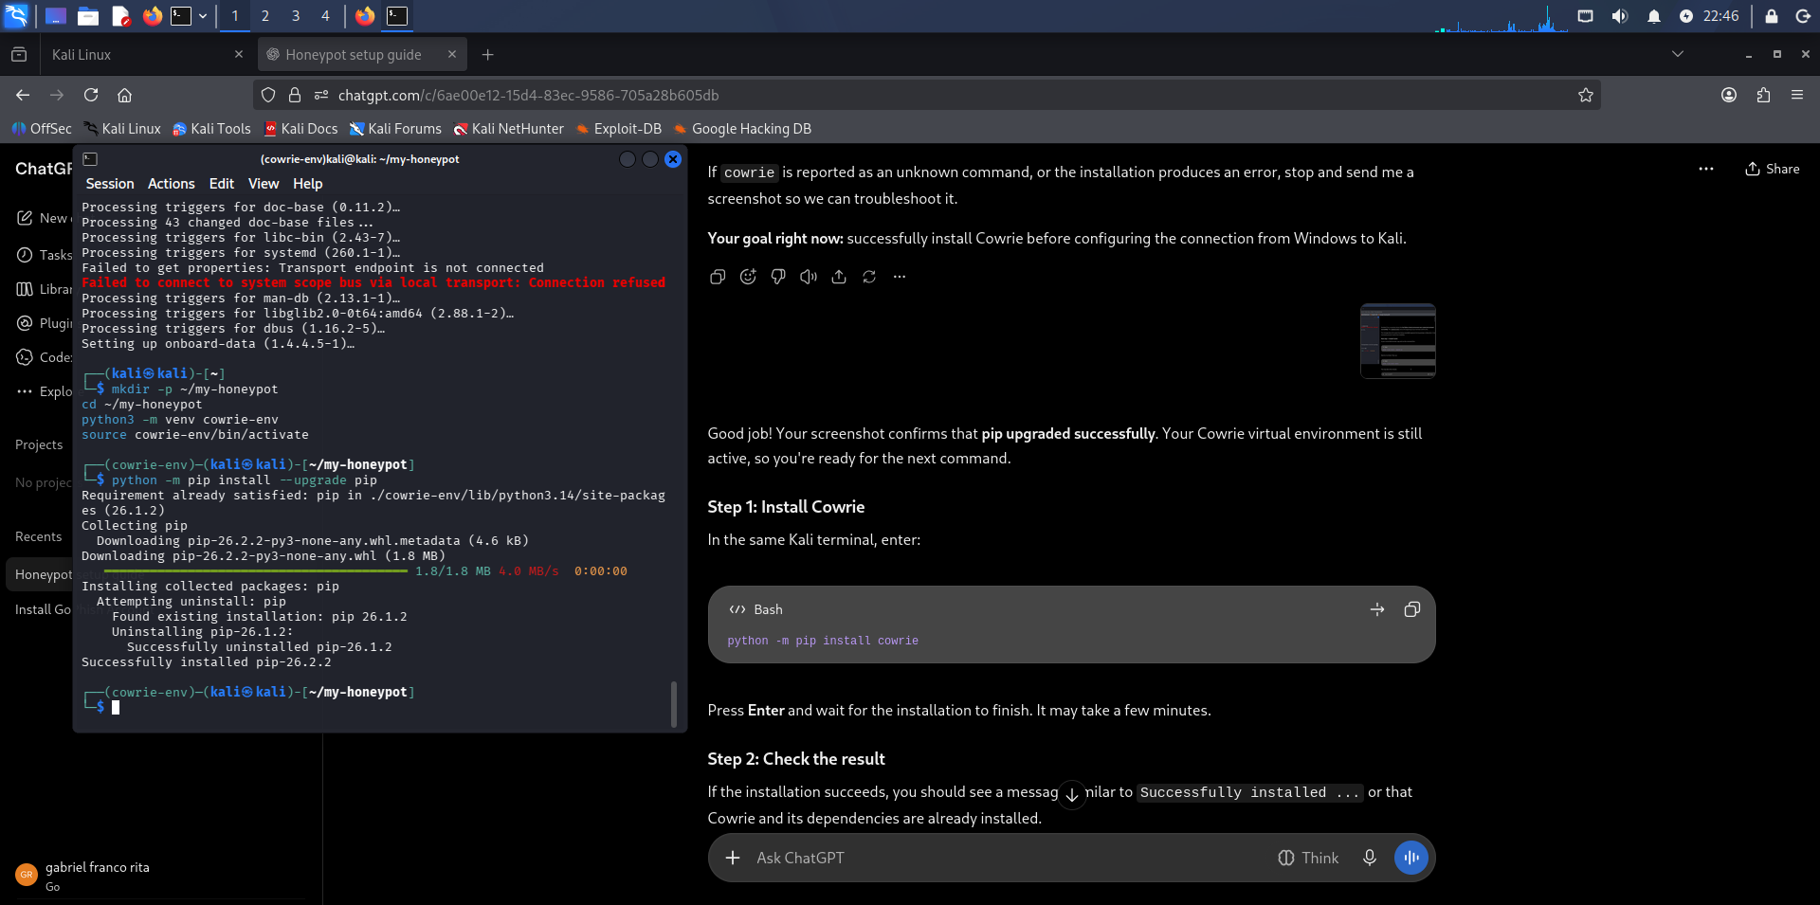
Figure 4. Kali network interfaces were checked to identify the Host-Only address 192.168.56.101.
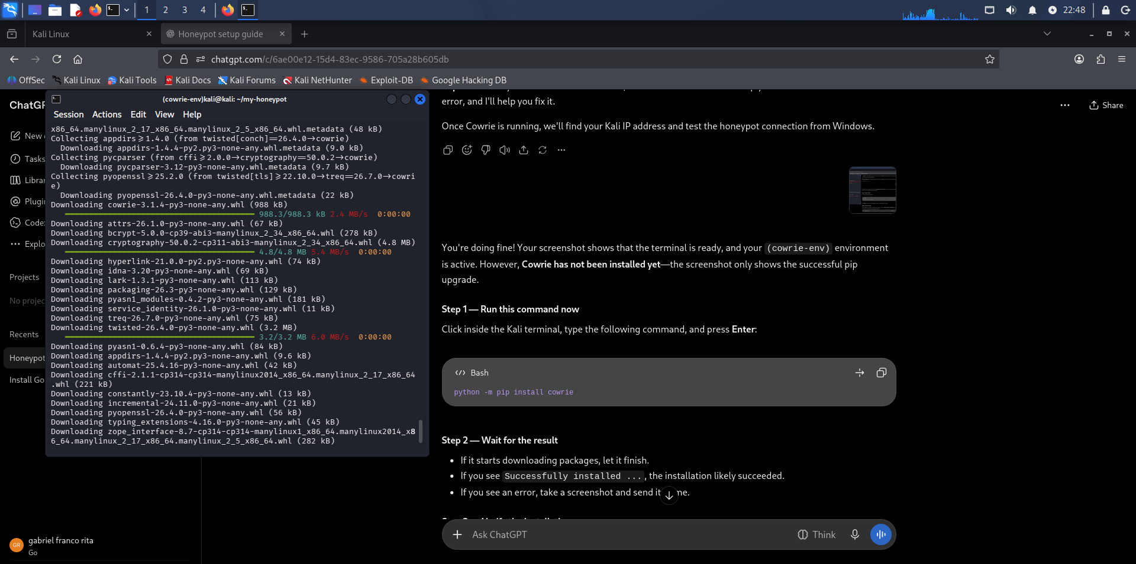
Figure 5. The listener check showed Cowrie listening on TCP port 2222.
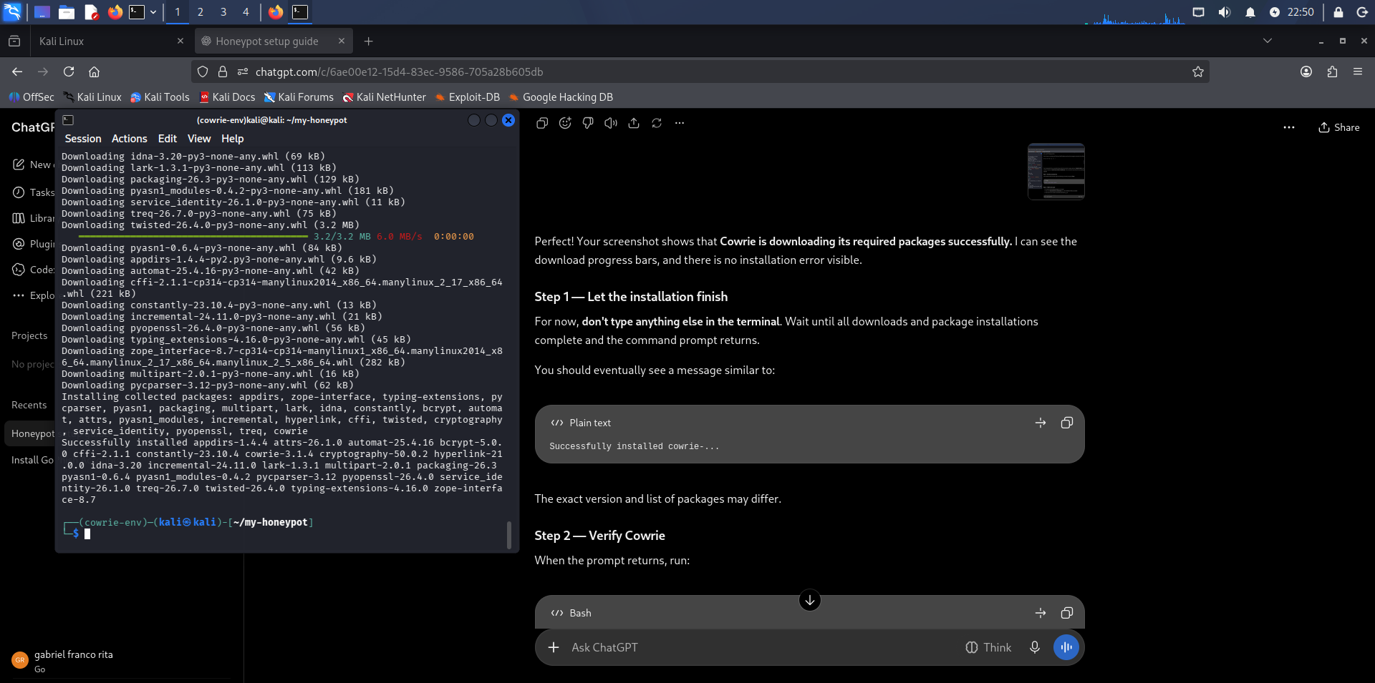
Figure 6. Windows PowerShell tested TCP connectivity to 192.168.56.101:2222.

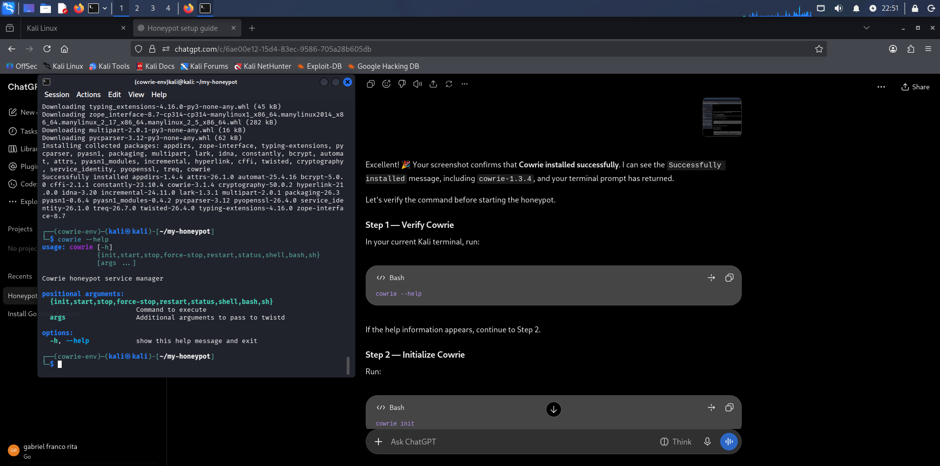
Figure 7. An SSH connection from Windows reached the Cowrie service and prompted for lab credentials.
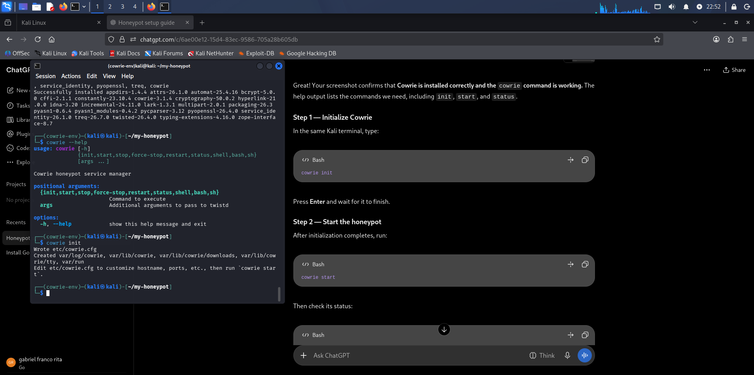
Figure 8. The Cowrie log recorded SSH connection events and initialization of the simulated shell.
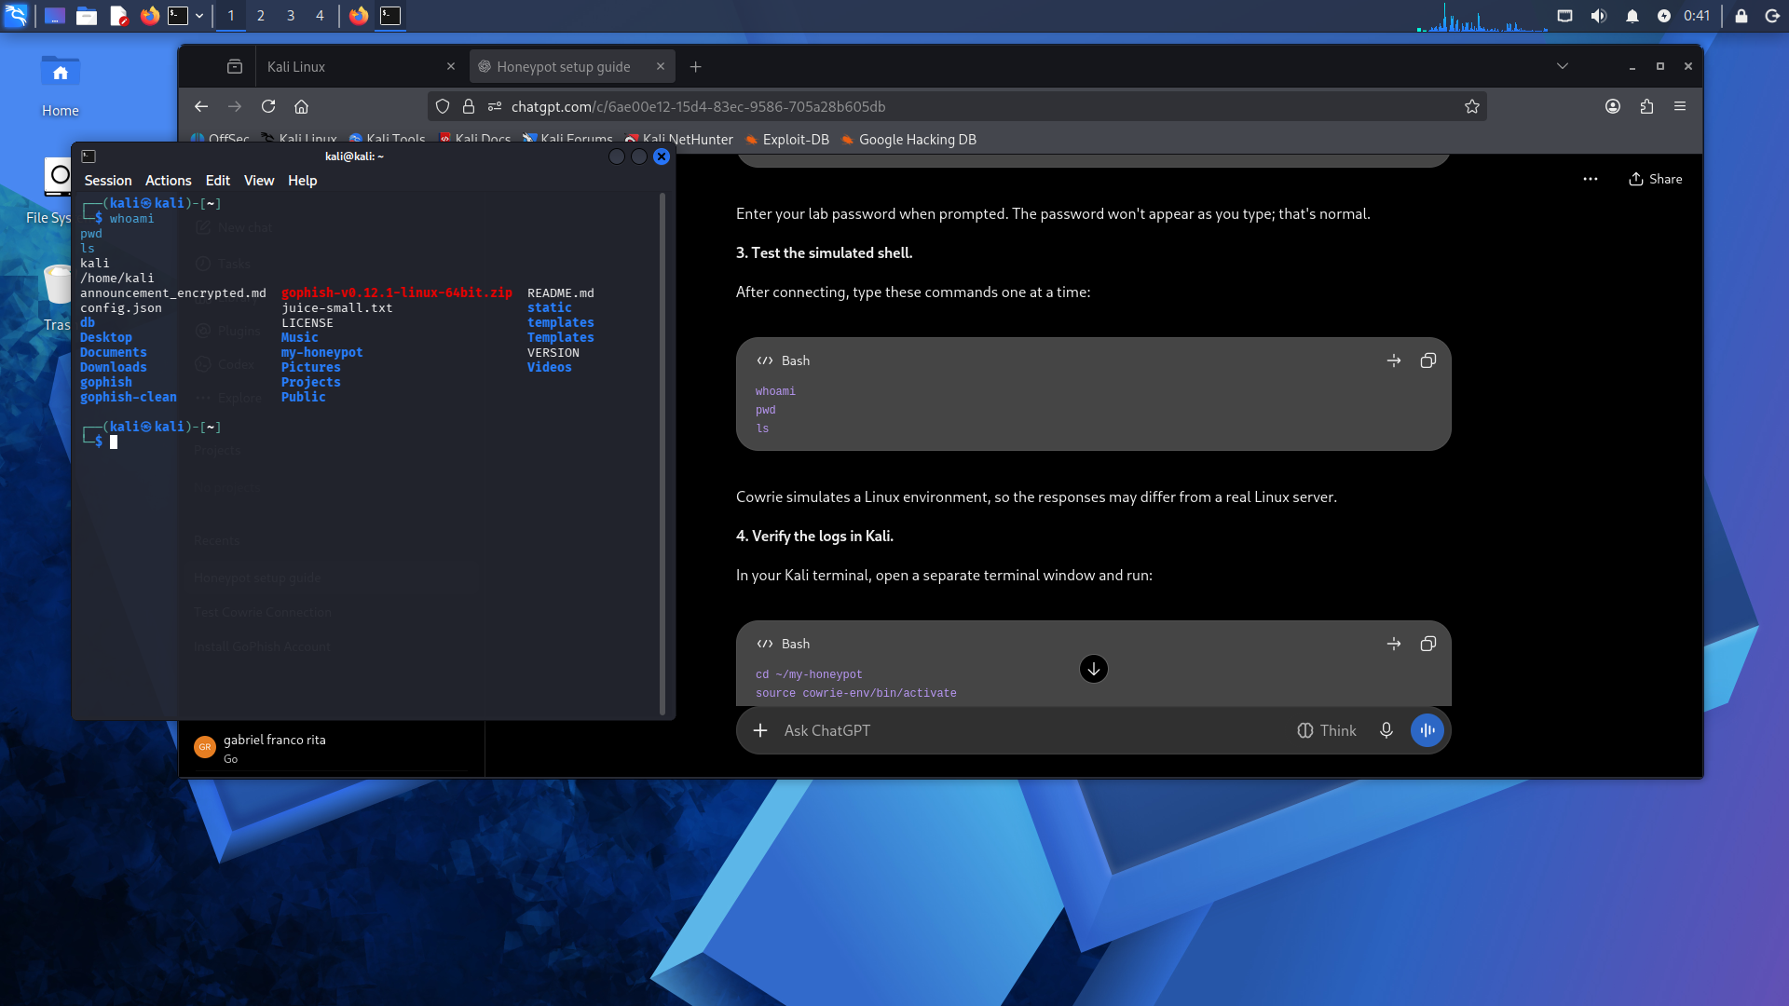
Figure 9. The terminal was returned to the local Kali prompt before checking the activity again.

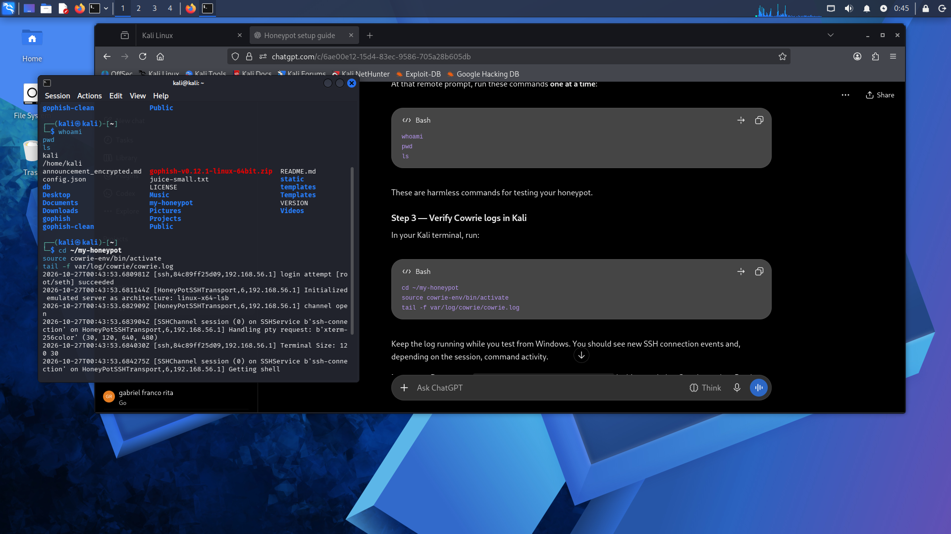
Figure 10. The Cowrie log showed shell activity, including recorded command events.
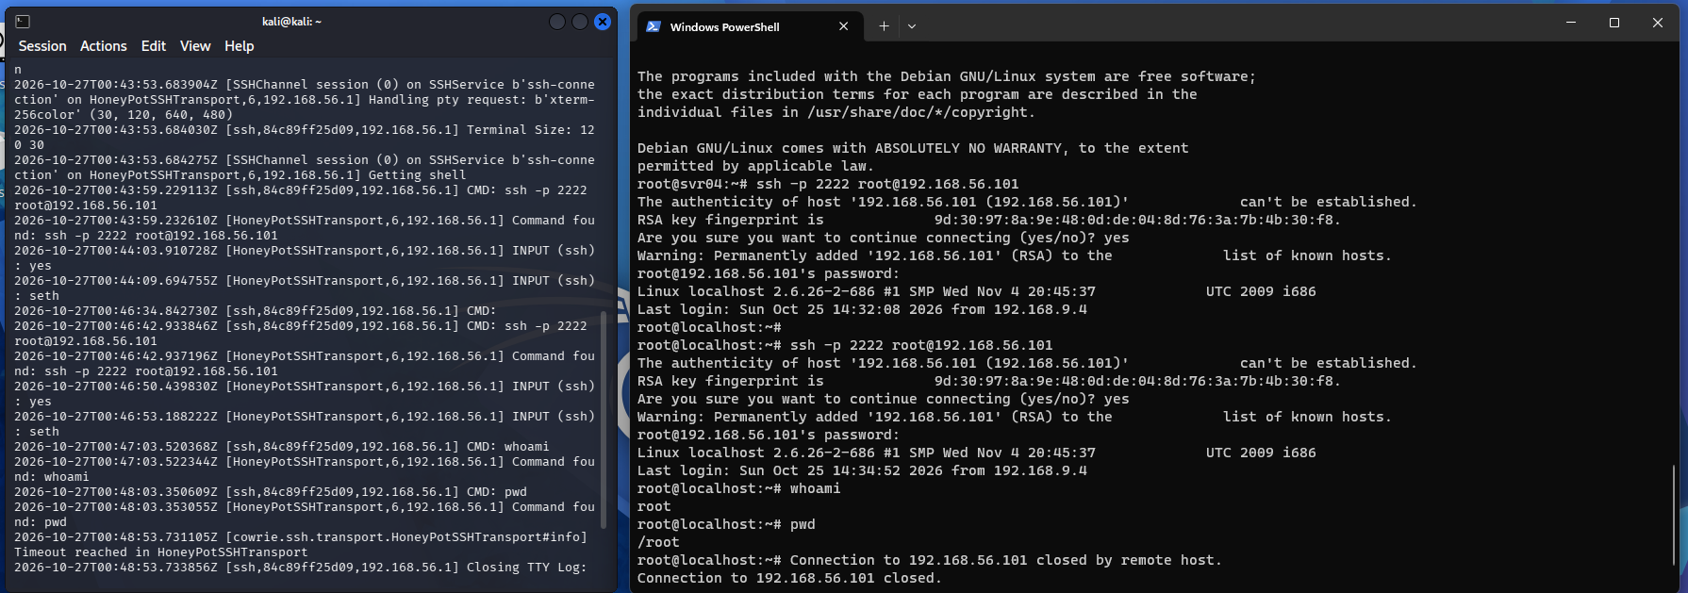
Figure 11. Final verification: Windows ran whoami and pwd in the simulated shell, while Kali recorded CMD events for whoami and pwd.

5. Results
- Cowrie was installed and initialized successfully.
- The service was started and reported as running.
- Kali's Host-Only interface used 192.168.56.101.
- Cowrie listened on TCP port 2222.
- Windows PowerShell successfully tested TCP connectivity to the honeypot.
- An SSH connection reached Cowrie and opened a simulated shell.
- The Cowrie log showed connection, shell initialization, and command events, including `whoami` and `pwd`.

6. Conclusion
The lab successfully demonstrated a Windows-to-Kali Cowrie honeypot connection over VirtualBox Host-Only networking. The successful TCP test, SSH session, simulated shell, and corresponding Cowrie log entries show that the honeypot was reachable and capturing activity. Cowrie provides a simulated environment; shell responses should not be treated as evidence of commands running on the real Kali host.

7. Commands Used
cowrie --help
cowrie init
cowrie start
cowrie status
ip -4 addr
ss -lntp | grep 2222
Test-NetConnection 192.168.56.101 -Port 2222
ssh -p 2222 root@192.168.56.101
tail -f ~/my-honeypot/var/log/cowrie/cowrie.log
Safety note: This activity should be performed only in an authorized lab environment. Use lab-only credentials and keep the honeypot isolated from untrusted networks unless exposure is explicitly intended and safely controlled.

