# Relatório de VVS01

## Line Coverage

## Branch Coverage

## Edge-Pair Coverage

## Prime Path Coverage

## All-Du-Paths Coverage

|  |  |  |
| --- | --- | --- |
| Nodes & Edges: I | def(I) | use(I) |
| 1 | {query} |  |
| (1,2), (1,3) |  | {query} |
| 3 |  |  |
| (3,4), (3,5) |  | {query} |
| 5 | {len, x, i} |  |
| (5,6) |  |  |
| 6 |  |  |
| (6,7), (6,16) |  | {x, i, query} |
| 7 | {c} | {query, i} |
| (7,8) |  |  |
| 8 |  |  |
| (8,9), (8,10) |  | {c, x} |
| 9 | {x} | {x} |
| (9,6) |  |  |
| 10 |  |  |
| (10,11), (10,12) |  | {c, x} |
| 11 | {x} | {x} |
| (11,6) |  |  |
| 12 | {i} | {i} |
| (12,13) |  |  |
| 13 |  |  |
| (13,14), (13,15) |  | {x} |
| 14 | {len} | {i} |
| (14,15) |  |  |
| 15 | {x} | {x} |
| (15,6) |  |  |
| 16 |  | {query, len} |

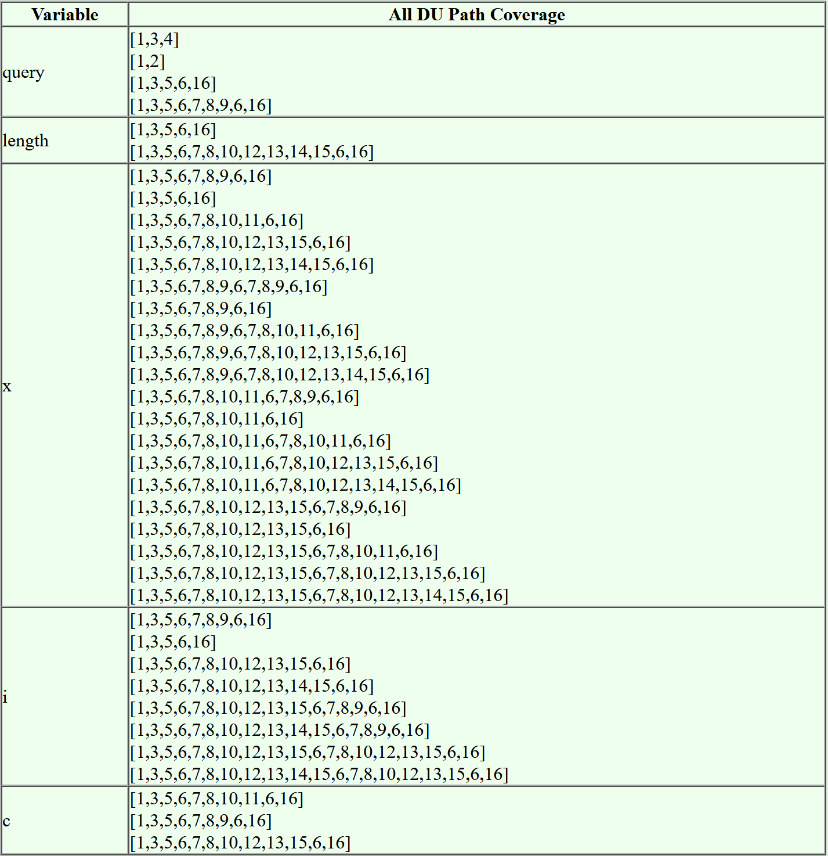

## All-Coupling-Use-Paths Coverage

## Logic-based Coverage

Escolha: Combinatorial Coverage

**Reachability Predicates**

|  |  |
| --- | --- |
| **p** | **r(p)** |
| p1 | true |
| p2 | r(p1) && !p1 |
| p3 | r(p2) && !p2 |
| p4 | r(p3) && p3 |
| p5 | r(p4) && !p4 |
| p6 | r(p5) && !p5 |

|  |  |  |  |  |  |
| --- | --- | --- | --- | --- | --- |
| query | x.c | x.val | i | x | Reach & cover |
| null | - | - | - | - | p1, c1 |
| empty | - | - | - | - | r(p2), p2, c2 |
| ‘a’ | ‘c’ | - | 0 | != null | r(p3), c3, c4 |
| ‘c’ | ‘c’ | null | 1 | != null | r(p3), c3, !c4 |
| ‘a’ | - | - | 0 | null | r(p3), !c3, c4 |
| ‘c’ | ‘c’ | 1 | 1 | null | r(p3), !c3, !c4 |
| ‘a’ | ‘c’ | - | - | - | r(p4), c5 |
| ‘d’ | ‘c’ | - | - | - | r(p5), c6 |
| ‘c’ | ‘c’ | 1 | - | - | r(p6), c7 |
| ‘c’ | ‘c’ | null | - | - | r(p6), !c7 |

## Base Choice Coverage

## PIT Mutation Coverage

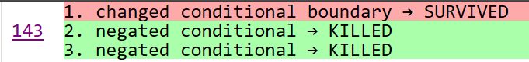

## JUnit QuickCheck