DEVELOPMENT OF AN AUTOMATIC SPEECH-TO-SPEECH SYNTHESIS ARCHITECTURE FOR ENGLISH-TO-YORÙBÁ LANGUAGE USING NEURAL MACHINE TRANSLATION APPROACH

BY

SOBOLA GABRIEL OLUWATOBI
23PCK02485

A Ph.D Thesis Submitted as Part of the Requirements for the Award of the Degree of Doctor of Philosophy (Ph.D) in Information & Communication Engineering of the Department of Electrical and Information Engineering, Covenant University, Ota, Ogun State, Nigeria.

Supervisor(s):
Prof. Emmanuel Adetiba
Dr. Olabode Idowu-Bismark

AUGUST 2026

DECLARATION
I hereby declare that I carried out the work reported in this project in the Department of Electrical and Information Engineering, Covenant University, under the supervisions of Prof. Adetiba Emmanuel, and Dr. Idowu Bismark. I solemnly declare that to the best of my knowledge, this thesis has yet to be submitted here or elsewhere in a previous application for the award of a Doctorate degree. All sources of knowledge used have been duly acknowledged.

CERTIFICATION
This is to certify that the project titled “Development of an Automatic Speech-To-Speech Synthesis Architecture for English-To-Yorùbá Language Using Neural Machine Translation Approach by Sobola Gabriel Oluwatobi meets the requirements and regulations governing the award of the Doctor of Philosophy (Communication Engineering) degree of Covenant University.

DEDICATION
I dedicate this report to God Almighty, that enable me with the guidance, wisdom, understanding, and strength to execute this project successfully.

ACKNOWLEDGEMENTS
I am deeply grateful to God, whose strength sustained me throughout the course of this PhD journey, especially during the compilation of the chapters of this work.
My sincere appreciation goes to Prof. Ademola Abdulkareem, Head of the Department of Electrical and Information Engineering, Covenant University, for his support and guidance. I am profoundly indebted to my supervisor, Prof. Adetiba Emmanuel, whose intellectual contributions and wealth of experience were invaluable to the timely and successful completion of this research. I also extend my gratitude to my co-supervisor, Dr. Idowu-Bismark Olabode, for his insightful advice and encouragement from the beginning of this work.
I acknowledge the Covenant Applied Informatics Africa Centre of Excellence (CApIC-ACE), a World Bank–funded initiative, for making my PhD enrolment possible and for their support through scholarships, training, seminars, and workshops. I am equally thankful to Google for their funding, which enabled the creation of the English–Yoruba parallel speech corpus, the acquisition of a high-performance GPU system, coverage of publication costs, and support for data collection logistics. Their contribution was instrumental in advancing research on speech model development for the Yoruba indigenous language.
Finally, I express my heartfelt appreciation to my parents, Mr. Amos Sobola and Mrs. Felicia Sobola, for their unwavering support throughout the duration of this doctoral program.

TABLE OF CONTENTS
DECLARATION ii
CERTIFICATION iii
DEDICATION iv
ACKNOWLEDGEMENTS v
TABLE OF CONTENTS vi
LIST OF FIGURES xii
LIST OF TABLES xiv
ABBREVIATIONS AND SYMBOLS xvi
ABSTRACT xix
1. CHAPTER ONE 1
INTRODUCTION 1
1.1 Background to the study 1
1.2 Statement of the Problem 5
1.3 Aim and Objectives 7
1.3.1 Aim 7
1.3.2 Objectives 7
1.4 Scope of the Study 7
1.5 Justification for the Study 8
1.6 Contributions to Knowledge 8
2. CHAPTER TWO 10
LITERATURE REVIEW 10
2.1 Introduction 10
2.2 Speech Production and Translation in Humans 10
2.2.1 Speech Production and Recognition 10
2.2.2 Speech Translation in Human 12
2.2.3 Low and High-Resourced Language 12
2.2.3.1 Low Resourced Language 13
2.2.3.2 High-Resourced Language 13
2.3 Overview of Automatic Speech-to-Speech Translation 13
2.3.1 Traditional Speech-to-Speech Translation 13
2.3.1.1 Probabilistic Approach to modelling ASR 14
2.3.1.2 Statistical Approach to Machine Translation 15
2.3.1.3 Concatenative Speech Synthesis 15
2.3.1.4 Statistical Parametric Speech Synthesis 16
2.3.2 Conventional Speech-to-Speech Translation 16
2.3.2.1 Automatic Speech Recognition 16
2.3.2.2 Machine Translation 18
2.3.2.3 Text-To-Speech 18
2.3.3 Neural Speech-to-Speech Translation 19
2.3.3.1 Neural Network Approach to Automatic Speech Recognition 19
2.3.3.2 Neural Network Approach to Machine Translation 20
2.3.3.3 Neural Network Approach to Modelling TTS 21
2.3.4 Direct Speech-to-Speech Translation 23
2.3.4.1 Generic Architecture 23
2.3.4.2 Speech Mel Spectrogram 24
2.3.4.3 The Fast Fourier Transform 25
2.3.4.4 Synthesizer 27
2.3.4.5 Encoder 27
2.3.4.6 Attention Mechanism 28
2.3.4.7 Decoder 28
2.3.4.8 Vocoder 28
2.4 State-of-the-Art Approaches for Speech-to-Speech Translation 29
2.4.1 Sequence-to-Sequence Learning 29
2.4.2 Encoder-Decoder Network 29
2.4.3 Attention Mechanism 31
2.4.4 Sequence-to-Sequence Modelling 31
2.4.5 Transformer 34
2.4.5.1 Self-Attention 36
2.4.5.2 Multi-Head Attention 36
2.4.5.3 Positional Encoding 37
2.4.6 Cross lingual Voice Cloning 37
2.5 Stages Involved in Neural End-To-End Approaches to Speech Translation 38
2.5.1 Data Collection 38
2.5.2 Data Analysis 38
2.5.3 Data Preprocessing 38
2.5.4 Data Cleaning 39
2.5.5 Feature Extraction Stage 39
2.5.6 Discretisation 39
2.5.7 Sequence-to-Sequence Modelling 39
2.6 Performance Metric 39
2.6.1 Bilingual Evaluation Understudy 39
2.6.2 Mean Opinion Score 41
2.6.3 Statistical Evaluation 42
2.6.4 Perceptual Evaluation of Speech Quality (PESQ) 43
2.6.4.1 Steps to Compute the PESQ 43
2.6.5 Sort-Time Objective Intelligibility (STOI) 43
2.6.5.1 Steps to Compute the STOI of Speech Signal 43
2.7 Regularisation Techniques 44
2.8 Review of Related Works 44
2.8.1 Review of Literature on Dataset 44
2.8.2 Review of Literature on Speech-To-Speech Translation 46
2.8.3 Review of Literature on Utilisation of Machine Translation in the Medical World 60
2.8.4 Review of Literature on Unit Based Vocoder 62
2.8.4.1 Unit Based S2ST 62
2.8.4.2 Discrete-Units TTS and Resynthesis 62
2.8.4.3 High and Low-Resourced Settings 63
2.8.5 Summary of Literature Review on Speech-To-Speech Synthesis 65
2.8.6 Summary of Literature Review on Unit Vocoder 71
2.9 Gaps in existing knowledge 73
3. CHAPTER THREE 76
METHODOLOGY 76
3.1 Introduction 76
3.2 Summary of Methodology 76
3.3 Data Curation 78
3.4. Steps for Corpus Curation 78
3.4.1 Searching of online databases for public health and general domain texts 78
3.4.2 Pre-Processing of Obtained Transcripts 78
3.4.3 Development of both source and target texts 79
3.4.4 Development of web page for audio recording 79
3.4.4.1 The Landing Page 80
3.4.4.2 The English Corpus Page 80
3.4.4.3 The Yoruba Corpus Page 81
3.4.4.4 Transcripts Page 82
3.4.5 Development of Manifest Files 83
3.4.5.1 Manifest File for each Speaker 83
3.4.5.2: Transcripts and Audio Manifest File 84
3.4.6 Development of Metadata Files 84
3.4.7 Focus Language 84
3.4.8 Sourcing of participants 85
3.4.9 Obtaining Consent 85
3.4.10 Registration 85
3.4.11 Audio Recording 86
3.4.12 Instructions 86
3.4.12.1 Recording Instructions 86
3.4.12.2 Annotation Instructions 87
3.4.12.3 Saving and Storage Instructions 87
3.4.13 Feedback 88
3.5. Storage of Curated Corpora 88
3.6. Other Steps for Data Curation 88
3.6.1 Application for Ethical Approval 88
3.6.2 Development of informed consent form 88
3.6.3 Letter of Introduction 89
3.7. Preprocessing of the completed 400 Audios per participant 89
3.8 Statistics of the BENYO-S2ST-CORPUS-R1 Corpus 90
3.9. Evaluation of the Corpus / Machine Learning Training – S2ST Model Training 91
3.9.1 Quality Assurance 91
3.9.1.1 Sampling Method 92
3.9.1.2 Percent Confidence with +-5% Margin of Error 92
3.9.1.3 Five Percent of Audios in Each compressed folder per institution 94
3.9.2 Pseudo Code for Audio Selection 94
3.10 Evaluation of the Curated Parallel English and Yoruba Audios Plus Texts 94
3.10.1 Spectrogram to Speech Synthesis Experiment 95
3.10.2 Comparison of BENYO-S2ST-CORPUS-R1 Dataset Results with Developing an Open-Sourced Dataset for Spectrogram to Audio Generation Experiments 96
3.10.3 HuBERT vs MFCC Base Audio Generation Experiments 98
3.10.4 Evaluation Metrics for the Speech Resynthesized with Spectogram 99
3.11 The Direct Unit-to-Unit S2ST Architecture 99
3.12 Architectural Design of the U2UT model 103
3.12.1 HuBERT Versus Other Discrete Unit Generation Models Experiments 103
3.12.2 Evaluation of the Discrete Units plus Audios Experiments 104
3.12.3 Choice of Unit based Vocoder for S2ST Model 105
3.12.4 Design of the U2UT model 105
3.12.4.1 Python Framework 105
3.12.4.2 Creation of Virtual Environment and Importing of Python Module 105
3.12.4.3 Audio Preprocessing / Augmentation Techniques 107
3.12.4.4 HuBERT Discretisation 108
3.12.4.5 Feed Forward Layer 109
3.12.4.6 Multi-Head Attention 110
3.12.4.7 Conformer Convolution Module 111
3.12.4.8 Encoder (Conformer Encoder) 111
3.12.4.9. Block of Encoder 112
3.12.4.10 Decoder 113
3.12.4.11 Phoneme Decoder Block 114
3.12.4.12 Cross-Attention 114
3.12.4.13 Synthesiser 115
3.12.4.14 Inference Decoding 116
3.12.4.15 U2UT Model 117
3.12.5 U2UT Model Training Experiments 117
3.12.5.1 Experimental Setup 117
4. CHAPTER FOUR 120
RESULTS AND DISCUSSIONS 120
4.1 Introduction 120
4.2 Data Curation 120
4.2.1 Spectrogram to Audio Generation Experiment Using BENYO-S2ST-CORPUS-R1 Dataset 120
4.2.2 Comparison of BENYO-S2ST-CORPUS-R1 Dataset Results with Developing an Open-Sourced Dataset for Spectrogram to Audio Generation Experiments 123
4.2.3 HuBERT vs MFCC Base Audio Generation Experiments with BENYO-S2ST-CORPUS-R1 Dataset 131
4.2.3.1 Size and Memory Space 131
4.2.3.2 Global Steps Losses of HuBERT- and Spectrogram-Based HiFi-GAN Vocoder 131
4.2.3.3 General Comparison 134
4.2.3.4 Evaluation Metrics Comparison for HiFi-GAN and HuBERT Unit HiFi-GAN 134
4.2.3.5 Generated vs Ground Truth for both HiFi-GAN and Unit HiFi-GAN 138
4.3 Discrete Values Representations Unit HiFi-GAN Based Experiments 138
4.3.1 Discrete Units Comparison (HuBERT vs Wav2vec 2.0 vs WavLM) 138
4.4 U2UT Model based Experiments 143
4.4.1 U2UT Model Training Experiments with 200 audios of General Domain of UI_3 143
4.4.2 U2UT Model Training Experiments with 1000 audio files of the Public Health Domain of UI_5 153
4.4.2.1 With Maximum of 1250 Parallel Audios of English and Yoruba 153
4.4.2.2 With Scaling of 1250 Parallel Audios of English and Yoruba to 1950 166
4.4.2.3 Switching to AdamW Optimiser 179
4.4.2.4 Adam Versus AdamW Optimiser 182
5. CHAPTER FIVE 187
CONCLUSION AND RECOMMNEDATION 187
5.1 Conclusion 187
5.2 Limitation 187
5.3 Recommendation 188
References 189
Appendix 199
A1. Link to the Generated Audio Samples 199
1. Spectrogram to Speech Experiment 199
2. Comparison of BENYO-S2ST-CORPUS-R1 Dataset Results with Developing an Open-Sourced Dataset for Spectrogram to Audio Generation Experiments 199
3. HuBERT vs MFCC Base Audio Generation Experiments 199
4. HuBERT Versus Other Discrete Unit Generation Models Experiments 199
A. HuBERT Generated Audio Samples 199
B. Wav2vec Generated Audio Samples 199
C. WaVLM Generated Audio Samples 199
5. U2UT Model Training Experiments with 200 sections of General Domain of UI_3 200
A. Audio Generated Samples with 190 Parallel Audios 200
B. Audio Generated Samples with 336 Parallel Audios 200
C. Audio Generated Samples with 1400 Parallel Audios 200
6. U2UT Model Training Experiments with 1000 audio files of the Public Health Domain of UI_5 200
A. Audio Generated Samples with 819 Parallel Audios 200
B. Audio Generated Samples with 1250 Parallel Audios 200
C. Audio Generated Samples with 1950 Parallel Audios 200

LIST OF FIGURES
Figure 2.1: Conceptual Model of Speech Production and Speech Recognition Processes (Rabiner et al., 2007) 11
Figure 2.2: Block Diagram of an Overall Speech Recognition System (Rabiner et al., 2007). 12
Figure 2.3: Pipeline (Probabilistic Approach) ASR (Medeiros, E. F., 2023a) 14
Figure 2.4: Different Speech Features Obtained at Different Processing Stages (Medeiros, 2023). 14
Figure 2.5: Conventional Approach to Modelling Speech-to-Speech Translation 16
Figure 2.6: A Generic Two-Stage Neural TTS Architecture (de Martos, 2022) 21
Figure 2.7: Generic Direct Speech-to-Speech Architecture (Translatotron 2) (Jia et al., 2022) 24
Figure 2.8: Spectrogram for English Audio - "I will be back soon” (Limbu, 2020) 24
Figure 2.9: Spectrogram for Swedish Audio - "Jag Kommer Tillbaka Snart" (Limbu, 2020) 25
Figure 2.10: Spectrogram for Speech Signal “Should we chase” with Hamming Window Length M = 101 for the Upper Plot and M = 401 for the Lower Plot (Rabiner & Schafer, 2007) 27
Figure 2.11: A Basic Encoder-Decoder Network using LSTM (Limbu, 2020) 30
Figure 2.12: A Basic Encoder-Decoder Network Showing the Encoded Vectors (de Martos, 2022) 32
Figure 2.13: Attention Mechanism Overview (Zhang, A., Lipton, Z. C., Li, M., & Smola, A. J., 2021) 33
Figure 2.14: The Original Transformer Architecture (Vaswani et al., 2017) 35
Figure 3.1: The Home Page 80
Figure 3.2: The English Corpus Page 81
Figure 3.3: The Yoruba Corpus Page 82
Figure 3.4: The Transcript Page 83
Figure 3.5: The Unit-To-Unit (U2UT) Architecture (A modification to Translatotron 2) 100
Figure 3.6: The Target Yoruba Discrete Synthesizer of U2UT Architecture 100
Figure 3.7: Feed Forward Layer 109
Figure 3.8: Multi-Head Self-Attention 111
Figure 3.9: Conformer Convolution Module 111
Figure 3.10: A U2UT Encoder (Conformer Encoder) 112
Figure 3.11: U2UT Conformer Encoder Block with Nth Encoders 113
Figure 3.12: Target Yoruba Discrete Synthesiser 116
Figure 4.1: Reference Versus Generated Spectrograms - Audio Sample 1 121
Figure 4.2: Reference Versus Generated Spectrograms - Audio Sample 2 121
Figure 4.3: Reference Versus Generated Spectrograms - Audio Sample 3 122
Figure 4.4: Generator Loss Total 122
Figure 4.5: Mel Spectrogram Error (Training) 123
Figure 4.6: Mel Spectrogram Error (Validation) 123
Figure 4.7: Reference Versus Generated Spectrogram Comparison of both Datasets 126
Figure 4.8: Comparison of Loss and Metrics for both Datasets 128
Figure 4.9: Train Mel Loss of Spectrogram Based HiFi-GAN 132
Figure 4.10: Validation Mel Loss of Spectrogram Based HiFi-GAN 132
Figure 4.11: Training Losses for HuBERT 142
Figure 4.12: Training Losses for Wav2vec 2.0 142
Figure 4.13: Training Losses for WavLM 143
Figure 4.14: Training Loss for Epochs 530 to 540 146
Figure 4.15: Validation Loss for Epochs 530 to 540 147
Figure 4.16: Losses and Accuracies Values at Epoch 524 147
Figure 4.17: Losses and Accuracies Values at Epoch 526 148
Figure 4.18: Training Loss from Epochs 1 to 3 153
Figure 4.19: Validation Loss from Epochs 1 to 3 154
Figure 4.20: Train Accuracies from Epochs 1 to 3 154
Figure 4.21: Validation Accuracies from Epochs 1 to 3 155
Figure 4.22: Train Loss from Epochs 250 to 261 158
Figure 4.23: Validation Loss from Epochs 250 to 261 158
Figure 4.24: Train Accuracy from Epochs 250 to 261 159
Figure 4.25: Validation Accuracy from Epochs 250 to 261 160
Figure 4.26: Train Loss from Epochs 336 to 347 160
Figure 4.27: Validation Loss from Epochs 336 to 347 161
Figure 4.28: Train Accuracy from Epochs 336 to 347 161
Figure 4.29: Validation Accuracy from Epochs 336 to 347 162
Figure 4.30: Training Loss for Epochs 470 to 480 166
Figure 4.31: Validation Loss for Epochs 470 to 480 167
Figure 4.32: Training Accuracy for Epochs 470 to 480 168
Figure 4.33: Validation Accuracy for Epochs 470 to 480 169
Figure 4.34: Train Loss Comparison of Adam and AdamW Opimsers at Epoch 424 182
Figure 4.35: Validation Loss Comparison of Adam and AdamW Opimsers at Epoch 424 183
Figure 4.36: Train Accuracy Comparison of Adam and AdamW Opimsers at Epoch 424 183
Figure 4.37: Validation Accuracy Comparison of Adam and AdamW Opimsers at Epoch 424 184
Figure 4.38: Train Loss Comparison of Adam and AdamW Opimsers at Epoch 469 185
Figure 4.39: Validation Loss Comparison of Adam and AdamW Opimsers at Epoch 469 185
Figure 4.40: Train Accuracy Comparison of Adam and AdamW Opimsers at Epoch 469 185
Figure 4.41: Validation Accuracy Comparison of Adam and AdamW Opimsers at Epoch 469 186

LIST OF TABLES
Table 2.1: A summary Table for the Computation of BLEU score 40
Table 2.2: Summary of Literature Review on Speech-To-Speech Synthesis 65
Table 2.3: Summary of Literature Review on Speech-To-Speech Synthesis (Cont.) 66
Table 2.4: Summary of Literature Review on Speech-To-Speech Synthesis (Cont.) 67
Table 2.5: Summary of Literature Review on Speech-To-Speech Synthesis (Cont.) 68
Table 2.6: Summary of Literature Review on Speech-To-Speech Synthesis (Cont.) 69
Table 2.7: Summary of Review on Unit Vocoder 71
Table 2.8: Summary of Gaps in Literature 73
Table 3.1: Summary of methodology 77
Table 3.2: Overall Statistics of BENYO-S2ST-CORPUS-R1 Dataset 91
Table 3.3: Two Scenarios Audio Selection 93
Table 3.4: Hyper parameters utilized for spectrogram plus audio & discrete plus audio trainings 96
Table 3.5: Statistics of BENYO-S2ST-CORPUS-R1 and Developing an Open-Sourced Dataset 97
Table 3.6: Comparison Between Translatotron2 and Remodified Translatotron2 (U2UT model) 102
Table 3.7: Python Modules Installed in the Three (3) Created Virtual Environments 106
Table 4.1: Experimental Results of BENYO-S2ST-CORPUS-R1 and Developing an Open-Sourced Dataset 124
Table 4.2: Extreme Values of PESQ, STOI and NISQA MOS Metrics Result of 50 Test Samples for Spectrogram-Based HiFi-GAN Vocoder with BENYO-S2ST-CORPUS-R1 and Dev. an Open Source Datasets 129
Table 4.3: MOS, PESQ, and STOI Average Metrics Comparison of Spectrogram-based and HuBERT unit-based HiFi-GAN Vocoder 130
Table 4.4: Mel Loss of Unit HiFi-GAN and HiFi-GAN Between 11k to 20K Global Steps 133
Table 4.5: Mel Loss of Unit HiFi-GAN and HiFi-GAN Between 21k to 30K Global Steps 133
Table 4.6: Comparison of results 134
Table 4.7:Average PESQ and STOI Metrics Result of 50 Test Samples for Spectrogram HiFi-GAN Vocoder 135
Table 4.8: Extreme Values of PESQ, STOI and NISQA MOS Metrics Result of 50 Test Samples for Spectrogram HiFi-GAN Vocoder 135
Table 4.9: Average PESQ and STOI Metrics Result of 50 Test Samples for HuBERT unit-based HiFi-GAN Vocoder 136
Table 4.10: Extreme Values of PESQ, STOI and NISQA MOS Metrics Result of 50 Test Samples for HuBERT unit-based HiFi-GAN Vocoder 136
Table 4.11: MOS, PESQ, and STOI Metrics Comparison of Spectrogram-based and HuBERT unit-based HiFi-GAN Vocoder 137
Table 4.12: Average PESQ and STOI Metrics Result of 50 Test Samples for wav2vec 2.0 Unit Based HiFi-GAN Vocoder 139
Table 4.13: Extreme Values of PESQ, STOI and NISQA MOS Metrics Result of 50 Test Samples for wav2vec 2.0 unit-based HiFi-GAN Vocoder 139
Table 4.14: Average PESQ and STOI Metrics Result of 50 Test Samples for WavLM Unit Based HiFi-GAN Vocoder 139
Table 4.15: Extreme Values of PESQ, STOI and NISQA MOS Metrics Result of 50 Test Samples for WavLM unit-based HiFi-GAN Vocoder 140
Table 4.16: MOS, PESQ, and STOI Metrics Comparison of Discrete Unit-based HiFi-GAN Vocoder 140
Table 4.17: ASR Outputs in Comparison to the Ground Truth Texts of Four Selected Audio Samples 149
Table 4.18: BLEU Score of Four Selected Audios with Original NCAIR ASR Texts Outputs 149
Table 4.19: BLEU Score of Five Selected Audios with Normalised NCAIR ASR Texts Outputs 150
Table 4.20: ASR Normalised Outputs in Comparison to the Ground Truth Normalised Texts of Four Selected Audio Samples 150
Table 4.21: PESQ and STOI of Seven Selected Audio Outputs 151
Table 4.22: MOS of Randomly Selected Audios and U2UT model outputs 152
Table 4.23: Output texts Samples from the U2UT model trained on Public Health Domain Dataset 163
Table 4.24: BLEU and ROUGE-L Scores of the Table 4.17 Selected Audio Samples 165
Table 4.25: MOS, PESQ, and STOI scores of Generated Samples from U2UT Model 165
Table 4.26: Comparison of U2UT model ASR outputs with Ground Truth and that of the Original Fed Directly to HuBERT 170
Table 4.27: BLEU Scores, CER, and ROUGE-L Scores of Table 4.26 Generated Texts 172
Table 4.28: MOS, PESQ, and STOI of the Selected 14 Audio Samples 175
Table 4.29: Performance of Same Audio Samples Across Different Model Checkpoints 178
Table 4.30: Output texts Samples from the U2UT model trained on Public Health Domain Dataset with AdamW Optimiser 179
Table 4.31: Metrics Results of U2UT Model with AdamW Optimiser 180
Table 4.32: STOI, PESQ, and MOS Metrics Results of U2UT Model with AdamW Optimiser on Public Health Domain 181

ABBREVIATIONS AND SYMBOLS
AI - Artificial Intelligence
API – Application Programming Interface
ANN - Artificial Neural Network
ASR - Automatic Speech Recognition
BERT – Bidirectional Encoder Representation of a Transformer
BLEU – Bilingual Evaluation Understudy
BLSTM - Bidirectional Long Short Time Memory
CNN - Convolutional Neural Network
CSS – Cascading Style Sheet
DL – Deep Learning
DNN - Deep Neural Network
DTFT – Discrete Time Fourier Transform
DFT – Discrete Fourier Transform
DSP – Digital Speech Processing
4IR - Fourth Industrial Revolution
FEDGEN – Federated Genomics
FFN – Feed Forward Network
FFT - Fast Fourier Transform
FMLLR - Feature-space Maximum Likelihood Linear Regression
GA - Genetic Algorithm
GAN – Generative Adversarial Network
GAU – Gated Activation Unit
GLU – Gated Linear Unit
GMM - Gaussian Mixture Model
GPT – Generative Pretrain Transformer
GPU - Graphic Processing Unit
HMM - Hidden Markov Model
HTML – Hypertext Mark-up Language
HuBERT – Hidden Unit Bidirectional Encoder Representation of a Transformer
IDLE – Integrated Development Learning Environment
IEEE - Institution of Electrical and Electronics Engineers
IPA - International Phonetic Alphabet
LASSO – Least Absolute Shrinkage and Selection Operator
LPC - Linear Predictive Coding
LPCC - Linear Predictive Cepstral Coefficients
LSTM - Long Short Time Memory
MATLAB – Matrix Laboratory
MFCCs - Mel Frequency Cepstral Coefficients
MHCA – Multi-Head Cross-Attention
MHSA – Multi-Head Self-Attention
ML – Machine Learning
MLP - Multilayer Perceptron
MOS – Mean Opinion Score
MSK - Mask
MT – Machine Translation
NIST - National Institute of Standards and Technology
NLP – Natural Language Processing
NLU – Natural Language Understanding
NMT – Neural Machine Translation
PLP - Perceptual Linear Predictive
RASTA - Relative Spectral Filtering
RASTA - PLP - Relative Spectral Perceptual Linear Predictive
ReLU – Rectified Linear Unit
ROUGE-L: Recall Oriented Understudy for Gisting Evaluation
RNN - Recurrent Neural Network
RR - Recognition Rate
SDGs – Sustainable Development Goals
SOTA – State-of-the-Art
S2ST – Speech-to-Speech Translation
SR – Speech Recognition
SS – Speech Synthesis
STFT - Short Time Fourier Transform
STT – Speech-to-Text
TIMIT - Texas Instruments Massachusetts Institute of Technology
TTS – Text-to-Speech
U2UT – Unit-to-Unit Translation
UDR – Unaligned Duration Ratio
VQ - Vector Quantization
WER - Word Error Rate
WSJ – Wall Street Journal

ABSTRACT
The speech-to-speech translation model is an area of research in speech processing applications that has gained recognition. It is mostly aided with the application of deep learning that ensures training of models on fast accelerating Graphic Processing Unit (GPU). The model has solved language barriers, ensured real time communication between citizens of different backgrounds. Two well-known approaches for developing the model are the cascaded approach that involves Speech Recognition (SR), Natural Language Understanding (NLU), Machine Translation (MT), & Speech Synthesis (SS); and Direct Sequence-to-Sequence approach. The existing models suffer misalignment problem between input and output spectrograms, optimised approach of speech input data pre-processing algorithms, complexity of the model, unavailability or insufficient of training dataset, and cross lingual voice transfer. In this thesis, a speech-to-speech translation called Unit-to-Unit Translation (U2UT) for English-to-Yorùba using the direct sequence-to-sequence neural machine translation approach taking discretisation as a key pre-processing algorithm that solves the complexity of the model and enhances reduction in errors generated were developed. Both the general and public health domain sections of the curated BENYO-S2ST-CORPUS-R1 dataset which curated over 117,000 parallel audios of English and Yoruba were utilised for model developments. This work remodified the Google Translatotron2 architecture utilising discrete units of the source and target languages rather than spectrograms, and utilisation of a unit HiFi-GAN vocoder for audio generation. To develop the models, a unit HiFi-GAN vocoder was fine-tuned with Yoruba female speakers of the public health domain section of the BENYO-S2ST-CORPUS-R1 Dataset. This finetuned vocoder model was integrated into the U2UT model. Models were developed for the general, and public health domains. Different discrete values for the same audio sample were generated, leveraging on the augmentation techniques utilised. With just approximately 2000 parallel audio samples of English and Yoruba, best Bilingual Evaluation Understudy (BLEU) score of 33.38, Character Error Rate (CER) of 0.170, NISQA Mean Opinion Score (MOS) of 3.477, Recall Oriented Understudy for Gisting Evaluation (ROUGE-L) Precision score of 0.60, Recall of 0.65, F1-score of 0.61, and Short-Term Objective Intelligibility (STOI) score of 0.61 were obtained from target audios via validation. This thesis is limited in terms of GPU space as trainings were carried out on a limited 8 GB GPU space. Future work should utilise a large GPU space especially for target inference generation from the source discrete values. This work addresses the United Nations Sustainable Development (SDG) Goals 3, ensuring healthy lives and well-being, and 10 – reducing inequality within and among the communities, as well as addressing the fourth industrial revolution (4IR).

Keywords: Attention Mechanism, Discretisation, HiFi-GAN Vocoder, Neural Machine Translation, Sequence-To-Sequence Modelling, Speech Synthesis, Transformer, U2UT Model

CHAPTER ONE

INTRODUCTION

1.1 Background to the study
The translation of speech from one language to another is an area in speech processing applications that has gained recognition in recent years (Chang, X., Yan, B., Choi, K., Jung, J., Lu, Y., Maiti, S., Sharma, R., Shi, J., Tian, J., Watanabe, S., Fujita, Y., Maekaku, T., Guo, P., Cheng, Y.-F., Denisov, P., Saijo, K., & Wang, H.-H., 2023) - It is termed speech-to-spech translation. There is also the translation of text from one language to another, known as machine translation (Hujon, A. V., Singh, T. D., & Amitab, K., 2022; Ranathunga, S., Lee, E.-S. A., Skenduli, M. P., Shekhar, R., Alam, M., & Kaur, R., 2021). Language translation models /applications / Application Programing Interface (API) are prominent and easily accessible and available for high resourced languages unlike the African indigenous languages. Speech models for African indigenous languages are few or unavailable due to large volume of data needed to train AI model. In Nigeria, non-Yoruba speakers found it difficult to communicate with Yoruba speakers due to unavailability of English to Yoruba translation models and vice versa.
The English language, which is a Germanic language first spoken in the Early Middle Ages in England, is an official language spoken in the United Kingdom, the United States, Ireland, Australia, Canada, and New Zealand as the first language (Dogra, T., & Malik Student, R., 2024). It is also an official and second language spoken by the Commonwealth of Nations, the European Union, and some other organisations. Findings showed that the English language is the third most widely spoken native language in the world behind Mandarin Chinese and Spanish, as well as the most spoken language in the world spoken by nearly 1.5 billion speakers, which is slightly higher than 1.1 billion Mandarin Chinese speakers (Silaban, W. Y., Lestari, M., Desi, W. ;, Barumbu, N., Kawet, K., Yosua, ;, Sunkudon, A., Darmawan, ;, & Winoto, E., 2023). The Yorùbá language is the target language of focus in this work. It is a language that shares membership with the Niger-Congo language family Knowles, K. L., Patten, K. J., Durojaye, C., Dada, B. O., & McBeath, M. K., (2025); Oyewole, J. A., Oyewole, C. F., Ayomide, P. A. O., & Oyewole, J. A., (2025) and is one of Nigeria's three official languages. The Yorùbá language is also a native language of Nigeria, Benin, and Togo. It is spoken by a population of about 50 million across Southwestern Nigeria, coupled with the USA, UK, Brazil, Benin, and Togo (Bakenne & Salawu, 2025).
English language, a tool for oral and written communication, is also the language mostly utilized for accessing information, fostering international relations, and developing technology and science, just to mention a few. Most foreign personnel who are English speakers find it difficult to interact when they arrive at a nation whose natives are non-English speakers and sometimes experience language barriers, which hinders their communications. In Nigeria, for instance, English speakers face language barriers when they meet native Yoruba speakers who cannot communicate in English. In the public health sector, health practitioners face difficulties communicating with patients who are Yoruba speakers or when discharging health-related information for public consumption.
The conventional approach to translating speech from one language to the target language involves the conversion of the source speech to text, natural language understanding, source language text translation to the target language text, and finally, the conversion of the target language text to the target language speech. The first step is carried out using Automatic Speech Recognition (ASR), the second step is an area of speech processing that is called Natural Language Processing (NLP), the third stage is Machine Translation (MT), and finally, Speech Synthesis (SS) to obtain the output target speech (Jia, Y., Weiss, R. J., Biadsy, F., Macherey, W., Johnson, M., Chen, Z., & Wu, Y., 2019; Rubenstein, P. K., Asawaroengchai, C., Nguyen, D. D., Bapna, A., Borsos, Z., Quitry, F. de C., Chen, P., Badawy, D. El, Han, W., Kharitonov, E., Muckenhirn, H., Padfield, D., Qin, J., Rozenberg, D., Sainath, T., Schalkwyk, J., Sharifi, M., Ramanovich, M. T., Tagliasacchi, M., … Frank, C., 2023). This approach involves text representations, generating enormous errors during the conversion stages (Jia, Weiss, et al., 2019; McArthur, B., & Richardson, S. D., 2023). The system also suffers from increased latency and mismatch problems (Jia, Y., Johnson, M., Macherey, W., Weiss, R. J., Cao, Y., Chiu, C.-C., Ari, N., Laurenzo, S., & Wu, Y., 2019), as well as limitations to the languages they were trained with and the inability to function well for languages with accent types, tonal, and special sounds (Barrault, L., Chung, Y.-A., Meglioli, M. C., Dale, D., Dong, N., Duquenne, P.-A., Elsahar, H., Gong, H., Heffernan, K., Hoffman, J., & others., 2023; Chen, P.-J., Tran, K., Yang, Y., Du, J., Kao, J., Chung, Y.-A., Tomasello, P., Duquenne, P.-A., Schwenk, H., Gong, H., & others., 2022; Kaur, P., Bush, L. A. M., & Shi, W., 2024).
Due to the availability of data and high computing power, an end-to-end machine-learning approach for speech-to-speech synthesis has gained popularity for quite a number of years (Limbu, S. H., 2020). This one-step approach, which involves the use of an encoder/decoder block configuration with one input and one output, seems to be faster and more convenient for the generation of speech of the target language, and it is called direct Speech-to-Speech Translation (S2ST) (Rubenstein, et. al, 2023). It was first achieved by Jia et al., (2019), where Translatotron was developed. English-to-Yoruba speech-to-speech translation model using direct neural machine translation based on a transformer architecture was carried out by Julius et al., (2024), where spectrograms of both English and Yoruba were utilised, yielding a translation accuracy of 98 % with a noteworthy BLEU score of 70. This high BLEU score further shows the benefits of sufficient training data (200, 023 audios) utilised unlike the English-to-Hausa speech-to-speech translation model (trained on 8 hours of audios) and English-to-Yoruba speech-to-speech translation model (trained on 432 hours of audios) developed for Whisper, where the best BLEU scores of 0.5 and 1.4 were obtained for Whisper large, and Whisper large-v2 respectively (Radford, A., Kim, J. W., Xu, T., Brockman, G., McLeavey, C., & Sutskever, I., 2023). (Olagunju, O. B., Abiola, O. B., Saka-Balogun, O. Y., Badeji-Ajisafe, B., Oguntimilehin, A., Adewole, L. O., Adigun, K. A., Obamiyi, S. E., & Oluwatoki, T. G., 2024) developed an English-to-Yoruba text-to-text neural machine translation model using a transformer architecture, taking texts as the input and target. Using direct speech translation or representation approach, the paralinguistic features such as the voice, emotion, and prosody of the speaker are preserved as it is converted from one language to the target language (Jia, et al., 2019; Kharitonov, E., Copet, J., Lakhotia, K., Nguyen, T. A., Tomasello, P., Lee, A., Elkahky, A., Hsu, W.-N., Mohamed, A., Dupoux, E., & others., 2022; Limbu, 2020; Gupta et al., 2022), unlike the conventional approach where these features are lost during each of the stages involved. The direct S2ST can handle names and proper nouns that need not be translated (Jia, Weisset al., 2019). The problem associated with it is generating (curating) parallel speech corpus data for both languages, which seems to be cumbersome compared to its text-to-text translation (Limbu, 2020). Consequently, researchers have developed various ways to generate training data to train speech translation models. These include (i) Text-to-Speech Application Programming Interface (TTS APIs) to generate speech corpus of the easily accessible text pairs of both languages of concern, (ii) Use of already developed S2ST models to obtain speech utterance of the target language from the source language (Limbu, 2020; Jia, Y., Ramanovich, M.T., Wang, Q., and Zen, H., 2022; Alexis Conneau, Min Ma, Simran Khanuja, Yu Zhang, Vera Axelrod, Siddharth Dalmia, Jason Riesa, Clara Rivera, and Ankur Bapna, 2023), etc. Another solution to this is to train a direct speech-to-speech translation model in an unsupervised fashion. This involves the utilisation of unpaired or unparalleled datasets of both the source and target languages. This was first utilised for an improved Translatotron 2 model called Translatotron 3 developed by Google researchers for English-to-Spanish and vice versa (Nachmani, E., Levkovitch, A., Ding, Y., Asawaroengchai, C., Zen, H., & Ramanovich, M. T., 2023). This unsupervised approach has also been utilised in machine translation for texts (Chauhan, S., Daniel, P., Saxena, S., & Sharma, A., 2022).
To address the aforementioned gaps in the literature, first, this thesis curated over 115,000 parallel English-Yoruba audios and texts (BENYO-S2ST-CORPUS-R1-2026 dataset) with detailed documentation, via crowdsourced participants sourced from four (4) institutions in Nigeria, including the University of Lagos, University of Ibadan, Federal University of Agriculture, Abeokuta, and Lagos State University. Second, the collected audio was pre-processed, and will be licensed for public utilisation (research purposes) in speech processing applications, with a portion utilised for S2ST model development reported in this work. Third is the utilisation of discrete values extracted from the HuBERT pretrained model (with K = 500) as input to the model training. Discrete values are good representations of speech as they carry linguistic and other speech features such as prosody, intonation, and pitch, and are also able to minimise errors in training, as well as ensuring alignment between source and target language. Fourth, is the development of a unit vocoder (unit HiFi-GAN) to output Yoruba audio from the target Yoruba discrete output obtained from the U2UT models. The unit vocoder was fine-tuned using the Yoruba audio and discrete values (obtained from the HuBERT pretrained model), using a portion of the Yoruba audio of BENYO-S2ST-CORPUS-R1-2026 dataset. Fifth is the development of a unit-based speech-to-speech translation models termed Unit-to-Unit translation (U2UTs) (Diwan, A., Srinivasan, A., Harwath, D., & Choi, E., 2023; Duret, J., O’Brien, B., Estève, Y., & Parcollet, T., 2023; Nguyen, L. T., & Sakti, S., 2025) by modifying the Translatotron 2 architecture developed by Google (Jia, Y., Ramanovich, M. T., Remez, T., & Pomerantz, R., 2022). Models were developed for general and public health domain data involving general and public health domain data. A unified resampling rate of 16KHz was utilised as it captures the linguistic content of the audio (Kim, S. M. 2025). The architectural design of the U2UT models is such that it reduces the complexity of a typical S2ST model, with fast convergence being achieved at earlier epochs into the training. The system outputs the discrete representations of the target language, which are fed to the fine-tuned Unit-HiFi-GAN vocoder. This work solves the language barrier problems between English and Yoruba speakers, and help public health personnel discharge their duties etc. It also addresses the Fourth Industrial Revolution (4IR), encompassing deep learning, AI, Internet technology, and cloud computing, by leveraging big data and cloud computing platforms to develop state-of-the-art U2UT models. At present, the United Nations aims to build a suitable and conducive world; hence, they desire to achieve 17 goals on or before 2030. Goal 3 – Ensuring healthy lives and well-being,- and Goal 10 – reducing inequality within and among communities are addressed via the developed S2ST model.
The developed models (pretrained), when trained (fine-tuned) on large GPU space, will produce state-of-the-art results that can be utilised for educational purposes by ensuring an inclusive education for everyone, including speech impaired individuals; content accessibility; language learning support, amongst others. The native Yoruba speakers will not be isolated in acquiring information for personalized learning about health-related matters related to malaria. Also, this thesis provides the curated parallel English-Yoruba speech dataset to the research community for speech processing applications, including ASR, TTS, Automatic Speech Translation (AST), S2ST, etc.

1.2 Statement of the Problem
The exchange of information between speakers of different languages has led to difficulties in communication or an inability to communicate due to language diversity. In international events, various tools have been developed to translate from the speaker’s language to the respective participant languages. Speech technologies such as SS, SR, S2ST, etc., with progressively improved performance have been utilised. Nonetheless, the development of speech-to-speech synthesis has not been proportionally distributed across all world languages. Only a few languages like English, Spanish, and French (which are termed high-resource languages) have seen a revolution in speech-to-speech synthesis (Azterketa Eta Prozesamendua, H., 2023; Kim, S.-B., Lee, S.-H., & Lee, S.-W., 2024; Wadhawan, A., 2023). Most language translator kits from English to Yoruba and vice versa are mostly text-based translators due to the limited size of the available Yoruba speech corpus (Meyer, J., Adelani, D. I., Casanova, E., Öktem, A., Weber, D. W. J., Kabongo, S., Salesky, E., Orife, I., Leong, C., Ogayo, P., Emezue, C., Mukiibi, J., Osei, S., Agbolo, A., Akinode, V., Opoku, B., Olanrewaju, S., Alabi, J., & Muhammad, S., 2022). Hassana, I. L., & Sanusi, M., (2019) utilised text-to-speech from English to Yoruba as a plugin in the Mozilla browser using Google API for text-to-text and text-to-speech in Yoruba, using an online platform application; the collection of the S2ST dataset is a challenge at present (Jia, et al., 2019). Also, the performance of speech-to-speech translation is associated with the volume of the dataset (Julius et al., 2024). Models trained on small datasets give poor performance (McArthur & Richardson, 2023).
In the health domain, public health professionals need a system that can translate their conversation into the community (or population) language in real time. Such a system reduces the language barrier, saves time, saves lives, brings out the professionalism of their work, and aids the communication of health-related information to the public (Javaid, M., Haleem, A., & Singh, R. P., 2023; Panayiotou, A., Hwang, K., Williams, S., Chong, T. W. H., LoGiudice, D., Haralambous, B., Lin, X., Zucchi, E., Mascitti-Meuter, M., Goh, A. M. Y., You, E., & Batchelor, F., 2020; Tu, T., Palepu, A., Schaekermann, M., Saab, K., Freyberg, J., Tanno, R., Wang, A., Li, B., Amin, M., Tomasev, N., Azizi, S., Singhal, K., Cheng, Y., Hou, L., Webson, A., Kulkarni, K., Mahdavi, S. S., Semturs, C., Gottweis, J., Natarajan, V., 2024). The model’s benefit, when trained on a large volume of data, can be used as a translational tool in real time for public use or one-on-one physical conversation between health practitioners and the public. Individuals will not need to search for a transcriber to converse or go a longer distance in search of a public health practitioner who understands and speaks his or her language. Medical speech corpora are not readily available to train S2ST models, especially for low-resourced languages, considering Yoruba to other languages and vice versa (Cherednichenko, O., 2020; Grabar, N., & Cardon, R., 2019; Qian, K., Huang, R., Bao, Z., Tan, Y., Zhao, Z., Sun, M., Hu, B., Schuller, B. W., & Yamamoto, Y., 2023). In addition to this, the output audio samples of the target language are not real representations of the input audio samples due to loss of speech features such as emotion, voice, and prosody of the input audio sample (Limbu, 2020) and the uncertain alignment between the input and output spectrograms is challenging (Jia, et al., 2019). Hence, speech discretisation (Chang et al., 2023, Hsu, W. N., Bolte, B., Tsai, Y. H. H., Lakhotia, K., Salakhutdinov, R., & Mohamed, A., Rubenstein, et al., 2023), which ensures reduced errors in the training datasets, is utilised for improved transformer architectures, leveraging the attention mechanism of the transformer model.

1.3 Aim and Objectives

1.3.1 Aim
The aim of this research is to develop an automatic Speech-to-Speech synthesis architecture for the English-to-Yorùbá language pair based on a neural machine translation approach.

1.3.2 Objectives
The specific objectives to realise the aim are to:
- create a general and public health speech corpus for English-to-Yorùba language pair, focusing on the accents of the speakers of the two languages.
- carry out preprocessing of the collected data in (i)
- design and implement improved transformer architectures including Translatotron2 for speech-to-speech translation (S2ST) of English-to-Yoruba language pair and
- evaluate the performance of the developed S2ST models in (iii).

1.4 Scope of the Study
This thesis work aims to develop speech-to-speech synthesis for English-to-Yorùbá language translation for engagement between medical practitioners and patients as well as between a public health practitioner and their communities. Both health and general English-Yorùbá speech corpora were utilised for training the deep learning models developed. The source and target languages are English and Yorùbá languages respectively. The parallel data (audio and text) of English and Yorùbá were curated containing both general and malaria-related health data, were pre-processed, and fed as input to the improved U2UT transformer architectures developed. This was a remodification of the original Translatotron2 S2ST model. The developed models were tested, and evaluations of these models were carried out using metrics such as MOS, BLEU, Perceptual Evaluation of Speech Quality (PESQ), Short Time Objective Intelligibility (STOI) scores, and statistical metrics. Besides, the models when trained of hundreds of thousands of parallel data could also be used for public engagements for translation purposes from English to Yorùbá between public health practitioners and the population, as well as aiding the translation service between medical practitioners and patients who have, over the years, relied on human language translators.
Hence, thesis is limited to the translational use case of language translation from English to Yorùbá languages leveraging on the existing end-to-end approach without taking into consideration the conventional approach to speech-to-speech translation from English to Yorùbá languages. Besides, the models developed did not include the conversational use case of language model for medical and public domain applications.

1.5 Justification for the Study
Speech-to-speech translation can minimize the language barriers experienced by individuals in their conversations with colleagues who speak other languages. Direct speech-to-speech translation considered in this work has the benefit of preserving the prosody, emotion, accent, and voice of the speaker, thereby improving the overall performance of the system. This is due to exploring the transformer attention mechanism for accurate alignment and reduction of errors, as well as utilisation of discrete integers rather than spectrograms. The latency associated with the conventional approach is reduced to the barest minimum. Utilising curated speech data recorded by the same speakers for both English and Yoruba can be explored for voice transfer from source to target languages model development, as well as preserving the speech features by leveraging the transformer’s attention mechanism and a one-time pass from source-to-target language processing of the encoder to decoder model. Reducing the delay ensures that the target speech is obtained in real-time without delay. More speech data for English-Yoruba language pairs are publicly made available through this thesis work for more future research in speech processing applications. Via this work, the Public and medical health practitioners can leverage the model developed in this thesis, when trained on a large volume of data, to find their engagements with the public and patients easier than ever, and impediments in the dissemination of messages are curbed.

1.6 Contributions to Knowledge
The contributions to knowledge in this research work are as follows:
- General and public health corpus for English-to-Yoruba direct S2ST corpus is created and open-sourced for the language technology research community.
- Improved data preprocessing algorithms for the audio corpus
- An improved direct S2ST transformer architecture, including Translatotron2 for English-to-Yoruba that can be fine-tuned for other low-resourced African language pairs.
- A crowd-sourcing web application for audio recordings of speech-to-speech translation tasks.

CHAPTER TWO

LITERATURE REVIEW

2.1 Introduction
This section of the proposal investigates the theories and foundational knowledge in relation to the synthesis of speech from other audio files (languages). The technologies involved, as well as the statistical background information, are highlighted. In addition to this are the reviews of researchers, experts, and professionals in this field and what they have been able to achieve. This considers the findings/results of their experiments and their exploration of the well-known deep learning architectures, transformers, etc, for modelling speech-to-speech synthesis.

2.2 Speech Production and Translation in Humans

2.2.1 Speech Production and Recognition
Speech originates from human thought, expressed through coordinated activity of the lungs, vocal cords, and articulators to produce sound. This sound travels through a medium, often subject to noise, and is perceived by listeners through their auditory system. The forward process is called speech production, while the reverse i.e. perceiving and interpreting spoken language is speech recognition.
A general overview of the speaker model for speech production and speech recognition is given in Figure 2.1. The figure comprises a speaker model and speech recognizer for generating speech and text equivalents. The speaker model consists of the speaker's intention and speech production mechanism parts. The first part commences with the development of thought, which is then expressed as a sequence of words, W. To utter the sequence of words as sounds, the speaker then sends appropriate control signals to the articulatory speech organs that form the speech sounds to be utter, which are in proportion to the constructed sentence W. This shows that the speaker model follows three stages: development of thoughts, expression of thought as a sequence of words, W, and then utterances of W as sounds after appropriate triggering of the articulatory speech organs. The speech waveform formed is represented as s[n], as shown in Figure 2.1. The output of this model is fed into the second part, which is the speech recognizer. The first part of the speech recognizer is the acoustic processor, which preprocesses the speech signal and extracts relevant features. X. Then, the feature extracted indicates some phonemes, words, and sentences of the speech signal.
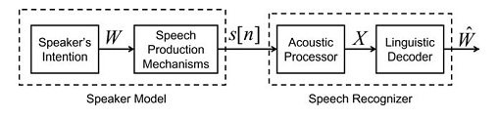
Figure 2.1: Conceptual Model of Speech Production and Speech Recognition Processes (Rabiner et al., 2007)
This goes into the linguistic decoder that explores the Viterbi algorithm of the Hidden Markov Model (HMM) to choose the maximum sequence of words, W, that relates to the observed features extracted. Language modelling, dictionary development, and acoustic modelling are also part of the speech recognition system, which are shown in Figure 2.2. From that figure, it can be seen that the Language model, the acoustic model, and the word lexicon are the three models that form the decoding algorithm of the speech recognition system. The acoustic modelling exploring the Viterbi algorithm, or the Baum-Welch Expectation-Maximization algorithm, which produces the maximum sequence of words starting by comparing phonemes generated with the word lexicon and language model to get the probability of producing a word to form the intended sequence. The language model is an N-gram, which can be 2 grams, e.g., “He comes,” 3 grams, e.g., “He comes home,” etc. The output of this pattern classification is confidence scoring, which gives the confidence score for each word in the sequence of words (Rabiner, L. R., & Schafer, R. W., 2007; Xu, K., Peng, Z., Huang, S., Zhang, G., Hu, Y., & Peng, W., 2026). From Figure 2.2, the generated output, an equivalent of the input speech signal, which was constructed from their phonemes, was “Hello World,” with probabilities of 0.9 and 0.8, respectively.

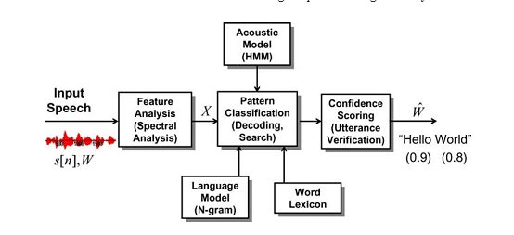
Figure 2.2: Block Diagram of an Overall Speech Recognition System (Rabiner et al., 2007).

2.2.2 Speech Translation in Humans
Translating speech from one language to another has been of utmost desire. Humans, at an early age, utilised human translators to achieve these tasks. Speech produced from the vocal tract of an individual, as illustrated in Figure 2.1, is at some point translated into other languages based on the individual involved in the conversation. Humans have been able to achieve this with some outstanding results, where the produced speech is converted from one language to another. However, only a few trained human translators can translate from one language to others across different national or multinational languages (Kocmi, Tom., Macháček, Dominik., & Bojar, O., 2022; Workshop, B., :, Scao, T. Le, Fan, A., Akiki, C., Pavlick, E., Ilić, S., Hesslow, D., Castagné, R., Luccioni, A. S., Yvon, F., Gallé, M., Tow, J., Rush, A. M., Biderman, S., Webson, A., Ammanamanchi, P. S., Wang, T., Sagot, B., … Wolf, T., 2022). Hence, there is a need to develop speech technology that could convert from one language to another.

2.2.3 Low and High-Resourced Languages
The language itself plays a vital role in language translation. Some languages are well-known and spoken by a large population, while others are yet to gain popularity or are spoken by a minority of the world population (Bozkurt, A. ;, Junhong, X. ;, Lambert, S. ;, Pazurek, A. ;, Crompton, H. ;, Koseoglu, S. ;, Farrow, R. ;, Bond, M. ;, Nerantzi, C. ;, Honeychurch, S. ;, Bali, M. ;, Dron, J. ;, Mir, K. ;, Stewart, B. ;, Costello, E. ;, Mason, J. ;, Stracke, C. M. ;, Romero-Hall, Bozkurt, A., … Stracke, J., 2023). These languages could be classified as high-resourced or low-resourced languages, respectively.

2.2.3.1 Low-Resourced Language
These are languages whose parallel speech pair datasets are not mostly available for language translation modelling and training. Data insufficiency has led to little development of language translation for these languages (Ranathunga et al., 2021). Parallel pair corpora of both source and target languages are mostly available for well-known European nations and American or high-resourced languages. Most of the African indigenous languages, including Yorùbá, have lesser research works done in this field of language translation (Gutkin, A., Demirsahin, I., Kjartansson, O., Rivera, C. E., & Túbòsún, K., 2020).

2.2.3.2 High-Resourced Language
These are languages whose corpora are publicly available and in large amounts for language translation modelling and have seen great development in this domain. Such languages include English, Chinese, French, Russian, etc. However, most of these languages also have challenges with enough parallel pairs of training data for modelling language translation, where the expertise can synthetically generate the source and/or target speech corpus (Barrault et al., 2023).

2.3 Overview of Automatic Speech-to-Speech Translation

2.3.1 Traditional Speech-to-Speech Translation
In the traditional approach to speech-to-speech translation, various statistical techniques like the HMM, Viterbi algorithms, and Baum-Welch expectation maximisation were utilised to model speech-to-speech translation. During this era, statistical approaches were utilised to model ASR, MT, and TTS. For the ASR, for instance, the algorithms were utilised to model the conversion from speech to text, where the acoustic model was done using the GMM, and the decoding search of the correct sequence of texts was carried out using the Viterbi algorithm with the language models and lexical model. This output is fed to a statistically modelled MT, where the target language text is obtained. The output of this MT is fed to a statically modelled TTS, where the output speech of the target language is obtained. Other approaches utilised during this era are the rule-based approach for MT, concatenative approaches for TTS, etc.

2.3.1.1 Probabilistic Approach to modelling ASR
The probabilistic approach to ASR is mostly referred to as a pipeline, as shown in Figure 2.3, because it is a system of large components where the output of one stage is the input to the next stage of the system.

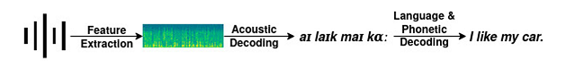
Figure 2.3: Pipeline (Probabilistic Approach) ASR (Medeiros, E. F., 2023a)
The preprocessing of the audio signals is carried out first, then the next stage is the framing and windowing to minimize the discontinuity of the signal (Armaisya, D. D., Pamungkasari, P. D., Rifai, A. P., Sholihati, I. D., & Sakarkar, G., 2025). Through this, the audio signal is split into slices typically ranging from 20 ms to 40 ms with a well-known standard value of 25 ms. Next is the smoothing of its border to minimize the impact of framing (Medeiros, 2023). The next step is the application of different filters, as shown in Figure 2.4, to extract the feature vector coefficients, which in this case are the Mel Frequency Cepstral Coefficients (MFCC).

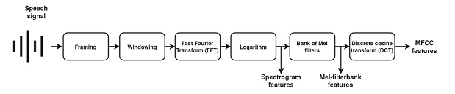
Figure 2.4: Different Speech Features Obtained at Different Processing Stages (Medeiros, 2023).
From Figure 2.4, the framing output goes into the FFT filter to change the signal from the time domain to the frequency domain for easy analysis and visualization, and this is converted to a logarithmic scale for ease of understanding and differentiation among sounds of the speech signal. The extracted feature vector is trained using the GMM, and a beam search for the correct sequence of words replica of the speech input is decoded using the Viterbi algorithm.

2.3.1.2 Statistical Approach to Machine Translation
The statistical approach for modelling MT can be carried out by adjusting the Bayes equation (2.1) implemented for modelling ASR where the acoustic model, $P_{A}(X/W)$ is being replaced by the translation model and the language model, $P_{L}(W)$ replaced by the target language model.
$P(W/X)=\underset{W}{W^{'}= agrmax}{P_{A}(X/W)P_{L}(W)}$ (2.1)
Hence, the MT translation model is given in equation (2.2) (de Martos, A. M., 2022) as
$P(y/x)=\underset{yϵ Y}{y^{'}= argmax}{P_{T}(x/y)P_{L}(y)}$ (2.2)
Where:
$P_{T}(x/y)$ = Translation model
$P_{L}(y)$ = Target language model
$P(y/x)=arg\max_{yϵ Y}{()}$ = The decoded word string that corresponds to the source word
string and can be interpreted as the probability of $y$ being the translation of $x$.
The translation model is trained on source-target parallel sentences so that the mapping of the source to target sentences is carried out. The language model is trained on the single language data of the needed target language such that the correct word sequence (sentence) equivalent of the source sentence is decoded. The HMM utilising the Viterbi algorithm is one of the algorithms for searching the correct word string to be outputted, which is the most likely string equivalent of the source string.

2.3.1.3 Concatenative Speech Synthesis
The CSS approach to modelling TTS involves concatenating several pieces of speech, otherwise called units (generated from texts), to form the decoded speech waveform. For this approach, there is a need for a large recording database (Baral, 2025; Nallabala, N. K., Souprayen, B., Ramasamy, M., Penumarti, S. K., & Navuluri, N. C., 2025; Suikkila, 2025) that stores and covers all possible combinations of these speech units, which are merged to construct the output speech utterance, and a unit selection algorithm such as Viterbi decoding (White & Watson, 2025) using prosodic mismatch objective cost measures and spectral discontinuity instead of HMM, is utilised for these units’ selection (de Martos, 2022).

2.3.1.4 Statistical Parametric Speech Synthesis
In this approach to generating speech from text, the speech generated relies on a statistical approach rather than depending on the pre-recorded speech. Trained on text-audio pairs similar to ASR, it consists of three stages: text-analysis, acoustic model or parametric prediction model, and vocoder (de Martos, 2022). The recording is mostly carried out in professional studio settings to ensure good audio quality and the best acoustic modelling (de Martos, 2022).

2.3.2 Conventional Speech-to-Speech Translation
The conventional approach to modelling speech-to-speech synthesis involves the cascaded blocks of SR, MT, and TTS. The three blocks are arranged in a pipeline where the output of one is the input to the next block. One of the problems associated with this approach is the delay experienced from one block to the next, leading to an overall delay in the system (de Martos, 2022). Another issue with this approach is the misalignment between the input and output, which leads to the generation of errors within the system. Both the statistical and the neural network approaches are utilised to model each of the blocks of the speech-to-speech translation model. The pipeline for the conventional speech-to-speech approach is illustrated in Figure 2.5.
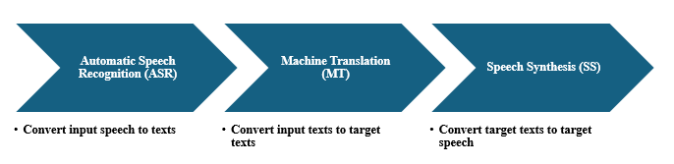
Figure 2.5: Conventional Approach to Modelling Speech-to-Speech Translation

2.3.2.1 Automatic Speech Recognition
Speech recognition, also known as Automatic Speech Recognition or computer speech recognition and speech-to-text conversion (Huang, A. 2026), is the ability of a program or machine to recognise or identify the phonemes, words, phrases, or sentences of a speaker's spoken words (Armaisya et al., 2025; Medeiros, 2023). This means that the Automatic Speech Recognition (ASR) will take speech as its input, process or decode the speech (based on the training it has acquired), and produce the text equivalent of the same spoken words or the textual translation of speech signal (Liu, H., Zhang, H., Zhang, Q., Zhang, X., Shi, D., Chng, E. S., & Li, H., 2026). Other useful outputs from the ASR include the speaker's emotional state, the speech language, and the identity of the speaker (Yoon, Y. C., & Kim, S., 2025; He, X., Polok, A., Villalba, J., Thebaud, T., & Maciejewski, M. 2026). The speech signal, whether the original human voice signal or the recorded audio signal, represents the human vocal tract. The human speech signal primarily occupies a bandwidth up to about 8 kHz, sufficient for intelligible and natural-sounding speech. Unlike telephony or AM radio, which restrict speech to narrower bandwidths, higher-quality audio systems (such as FM or digital recordings) capture a wider range, improving clarity and naturalness, though speech itself does not extend to the full 20 kHz human hearing range. (Schneider, P., Feng, X., Linbao, G., Jie, L., Goncalves, M., & Greten, H. J., 2026).
The conversion of speech to text can be achieved via ASR and other technologies like HMM and Artificial Neural Networks (ANNs). The goal of an ASR is to efficiently and accurately obtain written text from a speech signal, which depends on the acoustic environment of the speaker (which can be outdoors, a quiet office, noisy room), the speaker's accent, and the device type used in recording the speech (which can be a microphone or transducer). The biggest challenge of an ASR system is its ability to handle its variabilities, such as the speaker’s environment, the types of speakers such as dependent speakers, independent speakers, adaptive speakers, variation in environments, etc. (Vijayalakshmi, P., Nagarajan, T., Ananthakrishnan, K., Sanjay, B., & Gayathri, P., 2026). The most difficult variability that ASR must handle is the channel noise, background noise, and other external distortions. Hence, an ASR must be designed to meet and cater to this challenge (Wang, P., 2026). However, its ultimate goal is to perform as a human listener, which is yet to be achieved (Chang, X., Watanabe, S., Delcroix, M., Ochiai, T., Zhang, W., & Qian, Y., 2025; Rabiner et al., 2007). Vocal sound (single utterance or separate utterance), vocabulary (to determine the system complexity, precision, and performance), and speaker (independent or individual speaker) are the parameters used to classify speech recognition (Jiang, S., Qi, J., Huo, C., Gao, Y., & Chen, Q. 2023; Qi, J., & Van hamme, H. 2025) while speech itself can be classified as highly conversational speech (meetings and discussions involving a group of people), isolated speech (containing pauses between words), spontaneous speech (human-to-human dialog), continuous speech (without pauses between words), and spelled speech (having pauses between letters or phonemes) (Medeiros, 2023).

2.3.2.2 Machine Translation
This is a technique implemented to translate text in one language to text in another language, which is otherwise called the target language. It is a type of translation that shares similarities with speech-to-speech translation. Unlike speech-to-speech translation, which involves speech conversion, it involves text conversion. The use of MT started in the 1940s and is seen as a threat to professional human translators even though it is technologically indispensable and economically viable (Moorkens, J., Lankford, S., & Way, A. 2025). Some well-known MT models are Li, R., Wang, X., & Yu, H. (2020); Rapp, R., (2021); and Xue, L., Constant, N., Roberts, A., Kale, M., Al-Rfou, R., Siddhant, A., Barua, A., & Raffel, C., (2020). Mathematically, MT translates source sentences, $x$ into target sentence into target sentence, $y$ given in equation (2.3) (de Martos, 2022) as
$x= x_{1}, x_{2}, x_{3},…, x_{i} x_{i}∈ X$
$y= y_{1}, y_{2}, y_{3},…, y_{i} y_{i}∈ Y$ (2.3)
Where:
$x$ and $y$ are the source and target sentences.
$x_{i}$ and $y_{i}$ are the source and target words in each sentence and;
$X$ and $Y$ are the vocabularies that contain the source and target words.
The approaches to modelling the MT are the rule-based approach, statistical approach, and neural network approaches. Among these approaches, the neural network approach has yielded state-of-the-art results.

2.3.2.3 Text-To-Speech
This is the reverse of speech recognition. It takes text as input and outputs the speech equivalent of the text. It is a speech synthesis system that generates utterances of the text given as input. The TTS consists of text analysis, natural language processing, and digital signal processing (Yao & Poonpon, 2025) . The input to the TTS is the sequence of texts $y_{1}, y_{2}, y_{3},…, , y_{i}$ where the initial output is the speech Mel-spectrogram features $x_{1}, x_{2}, x_{3},…, x_{i}$ which is further processed to obtain the speech audio waveform. In comparison to speech recognition, where the probability of word string given feature vector, $P(W|x)$ is decoded as the output, in TTS, the probability of the feature vector given the word string $P\left(x | W\right)=P(x|y)$ is decoded where the word string, $W$ has been replaced by a string $y$.

2.3.3 Neural Speech-to-Speech Translation
This involves using a deep neural network to model speech-to-speech synthesis. It works by training on a large dataset of speech in both the source and target languages to model speech-to-speech synthesis. Machine learning models such as the RNN, LSTM, and BiLSTM have been implemented to achieve the translation of speech from one language to another. The BiLSTM has found application in sequence-to-sequence learning for converting sequences from one language to another language (Limbu, 2020). The RNN suffers from dependence issues, as it cannot go deeper into the network to make predictions of the present output. Hence, the LSTM was developed to overcome this, but it was deficient in fulfilling its task when a large volume of parallel speech corpus was involved. This led to the utilisation of the transformer architecture. The result of this approach is a high-quality output. However, as the size of the dataset increases, the performance of the system is reduced; hence, there is a need to develop techniques to overcome this drawback. At present, transformer architectures are implemented to overcome the deficiency of the neural network approach in a sequence-to-sequence fashion.

2.3.3.1 Neural Network Approach to Automatic Speech Recognition
Recent technological advances have seen the application of ANN in Natural language processing, ASR, computer vision, handwritten recognition, etc. This development, coupled with the large amount of available data for training, has increased the exploration of ANN in these areas of research.
A convolutional neural network is an example of a neural network model that explores the convolution property by convolving many layers within the network. It has found applications in computer vision for filtering images. The same is true in its application to ASR, where different filters represented by the layers of the network are used to extract relevant features from the input audio signal, unlike the probabilistic approach that exploits framing, windowing, spectral, and cepstral analysis for the same function. Wav2Letter is an example of an ASR system that uses end-to-end CNNs, where graphemes, which are base unit representations, are used instead of phonemes. A grapheme is a single letter that represents a phoneme; hence, there is no need to use phonetic transcription (Medeiros, 2023). Exploring the Wav2Letter approach, NVIDIA developed a new ASR system called Jasper that uses 1 Dimensional Convolutional Neural Networks ($1D-CNN$) (Li, J., Lavrukhin, V., Ginsburg, B., Leary, R., Kuchaiev, O., Cohen, J. M., Nguyen, H., & Gadde, R. T., 2019a; Medeiros, 2023). It has 54 convolutional layers (333M parameters), while the smaller model uses 34 (201M parameters) and a mix of activation and normalization functions such as batch normalization and ReLU functions, and it has a tremendous improvement on the WER of the ASR system. Jasper belongs to the end-to-end ASR models that replace the pronunciation model (language model and phonetic model) and the acoustic model with CNN. It uses Mel filterbank feature coefficients that are calculated from 20 ms windows with an overlap of 10 ms in which 64 features were calculated. The output probability distribution is in characters per frame. Jasper has $B*R$ block architectures where each $B$ block has $R$ sub-blocks (with the same number of output channels) that apply the $1D$ Convolution, ReLU function, batch normalization function, and dropout. Other types of normalization functions, such as the layer and weighted normalization; activation functions, such as clipped ReLU and leaky ReLU; and gated units, like the gated linear unit (GLU) and gated activation unit (GAU), were explored in Jasper. Besides, the modelling of the language model was done using Recurrent Neural Network (RNN), ConvLM, $N-gram$ language model, Long Short-Term Memory (LSTM), as well as a Transformer $XL$. It also has different architectures for the residual connections of layers within the network, such as Residual, Dense Residual, DenseNet, and DenseRNet (Li J., et al., 2019a).

2.3.3.2 Neural Network Approach to Machine Translation
This is also termed the Neural Machine Translation (NMT) approach to modelling MT. It is a sequence-to-sequence modelling approach that is based on the transformer architecture implemented at the encoder and decoder. It has been implemented to achieve improved MT performance and SOTA results (de Martos, 2022). It models MT by directly estimating the probability of the output sentence given the input word string, as given in equation (2.4) (Banerjee, A., & Banik, D. 2025; Berger, N., 2026; Hatami, A. 2026).
$p\left(y|x\right)= \prod_{j=1}^{J}{p(y_{j}|{y_{1}}^{j-1}, x)}$ (2.4)
The beam or greedy search decoding algorithm is implemented to output the correct word sentence that comes from the source sentence. Other approaches to modelling MT involve standard neural networks like CNN and RNN, but the results achieved cannot be compared to SOTA results obtained using transformer architectures (Julius et al., 2024).

2.3.3.3 Neural Network Approach to Modelling TTS
DNN has been utilized to model TTS using SPSS by replacing some HMM components (Fan, Y., Qian, Y., Xie, F.-L., & Soong, F. K., 2014). In the late 2010s, with the introduction of an end-to-end autoregressive neural vocoder and acoustic model, the quality and naturalness of the generated speech were improved. The end-to-end model works by taking text or phonemes as input to an encoder and generating the output Mel-spectrogram by a decoder, after which a vocoder generates the speech utterance. Some of the pioneering TTS models that have gained popularity are Deep Voice (Ding, P., 2026), WaveNet (Oord, A. van den, Dieleman, S., Zen, H., Simonyan, K., Vinyals, O., Graves, A., Kalchbrenner, N., Senior, A., & Kavukcuoglu, K., 2016; O'Shaughnessy, D., 2026), and Tacotron (Battenberg, E., Skerry-Ryan, R. J., Stanton, D., Mariooryad, S., Shannon, M., Salazar, J., & Kao, D., 2025). A neural TTS model is illustrated in Figure 2.6
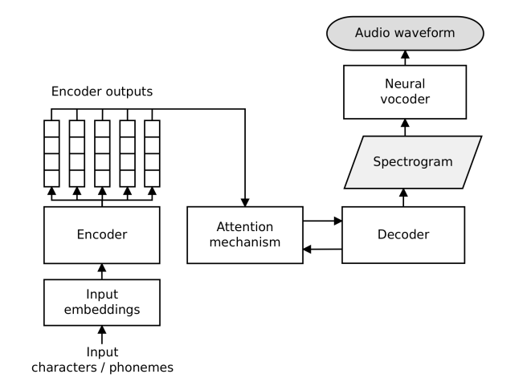
Figure 2.6: A Generic Two-Stage Neural TTS Architecture (de Martos, 2022)

As illustrated in Figure 2.6, the neural end-to-end TTS synthesis consists of two stages. The first stage is the end-to-end modelling of the input sentence to generate the output spectrogram features. The input sequence, which is converted into a vector (using embedding) that is easily understood during training, is fed to an encoder; the encoded output vector is passed through an attention mechanism to ensure all features of the text input are well extracted ensuring accurate mapping of text to spectrogram features. The output of this is fed to a decoder that finally generates the output spectrogram. The encoder and decoder are nothing but stacked of neural network algorithms such as MLP, LSTM, BiLSTM, RNN, etc. The second stage converts the acoustic speech features to an output waveform using a vocoder (Shen et al., 2018) or another algorithm (Ren, Y., Ruan, Y., Tan, X., Qin, T., Zhao, S., Lu, J., & Liu, T., 2020; Popov, V., Vovk, I., & Kudinov, M., 2021).
For the first stage, which is text-to-spectrogram, the acoustic model is trained on a collection of text-audio pairs represented in equation (2.5) as:
$D={\{x_{i}, w_{i}\}}_{i=1}^{N} <text, audio>$ (2.5)
And its goal is to minimise the loss between the predicted, $\hat{y}$ and the target or ground truth spectrogram, $y$ obtained from the audio waveform, $w$ (de Martos, 2022). According to Murphy, (2022), a teacher forcing algorithm is utilised to train the autoregressive model in which the decoder output at time, $t$ is conditioned by the ground truth spectrogram frame, $y_{t-1}$. Hence, an exposure bias (Liu, R., Sisman, B., Li, J., Bao, F., Gao, G., & Li, H., 2020), which is a mismatch between inference conditions and training, is introduced.
For the second stage, which involves the spectrogram-to-audio waveform conversion, the vocoder is trained on a collection of untranscribed audio given in equation (2.6) as:
$D={\{w_{i}\}}_{i=1}^{N}$ (2.6)
From the training of equation (2.6), an intermediate representation of the spectrogram of the audio waveform can be obtained.
For the last 5 years, other TTS models that have achieved enhanced performance in terms of improvement of audio quality through Vocoder and matching the performance of WaveNet for TTS modelling are: FFNET Yun, S., Lee, J., & Ro, Y. (2024), WaveRNN Bouhajeb, E., Jlassi, C., & Arous, N. (2026), Parallel WaveNet Zeng, C., Wang, C., Miao, X., Zhao, J., Jiang, Z., & Chen, Y. (2024), WaveGlow Kong, Z., Huang, J., Zhao, K., Ping, W., & Catanzaro, B. (2021), LPC-Net Kim, T., & Skoglund, J. (2024) , as well generative approach such as the MelGAN Kumar, K., Kumar, R., De Boissiere, T., Gestin, L., Teoh, W. Z., Sotelo, J., De Brebisson, A., Bengio, Y., & Courville, A. C., (2019), Parallel WaveGANs Yamamoto, R., Song, E., & Kim, J.-M., (2020), HiFi-GAN Kong, J., Kim, J., & Bae, J., (2020) that tend to increase the speed and computational cost.

2.3.4 Direct Speech-to-Speech Translation
This is also called end-to-end speech-to-speech translation, where the deep neural network is utilised to obtain state-of-the-art results. In this method, the input side contains an encoder that consists of a stack of RNNs, BiLSTMs, or LSTMs networks, as well as the output encoder. There is also a transformer architecture with state-of-the-art techniques like positional encoding, embeddings, attention mechanisms, etc., to obtain SOTA results. The input to such a model is sequential data, and the output generated is also sequential data.

2.3.4.1 Generic Architecture
The generic direct S2ST architecture is illustrated in Figure 2.7 (Jia, Y., et al., 2022). As shown in Figure 2.7, the components of the architecture are the spectrogram, synthesizer, blocks of encoder, attention mechanism, and decoder; also utilized is the Graffin Lim Vocoder, and the outputs are the final speech waveform (English) and English phoneme. The constituent blocks of the architecture are explained in subsequent sub-sections. The architecture was an improvement to the original Translatotron that was carried out in (Jia, et al., 2019).

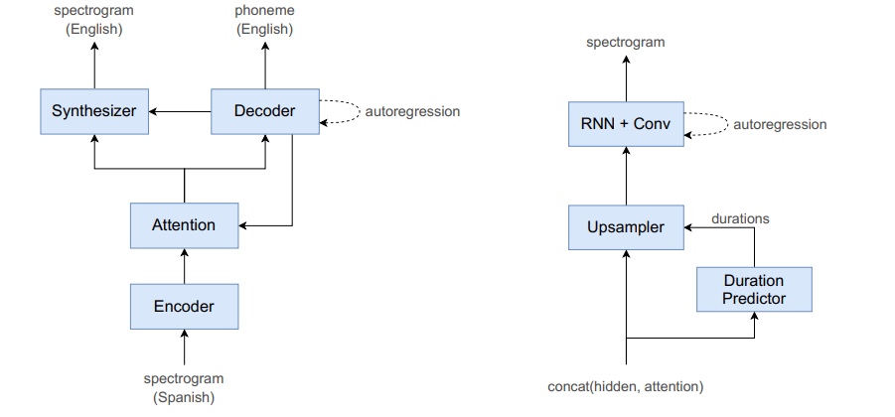
Figure 2.7: Generic Direct Speech-to-Speech Architecture (Translatotron 2) (Jia et al., 2022)

2.3.4.2 Speech Mel Spectrogram
This is a two-dimensional plot with time on the abscissa and frequency on the ordinate, along with the amplitude as a scale of color saturation or a colored heat map. It is a graph that shows the relationship between the spectrum of frequencies and time, where the amplitudes, which are the heat maps, are representations of audio files at a particular frequency and time. For using the S2ST approach for language translation, the model is input with the spectrograms of both the source and target languages during training. During evaluation and testing, only the spectrogram of the source language is fed as input to generate the output language spectrogram, which is later changed to an audio file via a block such as a vocoder as was done (Jia, et al., 2019). Displayed in Figures 2.8 and 2.9 are the speech spectrograms of the source English audio (“I will be back soon”)-target Swedish audio (“Jag Kommer Tillbaka Snart”) pair.

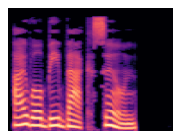
Figure 2.8: Spectrogram for English Audio - "I will be back soon” (Limbu, 2020)

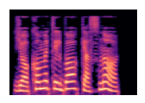
Figure 2.9: Spectrogram for Swedish Audio - "Jag Kommer Tillbaka Snart" (Limbu, 2020)

2.3.4.3 The Fast Fourier Transform
The FFT is a faster algorithm for computing the DFT of a discrete-time signal. The speech spectrogram is used to gain an understanding of how the phonetic information is encoded in the speech signal (McLoughlin, I., Pham, L., Song, Y., Miao, X., Phan, H., Cai, P., ... & Soh, D., 2026). Currently, spectrograms are made using digital speech processing (DSP) techniques and are displayed as grey-scale images or pseudo-color on computer screens (Govind, G., Gupta, D., & Jhajharia, K., 2026). The speech spectrograms are simply a display of the plot (time on x axis against frequency on the y axis with vertical color bar to the right of the graph) of the log of the Short Time Fourier Transform (STFT) given in equation (2.7) and plotted in Figure 2.10, where analysis windows of different lengths were used for the two plots and the speech waveform “Should we chase” is plotted atop them.
$S\left(t_{r}, f_{k}\right)=20\log_{10}\left|\overline{X_{rR}}\left[k\right]\right|=20\log_{10}{|X_{rR}\left[k\right]|}$ (2.7)
where:
$t_{r}=time in seconds$
$f_{k}=frequency in Hz$
$X_{rR}\left[k\right]=STFT$, which is the DTFT of the input signal $x_{\hat{n}}[m]=x\left[m\right]w\left[\hat{n}-m\right]$
$x\left[m\right]w\left[\hat{n}-m\right]=amplitude-weighted by the sliding window, w\left[\hat{n}-m\right]$
$\overline{X_{rR}}\left[k\right]=has the interpretation of N Point Discrete Fourier Transform (DFT)$
$t_{r}=rRT$ and $f_{k}= \frac{K}{NT}$
$T=Samling period of the discrete-time signal x\left[n\right]= x_{a}[nT]$
$X_{rR}\left[k\right]= \sum_{m=rR-L+1}^{rR}{x\left[m\right]w\left[rR-m\right]e^{-j\left(\frac{2πkm}{N}\right)}} k=0, 1, …, N-1,$ (2.8)
$\overline{X_{rR}}\left[k\right]= \sum_{m=0}^{L-1}{x\left[rR-m\right]w[m]}e^{j\left(\frac{2πkm}{N}\right)} k=0, 1, …, N-1$ (2.9)
And
$X_{rR}\left[k\right]= \overline{X_{rR}}\left[k\right]e^{-j\left(\frac{2πkrR}{N}\right)} k=0, 1, …, N-1$ (2.10)
$N=Total number of uniformly spaced frequencies within 0 ≤ \hat{ω} ≤2π$ N-point
Length of the DFT
$\hat{ω}=angular frequency in radian per seconds$
$L=Window length in samples$
$w\left[m\right] is within the range 0 ≤ m ≤L-1$ (Rabiner & Schafer, 2007)
Equation (2.8) shows that the STFT is computed in the frequency domain in a finite-duration window moved in steps of R > 1 samples in time.
When the window length chosen is short, the resulting spectrogram is called a wide-band spectrogram, but when the window length is long, it is called a narrow-band spectrogram (Rabiner & Schafer, 2007; Zeng, Z., Zhao, Y., Wang, K., Niyato, D., Shu, H., Zhao, J., ... & Wei, N., 2026).
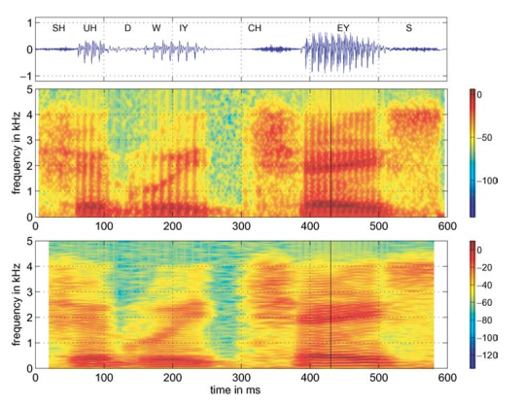
Figure 2.10: Spectrogram for Speech Signal “Should we chase” with Hamming Window Length M = 101 for the Upper Plot and M = 401 for the Lower Plot (Rabiner & Schafer, 2007)

2.3.4.4 Synthesizer
The synthesizer in the Translatotron 2 was built using an upsampler, duration predictor, mixture of RNN (LSTM), and Convolutional layer. The inputs to the block are outputs from the attention mechanism and phoneme decoder. The function of the synthesizer is to synthesize the needed output spectrogram (English spectrogram). The upsampler increases the dimension of the duration predicted inputs samples into the block, after which autoregressive decoding is carried out by the LSTMs – which is the main decoder of the synthesizer; and further processing is carried out by the Convolutional layer.

2.3.4.5 Encoder
This consists of a stack of deep learning architectures. They could be LSTM, BiLSTM, MLP, etc. The outputs of the encoder are vector representations of the input Mel spectrogram. For the speaker encoder, this is a trained model that is used to preserve the features of the speaker. Features such as emotion, voice, and prosody are transmitted to the output audio collected by the speaker encoder. It can be trained for a single-speaker voice or more than one speaker's voice. The concatenation block concatenates the output of both the encoder and speaker encoder.

2.3.4.6 Attention Mechanism
This is the mechanism to determine how much a particular input sequence or utterance contributes to the prediction of the audio samples. It involves the generation of another vector that is able to retain the features of the input layers in the hidden layer and carry out proper mapping of the source and target inputs during the training phase. Hence, it makes the model “attend to” certain parts of the input sequence to output the audio file. It enhances the overall output audio waves of the model.

2.3.4.7 Decoder
This could also be stacked of deep learning algorithms like the case of the encoder to generate the output spectrogram taking the output of the attention mechanism as its input. The decoder outputs the phonemes of the target language (English). The output of the decoder could be fed to a dense layer (original Translatotron) (Limbu, 2020), which is a neural network architecture that carries out further processing on the output spectrogram. Here, the general modelling equation of a neural network is illustrated in equation (2.11).
$f\left(z\right)=activation(w.x+b)$ (2.11)
Where:
$f\left(z\right)=output of the dense layer to be fed as input to a vocoder block$
$w=weight of the last deep learning algorithm \left(e.g. LSTM\right) of the decoder$
$x=input, which can be chosen to be input tensor$ (Limbu, 2020)

2.3.4.8 Vocoder
The output spectrogram obtained from the synthesizer is fed to a vocoder, which performs the the conversion of the spectrogram to the expected English waveform, which is a replica of the transmitted audio Spanish waveform. This could be WaveRNN or Graffin Lim Vocoder Griffin, D., & Lim, J., 1984; Jia, et al., 2019; Baoueb, T., Bie, X., Fontaine, M., & Richard, G., 2025; Mezza, A. I., Cicognani, M., Cicognani, R. L., & Bernardini, A. 2026; Yang, R., Li, K., & Hu, X., 2026). For better enhancement and generalisation of the synthesized English speech, Translatotron 2 combined the decoding tasks of both the phoneme and spectrogram during the same training time, unlike in the original Translatotron (Jia, et al., 2019), where phoneme decoding training tasks of both English and Spanish were separated from that of the English audio waveform decoding.

2.4 State-of-the-Art Approaches for Speech-to-Speech Translation

2.4.1 Sequence-to-Sequence Learning
This refers to a technique where the input and output are variable-length sequences. It is a deep learning approach that involves training on sequential data. For example, in the modelling of ASR, the input is the sequence of acoustic features while the output is a sequence of words, and the reverse is the case for TTS; for MT, the input and output are sequences of words (de Martos, 2022). It is shortened to Seq2Seq modelling. In this type of learning, an encoder and decoder are implemented on the fixed length of input source data to generate a fixed-length output target. The input and output are mapped to each other (Limbu, 2020). The encoder and decoder, in most cases, could be MLP (Radford et al., 2023), BiLSTM, or LSTM (Jia, et al., 2019). The use of sequence-to-sequence learning has yielded great performance for language translation for both text and audio.

2.4.2 Encoder-Decoder Network
This refers to the integration of an encoder and decoder in a sequence-to-sequence learning fashion to achieve the intended task. It has found applications for both text and audio translation from one language to another language (Limbu, 2020). The encoder could be a network of MLP, LSTM, or BiLSTM, which is also the case for the decoder. A typical example of an encoder-decoder network is displayed in Figure 2.11. The encoder consists of a stack of 3 BiLSTM layers, while the decoder consists of a stack of 2 LSTM networks.

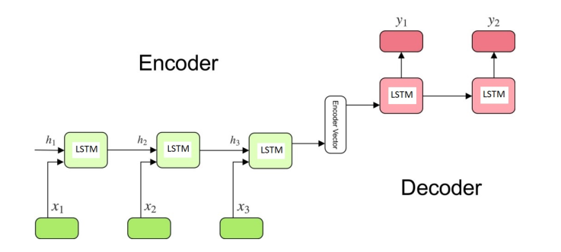
Figure 2.11: A Basic Encoder-Decoder Network using LSTM (Limbu, 2020)

As shown in Figure 2.11, each recurrent unit in the encoder accepts the input at each timestep and passes it through the hidden layer to the next unit. The final output passes to the decoder, where it is decoded at the corresponding time step to generate the final outputs. The encoder-decoder architecture is one of the most important aspects of Google’s translation services (Limbu, 2020). For ASR, the decoder is to generate the text representations of the vectors generated from the output of the encoder. Hence, it can be termed a language model (de Martos, 2022); for MT, the encoder and decoder can be taken as language models due to the text involvement of both blocks.
The formula to compute the hidden state from the encoder, the hidden state of the decoder, and the final output are given in equations (2.12), (2.13), and (2.14), respectively (Limbu, 2020).
$h_{t}=f(W^{hh}h_{t-1}+ W^{hx}x_{t})$ (2.12)
$h_{t}=f(W^{hh}h_{t-1})$ (2.13)
$y_{t}=Softmax(W^{s}h_{t})$ (2.14)
Where:
$h_{t}=current hidden state$
$h_{t-1}=Previous hidden state$
$x_{t}=Present input$
$W_{hh}=weight between two hidden layers*$
$W_{hx}=weight between a hidden layers and an input*$

2.4.3 Attention Mechanism
This is one of the important techniques utilized for encoder-decoder networks to obtain enhanced performance of the trained model. It could be self-attention, cross-attention (Radford et al., 2023), multi-head attention (Jia, et al., 2019), etc. During training, there is a need for the final hidden layer to capture all the important features of the input sequence for the proper working of the algorithms, but this becomes a problem when the length of the input sequence is large, as it causes a misalignment between the source and target inputs. To solve this misalignment, the attention mechanism, which introduces a new vector (different from the vector generated by the encoder when it acts on the input) is used. This vector preserves all the information in the hidden state of the encoder and aligns it with the target for enhanced performance. Hence, the model can “attend to” particular parts of the input sequence while the input is being mapped to the target, and then it enhances the relationship between the source and target inputs.

2.4.4 Sequence-to-Sequence Modelling
As depicted in Figure 2.12, the input sequence, $x=[x_{1}, x_{2}, x_{3},…,x_{N}]$ of length, $N$is being processed by the encoder to generate an output vector, $z=[z_{1}, z_{2}, z_{3},…,z_{N}]$, of length, $N$, that is otherwise called the encoder output or encoder hidden state (de Martos, 2022). This output vector is then changed to the output sequence, $y=[y_{1}, y_{2}, y_{3},…,y_{T}]$ by the decoder, as illustrated in equation (2.15) (de Martos, 2022).
$y_{t}=dec({y_{1}}^{t-1}, z_{n})$ (2.15)

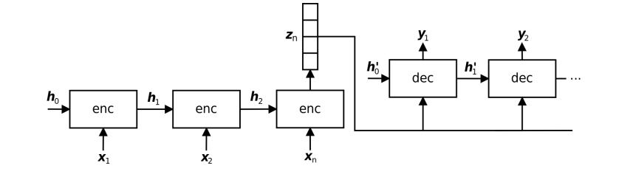
Figure 2.12: A Basic Encoder-Decoder Network Showing the Encoded Vectors (de Martos, 2022)

The fixed output vector, $z_{n}$ holds all the relevant features of the input sequence, which can be many words. As initially stated in section 2.4.3, this becomes a problem when the length of the input sequence is long, which depicts that the above architecture suffers from memory limitations because it will be difficult to map the input to the target output properly. Hence, a solution to this is the integration of the attention mechanism for Seq2Seq modelling.
For the attention mechanism, a context vector $c_{t}$ given in equation (2.16), which replaces the fixed vector, $z_{n}$ is computed dynamically at each decoding step, and it is utilised.
$c_{t}= \sum_{i=1}^{N}{α_{t, i}z_{i}}$ (2.16)
Where:
$α_{t, i}$ = weights assigned to each hidden state of the encoder at the time step, $t$ where the
highest weight is assigned to the most relevant vector, and they are computed by
utilising the Softmax function (2.17) as
$α_{t, i}= \frac{exp⁡(e_{t, i})}{\sum_{k=1}^{N}{(e_{t, k})}}$ (2.17)
And its value is within the range $0 ≤α_{t, i} ≤1$, for all i with probability condition:
$\sum_{i=1}^{N}{α_{t, i}}=1$
Where:
$e_{t, i}$ = attention score (energy value) obtained using some scoring function.
The scoring function is a depiction of the relevance of the encoder vector, $z_{i}$ at each time step. For recurrent Seq2Seq models, it is mostly obtained using the previous hidden state of the decoder, as given in equation (2.18)
$e_{t, i}=a(h_{t-1}, z_{i})$ for all i (2.18)
Where:
$a(.)$ = scoring function (de Martos, 2022)
A better illustration of the attention mechanism is given in Figure 2.13.
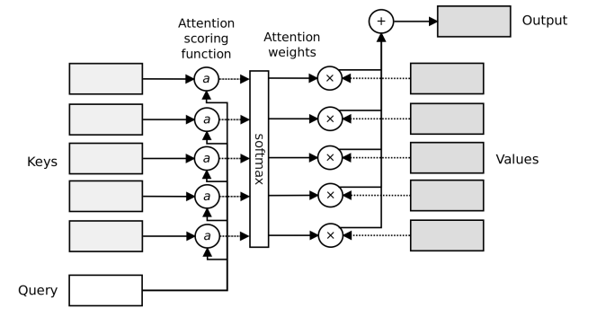
Figure 2.13: Attention Mechanism Overview (Zhang, A., Lipton, Z. C., Li, M., & Smola, A. J., 2021)

As illustrated in Figure 2.13, the attention mechanism can be compared to a dictionary look-up that consists of a key-value pair, $\left(k_{1}, v_{1}\right), \left(k_{2}, v_{2}\right),…, \left(k_{N}, v_{N}\right),$ of length $N$, where a query, $q ∈R^{d_{q}}$ is compared to each key, $k_{i} ∈R^{d_{k}}$ of the dictionary, and then retrieve the corresponding value $v_{i} ∈R^{d_{v}}$. As shown in Figure 2.9, a complex combination of values is obtained for each output. The scoring function, $a(.)$ can be obtained using scaled dot-product (Sanger, T. D., 2026) or additive (Shaker, A., Maaz, M., Rasheed, H., Khan, S., Yang, M.-H., & Khan, F. S. 2023; Shehzadi, T., Ifza, I., Stricker, D., & Afzal, M. Z. 2025) scoring functions as given in equations (2.19) Vaswani, A., Shazeer, N., Parmar, N., Uszkoreit, J., Jones, L., Gomez, A. N., Kaiser, Ł., & Polosukhin, I., (2017) and (2.20), respectively.
$a\left(q, k, v\right)= softmax\left(\frac{q^{T}k}{\sqrt{d}}\right)v ∈ R$ (2.19)
$a\left(q, k\right)= {w_{v}}^{T}\tanh\left(W_{q}q+ W_{k}k\right)∈ R$ (2.20)
Where:
$w_{v} ∈R^{h}, W_{q} ∈R^{h x q}, and W_{k} ∈R^{h x k}$ are learning model’s parameters (de Martos, 2022)
For the scaled dot-product equation (2.19), $q,$and $k$ have the same dimension, $d$ (de Martos, 2022)

2.4.5 Transformer
This is a type of Sequence-to-Sequence modelling utilising an encoder and decoder at the input and output points. It has found applications for modelling systems that take sequential data as input. Examples of such are speech processing applications such as TTS and ASR, coupled with NLP tasks such as MT. Some state-of-the-art (SOTA) speech resources (Chang et al., 2023), such as Jasper (Li et al., 2019a), Whisper ASR (Radford et al., 2023), and language translators, have implemented transformer architecture. It has been implemented for the development of ChatGPT (Haluza, D., & Jungwirth, D., 2023). A typical transformer architecture is shown in Figure 2.14.
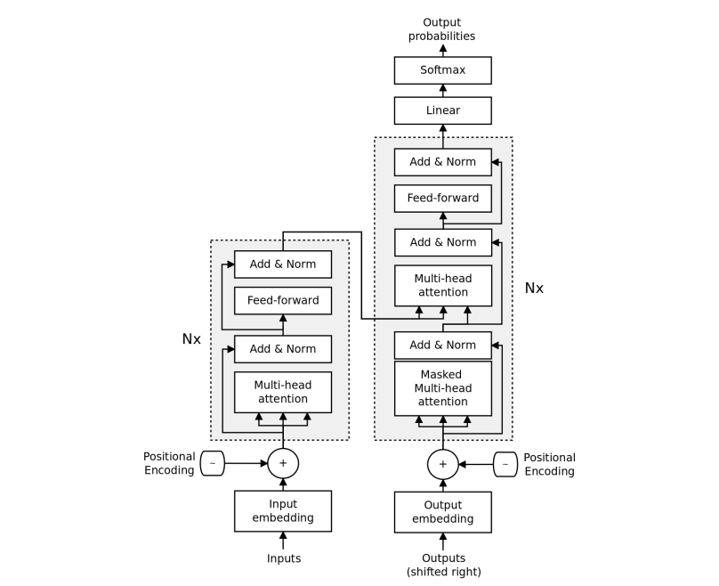
Figure 2.14: The Original Transformer Architecture (Vaswani et al., 2017)

As shown in Figure 2.14, the decoding of outputs from the decoder of the transformer encoder-decoder structure does not depend on the deep learning algorithm chosen; rather, it depends on three concepts, which are positional encoding, self-attention, and multi-head attention (de Martos, 2022). It utilises positional encoding and self-attention to investigate other positions of the sequence when it is processing a particular input, while multi-head attention is utilised for improved performance of the model (Murphy, K. P., 2022). The key parts of Figure 2.14 are highlighted below:

2.4.5.1 Self-Attention
This is a type of attention in which the encoder attends to itself in computing context-aware encodings whose length is the same as the input sequence. In this case, each input attends to all positions of the input sequence (de Martos, 2022).
Given an input sequence, $x=[x_{1}, x_{2}, x_{3},…,x_{n}]$ in which $x_{i}∈R^{d}$, to compute output sequence, self-attention utilises $x_{i}$ as a query on the key and value of the dictionary that are each depicted by $[x_{1}, x_{2}, x_{3},…,x_{n}]$.

2.4.5.2 Multi-Head Attention
In this type of attention, the attention mechanism can utilize varying representation sub-spaces of queries, keys, and values-this is done to capture different dependencies, such as long-range, short-range, etc., of the input sequence. Each attention head, $h_{i}$ in a multi-head, attention is computed using equation (2.21):
$h_{i}= f({W_{i}}^{\left(q\right)}q, {W_{i}}^{\left(k\right)}k, {W_{i}}^{\left(v\right)}v)$ (2.21)
Where:
$q=query, where q ∈R^{d_{q}}$
$k=key, where k ∈R^{d_{k}}$
$v=value, where v ∈R^{d_{v}}$
${W_{i}}^{\left(*\right)}=learnable parameters$
$f\left(.\right)=Attention funct which can be scaled dot-product or additive function.$
The multi-head attention head, $h$ which is the output obtained is the scaled value of the vector head (by the learned weight parameters) of size n as given in equation (2.22) as:
$h=W_{0}\left[ \begin{matrix}h_{1} \\ ⋮ \\ h_{n}\end{matrix}\right]$ (2.22)

2.4.5.3 Positional Encoding
This is a mechanism that is implemented in a transformer to keep track of the position of each word in an input embedding sequence. The positional encoding is done using sine and cosine functions on the input sequence as illustrated in equation (2.23):
$p_{i, 2j}=\sin\left(\frac{i}{C^{{2j}/d}}\right)$, $p_{i, 2j+1}=\cos\left(\frac{i}{C^{{2j}/d}}\right)$ (2.23)
Where:
$C$= fixed maximum length of a sequence.
$j$= dimension index of the embedding.
$i$ = position.
$d$= total dimensions number.
The benefits of this type of embedding are that it allows the model to attend relative positions effortlessly and it allows computation for arbitrary input lengths up to $C$.

2.4.6 Cross lingual Voice Cloning
Voice cloning refers to the synthetic production of a speaker's voice or intonation of one language in another language. For instance, an English speaker's voice is reproduced in the Yoruba language while the accent or intonation is preserved, and it is the English speaker who is being heard speaking Yoruba. For cascaded S2ST, this can be achieved by utilizing Tacotron 2 (for monolingual single speakers), which can be adapted to support voice cloning for language pairs of seen and unseen speakers as well as multiple speakers and languages. In this situation, the TTS system (Tacotron 2) is trained with speaker embeddings and language-specific phoneme embeddings, and then the output waveform or speech is a replica of the speaker's voice (de Martos, 2022). The trained Tacotron 2 is merged with the existing systems of ASR+MT. In direct S2ST, a speaker encoder is utilized (Jia, et al., 2019), where the model is trained with a speaker encoder pre-trained on multiple speakers, and the output speeches are replicas of the speakers’ voices, the model is trained with.

2.5 Stages Involved in Neural End-To-End Approaches to Speech Translation

2.5.1 Data Collection
The most available speech-to-speech parallel pair dataset for language translation modelling is the MustC dataset (Cattoni, R., Di Gangi, M. A., Bentivogli, L., Negri, M., & Turchi, M., 2021), Open Parallel Corpus-Opus website, 50 Languages website (Limbu, 2020), Conversational Spanish-English dataset, Fisher Spanish-English (Jia et al., 2022, Jia, et al., 2019), LibriS2S (German-English) (Jeuris & Niehues, 2022), FLEURS with 1625 parallel Punjabi-English speech (Kaur et al., 2024). Another approach to generating a parallel speech corpus is to utilize ASR or TTS speech corpora with their transcripts, where the speech is synthetically generated (Cattoni et al., 2021; de Martos, 2022; Jia et al., 2022; Jia, et al., 2019). The majorly available sources of speech corpus for ASR and TTS tasks are the TED-LIUM2/3, LibriSpeech, Wall Street Journal (WSJ), Hub, CHiME4, CSJ, Aurora4, HKUST, and Fisher-CALLHOME Spanish. For this research work, a speech-to-speech translation corpus was curated primarily by crowd-sourced individuals who were tasked with recording their voices reading some already prepared texts for both the general and public health domains.

2.5.2 Data Analysis
The collected parallel speech pair data is subjected to analysis to know the statistical properties of the data. Statistical properties that are considered are the normal distribution of the speech corpus, the frequency of variations in the data, the mean, variances, etc. This ensures that it satisfies the quantity and quality requirements of language-translation modelling, is able to train well, and provides more insight into the characteristics of the dataset. This statistical analysis can be carried out using SPSS software, MATLAB packages, or any statistical software package. Also, the quality of the speech pair, background noise, and the number of hours of the audio recordings are analysed.

2.5.3 Data Preprocessing
This involves the conversion of raw speech of both the source and target to Mel-spectrogram features, after which discrete representations of both will be derived by using the HuBERT model or any other available Mel-spectrogram or raw speech to discrete conversion. This ensures that the discrete representations of both the source and target are available for training as input and target. Preprocessing also ensures the audios are aligning at the sentence level to ensure the alignment needed for training is obtained.

2.5.4 Data Cleaning
This involves the removal of unwanted audio samples from both the source and target speech files. Restructuring the speech corpus to be in the format needed for training, such as using the appropriate format and the correct sampling frequency.

2.5.5 Feature Extraction Stage
This involves the extraction of speech feature vectors from the speech signals. The extracted feature vectors are Mel-spectrogram representations of both the raw source input and target speech. Typical Mel-spectrograms are shown in Figures 2.8 through 2.10 of section 2.3.4.2.

2.5.6 Discretisation
Here, the extracted feature vectors will be converted to discrete representations for both the source and target extracted features to be used for training. This ensures reduced size for speech data.

2.5.7 Sequence-to-Sequence Modelling
This involves the training of the pre-processed parallel speech corpora of both the source and target language using the transformer architecture and other state of the art techniques highlighted in section 2.4. Thereafter, the developed trained model is tested for functionality and performance evaluation.

2.6 Performance Metric

2.6.1 Bilingual Evaluation Understudy
This is an objective evaluation that involves the comparison of the speech target output with that of the reference or ground truth. To compute the BLEU score, the output of the speech translation is fed to an ASR model to generate the text equivalent. These texts generated are then compared with the ground truth texts, and the BLEU score is computed. Mathematically, the BLEU score is computed using equation (2.24):
$BLEU score= BP*\exp{\sum_{i=1}^{N}{w_{i}\log_{e}{p_{i}}}}$ (2.24)
Where:
$BP=Brevity Penalty=\exp\left(1- \frac{r}{c}\right)$ (2.25)
Which is also computed as: $BP=Brevity Penalty=\min\left(1, \frac{r}{c}\right)$
$r=length of machine translated output (text or speech)$
$c=length of reference translation (text or speech)$
$p_{i}=n- gram modified precision score of order i, which is given in equation \left(2.26\right) as:$
$p_{i}= \frac{Count Clip (matches, max-reference-count)}{candidatae n-gram}$ (2.26)
$N=maximum number of n-gram order to consider (usually up to 4)$
$w_{i}=weight for n-gram precision of order$
For instance, given the information below for both the machine-translated output (obtained using ASR) and reference output text:
Machine Translation (MT): The picture the picture by me.
Reference (Ref) 1: The picture is clicked by me. (used)
Reference (Ref) 2: This picture was clicked by me.
The analysis is indicated for each n-gram in Table 2.1.
Table 2.1: A summary Table for the Computation of BLEU score
n = 1 |  |  |  | n = 2 |  |  |  | n = 3 |  |  |  | n = 4
 | MT  l = 6 | Ref  r = 6 | Min (MT, Ref) |  | MT | Ref | Min (MT, Ref) |  | MT | Ref | Min (MT, Ref) |  | MT | Ref | Min (MT, Ref)
“the” | 2 | 1 | 1 | “the picture” | 2 | 1 | 1 | “the picture the” | 1 | 0 | 0 | “the picture the picture” | 1 | 0 | 0
“picture” | 2 | 1 | 1 | “picture the” | 1 | 0 | 0 | “picture the picture” | 1 | 0 | 0 | “picture the picture by” | 1 | 0 | 0
“by” | 1 | 1 | 1 | “picture by” | 1 | 0 | 0 | “the picture by” | 1 | 0 | 0 | “the picture by me” | 1 | 0 | 0
“me” | 1 | 1 | 1 | “by me” | 1 | 1 | 1 | “picture by me” | 1 | 0 | 0
$$p_{1}= \frac{4}{6}= \frac{2}{3}$$ |  |  |  | $$p_{2}= \frac{2}{5}$$ |  |  |  | $$p_{3}= \frac{0}{4}= 0$$ |  |  |  | $$p_{4}= \frac{0}{3}= 0$$

Hence, using equation (64), the Brevity Penalty is computed as:
$$BP=\min\left(1, \frac{r}{c}\right)= \min\left(1, \frac{6}{6}\right)=\min{(1, 1)=1}$$
Substituting into equation (63) with other parameters gives:
$$BLEU score= BP*\exp{\sum_{i=1}^{N}{w_{i}\log_{e}{p_{i}}}}$$
$$BLEU score= 1*\exp{\sum_{i=1}^{4}{w_{i}\log_{e}{p_{i}}}}$$
$BLEU score= 1*\exp{(0.25\log_{e}{\frac{2}{3}}+ 0.25\log_{e}{\frac{2}{5}}+ 0 \log_{e}{0}+ 0\log_{e}{0})}$ [$w_{1}=w_{2}=0.25, w_{3}=0, w_{4}=0];$
$$BLEU score= 0.718=71.8$$

2.6.2 Mean Opinion Score
This is a subjective performance metric that is based on the judgment made by the observer on the output translated speech of the target language. It could be MOS Naturalness or MOS Similarity. In this type of subjective evaluation, raters are sought, who then score the generated speech output on a scale from 1 to 5, where 1 = Poor, 2 = Satisfactory, 3 = Good, 4 = Very good, and 5 = Excellent. In MOS Naturalness, the raters judge the fluency and naturalness of the speech output, while in MOS Similarity, the raters score the output speech obtained by comparing it with a reference or ground truth output (which can be human-generated speech or a synthesized one) on a scale of 1 to 5.

2.6.3 Statistical Evaluation
This refers to the utilisation of machine learning evaluation metrics. This involves Precision, Recall, F1-Score, etc.
I. Precision
This is the ratio of True Positives (TP) to the sum of True Positives (TP) and False Positives (FP). Mathematically, it is obtained as given in equation (2.27) as:
$Precision= \frac{TP}{TP+FP}$ (2.27)
II. Recall
This is the ratio of True Positive (TP) to the sum of True Positive (TP) and False Negative (FN). Mathematically, it is obtained as given in equation (2.28):
$Recall= \frac{TP}{TP+FN}$ (2.28)
III. F1-Score
This is the ratio of the product of precision and recall to the sum of precision and recall. Mathematically, it is obtained using equation (2.29) as:
$F1-Score= \frac{2*Precision*Recall}{Precision+Recall}$ (2.29)
IV. Computation of Precision, Recall, and F1-Score in Speech-Speech Translation
Given the reference text (Ground Truth) of the target language (Yorùbá) as RT and the Translated text equivalent of the translated speech of the target language (Yorùbá) of the output of the translator as MT as given below, the precision, recall, and F1-Score are calculated using equations (2.27), (2.28), and (2.29) as illustrated below (Hujon et al., 2022):
RT/GT: A bẹ̀rẹ̀ ìmúlò àjẹsára ibà pọ́njú-pọ́ntọ̀ ní ọdún 1938.
MT: A bẹ̀rẹ̀ ìmúlò àjẹsá ibà pọ́njú-pọ́ntọ̀ ọdúni 1938.
$$No of correctly translated words (bold)=6$$
$$Total number translated words in the output of the translator=8$$
$$Total number of reference words=9$$
$Precision= \frac{No of correctly translated words (bold)}{Total number translated words} =\frac{6}{8} =0.75$
$Recall= \frac{No of correctly translated words (bold)}{Total number reference words} =\frac{6}{9} =0.66$
$F1-Score= \frac{2*Precision*Recall}{Precision+Recall}= \frac{2*0.75*0.66}{0.75+0.66}=0.702$

2.6.4 Perceptual Evaluation of Speech Quality (PESQ)
This measures the quality of speech signals obtained from speech models. It is mostly used for speech synthesis models. It can also be used for speech-to-speech translation models. It measures speech quality on a scale of -0.5 to 4.5 where a higher score means better speech quality. A PESQ of -0.5 means bad speech quality, while 4.5 PESQ denotes excellent speech (International Telecommunication Union, 2001; Torcoli, Halimeh, & Habets, 2025) .

2.6.4.1 Steps to Compute the PESQ
- Pre-process the clean and degraded speech signals (reference and target speech in the case of speech models) using pre-processing techniques such as filtering, and normalization.
- Carry out time alignment of both the degraded and clean speech to check for any distortions or delays.
- The disturbance or degradation which is the difference between the clean and target speech signals is computed.
- Mapping of the disturbance to a PESQ score that ranges from -0.5 to 4.5 to calculate the score.

2.6.5 Sort-Time Objective Intelligibility (STOI)
This metric measures the intelligibility of the speech signals. It can be used to evaluate how clean a speech signal is from its degraded replica. It is mostly utilised for text-to-speech models. For speech-to-speech translation task, it can be utilised to find how intelligible the target speech is from its reference speech. It is measured on a scale of 0 to 1 where 0 denotes unintelligibility while 1 means perfect intelligibility.

2.6.5.1 Steps to Compute the STOI of Speech Signal
- Split the speech signals into short-time frames which is typically between 32 – 64 ns (256 – 512 samples with 50 % overlaps.
- Calculate the Sort-Time Fourier Transform (STFT) for both the clean and degraded speech signals of each frame.
- Compute the spectral magnitude of the STFT for each frame of both the clean and degraded speech signals.
- Normalize the calculated spectral magnitude to have the same energy in each frame for both the clean and degraded speech signals.
- Compute the correlation coefficients between the clean and degraded speech signals for each frame.
- Calculate the STOI score by finding the average of step 5 across all frames.

2.7 Regularisation Techniques
The modelling of sequence-to-sequence translation involves the adjustment of training parameters to ensure the model generalises well for both the training and test cases (unseen data during training) and to prevent overfitting of the model. These are termed regularisation techniques. For deep learning, well-known regularisation techniques are L1 regularisation, L2 regularisation, normalisation, the addition of noise, denoising, volume normalisation, dropout, drop weight, data augmentation, etc. In both L1 and L2 regularisations, the goal is to adjust the weight within the model by setting the regularisation parameter high so as to reduce the weight coefficients.

2.8 Review of Related Works

2.8.1 Review of Literature on Dataset
In Gutkin et al., (2020), the authors presented a high-quality open-source speech corpus of the Yoruba language, which was released under a Creative Commons Attribution – ShareAlike 4.0 International (CC BY-SA 4.0) license and available for SOTA speech applications and academic, personal, and commercial use. According to the authors, the Yoruba language, with 11 other languages, can be traced to the Benue–Congo branch, a Yoruba sub-branch of the Niger-Congo family. The speech corpus contained a total of 4 hours, 1 minute, and 31 seconds of audio recordings sourced from 19 female and 17 male speakers. The average duration per recording was 3.9 secs and 4.2 secs for female and male speakers, respectively. The speakers within the age range of 21 to 43 years were sourced from Twitter feed and were asked to complete a voluntary form to participate in the process. The recording, which took place at two different centers (The office of LifeBank Nigeria in Yaba and The African Arts Foundation (AAF) in Victoria Island), was recorded using a Neuman KM184 diaphragm condenser cardioid microphone, which is a Blue ICICLE XLR to USB analog to digital (A/D) converter, with a sampling frequency of 48 KHz, and was saved as a 16-bit PCM RIFF wav file. The file has a total of 1,892 and 1,691 recordings (lines or sentences) for females and males, respectively; the minimum and maximum words (tokens) per sentence (recordings) were 2 and 23, respectively, for females, and 3 and 22, respectively, for males. The average words per sentence for males and females were 8.4 and 8.5, respectively. The total words for male and female were 14, 242, and 15, 880, respectively, while the total unique words were 3, 835, and 4, 113, respectively. Finally, to show the high-quality content of their speech corpus, it was demonstrated in a Simple Statistical Parametric Speech Synthesis (SPSS) scenario in which it was evaluated against the Yoruba Lagos –NWU Corpus (The first known available online Yoruba speech corpus) and related languages from CMU Wilderness dataset.
In Olatunji, T., Afonja, T., Yadavalli, A., Emezue, C. C., Singh, S., Dossou, B. F. P., Osuchukwu, J., Osei, S., Tonja, A. L., Etori, N., & Mbataku, C., (2023), the authors developed an ASR speech corpus (AfriSpeech) for speech research-related tasks. The focus of the dataset was on the accents of the speakers. According to them, there are no publicly available medically trained ASR systems taking African English accents into consideration and the nonexistence of accented speech data for African languages. Hence, their choice of developing an accented African speech corpus with transcripts for ASR model training and development. The data development started with sourcing texts from Wikitext-103 and web scraping. For the medical texts, they utilized PubMed and the NCBI disease datasets. The mobile application using Python/Flask was developed to collect the audio recording of the collected texts. Individuals were crowdsourced to record the speech equivalent of the text prompt on the web application with a payment of between $5 to $ 10. They could listen to their recordings to review before submission to the platform. Texts lesser than 5 characters or longer than 300 characters were removed as well as recordings lesser than 2 seconds or longer than 17 seconds. A total of 200 hours of accented generalized and medical English speech corpus with transcripts were developed that consisted of 13 countries, 67,577 clips, 120 Indigenous accents, and 2 463 speakers. The accents that did not consider North African were limited to Indo-European, Niger-Congo, Afro-Asiatic, Nilo-Saharan, and Khoe-Kwadi (Hainum) families. To evaluate the performance of their datasets, it was compared with the LibriSpeech test clean dataset. The AfriSpeech and LibriSpeech were evaluated on the HuBERT, Whisper, Wave2Vec, XLSR, conformer, and WavLM models, as well as ASR APIs such as GCP, AWS, and Microsoft Azure. They also finetuned Whisper medium and Wave2Vec large on general, medical, and combined domain datasets, and the WER of these models (6 pre-trained models, 3 APIs, and 2 pre-trained models) were compared. For instance, on Whisper large pre-trained model, LibriSpeech achieved WER of 0.167 on test clean while their finetuned Whisper medium and Wave2Vec large achieved WER of 0.351, 0.568, & 0.418 and 0.253, 0.415, & 0.314 for training with AfriSpeech-general, AfriSpeech-clinical, and AfriSpeech-combined respectively for the same LibriSpeech test clean. Utilising their AfriSpeech test dataset on the models, Whisper large had WER of 0.240, 0.375, & 0.306 on general, clinical, & combined datasets, respectively, fine-tuned Wave2Vec large (finetuned/trained on AfriSpeech-clinical) had WER of 0.424, 0.308, & 0.368 on general, clinical, and combined dataset respectively, while fine-tuned Whisper medium on combined dataset achieved WER of 0.192, 0.242, & 0.216 on general, clinical, and combined dataset respectively.

2.8.2 Review of Literature on Speech-To-Speech Translation
In Jia, et al., (2019), speech-to-speech translation using a neural network approach was carried out. The attention-based sequence-to-sequence neural network model was able to translate speech from one language to speech in another language. Translatotron, which offers the benefits of being able to retain voice, reducing errors propagated, handling untranslatable words, and possessing faster speed, consists of three components, which are the Optional speaker Encoder, sequence-to-sequence model, and Neural Vocoder. Adafactor optimiser with a batch size of 1024 was used for the training. Telephone conversational speech of Spanish Fisher corpus and its corresponding English translation, as well as another conversational corpus of read speech and parallel text pairs of Spanish-to-English translation (obtained through the reading of both sides of conversational Spanish-to-English MT dataset by crowdsourced humans), were utilised for the training. The performance of the Translatotron was carried out using BLEU score, translation quality, and subjective listening test using a 5-point Mean Opinion Score (MOS) for speaker similarity and naturalness for voice transfer. For the translation quality performance evaluation, a 16k Word-Piece attention-based ASR model trained on 960 hrs LibriSpeech dataset with WER of 13.4% and 4.7% on the test-other and test-clean sets, respectively, was utilised to obtain the text equivalent of the generated speech from Translatotron, and comparing the transcript generated with the ground truth reference translations. On the conversational Spanish-to-English dataset, 619 hrs target speech for the training was obtained using the English Tacotron 2 TTS model instead of the human target speech, in addition to the 1.4k hrs of source speech making whole 979k parallel utterance pairs. BLEU scores of 42.7, 48.7, and 74.7 were obtained for the Source+Target model, baseline model (STT & TTS cascade), and Ground truth, respectively.
In Radford et al., (2023), the authors developed Whisper, which was a supervised model (weak) that was trained on about 680, 000 hrs. of multitasking and multilingual supervision of the dataset, which were explored and generalized well in relation to the standard benchmarks. An encoder-decoder architecture consisting of MLP was chosen for many speech-processing tasks, such as spoken language identification, speech translation, alignment, voice activity detection, and multilingual speech recognition. 39 to 1550 million parameters were utilized and trained using gradient norm clipping with a linear learning rate, which decayed to zero over the first 2048 updates after a warmup and AdamW Optimiser, and the model was trained for up to $2^{20}$ updates with batch size of 256 segments. They developed different variants of Whisper such as Whisper tiny.en, Whisper tiny, Whisper base.en, Whisper base, Whisper small.en, Whisper small, Whisper medium.en, Whisper medium, Whisper large, and Whisper large-v2. Models were able to perform 74 language transcriptions and 98 language translations with English language transcription. The performance of the model was tested with other ASR models involving 4 commercials together with NVIDIA STT (CTC large), and it outperformed the best Open the NVIDIA model, an Open-sourced model. In comparison with unsupervised wav2vec 2.0 large (without LM) (Baevski, A., Zhou, H., Mohamed, A., & Auli, M., 2020), Whisper Large -v2 had WERs of 2.7 %, 4.0 %, 3.9 % on Supervised LibriSpeech, TEDLIUM, and WSJ respectively compared to 2.7 %, 10.5 %, and 7.7 % for wav2vec. For multilingual speech recognition, zero-shot Whisper outperformed XLS-R (IB) and mSLAM-CTC (2B) on the Multilingual LibriSpeech (MLS) dataset, where it had 7.3 % WER compared to 10.9 % & 9.7 % for XLS-R (IB) and mSLAM-CTC (2B) respectively.
In Chang et al., (2023), the authors looked into the topic titled Exploring speech recognition, translation, and understanding with discrete speech units. Unlike most research work that considers self-supervised speech features or mel-filter bank (MFCCs) as the feature extraction method for speech signals, they considered a new approach called discretisation where speech signals are converted to discrete representation equivalent of tokenised text, using different approaches. According to the authors, Vector Quantisation and K-Means clustering are some of these approaches. In this paper, they explored K-means clustering on the already extracted speech features where the cluster indices were used as the discrete representation of speech. However, it was observed that there was a temporal alignment between the discrete and original speech features. The experiments involve 12 ASR, 3 Speech Translations, and 1 Spoken Language Understanding. The seq-2-seq was used to map the discrete units to the target output. For the speech translation task, the MuST-C dataset (audio recording of transcription and translation from TED talks) was used. This dataset contains English-Dutch, English-Spanish, and English-French. The ESPnet toolkit was used for training. The setup was done for the encoder, which consists of a 12-layer EBranchformer, 256 hidden layers, with 4 heads in the self-attention. The decoder chosen was a 6-layer transformer decoder with 4 attention heads. The performance of the discrete representation of speech features was compared with that of the self-supervised learning (SSL) and mel-filter bank. It was observed that on the MuST-C En-De dataset, BLEU scores of 26.7, 28.6, and 29.7, respectively, were obtained for FBank, Discrete tokens, and SSL feature extraction approaches. For the MuST-C En-Fr dataset, BLEU scores of 37.1, 38.7, and 40.2 were obtained for FBank, Discrete tokens, and SSL feature extraction approaches, respectively.
In Limbu, (2020), Direct speech-to-speech translation exploring machine learning was carried out. The work carried out in this thesis was based on the Translatotron, a speech-to-speech model developed by Google (Jia, Weiss, et al., 2019). In this work, an encoder-decoder LSTM, which is a sequence-to-sequence (STS) network, was used to translate speech from Swedish to English and vice versa, unlike the conventional approach that involves text representations. Due to the unavailability of data, the author generated his own Swedish-English utterances using Google TTS API (which can be installed) on Swedish-English texts sourced from the Open Parallel Corpus-Opus website. Also, the Swedish-English speech corpus was sourced from the 50 Languages website, making two distinct datasets for the experiments. The building of the model, which involves data generation and cleaning, was carried out using Python 3.0 on Jupyter Lab Integrated Development Environment (IDE) and ran on the Google Colab Cloud platform for high computing processing and faster output results. Using the 50 Languages website dataset, for the first model, the model passed the first test of the first method, meaning it was able to memorise well but failed (resulted in white noise) the second test on the validation data, meaning it is not able to learn or generalise well on new data due to overfitting. Besides, the second method shows that the training loss is less than the validation loss, further depicting that the first model could not generalise well due to overfitting. For instance, at an epoch of 200, the training and validation loss were about 13.2 and 16.2, respectively. The training and validation loss for the second model were 11.9 and 14.7, respectively. With the introduction of the attention mechanism in the third model, the translation accuracy of target speech increases, but the difference between the loss vs epoch plots of the model and the previous immediate model was not that obvious.
In McArthur & Richardson, (2023), sequence-to-sequence speech translation from German to English language was carried out. It is an attention-based end-to-end model developed specifically for the aforementioned language pair, but it could be trained on any pair of languages. The Mel-spectrogram of German was fed as input to generate the target language Mel-spectrogram after which it is converted to the target speech waveform. The speech translation model developed was a modification to the architecture of Google's Translatotran model (Jia, Weiss et al., 2019) to make it easier and simpler to use. The LibriS2S speech-to-speech dataset that the human speaker generated to include the naturalness of the speech was utilised for training. The dataset consists of 40 hrs of German (De) recordings and corresponding 40 hrs of English (En) audio recordings making a total of 80 hrs of audio pair. Two models were developed; the baseline model, which utilizes the translatotron model with Tacotron code, was modelled and trained. Using TorchAudio for speech preprocessing, conversion from any file type of audio to Mel-spectrogram back to audio is easier to carry out. However, according to the author, the exploding gradient was experienced, which affected the training time of the baseline model. The second model was obtained via the altering of the base model's parameters and hyperparameters. Here the author first utilised TorchAudio for preprocessing of data for DataLoader, then adjustment made was the data normalisation in the DataLoader to make the data fall within 0 and 1, use of LeakyReLU activation function instead of tanh so as to solve the issue of exploding gradient, use of gradient clipping (value of 5) to avoid issues of the explosion, and finally, the regularisation techniques and learning rate were adjusted to ensure the model generalises well to unknown data. Then, the developed model was trained with a single sentence to ensure it also memorised that sentence in testing. The training on the full dataset was distributed on six Nvidia A100 GPUs. For performance evaluation, the output of the translator was fed to an ASR, and the generated texts were compared with the reference, and the BLEU score was computed. As initially stated, the baseline model using Translatotron and Tacotron yielded no results due to the exploding gradient. For single-sentence training, the predicted and target spectrogram plots showed similarity, and the predicted audio matched that of the reference (speech distinguishable to the human hear) after it had been converted to audio, even though some background noise could be heard. A BLEU score of 40.68 was obtained when an ASR was used to transcribe the predicted audio to text and then compared with the reference. The author noted that the BLEU score obtained was due to the used ASR and not due to the proposed second methodology implemented.
In Nyetanyane, J., & Masinde, M., (2019), with the aim of solving the language barriers experienced by non-Sesotho-speaking migrants from neighboring countries, the authors developed a speech translator from English to Sesotho language, which is an under-resourced language. According to the authors, most of the migrants in the Free State province of South Africa do not speak the language; hence, their choice is to develop UmobiTalk, which is a mobile-based speech translator for learning the Sesotho language English-speaking migrants. The parallel corpus utilised for the MT was centered on the major six language learning words, which are small talk, business, etiquette, greetings, tourism (places, culture, food, etc), and emergency words. For the usability evaluation, a sample of the population was selected, data was gathered about the platform, and this generalises to the entire population. The evaluation obtained from the selected sample of the population was compatibility, robustness, usability, and speed of the application. The researchers themselves conducted accuracy and speed experiments. The speed was based on the response time between the clicks of the application and when the output was obtained. According to them, the higher the number of texts the higher the response time and the smaller the speed and vice-versa. The accuracy was obtained by comparing the correct Sesotho texts with the machine-translated texts. An overall accuracy of 72.6 % and an overall translation speed of 57.5 % was obtained for UmobiTalk.
In Ayesha, M. L., Divya, M. O., & others, (2022), a single model that can translate several languages was developed with cutting-edge outcomes. The authors talked about the works Mark Zuckerberg, the co-founder of Meta, has implemented. It is in his interest to see how AI could be implemented for language translators. On February 23rd, 2022, Meta announced that it plans to develop an artificial intelligence (AI)-based translation system for anyone in the world. According to the authors, the top real-time translator applications are Google Translate, iTranslate app, Easy Language Translator, and iTranslate Voice 3. The Google Colab and cloud is a platform where Python could be easily implemented for various tasks. They implemented a sequence-to-sequence language translator that consists of multi-layered LSTM as the encoder to convert the input speech sequence into fixed-dimensional vector representation and fed to a decoder which consists of deep LSTM to decode the output sequence from the vector. Finally, the authors gave insight into the development of speech translators using the cascaded blocks of ASR, MT, and TTS using Python for implementation. According to them, the first step is to import required libraries such as speechrecognition, googletrans, pyttsx3 by first installing them and thereafter import them. For the first block, ASR functions for Define Recognition, Microphone Definition, and Recognise Speech were called. The result of the ASR is fed to the language translator block which consists of Define Translator functions that were called on the output of the ASR. Then the output translator is fed to the TTS Engines where functions are called for "Define Text to Speech Engine" and "Define Speaker Language," and the final step is to give the output of the MT as an argument to the TTS engine that has been configured. The benefit of this modelling program is its multilingual nature, i.e., being able to translate from one language to any language of one's choice.
In Kaur et al., (2024), the authors, in a quest to make contributions to speech translation research, developed a direct speech-to-speech translation model for one of the under-resourced Indic languages called Punjabi to English. The focus of the work was the utilisation of discrete representation of speech known as the discrete acoustic units as input to a transformer-based architecture. Hence, the developed model is called a Unit-to-Unit Translation (U2UT). The only publicly available parallel Punjabi-English dataset online is the FLEURS dataset, which consists of 1625 parallel speech corpus. Due to the insufficiency of the dataset, the authors obtained the Punjabi speech corpus and transcript using the Kathbath dataset and generated parallel English speech and text using the SeamlessM4T translation model. This shows that using this dataset, the Punjabi speech is naturally obtained while the corresponding English speech is synthetically generated, and both Punjabi speech and synthesised speech were sampled at 16 kHz. The discrete unit of speech for both the source and target utilised for the training were generated using the HuBERT Base model (6th-layered and 100 clusters), which was trained on 960 hours of Librispeech. According to the authors, the average number of discrete units in each sentence is about 300. Hence, they padded the discrete units with shorter sequences and trimmed discrete units with longer sequences so that a length of 300 was obtained. The pre-trained Vocoder called unit-based HiFi-GAN was utilized to convert discrete speech units to output audio waveform. For the model evaluation, the discrete unit of the test set with 3202 samples was generated and fed into the model to predict the target discrete units, after which it was converted to the target audio waveform by the Vocoder. To evaluate the performance of the U2UT model, the predicted English speech was fed to the Whisper large-v3 ASR model to generate texts that are compared with the ground truth text for the target language. Then, the BLEU score was evaluated. For comparison purposes, two other models were developed. First, the direct speech-to-unit translation (S2UT) consists of six encoder layers, six decoder layers, 4 heads attention, 2048 dimensions for the feed-forward, and 256 dimensions of the encoder embedding. The HuBERT Base model was utilised to generate the discrete unit of the target speech. The input to the system was the spectrogram of the source Punjabi speech, and the output of the decoder was the discrete unit representation of speech, which was fed to a Vocoder to generate the output audio waveform. Second was the cascaded system that consisted of ASR and MT that was obtained from Whisper large-v3 due to its multi-tasking capability. The Whisper ASR converted the speech input to generate Punjabi texts, which were later fed to the Whisper MT to generate the English text, which was compared with the ground truth texts to obtain its performance evaluation. It was obtained that the U2UT (BLEU score of 3.9829) model outperformed the S2UT model (BLEU score of 0.2954) by a BLEU score of 3.69. However, it was observed that both models performed lower compared to the cascaded system implemented with Whisper-large-v3 (BLEU score of 18.1136). This is because Whisper-large-v3 is a robust ASR that was trained on a large dataset of about 680,000 hrs of data. Hence, they suggested that if the dataset is increased beyond 83578 samples utilised for the present experiments, enhanced performance will be obtained. This U2UT model can be applied to any language pair other than Punjabi-English language translation.
In Rubenstein et al., (2023), the authors developed a large language model called AudioPaLM. The AudioPaLM is an integration of a text-based language model called PaLM-2 and a speech-based language model called AudioLM. The AudioPaLM was trained with both texts and audio files and could be used as a speech recognition system for transcribing speech-to-text, speech synthesis where speech is generated from texts, as well as speech-to-speech translation of various languages. The results show that AudioPaLM 8B AST, AudioPaLM 8B S2ST, AudioPaLM-2 8B AST, and AudioPaLM-2 8B cascaded ASR + translation had BLEU scores of 35.4, 36.2, 37.8, and 39.0 respectively on CoVoST2 dataset for AST task, whereas Whisper Large-v2 had 29.1 BLEU score. For zero-shot performance (using the FLEURS dataset), Whisper Large-v2 had a BLEU score of 23.3, while AudioPaLM-2 8B AST and AudioPaLM-2 8B AST had BLEU scores of 22.4 and 28.6, respectively. To check the quality of the generated speech, MOS was computed, where the subjective evaluation was calculated for both audio quality and voice similarity. Here, AudioPaLM was compared with Translatotron2 and CVSS-T, where it had a score of 3.65, while translatotron and CVSS-T had 3.36 and 3.41 scores, respectively, for objective evaluation on audio quality and values of 4.44, 3.96, and 3.88 for AudioPaLM, Translatotron2, and CVSS-T respectively on for subjective evaluation for audio quality. For voice similarity, AudioPaLM, Translatotron, and CVSS-T had subjective MOS scores of 4.00, 3.51, and 3.70, respectively. Thereafter, different experiments were performed, which are: training on multiple tasks, training from scratch vs. finetuning, different tokenisation schemes, training with combined tasks, training with additional speech-to-speech tasks, scaling the training data, decoding with AudioLM vs. SoundStorm, and impact of using architecture scale. For each of these experiments, the performance of the AudioPaLM was evaluated and it shows that varying the experiments tasks could generate different performance for the AudioPaLM. For instance, scaling the training data on AST and S2ST improves BLEU score performance but not WER performance improvement for ASR tasks.
In Jia et al., (2022), the author developed Translatotron2, an improvement on Tranlatotron1. It contains a speech encoder, a linguistic decoder, and an acoustic synthesiser, with a single attention mechanism that links them. The synthesiser consists of a duration predictor and upsampler, with RNN + Convolution. Just like Translatotron1, which generates speech and phonemes or texts as auxiliary outputs, Translatotron2 also has two outputs: The speech output from the synthesiser and the auxiliary output for phonemes of the target’s language from the decoder. It addresses the following problems of the original translation: noncontribution of the attention alignment learned by the auxiliary ST task on the S2ST task, challenges that occur due to two long spectrogram sequences with translation alignment modelling, and under-generation and over-generation issues known with attention-based speech generation. The dataset for the experiments was Conversational es-en, Fisher es-en, and multilingual CoVoST2 (es, fr, de, ca$→$en) datasets. Re-evaluating the Translatotron on Fisher and Conversational datasets and comparing it with Translatotron2, the translation quality shows that Translatotron2 outperformed Translatotron by 15.5 and 5.2 BLEU scores, respectively. Utilising the ConcatAug dataset lowered the BLEU scores from 16.4 to 0.4 and 8.4 to 3.7 for comparison between direct S2ST and cascaded system for both Fisher and Conversational datasets, respectively. Based on subjective MOS Naturalness for a single speaker's voice, it outperformed Translatotron, where it had 4.21$±$0.06, 4.19$±$0.06 with ConcatAug while Translatotron had 4.15$±$0.07 on the Conversational dataset. On Fisher dataset, it had scores of 3.98$±$0.08, 3.79$±$0.09 (with ConcatAug) while Translatotron had MOS of 3.70$±$0.08. For both cases of datasets, cascaded system & reference (synthetic) had values of 4.31 $±$ 0.06 & 3.37$±$0.09, and 4.04$±$0.08 & 3.95$±$0.07 on Conversational and Fisher datasets, respectively. On robustness, the robustness issues of over-generation in the predicted translation speech, like long pauses and babbling, were measured by an Unaligned Duration Ratio (UDR) with a 1-second threshold. Results showed that Translatotron2 has a UDR of 0.13 while Translatotron had 0.69 on the Conversational dataset, which showed it is about 7 times lower than Translatotron, which depicts it is more robust.
In Lee, A., Chen, P.-J., Wang, C., Gu, J., Popuri, S., Ma, X., Polyak, A., Adi, Y., He, Q., Tang, Y., Pino, J., & Hsu, W.-N., (2021), the authors worked on direct speech-to-speech translation with discrete units where a discrete speech encoder was applied to the target speech. It is a sequence-to-sequence, speech-to-unit translation (S2UT) where the source spectrogram is mapped to the target discrete representation during training and gets converted into speech by a converter (vocoder) using HiFi-GAN. The model was able to generate both the speech and texts (auxiliary task) as output. The auxiliary tasks are used during training. Using the Fisher Spanish-English dataset, the S2UT framework was able to achieve an improvement of 6.7 BLEU scores when compared to the baseline direct S2ST that predicts Mel-spectrogram features representations of the input Mel-spectrogram. To evaluate the translation quality, they obtained the text of the translated speech using an ASR system, and the BLEU scores were computed. For the MOS Naturalness, 200 utterances were collected, and 8 raters rated them on a scale of 1 to 5. For source and target written, on the development test, the cascaded baselines model of ASR+MT+TTS and S2T+TTS had BLEU scores of 42.1 and 38.5, respectively. The direct S2ST with transformer Translatotron had a BLEU score of 32.9, while S2UT had a BLEU score of 34.0. S2UT reduced with CTC and achieved a BLEU score of 38.2. When compared with Translatotron and Translatotron2, it outperformed them, where Translatotron with pre-trained encoder had a BLEU score of 30.1. For MOS Naturalness, the cascaded baselines model of ASR+MT+TTS and S2T+TTS had MOS of 3.37 plus or minus 0.15 and 3.43 plus or minus 0.14, respectively. The direct S2ST transformer Translatotron had a MOS score of 3.31 plus or minus 0.11, while S2UT, with no reduction, had a MOS score of $3.35±0.14$. S2UT reduced with CTC achieved a MOS score of $3.41±0.14$. When compared with Translatotron and Translatotron2, it outperformed them where Translatotron had MOS score of $3.69±0.07$ while Translatotron2 had MOS of $3.98±0.08$. For training with the source written and without target transcripts, on the development test set, cascaded baselines model of ASR+T2ST, ASR+T2UT had BLEU scores of 25.3 and 39.9 respectively, while Direct S2UT reduced had BLEU scores of 34.4, while Translatotron from literature had BLEU score of 7.4. For training without source transcripts and without target transcripts, Direct S2UT reduced achieved a BLEU score of 31.1. When compared with Translatotron, it outperformed Translatotron, which had a BLEU score of 0.4 on the development test set.
In de Martos, (2022), a cascaded S2ST was developed with a particular emphasis on the modelling of TTS for cross-lingual voice cloning of both seen and unseen speakers (zero-shot adaptation) of the generated output speech. In the work, the efficient incremental TTS model was designed and integrated with streaming ASR and simultaneous MT system to generate speech of the target language for Universitat Politècnica de València (UPV) media lecturers during live recordings of their lectures. 47 of the lecturers that generated the Dex TTS dataset participated in the evaluation, which involves Naturalness, Speaker Similarity, Real or Synthetic, and Survey. 50 samples were selected from the test set. MOS Naturalness of $4.1±0.1$, $4.1±0.1$, and $3.6±0.1$ were obtained for synthesized Spanish, Catalan, and English speeches respectively MOS Similarity of $4.0±0.5$, $4.0±0.2$, and $3.4±0.2$ were obtained for unseen cases of Spanish, Catalan, and English language respectively. The next experiment was carried out to address goal number 2 ,which deals with enhancing the robustness, controllability, and efficiency of modern SOTA TTS technology ,and this was achieved by using non-autoregressive attention-based TTS in place of the autoregressive attention-based model, in addition to this is the explicit modelling of energy and pitch (F0) in TTS model, as well as the use of GAN-based vocoder that has improved performance over WaveRNN, or WaveNET. For goal number 3, which involves simultaneous S2ST experiments, Europarl-ST v1.1 corpus , which is a multilingual spoken language translation dataset from the debates archive of the European Parliament (9 different official European languages),was utilised. Only English and Spanish languages were considered for both En-Es and Es-En translation. The focus of this experiment was on the incremental TTS that made cloning of the original speaker possible in the target language, i.e., retaining the speaker's voice in the English language when the source is Spanish language and vice versa. Streaming ASR achieved WER of 13.4 % and 10.7 % on English and Spanish speech corpora, respectively, and an offline WER of 12.7 % and 9.8 %, respectively. The simultaneous MT trained on the OPUS parallel public dataset achieved BLEU scores of 47.4 and 41.3 on English-Spanish and Spanish-English text-to-text MT,respectively. Its BLEU scores performance was compared with the fixed wait k policy for different values of k ,where it performed better than this policy. For incremental TTS, which was incorporated with speaker ID to generate speaker embeddings, language ID to generate language embeddings, phoneme sequence to generate phoneme embeddings, and speaker classifier, MOS Naturalness achieved BLEU scores of $4.15±0.20$, and $4.17±0.19$ on English and Spanish texts to waveforms respectively on full-sentence training. MOS Speaker Similarity achieved $3.84±0.22$, and $3.67±0.21$ on English and Spanish texts to speech, respectively on full-sentence training. The author achieved an acceptable latency range of 7 to 9 seconds, which is close to 3 to 6 seconds for human interpreters. The fourth goal, which involved zero-shot speaker adaptation experiments that involved inputting the model with unseen speakers during experiments, was achieved. The transfer learning approach for speaker encoders that had already been pre-trained on multiple speakers was integrated into the TTS models. An encoder/decoder block consisting of a stack of conformers was used for the TTS model of the cascaded system. The conformer block consists of a feed-forward module, a self-attention, a convolution module, and a second feed-forward module. A Mean Opinion Score (MOS) Naturalness of $2.8±0.06$, $4.1±0.05$ were obtained for conformer (baseline), conformer (Least Square GAN-LSGAN) models, respectively, and compared with ground truth values of $4.9±0.04$, and $4.9±0.05$ for Dex-TTS, and LibriTTS respectively.
In Niranjan et al., (2020), the authors developed whisper-to-natural speech-to-speech translation model using Whisper TIMIT (wTIMIT) Corpus and Speech Ocean (King-ASR-066 American English ASR Corpus). The architecture developed was an improved transformer architecture that consisted of three units: The first unit was the decoder block for the target phone prediction, the second unit was the encoder block for the source speech mel-spectrogram, and the last unit was the decoder block for the target speech mel-spectrogram. Each decoder unit was a stack of 6 decoder consisting of masked multi-head self attention, multi-head cross attention, and feed-forward network. The encoder consisted of multi-head self-attention, with feed-forward network and layer normalisation. Time stretching was performed on the source-target audio files to make them equal in length before being fed into the model for training. 18620 parallel training utterance of both the source and target speech of 15 hours was utilised for training; sampling of all utternace to sampling rate of 16 KKHz due to different sampling rate from the combined datasets. Both 80 dimensional MFCC features and 24 dimensional smooth spectral features generated using Librosa library were utilised for training. The BLEU scores and ASR WER were computed to evaluate the model.
In Gong et al., (2025), the authors developed speech-to-speech translation model from Tibetan to Chinese using encoder-decoder based sequence-to-sequence model (called here base transformer model). The training involves using the Tibetan audios source spectrograms as input to predict discrete Chinese units as output. The target hidden units were obtained using the HubERT model which was fine-tuned for the task and utilised for training. The model is a speech-to-unit translation (S2UT) model trained on the Tibetan mel-spectrogram features and Chinese discrete unit representation. The predicted Chinese discrete unit was fed to a vocoder to generate the Chinese audio waveforms.The model was able to capture linguistic differences which represents a direct end-to-end neural machine translation. To select the optimal set-up for the HuBERT model based on Phone-unit Normalized Mutual Information (PNMI) values, the perforrmance of HuBERT was evaluated on various configuration parameters such as number of layers, cluster size, etc. Via selection of the configuration of right parameters, HuBERT was fine-tuned and trained on the target Chinese mel-spectrogram for the training so as to generate the hidden discrete unit representation utilised for training.Auxiliary tasks such as Chinese texts, Tabitan character and Chinese character generations were integrated into the training to enhance the model performance. SOTA BLEU score and MOS Naturalness were computed to evaluate the model. Results showed promising translation quality from Tibetan to Chinese language. For instance, BLEU scores of 16.02, 19.34, 22.77, and 26.46 were obtained for base-transformer (original encoder-decoder model), base-transformer with HuBERT fine-tuning, base-transformer with auxiliary tasks and Base-transformer with HuBERT fine-tuning and auxiliary tasks respectively.
In Dong et al., (2022), the authors developed a speech-to-speech translation model using Spanish-English, and English-Chinese dataset. The model was an improved transformer architecture on the Google's original Traslatotron model. The authors utilised transformer encoder and decoder instead of the RNN based encoder and decoder utilised in translatotron model. Two auxiliary tasks involving ASR to generate the target phone and automatic machine translation to generate the source phoneme were added just like in translatatron to aid the model performance. The mel-spectrograms of both the source and target speech were fed to the model during training, as well as the phonemes of both the source and target data. For the English ASR, they utilised Wave2vec and CTC models and Conformer model for the Chinese ASR. For data scarcity, they employed pseudo-labelling and results showed that the improved transformer based translatotron performed better than the original translatotron. ABLEU score of 42.4 was obtained for improved transformer-based translatotron using pseudo labeling in comparison to 24.8 obtained for translatotron model.
In Li et al., (2022), the authors developed a textless speech-to-speech translation model which is an improvement on translatotron 2. Auxiliary task was also added. Unlike in translatotron 2 where the target phonemes are being predicted by the auxiliary tasks, here, the auxiliary task is trained to predict the discrete speech reprrsentation. In comparison to translatotron 2, a VQ-VAE based speech quantizer was utilised to extract the discrete target speech obtained from the linguistic decoder so as to be guided by the linguistic decoder during training. The extracted targetdiscrete units are compared with the discrete units obtained from the traget predicted mel-spectrogram. The use of a speech quantizer is to address the problem of when transcripts are not available for the target speech language to be utilised in training, hence, a self-supervised approach is needed to be used for training. A pre-trained w2v-BERT encoder was used unlike a model from scratch utilised in translatotron 2. On CVSS-C dataset, a BLEU score of 17.7 and 10.1 were obtained for textless translatotron 2 and translatotron 2 respectively.
In Shi et al., (2023), the focus of the speech-to-speech translation model was on the utilisation of different TTS models for generating different target speeches of the same traget language. The speech-to-speech model was a Speech-to-Unit that predicts the traget discrete unit. To carryout the experiments, the authors utlised three different TTS models-these are VITS, Fastspeech2, and Tacotron2. While tacotron2 and Fastspeech2 generate target spectrogram, VITS generate target waveform. They further experimented by using three set of vocoders as inputs to the Fastspeech2 and Tacotron2 that generate mel-spectrogram. The vocoders utilised were Hifi-GAN, WaveGAN, and StyleMelGAN. For training, the HuBERT model was utilised to transformed the target speech to target dsicret units, which is then fed with source mel-spectrogram. The training results was the predicted target discrete units.According to the authors, the proposed approach gave a 2.8 BLEU score improvements over the baseline Fisher Spanish-English dataset.
In Nachmani et al., (2023), the authors developed an unsupervised direct speech-to-speech translation model to translate from Spanish to English and vice-versa. The model is called Translatotron 3, which is an unsupervised approach when compared to the original Translatotron and Translatotron 2 developed by the same organisation (Google). Translatotron 3 solved one of the problems associated with supervised direct speech-to-speech translation dataset, which is the difficulty in sourcing parallel audios of both the source and target languages by utilising unpaired audios. The authors trained two separate models at the training phase: The source spectrogram as input to predict the source spectrogram as output via a source decoder and a target spectrogram as input to predict the target spectrogram as output via a target decoder. These two models utilised a shared encoder with each having its own decoder. The source decoder consisted of a linguistic decoder, synthesiser, and a single attention mechanism. The target decoder also has similar structures. After separately training both the source spectrogram and target spectrogram in an unsupervised fashion, they were merged into a single model during the second phase called the reconstruction phase, where the source spectrogram was utilised to predict the target spectrogram via a target decoder, and the target spectrogram was back-translated to predict the source spectrogram by inputting it into a source decoder. The final predicted source spectrogram was then compared with the original source spectrogram to minimise the loss. When low loss is obtained, it can be concluded that the translation from source spectrogram (English) to target spectrogram (Spanish) or back translation from target (Spanish) to source spectrogram (English) is correct. Three (3) major losses were computed for the model. These are the Multilingual Unsupervised Embedding (MUSE) loss, Reconstruction loss (Spectrogram Loss, Phoneme Loss, and Duration Loss), and a back-translation loss. The authors via ablation studies showed that removing some of these losses had greater effects on the BLEU score results. For instance, removing the reconstruction loss reduces the English to Spanish translation from 18.85 to 0.41; removing the back translation loss reduces the Spanish to English translation from 24.27 to 3.62. It was further shown that Translatotron 3 performed better than a cascaded model with 18.14 BLEU score on synthesised CVSS dataset. It also achieved +0.75 BLEU score improvement over cascaded approach on real or natural CoVoST2 test set. However, its performance is closer to the supervised approached but considering the difficulty of the architecture, the results are worth nothing.
In Julius et al., (2024), English-to-Yoruba Speech-to-Speech translation was carried out using improved transformer architecture with designed augmented attention mechanism to enhance translation accuracy. The key improvement among the components of the transformer architecture as earlier mentioned was the attention mechanism utilized. In contrast to a single value (obtained from a single weight value matrix) used to multiply the attention weight / score in the original transformer architecture, the authors projected the weight matrix of the value into two sub weight matrix values (for instance splitting along the y dimension) and multiply the original value with each of the two sub weight matrices to obtain two new values, $V_{1},$and $V_{2}$. what followed was the multiplication of the two sub-values, then scaling with the square root of the original value size, then multiplication of softmax of this result with the original value to obtain a new value similar in dimension to the original value and this was later utilized to multiply the attention weight-this to ensure more representations of the input signals are captured during training considering the structure and complexity of Yoruba language with different diacritics, intonation, prosody, etc., in the training audio signals. Using 36 layers in the transformer for both the encoder and decoder, with 42 attention heads, the developed model was trained on about 200, 023 audios, obtained from the native speakers as well as the public database to achieve a BLEU score, MOS, and translation of accuracy of 0.7, 2.8, and 98 % respectively. The existing transformer model architecture, has translation accuracy of 88.16 %.

2.8.3 Review of Literature on Utilisation of Machine Translation in the Medical World
In Hudelson & Chappuis, (2024), the authors stated that MT applications are being used informally in health facilities where human interpreters are not available. Due to the accuracy and accessibility of this tool, healthcare professionals need guidance on how and when to safely use the tools, as well as mitigate the potential risks that come with it. The objective of the work was to explore the potential factors that could facilitate or hinder communications when using voice-to-voice MT. According to them, the underuse of medical professional interpreters is due to factors such as availability, cost, underestimation of patients' language skills, and difficulties in scheduling. The use of MT comes with errors generated, which pose challenges in the health sector as sensitivity is highly taken seriously. However, a move from the use of statistical MT to neural MT has significantly improved the quality of results obtained for MT. The participants in this experiment are the Geneva University Hospitals, Switzerland's staff, where 14 health professionals that, consists of 6 nurses, 5 doctors, and 3 allied health professionals working in the Primary Care Division, conducted 60 consultations (56 with Microsoft Translate and 4 with Pocketalk W) with their patients using one of the two voice-to-voice MT apps in 18 languages, out of which 15 consultations (13 with Microsoft Translate and 2 with Pocketalk W) were observed. The observed languages were English, Portuguese, Arabic, Spanish, Romanian, Ukrainian, Russian, and Turkish. The participants were instructed to either install the Microsoft Translate app on their smartphone devices or use Pocketalk W (PW) as an alternative for those who were unable or not willing to install the Microsoft app on their devices. The questionnaire utilised comprises 8 closed post-MT questions plus comments for the medical professionals, 4 questions for the patients asked by the professionals using the app, and 7 questions for the patients asked by the observer using the app. The observers were also health professionals who observed errors in communication while using the app, the comfortability of both parties while engaging the app, whether there was eye contact, etc. Results of the experiments showed that the professionals were satisfied with MT communications in only 53.8 %, with 82.7 % of consultation goals achieved. All 4 consultations attempted with Pocketalk W in Tamil, English, Albania, and Italian were completely unsatisfactory due to technical difficulties, such as delays in the audio translation due to cellular network or Wi-Fi of PW, poor results obtained in the speech recognition stage of the translator leading to poor or nonsensical translation. Consequent upon this, they decided to present the result of the experiment with the Microsoft Translate app on 52 consultations for 13 languages.
In Tu et al., (2024), a conversational text-based diagnostic AI called Articulate Medical Intelligence Explorer (AMIE), a Large Language Model (LLM) that could increase quality of care, accessibility, and consistency was developed by the researchers-this involves more work to be carried out on such system as the desire to make the AI diagnostic dialogue tool to approximate clinician expertise is an outstanding challenge. AMIE was developed with the help of training data sourced from medical reasoning multi-choice questions (MedQA), which consists of 11,450 questions for training, 1,273 questions for the test, and 191 curated questions; summaries of electronic health record (EHR); expert-curated long-form medical question answering, and real-world conversations (which resulted in 89,027 conversations for training and 9,892 for validation). The framework consisted of a Vignette Generator, a Simulated Dialogue Generator (a doctor agent, patient agent, and moderator), and a Self-play Critic. A chain of reasoning, which comprises analysing patient information, formulating a response and action, and refining the response, was incorporated into the AI-based diagnostic tool. The AMIE diagnostic-based tool can perform better in terms of diagnostic accuracy, management reasoning, history-taking, empathy, and communication skills. Utilizing the style of an Objective Structured Clinical Examination (OSCE), Experiments involve simulated patient actors interacting with AMIE and simulated patient actors interacting with 20 Primary Care Physicians (PCPs) using text-based consultations with validated patient actors in a randomised crossover study. The 149 case scenarios used for the study were obtained from clinical facilities from UK, Canada, and India, and patient actors and specialist physicians carried out its evaluation. Results showed that AMIE achieved superior performance and greater diagnostic accuracies over human PCP on 24 out of 26 and 28 out of 32 cases considered according to the patient actors and specialist physicians (AMIE & 23 selected specialist physicians), respectively, while it is non-inferior on the rest of the cases. The limitation of the work is the use of unfamiliar synchronous text-chat, which the clinicians were not used to, that allows LLM patients' interaction but is not a representation of the usual clinical practice.

2.8.4 Review of Literature on Unit Based Vocoder

2.8.4.1 Unit Based S2ST
In the AV-TranSpeech study Huang, R. et al., (2023), the authors developed Audio Visual S2ST and S2ST models using self-supervised learning. Source inputs combined speech and visual features, processed through multilayer extractors, and fed into a sequence-to-sequence NMT framework, while the target speech was represented as discrete units derived from the HuBERT encoder (Hsu, W. N. et al., 2021). Three variants were trained—V2ST, AV-S2ST, and S2ST—with target audio reconstructed via a unit-based vocoder. To address data scarcity and improve performance, the system leveraged self-supervised Audio-Visual Hidden Unit BERT (AV-HuBERT) (Shi, B., Mohamed, A., and Hsu, W. N., 2022), pretrained S2ST (Popuri, S., et al., 2022) Wav2vec 2.0 (Baevski, A., 2020), and mBART S2ST (Liu, Y. et al., 202) for contextual representation. Using LRS3, parallel AV to audio dataset was curated, and the CVSS – C (Jia, et al., 2022 – CVSS), a single speaker canonical dataset was used for S2ST training, covering English-to-Spanish and English-to-French translation. Using FIARSEQ framework, results show that self-supervised pretraining (AV-HuBERT) and no self-supervision yielded BLEU scores of 45.2 and 0.67 respectively for English-to-Spanish for AV only model. For Audio only model, self-supervised pretraining (AV-HuBERT) and no self-supervision yielded BLEU scores of 31.6 and 0.90 respectively.

2.8.4.2 Discrete-Units TTS and Resynthesis
In Hayashi, T and Watanabe, S., (2020), researchers proposed an end-to-end TTS model framed as neural machine translation, where Vector Quantization Variational Autoencoder (VQ-VAE) was used to produce discrete speech representations instead of relying on self-supervised encoders like HuBERT or wav2vec 2.0. The training was supervised, with VQ-VAE applied directly to raw speech to generate discrete labels that functioned like text tokens. First, the VQ-VAE encoder-decoder was trained to map waveforms into discrete units, which were then converted into subword sequences using SentencePiece. These subwords (targets) were paired with source text for training, and predicted discrete symbols were decoded back into speech via the VQ-VAE decoder. The developed TTS NMT VQ-VAE based model was evaluated against a conventional mel-spectrogram TTS model with Parallel WaveGAN (Yamamoto, R., et al., 2020) using the JSUT corpus (single female Japanese speaker, speech + text). Implemented with ESPnet-TTS, the VQ-VAE model achieved higher naturalness (MOS 3.99 ±0.06 with Down Sampling Factor (DSF)=128) compared to the baseline (MOS 3.48 ±0.08), and similar CERs (14.8 vs 15.1). The main limitation was the small DSF, which made NMT training more challenging.

2.8.4.3 High and Low-Resourced Settings
In Mingote V, et al., (2023), researchers proposed a text-to-unit translation model that differs from prior S2UT, TTS, and S2ST works by focusing on automatic text translation across languages. The system takes source text in one language as input and predicts a discrete speech representation of English using mHuBERT. These discrete units, trained on the CVSS-C corpus (Jia, et al., 2022 – CVSS), are then converted into target speech with a HiFi-GAN vocoder. To build the text-to-unit framework, two pretrained variants of mBART (mBART25 and mBART50) were fine-tuned within an encoder-decoder setup. Results showed that for high-resource languages, mBART50 outperformed both mBART25 and a cascaded MT+TTS approach, achieving BLEU scores of 32.1 compared to 24.4 for mBART25 and 29.7 for the cascaded pipeline. This highlights the effectiveness of fine-tuned text-to-unit models in direct text-to-speech translation. In low-resource settings, however, performance dropped: mBART25 scored 10.3, mBART50 20.8, while the cascade approach remained strongest at 22.3. These findings highlight that fine-tuned text-to-unit models can surpass cascaded pipelines in high-resource scenarios, but cascaded systems still hold an advantage for low-resource languages.
In Wang, D., et al., (2025), the studied explored whether discrete speech units, obtained by applying k‑means clustering to latent representations from Self‑Supervised Learning (SSL) models, can adequately capture tonal distinctions in Mandarin and Yoruba. Discrete units are often used in low‑resource language settings, but the experiments revealed that they consistently lose tone information—even when using language‑specialized SSL models such as MandarinHuBERT. For the experiments, the authors used AISHELL‑1 (170 hours of Mandarin recordings from 400 speakers, downsampled to 16 kHz) and BibleTTS Yoruba data (93 hours from a single speaker, also resampled to 16 kHz). Latent vectors were extracted from the 9th transformer layer of HuBERT (trained on English), MandarinHuBERT, and XLS‑R (a multilingual wav2vec 2.0 model covering 128 languages, including ~22 tonal ones). These latents were clustered with k = 50, 100, and 200; increasing k to 1000 did not yield meaningful improvements. Two probing methods were applied: classification tasks (vowel‑with‑tone, vowel‑without‑tone, tone‑only) using LSTM for latents/discrete units and logistic regression for averaged latents, resulting in nine classifiers per language; and pairwise edit distance (Levenshtein distance) between sequences of discrete symbols representing phones. Results showed that discrete units performed worst in tone classification. For Mandarin, HuBERT base and MandarinHuBERT achieved F1 scores of 0.70/0.79 (latents), 0.62/0.74 (averaged latents), but only 0.38/0.46 (discrete units). For Yoruba, HuBERT base and XLS‑R scored 0.83/0.65 (latents), 0.78/0.86 (averaged latents), and 0.33/0.37 (discrete units). These findings confirm that discretization strips away tonal information. Moreover, language‑specific models offered only marginal gains compared to HuBERT. The edit‑distance analysis further supported this conclusion, showing that discrete symbol sequences did not encode tone patterns, rather Continuous latents preserve tone better than discrete clustered units.

2.8.5 Summary of Literature Review on Speech-To-Speech Synthesis
Tables 2.2 to 2.6 highlights some of the literature reviewed on S2ST model. It documents some of the state-of-the-art results BLEU score obtained for Translatotron2, Translatotron, AudioPalm etc. features dataset utilized, feature extraction techniques including discrete units or MFCC, approach to S2ST model development, as well as the advantages and limitations of each of the summarized models.
Table 2.2: Summary of Literature Review on Speech-To-Speech Synthesis
REFERENCE | METHODS | DATASETS/LANGUAGE | RESULTS | FEATURE EXTRACTION METHODS | ADVANTAGES / LIMITATIONS
(Chang et al., 2023) | Sequence-to-sequence modelling using Convolution Sub-Sampling | Dataset:  MuST-C dataset:  Average of 430 hours of audio recordings of TED talks.  Languages:  English-German  English-Spanish  English-French | BLEU scores using FBaank:  En-De: 26.7  En-Es: 31.2  En-Fr: 37.1  BLEU scores using Discrete tokens:  En-De: 28.6  En-Es: 33.0  En-Fr: 38.7 | (1) Use of discretisation for speech extracted features.  (2) De-duplication and sub-word modelling were used to further reduce the size of the speech features. | Advantages  1. Performance enhancement due to reduction in the size of the speech features (implementation of discrete tokens).  2. Reduction in training time due to discrete tokens.  Limitations  1. The work did not consider the comparison of other discretisation approaches, such as Vector Quantisation, with the K-Means clustering utilised for discretisation.
(Limbu, 2020) | Sequence-to-Sequence modelling with a multi-head attention mechanism | Datasets:  1. Open Parallel Corpus-Opus website  2. 50 Languages website  Language:  Swedish-English | 50 Languages website dataset  Model 1(LSTMs encoder & decoders)  Training loss:  13.2  Validation loss: 16.2  Model 2 (BiLSTMs encoder & decoder):  Training loss:  11.9  Validation loss: 14.7 | Mel-spectrogram (MFCCs) | Advantages  1. It explores different model training.  2. It involves the use of multi-head attention for enhanced performance.  Limitation  1. It did not take the speaker's features such as prosody, voice, accents, etc. Into consideration.  2. The computational time of the algorithm was not considered.

Table 2.3: Summary of Literature Review on Speech-To-Speech Synthesis (Cont.)
REFERENCE | METHODS | DATASETS/LANGUAGE | RESULTS | FEATURE EXTRACTION METHODS | ADVANTAGES / LIMITATIONS
(Jia, Weiss, et al., 2019) | Attention Sequence-to-Sequence approach with:  Speaker Encoder and Neural Vocoder  Translatotron1 | Datasets:  Conversational Spanish-to-English dataset  Fisher Spanish-to-English dataset:  Language  Spanish-English | Conversational Spanish-to-English dataset:  BLEU scores:  Source + Target model: 42.7,  Cascaded model (STT & TTS): 48.7,  Ground truth: 74.7  Fisher Spanish-to-English  BLEU scores:  Source + Target model with 1 attention head: 24.2,  Source + Target model with 4 attention heads:  31.5, | Mel-spectrogram (MFCCs) | Advantages  1. It explores different model trainings.  2. It utilises multi-head attention for speech-to-speech translation.  3. it utilises two (2) datasets for comparison  Limitation  1. The computational time of the algorithm was not considered.  2. Challenges encountered with cross-language voice transfer.  3. Performance was lesser than the cascaded system.
(Jia et al., 2022) | Direct speech-to-speech  Translatotron 2 | Datasets:  Conversational es$→$en,  Fisher es$→en,$  Multilingual CoVoST2  (es, fr, de, ca$→$en)  Languages:  Spanish-English  French-English  German-English  Catalan-English | Translation Quality  Fisher dataset:  Translatotron2 outperformed Translatotron by 15.5 BLEU score.  Subjective MOS Naturalness for single speaker’s voice:  Fisher dataset:  Translatotron: $3.70±0.08$  Translatotron2: $3.98±0.08$ | Mel-spectrogram features | Problems it addresses from the original Translatotron:  1. Non-contribution of the attention alignment learned by the auxiliary ST task on the S2ST task.  2. Challenges that occur due to two long spectrogram sequences with translation alignment modelling.  Advantages  1. Performance was closer to the cascaded system, where the translation quality reduced from 16 to 0.4 BLEU score.  Limitations  1. it does not consider the discrete representation of speech.

Table 2.4: Summary of Literature Review on Speech-To-Speech Synthesis (Cont.)
REFERENCE | METHODS | DATASETS/LANGUAGE | RESULTS | FEATURE EXTRACTION METHODS | ADVANTAGES / LIMITATIONS
(McArthur & Richardson, 2023) | Direct Speech to speech-to-speech translation, | Datasets:  The LibriS2S speech-to-speech dataset  Language:  German-English | Model 1: Translatotron + Tacotron  No results were obtained due to exploding gradients  Model 2:  Single Sentence Training  BLEU score: 40.68 for a single sentence. | Mel-spectrogram  Utilises TorchAudio for speech preprocessing of input spectrogram. | Advantage  1. The work did put prosody, voice, and emotion into consideration.  2. Data normalisation technique was implemented.  Limitation  1. Unreliability of the ASRBLEU score.  2. The work did not consider the use of other performance measures, such as BLAZER for text-free
(Nyetanyane & Masinde, 2019) | ASR+NLU+MT+TTS  UmobiTalk Application | Datasets:  Sesotho Speakers  Language:  English-Sesotho | Overall Translation Accuracy: 72.6%  Overall Translation Speed:  57.5% | Feature Extraction was mentioned for the ASR, but the type was not stated. | Advantages:  1. It serves to solve the language barriers experienced by non-Sesotho migrant speakers.  Limitations:  1. It is a one-way translation from English to Sesotho language and not the reverse.
(Ayesha et al., 2022) | ASR+MT+TTS  Python Code for implementation  The End-to-end approach was also discussed | Datasets:  Not mentioned  Language:  Multi-lingual (from one language to any language.) | Not mentioned  Just the Python code for implementation was discussed.  Installed libraries:  pip install speechrecognition pyttsx3 googletrans | Not mentioned | Advantages of end-to-end approach:  1. it reduces latency and avoids mismatch.  Advantages of the Python codes for the cascaded system:  1. it is multi-lingual  Disadvantages  1. The paper did not discuss the technologies behind the speech-to-speech translation

Table 2.5: Summary of Literature Review on Speech-To-Speech Synthesis (Cont.)
REFERENCE | METHODS | DATASETS/LANGUAGE | RESULTS | FEATURE EXTRACTION METHODS | ADVANTAGES / LIMITATIONS
(Kaur et al., 2024) | Sequence-to-sequence model:  Direct Unit-to-Unit Translation (U2UT) model | Datasets:  1. FLEURS with 1625 parallel Punjabi-English speech.  2. Synthetically generated English speech using SeamlessM4T translator from the Kathbath dataset.  Language:  Punjabi-English | U2UT Model:  BLEU score: 3.9829  S2UT Model:  BLEU score: 0.2954  Cascaded Model (Whisper-large-v3):  BLEU score: 18.1136 | U2UT Model:  No feature extraction was utilised.  Rather, a discrete representation of raw audio speech was obtained by passing raw audio speech into the HuBERT Base model trained on 960 hours of Librispeech | Advantages:  1. The use of discrete speech units that reduce the dimension of the speech signal while also preserving the original speech contents.  Limitations:  1. The dataset size was insufficient for training; hence, the performance of the proposed approach was lower than the cascaded system implemented with Whisper-large-v3.  2. There was a limitation of available computing.
(Rubenstein et. al., 2023) | Discretisation + Decoder-only transformer model  Models:  AudioPaLM 8B AST,  AudioPaLM 8B S2ST,  AudioPaLM-2 8B AST,  AudioPaLM-2 8B  cascaded ASR + translation | Datasets:  CoVoST2, CVSS, VoxPopuli, Common Voice,  Conversational ExEn, YouTube ASR, WMT/TED TTS, PaLM MT TTS  Language:  Nonspecific | CoVost2 Dataset (AST Task):  BLEU scores:  AudioPaLM 8B AST: 35.4, AudioPaLM 8B S2ST: 36.2, AudioPaLM-2 8B AST: 37.8,  AudioPaLM-2 8B cascaded ASR + translation: 39.0  Whisper Large-v2: 29.1 | No feature extraction  Discrete tokenisation | Advantages:  1. It performed better than the SOTA Whisper-Large-v2 Model.  2. It utilises discrete tokens for training.  Limitations:  1. It is not a sequence-to-sequence modelling,  2. There might be possible delays introduced during training.

Table 2.6: Summary of Literature Review on Speech-To-Speech Synthesis (Cont.)
REFERENCE | METHODS | DATASETS/LANGUAGE | RESULTS | FEATURE EXTRACTION METHODS | ADVANTAGES / LIMITATIONS
(Lee et al., 2021) | Sequence-to-sequence modelling:  Speech-to-Unit Translation (S2UT) | Datasets:  Fisher Spanish-English dataset  Language  Spanish-English | Training with source transcripts, target transcripts, source speech, target speech  Dev Testset (BLEU score):  ASR+MT+TTS: 42.1  S2T+TTS: 38.5  Direct S2ST with transformer Translatotron: 32.9  Direct S2UT: 34.0  S2UT reduced with CTC: 38.2  Translatotron with pre-trained encoder: 30.1  transcripts, source speech, target speech  Direct S2UT reduced: 31.1.  Translatotron: 0.4 | Mel-Filterbank with 10ms frame size utilised for developing models (cascaded systems of ASR+MT+TTS, STT+TTS, S2ST) compared with S2UT.  Discrete representation of the target speech carried out on the target English speech | Advantages:  1. Reduced size of the direct S2ST due to the discrete representation of speech, hence the name S2UT.  2. The work explores training with source speech, source transcripts, target speech, and target transcripts and other situations when either transcript was present.  Limitations:  1. Paralinguistic features present in speech, such as prosody, voice, and emotion, were not taken into consideration during training.  2. The other models developed are complex compared to other existing direct S2ST model
(de Martos, 2022) | Cascaded S2ST:  Streaming ASR+Simultaneous MT+ Incremental TTS  Tacotron 2 TTS remodified to allow cross-lingual voice cloning  WaveRNN | Datasets:  Dex TTS (Consists of 98 UPV Lecturers in English, Catalan, and Spanish):  To train the Modified Tacotron 2 TTS model  Europarl dataset  OPUS Parallel Public and | ASR (WER):  Streaming and online:  English speech corpus: 13.4 %  Spanish speech corpus: 10.7 %  Offline:  English speech corpus: 12.7 %  Spanish speech corpus: 9.8 %  MT (BLEU SCORES):  English-Spanish text-to-text: 47.4  Spanish-English text-to-text: 41.3 | Mel-spectrogram:  100-bin log magnitude, hanning window length: 50 ms,  Frame size: 12.5 ms,  FFT: 1024-point | Advantages:  1. Robust, controlled, and efficient text-to-speech system.  2. It enables the voice transfer of the original speaker to the target language by retaining the emotion, voice, and prosody (rhythm, intonation) of the speech.  Limitations  Delays encountered in the cascaded system were designed with reduced value in comparison to human interpreters.
(Julius et al., 2024) | End-to-end transformer architecture with improved or augmented attention | Datasets:  Publicly available dataset & dataset curated using native speakers’ recordings  Language:  English-Yoruba | Average BLEU score: 70  Translation accuracy: 98 %  MOS: 2.8 | Mel-spectrogram-based model | Advantages:  1. The model incorporated an enhanced attention mechanism to capture more input representation.  2. The model performed better than the original transformer model.  Limitation:  1. The complexity of the model which took about 73 hours for training in comparison to 71 hours for the existing transformer model.  2. The number of audios is limited to 200,023.

2.8.6 Summary of Literature Review on Unit Vocoder
Table 2.7 shows summaries of the paper reviewed specifically on the unit vocoder, discretization and U2UT model. It details the dataset/language used, the name of the unit encoder used, unit vocoder name, metrics, as well as key limitations and relevance of their works.
Table 2.7: Summary of Review on Unit Vocoder
REF. | TASK | DATASET/LANGUAGE | UNIT ENCODER | VOCODER | METRICS | KEY LIMITATIONS | RELEVANCE
(Lee, et al., 2021) | Direct speech-to-unit translation (S2UT) | Fisher Spanish–English (Spanish audio, English text + synthetic English speech) | HuBERT Base | HiFi-GAN | BLEU: 39.9 (S2UT+CTC), 33.2 (Translatotron), 43.9 (ASR+MT+TTS), 40.2 (S2T+TTS); Speed: 1.5× faster than cascaded S2T+TTS, 1.3× faster than Translatotron | Limited to Spanish–English; synthetic English speech with single female voice; not tested on diverse languages or natural target speech | Demonstrates efficiency and accuracy of direct S2UT, showing it can approach cascaded pipelines while being faster and more resource-efficient
(Huang, R et al., 2023) | Audio-Visual Speech-to-Speech Translation (S2ST) | LRS3 (English AV data), CVSS-C (English→Spanish, English→French) | HuBERT, AV-HuBERT, wav2vec 2.0 + mBART | Unit-based HiFi-GAN vocoder | BLEU: AV-only model 45.2 (with AV-HuBERT) vs 0.67 (no pretraining); Audio-only model 31.6 (with AV-HuBERT) vs 0.90 (no pretraining) | Limited to English→Spanish/French; single-speaker canonical dataset; synthetic setup; not extended to diverse or low-resource languages | Shows that self-supervised pretraining (AV-HuBERT, Wav2Vec2.0, mBART) is critical for boosting AV-S2ST performance, highlighting potential for robust multimodal speech translation
(Hayashi, T & Watanabe S., 2020) | End-to-End Text-to-Speech via NMT | JSUT corpus (Japanese, single female speaker, speech + text) | VQ-VAE (encoder-decoder, discrete units + SentencePiece subwords) | VQ-VAE decoder for reconstruction; compared against Parallel WaveGAN | MOS: 3.99 ±0.06 (VQ-VAE, DSF=128) vs 3.48 ±0.08 (spectrogram baseline); CER: 14.8 vs 15.1 | Small down-sampling factor (DSF=128) made NMT training difficult | Shows that discrete unit-based TTS with VQ-VAE can outperform conventional mel-spectrogram models in naturalness while maintaining comparable error rates
(Mingote V., et al, 2023) | Text-to-Speech Translation via Text-to-Unit | CVSS-C corpus (English target speech; high-resource and low-resource languages) | mHuBERT; fine-tuned mBART25 & mBART50 (text-to-unit pretrained models) | HiFi-GAN vocoder | High-resource: BLEU 24.4 (mBART25), 32.1 (mBART50), 29.7 (cascaded MT+TTS). Low-resource: BLEU 10.3 (mBART25), 20.8 (mBART50), 22.3 (cascaded MT+TTS). | Performance drops sharply for low-resource languages; evaluation limited to CVSS-C synthetic setup | Shows that fine-tuned text-to-unit models (mBART50) can outperform cascaded pipelines in high-resource settings, but cascaded remains stronger in low-resource scenarios
(Wang, D. et al., 2025) | Classification (vowel-with-tone, vowel-without-tone, tone-only) and pairwise edit distance | AISHELL-1 (Mandarin, 170h, 400 speakers, 16kHz); BibleTTS (Yoruba, 93h, 1 speaker, resampled to 16kHz) | HuBERT base (English), MandarinHuBERT (Mandarin-specific), XLS-R (multilingual, 128 languages incl. tone languages) | None (focus was on representation probing, not synthesis) | F1-score  Yoruba, HuBERT base and XLS‑R scored 0.83/0.65 (latents), 0.78/0.86 (averaged latents), and 0.33/0.37 (discrete units).s | Discretization via k-means strips away tonal information; language-specific SSL models give only marginal improvements; increasing cluster size (K=1000) does not help | Shows that task-agnostic discretization is unsuitable for tone languages; highlights need for task-aware discretization methods for downstream tasks like speech synthesis and translation

2.9 Gaps in existing knowledge
Based on the literature reviewed so far for the speech-to-speech modelling, which also involves dataset sourcing, the existing gaps identified in the literature are summarised in Table 2.8.
Table 2.8: Summary of Gaps in Literature
Consideration | Authors | Gaps
Dataset | (Kaur et al., 2024);  (Cherednichenko, 2020);  (Grabar & Cardon, 2019);  (Qian et al., 2023);  (Kaur et al., 2024) | Insufficient amount of medical and nonmedical parallel speech corpus for the modelling of speech-to-speech translation  Difficulty in acquiring parallel speech corpus
Speech-to-speech Development | (Meyer et al., 2022); | Lack of development of speech-to-speech translation for Indigenous African language
Speech discretisation | (Chang et al., 2023)  (Rubenstein, et. al, 2023). | Not much work had been done  Possible generation of errors due to lack of discretisation
Speech features | (Limbu, 2020)  (A. Lee et al., 2021) | Speech paralinguistic features such as the prosody (intonation), accent, and emotion are not mostly taken into consideration
Cross-lingual voice transfer | (Jia, Weiss, et al., 2019);  (Kaur et al., 2024) | Challenges are encountered with cross-language voice transfer, and performance was lesser than the cascaded system
Complexity of the architectures | (Jia et al., 2022) | The system is complex due to the architecture implemented, and the computational complexity of the models is not mostly stated
Training data contents | (Nyetanyane & Masinde, 2019) | The inclusion of words for the MT parallel corpus was limited to six major languages, which are etiquette, small talk, greetings, business, tourism (places, culture, food, etc), and emergency words
Computing | (Kaur et al., 2024) | Limitation of available computing

In this work, the unavailability of dataset, speech discretization, enhanced transformer architecture taking discrete units as inputs, and computing complexities are major gaps found in existing literature that were filled. The curation of dataset exercises facilitates availability of English-Yoruba speech corporal for speech-to-speech translations. The discretization which was carried out using the HuBERT model ensures reduced complexity of the model, and faster training speed even with little memory space for data.

CHAPTER THREE

METHODOLOGY

3.1 Introduction
The development of speech-to-speech synthesis for English-to-Yorùbá language involves several stages, as highlighted in Chapter 2. Different approaches could be utilised to achieve different results; however, for SOTA results, the utilization of the deep learning approach has made this possible. This chapter highlights the tools utilised to achieve this work. It highlights the approaches utilised for the curation of parallel English-Yoruba audios and texts data. Coupled with this is the architecture design of a direct U2UT model developed by modifying the Translatotron2 architecture. The chapter highlights the steps used to develop the unit-HiFi-GAN utilised as a unit vocoder for the generation of the Yoruba target language audios. This chapter gives an in-depth understanding of the different experiments and ablation studies of various models developed for general, and public health datasets developed from scratch. Transfer learning was utilised for unit HiFi-GAN vocoder development, where the pretrained HiFi-GAN vocoder was finetuned using a portion of BENYO-S2ST-CORPUS-R1-2026 yoruba audios and discrete values. However, transfer learning was not utilised for the U2UT as the Translatotron2 model was not available yet on the online repository at the time of carrying out this project. The roles of various parts of this work, and the methodology implemented to achieve the aim are well documented in this chapter.

3.2 Summary of Methodology
A brief summary of the methodology utilised to achieve each of the specific objectives geared towards achieving the aim of this project is given in Table 3.1. The table highlights the materials, software as well as the expected output of each of the specific objectives. It includes information about the utilisation of text translators for text preparation in both languages. In this work, Google Translates, Microsoft Copilot, as well as Facebook Llama were utilised for text-to-text translators. A web-based application (ASPMIR language application) developed for this project was used by crowdsourced participants to record their voices. HuBERT discrete values of both the source and target languages were utilised as input to the model’s training, a unified sampling rate of 16,000Hz was used and preprocessing/argumentation techniques such as speech perturbation, pitch shifting, silence removal, and noise addition were carried out on the audio before being fed to the HuBERT for discrete units’ extraction. Leveraging the Translatotron2 model architecture, a unit based S2ST model called U2UT model was developed. A unit-base vocoder (Unit HiFi-GAN) was fine-tuned and integrated into the speech-to-speech translation model. Different ablation studies, including model developments for general and public health domains tuning model hyper-parameters were carried out. The developed model was evaluated using metrics such as the PESQ, STOI, BLEU scores, and NISQA MOS.
Table 3.1: Summary of methodology
Specific Objectives | Methodology | Materials | Expected Results
1 | Sourcing of transcripts; Utilisation of a translator engine, Development of web recording page Crowd-sourcing of participants. | Online news media, outlet; Google translate, Llma; Python, Flask, HTML, CSS; Awareness creation tools such as WhatsApp, friends etc. | Quality English-Yorùbá parallel corpus
2 | Cleaning of audios during collation; Resampling of audios to a unified sampling rate; normalization; band-limiting of audios to speech range; silence removal; augmentation; discretization of audios using HuBERT + Kmeans clustering | Python scripts; Python modules (Librosa); pretrained HuBERT model | Processed curated dataset ready for utilisation; Discretized features with reduced dimensions that are ready and fed as input to the model.
3 | Creation of a virtual environment; development of a unit vocoder (HiFi-GAN); encoder; decoder; synthesizer; inference decoding. | Python programming packages e.g. Pytorch modules | State-of-the-art English-Yorùbá language translation model with speaker voice being preserved.
4 | Computation of Evaluation metrics such as BLEU scores, ROUGE-L score, PESQ, etc | Python packages | SOTA BLEU scores and MOS that is typical of a S2ST models.

3.3 Data Curation
The data curation process is the first specific objective of this project. To achieve this, crowdsourced participants were sourced from 4 different institutions in Nigeria, including the University of Lagos, the University of Ibadan, Lagos State University, and the Federal University of Agriculture, Abeokuta (FUNAAB).

3.4. Steps for Corpus Curation

3.4.1 Searching online databases for public health and general domain texts
As highlighted above, online newspapers such as Daily Times, Leadership News, AP News, Vanguard, Punch, etc, World Bank, WHO, NCBI, and PubMed in the public health domain, as well as ASR databases such as LibriSpeech, Mozilla Common Voice, MuST-C, etc were first sourced to find relevant malaria related transcripts and general texts, respectively. The diversity in sourcing different databases is to ensure the transcripts are rich in different content that represent real world scenarios and project the generalization of the machine learning speech-to-speech translation model to be developed. For the general domain transcripts, Yorùba texts were obtained from Leipzip and Developing an open-source databases. English transcripts were obtained from the Mozilla Common Voice, MuST-C, and LibriSpeech. In the case of the public health texts, English texts were obtained from all the aforementioned databases.

3.4.2 Pre-Processing of Obtained Transcripts
The transcripts obtained from ASR databases such as Leizip, Iroyin Speech, Mozilla Common Voice, Must-C, and LibriSpeech were already in sentence form, arranged line by line with other information such as the duration of the recorded speech for each text. Python code was developed to extract the text from each file in their respective databases and saved with a .txt extension. All the transcripts in the public health domain, including the WHO, World Bank, NCBI, PubMed, and online newspaper outlets were in raw form, in the form of long sentences and paragraphs with punctuation marks and unneeded characters; as in publication papers etc. They needed to be transformed into sentences of an average of 14 to 120 characters (Cattoni et al., 2021). Different Python codes were written, tailored to the format of the raw nature of the respective database files extracted, and were used to filter out sentences lesser than or longer than the ranges earlier mentioned. The Python codes were carefully developed to ensure the content of the raw sentences were not lost. Breaking of the original texts was done at the period, “.”, some at comma, “,”, and some at “and” to generate different sentences from the same text file. They were eventually saved as text files.

3.4.3 Development of both source and target texts
English texts generated from the raw transcripts were translated to their Yorùba equivalent using Google Translate, and vice versa. Some of the words in the obtained Google Translate were re-written using hands due to poor translation given to them by the translator. Examples of such include naming words that were translated, such as names of places or things like Ade to crown whereas Ade, as used in the sentence, refers to the name of a person, words containing mountain in Yoruba but their English translations do not permit them to be altered for example, the translation of “Oladejo Okediji, gbajúgbajà òǹkọ̀wé Yorùbá papòdà ní ọdún tó kọjá”. To ensure the texts were rich in Nigerian names, places, things, some of the nouns in the sentences were changed to Nigerian names of places, things, humans, etc via the Python code developed. Examples of such names utilized were the change of other country names such as Algeria, Malaysia, Cabo Verde, Mexico, South Africa, Ecaudor, etc, to Nigeria, replacement of foreign names to Nigerian names such as Àdùnní, Ọlọ́runyọmí, Kúnlé, Ìwàlọlá, Ẹniafẹ́, Ìfẹ́lódùn, Ọládiípọ̀, Tàlàbí, Akíntọ́lá, etc, replacement of foreign names of places to Nigeria names of places like Àbújá, Ikọ̀tún, Èbúté Mẹ́ta, Ìjẹ̀bú, Ìsẹ́yìn, Òǹdó, Sáàgámù, etc, and inclusion of names of things like gaàrí, mọ́in-mọ́in, gààrí, Jàlabíà, Bùgan etc (Olatunji et al., 2023). The Yorùba number system sourced (Adeniyi, S. K., Ajiboye, O. J., & Ilori, J. F. 2025; Elesemoyo, I. O. 2025; Overmann, K. A. 2025) were also included to ensure the developed texts were rich in the indigenous Yorùba number system and were also translated to English texts manually since Google Translator was not giving the correct Yoruba number system translations as expected. Normalization of the English and Yoruba texts was carried out, particularly to ensure the texts were free of numerical values.

3.4.4 Development of web page for audio recording
The next step in the curation of the parallel speech corpora is the development of a user-friendly website called ASPMIR SpeechTech Crowdsourcing Portal. The website was developed using HTML, CSSS, and JavaScript. The web site developed consists of 4 web pages, including the Landing, Yorùba Corpus, English Corpus, and Transcripts page.

3.4.4.1 The Landing Page
The Landing page, as shown in Figure 3.1, contains information about the portal and highlights detailed information to the intended crowd-sourced participants. A user feedback form was also included on this page to get user experience per day during the recording exercises. This page is found here: https://testing-new-app-latest-3e4l.vercel.app

Figure 3.1: The Home Page

3.4.4.2 The English Corpus Page
The English Corpus page is where the users are expected to record their voices for the English audios. It has a recording button that the users engage with. This consists of Start, Pause and Stop bottom. Once activated by a user, the microphone on the smart device which can be a laptop, or a mobile phone is activated to start the recording. A user may decide to pause the recording, probably due to an interruption, and resume at a later time by pressing the Pause button twice to resume from where they stopped, and finally a stop buttom to end the recording for that particular transcript. The recorded audio is saved as a .wav file with a sampling rate of 48 KHz. Information on how to make selection of texts from the storage via the transcripts page, saving of recorded audio etc., are also given in this page. The page also contains some text areas for user engagement for pasting their intended texts to be recorded. A link to the audio storage space is also provided on this page. It also contains audio recording information such as length, type (general or public health), accent, and file name. The English Corpus page is shown in Figure 3.2. It is available here: https://testing-new-app-latest-3e4l.vercel.app/English_corpus
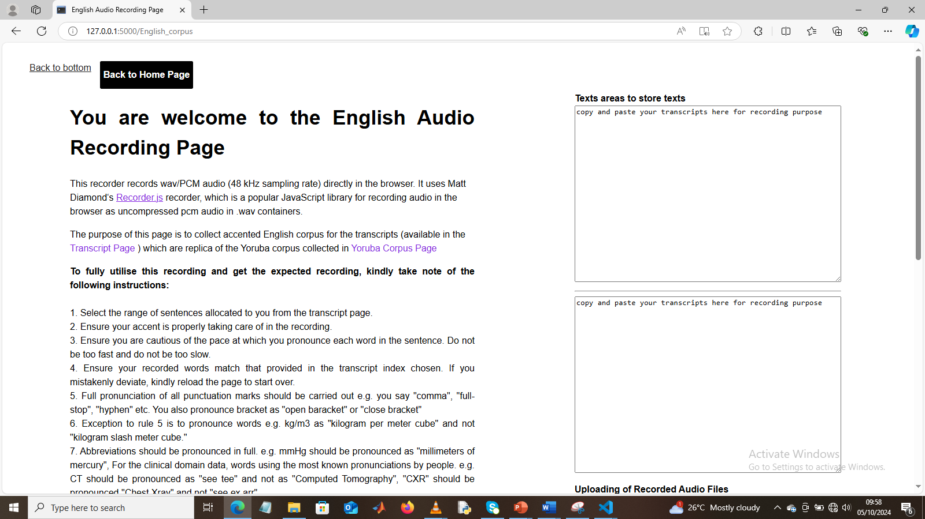
Figure 3.2: The English Corpus Page

3.4.4.3 The Yoruba Corpus Page
This is the page where users are expected to record their Yorùba audio of the selected texts. It works similarly to the English Corpus page and has the same interface. Users may decide to do the recording of the English and corresponding Yorùba audio on the Yorùba Corpus page, or both on the English Corpus page, based on their choices. It is displayed in Figure 3.3. The link to the page is https://testing-new-app-latest-3e4l.vercel.app/Yoruba_corpus

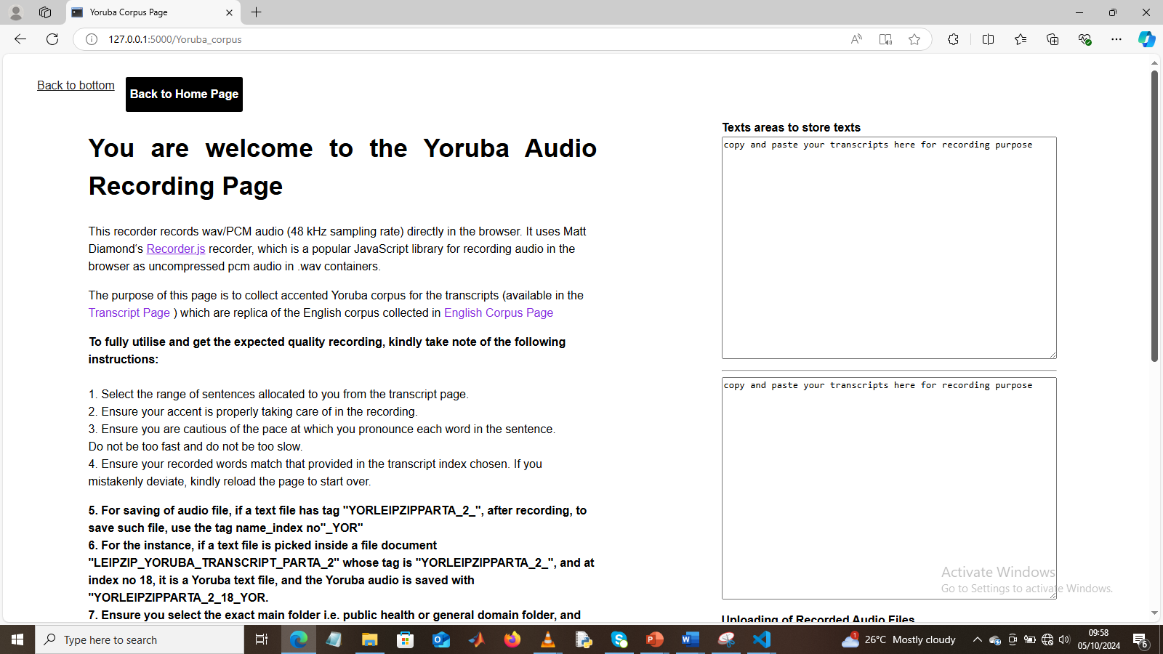
Figure 3.3: The Yoruba Corpus Page

3.4.4.4 Transcripts Page
Via the transcripts page, whose section is shown in Figure 3.4, the participants have access to the storage database where text transcripts of the English and Yorùba equivalents are stored. The transcripts page contains information on how to navigate the page to access these files. It has hyperlinks to the general domain texts storage, public health domain texts storage, English Corpus page, Yorùba Corpus page, and Home page, as well as links to some selected databases such as NCBI, Mozilla Common Voice, PubMed, Youtube Videos, etc. The transcript page can be found here: https://testing-new-app-latest-3e4l.vercel.app/ Transcript_page
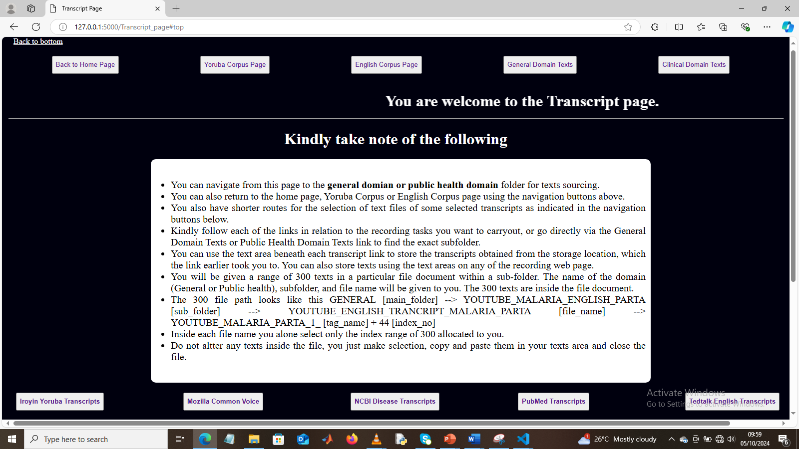
Figure 3.4: The Transcript Page

3.4.5 Development of Manifest Files
Manifest files are files that contain the metadata and text information of each audio file. In this work. It was created for 60 % of the total datasets allocated for the public health domain and 40 % for the general domain. A manifest file could be prepared using a normal text editor, json file, yaml file, excel file, etc.

3.4.5.1 Manifest File for each Speaker
At speaker level, manifest files were created using text editor. They were created for both English and Yoruba per speaker folder. A typical example of the manifest file developed contains the information shown in display A.
{
"metadata": {"project_name": "General Speech Corpus",
"discreption": "A speech corpus for general related terms and discussions",
"version": "1.0",
"speaker_id": "SPK_060",
“gender”: “female”,
"domain": "General",
"language": "English",
"sampling_rate": "48000" },
"audio_files":[{'file_name': 'YORLEIPZIPPARTD_4_SPK_000UI_NEW5_ENG_1000.wav', 'speaker_ID':
'speaker_000', 'duration': '2.389333', 'bit_rate': 768.0, 'file_size': 229420}
{'file_name': 'YORLEIPZIPPARTD_4_SPK_000UI_NEW5_ENG_1001.wav', 'speaker_ID':
'speaker_000', 'duration': '5.888000', 'bit_rate': 768.0, 'file_size': 565292}]
}
Display A: Manifest File for Each Speaker Recording
These manifest files were included in each speaker’s folder for both English and Yoruba alongside a metadata text file, and as well as audio and transcripts folder. The audio folder is to be used by each speaker to store their recorded audios of the transcripts made available in the transcripts folder. The aforementioned manifest files and metadata were used to extract speaker, text and audio information of each speaker. These were prepared specifically for audio collation of each speaker folder.

3.4.5.2: Transcripts and Audio Manifest File
Another manifest file was developed using an Excel spreadsheet that has five columns. The first column consists of the Yoruba filenames of audios. Yoruba transcripts, English transcripts, English filenames of audios, and domain occupied the second, third, fourth, and fifth columns. These were prepared for each institution grouped by the domain. This is the document that is to be used alongside the audio files during model development, as it contains the audio filenames and corresponding transcripts of all audios recorded. These were prepared after audio collations of all speakers’ folders per domain of each institution.

3.4.6 Development of Metadata Files
Text files containing the statistics of audio files at speaker folder level, domain level, institutional level, combined domain level, and combined institutional level were prepared, detailing the statistics of the curated corpus such as the number of audios recorded, number of lines of texts, total hours of audios etc. These metadata were also prepared using Excel documents. The metadata serves to acquaint the readers with first-hand information about the corpus to enable them to know how to make their choices of any sections of the dataset for their speech works.

3.4.7 Focus Language
The source and target languages whose speech corpora were curated are English and Yoruba, respectively. For the state-of-the-art result to be obtained, the accents of the speakers were taken into consideration. In Nigeria official settings such as educational, private, and government institutions, the Yoruba dialect of Oyo is used for communication. Hence, the Oyo Yorùba dialect was taken into consideration which is to be spoken across different Yorùba accents. Different speakers of different Yoruba tribes across the different institutions visited recorded their audios using Oyo Yoruba dialects using their individual accent.

3.4.8 Sourcing of participants
Participants were sourced from 4 institutions within the Southwestern geopolitical zone of Nigeria. The 4 institutions visited are University of Lagos, Lagos State, Nigeria (UNILAG); Lagos State University, Lagos State, Nigeria (LASU); Federal University of Agriculture Abeokuta (FUNAAB), Ogun State, Nigeria; and University of Ibadan, Oyo State, Nigeria (UI). Obafemi Awolowo University, Ile Ife (OAU) was also visited but their services could not materialize due to time unavailability. The choice of these locations was based on dominancy of the Yorùba ethnic group within these locations. Participants within the age range of 18 years and above including staff and students were engaged per institution. The initial plan was to utilize a 5-working day for each institution. But due to time constraint, engagement with participants was carried out at UNILAG for four (4) working days, for the recording exercises. For the other three (3) institutions, WhatsApp groups were created to engage the participants, prior to at least a day visit in each institution to see the faculty head and acquaint them with the audio recording project to be carried out. Each participant was tasked with 200 audio recordings each of English and corresponding Yorùba. Each participant is rewarded with at least $ 7 (Olatunji et al., 2023).

3.4.9 Obtaining Consent
A letter of informed consent containing information and consent section of the recording exercise was made available to the participants both physically and virtually via the recording platform, via which their consents were sought prior to commencement of the recording activities.

3.4.10 Registration
Crowd-sourced individuals were instructed to register their details using the Google form provided via the link on the home page of the web applications. This facilitates knowing their statistics. Registration was meant for individuals just joining the speech work. Other approaches to knowing the number of participants were via lists passed in the WhatsApp group. The registration gave information about the institutions, age group, sex, and tribe of those participated in the project.

3.4.11 Audio Recording
The curation of speech data involves recording selected text files made available to the crowdsourced individuals. The recordings were carried out for this task using the developed online web application (Gutkin et al., 2020; Olatunji et al., 2023) to accelerate the curation exercises. Participants haven’t being allocated speakerIDs were directed to the storage location via links sent to them, to locate their speakerID folder. The transcripts (200 lines of texts each of English, and Yoruba) to be recorded were stored inside the speakerID folder of each speaker. Participants were expected to identify or label each audio file with the same tag on the text file with the addition of “_ENG” for English and “_YOR” for Yoruba. For instance, if English and corresponding Yoruba texts tag read: YORMOZPARTA_1_2, the audio files read: YORMOZPARTA_1_2_ENG, and YORMOZPARTA_1_2_YOR for English and Yorùba audio respectively (Cattoni et al., 2021). For a particular index number in the text file. For instance, index number 004, the files are named as YORMOZPARTA_1_2_ENG_004.wav, and YORMOZPARTA_1_2_YOR_004.wav for English and Yorùba audio respectively This ensures easy identification and orderliness and aids in the training of the ML models developed. Each participant was tasked to produce 200 audio recordings of both English and Yoruba texts. They were duly notified to take the accent (Olatunji et al., 2023) into consideration during each recording because the project lays more emphasis on the accent of the speakers as well as the speech.

3.4.12 Instructions

3.4.12.1 Recording Instructions
Participating individuals were instructed to record in groups, for instance, recording 5 lines of English texts, and save properly, and continue with that trend till the whole 200 lines of texts for English is completed. Then pick up the Yoruba texts and follow same approach to ensure efficiency and neatness of their work. Others who prefer to record same line of texts in English and Yoruba simultaneously were also encouraged to do if that will make their work convenient for them. Participants were also instructed to ensure the file name, particularly the index number for each audio, corresponds to the index number of the line of text being recorded.

3.4.12.2 Annotation Instructions
At first, recorders were tasked to read out punctuation marks in full such as saying “full stop”, “comma”, “question mark,” etc., (Olatunji et al., 2023) where appropriate – this instruction was given to participants at UNILAG and the first 2 sets of audios recorded at UI (UI_1 and UI_2). For other sections of the dataset (major), crowd-sourced participants were instructed to record fluently and seamlessly, without the punctuation marks, while only observing them in the recordings, and to also ensure their accent is maintained. Participants were instructed to ensure that what is read out is the same as what is in the transcripts, taking note of some annotations such as snap, abrupt, external [noise], hesitation etc., available on some texts. Recorders were also given text-to-speech online platforms that they could input their texts into to get correct pronunciation of some words (particularly the malaria related words) to be sure of using the exact pronunciation in the recording. Examples of such is the OpenAI platform.
They were further given instruction on how to record html links. They were told to pronounce each character out as available in the texts e.g. https://www.justtellmenow.com should be recorded as h t t p s colon slash slash w w w dot j u s t t e l l m e n o w dot c o m or where words are seen within the link should be pronounced as words instead of individual letter e.g. same link: https://www.justtellmenow.com will be recorded as h t t p s colon slash slash w w w dot just tell me now dot com – this is to be replicated same way for both English and Yoruba audios recorded for any lines of texts containing hyperlink.
For abbreviated medical terms, they were instructed to record the full meaning where available else the abbreviations. Where units are involved, the interpretations of the units were made available in brackets close to the units. E.g for values like 2.5 mg /dl, it was made available as 2.5 mg /dl (2.5 miligram per decilitre). This is to ensure correct pronunciations and interpretations are given to such values.

3.4.12.3 Saving and Storage Instructions
They were further instructed of the purpose the curation exercise, that is parallel English and Yoruba meaning the contents of both English and Yoruba per line should be same. Hence, they should ensure they save appropriately and also ensure to record efficiently as earlier instructed to achieve these needed alignments.

3.4.13 Feedback
A Google form was made available to harness information on how the participants feel about their participation on the recording exercises. They were asked to provide feedback on what to improve on, such as the web application interface, navigation of the pages, and the transcripts given out. Some of this feedback was used as a quality check to make the project more efficient for subsequent ones.

3.5. Storage of Curated Corpora
Participants stored the recorded audios inside the ENGLISH and YORUBA folders available in their speakerID folder using the links initially given to them. They uploaded them to their folder ID and notified the instructor of the completion of their tasks for verification and processing. This way, this ensures speaker001’s 200 English audios and 200 Yoruba audios are properly saved inside the speaker001 folder, and do not get mixed up with another speaker, say speaker002, whose audios are kept inside the speaker002 folder.

3.6. Other Steps for Data Curation
This details other engagements embarked upon for the successful curation of the English-Yorùba speech parallel corpora. It involves the application for ethical approval and development of an informed consent form

3.6.1 Application for Ethical Approval
The ethical approval was obtained from the Covenant Health Research Ethics Committee (CHREC). The CHREC is duly registered with the National Health Research Ethics Committee of Nigeria (NHREC). The requirements for ethical approval include an application form, an abridged CV of the Supervisor, inform consent form, a proposal, and online training called (Collaborative Initiative Training Institutes, CITI), and a payment of #5000.00. All these requirements were met, and ethical approval (certification & letter of approval) was granted prior to commencement of the recording exercises.

3.6.2 Development of informed consent form
This is the 2-page form that details the information about the curation exercises on one page, and a consent form on the second page. The template obtained from the CHREC was used to develop the participants’ informed consent form. The consent form was provided both virtually and in physical.

3.6.3 Letter of Introduction
As the name implies, it contains information that introduces what the exercises are all about. It gives the crowd-sourced individual information about the researcher, such as the institution, supervisor, area of interest, affiliation, etc. It consists of the following: introduction, project overview, purpose of data collection, target population, data collection methods, confidentiality, and anonymity, as well as contact information of the researcher.

3.7. Preprocessing of the completed 400 audio files per participant
Each crowd-sourced individual reported the completion of their tasks with notification of their speakerID folder. Inside each folder sit two main folders and three files. The two folders are named ENGLISH and YORUBA, inside each are the AUDIOS folder (containing 200 audio recordings) and TRANSCRIPTS folder (containing the transcripts.txt file given). The three other files are text files containing the statistics of the speaker, manifests files for English and Yoruba.
The renaming of all audio files within the AUDIOS folder of each of ENGLISH and YORUBA was first carried out. This ensures the audio filenames correspond to the default naming convention of audio files mentioned in section 3.4.11 and section 3.4.12. A Python code was developed to rename the audios and identify missing index numbers for efficient purposes rather than looking through all 200 audios for missing index numbers (identification of missing files for individuals who reported less than 200 audios in each AUDIOS folder).
The 200 file names of all audios in each English and Yoruba folder were extracted using another Python code tailored to that function and saved inside text files as manifest files. The manifest file also contained metadata information such as the description of the recorded audios, speakerID, gender, language, and sampling rate, as well as the information of the audios such as the duration, bit rate, and file size – these were done for English and Yoruba. The last text file contains detailed metadata of the audios and texts for each speakerID. Example of descriptive statistics available are number of audios for both source and target languages, length of audios for both source and target languages, minimum, maximum, and average length of audios for both source and target languages, number of lines of texts for both source and target languages, number of words, number of unique words, minimum, and maximum length of words for both source and target languages. It also contains the gender and speakerID info.
To ensure audios and texts are aligning at sentence level as made available to the participants, audios are selected at random from each AUDIOS folder and played to ensure the contents aligns with the line of texts being played -this was done for both English and Yoruba. There were times, deviations were spotted in the saved audios. In these instances, corrections were made by renaming the audios with carefulness to ensure the needed alignment is obtained.
All the processed speaker sub-folders for general were stored in the same folder-same was also done for public health domain speakerIDs. Each 200 English audios from each speakerID for all general were later merged into a single folder and renamed appropriately using Python code developed. Their corresponding transcripts were also extracted orderly into Excel documents to ensure the renamed audios correspond to each line of texts. Further normalization of the texts files to remove all numerical values was carried out again at this stage prior to extraction and saving in the excel documents. This was also done for Yoruba General, as well as English and Yoruba of public health domain. In another case, grouping of audios was done using gender where male audios were separated from female audios.
The metadata and manifest files of all the audios per institution per domain have been made available in the database alongside the corpus for detailed comprehension of the dataset.

3.8 Statistics of the BENYO-S2ST-CORPUS-R1 Corpus
The BENYO-S2ST-CORPUS-R1-2026 which was curated from crowdsourced university participants, where each individual was given the texts to record using their smart devices generated 103,767 parallel audios and corresponding texts of English and Yoruba languages (207,534 audio recordings), covering a total length of 463.12 hours. By domain specific, General Domain has a total of 70,944 audios with a total of 131.20 hours partitioned into General English with 35,472 audios (60.55 hrs.) and General Yoruba with 35,472 audios (70.65 hrs.). The Public Health Domain generated a total of 136,590 documented audios spanning a total length of 331.92 hours (Public Health English: 68,295 audios (152.72 hrs.); and Public Health Yoruba: 68,295 audios (179.21 hrs. A total of 170 and 351 number of male and female speakers respectively comprising students / staff of the four (4) higher institutions of learning in Nigeria including the University of Lagos, Lagos State University, Federal University of Agriculture Abeokuta, and University of Ibadan, participated in this recording exercises. Table 3.2 gives the overall statistics across the four (4) institutions visited. Breakdown per domain specific statistics is also given in the table.
Table 3.2: Overall Statistics of BENYO-S2ST-CORPUS-R1 Dataset
S/N | Information | Values
Audio Statistics
1 | Number of audios | 207,534
2 | Minimum length of audio (secs) | 0.341333
3 | Maximum length of audio (secs) | 93.44
4 | Length of audio (time) (secs) | 1,667,249.71 (463.12 hrs.)
5 | Average length of audio (secs) | 8.03
Transcript Statistics
6 | Number of words | 2,523,859
7 | Number of unique words | 96,760
8 | Minimum length of a word | 1
9 | Maximum length of a word | 121
10 | Number of characters | 12,142,059
11 | Number of lines of text | 207,534
Speaker Statistics
12 | Number of males | 170
13 | Number of females | 351
14 | Number of multiple speakers | 2
15 | Number of speakers | 523
16 | Demographic | Oyo, Lagos, Egba, other Southwestern part of Nigeria
17 | Age group | 18 years +

3.9. Evaluation of the Corpus / Machine Learning Training – S2ST Model Training

3.9.1 Quality Assurance
The evaluations of the curated audios were first carried out during preprocessing of the collated audios per speaker. Thorough random scanning of the audios was carried out where audios not aligning were identified and renamed properly to ensure alignment. The contents of the audios were also listened to ensure they align with the texts per line. Where the contents of the audios are not clear or with pauses, such audios were removed and renotification was given to the participating individual to re-record the text (s). Also, at some point in the recording exercises, participants whose audio recorded volumes were high with fluency and clarity were selected to be allocated speakerIDs to record. For further quality check of the audios typical for speech processing applications and to ensure the remainders of the recording exercise are strictly professionally embarked on based on the feedback via this quality check, a group of audios were selected per institution when the total number of audios was 96,195 per language. The selection was done using two different sampling types including stratified and systematic sampling. A language linguist who is an expert in both English and Yoruba language was consulted to do this task.

3.9.1.1 Sampling Method
The sampling approach used for audio selections involves random selection of audios using random module in Python. To ensure deviation do not exist at any time the code is run, and also avoiding bias, the code was seeded. The other selection strategy was to use a fixed length interval where audios were selected in each stratum (e.g. institution’s general or public health domain or based on gender) at a fixed interval from each other based on the total number of audios. This was done with the step input argument in Python range method. The total samples selected out of the pool of 96,195 audios was based on two strategies involving 95 % confidence with $±5\%$ margin of error and 5 % each where each provided a total of 384 and 4812 audio samples respectively. This implies two different (384 & 4812 pool of selected audios) were made available to the language linguist for quality check.

3.9.1.2 Percent Confidence with +-5% Margin of Error
This is a statistical approach that led to choice of a total of 384 audio samples being selected for quality check of the audios out of the total of 96,195 audios curated as at the time of this computation.
For a population of size, N, the sample size, n is calculated using Cochran Formula (Ullah, F., Ali, G., Bilal, M., Munir, S., & Hussain, M., 2026) equation (3.1) as:
$n=\frac{z^{2}*p*(1-p)}{e^{2}}$ (3.1)
Where:
$$z= Z-score for the confidence level$$
For $95\%$ confidence, $z=1.96$
$p=$ estimated proportion of the population with the characteristic of interest (often set to 0.5 for maximum variability)
$e=$ margin of error (commonly $0.05=5 \%$)
$$n=\frac{{1.96}^{2}*0.5*(1-0.5)}{{0.05}^{2}}$$
$$n=\frac{3.8416*0.5*0.5}{0.0025}$$
$$n=\frac{0.9604}{0.0025}=384.16≈384$$
Hence, all institutions share a proportion of the 384 audio samples as indicated in Table 3.3.
The audio selection involves random selection using python code for all institutions except UI_4_GEN where fixed length interval was utilized for male and female strata to obtain different variations in sampling selection techniques across the selected audios.
Table 3.3: Two Scenarios Audio Selection
S/N | Strata |  | Total Samples | Scenario 1 (95 % Confidence = 384) | Scenario 2 (5 % audios = 4812)
1 | UNILAG_GEN |  | 2103 | 8 | 105
2 | UNILAG_PH |  | 2150 | 9 | 108
3 | FUNAAB_GEN |  | 4980 | 20 | 249
4 | FUNAAB_PH |  | 3973 | 16 | 199
5 | LASU_GEN |  | 788 | 3 | 39
6 | LASU_PH |  | 193 | 1 | 10
7 | UI_1_GEN |  | 6704 | 27 | 335
8 | UI_1_PH |  | 9841 | 39 | 492
9 | UI_2_GEN |  | 7750 | 31 | 388
10 | UI_2_PH |  | 11339 | 45 | 567
11 | UI_3_GEN |  | 597 | 2 | 30
12 | UI_3_PH |  | 19073 | 76 | 954
13 | UI_4_GEN | Male | 3195 | 13 | 163
13 | UI_4_GEN | Female | 8756 | 36 | 445
14 | UI_4_PH |  | 9374 | 37 | 469
15 | UI_5_GEN |  | 399 | 2 | 20
16 | UI_5_PH |  | 4780 | 19 | 239
Total |  |  | 96195 | 384 | 4812

3.9.1.3 Five Percent of Audios in Each compressed folder per institution
Here 5 % of the total 96,195 audios (4809.75) was selected. Then this was shared in proportion across all the institutions. It is shown in Table 3.3 for each institution’s proportion. For each institution, as seeded random number generator in Python was utilized for all institutions except UI_4_GEN where fixed length interval was used for male and female strata.

3.9.2 Pseudo Code for Audio Selection
The pseudo code for audio selection for the scenario of random number selection of audio approach is given in Algorithm a.
Algorithm a: Pseudocode of randomly selected audios
For each partition in dataset:
total_samples = number of audios in partition
sample_size = number of audios to select (from Scenario 1 or Scenario 2)

If partition is UI_4:
Split into male and female subsets
male_total = 3195
female_total = 8756
male_sample_size = proportional count (e.g., 13 or 158)
female_sample_size = proportional count (e.g., 36 or 450)

Randomly select male_sample_size from male_total
Randomly select female_sample_size from female_total
Else:
Randomly select sample_size from total_samples

Save selected IDs for QA log

3.10 Evaluation of the Curated Parallel English and Yoruba Audios Plus Texts
To test the quality of the GC-ENYO speech curated, various experiments such as speech generation from spectrograms, and speech generations from discrete representations were carried out. The experiments were done on Hp Victus 15 Gaming Intel Core I7 13th Gen 900 GB hard disk, with 8GB GeForce RTX 4060 GPU on Windows 11. Windows Subsystem for Linux and Jupyterlab were installed to facilitate the training carried out. Two experiments involving spectrogram to audio generations and discrete units to audio generations were carried out to access the quality of the audios curated in this project.

3.10.1 Spectrogram to Speech Synthesis Experiment
To carry out the speech synthesis from spectrogram, a virtual environment named virt_env was created, activated and necessary Python libraries such as Librosa, matplotlib, numpy etc. were installed on the activated virtual environment. The training command was run from the Ubuntu environment. For audio generation from spectrogram, this was done via a Python script developed and run through Jupyter lab IDLE. The directory folder named “cleaned_hifi_vocoder” was created and all files worked with were saved inside it. A fraction of the dataset of 1050 audios from UI_3 for Yoruba of BENYO-S2ST-CORPUS-R1 dataset curated for speech processing application, was utilized for transfer learning. The data was randomly split into 900, 100, and 50 for training, validation, and test sets using Python script developed for that purpose. The audios consist of female audio samples with the contents being malaria public health talks. The transfer learning was carried out starting with the HiFi-GAN pretrained generator checkpoint (taking that of the vocoder). The HiFi-GAN model was cloned to the local system (cleanded_hifi_vocoder directory) as well as a separate cloning of the vocoder generator checkpoint for HiFi-GAN (used for CoquiTTS). The HiFi-GAN model comes with its own config file, Python scripts such as train, inference, and utils. The config file was copied to the main folder directory so as not to alter the original config file that came with the HiFi-GAN model. Prior to finetuning the cloned HiFi-GAN model with its pretrained generator checkpoint in the HiFi-GAN model main folder, the audios were first resampled to a sampling rate of 22050 Hz to align with the training setup of HiFi-GAN. The spectrograms of all the audios were generated (as .npy extensions) using the tacotron2 spectrograms generation Python code obtained from another separately cloned Tacotron2 model, where the mel frequency, windows size, hop size, and sampling frequency were set to 80, 1024, 256, and 22050 Hz respectfully. Other hyperparameters such as the epoch, the Adam optimiser, gamma loss weight, learning rate decay, gradient clipping, and sampling rate were set in the config file. The dataset texts files for both training and validation were prepared to align with the format for finetuning HiFi-GAN. The correct path to the audios and spectrograms were indicated in these text files. Starting from the pretrained checkpoint of g_0000000 for the generator, finetuning commenced by utilising necessary training commands pointing to the training Python script, training and validation text files (containing paths to the audios and melspectrogram aligned at audio clip level), config file path, and specification of the output folder for collection of checkpoints collected at 1000 steps interval. Both the generator and discriminator checkpoint files were saved at each of the 1000 steps interval. Tensorboard was logged and metrics of the training were monitored from the Tensorboard as well as from the Ubuntu environment where training was run. Generated, and ground truth audio samples were played from the Tensorboard as well as observing their respective spectrograms to see how close the generated spectrograms are to the ground truth. Other testing involves utilising developed Python script to test the saved checkpoint generator at interval by feeding spectrograms of fifty (50) test audio samples and obtaining the generated audios from the saved checkpoint vocoder output for that of 27K, 45K, and 60K global steps. Another option available was to feed the original audios directly to the saved checkpoint to obtain the generated audio samples from the saved vocoder generator file (this time the spectrogram is generated internally and fed as input to the vocoder). Table 3.4 presents the hyperparameters set for this experiment, and that of the discrete units to audio generations.
Table 3.4: Hyper parameters utilized for spectrogram plus audio & discrete plus audio trainings
S/N | Hyperparameters | HiFi-GAN | Unit HiFi-GAN
1 | Number of units | Nill | 500
2 | Batch size | 16 | 16
3 | Sampling rate | 25050Hz | 16000Hz
4 | Learning rate | Gen: 0.0001; disc: 0.0001 | 0.0001
5 | Learning rate decay | 0.995 | Nill
6 | Adam optimiser (betas) | 0.8, 0.99 | 0.8, 0.99
7 | Loss weight factor (gamma) | Nill | 0.999
8 | hop size / Unit hop size | 256 | 320
9 | Maximum epoch | 10,000 | 2,000
10 | Maximum steps | Nill | 50,000
11 | Number of mels | 80 | Nill

3.10.2 Comparison of BENYO-S2ST-CORPUS-R1 Dataset Results with Developing an Open-Sourced Dataset for Spectrogram to Audio Generation Experiments
To compare the previously obtained results of HiFi-GAN finetuning using the BENYO-S2ST-CORPUS-R1-2026 dataset, data samples of 1050 audios were selected from the Developing an Open-Source dataset. It was also split into 900, 100, and 50 for training, validation, and test samples respectively. The statistics of the audios and some of the outcomes of the experiments are illustrated in Table 3.5. It shows that BENYO-S2ST-CORPUS-R1 has a total length of 1000 audios (train/validation) to be 7854.353878 secs (2.18 hrs.) while train and validation samples of 1000 for the Developing an open source is 3845.461 secs (1.07 hrs.). Developing an Open Source is a Yoruba dataset that has the dataset partitioned into male and female parts. It was selected because it is rich in Yoruba words, with Yoruba accents properly captured in the recordings and texts with tonal marks. The 1050 randomly selected audio files were female audio files utilized for this comparison experiment. Also, in comparison with the BENYO-S2ST-CORPUS-R1 dataset, the selected audios were generally human conversations, unlike public health (malaria specific) data selected for the BENYO-S2ST-CORPUS-R1 dataset and utilized for the training- this was a design choice. Both datasets were resampled to 22050 Hz to align with HiFi-GAN vocoder settings. The same project directory (“cleaned_hifi_vocoder”) was utilised to store the sub directories for the Dev. An Open Sourced based experiment. To ensure comparisons align well, the same configuration settings in the config file as BENYO-S2ST-CORPUS-R1 dataset were used. This includes the learning rate, learning rate decay, maximum epoch, maximum steps, etc.
Table 3.5: Statistics of BENYO-S2ST-CORPUS-R1 and Developing an Open-Sourced Dataset
S/N | Feature | BENYO-S2ST-CORPUS-R1 (Yoruba) | Dev Open-Source
1 | Sample count | 1050 (900/100/50) | 1050 (900/100/50)
2 | Min audio length | 1.706 sec | 1.536 sec
3 | Max audio length | 30.72 sec | 11.178 sec
4 | Average length | 7.854 sec | 3.845 sec
5 | Total duration | 7854 sec (~2.18 hours) | 3845 sec (~1.07 hours)
6 | Speech emergence | 11k steps | 13k steps
7 | Training stability | Loss spike at 28k (catastrophic, required reset) | Stable, no spikes
8 | Noise in outputs | Faint background noise | Faint background noise
9 | Plateau | 35k steps, no further improvement | 35k steps, no further improvement

3.10.3 HuBERT vs MFCC Base Audio Generation Experiments
Unit based speech generation using unit HiFi-GAN (unit vocoder) speech generation experiment was carried out. The experimental setup was carried out on the same NVIDIA GeForce RTX 4060 GPU Laptop. The same 1050 audio samples (all female speakers of the public health-malaria) utilised for spectrograms to audio generation were selected from the Yoruba section of the BENYO-S2ST-CORPUS-R1 dataset. For this setup also, 900 audio files were utilized for training and 100 audios for validation, and 50 for test sets.
For the unit extraction, first, HuBERT units were extracted equivalent of audio samples. HuBERT Base model (Hubert-base-ls960) with the wav2vec 2.0 feature extractor was used. The Hidden states from layer 9 were clustered using a pretrained k-means model with K = 500, trained on the LibriSpeech 960 h subset. The k-means model was loaded via joblib.load(Hubert_base_ls960_L9_km500.bin). Features were extracted at a sampling rate of 16 KHz with a frame stride of 20 ms (approximately 50 frames per second). No additional features normalization was applied beyond the model’s internal layer normalization. Consecutive duplicate units IDs were retained as extracted resulting in sequences with constant runs of the same unit when the underlying acoustic features remained stable. Random seed followed the default setting used in the released k-means checkpoint. No duplicate-unit reduction was applied, so consecutive identical unit IDs were retained in the sequence
The pretrained model of the unit HiFi-GAN was cloned as well as the pretrained checkpoints. The hyperparameters utilized for trainings are given in Table 3.4. Audio samples (1050) were resampled to 16000 Hz for unit HiFi-GAN vocoder experiment, to ensure unification of the HuBERT discrete unit extraction and unit HiFi-GAN vocoder sampling frequencies. In addition to this, the NISQA MOS was configured to their respective sampling frequencies for the test samples of discrete unit based HiFi-GAN. For the PESQ and STOI scores computations, it was observed sampling frequencies can either be 8 KHz or 16000 Hz, hence, the sampling frequency was set as 16000 Hz to align with ITU‑T standards for PESQ/STOI and ensure comparability with baselines. To set the sampling frequencies, for NISQA MOS, the ms_sr, ms_fmax, and sr were set to 16000, 8000, and 16,000 respectively for unit HiFi-GAN inside the NISQA_lib.py script. For PESQ/STOI, sr was set to 16000Hz inside the developed Python script.
To extract the discrete units of HuBERT, the continuous features were extracted with HuBERT model, and these features were fed to a pretrained k-means model (K = 500) that clustered the continuous values into discrete values and saved as .npy files. The discrete values of all .npy files were then extracted in order to be used as input data needed for fine-tuning. The discrete integers with audio pairs were fed as input data to the HuBERT pretrained checkpoints and fine-tuning commences, which was run for the full 50K global steps (892 epochs) set for fine-tuning (approximately 16 hours).

3.10.4 Evaluation Metrics for the Speech Resynthesized with Spectogram
The speech generated were evaluated for their naturalness, intelligibility, and quality. The speech quality was evaluated with Perceptual Evaluation of Speech Quality (PESQ), Speech Time Objective Intelligibility (STOI), and NISQA Mean Opinion Score (MOS) evaluate for speech intelligibility and naturalness respectively. Other metrics utilised were the generation loss total, and Spectrogram errors for both training and validations. The generation loss total and spectrogram loss for both training and validations were configured as part of the outputs of the finetuned HiFi-GAN and unit HiFi-GAN vocoder utilised. The PESQ and STOI were computed using python scripts developed from which their respective modules were imported via import function.

3.11 The Direct Unit-to-Unit S2ST Architecture
This section details the architectural design for the developed U2UT model where the source and target languages are English and Yoruba languages.
The architecture implemented in this S2ST is an extension to Translatotron 2, a speech-to-speech translation model that was trained on conversational English to Spanish, Fisher English to Spanish datasets as well as Multilingual CoVoST2 (es, fr, de, ca$→$en) datsetes. The Translatotron 2 is shown in Figure 2.7. The U2UT architecture developed in this project is shown in Figure 3.5, where some modifications had been carried out on the Translatotron2 S2ST model. The synthesiser of the U2UT is also shown in Figure 3.6
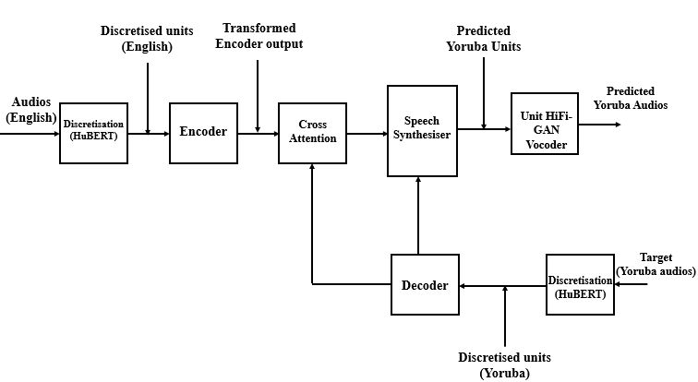
Figure 3.5: The Unit-To-Unit (U2UT) Architecture (A modification to Translatotron 2)
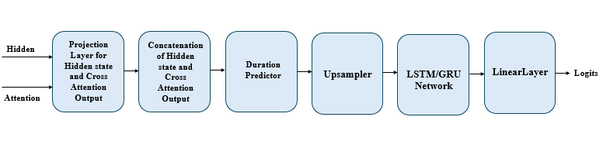
Figure 3.6: The Target Yoruba Discrete Synthesizer of U2UT Architecture
The modification carried out are summarised as follows:
- The use of discrete values of both the source and target languages unlike the utilisation of spectrograms as input to the model for Translatotron2: The justification for this is recent researchers in speech processing applications had been driven towards the use of discrete integers for training rather than spectrogram as discrete values are rich in speech features retention such as prosody, voice transfer, intonation, pitch etc. in addition to this, they are known to reduce errors in training and also reduce the complexity of the model training as truly confirmed in the ablation studies carried out in this project (Choi, J., Kim, J. H., Hu, S., & Chung, J. S. 2026). They also ensure faster convergence during training. As a result of utilisation of units of both source and target languages, it is termed a remodified Translatotron2 U2UT model.
- In this proposed architecture, alignment (cross attention) is between the source and target discrete values unlike between source spectrogram and target phonemes in Translatotron2 architecture: In the paper, the authors specified they utilised target phonemes for alignment with the source spectrogram to reduce the error known to occur between two long mel-spectrograms of the source and target language. The two mel-spectrogram also create instability in training. Here the target discrete values can retain speech features such as phonetics features, prosody, intonation of speech and are potentially better for low-resource languages (like Yoruba) because discrete units capture essential features without requiring massive amounts of raw audio as also confirmed in the ablation studies carried out in this work.
- Another modification is the fact that target audio was used for training with target phoneme for auxiliary training: In Translatotron2 architecture, target phoneme is needed for alignment to avoid the error between two long mel-spectrogram and same target texts was also outputted as part of the output of the model alongside the target speech whereas in this proposed architecture, only the target audio was generated. The target phoneme was not used as the target discrete values captures enough speech features.
- In Translatotron2, a neural vocoder such as GraffinLim, WavRNN specifically for spectrogram-based audio generation was utilised, whereas in this architectural design, a unit-based vocoder (unit HiFi-GAN) was developed: A unit vocoder was used to transform the output discrete Yoruba target produced at the transformer decoder into their respective audios. The unit HiFi-GAN pretrained checkpoint was finetuned using discrete units-audio pairs of the Yoruba target language.
- Another difference between Translatotron2 is in terms of the source and target languages utilised for model development: In translatotron2, Spanish was the source language and English the target language. Models were also developed for German to English and Catalan to English languages. In this architecture, the source and the target languages are English and Yoruba. Yoruba is a low-resourced language, whereas all languages utilised for Translatotron2 models are high-resourced languages.
- In translatorron2 model architecture, the authors utilised LSTM based synthesizer: In this project both LSTM, and GRU were utilised for model development.
Table 3.6 compare and contrast the Translatotron2 and the remodified U2UT models
Table 3.6: Comparison Between Translatotron2 and Remodified Translatotron2 (U2UT model)
S/N | Feature | Translatotron2 | Remodified Translatotron2 U2UT
1 | Input Representation | Source spectrogram | Source discrete units
2 | Target Representation | Target phonemes (for alignment) + target text + target audio | Target discrete units only (captures phonetics, prosody, intonation)
3 | Alignment (Cross Attention) | Between source spectrogram and target phonemes (to avoid instability of spectrogram-to-spectrogram) | Between source discrete units and target discrete units (simpler, more stable, retains speech features)
4 | Output | Target audio + target text | Target audio only (phoneme output not required)
5 | Vocoder | Spectrogram-based vocoder (e.g., Griffin-Lim, WavRNN) | Unit-based vocoder (Unit HiFi-GAN) finetuned on Yoruba discrete units–audio pairs
6 | Languages Used | Spanish→English, German→English, Catalan→English (all high-resource) | English→Yoruba (low-resource language)
7 | Encoder | Conformer encoder | Conformer encoder (same as original)
8 | Synthesizer | LSTM-based | Both LSTM and GRU tested
9 | Training Complexity | Higher (spectrograms are continuous, high-dimensional) | Lower (discrete units reduce complexity, errors, and training instability)
10 | Speech Feature Retention | Phonemes capture linguistic features but lose prosody/intonation | Discrete units retain prosody, intonation, pitch, and voice transfer
11 | Training Stability | Risk of instability (spectrogram-to-spectrogram alignment unstable) | More stable, faster convergence, fewer errors (confirmed in ablation studies)

3.12 Architectural Design of the U2UT model
The architecture consists of two parts which are the transformer encoder-decoder side (U2UT model) and a unit vocoder part. To ensure the target discrete values are transformed and heard as audio, a trained unit vocoder is needed. In this thesis, unit vocoders were first developed. The choice of a unit vocoder was based on the target output of the U2UT model. The target outputs are discrete units and these are fed as inputs to a unit vocoder finetuned using discrete values plus audios pair of the target Yoruba language. The vocoders developed includes the HuBERT-based unit vocoder, WavLM-based unit vocoder, and a Wav2vec-Based unit vocoder. The outcome of the experiments led to the choice of HuBERT which was integrated into the U2UT model.

3.12.1 HuBERT Versus Other Discrete Unit Generation Models Experiments
Units to audio generation experiments were carried out involving the comparison of speech generation using discrete units of HuBERT, Wav2vec, and WavLM. For these experiments, a Unit-HiFi-GAN was selected as it is known to produce high fidelity output speech when fed with discrete values (Kong, J., Kim, J., & Bae, J., 2020; Lakhotia, K., Kharitonov, E., Hsu, W.-N., Adi, Y., Polyak, A., Bolte, B., Nguyen, T.-A., Copet, J., Baevski, A., Mohamed, A., & Dupoux, E. 2021; Poli, M., 2026). The unit HiFi-GAN is a discrete unit-based vocoder equivalent of the spectrogram-based vocoder. All audio was resampled to 16KHz as expected for unit HiFi-GAN vocoder experiment. The same experimental set up utilised for HuBERT as detailed in section 3.10.3 was embarked on for the other two discrete unit generation models, including Wav2vec and WavLM models. Unlike HuBERT discrete unit generation using HuBERT pretrained checkpoint, both wav2vec and WavLM were first pre-trained using the same cluster size of 500 utilised for HuBERT, and their respective discrete units for the 1000 audios consisting of 900 and 100 for training, and validation, respectively, were generated. The design of the finetuning ensures the same hyperparameters setup of Table 3.4 (HuBERT + unit HiFi-GAN finetuning) were used for the finetuning of both wav2vec + unit HiFi-GAN and WavLM + unit HiFi-GAN setup, setting the maximum global steps to 50, 000 (maximum epochs = 892).
Different sets of experiments were carried out. First is the utilisation of the discrete units extracted from Wav2vec with audios for finetuning unit-HiFi-GAN and the second experiments involved utilising the discrete units obtained from WavLM with audios for finetuning the unit-HiFi-GAN. Each training ran for the maximum global step of 50K for over 16 hours per each experiment. Trainings were monitored and checkpoints (model representations) which were saved in multiple of 1000 global steps were tested by feeding them with discrete units for each of Wav2vec and WavLM. Both seen and unseen discrete units were also tested on the finetuned unit HiFi-GAN with each saved checkpoint prior to and on reaching the maximum global steps set. Here, one must be careful not to feed discrete units from Wav2vec into WavLM-based finetuned unit HiFi-GAN as this produces gibberish in the audios. This implies that discrete unit from WavLM can only be fed to unit HiFi-GAN finetuned with WavLM discrete units, discrete unit from Wav2vec can only be fed to unit HiFi-GAN finetuned with Wav2vec discrete units etc. to produce expected audios. The results of these two experiments were thereafter compared with that of HuBERT.

3.12.2 Evaluation of the Discrete Units plus Audios Experiments
Four (4) different samples of the audios were chosen. Both the reference and generated audios from their respective finetuned models were evaluated. The evaluations of the audios were carried out using STOI, PESQ, and DNSMOS. Other evaluations involved the use of training generation loss, mel-spectrogram losses for both training and validation as these were part of the customed made evaluation metrics for the pretrained unit HiFi-GAN vocoder pretrained checkpoint.

3.12.3 Choice of Unit based Vocoder for S2ST Model
The two experiments carried out in section 3.12.1 for WavLM based unit HiFi-GAN vocoder and Wav2vec based unit HiFi-GAN vocoder were evaluated and compared with that of the HuBERT based unit HiFi-GAN vocoder. The result of the comparison of the three models gave rise to the selection of HuBERT in the experiment setup of the U2UT model developed and reported in this thesis. As a result, finetuned HuBERT based unit HiFi-GAN vocoder (pretrained on the medical domain containing 1000 Yoruba audios of the BENYO-S2ST-CORPUS-R1) was integrated into the U2UT model. As a result of the selection of HuBERT, its discrete units were extracted for both of the source, English and target, Yoruba audios and fed as input data into the U2UT model training.
The outputs of the U2UT model are discrete integers representative of the target Yoruba and the finetuned unit vocoder is to aid in the conversion of these units into waveform equivalent.

3.12.4 Design of the U2UT model

3.12.4.1 Python Framework
For the experiments carried out in this project, the Pytorch framework was utilised. It provides the necessary modules with any class name that can be utilised for seamless for model development and training. It enables the creation of class object where the nn,Module package method of Pytorch can be explored for model development. The nn.Module methods avoids the recreation of some function definitions in Python. Examples of such utilised in the model development here includes the nn.ModuleList(), nn.Linear(), nn.Embedding(), nn.LayerNorm(), nn.Dropout(), nn.SiLU(), nn.weight(), nn.Conv1d(), etc.

3.12.4.2 Creation of Virtual Environment and Importing of Python Module
The virtual environment, which is a dedicated and isolated environment from other model developments was created for the Python Integrated Development Learning Environment (IDLE) on Ubuntu. The Windows Subsystem for Linus with Ubuntu was utilised for all model developments and experiments. Three (3) virtual environments were created named s2st_env with Python 3.12 installed on it, hifi_discrete_env with Python 3.12 installed on it, and hifi_discrete_env_py313 with python 3.13 installed on it. s2st_env with Python 3.12 enabled virtual environment was where the U2UT model training took place via the Jupyter Notebook IDLE. Other tasks that took place inside the s2st_env environment were generation of target discrete units from the saved model checkpoints and generation of BLEU scores as well as CER, and WER results, all via the Ubuntu environment. hifi_discrete_env_py313 with python 3.13 enabled virtual environment was where unit HiFi-GAN vocoder with Hubert, wav2vec, and WavLM discrete units training took place all via the Ubuntu environment. Other task that took place inside the hifi_discrete_env_py313 with python 3.13 is audio generation from the target discrete unit (obtained from U2UT model checkpoint) by running the generation Script on the hifi_discrete_env_py313 environment, as well as generation of STOI, and PESQ scores, via the Ubuntu. The extraction of discrete units from HuBERT, wav2vec, and WavLM pretrained models took place within the hifi_discrete_env with python 3.12 due to incompatibility issues of transformers with Python 3.13 and torch (cuda), all via Ubuntu. The generation of ASR texts with NCAIR ASR also took place inside hifi_discrete_env via Ubuntu. Table 3.7 highlights the most important Python packages installed in each of the three (3) virtual environments.
Table 3.7: Python Modules Installed in the Three (3) Created Virtual Environments
S/N | Virtual Environment | Installed Python Packages
1 | s2st_env, with Python 3.12 | huggingface_hub 1.22.0, ipykernel 7.2.0, jiwer 4.0.0, librosa 0.11.0, matplotlib 3.10.9, numpy 2.4.6, sacrebleu 2.6.0, safetensors 0.7.0, scikit-learn 1.8.0, scipy 1.17.1, soundfile 0.13.1, torch 2.5.1+cu121, torchaudio 2.5.1+cu121, transformers 5.9.0
2 | hifi_discrete_env, with Python 3.12 | fairseq 0.12.2, joblib 1.5.3, librosa 0.11.0, numpy 2.4.4, sacrebleu 2.6.0, scipy 1.17.1, tokenizers 0.22.2, torch 2.11.0+cu130, torchaudio 2.11.0+cu130, transformers 5.8.0
3 | hifi_discrete_env_py313, with Python 3.13 | Joblib 1.5.3, librosa 0.11.0, matplotlib 3.10.9, numpy 2.4.4, pandas 3.0.2, Pesq 0.0.4, pystoi 0.4.1, scikit-learn, 1.8.0, Scipy 1.17.1, soundfile 0.13.1, tensorboard 2.20.0, torch 2.11.0, torchaudio 2.11.0, unit-hifigan 0.1.3,

3.12.4.3 Audio Preprocessing / Augmentation Techniques
Prior to inputting the parallel audios of English and Yoruba to the models developed in this project, audios were pre-processed to ensure the training get enriched in speech features inputted into the model. Some of the preprocessing carried out includes resampling, silence trimming, speed perturbation, pitch shifting, and noise addition.
A. Resampling
Parallel audios of English and Yoruba were first resampled to a unified sampling frequency of 16 KHz before being fed to the model training. This sampling frequency was chosen as it represents speech features retention needed for model training. The load method of the Python librosa module was utilised for this resampling, where the sr input argument was set to 16000.
B. Silence Trimming
Some of the audios had silence at both the beginning and end of their contents. So there is the need to remove the silence in the audios so that all audios particularly the recorded audios are having the silence removed. The librosa.effects.trim() method was used where the input arguments where the top_db was set to 20.
C. Speed Perturbation
Both speed up and speed down speed perturbation was used. They ensure the input training data includes contents that have high and low speaking rates to mimic life scenarios. The librosa.effects.time_stretc() method was used, where rate was set to 1.1 and 0.9 for speed up and speed down respectively.
D. Pitch Shift
Both high and low pitch were used in this project. The pitch shift is to ensure different variations in frequencies of the audios. The librosa.effects.pitch_shift() method was used. The n_steps argument was set to 2 and -2 for upward and downward shifting respectively, in the pitch of the fed in audios.
E. Noise Addition
Noise is needed to be injected in the audios to represent real life audios. Some section of the curated BENYO-S2ST-CORPUS-R1 has noise injected into the recorded audios as stipulated in the annotation provided in the transcripts files. The np.random.normal() was utilised to create noise, where the input argument noise_factor was set to 0.005, and subsequently added to the original audio for each of the fed in audios.
F. Data Augmentation
For the augmentation of the audios. Each of the silenced removed audio was passed through each of the defined function for speed up and speed down perturbation, pitch up and pitch down pitch shifting, and noise addition. The six different augmentations were then added to the original audios meaning each audio file is now represented with 7 of its similar self, including the original and the 6 augmentations. These data augmentations ensure the different developed models see different speech contents that are typical of real life scenarios and the purpose of this is to have developed models tailored to those real life utilisation and best user experience.

3.12.4.4 HuBERT Discretisation
Haven’t selected HuBERT as the model for units’ extractors, the HuBERT features were first extracted from the audios using the Wav2Vec2FeatureExtractor() method of the transformer’s module, and the output of this was fed to the HubertModel() method (also of the transformers module), and continuous HuBERT values were obtained (last hidden state). As discrete values were needed, HuBERT continuous values were fed into a HuBERT base pretrained on LibriSpeech 960 hours of audios with K = 500 using the joblib.load() module, where the argument was set to hubert_base_ls960_L9_km500.bin, which was downloaded from the repository and saved into the project directory. The outputs of this were discrete values with shape [number_of_audios, sequence_length]. This was the discrete value shape for both source, English and target, Yoruba audios at the output of HuBERT. In the experiment carried with HuBERT, the HuBERT base with the 6th transformer encoder layer output was utilised for unit extractions.
A. Mapping of English Discretised Values to Embedding Space
The English discretised values with shape [number_of_audios, sequence_length] was remapped into embedding space with the help of a vocabulary with value of the vocabulary set to 500. The new shape becomes [number_of_audios, sequence_length, d_model], where d_model was the embedding dimension utilised. In this project, embedding was set to 512 meaning each sequence length is now being mapped into 512 embedding space, before being fed into the model training. The reverse of the remapping here is carried out at the synthesiser stage of the architecture where each sequence is remapped into its vocabulary space where the unit with maximum score (softmax) is selected and its vocabulary ID represented is outputted. The shape of the target Yoruba discrete values still remains as [number_of_audios, sequence_length]. When both were fed into dataloader() method of torch.utils.data module in Python, the shapes become [batch_size, sequence_length, d_model] and [batch_size, sequence_length] for both source and target discretised values respectively. The batch_size utilised was 16, with random shuffling. These two discretised values were stored in their respective variable and fed as input into the model trainings.

3.12.4.5 Feed Forward Layer
A Feed Forward layer was developed with the FeedForward Class, designed and initialised with d_model, d_ff, and dropout=0.1 It consists of the following blocks arranged sequentially: layernorm, linear (fully connected layer), activation, dropout, second linear layer (fully connected layer), and a final drop out, where the output of one stage is the input to the next block in the line. The Feedforward layer is shown in Figure 3.7.
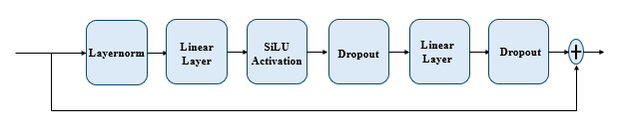
Figure 3.7: Feed Forward Layer
Mathematically, the feedforward layer is represented in equation (3.2) as
${layernorm}_{out}= x+ Dropout\left(LinearLayer\left(Dropout\left(SiLU\left(LinearLayer\left(LayerNorm\left(x\right)\right)\right)\right)\right)\right)$ $(3.2)$
Where $x$ is the English discretised embedded input.
The FeedFoward Class is called with input argument, $x$ (equation(3.2)) which represents the English discretised embedded input. The output is of shape [batch_size, sequence_length, d_model], which is fed as input to the Multi-Head Self Attention (MHSA).

3.12.4.6 Multi-Head Attention
A. Positional Encoding
To know the order of words in the audios, a positional encoding is needed. It ensures, there is a relative positional relationship and absolute relationship amongst words in the recordings. A RelativePositionEncoding Class was initialised with argumnets num_heads, and max_len=10000 utilised in the experimental setup with num_heads set to 4. The maximum sequence length aligns with was used in the original transformer architecture (Vaswani et al., 2017). The forward function is called with input arguments q_len, k_len, and device=None. The positional encoding is of shape [batch_size, num_heads, q_len, k_len]. The positional encoding is called within the MHSA whose output is fed to a masked fill, and finally to softmax, and dropout layer.
B. Multi-Head Self-Attention
The Multi-Head Self-Attention (MHSA) was defined with MultiHeadAttention Class object and initialised with d_model, num_heads, dropout=0.1, use_positional_encoding=True, and max_len=10000. The forward method is called with input arguments query, key, value, and mask=None. The query, key, and value vectors are from the input discretised English. The MHCA is to confirm if the number of heads is divisible by the d_model dimension of 512 utilised. The MHSA as shown in Figure 3.8 consists of the following stages sequentially: computation of $Q, K$, and $V$ vectors with nn.Linear, computation of attention scores using $Q,$ and $K$ vectors, summation of positional encoding and attention scores, masking (zero masking) of attention outputs, softmax, and dropout layer.
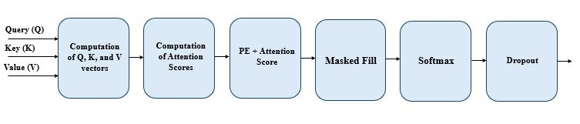
Figure 3.8: Multi-Head Self-Attention

3.12.4.7 Conformer Convolution Module
A ConformerConvModule Class was created and intialised with d_model, kernel_size=31, and dropout=0.1. The forward function can be called with input argument, $x$ which is the output of the MultiHead cross-attention. It consists of the following stages in order: Layernorm, pointwise convolution with Conv1d, sigmoid activation function, depthwise convolution with Conv1d, batch_norm with BatchNorm1d, SiLU activation, second pointwise convolution with Conv1d, and finally a dropout method with nn.Dropout as shown in Figure 3.9.
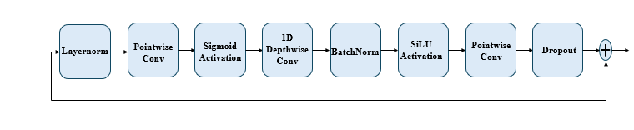
Figure 3.9: Conformer Convolution Module
The stages in Figure 3.9 can be represented in equation (3.3) as:
${ConformerConvModule}_{out}= x+ Dropout\left(PointwiseConv\left(SiLU\left(BatchNorm\left(DepthwiseConv\left(Sigmoid\left(PointwiseConv\left(LayerNorm\left(x\right)\right)\right)\right)\right)\right)\right)\right)$ $(3.3)$
Where $x$ is the output of the Multi-Head Attention (MHA) block.

3.12.4.8 Encoder (Conformer Encoder)
The encoder of the U2UT architecture is a conformer encoder that consists of the following stages / layer: feedforward, MHSA, Conformer Convolution Module, second feedforward, and layernorm as shown in Figure 3.10. The Conformer Encoder was defined using ConformerBlock Class and initialised with d_model, d_ff, num_heads, kernel_size=31, dropout=0.1. The forward method was called with input argument, $x$ which is the discretised units representing the source language, English.
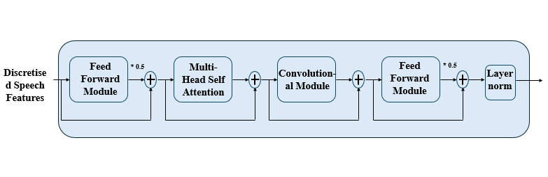
Figure 3.10: A U2UT Encoder (Conformer Encoder)
The Conformer Encoder of Figure 3.10 can be represented mathematically in equations (3.4a) to (3.4e) as:
${First FeedForward}_{out}=\left(FeedForward\left(Discretised English\right)*0.5\right)+Discretised English$ $(3.4a)$
${MHSA}_{out}=MHSA\left({First FeedForward}_{out}\right)+ {First FeedForward}_{out}$ $(3.4b)$
${ConformerConvModule}_{out}=ConvolutionalModule\left({MHSA}_{out}\right)+ {MHSA}_{out}$ $(3.4c)$
${Second FeedForward}_{out}=\left(FeedForward\left({ConformerConvModule}_{out}\right)*0.5\right)+{ConformerConvModule}_{out}$ $(3.4d)$
${ConformerEncoder}_{out}=LayerNorm\left({Second FeedForward}_{out}\right)$ $(3.4e)$

3.12.4.9. Block of Encoder
A group of encoders are utilised for transformer encoder-decoder architecture where each block processes the output of the previous block and final output utilised for cross attention is obtained from the last encoder block in the pipeline. For this architecture, the number of encoders in the group was set to 6 with num_layers input argument. A ConformerEncoder Class was created and initialised with input arguments num_layers, d_model, d_ff, num_heads, kernel_size=31, dropout=0.1, and input_dim=None. The forward method was called with input argument, $x$ which represents the input to each of the encoders. The input to the first conformer encoder is the discretised English input and inputs to subsequent encoders are output of the previous encoder. ConformerEncoder Class was developed with nn.ModuleList method in Pytorch. It is represented as shown in Figure 3.11.
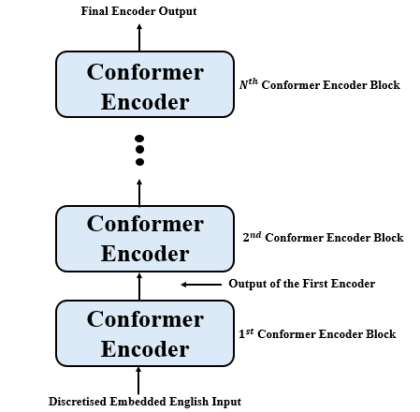
Figure 3.11: U2UT Conformer Encoder Block with Nth Encoders

3.12.4.10 Decoder
In this architectural design, decoders were designed for Long Short-Term Memory (LSTM), and Gated Recurrent Unit (GRU). The decoder was developed with LSTMDecoderBlock Class name (default name) and initialised with input arguments d_model, hidden_size, vocab_size, and dropout=0.1. The forward method was called with argument $x$ that refers to the discretised target output with shape [batch_size, sequence_length]. The nn.LSTM method of the nn.Module package was explored for the development of the LSTM, while that of GRU was developed with nn.GRU method. Dropout was applied to the output of the LSTM and two linear layers were applied to get the final output of the LSTM phone decoder. Phoneme logits, Projected states (hidden states), and hidden were the three output of the LSTM decoder. The hidden states are fed as input to the synthesiser, and cross attention module. For cross attention, the hidden states represent the query, while the key, and value were from the encoder output.

3.12.4.11 Phoneme Decoder Block
This comprises of groups of LSTM decoder. It was called a Phoneme decoder block even though each LSTM decoder block was fed with target discretised values unlike the target phonemes used in the original Translatotron2 architecture, and to maintain the name in the vanilla Translatotron2. Here the phoneme decoder block was not designed to output predicted target phoneme. The hidden state from each decoder block was fed to the cross-attention module for alignment between the source encoder output (from discrete) and target decoder output (from target discrete) from LSTM decoder. In the vanilla Translatotron2, alignment was between the source spectrogram and target phoneme. This design architecture ensures alignment is simplified for the U2UT models and mapping of the source to target is enhanced at earlier epochs into the training. It was indeed observed that at earlier epochs around 425 epochs (37,187 steps) into the training from scratch, some of the tested output samples obtained via evaluation were intelligible and sound very similar to the reference audio samples. In this decoder block, the input to the first decoder in the block is the discretised target output whose output is fed as input to the next decoder block (and to the cross- attention module) and the final decoder block output’s hidden state is fed to the synthesiser. The decoder block was developed with nn.ModuleList method with the following input arguments: d_model, hidden_size, vocab_size, and dropout. Here, 2 decoders are integrated to make the phoneme decoder block with num_layers set to 2. The hidden_size was set to 512 while vocab_size, d_model, and dropout were set to 500, 512, and 0.1 respectively.

3.12.4.12 Cross-Attention
The MHSA initially designed in section 3.12.4.6 was used as the cross-attention. It should be noted that while MHSA was finding relationship amongst words on the same side of the encoder, or same side of the decoder, Multi-Head Cross Attention (MHCA) is meant to find the relationship (mapping) between the source English embedded discretised input and target Yoruba discrete values. Hence, to use MHSA as MHCA, the Query is from each of the phoneme decoder in the phoneme decoder block, while the Key, and Value are from the final output of the conformer encoder block fed to each phoneme decoder in the phoneme decoder block. The same input arguments as used for the MHSA were also used for the MHCA.

3.12.4.13 Synthesiser
A. Duration Predictor
This was designed with two linear layers. and a ReLU activation function placed in between the two linear layers. Its function is to predict the duration per discrete values (hidden states) whose output is needed by the Upsampler where each value in the hidden state is multiplied based on the duration provided by the duration predictor. It was developed with Class name, DurationPredictor and initialise with input arguments input_dim, and hidden_dim. The defined forward function was called with input argument, $x$ Mathematically, the Duration Predictor can be represented in equation (3.5) as:
${DurationPredictor}_{out}= Linearlayer\left(ReLU\left(LinearLayer\left(x\right)\right)\right)$ $(3.5)$
Where $x$ is the concatenation of the cross-attention, and hidden state output.
B. Upsampler
This is defined function named as “Upsampler” whose function was to upsample or project each hidden state to a factor specified by the Duration Predictor.
C. Discrete Target Synthesiser
This is a synthesiser whose job is to synthesise the target Yoruba discrete integers leveraging on the two inputs (hidden state from the phoneme decoder block, and cross-attention output). It was created with Python Class Synthesizer exploring the functionality of the nn.Module package. It was initialised with d_model, rnn_dim, and vocab_size input arguments. The forward was called with two input arguments: hidden, and attention. Synthesisers were developed for both LSTM and GRU. The designed synthesiser consists of the following stages: projection of the hidden and cross-attention output to shape [batch, seq_len, d_model], concatenation of the projected values, Duration Predictor of the concatenated results, Upsampling of the concatenated results using the duration predicted by the Duration Predictor, LSTM/GRU stage and the output fed into a linear layer to obtain the final logits of shape [batch, seq_len, vocab_size]. The synthesier can be represented as shown in Figure 3.12.
Figure 3.12: Target Yoruba Discrete Synthesiser

3.12.4.14 Inference Decoding
A. Parallel Decoding
During inference generation of the target discrete values, both parallel and autoregressive decoding were utilised. The parallel decoding involved feeding the embedded discretised English input to the transformer conformer encoder block, whose output is fed as input to a cross-attention, where the query, key, and values are the conformer encoder block output. The encoder output which was taken as the hidden state was fed to the synthesiser along with the attention output to generate the unit logits and argmax of this was found to find the final predicted target Yoruba units that was fed to the finetuned unit HiFi-GAN vocoder
B. Autoregressive Decoding
In the autoregressive decoding, the input argument to the defined “infer_autoregressive” function defined are src_feats, mask=None, max_len=200, start_token=1, and eos_token=2. The present output is conditioned only on the previous token and not future token, and the autoregression was meant to iterate over the max_len = 200 in the experimental setup. For the first iteration, the present token, which represents the start_token (in tensor), with hidden (set to None) were fed to the Phoneme decoder. The output of this were phoneme_logits, hidden_states, and hidden (for the next iteration). The next stage was to find the cross-attention between the hidden_states, enc_out, and enc_out. The encoder output was obtained from the output of the conformer encoder block that was fed with the source, English embedded discretised value (whose audio is to be generated). Then the attention output with hidden_states were fed to the synthesiser to generate the unit logits. The unit logits was fed into the argmax function to obtain the first token (discrete value). At the end of all iterations, the discrete Yoruba target was generated that was then fed into the finetuned unit HiFi-GAN vocoder to obtain the target Yoruba audio replica of the source input English audio or waveform.

3.12.4.15 U2UT Model
The U2UT model was developed, which is an integration of all the above sub-modules including the conformer encoder block, with MHSA and positional encoding, phoneme decoder block, cross-attention, and synthesiser with duration predictor and upsampler. The U2UT model (see Figure 3.5) was then integrated with unit HiFi-GAN vocoder. Model developments and different ablation studies were carried out using the general and public health domain (two sections of the BENYO-S2ST-CORPUS-R1-2026 dataset). All hyperparameters (keyword, positional arguments) mentioned in the model architectural designed above where utilised.

3.12.5 U2UT Model Training Experiments

3.12.5.1 Experimental Setup
Using NVIDIA GeForce RTX 4060 GPU, with Windows 11 operating system, the virtual environment (see section 3.12.4.2) was activated on the Ubuntu with Windows Subsystem for Linux. Python 3.12 was installed into the virtual environment with major important libraries such as Scipy 1.17.1, soundfile 0.13.1, torch 2.5.1 + cu121, torchaudio 2.5.1 + cu121, transformers 5.9.0, and matplot 3.10.9. For the trainings and experiments reported in this Thesis, a whole sequence length of any audio file was not used because of insufficient of GPU space of 8 GB utilised for each of the experiments. The sequence length was capped at 600. The experiments were carried out one after the other.

A. U2UT Model Training Experiments with 200 section of General Domain of UI_3
Two hundred (200) audio audios from speaker 000 of UI_3 of the BENYO-S2ST-CORPUS-R1 datatset was selected and augmented using section 3.12.4.3 to scale the parallel audios to 1400 audios. At start, a dataset sample of size 190 was chosen randomly and partitioned into 158 and 32 parallel audios of English and Yoruba for training and validation respectively. An Adam optimizer with a learning rate was set to 0.0001 was utilised for this experiment. The default values of the other hyper-parameters were utilised. Both checkpoint files and best models were saved. Validation accuracy, as well as training and validation losses were monitored. After over 2 weeks, the dataset was scaled to 336 parallel audios of English and Yoruba with distribution as 266 for training and 70 for validation. This was run for over 2 weeks after which the data was scaled to the full size of 1400 of the augmented audios. The dataset was partitioned into 1120 and 280 for training and validation respectively. Finally, the training commenced with full dataset of 1400 parallel audios and training ran for another over 2 weeks. At around epoch 618 and above, it was observed there was no improvement in the validation errors, hence, training was terminated and a new Adam W optimiser with learning rate, beta, and weight_decay of 0.0001, (0.9, 0.98), and 0.01 respectively was used to resume training but it was observed there was no improvement. Training was terminated and resumed back with epoch 618 and left till epoch 664 to see what changes will place. It was once again observed there were no improvement in the audio qualities as the played audios sounded worst than previous ones. Finally, since there was no improvement in the validation loss even though with higher accuracies for both training and validation, training was terminated at this epoch. It is intended training will resume on a higher GPU space with enough dataset of around 10,000 parallel audios from epoch 664.

B. U2UT Model Training Experiments with 1000 audio files of the Public Health Domain of UI_5
In another experiments for public health domain-based model, 1000 parallel audio files of UI_5 was selected. It contains both male and female speakers. This time, a new augmentation technique that band limit the audio selected signals within the audio frequencies range of 300 Hz, and 3400 Hz with a Butterworth filter was utilised and termed pre-processed. This in addition to the other existing augmentation/pre-processing including speed perturbation up, speed perturbation down, frequency pitch up, frequency pitch down, noise addition, silence trimmed, and the original audios were used to scale the 1000 parallel audios of English and Yoruba to 8 audio samples of each selected audio making a total generated 8,000 parallel audio files (16,000 audios in total). The same Adam optimiser with same learning rate of 1e-4 and same default other hyper-parameters were used. Training commenced with 899 parallel audios of English and Yoruba where 655, and 164 were for training and validation respectively. This ensures a ratio of 4 to 1 for dataset split. Stating at epoch 0, training was monitored, checkpoint files, and best models were saved. Training and validation step losses and accuracies were saved. Target discrete values were also fed to the unit HiFi-GAN vocoder to listen to the output target audios. This ran for about 4 hours afterwhich the training was terminated at 62 epoch. Thereafter, the dataset was increased to 1250 audios with 1000 for training and 250 for validation. This ran for another 1 week till epoch 347, after which it was scaled to 1950 parallel audios of English and Yoruba, and training resumed with this new dataset samples from this epoch. The training ran from epochs 347 to 550 for another 3 weeks after which it was once again terminated for evaluations. This time there was no improvement in the calculated evaluation metrics at higher epochs in comparison to earlier ones.
Then, optimiser was replaced with AdamW with a Scheduler using CosineAnnealing, where Tmax was set to 50, and learning rate to 1e-4, betas = (0.9, 0.98), and weight_decay=1e-2. Training once again resumed with checkpoint 401. This was selected at it was among the earlier best models. Training was run from this epoch till epoch 469 after which it was terminated. The purpose of this change of experimental setup was to see how AdamW can be compared with initially used Adam optimiser, and make findings in terms of the metric results for both. The highest BLEU score of 33.38 was obtained at checkpoint 424. The corresponding WER and CER of 0.53, and 0.2 respectively were obtained at this same checkpoint.
Clarification Note:
In the initial experiments (Sections A and B), the training corpus combined 48 kHz original recordings with augmented data resampled to 16 kHz. All audios used for training was resampled to 16KHz prior to unit extraction. Since HuBERT applies sr = 16,000 Hz internally, unit extraction was consistent across experiments. This implies all experiments carried out in Sections A and B were unified with same sampling frequency of 16 KHz for parallel audio clips, unit vocoder, and STOI/PESQ alone. The computation of NISQA MOS was done with the default sampling frequency 48 KHz. In the reminder of the experiments carried out, the above settings for sampling frequencies were maintained; the ms_sr, ms_fmax, and sr were set to 16,000, 8000, and 16,000 respectively inside the NISQA_lib.py script for NISQA MOS computation. In addition to that, first, the same training clips (including the original audios with silence) as that of the Adam optimiser trained model were used to develop the next experiment in Section C, comparing Adam with AdamW optimiser. In the next set of experiments thereafter, the original audio samples were excluded from the training data as some contained silence at the beginning and end. They were being replaced with processed (trimmed band-limited versions) – this implies 7 versions of each audio clip were available in the training input data.

CHAPTER FOUR

RESULTS AND DISCUSSIONS

4.1 Introduction
This section presents the results and discussions of the various experiments carried out in this thesis. It highlights the outcome of the data curation exercise, evaluation of the audio quality, model developments and different ablation studies carried out geared towards achieving the goal of the work. It also details the evaluation metrics results obtained for each of the developed models. It ended by drawing conclusion based on the outcomes of the experiments reported here.

4.2 Data Curation
As previously reported in Chapter three, two experiments were carried out, including spectrogram to audio and discrete integers to audio generations experiments. The transfer learning was leveraged on for both sets of experiments.

4.2.1 Spectrogram to Audio Generation Experiment Using BENYO-S2ST-CORPUS-R1 Dataset
Finetuning of the pretrained HiFi-GAN vocoder started with a pretrained check point of g_0000000 for the generator, and at about 11000 global steps, the finetuning checkpoint files when tested, were already generating Yoruba speech (unintelligible). At about 27K global steps, around 492 epochs, the audio generation was also tested using the generator checkpoint file. It produced intelligible Yoruba speech which still needed to be finetuned further for clarity. The comparison between the reference and generated spectrograms of three audio female samples at epoch 492, as obtained from the Tensorboard are shown in Figures 4.1, 4.2, and 4.3.
Figure 4.1 shows that despite differences in amplitude scaling (color bar ranges - 0 to 30 for Figure 4.1 (a) and -11 to -9 for Figure 4.1 (b)), the generated spectrogram visually matches the reference, indicating that HiFi-GAN successfully reproduces the fine-grained spectral details of speech. The similarity between the two spectrograms highlights HiFi-GAN’s ability to synthesize audio with high fidelity, making the generated speech perceptually close to real human speech.
The main difference between Figures 4.2 (a) and 4.2 (b) from Figures 4.1 (a) and 4.1 (b) lies in amplitude scaling, but structurally the generated spectrogram this time also aligns well with the ground truth. Figure 4.3 (a) and Figure 4.3 (b) continue the same comparative analysis between reference audio and generated audio at 27,000 global steps (492 epochs). It demonstrates that HiFi-GAN is capable of faithfully reconstructing the spectral features of speech. Together, Figures 4.1 to 4.2 provide strong evidence that HiFi-GAN can efficiently learn and reproduce the fine-grained spectral details of speech. The generated audio is nearly virtually and perceptually indistinguishable from ground truth audio samples, supporting its claim as a state-of-the-art model for high-quality speech synthesis.

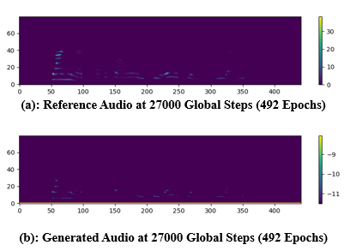
Figure 4.1: Reference Versus Generated Spectrograms - Audio Sample 1

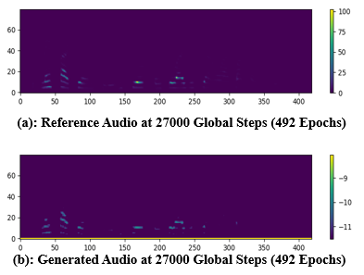
Figure 4.2: Reference Versus Generated Spectrograms - Audio Sample 2

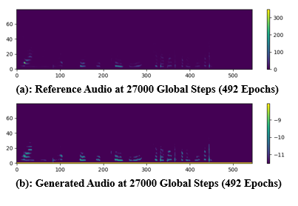
Figure 4.3: Reference Versus Generated Spectrograms - Audio Sample 3
A graph of the generation total loss (gen_loss_total), melspectrogram error for training and validation (mel_spec_error) are represented by Figures 4.4, 4.5, and 4.6 for up to 35,000 plus global steps. it can be shown that at about 27K global steps, the generator total loss was around 20, which is typical of results range of within 18 to 50. At these same global steps, the mel_spec_error for training was around 0.06 while that of validation gave a value of about 0.05, and the score balance as measured at this same period gave a value of about 1.06 which is approximately 1, which shows the generator and discriminator are both in a stable state. It can also be seen that at about 11,000 global steps when first set of audios were produced, that the mel spectrogram error for validation in Figure 4.6 with a sharp curve decrease to a lower value of 0.09, after which it reduces further to 0.05 and remains constant at this value up till about 35000 global steps. Furthermore, the hyperparameters such as the learning rate decay, learning rate were adjusted to ensure the training converges in time.

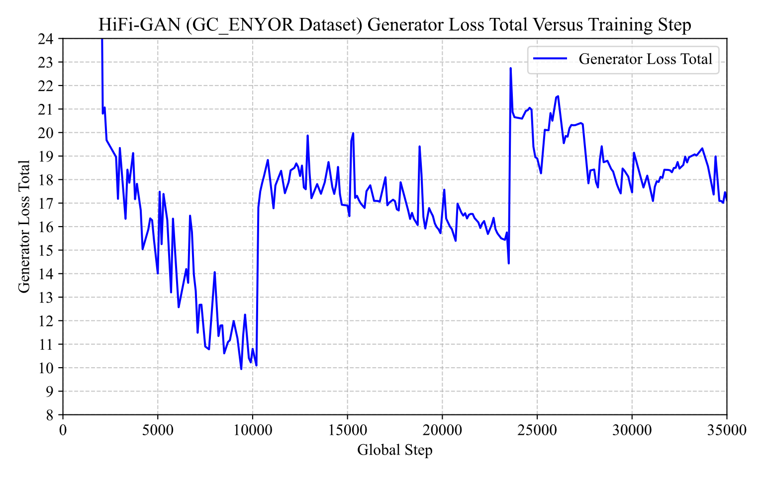
Figure 4.4: Generator Loss Total
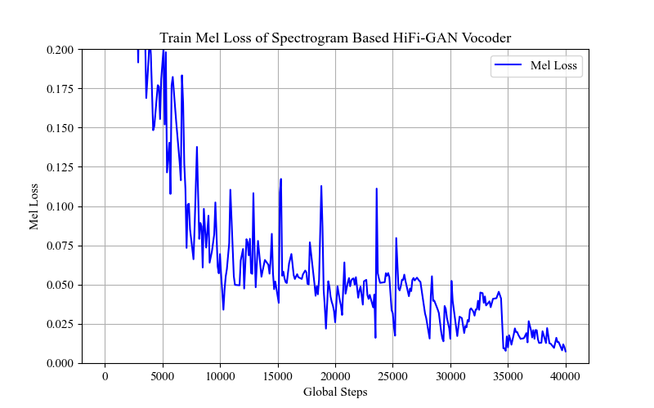
Figure 4.5: Mel Spectrogram Error (Training)
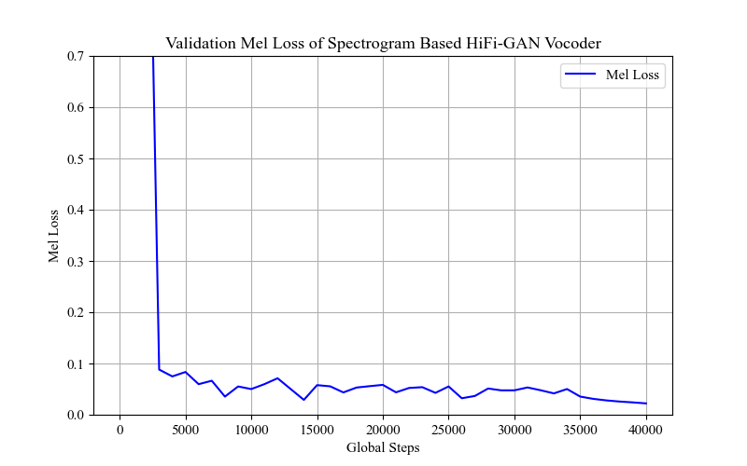
Figure 4.6: Mel Spectrogram Error (Validation)

Due to the need to generate clearer Yoruba speech, finetuning was resumed at around epoch 492, and at about 1231 epochs equivalent of 81,000 global steps, the model developed was again tested. It was discovered that it made little difference in terms of audio intelligibility when compared to that obtained at 27000 global steps. This implies that the model has fully converged at around 492 epochs.

4.2.2 Comparison of BENYO-S2ST-CORPUS-R1 Dataset Results with Developing an Open-Sourced Dataset for Spectrogram to Audio Generation Experiments
Finetuning of the HiFi-GAN vocoder utilising Developing an Open datasets commenced with a generator pretrained checkpoint of g_0000000, and proper monitoring of the log was carried out. Finetuning, which commenced with a higher generation loss of about 187, mel spec error of 3.992 and score balance (s/b) of 10.594 later stabilized as training continued. As shown in Table 4.1, at about 13,000 global steps, speech like audio was generated unlike the BENYO-S2ST-CORPUS-R1 that generated same at about 11,000 steps. This can be attributed to the smaller audio lengths available in the Developing an Open-Source dataset with an average of 3.845461 secs which is small in comparison to 7.854354 secs for BENYO-S2ST-CORPUS-R1. As can be seen in Table 4.1, BENYO-S2ST-CORPUS-R1 has a total of 2.18 hours in comparison to Dev. An Open Source with 1.07 hours. This implies the BENYO-S2ST-CORPUS-R1 has enough features within each audio for the training to learn from to produce results at such a lower global step. It also implies the BENYO-S2ST-CORPUS-R1's longer utterances signify richer prosody and phonetic diversity. Both produced similar results across metrics at approximately 27, 000 global steps, 492 epochs, when tested on both seen (validation samples) and unseen (test samples) audios. It was further observed that as training continued beyond 28,000 steps, BENYO-S2ST-CORPUS-R1 was spiking as seen in the Gen_loss total, which was already given hundreds, then thousands, then millions of values, which prompted early stopping and updating to the configuration file before resuming training. This means the longer sequences stress adversarial balance.
Table 4.1: Experimental Results of BENYO-S2ST-CORPUS-R1 and Developing an Open-Sourced Dataset
S/N | Feature | BENYO-S2ST-CORPUS-R1  (Yoruba) | Dev Open-Source (Yoruba)
5 | Total duration (1000 audio clips) | 7854 sec (~2.18 hours) | 3845 sec (~1.07 hours)
6 | Speech emergence | 11k steps | 13k steps
7 | Training stability | Loss spike at 28k (catastrophic, required reset) | Stable, no spikes
8 | Noise in outputs | Faint background noise | Faint background noise
9 | Plateau | 35k steps, no further improvement | 35k steps, no further improvement
For Developing an Open-source dataset, training stabilized beyond 28,000 global steps, that implies shorter utterances lead to smoother training, and no catastrophic spikes.
It was also observed that there was no improvement in the audio generated for both BENYO-S2ST-CORPUS-R1 and Developing an Open-Source datasets beyond 28,000 steps. As a final observation, which is probably due to issues with the inference scripts utilized, faint background noises were heard inside the audio generated for both, which degraded the speech produced.
A comparison of the generated and original (reference) spectrograms for different audio samples for both BENYO-S2ST-CORPUS-R1 and Developing an Open-Source at 27K global steps, as obtained from the Tensorboard are shown in Figure 4.7.
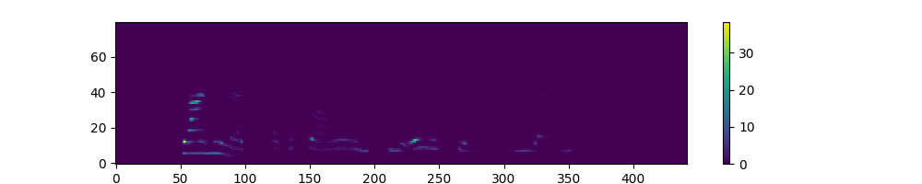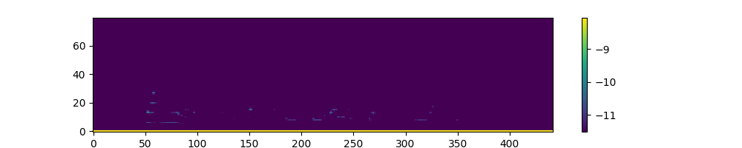
(a)(i) BENYO-S2ST-CORPUS-R1_Ref1 (a)(ii) BENYO-S2ST-CORPUS-R1_Gen1

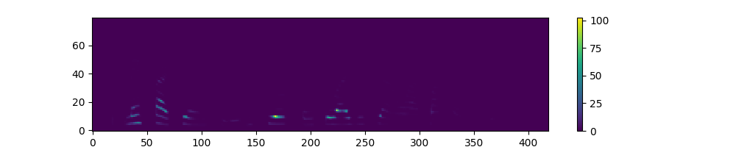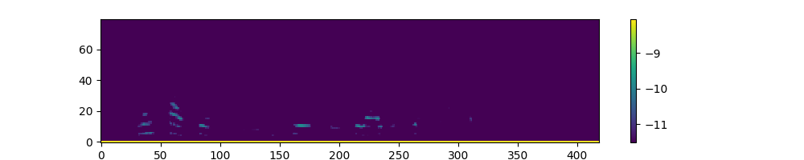
(b)(i) BENYO-S2ST-CORPUS-R1_Ref2 (b)(ii) BENYO-S2ST-CORPUS-R1_Gen2
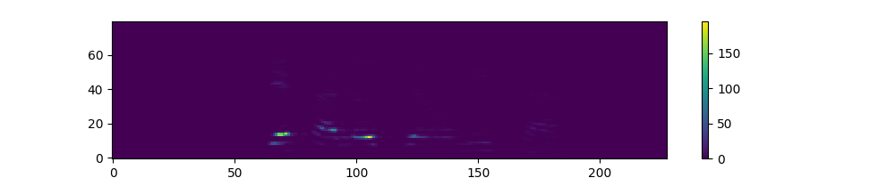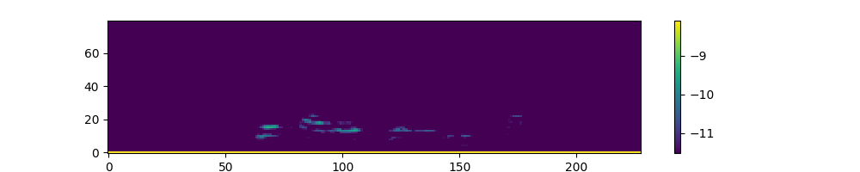
(c)(i) Dev_Ref1 (c)(ii) Dev_Gen1
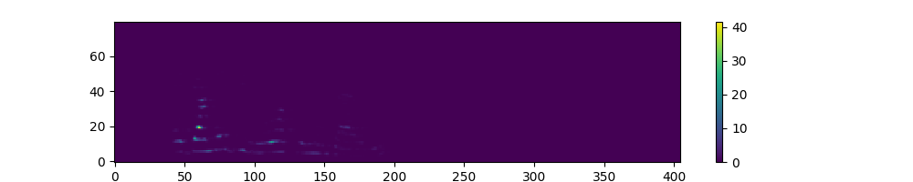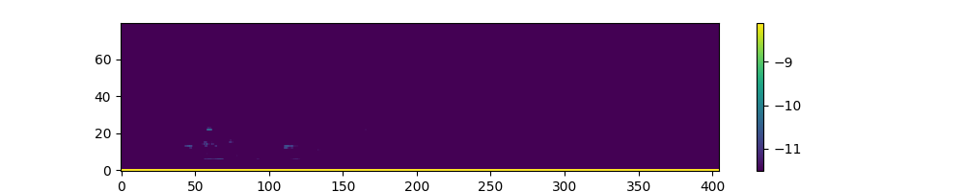
(d)(i) Dev_Ref2 (d)(i) Dev_Gen2

Figure 4.7: Reference Versus Generated Spectrogram Comparison of both Datasets
In terms of generation quality, for BENYO-S2ST-CORPUS-R1, the generated spectrograms (Gen1, Gen2) broadly capture the structure but lose sharpness and intensity. In Dev. an Open-Source, Gen1 is relatively close to Ref1, but Gen2 shows more degradation — weaker replication and more diffuse energy. This suggests that generation quality varies more in Dev. an Open-Source than in BENYO-S2ST-CORPUS-R1.
In terms of dataset difficulty, BENYO-S2ST-CORPUS-R1 appears to be easier for the generation process to replicate consistently, even if at lower intensity. Dev. an Open-Source shows higher variability: sometimes good fidelity (Dev_Gen1) and sometimes poor (Dev_Gen2). This implies Dev. an Open-Source may contain more complex or less predictable spectral features.
The generated signals in both datasets capture the general time-frequency distribution of their references but with reduced clarity. BENYO-S2ST-CORPUS-R1 generations are more stable but weaker in amplitude, while Dev. an Open-Source generations are less consistent — sometimes close, sometimes far off.
For further comparison, Figures 4.8(a)-(c) are being compared with those of Figures 4.4 to 4.6 (BENYO-S2ST-CORPUS-R1) for the training_gen_loss_total, training_mel_spec_error, and validation_mel_spec_error for both datasets at 35000 global steps.

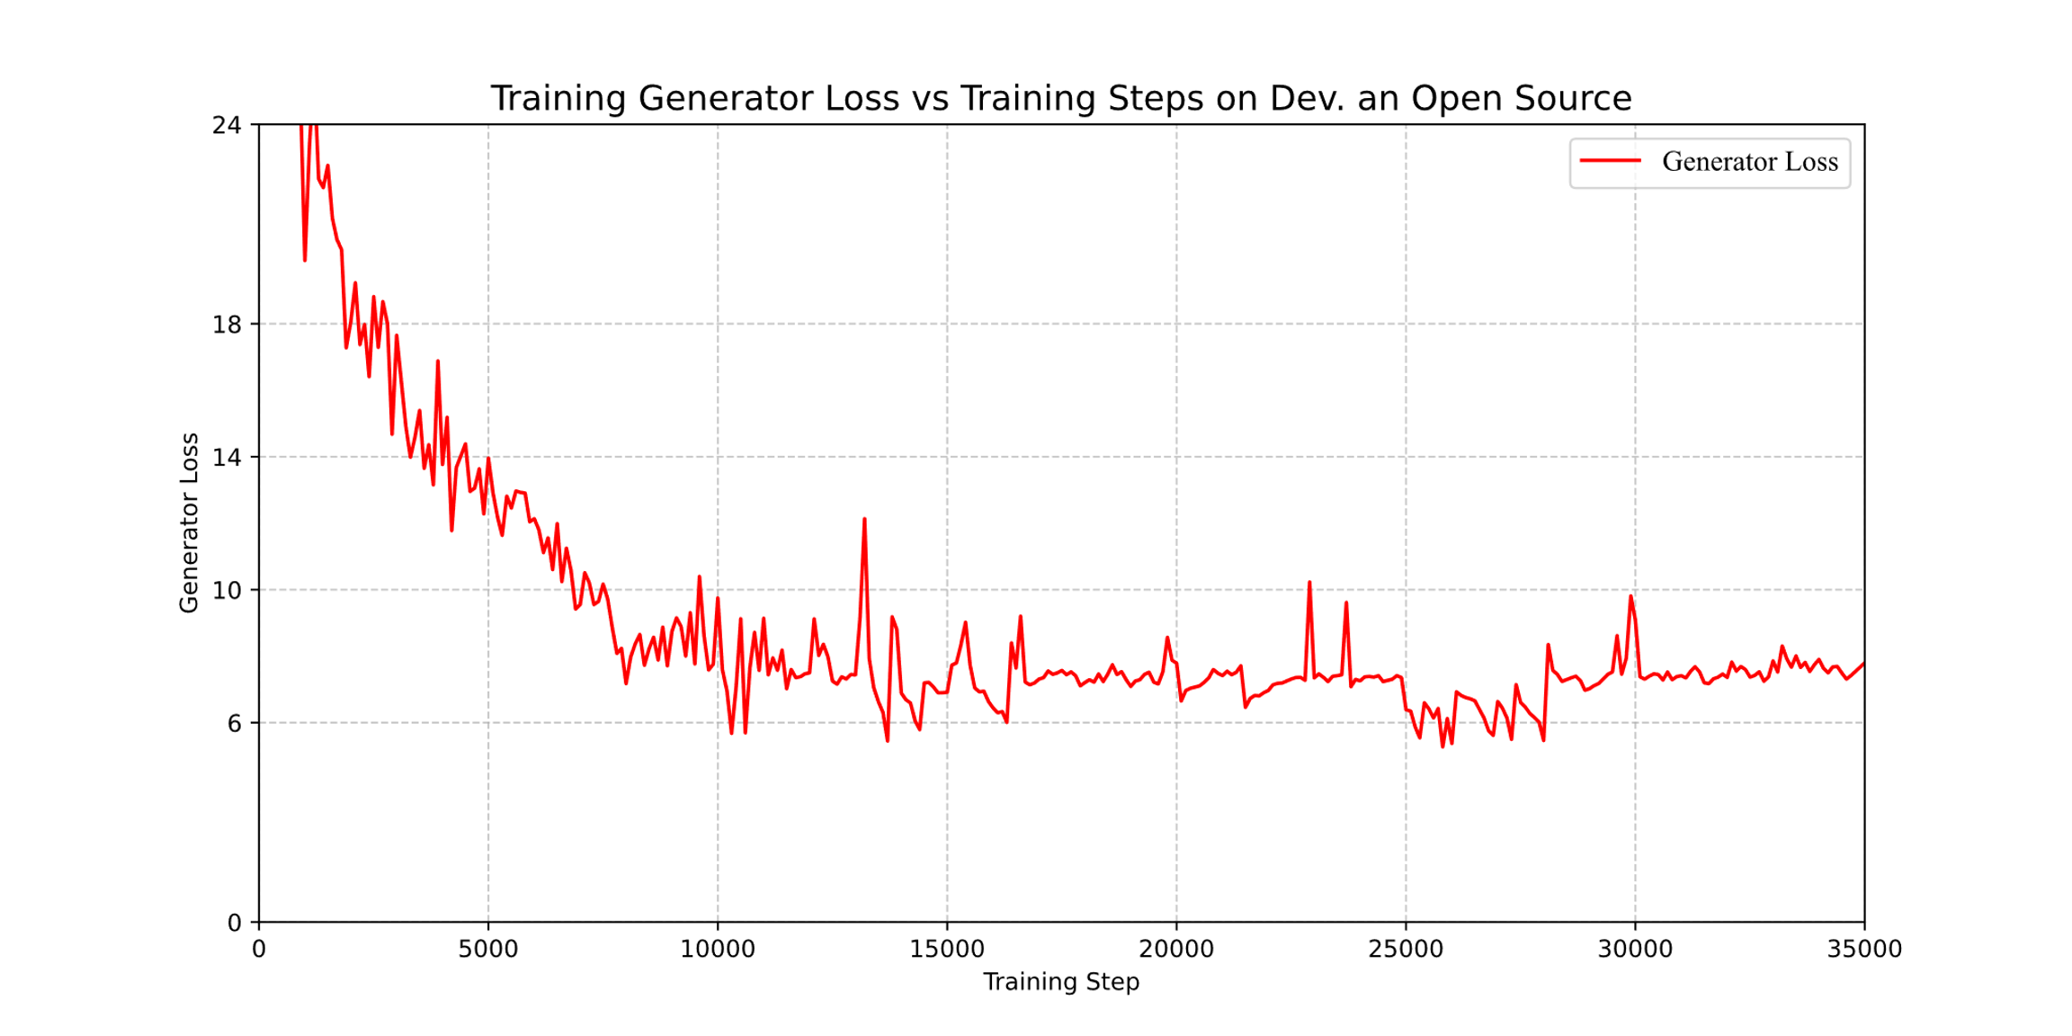
(a): Dev_train_gen_loss_total

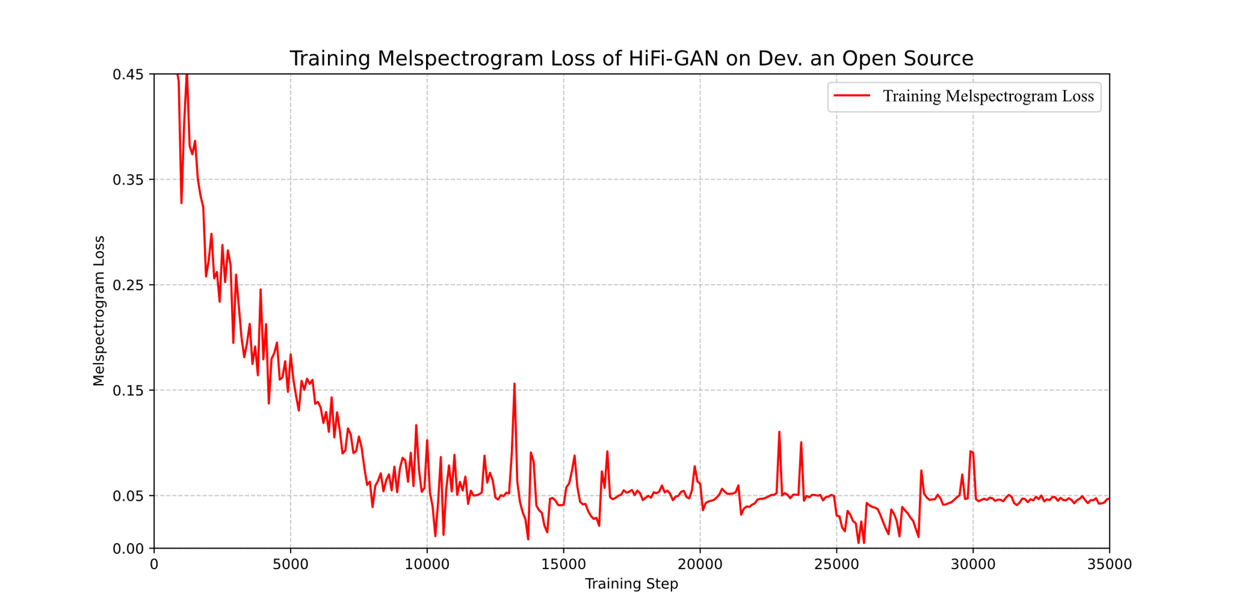
(b): Dev_training_mel_spec_error

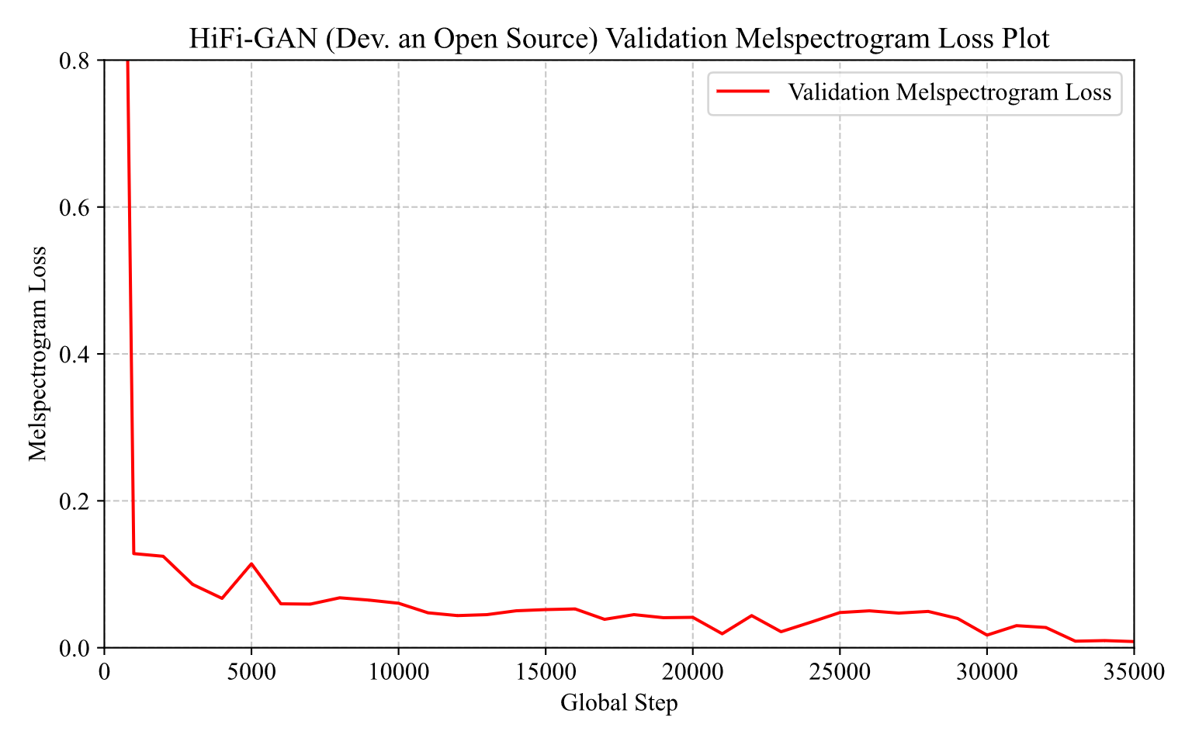
(c): Dev_validation_mel_spec_error

Figure 4.8: Comparison of Loss and Metrics for both Datasets
Figure 4.4 shows that at about 25K steps, BENYO-S2ST-CORPUS-R1 has gen_loss_total for training to be 19 while that of Developing an Open Source was 6 as shown in Figure 4.8(a). This suggests BENYO-S2ST-CORPUS-R1’s generator is struggling more to fool the discriminator, indicating less stable adversarial training at that point. Again, the mel_spec_errors for training were 0.03 and 0.025 for BENYO-S2ST-CORPUS-R1 and Developing an Open-Source datasets at same 25K steps as shown in Figures 4.5 and 4.8(b) respectively. This implies both are close, but Open-Source is slightly lower, meaning it reconstructs spectrograms with marginally better accuracy at the same step. Finally, the mel_spec_error_validation for BENYO-S2ST-CORPUS-R1 dataset was already around 0.09 at 10,000 global steps and remained same from 15K to 35K steps with value of 0.05. The Developing an Open-Source dataset has 0.08 at 10K steps, which decreases to a value of 0.04 at about 23K after which it spiked up again to 0.05 at about 28K steps and finally reduced to a lower best value of around 0.01 at 35K steps-these are shown in Figures 4.6 and 4.8(c). This means BENYO-S2ST-CORPUS-R1 reached a stable but limited performance ceiling, showing little improvement after 15K, whereas the Developing an Open-Source dataset continued improving, showing resilience and better generalization, despite a temporary instability. Conclusively, the two experiments show that BENYO-S2ST-CORPUS-R1 has faster early convergence (speech emergence earlier, validation error plateau by 15K), but limited improvement afterward and higher generator loss suggests dataset richness but training instability. The Dev. an Open-Source is slower at start, but with a steady improvement, lower generator loss, and eventually much better validation error of approximately 0.01 indicates stronger generalization and stability.
Table 4.2 shows the extreme PESQ, STOI, and MOS metrics values of both BENYO-S2ST-CORPUS-R1 and Dev. an Open Source datasets on 50 test samples. The PESQ/STOI evaluations were carried out at 16KHz to algign with ITU standard as sampling frequencies of only 8KHz, and 16KHz were possible. For the NISQA MOS, the the ms_sr, ms_fmax, and sr were set to 22050, 16,000, and 22050 respectively inside the NISQA_lib.py script. For BENYO-S2ST-CORPUS-R1, PESQ, shows a tight range (1.0177 → 1.0367). The lowest perceptual quality was at File 01045 (Step 60k), while the highest was at File 01024 (Step 60k). STOI shows wider spread (0.4653 → 0.7343). The lowest intelligibility occurred at File 01029 (Step 60k), while the highest was at File 01040 (Step 45k). This shows that PESQ is stable but capped, while STOI varies more strongly across samples, with certain cases achieving very high intelligibility. For Dev. an Open Source, the highest perceptual quality spike (1.4976) at Step 38K from a PESQ value of 1.018 for File yof_05223_01388550871 at 27K steps, suggests some samples benefited heavily from training. STOI also shows widespread (0.340 → 0.711). The lowest intelligibility (0.3400) at Step 38K indicates degradation for certain samples. The highest intelligibility (0.7111) at Step 27K shows strong clarity in some cases. The lowest PESQ (1.0181) shows that some samples remained weak in fidelity. For BENYO-S2ST-CORPUS-R1, the MOS has the lowest score at File 01045 and highest at File 01012 with values of 0.7894 and 4.3300 respectively. In fact, the highest values among the generated samples between epochs 27K, and 60K was 1.8243 for File 01040 (not available in the Table 4.2). For Dev. an Open Source, the lowest MOS score was 1.2553 at File 00363408145 (27K) as against the highest score 4.7233 which was obtained for an original sample (File 01182310093). Among the generated samples, the highest was 2.1291 at File 00567029601 (38K).
Table 4.2: Extreme Values of PESQ, STOI and NISQA MOS Metrics Result of 50 Test Samples for Spectrogram-Based HiFi-GAN Vocoder with BENYO-S2ST-CORPUS-R1 and Dev. an Open Source Datasets
Metrics \ Global Steps | BENYO-S2ST-CORPUS-R1  PESQ STOI MOS |  |  | Dev. an Open Source  PESQ STOI MOS
Minimum  File  Global Step | 1.0177  01045  60K | 0.4653  01029  60K | 0.7894  01045  60K | 1.0181  01388550871  27K | 0.340  00644756392  38K | 1.2553  00363408145  27K
Maximum  File  Global Step | 1.0367  01024  60K | 0.7343  01040  45k | 4.3300  01012  Original audio | 1.4976  01186842869  38K | 0.7111  01406099113  27K | 4.7233  01182310093  original

Table 4.3 highlights the differences between average PESQ, STOI, and NISQA MOS for each of the Dev. An Open Source and BENYO-S2ST-CORPUS-R1 datasets 50 test samples.
Table 4.3: MOS, PESQ, and STOI Average Metrics Comparison of Spectrogram-based and HuBERT unit-based HiFi-GAN Vocoder
Dataset \ Metrics | Spectrogram-based HiFi-GAN Vocoder with BENYO-S2ST-CORPUS-R1 |  |  |  | Spectrogram-based HiFi-GAN Vocoder with Dev. An Open Source
Dataset \ Metrics | Original 27K 45K 60K |  |  |  | Original 27K 38K
PESQ |  | 1.0244 | 1.0251 | 1.0250 |  | 1.0485 | 1.0780
STOI |  | 0.6282 | 0.6324 | 0.6319 |  | 0.5898 | 0.4407
NISQA MOS | 3.1330 | 1.3603 | 1.3608 | 1.1018 | 3.8158 | 1.6653 | 2.0430

Table 4.3 shows spectrogram‑based HiFi‑GAN training on the BENYO-S2ST-CORPUS-R1 dataset produced highly stable PESQ values (approximately 1.025) across checkpoints, with STOI peaking at 45K steps (0.6324). For Dev. an Open-Source PESQ improves from 1.048 at 27K to 1.078 at 38K. This suggests that perceptual quality (fidelity of the reconstructed audio) benefits from more training steps in this dataset. Also, STOI drops from 0.590 at 27K to 0.441 at 38K, which indicates that while perceptual quality improves, intelligibility decreases with more training. These results show that the Dev. an Open Source dataset highlights a quality vs clarity trade‑off where more training improves PESQ but harms STOI, and it is different from BENYO-S2ST-CORPUS-R1, where STOI remained stable (0.63) and PESQ stayed flat (1.025). MOS analysis on the BENYO-S2ST-CORPUS-R1 dataset revealed a sharp decline from the original audio (3.13) to synthesized outputs (1.36 at 27K/45K). By 60K steps, MOS dropped further to 1.10, indicating perceptual degradation with extended training. This contrasts with PESQ and STOI, which remained stable, underscoring MOS as a more sensitive measure of naturalness loss in spectrogram‑based HiFi‑GAN. On the Dev Open Source dataset, MOS dropped from 3.82 (original) to 1.67 at 27K steps, but recovered to 2.04 at 38K steps, indicating improved perceptual naturalness with additional training. In contrast, BENYO-S2ST-CORPUS-R1 showed a decline in MOS with extended training. While direct numerical comparison is not valid due to different test samples, these results highlight dataset‑specific trends: BENYO-S2ST-CORPUS-R1 emphasizes stability, whereas Dev open source demonstrates recovery potential.

4.2.3 HuBERT vs MFCC Base Audio Generation Experiments with BENYO-S2ST-CORPUS-R1 Dataset
It should be noted that while both models (HuBERT- vs Spectrogram-based HiFi-GAN vocoders) were trained on the same underlying 1000 audio samples, the difference in sampling frequency and conditioning features means that raw generator and mel-spectrogram losses reported in this section are not directly comparable across models. Accordingly, losses have been reported separately and reliance on objective evaluation metrics such as PESQ, STOI, and NISQA MOS for cross-model comparison. Informal listening impressions (e.g. “speech emergence”, “richer timbre”, “clearer”) are labelled explicitly as qualitative observations rather than quantitative results

4.2.3.1 Size and Memory Space
It was observed that the .npy files of the 1000 audios (training and validation) had a reduced size of about 1.61 MB for the HuBERT discrete units when compared to the .npy file size of 206 MB of that of melspectrogram. This is about a 99.21% reduction in size utilising a discrete unit approach. This also implies the training runs faster than spectrogram-based speech generation model, highlighting the reduction in storage and memory requirements, using discrete approach while still retaining enough information of the original audios.

4.2.3.2 Global Steps Losses of HuBERT- and Spectrogram-Based HiFi-GAN Vocoder
Table 4.4 shows that between 11,000 and 20,000 global steps, Spectrogram plus Audio-based model had train mel loss drops to 0.026 by 20k steps (Figure 4.9 and Table 4.4), validation mel loss stays low (approximately 0.03–0.07) (Figure 4.10 and Table 4.4), showing strong generalization, and its quick convergence with very low error values. However, for Discrete Units plus Audio-based model, train mel loss remains higher (approximately 0.89–0.97) (Table 4.4) across 11k–20k, while validation mel loss also was higher (approximately 1.05–1.15) (Table 4.4)-this shows that convergence is slower in terms of mel loss, but training is stable and consistent. This implies that on the same GC‑ENYOR dataset, spectrogram‑based HiFi‑GAN achieves much lower mel losses (better raw spectral fidelity). Unit HiFi‑GAN shows higher mel losses, but with good audio quality obtained — as discrete units often yield better phonetic clarity and robustness.
Figure 4.9: Train Mel Loss of Spectrogram Based HiFi-GAN

Figure 4.10: Validation Mel Loss of Spectrogram Based HiFi-GAN
Table 4.5 also shows similar trends were also obtained between 21K and 30K global steps. For Spectrogram plus Audio-based model, train mel loss drops to approximately 0.015 by 30k, its validation mel loss stays low and stable (approximately 0.03–0.05). This shows excellent convergence and spectral fidelity. For discrete Units plus Audio-based model, train mel loss remains higher (with approximately 0.82–0.88) across 21k–30k, but slightly lower than those of Table 4.4. Its validation mel loss is also higher (approximately 1.04–1.12)-thus, it shows convergence is slower in mel loss terms, but training is stable and consistent.
Table 4.4: Mel Loss of Unit HiFi-GAN and HiFi-GAN Between 11k to 20K Global Steps
Global Step | Spectrogram Train | Spectrogram Val | Discrete Train | Discrete Val
11k | 0.050 | 0.0597 | 0.972 | 1.155
12k | 0.073 | 0.0712 | 0.964 | 1.138
13k | 0.072 | 0.0501 | 0.951 | 1.137
14k | 0.063 | 0.0290 | 0.933 | 1.119
15k | 0.038–0.117 | 0.0577 | 0.924 | 1.073
16k | 0.064 | 0.0577 | 0.922 | 1.079
17k | 0.054–0.059 | 0.0435 | 0.911 | 1.054
18k | 0.051–0.077 | 0.0531 | 0.907 | 1.136
19k | 0.036–0.086 | 0.0558 | 0.899 | 1.105
20k | 0.026 | 0.0583 | 0.894 | 1.079

Table 4.5: Mel Loss of Unit HiFi-GAN and HiFi-GAN Between 21k to 30K Global Steps
Global Step | Spectrogram Train | Spectrogram Val | Discrete Train | Discrete Val
21k | 0.051–0.054 | 0.044 | 0.883 | 1.017
22k | 0.041–0.049 | 0.052 | 0.878 | 1.117
23k | 0.035–0.043 | 0.054 | 0.863 | 1.097
24k | 0.051–0.057 | 0.043 | 0.864 | 1.083
25k | 0.031–0.079 | 0.055 | 0.860 | 1.109
26k | 0.046–0.056 | 0.032 | 0.859 | 1.060
27k | 0.052–0.054 | 0.037 | 0.855 | 1.060
28k | 0.015–0.055 | 0.051 | 0.834 | 1.046
29k | 0.013–0.036 | 0.048 | 0.833 | 1.040
30k | 0.015 | 0.048 | 0.822 | 1.086

4.2.3.3 General Comparison
Table 4.6 further shows a comparison of the two models in terms of the dataset utilized, the global steps at which speech first emerge, etc.
Table 4.6: Comparison of results
Aspect | MelSpec + Audio (BENYO-S2ST-CORPUS-R1) | Unit HiFi-GAN (HuBERT Discrete) + Audio)
Dataset | Same 1050 audios (900 train, 100 val, 50 test) | Same 1050 audios (900 train, 100 val, 50 test)
Speech Emergence | ~11k steps (speech audible, but muffled) | ~14k steps (speech audible, clearer)
Clarity Progression | Plateau around 35k, faint background noise, little improvement | Still improving at 32k, clarity increasing
Training Stability | Loss spike at ~28k (catastrophic, required reset) | Stable, no catastrophic spikes
Phonetic Accuracy | Captures prosody, but muffled clarity | Better phonetic precision, clearer articulation
Naturalness | Richer timbre, but noisy | Cleaner phonetics, slightly robotic timbre
Noise/Artifacts | Faint background noise persisted | Less noise, but unit resolution affects smoothness

4.2.3.4 Evaluation Metrics Comparison for HiFi-GAN and HuBERT Unit HiFi-GAN
The evaluations were carried out on the same Fifty (50) test samples at different sampling rates of 22050 Hz, and 16,000 Hz for spectrogram based HiFi-GAN vocoder and unit HiFi-GAN vocoder respectively. The results of the average values across each global step saved checkpoint for each of the spectrogram based HiFi-GAN vocoder are reported in Table 4.7. The table shows the PESQ, STOI, NISQA MOS metrics average values for the 50 test samples. As shown in Table 4.7, the PESQ score is very stable across checkpoints (approximately 1.024–1.025). No meaningful perceptual gain with more training. STOI on the other hand peaks slightly at 45k (0.6324), then dips marginally at 60k (0.6319) – this suggests best intelligibility at 45k, but overall stability across steps. These results show that spectrogram‑based HiFi‑GAN training on the BENYO-S2ST-CORPUS-R1 dataset produced stable PESQ values (approximately 1.025) across checkpoints, with STOI peaking at 45k steps (0.6324).
Table 4.7:Average PESQ and STOI Metrics Result of 50 Test Samples for Spectrogram HiFi-GAN Vocoder
Metrics \ Global Steps | Original Audio | 27 K | 45 K | 60 K
PESQ |  | 1.0244 | 1.0251 | 1.0250
STOI |  | 0.6282 | 0.6324 | 0.6319
NISQA MOS | 3.1330 | 1.3603 | 1.3608 | 1.1018

Table 4.8: Extreme Values of PESQ, STOI and NISQA MOS Metrics Result of 50 Test Samples for Spectrogram HiFi-GAN Vocoder
Metrics \ Global Steps | PESQ | STOI | MOS
Minimum  Value  File  Global Step | 1.0177  01045  60K | 0.4653  01029  60K | 0.7894  01045  60K
Maximum  Value  File  Global Step | 1.0367  01024  60K | 0.7343  01040  45k | 4.3300  01012  Original audio

Table 4.8 shows the lowest perceptual quality was obtained from File 01045 (Step 60k) with PESQ 1.0177, while the highest was from File 01024 (Step 60k) with PESQ value of 1.0367. For STOI, the lowest and highest intelligibility occurred at Files 01029 (Step 60k) and 01040 (Step 45k) with STOI values of 0.4653 and 0.7343 respectively. Extreme value analysis of spectrogram‑based HiFi‑GAN on the BENYO-S2ST-CORPUS-R1 dataset revealed a narrow PESQ range (1.0177–1.0367), indicating stable perceptual quality across checkpoints. STOI values varied more widely (0.4653–0.7343), with File 01040 at Step 45k achieving the highest intelligibility. These results highlight HiFi‑GAN’s robustness in perceptual stability and its potential for strong intelligibility peaks. For MOS, the lowest and highest values occur at Files 01045 (60K) and 01012 (original audio) with values of 0.7894 and 4.3303 respectively as shown in Table 4.8. Extreme MOS analysis on spectrogram-based vocoder revealed that original audio ranged from 1.59 to 4.33, while synthesized outputs plateaued around 1.1–1.8 at 27k/45k steps. By 60k steps, MOS dropped further, with the lowest score of 0.789 (File 01045), indicating perceptual degradation. These results highlight the gap between natural and synthesized audio, and the sensitivity of MOS to over‑training compared to PESQ and STOI.
Tables 4.9 and 4.10 shows the equivalent result of Table 4.7 and 4.8 when the metrics were evaluated for the 50 generated audios of the same 50 test audio clips, whose average values are listed in Table 4.7, using HuBERT unit-based HiFi-GAN at 32K, 45K, and 50K global steps.
Table 4.9: Average PESQ and STOI Metrics Result of 50 Test Samples for HuBERT unit-based HiFi-GAN Vocoder
Metrics \ Global Steps | Original Audio | 32 K | 45 K | 50 K
PESQ |  | 1.0522 | 1.0484 | 1.0483
STOI |  | 0.5417 | 0.5536 | 0.5478
NISQA MOS | 3.0671 | 2.7605 | 2.9194 | 2.8652

Results of Table 4.9 show that MOS improves from 32K to 45K (2.760 → 2.919), then dips slightly at 50k (2.87) for HuBERT unit based HiFi-GAN vocoder. This implies that across 50 test samples, HuBERT units achieve moderate improvements in naturalness up to 45K steps before slightly declining. For HuBERT‑unit HiFi‑GAN vocoder, average PESQ scores remained stable (approximately 1.05) across checkpoints, indicating early convergence in perceptual quality. STOI scores improved modestly from 0.542 at 32K to 0.554 at 45K, before slightly declining to 50K. These results suggest that while perceptual fidelity is achieved early, extended training contributes marginally to intelligibility, with 45K steps offering the best balance. These results reinforce HuBERT’s superiority in naturalness alongside intelligibility.
Table 4.10: Extreme Values of PESQ, STOI and NISQA MOS Metrics Result of 50 Test Samples for HuBERT unit-based HiFi-GAN Vocoder
Metrics \ Global Steps | PESQ | STOI | NISQA MOS
Minimum  Value  File  Global Step | 1.0294  01018  50K | 0.4519  01035  50k | 1.8358  01012  32k
Maximum  Value  File  Global Step | 1.0894  01026 & 01042  32K | 0.6738  01015  45k | 4.3946  01012  Original audio

The extreme analysis (Table 4.10) shows HuBERT based HiFi-GAN vocoder spans from 1.03 to 1.09 for PESQ, and in terms of STOI it varies from 0.45 to 0.68. A value of 0.68 shows a moderate level of intelligibility of HuBERT, though with poor audio quality as indicated with its PESQ score. The overall results of HuBERT unit based HiFi-GAN vocoder shows it has some level of perceived naturalness coupled with moderate level of intelligibility, and poor quality of the generated audios – though resynthesized test samples appear to be clear and perceivable when listened to.
The comparisons of the average metrics values for the 50 test samples between Spectrogram-based and HuBERT unit-based HiFi-GAN Vocoder are highlighted in Table 4.11. As highlighted in the table, HuBERT unit based HiFi-GAN vocoder showed more variability in STOI and PESQ than the spectrogram based HiFi-GAN vocoder. HiFi‑GAN spectrogram‑based training is more stable but capped at lower PESQ values (1.025 versus 1.05 for units based). Spectrogram based HiFi-GAN vocoder’s STOI is competitive (0.63), and higher than HuBERT’s 0.55, showing spectrogram‑based HiFi‑GAN can deliver strong intelligibility. These results show that while unit‑based models such as HuBERT achieved higher PESQ scores (1.05), spectrogram‑based HiFi‑GAN maintained competitive intelligibility, underscoring its robustness and stability in perceptual metrics, even though there were faint background noises in the resynthesized audios. In terms of audio naturalness, HuBERT unit based HiFi-GAN vocoder outperforms spectrogram based HiFi-GAN vocoder with values within the range of 2.8 to 2.9 as against 1.1 to 1.4 for spectrogram based HiFi-GAN vocoder.
Table 4.11: MOS, PESQ, and STOI Metrics Comparison of Spectrogram-based and HuBERT unit-based HiFi-GAN Vocoder
Metrics \ Global Steps | Spectrogram-based HiFi-GAN Vocoder |  |  |  | HuBERT unit-based HiFi-GAN Vocoder
Metrics \ Global Steps | Original 27K 45K 60K |  |  |  | Original 32K 45K 50K
PESQ |  | 1.0244 | 1.0251 | 1.0250 |  | 1.0522 | 1.0484 | 1.0483
STOI |  | 0.6282 | 0.6324 | 0.6319 |  | 0.5417 | 0.5536 | 0.5478
NISQA MOS | 3.1330 | 1.3603 | 1.3608 | 1.1018 | 3.0671 | 2.7605 | 2.9194 | 2.8652

4.2.3.5 Generated vs Ground Truth for both HiFi-GAN and Unit HiFi-GAN
Both models gave promising results when tested for samples used during training and off training. Unit HiFi-GAN gave moderate level of speech intelligibility as the generated audio became so clear even at lower global steps of 14K. The speech became even clearer at higher global steps. When unit HiFi-GAN was tested at 32K, 45K, and 50K steps, it gave output so close to the reference in terms of its naturalness, and these results are backed up by Tables 4.9 and 4.10. For HiFi-GAN, the generated audios were not close to the ground truth in terms of content but with background noise that eroded the speech, even though with higher STOI score than that of HuBERT was obtained.

4.3 Discrete Values Representations Unit HiFi-GAN Based Experiments
Here the results of HuBERT-based unit HiFi-GAN vocoder reported in section 4.2.3 were compared with the experimental results of Wav2vec 2.0-based unit HiFi-GAN vocoder and WavLM-based unit HiFi-GAN vocoder.

4.3.1 Discrete Units Comparison (HuBERT vs Wav2vec 2.0 vs WavLM)
The results of the experiments when discrete units from each of wav2vec 2.0 and WavLM were fed to unit HiFi-GAN are given in Tables 4.12 to 4.15. The tables highlight the average metrics results, as well as their extreme values which were computed for the same 50 test samples. Results of Table 4.12 means for Wav2Vec 2.0‑unit HiFi‑GAN vocoder, average PESQ scores remained stable (1.042) across checkpoints, indicating early convergence in perceptual quality. However, STOI scores declined from 0.475 at 32K to 0.466 at 50K, reflecting reduced intelligibility with extended training. Compared to HuBERT units, wav2vec 2.0 units yield similar perceptual fidelity but consistently lower intelligibility, suggesting HuBERT units are better suited for vocoding tasks where clarity, and intelligibility are prioritized. As shown in Table 4.13, wav2vec 2.0 has the highest NISQA MOS value of 4.0393 (File 01032) at 50 K – this implies it has the ability to produce audios of high degree of naturalness, though with instability nature in its training. As highlighted in Table 4.12, it has the lowest average MOS at 32K (2.48), improves at 45K (2.89), but drops again at 50K (2.86).
Table 4.12: Average PESQ and STOI Metrics Result of 50 Test Samples for wav2vec 2.0 Unit Based HiFi-GAN Vocoder
Metrics \ Global Steps | Original Audio | 32 K | 45 K | 50 K
PESQ |  | 1.0422 | 1.0434 | 1.0410
STOI |  | 0.4745 | 0.4714 | 0.4663
NISQA MOS | 3.0671 | 2.4821 | 2.8878 | 2.8585

Table 4.13: Extreme Values of PESQ, STOI and NISQA MOS Metrics Result of 50 Test Samples for wav2vec 2.0 unit-based HiFi-GAN Vocoder
Metrics \ Global Steps | PESQ | STOI | NISQA MOS
Minimum  Value  File  Global Step | 1.0255  01041  45K | 0.3169  01043  50K | 1.4428  01034  50K
Maximum  Value  File  Global Step | 1.0899  01015  45K | 0.6236  01008  45K | 4.0393  01032  50K

Tables 4.14 and 4.15 highlight the average metrics and extremes results for WavLM units based HiFi-GAN vocoder. As depicted in Table 4.14, for WavLM‑unit HiFi‑GAN, average PESQ scores increased gradually from 1.049 at 32K to 1.052 at 50K, reflecting incremental improvements in perceptual fidelity. STOI scores peaked at 0.546 at 45K before declining to 0.536 at 50K, suggesting that intelligibility benefits from moderate training but diminishes with extended training. Its MOS falls within the range of 2.8 to 2.9, which shows some level of intelligibility and is somewhat natural. In terms of its extreme value (Table 4.15), it achieves the highest PESQ (1.1001) and strong STOI peaks (0.6491), but less stable than HuBERT.
Table 4.14: Average PESQ and STOI Metrics Result of 50 Test Samples for WavLM Unit Based HiFi-GAN Vocoder
Metrics \ Global Steps | Original Audio | 32 K | 45 K | 50 K
PESQ |  | 1.0489 | 1.0505 | 1.0523
STOI |  | 0.5365 | 0.5457 | 0.5359
NISQA MOS | 3.0671 | 2.7647 | 2.8660 | 2.9656

Table 4.15: Extreme Values of PESQ, STOI and NISQA MOS Metrics Result of 50 Test Samples for WavLM unit-based HiFi-GAN Vocoder
Metrics \ Global Steps | PESQ | STOI | NISQA MOS
Minimum  Value  File  Global Step | 1.0277  01041  32K | 0.4183  01009  32K | 1.6237  01034  32K
Maximum  Value  File  Global Step | 1.1001  01014  45K | 0.6491  01017  45K | 3.7018  01050  50K

Table 4.16 compares the average metrics values of HuBERT, Wav2vec, and WavLM unit-based HiFi-GAN vocoders.
Table 4.16: MOS, PESQ, and STOI Metrics Comparison of Discrete Unit-based HiFi-GAN Vocoder
Metrics \ Global Steps | HuBERT unit-based HiFi-GAN Vocoder |  |  |  | wav2vec 2.0 unit-based HiFi-GAN Vocoder |  |  |  | WavLM unit-based HiFi-GAN Vocoder
Metrics \ Global Steps | Orig 32K 45K 50K |  |  |  | Orig 32K 45K 50K |  |  |  | Orig 32K 45K 50K
PESQ |  | 1.0522 | 1.0484 | 1.0483 |  | 1.0422 | 1.0434 | 1.0410 |  | 1.0489 | 1.0505 | 1.0523
STOI |  | 0.5417 | 0.5536 | 0.5478 |  | 0.4745 | 0.4714 | 0.4663 |  | 0.5365 | 0.5457 | 0.5359
NISQA MOS | 3.0671 | 2.7605 | 2.9194 | 2.8652 | 3.0671 | 2.4821 | 2.8878 | 2.8585 | 3.0671 | 2.7647 | 2.8660 | 2.9656

The results of Table 4.16 show that across unit types, HuBERT consistently achieved the highest intelligibility while maintaining stable perceptual quality. wav2vec 2.0 units converged early in perceptual fidelity but yielded the lowest intelligibility. WavLM units offered a middle ground, with gradual improvements in PESQ and STOI peaking at 45K steps before declining. These findings highlight HuBERT as the most effective representation for vocoding tasks where clarity (intelligibility) is prioritized. For MOS evaluations across 50 test samples show that HuBERT units achieve moderate improvements in naturalness up to 45K steps before slightly declining. wav2vec 2.0 units start with the lowest MOS and, despite improvements at 45K, remains weaker overall. WavLM units demonstrate the most consistent gains, culminating in the highest MOS at 50K steps (2.97), suggesting superior perceptual naturalness compared to HuBERT and wav2vec 2.0.
The results of Table 4.7 for spectrogram based HiFi-GAN vocoder when compared with Table 4.16 shows that while direct numerical comparison between discrete unit‑based and spectrogram‑based pipelines is imperfect, spectrogram-based HiFi‑GAN serves as a perceptual stability baseline (PESQ 1.025, STOI 0.63). Against this baseline, HuBERT and WavLM based unit HiFi-GAN achieved higher PESQ (1.05) but lower STOI (0.55), indicating stronger fidelity but reduced intelligibility. wav2vec 2.0 consistently underperformed. Thus, spectrogram‑based HiFi‑GAN remains the intelligibility benchmark, while discrete approaches demonstrate potential advantages in perceptual fidelity. Also, in terms of the audio naturalness, the three discrete units-based approaches perform better than this spectrogram baseline approach.
Figures 4.11, 4.12, and 4.13 compare the training losses for HuBERT, Wav2vec 2.0, and WavLM respectively. It can be seen that the three discretization approaches have almost same generation loss at the earlier steps in the training, but at about 10K steps into the finetuning, HuBERT and WavLM show similar trend with lower train generation loss of about 53, while wav2vec 2.0 has a value of 60. At the latter end of the training at about 50K steps, HuBERT, wav2vec 2.0, and WavLM have a train generation loss of about 46, 50, and 45 respectively which shows that HuBERT and wav2vec 2.0 prove to be faster in training than wav2vec. This was also confirmed by the quality of the audio generated from each of the finetuned models.
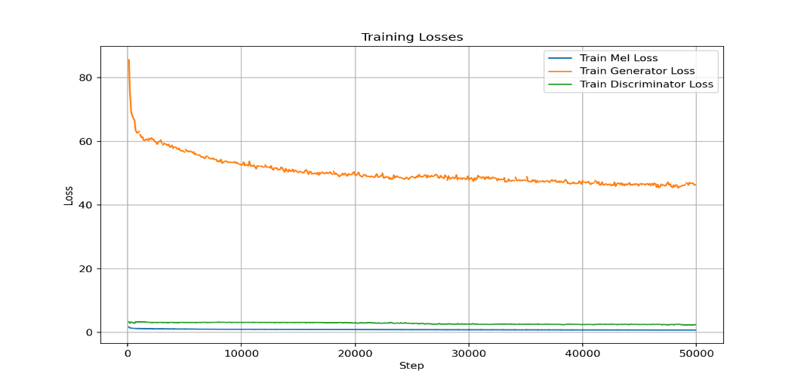
Figure 4.11: Training Losses for HuBERT
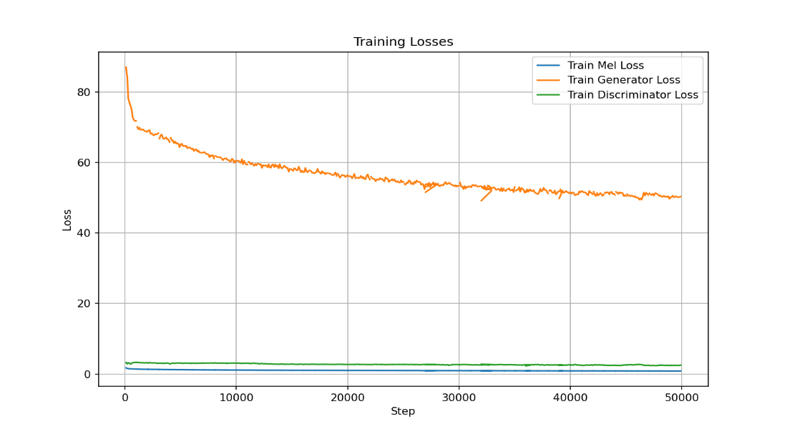
Figure 4.12: Training Losses for Wav2vec 2.0
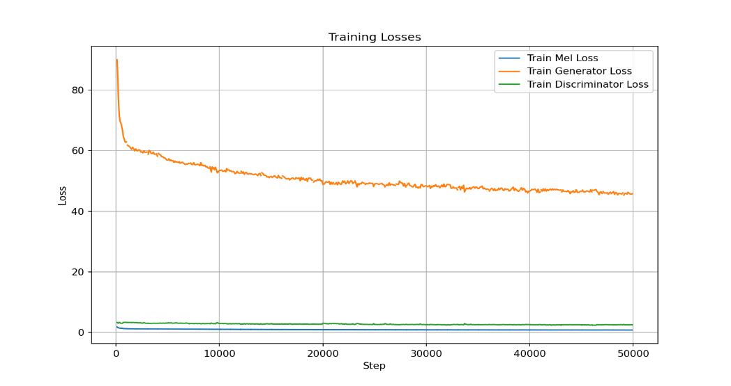
Figure 4.13: Training Losses for WavLM
Consequently, the results of the experiments conducted in this study show that discrete units-based approach to speech generation is better than the spectrogram-based approach where the HuBERT units’ speech generation based performs better than spectrogram-based speech generation in terms of speech quality, naturalness, faster training speed as a result of data reduction results (Wang, D. et al. 2025). Based on the evaluation metrics reported as detailed Tables 4.11 and 4.16, HuBERT units were able to generate high quality and natural speech even at 32K steps in comparable to faint produced speech-like generated by spectrogram-based approach at a higher 45K steps. However, in terms of speech intelligibility, spectrogram-based approach scored higher than the discrete approach. Furthermore, comparing the discrete based approach, HuBERT and WavLM are both strong candidates, i.e. faster training, higher PESQ, and more consistent MOS. Wav2Vec 2.0 lags behind with slower training and lower intelligibility. Between HuBERT and WavLM, the differences are subtle, HuBERT sometimes edges in STOI, while WavLM shows better MOS on certain files (Chen, S. et al, 2022). As reported in Chen, S. et al, (2022), the results of WavLM and HuBERT are better than that of wav2vec 2.0 for most of the models developed including ASR, and ST, where they were evaluated for WER, BLEU scores, STOI scores, and PESQ scores. The results obtained and reported in this thesis corroborate the earlier reported results of HuBERT, WavLM, and wav2vec 2.0 (Hsu, W.N., 2021; Chen, S. et al, 2022) In practice, when speed, quality, and intelligibility are needed, HuBERT is the most balanced. If robustness, naturalness, and newer architecture are needed, WavLM is a solid alternative (Chen, S. et al, 2022). However, the results show that wav2vec 2.0 is weak for HiFi‑GAN fine‑tuning as depicted by its metrics in this discrete unit setup. As a result of these experimental results in favour of HuBERT, it was selected for unit extractions of both the English and Yoruba audios utilised for U2UT model experiment and ablation studies.

4.4 U2UT Model based Experiments

4.4.1 U2UT Model Training Experiments with 200 audios of General Domain of UI_3

With dataset size of 190 parallel audios (158 for training and 32 for validation) of English and Yoruba, validation accuracy was around 0.002 while training and validation losses were as high as 5.4 at earlier epochs into the training and training continues till epoch 213. Target discrete values constructed were monitored as well. From epoch 213, and with dataset size of 336 parallel audios (266 for training and 70 for validation) training resumed and the output target discrete values when fed to the finetuned vocoder were having signs of intelligibility. The validation accuracy was approaching approximately 0.3. This training continues till epoch 426 when it was terminated. Then with full dataset size of 1400 augmented data (1120 for training and 280 for validation). Training once again resumed and it was observed at earlier epochs from around 427 epoch that validation accuracy jumped geometrically with increments of around 0.1 till it reaches around 0.88. At this point, the reconstructed discrete unit of the target language when tested was almost similar to the original audio in terms of intelligibility. In fact, it was easy locating these set of audios’ texts from the transcript file.
Observations:
- At around 450 epochs (31,500 global steps) into the training, some audio samples’ constructed discrete values of that of the original audio sample and that of the augmented replica of the same audio. The U2UT model was able to generate target discrete value list of any of the augmentation for an audio such that when fed to the unit HiFi-GAN, generated audio replica of each other. Unlike at the augmentation stage where different augmentation techniques such as pitch perturbation, pitch shifting, silence removal, noise addition introduce different variations on the audio, this time all are unified to the same audio content irrespective of whose discrete values was generated at the output of the unit HiFi-GAN vocoder. Display A shows the original audio samples from HuBERT while the immediate two (2) discrete values represent that of the augmentation techniques at epochs 427 and 433, all playing the same audio content though not exactly in terms of index values similarity across the two list between that generated from the U2UT model and the original discrete value. The last discrete value represents that of the inference decoding obtained by feeding the original source English discrete values to the trained saved model at epoch 434. The first 100 samples of the discrete units have been selected for space minimisation. Display B shows that the U2UT model was able to generate the same discrete point as the original audio (without augmentation) at epochs 434 and 497 for sample 180.
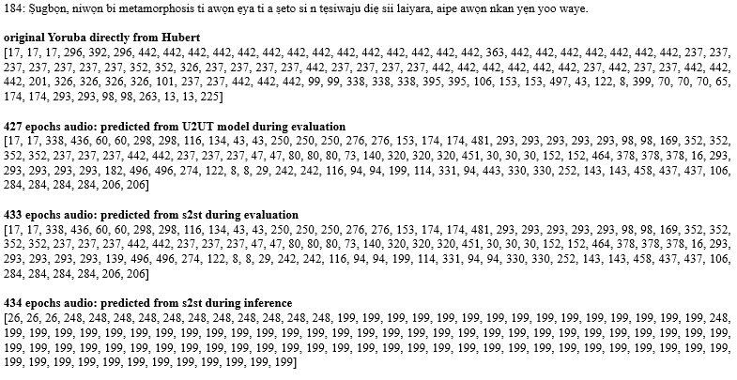
Display A: U2UT Model Discrete Target Units of any Augmentation Techniques Different from HuBERT direct units for the Original Same Audio
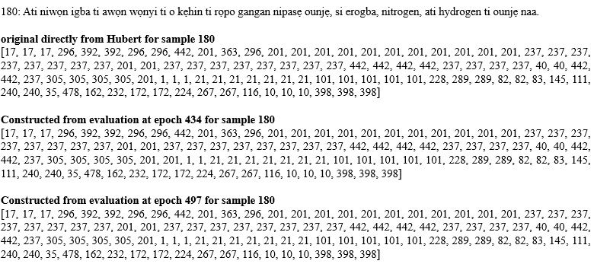
Display B: U2UT Model Discrete Target Units Same as that of HuBERT direct units for the Original Audio
The training and validation accuracies as well as that of the training and validation loses were monitored for improvement. Accuracy was already approaching 0.99 around 480 epochs. The tested outputted target discrete values give high level of intelligibility but inference testing (feeding with just source discrete values) result was not giving result at this epoch. Both parallel and autoregressive decodings scripts were utilised for inference. As a result of high accuracy (for both training and validation) obtained while inference audios were yet to be intelligible, training continuous. This time, the validation loss, and training losses were monitored. The validation loss was monitored for when it will plateau or start increasing at which time training will be terminated.
Figure 4.14 shows the training losses for epoch 530 to 540, while that of the validation is shown in Figure 4.15.
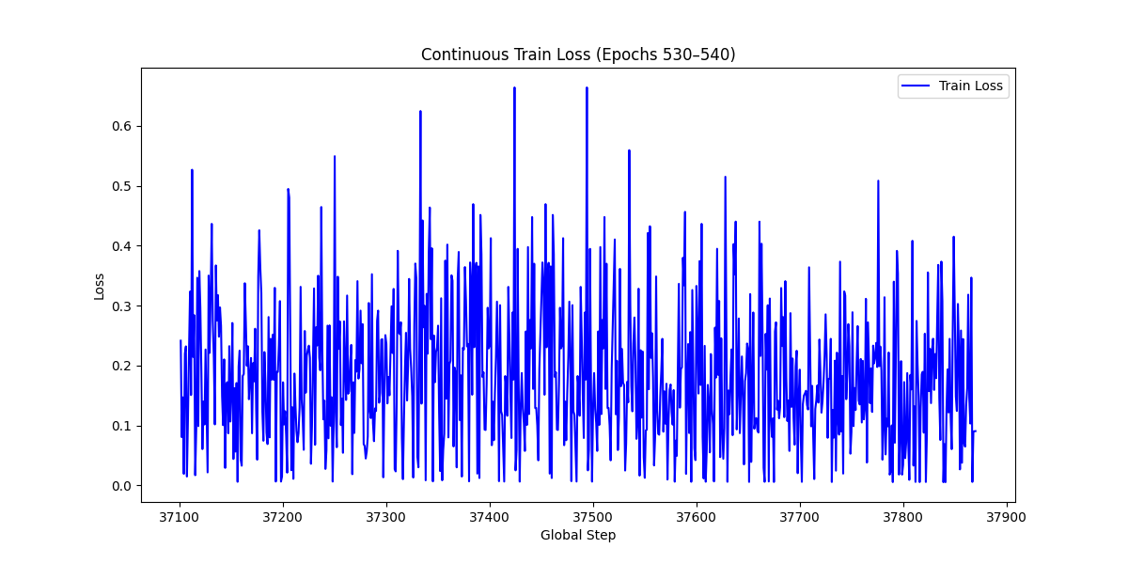
Figure 4.14: Training Loss for Epochs 530 to 540
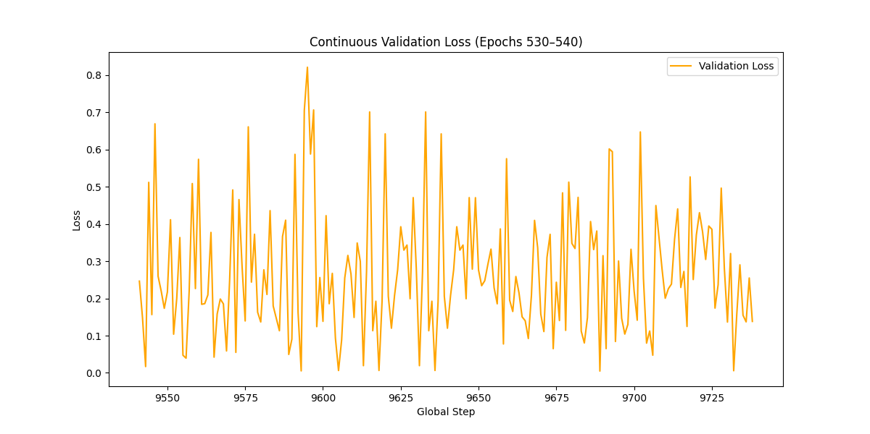
Figure 4.15: Validation Loss for Epochs 530 to 540
As can be seen from the two graphs, the losses are not yet stable but fluctuating between 0.01 and 0.7 for training where majority of the losses are around 0.1 to 0.2. for validation, majority of the losses are centred around 0.2 to 0.3. These two graphs show convergence is yet to be achieved at this epoch range.
Figures 4.16 and 4.17 show training and validation losses for epochs 524 and 526. The graphs also show the average loss for each of the epoch computed over the 70 and approximately 18 steps length for epochs 524 and 526. The accuracies which are already approaching 100 % are also shown.
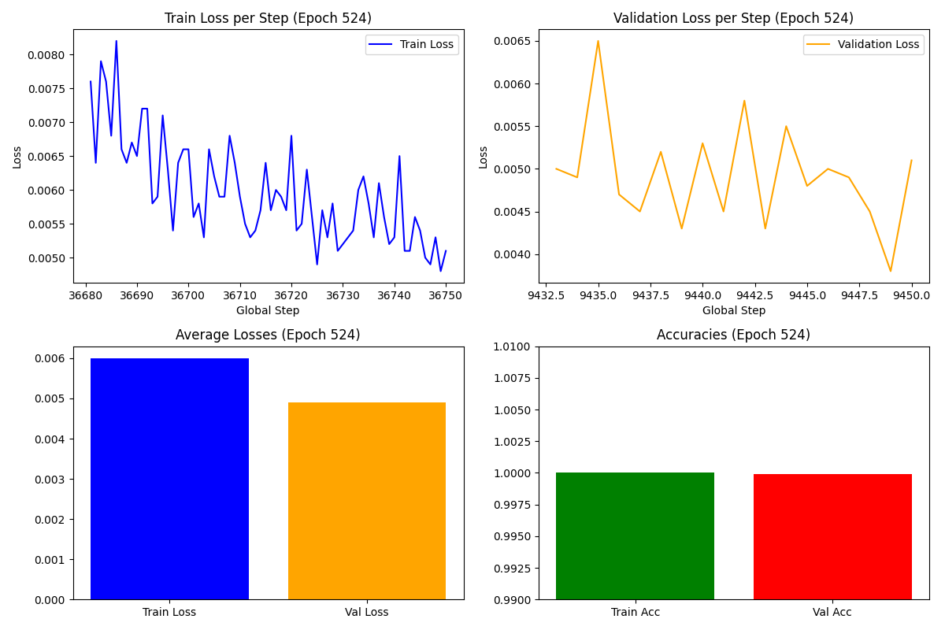
Figure 4.16: Losses and Accuracies Values at Epoch 524
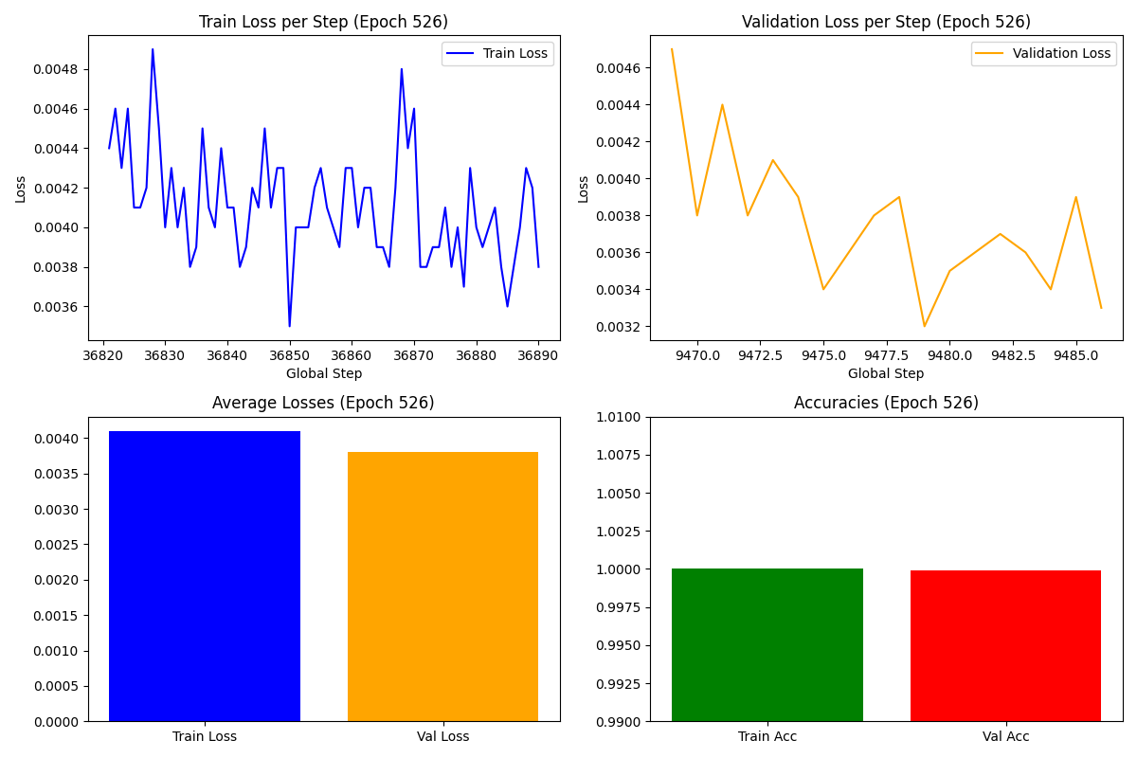
Figure 4.17: Losses and Accuracies Values at Epoch 526
The BLEU scores, CER, PESQ, STOI, and DNSMOS were also computed for some selected samples from the output of the U2UT model.
Table 4.17 shows the ASR texts obtained for 4 selected output target audios of the U2UT model. It also shows the ground truth texts and texts of the original audios obtained from the ASR model. Table 4.18 shows the BLEU scores computed for the 4 audio samples as well as their corresponding original audios. To compute the BLEU score, at first Whisper ASR model that was finetuned with limited number of Yoruba audios gave poor BLEU scores. Then a Nigerian developed NCAIR with training data of 627.09 hours of Yoruba speech for finetuning Whisper Small was used. The output texts are indicated in Table 4.17. Due to character based tonal marks of Yoruba which gives lower BLEU score as shown in Table 4.18 even though the generated samples from the U2UT model when fed to an ASR model have some words common to both the ground truth and obtained targets, another BLEU scores were computed with normalised ground truth and normalised target output as indicated in Table 4.19, along with their CER. This time the BLEU score appears large in comparison to that of Table 4.18. The normalised texts are shown in Table 4.20.
Table 4.17: ASR Outputs in Comparison to the Ground Truth Texts of Four Selected Audio Samples
Selected Samples\Features | Ground Truth | Original Audio Fed Directly to ASR | From U2UT model
Sample 184 @ 504 with 1400 audios | Ṣugbọn, niwọn bi metamorphosis ti awọn ẹya ti a ṣeto si n tẹsiwaju diẹ sii laiyara, aipe awọn nkan yẹn yoo waye. | ọ̀ṣọ̀gbọ́n ni wọ́n bí mẹ́ta mọ́ pọ́ọ̀sì ti àwọn ẹ̀yà tí a ṣẹ̀dọ̀ sí ẹ̀fẹ̀sìwájú díẹ̀ sí láì yàrá àì pé àwọn ọkàn yẹn yóò wáyé | mi ò mọ̀ mi mẹ́pamọ́ fọ́ọ̀ṣì sí àìyàn ẹ̀yà tí a ṣètò sí ìfẹ̀sìwà tí jẹ́ sí láìní ara àìpẹ̀ ọ̀pọ̀ yẹn yóò wáyé
Sample 186 @ 484 with 1400 audios | Pupọ kere si erogba ati hydrogen ni fọọmu ti a ṣe deede fun ilana atẹgun ju ni ibamu si atẹgun ti o gba ninu ẹdọforo. | púpọ̀ kékeré ṣe ìrùgbà àti àjọ́jù ni fọ́ọ̀mù tí a ṣèlédé fún ìlànà àtẹ́gùn jù ní ìbámù sí àtẹ́gùn tí ó gbà nínú ẹ̀dọ̀fọ̀ọ́ | àwọn òkèké rẹ̀ sí ìrùbá àti agbóṣèmi ni fọ́ọ̀mù tí a ṣe díndín fi máa tẹ̀gbọ́n gbọ́gbé ìgbámù sí àtẹ̀wò tí ìrùbá ìgbẹ́ ẹgbẹ́.
Sample 184 @ 455 with 1400 audios | Ṣugbọn, niwọn bi metamorphosis ti awọn ẹya ti a ṣeto si n tẹsiwaju diẹ sii laiyara, aipe awọn nkan yẹn yoo waye. | ọ̀ṣọ̀gbọ́n ni wọ́n bí mẹ́ta mọ́ pọ́ọ̀sì ti àwọn ẹ̀yà tí a ṣẹ̀dọ̀ sí ẹ̀fẹ̀sìwájú díẹ̀ sí láì yàrá àì pé àwọn ọkàn yẹn yóò wáyé | mi ò mọ́, mi mẹ́pamọ́ fọ́ọ̀sì sí àìyàn ẹ̀yà tí a ṣètò sí ìfẹ̀sìwà tí jẹ́ sí láìní ara àìpẹ̀ ọ̀pọ̀ yẹn yóò wà yẹ́yẹ
Sample 187 @ 467 with 1400 audios | Ati pe yoo jẹ dandan fun iṣẹ ti atẹgun, kii ṣe aipe erogba ati hydrogen ti a pese lati orisun miiran. | àti pé yóò jẹ́ dọdọ fún iṣẹ́ ti a tẹ́gùn kí a kí ṣe àìpé-ìrùgbà àti àìjíríìnì tí a pèsè láti orísùmíràn. | ọti pe irúdí ìbọ̀dó fún iṣẹ́ tí a tẹ̀gùn kí a ṣìkí ṣe àìpẹ̀ ìrùbà àti àìjíríà tí a pẹ̀ sọlá tí wọ́n ìsún mìíràn.

Table 4.18: BLEU Score of Four Selected Audios with Original NCAIR ASR Texts Outputs
Selected Samples | Original Audio Fed Directly to ASR | From U2UT model
Sample 184 @ 504 with 1400 audios | 1.90 | 1.79
Sample 186 @ 484 with 1400 audios | 2.05 | 3.44
Sample 184 @ 455 with 1400 audios | 1.90 | 1.90
Sample 187 @ 467 with 1400 audios | 3.92 | 2.04
As shown in Table 4.18, lower BLEU scores were also obtained for the original audios’ texts with high similarity to the ground truth. The highest BLEU scores of 3.92 for the original audio samples 187 shows the finetuned NCAIR ASR model could not process the tonal marks so well. Same reason can be related to the U2UT model output even though the similarities aren’t much as shown in Table 4.17. as reported in Table 4.19, when the texts including the ground truth were normalised with removal of diacritics, the highest BLEU score of 20.83 for sample 184 showing there are quite some similarities between the ground truth and ASR outputs of the U2UTmodel. At character level, the CER gave the lowest value of 0.59 for the U2UT model and a lowest value of 0.14 for the original audio texts. The results here show that more errors are generated in the U2UT model at this epoch range (even though training was still ongoing) in comparison to the original audio texts.
Table 4.19: BLEU Score of Five Selected Audios with Normalised NCAIR ASR Texts Outputs
Selected Samples | Original Audio Fed Directly to ASR  BLEU Scores CER |  | From U2UT model  BLEU Scores CER
Sample 184 @ 504 with 1400 audios | 20.02 | 0.40 | 20.83 | 0.59
Sample 186 @ 484 with 1400 audios | 57.05 | 0.14 | 16.36 | 0.46
Sample 184 @ 455 with 1400 audios | 20.02 | 0.40 | 17.27 | 0.60
Sample 163 @ 451 with 1400 audios | 53.69 | 0.29 | 2.35 | 0.64
Sample 187 @ 467 with 1400 audios | 27.74 | 0.44 | 9.01 | 0.37

Table 4.20: ASR Normalised Outputs in Comparison to the Ground Truth Normalised Texts of Four Selected Audio Samples
Selected Samples\Features | Ground Truth | Original Audio Fed Directly to ASR | From U2UT model
Sample 184 @ 504 with 1400 audios | sugbon niwon bi metamorphosis ti awon eya ti a seto si n tesiwaju die sii laiyara aipe awon nkan yen yoo waye. | osogbon ni won bi meta mo poosi ti awon eya ti a sedo si efesiwaju die si lai yara ai pe awon okan yen yoo waye. | mi o mo mi mepamo foosi si aiyan eya ti a seto si ifesiwa ti je si laini ara aipe opo yen yoo waye
Sample 186 @ 484 with 1400 audios | pupo kere si erogba ati hydrogen ni foomu ti a se deede fun ilana ategun ju ni ibamu si ategun ti o gba ninu edoforo | pupo kekere se irugba ati ajoju ni foomu ti a selede fun ilana ategun ju ni ibamu si ategun ti o gba ninu edofoo | awon okeke re si iruba ati agbosemi ni foomu ti a se dindin fi maa tegbon gbogbe igbamu si atewo ti iruba igbe egbe
Sample 184 @ 455 with 1400 audios | sugbon niwon bi metamorphosis ti awon eya ti a seto si n tesiwaju die sii laiyara aipe awon nkan yen yoo waye. | osogbon ni won bi meta mo poosi ti awon eya ti a sedo si efesiwaju die si lai yara ai pe awon okan yen yoo waye. | mi o mo mi mepamo foosi si aiyan eya ti a seto si ifesiwa ti je si laini ara aipe opo yen yoo wa yeye
Sample 187 @ 467 with 1400 audios | ati pe yoo je dandan fun ise ti ategun kii se aipe erogba ati hydrogen ti a pese lati orisun miiran. | ati pe yoo je dodo fun ise ti a tegun ki a ki se aipeirugba ati aijiriini ti a pese lati orisumiran. | oti pe irudi ibodo fun ise ti a tegun ki a siki se aipe iruba ati aijiria ti a pe sola ti won isun miiran

Table 4.21 shows the computed PESQ and STOI of the selected audio samples. A highest PESQ score of 2.58 and higher STOI score of 0.58 were obtained. A PESQ score of 2.58 shows the U2UT model output is of good quality with clear speech and minor distortions. On the other hand, an STOI score of 0.58 shows moderate level of intelligibility of the audio samples from the U2UT model.
Table 4.21: PESQ and STOI of Seven Selected Audio Outputs
Selected Samples | U2UT model  PESQ STOI
Sample 180 @ 478 with 1400 audios | 2.58 | 0.13
Sample 184 @ 565 with 1400 audios | 1.79 | 0.18
Sample 184 @ 451 with 1400 audios | 1.64 | 0.17
Sample 187 @ 467 with 1400 audios | 1.67 | 0.13
Sample 180 @ 434 with 1400 audios | 1.09 | 0.55
Sample 183 @ 451 with 1400 audios | 1.17 | 0.46
Sample 187 @ 467 with 1400 audios | 1.11 | 0.58

Table 4.22 shows the MOS of the generated samples from the U2UT model, and that of the original audio samples. It can be seen that the highest MOS of 3.20 in comparison to 2.92 obtained for the original audio sample 190 at epoch 524. This shows the output audios of the U2UT model sounds intelligible with some signs of naturalness more than the original audio samples. Furthermore, it can be seen that MOS scores were higher for original audio samples 175, 197, and 185 than the U2UT model audio outputs.
Table 4.22: MOS of Randomly Selected Audios and U2UT model outputs
Selected Samples | Original Audio Fed Directly to ASR | From U2UT model
Sample 189 @ 520 with 1400 audios | 1.90 | 3.00
Sample 190 @ 524 with 1400 audios | 2.33 | 3.12
Sample 163 @ 451 with 1400 audios | 2.92 | 3.20
Sample 187 @ 451 with 1400 audios | 2.57 | 2.64
Sample 164 @ 536 with 1400 audios | 2.86 | 2.40
Sample 175 @ 526 with 1400 audios | 2.60 | 1.97
Sample 197 @ 478 with 1400 audios | 2.27 | 2.04
Sample 185 @ 526 with 1400 audios | 2.78 | 2.09

Training was first terminated when it was over epoch 618 where it was observed there was no improvement in the validation loss. Specifically the training loss, training accuracies, validation loss, and validation accuracies were 0.06600, 0.9813, 0.3074, and 0.9314 respectively at epoch 657. The results of a change in the optimiser to Adam W showed no improvement in the audio qualities produced. Eventually training resumed back at epoch 618 with the previous optimiser and left till epoch 664 where the training loss, training accuracies, validation loss, and validation accuracies were 0.0623, 0.9822, 0.3277, and 0.9318 respectively at which training was terminated finally.
The results of this experiment show that the developed model has already reached its sweatpot around epoch 497 where the quality of the audio samples were high as indicated in Tables 4.17 to 4.22. This shows that for better or improved results than what were reported in this thesis, the dataset needs to be scaled beyond the maximum of 1400 parallel audio samples of English and Yoruba utilised here.

4.4.2 U2UT Model Training Experiments with 1000 audio files of the Public Health Domain of UI_5

4.4.2.1 With Maximum of 1250 Parallel Audios of English and Yoruba
With 819 parallel audio samples (655 for training, and 164 for validation), training commenced at epoch 1 after which it was scaled up to 1250 parallel audios of English and Yoruba partitioned into 1000 and 250 for training and validation respectively.

A. Training Performance of U2UT Model Using 1250 Parallel Audios
At epoch 1, the train loss, validation loss, train accuracies, and validation accuracies were 6.215, 5.638, 0.002989, and 0.0169 respectively. A plot of the continuous train loss, validation loss, train accuracies, and validation accuracies are shown in Figures 4.18 to 4.21.
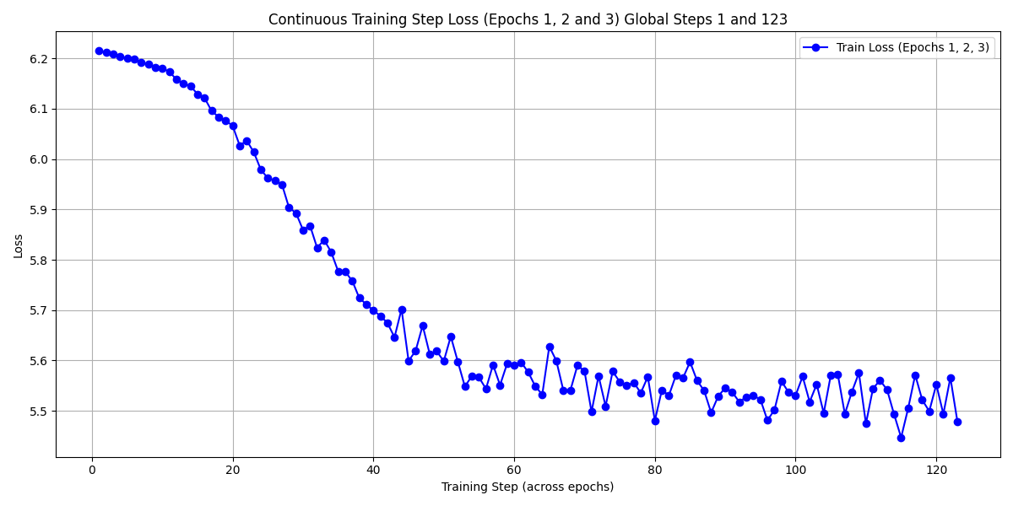
Figure 4.18: Training Loss from Epochs 1 to 3
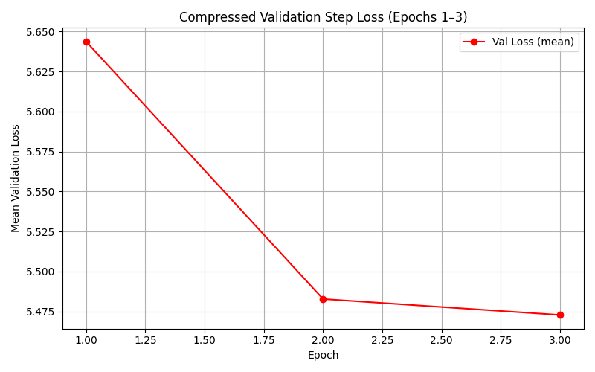
Figure 4.19: Validation Loss from Epochs 1 to 3
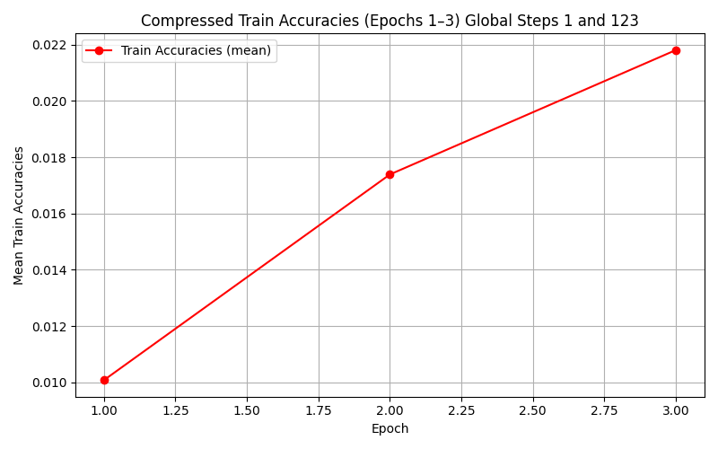
Figure 4.20: Train Accuracies from Epochs 1 to 3
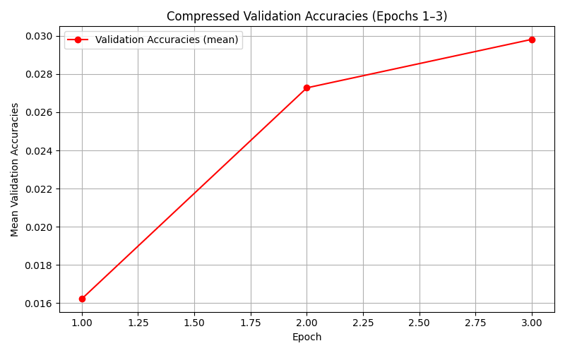
Figure 4.21: Validation Accuracies from Epochs 1 to 3
It can be seen from Figure 4.18 that at just a little bit above 40 global steps the train loss drops drastically from 6.21 to 5.65 after which it became stabilise to around 5.55 between 43 (a little above epoch 1) and 123 (at epoch 3) global steps. Similar occurrence occurred on the validation loss of Figure 4.19 where there was a sharp drop in the loss from 5.64 at epoch 1 to around 5.487 at epoch 2. Also, the accuracies also rise linearly from 0.01 to 0.0175 and 0.016 to 0.0275 from epoch 1 to epoch 2 for both train and validation respectively. These results show the model is gradually adapting well to the training data learning to map the English discrete values to Yoruba discrete values at earlier steps into the training.
At epoch 62 when these 819 data fed-model training was terminated, these values have changed to 4.954, 4.932, 0.049, and 0.064 for train loss, validation loss, train accuracies and validation accuracies respectively. At epoch 63 (an earlier epoch) when training resumed with 1250 parallel audios of English and Yoruba (1000 for training and 250 for validation), the train loss, validation loss, train accuracies, and validation accuracies were 4.673, 4.827, 0.0779, and 0.06724 respectively. Around epoch 110, intelligible audios have already been produced. It was also observed as before that some audio samples were obtained from reconstructed discrete values of any of the augmentation techniques, different from the original discrete values of the original audio, obtained directly from HuBERT. Examples of such are shown in Displays C and D where 100 discrete values have been extracted for illustrations.
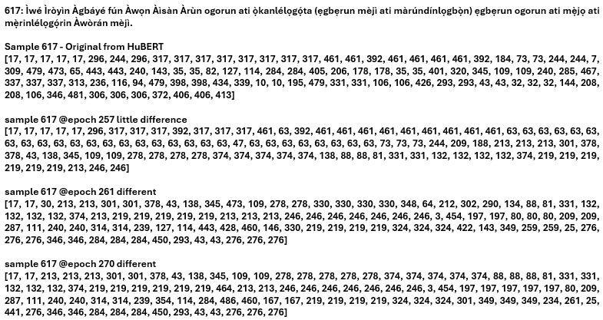
Display C: Generated Discrete Integers of the U2UT model during Validation.
It can be seen in Display C that sample of 617 generated at epoch 257 from U2UT model is sharing higher similarity with the original discrete values obtained directly from Hubert but samples obtained at epochs 261 and 270 are completely different from the HuBERT obtained discrete values. This set of discrete values at epoch 261 and 270 are of the augmentation techniques. This shows the U2UT model is able to develop cluster points of any of the augmentation techniques including the original audio sample which are all sounding similar unlike at augmentation stage. This shows the richness of the U2UT model towards audio generation dynamics.
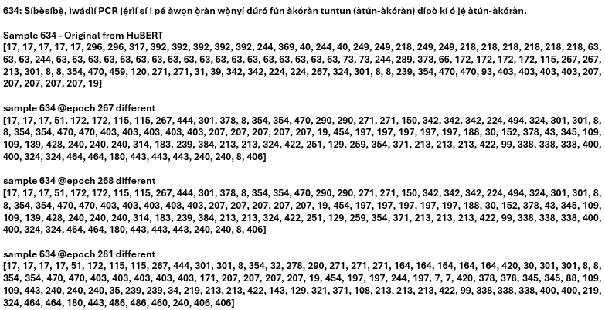
Display D: Generated Discrete Integers of the U2UT model during Validation.
Display D further shows the discrete nature dynamics of the developed U2UT model where entirely different discrete values of the augmentation techniques were obtained for the same audio at epochs 267, 268, and 281 in training.
Figures 4.22 to 4.25 show the train loss, validation loss, train accuracy and validation accuracy for epochs 250 to 261, while their respective plots for epochs 336 to 347 before training was terminated are shown in Figures 4.26 to 4.29.
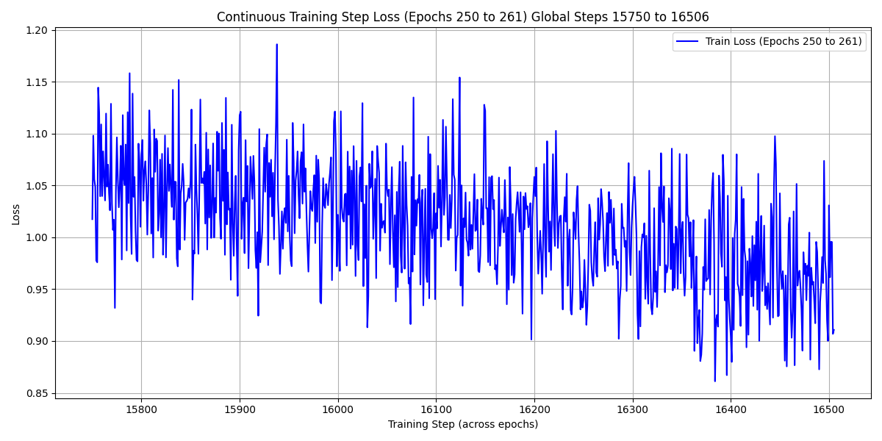
Figure 4.22: Train Loss from Epochs 250 to 261
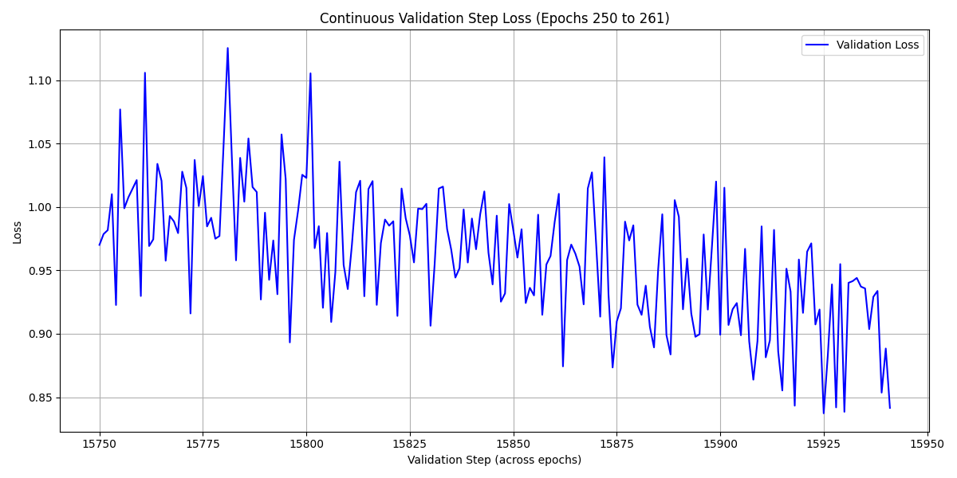
Figure 4.23: Validation Loss from Epochs 250 to 261
It can be seen from the continuous train loss plot of Figure 4.22, that between global steps 15,800 to 16000, the train loss centered around 1.05 and there was a decrease in the loss towards the 16500 steps even though there were regions of continuous fluctuations. The loss has an average value of around 1.00 between 16,100 and 16,300 steps and finally with an average value of around 0.95 at 16500 step. Similar results were obtained for the validation loss of Figure 4.23 with decreasing fluctuations from epoch 250 to epoch 261 where the value drops from an average value of 1.00 to 0.90. Similar trends for both train and validation losses were obtained in Figures 4.26 and 4.27 for epochs 336 to 347.
Figure 4.24 shows there was a fluctuation in the train accuracy around epoch 250 to 254 after which it linearly increases till epoch 261 from a value of around 0.786 (78.6 %) to around 0.814 (81.4 %). This shows stability in training and it was around this epochs that audio quality when tested shows improves performance across all metrics utilized. However, the validation accuracy kept increasing fluctuating from 0.80 (80 %) at epoch 250 to 0.828 (82.8 %) at epoch 261.
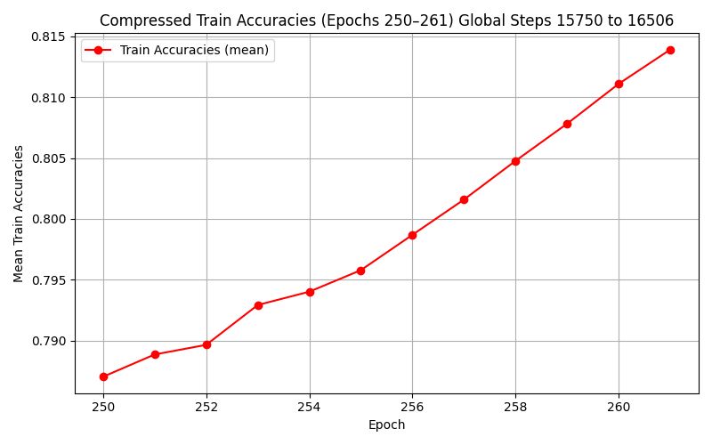
Figure 4.24: Train Accuracy from Epochs 250 to 261

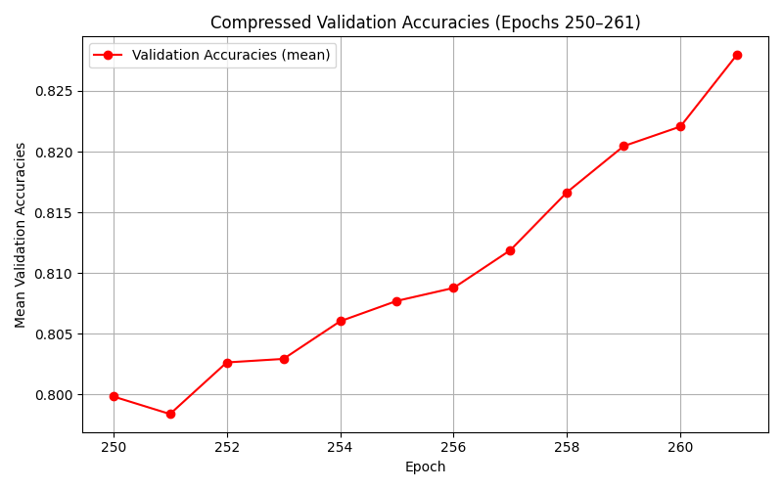
Figure 4.25: Validation Accuracy from Epochs 250 to 261
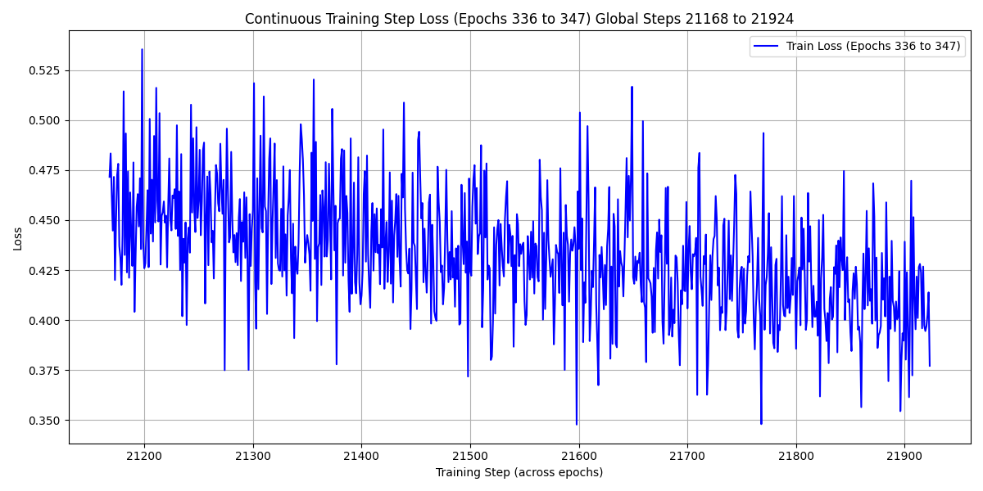
Figure 4.26: Train Loss from Epochs 336 to 347
Figure 4.26 shows that by epoch 336 (global step 21,168), the train loss has dropped to an around 0.450 and by step 21,900 and above, the train loss has reduced further to a value around 0.379. The graph of Figure 4.27 also shows a decline in the validation loss from around 0.42 at epoch 336 to around 0.37 around 21,350 global steps. Figure 4.28 shows an unusual instability in training between epochs 340 and 342 unlike what was earlier reported for epochs 250 to 261, after which the accuracy grows linearly till around 0.9395 at epoch 347. Around these same epochs 336 to 347, as observed in Figure 4.29, there is an instability indicated by rapid upward and downward trend in the validation accuracy. The audio quality when tested shows little improvement in metrics results and when listened to the audio generated at the output of the finetuned unit HiFi-GAN, there were little to no difference to the earlier generated epoch samples. Hence, training was terminated, with the intention of scaling the 1250 parallel audios used.
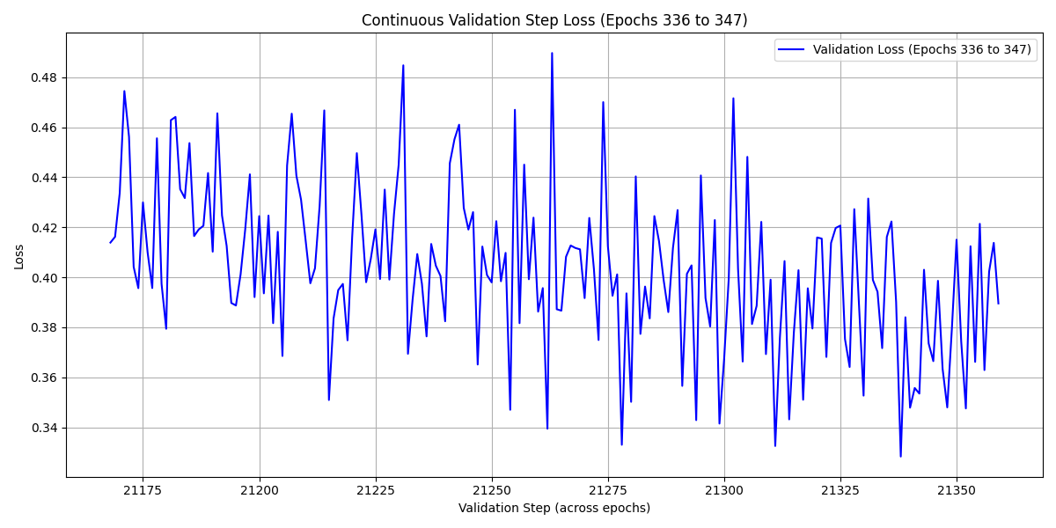
Figure 4.27: Validation Loss from Epochs 336 to 347
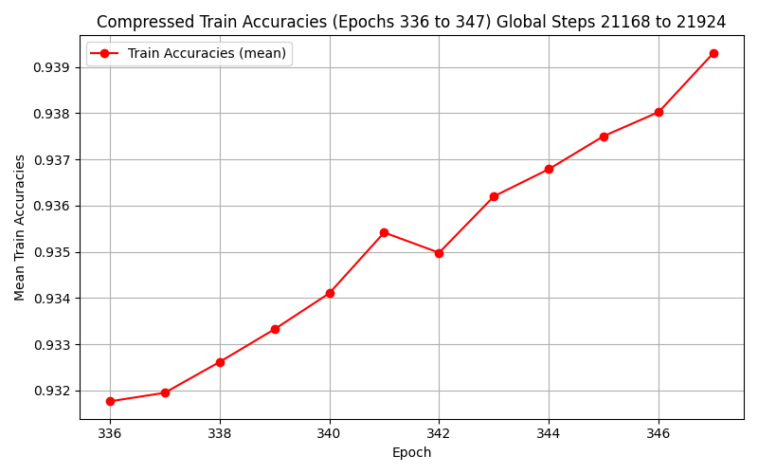
Figure 4.28: Train Accuracy from Epochs 336 to 347
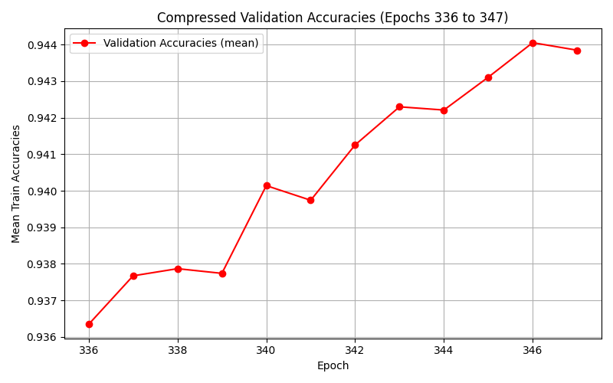
Figure 4.29: Validation Accuracy from Epochs 336 to 347

B. Metrics Results of U2UT Model Using 1250 Parallel Audios
For further evaluation of the U2UT model trained on the public health domain of the BENYO-S2ST-CORPUS-R1 dataset, metrics such as the BLEU scores, ROUGE-L scores, PESQ, STOI, and MOS are reported.
Table 4.23 lists some of the generated texts. The target discrete target values generated at validation (from saved checkpoints) were fed to the finetuned unit HiFi-GAN vocoder and the output audio samples which show signs of intelligibility were fed through NCAIR whisper finetuned ASR model (Whisper small), and some of the generated texts are highlighted in Table 4.23.

Table 4.23: Output texts Samples from the U2UT model trained on Public Health Domain Dataset
Selected Samples\Features | Ground Truth | From U2UT model
generated_s2st@188_sample625 | Iye awọn alaisan PP jẹ́ ogorun ati àádọ́rin ati ogorun ati mẹ̀rindínlàádọ́rin lati awọn ẹgbẹ idanwo ati afiwera, lẹsẹsẹ. | ìyá àwọn aláìsàn òbí gidi jẹ́ ọmọ́ọ̀rún àti áńtòrí, àti òfòrùn, àti mẹ́ríjìrán áńtòrí láti àwọn ìpè tó mú àti àdúròyìn máa ṣe ìṣẹ̀.
generated_s2st@308_sample625 | Iye awọn alaisan PP jẹ́ ogorun ati àádọ́rin ati ogorun ati mẹ̀rindínlàádọ́rin lati awọn ẹgbẹ idanwo ati afiwera, lẹsẹsẹ. | yàwó aláìsàn pípí di ọ̀gọ́rùn-ún àti áádọ́rí àti ọ̀gọ́rùn-ún àti mẹ́ríndínláàdòrí láti àwọn ẹ̀gbẹ́ inú wọ̀n àti àṣùwéra mẹsẹ̀ẹ́sẹ̀.
generated_s2st@257_sample617 | Ìwé Ìròyìn Àgbáyé fún Àwọn Àìsàn Àrùn ogorun ati ọ̀kanlélọgọ́ta (ẹgbẹrun mèjì ati màrúndínlọgbọ̀n) ẹgbẹrun ogorun ati mẹ̀jọ ati mẹ̀rinlélọgọ́rin Àwòrán mèjì | ìwé ìròyìn ọ̀dàgé ìgbọ̀n àwọn àìsàn, àwọn ọgọ́rùn àti ọ̀dọ̀lẹ́lọ́mẹ́dá ẹbẹ̀rún méjì àti máa di ọgbọ́, ẹbẹ̀ ló gbọ́rùn àti méjò
generated_s2st@261_sample617 | Ìwé Ìròyìn Àgbáyé fún Àwọn Àìsàn Àrùn ogorun ati ọ̀kanlélọgọ́ta (ẹgbẹrun mèjì ati màrúndínlọgbọ̀n) ẹgbẹrun ogorun ati mẹ̀jọ ati mẹ̀rinlélọgọ́rin Àwòrán mèjì | ìmẹrun yìí àtàyí fún àwọn àìsàn, àwọn ọkọrun àti ọ̀kan ni ọ̀dọ̀ta, àbẹ̀rún méjì àti máa jẹ́ lọ́gbọ́, àbẹ̀rún ọ̀dọ̀run, àti mẹ́̀dọ̀, àti mẹ́rin ni ọ̀dọ̀bí.
generated_s2st@270_sample617 | Ìwé Ìròyìn Àgbáyé fún Àwọn Àìsàn Àrùn ogorun ati ọ̀kanlélọgọ́ta (ẹgbẹrun mèjì ati màrúndínlọgbọ̀n) ẹgbẹrun ogorun ati mẹ̀jọ ati mẹ̀rinlélọgọ́rin Àwòrán mèjì. | ìwé ìròyìn àgbàgbé fún àwọn aláìsàn, àwọn ọgbọ́rùn-ún àti ọ̀kan rẹ̀ lọ́gọ́ta, àgbẹ̀rùn méjì àti báàrùndínlọ́gbọ́, àgbẹ̀rùn ọgbọ́rùn-ún àti méjò àti mẹ́̀rùn-ún-ún àgbẹ̀rùn-ún
generated_s2st@281_sample617 | Ìwé Ìròyìn Àgbáyé fún Àwọn Àìsàn Àrùn ogorun ati ọ̀kanlélọgọ́ta (ẹgbẹrun mèjì ati màrúndínlọgbọ̀n) ẹgbẹrun ogorun ati mẹ̀jọ ati mẹ̀rinlélọgọ́rin Àwòrán mèjì. | ìwé ìròyìn àbáyé fún àwọn àìsàn, àwọn ọgọrun àti ọkàrẹ̀gọ́gọ̀ntà, àgbẹ̀rọ̀nejì, àti màrúnjẹgbogbo, àgbẹ̀rọ̀ ọgọrun àti méjọ àti mẹ́rin ìròyìn.
generated_s2st@288_sample617 | Ìwé Ìròyìn Àgbáyé fún Àwọn Àìsàn Àrùn ogorun ati ọ̀kanlélọgọ́ta (ẹgbẹrun mèjì ati màrúndínlọgbọ̀n) ẹgbẹrun ogorun ati mẹ̀jọ ati mẹ̀rinlélọgọ́rin Àwòrán mèjì. | bẹ́ẹ̀ni, wọn ìròyìn àgbáyé fún àwọn àìsàn, àwọn ọkùnrin àti ọ̀kàrinlọ́gbàtà àbẹ̀rùn méjì àti máa òde lọ gbọ́, àbẹ̀rùn ọkùnrin àti méjì àti mẹ́rin ìròyìn.
generated_s2st@259_sample632 | Awọn eniyan ipilẹ ati awọn abuda ile-iwosan ni a ṣe iwọntunwọnsi laarin awọn ẹgbẹ mejeeji (Tabili ọ̀kan). | àwọn ènìyàn ìpele àti àwọn àrúndá ilé ìrùn sọ́ ni a ṣe ìwọ̀n tí wọ́n sí náírí àwọn ẹ̀gbẹ́déjì rẹ̀ bíi yọ kọ́ọ̀wọ̀.
generated_s2st@340_sample235 | A rí àwọn ìyípadà ní codon ọgọ́rin àti ẹ̀fàY àti ẹgbẹ̀rún kan, igba, ogójì àti ẹ̀fàY nínú jínì pfmdr1 ní èjìlá. | arí àwọn ìyípadà ni kọ́lọ́ ẹ̀górè àti ẹ̀fáà wáyìí, àti ẹ̀gbẹ̀rúnkọ́ ìgbà ogójì, àti ẹ̀fáà wáyìí, ìròjínì píẹ̀ méjì àrìwàá ni ìjìlá.
generated_s2st@346_sample630 | Ọ̀kan pere ninu ogorun-un) nínú ẹgbẹ́ Comparator ni wọ́n pàdánù sí àtẹ̀lé láàárín ọjọ́ ọ̀kan àti mèjìdínlọgbọ̀n, àti ọ̀kan (odo. | ọkọ̀ kò eré nínú ọkọ̀ nínú ẹgbẹ́ ẹ̀kọ̀ parítọ̀ ní ọ̀pọ̀n ìdànlọ̀ sí àtìlẹ̀ gba àyẹ̀rẹ̀ ọ̀kan àti méjìdínlọ́gbọ̀n àti ọkọ̀.

Observation: As indicated in Table 4.23, for sample 617 and other samples not reported here, the generated audios were cut out towards the end of the clip unlike when general domain dataset was used for training, where such issues never occurred. The reason for this is due to the longer translation of Yoruba audio files equivalent of their English audio files (shorter length) and the fact that the sequence length was shortened to 600 irrespective of the size of the audio length sequence. Hence, the cut parts of the audio file can be likened to the removed part of the sequence from 601 and above for most longer audio sequence length.
The BLEU and ROUGE-L scores of these samples when normalised are shown in Table 4.24. The table shows the highest BLEU score of 19.523 was obtained from sample 617 at epoch 281. The lowest BLEU score was obtained from sample 625 at epoch 188 with a BLEU score value of 5.450. There was an improvement in CER when compared to the earlier trained model on general domain dataset. Sample 625 at epoch 308 has the lowest CER with a value of 0.193 while the highest CER of 0.405 was reported in the table for sample 617 at epoch 257. These CER results show the developed public health domain U2UT model is better than the general domain counterpart. Besides, the results of the CER and even the WER (not reported here) testifies to that where majority of the audio samples generated gave promising and improved evaluation metrics results. In addition to these is the computation of the ROUGE-L Recall, Precision, and F1-score results as highlighted in Table 4.17. Sample 617 at epoch 281 with the highest BLEU score of 19.523 still has the highest ROUGE-L precision, recall, and f1-scores with values of 0.6, 0.545, and 0.571 respectively. A recall value of 0.545 shows the U2UT model to some extent has the capability of predicting more than half of the words in the reference samples with just 1250
parallel audios of English and Yoruba utilised for its training. A precision value of 0.6 also support the fact the generated sample’s order of words to the ground truth is more than 50 %. A conclusion can thus be made that if the size of the training data is scaled to a larger size, state-of-the-art S2ST model results will be obtained. It should also be noted that the inference audio samples are not intelligible yet at this reached epoch possibly due to the size of the dataset utilised for this experiment just like the general domain developed U2UT model.
Table 4.24: BLEU and ROUGE-L Scores of the Table 4.17 Selected Audio Samples
Selected Samples\Features | BLEU Scores | CER | ROUGE-L Scores  Recall Precision F1-Score
generated_s2st@188_sample625 | 5.450 | 0.386 | 0.474 | 0.375 | 0.419
generated_s2st@308_sample625 | 9.630 | 0.193 | 0.421 | 0.421 | 0.421
generated_s2st@257_sample617 | 7.744 | 0.405 | 0.455 | 0.476 | 0.465
generated_s2st@261_sample617 | 7.604 | 0.318 | 0.364 | 0.308 | 0.333
generated_s2st@270_sample617 | 10.414 | 0.257 | 0.455 | 0.435 | 0.444
generated_s2st@281_sample617 | 19.523 | 0.250 | 0.545 | 0.6 | 0.571
generated_s2st@288_sample617 | 18.157 | 0.351 | 0.455 | 0.400 | 0.426
generated_s2st@259_sample632 | 9.315 | 0.320 | 0.471 | 0.348 | 0.400
generated_s2st@340_sample235 | 11.967 | 0.365 | 0.429 | 0.409 | 0.419
generated_s2st@346_sample630 | 14.963 | 0.330 | 0.450 | 0.429 | 0.439

Table 4.25 highlights the MOS, PESQ, and STOI scores of some selected audio samples
Table 4.25: MOS, PESQ, and STOI scores of Generated Samples from U2UT Model
Selected Samples\Features | MOS Original Audio Sample | MOS Generated Sample | PESQ Score | STOI Score
generated_s2st@275_sample230 | 3.445 | 3.281 | 1.056 | 0.217
generated_s2st@343_sample250 | 3.501 | 3.199 | 1.051 | 0.595
generated_s2st@257_sample617 | 3.286 | 3.002 | 1.039 | 0.526
generated_s2st@281_sample617 | 3.286 | 2.917 | 1.105 | 0.136
generated_s2st@266_sample246 | 3.684 | 2.378 | 1.046 | 0.579
generated_s2st@335_sample634 | 2.998 | 3.166 | 1.079 | 0.207
generated_s2st@212_sample640 | 2.488 | 2.667 | 1.041 | 0.207
generated_s2st@224_sample639 | 2.914 | 2.895 | 1.285 | 0.091
generated_s2st@346_sample630 | 3.866 | 3.332 | 1.038 | 0.598
generated_s2st@278_sample266 | 4.086 | 3.477 | 1.058 | 0.193
Table 4.25 shows the highest MOS of 3.477 was obtained from the U2UT model which depicts higher level of naturalness. It can also be seen that majority of the generated samples from the U2UT model have their MOS so close to their original counterparts. Besides, MOS for the generated samples was higher than original audio files for samples 634 and 640 at epochs 335, and 212 respectively. Sample 634 at epoch 335 has MOS of 3.166 in comparison to 2.998 for the reference audios. Also, sample 640 at epoch 212 has MOS of 2.667 when compared to that of reference audio which has a MOS of 2.488. For PESQ, and STOI scores, highest value of 1.285 and 0.598 respectively were reported in Table 4.18. Majority of the PESQ scores centred around 1.00 showing the model’s audio quality still poor. A higher STOI score of 0.598 depicts the U2UT model has moderate level of intelligibility.

4.4.2.2 With Scaling of 1250 Parallel Audios of English and Yoruba to 1950
With 1950 parallel audios where split into 1560, and 390 for training and validation, improved metrics results were obtained better than those obtained with 1250 parallel audios. Training ran from epoch 347 to 480.

A. Training Performance of U2UT Model Using 1950 Parallel Audios
Figures 4.30 to 4.33 display the training loss, validation, loss, training accuracy, and validation accuracy for epochs 470 to 480.
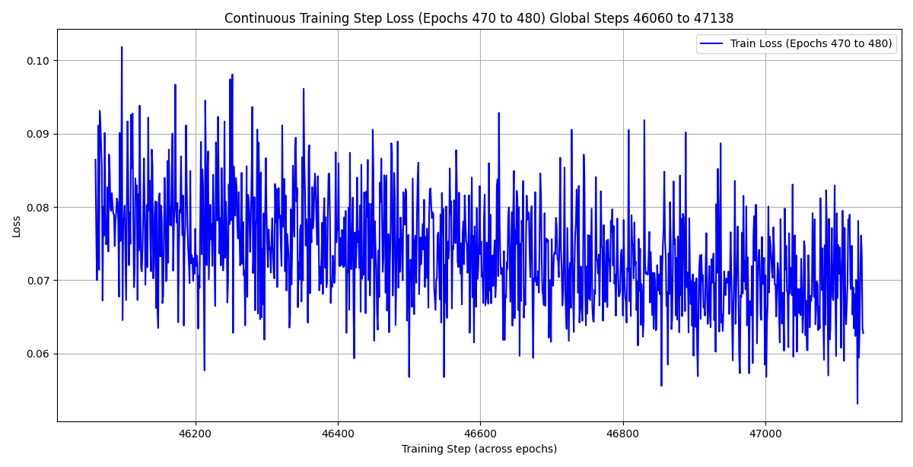
Figure 4.30: Training Loss for Epochs 470 to 480
Figure 4.30 shows the training loss has further reduced from the last reported value of 0.379 above 21,900 global steps (347 epochs) (Figure 4.26) to an average value of 0.08 at epoch 470 (global step 46060), and at above 47,000 global steps, the training loss has become to a lower average value of 0.07. This shows the U2UT model training on public health dataset is converging well. This is further supported by the validation loss plot of Figure 4.31 where the value at epoch 470 was already around 0.07 as against the last reported value of around 0.37 around 21,350 global steps (Figure 4.27) at epoch 347. By epoch 480, the validation loss in training is a value of around 0.065 showing improvement in the U2UT model training.
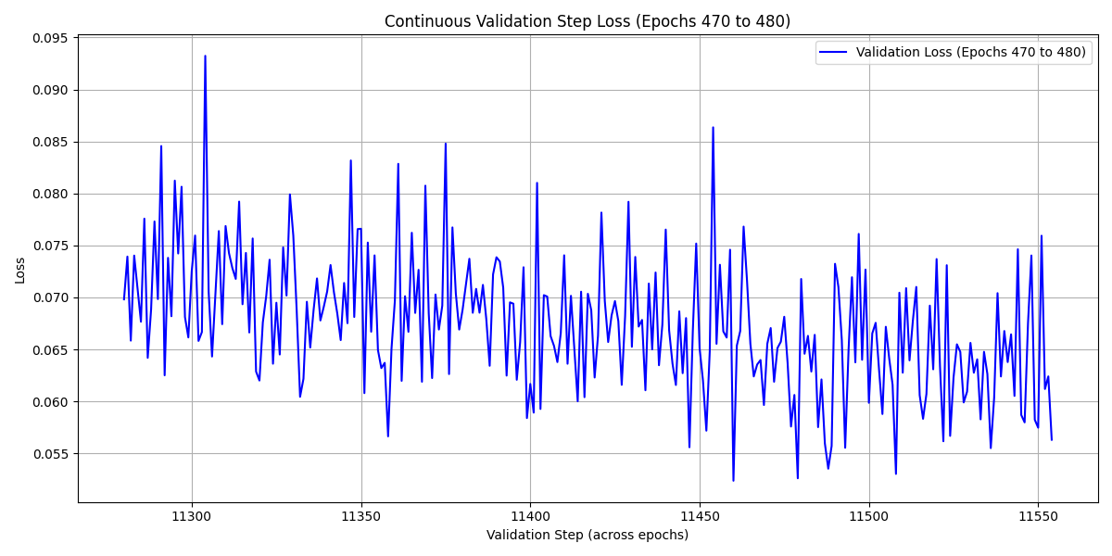
Figure 4.31: Validation Loss for Epochs 470 to 480
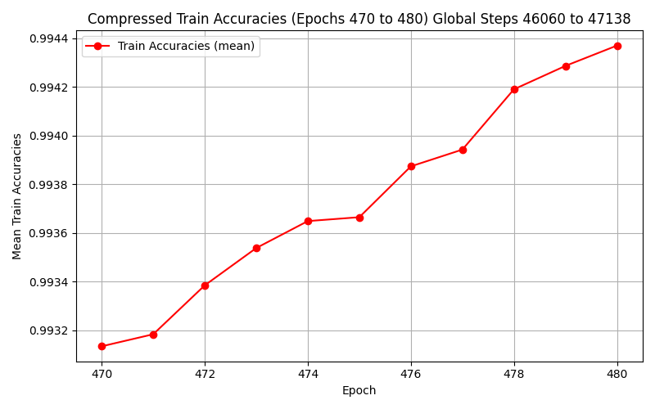
Figure 4.32: Training Accuracy for Epochs 470 to 480

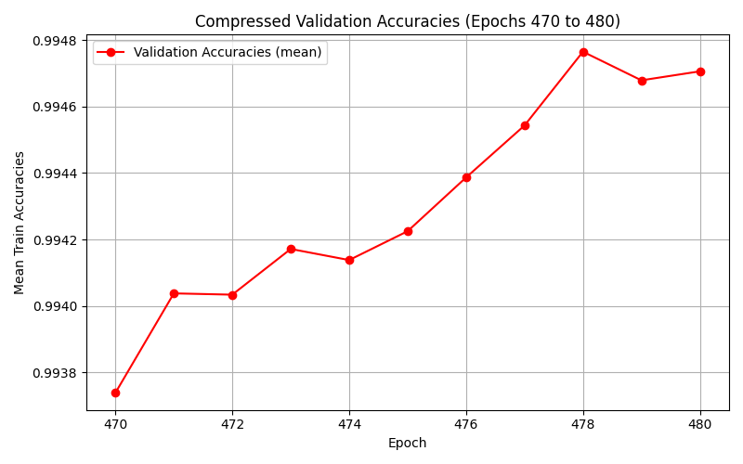
Figure 4.33: Validation Accuracy for Epochs 470 to 480
The training and validation accuracy plots of Figures 4.32 and 4.33 shows improvement in the training where the accuracies have average values of 0.99 for both training and validation for epochs 470 to 480 as against average values of 0.93 and 0.94 for training and validation accuracies of Figures 4.28 and 4.29.

B. Metrics Results of U2UT Model Using 1950 Parallel Audios
The generated discrete values when, the training data was scaled to 1950 parallel audios, were fed to the fine-tuned vocoder. The results for models (checkpoint) saved between epochs 347 and 480 show improved performance across all metrics utilised. Table 4.26 highlight the generated texts from the U2UT model output of 14 samples, in comparison to the ground truth samples., while their BLEU scores, WER, ROUGE-L’s Precision, Recall, and F1-Scores are highlighted in Table 4.27.

Table 4.26: Comparison of U2UT model ASR outputs with Ground Truth and that of the Original Fed Directly to HuBERT
S/N | Selected Samples\Features | Ground Truth | Original Fed to HuBERT | From U2UT model
1 | sample625@epoch 349 | Iye awọn alaisan PP jẹ́ ogorun ati àádọ́rin ati ogorun ati mẹ̀rindínlàádọ́rin lati awọn ẹgbẹ idanwo ati afiwera, lẹsẹsẹ. | ní ìyàwọ́n aláìsàn pípí di ọ̀gọ́rùn-ún àti áádọ̀rí, àti ọ̀gọ́rùn, àti mérìndé làádọ̀rí láti àwọn ẹgbẹ̀ lọ́wọ̀n àti àṣùwérá pẹ̀sẹ̀ẹ̀ṣẹ̀. | ìyàwó aláìsàn pípí di ọ̀gọ́rùn-ún àti áádọ́rí àti ọ̀gọ́rùn-ún àti mẹ́ríndínláàdọ̀rí láti àwọn ẹgbẹ́ ilúwọ̀n àti aṣúwéra mẹ́sẹ̀ṣẹ́
2 | sample627@epoch 354 | (odo pere ninu ogorun-un) àwọn aláìsàn (àwọn aláìsàn márùn-ún nínú ẹgbẹ́ ìdánwò àti àwọn aláìsàn mẹ́sàn-án nínú ẹgbẹ́ Comparator) ni wọ́n pàdánù sí àtẹ̀lé nígbà ìwádìí náà. | odò pèrè nínú ọ̀dọ́ mú àwọ̀ aláìsọ̀, àwọ̀ aláìsọ̀, pààrùn ìwẹ̀gbé lọ́wọ̀, àti àwọ̀ aláìsọ̀ mẹ́sàn-ọ̀, ilẹ̀ ìgbẹ̀ kan parítọ̀, ni wọ́n pàdánisì àtẹ̀lẹ̀ nígbà ìgbàdínlọ́wọ̀.̀ | odokunrinrin ni wọ́n kọ́ọ̀mu àwọ̀ aláìsọ̀, àwọ̀ aláìsọ̀ márùn-ún nínú ẹgbẹ́ ìdánwò àti àwọn aláìsímẹ̀sọ̀ ilọ̀-ẹgbẹ́kọ̀ọ́tọ̀rítọ̀ náà gba ìdánú sí àpèèrè nígbà ìgbàdíná.
3 | sample627@epoch 367 | (odo pere ninu ogorun-un) àwọn aláìsàn (àwọn aláìsàn márùn-ún nínú ẹgbẹ́ ìdánwò àti àwọn aláìsàn mẹ́sàn-án nínú ẹgbẹ́ Comparator) ni wọ́n pàdánù sí àtẹ̀lé nígbà ìwádìí náà. | odò pèrè nínú ọ̀dọ́ mú àwọ̀ aláìsọ̀, àwọ̀ aláìsọ̀, pààrùn ìwẹ̀gbé lọ́wọ̀, àti àwọ̀ aláìsọ̀ mẹ́sàn-ọ̀, ilẹ̀ ìgbẹ̀ kan parítọ̀, ni wọ́n pàdánisì àtẹ̀lẹ̀ nígbà ìgbàdínlọ́wọ̀.̀ | odò pèrè nínú ọgbà mú àwọ̀ aláìsọ̀, àwọ̀ aláìsọ̀ márùn-ún nínú ẹgbẹ́ ẹ̀dọ́wọ̀, àti àwọ̀ aláìsọ̀ mẹ́sàn-an, nínú ẹgbẹ́ kọ̀márìtọ̀, wọn pàdánù sí àpẹ̀rí nígbà ìwádìí náà.
4 | sample627@epoch 392 | (odo pere ninu ogorun-un) àwọn aláìsàn (àwọn aláìsàn márùn-ún nínú ẹgbẹ́ ìdánwò àti àwọn aláìsàn mẹ́sàn-án nínú ẹgbẹ́ Comparator) ni wọ́n pàdánù sí àtẹ̀lé nígbà ìwádìí náà. | odò pèrè nínú ọ̀dọ́ mú àwọ̀ aláìsọ̀, àwọ̀ aláìsọ̀, pààrùn ìwẹ̀gbé lọ́wọ̀, àti àwọ̀ aláìsọ̀ mẹ́sàn-ọ̀, ilẹ̀ ìgbẹ̀ kan parítọ̀, ni wọ́n pàdánisì àtẹ̀lẹ̀ nígbà ìgbàdínlọ́wọ̀.̀ | odò pèrè nínú ọ̀gárun àwọ̀ aláìsọ̀, àwọ̀ aláìsọ̀ márùn-ún nínú ẹgbẹ́ ẹ̀dọ̀wọ̀, àti àwọ̀ aláìsọ̀ mẹ́sùn ìlú ẹgbẹ́ kọ̀márítọ̀, wọ́n padà lò sí àpèrè nígbà ìwádìí náà.
5 | Sample233@epoch 372 | Ní àfikún, a ṣe àkíyèsí ìyípadà ní àádọ́rin àti àrúnE, àádọ́rin àti àrúnD, àádọ́rin àti àrúnK, àti àádọ́rin àti ẹ̀rinI ní mẹ̀talélọgọ́ta. | ní á fí kò, àìsíyà kìí sí ìyìnpàlà, ní á dọ̀rẹ̀ àti àrùn, á dọ̀rẹ̀ àti àrùn ìdí, àdọ̀rẹ̀ àti àrùn kìí, àti á dọ̀rẹ̀ àti eria ni mẹ́kàdẹ̀lọ́gọ̀ta. | ní á fí kùn, àìṣẹ́ àkíyèsí yìí pẹ́lá, ní á dọ̀rẹ̀ àti àrùn, á dọ̀rẹ̀ àti àrùn, àti á dọ̀rẹ̀ àti àrùn, àti á dọ̀rẹ̀ àti ẹ̀rí-àyì.
6 | Sample233@epoch 402 | Ní àfikún, a ṣe àkíyèsí ìyípadà ní àádọ́rin àti àrúnE, àádọ́rin àti àrúnD, àádọ́rin àti àrúnK, àti àádọ́rin àti ẹ̀rinI ní mẹ̀talélọgọ́ta. | ní á fí kò, àìsíyà kìí sí ìyìnpàlà, ní á dọ̀rẹ̀ àti àrùn, á dọ̀rẹ̀ àti àrùn ìdí, àdọ̀rẹ̀ àti àrùn kìí, àti á dọ̀rẹ̀ àti eria ni mẹ́kàdẹ̀lọ́gọ̀ta. | ní á fí kùn, àìṣẹ́ àkíyèsí yìí pàlà, ní á dọ̀rẹ̀ àti àrùn, á dọ̀rẹ̀ àti àrùn-ké, àti á dọ̀rẹ̀ àti eré-àyè ni mẹ́jọ́.
7 | sample617@epoch 401 | (Ìwé Ìròyìn Àgbáyé fún Àwọn Àìsàn Àrùn ogorun ati ọ̀kanlélọgọ́ta (ẹgbẹrun mèjì ati màrúndínlọgbọ̀n) ẹgbẹrun ogorun ati mẹ̀jọ ati mẹ̀rinlélọgọ́rin Àwòrán mèjì. | ìwé ìròyìn ọ̀dàyè fún àwọn àìsàn, àwọn ọgọ́rùn-ún àti ọ̀kànlẹ̀-ọ̀gọ́já, ẹ̀bẹ̀rú méjì, àti màròdì ọgbọ́, ẹ̀bẹ̀rú ọ̀gọ́rùn-ún àti méjọ àti mẹ́rìlẹ̀-ọ̀gọ́rì àwọn ọ̀rọ̀ méjì.̩̀ | ìwé ìròyìn àgbáyé fún àwọn àìsàn, àwọn ọkùnrin, àti ọkùnrin, ọ̀gáda, ẹgbẹ̀rún méjì àti máa odi lọ gbọ́, ẹgbẹ̀rún ọgọ́rin, àti mẹ́̀dọ́, àti mẹ́rin-ìrí lọ́gọ́rin.
8 | Sample634@epoch 403 | Síbẹ̀síbẹ̀, ìwádìí PCR jẹ́rìí sí i pé àwọn ọ̀ràn wọ̀nyí dúró fún àkóràn tuntun (àtún-àkóràn) dípò kí ó jẹ́ àtún-àkóràn | sìbẹ̀sìbẹ̀ ìwádìíkì fi arúdérì sí pé á wọ́ ọlọ́wọ̀n yìí dìbò fún ápọ̀lọ́ tuntun ápọ̀lọ́ dìpò kí o dé ápọ̀lọ́wọ̀.̩̀ | ìwọ̀sìbẹ̀sìbẹ̀ ìwọ̀dìdì ṣe arúdẹ́rìsì pé àwọn ọ̀rọ̀mọ̀ yìí dúró fún akọ̀rọ̀tì ṣóhùn, àti akọ̀rọ̀tì kòkòrò jẹ́ àtọ̀ akọ̀rọ̀.
9 | sample223@epoch 408 | Ọ̀kan) àti àwọn ìtẹ̀léra tí ó dúró ṣinṣin (NCBI reference: AAFẹgbẹ̀rún méjìlélọ́gọ́rin, ẹgbẹ̀rún mẹ́fà, ẹ̀ẹ́dẹ́gbẹ̀rún, ogún àti ẹ̀fà. | ọkọ àti àwọn ìtẹléra tí ó dúrò ṣiṣìn, ń sí ìbẹ ẹ̀rèfẹ̀sì ẹ̀èyàn ẹ̀bẹ̀rùn méjìlí lọ́gọ̀ọ́riǹ ẹ̀bẹ̀èrè mẹ́́fà ẹbẹ̀ègbẹ̀èrùn ogùn àti ẹ̀fà | ó̩kò̩ àti àwo̩n ìtàlé̩ àti lódúró s̩ò̩s̩ò̩, ǹs̩í ìbè̩è̩ àrígbè̩rùn-ìgbè̩rùn méjì níló̩gó̩̀ò̩ rí è̩gbè̩rùn mé̩è̩à èdé ìgbè̩rùn ógò̩ àti è̩fè̩
10 | sample888@epoch 409 | Níkẹyìn, nípa lílo òtítọ́ pé àwọn ìṣeéṣe náà jẹ́ ọ̀kan, a lè ṣírò p3 gẹ́gẹ́ bí p je mèjì | lítìyìí, nípa lílo òtítọ́pẹ́ àwọn ìṣẹ̀ṣẹ̀ náà jẹ́ ọ̀kan, á ní ìṣirópítìrì gẹ́gẹ́ bíi jẹ́ méjì.̀ | nígẹ̀yìn, nípa ilu òtítọ́pẹ́ àwọn ìṣèṣe náà jẹ́ ọ̀kan, a ní ìṣirúpìrì gẹ́gẹ́ bíi jẹ́ ẹgmedì.̀
11 | sample888@epoch 463 | Níkẹyìn, nípa lílo òtítọ́ pé àwọn ìṣeéṣe náà jẹ́ ọ̀kan, a lè ṣírò p3 gẹ́gẹ́ bí p je mèjì | lítìyìí, nípa lílo òtítọ́pẹ́ àwọn ìṣẹ̀ṣẹ̀ náà jẹ́ ọ̀kan, á ní ìṣirópítìrì gẹ́gẹ́ bíi jẹ́ méjì.̀ | níkẹ̀yì, ní ìpàlẹ̀ nílò ọkọ̀ títàpọ̀ àwọn ìṣẹ̀ṣẹ̀ náà jẹ́ ọ̀kan, a lè ìṣẹ̀ òbí gẹ́gẹ́ bíi jẹ́ ẹ̀gbẹ́jì
12 | sample630@epoch 452 | Ọ̀kan pere ninu ogorun-un) nínú ẹgbẹ́ Comparator ni wọ́n pàdánù sí àtẹ̀lé láàárín ọjọ́ ọ̀kan àti mèjìdínlọgbọ̀n, àti ọ̀kan (odo. | ọkọ̀ kò eré nínú ọkọ̀ nínú ẹgbẹ́ ìkàn parí tọ́ ní wọ́n pàdánlọ̀ sí àtẹ̀lẹ̀ gbàrẹ̀ ọjọ́ kan àti méjìdínlọ́gbọ́n àti ọkọ̀ kòdọ́ wọ́n. | ọkọ̀ ọkọ̀ eré nínú ọ̀dọ́rùn-ún nínú ẹgbẹ̀ẹ̀kọ́ maritọ́ ní wọ́n pàtàfíìsì àtòyí náà rẹ̀ òjọ́ kọ́ àti méjìdínlọ́gbọ́n àti ọkọ̀ òdúnwọ̀
13 | Sample900@epoch 468 | Mẹ̀ta pere ninu ogorun-un jẹ́ àrùn ibà-slide-negative (àti àwọn ọ̀ràn ibà-slide-negative), mèjì. | lẹ́tà pẹ̀rẹ̀ nínú ògàn àmọ̀ jẹ́ áàmì ìbásíláìdì mékítì àti àwọn òrò ìbásíláìdì mékìtì méjì. | lẹ́tà pẹ̀rẹ̀ nínú òókàn àmọ jẹ́ áàmì ìbá sílíìdì mékìtí àti àwọn ọ̀rọ̀ ìbá sílíìdì mékìtí méjì.
14 | Sample638@epoch 478 | Ogorun ati ogún Hemoglobin, giramu for decilita okan (g/dL) èjìlá. | ọkọ ìròyìn àti ògún ẹ̀bùgùn ògùn ìdíràmú fọ bẹ́ẹ̀ ta ọkọ́-dí-trash-dẹ́ẹ̀-èjìláà. | ọkọ ìròyìn àti ògún ẹ̀bùgùn ògùn ìdíràmú fọ bẹ́ẹ̀ ta ọkọ́-dí-trash-dẹ́ẹ́-èjìlá.

Table 4.27: BLEU Scores, CER, and ROUGE-L Scores of Table 4.26 Generated Texts
S/N | Selected Samples | BLEU Scores | CER | Precision | Recall | F1-Score
1 | sample625@epoch 349  Original audio fed to HuBERT | 9.664  13.264 | 0.175  0.202 | 0.444 | 0.421 | 0.432
2 | sample627@epoch 354  Original audio fed to HuBERT | 20.764  7.863 | 0.352  0.296 | 0.348 | 0.296 | 0.320
3 | sample627@epoch 367  Original audio fed to HuBERT | 17.555  7.863 | 0.170  0.296 | 0.593 | 0.593 | 0.593
4 | sample627@epoch 392  Original audio fed to HuBERT | 12.910  7.863 | 0.201  0.296 | 0.481 | 0.481 | 0.481
5 | Sample233@epoch 372  Original audio fed to HuBERT | 2.404  2.229 | 0.344  0.280 | 0.333 | 0.409 | 0.367
6 | Sample233@epoch 402  Original audio fed to HuBERT | 2.725  2.229 | 0.376  0.280 | 0.375 | 0.409 | 0.391
7 | sample617@epoch 401  Original audio fed to HuBERT | 25.895  12.962 | 0.250  0.189 | 0.520 | 0.591 | 0.553
8 | Sample634@epoch 403  Original audio fed to HuBERT | 5.748  9.107 | 0.402  0.393 | 0.277 | 0.250 | 0.263
9 | sample223@epoch 408  Original audio fed to HuBERT | 4.554  27.809 | 0.339  0.243 | 0.200 | 0.222 | 0.211
10 | sample888@epoch 409  Original audio fed to HuBERT | 15.094  18.134 | 0.231  0.220 | 0.500 | 0.421 | 0.457
11 | sample888@epoch 463  Original audio fed to HuBERT | 21.315  18.134 | 0.305  0.220 | 0.421 | 0.421 | 0.421
12 | sample630@epoch 452  Original audio fed to HuBERT | 9.560  10.190 | 0.278  0.296 | 0.381 | 0.400 | 0.390
13 | Sample900@epoch 468  Original audio fed to HuBERT | 7.159  8.226 | 0.393  0.357 | 0.353 | 0.500 | 0.414
14 | Sample638@epoch 478  Original audio fed to HuBERT | 7.496  7.496 | 0.525  0.541 | 0.182 | 0.200 | 0.190
Table 4.27 shows that out of the 14 samples, only in samples 625@epoch 349, 634@epoch 403, 233@epoch 408, 888@epoch 409, 630@epoch 452, and 900@epoch 468, that the original audio fed to HuBERT have high BLEU scores than the generated samples from the output of the U2UT model. This shows that the U2UT model is able to generate more of the reference words in its output than the HuBERT fed original audio generated. The highest BLEU score of 25.895 was generated for sample 617 @epoch 401 as against 12.962
obtained from the original audio fed directly to HuBERT. The highest BLEU score reported in the table was 27.809 which represents that of the sample 223 when its original audio content is fed to HuBERT to extract the discrete units and these units being fed to the unit HiFi-GAN vocoder. In terms of CER, the lowest value was highlighted for sample 627@epoch 367 with a value of 0.170 as against a value of 0.296 for the original audio fed to HuBERT. In fact, the highest CER from the output of the U2UT model was 0.525 for sample 638@epoch 478. This CER result shows that the U2UT model only generates errors in only about 17 out of 100 characters. This is a promising result depicting the advantage of utilising discrete units for training where 1950 parallel audios of English and Yoruba are utilised for training. In terms of order of orderly arrangement of words between reference and ground truth, which matters a lot when it comes to objective metrics on texts, the highest value of 0.525 was obtained for ROUGE-L Precision, Recall, and F1-Score for sample 627@epoch 367. This shows the model is able to predicts correctly more 50 % of the words in the generated texts in the correct order when compared to the ground truth texts. Lowest values of 0.182, 0.200, and 0.190 were obtained for Precision, Recall, and F1-Score respectively of sample 638 @epoch 478, which implies the model is converging to its final state. Another way to interpret this result will be from the BLEU score and CER of the original sample where they appear to be much closer to the generated sample with value of 0.7496 for both their BLEU scores and with CER values of 0.525 and 0.541 for generated and original audio fed to HuBERT respectively. It should also be noted here, that the female speaker’s dataset of the BENYO-S2ST-CORPUS-R1 dataset were used for finetuning the unit HiF-GAN vocoder. This implies some of the result reported here may be affected for original audio fed to the HuBERT, of male speakers, as all output voices from the unit Vocoder were female speaker voices, hence errors being generated in the ASR texts.
Table 4.28 highlights the MOS, as well as the PESQ, and STOI of these same reported audio samples
Table 4.28: MOS, PESQ, and STOI of the Selected 14 Audio Samples
S/N | Selected Samples\Features | MOS | PESQ Score | STOI Score
1 | Sample625@epoch 349  Original audio fed to HuBERT  Original Audio | 2.616  2.893  2.834 | 1.065 | 0.085
2 | Sample627@epoch 354  Original audio fed to HuBERT  Original Audio | 2.403  2.550  2.940 | 1.044 | 0.124
3 | Sample627@epoch 367  Original audio fed to HuBERT  Original Audio | 3.176  2.550  2.940 | 1.050 | 0.127
4 | Sample627@epoch 392  Original audio fed to HuBERT  Original Audio | 3.099  2.550  2.940 | 1.079 | 0.121
5 | Sample233@epoch 372  Original audio fed to HuBERT  Original Audio | 3.321  3.191  4.063 | 1.055 | 0.214
6 | Sample233@epoch 402  Original audio fed to HuBERT  Original Audio | 3.297  3.191  4.063 | 1.095 | 0.212
7 | Sample617@epoch 401  Original audio fed to HuBERT  Original Audio | 2.506  2.581  3.286 | 1.080 | 0.160
8 | Sample634@epoch 403  Original audio fed to HuBERT  Original Audio | 2.978  2.793  2.997 | 1.101 | 0.218
9 | Sample223@epoch 408  Original audio fed to HuBERT  Original Audio | 3.019  3.025  4.010 | 1.071 | 0.175
10 | Sample888@epoch 409  Original audio fed to HuBERT  Original Audio | 3.088  3.003  3.389 | 1.117 | 0.194
11 | sample888@epoch 463  Original audio fed to HuBERT  Original Audio | 3.148  3.003  3.389 | 1.156 | 0.173
12 | sample630@epoch 452  Original audio fed to HuBERT  Original Audio | 3.148  3.342  3.866 | 1.196 | 0.170
13 | Sample900@epoch 468  Original audio fed to HuBERT  Original Audio | 3.278  3.294  3.309 | 1.070 | 0.492
14 | Sample638@epoch 478  Original audio fed to HuBERT  Original Audio | 3.015  2.955  3.320 | 1.068 | 0.608
As shown in Table 4.28, for original audios, MOS values are generally high (between 3.3–4.0), reflecting natural recordings. For original fed to HuBERT, MOS drop by approximately 0.5–1.0 compared to the raw audio. That’s expected as HuBERT units to vocoder reconstruction loses some fidelity. For generated S2ST outputs, MOS values are usually close to the original reconstructions, sometimes slightly lower, sometimes slightly higher. This shows the U2UT model is learning to produce unit sequences that the vocoder can turn back into speech with quality comparable to direct HuBERT reconstructions. For sample 223@ epoch 372 & sample 233 @epoch 402, the generated MOS is approximately 3.0–3.3, which are very close to HuBERT reconstructions (approximately 3.0–3.2). This is a good sign that the U2UT model is not degrading quality much. Another observation is the fact that samples 617, 625, 627, and 638 were male speaker recorded clips, and their MOS values are lower (approcimately 2.4–3.2). This can be linked to the fact that the vocoder was fine‑tuned only on female voices, so male timbres are not well reproduced, leading to lower perceptual quality. For sample 627, there are variations in MOS as some generated outputs are low (approximately 2.4), but later checkpoints climb to approximately 3.1. That suggests the U2UT model is improving with training, but stability across speakers is uneven. For samples 630, 888, and 900, generated MOS values are consistently close to HuBERT reconstructions, showing the model is converging toward the reconstruction baseline. The MOS result shows the U2UT model is not yet surpassing the HuBERT reconstruction baseline, but it’s matching it, which is a solid first milestone, except for samples 627 @epoch 367, and sample 627@epoch 392 with the highest MOSs of 3.176, and 3.099 respectively.
For the PESQ, and STOI scores, PESQ scores all hover around approximately 1.0–1.2, which is low compared to natural speech (PESQ max appeoximately 4.5). This indicates noticeable degradation in perceptual quality. STOI scores are mostly approximately 0.12–0.22, showing poor intelligibility, except sample 900 (0.49) and 638 male (0.61), which stand out as much clearer. These results show the U2UT model is producing audio with perceptual quality similar across samples (with PESQ apprcimately 1.0–1.2), but intelligibility varies — with some promising spikes (0.49, 0.61) that suggest the model can capture clearer speech under certain conditions.

C. Performance of Same Audio Samples Across Different Model Checkpoints
To further see whether there were improvements in the same audios across different checkpoints saved during training, Table 4.29 highlights the results of same audio samples in terms of their BLEU scores, ROUGE-L scores, and CER across different saved checkpoints.
Table 4.29: Performance of Same Audio Samples Across Different Model Checkpoints
Selected Samples\Features | BLEU Scores | CER | ROUGE-L Scores  Recall Precision F1-Score
Sample625@epoch 188 | 5.450 | 0.386 | 0.474 | 0.375 | 0.419
Sample625@epoch 308 | 9.630 | 0.193 | 0.421 | 0.421 | 0.421
Sample625@epoch 349 | 9.664 | 0.175 | 0.421 | 0.444 | 0.432
Sample617@epoch 257 | 7.744 | 0.405 | 0.455 | 0.476 | 0.465
Sample617@epoch 261 | 7.604 | 0.318 | 0.364 | 0.308 | 0.333
Sample617@epoch 270 | 10.414 | 0.257 | 0.455 | 0.435 | 0.444
Sample617@epoch 281 | 19.523 | 0.250 | 0.545 | 0.6 | 0.571
Sample617@epoch 288 | 18.157 | 0.351 | 0.455 | 0.400 | 0.426
sample617@epoch 401 | 25.895 | 0.250 | 0.591 | 0.520 | 0.553
A thorough look at Table 4.29 shows there are improvements in U2UT model across checkpoints as training progresses. It can be seen for sample 617, the highest BLEU score of 25.895 was obtained at a higher epoch 401 into the training. It also has the lowest CER of that sample, as well as the highest Recall score. For the sample 625, the highest BLEU score came at the highest epoch 349 of the sample with a BLEU score of 9.664. This same sample produces the second lowest CER obtained up till section 4.4.2 in this public health domain model development with a value of 0.175. This shows the developed U2UT model trains improves as the training progresses.

4.4.2.3 Switching to AdamW Optimiser
The metrics results gave improved performance when switched to AdamW optimser from Adam. The BLEU score metrics gave the best score with a value of 33.38 at epoch 424, which is just at 24 epochs into training from the earlier saved checkpoint of 401 for Adam optimiser.

A. Metrics Results of U2UT Model Using 1950 Parallel Audios with AdamW Optimiser
Table 4.30 shows some of the generated output ASR texts, in comparison to the ground truth, while Table 4.31 shows the metrics results obtained. It was observed there was a general improvement in the BLEU score metrics for most samples checked, with the least score of 5.55 as highlighted in Table 4.31. The WER also improves with this change of setup, where the best WER of 0.53 was obtained as shown in Table 4.31.
Table 4.30: Output texts Samples from the U2UT model trained on Public Health Domain Dataset with AdamW Optimiser
Selected Samples\Features | Ground Truth | From U2UT model
Sample617@epoch 404 | Ìwé Ìròyìn Àgbáyé fún Àwọn Àìsàn Àrùn ogorun ati ọ̀kanlélọgọ́ta (ẹgbẹrun mèjì ati màrúndínlọgbọ̀n) ẹgbẹrun ogorun ati mẹ̀jọ ati mẹ̀rinlélọgọ́rin Àwòrán mèjì. | ìwé mu yìí adàyìràn àìsàn, àwọn ọmọ àti ọmọdé ọgbọ̀ta, ẹgbẹ́rùn méjì àti máa rí ọgbọ̀, ẹgbẹ́rùn ògbọ̀, àti méjò àti mẹrí ọgbọ́rin àwọn orí ìṣe.
Sample627@epoch 416 | (odo pere ninu ogorun-un) àwọn aláìsàn (àwọn aláìsàn márùn-ún nínú ẹgbẹ́ ìdánwò àti àwọn aláìsàn mẹ́sàn-án nínú ẹgbẹ́ Comparator) ni wọ́n pàdánù sí àtẹ̀lé nígbà ìwádìí náà. | odò pèrè nínú ọ̀gárun àwọ̀ aláìsọ̀, àwọ̀ aláìsọ̀ márùn-ún nínú ẹgbẹ́ ẹ̀dọ̀wọ̀, àti àwọ̀ aláìsọ̀ mẹ́sùn ìlú ẹgbẹ́ kọ̀márítọ̀, wọ́n padà lò sí àpèrè nígbà ìwádìí náà.
Sample625@epoch 422 | Iye awọn alaisan PP jẹ́ ogorun ati àádọ́rin ati ogorun ati mẹ̀rindínlàádọ́rin lati awọn ẹgbẹ idanwo ati afiwera, lẹsẹsẹ. | ìyàwó aláìsàn gbìdẹ̀ ọgọ́rùn-ún àti áádọ́rì àti ọgọ́rùn-ún àti mẹ́ríndínláàdọ́rìí láti àwọn ìgbé ìlú mọ̀ àti àṣùwérá ẹ̀sẹ̀ẹ̀sẹ̀.
Sample625@epoch 453 | Iye awọn alaisan PP jẹ́ ogorun ati àádọ́rin ati ogorun ati mẹ̀rindínlàádọ́rin lati awọn ẹgbẹ idanwo ati afiwera, lẹsẹsẹ. | ìyàwó aláìsàn pípí di ọgọ́rùn-ún àti áádọ́rí àti ọgọ́rùn-ún àti mérìndínláàdọ̀rí láti àwọn ẹgbẹ́ lọ́wọ́ àti àṣìwérá mẹsẹ̀ẹ́sẹ̀.
Sample632@epoch 424 | Awọn eniyan ipilẹ ati awọn abuda ile-iwosan ni a ṣe iwọntunwọnsi laarin awọn ẹgbẹ mejeeji (Tabili ọ̀kan). | awọn eniyan ipilẹ ati awọn abuja ile-iwosan ni a ṣe imọtiwọ si lari awọn ẹgbemideji tabili wọn kọọ wọn
Sample625@epoch 426 | Iye awọn alaisan PP jẹ́ ogorun ati àádọ́rin ati ogorun ati mẹ̀rindínlàádọ́rin lati awọn ẹgbẹ idanwo ati afiwera, lẹsẹsẹ. | ìyàwó aláìsàn gbìdẹ̀ ọgọ́rùn-ún àti áádọ́rì àti ọgọ́rùn-ún àti mẹ́ríndínláàdọ́rìí láti àwọn ìgbé ìlú mọ̀ àti àṣùwérá ẹ̀sẹ̀ẹ̀sẹ̀.
Sample275@epoch 427 | Mẹ̀ta pere ninu ogorun-un) láti oṣù kẹsàn-án sí oṣù kọkànlá ọdún ẹgbẹrun mèjì ati ọ̀kanlélogún ní Ìpínlẹ̀ Èkó, Gúúsù Ìwọ̀ Oòrùn, Nàìjíríà (Oyebola àti àwọn ẹlòmíràn) | bẹ́ẹ̀ta, pẹ̀rẹ̀ ni lọ́gọ́rùn láti oṣùkẹ́ sàn sí oṣù kọ̀ọ̀kanlá ọ̀jọ̀gbẹ̀ràn méjì àti ọ̀kànnìlógún ní ìpínlẹ̀ èkó, ìgòsùn ìwọn ọmọ nàìjíríà, bọ̀yẹ́gbọ̀lá àti àwọn ìlú mìíràn.
Sample630@epoch 451 | Ọ̀kan pere ninu ogorun-un) nínú ẹgbẹ́ Comparator ni wọ́n pàdánù sí àtẹ̀lé láàárín ọjọ́ ọ̀kan àti mèjìdínlọgbọ̀n, àti ọ̀kan (odo. | ọkọ̀ ọkọ̀ eré nínú ọ̀dọ́rùn-ún nínú ẹgbẹ̀ẹ̀kọ́ maritọ́ ní wọ́n pàtàkì sí àtòyí náà rẹ̀ òjọ́ kan àti méjìdínlọ́gbọ́n àti ọkọ̀ òdún wọ́n
Sample638@epoch 459 | Ogorun ati ogún Hemoglobin, giramu for decilita okan (g/dL) èjìlá. | ọkọ ìròyìn àti ògún ẹ̀bùgùn ògùn ìdíràmú fọ bẹ́ẹ̀ ta ọkọ́-dí-trash-dẹ́ẹ́-èjìlá.

Table 4.31: Metrics Results of U2UT Model with AdamW Optimiser
Selected Samples\Features | BLEU | WER | CER | ROUGE-L Scores  Recall Precision F1-Score
Sample617@epoch 404 | 10.52 | 0.77 | 0.34 | 0.45 | 0.38 | 0.42
Sample627@epoch 416 | 12.91 | 0.56 | 0.20 | 0.48 | 0.48 | 0.48
Sample625@epoch 422 | 5.56 | 0.68 | 0.19 | 0.37 | 0.39 | 0.38
Sample625@epoch 453 | 9.66 | 0.58 | 0.18 | 0.42 | 0.44 | 0.43
Sample632@epoch 424 | 33.38 | 0.53 | 0.20 | 0.65 | 0.58 | 0.61
Sample625@epoch 426 | 5.56 | 0.68 | 0.19 | 0.37 | 0.39 | 0.38
Sample275@epoch 427 | 9.56 | 0.58 | 0.23 | 0.46 | 0.46 | 0.46
Sample630@epoch 451 | 8.93 | 0.70 | 0.27 | 0.45 | 0.39 | 0.42
Sample638@epoch 459 | 7.50 | 0.90 | 0.52 | 0.2 | 0.18 | 0.19
Table 4.31 shows there were improvement in the U2UT model with AdamW optimiser across all epochs. What is most obvious is the WER, there it is better compared to other previously developed model (not reported as the values of majority of WER exceeded 1.00). Also, the table also show the best recall of 0.65 and F1 score of 0.61 have been obtained up to this point across all developed models.
Table 4.32 presents the PESQ, STOI, and MOS of these same sets of selected audios.
Table 4.32: STOI, PESQ, and MOS Metrics Results of U2UT Model with AdamW Optimiser on Public Health Domain
Selected Samples\Features | PESQ | STOI | MOS
Sample617@epoch 404  Original Sample | 1.0314 | 0.1258 | 2.3038  3.2863
Sample627@epoch 416  Original Sample | 1.0779 | 0.1218 | 2.9814  2.9399
Sample625@epoch 422  Original Sample | 1.0384 | 0.0984 | 2.8837  2.8337
Sample625@epoch 453  Original Sample | 1.0374 | 0.0877 | 3.0051  2.8337
Sample632@epoch 424  Original Sample | 1.0610 | 0.1922 | 2.6996  3.7112
Sample625@epoch 426  Original Sample | 1.0384 | 0.0984 | 2.8837  2.8337
Sample275@epoch 427  Original Sample | 1.0702 | 0.1451 | 3.0644  3.6454
Sample630@epoch 451  Original Sample | 1.1159 | 0.1726 | 3.0776  3.8660
Sample638@epoch 459  Original Sample | 1.0684 | 0.6093 | 2.9498  3.3201
Table 4.32 shows that AdamW produces the best STOI score of 0.6093 which is a moderate level of intelligibility in comparison to its Adam counterpart. The table also shows the highest MOS of 3.0051 obtained for sample 625 at epoch 453, which is far greater than the original audio with a value of 2.8337. This shows there are some degrees of naturalness of the generated audio samples when training was carried out with Adam optimiser.

4.4.2.4 Adam Versus AdamW Optimiser
The metrics results covering train, and validation losses and accuracies for the optimisers are reported in this section for two different epochs. The two optimisers were compared at epochs 424, and 469. It should be noted that both were trained with the same 1950 parallel audios under the same learning rate. AdamW with CosineAnneling Scheduler training started with an already saved checkpoint 401 from the Adam optimiser. Results show that generally, Adam edges out AdamW across the two epochs reported as against the results of the NCAIR ASR BLEU score metrics results.

A. Comparison at Epoch 424
Figure 4.34 shows train loss curve comparison of both optimiser, with Adam edging out AdamW where its loss span between 0.124 and 0.18, as against 0.128 to 0.19 for AdamW. This shows Adam is performing better than AdamW at this earlier epoch, with the lowest loss of 0.124. This result is also supported by the validation loss plot of Figure 4.35, where Adam has the lowest loss of 0.09 as against 0.121 for AdamW. Similar trends are also obtained from the train and validation accuracies as highlighted in Figures 4.36 and 4.37.
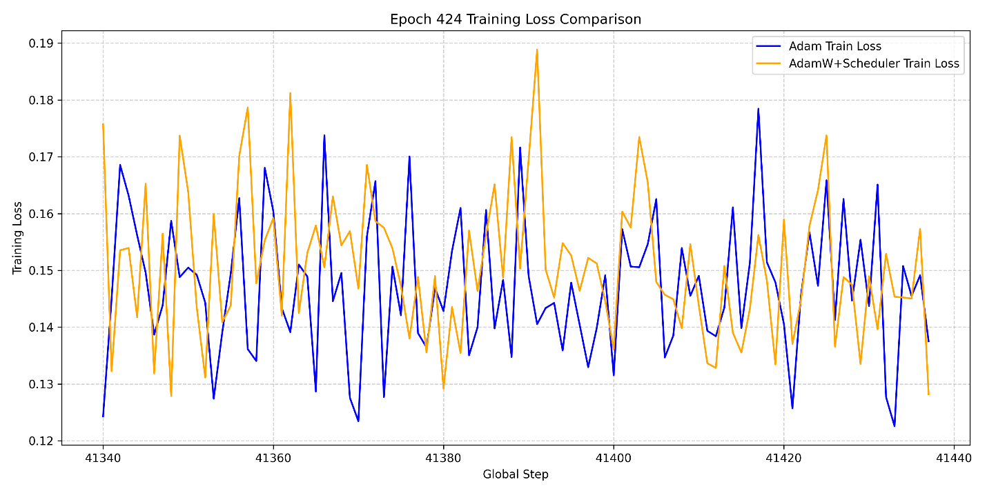
Figure 4.34: Train Loss Comparison of Adam and AdamW Opimsers at Epoch 424
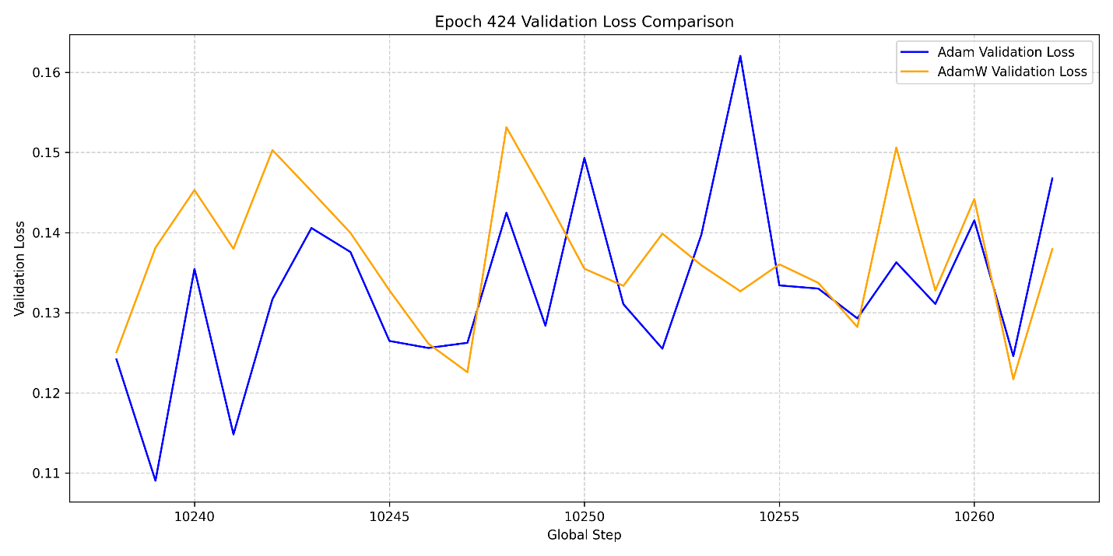
Figure 4.35: Validation Loss Comparison of Adam and AdamW Opimsers at Epoch 424

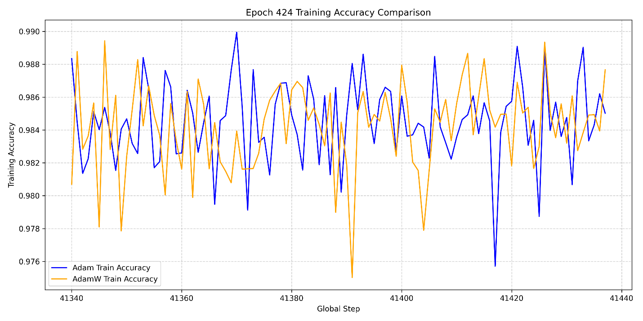
Figure 4.36: Train Accuracy Comparison of Adam and AdamW Opimsers at Epoch 424
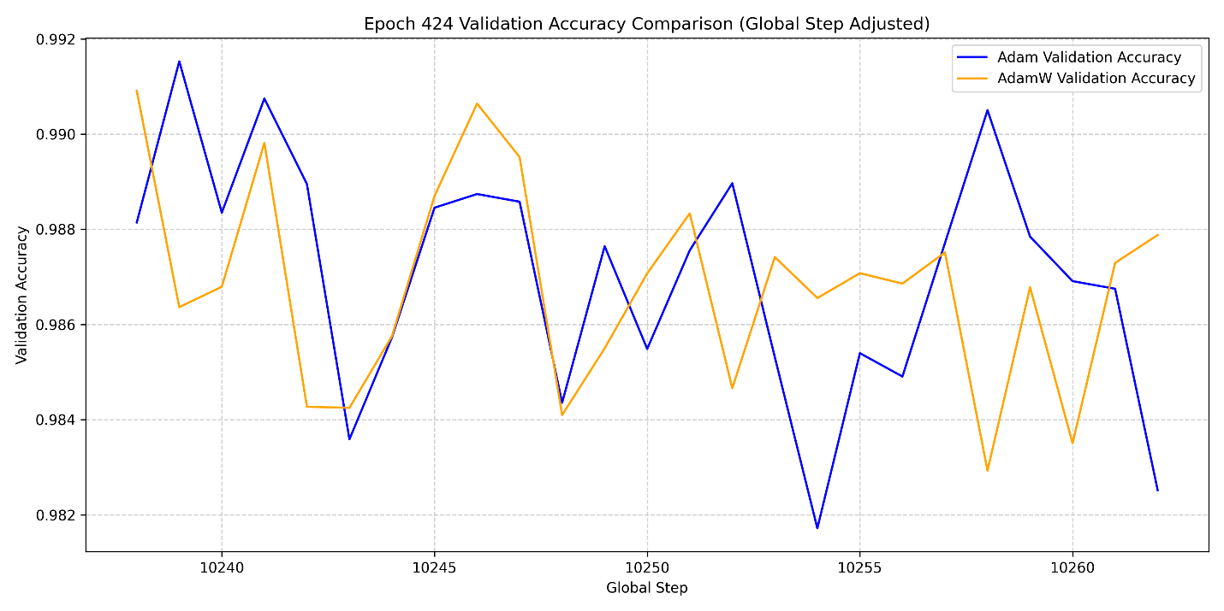
Figure 4.37: Validation Accuracy Comparison of Adam and AdamW Opimsers at Epoch 424

B. Comparison at Epoch 469
At epoch 469 for both optimisers, AdamW is nowhere close to Adam as seen in train loss, validation loss, train accuracy and validation accuracy plots of Figures 4.38 to 4.41. From the plots the wide gap between the two optimisers in terms of their losses and accuracies can easily be seen. The results here show that Adam is better than AdamW optimiser.
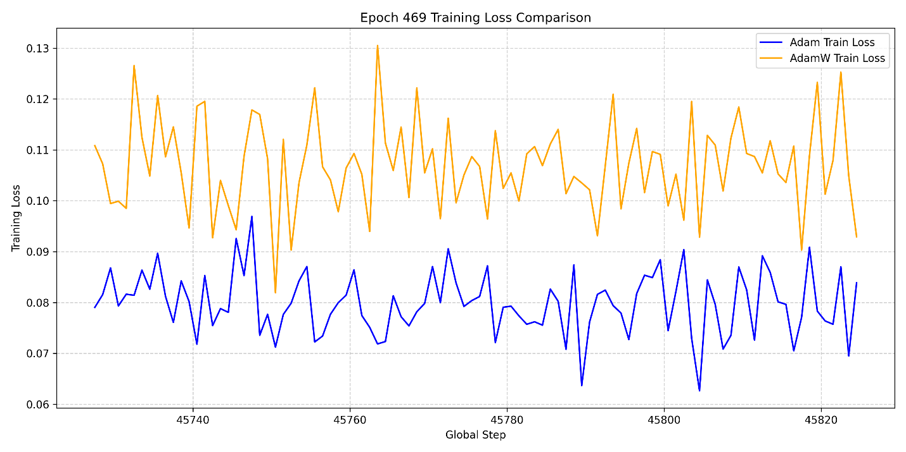
Figure 4.38: Train Loss Comparison of Adam and AdamW Opimsers at Epoch 469
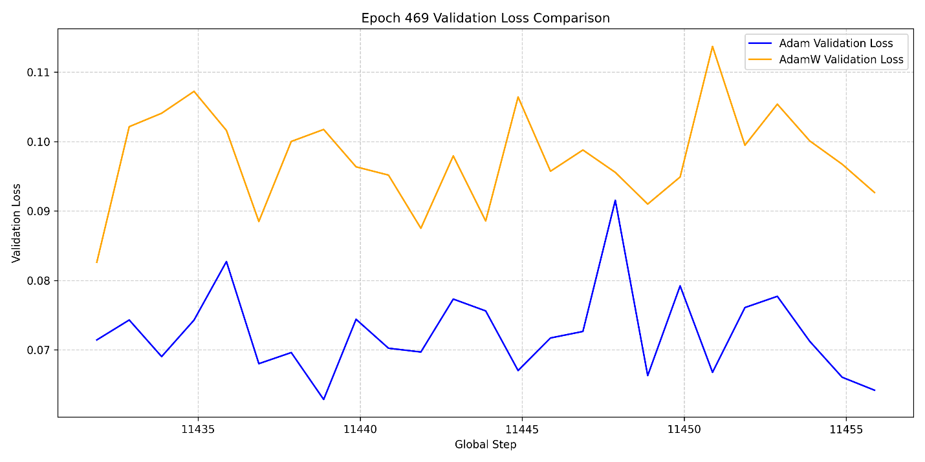
Figure 4.39: Validation Loss Comparison of Adam and AdamW Opimsers at Epoch 469
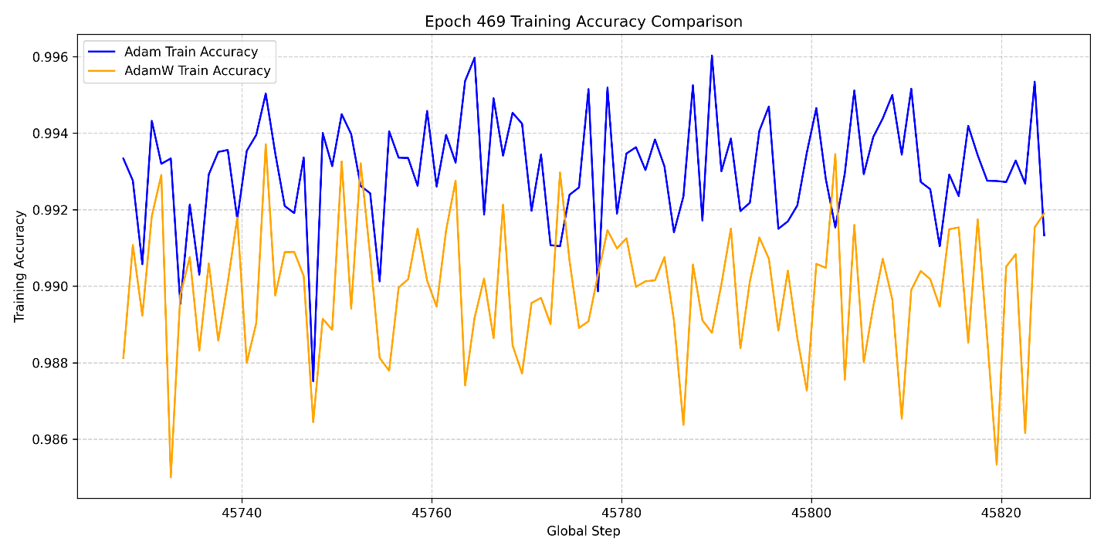
Figure 4.40: Train Accuracy Comparison of Adam and AdamW Opimsers at Epoch 469
It should be noted here that Adam performs better than AdamW but in the ASR computation, AdamW optimiser gave the best BLEU score of 33.8, and best STOI score of 0.609. One would have suggested introduction of errors into the ASR results would have led to lower BLEU scores in comparison to those of Adam. In fact, the BLEU scores computed for AdamW were generally better than that of Adam. In addition to that, with AdamW, the WER generally reduces drastically showing the model is able to capture well at character level than at word level. The only metric that validated the good performance of the AdamW over Adam is the best STOI score of 0.609 as this was computed directly on the U2UT model output. These results further imply the loss results should not be relied upon alone for model performance across different optimisers, rather focus should be on the output results obtained and how metrics perform amongst themselves leading to the choice of the best metrics for evaluation.
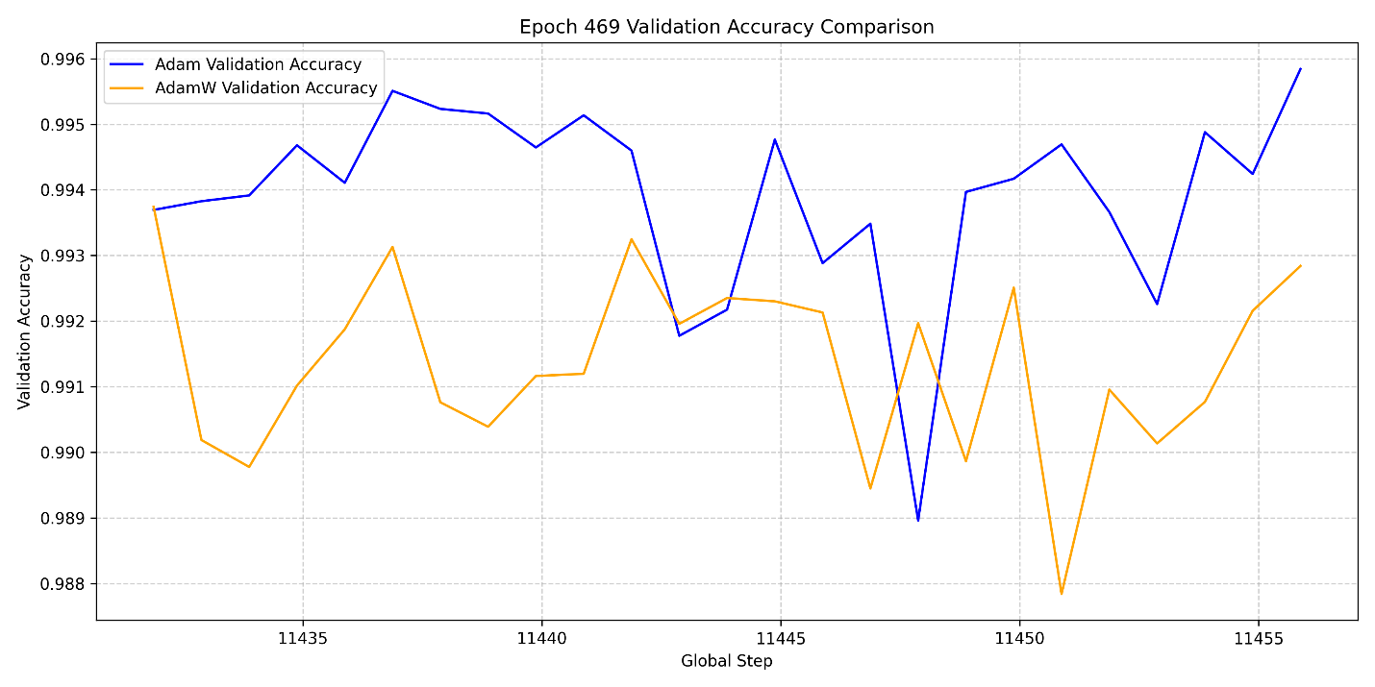
Figure 4.41: Validation Accuracy Comparison of Adam and AdamW Opimsers at Epoch 469

CHAPTER FIVE

CONCLUSION AND RECOMMNEDATION

5.1 Conclusion
The development of speech-to-speech modelling has seen revolution and improvement for high-resourced languages like English, Spanish, French, and German. However, the African indigenous languages, including the Yoruba language, are still underdeveloped in language translation from another language to Yoruba and vice versa. Besides, there is no availability of parallel English-Yoruba speech-to-speech dataset in the public repository. This work has curated over 117,000 parallel audios of English and Yoruba (BENYO-S2ST-CORPUS-R1 Dataset) and such is to be made available for research in speech processing applications. U2UT model has been developed for general, public health domains-based data, and experiments and ablation studies were carried out. One of the present results is the ability of the developed model to reconstruct discrete units of the target language even with less than 2000 parallel audios of English and Yoruba. This units were able to produce intelligible audios when fed to the finetuned vocoder in this work. The audios of both source and target were fed into preprocessing / augmentation techniques such as speed perturbation, pitch shifting, noise addition, bandpass Butterworth filter as well as silence trimming to simulate real life scenario in the data before being fed to the developed model. It was observed that slicing sequence length of the audios to 600 has the disadvantage of cutting out the end parts for longer audio length. A best BLEU score of 33.38 was obtained in this work, with the best CER and STOI scores of 0.170 and 0.61 respectively. These results are promising results such that when the model is trained on large volume of data or finetuned (saved checkpoints), state-of-the-art results typical of production stage can be obtained-hence the results obtained here are researched based and not ready for production stage. The results reported have been obtained via validation output during training rather than inference generation. This work addresses the United Nation Sustainable Development Goals (SDGs) 3-Healthy life and well-being and 10-reducing inequality and the IR4.

5.2 Limitation
This work will achieve state-of-the-art results when enough compute resources is made available. The training carried out in this thesis report are carried out on an NVIDIA GeForce RTX 4060 8 Gb GPU space. This is a small memory space when compared to what is required for S2ST model training. This utilisation of this “not enough” GPU space has led to the truncation of the sequence length of the discretised features to 600 due to “out of memory error”. This has also prevented simultaneous training of more than one S2ST model training and utilisation of enough training data.

5.3 Recommendation
For future experiments, the following recommendation are provided:
- The provision of enough compute resources is needed for best results to be obtained for the U2UT model developed.
- The best BLEU score obtained here was 25. For both BLEU score performance, the volume of the training data will need to be increased.
- Future work can be geared towards utilisation of other unit vocoder and comparison of different vocoders can be carried out on the output target speech per audio sample generated.

References
Adeniyi, S. K., Ajiboye, O. J., & Ilori, J. F. (2025). A Morphological and Computational Analysis of Yoruba Numeral Multiplicands: Linguistic Structure and Cultural Significance.
Armaisya, D. D., Pamungkasari, P. D., Rifai, A. P., Sholihati, I. D., & Sakarkar, G. (2025). Comparison Of Feature Extraction Techniques For Long Short-Term Memory Models In Indonesian Automatic Speech Recognition. Green Intelligent Systems and Applications, 5(1), 74–92.
Ayesha, M. L., Divya, M. O., & others. (2022). Universal Speech Translator. Kristu Jayanti Journal of Computational Sciences (KJCS), 88–96.
Azterketa Eta Prozesamendua, H. (2023). Basque and Spanish Multilingual TTS Model for Speech-to-Speech Translation hap/lap.
Baevski, A., Zhou, H., Mohamed, A., & Auli, M. (2020). wav2vec 2.0: A Framework for Self-Supervised Learning of Speech Representations. https://github.com/pytorch/fairseq
Bakenne, N. A., & Salawu, A. (2025). BBC News Yorùbá and Digital Public Sphere: Promoting Yorùbá Cultural Traditions among Youths of South-West Nigeria. E-BANGI, 22(1), 382–394.
Banerjee, A., & Banik, D. (2025). A comprehensive survey on transformer-based machine translation: Identifying research gaps and solutions for large language models. ACM Computing Surveys, 58(5), Article 124, 33 pages. https://doi.org/10.1145/3773076
Baoueb, T., Bie, X., Fontaine, M., & Richard, G. (2025). GLA-Grad++: An improved Griffin-Lim guided diffusion model for speech synthesis. In Proceedings of the International Conference on Learning Representations (ICLR). arXiv. https://doi.org/10.48550/arXiv.2511.22293
Baral, A. (2025). Preserving Indigenous Language: Text-To-Speech System for the Myaamia Language. Miami University.
Barrault, L., Chung, Y.-A., Meglioli, M. C., Dale, D., Dong, N., Duquenne, P.-A., Elsahar, H., Gong, H., Heffernan, K., Hoffman, J., & others. (2023). SeamlessM4T-Massively Multilingual & Multimodal Machine Translation. ArXiv Preprint ArXiv:2308.11596.
Battenberg, E., Skerry-Ryan, R. J., Stanton, D., Mariooryad, S., Shannon, M., Salazar, J., & Kao, D. (2025). Very attentive Tacotron: Robust and unbounded length generalization in autoregressive transformer-based text-to-speech. In Proceedings of the 2025 Conference of the North American Chapter of the Association for Computational Linguistics (NAACL). arXiv preprint arXiv:2410.22179. https://doi.org/10.48550/arXiv.2410.22179
Berger, N. (2026). Learning from human feedback on translation hypotheses (Doctoral dissertation). Heidelberg University Department of Computational Linguistics.
Bouhajeb, E., Jlassi, C., & Arous, N. (2026). Enhancing continuous speech recognition with CapsNet and WaveRNN: A transfer learning approach. International Journal of Machine Learning and Cybernetics, 17, Article 255. https://doi.org/10.1007/s13042-025-01789-3
Bozkurt, A. ;, Junhong, X. ;, Lambert, S. ;, Pazurek, A. ;, Crompton, H. ;, Koseoglu, S. ;, Farrow, R. ;, Bond, M. ;, Nerantzi, C. ;, Honeychurch, S. ;, Bali, M. ;, Dron, J. ;, Mir, K. ;, Stewart, B. ;, Costello, E. ;, Mason, J. ;, Stracke, C. M. ;, Romero-Hall, Bozkurt, A., … Stracke, J. (2023). Reflection from the Educational Landscape. Asian Journal of Distance Education, 18(1), 53–130. https://doi.org/10.5281/zenodo.7636568
Cattoni, R., Di Gangi, M. A., Bentivogli, L., Negri, M., & Turchi, M. (2021). MuST-C: A multilingual corpus for end-to-end speech translation. Computer Speech and Language, 66. https://doi.org/10.1016/j.csl.2020.101155
Chang, X., Watanabe, S., Delcroix, M., Ochiai, T., Zhang, W., & Qian, Y. (2025). Module-Based End-to-End Distant Speech Processing: A case study of far-field automatic speech recognition [Special Issue On Model-Based and Data-Driven Audio Signal Processing]. IEEE Signal Processing Magazine, 41(6), 39–50.
Chang, X., Yan, B., Choi, K., Jung, J., Lu, Y., Maiti, S., Sharma, R., Shi, J., Tian, J., Watanabe, S., Fujita, Y., Maekaku, T., Guo, P., Cheng, Y.-F., Denisov, P., Saijo, K., & Wang, H.-H. (2023). Exploring Speech Recognition, Translation, and Understanding with Discrete Speech Units: A Comparative Study. http://arxiv.org/abs/2309.15800
Chauhan, S., Daniel, P., Saxena, S., & Sharma, A. (2022). Fully unsupervised machine translation using context-aware word translation and denoising autoencoder. Applied Artificial Intelligence, 36(1), 2031817.
Chen, P.-J., Tran, K., Yang, Y., Du, J., Kao, J., Chung, Y.-A., Tomasello, P., Duquenne, P.-A., Schwenk, H., Gong, H., & others. (2022). Speech-to-speech translation for a real-world unwritten language. ArXiv Preprint ArXiv:2211.06474.
Chen, S. et al. (2022). WavLM: Large-Scale Self-Supervised Pre-Training for Full Stack Speech Processing. IEEE Journal on Selected Topics in Signal Processing, 16(6), 1505–1518, Oct. 2022, doi: 10.1109/JSTSP.2022.3188113
Cherednichenko, O. (2020). Collection and Processing of a Medical Corpus in Ukrainian.
Choi, J., Kim, J. H., Hu, S., & Chung, J. S. (2026). ProsoCodec: Prosody-oriented speech codec for voice conversion. arXiv preprint arXiv:2606.21888. https://arxiv.org/abs/2606.21888
Conneau, A., Ma, M., Khanuja, S., Zhang, Y., Axelrod, V., Dalmia, S., Riesa, J., Rivera, C., & Bapna, A. (2023). FLEURS: Few-shot learning evaluation of universal representations of speech. 2023 IEEE Spoken Language Technology Workshop (SLT), 798–805. https://doi.org/10.1109/SLT54892.2023.10023141 (doi.org in Bing)
de Martos, A. M. (2022). Deep neural networks for automatic speech-to-speech translation of open educational resources. Universitat Politècnica de València.
Ding, P. (2026, April). Exploring the current status of text-to-speech synthesis models in the field of AI voice cloning. In AIP Conference Proceedings (Vol. 3435, No. 1, p. 030008). AIP Publishing LLC. https://doi.org/ doi.org/10.1063/5.0331339
Diwan, A., Srinivasan, A., Harwath, D., & Choi, E. (2023). Textless low-resource speech-to-speech translation with unit language models. arXiv preprint arXiv:2305.15405. http://arxiv.org/abs/2305.15405
Dogra, T., & Malik Student, R. (2024). The Representation of the “Queer” in Alice Oseman’s Heartstopper and Casey McQuiston One Last Stop. In Certified Journal | (Vol. 9001).
Dong, Q., Yue, F., Ko, T., Wang, M., Bai, Q., & Zhang, Y. (2022). Leveraging Pseudo-labeled Data to Improve Direct Speech-to-Speech Translation. http://arxiv.org/abs/2205.08993
Duret, J., O’Brien, B., Estève, Y., & Parcollet, T. (2023). Enhancing expressivity transfer in textless speech-to-speech translation. arXiv preprint arXiv:2310.07279. http://arxiv.org/abs/2310.07279
Elesemoyo, I. O. (2025). An Android-Based Number Conversion System to Yorùbá Language Numeral Forms. FUOYE Journal of Pure and Applied Sciences (FJPAS), 10(1), 102–113.
Fan, Y., Qian, Y., Xie, F.-L., & Soong, F. K. (2014). TTS synthesis with bidirectional LSTM-based recurrent neural networks. Fifteenth Annual Conference of the International Speech Communication Association.
Gong, Z., Xu, X., & Zhao, Y. (2025). Tibetan–Chinese speech-to-speech translation based on discrete units. Scientific Reports, 15(1), 2592.
Govind, G., Gupta, D., & Jhajharia, K. (2026). Hand gesture recognition using hybrid deep learning models for deaf communication support. [Journal name], [volume(issue)].
Grabar, N., & Cardon, R. 2019. CLEAR-Simple Corpus for Medical French. http://natalia.
Griffin, D., & Lim, J. (1984). Signal estimation from modified short-time Fourier transform. IEEE Transactions on Acoustics, Speech, and Signal Processing, 32(2), 236–243.
Gutkin, A., Demirsahin, I., Kjartansson, O., Rivera, C. E., & Túbòsún, K. (2020). Developing an open-source corpus of Yoruba speech.
Haluza, D., & Jungwirth, D. (2023). Artificial Intelligence and Ten Societal Megatrends: An Exploratory Study Using GPT-3. Systems, 11(3), 120.
Hassana, I. L., & Sanusi, M. (2019). Text to Speech Synthesis System in Yoruba Language. International Journal of Advances in Scientific Research and Engineering, 5(10), 180–191.
Hatami, A. (2026). Advancing multimodal machine translation: The role of visual cues in enhancing translation quality. University of Galway.
Hayashi, T., & Watanabe, S. (2020). Watanabe3DiscreTalk: Text-to-Speech as a Machine Translation Problem. arXiv preprint arXiv:2005.05525.
He, X., Polok, A., Villalba, J., Thebaud, T., & Maciejewski, M. (2026, May). Scaling multi-talker ASR with speaker-agnostic activity streams. In ICASSP 2026—IEEE International Conference on Acoustics, Speech and Signal Processing (ICASSP) (pp. 16727–16731). IEEE.
Hsu, W. N., Bolte, B., Tsai, Y. H. H., Lakhotia, K., Salakhutdinov, R., & Mohamed, A. (2021). Hubert: Self-supervised speech representation learning by masked prediction of hidden units. IEEE/ACM transactions on audio, speech, and language processing, 29, 3451-3460.
Huang, A. (2026). Speech recognition based on mobile biosensor networks and quality evaluation of university political education. International Journal of High Speed Electronics and Systems, 35(2), 2540128.
Huang R. et., al (2023). AV-TranSpeech: Audio-Visual Robust Speech-to-Speech Translation. In Proceedings of the 61st Annual Meeting of the Association for Computational Linguistics, vol. 1, p. 8590-8604, 2023.
Hudelson, P., & Chappuis, F. (2024). Using Voice-to-Voice Machine Translation to Overcome Language Barriers in Clinical Communication: An Exploratory Study. Journal of General Internal Medicine. https://doi.org/10.1007/s11606-024-08641-w
Hujon, A. V., Singh, T. D., & Amitab, K. (2022). Transfer Learning Based Neural Machine Translation of English-Khasi on Low-Resource Settings. Procedia Computer Science, 218, 1–8. https://doi.org/10.1016/j.procs.2022.12.396
International Telecommunication Union. (2001). P.862: Perceptual evaluation of speech quality (PESQ): An objective method for end-to-end speech quality assessment of narrow-band telephone networks and speech codecs. ITU-T Recommendation P.862. https://www.itu.int/rec/T-REC-P.862/en
Javaid, M., Haleem, A., & Singh, R. P. (2023). ChatGPT for healthcare services: An emerging stage for an innovative perspective. BenchCouncil Transactions on Benchmarks, Standards and Evaluations, 3(1). https://doi.org/10.1016/j.tbench.2023.100105
Jeuris, P., & Niehues, J. (2022). Libris2s: A german-english speech-to-speech translation corpus. ArXiv Preprint ArXiv:2204.10593.
Jia, Y., Johnson, M., Macherey, W., Weiss, R. J., Cao, Y., Chiu, C.-C., Ari, N., Laurenzo, S., & Wu, Y. (2019). Leveraging weakly supervised data to improve end-to-end speech-to-text translation. ICASSP 2019-2019 IEEE International Conference on Acoustics, Speech and Signal Processing (ICASSP), 7180–7184.
Jia, Y., Ramanovich, M. T., Remez, T., & Pomerantz, R. (2022). Translatotron 2: High-quality direct speech-to-speech translation with voice preservation. International Conference on Machine Learning, 10120–10134.
Jia, Y., Ramanovich, M. T., Wang, Q., & Zen, H. (2022). CVSS corpus and massively multilingual speech-to-speech translation. Proceedings of the 13th Language Resources and Evaluation Conference (LREC 2022), 679–688. https://doi.org/10.48550/arXiv.2201.03713
Jia, Y., Weiss, R. J., Biadsy, F., Macherey, W., Johnson, M., Chen, Z., & Wu, Y. (2019). Direct speech-to-speech translation with a sequence-to-sequence model. http://arxiv.org/abs/1904.06037
Jiang, S., Qi, J., Huo, C., Gao, Y., & Chen, Q. (2023). Two-stage adaptation for non-normative speech recognition: Revisiting speaker-independent initialization for personalization. arXiv preprint arXiv:2310.07279. http://arxiv.org/abs/2310.07279
Julius, O., Obagbuwa, I. C., Michael, E. B., Adebiyi, A. A., Deborah, O., & Akinrinwa, S. P. (2024). Direct English-to-Yoruba speech Translation model using Transformer with Augmented Attention Mechanism. 2024 IEEE 5th International Conference on Electro-Computing Technologies for Humanity (NIGERCON), 1–6.
Kaur, P., Bush, L. A. M., & Shi, W. (2024). Direct Punjabi to English speech translation using discrete units. http://arxiv.org/abs/2402.15967
Kharitonov, E., Copet, J., Lakhotia, K., Nguyen, T. A., Tomasello, P., Lee, A., Elkahky, A., Hsu, W.-N., Mohamed, A., Dupoux, E., & others. (2022). textless-lib: A library for textless spoken language processing. ArXiv Preprint ArXiv:2202.07359.
Kim, S.-B., Lee, S.-H., & Lee, S.-W. (2024). TranSentence: Speech-to-speech Translation via Language-agnostic Sentence-level Speech Encoding without Language-parallel Data. https://doi.org/10.1109/ICASSP48485.2024.10447331
Kim, S. M. (2025). Frequency-aware multi-rate resampling with multi-band deep supervision for modular speech denoising. Electronics, 14(22), 4523. https://doi.org/10.3390/electronics14224523
Kim, T., & Skoglund, J. (2024). Neural speech and audio coding: Modern AI technology meets traditional codecs. IEEE Signal Processing Magazine, 41(6). https://doi.org/10.1109/MSP.2024.1234567
Knowles, K. L., Patten, K. J., Durojaye, C., Dada, B. O., & McBeath, M. K. (2025). Yorùbá Speech Surrogacy with the Dùndún Talking Drum: Recognition Accuracy is a Function of Language Familiarity and Music Training. Music Perception: An Interdisciplinary Journal, 1–24.
Kocmi, Tom., Macháček, Dominik., & Bojar, O. (2022). The reality of multi-lingual machine translation.
Kong, J., Kim, J., & Bae, J. (2020). Hifi-gan: Generative adversarial networks for efficient and high fidelity speech synthesis. Advances in Neural Information Processing Systems, 33, 17022–17033.
Kong, Z., Huang, J., Zhao, K., Ping, W., & Catanzaro, B. (2021). DiffWave: A versatile diffusion model for audio synthesis. arXiv. https://doi.org/10.48550/arXiv.2009.09761
Kumar, K., Kumar, R., De Boissiere, T., Gestin, L., Teoh, W. Z., Sotelo, J., De Brebisson, A., Bengio, Y., & Courville, A. C. (2019). Melgan: Generative adversarial networks for conditional waveform synthesis. Advances in Neural Information Processing Systems, 32.
Lakhotia, K., Kharitonov, E., Hsu, W.-N., Adi, Y., Polyak, A., Bolte, B., Nguyen, T.-A., Copet, J., Baevski, A., Mohamed, A., & Dupoux, E. (2021). Generative spoken language modeling from raw audio. Transactions of the Association for Computational Linguistics, 9, 1336–1354 https://doi.org/10.48550/arXiv.2102.01192
Lee, A., Chen, P.-J., Wang, C., Gu, J., Popuri, S., Ma, X., Polyak, A., Adi, Y., He, Q., Tang, Y., Pino, J., & Hsu, W.-N. (2021). Direct speech-to-speech translation with discrete units. http://arxiv.org/abs/2107.05604
Li, J., Lavrukhin, V., Ginsburg, B., Leary, R., Kuchaiev, O., Cohen, J. M., Nguyen, H., & Gadde, R. T. (2019a). Jasper: An end-to-end convolutional neural acoustic model. ArXiv Preprint ArXiv:1904.03288.
Li, R., Wang, X., & Yu, H. (2020). MetaMT, a meta learning method leveraging multiple domain data for low resource machine translation. Proceedings of the AAAI Conference on Artificial Intelligence, 34(05), 8245–8252.
Li, X., Jia, Y., & Chiu, C.-C. (2022). Textless Direct Speech-to-Speech Translation with Discrete Speech Representation. http://arxiv.org/abs/2211.00115
Limbu, S. H. (2020). Direct Speech to Speech Translation Using Machine Learning. http://www.teknat.uu.se/student
Liu, H., Zhang, H., Zhang, Q., Zhang, X., Shi, D., Chng, E. S., & Li, H. (2026). Code-switching speech recognition under the lens: Model- and data-centric perspectives. IEEE Transactions on Audio, Speech, and Language Processing.
Liu, R., Sisman, B., Li, J., Bao, F., Gao, G., & Li, H. (2020). Teacher-student training for robust tacotron-based tts. ICASSP 2020-2020 IEEE International Conference on Acoustics, Speech and Signal Processing (ICASSP), 6274–6278.
Liu, Y. et al., (2020) “Multilingual denoising pre training for neural machine translation,” Transactions of the Association for Computational Linguistics, 8:726–742, 2020.
McArthur, B., & Richardson, S. D. (2023). Direct Speech to Speech Translation: Model Improvements.
McLoughlin, I., Pham, L., Song, Y., Miao, X., Phan, H., Cai, P., ... & Soh, D. (2026). Spectrogram features for audio and speech analysis. Applied Sciences, 16(2), 572. https://doi.org/10.3390/app16020572
Medeiros, E. F. (2023). Deep learning for speech to text transcription for the portuguese language. Universidade de Évora.
Meyer, J., Adelani, D. I., Casanova, E., Öktem, A., Weber, D. W. J., Kabongo, S., Salesky, E., Orife, I., Leong, C., Ogayo, P., Emezue, C., Mukiibi, J., Osei, S., Agbolo, A., Akinode, V., Opoku, B., Olanrewaju, S., Alabi, J., & Muhammad, S. (2022). BibleTTS: a large, high-fidelity, multilingual, and uniquely African speech corpus. http://arxiv.org/abs/2207.03546
Mezza, A. I., Cicognani, M., Cicognani, R. L., & Bernardini, A. (2026). On the convergence of the fast Griffin-Lim algorithm. IEEE Signal Processing Letters.
Mingote, V., et al., (2023). Direct Text to Speech Translation System using Acoustic Units,” IEEE Signal Proceesing Letters, vol. 30, pp. 1262-1266.
Moorkens, J., Lankford, S., & Way, A. (2025). Sociotechnical effects of machine translation. arXiv. https://doi.org/10.48550/arXiv.2503.20959
Murphy, K. P. (2022). Probabilistic machine learning: an introduction. MIT Press.
Nachmani, E., Levkovitch, A., Ding, Y., Asawaroengchai, C., Zen, H., & Ramanovich, M. T. (2023). Translatotron 3: Speech to Speech Translation with Monolingual Data. http://arxiv.org/abs/2305.17547
Nallabala, N. K., Souprayen, B., Ramasamy, M., Penumarti, S. K., & Navuluri, N. C. (2025). An Efficient Speech Synthesizer: A Hybrid Monotonic Architecture for Text-to-speech via VAE & LPC-Net with Independent Sentence Length. Circuits, Systems, and Signal Processing, 1–25.
Nguyen, L. T., & Sakti, S. (2025). ZeST: A zero-resourced speech-to-speech translation approach for unknown, unpaired, and untranscribed languages. IEEE Access. Doi: 10.1109/ACCESS.2025.3527012
Niranjan, A., Sharma, M., Gutha, S. B. C., & Shaik, M. A. B. (2020). End-to-End Whisper to Natural Speech Conversion using Modified Transformer Network. http://arxiv.org/abs/2004.09347
Nyetanyane, J., & Masinde, M. (2019). UmobiTalk: Ubiquitous Mobile Speech Based Translator for Sesotho Language. Emerging Technologies for Developing Countries: Second EAI International Conference, AFRICATEK 2018, Cotonou, Benin, May 29–30, 2018, Proceedings 2, 93–106.
Olagunju, O. B., Abiola, O. B., Saka-Balogun, O. Y., Badeji-Ajisafe, B., Oguntimilehin, A., Adewole, L. O., Adigun, K. A., Obamiyi, S. E., & Oluwatoki, T. G. (2024). A Transformer-Based Model for English to Yoruba Machine Translation. 2024 IEEE 5th International Conference on Electro-Computing Technologies for Humanity (NIGERCON), 1–5.
Olatunji, T., Afonja, T., Yadavalli, A., Emezue, C. C., Singh, S., Dossou, B. F. P., Osuchukwu, J., Osei, S., Tonja, A. L., Etori, N., & Mbataku, C. (2023). AfriSpeech-200: Pan-African Accented Speech Dataset for Clinical and General Domain ASR. http://arxiv.org/abs/2310.00274
Oord, A. van den, Dieleman, S., Zen, H., Simonyan, K., Vinyals, O., Graves, A., Kalchbrenner, N., Senior, A., & Kavukcuoglu, K. (2016). Wavenet: A generative model for raw audio. ArXiv Preprint ArXiv:1609.03499.
O'Shaughnessy, D. (2026). Review of automatic text-to-speech synthesis methods. IEEE Transactions on Audio, Speech, and Language Processing. https://doi.org/ 10.1109/TASLPRO.2026.3693972
Overmann, K. A. (2025). Yoruba Numbers. In Cultural Number Systems: A Sourcebook (pp. 59–64). Springer.
Oyewole, J. A., Oyewole, C. F., Ayomide, P. A. O., & Oyewole, J. A. (2025). Language Practices and Social Integration among Multi-Ethnic Youth: A Yoruba Perspective. Yoruba Studies Review, 10(1), 137–164.
Panayiotou, A., Hwang, K., Williams, S., Chong, T. W. H., LoGiudice, D., Haralambous, B., Lin, X., Zucchi, E., Mascitti-Meuter, M., Goh, A. M. Y., You, E., & Batchelor, F. (2020). The perceptions of translation apps for everyday health care in healthcare workers and older people: A multi-method study. Journal of Clinical Nursing, 29(17–18), 3516–3526. https://doi.org/10.1111/jocn.15390
Poli, M. (2026). Unit-HiFi-GAN: Minimal re-implementation of HiFi-GAN training on discrete speech units. GitHub repository. https://github.com/bootphon/unit-hifigan
Popov, V., Vovk, I., & Kudinov, M. (2021). Grad-TTS: A diffusion probabilistic model for text-to-speech. arXiv preprint arXiv:2105.06337. https://doi.org/10.48550/arXiv.2105.06337
Popuri, S. et. al., (2022). Enhanced direct speech-to-speech translation using self-supervised pre-training and data augmentation,” Proc. Interspeech, 2022
Qi, J., & Van hamme, H. (2025). A study on model training strategies for speaker-independent and vocabulary-mismatched dysarthric speech recognition. Applied Sciences, 15(4), 2006. https://doi.org/10.3390/app15042006
Qian, K., Huang, R., Bao, Z., Tan, Y., Zhao, Z., Sun, M., Hu, B., Schuller, B. W., & Yamamoto, Y. (2023). Detecting somatisation disorder via speech: introducing the Shenzhen Somatisation Speech Corpus. Intelligent Medicine. https://doi.org/10.1016/j.imed.2023.03.001
Rabiner, L. R., Schafer, R. W., & others. (2007). Introduction to digital speech processing. Foundations and Trends®in Signal Processing, 1(1--2), 1–194.
Radford, A., Kim, J. W., Xu, T., Brockman, G., McLeavey, C., & Sutskever, I. (2023). Robust speech recognition via large-scale weak supervision. International Conference on Machine Learning, 28492–28518.
Ranathunga, S., Lee, E.-S. A., Skenduli, M. P., Shekhar, R., Alam, M., & Kaur, R. (2021). Neural Machine Translation for Low-Resource Languages: A Survey. http://arxiv.org/abs/2106.15115
Rapp, R. (2021). Similar language translation for Catalan, Portuguese, and Spanish using Marian NMT. Proceedings of the Sixth Conference on Machine Translation, 292–298.
Ren, Y., Ruan, Y., Tan, X., Qin, T., Zhao, S., Lu, J., & Liu, T. (2020). FastSpeech 2: Fast and high-quality end-to-end text to speech. arXiv preprint arXiv:2006.04558. https://doi.org/10.48550/arXiv.2006.04558
Rubenstein, P. K., Asawaroengchai, C., Nguyen, D. D., Bapna, A., Borsos, Z., Quitry, F. de C., Chen, P., Badawy, D. El, Han, W., Kharitonov, E., Muckenhirn, H., Padfield, D., Qin, J., Rozenberg, D., Sainath, T., Schalkwyk, J., Sharifi, M., Ramanovich, M. T., Tagliasacchi, M., … Frank, C. (2023). AudioPaLM: A Large Language Model That Can Speak and Listen. http://arxiv.org/abs/2306.12925
Rubenstein, P. K., Asawaroengchai, C., Nguyen, D. D., Bapna, A., Borsos, Z., Quitry, F. de C., Chen, P., Badawy, D. El, Han, W., Kharitonov, E., & others. (2023). Audiopalm: A large language model that can speak and listen. ArXiv Preprint ArXiv:2306.12925.
Sandeep Gupta, S., & Ramakant Shirodkar, V. (2022). A study on the techniques for speech to speech translation. www.irjet.net
Sanger, T. D. (2026). Scaled dot-product attention implements projection of inputs onto a common surface. arXiv preprint arXiv:2602.02521. https://doi.org/10.48550/arXiv.2602.02521
Schneider, P., Feng, X., Linbao, G., Jie, L., Goncalves, M., & Greten, H. J. (2026). Rediscovery of a seventh sense: Humans produce, perceive, and process ultrasound. Frontiers in Neuroscience, 20, 1732840. https://doi.org/10.3389/fnins.2026.1732840
Shaker, A., Maaz, M., Rasheed, H., Khan, S., Yang, M.-H., & Khan, F. S. (2023). Swiftformer: Efficient additive attention for transformer-based real-time mobile vision applications. In Proceedings of the IEEE/CVF International Conference on Computer Vision (ICCV) (pp. 17379–17390).
Shehzadi, T., Ifza, I., Stricker, D., & Afzal, M. Z. (2025). Efficient additive attention for transformer-based semi-supervised document layout analysis. In Proceedings of the IEEE/CVF International Conference on Computer Vision (pp. 3495–3503).
Shi, B., Mohamed, A., & Hsu, W.N. (2022). Learning lip-based audio-visual speaker embeddings with av-hubert,”, Proc. Interspeech, 2022
Shi, J., Tang, Y., Lee, A., Inaguma, H., Wang, C., Pino, J., & Watanabe, S. (2023). Enhancing Speech-to-Speech Translation with Multiple TTS Targets. http://arxiv.org/abs/2304.04618
Silaban, W. Y., Lestari, M., Desi, W. ;, Barumbu, N., Kawet, K., Yosua, ;, Sunkudon, A., Darmawan, ;, & Winoto, E. (2023). Comparative Study of Post-Marriage Nationality of Women in Legal Systems of Different Countries International Journal of Multicultural and Multireligious Understanding History of English Become an International Language. https://doi.org/10.18415/ijmmu.v10i2.4359
Suikkila, J. (2025). Museum wayfinding with AI-spoken voice guidance.
Torcoli, M., Halimeh, M. M., & Habets, E. A. (2025). Navigating PESQ: Up-to-date versions and open implementations. In *Speech Communication; 16th ITG Conference (pp. 51–55). VDE.
Tu, T., Palepu, A., Schaekermann, M., Saab, K., Freyberg, J., Tanno, R., Wang, A., Li, B., Amin, M., Tomasev, N., Azizi, S., Singhal, K., Cheng, Y., Hou, L., Webson, A., Kulkarni, K., Mahdavi, S. S., Semturs, C., Gottweis, J., … Natarajan, V. (2024). Towards Conversational Diagnostic AI. http://arxiv.org/abs/2401.05654
Ullah, F., Ali, G., Bilal, M., Munir, S., & Hussain, M. (2026). Comparison of surgical site infections in emergency laparotomy and elective laparotomy. Journal of Islamic International Medical College (JIIMC), 21(1), 25–31.
Vaswani, A., Shazeer, N., Parmar, N., Uszkoreit, J., Jones, L., Gomez, A. N., Kaiser, Ł., & Polosukhin, I. (2017). Attention is all you need. Advances in Neural Information Processing Systems, 30.
Vijayalakshmi, P., Nagarajan, T., Ananthakrishnan, K., Sanjay, B., & Gayathri, P. (2026, March). Tamil dysarthric speech data collection: Challenges and constraints. In 2026 Twelfth International Conference on Bio Signals, Images, and Instrumentation (ICBSII) (pp. 1–6). IEEE.
Wadhawan, A. (2023). SIMULTANEOUS SPEECH TO SPEECH TRANSLATION.
Wang, D. et al. (2025). Speech discrete tokens or continuous features? A comparative analysis for spoken language understanding in SpeechLLMs. In Proceedings of the 2025 Conference on Empirical Methods in Natural Language Processing, pp. 24924-24935
Wang, P. (2026). Parameter efficiency in neural networks for speech recognition and spoken language understanding. KU Leuven.
White, A., & Watson, C. (2025). Towards the Detection of Speech Deepfakes for Scam Prevention. ResearchSpace@ Auckland.
Workshop, B., :, Scao, T. Le, Fan, A., Akiki, C., Pavlick, E., Ilić, S., Hesslow, D., Castagné, R., Luccioni, A. S., Yvon, F., Gallé, M., Tow, J., Rush, A. M., Biderman, S., Webson, A., Ammanamanchi, P. S., Wang, T., Sagot, B., … Wolf, T. (2022). BLOOM: A 176B-Parameter Open-Access Multilingual Language Model. http://arxiv.org/abs/2211.05100
Xu, K., Peng, Z., Huang, S., Zhang, G., Hu, Y., & Peng, W. (2026). Improving pseudo-labeling by dynamic confidence calibration for semi-supervised sequence recognition. ACM Transactions on Multimedia Computing, Communications, and Applications.
Xue, L., Constant, N., Roberts, A., Kale, M., Al-Rfou, R., Siddhant, A., Barua, A., & Raffel, C. (2020). mT5: A massively multilingual pre-trained text-to-text transformer. ArXiv Preprint ArXiv:2010.11934.
Yang, R., Li, K., & Hu, X. (2026). Spectral diffusion vocoder for high-fidelity pitch-accurate singing voice synthesis. IEEE Transactions on Audio, Speech, and Language Processing.
Yamamoto, R., Song, E., & Kim, J.-M. (2020). Parallel WaveGAN: A fast waveform generation model based on generative adversarial networks with multi-resolution spectrogram. ICASSP 2020-2020 IEEE International Conference on Acoustics, Speech and Signal Processing (ICASSP), 6199–6203.
Yao, S., & Poonpon, K. (2025). The Effects of Text-to-Speech Dictation on Chinese Elementary Students’ Listening and Spelling Skills at a Primary School in China. Theory and Practice in Language Studies, 15(1), 294–306.
Yoon, Y. C., & Kim, S. (2025). MASKSER: A robust emotion recognition model based on voice data and noisy transcripts. IEEE Transactions on Audio, Speech, and Language Processing. https://doi.org/ 10.1109/TASLPRO.2025.3617234
Yun, S., Lee, J., & Ro, Y. (2024). FFNet: MetaMixer-based efficient convolutional mixer design. arXiv. https://doi.org/10.48550/arXiv.2406.02021
Zeng, C., Wang, C., Miao, X., Zhao, J., Jiang, Z., & Chen, Y. (2024). InstructSing: High-fidelity singing voice generation via instructing yourself. arXiv. https://doi.org/10.48550/arXiv.2409.06330
Zeng, Z., Zhao, Y., Wang, K., Niyato, D., Shu, H., Zhao, J., ... & Wei, N. (2026). SKANet: A cognitive dual-stream framework with adaptive modality fusion for robust compound GNSS interference classification. arXiv preprint arXiv:2601.12791. https://doi.org/10.48550/arXiv.2601.12791
Zhang, A., Lipton, Z. C., Li, M., & Smola, A. J. (2021). Dive into deep learning. ArXiv Preprint ArXiv:2106.11342.

Appendix

A1. Link to the Generated Audio Samples

1. Spectrogram to Speech Experiment with BENYO-S2ST-CORPUS-R1 Dataset
Link 1: Test_Samples/Spectrogram_based at main · Gabrinas/Test_Samples

2. Comparison of BENYO-S2ST-CORPUS-R1 Dataset Results with Developing an Open-Sourced Dataset for Spectrogram to Audio Generation Experiments
Link 2: https://github.com/Gabrinas/S2ST/tree/main/Link2_Comparison_of_BENYO-S2ST-CORPUS-R1_Dataset_Results_with_Developing_an_Open-Sourced

3. HuBERT vs MFCC Base Audio Generation Experiments
Link 3: https://github.com/Gabrinas/S2ST/tree/main/Link3_HuBERT_vs_MFCC_vocoder_Base_Audio_Generation_Comparison

4. HuBERT Versus Other Discrete Unit Generation Models Experiments

A. HuBERT Generated Audio Samples
Link 4: Test_Samples/Spectrogram_based at main · Gabrinas/Test_Samples

B. Wav2vec 2.0 Generated Audio Samples
Link 5: https://github.com/Gabrinas/Test_Samples/tree/main/discrete_based/wav2vec_2.0_Test_Samples

C. WaVLM Generated Audio Samples
Link 6: https://github.com/Gabrinas/Test_Samples/tree/main/discrete_based/WavLM_Test_Samples

5. U2UT Model Training Experiments with 200 sections of General Domain of UI_3

A. Audio Generated Samples with 190 Parallel Audios
Link 7: https://github.com/Gabrinas/S2ST/tree/main/Link7_Audio_Generated_Samples_of_U2UT_model_with_190_Parallel_Audios

B. Audio Generated Samples with 336 Parallel Audios
Link 8: https://github.com/Gabrinas/S2ST/tree/main/Link8_Audio_Generated_Samples_of_U2UT_model_with_336_Parallel_Audios

C. Audio Generated Samples with 1400 Parallel Audios
Link 9: https://github.com/Gabrinas/S2ST/tree/main/Link9_Audio_Generated_Samples_of_U2UT_model_with_1400_Parallel_Audios

6. U2UT Model Training Experiments with 1000 audio files of the Public Health Domain of UI_5

A. Audio Generated Samples with 1250 Parallel Audios
Link 10: https://github.com/Gabrinas/S2ST/tree/main/Link10_Audio_Generated_Samples_with_1250_Parallel_Audios

B. Audio Generated Samples with 1950 Parallel Audios
Link 11: https://github.com/Gabrinas/S2ST/tree/main/Link11_Audio_Generated_Samples_with_1950_Parallel_Audios

