Bilingual GC-ENYOR Speech – 2026: An Accented Parallel English Yoruba Speech Corporal for Speech Processing Applications

Abstract
The speech-to-speech translation models demand large volume of parallel corporal of both the source and target languages to train and develop deep learning models. However, there is presently insufficient or lack of training speech data particularly for the Africa indigenous languages – this limitation even becomes more pronounced in the medical domain field. In the African settings, particularly Nigeria, there is presently no presence of parallel English-Yoruba audio corpus, and this has led to no or insufficient Yoruba speech models known. Consequent upon, the project detailed in this paper curated about 105, 000 audios and corresponding texts of English-Yoruba pair making a total of about 210,000 audio-text samples. GC-ENYOR Speech – 2025 dataset was curated with the aim of making it publicly available for speech processing applications for the present and future research works. It was recorded as a 48 kHz Pulse Code Modulated (PCM) with wav extension using ASPMIR SpeechTech Crowdsourcing Portal, a user-friendly web application that utilizes the microphone already available on the smart devices of the crowd-sourced recorder. Detailed recording procedures of the corpus are highlighted, starting with sourcing of transcripts, creation of web pages, preprocessing of texts, to recordings, storage, post preprocessing and preparation of manifest files. Various experiments such as audios generation from spectrograms, TTS, and ASR were carried out to evaluate the corpus. The evaluation of the corpora was carried using Translatotron model where it achieves a BLUE score of------- in comparison to LibriSpeech dataset on the same model with a BLUE score of ------.
Keywords: Database, Dataset, Open-Sourced Platforms, Speech Recognition, Speech-to-Speech translation, Speech Synthesis

1. Introduction
The domain of Spoken Language Translation (SLT) suffers from insufficient amount of training data for training speech models. Of recent, training data had been curated for speech translation (ST), or Automatic Speech Translation (AST) which involves the translation of speech from one language to texts in another language [1], [2], [3], [4], [5], [6], [7]. Here the dataset consists of the source language audios and transcripts together with the target language transcripts. However, for speech-to-speech, especially parallel speech-to-speech translation tasks, most researchers are curating their dataset as a primary means rather than relying on the public domain for sourcing [8], [9], [10]. This is due to the lack of such training data in public space [11]. At present, some of the well-known public domain space housing such parallel training corpora are LibriS2S [12] for German language, multilingual FLEURS [13], Multilingual CVSS [14], VoxPopuli [15], and Fisher Caller Home for Spanish-to-English [16]. The aforementioned parallel speech-to-speech public domain space are mostly for high-resourced languages (Europeans & some Asians) except in FLEURS where some African Indigenous languages such as Hausa, Igbo, Lingala, Northern Sotho, Fula, Kamba, Nyanja, Shona, Somali, Swahili, Umbundu, Wolof, Xhosa, Yoruba, and Zulu were also curated [13]. The reasons for the scarcity of such training dataset are due to the difficulty of sourcing native speakers of the languages in recording their voices, the time, complexity of the exercise involved, and even the demand of payment, a form of compensation, which is quite expensive. Due to the difficulty of getting native speakers, some researchers prefer to generate the dataset synthetically using SOTA speech synthesis models [14], [17], or augment the few sourced native speaker voices with the synthetically generated voices as done in [17].
To curate such training corpora, the crowdsourced participants are tasked with recording their voices of the provided texts, using the microphones of their smart devices such as mobile phone, iPhone, laptops etc. [6], [18], [19], [20], [21] or a microphone in a studio [20], [21], [22], [23], [24]. The texts are sourced from the public domains such as Wikipedia [13], [25], TEDtalks, WHO, Newspaper outlets, NCBI, Bible, Wikitexts, textsbooks, Diary etc. [7], [18], [20], [22], [26], [27] and language or human translators are used to translate to the target language. The crowdsourced participants are then tasked to record both pair of languages per line to ensure alignment of the recordings (containing same contents in both languages). For parallel data curation obtained from an already recorded audio source such as TEDTalks [1], European Parliarment discussions, debates, or sessions [5], [15], recorded telephone conversation [16], [19], audiobooks [2], [4], [12], [28], [29], licensed videos of lectures [3] etc. Alignment tools such as Gentle¹, a readily available English forced-alignment tool & Aeneas² for audio-to-text alignment, Gargantua³ & Hunalign [30] sentence alignment tools for text-to-text alignment of different languages, and mweralign [31], [32] for text-to-text alignment of same language are utilized to ensure both the contents of the audios and texts of both language pairs are aligning per sentence level.
^{1”}Gentle: a forced aligner built on Kaldi. GitHub repository: https://github.com/lowerquality/gentle”
²“Aeneas: Automatic audio-text synchronization tool. GitHub repository: https://github.com/readbeyond/aeneas”
3Gargantua: https://github.com/braunefe/Gargantua
For GC-ENYOR Speech, similar approaches utilized in [18] was embarked on to curate [size here] accented parallel audio corpora, with their transcripts of English and Yoruba. The GC-ENYOR Speech is partitioned into the General and Public Health Domian (looking into the malaria related conversations). Sentences were first sourced from online databases such as Wikipedia (for Yoruba numbers), Librispeech (en), Mozilla Common Voice (en), Must-C (en), Developing an open-sourced (yor), Leipzip (yor), Iroyin speech (yor) for the general domain, and British Broadcasting Cooperation (BBC) news, Biomedical, Newspaper outlets (Daily Independence, Daily Trust, Guardian, Leadership news, Punch, This Day, Vanguard), Malaria Consortium, Malaria Report in Nigeria, 2022, Malaria symptoms, National Center for Biotechnology Information (NCBI), PubMed, TEDTalks, World Health Organisation (WHO), World Bank, and YouTube, with all in English language for the medical domain dataset. Google translator was then used to translate those in English language to Yoruba and vice-versa, Llma LLM was also used to translate some of the texts especially the medical terms. The texts were preprocessed into sentence level using Python programming languages and grouped based on source with proper tag for each. A total of [total line of texts here-general_english], [total line of texts here-general_yoruba], [total line of texts here-public_health_english] and [total line of texts here-public health_yoruba] sentences were obtained for the English (general), Yoruba (general), English (public health) and Yoruba (public health) domains respectively. Table 1 gives the overall statistics of the curated corpus. Tables 2 and 3 highlight the breakdown of the statistics for each of general and public health domains respectively. Participants within the age group of 18 years + were sourced from 4 institutions in Nigeria to record the already prepared texts. They were majorly from the Faculty of Arts; Departments of language as well as Faculty of education between 200 and 400 levels of each institution. The choice of the departments is to ensure correct pronunciation of the recorded texts being that students of these departments are well grounded in this area of recording exercises, in terms of fluency of their pronunciations, reading, and understanding of the texts’ contents. Students from other departments (particularly Engineering from FUNAAB) also participated in the recording exercise. The reason for the choice of the 4 institutions is to ensure different accents of the Yoruba language are captured for the official Yoruba language (Oyo dialect). The recording exercises which involved compensation given to the participating individual produces a total of [size of audio here] audios. A breakdown of the institution-based statistics is given in Tables 4 for all the 4 institutions that participated.
The contribution of this work is the curation of accented parallel English-Yoruba high quality corpora for speech processing applications including ASR, AST, TTS, MT, parallel S2ST, and unsupervised S2ST tasks. The corporal which is licensed is publicly available to aid research work in the areas of speech processing applications. it is available at [link here].

2. The Statistics of the Corpora and splitting
The GC-ENYOR which was curated from crowdsourced university participants, where each individual was given the texts to record using their smart devices generated a total of [------] no of audio recordings. The total hour of audios is [-------]. By domain specific, general domain has a total of [-------] hours of audios (General English: --- audios; General Yoruba: -----audios) obtained from [--------] no of audios. The public health domain generated [--------] no of audios giving a total of [--------] hours of audios (public health English: --- audios; public health Yoruba: -----audios). A total of [--------] students /staff of higher institutions of learning in Nigeria participated in this recording exercises. Table 1 gives the overall statistics across the [------] institutions visited. Breakdown per domain specific statistics is given in Table 2 and 3.
Table 1: Overall Statistics of GC-ENYOR Dataset
S/N | Information | Values
1 | Number of audios
2 | Number of audios source language (English)
3 | Number of audios target language (Yoruba)
4 | Hours of audios
5 | Hours of audios source language (English)
6 | Hours of audios target language (Yoruba)
7 | Minimum hours of audios (English)
8 | Maximum hours of audios (English)
9 | Minimum hours of audios (Yoruba)
10 | Maximum hours of audios (Yoruba)
11 | Average length of audios (English)
12 | Average length of audios (Yoruba)
13 | Line of texts source language (English)
14 | Lines of texts target language (Yoruba)
15 | Number of words source language (English)
16 | Number of words target language (Yoruba)
17 | Number of Unique words (English)
18 | Number of Unique words (Yoruba)
19 | Minimum length of words (English)
20 | Maximum length of words (English)
21 | Minimum length of words (Yoruba)
22 | Maximum length of words (Yoruba)
23 | Length of characters (English)
24 | Length of characters (Yoruba)
25 | Number of participants / speakers
26 | Number of institutions
27 | Number of males
28 | Number of females
29 | Accents | Oyo, Lagos, Egba, other South Western part of Nigeria
30 | Age group | 18 years +

Table 2: General Domain Statistics Breakdown
S/N | Information | Values
1 | Number of audios
2 | Number of audios source language (English)
3 | Number of audios target language (Yoruba)
4 | Hours of audios
5 | Hours of audios source language (English)
6 | Hours of audios target language (Yoruba)
7 | Minimum hours of audios (English)
8 | Maximum hours of audios (English)
9 | Minimum hours of audios (Yoruba)
10 | Maximum hours of audios (Yoruba)
11 | Average length of audios (English)
12 | Average length of audios (Yoruba)
13 | Line of texts source language (English)
14 | Lines of texts target language (Yoruba)
15 | Number of words source language (English)
16 | Number of words target language (Yoruba)
17 | Number of Unique words (English)
18 | Number of Unique words (Yoruba)
19 | Minimum length of words (English)
20 | Maximum length of words (English)
21 | Minimum length of words (Yoruba)
22 | Maximum length of words (Yoruba)
23 | Length of characters (English)
24 | Length of characters (Yoruba)
25 | Number of participants / speakers
26 | Number of institutions
27 | Number of males
28 | Number of females
29 | Accents | Oyo, Lagos, Egba, other South Western part of Nigeria
30 | Age group | 18 years +

Table 3: Public Health Domain Statistics Breakdown
S/N | Information | Values
1 | Number of audios
2 | Number of audios source language (English)
3 | Number of audios target language (Yoruba)
4 | Hours of audios
5 | Hours of audios source language (English)
6 | Hours of audios target language (Yoruba)
7 | Minimum hours of audios (English)
8 | Maximum hours of audios (English)
9 | Minimum hours of audios (Yoruba)
10 | Maximum hours of audios (Yoruba)
11 | Average length of audios (English)
12 | Average length of audios (Yoruba)
13 | Line of texts source language (English)
14 | Lines of texts target language (Yoruba)
15 | Number of words source language (English)
16 | Number of words target language (Yoruba)
17 | Number of Unique words (English)
18 | Number of Unique words (Yoruba)
19 | Minimum length of words (English)
20 | Maximum length of words (English)
21 | Minimum length of words (Yoruba)
22 | Maximum length of words (Yoruba)
23 | Length of characters (English)
24 | Length of characters (Yoruba)
25 | Number of participants / speakers
26 | Number of institutions
27 | Number of males
28 | Number of females
29 | Accents | Oyo, Lagos, Egba, other South Western part of Nigeria
30 | Age group | 18 years +

Table 4: Institution Breakdown Statistics
S/N | Institutions | UINLAG | FUNAAB | LASU | UI_1 | UI_2 | UI_3 | UI_4 | UI_5 | UI_6
1 | Total number of audios | 8,506 | 17906 | 1962 | 33090 | 38178 | 39340 | 43050
2 | Number of audios source language (English) | 4,253 | 8953 | 981 | 16545 | 19089 | 19670 | 21525
3 | Number of audios target language (Yoruba) | 4,253 | 8953 | 981 | 16545 | 19089 | 19670 | 21525
4 | Total hours of audios (hrs.) | 16.14 | 46.66 | 5.22 | 67.10 | 67.23 | 87.46 | 108.66
5 | Hours of audios source language (English) | 8.04 hrs. | 21.90 | 2.40 | 31.73 | 31.24 | 39.82 | 48.85
6 | Hours of audios target language (Yoruba) | 8.09 hrs. | 24.76 | 2.82 | 35.37 | 36.00 | 47.64 | 59.81
7 | Minimum length of audios (English) - secs | 0.938667 | 0.512 | 1.706667 | 0.682667 | 0.341333 | 1.194667 | 1.024
8 | Maximum length of audios (English) - secs | 69.973333 | 54.241814 | 32 | 93.44 | 64.256 | 35.072 | 43.178667
9 | Minimum length of audios (Yoruba) - secs | 0.938667 | 0.512 | 1.792 | 1.024 | 0.597333 | 0.371519 | 0.371519
10 | Maximum length of audios (Yoruba) - secs | 48.896 | 54.891973 | 42.154667 | 76.885333 | 58.368 | 42.074558 | 53.248
11 | Average length of audios (English) – secs | 6.80972 | 8.80501 | 8.800903 | 6.90486 | 5.89081 | 7.28779 | 8.17040
12 | Average length of audios (Yoruba) - secs | 6.85434 | 9.95627 | 10.33351 | 7.69629 | 6.78847 | 8.71841 | 10.00289
13 | Total lines of texts | 8,506 | 17906 | 1962 | 33090 | 38178 | 39340 | 43050
14 | Line of texts source language (English) | 4,253 | 8953 | 981 | 16545 | 19089 | 19670 | 21525
15 | Lines of texts target language (Yoruba) | 4,253 | 8953 | 981 | 16545 | 19089 | 19670 | 21525
16 | Number of words source language (English) | 40404 | 102197 | 12373 | 164230 | 160992 | 223063 | 311376
17 | Number of words target language (Yoruba) | 44247 | 111779 | 13016 | 178084 | 178327 | 261647 | 362813
18 | Number of Unique words (English)
19 | Number of Unique words (Yoruba)
20 | Minimum length of words (English)
21 | Maximum length of words (English)
22 | Minimum length of words (Yoruba)
23 | Maximum length of words (Yoruba)
24 | Length of characters (English) | 193862 | 500223 | 56754 | 781462 | 899072 | 1293412 | 1563223
25 | Length of characters (Yoruba) | 171099 | 445647 | 50552 | 686416 | 785255 | 1182595 | 1502789
26 | Number of participants / speakers | 22 | 45 | 5 | 84 | 96 | 99 | 108
27 | Number of males | 7 | 36 | 0 | 31 | 30 | 23 | 29
28 | Number of females | 15 | 9 | 4 | 53 | 66 | 76 | 78
29 | Multiple Speakers | 0 | 0 | 1 | 0 | 0 | 0 | 1
30 | Accents | Lagos Highland, Southwestern part of Yoruba | Egba, Ijebu, other Southwestern Nigeria | Badagry, Lagos; South Western Accent | Oyo, South Western Accent | Oyo, South Western Accent | Oyo, South Western Accent | Oyo, South Western Accent | Oyo, South Western Accent | Oyo, South Western Accent
31 | Age group (yrs.) | 16 - 26 | 18 + | 18 + | 18 + | 18 + | 18 + | 18 + | 18 + | 18 +

3. The Yoruba Language
The Yoruba language is a language of the Niger-Congo language family spoken majorly in the Southwestern part of Nigeria including Togo, Côte d’Ivoire, Ghana, Cuba, Benin, Brazil etc. It has a population of over 40 million native speakers majorly dominant in Nigeria and 50 million speakers in general [23][33]. It is the third most spoken language in the Africa continent [26]. It is the native language of the Yoruba tribe in Nigeria and a medium of communication amongst the native speakers. The Yoruba language is diversified in terms of dilaects found in Nigeria, Benin, etc. but its writing system is standardized in Nigeria, Benin ensuring unification in writing in academic environment. The standard Yoruba alphabet in Nigeria has 7 and 18 vowels and consonants respectively making 25 Latin letters [26].

4. The English Language
English language, which is of Indo-European language family [34], is the most spoken language in the world [35] with about 1.5 billion of speakers [34], [36] and followed by the Chinese Mandarin language (1.2 billion speakers) [37], [38]. Most countries across our world use English as their official language for communication in public spaces. It is also the third native speaking language with an estimated value around 380 million speakers, behind the Chinese Mandarin and Spanish languages. The construction of words in English is obtained from 5 vowels and 21 consonants making a total of 26 Latin alphabets used in writing system especially in academic environment.

5. Corpus Curation Tools
The English-Yorùba speech-to-speech translation model as previously stated requires sufficient amount of training parallel corpora. As there is presently no available English-Yorùba parallel corporal in the public domain, there is the need to curate dataset for training. Similar work carried out in [11] had their English-Yoruba parallel speech corpora curated themselves. This section details the tools utilized for the curation exercises.

5.1 Online General and public health databases
The refers to the relevant databases accessed to search materials to extract texts or transcripts. It involves accessing storage records that have these texts which were made available to the participating individual for recording. For this work, public health and general domain databases were searched. For general domain, this involved Wikipedia, available texts transcripts datasets such as Leipzip (Yorùba texts), Mozilla Common Voice (English texts), Developing an open source (Yorùba texts), MuST-C (English texts), LibriSpeech (English texts) etc. Databases such as NCBI (English texts), PubMed, a section of the NCBI for biomedical literature, WHO, Word Bank, BBC, Biomedical Malaria, Malaria Consortium, Malaria Report Nigeria, Malaria Symptoms File, Ted Talk, Youtube, and popular Nigeria newspapers such as Daily Times, Daily Independence, Vanguard, Guardian etc. were searched through for public health malaria related English text transcripts (Olatunji et al., 2023).

5.2 Text-to-text translators
This involves the utilization of State-of-the-Art (SOTA) text-to-text translators such as the Google translate, and Llama LLM, Microsoft translator, DeepL translator, Baidu translate, Amazon translate, open source text-to-text translators such as Moses, KantanMT, OpenNMT, Apertium, and other well-known translator, to translate texts from the source to the target languages and vice-versa. For this task, the Google translator and llama were used to translate from English to Yorùba and vice versa. Llama was mostly used for public health translations of some malaria related words which could not be translated by Google translator.

5.3 Web development tools
The user-interface for the speech-to-speech translation model must be user friendly. This can be achieved using web development tools such as Hyper Text Mark-up Language (HTML), Cascaded Style Sheet (CSS), JavaScript, React etc. Coupled to this is the testing and deployment stage using Flask application, and well-known server such as Vercel as used in this work.

5.3.1 Web Site Development
This involves utilization of HTML, CSS and JavaScript. They are web development tools for developing a user-friendly interface. The HTML 5 version with all its tags was used to design the interface of the web pages of the website in this work. CSS 3 is used to add aesthetics to the HTML pages. The JavaScript is used to add some functionality to the HTML Pages. For this work, HTML 5, CSS 3, and JavaScript were the web development tools used to develop a four-page user friendly website called ASPMIR SpeechTech Crowdsourcing Portal.

5.3.2 Flask application
This is a Python framework that is used to simulate a real time server deployment. It is a package with its functionality tailored to the HTML pages. It works with requirement files and Json files, the HTML pages and a Python file. In this work, it was used to initially simulate the real time user engagement website where the functionality of the pages was tested.

5.3.3 Vercel deployment
This is a real time online server for the deployment of the developed flask application. It functions as the backend via which user information can be accessed when inputted on the website. Details about the login, user statistics, such as user visit per day can be accessed via this application. It was used for the deployment of flask applications containing 4 HTML pages, 2 JavaScript files, requirements file (dependence), and a vercel.json file.

5.4 Crowd-sourced Participants
This involves the human participants recording their voices for the selected texts. Each participant will record the texts available in English and Yorùba equivalent for a certain number of transcripts allocated to each. For this work, individuals were projected with a recording of 200 voices for each of English and the corresponding Yoruba.

6. Steps for Corpus Curation

6.1 Searching of online databases for public health and general domain texts
As highlighted above, online newspapers such as Daily Times, Leadership news, AP News, Vanguagrd, Punch, etc, World Bank, WHO, NCBI, and PubMed in the public health domain, as well as ASR database such as LibriSpeech, Mozilla Common voice, MuST-C etc were first sourced to find relevant malaria related transcripts and general texts respectively. The diversity in sourcing different databases is to ensure the transcripts are rich in different contents that represent real world scenario and project a generalization of the machine learning speech-to-speech translation model to be developed. For the general domain transcripts, Yorùba texts were obtained from Leipzip and Developing an open-source databases. English transcripts were gotten from the Mozilla Common Voice, MuST-C, and LibriSpeech. In the case of the public health texts, English texts were obtained from all the aforementioned databases.

6.2 Pre-Processing of Obtained Transcripts
The transcripts obtained from ASR databases such as Leizip, Iroyin Speech, Mozilla Common Voice, Must-C, and LibriSpeech were already in sentence form arranged line by line with other information such as the duration of the recorded speech for each texts. Python codes were developed to extract the texts from each file in their respective databases and saved with.txt extension. All the transcripts in the public health domain including the WHO, World Bank, NCBI, PubMed, online newspaper outlet were in raw form in the form of long sentences and paragraphs with punctuation marks and unneeded characters; as a publication paper etc. They needed to be transformed into sentences of an average of 14 to 120 characters (Cattoni et al., 2021). Different Python codes were written tailored to the format of the raw nature of the respective database files extracted and were used to filter out sentences lesser than or greater than the ranges earlier mentioned. The Python codes were carefully developed to ensure the content of the raw sentences were not lost. Breaking of the original texts was done at the period, “.”, some at comma, “,”, and some at “and” to generate different sentences from the same text file. They were eventually saved as texted files.

6.3 Development of both source and target texts
English texts generated from the raw transcripts were translated to their Yorùba equivalent using Google translate, and vice versa. Some of the words in the obtained Google translate were re-written using hands due to poor translation given to them by the translator. Examples of such include naming words that were translated such as names of places or things like Ade to crown whereas Ade as used in the sentence refers to a name of a person, words containing mountain in Yoruba but their English translations do not permit them to be altered for example the translation of “Oladejo Okediji, gbajúgbajà òǹkọ̀wé Yorùbá papòdà ní ọdún tó kọjá”. To ensure the texts were rich in Nigeria names, places, things, some of nouns in the sentences were changed to Nigeria names of places, things, human etc via the Python Codes developed. Examples of such names utilized were the change of other country names such as Algeria, Malaysia, Cabo Verde, Mexico, South Africa, Ecaudor, etc, to Nigeria, replacement of foreign names to Nigerian names such as Àdùnní, Ọlọ́runyọmí, Kúnlé, Ìwàlọlá, Ẹniafẹ́, Ìfẹ́lódùn, Ọládiípọ̀, Tàlàbí, Akíntọ́lá, etc, replacement of foreign names of places to Nigeria names of places like Àbújá, Ikọ̀tún, Èbúté Mẹ́ta, Ìjẹ̀bú, Ìsẹ́yìn, Òǹdó, Sáàgámù, etc, and inclusion of names of things like gaàrí, mọ́in-mọ́in, gààrí, Jàlabíà, Bùgan etc (Olatunji et al., 2023). The Yorùba number system sourced [43], [44], [45] were also included to ensure, the developed texts were rich in indigenous Yorùba number system and were also translated to English texts manually since Google translator was not giving the correct Yoruba number system translations as expected. Normalization of the English and Yoruba texts were carried out to particularly to ensure the texts were numerical values free.

6.4 Development of web page for audio recording
The next step in the curation of the parallel speech corpora is the development of a user friendly web site called ASPMIR SpeechTech Crowdsourcing Portal. The website was developed using HTML, CSSS, with JavaScripts as previously mentioned in section 5.3. The web site developed consists of 4 web pages including the Landing, Yorùba Corpus page, English Corpus, and Transcripts page.

6.4.1 The Landing Page
The Landing page contains information about the portal, and highlights detailed information to the intended crowd-sourced participants. A user feedback form was also included on this page to get user experience per day during the recording exercises.
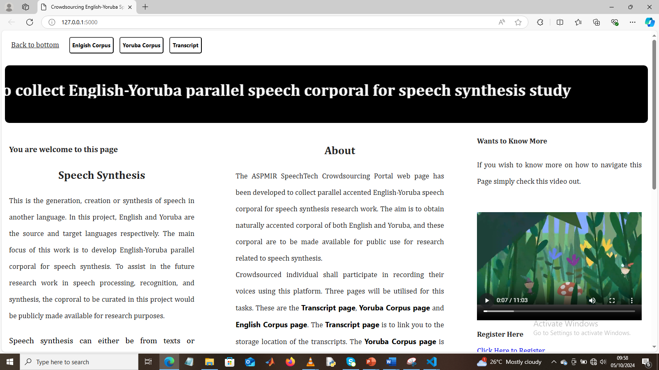
[Figure 3.6: The Home Page]

6.4.2 The English Corpus Page
The English Corpus page is where the users are expected to record their voices for the English audios. It has a recording bottom that the users engage with. This consists of Start, Pause and Stop bottom. Once activated by a user, the microphone on the smart devices which can a laptop, a mobile phone is activated to start the recording. A user may decide to pause the recording probably due to interruption, and resume at a later time by pressing the Pause bottom twice to resume from where they stop, and finally a stop bottom to end the recording for that particular transcripts. The recorded audio is saved as a .wav extension with a sampling rate of 48 KHz. Information on how to make selection of texts from the storage via the transcripts page, saving of recorded audio etc., are also given in this page. The page also contains some text areas for user engagement for pasting their intended texts to be recorded. A link to the audio storage space is also provided on this page. It also contains recording audio information such as length, type (general or public health), accent, and file named.
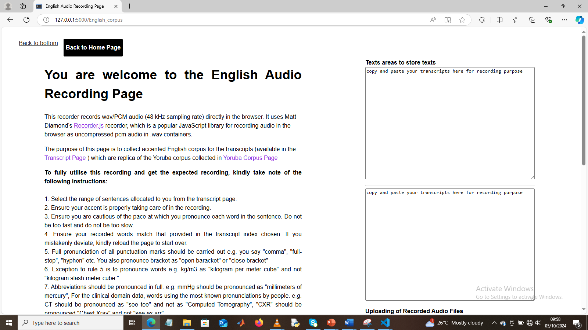
[Figure 3.7: The English Corpus Page]

6.4.3 The Yoruba Corpus Page
This is the page where users are expected to record their Yorùba audio of the selected texts. It works similar to the English Corpus page and same interface. Users may decide to do the recording of the English and corresponding Yorùba audios on the Yorùba Corpus page or both on the English Corpus page based on their choices.
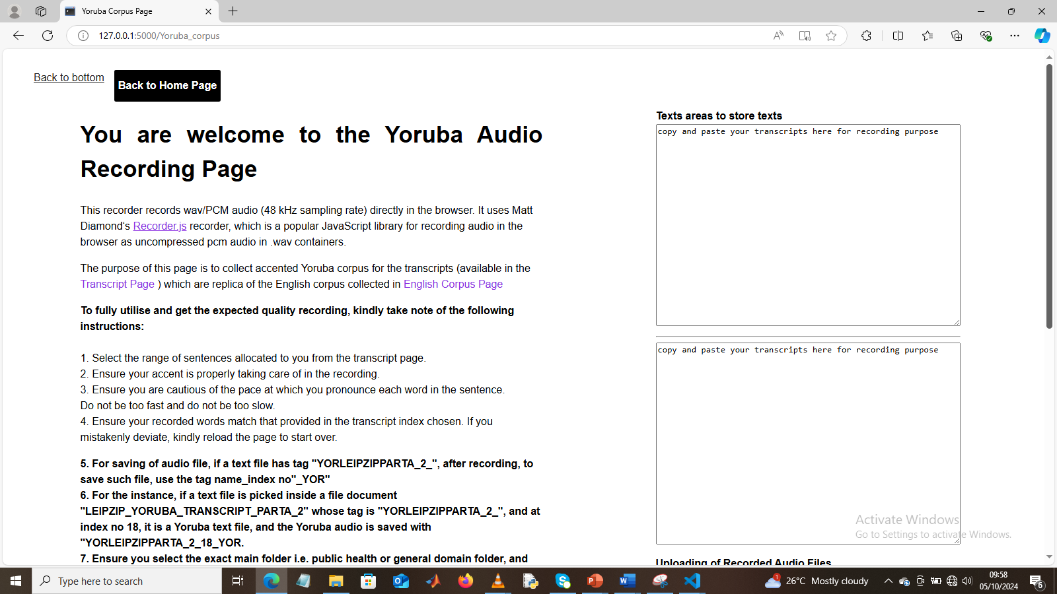
[Figure 3.8: The Yoruba Corpus Page]

6.4.4 Transcripts Page
Via the transcripts page, the participants have access to the storage database where texts transcripts of the English and Yorùba equivalent are stored. The transcripts page contains information on how to navigate the page to access these files. It has hyper links to the general domain texts storage, public health domain texts storage, English Corpus page, Yorùba Corpus page, and Home page, as well as links to some selected databases such as NCBI, Mozilla Common Voice, PubMed, Youtube Videos etc.
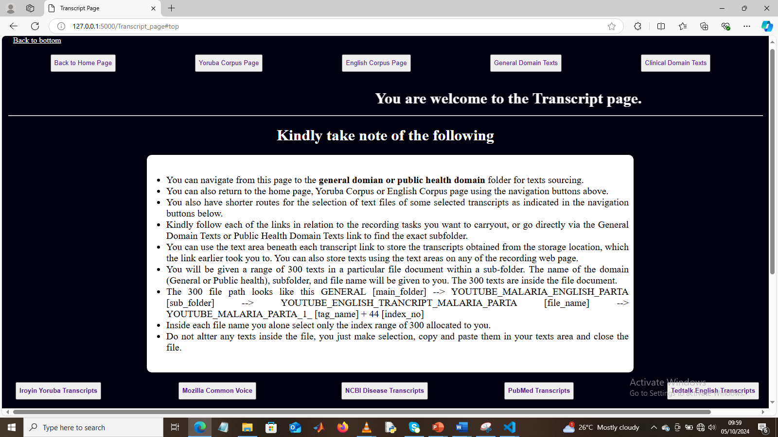
[Figure 3.9: The Transcript Page]

6.5 Development of Manifest Files
Manifest files are files that contain the metadata and texts information of each audio file. In this work. It was created for 60 % of the total datasets allocated for public health domain and 40 % for general domain. A manifest file could be prepared using a normal text editor, json file, yaml file, excel file etc.

6.5.1 Manifest File for each Speaker
At speaker level, manifest files were created using text editor. They were created for both English and Yoruba per speaker folder. A typical example of the manifest file developed contains the information shown in Figure A.
{
"metadata": {"project_name": "General Speech Corpus",
"discreption": "A speech corpus for general related terms and discussions",
"version": "1.0",
"speaker_id": "SPK_060",
“gender”: “female”,
"domain": "General",
"language": "English",
"sampling_rate": "48000" },
"audio_files":[{'file_name': 'YORLEIPZIPPARTD_4_SPK_000UI_NEW5_ENG_1000.wav', 'speaker_ID':
'speaker_000', 'duration': '2.389333', 'bit_rate': 768.0, 'file_size': 229420}
{'file_name': 'YORLEIPZIPPARTD_4_SPK_000UI_NEW5_ENG_1001.wav', 'speaker_ID':
'speaker_000', 'duration': '5.888000', 'bit_rate': 768.0, 'file_size': 565292}]
}
Figure A: Manifest File for Each Speaker Recording
These manifest files were included in each speaker’s folder for both English and Yoruba alongside a metadata text file, and as well as audio and transcripts folder. The audio folder is to be used by each speaker to store their recorded audios of the transcripts made available in the transcripts folder. The aforementioned manifest files and metadata were used to extract speaker, text and audio information of each speaker. These were prepared specifically for audio collation of each speaker folder.

6.5.2: Transcripts and Audio Manifest File
Another manifest file was developed using excel spreadsheet that has five columns. The first column consists of the Yoruba filenames of audios. Yoruba transcripts, English transcripts, English filenames of audios, and domain occupied the second, third, fourth, and fifth columns. These were prepared for each institution grouped by the domain. This is the document that is to be used alongside the audio files during model development, as it contains the audio filenames and corresponding transcripts of all audios recorded. These were prepared after audio collations of all speakers’ folders per domain of each institution.

6.6 Development of Metadata Files
Texts files containing the statistics of audio files at speaker folder level, domain level, institutional level, combined domain level, and combined institutional level were prepared, detailing the statistics of the curated corpus such as the number of audios recorded, number of lines of texts, total hours of audios etc. These metadata were also prepared using excel documents. The metadata serves to acquaint the readers with first-hand information about the corpus to enable them to know how to make their choices of any sections of the dataset for their speech works.

6.7 Focus Language
The source and target languages whose speech corpora were curated are English and Yoruba, respectively. For the state-of-the-art result to be obtained, the accents of the speakers were taken into consideration. In Nigeria official settings such as educational, private, and government institutions, the Yoruba dialect of Oyo is used for communication. Hence, the Oyo Yorùba dialect was taken into consideration which is to be spoken across different Yorùba accents. Different speakers of different Yoruba tribes across the different institutions visited recorded their audios using Oyo Yoruba dialects using their individual accent.

6.8 Sourcing of participants
Participants were sourced from 4 institutions within the Southwestern geopolitical zone of Nigeria. The 4 institutions visited are University of Lagos, Lagos State, Nigeria (UNILAG); Lagos State University, Lagos State, Nigeria (LASU); Federal University of Agriculture Abeokuta (FUNAAB), Ogun State, Nigeria; and University of Ibadan, Oyo State, Nigeria (UI). Obafemi Awolowo University, Ile Ife (OAU) was also visited but their services could not materialize due to time unavailability. The choice of these locations was based on dominancy of the Yorùba ethnic group within these locations. Participants within the age range of 18 years and above including staff and students were engaged per institution. The initial plan was to utilize a 5-working day for each institution. But due to time constraint, engagement with participants was carried out at UNILAG for four (4) working days, for the recording exercises. For the other three (3) institutions, WhatsApp groups were created to engage the participants, prior to at least a day visit in each institution to see the faculty head and acquaint them with the audio recording project to be carried out. Each participant was tasked with 200 audio recordings each of English and corresponding Yorùba. Each participant is rewarded with at least $ 7 (Olatunji et al., 2023).

6.9 Obtaining Consent
A letter of informed consent containing information and consent section of the recording exercise was made available to the participants both physically and virtually via the recording platform, via which their consents were sought prior to commencement of the recording activities.

6.10 Registration
Crowd-sourced individuals were instructed to register their details using the Google form provided via the link on the home page of the web applications. This facilitates knowing their statistics. Registration was meant for individuals just joining the speech work. Other approaches to knowing the number of participants were via lists passed in the WhatsApp group. The registration gave information about the institutions, age group, sex, and tribe of those participated in the project.

6.11 Audio Recording
The curation of speech data involves recording selected text files made available to the crowdsourced individuals. The recordings were carried out for this task using the developed online web application [18], [22] to accelerate the curation exercises. Participants haven’t being allocated speakerIDs were directed to the storage location via links sent to them, to locate their speakerID folder. The transcripts (200 lines of texts each of English, and Yoruba) to be recorded were stored inside the speakerID folder of each speaker. Participants were expected to identify or label each audio file with the same tag on the text file with the addition of “_ENG” for English and “_YOR” for Yoruba. For instance, if English and corresponding Yoruba texts tag read: YORMOZPARTA_1_2, the audio files read: YORMOZPARTA_1_2_ENG, and YORMOZPARTA_1_2_YOR for English and Yorùba audio respectively [46]. For a particular index number in the text file. For instance, index number 004, the files are named as YORMOZPARTA_1_2_ENG_004.wav, and YORMOZPARTA_1_2_YOR_004.wav for English and Yorùba audio respectively This ensures easy identification and orderliness and aids in the training of the ML models developed. Each participant was tasked to produce 200 audio recordings of both English and Yoruba texts. They were duly notified to take the accent [18] into consideration during each recording because the project lays more emphasis on the accent of the speakers as well as the speech.

6.12 Instructions

6.12.1 Recording Instructions
Participating individuals were instructed to record in groups, for instance, recording 5 lines of English texts, and save properly, and continue with that trend till the whole 200 lines of texts for English is completed. Then pick up the Yoruba texts and follow same approach to ensure efficiency and neatness of their work. Others who prefer to record same line of texts in English and Yoruba simultaneously were also encouraged to do if that will make their work convenient for them. Participants were also instructed to ensure the file name, particularly the index no for each audio corresponds to the index number of the line of texts being recorded.

6.12.2 Annotation Instructions
At first, recorders were tasked to read out punctuation marks in full such as saying “full stop”, “comma”, “question mark,” etc., [18] where appropriate – this instruction was given to participants at UNILAG and the first 2 sets of audios recorded at UI (UI_1 and UI_2). For other sections of the dataset (major), crowd-sourced participants were instructed to record fluently, and seamlessly without the punctuation marks, while only observing them in the recordings, and to also ensure their accent is maintained. Participants were instructed to ensure that what is read out is the same as what is in the transcripts, taking note of some annotations such as snap, abrupt, external [noise], hesitation etc., available on some texts. Recorders were also given a text-to-speech online platforms that they could input their texts into to get correct pronunciation of some words (particularly the malaria related words) to be sure of using the exact pronunciation in the recording. Examples of such is the OpenAI platform.
They were further given instruction on how to record html links. They were told to pronounce each character out as available in the texts e.g. https://www.justtellmenow.com should be recorded as h t t p s colon slash slash w w w dot j u s t t e l l m e n o w dot c o m or where words are seen within the link should be pronounced as words instead of individual letter e.g. same link: https://www.justtellmenow.com will be recorded as h t t p s colon slash slash w w w dot just tell me now dot com – this is to be replicated same way for both English and Yoruba audios recorded for any lines of texts containing hyperlink.
For abbreviated medical terms, they were instructed to record the full meaning where available else the abbreviations. Where units are involved, the interpretations of the units were made available in brackets close to the units. E.g for values like 2.5 mg /dl, it was made available as 2.5 mg /dl (2.5 miligram per decilitre). This is to ensure correct pronunciations and interpretations are given to such values.

6.12.3 Saving and Storage Instructions
They were further instructed of the purpose the curation exercise, that is parallel English and Yoruba meaning the contents of both English and Yoruba per line should be same. Hence, they should ensure they save appropriately and also ensure to record efficiently as earlier instructed to achieve these needed alignments.

6.13 Feedback
A Google form was made available to harness information on how the participants feel about their participation on the recording exercises. They were asked to provide feedback on what to improve on, such as the web application interface, navigation of the pages, the transcripts given out. Some of these feedback were used as quality check to make the project more efficient for subsequent ones.

7. Storage of Curated Corpora
Participants stored the recorded audios inside the ENGLISH and YORUBA folders available in their speakerID folder using the links initially given to them. They uploaded to their folder ID and notify the instructor of the completion of their tasks for verification and processing. This way, this ensures speaker001 200 English audios and 200 Yoruba audios are properly saved inside speaker001 folder, and do not mix up with another speaker, say speaker002 whose audios are kept inside the speaker002 folder.

8. Other Steps for Data Curation
This details other engagements embarked upon for the successful curation of the English-Yorùba speech parallel corpora. It involves the application for ethical approval, and development of an informed consent form

8.1 Application for Ethical Approval
The ethical approval was obtained from the Covenant Health Research Ethics Committee (CHREC). The CHREC is duly registered with the National Health Research Ethics Committee of Nigeria (NHREC). The requirements for ethical approval include an application form, an abridged CV of the Supervisor, inform consent form, a proposal, and online training called (Collaborative Initiative Training Institutes, CITI), and a payment of #5000.00. All these requirements were met, and an ethical approval (certification & letter of approval) was granted prior to commencement of the recording exercises.

8.2 Development of informed consent form
This is the 2-page form that details the information about the curation exercises on one page, and a consent form on the second page. The template obtained from the CHREC was used to develop the participants’ informed consent form.

8.3 Letter of Introduction
As the name implies, it contains information that introduces what the exercises are all about. It gives the crowd-sourced individual to know about the researcher such as the institution, supervisor, area of interest, affiliation, etc. It consists of the following: introduction, project overview, purpose of data collection, target population, data collection methods, confidentiality, and anonymity, as well as contact information of the researcher.

9. Preprocessing of the completed 400 Audios per participant
Each crowd-sourced individual reported the completion of their tasks with notification of their speakerID folder. Inside each folder sit two main folders and three files. The two folders are named ENGLISH and YORUBA, inside each are contained AUDIOS folder (containing 200 audios recorded) and TRANSCRIPTS folder (containing transcripts.txt file given). The three other files are texts files containing the statistics of the speaker, manifests files for English and Yoruba.
The renaming of all audios within the AUDIOS folder of each of ENGLISH and YORUBA was first carried out. This ensures the audio filenames correspond to the default naming convention of audio files mentioned in section 6.9. A Python code was developed to rename the audios and identify missing index numbers for efficient purposes rather than looking through the whole 200 audios for missing index numbers (identification of missing files for individual who reported less than 200 audios in each AUDIOS folder).
The 200 file names of all audios in each English and Yoruba were extracted using another Python code tailored to that function and saved inside text files as manifest files. The manifest file also contained metadata information such as the description of the recorded audios, speakerID, gender, language, and sampling rate, as well as the information of the audios such as the duration, bit rate, and file size – these were done for English and Yoruba. The last text file contains detailed metadata of the audios and texts for each speakerID. Example of descriptive statistics available are number of audios for both source and target languages, length of audios for both source and target languages, minimum, maximum, and average length of audios for both source and target languages, number of lines of texts for both source and target languages, number of words, number of unique words, minimum, and maximum length of words for both source and target languages. It also contains the gender and speakerID info.
To ensure audios and texts are aligning at sentence level as made available to the participants, audios are selected at random from each AUDIOS folder and played to ensure the contents aligns with the line of texts being played -this was done for both English and Yoruba. There were times, deviations were spotted in the saved audios. In these instances, corrections were made by renaming the audios with carefulness to ensure the needed alignment is obtained.
All the processed speaker sub-folders for general were stored in the same folder-same was also done for public health domain speakerIDs. Each 200 English audios from each speakerID for all general were later merged into a single folder and renamed appropriately using Python code developed. Their corresponding transcripts were also extracted orderly into Excel documents to ensure the renamed audios correspond to each line of texts. Further normalization of the texts files to remove all numerical values was carried out again at this stage prior to extraction and saving in the excel documents. This was also done for Yoruba General, as well as English and Yoruba of public health domain. In another case, grouping of audios was done using gender where male audios were separated from female audios.
The metadata and manifest files of all the audios per institution per domain have been made available in the database alongside the corpus for detailed comprehension of the dataset.

10. Evaluation of the Corpus / Machine Learning Training – S2ST Model Training

10.1 Quality Assurance
To ensure the recorded audios were of high quality or typical of the audios needed for speech processing applications and to ensure the remainders of the recording exercise are strictly professionally embarked on based on the feed back via this quality check, a group of audios were selected per institution when the total number of audios was 96,195 per language. The selection was done using two different sampling types including stratified and systematic sampling. A language linguist who is an expert in both English and Yoruba language was consulted to do this task.

10.1.1 Sampling Method
The sampling approach used for audio selections involves random selection of audios using random module in Python. To ensure deviation do not exist at any time the code is run, and also avoiding bias, the code was seeded. The other selection strategy was to use a fixed length interval where audios were selected in each stratum (e.g. institution’s general or public health domain, or based on gender) at a fixed interval from each other based on the total number of audios. This was done with the step input argument in Python range method. The total samples selected out of the pool of 96,195 audios was based on two strategies involving 95 % confidence with $±5\%$ margin of error and 5 % each where each provided a total of 384 and 4812 audio samples respectively. This implies two different (384 & 4812 pool of selected audios) were made available to the language linguist for quality check.

10.1.2 Percent Confidence with +-5% Margin of Error
This is a statistical approach that led to choice of a total of 384 audio samples being selected for quality check of the audios out of the total of 96,195 audios.
For a population of size, N, the sample size, n is calculated using Cochran Formula [@1] equation (1) as:
$n=\frac{z^{2}*p*(1-p)}{e^{2}}$ (1)
Where:
$$z= Z-score for the confidence level$$
For $95\%$ confidence, $z=1.96$
$p=$ estimated proportion of the population with the characteristic of interest (often set to 0.5 for maximum variability)
$e=$ margin of error (commonly $0.05=5 \%$)
$$n=\frac{{1.96}^{2}*0.5*(1-0.5)}{{0.05}^{2}}$$
$$n=\frac{3.8416*0.5*0.5}{0.0025}$$
$$n=\frac{0.9604}{0.0025}=384.16≈384$$
Hence, all institutions share a proportion of the 384 audio samples as indicated in Table b.
The audio selection involves random selection using python code for all institution except UI_4_GEN where fixed length interval was utilized for male and female strata.
[@1 ORIGINALARTICLE Comparison of Surgical Site Infections in Emergency Laparotomy and Elective Laparotomy Fazal Ullah, Gohar Ali, Muhammad Bilal, Shahid Munir, Musarrat Hussain]
Table b: Two Scenarios Audio Selection
S/N | Strata |  | Total Samples | Scenario 1 (95 % Confidence = 384) | Scenario 2 (5 % audios = 4812)
1 | UNILAG_GEN |  | 2103 | 8 | 105
2 | UNILAG_PH |  | 2150 | 9 | 108
3 | FUNAAB_GEN |  | 4980 | 20 | 249
4 | FUNAAB_PH |  | 3973 | 16 | 199
5 | LASU_GEN |  | 788 | 3 | 39
6 | LASU_PH |  | 193 | 1 | 10
7 | UI_1_GEN |  | 6704 | 27 | 335
8 | UI_1_PH |  | 9841 | 39 | 492
9 | UI_2_GEN |  | 7750 | 31 | 388
10 | UI_2_PH |  | 11339 | 45 | 567
11 | UI_3_GEN |  | 597 | 2 | 30
12 | UI_3_PH |  | 19073 | 76 | 954
13 | UI_4_GEN | Male | 3195 | 13 | 163
 |  | Female | 8756 | 36 | 445
14 | UI_4_PH |  | 9374 | 37 | 469
15 | UI_5_GEN |  | 399 | 2 | 20
16 | UI_5_PH |  | 4780 | 19 | 239
Total |  |  | 96195 | 384 | 4812

10.1.3 Five Percent of Audios in Each compressed folder per institution
Here 5 % of the total 96,195 audios (4809.75) was selected. Then this was shared in proportion across all the institution. It is shown in Table b for each institution’s proportion. For each institution, as seeded random number generator in Python was utilized for all institutions except UI_4_GEN where fixed length interval was used for male and female strata.
10.2 Pseudo Code for Audio Selection
The pseudo code for audio selection for the scenario of random number selection of audio approach is given in Algorithm a.
Algorithm a: Pseudocode of randomly selected audios
For each partition in dataset:
total_samples = number of audios in partition
sample_size = number of audios to select (from Scenario 1 or Scenario 2)

If partition is UI_4:
Split into male and female subsets
male_total = 3195
female_total = 8756
male_sample_size = proportional count (e.g., 13 or 158)
female_sample_size = proportional count (e.g., 36 or 450)

Randomly select male_sample_size from male_total
Randomly select female_sample_size from female_total
Else:
Randomly select sample_size from total_samples

Save selected IDs for QA log

10.2 Experiments
To test the quality of the GC-ENYO speech curated, various experiments such as speech generation from spectrograms, TTS, and ASR were carried out using Hp Victus 15 Gaming Intel Core I7 13th Gen 900 GB hard disk, 8GB Ram 15.6" RTX 1350 8GB GPU, Windows 11. Windows Subsystem for Linux and Jupyterlab were installed to facilitate the training carried out.

10.2.1 Spectrogram to Speech Experiment
For the speech to spectrogram experiment, a fraction of the dataset of 1000 audios from UI_3 for Yoruba of GC-ENYOR dataset curated for speech processing application, was utilized for transfer learning. The data was split into 900 for training and 100 for validation. It consists of female audio samples with the contents being malaria public health talks. The transfer learning was carried out using the HiFi-GAN pretrained checkpoint (taking that of the vocoder). The HiFi-GAN was cloned to the local system alongside the vocoder checkpoint for HiFi-GAN (used for CoquiTTS). Prior to finetuning, the audios were first resampled to sampling rate of 22050 Hz to align with the training setup of HiFi-GAN. The spectrograms of all the audios were generated using the tacotron2 spectrograms generation python code where the mel frequency, windows size, hop size, sampling frequency were set to 80, 1024, 256, and 22050 Hz respectfully. Other hyperparameters such as the epoch, the Adam optimiser, gamma loss weight, learning rate decay, gradient clipping, sampling rate were set in the config file. Starting from the pretrained checkpoint of g_0000000 for the generator, finetuning commenced. At about 11000 global steps, the finetuning checkpoint files when tested was already generating Yoruba speech (unintelligible). At about 27K global steps, around 492 epochs, the audio generation was also tested using the generator checkpoint file. It produced intelligible Yoruba speech which still needed to be finetuned further for clarity. Testing was carried out using audio samples used for training and unseen audios, and both produced speech output showing the finetuning not only memorise but also generalize well. The comparison between the reference and generated spectrograms of three audio female samples at epoch 492 are shown in Figures 1, 2, and 3.

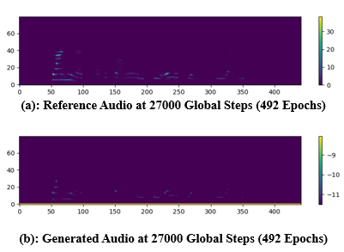
Figure 1: Reference Versus Generated Spectrograms - Audio Sample 1

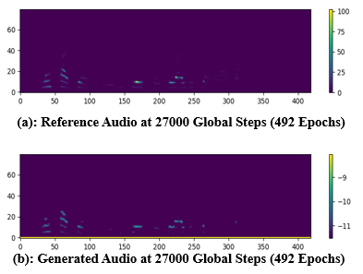
Figure 2: Reference Versus Generated Spectrograms - Audio Sample 2

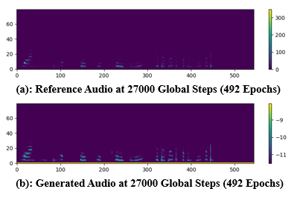
Figure 3: Reference Versus Generated Spectrograms - Audio Sample 3
A graph of the generation total loss (gen_loss_total), melspectrogram error for training and validation (mel_spec_error) are shown in given in Figures 4, 5, and 6 for upto 35,000 plus global steps. it can be shown that at about 27K global steps, the generator total loss was around the 20, which is typical of results range of within 18 to 50 around 20+ global steps. At this same global steps, the the mel_spec_error for training was around 0.06 while that of validation gave a value of about 0.15, and the score balance as measured at this same period gave a value of about 1.06 which is approximately 1 which shows the generator and discriminator are both in a stable state. It can also be seen that at about 11,000 global steps when first set of audios were produced, that the mel spectrogram error for validation in Figure 6 with a sharp curve decrease to a lower value of 0.17, after which it reduces further to 0.16 and remains constant at at this value up till about 35000 global steps. Furthermore, the hyperparameters such as the learning rate decay, learning rate were adjusted to ensure the training converge in time.

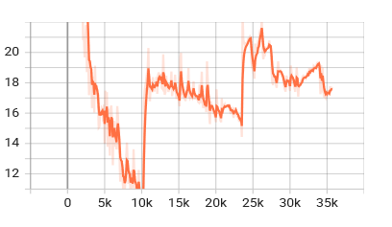
Figure 4: Generator Loss Total
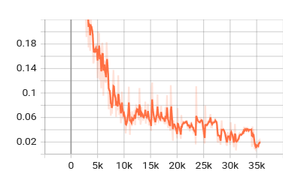
Figure 5: Mel Spectrogram Error (Training)
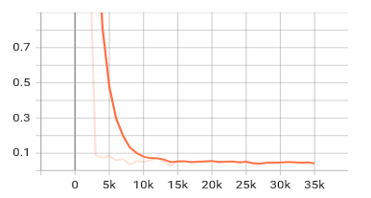
Figure 6: Mel Spectrogram Error (Validation)

Due to the need to generate high clearer Yoruba speech, finetuning was resumed at around the 492 epoch, and at about 1231 epochs equivalent of 81000 global steps, the model developed was again tested. It was discovered it made little difference in terms of audio intelligibility when compared to that obtained at 27000 global steps.

10.2.2 Comparison of Results with Developing an Open-Sourced Dataset
To compare the previously obtained results of HiFi-GAN finetuning using the GC-ENYOR dataset, data samples of 1000 audios were selected from the Developing an Open-Source dataset. It was also split into 900 for training and 100 for validation. The statistics of the audios are illustrated in Table 1. It shows that GC-ENYOR has a total length of 1000 audios to be 7854.353878 secs (2.18 hrs.) while that of the Developing an open source is 3845.461 secs (1.07 hrs.). Developing an Open Source is a Yoruba dataset that has the dataset partitioned into Male and Female parts. It was selected because it is rich in Yoruba words with Yoruba accents properly captured in the recording and texts with tonal marks. The 1000 randomly selected audios were female audios utilized for this comparison. Also, in comparison with GC-ENYOR dataset, the selected audios were generally human conversations unlike public health (malaria specific) selected for the GC-ENYOR dataset and utilized for the training.

Table 1: Statistics of GC-ENYOR and Developing an Open-Sourced Dataset
S/N | Feature | GC-ENYOR (Yoruba) | Dev Open-Source
1 | Sample count | 1000 (900 train, 100 validation) | 1000 (900 train, 100 validation)
2 | Min audio length | 1.706 sec | 1.536 sec
3 | Max audio length | 30.72 sec | 11.178 sec
4 | Average length | 7.854 sec | 3.845 sec
5 | Total duration | 7854 sec (~2.18 hours) | 3845 sec (~1.07 hours)
6 | Speech emergence | 11k steps | 13k steps
7 | Training stability | Loss spike at 28k (catastrophic, required reset) | Stable, no spikes
8 | Noise in outputs | Faint background noise | Faint background noise
9 | Plateau | 35k steps, no further improvement | 35k steps, no further improvement

Finetuning commenced with a generator pretrained checkpoint of g_0000000, and proper monitoring of the log was carried out. Finetuning, which commenced with a higher generation loss of about 187, mel spec error of 3.992 and score balance (s/b) of 10.594 later stabilized as training continued. At about 13,000 global steps, speech like audio was generated unlike the GC-ENYOR that generated same at about 11,000 steps. This can be attributed to the smaller audio lengths available in the Developing an Open-Source dataset with an average of 3.845461 secs which is small in comparison to 7.854354 secs for GC-ENYOR. This implies the GC-ENYOR has enough features within each audio for the training to learn from to produce results at such a lower global step. It also implies the GC-ENYOR's longer utterances signify richer prosody and phonetic diversity. Both produced similar results at approximately 27, 000 global steps, 492 epochs, when tested on both seen and unseen audios. It was further observed that as training continued beyond 28,000 steps, GC-ENYOR was spiking as seen in the Gen_loss total, which was already given hundreds, then thousands, then millions of values, which prompted early stopping and updating to the configuration file before resuming training. This means the longer sequences stress adversarial balance. For Developing an Open-source dataset, training stabilized beyond 28,000 global steps, that implies shorter utterances leads to smoother training, and no catastrophic spikes.
It was also observed that there was no improvement in the audio generated for both GC-ENYOR and Developing an Open-Source datasets beyond 28,000 steps. As a final observation, which is probably due to issues with the inference scripts utilized, faint background noises were heard inside the audio generated for both, which degraded the speech produced. Some of the finetuning results for both datasets are shown in Table 1.
A comparison of the generated and original spectrograms for both GC-ENYOR and Developing an Open-Source at 27K global steps are shown in Figure 7.
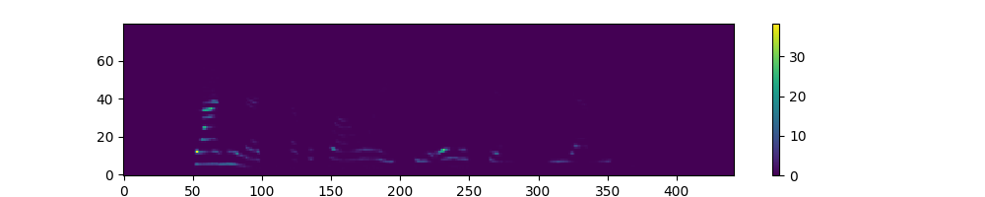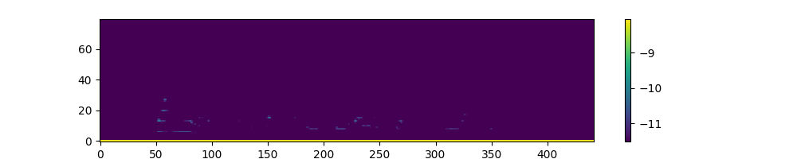
GC_ENYOR_Ref1 GC_ENYOR_Gen1

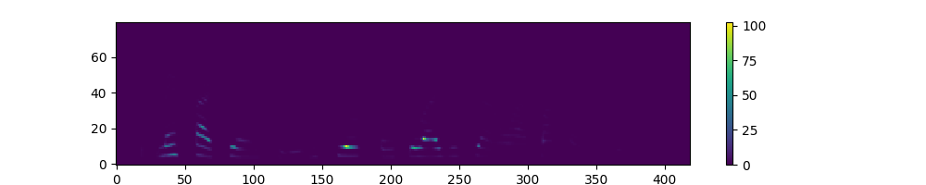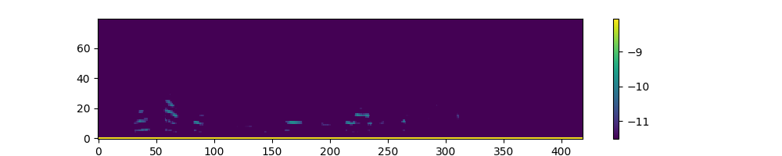
GC_ENYOR_Ref2 GC_ENYOR_Gen2
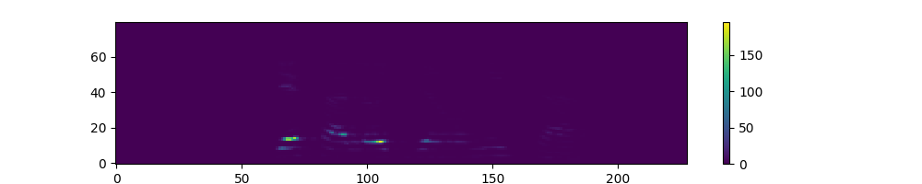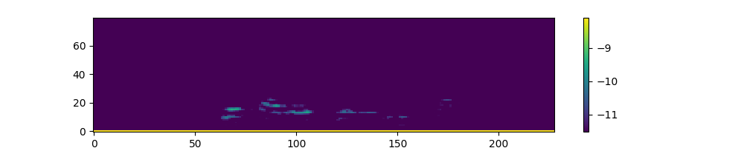
Dev_Ref1 Dev_Gen1
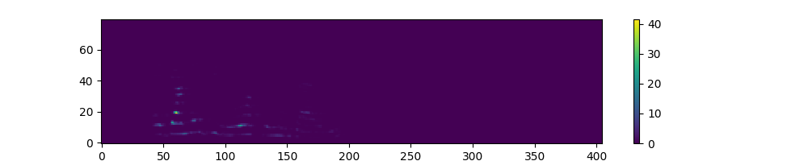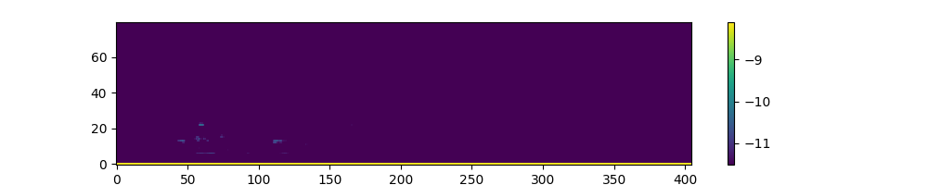
Dev_Ref2 Dev_Gen2

Figure 7: Reference Versus Generated Spectrogram Comparison of both Datasets

Figure 7 shows that both reference and generated look alike for both datasets.

For further comparison, Figures 8, 9, and 10 show the training_gen_loss_total, training_mel_spec_error, and validation_mel_spec_error for both datasets at 35000 global steps.

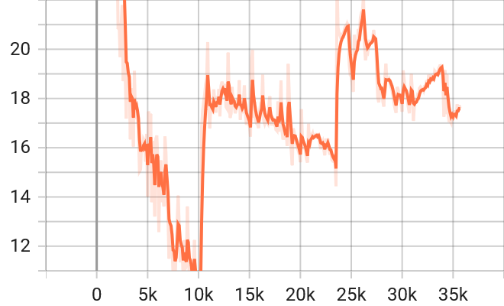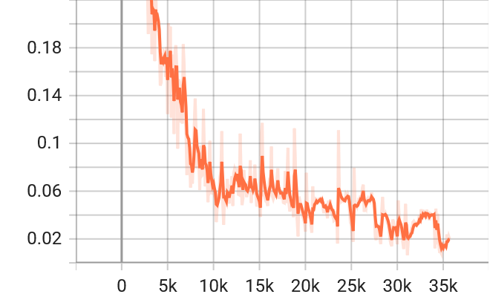
GC_ENYOR_train_gen_loss_total GC_ENYOR_training_mel_spec_error

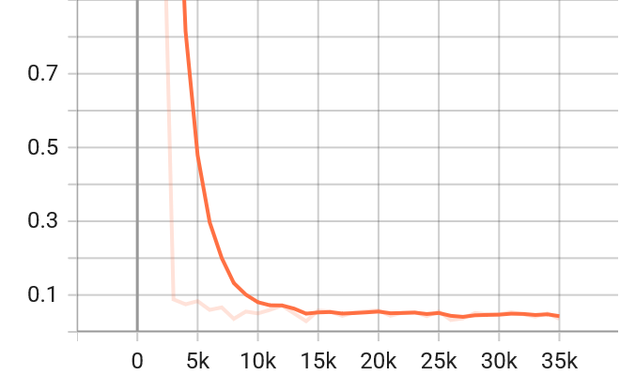
GC_ENYOR_validation_mel_spec_error

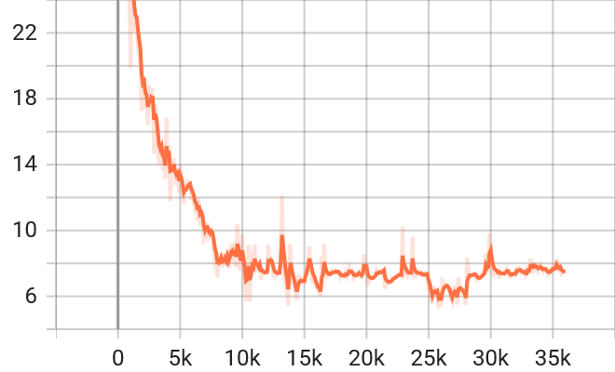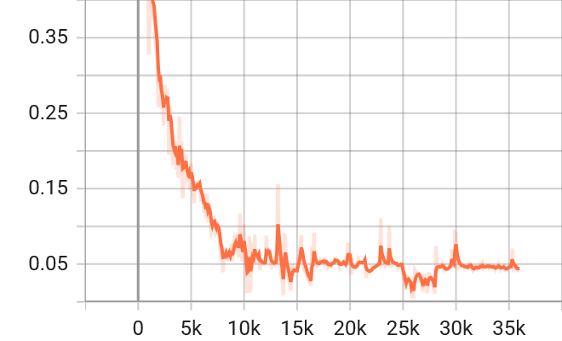
Dev_train_gen_loss_total Dev_training_mel_spec_error
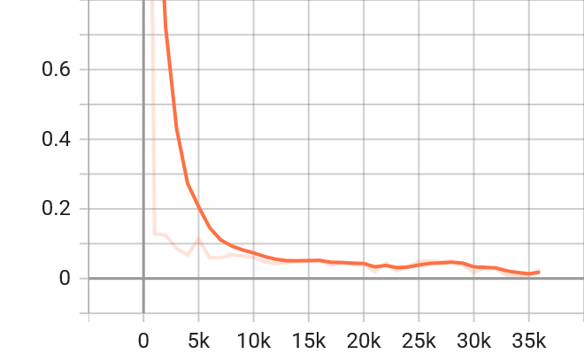
Dev_validation_mel_spec_error

Figure 8: Comparison of Loss Metrics for both Datasets

Figure 8 shows that at about 25K steps, GC-ENYOR has gen_loss_total for training to be 19 while that of Developing an Open Source was 6. This suggests GC-ENYOR’s generator is struggling more to fool the discriminator, indicating less stable adversarial training at that point. Again, the mel_spec_errors for training were 0.03 and 0.025 for GC-ENYOR and Developing an Open-Source datasets at same 25K steps. This implies both are close, but Open-Source is slightly lower, meaning it reconstructs spectrograms with marginally better accuracy at the same step. Finally, the mel_spec_error_validation for GC-ENYOR dataset was already around 0.09 at 10,000 global steps and remained same from 15K to 35K steps with value of 0.05. The Developing an Open-Source dataset has 0.08 at 10K steps, which decreases to a value of 0.04 at about 23K after which it spiked up again to 0.05 at about 28K steps and finally reduced to a lower best value of around 0.01 at 35K steps. This means GC-ENYOR reached a stable but limited performance ceiling, showing little improvement after 15K, whereas the Developing an Open-Source dataset continued improving, showing resilience and better generalization, despite a temporary instability. Conclusively, the two experiments show that GC-ENYOR has Faster early convergence (speech emergence earlier, validation error plateau by 15K), but limited improvement afterward and higher generator loss suggests dataset richness but training instability. The Open-Source is slower start, but with a steady improvement, lower generator loss, and eventually much better validation error of approximately 0.01 indicates stronger generalization and stability.

10.2.3 TTS Experiment

10.2.4 ASR Experiment

10.2.5 Subjective Evaluation - MOS

11. Conclusion

Acknowledgements
The authors wish to acknowledge the Covenant University Center for Research, Innovation and Discovery (CUCRID) and Google for providing funds towards the publication of this study.

References
[1] M. A. Di Gangi, R. Cattoni, L. Bentivogli, M. Negri, and M. Turchi, “Must-c: a multilingual speech translation corpus,” in Proceedings of the 2019 Conference of the North American Chapter of the Association for Computational Linguistics: Human Language Technologies, Volume 1 (Long and Short Papers), 2019, pp. 2012–2017.
[2] A. C. Kocabiyikoglu, L. Besacier, and O. Kraif, “Augmenting librispeech with french translations: A multimodal corpus for direct speech translation evaluation,” arXiv preprint arXiv:1802.03142, 2018.
[3] R. Zhang et al., “Bstc: A large-scale chinese-english speech translation dataset,” arXiv preprint arXiv:2104.03575, 2021.
[4] B. Beilharz, X. Sun, S. Karimova, and S. Riezler, “LibriVoxDeEn: A corpus for German-to-English speech translation and German speech recognition,” arXiv preprint arXiv:1910.07924, 2019.
[5] J. Iranzo-Sánchez et al., “Europarl-st: A multilingual corpus for speech translation of parliamentary debates,” in ICASSP 2020-2020 IEEE International Conference on Acoustics, Speech and Signal Processing (ICASSP), 2020, pp. 8229–8233.
[6] C. Wang, A. Wu, and J. Pino, “Covost 2 and massively multilingual speech-to-text translation,” arXiv preprint arXiv:2007.10310, 2020.
[7] W. I. Cho, S. M. Kim, H. Cho, and N. S. Kim, “Kosp2e: Korean speech to english translation corpus,” arXiv preprint arXiv:2107.02875, 2021.
[8] J. R. Kala, E. Adetiba, A. Abayom, O. E. Dare, and A. H. Ifijeh, “Speech to Speech Translation with Translatotron: A State of the Art Review,” arXiv preprint arXiv:2502.05980, 2025.
[9] S. Stüker, F. Kraft, C. Mohr, T. Herrmann, E. Cho, and A. Waibel, “The KIT lecture corpus for speech translation,” in Proceedings of the Eighth International Conference on Language Resources and Evaluation (LREC’12), 2012, pp. 3409–3414.
[10] Y. Jia et al., “Direct speech-to-speech translation with a sequence-to-sequence model,” in Proceedings of the Annual Conference of the International Speech Communication Association, INTERSPEECH, International Speech Communication Association, 2019, pp. 1123–1127. doi: 10.21437/Interspeech.2019-1951.
[11] O. Julius, I. C. Obagbuwa, E. B. Michael, A. A. Adebiyi, O. Deborah, and S. P. Akinrinwa, “Direct English-to-Yoruba speech Translation model using Transformer with Augmented Attention Mechanism,” in 2024 IEEE 5th International Conference on Electro-Computing Technologies for Humanity (NIGERCON), 2024, pp. 1–6.
[12] P. Jeuris and J. Niehues, “Libris2s: A german-english speech-to-speech translation corpus,” arXiv preprint arXiv:2204.10593, 2022.
[13] A. Conneau et al., “Fleurs: Few-shot learning evaluation of universal representations of speech,” in 2022 IEEE Spoken Language Technology Workshop (SLT), 2023, pp. 798–805.
[14] Y. Jia, M. T. Ramanovich, Q. Wang, and H. Zen, “CVSS Corpus and Massively Multilingual Speech-to-Speech Translation,” Jan. 2022, [Online]. Available: http://arxiv.org/abs/2201.03713
[15] C. Wang et al., “VoxPopuli: A large-scale multilingual speech corpus for representation learning, semi-supervised learning and interpretation,” arXiv preprint arXiv:2101.00390, 2021.
[16] M. Post, G. Kumar, A. Lopez, D. Karakos, C. Callison-Burch, and S. Khudanpur, “Improved speech-to-text translation with the Fisher and Callhome Spanish-English speech translation corpus,” in Proceedings of the 10th international workshop on spoken language translation: papers, 2013.
[17] Y. Jia, M. T. Ramanovich, T. Remez, and R. Pomerantz, “Translatotron 2: High-quality direct speech-to-speech translation with voice preservation.” [Online]. Available: https://google-research.github.io/
[18] T. Olatunji et al., “AfriSpeech-200: Pan-African Accented Speech Dataset for Clinical and General Domain ASR,” Sep. 2023, [Online]. Available: http://arxiv.org/abs/2310.00274
[19] Z. Yang et al., “Open source magicdata-ramc: A rich annotated mandarin conversational (ramc) speech dataset,” arXiv preprint arXiv:2203.16844, 2022.
[20] P. Ogayo, G. Neubig, and A. W. Black, “Building African Voices,” arXiv preprint arXiv:2207.00688, 2022.
[21] H. Bu, J. Du, X. Na, B. Wu, and H. Zheng, “Aishell-1: An open-source mandarin speech corpus and a speech recognition baseline,” in 2017 20th conference of the oriental chapter of the international coordinating committee on speech databases and speech I/O systems and assessment (O-COCOSDA), 2017, pp. 1–5.
[22] A. Gutkin, I. Demirsahin, O. Kjartansson, C. Rivera, and K. Túbòsún, “Developing an open-source corpus of yoruba speech,” in Proceedings of the Annual Conference of the International Speech Communication Association, INTERSPEECH, International Speech Communication Association, 2020, pp. 404–408. doi: 10.21437/Interspeech.2020-1096.
[23] T. pé Ógúnrè mí, K. lá Túbò sún, A. Aremu, I. Orife, and D. Ifeoluwa Adelani, “ÌròyìnSpeech: A multi-purpose Yorùbá Speech Corpus.” [Online]. Available: https://github.com/Niger-Volta-LTI/
[24] J. Meyer et al., “BibleTTS: a large, high-fidelity, multilingual, and uniquely African speech corpus,” Jul. 2022, [Online]. Available: http://arxiv.org/abs/2207.03546
[25] N. Goyal et al., “The flores-101 evaluation benchmark for low-resource and multilingual machine translation,” Trans. Assoc. Comput. Linguist., vol. 10, pp. 522–538, 2022.
[26] D. I. Adelani et al., “MENYO-20k: A Multi-domain English-YorùbáYor`Yorùbá Corpus for Machine Translation and Domain Adaptation.” [Online]. Available: https://github.com/dadelani/
[27] K. Park, “Kss dataset: Korean single speaker speech dataset,” Kss dataset: Korean single speaker speech dataset, 2018.
[28] V. Panayotov, G. Chen, D. Povey, and S. Khudanpur, “Librispeech: an asr corpus based on public domain audio books,” in 2015 IEEE international conference on acoustics, speech and signal processing (ICASSP), 2015, pp. 5206–5210.
[29] V. Pratap, Q. Xu, A. Sriram, G. Synnaeve, and R. Collobert, “Mls: A large-scale multilingual dataset for speech research,” arXiv preprint arXiv:2012.03411, 2020.
[30] D. Varga, P. Halácsy, A. Kornai, V. Nagy, L. Németh, and V. Trón, “Parallel corpora for medium density languages,” in Recent advances in natural language processing IV: selected papers from RANLP 2005, John Benjamins Publishing Company, 2008, pp. 247–258.
[31] E. Matusov, G. Leusch, O. Bender, and H. Ney, “Evaluating machine translation output with automatic sentence segmentation,” in Proceedings of the Second International Workshop on Spoken Language Translation, 2005.
[32] M. Post and H. Hoang, “Effects of automatic alignment on speech translation metrics,” in Proceedings of the 22nd International Conference on Spoken Language Translation (IWSLT 2025), 2025, pp. 84–92.
[33] D. M. Eberhard, G. F. Simons, and C. D. Fennig, “Ethnologue: Languages of the world. Twenty,” 2019, SIL International, Dallas, www. ethnologue. com.
[34] D. Deckker and S. Sumanasekara, “THE ORIGIN OF THE ENGLISH LANGUAGE: A HISTORICAL AND LINGUISTIC REVIEW”.
[35] N. Djampulatova, “New methods of teaching English: today and tomorrow,” International Journal of Artificial Intelligence, vol. 1, no. 1, pp. 1089–1093, 2025.
[36] R. Al-Jarf, “Why Some Arab Parents Speak to Their Children at Home in English (L2),” Journal of Learning and Development Studies, vol. 5, no. 1, pp. 22–31, 2025.
[37] L. Miao et al., “‘Fatty’ or ‘steatotic’: Position statement from a linguistic perspective by the Chinese-speaking community,” J. Hepatol., vol. 82, no. 2, pp. e102–e104, 2025.
[38] B. Ismail and E. Brown, “Wikipedia Potential Audience Research,” in Wikimedia Research Fund,
[39] R. Cattoni, M. A. Di Gangi, L. Bentivogli, M. Negri, and M. Turchi, “MuST-C: A multilingual corpus for end-to-end speech translation,” Comput. Speech Lang., vol. 66, Mar. 2021, doi: 10.1016/j.csl.2020.101155.
[40] Y. Jia, M. T. Ramanovich, T. Remez, and R. Pomerantz, “Translatotron 2: High-quality direct speech-to-speech translation with voice preservation,” in International Conference on Machine Learning, 2022, pp. 10120–10134.
[41] Y. Jia et al., “Direct speech-to-speech translation with a sequence-to-sequence model,” Apr. 2019, [Online]. Available: http://arxiv.org/abs/1904.06037
[42] A. M. de Martos, “Deep neural networks for automatic speech-to-speech translation of open educational resources,” Universitat Politècnica de València, 2022.
[43] K. A. Overmann, “Yoruba Numbers,” in Cultural Number Systems: A Sourcebook, Springer, 2025, pp. 59–64.
[44] S. K. Adeniyi, O. J. Ajiboye, and J. F. Ilori, “A Morphological and Computational Analysis of Yoruba Numeral Multiplicands: Linguistic Structure and Cultural Significance.”.
[45] I. O. Elesemoyo, “An Android-Based Number Conversion System to Yorùbá Language Numeral Forms,” FUOYE Journal of Pure and Applied Sciences (FJPAS), vol. 10, no. 1, pp. 102–113, 2025.
[46] R. Cattoni, M. A. Di Gangi, L. Bentivogli, M. Negri, and M. Turchi, “Must-c: A multilingual corpus for end-to-end speech translation,” Comput. Speech Lang., vol. 66, p. 101155, 2021.

