Games Engineering: Programming and Fundamental Algorithms Report
  - Gabriel Faes – u5711834 (University of Warwick)

Introduction
The assignment in the course was to create a “Vampire Survivors”-like game in C++ by having a player control a character in the middle of the screen in a two-dimensional environment with enemies coming in from outside the top-down camera view.
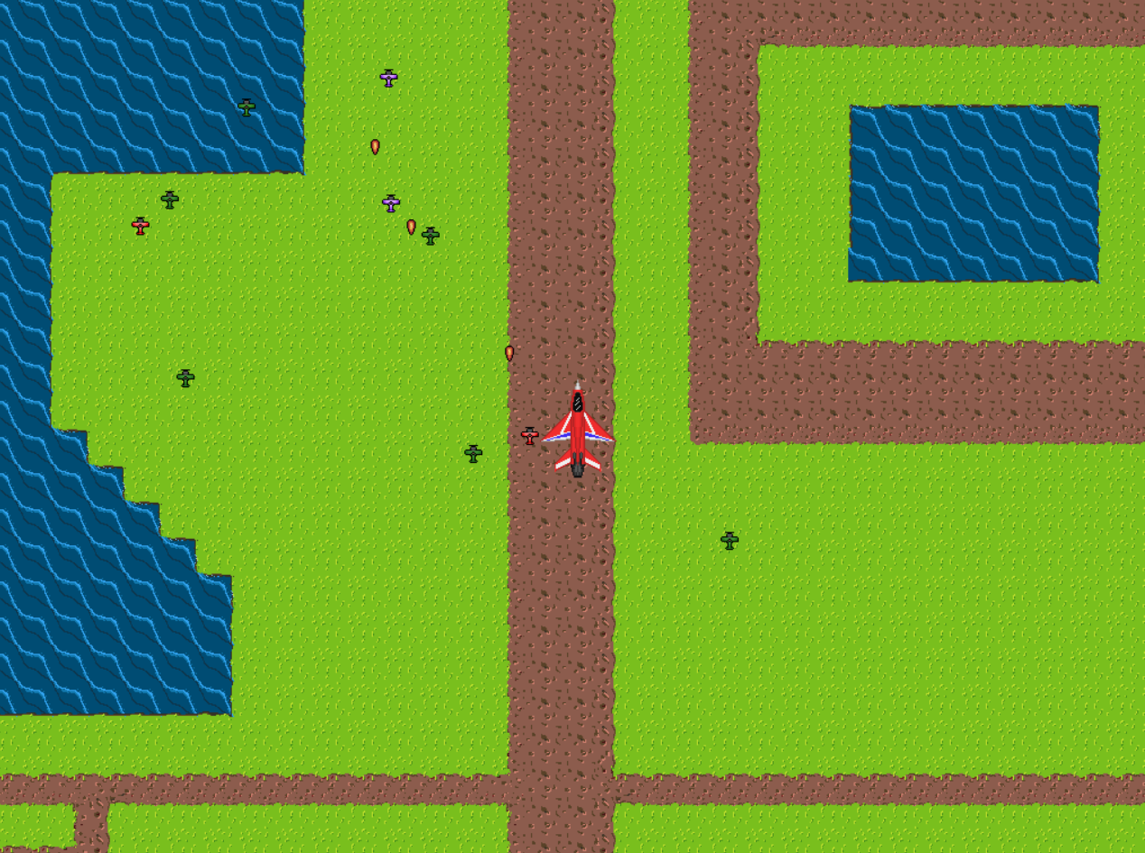
Figure 1: Plane Survivors after 30 seconds of gameplay
Here, the player controls a fighter plane and has enemy planes trying to take the player down by physically colliding with them or by sending projectiles. The player moves faster than all other enemies, but only slightly, and as more enemies spawn (and they spawn faster as time goes on), the player will slowly get overwhelmed with enemy planes and lose all their health. The aim of the game is to survive for as long as possible.
The player has 3 distinct attacks to help in this task. The first is automatic and very frequent, damaging the closest enemy slightly. The second is activated by the player and deals moderate to high damage to the enemy planes with the highest health and their surroundings. The third shoots a flare which redirects all current enemy projectiles towards it and eliminates them if they touch it, as well as dealing a very high amount of damage if it touches an enemy plane.
The game uses the provided two-dimensional basic game engine “GameEngineeringBase.h” file and builds upon it. The only other external libraries used are “random”, “fstream”, and “iostream”.

Implementation Criteria List
- Camera follows player at its centre: Fully Implemented.
- NPCs attack the player: Fully Implemented
- Collision System: Partially Implemented
  - Hero vs Impassable Terrain: Not Implemented
  - Other Collision: Fully Implemented
- Hero has at least 2 different attacks: Partially Implemented
  - 2 Attacks: Fully Implemented
  - Manual AoE Attack Powerup: Not Implemented
- Background: Partially Implemented
  - 4 different tile types with one impassable: Partially Implemented (no impassable tile type)
  - Data Driven Loading: Fully Implemented
  - Infinite World with repeating tiles: Fully Implemented
  - Fixed World: Fully Implemented
- 2-minute level: Fully Implemented
- Save & Load: Fully Implemented

Implementation Details

Overall Implementation
The code starts by creating a window and initializing a GameManager object which will handle the game scene and the game update loop after start-up. The sprites are then loaded, any setup code is run, before engaging in the main loop of the code which will run continuously.
First, the game loop processes player inputs and checks the time the last frame took to compute (the delta time). It then checks whether the player has (un)paused the game before proceeding with updating the scene (if not paused). Finally, the scene is called again to draw the current state of the game to the screen.
The updateData struct contains all necessary input data as well as the frame delta time. An instance of the class is created each frame and passed to any function that requires it.
The scene manages the level, including the player, camera, enemies, projectiles, and background. Apart from keeping data, it has two main tasks: update all objects in the scene appropriately and draw the current state of the game to the screen. Objects in the scene are updated in a specific order (player, camera, enemies, and finally projectiles) each of which will be discussed more in depth.
When drawing the current state of the game, different parts of the image are drawn at different times:
- First the background is drawn. Since the background will usually or always take up the whole screen, a double “for” loop is ran such that, for each pixel, the correct colour is drawn to the screen.
- Then the player sprite is drawn. From a game design perspective, this is to ensure the player can always see enemies and make the player feel overwhelmed if there are several enemies on top of them.
- Enemies are then drawn one by one. This ensures the frame rate does not dip significantly when drawing lots of enemies (in contrast to getting the colour of a particular pixel one at a time, which requires checking every single enemy for every pixel).
- Finally, projectiles are drawn similarly to enemies. Projectiles have an additional feature which gives them an animation over a few frames. This is less visible at high frame rates as the animation is much faster then. A possible improvement here is to pass the frame delta time when drawing to ensure consistent animations no matter the frame rate.
Sprites are drawn using a class Sprite which takes a GameEngineeringBase Image and adds some coordinates as well as a couple of methods to more efficiently draw the image to the screen. Unless the class would only ever need one sprite (such as the player class with no animations), each class keeps a sprite pointer. This pointer can be dynamically allocated and allows each entity to have its own sprite even when created from the same class.
A game parameter header file keeps all developer variables in one easy to access place. This allows the editing of variables which are hard coded without having to search each reference in other files. While very practical, a game parameter header file is unsuitable for larger projects as it requires the recompilation of all files which include it, even when modified variable(s) do not alter those files.

Camera
The game code uses a global frame of reference, which has a universal (0, 0) pixel. The coordinates for an object will then either be placed in the middle of the object (such as for the player, enemies, and projectiles) or the top left corner (such as for sprites). It is placed in that specific corner because the “GameEngineeringBase” engine uses a Y-down coordinate system, which has been followed in the rest of the code.
These coordinates can be stored as a float or as an int; if the object will move and its coordinates will change, it uses a floating-point number to ensure the object can move independently of the frame delta time, otherwise it uses an integer. When converting from float to int, 0.5 is added to the float before casting to an int to ensure proper rounding.
The camera follows the player with a delay. The movement was originally meant to be very smooth by using the cubic smooth step function for interpolation. This would allow the camera to smoothly accelerate at the beginning and then decelerate when getting to its destination.
However, because the delta frame time is not guaranteed nor consistent, it would require a global counter to store the time until the destination is reached (the camera could otherwise never reach or be extremely slow in reaching the destination if there were too many frames). Keeping such a counter is impossible however, as the player can keep moving, changing the destination and therefore how the camera needs to move to reach the new destination.
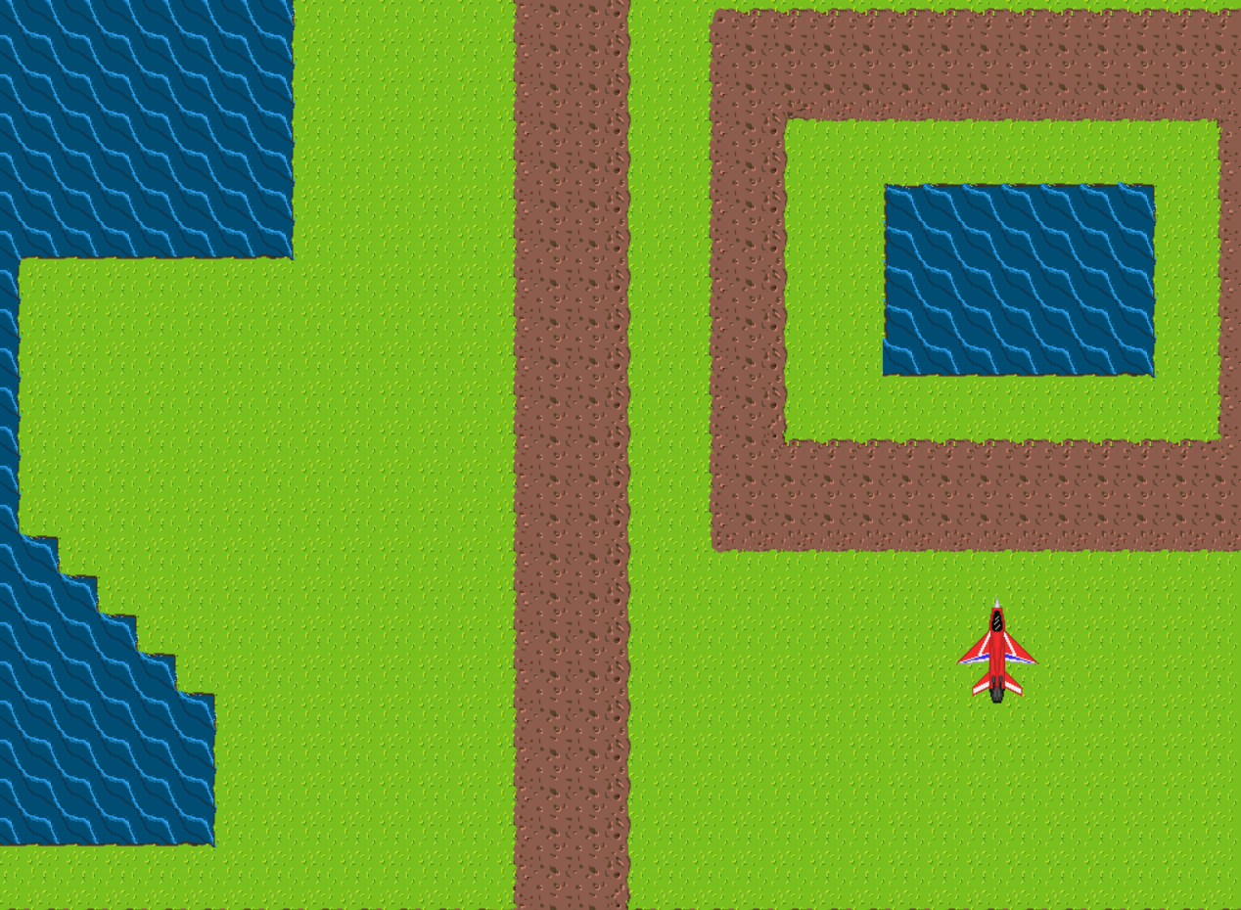
Figure 2: The camera lagging behind when using cubic smooth step for interpolation
Due to time constraints and to limit scope-creep, a linear alternative was instead chosen. While it presents the same problems, they are much more limited and still allow the player to feel like they are moving in a particular direction with the camera following.

Enemies
All enemies use a single class. There are 4 enemy types present which differ in health, speed, strength, and visuals, one enemy type also throws projectiles. These are set when instantiated but could be changed during the game loop as well if necessary.
The enemies are spawned by the scene when needed. The scene decides to spawn an enemy when an enemy-type cooldown timer has expired, at which point it spawns an enemy of that type and adds a certain amount of time to that timer.
The time added differs depending on how long the game has been running for. Each enemy type has a unique spawn schedule. An array stores the amount of time to add for each “chunk”, and the chunk is determined by how much time has passed.
Enemies spawn outside of the camera view. A RNG is used to determine where it spawns in a size which is twice the length and width of the screen (four times by area) and centred on the camera. If the enemy would spawn completely or partially on screen, the spawn point is rerolled.
When the “update” method of the enemy is called by the scene, the enemy moves towards the player appropriately, making sure it is not already on top of the player or close enough for projectiles (enemies shooting projectiles do not attempt to collide with the player), and adjusting its speed with the angle in which its moving by using Pythagoras’ theorem so that it is always moving at the same speed.
The enemy class does not handle dealing damage to the player nor throwing projectiles, which is done by the Player and Scene class respectively.
The scene class decides to throw projectiles when that enemy’s projectile delay has expired. It instantiates an enemy projectile at the location of the enemy. This projectile will continuously follow the player, or the player’s flare instead if one currently exists. It only expires once the projectile either collides with the player or with the flare.
When enemies run out of health, their spot in the “enemies*” array which the scene holds (the array itself is on the heap) is replaced by the last enemy on the array (therefore actually removing the last enemy that spawned; but since it is then copied to the location of the dead enemy, the player only sees the dead enemy disappearing). This enemy clean up routine also has the side-effect of not guaranteeing the enemy order. A counter keeps track of how many enemies are currently in the world to know the length of the array. The array is initialised with a very large size, but the scene uses it similarly to an “std::vector”, with a fixed maximum size. If an enemy would spawn when the maximum size has been reached, the enemy does not spawn.

Collision System
The collision class handles collisions between any entity. Any entity which needs it will have a collision object. The collision object pointer is passed to another collision object which will then check whether a collision has occurred or is occurring in the current frame. Entities must supply their position and size (as well as speed if needed), and the collision system will determine if they are either touching right now or will be touching after movement is processed. Collisions are currently handled entirely through circles due to time constraints, adding rectangle collisions could be useful (although the game currently handles collisions quite well with the current parameters).
Ideally (to avoid as many movement bugs as possible), movement would be processed twice, once only to calculate the theoretical movement of an entity then it would be applied after collision has been checked. These need to be separate steps as all entities need to supply their collision object with their current position and speed for the frame before collision can be checked. This has not been done due to time constraints, but the structure of the class and update functions were constructed with this feature in mind. Similarly, catching movement collisions in between frames (such as with very fast-moving objects) has not been implemented, but could be implemented given only slightly more time as the basic structure is already present (namely with the collision object knowing the entity’s velocity).
Collisions between the player and enemy planes is handled by the player class. The player calls each enemy’s collision object and checks collision. If a collision has occurred, it requests that enemy’s attack damage and damages itself. The player has a very short total invulnerability (to avoid making damage frame time dependent) and then has a shield which gives temporary invulnerability for a little longer (and drains faster if more attacks hit it).
There is currently no collision check between the player and background tiles due to time constraints. The implementation would require the player to check which tiles their collision intersects with (or would intersect with after movement) and check if any have the Boolean is_solid (in the collision class) set to true (which the impassable tile type would have). The player would then be unable to move in the direction of the tile (but, critically, could still move away from the tile or at a 90-degree angle).
The player can send a projectile with one of their attacks. This “friendly” projectile checks all enemy projectiles and if any of them are colliding, then the enemy projectile expires. Similarly, the friendly projectile also checks collision with enemies, if any of them collide, the friendly projectile deals a sizable amount of damage to the enemy (destroying almost all types of enemies) but then expires. This is checked by the scene. When updating all projectile positions, the scene checks whether a friendly projectile is present, if one is, then the collision routine for it is ran.
As enemies and projectiles are quite similar, the player class also checks whether projectiles are colliding with the player in the same way as enemies. If a projectile is colliding with the player, the player requests the projectile’s damage and damages itself. The projectile also expires at that point. Enemies and projectiles are so similar that, if the project were started over, it would be easier to make projectiles enemy entities and have a Boolean variable check whether that enemy is a projectile.
As enemies do not collide with each other nor the terrain, their update routines only update their positions, collisions caused by them are instead handled by the player (which is the only entity which cares whether an enemy has collided).

Player Attacks
The player has 3 distinct attacks. One of them is automatic and has a very short cooldown. The other two require the player to press a button and have a much longer cooldown.

1st: Continuous Automatic Attack
The first attack continuously damages the closest enemy to the player. This is done by checking every enemy’s position and calculating which one is closest, then damaging that enemy accordingly. The update method of the player checks whether the attack cooldown has elapsed and runs the corresponding attack if so and adds the cooldown back to the timer.
Most cooldown timers which run continuously have their cooldown time added to the timer instead of setting the timer to it directly (this is the case for enemy spawn timers as well for example). This ensures the timing is independent to the frame time. This is not the case for the other two attacks as the player could have waited longer before pressing the attack button.

2nd: AoE Manual Attack
The second attack is the most complicated one. It attacks N enemies (with N chosen in advance) and their immediate surroundings (as well as the surroundings of the player to shake off nearby enemies). The N enemies with the highest health are chosen (if multiple enemies have the same health, the closest ones to the player are chosen). This requires an algorithm which goes through all enemies and selects the N required.
This 2nd attack algorithm starts by getting the index (call it index x) of the enemy with the lowest health out of the N first enemies (the first by index in the enemies array). Each enemy after that is then checked: if it has a higher health than enemy x then this new enemy is retained (replacing enemy x for the N enemies), and a new enemy x is chosen (the one with the lowest health out of the new N enemies). Given the size of the enemies array as M, the complexity of this algorithm is $O\left(NM\right)$ in the worst case (when the next enemy always has a higher health).
After finding the N enemies, each enemy and the enemies in their immediate surroundings (by checking their distance is smaller than a certain amount) is damaged accordingly.

3rd: Flare Manual Projectile Attack
The third attack sends a projectile in the direction the player is currently moving in (or was last moving in) and will go in a straight line for a short period of time. This projectile also attracts any enemy projectiles towards it and will destroy them if they collide (this is the only way for the player to remove enemy projectiles). The projectile also deals a very large amount of damage to any plane it collides with (but this also causes the projectile to expire).

Background
The background keeps all tile sprites and a map of which tile sprite to match with each position. When getting the pixel colour, the background class checks which tile it lands on and which pixel of that tile it is requesting. Then it fetches the corresponding tile sprite and the pixel colour before returning it.
If the world is infinite, the pixel positions are summed (or subtracted) by a multiple of the map size such that they land between (0, 0) and (width, height).
When loading the map, all characters are fetched one by one. Since a comma always separates the numbers in the map, each digit fetched is added to 10 times the previous result until a comma is encountered, at which point the number obtained is returned (this is the tile index for the sprites). If a new line is encountered, the numbers fetched now represent the next row of tiles. Map loading is handled by the scene and then passed to the background.

Game Start & End
When starting the game, the player is shown a short introductory story and told the controls. The player then chooses whether to load the infinite world, fixed world, or load from a save file. Starting the game from the beginning (not from a save file) will have the player get familiar with the controls and throwing a flare.
While most enemies are dying very quickly due to the automatic attack and do not make it on screen for the first 30 seconds, this quickly changes after, and the player now needs to avoid a growing number of planes. After 75 seconds, the boss plane spawns, and other planes spawn less often for 15 seconds to allow the player to deal with the boss. After this, the player attempts to survive for as long as possible with their limited health.
Once the game ends, the player loses control of their airplane and is given their survival time and number of enemy kills. The average frame rate of the game is also displayed.

Saving & Loading
When the player pauses the game, the game saves the current state of the game to a text save file. The player can then, when starting a new game, choose to load this save file to start from there again.
All variables saved are integers or floats (with Booleans converted to integers). The only variable numbers which could change the number of items to read are the enemy numbers and projectile numbers. Each enemy and projectile is given a line, and the save file also contains how many enemies and projectiles there are.
The scene handles both saving and loading (with the player class handling its own saving to the save file, but not its loading). New lines are arbitrarily placed for readability of the save file only, they are not required. All numbers are delimited by a comma. Floats require a slightly more complicated algorithm to read them character by character, making sure negative numbers, exponential numbers, and whole numbers are all accounted for.
This saving/loading routine is hard-coded. Any changes to the code would require the save and load methods to be modified. A potential major improvement is the introduction of Serialization, which would allow more automatic fetching and setting of variables when saving and loading respectively.

Game Performance
The game runs at 500 frames per second (fps) when there are no enemies or background tiles present. Adding the background to the entire screen reduces this to 150 fps (which suggests a big potential efficiency improvement with the background). Enemies do not affect fps significantly during regular gameplay.
When enemy spawns are adjusted such that there are a thousand enemies on screen after just a few seconds (the theoretical maximum during regular gameplay), the game runs at 120 fps without the background and around 70 fps with.
When the maximum enemy count is increased to ten thousand, the game runs at 20 fps, and crashes when trying to throw a friendly projectile (most likely due to stack overflow).
These numbers are relatively expected for a game handling both its logic and drawing to screen.

Limitations & Improvements
The game does not use any dynamic array (or vectors). This was, of course, partially on purpose as the inclusion of standard libraries for data types was prohibited. This limitation is not visible during regular gameplay as the parameters set never reach any array limit, but it did influence certain coding decisions and make the application rather inefficient space wise.
A more efficient solution could also be found for the Game Parameters header file as it currently requires the recompilation of all files that include it when making any changes to it. Ideally, only files which are affected by the change should be recompiled.
Saving and Loading similarly could have a much better solution, as they are currently hard-coded, and changes to any part of the code requires changing those functions for them to work.
Overall, the implementation is relatively efficient code-wise and should allow any future feature implementations to be coded efficiently (ignoring saving/loading), although there are a couple of areas which could be simplified (notably the use of a Projectile class instead of simply making projectiles part of the Enemy class).
Collisions are a big and easy area of improvement if the game needs fast moving objects or more precise collisions. Continuous collisions are incredibly interesting and useful to avoid many out of bounds bugs players can encounter. Making sure such collisions are efficient can be challenging, but generally narrowing down the specific collision cases and getting early conclusions for most collisions checks (>99%) will not result in a performance bottleneck.

Conclusion
The game follows almost all criteria (except for tile collisions) and attempts to make the code as future-proof as possible. I would be particularly interested in knowing where and how the code could be improved (without importing any other libraries that is), not only on the practical side, but also for general coding conventions.
The GitHub repository can be found here: https://github.com/Gabrio05/WM908Algorithms/tree/main

