RL PCB: A Tool-Based Assistant for Printed Circuit Board Design in KiCad,
and an Evaluation of Its Use by a Smaller Language Model
Dalton Omondi
Independent researcher, Kenya
Technical report, September 2026
Abstract
RL PCB is an assistant for printed circuit board (PCB) design that runs alongside KiCad, the open-source electronics design suite. It gives a language model about seventy tools for reading and editing KiCad projects: part search over the user's own libraries, engineering calculators, a design plan, symbol placement, wiring instructions, verification of hand-drawn schematics, board placement, autorouting and design-rule checks. By design, the assistant never draws schematic wires. The model plans and checks; the human draws. Every claim the assistant makes can then be verified by computation against the drawing. The core connectivity engine reproduces KiCad's own netlist on all 13 KiCad 7 demonstration projects. With a frontier model (Claude Opus), RL PCB took a 61-part drone flight controller from a written brief to a verified schematic and a two-sided, four-layer board that was 88–91 % autorouted.
Smaller models are cheaper, faster, more widely available and can run on modest or local hardware, so we then asked whether RL PCB's tool design could let such a model do the same kind of work. In 16 runs on a fixed brief (a USB-C data logger), Claude Haiku was given either pin-level tools only, or pin-level tools plus pre-verified circuit blocks, a guided next-step tool and automatic engineering checks. With blocks, the mean functional score was 18.1 out of 19 (4 of 8 runs perfect, 37 tool calls on average). With pin-level tools only, it was 16.0 out of 19 (1 of 8 perfect, 88 calls). The errors the smaller model made, such as swapped USB data lines, reversed regulators, reversed LEDs and wrong USB-C configuration resistors, were turned into automatic checks. The final check set flags every flawed design in the study and none of the correct ones. The sample is small and the tools were changed between rounds, so the results show a direction rather than a precise effect size.

1. Introduction

1.1 The problem
Designing a PCB requires several kinds of knowledge at once:
- choosing parts that exist and are available;
- deriving component values from datasheets;
- connecting every pin correctly;
- placing and routing the board so that it meets electrical and manufacturing rules.
A single wrong connection usually means a board that does not work. A new fabrication run costs weeks and money. For students, makers and small hardware teams, including most of those working in Africa, there is often no experienced engineer available to review a design before it is ordered.
General-purpose language models can explain electronics well, but they are poor at producing schematics directly. When asked to draw, they produce wires that appear to connect but do not ("ghost" wires, wire ends that stop short of a pin, junctions that KiCad does not recognise), and they sometimes name parts, pins or footprints that do not exist. These errors are hard for a beginner to see, which makes this kind of help risky.

1.2 Approach
RL PCB divides the work. The model does what it does well: gathering requirements, reasoning about architecture, searching parts, calculating values and explaining. Deterministic tools do everything that must be exact: coordinates, netlists, geometry and rule checking. The model never creates schematic wires. It records the intended circuit in a design plan (parts, nets and deliberate no-connects), places the symbols, and gives the user exact wiring instructions. It then compares the user's drawing against the plan. The plan acts as a contract and the drawing as the evidence, so every claim of "correct" or "missing" is the result of a computation.

1.3 Contributions
- A working assistant for KiCad 7–10 with about seventy tools, exposed through the Model Context Protocol (MCP) and through a chat panel inside KiCad.
- A connectivity engine that reproduces KiCad's netlist rules, validated against KiCad's own netlister.
- A complete case study, run with a frontier model, taking a drone flight controller from brief to routed board.
- A controlled comparison of a smaller model with and without structural support (circuit blocks, guided flow, engineering checks), with a list of the errors observed and how each is now detected.

2. System design

2.1 Architecture
RL PCB is written in Python. It reads and writes KiCad's S-expression files directly: schematics, boards, symbol and footprint libraries, and legacy KiCad 4/5 files. Edits are made by splicing text into the original file, so the rest of the user's file is left unchanged. Every modified file is re-parsed before it is saved, and a timestamped backup is kept. The main components are listed in Table 1.
Component | Function
Connectivity engine | Computes nets from the drawing: wires, junctions, local/global/hierarchical labels, power symbols, hierarchical sheets, buses and bus aliases, no-connect flags. Detects ghost wires, near-misses and wire ends that touch another wire without a junction.
Library index | Full-text search (SQLite FTS5) over every symbol and footprint in the user's libraries, with pins, footprint filters, pad counts and pitch. The model cannot use a part that is not in the index.
Design plan | The intended circuit (parts, nets with class/current/voltage/impedance annotations, no-connects, requirements, decisions), stored with the project.
Review and verification | Plan review checks the intent before drawing; verification compares the drawing with the plan (progress, missing connections, shorts, unplanned connections, wrong values).
Placement and wiring guide | Places symbols grouped around the pins they serve (no wires) and produces per-net wiring steps with exact pin coordinates.
Board tools | Stackup advice, net classes, placement of passives next to their pins (two-sided, collision-free), footprint moves and flips, Freerouting autorouting, DRC and fabrication outputs.
Knowledge | 34 engineering guides and reference architectures, the user's own PDFs, and a corpus of 136 open-source KiCad designs (3,518 parts) used to show how real designs wire a given chip.
Calculators | IPC-2221 trace width, impedance, dividers, buck/boost stages, LDO dissipation, crystal load capacitors, LED resistors and others; each result states its formula.
Interfaces | MCP server (Claude Desktop or any MCP client), a chat panel launched from KiCad, and live control of the open editor through KiCad 9/10's IPC API.
Table 1. Main components of RL PCB.

2.2 Why the assistant does not draw wires
Wires are the part of a schematic where language-model output is least reliable and where errors are hardest to see. A wire that stops 0.6 mm short of a pin looks connected on screen but is electrically open. RL PCB therefore limits the model to placing symbols and, on request, placing net labels exactly on pin ends. The label coordinates are computed, not estimated. The human draws the wires, and verification then reports exactly which connections are missing or wrong, with coordinates. This keeps the human's attention on the part of the task where it matters most.

2.3 Validation of the connectivity engine
Everything else depends on the connectivity engine, so it was tested against KiCad itself (Table 2).
Test set | Comparison | Result
13 KiCad 7 demonstration projects (including hierarchical and bus-heavy designs) | Every net vs. the netlist exported by kicad-cli | 13 / 13 identical
VESC motor controller (open source, KiCad 4 format) | Every net vs. the project's own netlist | Identical
KiCad 9/10 demonstration projects | Schematic nets vs. the boards' nets | Match, apart from items stale in the demo files
Footprint flip to the bottom side (file mode) | Pads, graphics and text vs. KiCad's own flip; 12 footprint types × 4 rotations | Exact
Table 2. Validation of the connectivity engine and board editing against KiCad.

3. Case study with a frontier model
To see how a new project flows through RL PCB, the assistant was asked, running on Claude Opus, to design a flight controller for a 5-inch quadcopter. The brief was:
- a 36 × 36 mm board with 30.5 mm M3 mounting holes;
- a 2–6S lithium-polymer battery input (7–25.2 V);
- an STM32F405 microcontroller;
- an ICM-20602 inertial sensor on SPI and a BMP280 barometer on I2C;
- 128 Mbit flash for flight logs;
- USB-C for configuration;
- connectors for the motor controller, radio receiver, video transmitter and debugger.

3.1 Schematic stage
The model recorded the requirements and design decisions in the plan. It then chose 61 parts, all from the stock KiCad libraries, and calculated the component values, showing the formula for each:
- a feedback divider of 9.31 kΩ / 3.01 kΩ for a 4.998 V output from the TPS5430 regulator;
- 18 pF crystal load capacitors, from 2·(12 − 3) pF;
- a 10 kΩ / 1 kΩ battery-sense divider, which reads 25.2 V as 2.29 V;
- a 15 µH buck inductor (13.4 µH calculated).
The plan review reported no errors and no warnings. The symbols were placed on four hierarchical sheets, grouped around the pins they serve (Figure 1), and the tool produced per-net wiring instructions.
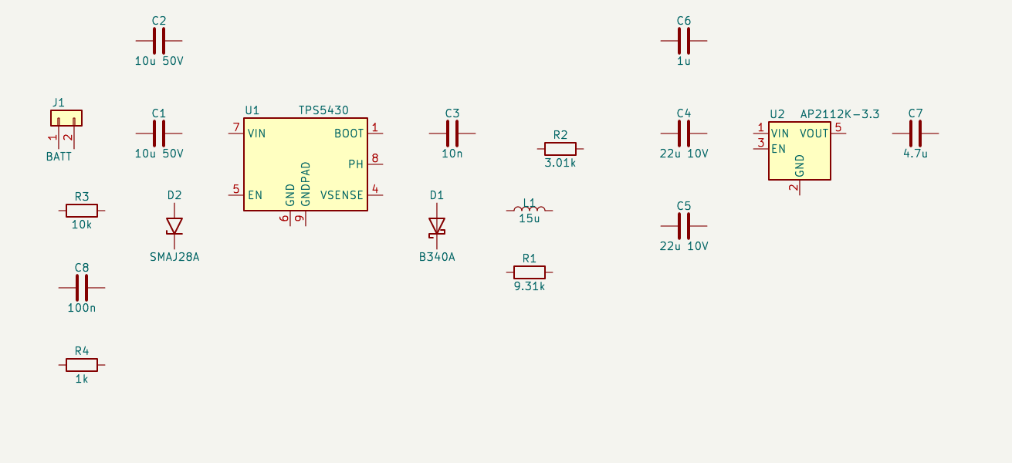
Figure 1. Power sheet as placed by RL PCB. Symbols and values only; the wires are left to the user.
To test verification without a human drawing the wires, the finished drawing was simulated by placing net labels on pin ends. Verification reported 174 of 174 planned connections, and KiCad's netlister agreed on all 79 nets. Two deliberate mistakes were then introduced:
- the barometer's SDA and SCL lines were swapped;
- a label was placed 0.64 mm away from the pin it should connect to.
Both were reported by name. The second came with the nearest pin and the distance to it.

3.2 Board stage
The stackup advisor recommended four layers. Net classes were written to the project. After about twenty anchor parts had been placed according to the plan's layout notes, RL PCB placed the remaining 40 passive components next to the pins they serve, using both sides of the board. The result had no courtyard overlaps (Figure 2). Freerouting, run for three minutes on a copy of the board, routed 88–91 % of the connections across runs. KiCad's design-rule check found no clearance violations between routed tracks. The remaining errors came from fine-pitch footprints under KiCad's default 0.2 mm clearance, and from one via placed 0.03 mm inside the edge clearance.
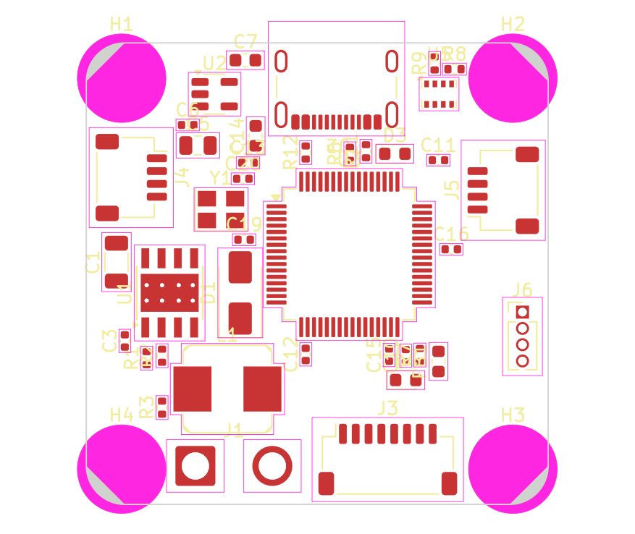 | 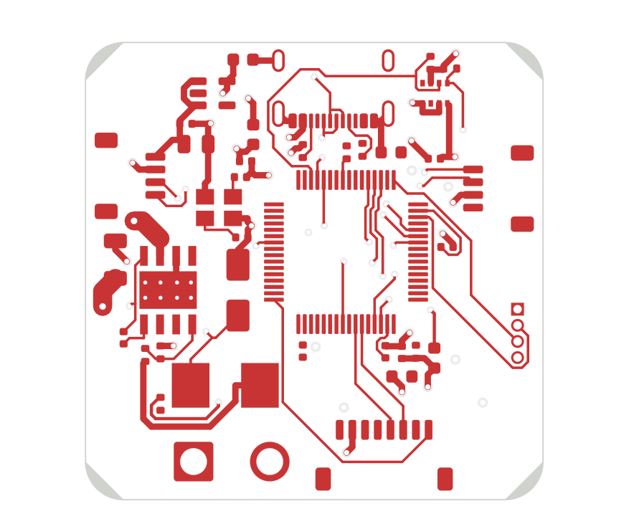
Figure 2. Drone flight controller: placement (left) and top copper after autorouting (right).

3.3 Defects found in the tool during the case study
The case study also served as a test of RL PCB itself, and it exposed several defects that had passed the unit tests. Each was corrected, and most were covered by new tests:
- Placement suggestions assigned the microcontroller's decoupling capacitors to the flash chip, because both share the 3.3 V net. Assignment now prefers the chip in the same functional block, one capacitor per supply pin.
- The crystal-distance rule measured against the regulator instead of the microcontroller.
- Suggested positions could fall outside the board outline, and mounting holes were treated as having zero size.
- Moving a part to the bottom side required KiCad to be open. A file-level flip was implemented and verified against KiCad's own flip.
- The installed version of Freerouting ignores its pass limit in headless mode, so on a board it could not finish it ran until killed and produced no output. The router is now bounded by a time limit.
- On the author's Windows laptop, the live API connected to a KiCad process that had no board open. RL PCB now searches all KiCad API sockets.
The tool was then installed on the author's laptop (Windows, KiCad 10.0.6). The library index there covers 22,860 symbols and 15,450 footprints. The self-check passed, the KiCad API was reachable, and the tools became available in Claude Desktop.

4. Why test smaller models
The case study used a frontier model. Such models are the most capable, but they are also the most expensive per task and are available only through cloud services with usage limits. Smaller models matter for practical reasons:
- Availability. They are offered on free and low-cost plans, and many open-weight models of similar size can be downloaded and run without an account.
- Compute. They need far less memory and processing, and some can run on a single consumer GPU or a laptop. RL PCB's chat panel already accepts any OpenAI-compatible local server (for example Ollama or LM Studio).
- Cost and latency. Each step is cheaper and faster, which matters for a tool that makes dozens of calls per design.
- Local use. Designs can stay on the user's machine, and the tool can work with limited internet access. This is relevant for many users in Africa, where connectivity and subscription costs are real constraints.
The research question was therefore whether the structure of the tools can make up for a weaker model. Tools that carry verified engineering knowledge and report errors as explicit pass/fail signals should reduce how much the model has to know and notice by itself. If so, a smaller model should produce more correct designs, with fewer steps.

5. Experiment

5.1 Task
Every run received the same brief: a USB-C data logger. It specified:
- a USB-C connector for USB 2.0 device operation, with ESD protection and correct CC configuration;
- a 3.3 V linear regulator powered from USB;
- an STM32F405 microcontroller with an 8 MHz crystal (12 pF load), decoupling, VCAP capacitors and BOOT0 handling;
- a BMP280 barometer on I2C, W25Q128JV SPI flash and a status LED;
- a 4-pin debug UART header, on a 40 × 30 mm board;
- unused microcontroller pins marked as no-connect.
The task was to produce a complete design plan, since the plan is where most design errors originate. Drawing and layout were not part of the task.

5.2 Conditions
Two conditions were compared, using the same model (Claude Haiku) and the same tool descriptions that an MCP client would show (Table 3).
Condition | Tools available
A: pin-level | Symbol and footprint search, add components, connect pins, mark no-connects, plan review, calculators, knowledge base and reference designs (16 tools)
B: blocks | All of A, plus list_blocks, add_block, block_connect, next_step and design_checks (21 tools)
Table 3. Experimental conditions.
A block is a pre-verified sub-circuit with parameters and named ports: for example a 3.3 V regulator with its capacitors, or the STM32F405 with its decoupling, crystal, VCAP capacitors and boot configuration. Values are calculated from the parameters. The microcontroller block is connected by peripheral function (for example SPI1_SCK or USB_DP); the block chooses a valid pin and refuses conflicts. next_step reads the project state and returns the single next action. design_checks runs the engineering checks described in Section 6.3.

5.3 Procedure
Each run was an independent agent session starting from an empty project. The agent called RL PCB through a command-line wrapper that enforced the tool list of its condition and logged every call. It was told not to read source code or edit files directly, and to stop when it judged the design complete and the plan review clean, or after about 90 tool calls. There were four rounds, each with two runs per condition, giving 16 runs in total.
Between rounds, the tools were improved using the errors seen in the previous round, and the tool documentation was regenerated. This is a design-iteration study rather than a single fixed experiment. Its consequences are discussed in Section 7.3.

5.4 Scoring
An independent script scored each final plan against 19 functional criteria (Appendix A). Examples:
- USB D+ reaches pin PA12 and D− reaches PA11, through the ESD part, on both rows of the USB-C connector;
- the CC pins have 5.1 kΩ resistors to ground;
- the VCAP capacitors are between 1 and 4.7 µF;
- the barometer's clock and data lines sit on a valid I2C pin pair;
- the flash's clock, MISO and MOSI belong to one valid SPI peripheral;
- the LED is correctly oriented and has a series resistor.
The scorer does not use RL PCB's own checks. A hand-built reference design scored 19/19. Swapping the flash's MISO and MOSI lines in that reference reduced the score by exactly one criterion, which shows the scorer detects single faults.

6. Results

6.1 Scores
Round | Pin-level (A): score, tool calls | Blocks (B): score, tool calls
1 | 15/19, 68 · 17/19, 70 | 16/19, 23 · 19/19, 23
2 | 16/19, 92 · 18/19, 103 | 19/19, 15 · 19/19, 47
3 | 15/19, 102 · 10/19, 70 | 18/19, 91 · 17/19, 40
4 | 19/19, 103 · 18/19, 99 | 19/19, 22 · 18/19, 34
All 8 runs | Mean 16.0/19; 1 perfect; mean 88 calls | Mean 18.1/19; 4 perfect; mean 37 calls
Table 4. Functional scores (out of 19) and tool calls for each run.
With blocks, the smaller model produced more correct designs (mean 18.1 against 16.0; four perfect designs against one) in about 2.4 times fewer tool calls. The lowest block-condition score in rounds 2–4 was 17/19. The pin-level condition ranged from 10/19 to 19/19.

6.2 Errors observed
The pin-level errors were often severe. Table 5 lists every error class observed and the check that now detects it.
Error (run) | Consequence | Detected by
USB D+ on PA11 and D− on PA12 (A1, A2) | USB does not work | mcu_pin_function
CC resistors of 100 kΩ or 1 MΩ (A1, A2) | USB-C chargers do not supply power | usb_c_cc
ESD array anode connected to D− (A1) | Clamps the data line | tvs_orientation
Connector rows cross-wired; D+ shorted to D− (A2) | USB fails | usb_c_data
Only one connector row wired (A5); 2 of 4 VBUS pins (B8) | Works in one cable orientation only | usb_c_data, partial_pin_group
Regulator ground pin on 3.3 V, output on ground (A3) | Regulator output shorted | pin_role
LED anode to ground, directly or through its resistor (A1–A4, A6) | LED never lights | led_polarity
VCAP of 100 nF, or VCAP_1 and VCAP_2 joined (A1, A4, A6) | Microcontroller core supply unstable | stm32_vcap
Nets named SPI1_SCK or PA4 without the matching pin (B1, B6) | Peripherals not connected | mcu_pin_function, net_named_like_pin
Connector data net connected to nothing else (B5, B6) | No USB | net_goes_nowhere, block_port_open
Second ground pin of the ESD part left open (A5) | Reduced protection | ground_pin_open
Barometer address pin marked no-connect (A8) | Undefined I2C address | must_connect
Table 5. Error classes observed in the runs and the checks added to detect them.
Two tool-design problems also appeared in the block condition. In round 1, one run named nets after microcontroller functions (for example SPI1_SCK), assuming this would connect them. Because the tools offered no way to add connections to an existing microcontroller block, it then guessed pin numbers, and every guess was wrong. A block_connect tool was added. In round 4, a run made an invalid add_block call that left a partially created block, and the model repaired it by hand, incompletely. add_block now either succeeds completely or changes nothing. One run (B5) ignored the blocks entirely and built the circuit pin by pin; plan_add_components now points to the matching block when one exists.

6.3 Agreement between the checks and the independent scorer
With the final set of checks, every design the scorer marked as flawed produced at least one design_checks error, and every design the scorer marked perfect produced none. This held for all 17 designs (16 runs and the reference). The checks also produced no errors on the two drone flight-controller designs from Section 3. Because the checks were written after the errors were seen, this agreement is measured on the same designs that motivated the checks. It shows that the checks cover the observed errors; it does not show how well they generalise.

7. Discussion

7.1 What the blocks change
Blocks move the most error-prone details out of the model: support components, values, and which pin can carry which function. The errors that remained in the block condition were almost all at the connections between blocks, or in parts the model built outside a block. That is where the checks are most useful.

7.2 What the checks change
Checks convert expert noticing into explicit feedback. From round 2 onwards, pin-level runs connected USB correctly, because the plan review now stated which pin to use. Checks do not make the model converge, however. A small model fixing errors one at a time can run out of budget (run A6 stopped with nine reported errors). It can also argue past an error: run A4 described a real VCAP error as "correct and expected". Checks work best combined with blocks, which prevent most errors from occurring in the first place.

7.3 Limitations
- Sample size. There were 16 runs, on one brief, with one small model. Differences of one or two points per run should not be over-interpreted.
- Changing tools. The tools were improved between rounds, so the rounds are not replications, and later rounds benefit from fixes made in response to earlier ones.
- In-sample checks. The checks were derived from the observed errors, so the reported agreement is in-sample. A held-out set of briefs is needed.
- Scorer. The scorer was written by the same team as the tool. It was validated only on a reference design and one mutation.
- Scope. Only the design plan was evaluated, not schematic drawing, board layout or fabricated hardware. The drone board has not been manufactured, and it has open datasheet questions (inductor saturation current and USB back-feed into the battery rail).
- Block coverage. Blocks exist for eleven circuits. Outside that set, a smaller model falls back to pin-level work, with the error rates seen in condition A.

8. Conclusion and future work
RL PCB shows that a language model can take part in PCB design reliably if it is not asked to do the parts it does badly. Keeping wiring with the human, and exact work with deterministic tools, allowed a frontier model to take a 61-part board from brief to a verified schematic and a mostly routed layout. The same structure, extended with pre-verified circuit blocks, a guided next step and engineering checks, raised a smaller model's functional score and more than halved the steps it needed. This supports the aim of making design assistance usable with cheaper models that can run on local hardware.
The next steps are:
- A held-out evaluation on new briefs, with more runs per condition and with open-weight models run locally.
- A larger block library (more microcontrollers, motor drivers, isolated inputs, battery management).
- Fabrication and testing of the drone board.
- A study with students measuring time to a working board and errors caught before fabrication.
- Support for multi-board products, which has been implemented but not yet evaluated.

Authorship and use of AI
The author defined the problem, the division of labour (no AI-drawn wires), the requirements and the evaluation questions, and tested the software on his own KiCad installation. The implementation, the case study and the evaluation runs were carried out with extensive assistance from Anthropic's Claude models: an Opus-class model for development and the case study, and Claude Haiku as the evaluated model.

References
[1] KiCad EDA. KiCad open-source electronics design suite, versions 7–10. https://www.kicad.org
[2] Freerouting. Open-source PCB autorouter. https://github.com/freerouting/freerouting
[3] IPC. IPC-2221B, Generic Standard on Printed Board Design. 2012.
[4] STMicroelectronics. STM32F405xx/STM32F407xx datasheet (DS8626).
[5] USB Implementers Forum. Universal Serial Bus Type-C Cable and Connector Specification.
[6] Texas Instruments. TPS5430 3-A, wide-input-range step-down converter datasheet.
[7] Model Context Protocol specification. https://modelcontextprotocol.io

Appendix A. Scoring criteria
# | Criterion
1 | An STM32F405 is present
2 | All VDD, VBAT and VDDA pins are on one 3.3 V rail (VDDA may pass through a filter)
3 | All VSS and VSSA pins are on ground
4 | VCAP_1 and VCAP_2 each have a 1–4.7 µF capacitor to ground and are not on the rail
5 | BOOT0 is tied or pulled down to ground
6 | A crystal is on PH0 and PH1, each with a load capacitor to ground
7 | At least four decoupling capacitors on the 3.3 V rail
8 | USB D+ reaches PA12 and D− reaches PA11 (through an ESD part if present), on both connector rows
9 | Both CC pins have 5.1 kΩ to ground
10 | The ESD part's ground or anode pins are on ground
11 | USB VBUS reaches the regulator input; the regulator output is the microcontroller's rail
12 | The regulator's input and output each have a capacitor to ground
13 | The barometer's SCK and SDI are on a valid I2C SCL/SDA pin pair of the microcontroller
14 | Both I2C lines have pull-up resistors to the 3.3 V rail
15 | The barometer is in I2C mode (CSB high), its address pin is tied, and it is powered
16 | The flash's CLK, DI and DO are on SCK, MOSI and MISO of one valid SPI peripheral, and CS is on a GPIO
17 | The flash's /WP and /HOLD are tied high, and it is powered and decoupled
18 | The LED is correctly oriented, with a series resistor, driven from a GPIO or the rail
19 | A header carries ground and a valid USART TX/RX pair
Table A1. The 19 functional criteria used by the independent scorer.

